10. Workforce Updates and Actions
This section of the report provides further detail on key workforce measures. Caveats and Limitations (C&L) detailed beneath data in each section.
Staff sickness rates - Percentage of sickness absence rate of staff (two metrics provided, ‘rolling 12 month’ and ‘in month’)  Sickness absence target – 5.5% | % of full time equivalent (FTE) days lost to sickness absence  Caveat & Limitations;- Report generated November 2024, within SBUHB (Performance Team) for substantive and FTC employee types. Data source – ESR. Target of 5.5% added as blue line
Current Performance
In month sickness absence has increased, from 7.22% in October 2024 to 7.73% in December 2024. Long term sickness fell by 0.3% during the quarter, however, short term absence rose by 0.9% from 2.18% at the end of October 2024 to 3.04% by December 2024.
- Anxiety/stress related absence remains the highest reason for absence (33% of days incurred), a trend witnessed across NHS Wales.
- The highest number of absence occurrences (single episodes) during the quarter, were as a result of cold, cough and flu, this is consistent with seasonal trends. There is also an increase in absence occurrences relating to Gastrointestinal problems. This picture reflects the reported national rise in ‘quad-demic’ viruses, with a reported 350% increase in cases of flu alone.
- The Directorate with the highest absence levels at the end of this quarter is the COO Directorate at 11.89%. This is as a result of high long term absences recorded as stress/depression/anxiety within Hotel Services.
- Mental Health & Learning Disabilities remains the Service Group with the highest levels of absence at 8.62%, a 1% rise since the last quarter and whilst Primary Community Care & Therapies Service Group also remains as the Service Group with the lowest levels of absence at 6.91%, there was also a 0.2% increase in absence since the last quarter within this Group. Both Service Groups record Anxiety/Stress/Depression as the highest reason for absence.
- Both Morrison and Neath Port Talbot Service Groups saw a 0.6% increase in sickness absence from the last quarter. Whilst Stress/Depression remained the highest reason for long term absence, both Service Groups saw a significant increase in short term absence due to Cough, Cold and Flu cases.
- Mental Health absence reasons are typically in the top three absence reasons (usually highest). This is a long term pattern and consistent not just within the Health Board or across NHS Wales but also across other professions and industries. The Health Board’s Wellbeing support is well utilised, with specific activity covered in more detail below.

Actions for Next Period
General
Current focus on areas with high absences rates, examples of initiatives to support our employees:
- Continuing with tailored adjustments training for managers to increase experience of using these to flexibly support staff to remain in work/return to work
- Case conference training for leaders in partnership with OH continue.

Occupational Health and Staff Health and Wellbeing
The services continue to develop high quality multi-disciplinary interventions to contribute to an engaged, motivated and healthy workforce.
- Increased promotion of Staff Wellbeing Services across the Health Board with gold Comms focus on staff support during January 2025 – mental health referrals to the service increased by 29% and Physiotherapy referrals by 54% in 2024 compared with 2023
- The first ‘Healthy People Forum’ took place in Nov 2024 with outputs including pilot OH&WB Physiotherapy and Occupational Therapy support for Hotel Services to support reducing sickness absence – Feb-May 2025.
- Occupational Health Nurses continue supporting the staff flu campaign with support from Comms and Imms team; senior flu leads identified in Service Groups to coordinate local vaccinations with additional Comms to promote uptake – Jan/Feb 2025.
- Occupational Health service undertaking the UK gold standard quality kite-mark initial assessment (SEQOHS) during Feb/March 2025 and consistently meeting waiting/service delivery KPI’s
- Paper for Medical Agency Control Group and Quality Impact Assessment developed supporting the ongoing need for Medical agency support for Occupational Health whilst Medical agency freeze is implemented. Failure to secure this will undermine the ability to provide medical support for the most complex management referrals and undermine support for reducing sickness absence.

Mandatory & Statutory Training-  Percentage compliance for all completed Level 1 competencies within the Core Skills and Training Framework by organisation  Mandatory & Statutory Training target – 85% | % of compliance (Headcount) with Core Skills and Training Framework  C&L;- Report generated January 2025, within SBUHB (Performance Team) for substantive and FTC employees. Data source – ESR (OLM Module). Accuracy levels subject to local maintenance and validation standards. Target of 85% added as blue line
Current Performance
- Health Board Statutory and Mandatory Training compliance rates as of 31st December 2024 are:
- 89.36% - 10 CSTF (Core Skills Training Framework) competencies as reported to Welsh Government with the target being 85%.
- 89.28% - *15 core competencies (including 10 CSTF, 1 Lang and 1 Mand Competence reportable to WG and an additional 3 competencies SBUHB specific) this has maintained since October 2024
- Medical & Dental Staff Group remain the lowest performing area with 66.42% compliance showing a 2% increase since October 2024. Compliance figures (*15 core competencies) per Service Group - MH&LD 91.54%, PCCT 89.28%, Morriston 85.93%, Finance & Estates 88.56%, NPTS 91.84%
- Following agreement at Management Board in July 2024 and subsequent communications across the Health Board, the Paul Ridd Foundation Learning Disability Awareness Training is to be mandated at Tier 1 on ESR. The levels of compliance for this e-learning package will be included in the overall SBU compliance figures for Statutory/Mandatory Training in the next report. As of the next report there will be 15 packages included in tier 1 learning on ESR. N.B. with all newly mandated training, this is likely to have an impact on compliance, until the organisation has had time to catch up with the elevated requirement.

Actions for Next Period
- Subscription to Learning Certification and Enrolment onto Statutory/Mandatory Courses – User issues identified are being supported on a case-by-case basis via Action Point and from direct contact. This has been the case over a number of months and continues to be the case going forward.
- Medical and Dental Staff Group – A well-attended support session arranged in conjunction with the Executive Medical Directors Department and the E-Learning Project Support Manager to assist Dr’s with e-learning access issues on 3rd December 2024 took place with positive effect. Further sessions are arranged for 2025.
NPTS - The focus on improving Mandatory Training compliance within the Medical Staff group is ongoing, Compliance for this staff group has seen an increase of 4% up to 73.05% over the past 2 months.

Vacancies  Medical and Nursing and Midwifery | Vacancies (FTE) Nov 24 to Dec 24  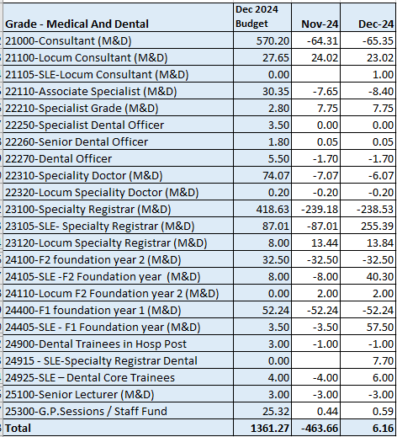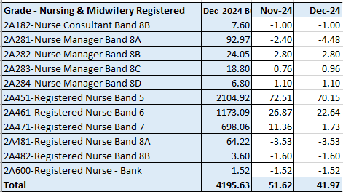  C&L;- Report generated January 2025, within SBUHB (ESR Team), using currently available methodology. Data source – ESR (Workforce) and General Ledger (Finance). We compare the SIP v’s the finance ledger, appreciating limitations on accuracy in some areas. Accuracy levels are subject to local validation practices based on budget holders intelligence.
Current Performance
- Clarity around M&D vacancies has now been built in to the table above with effect from December 2024, as a line of regular data has been established with NWSSP (the Single Lead Employer (SLE) for rotating trainees). This reveals a healthy position in terms of vacancies within this staff group. Further data quality improvements will continue to be sought, in order to better understand the SLE factor in terms of budget allocation.
- The registered nursing establishment data indicates that we were over-recruited in December 2024 by 41.97 FTE against our budgeted registered nursing establishment of 4,195.63 FTE.
- For Band 5 nurses in particular, we were over-recruited by 70.15 FTE as of Dec 24. This is due to a recent cohort of newly qualified nurses starting in Band 5 roles through our student streamlining programme, whereby 132 have started in post between 01/09/24 and 14/01/2025. A further 4 are currently undertaking pre-employment checks and a second cohort of up to 53 newly qualified nurses are due to commence in March 2025.
- Our corporate nursing team continue to support service groups with overseas recruitment for hard to recruit roles, with 4FTE nurses starting in mental health services in November 2024 and a further 13 due to arrive in January and February 2025. Note these will commence in Band 4 posts until they have passed their OSCE and completed their NMC registration, which can take up to 3 months. For 2025/26, 16 international nurses have been offered posts in the NPTS Service Group (10 for theatres and 6 for medicine/ cancer services)
- In addition to the above, our Central Resourcing Team continue to support service groups with any other Band 5 recruitment needs. For example, they are currently supporting with the domestic recruitment of 0.44 FTE in NPTS SG, with a further 1 FTE potentially pending, depending on the outcome of a redeployment trial. The CRT are awaiting confirmation to re-advertise for 2 FTE for MHLD, and 3.98 FTE for Emergency Department Paediatrics, after successfully appointing 6 FTE.
- The rich supply of Band 5 nurses from all three recruitment sources should ensure that no band 5 nursing gaps arise over the next 12 months due to turnover and/or internal movements into higher banded roles

Actions for Next Period
- International nurse recruitment, student streamlining and domestic recruitment will continue as per the above
- The CRT have developed a checklist of actions for recruiting managers to consider when trying to fill hard to recruit roles, which is currently pending final sign off
- The CRT is reviewing their service offer to all service groups to ensure they are providing a high-quality service and that they also have the capacity to prioritise new work e.g. the administration of a new executive scrutiny panel announced in December 24
- The CRT are also supporting with the implementation of Welsh Language in recruitment. In addition to training 116 managers, they have also supported managers with 104 vacancies that have been non-compliant since implementation on 1st November 2024.

Recruitment  Metrics provided by NWSSP. Comparison with all-Wales benchmarking  Target 44 days | Vacancy Creation to Conditional Offer December 2024 (working days) T13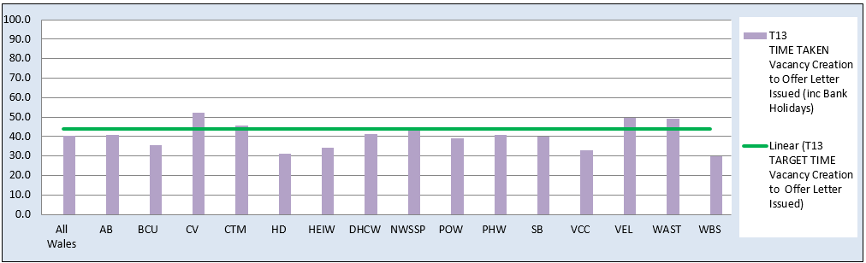  C&L;- Report generated January 2025, by NWSSP (Recruitment). Data source – TRAC system. Outliers are excluded. This is day to day vacancy management. Data excludes outliers.
Current Performance
- Swansea Bay UHB’s time to hire performance remains within the 44 day All Wales T13 target. SBUHB’s 12m average is 39.6 days, a slight increase from October, which was 38.9 days. The in-month average for December is 40 days, a slight increase compared to October at 39 days. However, we remain within the national target and the NHS Wales performance of 41.5 days (12m) and 40.4 days (in-month)
- SBUHB’s time to hire performance also continues to be significantly below the 27 day All Wales T23 metric (target of 27 days) which is the measure from point of issuing an offer letter to agreeing a start date. SBUHB’s 12-month average is 16.5 days and the in-month average for December is 17.9 days, an improvement from October at 18.6 days. NHS Wales performance sits at 14.7 days (12m average)
- The Central Resourcing Team (CRT) have continued to coach candidates through the pre-employment check process for Band 5 nursing roles and Band 2 Health Care Support Worker roles and have also been supporting with other stages of the recruitment process for some areas (e.g., shortlisting for mental health nursing and HCSW roles) to continue to assist in reducing the T13 time to hire target, mentioned above

Actions for Next Period
- NWSSP continue to provide training sessions and drop-in sessions for SBU recruiting managers to improve time to hire. They are also delivering a recruitment module as part of SBU’s management development programme
- The CRT will continue focussing on the recruitment of B5 nurses, B2 ward based HCSWs, assisting with overseas nurse recruitment and newly qualified nurses, as well as specific hard to recruit posts and Exec recruitment.
- In collaboration with NWSSP, the CRT will continue to chase outstanding management actions on vacancies and pre-employment checks with applicants, to further improve the HB’s overall time to hire performance. This includes the Welsh language translation requirement as of 01/11/24 to comply with legislation, which is currently having an impact on time to hire but will be monitored closely. Communications and Q&A sessions have been in place over the last couple of months to notify managers of this new requirement, and work is continuing to support managers who are adding vacancies to Trac to ensure they are compliant.
- In addition, note that the panel process that has been in place for approving admin and clerical posts over recent months and a newly proposed process due to be introduced (quality impact assessment) will have an impact on time to hire performance. This is because there is a requirement for these vacancies to be added to Trac before they can be considered by the panel. NWSSP agreed to exclude these from SBU’s time to hire reports as outliers for the initially agreed 3-month period but they have highlighted that they may not be able to continue this indefinitely due to the time it takes to manually amend the reports. The same will be true for all clinical vacancies across the HB from 20th December 2024, due to a new scrutiny panel being introduced. The CRT are currently developing a new process to mitigate this.

Turnover  % turnover by occupational group | Period Turnover Rate (Swansea Bay) – 01 Jan 2024 – 31 Dec 2024  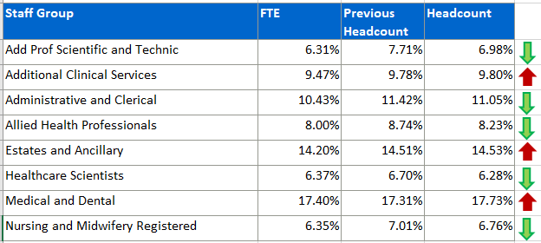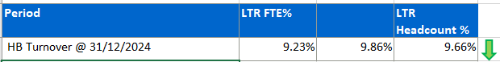  C&L;- Report generated January 2025, within SBUHB (ESR Team). Data source – ESR (Workforce). Small risk of margin of error due to late communication of terminations. Report excludes Bank, Locum, Honorary & Widow/Widower, Junior M&D staff. Internal movement not included – measure is about leaving Swansea Bay UHB.
Current Performance
- Organisationally, our turnover has decreased marginally in this reporting period (Headcount from 9.86% to 9.66%, FTE from 9.32% to 9.23%) demonstrating the ongoing impact of retention-focused initiatives.
- It is important to recognise that this data reflects a 12-month rolling period of turnover.
- Admin and Clerical has seen a marginal increase since November with a 0.05% increase in turnover in headcount and a 0.09% increase in FTE (Nov 24 11.0% - Dec 24 11.05% - Headcount, Nov 24 10.34% - Dec 24 10.43% - FTE) this area will remain a focus for retention actions in the next reporting period, however with the pause on admin and clerical recruitment and other staff groups this may increase in the short term
- Estates and Facilities has had a positive decrease in turnover from 14.80% in Nov 24 to 14.53% in Dec 24 (headcount) and 14.69% Nov 24 to 14.20% (FTE) highlighting the positive work ongoing
- Healthcare Scientists have also seen a reduction in turnover from 6.72% headcount and 6.70% FTE to the latest figures of 6.28% headcount and 6.37% FTE
- Medical and Dental continues to see an increase in turnover with 0.42% increase in Headcount and a 0.36% increase in FTE. This will require additional engagement with key stakeholders to identify and address potential drivers of turnover in this area
- Nursing and Midwifery continues the positive trend of a reduction in turnover with a 0.25% reduction in headcount and 0.17% reduction in FTE reinforcing the success of the Nurse Retention Plan, indicating that efforts in this area are making a sustained impact.

Actions for Next Period
- The drafted retention plan will be presented at key forums for final ratification, ensuring alignment with organisational priorities.
- ESR flexible working request system, provisionally set for January, will be a cornerstone of the flexible working group's initiatives. Sub-groups will continue driving communication, training, and the review of declined flexible working requests.
- The Retention Lead will further engage Workforce Business Partners to share best practices and strengthen retention strategies across all staff groups.
- The dedicated retention plan for the Emergency Department will continue to be developed and supported, addressing specific challenges in this critical area.
Focus will be placed on staff groups experiencing increased turnover, such as Admin and Clerical, and Medical and Dental, to implement tailored interventions.

PADR  % staff who have a current PADR review recorded  PADR target – 85% | % of staff (Headcount) who have had a PADR in previous 12 months  C&L;- Report generated January 2025, within SBUHB (Performance Team). Data source – ESR (OLM Module). Accuracy levels subject to local maintenance and validation standards. Target of 85% added as blue line.
Current Performance
- Staff who have had a Personal Appraisal and Development Review (PADR) as of 31st December 2024 is 74.04 %, this is a 1.32% increase in completion rates over the past 6 months.
- In the month of December 15 staff attended PADR training session delivered by the Education and Learning Team. The Education Team signpost colleagues to SBU ESR - ESR User Guides SharePoint Page for resources on how enter PADR Dates in ESR.
- Compliance figures per Service Group (excluding Medical and Dental Staff) – MH&LD 76.26%, NPTS 79.14%, PCCT 82.59%, Morriston 69.93%, Finance and Estates 61.67%
Actions Planned for Next Period
- Supporting activity outlined in previous reports continues, Service Groups continue to focus on highlighting areas for focus.
NPTS – A PADR Deep Dive is to take place – understanding how the quality of PADRs can be improved. Improvement plans are in place for Divisions below the target of 85%. The unit are continuing to use PADRs as an enabler to support Quality and Safety Strategy
Operational Casework  Number of current operational cases. | C&L;- Report generated January 2024, within SBUHB (Workforce Digital). Data source – ER Tracker. Accuracy levels subject to local maintenance and validation standards.
Current Performance
- No. of open Formal Disciplinaries since the last reporting period have decreased from 55 to 50 open cases
- Number of Formal requests for Resolution has increased from 15 to 24
- Suspensions, since the last reporting period have increased from 10 to 11
- ET’s have remained at 3
Actions for Next Period
- A number of actions are on-going in line with the Best Practice Review
- The Best Practice Review project has been refreshed with the introduction of multidisciplinary subgroups focusing on priority areas of work, reporting into the Core Working Group.
- workshops will continue to take place in partnership with our Trade Unions facilitated by HEIW and SBUHB covering the following: Employee Investigations – Avoiding Employee Harm.

