

Meeting | Workforce OD, & Digital Committee
Meeting Date | 15 February 2024 |  | Agenda Item |  |  | 4.1
Report Title | Medical Appraisal and Revalidation
Report Author | Sharon Penhale, Appraisal and Revalidation Manager
Report Sponsor | Dr Raj Krishnan, Deputy Responsible Officer / Interim Executive Medical Director
Presented by | Dr Raj Krishnan, Interim Executive Medical Director
Freedom of Information | Open
Purpose of the Report | This report is submitted to the Workforce, OD and Digital Committee to provide an update on the progress of appraisal and revalidation within the Health Board. Information reported to ROAG (Responsible Officer Advisory Group) and Medical Workforce Board. The report is also submitted to Workforce and Digital Committee for information, approval and/or ratification of guidance, policies, etc.
Key Issues | This report sets out:  - the work of the Medical Appraisal and Revalidation Team to support doctors’ appraisal and revalidation, outlining additional support required to engage colleagues in the appraisal process in preparation for revalidation.  - Revalidation and appraisal figures including comparison data for revalidations across Wales.  - All Wales Constraints Data reported by doctors during appraisals undertaken.  - Physician Associate (PA) appraisal pilot project using MARS appraisal system to support. In readiness to support PAs who will come under the umbrella of the GMC (General Medical Council) at the end of 2024.  - All Wales Appraisal policy revised requiring ratification.
Specific Action Required  (please choose one only) | Information | Discussion |  | Assurance | Approval
Specific Action Required  (please choose one only) | ☒ | ☐ |  | ☒ | ☒
Recommendations | Members are asked to:  - NOTE the current progress of appraisal and revalidation within SBUHB;  - NOTE the support offered to our doctors and secondary care dentists, and the progress made in appraisal and revalidation processes.  - NOTE the health board’s participation in the physician associate pilot;  - RATIFY the all-Wales Appraisal Policy

MEDICAL APPRAISAL & REVALIDATION UPDATE

- INTRODUCTION

To inform Workforce, OD and Digital Committee of current status of appraisal and revalidation and demonstrate progress made and future developments.

- BACKGROUND

Revalidation is the process by which a doctor has the opportunity to demonstrate that they remain up-to-date and eligible to retain their General Medical Council (GMC) licence to practise. Revalidation is based on local clinical governance and appraisal processes. Effective medical appraisal and subsequent revalidation will satisfy the requirements of the GMC’s Good Medical Practice (GMP) and support the doctor’s professional development.

As part of annual appraisal, the portfolio of supporting information based on the GMP framework for appraisal and revalidation will be reviewed and discussed, and an evaluation made of the doctor’s professional practice. This process is supervised by the Responsible Officer (RO) of a ‘designated body’ (an organisation that employs a doctor or manages their medical performers list) – this is usually the Medical Director of the Health Board/Trust. Every five years the RO will make a recommendation to the GMC that the doctor is suitable for revalidation by the GMC, based on their Whole Practice. This means that private as well as NHS work, academic, research and voluntary activity, and any work outside of the NHS that requires the doctors GMC licence in the UK are all considered. Where indicated, the RO will inform the GMC of any concerns about a doctor’s fitness to practise, or a doctor’s refusal to engage in the processes that inform the revalidation process. However, concerns about a doctor’s fitness to practice should be shared with the GMC at the time they arise, and not left to the revalidation decision before reporting.

The Responsible Officer is supported by a Deputy Responsible Officer and the Appraisal and Revalidation Team which consists of a small team incorporating the Appraisal and Revalidation Manager, Appraisal and Revalidation Support Officer, and shared support of 2 part time Admin Assistants. Appraisal Leads (5 in secondary care) and Appraisal Co-ordinator (1 in primary care) are appointed to support appraisers within primary and secondary care. Nationally, appraisal and revalidation processes and quality assurance are supported and overseen by the Revalidation Support Unit of HEIW, which is responsible for developing and maintaining the MARs online appraisal portfolio platform, Orbit360 formal patient and colleague feedback system and standard setting, plus all GP Appraiser appointments/training.

- CURRENT SITUATION/PROGRESS

3.1 GMC (General Medical Council) Revalidation Recommendations

In SBUHB, doctors due for revalidation are discussed and reviewed at the Revalidation Decision Group (RDG) meetings (held weekly) and the recommended outcomes reported to ROAG (Responsible Officer Advisory Group) on a monthly basis. A new member of the Revalidation Support Unit attended the RDG in an observer role to understand local processes.

The following graph shows a total of 223 recommendations were submitted to the GMC during the period December 2022 to December 2023 for doctors due for revalidation. There were 174 positive recommendations submitted and 49 deferral recommendations – some deferral recommendations were for second or third deferrals and reasons may be because a doctor is on long term sick, under investigation, etc. Multiple deferrals for a doctor require further information being submitted to the GMC for justification and decision making.
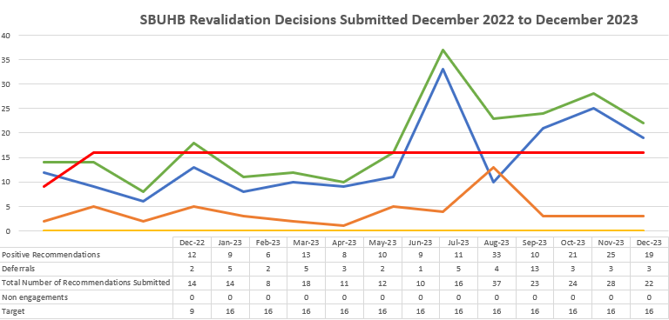
The following graph shows the trends of successful revalidation recommendations within SBUHB over the past 5 years from 2019 to 2023:
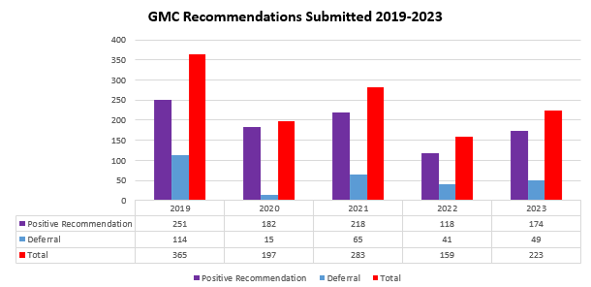
This shows that deferral rates were high in 2019, 114 deferrals submitted, which was prior to COVID although. Deferrals submitted in 2023 have reduced in comparison to previous years.

Deferrals, some of which have been multiple deferrals, seem to be due to patient and colleague feedback not being completed in time, as well as exceptional circumstances. Consequences of continued clinical pressures, as well as any doctors who are under investigation or on long term sickness.

The appraisal and revalidation team have put in the following measures to help prevent deferrals, where possible by:
- Reviewing appraisal summaries prior to the final appraisal being completed;
- Sending reminders about completing patient and colleague feedback to doctors a year in advance e.g. sending communication early in 2024 to doctors due for revalidation in 2025.

The following table outlines the number of doctors due for revalidation based on those with a GMC connection to SBUHB – this helps to plan workload and future pressures:
Year | Drs Due for Revalidation
2024 | 279
2025 | 118
2026 | 370
2027 | 216
2028 | 228
Currently there are 375 primary and 857 secondary care doctors with a GMC connection to our Health Board – total of 1232 doctors who currently have a GMC connection as of January 2024. GP numbers are static compared to secondary care. Short term, adhoc locum bank doctors are monitored by the Appraisal and Revalidation Team linking in with the Medical HR Department. This intensive work ensures that SBUHB are aware of the appraisal/revalidation status of any doctor working in SBUHB for more than a few shifts, and supporting them to engage with the processes. The team also identify GPs who may not be eligible to remain on the SBUHB Medical Performers List. The team liaises closely with colleagues in Primary Care to ensure that any issues are addressed.
As you will see from the graph below the number of primary care doctors has slightly decreased, whereas secondary care numbers have increased:
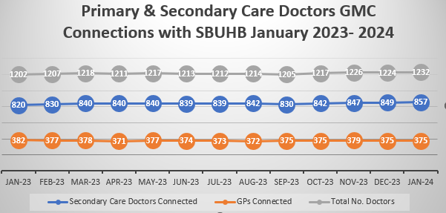
All of the 1232 doctors must have an annual appraisal, unless they have exceptional circumstances to consider e.g. sick leave, career break, maternity leave etc, and on average at least 227 will need a revalidation decision each year.
3.2 GMC Revalidation data for Wales 1January 2023 to December 2023
There continue to be some challenges with engaging some doctors in annual appraisal, but these are highlighted to the Responsible Officer and Deputy by the Appraisal and Revalidation Team. Challenges the doctors have are additional workload pressures, burnout, etc but the Appraisal and Revalidation Team provide additional individual support when required.

The Appraisal & Revalidation team are working hard to support doctors to achieve their revalidation deadlines by providing one to one adhoc support, when required. Doctors are encouraged to have a light/supportive appraisal to engage in the process and help plan towards their revalidation, and include ongoing work and requirements in their Personal Development Plan (PDP). Plan to provide ‘drop in’ sessions across various hospital for doctors during 2024 to allow face to face contact/support.

The number of deferrals slightly increased during 2023. The following tables shows comparisons against other Health Boards in Wales – SBUHB deferral rate showing as 17.54%:
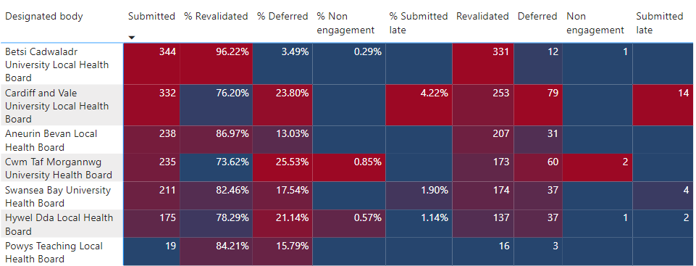
The information has been obtained from the GMC Dashboard and includes all recommendations submitted to the GMC by all countries within the UK between 1 January 2023 and December 2023 for all Designated Bodies (DB) – ‘‘By country’ outlines a similar percentage for ‘revalidated’ and ‘defer’ rates submitted to the GMC:
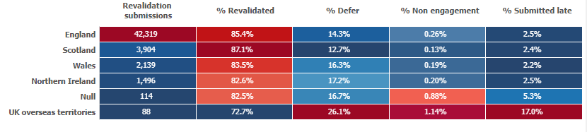
Non-engagement in Revalidation
The Appraisal and Revalidation Team work hard to spot struggling doctors and support them, there continue to be no SBUHB doctors who are classed as ‘non-engagers’.

Revalidation Deferral
The RO must decide if there is sufficient evidence in the annual appraisal portfolios over 5 years to recommend revalidation to the GMC, or to request deferral to allow more time to gather missing essential evidence, or, rarely, to report that the doctor is not engaging with the appraisal process. All evidence is uploaded electronically by doctors and appraisers to a national online platform, ‘MARS’. Where doctors have required multiple deferrals, the GMC require further information and a timeline for the doctor to get back on track. The main reason for deferrals seems to be due to delays in obtaining patient and colleague feedback – regular communications are being sent to doctors to complete early.

The Appraisal and Revalidation Team have worked extremely hard to ensure that revalidation deferrals are kept to a minimum, making direct contact and meeting with doctors, repeatedly if necessary.

- ‘1 month rule’ requiring all final appraisal meetings on MARS appraisal website to be completed one month before the revalidation date, to ensure that all information is available for review at the Revalidation Decision Group meeting.
- A 360/Multi-Source Feedback (MSF) patient and Colleague feedback is required to be undertaken once in the 5 year revalidation cycle. The system used in Wales for 360/MSF Feedback is Orbit360, requiring a minimum of 20 patient responses and 15 colleague responses. The Appraisal and Revalidation Team monitor Orbit360 to ensure that the doctor completes this element for revalidation. If a doctor fails to include their 360 report within their final appraisal this may result in a deferral of their revalidation date to the GMC. Woking with doctors who struggle to obtain patient feedback to look at alternative options. Working with the Patient Feedback Team who may have feedback naming the doctor to include in their annual appraisals.
- Online MARS training: Doctors continue to require additional support - online MARS (Medical Appraisal and Revalidation System) training is offered monthly as a TEAMs event, as well as one to one training, for some doctors. The training is offered to new doctors as well as refresher training for existing colleagues. These events are publicised to all doctors, as well as secondary dentists that use MARS
- Review of MARS accounts: As part of the Appraisal and Revalidation ongoing support to Doctors, regular reviews of MARS accounts are undertaken. This is to ensure Doctors Personal and Professional details are up to date and accurate. The data is drawn from MARS monthly. Information is also received from colleagues.
- Monthly reconciliation exercises and monitoring starters and leavers to ensure an accurate record and that doctors have the correct GMC connection.
- Liaison with Private Health care providers: The revalidation decision is based on the doctor’s Whole Practice Appraisal and they must declare within MARS any work undertaken inside the NHS, as well as outside, that requires their GMC licence. The Appraisal and Revalidation Team work closely with private hospitals to ensure that we are aware of doctors undertaking work outside of the NHS and ensure governance checks are undertaken for revalidation. Annual reconciliations are undertaken to ensure that our information is correct and up to date. It is important that information sharing for any clinical governance concerns between the Health Board and private hospital/practice will be monitored and discussed at ROAG (Responsible Officer Advisory Group).

Appraisal Performance
The graph outlines the number of appraisals undertaken by primary and secondary care during December 2022 to December 2023 – during this period 830 appraisals completed in secondary care, 420 in primary care totalling 1250 appraisals. Exceptional circumstances, for example career break, long term sick leave, maternity leave, etc are also taken into consideration. Other factors may be that some doctors may be on short term contracts and may or may not require an appraisal whilst working within the organisation. New starters who may require an appraisal or may have already completed an appraisal with previous employers may not be due for annual appraisal during this period, and doctors whose appraisal quarters have had to be moved to allow them to re-engage in the process.
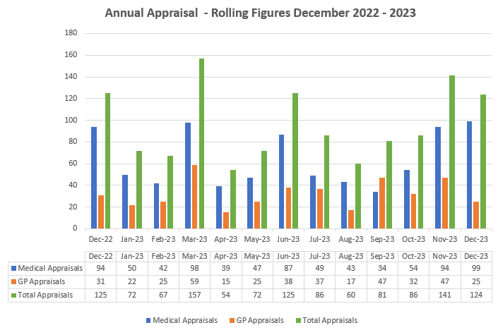
3.2 Quality Assurance
Internal Quality Assurance

The Appraisal and Revalidation Team work to ensure that GPs, Consultants, SAS and Non-Training Grade doctors working within SBUHB have access to appraisal systems, and support for revalidation (Training Grade doctor’s designated body is HEIW (Health Education Improvement Wales).

In order to ensure that the SBUHB processes are effective and efficient, and standards within SBUHB are upheld, the Appraisal & Revalidation Team focus on the following;
- Effective onboarding of all new doctors to SBUHB’s Appraisal system, by maintaining accurate records of their employment and appraisal history, and offering flexible training on the MARS platform
- Regular Reviews of struggling doctors who are falling behind
- Supporting Appraisal Leads to oversee the quality of appraisers
- Ensuring appraisers are trained and monitored, and in sufficient supply, including succession planning.

Effective Onboarding
All new doctors who commence employment with SBUHB are sent a welcome email with details of next steps. The previous Designated Body (Health Board/Trust) is sent a Transfer of Information form to complete to provide information of the doctor’s appraisal history, revalidation information and inform of any governance concerns.

New starter notifications are sent by Medical HR with basic details and start and end date, if short term contract. Also monthly starter and leaver reports are sent monthly by the ESR Team allowing the Appraisal and Revalidation Team to hold accurate information and records.

MARS Online training is held monthly and is offered to all doctors and following each training session the doctors are sent certificates and feedback forms. All feedback received is reviewed and the training sessions adapted following feedback – for example, aiming to make the sessions more interactive.

Annual appraisals are monitored for doctors, and secondary care dentists, regularly as well as part of a quarterly review. This is undertaken in a supportive way to ensure that the doctor has the necessary appraisal content for a successful revalidation to the GMC.

Regular Review of Struggling doctors
The Appraisal and Revalidation team organise quarterly reviews for Medical MARS and GPs with the support of the Appraisal Leads and Appraisal Co-ordinator.
- Medical MARS quarterly reviews highlight doctors overdue their annual appraisal and continued the ‘additional step process’ for doctors overdue annual appraisal, by sending a list of names to the Clinical Lead/Director and Service Group Medical Directors – deadline date of 6 weeks to respond to allow time for all parties (records are held for all actions taken). The additional step process was introduced in response to feedback from doctors who had received letters based on a national template and felt it was unsupportive. The additional step process has helped support the secondary care doctors and prompted better engagement and identify andy exceptional circumstances. The Appraisal Leads support this process.
- GP MARS quarterly reviews are held with the Revalidation Support Unit and GP Appraisal Co-ordinator monitoring GPs appraisals, and noting those who have exceptional circumstances. Following a review of GP MARS some GPs appraisal quarters (AQ) are changed to allow sufficient time to complete the required number of appraisals for their revalidation date.
- ‘Light supportive appraisals” Continue to promote light/supportive appraisals for doctors due to the continued clinical pressures. The light/supportive appraisals are recommended for anyone returning to work following along absence e.g. sick leave, maternity, career break, etc – this can help to signpost the doctor, provide and understand any additional support and plan their personal development plan.
- All Wales Exceptional Management Process is implemented when a doctor continues to fail to engage with annual appraisal. Overdue Appraisal and/or Non Engagement Letters will be sent to the doctor(s) following the Medical MARS and GP MARS quarterly reviews with deadlines to achieve and complete appraisal.
- Wellbeing Support – doctors who may be struggling or who have exceptional circumstances are provided information about internal/external support available.

If doctors are not engaging in the process this will be escalated and discussed in the ROAG meeting. These doctors may also be highlighted at the quarterly GMC meetings.

Appraisal Leads (secondary care) and Appraisal Co-ordinators (primary care) Regular meetings are held with the secondary care Appraisal Leads and the Appraisal Co-ordinator for primary care to discuss current issues, changes and developments.

Secondary Care:
Appraisal Leads (ALs) continue to update secondary care appraisers on requirements and/or changes and the expectation of the appraiser role, as well as supporting doctors in conjunction with the Appraisal and Revalidation Team. There are currently 107 appraisers within secondary care. New appraisers undertake online appraiser training which are modules produced and provided by the Revalidation Support Unit. All new appraisers are supported and the ALs will provide feedback for their first 2/3 appraisals.

Succession planning is in place for any appraisers due to retire or leave the organisation.

ALs facilitate, supported by the Appraisal and Revalidation Team Local Quality Assurance assessments of appraisal summaries with appraisers to provide support, updates, allow networking and development of their appraiser role. Allowing the appraisers the opportunity to develop and keep up to date. Feedback from these events are obtained to continue developing and providing the relevant support to appraisers.

The ALs also attend the Revalidation Decision Group meetings to provide a secondary care perspective, as well as helping them to understand the requirements for decision making and reviewing the quality of the appraisal summaries. They have also been invited to attend one of the WRAG (Wales Revalidation Appraisal Group) meetings to observe the All Wales meetings.
Appraisal Leads support events to facilitate the All Wales Appraisal Quality Assurance and Appraiser Conferences. All Wales Revalidation Manager and Appraisal Lead meetings are also held bi-annually.
Primary Care:
The Appraisal Co-ordinator supports and monitors GP appraisers (currently 13) within Swansea and Neath Port Talbot Locality, working closely with the Appraisal and Revalidation Team, Revalidation Support Unit and Clinical Director of Quality & Safety and Service Group Medical Director of Primary Care, Community Services and Therapies.

Appraisers
This important group of specially trained doctors are supported by the Appraisal Leads and Appraisal Co-ordinators. All new appraisers are supported for their first few appraisals by their lead/coordinator to mentor them and ensure quality of appraisals. Adhoc checks of appraisals summaries are undertaken looking at the quality and content – this information is fed back to the appraiser(s) and appraisal lead/coordinator.

The Appraisal and Revalidation Team undertake annual review of appraisers within secondary care ensuring there is succession planning and sufficient appraisers available across various specialties. Online appraiser training is available for new appraisers to complete and this is also offered to current appraisers for refresher training.
The Revalidation Support Unit (RSU) recruit GP appraisers with the support of the Appraisal Co-ordinator. The next recruitment round will be in the summer of 2024 and the Appraisal and Revalidation Manager offers support to be on the interview panel.

Secondary Care Appraiser Tariff has been agreed nationally by Dr Frank Atherton, CMO, circulated a letter dated 11 March 2022, for the appraiser role and SPA time to be recognised with the doctor’s job plan. The Appraisal and Revalidation Manager wants to ensure all appraisers appraiser role recognised within their job plan, and sufficient funding available, as this continues to be an issue. Another Health Board has put together a business plan to ensure that their appraisers have the role recognised and funded – the Appraisal and Revalidation Manager will be linking with her peers to discuss further.

All appraisers are offered various training events both local and national to ensure that they are up to date and current to undertake their role.

Appraisal and Revalidation Team – Extract of feedback received
Regular feedback for the support provided, as well as for other work undertaken within the department.
Support for Revalidation: Thanks Sharon, I'm very grateful to you for the time you have put into this.
Retirement & Appraiser Role: Thanks for all your support over the years! I did appreciate it.
Exceptional circumstances support: Thank you for all of your help and guidance last year when I had the news about my husband’s terminal condition. I am beginning to come back into work slowly.
Revalidation governance check: Thank you so much for forwarding the comments below to me. It means a lot to hear positive feedback.
MARS Training: Many thanks for an excellent session on MARS today.
Doctor Retiring: Hello Sharon, as you may have heard I have resigned and will be leaving the HB at the end of the month. Devastated to leave the two brilliant teams I work with but that is how it goes! Would like to thank you very much for all your support. You have always been extremely helpful and very prompt to respond to my numerous queries. All the best and kind regards
Support over the years: I also wanted to say thank you for all of your time and helpful advice/support over the years, you’re an absolute asset to the Health Board J
Successful Revalidation: Many thanks Sharon for the support and advice.
Successful Revalidation: I'm sorry this email is delayed as I only get access to my full emails when I'm up at Morriston, but I just wanted to say a huge thank you for all the help that both you and Alison provided over the last year to help me get revalidated. Please know that the work you do is very much appreciated and valued
Support with Intrepid: Thanks a lot Sharon for your help.
Supporting dr accessing mandatory training: All sorted, thanks to you. I am really grateful. It makes a real difference to know there is someone in the organisation who is competent and doesn’t spout BS when asked for help. If you ever need a glowing reference of any kind having to do with the way in which you are supporting the Drs – you know where to find me.
First Revalidation Cycle: Thank you very much indeed for your support through my first revalidation. I have now received the confirmation from GMC.
GMC Connection Support: Appreciate your help.
MARS Support: Thank you so much Lucy.
GMC Connection Support: Many thanks for the email. Will do. Thank you so much.
Revalidation: I am very grateful for all the support I have received in preparing for the appraisal from the entire MARs team and my appraiser Dr Saurabh Patwardhan.
Study leave expenses: Thank you very much Sharon for your quick response and help.
MARS Support: Your assistance is greatly appreciated.
Supporting Doctor: Good morning, thank you so much for the call, you epitomise what good friends are.
External Quality Assurance
- The Revalidation Progress Report (RPR) is an annual self-reporting process designed to enable Designated Bodies (DBs) in Wales to report their annual appraisal and revalidation data. This process supports the Wales Appraisal Quality Management Framework and forms a significant part of the data set for the Revalidation Quality Assurance Reviews. The report for 2022/23 was completed and submitted by the deadline of 5 June 2023.

- Revalidation Quality Assurance (QA) Review
The Revalidation Support Unit (RSU) of HEIW has been tasked by the CMO (as higher-level RO for all Designated Bodies (DBs) in Wales) to conduct Revalidation QA visits. This was undertaken on 5 October 2022 for SBUHB

This was a very positive review – please see the comments:
The Review Team felt the visit was positive with clear progress of previous visit actions and innovative quality improvement projects in progress. The Health Board have a range of robust policies and guidance regarding the appraisal and revalidation processed locally and should look to share this knowledge as appropriate. The actions identified for the Health Board are to further develop areas rather than related to a concern of any kind.

The following actions were identified and have/are being addressed:
1. Take steps to ensure that Appraisers SPA time is appropriately recognised within job planning
2. Develop a process for providing Appraisal Leads with a review for WPA purposes and feedback specifically on their role
3. To consider options for sharing good practice and quality improvement projects with other Designated Bodies

Actions:
- Continue to progress to drive the recognition and funding of appraisers SPA time;
- All Appraisal Leads have completed a PADR with the Responsible Officer (RO) which will continue annually;
- Good practice and projects are shared regularly with other Designated Bodies at meetings and the Revalidation Managers work collaboratively for advice/support. The ROs also provide support for each other and discuss situation/scenarios at the All Wales RO meetings.

The Appraisal and Revalidation Manager, as representative on the panel, for other Health Boards’ Revalidation Quality Assurance reviews providing support to the Revalidation Support Unit. This also allows sharing of good practice and learning.

- General Medical Council (GMC)
The GMC Employer Liaison Advisor Wales meet quarterly to discuss doctors under investigation locally and through the GMC. Appraisal and revalidation updates are also provided at this meeting and any struggling doctors will be discussed.

The Appraisal and Revalidation Manager will link in with Workforce for the launch of the revised Good Medical Practice guidance which is effective from the 30 January 2024.

- LEARNING

- Constraints section within the MARS system is an optional section for doctors and secondary care dentists to complete to record where they have experienced barriers to providing care. There are headings for Personal, Service and Hospital constraints with further sub headings to select for discussion at appraisal. The appraiser’s role is to help signpost the appraisee. Anonymised high-level constraints report will be shared with the Service Group Medical Directors for information and action.

- All Wales Constraints Report 2022-23 (Appendix 1) – This report contains data on the constraints reported by doctors who completed an appraisal on MARS between 1st April 2022 to 31st March 2023. The focus is on national trends across Wales with comparisons of previous years.

The highest number of reported constraints in Secondary Care is ‘Change in working practices due to Covid-19’, making Covid-related constraints the highest reported section for the third year in a row. The second highest, ‘changes to work environment’, continues this theme. The highest non-Covid related reported constraint remains ‘Inadequate inpatient beds for my speciality’. These areas should maintain a strong focus across all DBs .

The highest reported constraint in Primary Care are ‘Waiting Lists – General’, with ‘Ambulance Problems’ and ‘Workload Shift from Secondary to Primary Care’ recorded as the second and third highest respectively. These constraints have consistently been within the top highest reported constraints for several years, both during and prior to the Covid pandemic, so should remain a focus for DBs across Wales. The top five reported constraints are all within the Service section, and all feature a similar theme with secondary care challenges. The Covid-19 categories ‘Covid-19 infection’ and ‘Changes to work environment’ feature again this year in the top reported constraints within Primary Care.

In summary the constraints reported remain consistent with previous years for secondary care but has increased slightly within primary care across Wales.

Recommendations would be to analyse the constraints within SBUHB and triangulate with All Wales constraints. If ‘discrimination’ is selected as a constraint appraisers are advised to escalate to the Appraisal Lead and the Responsible Officer to be made aware.

- Breaches of duty letters, provided by the SBUHB legal team, are sent on behalf of the Executive Medical to doctors following notifications from the Legal Team, and they are to discuss the breach of duty case at their appraisal. The Legal Team have agreed the following:

- Handlers to identify factual witnesses involved from Legal & Risk letter of advice advising on liability, and to be clear on who the clinicians were in terms of responsibility for the issues in question
- If this is not clear, handlers to contact Legal & Risk to identify
- When requesting a BOD/Liability memo draft from SBU. Claims, to identify whether an appraisal letter is triggers or not. If one is triggered, handler to identify the clinician involved in issue/failing
- When SBU Claims send memo for sign off, it will include information as to whether or not an appraisal letter is triggered or not – if one is triggered, SBU Claims will include clinician details and draft appraisal letter.

- Feedback from training events to help develop and adapt the training for doctor’s needs.

- PHYSICIAN ASSOCIATE PILOT PROJECT

The General Medical Council (GMC) plans to commence the Appraisal and Revalidation process for the Physician Associates (PAs) and Anaesthetic Associates (AAs) from end of 2024. Once the GMC regulation commences, all PAs and AAs will be expected to join the register. There will be a transitional period before it becomes an offence to practise as a PA or AA without being registered with the GMC.

The project will oversee the adoption of the Medical Appraisal and Revalidation System Wales (MARS) for PA appraisals before the GMC regulation commences. This is on a pilot basis and will identify the feasibility of rolling out the MARS for PA appraisals at an All Wales level. The project commenced in April 2023 and is for 12 months.

At Swansea Bay University Health Board (SBUHB) there are 39 Physician Associates (PA) who have been linked with appraisers (23 secondary and 13 primary care PAs). The Appraisal and Revalidation Team are providing training and support for the PAs. 8 appraisals have been completed for secondary care. The GP PAs appraisals are being supported by the GP appraisers.

Upon completion of each appraisal a separate questionnaire will be sent to each PA and the appraiser which will be reported at the end of the pilot.

The Appraisal and Revalidation Team are working collaboratively with the PAs, Revalidation Support Unit, Education Centre and Medical HR, amongst other stakeholders.

Monthly PA Project Board meetings are held to record progress and developments. There will be an evaluation and report completed at the end of the pilot.

- ALL WALES MEDICAL APPRAISAL POLICY

The All Wales Medical Appraisal Policy (Appendix 2) is developed at an All Wales level, by the Revalidation Support Unit, to ensure a consistent approach across Wales. It promotes the value and worth of appraisals for ALL medical employees and contractors, and to ensure effective arrangements exist to facilitate appraisal for all such employees in a fair and consistent manner. It is not a mechanism by which employers review or judge performance against a contract of employment, job plan or service objectives. Appraisal and job planning are separate processes, though the outputs from each will inform the others. The policy is signed off at an All Wales level by the Wales Revalidation Oversight Group.

Changes have been made in line with current guidance and legislation.

The policy has been shared with Medical Workforce Board and the Responsible Officer Advisory Group. The Workforce, OD and Digital Committee are asked to ratify the All Wales policy.

- RECOMMENDATIONS
This report sets out:
- the work of the Medical Appraisal and Revalidation Team to support doctors’ appraisal and revalidation, outlining additional support required to engage colleagues in the appraisal process in preparation for revalidation.

- Revalidation and appraisal figures including comparison data for revalidations across Wales.

- All Wales Constraints Data reported by doctors during appraisals undertaken.

- Physician Associate (PA) appraisal pilot project using MARS appraisal system to support. In readiness to support PAs who will come under the umbrella of the GMC (General Medical Council) at the end of 2024.

- All Wales Appraisal policy revised requiring ratification.

Members are asked to:
- NOTE the current progress of appraisal and revalidation within SBUHB;
- NOTE the support offered to our doctors and secondary care dentists, and the progress made in appraisal and revalidation processes.
- NOTE the health board’s participation in the physician associate pilot;
- RATIFY the all-Wales Appraisal Policy

Governance and Assurance

Link to Enabling Objectives  (please choose) | Supporting better health and wellbeing by actively promoting and empowering people to live well in resilient communities
Link to Enabling Objectives  (please choose) | Partnerships for Improving Health and Wellbeing |  | ☒
Link to Enabling Objectives  (please choose) | Co-Production and Health Literacy |  | ☐
Link to Enabling Objectives  (please choose) | Digitally Enabled Health and Wellbeing |  | ☐
Link to Enabling Objectives  (please choose) | Deliver better care through excellent health and care services achieving the outcomes that matter most to people
Link to Enabling Objectives  (please choose) | Best Value Outcomes and High Quality Care |  | ☒
Link to Enabling Objectives  (please choose) | Partnerships for Care |  | ☒
Link to Enabling Objectives  (please choose) | Excellent Staff |  | ☒
Link to Enabling Objectives  (please choose) | Digitally Enabled Care |  | ☐
Link to Enabling Objectives  (please choose) | Outstanding Research, Innovation, Education and Learning |  | ☒
Health and Care Standards
(please choose) | Staying Healthy |  | ☐
(please choose) | Safe Care |  | ☒
(please choose) | Effective Care |  | ☒
(please choose) | Dignified Care |  | ☐
(please choose) | Timely Care |  | ☐
(please choose) | Individual Care |  | ☒
(please choose) | Staff and Resources |  | ☒
Quality, Safety and Patient Experience
Purpose of appraisal and revalidation is to provide assurance for patients and the public, employer and other healthcare professionals that licensed doctors are up to date and fit to practise by providing a focus for doctor’s efforts to maintain and improve their practice.

Financial Implications
None.

Legal Implications (including equality and diversity assessment)
None.

Staffing Implications
None.

Long Term Implications (including the impact of the Well-being of Future Generations (Wales) Act 2015)
None.

Report History |  | Last report submitted in August 2023. Regular reports and updates to Medical Workforce Board and ROAG (Responsible Officer Advisory Group).
Appendices |  | Appendix 1 – All Wales Constraints Report 2022-23  Appendix 2 – All Wales Medical Appraisal Policy

