Meeting Date | 15 February 2024 |  | Agenda Item |  | 2.4
Report Title | Digital Strategy Update
Report Author | Matthew John, Director of Digital
Report Sponsor | Matthew John, Director of Digital
Presented by | Matthew John, Director of Digital
Freedom of Information | Open
Purpose of the  Report | This paper provides an update on the Health Board’s approach to establishing a new digital strategy and the progress so far.
Key Issues | - Welsh Government’s (WG) Digital and data strategy for health and social care in Wales  - The work undertaken on the Health Board’s digital maturity using the HIMSS (Health Information and Management Systems Society) EMRAM model (Electronic Medical Record Adoption Model).  - The work undertaken on surveying the Health Board’s Clinical User Experience: KLAS Survey  - The establishment of a Swansea Bay University Health Board (SBUHB) 10 year digital strategy underpinned by a 3 year road map and mobilisation plan
Specific Action Required  (please choose one only) | Information | Discussion | Assurance | Approval
Specific Action Required  (please choose one only) | ☐ | ☐ | ☒ | ☐
Recommendations | Members are asked to:  - NOTE: the high level aspirations of the WG Digital and data strategy for health and social care in Wales  - NOTE: the key outcomes of the digital maturity assessment and clinical user survey undertaken by the Health Board  - NOTE: the progress that has been made in establishing a new digital strategy for the Health Board

Digital Strategy Update
- INTRODUCTION
This paper provides an update on the Health Board’s approach to establishing a new digital strategy and the progress so far.

- BACKGROUND

  - Abertawe Bro Morgannwg University Health Board (ABMU) Digital Strategy 2017-2022
The previous digital strategy was created for Abertawe Bro Morgannwg University Health Board (ABMU), the former iteration of the Health Board prior to the Bridgend disaggregation. The strategy set out the digital aspirations of the organisation spanning 2017-2022.
During this period, the organisation made significant progress in its digital journey, achieving whole scale digitally enabled business change across many clinical settings. The Welsh Clinical Portal (WCP) has played a key role in enabling clinicians to access patient records digitally. The Health Board has led the way for Wales in Electronic Prescribing and Medicines Administration (EPMA) and in empowering patients with access to their results and documents via the Swansea Bay Patient Portal.
The Covid19 Pandemic was a major factor in determining digital priorities for the second half of the strategy’s duration. Emphasis was placed on supporting the organisation to work remotely; digitally enabling field hospitals; streamlining and recording vaccination programmes; and advancing our use of business intelligence and analytics. As a result, other planned priorities had to be stopped or paused.
There are many areas of the Health Board that are still predominantly paper based. The Health Board holds paper records for every patient that it serves and continues to add more and more paper to these records on a daily basis. There is a lack of data in some areas, particularly Community and Mental Health, with which to make data informed decisions. Essentially, the task of digitally transforming the organisation to deliver maximum efficiencies and quality and safety benefits remains a significant one.

  - Welsh Government Digital and Data Strategy for Health and Social Care in Wales

The Welsh Government refreshed its Digital Strategy for Health and Social Care in Wales in July 2023 (Appendix 1). The strategy sets out expectations on all NHS Wales organisations to collaborate together with DHCW to take full advantage of the digital opportunity by:

- using technology to optimise and standardise in order to reduce variation in health and social care provision and outcomes
- taking advantage of emerging technologies and sciences like Artificial Intelligence and genomics
- enabling our digital workforce to drive forward change in health and social care delivery
- continuing our journey to improve how we share information across health and social care provider settings
- utilising and curating data to underpin population health management and demonstrate the value and benefit of our investments

Cleary, the national strategy is a key factor in how we devise our local strategy. There needs to be full alignment with the core aims and missions of WG. In executing our strategy, we must take full advantage of the opportunity of working together at a national and regional level, yet ensure we are able to advance locally with pace and innovation.

  - SBUHB Digital Maturity: Electronic Medical Record Adoption Model (EMRAM)

National collaboration between NHS Wales digital leaders has significantly improved over recent years. Whilst a new formal national digital governance model is still in its infancy, the monthly Directors of Digital peer group, attended by digital leads from all NHS Wales organisations and WG Digital Policy Leads, has a key strategic focus on the digital way forward. In focussing on the delivery of the national strategy, the group has commissioned a number of strategic actions. One of these actions has been for all organisations to complete the EMRAM model of the HIMSS (Health Information and Management Systems Society) digital maturity index during 2023.

There are a number of models within the HIMSS portfolio, but it was agreed nationally that EMRAM would be the obvious place to start. Each organisation undertook the process individually. The process involved a self-assessment against a comprehensive list of digital solution capabilities. The self-assessment was followed on by a one day site visit by a HIMSS Assessor, who visited several departments and wards in Morriston Hospital to analyse the systems that are in operation.

Each organisation received an individual digital maturity status report displaying their maturity levels across a number of categories (Appendix 2). HIMSS also produced a composite report for Wales.

The EMRAM model identifies organisations as being between Stage 0 and Stage 7 on their digital maturity journey. All organisations in Wales came out at a Stage 1, with the exception of Cwm Taf Morgannwg (CTM) who are at Stage 0.

Whilst SBUHB is currently at Stage 1, the percentages against each level (below) indicate that the organisation is progressing well towards higher stages.

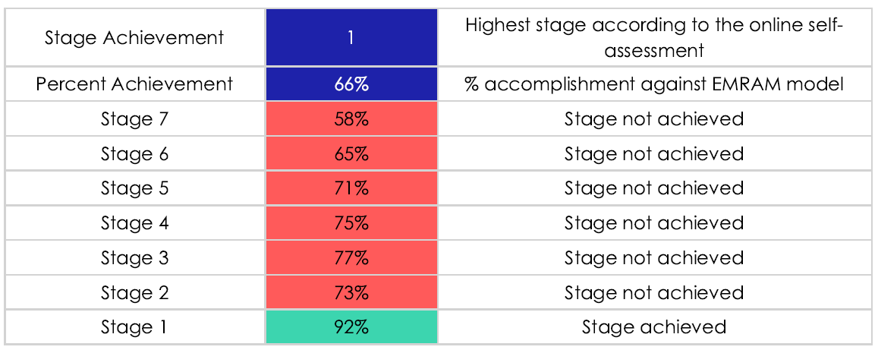

The successful implementation of EPMA and the Patient Portal enabled higher scoring than other NHS Wales organisations in some of the categories. The main gap that the process identified across Wales is the lack of a Clinical Data Resource. Essentially a solution that provides clinicians with a single view of the patients record. Many organisations outside of Wales, refer to this as either an Electronic Patient Record (EPR) or Electronic Health Record (EHR).

These findings have been the catalyst in progressing conversations nationally to determine the way forward for a CDR/EPR/EHR model across NHS Wales.

  - SBUHB Digital User Experience: KLAS Usability Survey

Following on from the EMRAM work, Directors of Digital also commissioned a usability survey from a Clinical User’s perspective working with KLAS Research. As the name suggests, the format of this process was an online survey to staff across the organisation. Whilst completion rates of the survey were not as high as anticipated (240), the final reports received in quarter 3 2023/24 has provided some excellent insights and useful comparisons with other NHS Wales organisations, and also other health organisations across the world. This output is being assessed as part of the ongoing digital strategy project.

- SBUHB Digital Strategy 2024-2035
In developing our new digital strategy, the Digital Leadership Team have contracted with a consultancy partner, Public Service Consultants (PSC), to facilitate a 3 month project of engagement with stakeholders across the organisation. The project comprises of the 4 phases depicted below.
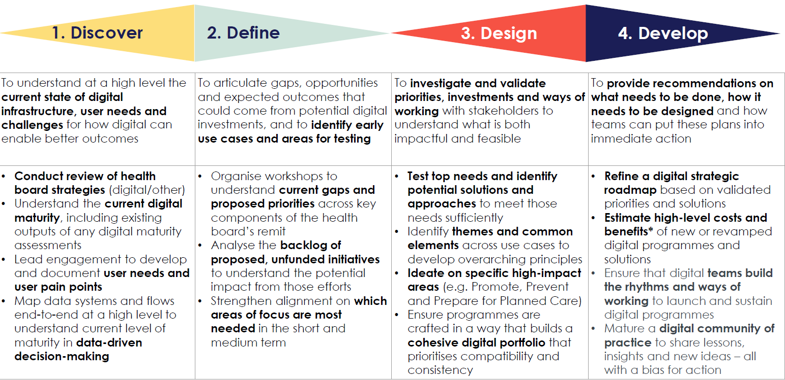

Through analysis of existing strategies/programmes and a series of surveys, workshops, 1 to 1 interviews and interactive sessions with various groups across the organisation, the process is focussing on 3 major outputs:

- Digital Strategy
- Vision for how digital drives a stronger service
- Outline of top use cases, needs and priorities in the short-term
- Key target opportunities for the longer term
- Alignment of to current programmes of work, nationally and locally

- 3 Year Delivery Roadmap
  - Design of a cohesive digital portfolio
  - Delivery planning, building on the strategy
  - High-level costing estimates/investments
  - Identification of key workstreams

- Mobilisation Plan
  - Capacity and resourcing to progress delivery
  - Governance and accountability approach
  - Detailed early timeline
  - KPIs / Success factors
  - Digital team readiness and ways of working

The project commenced in December 2023 and will complete by the end of February 2024. To date the following activities have taken place:

- 76 workshop participants
- 25 SRO and Executive interviews including the CEO and Chair of WODD
- 20 participants at Grand Rounds engagement session
- 18 participants at Clinical Senate engagement session
- 82 Attendees at Digital Directorate session
- 108 survey responses submitted so far
- 14 attendees at the MH & LD Digital Services Group
- Updates given at the Therapies & Health Sciences Professional and Governance Meeting and at the Patient and Citizen Empowerment Programme Board

- GOVERNANCE AND RISKS
The Digital Strategy development project is being overseen by the Digital Leadership Team with overall responsibility held by the Director of Digital on behalf of the Executive Team. Arrangements are being made for a presentation of the final products at Executive Team and Board Development/IM Briefing. Timings for the approval process to reach Health Board in March are being worked through.
Key risks in completing the development of the strategy:
- Organisational pressures compounded by the planned Industrial Action in February may reduce engagement opportunities and delay completion of the work. However, the majority of the planned engagement sessions have already taken place and so far we have been able to workaround other pressure issues as they have arisen including the Industrial Action in January.

Key risks in executing the Strategy and 3 year roadmap:
- Lack of funding to maintain the growing digital estate and lack of investment in new digital solutions and the resource required to implement them could lead to failure to deliver the aims of the digital strategy and roadmap. The Digital Strategy will provide high-level costing estimates upon which the Health Board will need to develop a tactical investment plan in order to deliver the medium and long-term digital benefits. In parallel, there is a national focus on digital spend requirements over the next ten years, which will validate our strategy and also provide WG with the information required for long term digital financial plans.
- Difficulty recruiting digital professionals may lead to an inability to deliver and maintain the required digital solutions. The challenge of retaining specialist technical skills in NHS Wales is clearly a factor. The delivery of the digital strategy will need to strike a balance between in-house innovation, collaborative working regionally and nationally, and partnership with the private sector in order to mitigate against resourcing challenges. SBUHB Digital Services is also developing a Digital Workforce Strategy to underpin the Digital Strategy and furthermore contributing to national work in this space.
- Organisational pressures and resistance to change will impact the success of digital solution implementations and not achieve the necessary business change to realise planned benefits. The aspirations of the Digital Strategy must be championed by senior stakeholders across the organisation. The Strategy will emphasise the need to grow Clinical Digital Leaders across all clinical disciplines. This will be fundamental to achieving clinical buy in and driving through digitally enabled clinical process change.

- FINANCIAL IMPLICATIONS
- The cost of the contract with PSC is £117k. This was covered by the Digital Services budget.
- The Digital Strategy will provide high-level costing estimates upon which the Health Board will need to develop a tactical investment plan in order to deliver the medium and longer term digital benefits. In parallel, there is a national focus on digital spend requirements over the next ten years, which will validate our strategy and also provide WG with the information required for long term digital financial plans.

- RECOMMENDATION

Members are asked to:

- NOTE: the progress that has been made in establishing a new digital strategy for the health board
- NOTE: the aspirations of the WG Digital and data strategy for health and social care in Wales
- NOTE: the key outcomes of the digital maturity assessment undertaken by the health board

Governance and Assurance

Link to Enabling Objectives  (please choose) | Supporting better health and wellbeing by actively promoting and empowering people to live well in resilient communities
Link to Enabling Objectives  (please choose) | Partnerships for Improving Health and Wellbeing |  | ☒
Link to Enabling Objectives  (please choose) | Co-Production and Health Literacy |  | ☐
Link to Enabling Objectives  (please choose) | Digitally Enabled Health and Wellbeing |  | ☒
Link to Enabling Objectives  (please choose) | Deliver better care through excellent health and care services achieving the outcomes that matter most to people
Link to Enabling Objectives  (please choose) | Best Value Outcomes and High Quality Care |  | ☒
Link to Enabling Objectives  (please choose) | Partnerships for Care |  | ☒
Link to Enabling Objectives  (please choose) | Excellent Staff |  | ☒
Link to Enabling Objectives  (please choose) | Digitally Enabled Care |  | ☒
Link to Enabling Objectives  (please choose) | Outstanding Research, Innovation, Education and Learning |  | ☐
Health and Care Standards
(please choose) | Staying Healthy |  | ☐
(please choose) | Safe Care |  | ☒
(please choose) | Effective Care |  | ☒
(please choose) | Dignified Care |  | ☐
(please choose) | Timely Care |  | ☒
(please choose) | Individual Care |  | ☐
(please choose) | Staff and Resources |  | ☐
Quality, Safety and Patient Experience
The execution of the Digital Strategy will enable quality and safety improvements across the Health Board
Financial Implications
- The cost of the contract with PSC is £117k. This was covered by the Digital Services budget.
- The Digital Strategy will provide high-level costing estimates upon which the Health Board will need to develop a tactical investment plan in order to deliver the medium and longer term digital benefits. In parallel, there is a national focus on digital spend requirements over the next ten years, which will validate our strategy and also provide WG with the information required for long term digital financial plans.
Legal Implications (including equality and diversity assessment)
None known
Staffing Implications
None known
Long Term Implications (including the impact of the Well-being of Future Generations (Wales) Act 2015)
- Long Term – Health and Social Care “A Healthier Wales” (2018) sets out a long term future vision of a ‘whole system approach to health and social care’, which is focussed on health and wellbeing, and on preventing illness
- Wellbeing of Future Generations Act (2015)
  - Focus on prevention, not service provision.
  - Prevent ill health, reduce impact of illness or injury and delay onset of frailty.
  - Provide services to carers that prevent, reduce, or delay them developing a need for support.
- Primary Care Model for Wales (April 2019)
  - Focuses on a whole system approach that integrates health, local authority and voluntary sector services, and is facilitated by collaboration and consultation.
  - A more preventative, pro-active and coordinated care system which includes general practice and a range of services for communities
  - Technological solutions to improve access to information, advice and care, and to support self-care.
- SBU HB’s Clinical Services Plan (2019-2024)
  - Adoption of digital solutions and technology.
  - Create a mobile workforce that is digitally connected to ensure staff work seamlessly to ‘Make Every Contact Count’.
  - Technology to support care closer to the patient’s home or in the community.
Report History |  | None

Appendix 1: Digital Strategy for Health and Social Care in Wales 2023
Appendix 2: SBUHB Electronic Medical Record Assessment Model Report 2023

