10. Workforce Updates and Actions
This section of the report provides further detail on key workforce measures. Caveats and Limitations (C&L) detailed beneath data in each section.
Staff sickness rates - Percentage of sickness absence rate of staff (two metrics provided, ‘rolling 12 month’ and ‘in month’)  Sickness absence target – 5.5% | % of full time equivalent (FTE) days lost to sickness absence  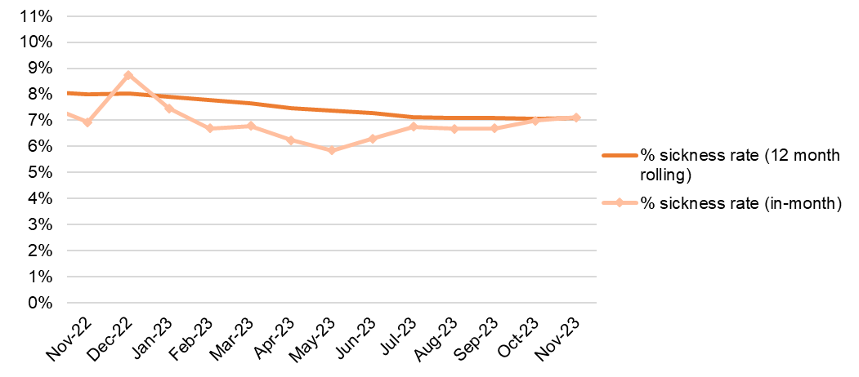  Caveat & Limitations;- Report generated Nov 2023, within SBUHB (Performance Team) for substantive and FTC employee types. Data source – ESR. Target of 5.5% added as blue line
Current Performance
- Health Board total for in month sickness absence for November 23 increased from the last reporting period to 7.11% (rising from 6.69% in Sept 23, 6.99% Oct 23). This is an increase compared to the in month reported figure for November 2022 which was 6.88%.
- Increase to in month sickness is a typical trend over the winter period. Interrogation of data reveals that ‘Cold, Cough, Flu’ category spiked over October and November and that is likely to continue across December and January. Other categories remain fairly stable, indicating that seasonal illness is responsible for the overall increase. This is not unusual.
- Anxiety/stress related absence remained the highest reason for absence, with MSK remaining second. This is consistent across NHS Wales and is a long term pattern.
- Mental Health and Learning Disabilities Service Group has the highest in month percentage absence in November 23 at 8.93% although this level has been stable over September and October. Neath Port Talbot are next at 7.44% (decreasing from 7.6% in Oct 23), followed by Morriston at 6.64% (decreasing from 6.93% in Oct 23), and then PCST at 6.23% (decreasing from 6.54% in Oct 23).
- The balance of short and long term sickness remains stable, however levels have changed slightly, with short term increasing over the duration from 2.05% in September to 2.64% in November. Long term has changed from 4.91% in September to 4.48% in November. This slight shift is supported by the increase in ‘Cough, Cold, Flu’ category which are most often short term in nature, but higher in frequency over winter.
Actions for Next Period
Current focus on areas with high absences rates, examples of initiatives to support our employees:
- HR team and managers encouraged to attend Healthy Working Wales session in December 23 on Understanding and Managing MSK conditions (currently the Health Board’s second highest reason for absence).
- Time table for sickness absence audits across hot spots areas to facilitate ongoing examination of areas with higher absence levels.
- Best Practice Review continues to improve our employee relations processes.
- Stress at work session for the Operational HR Team facilitated by Legal and Risk was held in November 2023 and was well received.
- Training for managers is being enhanced to promote awareness and effective management of attendance at work.
- A broader adoption of the sickness absence deep dive activities that were implemented in the Morriston Service Group as identified in the recent sickness absence audit.

Staff Health and Wellbeing
The services continue to develop prudent processes and multi-disciplinary working to maximise resources and maintain waiting times within KPI’s.
- NHS Shared Services Partnership audit of Sickness Absence recommended updated evaluation report of Staff Wellbeing clinical interventions to demonstrate efficacy – the report had been drafted and elements will be presented to WF&OD Development Group on 23/1/24.
- Occupational Health (OH) have been supporting the Staff Flu and Covid campaign led by the Immunisation Service – 28.6% of front-line staff had received the vaccination as 11/1/24. The OH Nursing team provided intensive support at the start of the campaign and are continuing to offer Flu Vaccinations within the Occupational Health Departments .
- Band 5 OH Nurses currently being appointed to support the roll out of staff health checks from 1st April ’24.
- Men's Health network commencing January 2024 to support male staff’s physical and mental health.

Helping our employees
The Health Board implemented Wagestream Instant pay which allows our bank staff to access up to 60% of their salary of shifts worked before pay day.
- 209 additional employees (130 RN’s, 56 HCA’s,13 other & 10 A&C staff) have joined the Health Board bank.
- 965 employees have registered with Instant pay
- 1,523 streams have been made by staff (totalling £180,681.87)

Mandatory & Statutory Training-  Percentage compliance for all completed Level 1 competencies within the Core Skills and Training Framework by organisation  Mandatory & Statutory Training target – 85% | % of compliance (Headcount) with Core Skills and Training Framework  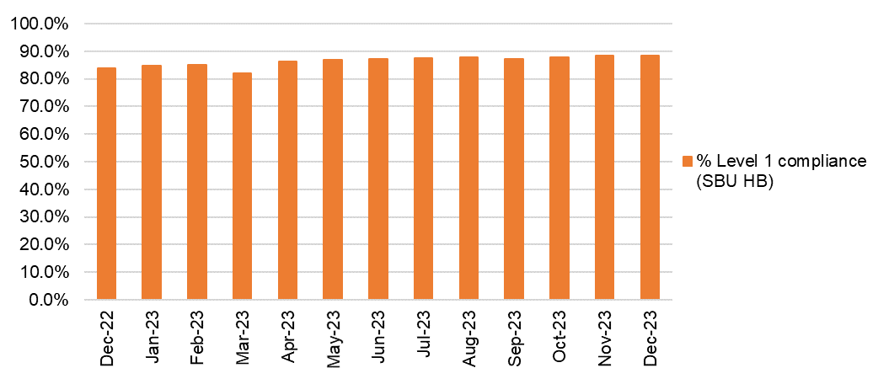  C&L;- Report generated Nov 2023, within SBUHB (Performance Team) for substantive and FTC employees. Data source – ESR (OLM Module). Accuracy levels subject to local maintenance and validation standards. Target of 85% added as blue line
Current Performance
- Statutory and Mandatory Training compliance rates for the Health Board recorded 31st December 2023 are:
88.47% - 10 CSTF (Core Skills Training Framework) competencies as reported to Welsh Government (The Welsh Government target is 85%).
87.9% - 14 core competencies (including the 10 CSTF and 4 additional competencies required by SBUHB).
- Medical & Dental staff Group remain the lowest performing area, although they have seen an increase to 62.32% compliance against the 14 combined competencies. The service groups are undertaking targeted activities to improve compliance which is being led by the Unit Medical Directors and HR Business Partners.
- Ad-Hoc ESR E-Learning Support Sessions are being provided to support colleagues with any access or competence recording issues.
Actions for Next Period
Subscription to Learning Certification and Enrolment onto Statutory/Mandatory Courses (E-Learning) – User issues identified are being supported on a case-by-case basis via Action Point and direct point.

- Compliance figures (14 core competencies) per Service Group;-
- MH&LD 90.36%, PCCT 92.54%, Morriston 82.16%, Finance & Estates 89.71% - No further update since last report.
- NPTS 89.68% - The Service Group will continue to focus on improving compliance rates for the Medical and Dental staff group (note recently we have observed an improvement within this staff group) this staff group are currently at 69.11% compliant in the 14 core modules.
- Note: Infection Prevention and Control Level 2 compliance introduced January 2024. Figure will be reported in the next update
Vacancies  Medical and Nursing and Midwifery | Vacancies (FTE) Oct 2023 to Dec 2023  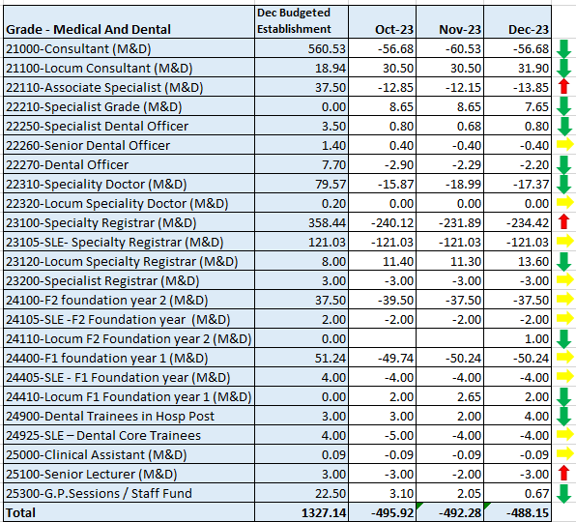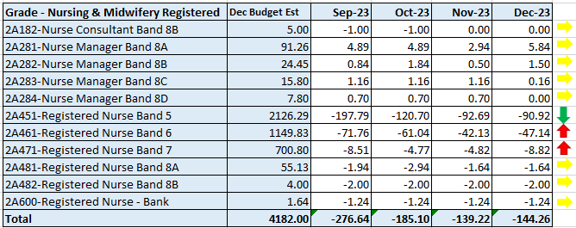  C&L;- Report generated 18 Sep 2023, within SBUHB (ESR Team), using currently available methodology. Data source – ESR (Workforce) and General Ledger (Finance). We compare the SIP v’s the finance ledger, appreciating limitations on accuracy in some areas. Accuracy levels are subject to local validation practices based on budget holders intelligence. N.B. a 12 month project (ESR Establishment control) has commenced which will harmonise vacancy data including Grade detail shown above.
Current Performance
- NMC vacancies have reduced considerably, primarily due to annual ‘streamlining’ (the recruitment of newly qualified Band 5 nurses). Progressive reductions have taken place in Band 5 nurse vacancies over recent months, with August showing -291.92 against budgeted FTE, and a total of 201 FTE improvement to end Dec. This impacted overall NMC vacancy rate from -366 in August 23, to -144 in December 23. This shows a significant reduction in vacancies over the last 5 years (December 2019 -381.4, December 2020 – 305.98, December 2021 -351.85 and December 2022 -345.23).
- Latest cohort of circa 14 overseas nurses (6 adult and 8 mental health) commenced OSCE preparation training in January. Further cohorts are being carefully planned as vacancies for general Band 5 nurses have mostly been recruited in terms of active pipeline, as per feedback from Service Groups. Focus is now on more specialist areas i.e Mental Health, Midwifery and Neonates
- Temporary agency costs have greatly reduced due to the efforts to recruit to both Band 5 nursing vacancies and medical vacancies
Actions for Next Period
- Overseas Nurse recruitment business case for 2024/25 to be considered by Management Board after previous delay in this happening. This supported the recommendation included to support ongoing work and recognised the opportunity to offer to other Health Boards (eg Velindre)
- Pre-employment checks for the circa 70 newly qualified nurses (NQNs) due to qualify in March 24 recently been allocated posts with the Health Board via Student Streamlining Process (SSP) have commenced within the SBUHB Recruitment Team and will continue.
- Interviews for a Retention Lead funded for two years by HEIW due to be completed.
- Support to commence to various Therapy services to attract newly qualified staff due to qualify this summer into existing vacancies across the Health Board.
Recruitment  Metrics provided by NWSSP. Comparison with all-Wales benchmarking  Target 44 days | Vacancy Creation to Conditional Offer December 2023 (working days: excluding outliers) T13  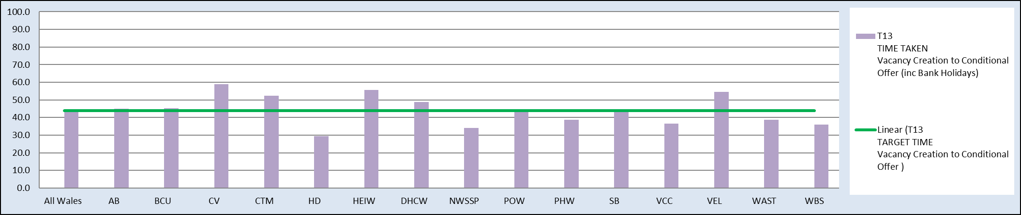  C&L;- Report generated Sep 2023, by NWSSP (Recruitment). Data source – TRAC system. Outliers are excluded. This is day to day vacancy management.
Current Performance
- Swansea Bay UHB overall performance continues to be below target in December 23, and our monthly average over the last 12 months remains in target. In addition our performance for conditional offer to ready for start date start date was 24 days, which remains below the set target of 27 days.
- The Central Resourcing Team continue to focus efforts on the recruitment of acute ward based HCSW’s and Band 5 nurses as well as providing support to specific difficult to recruit to posts (see above) and vacancy gap has closed significantly evidenced by significant reduction in nurse temporary agency spend
- Current KPI’s (Dec 23) comparing SBUHB averages vs the CRT on HCSW recruitment is 70 days vs 53 days based on average time taken from vacancy creation to unconditional offer.

Actions for Next Period
- HRBP’s continue to discuss with Service Groups opportunities to reducing the lag between the date termination of posts are being requested versus date a TRAC entry was initiated.
- The Central Resourcing Team will continue focusing on the recruitment of B5 nurses, B2 ward based HCSW’s and assisting in overseas nurse recruitment, Specific focus will be to recruit in Neonates, Children services, Mental Health & ED. In addition, they are assisting in the recruitment of newly qualified nurses, via the all Wales Student Streamlining process. As well as specifically identified hard to recruit to posts.
- In collaboration with NWSSP, we will continue supporting the wider HB by trying to ‘chase’ outstanding actions on vacancies / pre-employment checks with applicants, in an effort to further reduce the overall HB time to hire.
- For doctors we continue to recruit overseas on a post by post basis and specifically targeting specialty registrars.

Turnover  % turnover by occupational group | Period Turnover Rate (Swansea Bay) – 01 Dec 2022 - 31 Nov 2023  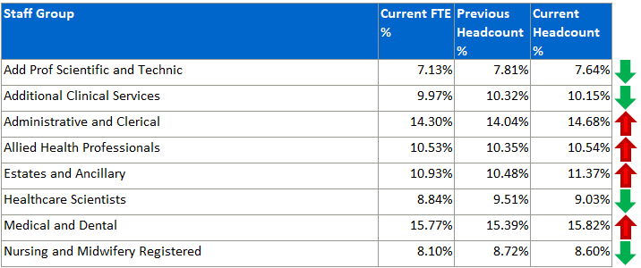  C&L;- Report generated Sep 2023, within SBUHB (ESR Team). Data source – ESR (Workforce). Small risk of margin of error due to late communication of terminations. Report excludes Bank, Locum, Honorary & Widow/Widower, Junior M&D staff. Internal movement not included – measure is about leaving Swansea Bay UHB.
Current Performance
- Organisationally our turnover has increased marginally in this reporting period (from 10.83% to 10.94%). This is also a slight increase on what was reported as at the end of December 2023 at 10.38%.
- It is important to recognise that this is reporting on a 12 month rolling period of turnover which ended September 2023.
- Admin and Clerical turnover remains the highest rate at 14.68%. However, this high figure is influenced by a service transfer of ‘Delivery Unit’ consisting of 75 individuals in March 2023 from SBUHB to Public Health Wales. This large peak will continue to influence the 12 month rolling figure until March 2024.
- N.B. as previously reported there has been an increase in movement of Medical and Dental staff linked to the SLE rotations which will continue to result in elevated turnover every three months.
- Other categories are either stable or improving.
- It is worth noting that the turnover for the Health Board is relatively consistent across the period other than in March and April 2023 as commented above.
- The Health Board position across Wales places us with the 5th lowest turnover rate, the highest being reported by Powys at 19.3%.

Actions for Next Period
Actions which will feed into Turnover improvement are currently being led by two ongoing groups – Recruitment and Retention, and Flexible Working Group.
- Flexible Working Group introductory meetings are taking place, to identify means of improving retention by reducing attrition attributable to flexibility. Workplan was shared in the Deep Dive on Recruitment and Retention shared at the last WOD committee.
- HRBP support each of the Service Groups with their own local focus on retention based on the needs of the service group.
- Interviews for a Retention Lead who will support the implementation of the Nurse Retention plan are due to take place by the end of January.

PADR  % staff who have a current PADR review recorded  PADR target – 85% | % of staff (Headcount) who have had a PADR in previous 12 months  C&L;- Report generated Sep 2023, within SBUHB (Performance Team). Data source – ESR (OLM Module). Accuracy levels subject to local maintenance and validation standards. Target of 85% added as blue line.
Current Performance
- Staff who have had a Personal Appraisal and Development Review (PADR) at the end of this time period stands at 67.13%
In the past two months 47 staff have attended 130 PADR - Personal Appraisal Review for Managers the Learning and Education Team signpost colleagues to SBU ESR - ESR User Guides SharePoint Page for resources on how enter PADR Dates in ESR
- Compliance figures per Service Group - MH&LD 73.67%, NPTS 71.55%, PCCT 82.25%, Morriston 56.18%, Finance & Estates 69.92%

Actions Planned for Next Period
- MH&LD, PCCT, Estates and Facilities - No further update since last report
- NPTS – Neath Port Talbot and Singleton Service Group has seen an improved position compared to rates previously reported in November 2023 which were 67.93%. The Service Group will need to continue focusing on improving compliance within the additional Clinical Service Staff which are currently the lowest reporting staff group at 67.92%
- Morriston - Morriston Service Group has seen a declining position with PADR compliance, a deep dive exercise is currently being undertaken to establish reasons for poor compliance. Main findings so far of the deep dive exercise are that hierarchies in ESR are wrong, meaning the wrong manager is assigned in the system and where PDRs are completed they are not being placed on the system, there also seems to be a failure in the process of entering PADR’s into ESR. Early intel indicates that PADR’s are being completed but the system is not updated and therefore reporting a lower compliance than in reality. An improvement plan is now being actively worked on to address these failings, with the aim of seeing significant improvements by March 24.
Operational Casework  Number of current operational cases. | 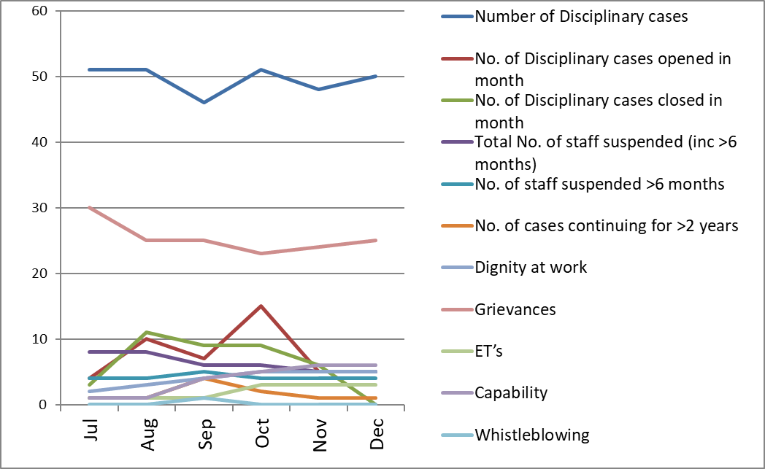  C&L;- Report generated Nov 2023, within SBUHB (Workforce Digital). Data source – ER Tracker. Accuracy levels subject to local maintenance and validation standards.
Current Performance
- No. of open Formal Disciplinaries since the last reporting period has decreased to 50.
- Suspensions remain at 5. A review of suspensions currently being undertaken as part of our Best practice review to consider opportunities for improvement of process and decision making.
- ET’s have reduced to 3. Since the last reporting period, two cases have been settled. Our Best Practice review has really focused on better management of ET cases, challenging where appropriate and when needing to settle opportunities to learn being shared.
- Our Trade Union compact has now been agreed with our Trade Union partners and is being launched with our WOD Strategy – this is the cornerstone of how we will work together to achieve quality in the work we do together.

Actions for Next Period
- A number of actions are on-going in line with the Best Practice Review, workshops arranged over the next 3 months jointly with our Trade Unions facilitated by HEIW and Legal & Risk covering the following: Respect and Resolution and Managing Disciplinary cases, which had to be rearranged due to a clash with the RCN conference and December service pressures.
- Launching new documentation to support a management review early in the process to determine the most appropriate course of action the very early stages
- HR Operational share point site is now live, which includes policies and toolkits for all the main employee relations management processes. The team are signposting managers to the site as a first port of call where appropriate. Feedback has been shared that the transparency of this is favoured by our Trade Union partners to help staff understand what may come during a process.
- Investigation Officer Training facilitated by Legal and Risk to be held in January 2024.
- Series of sessions to be held on ‘avoiding employee harm through investigations’ over the course of the next 12 months to ensure we continue to focus on “putting people at the centre of what we do”.

