Appendix 4:

Swansea Bay Careers, Widening Access and Work Experience

Work internships
In September 2019, the organisation entered in a partnership with Gower College Swansea to deliver work internships to students in their Independent Living Skills (ILS) department. Due to the pandemic lockdown, SBUHB paused the programme and was able to reinstate it in September 2022 with four students with additional learning needs (ALN).
The students are on long-term work placements in Morriston Hospital to help improve their employability skills and give them the confidence and experience to apply for jobs in the future. We profiled them and the programme in an intranet bulletin in November 2022.
Below is a photo of the four students who started the programme with our organisation. Three are remaining.
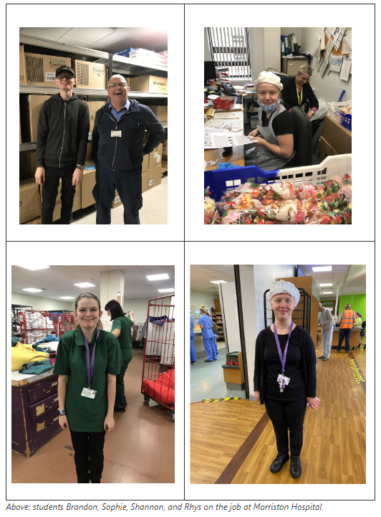
- Brandon is working well within the team in the Stores Department at Morriston and is showing improvement as he will bring more than 1 of each item in the form of packs rather than one at a time now, therefore he is beginning to retain some instructions. Brandon adds value to the department although he is not keen on cleaning on Wednesdays, he will still do it.
- Sophie is in the Catering team at Morriston and is getting used to the world of work by having targets to help improve her growing job performance in the kitchen
- Rhys has proved indispensable in HSDU with deliveries being his forte; the team would like to see a junior position be created for him.
- Shannon started in the linen room for a few weeks but it did not suit her skills set and career goals so has moved to a placement outside the hospital.
We are in talks to expand the model to other sites and to work with other educational partners in the Neath Port Talbot area.

Some statistics for 2022
- 25 people complete work experience, despite the start-stop guidance to bring work experience under pandemic restrictions
- 12 Career Talks
- 6 Job / Career Fairs
- Reached 1500+ people through the events mentioned above as well as through working in collaboration with community groups such as South Wales Ethnic Minority Employability Group, Refugees, African Community Centre, Career Wales and various job centres, schools and colleges

Looking into 2023
In 2023, we will be increasing our presence across the Swansea and Neath Port Talbot geographic area.
We have events and programmes line up such as:
- Choose Your Future
- Career Discovery Week
- Welsh in the Work Place
- Multiple Career Talks with Schools & Colleges
- New Work Experience Programme for Health & Social Care students with Gower and Neath Port Talbot colleges.
We are always looking to collaborate with departments, whether it’s work experience or career events. Working together, we can help to build a motivated, highly-skilled, talented future work force in Swansea Bay University Health Board to deliver the best care to our patients.

Examples of our team on the terrain
Attending Swansea Pride as part of widening access, with Calon LGBT+ Staff Network
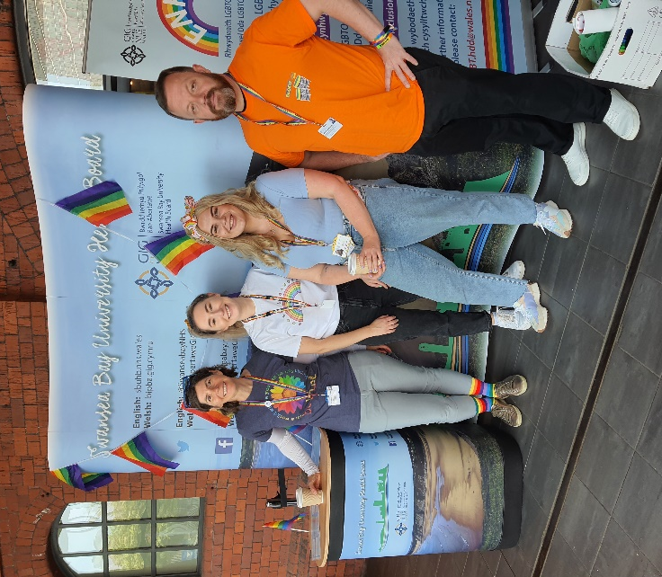

Attending a career fair in Port Talbot with Nursing Education
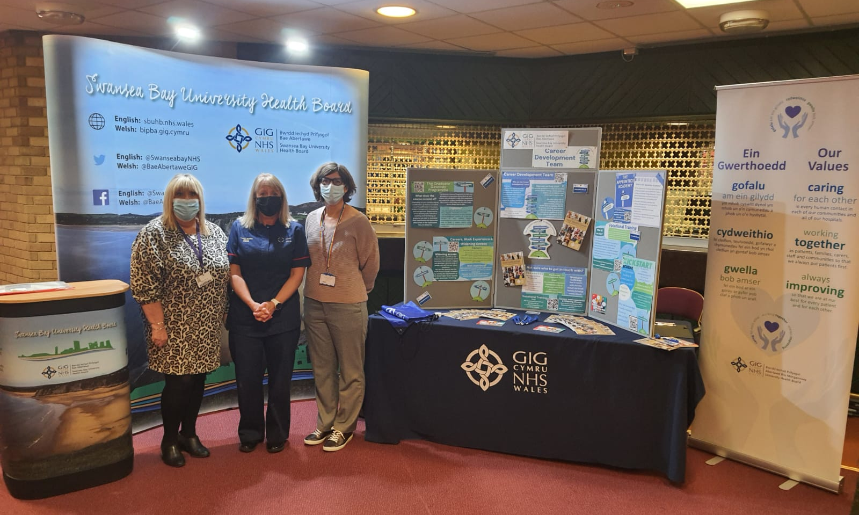

Promoting our services to colleagues at the Singleton Wellbeing Fair:
