Appendix 2: Swansea Bay Vocational Training

Through the years of being in existence, the Vocational Training team still finds great satisfaction and pride in seeing positive changes in trainees, from the moment that they join the programme to their completion date. This comes from the fact that several trainees lack in confidence when it comes to looking for work or starting in a new role, and the support that the Vocational Training team offers makes them believe in themselves.
Many of the trainees taking advantage of the Vocational Training employability programmes have either never worked, been without work for a long period of time (e.g. bringing up a family, health issues or just starting out on their career), or may be new comers to the UK (e.g. refugees). Those selected to participate in the programme get the opportunity to enter the workplace in a supported and caring way, where their success is at the heart of the line manager, mentors, and Vocational Training team.
The support that the team offers has sometimes extended beyond what would be considered in their remit. Examples of the way they have supported and cared for individuals include but are not limited to:
- Supporting individuals to access support following domestic abuse
- Supporting individuals to access support for addiction including accompany individuals to AA meetings
- Enabling individuals to open bank accounts, register for benefits and access childcare, including driving individuals to appointments

Supporting SBU’s Mass Vaccination Centre
In 2020, the Vocational Training team was instrumental in supporting the recruitment of admin staff in SBU’s Mass Vaccination Centre (MVC). Through its contacts in the JobCentres, the team was able to recruit close to 200 people.
The work of the team was highlighted on SBU’s internet and in Swansea’s local papers in 2022. The article profiled the variety of people that benefited from the Vocational Training support:
- Mohamed Ferooz Nori fled Afghanistan when the Taliban stormed Kabul. He was a translator for the British Army.
- Mwape Burke was a pharmacian in Zambia
- An asylum seeker from Egypt saw the work at the MVC as a way to resurrect her career as a doctor
- Nigel Poole, 63 years old, was appreciative of the work placement and was able to boost his confidence
Please refer to Anju’s and Sharon’s stories to read how a placement at the MVC offered them more than expected (pp 3-4).

Supporting DWP’s Kickstart Scheme
From October 2021 to September 2022, Vocational Training focused on placing young adults through DWP’s Kickstart Scheme. The scheme aimed to provide employment to 16-24 years old on universal credit. It was designed to help a demographic group that was hit harder through the pandemic. The goal was to place 50 young adults. In the end, the team placed 55 young adults, being one of the most successful organisation in South Wales.
Upon completion of the Kickstart Scheme, the team contacted the participants and found that 31 candidates had gained employment; 23 of them in the Health Board and 8 securing jobs with outside organisations. Whilst it is the preference is to place candidates permanently in our organisation, the team considers that a placement outside of the organisation is a success since this is what is most important in the candidate’s life.
Please refer to Daniel’s and Britanny’s stories to understand how they benefitted from the Kickstart Scheme and the support of the Vocational Training team (pp 5-6).
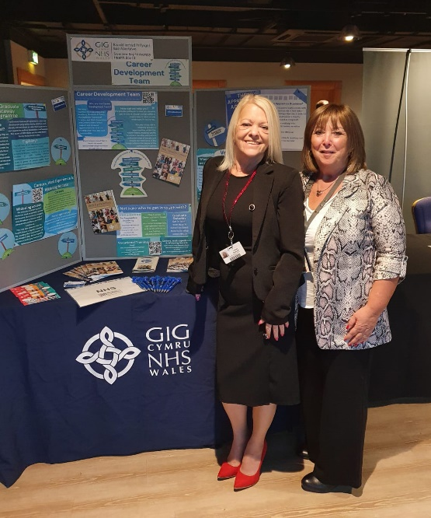

(Attending DWP’s Job Fair to recruit Kickstart candidates)

Current Provisions
Currently, the Vocational Training team has an agreement with Swansea Council and Neath Port Talbot Council to provide work placements to people who are on their Communities for Work Plus programme. The provision will support 80 individuals through a 3-month placement, 16 hours weekly.

Some Vocational Training success stories
