Meeting Date | 11th December 2025 |  | Agenda Item |  | 3.2
Report Title | Regular report from the Director of Workforce & OD
Report Author | Tina Ricketts, Executive Director of Workforce & OD
Report Sponsor | Tina Ricketts, Executive Director of Workforce & OD
Presented by | Tina Ricketts, Executive Director of Workforce & OD
Freedom of Information | Open
Purpose of the Report | This is a regular report to notify the Committee of key national and local issues that may impact on our workforce. The report covers the period 1st October to 31st December 2025
Key Issues | The report contains the following updates:  National issues:  - National labour market – latest update  - Resident Doctor Contract Reform  - GP Out of Hour Contract National Update  - Locum Consultants National Update  - Consultation on the Employment Rights Bill  - Guidance on Special Payments  - Education and Commissioning Plan 2026/7  Local issues:  - Staff Survey 2025 completion rate  - Band 2/3 Update  - Budget Holder and Line Manager objectives  - Recording of Mental Health Training
Specific Action Required  (please choose one only) | Information | Discussion | Assurance | Approval
Specific Action Required  (please choose one only) | ☒ | ☐ | ☐ | ☐
Recommendations | The Committee is asked to receive the report which is provided for information.

Workforce HORIZON SCANNING

- INTRODUCTION
This is a regular report to alert the Committee to matters and issues that may impact on our workforce. We work within a complex and changing environment with many factors that may impact on our workforce. It is therefore important that the Committee are notified of these updates to help anticipate impact and risk.

The aim of this report is to horizon scan on a national, regional and local basis.

- NATIONAL ISSUES

2.1 Labour Market in Wales – latest update
A good source of data on employment trends is provided by HMRC’s Pay as You Earn (PAYE) count of the actual number of employees on payrolls. The PAYE data shows that employment in Wales has weakened over the last few months. Business surveys suggest that the increase in employer national insurance contributions (NICs), the lowering of the NICs threshold and an increase in the national living wage, all effective April 2025, are contributing to job losses. In addition, surveys report that many employers are concerned about pending legislation regarding workers’ rights and in consequence are reluctant to hire new workers.
Job losses are occurring predominantly in private sector industries (see Table 1). In the second quarter of 2025, private sector PAYE jobs were down 1.5% on the prior year. Job losses have been most pronounced in relatively low paying activities. For example, in hospitality the number of PAYE employees was down 5% on the prior year. In contrast to developments in private sector job numbers, the number of PAYE jobs in the public sector has continued to increase in both Wales and the UK.
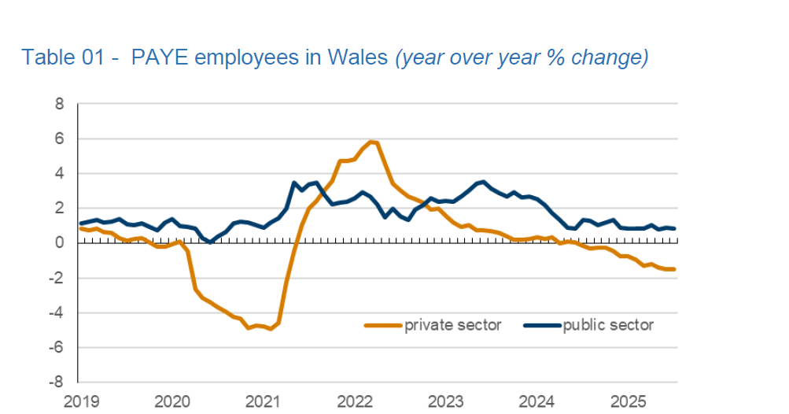
Claims for unemployment related benefits published by the Department for Work and Pensions suggest unemployment has been edging up from a low rate. However, economic inactivity has decreased slightly over the last few months. Behind this headline is that economic inactivity caused by long-term sickness remains high while looking after family (as the reason for inactivity) is reducing.

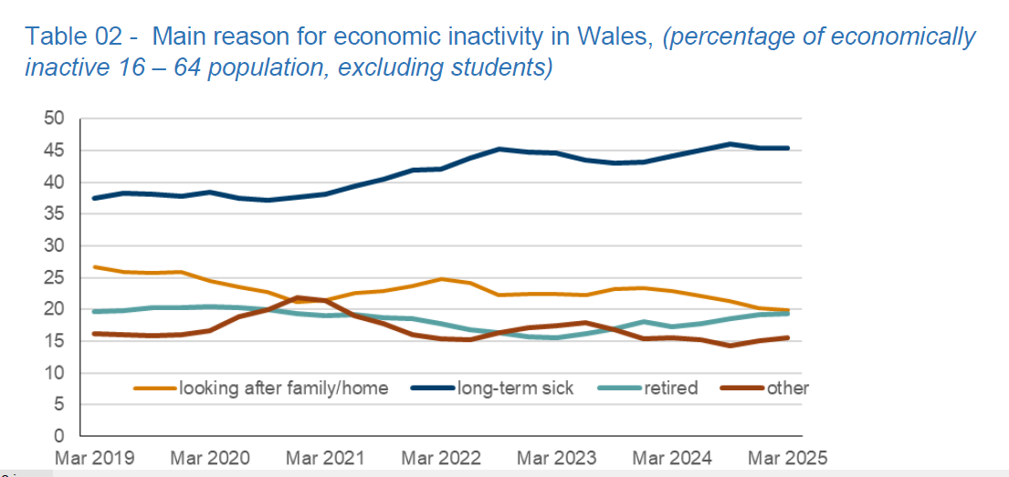

Average UK weekly nominal regular earnings in the public sector, excluding bonuses and before inflation, was up 5.7% in the second quarter of 2025 compared with a year earlier. Pay increased by 4.7% in the private sector. Adjusted for inflation, public sector pay was up 2.1%. Private sector real pay was up 1.1%.

This helps explain why we are seeing a reduction in our staff turnover rate and our vacancy rates as there is less competition with the private sector.

2.2 Resident Doctor Contract Reform
The BMA is currently engaging with its members on the proposed contract reforms, with results of the ballot anticipated by 15 December 2025.

As previously reported, the proposed reforms include:
- A simpler pay system with fewer pay points
- The opportunity for pay progression
- Safe working hours, in conjunction with current charters
- The introduction of Resident Doctor job plans
- A new role of Guardian of Safe and Flexible Working (GSFW)

A national Resident Doctor Contract Programme Board is to be established in December, to coincide with the result of the ballot.

Work continues with Health Education and Improvement Wales and Welsh Government to work through the profiling of the funding for 2026/7.

The Health Board has established a task and finish group to oversee the implementation of the new contract. The first tranche of doctors transitioning to the new contract will occur in August 2026. There is a considerable amount of work to undertake between now and then. The final transition needs to happen by August 2028.

A Locally Employed Doctor cost modeler has been provided to Directors of Finance. The total cost of implementing the new contract is still being worked through and will be shared at the next meeting.

2.3 GP OOH Contract
NHS Employers Wales have advised that progress has been made with the BMA in terms of adjustments to the proposed rates of pay. It is proposed that a standardised agreement across all NHS Wales organisations is developed and would include full and final settlement of claims under both the Wages Act and Working Time Regulations. Health Boards have been asked to agree that NHSWE continue to negotiate on their behalf.

The implications for SBUHB are as follows. We have raised these points with NHS Employers Wales
- Pay Progression: The proposed GPOOH worker agreement pay rates include pay progression based on completed years’ experience, a benefit which is not present in other worker agreements within the Health Board. This results in inequity amongst other staff groups and may result in potential future challenges. There is also no reference to the minimum number of shifts required to work to move to the next pay point. For example, if a worker only works one shift in two years, will they automatically move to the pay scale. There is also no reference to the pay progression being performance based

- Increased Financial Impact: SBUHB currently pay one of the highest rates in NHS Wales for GP IR35 self-employed contractor sessions in OOH. This is largely due to historical issues over unavailability and roster fill rates. The original proposal identified a financial benefit to the Health Board of £280,780, however the impact of the current proposal creates a cost pressure of £169,692 due to the increased rates

- No Obligation: GPs are not obliged to accept the new terms and may remain on their current consultancy terms if preferred. This presents a potential risk for future claims and inconsistent rates across NHS Wales for contractors

- Remote Sessions: GPs who undertake OOH shifts remotely are currently paid lower rates in SBUHB. Remote shifts have not been factored into the National negotiations
- Contact First Sessions: SBUHB pay higher GP OOH rates for Contact First sessions. These higher sessional rates have not been factored into the National negotiations

- Increased Holiday Pay Backstop: Previous Employment tribunal claims have been settled on the basis of a two-year backstop for holiday pay. These terms agree a backstop of four years backpay

- Impact on Existing and Future Salaried GPs in OOH: The new pay scale for GP OOH workers is aligned with the Salaried GP pay scale, with a higher minimum point to reflect the experience required for ad hoc cover. The scale is shorter than the employee scale. SBUHB have Salaried GPs in OOH services who may be potentially on lower rates. This may present a challenge from existing employees and present recruitment challenges when recruiting into further Salaried GP roles within the GPOOH service.
2.4 Locum Consultants
NHS Employers Wales has undertaken work to help inform the pay negotiations taking place with the Consultant Committee and the BMA on pay scale changes. The work included the collation and analysis of the levels of locum consultants across NHS Wales, and the dual rates of pay in effect at that time. There is now one locum consultant rate of pay, and the rate for Retire & Return consultants has been removed.

Length of service and whether locum consultants were on the Specialist Register was also reviewed. Health Boards have been advised to consider plans to transition locum consultants with a long length of service in temporary roles, into substantive roles. There is also the need to hold conversations for those who were not on the Specialist Register and were not likely to be (i.e. those not going through the CCT process).

SBUHB has 50 long term locum consultants, many of which were appointed to hard to fill posts and to allow them to pursue a
CESR application for entrance on to the specialist register, permitting them to apply for substantive consultant posts. We are working through the details of these appointments.

2.5 Consultation on the Employment Rights Bill
I would like to draw to the Committees attention the 4 x Employment Rights Bill consultations launched by the Department of Business and Trade, which we will respond to from a SBUHB organisational perspective.
Most of the questions in the consultations take the form of multiple-choice responses so there is no easy way to gather views. My recommendation is that we would be in favour of these being included in the Bill, however, I would welcome any thoughts or specific points that the Committee may want to make. The consultation deadlines are as follows are as follows:
18 December:
- Duty to inform workers of right to join a union (a new duty on employers to give a written statement to their workers, informing them of their right to join a trade union at the start of their employment and at other times),
- Trade union right of access (a new framework for trade unions to access workplaces physically, and to communicate with workers in person or digitally).
15 January:
- Enhanced dismissal protections for pregnant women and new mothers (legislation which will make it unlawful to dismiss pregnant women, mothers on maternity leave, and mothers who return to work for at least a 6-month period after they return – except in specific circumstances),
- Leave for bereavement, including pregnancy loss (a new day-one right to unpaid bereavement leave for employees who experience the loss of a loved one, including pregnancy loss before 24 weeks),

2.6 Updated Guidance on Special Payments
The Government have issued updated guidance on the payment of losses and special payments linked to employment. A summary of the guidance is set out below. Special payments are subject to special control procedures and must be brought to the attention of Welsh Government if they exceed the delegated limit. In considering special payments, value for money should be considered. The need for corrective action must also be carefully assessed to minimise the number (and cost) of future cases. This includes any wider lessons for NHS Wales.
Categories of Special Payments:
Contractual redundancy - Contractual redundancy payments refer to payments made to employees upon termination of employment as required under the terms of their contract. Organisations have delegated authority from a financial accounting perspective to pay statutory or contractual entitlement. Welsh Government requires organisations to inform them of any contractual redundancy for noting and not for approval apart from Executive Directors whereby prior to any such contractual arrangements being signed off, approval is sought from the Director General Health and Social Care in their role as accounting officer.
Voluntary Early Release Scheme (VERS) - The Voluntary Early Release Scheme is designed to assist employees who wish to leave their employment voluntarily, particularly in the context of organisational changes within the NHS or civil service. This scheme provides a structured way for employees to exit their roles while receiving a compensatory payment based on their length of service. Organisations have delegated authority for payments up to £50,000 as set out on the VERS Model Scheme rule. Payment over this level requires Welsh Government Accounting Officer approval, and there is a template Business Case to submit to Welsh Government for approval.
Compensation under legal obligation - Payments fall into this category only if a clear liability exists as a result of a Court Order or a legally binding arbitration award. This category can include compensation for injuries to persons, damage to property and unfair dismissal. There is full delegated limit for the Health Boards to make these payments, and Welsh Government is not required to provide approval, however NHS organisations are required to send each individual case to the Director General of Health and Social Care as Accounting Officer for noting and to notify of any novel or contentious cases.
Ex gratia payments - Ex gratia payments are payments which a health body is not obliged to make or for which there is no statutory cover or legal liability. An example is a payment to compensate for financial loss resulting from an act or failure of the body or its servants which does not give rise to a legal liability, or the payment of compensation claims or damages. It will also cover payments to end employment that are above contractual terms which have been directly negotiated with the individual or their representative (for example to settle a claim against the health body for breach of contract). NHS Wales bodies must consider special severance payments as exceptional. They are usually novel and contentious and potentially repercussive. The amount agreed with the individual must be subject to Welsh Government approval, before any offer is made verbally or in writing whatever the value of the proposed payment.
2.7 Education and Commissioning Plan 2026/7
Health Education Improvement Wales (HEIW) are developing the Education and Training plan for 2026/27. They have shared that this work is more than just a training plan, rather an opportunity to shape the workforce of NHS Wales by continually scanning the horizon, taking the information provided by each organisation’s IMTP and tying in with a range of live policy influences including the Ministerial Advisory Group report alongside Cabinet Secretary priorities.
The plan will be approved by the HEIW Board and submitted to Welsh Government and will be considered in the context of national requirements and priorities. The plan is being developed through extensive engagement, looking at the priorities of different organisations, being cognisant of workforce pressures and gaining professional insights to address whole-system requirements.
Both the UK and world-wide political landscape is being taken into account, and consideration is being given to future planning and training capacity, looking specifically at what local populations need, including training for the 56 different medical specialties in Wales. As an example, a phased increase is being proposed in GP training capacity to align care closer to the community.
The plan will include recommendations for investment into post-graduate priorities, i.e. primary and community care, continued expansion of specialist community public health nurses, and support for mental health initiatives. The plan makes provision for work-based learning to diversify routes for entry, as well as funding for advanced and enhanced practice such as independent prescribing by a range of professionals.
The plan will be published by 31st March 2026.
- LOCAL ISSUES/MATTERS

3.1 NHS Wales Staff Survey 2025
The final national staff survey completion rate will be issued after the deadline for this paper and following all paper copies of the survey have been counted on 5th December 2025.

At the point of reporting on the afternoon of 21st November 2025 (just over a week before the close) we had surpassed last years' response rate by 2.2% (640 responses) and were at 15.1% (2,648 responses).

The breakdown of compliance by Service Group/ Corporate area up to that point was as follows. The 2,200 headcount in the WOD Directorate includes all bank staff.

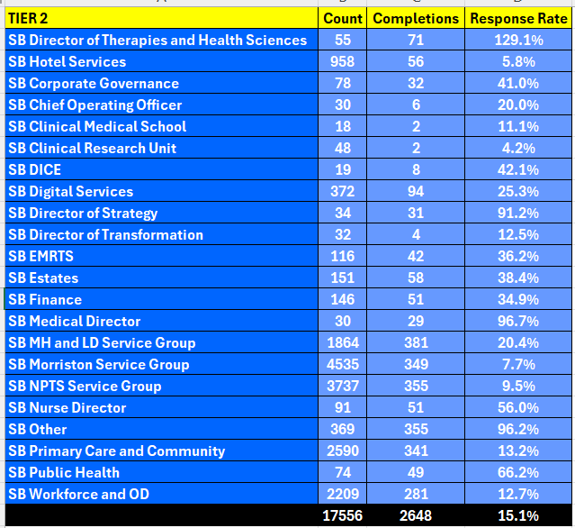

3.2 Band 2/3 Matter
Following the approval by Board to make payments to the members of staff who have been validated as working at band 3 level we have agreed an assimilation date of 1st December 2025. We are on track for payments to be made in the December payroll with a pay date of 19th December 2025. For staff in scope the payments will include the one-off recognition payment, arrears to 1st January 2025 and assimilation to the appropriate incremental point on the band 3 pay scale.

A task and finish group has been set up to oversee the assimilation plan which includes briefings for managers and staff, the development of Frequently Asked Questions, a mocked-up payslip and a central contact point for colleagues who may have queries regarding their pay.

3.3 Budget Holder/ Line Manager Objectives

The following corporate objectives will be set for all budget holders and line managers from 1st April 2026. A lead in period is needed to socialise the objectives across the Health Board.

For Budget holders (in line with Standing Financial Instructions, Procurement Regulations and Financial Control Procedures):
- To develop a workforce plan showing actual funded establishment (WTE) and projected worked WTE for my budget area(s) using the Health Board templates. To monitor the workforce plan on a monthly basis taking corrective action if either the WTE or £ is off track.
- To manage staffing costs within the available £ pay budget (the definition of available pay budget is the allocated budget less the savings requirement less any vacancy factor). To monitor staffing costs on a monthly basis taking corrective action if the pay budget is off track.
- To manage non-pay costs within the available £ budget (the definition of the available budget is the allocated budget less the savings requirement. To monitor non-pay costs on a monthly basis taking corrective action if the non-pay budget is off track.
For line managers:
- To achieve over 85% compliance in PADR for my area(s) of responsibility.
- To achieve over 85% compliance for mandatory training for my areas(s) of responsibility.
- To ensure compliance with the Managing Attendance Policy ensuring:
- the reporting and recording of absence is in line with policy
- all back to work interviews are undertaken with 7 days of the member of staff returning to work
- that sickness absence review meetings are held for all staff who have met the triggers as set out in the All Wales Policy

3.4 Recording of Mental Health Training
A query was raised at the September meeting on the recording of mental health training. At the meeting it was acknowledged that some data was available; however, the data on training compliance was proven difficult to identify and collate. This was impacting on the ability of Best Interests Assessors to discharge their role, and to assess outstanding training requirements.
This query has been checked with the workforce team who confirmed that reports on training compliance can be broken down by the level of training if this has been set up correctly on the ESR system. The workforce team will link in with the Assessors to resolve this issue.

- RECOMMENDATION
The Committee is asked to note the report which is provided for information.

Governance and Assurance

Link to Enabling Objectives  (please choose) | Supporting better health and wellbeing by actively promoting and empowering people to live well in resilient communities
Link to Enabling Objectives  (please choose) | Partnerships for Improving Health and Wellbeing |  | ☐
Link to Enabling Objectives  (please choose) | Co-Production and Health Literacy |  | ☐
Link to Enabling Objectives  (please choose) | Digitally Enabled Health and Wellbeing |  | ☐
Link to Enabling Objectives  (please choose) | Deliver better care through excellent health and care services achieving the outcomes that matter most to people
Link to Enabling Objectives  (please choose) | Best Value Outcomes and High Quality Care |  | ☐
Link to Enabling Objectives  (please choose) | Partnerships for Care |  | ☐
Link to Enabling Objectives  (please choose) | Excellent Staff |  | ☒
Link to Enabling Objectives  (please choose) | Digitally Enabled Care |  | ☐
Link to Enabling Objectives  (please choose) | Outstanding Research, Innovation, Education and Learning |  | ☐
Health and Care Standards
(please choose) | Staying Healthy |  | ☐
(please choose) | Safe Care |  | ☐
(please choose) | Effective Care |  | ☐
(please choose) | Dignified Care |  | ☐
(please choose) | Timely Care |  | ☐
(please choose) | Individual Care |  | ☐
(please choose) | Staff and Resources |  | ☒
Quality, Safety and Patient Experience
None identified
Financial Implications
As identified in the report
Legal Implications (including equality and diversity assessment)
As identified in the report.
Staffing Implications
As set out in the report.
Long Term Implications (including the impact of the Well-being of Future Generations (Wales) Act 2015)
There are no long term implications in relation to the impact of the Wellbeing of Future Generations Act unless identified specifically.
Report History |  | None
Appendices |  | None

