Meeting Date | 11 December 2025 |  | Agenda Item |  |  | 2.2
Name of Meeting | Workforce and OD Committee
Report Title | Workforce Report – Mental Health and Learning Disabilities (MH&LD)
Report Author | Dermot Nolan, Interim Service Group Director Mental Health and Learning Disabilities
Report Sponsor | Deb Lewis, Chief Operating Officer / Executive Director of Primary Care & Mental Health
Presented by | Dermot Nolan, Service Group Director Mental Health and Learning Disabilities
Freedom of Information | Open
Purpose of the Report | The purpose of the report is to provide an update on the following:  - Workforce performance against key metrics and associated actions  - An overview of workforce risks and issues affecting MH&LD  - Staff Survey Action Plan Progress
Key Issues | The key issues relate to the following:  - Ongoing unavailability challenges across staff groups  - Engagement in Staff Survey for Service Group  - Establishment and vacancies impact based on underlying deficit allocation  - Overview of main workforce risks
Specific Action Required  (please choose one only) | Information | Discussion |  | Assurance | Approval
Specific Action Required  (please choose one only) | ☒ | ☐ |  | ☒ | ☐
Recommendations | - ACKNOWLEDGE the Service Groups Workforce Metrics, Risks and Staff Survey Progress.  - BE ASSURED of the actions being taken to ensure compliance with workforce metrics to support and improve the health and wellbeing of staff.

WORKFORCE REPORT
Mental Health and Learning Disabilities

- INTRODUCTION

This report will provide a workforce update on the following:

- Performance against key workforce metrics and associated action
- An overview of workforce risks/issues affecting MH&LD
- Staff Survey Action Plan Progress

- BACKGROUND

2.1 Performance against key workforce metrics and associated action

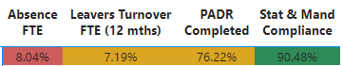

Sickness Absence

Sickness absence for the Service Group for the last 12 months has ranged between from 6.67% and 8.71%

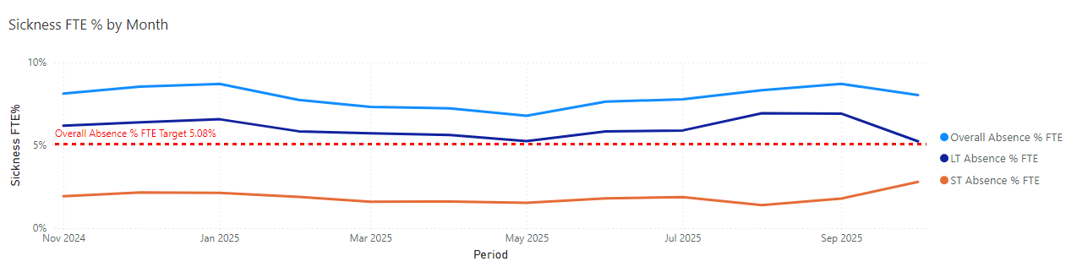

Overall total absent days by total employees amounted to 4,227 work days lost during October 2025, ranging between 120 to 188 absences per day.

Sickness in-month for October 2025 was 8.03%

Long term absence decreased to 5.24% in October 2025. Short term absence increased to 2.79% in October 2025.

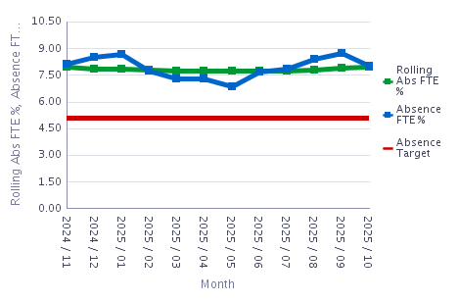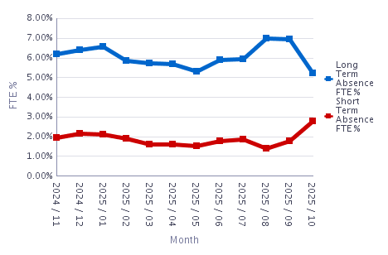

The Directorates’ short-term absence and long-term absence for October 2025 were as follows, those highlighted in red are above target level.

Managers are asked to ensure that all absence is monitored and support is identified for staff within these areas.

Org L6 | Short Term | Long Term
130 Adult Directorate - Serv | 2.05 | 5.85
130 CAMHS Directorate - Serv | 1.78 | 5.95
130 CDAT Directorate - Serv | 1.42 | 6.81
130 Head of Nursing - Serv | 0.77 | 3.03
130 Head of Psychology - Serv | 0.66 | 2.91
130 LD - Cardiff Directorate - Serv | 1.86 | 5.79
130 LD - Cwm Taf Directorate - Serv | 1.62 | 6.61
130 LD - Learning Disabilities Management - Serv | 1.11 | 3.10
130 LD - Swansea Directorate - Serv | 1.54 | 4.57
130 MH & LD Service Group - Dir | 0.27 | 45.75
130 MH LD Management & Operations | 0.66 | 3.04
130 MH Management - Serv | 1.67 | 3.86
130 Older Peoples MH Directorate - Serv | 2.32 | 6.37
130 Secure - Medium Secure Directorate - Serv | 1.84 | 7.19
130 Secure - Perinatal Directorate - Serv | 3.30 | 2.59
130 Secure - Rehabilitation Directorate - Serv | 2.44 | 9.38

Ten areas have been identified as being consistently above 11% absence over a rolling 12 months, with a minimum of 20 staff for audits and to identify improvement. Follow up audits are currently being scheduled. Current learning has identified that managers are not always following administrative processes.

Monday has remained our highest day of absence with a steady decline through the week, rising again on Sunday. The highest level of absence has been between 0 and 1 days, with absences between 28 days and 6 months the next highest area. This is illistrated in the October data below.

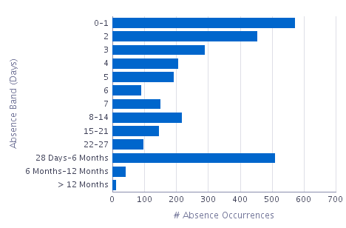 | 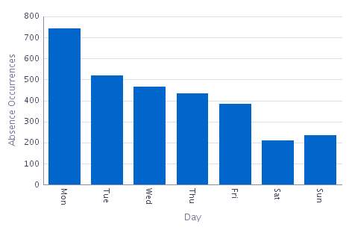

The three consistent main reasons for sickness absence within the group do not change. The figures for October 2025 are below:

Absence Reason | Grand Total
S10 Anxiety/stress/depression/other psychiatric illnesses | 111
S13 Cold, Cough, Flu - Influenza | 93
S25 Gastrointestinal problems | 41

The TRIM support continues to be widely shared across the group; a new TRIM manager is currently being sourced.

Managers are reminded to utilise Occupational Health and wellbeing for staff who are absent, along with other mechanisms available. The Staff Counsellor can be utilised for group work to support wellbeing and also supports individuals with counselling support if access is delayed within Occupational Health or individuals need additional support following their use of Occupational Health.
The Health Board’s Flu Vaccination Campaign for staff is underway and 655 staff (34.9% of staff) have been vaccinated within MH&LD (figure correct at 26th November 2025)
Absence rates within nursing and additional clinical services staff have remained high throughout the year. The absence rate for October by staff group is below;

Staff Group | Absence FTE | Available FTE | Absence FTE %
Add Prof Scientific and Technic | 1,352.49 | 36,535.41 | 3.70%
Additional Clinical Services | 18,845.04 | 205,417.30 | 9.17%
Administrative and Clerical | 5,998.63 | 71,429.76 | 8.40%
Allied Health Professionals | 1.00 | 1,180.17 | 0.08%
Estates and Ancillary | 176.75 | 4,485.88 | 3.94%
Medical and Dental | 975.38 | 25,353.90 | 3.85%
Nursing and Midwifery Registered | 21,901.82 | 276,390.64 | 7.92%

- In month absence rates across the Service Group have been below the projected (forecasted) rate.
- October 25 in month absence rates have exceeded the projected (forecasted) rates. In October the actual in month rate was 8.03% and the projected rate was 7.32%

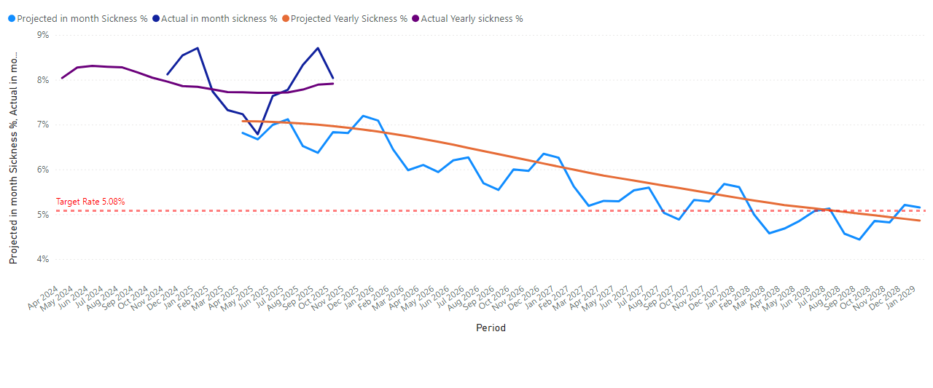
To address these issues the following actions are ongoing:

Overarching Sickness Improvement Actions

MH&LD Managing attendance at work action plan is attached (Appendix 1) and we have summarised below the key themes.

Themes | Actions
Leadership Engagement and Managerial Accountability | Strengthening Our Focus on Sickness Improvement:  - Clear messaging around sickness being a key priority  - Reinforcing the message that this is a key area that requires our collective attention and commitment.  - As leaders there is a vital role to play in shaping the environment our teams work in and by taking clear ownership of sickness performance, each leader has the power to make a real difference.
Sickness Management | - Programme of audits for ‘Hot Spot Areas’ scheduled between 09/25 and 01/26 with a re-audit programme commencing 01/26.  - Absence Reviews – undertaken in 10 ‘Hot Spot Areas’ These reviews have been designed to enable a proactive approach to supporting both long and short-term staff absence. The HR Business Partner Team and Operational HR Team work alongside the management team to ensure long and short-term cases are being appropriately managed and progressed. The meeting also initiates case reviews, which may require specialist advice input e.g., Occupational Health.
Key improvement actions relating to stress and anxiety | Specific actions taken for anxiety, stress and depression are:  - Early contact – with a compassionate approach  - Regular contact / touch points during absence period  - Regular sickness review meetings with HR Ops Team  - Immediate support and signposting  - Tailored and flexible return to work plans  - Ongoing monitoring and touchpoints on return to work  - Occupational Health referral  - Stress risk assessment to be completed  - Referral and signpost to relevant support groups and wider support
Staff Experience, Wellbeing and Retention | - Development of staff experience, wellbeing & retention plans draws on the evidence and best practice contained within the Staff Health and Wellbeing – A Best Practice Guide for NHS Wales.
Monitoring and Assurance | - Monthly workforce groups (KPIs are reviewed and plans agreed to improve performance if required)  - Audit / workforce KPI Reports  - Monthly roster scrutiny meetings  - Absence summits/audits  - Business assurance and accountability meeting (sickness performance is specifically reviewed as part of this assurance and accountability process)
Education and Training | - Managers continue to have access to the “Managing Attendance at Work” training and the Brilliant Basics platform (interactive learning and education tool accessible 24/7).  - Support/coaching from HR Business Partner Team and HR Advisors.
Workforce Planning | - The HEIW Strategic Workforce Planning Toolkit has been used to develop MDT Workforce Plans across all Divisions so that services identify all opportunities to plan and design the workforce to maximise capacity and focus on effective workforce design (using the principles in the Staff Health and Wellbeing – A Best Practice Guide for NHS Wales) to support services in maximising staff availability. These workforce plans are subject to continual review.

Personal Development Reviews (PADR)

The target set for PADR compliance and Statutory Mandatory training is 85%. Reports for October 2025 are attached on the first page.

PADR compliance has decreased slightly in month to 76.18% on 31st October 2025. Managers are reminded to arrange to meet with staff who still require a PDR and Managers must take responsibility for ensuring they have rolling plans in place to meet with staff and that they are recorded on ESR. Training on how to conduct a meaningful PADR is available to be booked on with Learning and Development each month.

34 Areas out of 141 areas in the Service Group are in the red. Managers are reminded that reviews can be taken over teams. 425 staff need to be given the opportunity of a PADR. There has been an increase across all staff groups. Staff groups highlighted in red are below target. All Managers have been directed to ensure there is a plan for reviews to be scheduled to include a check in with their staff wellbeing. Progress plans are reviewed in Divisional Meeting, Nurse Workforce, Board and Senior Team Meetings.

Staff Group | Assignment Count | Reviews Completed June 2025% | Reviews Completed July 2025% | Reviews Completed August % | Reviews Completed September % | Review Completed October %
Add Prof Scientific and Technic | 84 | 86.78↑ | 85.00↓ | 86.55↑ | 87.39↑ | 83.19↓
Additional Clinical Services | 553 | 76.39↓ | 74.43↓ | 76.75↑ | 77.81↑ | 78.38↑
Administrative and Clerical | 197 | 73.89↑ | 72.00↓ | 73.42↑ | 75.66↑ | 74.55↓
Estates and Ancillary | 21 | 94.44↑ | 83.33↓ | 88.89↑ | 94.44↑ | 94.44↔
Nursing and Midwifery Registered | 652 | 76.42↑ | 63.75↓ | 73.91↑ | 75.16↑ | 73.55↓
Grand Total | 1,522 | 76.40↑ | 73.92↓ | 75.05↑ | 77.09↑ | 76.18 ↓

The following areas need to focus on planning PADRs to staff. (please note only those with 10+ staff have been included). Please note this was the status on 31st October 2025)

Org L6 | Org L8 | Assignment Count | Reviews Completed | Reviews Completed %
130 Adult Directorate - Serv | 130 R067 NPTH Ward F Acute | 42 | 25 | 59.52
130 Adult Directorate - Serv | 130 R084 Fendrod Ward CCH | 29 | 12 | 41.38
130 Adult Directorate - Serv | 130 R089 Community Acute Area 3 (Ty-Einon) | 33 | 18 | 54.55
130 LD - Cardiff Directorate - Serv | 130 T063 Special Services - Rowan | 23 | 13 | 56.52
130 LD - Swansea Directorate - Serv | 130 T015 Community Health Team - Swansea | 14 | 8 | 57.14
130 LD - Swansea Directorate - Serv | 130 T024 Learning Disabilities Intensive Support Team (LDIST) | 20 | 10 | 50.00
130 Older Peoples MH Directorate - Serv | 130 R063 CMHT EMI Tonna | 17 | 9 | 52.94
130 Older Peoples MH Directorate - Serv | 130 R161 CC Derwen Ward | 36 | 19 | 52.78
130 Secure - Medium Secure Directorate - Serv | 130 R265 Forensic Nursing Services | 11 | 5 | 45.45
130 Secure - Perinatal Directorate - Serv | 130 R177 Perinatal Inpatient Unit | 26 | 11 | 42.31

The following areas with 10+ staff are commended for being on or above target

Org L6 | Org L8 | Assignment Count | Reviews Completed | Reviews Completed %
130 Adult Directorate - Serv | 130 R087 Community Acute Area 1 (Central Clinic) | 32 | 29 | 90.63
130 CAMHS Directorate - Serv | 130 R180 CAMHS - Admin & Service Support | 14 | 13 | 92.86
130 CAMHS Directorate - Serv | 130 R182 CAMHS - Psychology | 13 | 13 | 100.00
130 CAMHS Directorate - Serv | 130 R183 CAMHS - School In-Reach Team | 13 | 13 | 100.00
130 CAMHS Directorate - Serv | 130 R186 CAMHS - Crisis Team | 11 | 11 | 100.00
130 CAMHS Directorate - Serv | 130 R187 CAMHS - Assessment & Treatment Team | 15 | 15 | 100.00
130 CAMHS Directorate - Serv | 130 R192 CAMHS - Part 2 Team | 11 | 10 | 90.91
130 CDAT Directorate - Serv | 130 R102 NPT Detox Ward | 18 | 16 | 88.89
130 CDAT Directorate - Serv | 130 R220 MH Neath Comm Drug & Alcohol | 13 | 13 | 100.00
130 CDAT Directorate - Serv | 130 R244 Community Drugs Team | 29 | 28 | 96.55
130 Head of Psychology - Serv | 130 R305 Psychology Neuro | 10 | 10 | 100.00
130 Head of Psychology - Serv | 130 R306 Psychology Paediatrics | 16 | 14 | 87.50
130 LD - Cardiff Directorate - Serv | 130 T047 Special Services - Lletty Newydd | 24 | 23 | 95.83
130 LD - Cardiff Directorate - Serv | 130 T081 Special Services Behavioural Team | 14 | 12 | 85.71
130 LD - Cwm Taf Directorate - Serv | 130 T040 Special Services - Meadow Court | 21 | 21 | 100.00
130 LD - Cwm Taf Directorate - Serv | 130 T041 Special Services - Dan-y-Bont | 21 | 20 | 95.24
130 LD - Cwm Taf Directorate - Serv | 130 T042 Special Services - Ty Garth Newydd | 20 | 17 | 85.00
130 LD - Learning Disabilities Management - Serv | 130 T010 LD Management | 25 | 23 | 92.00
130 MH Management - Serv | 130 R410 Swansea Locality Management | 12 | 11 | 91.67
130 Older Peoples MH Directorate - Serv | 130 R139 Support and Stay | 12 | 11 | 91.67
130 Older Peoples MH Directorate - Serv | 130 R148 NPT Care Home In Reach Team | 10 | 9 | 90.00
130 Older Peoples MH Directorate - Serv | 130 R149 CMHT EMI Port Talbot | 14 | 13 | 92.86
130 Older Peoples MH Directorate - Serv | 130 R174 CMHT EMI Areas 3&4 | 17 | 15 | 88.24
130 Secure - Medium Secure Directorate - Serv | 130 R268 Forensic Cardigan Ward | 37 | 32 | 86.49
130 Secure - Rehabilitation Directorate - Serv | 130 R056 Rowan Ward | 36 | 33 | 91.67
130 Secure - Rehabilitation Directorate - Serv | 130 R097 Gwelfor Unit CC | 29 | 27 | 93.10

Mandatory Training

Mandatory training is improved and remains above target at 90.34% on 31st October 2025. Staff groups with the exception of medical staff and ancillary staff are above target.
Staff Group | Compliance May 2025 % | Compliance June 2025 % | Compliance July 2025 % | Compliance August 2025 % | Compliance September 2025 % | Compliance October 2025 %
Add Prof Scientific and Technic | 96.23%↑ | 95.76%↓ | 95.61%↓ | 96.15%↑ | 92.20↓ | 95.47↑
Additional Clinical Services | 91.99%↑ | 92.81%↑ | 92.85%↑ | 93.19%↑ | 88.99↓ | 91.12↑
Administrative and Clerical | 90.72%↑ | 91.48%↑ | 92.05%↑ | 90.79%↓ | 82.99↓ | 88.04↑
Estates and Ancillary | 87.85%↑ | 88.89%↑ | 89.58%↑ | 90.28%↑ | 81.48↓ | 81.87↑
Medical and Dental | 74.68%↑ | 74.77%↑ | 73.51%↓ | 74.68%↑ | 72.08↓ | 74.92↑
Nursing and Midwifery Registered | 92.54%↑ | 93.01%↑ | 93.41%↑ | 93.70%↑ | 90.43↓ | 91.54↑

Staff that are not compliant are reminded that this is a contractual requirement and that they be provided with a deadline to ensure completion of their mandatory training, it is a contractual requirement. It needs to be reinforced that mandatory training can be accessed from home. This is reinforced within PADR’s and non-compliance will result in staff not going through a pay progression point. A particular focus is being driven for our medical staff and those not in compliance are having study leave declined. Progress plans are reviewed in Divisional Meeting, Nurse Workforce, Medical Workforce, Board and Senior Team Meetings.

All Directorates % achieved or exceeded the Mandatory training compliance target:

Org L6 | Assignment Count | Required | Achieved | Compliance %
130 Adult Directorate - Serv | 421 | 7999 | 7026 | 87.84%
130 CAMHS Directorate - Serv | 103 | 1957 | 1905 | 97.34%
130 CDAT Directorate - Serv | 68 | 1292 | 1225 | 94.81%
130 Head of Psychology - Serv | 98 | 1862 | 1805 | 96.94%
130 LD - Cardiff Directorate - Serv | 122 | 2318 | 2135 | 92.11%
130 LD - Cwm Taf Directorate - Serv | 151 | 2869 | 2647 | 92.26%
130 LD - Learning Disabilities Management - Serv | 26 | 494 | 457 | 92.51%
130 LD - Swansea Directorate - Serv | 98 | 1862 | 1760 | 94.52%
130 Older Peoples MH Directorate - Serv | 300 | 5700 | 5166 | 90.63%
130 Secure - Medium Secure Directorate - Serv | 224 | 4256 | 3670 | 86.23%
130 Secure - Perinatal Directorate - Serv | 37 | 703 | 625 | 88.90%
130 Secure - Rehabilitation Directorate - Serv | 151 | 2869 | 2608 | 90.90%

With regards to specific competencies the Service Group is above target in all competencies apart from Safeguarding Children, Level 2 (84.25%) and the recently mandated Anti Racism module (62.35%).

Competence Name | Assignment Count | Required | Achieved | Compliance %
NHS|CSTF|Equality, Diversity and Human Rights - 3 Years| | 1886 | 1886 | 1761 | 93.37%
NHS|CSTF|Fire Safety - 2 Years| | 1886 | 1886 | 1744 | 92.47%
NHS|CSTF|Health, Safety and Welfare - 3 Years| | 1886 | 1886 | 1769 | 93.80%
NHS|CSTF|Infection Prevention and Control - Level 1 - 3 Years| | 1886 | 1886 | 1751 | 92.84%
NHS|CSTF|Infection Prevention and Control - Level 2 - 1 Year| | 1886 | 1886 | 1663 | 88.18%
NHS|CSTF|Information Governance (Wales) - 2 Years| | 1886 | 1886 | 1690 | 89.61%
NHS|CSTF|Moving and Handling - Level 1 - 2 Years| | 1886 | 1886 | 1695 | 89.87%
NHS|CSTF|Resuscitation - Level 1 - 3 Years| | 1886 | 1886 | 1780 | 94.38%
NHS|CSTF|Safeguarding Adults - Level 1 - 3 Years| | 1886 | 1886 | 1798 | 95.33%
NHS|CSTF|Safeguarding Adults - Level 2 - 3 Years| | 1886 | 1886 | 1607 | 85.21%
NHS|CSTF|Safeguarding Children - Level 1 - 3 Years| | 1886 | 1886 | 1779 | 94.33%
NHS|CSTF|Safeguarding Children - Level 2 - 3 Years| | 1886 | 1886 | 1589 | 84.25%
NHS|CSTF|Violence and Aggression (Wales) - Module A - No Specified Renewal| | 1886 | 1886 | 1816 | 96.29%
NHS|LANG|Welsh Language Awareness - 3 Years| | 1886 | 1886 | 1820 | 96.50%
NHS|MAND|Dementia Awareness - No Renewal| | 1886 | 1886 | 1823 | 96.66%
NHS|MAND|NHS Wales - Anti-racism| | 1886 | 1886 | 1176 | 62.35%
NHS|MAND|Paul Ridd Learning Disability Awareness Training - No Specified Renewal| | 1886 | 1886 | 1659 | 87.96%
NHS|MAND|Social Services and Well Being Act Wales Awareness (2014) - No Specified Renewal| | 1886 | 1886 | 1797 | 95.28%
NHS|MAND|Violence Against Women, Domestic Abuse and Sexual Violence - 3 Years| | 1886 | 1886 | 1686 | 89.40%

Vacancies / Turnover

Unfilled Vacancies October 2025
Staff Group | Vacancies June 2025 Establishment Control | Vacancies 12th July 2025 Establishment Control | Vacancies August 2025 Establishment Control | Vacancies September 2025 Establishment Control | Vacancies October 2025 Establishment Control
Add Prof Scientific and Technic | 1.89 | 1.59 | 3.49 | 3.19 | 1.34
Additional Clinical Services | 49.32 | 54.42 | 61.56 | 65.67 | 76.77
Administrative and Clerical | 15.70 | 13.4 | 12.61 | 10.12 | 14.79
Allied Health Professionals | 5.00 | 5.00 | 5.00 | 5.00 | 5.85
Estates and Ancillary | 1.59 | 1.59 | 1.49 | 1.49 | 1.49
Medical and Dental | 10.76 | 6.56 | 11.66 | 9.56 | 19.30
Nursing and Midwifery Registered | 11.55 | 11.46 | 24.56 | 19.53 | 6.48
Grand Total | 95.8 | 94.02 | 120.35 | 114.56 | 126.01

There are 126.01 vacancies within MH&LD, the main pressures within the group remain for medical (19.30) and HCSW (76.77) which is contributing to variable pay usage.

Additional processes have been implemented in line with the Health Board decision to have further scrutiny over the suitability of recruiting to all vacancies in the current financial climate; this is now impacting on the timeline to recruit to vacancies with additional delays build in.

A report is available each month for a review to be undertaken of overall progress of posts excluding medical that are processed within the Shared Services TRAC system to identify delays and take corrective action.

All vacancies continue to be subject to the current Workforce Controls in place across the Health Board.

Vacancies for MH&LD are under scrutiny. Divisions alongside the Senior Team have undertaken vacancy review panels. Vacancies are also reviewed in Nurse Workforce and Medical Workforce Meetings and are being considered in our Modernisation Subgroups. The Service Group review factors affecting the retention of the Qualified Nursing workforce on a 6 monthly basis to inform projections for student streamlining recruitment and complete education commissioning data on an annual basis in line with Workforce Plans. Vacancies and establishments are reviewed annually in line with national benchmarking. Budgets are being reviewed to manage the adjustment of the HCSW move from band 2 to band 3, this may impact on the overall number of HCSW posts we can now recruit to.

Turnover

Turnover for the Service Group is 7.61% as of 31st October 2025. The main reason for leaving remains age retirement and Additional Clinical staff are the main staffing group for leavers due to age profile (albeit a number of staff are returning to work under the retire and return scheme and supported with flexibility arrangements).

The Service Group has highlighted to Divisions the importance of recording accurately the reason why staff leave our organisation as it is essential for understanding workforce trends, identifying retention challenges, and shaping our support for staff and services. In addition, the service continues to promote the use of Exit Interviews to provide critical intelligence to further inform staff experience and retention approaches. The Service Group also has a retention nursing group which feeds into the Health Board’s recruitment and retention group with a particular focus on ensuring flexibility is supported for staff.
Staff Group | Headcount May 2025 | Headcount June 2025 | Headcount July 2025 | Headcount August 2025 | Headcount September 2025 | Headcount October 2025
Add Prof Scientific and Technic | 9.65%↓ | 8.73%↓ | 9.69%↑ | 8.77%↓ | 7.89%↓ | 6.90%↓
Additional Clinical Services | 7.84%↓ | 8.33%↑ | 8.15%↓ | 7.28%↓ | 6.95%↓ | 6.98%↑
Administrative and Clerical | 11.89%↓ | 11.71%↓ | 12.17%↑ | 11.74%↓ | 10.87%↓ | 11.79%↑
Estates and Ancillary | 11.11%↔ | 10.81%↓ | 10.81%↔ | 10.81%↔ | 10.81%↔ | 0.00%
Medical and Dental | 17.93%↓ | 15.07%↓ | 15.17%↑ | 16.90%↑ | 15.28%↓ | 17.93%↑
Nursing and Midwifery Registered | 7.60%↑ | 6.70%↓ | 6.71%↑ | 6.86%↑ | 6.68%↓ | 6.29%↓

During October 2025 we welcomed 13 new / returning staff, we had 36 staff absent on maternity leave, and we had 9 staff who left in month.

Staff Turnover – Mental Health and Learning Disabilities November 2024 to October 2025

The three main reasons for staff leaving are indicated in the table below.
Staff Group | Retirement Age | Voluntary Resignation - Relocation | Voluntary Resignation - Work Life Balance
Add Prof Scientific and Technic | 1.60 |  | 2.28
Additional Clinical Services | 14.52 | 2.35
Administrative and Clerical | 9.23 |  | 2.00
Estates and Ancillary | 0.43
Medical and Dental | 1.00 |  | 0.75
Nursing and Midwifery Registered | 11.11 | 11.60 | 7.40
Grand Total | 37.89 | 13.95 | 12.43

2.2 An overview of workforce risks and issues affecting MH&LD

This table is a summary of all MH&LD risks

Mental Health & Learning Disabilities Risks Rated 16 plus
Type | Mental Health and Learning Disabilities Delivery Unit
Compliance with legislation and Statutory/regulatory inspections | 1
Environment, Estates and Infrastructure | 11
Financial Management | 2
Governance and Assurance | 4
Patient Safety | 1
Sustainable Services | 9
Workforce & OD | 9
Grand Total | 37

This table is a focus on risks that affect our workforce
ID | Title | Opened | Rating (current) | Adequacy of Controls
3961 | Cefn Coed Environments of Care - Fendrod & Clyne Wards | 05/11/2024 | 20 | Inadequate
4210 | Environmental Constraints of existing MBU | 16/06/2025 | 20 | Adequate
4148 | Inadequate Seclusion Facilities at Caswell Clinic | 07/04/2022 | 20 | Inadequate
3962 | Mental Health Site Security Issues (Cefn Coed & Garngoch) | 05/11/2024 | 20 | Inadequate
3307 | Tonna site - security & environmental risks - including roof in inpatient areas & Sensory Garden | 24/03/2023 | 20 | Inadequate
3226 | Ward F Seclusion Facility Non-Compliant with Standards | 09/12/2022 | 20 | Adequate
3981 | Environmental Concerns YYC | 12/11/2024 | 16 | Inadequate
4156 | Inadequate Estates Maintenance and Infrastructure at Caswell Clinic | 18/07/2023 | 16 | Inadequate
4195 | Inadequate Estates Maintenance and Infrastructure at Taith Newydd | 04/06/2025 | 16 | Inadequate
2026 | LD - Estates Responsibilities/Units not fit for purpose | 20/08/2019 | 16 | Adequate
4149 | Outdated and Inadequate Seclusion Suite Design (Penarth Ward) | 07/04/2022 | 16 | Inadequate
3346 | Inadequate establishment and staff in post to comply with Part 1A&B MHM and timely patient care | 04/05/2023 | 16 | Adequate
4181 | Limited acute liaison nursing roles across the service group and commissioning HBs | 16/05/2025 | 16 | Adequate
3406 | Overoccupancy in adult acute mental health services/Adult patients on older persons MH wards | 07/06/2023 | 16 | Inadequate
3214 | Clinical Risk - Typing Backlog for consultants and in CMHT's due to workload and lack of workforce capacity | 24/11/2022 | 20 | Inadequate
3407 | Deficits in administrative cover across adult mental health services | 07/06/2023 | 20 | Inadequate
3628 | MH & LD Nursing workforce/Safe Staffing levels in accordance with the Nurse Staffing Act | 12/01/2024 | 20 | Inadequate
3275 | Cefn Coed Hospital wards night staffing | 22/02/2023 | 16 | Inadequate
4183 | Insufficient medical cover for inpatient wards for adult mental health Tawe Clinic | 19/05/2025 | 16 | Adequate
1048 | Medical Cover SG Wide/Psychiatric Cover on CCH Site | 07/11/2016 | 16 | Inadequate
1581 | No funded SLT for Mental Health services across SBUHB | 20/06/2018 | 16 | Inadequate
4253 | Psychology - Significant workforce gaps and resource issues impacting quality of care/treatment/MDT risk management | 08/08/2025 | 16 | Adequate
4200 | Rowan ward functioning as a stand alone ward in Taith Newydd | 05/06/2025 | 16 | Inadequate

These risks are being worked through as part of the modernisation and transformation work. In addition the work around Nurse Staffing requirements will also address a number of these risks.

2.3 Staff Survey Action Plan Progress

The service group identified the following key actions following receipt of the staff Survey date from the Staff Survey in 2024. Our engagement score was 73.5% and 227 staff (14.7% completed the survey)

The following table summarised results against the 10 question themes for MH&LD for 2024:
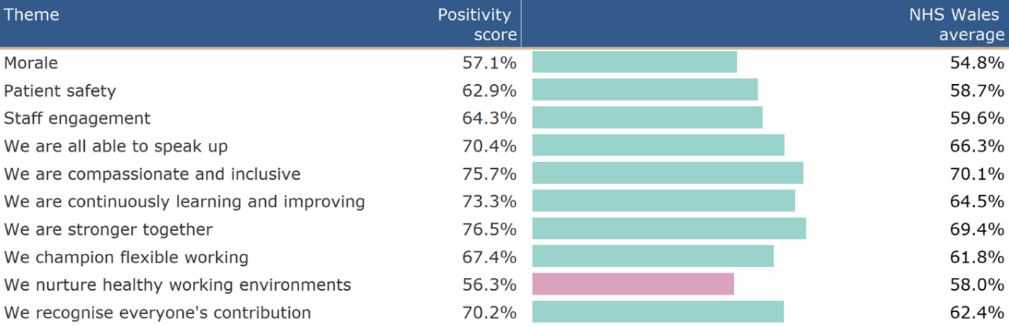
We developed short and medium term goals which are outlined below
Short-term goals
Leadership, Engagement and Accountability at SMT/Divisional/Directorate Level.
Our 3 key areas of focus include:
- Leadership & Management
Staff are accessing Brilliant Basics, being supported to access education and clinical leadership opportunities and development. Use of Rdial
- Speaking Up Safely / Raising concerns
This has been picked up in Divisional Meetings and then reported into Quality & Safety on a monthly meeting. All staff have been provided with Webinar and information regarding how to speak and raise concerns.
- Values & Behaviours
Active Equality Group in place to ensure inclusion of all staff, embedding values in all aspects of work. The service group also established a Disability Staff Network which has now been rolled out across the Health Board.
- Healthy Working Environments
Changes to the current Estate are being undertaken as part of transformation work. Sickness Audits have commenced and action plans are in place to address wellbeing of staff, use of TRIM, staff counsellor

We are continuing to promote Workforce Strategies focussing on retention.
Divisions are taking a collective and compassionate leadership approach to developing local plans.
We are embarking on transformation of services, which is involving representatives from local teams as well as managers and Trade Union Representatives to develop plans.
Each Division is focusing on a communication and engagement strategy.
We are continuing to develop a talent pathway through the “Grow your own” ethos for MH&LD.
We benchmarked results against 2023 survey to assess improvements.
Medium-term goal
To identify leadership, management (including compassionate leadership) and professional development needs and plans as part of MH&LD PADRs to inform MH&LD development plan.
Benchmarking results against 2025 survey to assess improvements and highlight areas for further improvement which will form the medium-term goals.
Implement training and education to enhance use of digital systems within MH&LD
Alignment to IMTP and 7 people aims set out in SBU People Strategy.

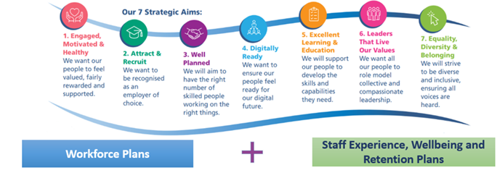

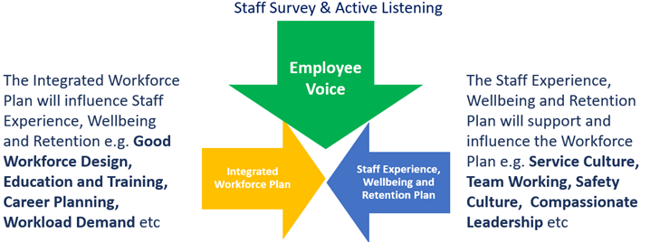

Key Actions/ Milestones leading up to 2025 staff survey
Actions/ Milestones | Lead | By When | Status
Nominate SG leads to access staff survey results via dashboard. | DN | 03/25 | Complete
Share 3 key areas of focus for the Health Board along with Divisional level staff survey results highlighting the specific themes for MH&LD | DN | 05/25 | Complete
Management teams to discuss the results and to agree how they will shape local Divisional Staff Survey Plans. | Divisional Leads | 05/25 | Complete
Utilise the “Meet the Senior Team” quarterly briefing to share overarching and Divisional results and actions planned. In addition highlight the launch of the 2025 survey | SMT | 06/25 | Complete
Divisional Staff Survey Plan to be shared during Divisional and Directorate Meetings | Divisional Leads | 06/25 | Complete
Progress update on Divisional Staff Survey Plan to be reported during SMT ahead of the launch of the 2025 Staff Survey (Oct 25). | Divisional Leads | 09/25 | Ongoing

Current Progress with the 2025 Staff Survey

The current survey closes on 1st December 2025, the current rate is 20.4%. 381 staff have already completed the survey within MH&LD. Managers are continuing to promote completion of the survey. A breakdown of compliance by directorate is outlined in the table below.

Staff Survey Response rate for MH&LD (figure correct at 21st November 2025)

 | 1864 | 381 | 20.4%
SB Adult Directorate | 418 | 52 | 12.4%
SB Associate Service Group Director | 18 | 1 | 5.6%
SB CAMHS Directorate | 96 | 57 | 59.4%
SB CDAT Directorate | 64 | 27 | 42.2%
SB Development and Commissioning | 10 | 2 | 20.0%
SB Secure - Medium Secure Directorate | 220 | 30 | 13.6%
SB Head of Nursing | 37 | 7 | 18.9%
SB Head of Psychology | 96 | 21 | 21.9%
SB LD - Cardiff Directorate | 117 | 12 | 10.3%
SB LD - Cwm Taf Directorate | 156 | 10 | 6.4%
SB LD - Learning Disabilities Management | 26 | 12 | 46.2%
SB LD - Swansea Directorate | 98 | 20 | 20.4%
SB MH LD Other CCs | 10 | 56 | 560.0%
SB MH Management | 16 | 19 | 118.8%
SB Older Peoples MH Directorate | 299 | 41 | 13.7%
SB Secure - Perinatal Directorate | 37 | 5 | 13.5%
SB Secure - Rehabilitation Directorate | 146 | 9 | 6.2%

- GOVERNANCE AND RISK ISSUES
The Workforce Metrics, Risks and Staff Survey Progress will continue to be monitored and evaluated through the Division’s Monthly Workforce Groups, Nurse Workforce, Medical Workforce, Board and SMT
Violence and Aggression Incidents in MH&LD
The information in this section has been taken from incidents recorded in the Datix system between October 2024 – September 2025.
This looks at Datix under the following categories
- Aggressive/threatening behaviour
- Inappropriate behaviour / attitude
- Patient clinically challenging behaviour
- Physical assault (physical contact)
- Sexual (inappropriate) behaviour
- Verbal assault (gender/sexual orientation)
- Verbal assault (racial abuse)
- Verbal assault (swearing etc.)
1178 incidents were reported in the period, this correlates to sickness absence levels. The graph below shows a breakdown of the incidents reported across the service group per month

The graph below shows the incidents in the wards and community teams. Non specified. Please note locations are those incidents not located to teams but to areas such as carparks or patients’ homes.

The final graph shows who was impacted by the incident

This graph shows self-harm incidents which are stressful for staff to manage shown by location and harm at managers assessment. This does not include self harm leading to suicide as these would be classed as death of a patient seen by mental health services.

Management of ER cases also impacts on sickness levels and availability of staff. Currently we have the following number of cases

Type | Number of Cases
Disciplinary | 22
Respect and Resolution | 6
Professional concerns (Safeguarding Process) | 3 not in other processes
Appeal (all policies) | 2

From a risk perspective the impact of unavailability and specifically sickness can impact on service delivery.

- FINANCIAL IMPLICATIONS

Unavailability of staff above funded levels results in variable pay usage to maintain service capacity and safeguard patient and service user care.

Nurse staffing act principles are currently being reviewed within all our inpatient areas. It is anticipated that it will identify that we are insufficiently staffed which contributes to additional variable pay.

The financial implications of changing the HCSWs to band 3 will have cost implications for recruitment to vacancies where the budget is currently set at band 2.

- RECOMMENDATION
- ACKNOWLEDGE the Service Groups Workforce Metrics, Risks and Staff Survey Progress.
- BE ASSURED of the actions being taken to ensure compliance with workforce metrics to support and improve the health and wellbeing of staff.

Governance and Assurance

Link to Enabling Objectives  (please choose) | Supporting better health and wellbeing by actively promoting and empowering people to live well in resilient communities
Link to Enabling Objectives  (please choose) | Partnerships for Improving Health and Wellbeing |  | ☐
Link to Enabling Objectives  (please choose) | Co-Production and Health Literacy |  | ☐
Link to Enabling Objectives  (please choose) | Digitally Enabled Health and Wellbeing |  | ☐
Link to Enabling Objectives  (please choose) | Deliver better care through excellent health and care services achieving the outcomes that matter most to people
Link to Enabling Objectives  (please choose) | Best Value Outcomes and High Quality Care |  | ☐
Link to Enabling Objectives  (please choose) | Partnerships for Care |  | ☐
Link to Enabling Objectives  (please choose) | Excellent Staff |  | ☒
Link to Enabling Objectives  (please choose) | Digitally Enabled Care |  | ☐
Link to Enabling Objectives  (please choose) | Outstanding Research, Innovation, Education and Learning |  | ☐
Health and Care Standards
(please choose) | Staying Healthy |  | ☐
(please choose) | Safe Care |  | ☐
(please choose) | Effective Care |  | ☐
(please choose) | Dignified Care |  | ☐
(please choose) | Timely Care |  | ☐
(please choose) | Individual Care |  | ☐
(please choose) | Staff and Resources |  | ☒
Quality, Safety and Patient Experience
Staff health and wellbeing has an impact on staff engagement and experience, and this in turn enables organisational productivity, individual performance and ultimately the quality of patient care and outcomes across the Service Group.
Financial Implications
High absence levels will result in variable pay usage in order to maintain the services capacity and safeguard patient care.
Legal Implications (including equality and diversity assessment)
Actions taken by the service will be required to comply with employment legislation.
Staffing Implications
Actions taken should contribute to improved employee availability and have a positive impact on staff health and wellbeing.
Long Term Implications (including the impact of the Well-being of Future Generations (Wales) Act 2015)
Developing and retaining a skilled workforce is a key objective of the Health Board and is a fundamental principle of the One Bay Way.
Improving population health is a key objective of the Health Board and the workforce plays a critical role in influencing the wellbeing of future generations.
Report History |  | None
Appendices |  | Appendix 1

