Meeting Date | 11 December 2025 |  | Agenda Item |  | 2.1
Name of Meeting | Workforce and OD Committee
Report Title | Minor Injury Unit, Neath Port Talbot Hospital Staff Story with Underpinning Evidence
Report Author | Kevin Randall, Lead Nurse Consultant
Report Sponsor | Deb Lewis, Chief Operating Officer and Neil Cooper, Assistant Director of Operations
Presented by | Neil Cooper, Assistant Director of Operations and Kevin Randall, Lead Nurse Consultant
Freedom of Information | Open
Purpose of the Report | This paper provides the Workforce & OD Committee with:  - A staff story illustrating positive experiences and pressures faced by the Minor Injury Unit (MIU) workforce.
Key Issues | - Escalating activity, increasing acuity, rising violence and aggression, deteriorating performance, and workforce vulnerability.  - Emergency Nurse Practitioners (ENP) receive no protected non-clinical development and education time, contrary to Health Inspectorate Wales (HIW) recommendations, the Faculty of Emergency Nursing (FEN) standards, and practice across other Welsh Health Boards.  - Workforce modelling demonstrating a significant ENP deficit, an ageing specialist nursing workforce, and the urgent need to invest in a sustainable staffing model.  - The Committee is asked to note the risks, support the requirement for protected ENP non-clinical time, and endorse the workforce actions required to ensure a safe and sustainable MIU service across Swansea Bay UHB.
Specific Action Required  (please choose one only) | Information | Discussion | Assurance | Approval
Specific Action Required  (please choose one only) | ☐ | ☐ | ☐ | ☐
Recommendations | Members are asked to:  - Receive an account of the staff experience with underpinning evidence. Note the staff story and the significant workforce pressures affecting the MIU;  - Acknowledge that ENPs currently have no protected non-clinical development time, placing SBUHB in breach of HIW 2020 & 2025 requirements;  - Endorse the introduction of rostered ENP non-clinical development time (minimum 3.75 hrs/week WTE);  - Recognise the risk to Health Board 4-hour performance and overall unscheduled care resilience if no action is taken;  - Support ongoing development of the MIU workforce plan, including cross-site ENP integration and trainee pipeline strengthening.

Minor Injury Unit, Neath Port Talbot Hospital - Staff Story with Underpinning Evidence

- INTRODUCTION

The service at the Minor Injury Unit at Neath Port Talbot Hospital is a completely nurse led service. There are 2.8 WTE consultant nurses who oversee the clinical care at the unit provided by 16.4 WTE Emergency Nurse Practitioners (ENPs). There is a matron who has managerial responsibility for the ENP, registered nurse and HCSW team.
An ENP is an experienced emergency nurse who undertakes an All-Wales level seven course (M level) in the autonomous management of minor injuries. This course awards 180 credits at level seven and takes 18 months to 2 years to complete.
ENPs can autonomously assess, investigate, diagnose and prescribe treatments for patients with minor injury presentation. They are highly skilled in the interpretation of radiological investigations and making clinical decisions. They can also refer onwards patients who require specialist input. In stand-alone units, they are also required to assess and provide initial resuscitation to critically ill or injured patients prior to emergency transfer out.

- BACKGROUND – Staff Story
An Emergency Nurse Practitioner (ENP), Hannah King describes her professional story:
- Registered Nurse since 2002
- Commenced ENP education in 2020 at Neath Port Talbot Minor Injury Unit
- Qualified 18 months later in Sept 2021.
Hannah’s Role
Role described as, specialist in the acute management of minor injuries, delivering holistic, evidence-based, and patient-centred care. She assesses, diagnoses, treats, discharges, or refers patients who present with a wide range of conditions, including:
- Fractures
- Dislocations
- Wound management
- Minor head injuries
- Also required to assess and manage acutely unwell patients who present inappropriately to the MIU, stabilising/resuscitating them while awaiting ambulance transfer to the Emergency Department (ED) or a Major Trauma Centre.
Working at the MIU
- Small and friendly nurse led service
- Highly experienced and supportive team
- Teamwork ensures efficiency, safe and effective care
- Environment- busy and challenging but deeply rewarding
- Pride in delivering a positive patient experience
- Reflected in an exceptionally positive HIW report and written and verbal feedback
- Educate more ENPs than anywhere else in Wales
- First to develop Emergency Physiotherapy Practitioners
The Best Things about working in the MIU?
- The team! – strong team dynamic is what makes working here so rewarding
- High pressured environment – supportive, level of experience and resilience is invaluable.
- Rely on each other’s strengths to navigate challenging and complex situations

What are the most challenging aspects?
- Despite being a Minor Injury Unit – we regularly see patients with major trauma and acute medical conditions presenting, sometimes creating a risk to life
- Significant issue is the public’s understanding of the role, often worsened by the Health Board’s social media, encouraging patients to avoid ED
- Reliance on digital information messaging when many may not be digitally literate.
- Being a stand-alone unit with little onsite support (especially when critically ill / injured patients attend)
- Rapidly increasing workload (patient numbers) with no expansion of the unit or staffing has placed a strain on service capacity
- Not being able to treat all the patients on the day they attend. We have to turn patients away and ask them to reattend the next day despite our best effort.
- Multiple lengthy waits resulting in verbal abuse, threats, and aggression incidents with no security on site
- She described at times feeling unsafe, overwhelmed, and professionally compromised
- She had no time for reflection, supervision, or clinical and professional development, highlighting that ENPs receive no protected non-clinical time
Her experience mirrors feedback from across the ENP workforce and correlates with service data.
- GOVERNANCE AND RISK ISSUES

  - Activity
The Minor Injury Unit at Neath Port Talbot Hospital (NPTH) is the busiest MIU in Wales and one of the busiest in the UK, now managing about 60,000 patients annually and handling 40–46% of all Swansea Bay UHB emergency care attendances. There have been weeks this year, where the unit has seen over 1350 patients arrive for care.
Activity has risen by 20% in two years (50,000 in 2023 → 60,000 in 2025)
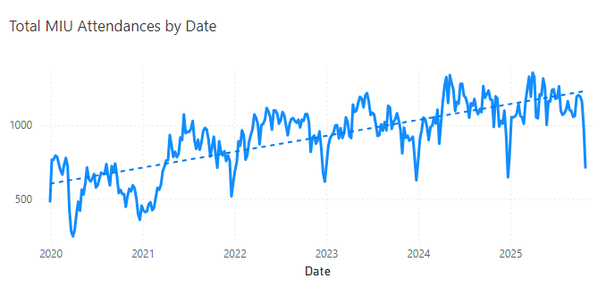
01 January 2020 to 31 October 2025 (Weekly)

On peak days, NPTH MIU manages more patients in 13 hours than some Type 2 EDs manage in 24 hours. On 23 June 2025, the unit saw 249 patients with 90% four-hour performance.
Despite historically reporting very high performance (>96%), against the Welsh Government’s Tier One Target, the MIU returned its lowest ever 4-hour performance in May 2025 (90%) and has recorded 77 days below 95% this year to date (01 Jan 25-31 Oct 25), with some days <70%.
Length of stay is increasing due to workload and acuity, shifting the patient journey curve and causing a risk of a potential exponential increase in breaches.
HIW (2025) unannounced inspection report stated “Timeliness of care was mostly good, with many patients seen within four hours, though increasing patient numbers and staffing shortages were causing delays.”
It also stated:
“The health board must review the staffing establishment to ensure the MIU always has the right number of staff available each shift and with an appropriate staff skill mix.”
  - Demand
Activity is significantly increasing with no reason to believe this trajectory will change. Cwm Taf Morgannwg patients represent ~14% of attendances; activity now exceeds the existing LTA by over 2,100 patients annually
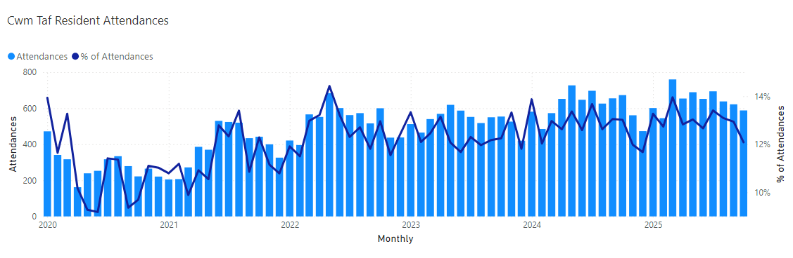
Recent dis-investment in Princess of Wales Minor stream which may increase Cwm Taf patient attendances and have further negative effect on MIU NPTH performance.
  - Rising Acuity & Complexity
There has been a significant increase in major illness/major trauma presentations requiring extended monitoring, investigations, interventions and ambulance transfers.
Many patients attend daily with conditions outside of the scope of MIU. (e.g., difficulty breathing, chest pain, general illness). Most are redirected via private transport to appropriate services.
Some patients with more major illness / major injury requiring resuscitation and emergency transfer out by road or air transfer. (Recent paper-based monitoring system, demonstrates up to 50 patients per month with up to 20 per month requiring emergency transfer).
>50% of patients require X-ray; radiology delays (evenings) are contributing to overall length of stay in MIU. Fracture clinic referrals and MSK complexity have markedly increased. Particularly the number of complex elderly fallers attending MIU. In 2024, Morriston ED referred 2295 patients to SBUHB fracture clinic, with 7485 being referred by MIU at NPTH.
  - Performance Deterioration
The unit’s four-hour performance is falling with the lowest ever recorded in May 2025.
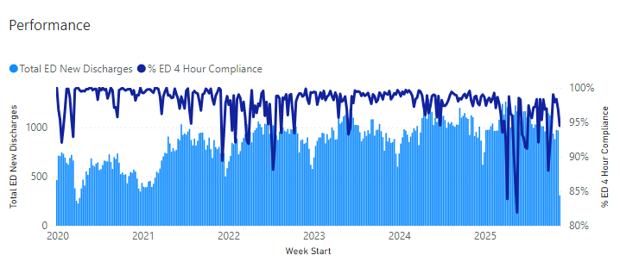
77 days this year (25% of days) the unit reported less than <95% this year; some days <70% due to workforce gaps.
The length of stay in the unit is increasing, and as the normalised curve of length of stay shifts right (increase time in unit), there is a risk of an exponential increase in four-hour breaches.
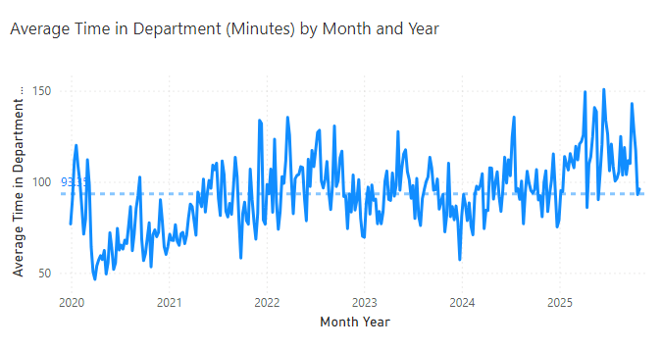
01 January 2020 and is before 01 November 2025
HIW (2025) received some comments about waiting times, which included: “My mother is 83 and has been waiting over 2 hours. Triaged quickly but the number of patients attending is too high for the size of unit”
3.5 Patient Satisfaction

As patient satisfaction is closely related to waiting times, it is unsurprising that we are seeing patients report decreasing satisfaction with the MIU service. This reduction is also reflecting feedback from those patients who present in the evening but are unable to be assessed by an ENP, and who are often advised to attend an ED or reattend the next day dependant on urgency of the presentation.

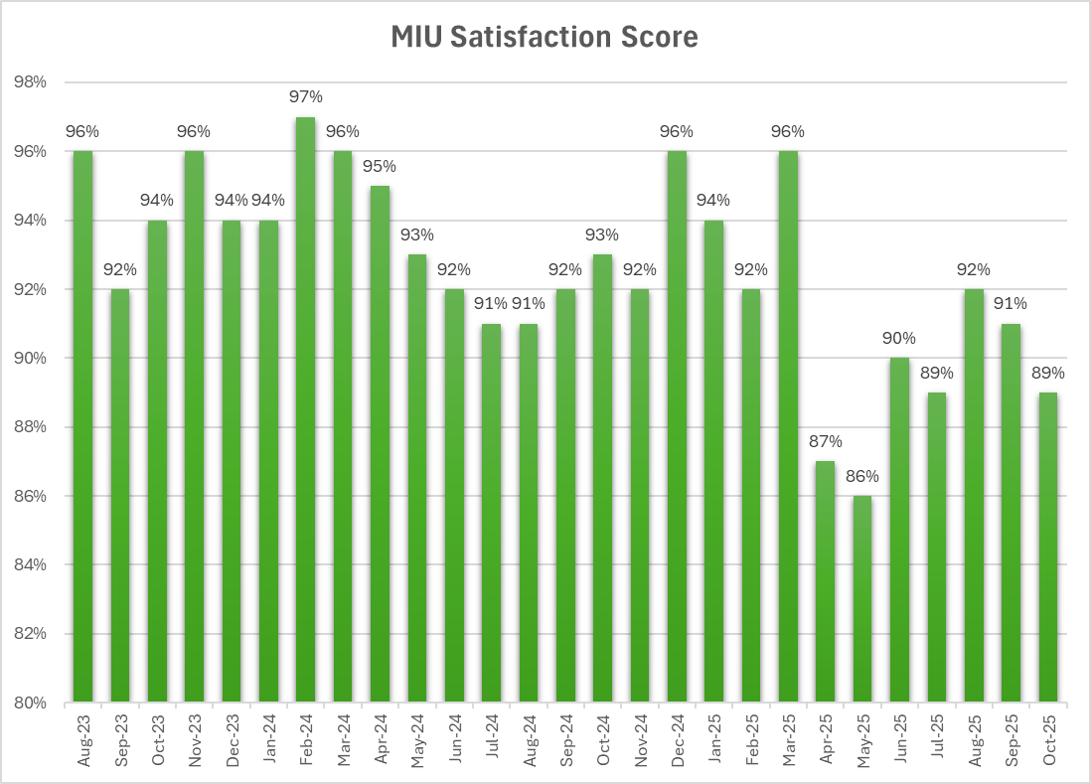
  - Violence & Aggression
There is a strong upward trend in verbal abuse, physical threats, high-risk patients and clinical situations. There is also an Increase in patients attending who are not appropriate for MIU such as drug and alcohol intoxication and intentional overdose patients.
This results in a direct impact on morale, and staff wellbeing. On occasion staff have reported being “scared”, “frightened” for their personal and team safety. This issue is compounded by not having any security staffing on site. The CCTV coverage is inadequate, and the unit cannot be locked down.
Considering the escalating frequency of aggression and lack of security measures, the senior team believes it is just a matter of time before a member of staff gets injured
Despite encouraging staff to report all violence and aggression, sadly, due to time pressures and workforce constraints, and a developing level of tolerance, we know that only the most serious incidents are reported.
Often V&A incidents are reported but are classified under other incident categories’ such when a male patient recently banged on the front door after closing time, he was let in, as he had been assaulted, attacked with a knife and stabbed allegedly by several men in balaclavas. When we contacted the police, they were already aware of the assault and sent two-armed response vehicles due to the risk of further violence. This incident was reported as an “access” incident due to the patient attending MIU with stab wounds.
There were 15 V&A incidents reported in MIU in 2024 and already 23 V&A incidents reported in year to date (first 10 months). Hospital wide there were 449 V&A incidents in this year to 31 Oct 2025.
3.7 Template & Space Constraints
The unit regularly exceeds physical capacity:
  - Crowded waiting areas with no space to sit for patients who are elderly or have suffered a low limb or back injury
  - Patients waiting outside on benches and in summer patients frequently sit on pavements waiting to be seen.
  - No physical space to expand seating
  - Limited clinical space and at peak times clinicians compete for clinical space
Template size now limits flow and creates delays, although further efficacies could be made with improved staffing. The unit was designed for 20,000 patients when open 24/7 and is now dealing with approx. 60,000 patients per annum, in 13 hours per day.
3.8 ENP staff in Post
We have seen a recent reduction in ENPs in post due to retirements. In June 2025 we achieved 17.3 WTE but today we have 16.4 WTE. Morriston ED ENP staff in post is 7.0 WTE with establishment yet to be defined.
- Total ENP establishment across the Health Board is 23.4 WTE

3.9 ENP Workforce Position – Establishment, Age Profile & Trajectory
Calculated staffing for safe and adequate staffing with non-clinical time allocated (1 session per week/ per WTE) =22.6WTE required at NPTH MIU and 8.6 WTE required for MH ED
- Total required ENPs = 31.2 WTE for both sites
  - Trajectory of ENP workforce
This demonstrates a 7.8 WTE deficit currently but in considering the trajectory of trainees who will qualify and planned retirements we should achieve 25.96 WTE by end 2027
Therefore, ENP staffing deficit across the Health Board will be 5.24 WTE
NB. This calculation does not include any unforeseen reduction in staffing from staff leaving posts or any other unexpected losses or the current contribution of trainees to the workload. It also does not include calculations for any increase in activity.
3.11 Age Profile
37% of ENPs are over 50; 25% over 55, with three already retired and returned.
A major challenge is the recruitment of qualified ENPs; almost all our ENPs are “home-grown”. In the last six years, despite multiple adverts we have only managed to recruit 0.5 WTE qualified ENP. Developing our own ENPs takes approximately two years. There is only one course a year and this commences in March / April 2026. If we do not recruit trainees now, we will be heading for a significant workforce deficit and a significant risk to performance and service sustainability.
3.12 Organisational Change Policy – SBUHB ENP workforce
We are currently undertaking pre-engagement meetings with the team around a proposal to integrate the ENP team across the Health Board.
The proposals include:
- A plan to integrate the Emergency Nurse Practitioner (ENP) workforce across Neath and Morriston hospital sites
- Development of a single roster for ENP’s enabling flexibility of resources across the Neath and Morriston Hospital sites
- Improvements to ENP education and training
- Transfer of the line management for the ENP workforce to the MIU Matron to strengthen consistent leadership and professional governance across Neath and Morriston hospital sites
- There is a plan to take this OCP to the partnership forum on the 4th December 2025

3.13 Protected Non-Clinical Development & Education Time
ENPs do not have any protected non-clinical or SPA time beyond statutory/mandatory training. This would certainly not be the case if these staff members were medical staff, despite the fact that they are performing traditional medical tasks.
HIW highlighted this issue in the report of their follow up inspection of the unit (2020). In the improvement plan the health board was asked to
“Consider:
- Sustainable ways in which ENP’s are able to access educational training
• the benefits of providing time within the working week for ENP’s to develop leadership skills and develop professionally.”

Due to the massive increase in attendance seen at the MIU, this was commenced for a short period, but was not sustained.

In their recent report of their unannounced inspection, HIW (2025) again highlighted this action in their published report. It stated:

“The health board must allocate dedicated time for clinical development beyond mandatory training, to ensure staff can enhance their professional skills despite the unit's high clinical demands.”
Other health boards across South Wales, all provide their ENP team with a 90/10 split roster, with one session of non-clinical time per week (3.75hrs) for full time staff.
The NHS Workforce Plans for all four nations (NHS England 2023; Department of Health Northern Ireland 2016; NES 2022; Welsh Government 2023) clearly identify the importance of having a workforce fit for purpose, with the Welsh Government recognising that “we cannot simply recruit our way out of the situation.” These workforce plans articulate the requirement for staff to have sufficient high-quality training and development, “properly planned and sustainably provided”. 'Sufficient education’ could be delivered through traditional university courses, vocational qualifications or workplace learning. All of which should be equitably provided to individual nurses to increase career prospects, job satisfaction and retention of our workforce.
In a paper recently presented to the UK CNO’s By Faculty of Emergency Nursing and Supported by experts in Emergency Nursing and Emergency Medicine (2025), it is stated that:
“Autonomous Practitioners i.e. ENPs, ANPs and EC-ACPs should have 7.5 hours a week or an annualised equivalent amount of SPA time 47 (pro rata) whether in a training or substantive position.”
The requirement is equivalent to medical SPA time and is essential for safe practice in autonomous advanced roles.
3.14 Impact of No Protected Time
- ENPs are unable to maintain advanced trauma, paediatric, resuscitation and MSK competencies
- Governance tasks (audit, supervision, leadership development) are not being completed
- Burnout, attrition, and recruitment difficulties are increasing
- Workforce sustainability is at risk
3.15 Requirement
To meet a 90/10 clinical-to-education split (3.75 hours per week per ENP), an additional 2.35 WTE Band 7 ENPs are required for the current workforce across the Health Board. Non clinical time is built in to the calculation in section 3.9 & 3.10 above.

- FINANCIAL IMPLICATIONS

HIW (2025) in their report of the unannounced inspection advised a staffing and skill mix review, which the service is currently undertaking.

In the short term the service requires urgent funding 4.0 WTE Band 7 (annex 21) Trainee Emergency Nurse Practitioner posts to commence on the March / April intake. This will ensure a sustainable service and prevent a continued downward trajectory in patient experience, performance and risk to service.

- RECOMMENDATION
The Workforce & OD Committee is asked to:
- Receive the staff story and the significant workforce pressures affecting the MIU
- Acknowledge that ENPs currently have no protected non-clinical development time, placing SBUHB in breach of HIW 2020 & 2025 requirements
- Endorse the introduction of rostered ENP non-clinical development time (minimum 3.75 hrs/week WTE)
- Recognise the risk to Health Board 4-hour performance and overall unscheduled care resilience if no action is taken
- Support ongoing development of the MIU workforce plan, including cross-site ENP integration and trainee pipeline strengthening

References
Faculty of Emergency Nursing (FEN) (2025) Emergency Nurse Education and Study Time Standards: Key Recommendations for a Competent, Capable and Sustainable Workforce, available at Emergency-Nurse-Education-and-Study-Time-Standards-Key-Recommendations-for-a-Competent-Capable-and-Sustainable-Workforce.pdf. Accessed 21 October 2025).
NHS England. 2023. NHS Long Term Workforce Plan. https://www.england.nhs.uk/wp-content/uploads/2023/06/nhs-long-term-workforce-plan-v1.21.pdf [accessed 23/07/2025].
Department of Health Northern Ireland. 2016. Health and Social Care Workforce Strategy 2026. [accessed 23/07/2024]
Health Inspectorate Wales (2020) Follow-up Inspection (Announced) Minor Injuries Unit Neath Port Talbot Inspection date: 17 November 2020 Publication date: 02 March 2021
Health Inspectorate Wales (2025) Hospital Inspection Report (Unannounced) Minor Injury Unit (MIU), Neath Port Talbot Hospital, Swansea University Health Board Inspection date: 20 and 21 May 2025 Publication date: 28 August 2025
NES. 2022. Strategic Workforce Plan 2022 – 2025. https://www.nes.scot.nhs.uk/media/ctsfrt55/nes-strategic-workforce-plan-22-25-oct-22.pdf NES. 2022.
Strategic Workforce Plan 2022 – 2025. NHS Education for Scotland. https://www.nes.scot.nhs.uk/media/ctsfrt55/nes-strategic-workforce-plan-22-25-oct22.pdf
Welsh Government. 2023. National Workforce Implementation Plan: Addressing NHS Wales Workforce Challenges https://www.gov.wales/sites/default/files/publications/2023-01/national-workforce-implementation-plan.pdf [accessed 23/07/2024]
Welsh Government. https://www.gov.wales/sites/default/files/publications/2023-01/national-workforce-implementation-plan.pdf [accessed 23/07/2025]

Governance and Assurance

Link to Enabling Objectives  (please choose) | Supporting better health and wellbeing by actively promoting and empowering people to live well in resilient communities
Link to Enabling Objectives  (please choose) | Partnerships for Improving Health and Wellbeing |  | ☒
Link to Enabling Objectives  (please choose) | Co-Production and Health Literacy |  | ☐
Link to Enabling Objectives  (please choose) | Digitally Enabled Health and Wellbeing |  | ☒
Link to Enabling Objectives  (please choose) | Deliver better care through excellent health and care services achieving the outcomes that matter most to people
Link to Enabling Objectives  (please choose) | Best Value Outcomes and High-Quality Care |  | ☒
Link to Enabling Objectives  (please choose) | Partnerships for Care |  | ☐
Link to Enabling Objectives  (please choose) | Excellent Staff |  | ☒
Link to Enabling Objectives  (please choose) | Digitally Enabled Care |  | ☐
Link to Enabling Objectives  (please choose) | Outstanding Research, Innovation, Education and Learning |  | ☒
Health and Care Standards
(Please choose) | Staying Healthy |  | ☒
(Please choose) | Safe Care |  | ☒
(Please choose) | Effective Care |  | ☒
(Please choose) | Dignified Care |  | ☒
(Please choose) | Timely Care |  | ☒
(Please choose) | Individual Care |  | ☒
(Please choose) | Staff and Resources |  | ☒
Quality, Safety and Patient Experience
To improve the delivery of timely, safe patient care and the UEC care standards will improving patient experience.
Financial Implications
The mitigation of any incurred costs will be requested by either existing funding or by business case development
Legal Implications (including equality and diversity assessment)
There are no direct legal implications arising from the recommendations in this report.
Staffing Implications
There are no direct staffing implications arising from the recommendations in this report outside of the current ENP team OCP.
Long Term Implications (including the impact of the Well-being of Future Generations (Wales) Act 2015)
Report History |  | N/A
Appendices |  | N/A

