10. Workforce Updates and Actions
This section of the report provides further detail on key workforce measures. Caveats and Limitations (C&L) detailed beneath data in each section.
Staff sickness rates - Percentage of sickness absence rate of staff (two metrics provided, ‘rolling 12 month’ and ‘in month’)  Sickness absence target – 5.5% | % of full time equivalent (FTE) days lost to sickness absence  Caveat & Limitations;- Report generated November 2024, within SBUHB (Performance Team) for substantive and FTC employee types. Data source – ESR. Target of 5.5% added as blue line
Current Performance
Health Board total for in month sickness absence for October 2024 has increased from the last reporting period to 7.05% (compared to 6.67% in August 24). The number of absences relating to Cold, Cough, Flu have significantly increased across all areas since the last period as detailed below.
- Anxiety/stress related absence remained the highest reason for long term and short-term absence (33% of all absences), this is consistent across NHS Wales and is a long-term pattern. In October, 12% of all absences relate to Cold, Cough, Flu which is the second highest reason for long term and short-term absence. This is compared to the last reporting period in August where Cold, Cough, Flu was the 7th highest reason for absence, 5% of all absences. This trend is likely to continue during the winter months.
- Absence levels across SG’s remain fairly stable with some areas seeing a slight increase which have accumulated into the overall elevation of 0.38% seen above.
- Mental Health & Learning Disabilities(MH&LD) service group currently carries the highest sickness at 7.57% and PCT being the lowest with 6.51%, both show Anxiety, Stress and Depression (ASD) being the highest reason. A recent questionnaire commissioned within MH&LD indicates underlying reasons mostly relate to long term diagnosis of MH condition, followed by bereavement and carer’s responsibilities. There is also a correlation with short term ASD absence relating to ward incidents including violence and aggression.
- Mental Health absence reasons are typically in the top three absence reasons (usually highest). This is long term pattern and consistent not just within the HB or across NHS Wales but also across other professions and industries. SBUHB Wellbeing support is well utilised, with specific activity covered in more detail below.

Actions for Next Period
General
Current focus on areas with high absences rates, examples of initiatives to support our employees:
- Piloting Tailored Adjustments training for managers to increase experience of using these to flexibly support staff to remain in work/return to work
- Wellbeing resource pack – physical and electronic copies available – includes new starter feedback questionnaires
- Case conference training for leaders in partnership with Staff Health and Wellbeing.
- The Human Resources Business Partners (HRBP’s) leading on the initiatives listed above are working together to share best practice with the intention to deploy initiatives across the Health Board.
- Managing Attendance at Work stand-alone training module has been developed along with ‘how to’ guides which will be available centrally. Training attendance is now recorded on the Electronic Staff Record (ESR) System.

Occupational Health and Staff Health and Wellbeing
The services continue to develop high quality multi-disciplinary interventions to contribute to an engaged, motivated and healthy workforce.
- The Faculty of Occupational Medicine has signed off the Occupational Health (OH) Consultant job description – plan to commence recruitment once the Job Description is translated into Welsh – Dec/Jan 25
- The ‘Healthy People Forum’ terms of reference have been compiled and the first meeting is planned for 26/11/24. This will enable strategic overview of attendance at work and sickness absence; sharing data and best practice; membership to include staff side, senior clinicians and managers.
- Occupational Health Nurses continue supporting the staff flu campaign with support from Comms and Immunisation team; senior flu leads identified in Service Groups to coordinate local vaccinations with additional Comms to promote uptake.
- Occupational Health service undertaking the UK gold standard quality kite-mark initial assessment (SEQOHS) during Nov/Dec 24 and consistently meeting waiting/service delivery Key Performance Indicators.

Mandatory & Statutory Training-  Percentage compliance for all completed Level 1 competencies within the Core Skills and Training Framework by organisation  Mandatory & Statutory Training target – 85% | % of compliance (Headcount) with Core Skills and Training Framework  C&L;- Report generated November 2024, within SBUHB (Performance Team) for substantive and FTC employees. Data source – ESR (OLM Module). Accuracy levels subject to local maintenance and validation standards. Target of 85% added as blue line
Current Performance
- Health Board Statutory and Mandatory Training compliance rates as of 31st October 2024 are:
  - 89.02% - 10 CSTF (Core Skills Training Framework) competencies as reported to Welsh Government with the target being 85%.
  - 88.96% - *15 core competencies (including 10 CSTF, 1 Lang and 1 Mand Competence reportable to WG and an additional 3 competencies SBUHB specific) this has maintained since August 2024
- Medical & Dental Staff Group remain the lowest performing area with 64.34% compliance showing a 4% increase since August 2024.
- Compliance figures (*15 core competencies) per Service Group - MH&LD 90.85%, PCCT 92.64%, Morriston 85.47%, Finance & Estates 87.01%, NPTS 91.41% each of these areas have marginally improved with PCCT

Actions for Next Period
- Subscription to Learning Certification and Enrolment onto Statutory/Mandatory Courses (E-Learning) – User issues identified are being supported on a case-by-case basis via Action Point and from direct contact. This has been the case over a number of months and continues to be the case going forward.
- Medical and Dental Staff Group – A support session has been arranged in conjunction with the Executive Medical Directors Department to assist Dr’s with e-learning access issues for 3rd December 2024
- NPTS - The focus on improving Mandatory Training compliance within the Medical Staff group is ongoing, Compliance for this staff group is maintained at 69% over the past 2 months.
- Morriston – work is taking place with divisions to increase compliance and focus on areas with lower levels of compliance.
MH&LD - Clinical Directors & Directorate Managers to work together to focus on improvement of mandatory training for Medical staff which has increased in month to 77.22% based on the compliance information that has been circulated
Vacancies  Medical and Nursing and Midwifery | Vacancies (FTE) Sep 24 to Oct 24  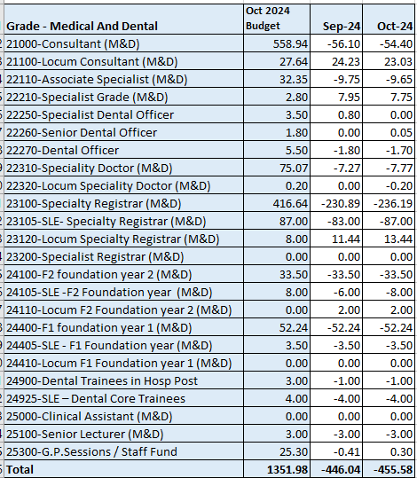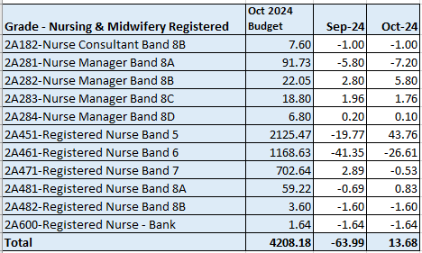  C&L;- Report generated November 2024, within SBUHB (ESR Team), using currently available methodology. Data source – ESR (Workforce) and General Ledger (Finance). We compare the SIP v’s the finance ledger, appreciating limitations on accuracy in some areas. Accuracy levels are subject to local validation practices based on budget holders intelligence.
Current Performance
- Whilst M&D vacancies appear to have increased, underlying data confirms that this is due to a further budget increase over the period. In reality, M&D resource has increased again since August by a further 20.6 WTE. Work continues to move towards a clear line of sight for the medical staff employed via the single lead employer model hosted by NWSSP. These are Health Board doctors that do not appear on our Electronic Staff Record (ESR) system, therefore, these appear as a vacancy.
- The registered nursing establishment data indicates that we have over-recruited in September 2024 by 13.68 FTE against our budgeted registered nursing establishment of 4,208.18 FTE.
- For Band 5 nurses in particular, we are over-recruited by 43.76FTE as of 31/10/24. This is due to a recent cohort of newly qualified nurses starting in Band 5 roles, whereby 98 have started in post between 01/09/24 and 31/10/24. A further 21 are currently undertaking pre-employment checks and are at various stages (e.g., as of 19/11/24, 11 are waiting for their registration, 2 are due to complete their checks shortly, 10 are ready for start dates and 9 have start dates booked). A second cohort of up to 53 newly qualified nurses are also due to commence in March 2025.
- Variable pay usage remains high across SBUHB. October records approx. 820 WTE variable pay utilised. Absence for the same period totals almost 2,200 WTE, including annual leave and ‘other’ categories. Whilst headroom is built in to some areas to offset this need, narrative indicates that acuity is elevated in many places and additional beds have been opened to respond to surge. These factors are not included within allocated budget.
- In addition, our corporate nursing team continue to support service groups to ensure a steady flow of incoming recruits through overseas recruitment, with 24 nursing FTEs for mental health services due to be added onto ESR between 01/11/24 and 31/03/25. For 2025/26, up to 23 international nurses could also be offered posts (10 for theatres, 6 for medicine/ cancer services and 5 for learning disabilities)
- Our Central Resourcing Team have continued to support service groups with any other Band 5 recruitment needs. For example, they are currently supporting with the domestic recruitment of 3.44 FTE nurses for the NPTS service group, 5 FTE for the MHLD service group and Morriston SG are due to advertise for 10 FTE Emergency Department Nurses in the near future.
- The rich supply of Band 5 nurses from all three recruitment sources should ensure that no band 5 nursing gaps arise over the next 12 months due to turnover and/or internal movements into higher banded roles
Actions for Next Period
- International nurse recruitment, student streamlining and domestic recruitment will continue as per the above
- The CRT are developing a checklist of actions for recruiting managers to consider when recruiting to hard to fill roles
- The CRT will be reviewing their service offer to all service groups to ensure they are providing a high-quality service

Recruitment  Metrics provided by NWSSP. Comparison with all-Wales benchmarking  Target 44 days | Vacancy Creation to Conditional Offer October 2024 (working days) T13  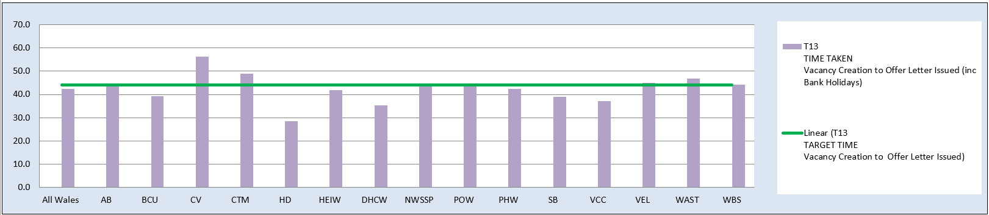  C&L;- Report generated November 2024, by NWSSP (Recruitment). Data source – TRAC system. Outliers are excluded. This is day to day vacancy management. Data excludes outliers.
Current Performance
- Swansea Bay UHB’s time to hire performance remains within the 44 day All Wales T13 target. SBUHB’s 12m average is 38.9 days, a reduction from August, which was 42.3 days. The in-month average for October is 39 days, a slight reduction compared to August at 39.8 days. We remain within the national target and the NHS Wales performance of 41.9 days (12m) and 42.3 days (in-month)
- SBUHB’s time to hire performance also continues to be significantly below the 27 day All Wales T23 metric (target 27 days) which is the measure from point of issuing an offer letter to agreeing a start date. SBUHB’s 12-month average is 16.3 days and the in-month average for October 24 is 18.6 days, a reduction from September at 18.9 days. NHS Wales performance sits at 14.4 days (12m average)
- The Central Resourcing Team (CRT) have continued to coach candidates through the pre-employment check process for Band 5 nursing roles and Band 2 Health Care Support Worker roles and also been supporting with other stages of the recruitment process for some areas (e.g., shortlisting for mental health nursing and HCSW roles) to continue to assist in reducing the T13 time to hire target, mentioned above

Actions for Next Period
- NWSSP have provided training sessions with SBU recruiting managers tackling time to hire and will continue to do so over the coming months. They are also delivering a recruitment module as part of SBU’s management development programme
- The CRT will continue focussing on the recruitment of B5 nurses, B2 ward based HCSWs, assisting with overseas nurse recruitment and newly qualified nurses, as well as specific identified hard to recruit to posts and Exec recruitment.
- In collaboration with NWSSP, CRT will continue to chase outstanding management actions on vacancies and pre-employment checks with applicants, to further reduce the overall HB time to hire. This will include the new Welsh language translation requirement as of 01/11/24 to comply with legislation. This is likely to have an impact on time to hire compliance for the next period but will be monitored closely. Communications and Q&A sessions have been in place over the last couple of months to notify managers of this new requirement.
- In addition, it is worth noting that the new process for approving admin and clerical posts via a scrutiny panel is having a significant impact on time to hire for these posts, which would usually skew our T13 performance. This is because there is a requirement for these vacancies to be added to Trac before they can be considered by the new exceptions/scrutiny panel. NWSSP agreed to exclude these from SBU’s time to hire reports as outliers for the initially agreed 3-month period but they have highlighted that they may not be able to continue this indefinitely due to the time it takes to manually amend the reports.
Turnover  % turnover by occupational group | Period Turnover Rate (Swansea Bay) – 01 Nov 2023 – 30 Oct 2024  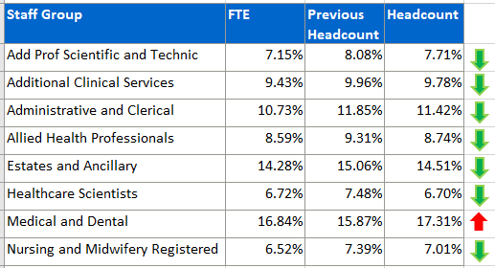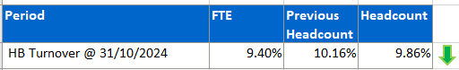  C&L;- Report generated November 2024, within SBUHB (ESR Team). Data source – ESR (Workforce). Small risk of margin of error due to late communication of terminations. Report excludes Bank, Locum, Honorary & Widow/Widower, Junior M&D staff. Internal movement not included – measure is about leaving Swansea Bay UHB.
Current Performance
- Organisationally, our turnover has decreased marginally in this reporting period (Headcount from 9.88% to 9.86%, FTE from 9.42% to 9.40%).
- It is important to recognise that this data reflects a 12-month rolling period of turnover.
- Estates and Facilities continues to show high turnover but has seen a significant improvement, with a decrease of 0.37% (Headcount) and 0.45% (FTE).
- Medical and Dental remains the highest turnover area, with increases of 0.15% (Headcount) and 0.21% (FTE). Seasonal fluctuations and expected SLE turnover spikes contribute to these elevated levels.
- Administrative and Clerical is the second-highest turnover area, with increases of 0.20% (Headcount) and 0.15% (FTE).
- Other areas are generally stable, with marginal decreases observed in: Nursing and Midwifery (Headcount decrease of 0.05%, FTE stable). AHP (Headcount decrease of 0.04%, FTE decrease of 0.05%). Healthcare Scientists (Headcount decrease of 0.06%).
- Positive trends include a reduction in turnover for Add Prof Scientific (Headcount down 0.04%, FTE down 0.23%) and Additional Clinical Services (FTE down 0.04%).

Actions for Next Period
- Retention lead has now drafted the plan and will be taking it to the appropriate forums for ratification
- Retention lead is now leading on the flexible working group with a provisional ESR flexible work request system launch date for January. The flexible working group is being split into sub groups to deliver communications, training and reviewing declined flexible working requests.
- Retention lead continues to engage with workforce business partners around retention plans within their areas and how we can share best practice
- Retention lead has began scoping work around exit questionnaires and feeding in on an all wales level.
- Retention lead is also focusing on supporting a plan for ED.

PADR  % staff who have a current PADR review recorded  PADR target – 85% | % of staff (Headcount) who have had a PADR in previous 12 months  C&L;- Report generated November 2024, within SBUHB (Performance Team). Data source – ESR (OLM Module). Accuracy levels subject to local maintenance and validation standards. Target of 85% added as blue line.
Current Performance
- Staff who have had a Personal Appraisal and Development Review (PADR) as of 31st October 2024 is 72.72%, this is a 2.06% increase in completion rates over the past 6 months.
- In the past two months 22 staff have attended 130 PADR - Personal Appraisal Review for Managers there have been no session for 130 MP PADR via Managers Pathway in this period. The Education Team signpost colleagues to SBU ESR - ESR User Guides SharePoint Page for resources on how enter PADR Dates in ESR.
- Compliance figures per Service Group (excluding Medical and Dental Staff) – MH&LD 73.99%, NPTS 77.22%, PCCT 81.48%, Morriston 70.65%, Finance and Estates 61.59%
Actions Planned for Next Period
- Supporting activity outlined in previous reports continues, Service Groups continue to focus on highlighting areas for focus.
- NPTS – Improvement plans will be in place for Divisions below the target of 85%. PADR’s will be used as an enabler to support Quality and Safety Stratergy
- Morriston – continue with conducting PADR audits and providing streamlined supportive documentation to help manages and staff have value added PADR discussions
- Plans to be put in place to identify dedicated time to meet with all staff for objectives and development and to prioritise the 486 staff that have not received a PADR and ensure ESR records are updated.

Operational Casework  Number of current operational cases. | C&L;- Report generated November 2024, within SBUHB (Workforce Digital). Data source – ER Tracker. Accuracy levels subject to local maintenance and validation standards.
Current Performance
- No. of open Formal Disciplinaries since the last reporting period have increased from 40 to 55 open cases
- Number of Formal requests for Resolution has reduced from 19 to 15
- Suspensions, since the last reporting period have decreased from 13 to 10, some of the cases have been resolved
- ET’s have decreased from 5 to 3
Actions for Next Period
- A number of actions are on-going in line with the Best Practice Review
- The Best Practice Review project has been refreshed with the introduction of multidisciplinary subgroups focusing on priority areas of work, reporting into the Core Working Group.
- 3 workshops have taken place in partnership with our Trade Unions facilitated by HEIW and SBUHB covering the following: Employee Investigations – Avoiding Employee Harm.
- We have successfully launched the Management Review document, to replace the initial assessment, which allows us to determine the most appropriate course of action at an early stage with the intention to resolve cases informally where possible – education and training ongoing with HR and leaders, this is being embedded and continually reviewed
- Suspension Guidance for leaders and employees has been shared for comment with the aim of supporting both groups and clarifying the process

