

HEALTH BOARD RISK REGISTER
October 2023 (V2)
WORKFORCE OD & DIGITAL COMMITTEE



Datix ID Number: 843  Health & Care Standard: Staff & Resources 7.1 Workforce |  |  | HBR Ref Number: 3  Risk Target Date: 31st March 2024 | Current Risk Rating  4 x 5 = 20
Objective: Delivering an Excellent Staff Experience |  | BAF Ref: 2 | Director Lead: Debbie Eyitayo, Director of Workforce and OD  Assuring Committee: Workforce and OD Committee
Risk: Workforce recruitment of medical & dental staff |  |  | Date last reviewed: October 2023
Risk Rating  (consequence x likelihood):  Initial: 5 x 4 = 20  Current: 4 x 5 =20  Target: 4 x 3 = 12 | 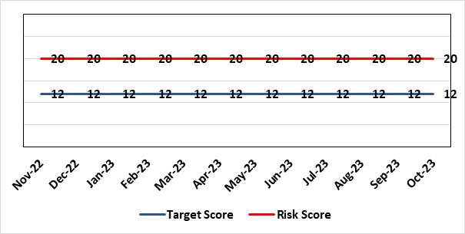 |  | Rationale for current score:  National shortages of numbers in some areas can lead to:  - Inability to recruit sufficient numbers of trainees to fulfil rotas on all sites  - Inability to attract non training grades to complete rotas  - Inability to fill Consultant grade posts in some specialties with adverse effects on patient safety and employer relations. Inability to recruit sufficient registered nursing staff.
Level of Control  = 70% |  |  | Rationale for target score:  This remains a challenge and is also a national problem.
Date added to the HB risk register
April 2012
Controls (What are we currently doing about the risk?) |  |  | Mitigating actions (What more should we do?)
- Regular monitoring of recruitment position with reports to Executive Team and Board via Medical Director and Medical Workforce Board.  - Specialty based local workforce boards established to monitor and control specific issues. The HB Workforce OD & Digital Committee will seek assurance of medical workforce plans to maintain services.  - Engagement of the Deanery about recruitment position.  - Weekly workforce delivery meetings with CEO to review progress against critical medical and clinical posts  - Working with specialist agency and head hunters to improve chances to fill hard to recruit posts  - Working with a marketing agency to develop a branding and attraction campaign for the health board. |  |  | Action |  | Lead | Deadline
 |  |  | Medical training initiatives pursued in a number of specialties to ease junior doctor recruitment |  | Director W&OD | 31/03/2024
 |  |  | The Medical Workforce Board continues to monitor recruitment and junior doctor’s rotas. |  | Director W&OD | 31/03/2024
 |  |  | Continue to recruit internationally. |  | Director W&OD | 31/03/2024
 |  |  | Continue to work with head hunters |  | Director W&OD | 31/03/2024
Assurances (How do we know if the things we are doing are having an impact?)  - General situation monitored through W&OD Committee  - Communication with Deanery  - Recruitment campaigns  - Monitoring by Executive Teams and specialty based local workforce boards  - Workforce planning and deployment taskforce meetings with service groups  - Weekly workforce delivery meetings with CEO as above |  |  | Gaps in assurance (What additional assurances should we seek?)  Locum cover  Adequate supply of doctors who can work in this country  Ability to flexibly deploy doctors in training.  Dedicated work between workforce and finance to review and confirm budgeted medical workforce establishment by service group to confirm SIP and vacancy factor.
Additional Comments / Progress Notes
21.04.2023 - The costs associated with overseas recruitment have become more visible in the last financial year once central reserves were not able to keep pace with the changes to how the HB recruits due to UK market forces. The introduction of the single lead employer has further complicated this element. It will be critical that this is appropriately funded for the next financial year or this will lead to a slowing or cessation of recruitment when the budget becomes overspent.
20.06.2023 - This is still being looked at as so far no additional funds have been allocated to the recruitment of medical staff.
14.08.2023 – There are no further updates at this time.
11.09.2023 – An allocation of £350K has been made available to supplement funds from Month 4 onwards. This is unlikely to be sufficient but there are non-recurring underspends in the WOD budget which will mitigate any likely overspends in this area for the remainder of this financial year. The stability of this funding however needs to be resolved for the next financial year.

Datix ID Number: 1035  Health & Care Standard: Effective Care 3.1 Clinically Effective Care |  |  | HBR Ref Number: 27  Risk Target Date: 29th December 2023 |  | Current Risk Rating  4 x 4 = 16
Objective: Adopting and Developing Innovative Digital Solutions to Support Care Delivery |  | BAF Ref: 5 | Director Lead: Matt John, Director of Digital  Assuring Committee: Workforce OD & Digital Committee
Risk: Digital Transformation Inability to deliver sustainable clinical services due to lack of Digital Transformation. There are insufficient resources to:  - invest in the delivery of the ABMU Digital strategy,  - support the growth in utilisation of existing and new digital solutions  - replace existing technology infrastructure and the end of its useful life. |  |  | Date last reviewed: October 2023
Risk Rating  (consequence x likelihood):  Initial: 4 x 4 = 16  Current: 4 x 4 = 16  Target: 5 x 2 = 10 | 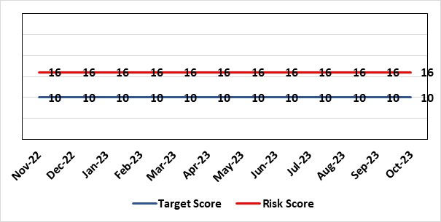 |  | Rationale for current score:  C – Reliance on digital ways of working has increased. Loss of IT service has a greater impact on ability to provide clinical care. Lack of investment in new digital solutions to make services more effective will mean clinical service provision will become unsustainable.  L- Reduction in capital funding in 22/23 has increased the likelihood of HB not being able to replace aging infrastructure such as the network equipment. There is a £15m capital requirement over the next 3 years. Acceleration of the CTM SLA disaggregation has been proposed and there are further pressures on revenue funding.
Rationale for target score:
C – Of failure will increase as the reliance and proliferation of the use of digital solutions increases.
L – Investment will mean the support mechanisms, rate of failure and ability to deliver solutions that meet the needs of users will improve sustainable digital services. There will however always be an inherent risk of failure of IT solutions.
Level of Control
= 50%
Date added to the HB risk register
2012
Controls (What are we currently doing about the risk?) |  |  | Mitigating actions (What more should we do?)
- Digital Strategy has been approved by the Health Board and outlines requirements  - HB Capital priority group considers digital risks for replacement technology which is fed into the annual discretionary capital plan  - Digital Services prioritisation process is in place Digital Leadership Group provides the overarching governance to the delivery of the Digital Strategic Plan including financial considerations.  - Digital Services revenue requirements are included in 21/22 annual plan |  |  | Action | Lead |  | Deadline
 |  |  | Continue to develop the 10yr investment plan that has been submitted to WG, which will inform the Health Board IMTP submission. | Assistant Director of Digital: Business Management and Information Governance |  | 29/12/2023
Assurances (How do we know if the things we are doing are having an impact?)  - Progress has been made in securing capital investment both internally and externally.  - The Digital Services plan is being delivered.  - Financial plan for 21/22 agreed and aligned to Digital Plan |  |  | Gaps in assurance (What additional assurances should we seek?)  - Lack of certainty over future capital and revenue funding streams makes planning and implementation difficult/less effective.
Additional Comments / Progress Notes
14/06/2023 – Action completed - To continue discussions with Finance on the identified requirement, both in-year for 2022/2023 and recurrent full year effect.
15/08/2023 – Action 3 - The assessment of the additional devices has been completed. The additional support requirements as part of this assessment highlights the need for four additional on-site engineers and two service desk staff.
28/09/2023 – SM Head of Service Delivery has raised an SBAR. It was agreed within the group to review the score after the end of the financial year. Action completed - Assess the impact of COVID on the resources required to support the increase in devices and software and the change in complexity of the support model required.

Datix ID Number: 1043  Health & Care Standard: Effective Care 3.1 Clinically Effective Care |  |  | HBR Ref Number: 36  Risk Target Date: 31st March 2024 |  | Current Risk Rating  4 x 4 = 16
Objective: Adopting and Developing Innovative Digital Solutions to Support Care Delivery |  | BAF Ref: 5 | Director Lead: Matt John, Director of Digital  Assuring Committee: Workforce OD & Digital Committee  For information: Quality & Safety Committee
Risk: Paper Record Storage: Lack of a single electronic record means there is greater reliance on the provision of the paper record. If we fail to provide adequate storage facilities for paper records, then this will impact on the availability of patient records at the point of care. Quality of the paper record may also be reduced if there is poor records management in some wards. There is an increased fire risk where medical records are stored outside of the medical record libraries. |  |  | Date last reviewed: October 2023
Risk Rating  (consequence x likelihood):  Initial: 4 x 5 = 20  Current: 4 x 4 = 16  Target: 3 x 3 =9 | 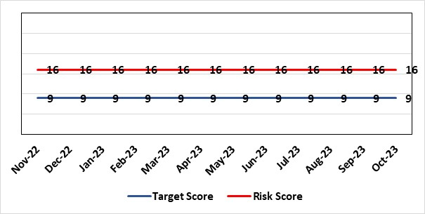 |  | Rationale for current score:  C - Inability to find records for patients could delay care/increase length of stay over 15 days. Could also mean patients receive incorrect treatment. Increased risk of fire where records are stored outside of the medical record libraries.  L - we know this happens from incidents raised
Level of Control  = 70% |  |  | Rationale for target score:  C - The increased development and adoption of the digital record will reduce the need for the paper health record being available at the point of care.  L - The increased development and adoption of the digital record, the introduction of RFID and the approach to management of the paper record identified in the Business case process should reduce the amount of paper required to be stored and managed.
Date added to the HB risk register
June 2016
Controls (What are we currently doing about the risk?) |  |  | Mitigating actions (What more should we do?)
- There is a plan in place to increase the functionality of the electronic record to document patient care. The delivery of the plan is overseen by the Digital Leadership Group and progress provided to Management Board. (Supported by individual project boards as appropriate).  - Records managed by the Medical Records libraries are RFID tagged and location tracked.  - Medical Record libraries are regularly risk assessed for fire by health and safety.  - Alternative offsite storage arrangements have been identified.  - All records must be documented on the Information Asset Register (IAR). |  |  | Action | Lead |  | Deadline
 |  |  | Amended: Re-develop a joint outline Business Case for centralisation of the health records and the scanning model. | Head of Health Records & Clinical Coding |  | 30/11/2023
 |  |  | Welsh Government sign off for long term conditions retention of records | Head of Health Records & Clinical Coding |  | 30/11/2023
Assurances (How do we know if the things we are doing are having an impact?)  - RFID has been implemented for the acute record improving the management and storage of records  - Health Records performance reports developed in line with RFID technology  - Attainment of the Tier 1 Health Board target for clinical coding completeness which relies on the timely availability and quality of the Paper record and electronic sources  - Monitoring complaints and incident reporting.  - Electronic record is being implemented in accordance with the plan eg implementation of WNCR, ETR, HEPMA etc. |  |  | Gaps in assurance (What additional assurances should we seek?)  Investment required supporting the delivery and operational costs of the Digital strategy.  Reliance on DHCW for delivery of the solution for a fully electronic patient record.  Impact of the Infected Blood Enquiry on the Health Boards ability to destroy notes.  Process for ensuring clinical adoption of electronic ways of working and cessation of adding information to the paper record that is already available electronically needs to be agreed and enforced by the Health Board.  Impact of the infected Blood Inquiry on the health boards ability to destroy notes and the change in the records code of practice is being reviewed by the Director of Digital.
Additional Notes
14/06/2023 – A potential suitable unit has been discovered with building work requirements currently being scoped for architects in order to acquire costings for a business case to be submitted to BCAG. Two actions completed - Assessment of the impact of the Records Management code of practice. Develop a revised destruction plan. Destruction of initial 100 boxes commences Monday 12/06/2023.
29/09/2023 - Action 1 is overdue, awaiting building costs for new centralised unit which has been found. Once costs are realised the business case can be re-submitted to BCAG. Timescale moved to 30th November as it is in the process of re-doing the cost of the business case.
16/10/2023 – MC to decide new actions and milestones.

Datix ID Number: 1217  Health & Care Standard: Effective Care 3.1 Safe & Clinically Effective Care |  |  | HBR Ref Number: 37  Risk Target Date: 29th December 2023 |  | Current Risk Rating  4 x 3 = 12
Objective: Adopting and Developing Innovative Digital Solutions to Support Care Delivery |  | BAF Ref: 5 | Director Lead: Matt John, Director of Digital  Assuring Committee: Workforce OD & Digital Committee
Risk: Operational and strategic decisions are not data informed:  - Business intelligence and information already available is not utilised  - Users are unable to access the information they require to make decisions at the right time  - Gaps in information collection including patient outcome measures |  |  | Date last reviewed: October 2023
Risk Rating  (consequence x likelihood):  Initial: 4 x 3 = 12  Current: 4 x 3 = 12  Target: 4 x 2 = 8 | 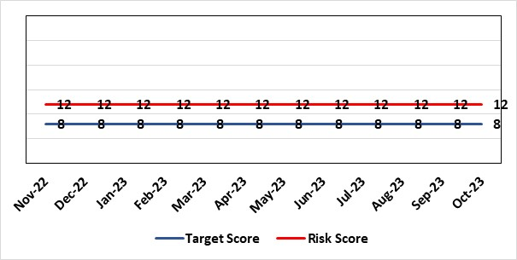 |  | Rationale for current score:  C – Opportunity cost of not acting on data could mean opportunities for improvement are missed, failures are not identified in a timely manner resulting in adverse national publicity and/or delays in care/increased length of stay.  L - Dashboard utilisation is lower than would be anticipated. Management Board have approved the investment for 4 BI partners to work with the SDGs to become more data driven.
Level of Control  = 70% |  |  | Rationale for target score:  C- will remain the same or increase due to increased reliance in information  L- Investment in BI will lead to more information be available and used. The higher the use of information at operational level will lead to better quality data.
Date added to the HB risk register
June 2016
Controls (What are we currently doing about the risk?) |  |  | Mitigating actions (What more should we do?)
- BI partner roles have been funded and will be introduced to support the SDG’s to become more data driven.  - COVID19 Dashboards Developed and utilised to inform the decision making process at Gold  - The Health Board has invested in interactive dashboards with the addition of the Power BI Business Intelligence software and infrastructure to support it.  - 33 dashboards in place including Cancer, Patient Flow, Outpatients, Mortality, Clinical Variation, Primary & Community Care Delivery Unit Dashboard and Ward Dashboard  - Safety Huddle implemented in Morriston has improved data quality and improved operational working  - Information Dept. working with Planning and Finance leads to develop meaningful indicators, utilising dashboards to present information in a user friendly way  - New technologies being reviewed for advanced analytics and integration into a new Health Board analytics platform.  - Health Board has representation on national groups such as the Advanced Analytics Group (AAG), all Wales Business Intelligence and Data Warehousing Group and Welsh Modelling Collaborative. |  |  | Action | Lead |  | Deadline
 |  |  | Additional development of self-service dashboards | Assistant Director of Digital Intelligence |  | 31st January 2024
 |  |  | Create Community of Practice for Power BI knowledge sharing across Health Board | Assistant Director of Digital Intelligence |  | 28th February 2024
 |  |  | Appointments of BI partners to vacant posts | Assistant Director of Digital Intelligence |  | 31st March 2024
 |  |  | Start of 2nd tranche of Data Literacy Module Manager’s Pathway program | Assistant Director of Digital Intelligence |  | 31st May 2024
 |  |  | Certified Analytical Programme with access to self- service datasets | Assistant Director of Digital Intelligence |  | 30th June 2024
Assurances (How do we know if the things we are doing are having an impact?)  More evidence based and proactive decisions being made.  Dashboard technology; assist in developing indicators / triangulating information to identify issues |  |  | Gaps in assurance (What additional assurances should we seek?)  Culture of the organisation needs to change to focus on information and Business intelligence for operational rather than reporting purposes. Capability of operational staff to utilise the tools and capacity to act on the intelligence provided.
Additional Comments / Progress Notes
04/07/2023 - First Self-service dashboard has been launched allowing users to create their own visuals for admitted activity. Further self-service dashboards are to be launched for ED, Referral and Outpatient activity a- after this it will be ascertained whether certification for advanced users is still required. Action completed - Commencement of Digital and Data Module on Manager’s Pathway. First session of the digital and data literacy module on Managers Pathway took place on June 16th.
15/08/2023 – Following the Go Live of self-service dashboards still assessing if requirement for further certified training programme for additional self-service tools.
28/09/2023 – MC, Programme Lead to provide an update following the Go Live of self-service dashboards, where assessment is being carried out to decide whether a requirement for further certified training programme for additional self-service tools. Three actions completed – Establishment of data literacy programme educating users on data concepts, skills and tools. Establishment of certified training programme for trained users to create their own dashboards. Commencement of Digital and Data Module for Managers.
24/10/2023 – Action completed – Delivery of data literacy programme educating users on data concepts, skills and tools.

Datix ID Number: 1759  Health & Care Standard: Staff & Resources 7.1 Workforce |  |  | HBR Ref Number: 51  Risk Target Date: 30th November 2023 |  | Current Risk Rating  5 x 4 = 20
Objective: Demonstrably Improved Quality, Safety & Reduced Harm |  | BAF Ref: 1 | Director Lead: Gareth Howells, Executive Director of Nursing  Assuring Committee: Workforce and OD Committee
Risk: Non Compliance with Nurse Staffing Levels Act (2016)  There is a risk that we might not be able to maintain safe staffing levels due to staff unavailability, vacancies and sickness levels. The potential impact of this maybe avoidable harm, suspension of services, non-compliance with the Nurse Staffing Act. |  |  | Date last reviewed: October 2023
Risk Rating  (consequence x likelihood):  Initial: 4 x 4 = 16  Current: 5 x 4 = 20  Target: 4 x 3 = 12 |  |  | Rationale for current score:  - Pressures at Morriston and Singleton Hospitals remain high. There were 27 areas with staff unavailability over 40% across all service groups, during roster period 27th August to 23rd September 2023. Breakdown of service groups: MH – 4, NPTSH – 11, MH/LD – 10, PCC – 2.  Previous reporting periods: 30th July to 26th August (includes school holiday time and CAHMS team) had 30 areas; 2nd July to 29th July 2023 had 21 areas.  - Nurse vacancies reported through ESR on 19th September 2023 were 299 Band 5 and 171 Band 2, 23rd October were 229 Band 5 and 169 Band 2.  - Skill mix related to internal promotion, newly qualified and international nurses recruitment and subsequent induction plans continues to impact on wards, although to a lesser extent than 2-3 months ago  - Staff retention, All Wales Framework launched, representatives as below.  - Home birth and NPT midwifery led unit remain on hold  - Ageing workforce, (MH - with staff choosing to take retirement at age 55).
Level of Control  = 80% |  |  | Rationale for target score:  - The Health Board is ensuring we have the structures and processes in place to provide reassurance under the Act and are allocating resources accordingly.  - Health Boards are duty bound to take all reasonable steps to maintain nurse staffing levels.  - Skill mix on wards, recruitment and induction plans impacting on wards. Projected decrease in vacancies by end of November 2023.  - Cladding work at Singleton Hospital ongoing.
Date added to the HB risk register
November 2018
Controls (What are we currently doing about the risk?) |  |  | Mitigating actions (What more should we do?)
The Health board has put the following controls in place:  - The responsibility for decisions relating to the maintenance of the nurse staffing level rests with the Health Board should be based on evidence provided by and the professional opinions of the Executive Directors with the portfolios of Nursing, Finance, Workforce, and Operations.  - Workforce Plans have been developed by Service Group Nurse Directors & each Service Group to agree staffing, with consideration of all reasonable steps.  - Designated person is confirmed as Director of Nursing & Patient Experience.  - The Ward Sister / Charge Nurse, Senior Nurses and Group Nurse Director should continuously assess the situation and keep the designated person formally appraised.  - Health Board has representation at the All-Wales Nurse Staffing Group and its sub groups.  - Bi-annual calculations undertaken across all Section 25B Wards.  - Following acuity audits, data collected is analysed and submission of acuity templates, scrutiny panels take place and are agreed templates for all Section 25B wards, with representation from Nursing, Workforce and Digital and Finance Colleagues.  - Bi-annual reporting to Board, in May (agreed Once for Wales) and November (mandatory). Three year mandatory paper to Welsh Government, due May 2024.  - Workforce planning & redesign, training and development. Recruitment and retention continues. HB Workforce Group has been set up and links to HEIW Retention Workstream, HB representatives on HEIW Group are Associate Head of HR, Recruitment and Retention Manager and Matron, Corporate Recruitment.  - Work assessing the impact of the 'Team around the Person' is underway currently lead by HEIW.  - Robust roster scrutiny is undertaken to optimise nursing workforce.  - The HB actively supports the Retire and Return policy.  - SafeCare has been implemented. All Wales SOP has been supported by All Wales NSA Group and remains a working document as understanding evolves.  - Service groups continue daily staffing huddles and daily staffing tool and escalate as appropriate. |  |  | Action | Lead |  | Deadline
 |  |  | Student Streamlining and Overseas recruitment | Executive Director of Nursing |  | 31/12/2023  Monthly ongoing
 |  |  | Review of workforce, consider more diverse skill mix, including development of Band 3 and Band 4 roles. Bi-annual re-calculations of inpatient wards have resulted in the addition of Band 3 and 4 roles within the NSA templates. These posts are being recruited into, there is a need for training and supervision for these new posts. | Executive Director of Nursing |  | 31/12/2023
Assurances (How do we know if the things we are doing are having an impact?)  - Ongoing robust recruitment and retention plans in place to reduce vacancies in key clinical areas, which is in line with the Health Board recruitment plan.  - Accurate reporting of acuity data and governance around sign off.  - Agreed establishments to be funded.  - E-Rostering implemented and roster scrutiny undertaken, ensuring effective staff allocation  - All Wales Templates are visible informing patients/visitors of planned roster on all Section 25B wards.  - Bi-annual Board reports, provide assurance and outline compliance and any key risks, submitted in November and May each year, with three yearly report to Welsh Government due May 2024.  - The Health Board Nursing and Midwifery Safe Staffing Assurance and Improvement Group (formally the Nurse Staffing Act Steering Group, amended July 2023) meets on a bi-monthly basis, ensuring risks from all service groups are represented at each meeting and escalated appropriately as required. This group is chaired by the Associate Director of Nursing and reports to Nursing and Midwifery Board and the Workforce, Organisational Development and Digital Committee. Terms of reference agreed, membership extended to provide further assurance and forum for learning and improvement.  - Service Group risk assessments have been updated and segregated into different areas for clear escalation of any risks, supporting clearer governance.  - There is a clear process for scrutiny during bi-annual re-calculations and at any other time when wards require a re-calculation, for example: change to ward purpose, increased bed numbers or increase patient acuity.  - SafeCare system has been implemented. Support given to help embed the system into everyday use. Use of SafeCare linked to daily staffing huddles.  - Patient Information available on all Section 25B wards, Service groups have access to all HEIW documents via a SharePoint.  - HB NSA Shared drive available for all to view all current and historical NSA information, including templates, informing patient templates. |  |  | Gaps in assurance (What additional assurances should we seek?)  - Issue remains regarding Information Technology barriers around the capture of data required for the Act on an All- Wales and Health Board basis. All Wales work with Allocate (Safecare) to improve reporting capabilities of Safecare, via a dashboard continued to progress. SBU is pilot site for testing. Update to Allocate system received, working with rostering team and BCU NSA Lead to check accuracy of reporting.  - Ongoing work across Wales to ensure IT systems are compatible with each other for operational and reporting purposes.
Additional Comments / Progress Notes
Update 23.10.2023:
Risk scores reported by Service Groups:
Morriston SG - 20
NPT/SH Section 25B areas - 9
NPT/SH Section 25A areas - 12
Paediatrics: In-patient wards - 12; Neonates and Community Team - 20
Maternity Service - 25
District Nursing and Health Visiting - 20
Corporate risk discussed and remains at 20
Next bi-monthly NMAISG (on 21st November 2023) will further discuss reported risks and will look to separate risk into areas, for example: Section 25B wards only in MHSG.
Surgical re-design planned within MH SG, phased implementation starting w/c 5th November 2023.
Successful recruitment of International nurses (for adults, paediatric and neonatal areas) and student streamlining has resulted in decreased vacancies, reported vacancies above are higher than currently due to time taken to on-board and update ESR reporting. Aware of the impact of new staff to clinical areas and need for ongoing monitoring of skill mix.

Datix ID Number: 2788  Health Care Standards: 7.1 Workforce |  |  | HBR Ref Number: 81  Risk Target Date: 31/12/2023 |  | Current Risk Rating  5 x 5 = 25
Objective: Children, Young People & Maternity Services |  | BAF Ref: 3.6 | Director Lead: Gareth Howells, Executive Director of Nursing  Assuring Committee: Quality & Safety Committee  For Information: Workforce OD & Digital Committee
Risk: Critical staffing levels – Midwifery  Unplanned absences resulting from long and short-term sickness, alongside maternity leave, have resulted in critical staffing levels, which undermine the ability to maintain the full range of expected services safely, increasing the potential for harm, poor patient outcomes and/or choice of birthplace. Poor service quality or reduction in services could impact on organisational reputation. |  |  | Date last reviewed: October 2023
Rationale for current score:
The vacancy position has improved for registered staff – however, the current score will remain while the impact of staffing is reviewed. Some aspects of service provision continue to suspended in order to ensure resource is best directed to support safe provision. This is also subject to review.
Risk Rating  (consequence x likelihood):  Initial: 4 x 5 = 20  Current: 5 x 5 = 25  Target: 4 x 4 = 16 | 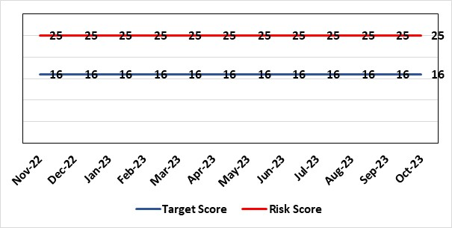
Level of Control  = % |  |  | Rationale for target score:  It is intended that through actions currently identified to address vacancies we can reinstate services fully and reduce the likelihood of the need to suspend elements further.
Date added to the risk register
12/10/2021
Controls (What are we currently doing about the risk?) |  |  | Mitigating actions (What more should we do?)
- All midwives are working at the hours they require up to full time.  - Specialist midwives and management redeployed to support clinical care as required  - Birth rate plus Intrapartum acuity tool completed 4 hourly to guide safe service provision and escalation;  - Escalation meeting held daily during the week to review rotas and reallocate staff as required chaired by Head of Midwifery  - Morning safety huddle for community midwifery teams  - Morning safety huddle for obstetric unit generates RAG-rated daily acuity and shares this with the Service Group for its daily meeting.  - Additional shifts offered via Bank, additional hours and overtime at enhanced rates  - Utilisation of off-contract midwifery agency authorised by Executive Director of Nursing  - Open advert for recruitment on TRAC  - On-Call Manager Rota in place.  - Continue to suspend services in the FMU at NPT.  - International recruitment campaign initiated with MEDACS.  - Offer of additional support worker shifts particularly in the postnatal area for additional support for women  - Maternity Care Assistance (MCA) role in place to support Midwives in providing care in women and their families.  - Regular communication with stakeholders includes: Early warnings to Welsh Government; Verbal and formal communication with CHC; Internal communications on home births, RCM updates; weekly staff briefings and bulletins. |  |  | Action | Lead |  | Deadline
 |  |  | Development and dissemination of the organisational change to practice (OCP). Phase 1 consultation period closed. Outcome has been reviewed and further work is being undertaken to resolve | Head of Midwifery |  | 14/11/2023 (phase1 completion)
 |  |  | OCP Phase 2 consultation period closed 24th Oct 2023. Outcome is to be reviewed and actions completed – target 28th November. | Head of Midwifery |  | 28/11/2023
Assurances (How do we know if the things we are doing are having an impact?)  The following assurance mechanisms in place currently:  Birth-rate Plus Intrapartum acuity tool completed 4 hourly  Daily staff escalation meetings chaired by Head of Midwifery which considers sickness & other absences and daily review of safety and quality outcomes. The Group Head of Quality Safety & Risk is supporting daily oversight of Datix incidents. The following red flag events are monitored:  • Delayed or cancelled elective caesarean sections;  • Missed or delayed care incidents;  • Delayed or cancelled induction of labour;  • Delay of 2 hours or more between admission for induction of labour and beginning of process;  • Delay of 30 minute or more between presentation and triage.  Birthrate Plus assessment outcome (last internal assessment Oct 2023 – now compliant) |  |  | Gaps in assurance (What additional assurances should we seek?)
Additional Comments / Progress Notes
11/08/23 – OCP consultation continues and staff offered drop in sessions and one to one with senior team. Recruitment of 7 midwives Band 5 and Band 6 (variable hours) and 15 newly qualified midwives commencing employment in October 2023. Induction for newly qualified midwives commenced 11/8/23. Action completed - Review of the Maternity Escalation guideline to ensure robust processes in place if acuity is high or critical staffing. Guideline receiving comments following discussion in Maternity Quality and Safety.
13/10/2023 -Incidents continue to be linked. Further advert for recruitment submitted. Band 5's commencing w/c 16.10.2023. OCP consultations continue. Weekly engagement staff meetings ongoing and wellbeing support is being provided.
25/10/23 – Eleven Band 5 midwives commenced in October 2023. Currently band 5 and 6 positions are filled to establishment levels. Some unregistered positions remain vacant. Weekly engagement staff meetings are ongoing with Director attendance and wellbeing support is being provided. Action required following OCP consultation is being reviewed.

Datix ID Number: 2554  Health & Care Standard: Standard 5.1 Timely Access |  |  | HBR Ref Number: 82  Risk Target Date: 1st December 2023 |  | Current Risk Rating  4 x 3 = 12
Objective: Networked Hospitals – A Systems Approach – Urgent & Emergency Care |  | BAF Ref: 3.3 | Director Lead: Raj Krishnan, Acting Executive Medical Director  Assuring Committee: Performance & Finance Committee  For Information: Quality & Safety Committee, Workforce OD & Digital Committee
Risk: Risk of closure of Burns service if Burns Anaesthetic Consultant cover not sustained  There is a risk that adequate Burns Consultant Anaesthetist cover will not be sustained, potentially resulting in closure to this regional service, harm to those patients would require access to it when closed and the associated reputational damage. This is caused by:  - Significant reduction in Burns anaesthetic consultant numbers due to retirement and long-term sickness  - Inability to recruit to substantive burns anaesthetic posts  - The reliance on temporary cover by General intensive care consultants, and Consultants from the Morriston General on-call and Paediatric Anaesthesia rotas, to cover while building work is completed in order to co-locate the burns service on General ITU  - Reliance on capital funding from Welsh Government to support the co-location of the service |  |  | Date last reviewed: October 2023
Risk Rating  (consequence x likelihood):  Initial: 4 x 3 = 12  Current: 4 x 3 = 12  Target: 3 x 1 = 3 | 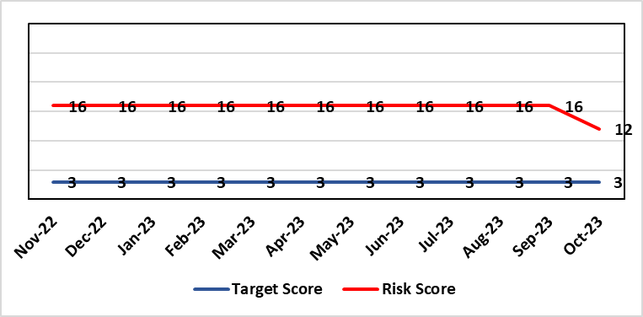 |  | Rationale for current score:  Funding has been confirmed and enabling works are due to start in December with main construction starting in January 2024. This can be de-escalated to 12.
Level of Control  = |  |  | Rationale for target score:  This is a small clinical service with staff with highly specialised skills. While a small service may always be vulnerable to challenges (eg staff) the intention will be to operate a more resilient clinical model that is supported by other clinical groups.
Date added to the HB risk register
December 2021
Controls (What are we currently doing about the risk?) |  |  | Mitigating actions (What more should we do?)
- The general ITU consultants, and some Consultants from the Morriston General and Paediatric Anaesthetists to support the Burns service on a temporary basis, supporting the remaining burns anaesthetic colleagues to provide cover for the Burns service.  - The agreement reached is that they will cover the current Burns Unit on Tempest ward at Morriston hospital for 6-9 months while capital work is underway on general ITU to enable co-location of the service.  - Capital works will be completed by mid-2023 to co-locate the burns patients within the GICU footprint.  - WHSSC as commissioners of the service have been kept fully informed, as has the South West (UK) Regional Burns Network  - Other UK burns units have ICU co-located with Burns ICU, removing the need for dual certified consultants |  |  | Action | Lead |  | Deadline
 |  |  | WG have agreed funding in principle for capital works to progress. Scoping document submitted to WG and discussions ongoing about expediting a decision on an outline/full business case. | Morriston Service Group |  | Complete (Funding agreed and enabling works commencing December 2024)
Assurances (How do we know if the things we are doing are having an impact?)  Effect on patients of the temporary closure of the burns service in Swansea is mitigated by maintaining an urgent assessment/stabilisation service for patients in Wales with severe burns, with onward transfer for inpatient care to another unit in the UK following the initial assessment.  The service reopened fully on 14/02/2022. |  |  | Gaps in assurance (What additional assurances should we seek?)
Additional Comments / Progress Notes
17.01.23 No change to consultant cover, which remains reliant on cross-cover from general critical care and anaesthetics. A business case for the strategic and capital investment of £7.3m has been completed and will be presented to the Board on the 26th January.
03.11.23 Funding agreed for capital works - enabling works are due to start in December with main construction starting in January 2024.

Datix ID Number: 2796  Health Care Standards: Effective Care Standard 3.5 Record Keeping |  |  | HBR Ref Number: 90  Target Risk Date: 30th April 2024 |  | Current Risk Rating  4 x 4 = 16
Objective: Adopting and Developing Innovative Digital Solutions to Support Care Delivery |  | BAF Ref: 5 | Director Lead: Matt John, Director of Digital  Assuring Committee: Workforce OD & Digital Committee
Risk: Non-compliance with UK-GDPR Article 15 regarding Subject Access Requests (SARs), along with other health records requests for disclosure of personal data  The Health Board does not have adequate resources to deal with the sustained increase in volume and complexity of subject access /access to health records requests received from requestors. The ICO are already involved with a number of breaches and complaints in this area and there is the potential for future enforcement action if significant improvements are not made. Misfiling and redaction are major issues for Health Records, IG and Health Professionals. SAR breaches have led to successful compensation claims and media interest. |  |  | Date last reviewed: October 2023
Rationale for current score:
C – The Health Board has a statutory requirement to comply with UK GDPR and Data Protection Act 2018. This includes compliance with an individual’s Right to Access their personal data. The Information Commissioner has the power to take enforcement action, including substantial monetary penalties, for non-compliance. A number of complaints regarding the handling of SARs within SBUHB have been highlighted in both the mainstream media and on social media, leading to a loss of trust in the Health Board with damage to staff and Health Board reputation.
L- The Health Board does not have adequate resources to deal with the sustained increase in volume and complexity of SARs received from both patients and staff. There are inconsistent processes across the Health Board, with varying levels of robustness regarding legislative compliance. The increased use of various digital applications has impacted the volume and complexity of content and the ability to retrieve the personal data required to comply with SARs. The process for ensuring information is appropriately reviewed and redacted has become far more complex and resource intensive increasing the likelihood of personal data breaches and/or non-compliance with legal timescales. The ICO are already involved with a number of complaints in this area and there is an increased potential for future enforcement action if significant improvements are not made.
Risk Rating  (consequence x likelihood):  Initial: 4 x 4 = 16  Current: 4 x 4 = 16  Target: 4 x 2 = 8 | 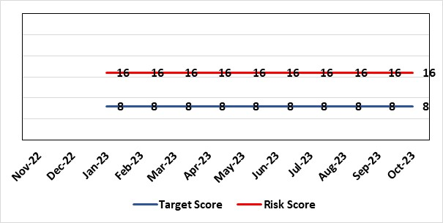
Level of Control  = 50% |  |  | Rationale for target score:  C – As above  L – Additional resources would allow the organisation to make significant improvements to the process by which SARs are managed. Being able to adequately comply with legislative requirements reduces the likelihood of enforcement action and fines from the ICO, as well as minimising the risk of reputational damage.
Date added to the risk register
Jan 2023
Controls (What are we currently doing about the risk?) |  |  | Mitigating actions (What more should we do?)
- SAR (Subject Access Request) Task & Finish Group established  - Prioritisation of workload  - Existing policies and processes in place (to be reviewed & updated)  - Advice sought from Legal and Risk on complex cases  - Legal and risk completing redaction tasks on complex and lengthy cases  - Quarterly SARs report submitted to IGG (Information Governance Group) |  |  | Action | Lead |  | Deadline
 |  |  | Implement key tasks outlined within the action plan within agreed timescales | Data Protection Officer |  | 28th April 2024
 |  |  | Review all SAR documentation across the Health Board | Data Protection Officer |  | 29th December 2023
Assurances (How do we know if the things we are doing are having an impact?)  - Quarterly IGG chaired by SIRO (Senior Information Risk Owner) and attended by Deputy Caldicott Guardian and Data Protection Officer  - Quarterly briefing from IGG to Management Board & Workforce OD & Digital Committee  - IG governance structures in place with key roles and responsibilities established e.g. SIRO, Caldicott Guardian (Deputy), DPO (Data Protection Officer) |  |  | Gaps in assurance (What additional assurances should we seek?)  Recent internal audit identified the requirement to invest in resources to address gap in assurance.
Additional Comments / Progress Notes
09/05/2023 - An organisational-wide SAR Policy has been drafted and is currently going through internal review by the end of May 2023 before following the Health Board’s approval processes. Monies have been identified to recruit for a new Band 7 Information Governance Manager to lead on SARs. This will take up to 3-6 months to put into place and all possible mitigations are taking place in the interim period to manage the ongoing risk.
07/06/2023 - The recruitment of a Band 7 IG Manager (SAR Lead) is being pursued, the vacancy control form has been approved and processed onto TRAC. Action completed - Develop organisational-wide policy to support the compliant and effective management of SARs across the Health Board.
16.08.23 – Interviewing is taking place this month and a full time SAR Lead should be in post by the end of September 2023.
28/09/2023 - The date of employment commencing the full-time SAR Lead has been amended from the end of September to the end of October 2023.
09/10/2023 – SAR Lead starting date confirmed as the 30th of Oct. 2023.

Risk Score Calculation

For each risk identified, the LIKELIHOOD & CONSEQUENCE mechanism will be utilised. Essentially this examines each of the risks and attempts to assess the likelihood of the event occurring (PROBABLILITY) and the effect it could have on the Health Board (IMPACT). This process ensures that the Health Board will be focusing on those risks which require immediate attention rather than spending time on areas which are, relatively, a lower priority.

