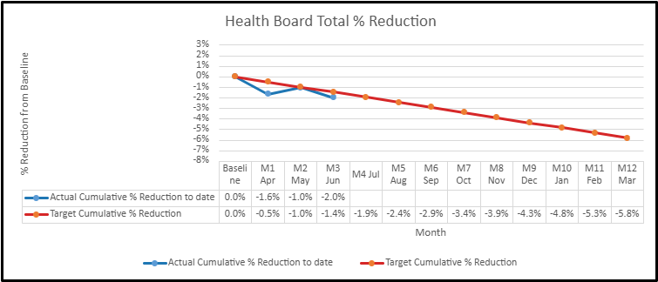

Insights
We are ahead of plan at Month June 2026: actual change is -2.0% versus a target reduction of -1.4%.
Current total actual FTE is 13,542.4 versus target FTE of 13,614.8 for M3 Jun, 72.4 FTE above target.
Largest actual reduction so far: Additional Clinical Services at 3.4% from baseline.
6 of 8 staff groups have met or exceeded their target reduction for M3 Jun; the largest gap to target is Medical & Dental.
By M12, the Health Board target reduction is 5.8%
Actual lines stop where future actual values are not yet available, so remaining months show target trajectory only.

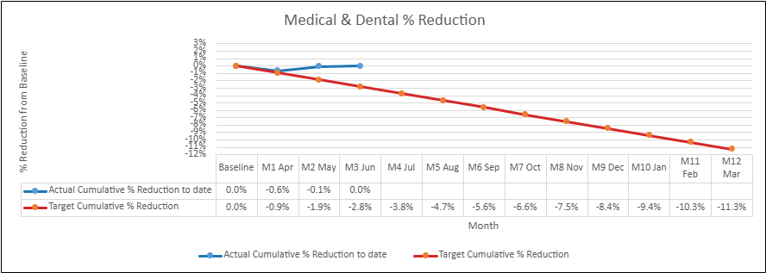
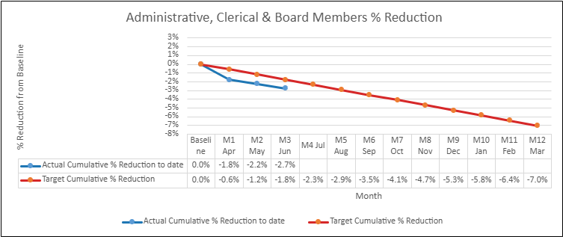
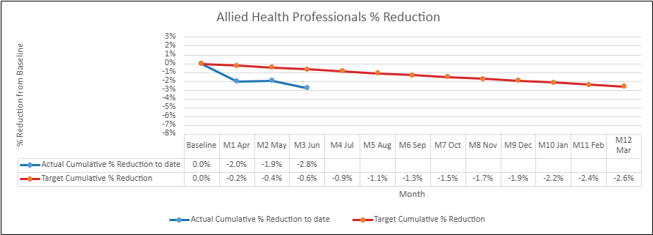
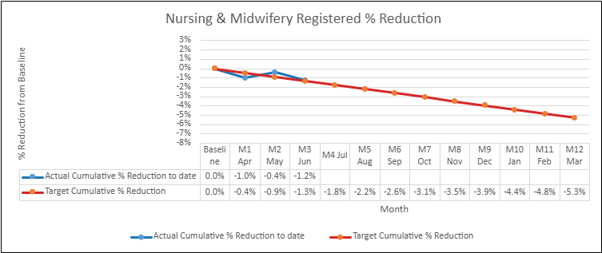
Staff Groups
