10. Workforce Updates and Actions
This section of the report provides further detail on key workforce measures. Caveats and Limitations detailed beneath data in each section.
Staff sickness rates - Percentage of sickness absence rate of staff (two metrics provided, ‘rolling 12 month’ and ‘in month’)  Sickness absence target – 5.5% | % of full time equivalent (FTE) days lost to sickness absence  Caveat & Limitations;- Report generated Jul 2025, within SBUHB (Performance Team) for substantive and FTC employee types. Data source – ESR. Target of 5.5% added as blue line
Current Performance
In month sickness absence has increased slightly in June to 6.82% from 6.76% reported in April 2025. Long term absence reported in June is 4.31% a slight reduction since the last reporting period by 0.67%. Short term absence reported in June is 2.51%, an increase of 0.76% since the last reporting period.
- Anxiety/stress related absence remains the highest reason for long term and short-term absence and accounts for 2.40% of all in month sickness absence. The number of FTE days lost due to Anxiety/Stress/Depression has increased by 0.01% since the last reporting period.
- MSK is the second highest long term absence reason at 0.53% of long-term absence. The second highest reason for short term absence is Gastrointestinal problems at 0.31%.
- Estates and Ancillary report the highest sickness amongst staff groups at 9.56% in June. Our data supports that the hot spot areas within this professional group is Catering and Domestics.
- Mental Health & Learning Disabilities remains the Service Group with the highest levels of absence at 7.57%, an increase of 0.53% since the last reporting period. Long term sickness has reduced in this Service Group since the last reporting period but short-term absence has increased by 1.23%
- Primary Community Care & Therapies Service Group remain the Group with the lowest level of sickness absence, but this has increased from 6.63% in April 2025 to 6.66% in June, this is due to increased absences in the District Nursing team.
- Sickness absence in Morrison (6.81%) has increased slightly since the last reporting period, whereas sickness absence in Neath Port Talbot/Singleton (6.71%) has decreased slightly since the last reporting period.

Actions for Next Period
General
Current focus on areas with high absences rates, examples of initiatives to support our employees:
- Continuing tailored adjustment training for managers to increase experience of using these to flexibly support staff to remain in work/return to work
- Case conference training for leaders in partnership with Occupational Health
- A sickness absence action plan has been developed for the Health Board, with a focus on ensuring compliance with the Managing Attendance at Work Policy

Occupational Health and Staff Health and Wellbeing
The services continue to develop high quality multi-disciplinary interventions to contribute to an engaged, motivated and healthy workforce.
- Substantive Occupational Health Specialist Doctor recruited to give clinical sustainability/service stability – recruiting sessional Occupational Health Consultant during July/August 2025
- Roll out of Staff Health Passport, based on NHS Employers model, across the organisation to promote early support/intervention of health conditions and disability in the workplace – July/August 2025
- Review and update Occupational Health Management referral training for managers based on feedback and development of recent wellbeing services – July

Mandatory & Statutory Training-  Percentage compliance for all completed Level 1 competencies within the Core Skills and Training Framework by organisation  Mandatory & Statutory Training target – 85% | % of compliance (Headcount) with Core Skills and Training Framework  Report generated Jul 2025, within SBUHB (Performance Team) for substantive and Fixed Term employees. Data source – ESR (OLM Module). Accuracy levels subject to local maintenance and validation standards. Target of 85% added as blue line
Current Performance
Welsh Government (WG) requirement for All Staff (Target 85%).Overall compliance rate of 90.23% achieved in the 12 modules.

Welsh Government (WG) requirement for Staff in Public Facing Role (Target 85%), achieved 71.55% to date **

**Please note: Paul Ridd Learning Disabilities Awareness Training was mandated for completion by ALL Staff in SBUHB as of 30th April 2025. The figure of 71.55% is in reference to All Staff, this is an improvement on the compliance rate of 46.08% as of February 2025.

SBU Health Board requirement for All Staff (Target 85%) - Overall Compliance – 88.99% achieved in the full 15 mandated modules:

Service Groups - MH&LD 92.12%, PCCT 93.00%, Morriston 85.62%, Finance & Estates 87.28%, NPTS 92.21%

Staff Groups - Medical and Dental Staff Group remain the lowest performing area with 69.44%. Support for this staff group is ongoing by the E-learning Project Support Manager and Executive Medical Directors Department. Support provided has already seen a positive outcome and continuing improvement of compliance.
Actions for Next Period
- Subscription to Learning Certification and Enrolment onto Statutory/Mandatory Courses – User issues identified are being supported on a case-by-case basis via Action Point and from direct contact. The number of queries seen are minimal, and these have been investigated and resolved with no impact to compliance figures reported.
- Medical and Dental Staff Group – Ongoing support sessions arranged in conjunction with the Executive Medical Directors Department and the E-Learning Project Support Manager to assist Dr’s with e-learning access issues to continue through 2025.
- Monitoring Compliance – Completion of e-learning and compliance rates to be scrutinised bi-monthly to identify where learning has been completed but compliance not recorded due to technical issues experienced by user when undertaking the e-learning, this is to ensure that the learning has been updated accurately for the user and to reflect in overall levels of compliance.
- Safeguarding Adults and Safeguarding Children Level 2 –Levels of compliance for Safeguarding Adults and Safeguarding Children Level 2 are expected to be reportable as a SBU Health Board requirement for All Staff (Target 85%) from August 2025.
- NPTSSG updated that there is a need to continue to focus on improving Mandatory Training compliance within the Medical Staff Group.
- MH & LD Clinical Directors & Directorate Managers to work together to focus on improvement of mandatory training for Medical Staff which has improved but remains below target at 74.77%

Vacancies  Medical and Nursing and Midwifery | Vacancies (FTE) Mar 25 to Apr 25  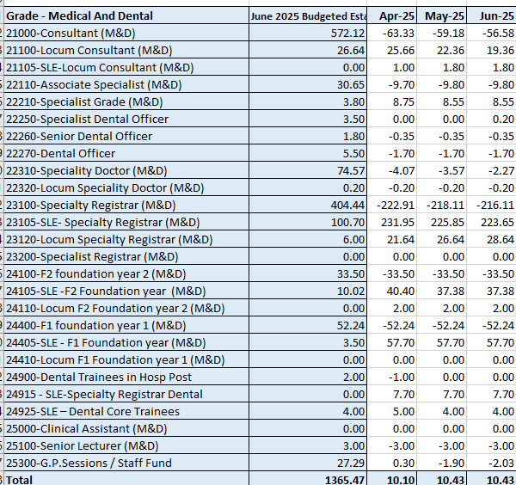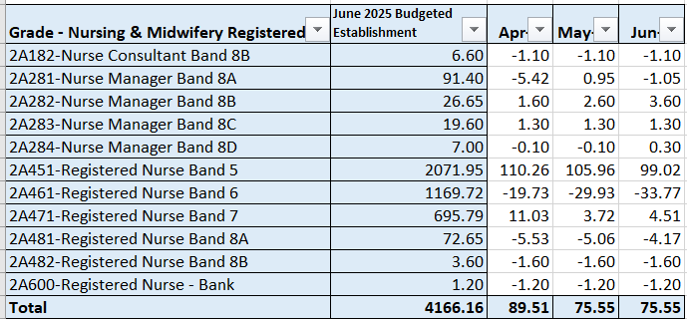  Report generated July 2025, within SBUHB (ESR Team), using currently available methodology. Data source – ESR (Workforce) and General Ledger (Finance). We compare the SIP v’s the finance ledger, appreciating limitations on accuracy in some areas. Accuracy levels are subject to local validation practices based on budget holders intelligence.
Current Performance
Budget for NMC Registrants has increased from 4,154.02 WTE to 4,166.16 WTE between April and June 2025.
Budget for M&D has increased from 1,361.7 in Apr 2025 to 1,365.47 in Jun 2025.

The Health Board (HB) continues to be over-recruited on NMC Registrants as at the end of June 2025 by 75.55 FTE, in spite of an increase to budget.For Band 5 nurses, the HB was over-recruited by 99 FTEs as of June 25, a reduction from 110FTEs in April 2025. This is due to the Health Board continuing to accommodate newly qualified nurses starting in Band 5 roles through our student streamlining programme, whereby 181 have now started in post between 01/09/24 and 10/07/2025 (compared to 145 as of 18/03/2025).
In July 2025, 5 international nurses have started in post for theatres. No further international recruitment is planned for this financial year. The 5 staff will remain on a Band 4 salary until OSCE training is completed and their NMC PIN is received, after which point, they will then move to a Band 5 post.
In addition to the above, our Central Resourcing Team (CRT) continue to support service groups with any other Band 5 Nursing or Band 2 HCSW recruitment. They are currently supporting Morriston Service Group with their latest recruitment round for HCSWs. They also continue to provide support for the Mental Health and Learning Disabilities Service Group for various Nursing and HCSW vacancies

The rich supply of Band 5 nurses from all three recruitment sources should ensure that no band 5 nursing gaps arise over the next 12 months due to turnover and/or internal movements into higher banded roles

It is important to note that the vacancy exception process remains in place which is impacting on timescales, staff wellbeing/experience and can be demonstrated within the high levels of variable pay.

Actions for Next Period
- International recruitment to cease
- We will continue to support pre-employment checks for newly qualified nurses for the March 2025 cohort and will start to support the September 2025 cohort of approximately 140 newly qualified nurses over the coming months
- Domestic nurse and HCSW recruitment will continue as approved by the vacancy control panel
- We will continue to support with chasing pre-employment checks for key roles to reduce time to hire and fill vacancies
- We have developed a checklist of actions for recruiting managers to consider when trying to fill hard to recruit roles, which is now published and available on the intranet
- We will continue supporting the Executive Clinical Vacancy Scrutiny Panel which takes place weekly, including collating submissions, attending the panel meetings, and distributing outcomes to the Service Groups.

Recruitment  Metrics provided by NWSSP. Comparison with all-Wales benchmarking  Target 44 days | Vacancy Creation to Conditional Offer April 2025 (working days) T13 (exc outliers)  C&L;- Report generated Jul 2025, by NWSSP (Recruitment). Data source – TRAC system. Outliers are excluded. This is day to day vacancy management. Data excludes outliers.
Current Performance
Swansea Bay UHB’s in-month (June 2025) time to hire performance continues to exceed the 44 day T13 target at 50.9 working days, albeit a slight improvement to May’s figure of 57.7 working days. SBUHB’s T13 average for the previous 12 months as of June 2025 is also above the 44-day target at 53.1 working days, which is also above the All-Wales 12 month average of 43.9 working days.

The increase in T13 time is mainly due to Welsh language translation requirements, which came into force in November 2024, and additional approvals required due to the ongoing admin and clerical recruitment pause. The HB’s recruiting managers also need to reduce the time taken to shortlist during this period (currently 7.1 working days on average instead of the 3 working days target) to improve the position.

On a more positive note, SBUHB’s in month (June 2025) time to hire from the point a conditional offer letter is issued to the point a start date can be agreed is 11.6 working days, which continues to be significantly below the All Wales T23 target of 27 working days (without outliers). This is also an improvement compared to May, which was 13.2 working days. SBUHB’s 12-month average remains stable at 13.5 working days (without outliers) which is similar to the All-Wales average to date performance of 13.6 working days.

During June 2025, the Central Resourcing Team (CRT) have continued to coach candidates through the pre-employment check process for Band 5 nursing roles and Band 2 Health Care Support Worker roles and have also been supporting with other stages of the recruitment process for some areas as and when requested (e.g., shortlisting for mental health nursing and HCSW roles) to continue to assist in reducing the T13 and T27 time to hire targets, mentioned above.

The CRT also took over the final quality check/ granting stage for all agenda for change posts in April 2025, which has started to show an improvement in our “time to approve vacancy requests” T1a performance data, whereby it was taking, on average, 15 working days across January to March 2025, but is now taking, on average, 10.1 days across April to June 2025 and is currently 9.4 working days for June 2025 (target of 10 working days)

Actions for Next Period
- NWSSP will continue to provide training sessions and drop-in sessions for SBU recruiting managers to improve time to hire. There are also guidance documents on the HB and NWSSP recruitment SharePoint pages
- The CRT will continue focussing on the recruitment of B2 ward based HCSWs and newly qualified nurses, as well as specific hard to recruit posts.
- In collaboration with NWSSP, the CRT will continue to chase outstanding management actions for the recruitment process, to further improve the HB’s overall time to hire performance.
- Members are asked to note that the HB’s T13 time to hire performance is likely to continue to deteriorate over the coming months due to the additional executive scrutiny panel processes. Suggestions to amend the process have been submitted but require a decision on the scope of the panels before finalising
- Over the next 6 months, the CRT will also be working on updating the recruitment SharePoint pages to provide additional guidance to recruiting managers

Turnover  % turnover by occupational group | 12 month rolling Turnover Rate (Swansea Bay) – 01 May 2024 – 28 Apr 2025  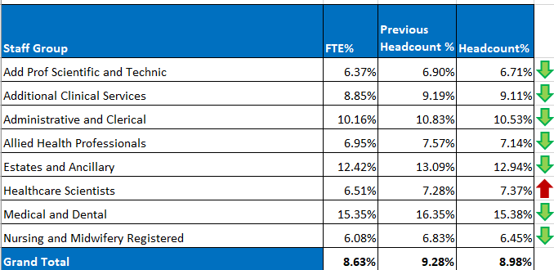  Report generated Jul 2025, within SBUHB (ESR Team). Data source – ESR (Workforce). Small risk of margin of error due to late communication of terminations. Report excludes Bank, Locum, Honorary & Widow/Widower, Junior M&D staff. Internal movement not included – measure is about leaving Swansea Bay UHB.
Current Performance
Organisational turnover has decreased by 1% since May 2024 to June 2025 highlighting the impact of retention initiatives.

Medical and Dental staffing has shown the most notable improvement in retention, with a 0.72% decrease in FTE turnover. This positive trend reflects the success of recent retention strategies. While turnover in this group may appear as an outlier compared to other staffing categories, this is largely due to the short-term nature of some substantive appointments. For instance, the Medical HR team may fill a post lasting only four months using fixed term and locum appointments to cover vacant HEIW posts. This approach not only enhances continuity of patient care but also contributes to reduced reliance on bank staffing, leading to cost efficiencies.
The Nursing and Midwifery staff group remained relatively stable between May and June 2025, with a slight decrease in FTE turnover (0.36%). Looking at the longer-term trend, from May 2024 to June 2025, the group has seen an overall reduction in turnover of nearly 1% (0.89% in headcount and 0.72% in FTE), suggesting that retention strategies are gradually taking effect within this workforce.
Turnover within the Admin and Clerical group has experienced a modest decline, accompanied by a slight improvement in headcount stability. This suggests that fewer staff are leaving, despite the ongoing vacancy freeze affecting this group.
Actions for Next Period
The Retention Lead will continue collaborating with Workforce Business Partners to ensure effective rollout of targeted actions, particularly in hotspot areas of increased turnover.
Stakeholder engagement within Medical and Dental will remain a key focus, capitalising on current improvements to understand success factors and reinforce long-term workforce stability.

PADR  % staff who have a current PADR review recorded  PADR target – 85% | % of staff (Headcount) who have had a PADR in previous 12 months  Report generated Jul 2025, within SBUHB (Performance Team). Data source – ESR (OLM Module). Accuracy levels subject to local maintenance and validation standards. Target of 85% added as blue line.
Current Performance
Staff who have had a Personal Appraisal and Development Review (PADR) as of 30th June 2025 is 72.82 %.
During March and April 2025, a total of 58 staff completed Personal Appraisal Review for Managers delivered by the Education and Learning Team. In addition, the How to Complete PADR Documentation and PADR Hints & Tips bitesize learning modules have been added to the Brilliant Basics Platform from January 2025.
Compliance figures per Service Group (excluding Medical and Dental Staff) – MH&LD 76.97%, NPTS 79.47%, PCCT 83.24%, Morriston 64.32%, Finance and Estates 64.21%
Actions Planned for Next Period
NPTSG updated that Improvement plans should be in place for Divisions below the target of 85% (this is coordinated via the Divisional Workforce Groups) and that they are using PADRs as an enabler to support Quality and Safety Strategy.
MH & LD Plans to be put in place to identify dedicated time to meet with all staff for objectives and development and to prioritize the 412 staff that have not received a PADR and ensure ESR records are updated.

The Education & Learning team within Workforce & OD has an enabling role in delivering PADR training to managers and leaders so they can deliver high-quality, person-centred reviews that meet the needs of our staff as aligned to our People Strategy.
PADR training is currently offered through two primary formats to support staff development and accessibility:
- Face-to-Face Training integrated into the Managers’ Pathway Programme, providing structured learning for managers enrolled on the programme.
- Delivered as standalone sessions, which managers and leaders can book independently to enhance their understanding and application of the PADR process.
In the last 12 months, 245 participants have attended a face-to-face PADR training module. Flexible early morning training sessions are being trialled to provide participants with the option of attending a session outside of core operating hours of 9am-5pm.

Digital Learning: Bitesize modules were launched as part of the Brilliant Basics digital learning platform in January 2025, offering flexible, on-demand access to core PADR content. The bitesize learning has been highlighted as part of one of three key areas of learning in the Brilliant Basics communication campaign. This blended approach to learning ensures that staff at all levels have access to appropriate training in a format that suits their learning preferences and operational needs.

Service Groups are being supported to monitor compliance through the following operational activities
- Development of an Establishment Control Toolkit for leaders. Ensuring our establishment is correct on ESR supports the accurate recording of PADR discussions.
- The introduction of the Workforce Dashboard in 2024 enables us to report and monitor PADR compliance by Service Grou
- Monthly Service Group Performance Meetings are utilised to report and monitor PADR compliance. Barriers to completing the PADR process explored and actions to address agreed.
- Leaders are encouraged to allocate dedicated time to conduct quality PADRs.

Operational Casework  Number of current operational cases. | Report generated Jul 2025, within SBUHB (Workforce Digital). Data source – ER Tracker. Accuracy levels subject to local maintenance and validation standards.
Current Performance
Number of open Formal Disciplinaries since the last reporting period have increased from 56 to 68 open cases
Number of Formal requests for resolution which remain open within this period have increased from 52 to 55.
Suspensions, since the last reporting period, have increased from 6 to 9
Employment tribunals have increased from 3 to 4
Actions for Next Period
A number of actions are on-going in line with the Best Practice Review. This project has been refreshed with the introduction of multidisciplinary subgroups focusing on priority areas of work, reporting into the Core Working Group.
3 workshops have taken place in partnership with our Trade Unions facilitated by HEIW and SBUHB covering the following: Employee Investigations – Avoiding Employee Harm.
We have successfully launched the Management Review document, to replace the initial assessment, which allows us to determine the most appropriate course of action at an early stage with the intention to resolve cases informally where possible – education and training ongoing with HR and leaders, this is being embedded and continually reviewed
Suspension Guidance for leaders and employees has been shared for comment with the aim of supporting both groups and clarifying the process

