NHS Wales Staff Survey 2024 – Health Board Action Plan Template

1. Staff Survey Update for Morriston Service Group |  |  | Date Agreed: May 2025  Lead: Sue Moore
1. High level summary of survey findings: |  | 2. Response Rate
MSG achieved a Staff Engagement Index score of 64.5% in 2024. This is compared with the 72% average NHS Wales Staff Engagement Index score.  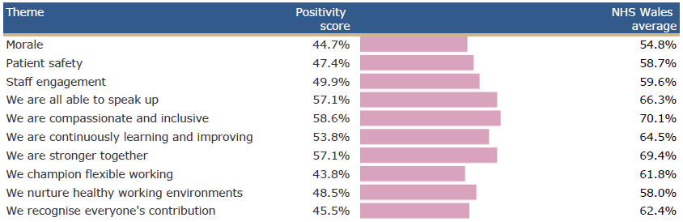  Below is a summary of responses by theme for MSG: |  | Response Rate 2024: 5.8% |  | Target for 2025: 25% (min.)
 |  | 3. Key actions being taken to Improve Response Rate
- Leadership Engagement and Accountability at Divisional Level
- Active ongoing promotion through multiple forums to reach as many staff as possible
- Give staff sufficient time to respond and where possible provided protected time.
- Development of a communication plan emphasising messages around confidentiality and examples of staff stories around the ‘You Said, We’re Delivering Together’ campaign confirming action taken as a result of the survey.
- Assurance on the independent management of the survey which maintains anonymity
- Due to low response rates from Band 2/3's and to boost engagement, consider exploring a hands-on approach where teams will visit with iPads to support participation, and hold in-person engagement sessions with staff, as well as interactive stations that will support staff to participate where they do not have regular access to computers.

 |  | 4. Key Exit Criteria (what will success look like for the staff survey in 2025?) *linked to national survey measures in 2024.
- Improved staff engagement score
- Improved positivity score for “we are all able to speak up”
- Improved positivity score for “we are inclusive and compassionate”

5. Short term Goals 2025/26 | 6. Medium term Goals 2026/7 | 7. Key Actions/ Milestones leading up to 2025 staff survey
Strengthening Leadership, Engagement, and Accountability at Divisional Level  Share the 3 key areas of focus for the Health Board along with Divisional level themes:  - Leadership & Management  - Speaking Up Safely / Raising concerns,  - Values & Behaviours  - Flexible Working  - Healthy Woking Environments  Divisions should adopt a collective and compassionate leadership approach to developing their local staff experience plans.  Plans should be co-designed with input from:  - Local team representatives  - Line managers  - Trade Union representatives  Each divisional plan must include a dedicated communication and engagement section, outlining how staff will be:  - Informed  - Involved  - Updated on progress and outcomes  Where applicable, divisional staff survey plans should be aligned with the development of the Staff Experience, Wellbeing, and Retention Plans, particularly in areas where this work is already underway. | Benchmark 2025 survey results to measure progress and identify ongoing priorities, which will inform medium-term improvement goals.  Continue to develop and implement the Staff Experience, Wellbeing, and Retention Plan to address key themes and sustain positive change. | Actions/ Milestones |  | Lead | By When | Status
 |  | Nominate SG leads to access staff survey results via dashboard. |  | SM | Mar-25 | Complete
 |  | Attend webinars to support running local reports from the dashboard. |  | SM | Mar-25 | Complete
 |  | Share 3 key areas of focus for the Health Board along with Divisional level staff survey results highlighting the specific themes for MSG. |  | SM | Mar-25 | Complete
 |  | Management teams to discuss the results and to agree how they will shape local Divisional Staff Survey Plans. |  | ASGDs | Aug-25 | Discussions had; local plans being finalised
 |  | Divisional Staff Survey Plan to be shared during senior team meeting |  | ASGDs | Aug-25
 |  | Progress update on Divisional Staff Survey Plan and the overall Service Group plan to be reported during senior team meeting ahead of the launch of the 2025 Staff Survey (Oct 25). |  | SM & ASGDs | Sept-25
 |  | Progress up-date on delivery of action plans including examples of staff stories around “You Said, We’re Delivering together” culminated from Service Groups / Directorates and launch of 2025 staff survey to WOD Delivery Group and Committee |  | SM, TR, JL | Sept-Oct 2025 | On-track
8. Key Risks | 9. Mitigating Actions
- Operational pressures and competing priorities may delay progress on staff survey-related actions.  - Staff concerns about confidentiality may impact willingness to provide honest feedback.  - Low confidence in follow-through may lead to scepticism about whether feedback will result in meaningful change. | - Allocate time within Divisional Workforce Groups to regularly review and track progress on staff survey action plans, with support from HR Business Partner teams.  - Monitor and report on progress against agreed actions to ensure accountability.  - Reinforce the independence and anonymity of the survey process to build staff trust.  - Regularly communicate actions taken in response to staff feedback to demonstrate impact.  - Include a dedicated communication and engagement section in each Divisional plan to support visibility and involvement.
10. Interdependencies
