

HEALTH BOARD RISK REGISTER
June 2024

WORKFORCE, OD & DIGITAL COMMITTEE

Datix ID Number: 843  Health & Care Standard: |  |  | HBR Ref Number: 3  Risk Target Date: 31/03/2025 | Current Risk Rating  4 x 5 = 20
Objective: The Health Board is a great place to work where staff feel valued and work together towards a common goal |  | BAF Ref: 5 | Director Lead: Sarah Jenkins, Interim Director of Workforce and OD  Assuring Committee: Workforce OD & Digital Committee
Risk: Recruitment of consultant medical & dental staff in hard to fill roles.  Due to national shortages, there is a risk that that the health board will be unable to recruit consultant medical & dental staff into particular hard to fill roles which may result in difficulties fulfilling rotas on all sites, and adverse impact upon patient safety, service provision, quality and financial matters. |  |  | Date last reviewed: June 2024
Risk Rating  (consequence x likelihood):  Initial: 5 x 4 = 20  Current: 4 x 5 =20  Target: 4 x 3 = 12 | 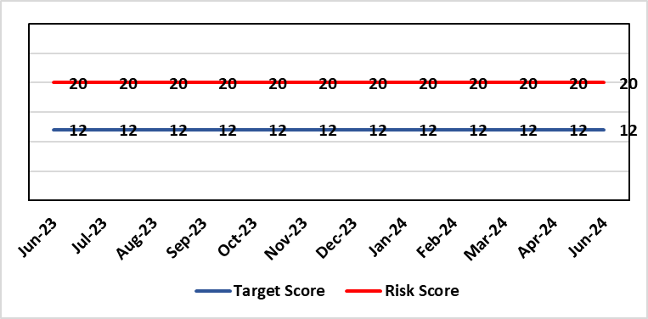 |  | Rationale for current score:  National shortages of numbers in some areas can lead to:  - Inability to recruit sufficient numbers of trainees to fulfil rotas on all sites  - Inability to attract non training grades to complete rotas  - Inability to fill Consultant grade posts in some specialties with adverse effects on patient safety and employer relations. Inability to recruit sufficient registered nursing staff.  - The situation has improved around the recruitment of junior staff but there are many hard to fill consultant posts which impact on the ability to run services which impacts patient care.
Level of Control  = 70% |  |  | Rationale for target score:  This remains a challenge and is also a national problem.
Date added to the HB risk register
April 2012
Controls (What are we currently doing about the risk?) |  |  | Mitigating actions (What more should we do?)
- Regular monitoring of recruitment position with reports to Executive Team and Board via Medical Director and Medical Workforce Board.  - Specialty based local workforce boards established to monitor and control specific issues. The HB Workforce OD & Digital Committee will seek assurance of medical workforce plans to maintain services.  - Engagement of the Deanery about recruitment position.  - Weekly workforce delivery meetings with CEO to review progress against critical medical and clinical posts  - Working with specialist agency and head hunters to improve chances to fill hard to recruit posts  - Working with a marketing agency to develop a branding and attraction campaign for the health board.  - Consideration of the RPO (Recruitment Process Outsourcing) model.  - Implemented the CESR (Certificate of Eligibility for Specialist Registration) framework to grow your own consultants |  |  | Action |  | Lead | Deadline
 |  |  | Medical training initiatives pursued in a number of specialties to ease junior doctor recruitment |  | Director W&OD | 31/03/2025
 |  |  | The Medical Workforce Board continues to monitor recruitment and junior doctor’s rotas. |  | Director W&OD | 31/03/2025
 |  |  | Continue to recruit internationally. |  | Director W&OD | 31/03/2025
 |  |  | Continue to work with head hunters |  | Director W&OD | 31/03/2025
Assurances (How do we know if the things we are doing are having an impact?)  - General situation monitored through W&OD Committee  - Communication with Deanery  - Recruitment campaigns  - Monitoring by Executive Teams and specialty based local workforce boards  - Workforce planning and deployment taskforce meetings with service groups  - Weekly workforce delivery meetings with CEO as above |  |  | Gaps in assurance (What additional assurances should we seek?)  Locum cover  Adequate supply of doctors who can work in this country  Ability to flexibly deploy doctors in training.  Dedicated work between workforce and finance to review and confirm budgeted medical workforce establishment by service group to confirm SIP and vacancy factor.
Additional Comments / Progress Notes
25/01/2024: Workforce team reviewing & refreshing risk entry for Feb HBRR.
12/04/2024: Description refreshed to reflect that the focus of this risk is on particular consultant roles, following improvements in recruitment to training grades.

Datix ID Number: 1035  Health & Care Standard: |  |  | HBR Ref Number: 27  Risk Target Date: TBC |  | Current Risk Rating  4 x 4 = 16
Objective: The delivery of care is supported by innovative digital solutions |  | BAF Ref: 4 | Director Lead: Matt John, Director of Digital  Assuring Committee: Workforce OD & Digital Committee
Risk: Digital Transformation  Inability to deliver sustainable clinical services due to lack of resources to deliver sustainable Digital Transformation and services. There are insufficient resources to:  - Invest in the delivery of the SBU Digital strategy  - Support the growth in utilisation of existing and new digital solutions  - Replace existing technology infrastructure or software at the end of its useful life. |  |  | Date last reviewed: June 2024
Risk Rating  (consequence x likelihood):  Initial: 4 x 4 = 16  Current: 4 x 4 = 16  Target: 5 x 2 = 10 | 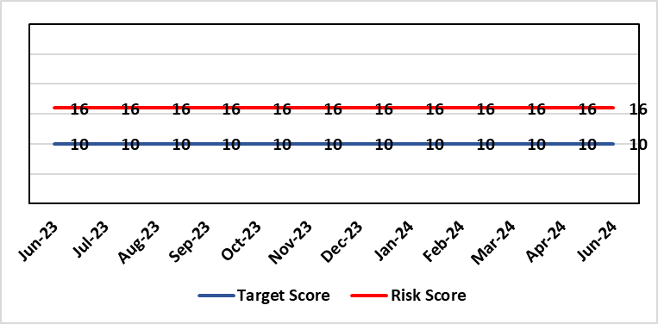 |  | Rationale for current score:  C – Reliance on digital ways of working has increased. Loss of IT service has a greater impact on ability to provide clinical care. Lack of investment in new digital solutions to make services more effective will mean clinical service provision will become unsustainable.  L- Reduction in capital funding in 2022/23/24 has increased the likelihood of HB not being able to replace aging infrastructure such as the network equipment. There is a £15m capital requirement over the next 3 years. Acceleration of the CTM SLA disaggregation has been proposed and there are further pressures on revenue funding. The shift to cloud and software as a service contracting models will increase the requirement for revenue funding to deliver digital transformation and ongoing services.
Rationale for target score:
C – Of failure will increase as the reliance and proliferation of the use of digital solutions increases.
L – Investment will mean the support mechanisms, rate of failure and ability to deliver solutions that meet the needs of users will improve sustainable digital services. There will however always be an inherent risk of failure of IT solutions.
Level of Control
= 50%
Date added to the HB risk register
2012
Controls (What are we currently doing about the risk?) |  |  | Mitigating actions (What more should we do?)
- Digital Strategy has been approved by the Health Board and outlines requirements  - HB Capital priority group considers digital risks for replacement technology which is fed into the annual discretionary capital plan  - Digital Services prioritisation process is in place Digital Leadership Group provides the overarching governance to the delivery of the Digital Strategic Plan including financial considerations.  - Digital Services Management Group assesses current service provision and flags risks and issues  - Digital Services revenue requirements are included in 2023/24 annual plan |  |  | Action | Lead |  | Deadline
 |  |  | Refresh the Digital Strategy including a high level investment plan to set out vision for the Health Board | Assistant Director of Digital: Business Management and Information Governance |  | 31/09/2024
Assurances (How do we know if the things we are doing are having an impact?)  - Internal Audit Program assesses Digital in 4 areas annually |  |  | Gaps in assurance (What additional assurances should we seek?)  - Lack of certainty over future capital and revenue funding streams makes planning and implementation difficult/less effective.
Additional Comments / Progress Notes
15/03/2024 – Digital Strategy redevelopment process has completed. The strategy will go to Board for approval in May 2024
11/04/2024 – The 10-year investment plan has been drafted. A 3-year plan has been submitted to WG via DHCW. The draft Digital strategy includes the 10-year investment plan. The Strategy will be finalised and taken through the Health Board’s governance processes for approval over the coming months.
10/05/2024 – The Digital Strategy will be presented and approved by the Health Board in July 2024.
10/06/2024 – Action 1 target date extended to 30/09/2024.

Datix ID Number: 1043  Health & Care Standard: |  |  | HBR Ref Number: 36  Risk Target Date: TBC |  | Current Risk Rating  4 x 4 = 16
Objective: The delivery of care is supported by innovative digital solutions |  | BAF Ref: 4 | Director Lead: Matt John, Director of Digital  Assuring Committee: Workforce OD & Digital Committee  For information: Quality & Safety Committee
Risk: Paper Record Storage  Lack of a single electronic record means there is greater reliance on the provision of the paper record. If we fail to provide adequate storage facilities for paper records, then this will impact on the availability of patient records at the point of care. Quality of the paper record may also be reduced if there is poor records management in some wards. There is an increased fire risk where medical records are stored outside of the medical record libraries. |  |  | Date last reviewed: June 2024
Risk Rating  (consequence x likelihood):  Initial: 4 x 5 = 20  Current: 4 x 4 = 16  Target: 3 x 3 =9 | 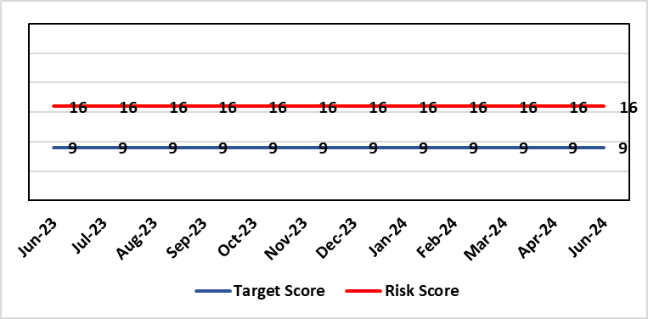 |  | Rationale for current score:  C - Inability to find records for patients could delay care/increase length of stay over 15 days. Could also mean patients receive incorrect treatment. Increased risk of fire where records are stored outside of the medical record libraries.  L - we know this happens from incidents raised
Level of Control  = 70% |  |  | Rationale for target score:  C - The increased development and adoption of the digital record will reduce the need for the paper health record being available at the point of care.  L - The increased development and adoption of the digital record, the introduction of RFID and the approach to management of the paper record identified in the Business case process should reduce the amount of paper required to be stored and managed.
Date added to the HB risk register
June 2016
Controls (What are we currently doing about the risk?) |  |  | Mitigating actions (What more should we do?)
- There is a plan in place to increase the functionality of the electronic record to document patient care. The delivery of the plan is overseen by the Digital Leadership Group and progress provided to Management Board. (Supported by individual project boards as appropriate).  - Records managed by the Medical Records libraries are RFID tagged and location tracked.  - Medical Record libraries are regularly risk assessed for fire by health and safety.  - Alternative offsite storage arrangements have been identified.  - All records must be documented on the Information Asset Register (IAR). |  |  | Action | Lead |  | Deadline
 |  |  | Awaiting WG approval for Health Records Business Case | Head of Health Records & Clinical Coding |  | 30/06/2024
 |  |  | Requirement for legal agreement with landlord once approval from WG received | Head of Health Records & Clinical Coding |  | 30/06/2024
Assurances (How do we know if the things we are doing are having an impact?)  - RFID has been implemented for the acute record improving the management and storage of records  - Health Records performance reports developed in line with RFID technology  - Attainment of the Tier 1 Health Board target for clinical coding completeness which relies on the timely availability and quality of the Paper record and electronic sources  - Monitoring complaints and incident reporting.  - Electronic record is being implemented in accordance with the plan eg implementation of WNCR, ETR, HEPMA etc. |  |  | Gaps in assurance (What additional assurances should we seek?)  Investment required supporting the delivery and operational costs of the Digital strategy.  Reliance on DHCW for delivery of the solution for a fully electronic patient record.  Impact of the Infected Blood Enquiry on the Health Boards ability to destroy notes.  Process for ensuring clinical adoption of electronic ways of working and cessation of adding information to the paper record that is already available electronically needs to be agreed and enforced by the Health Board.  Impact of the infected Blood Inquiry on the health boards ability to destroy notes and the change in the records code of practice is being reviewed by the Director of Digital.
Additional Notes
09/04/2024 - Business Case for Centralisation project approvals to date: Business Case Assurance Group 30th Jan 24, Management Board 13th March 24 & Health Board 28th March 24.
07/05/2024 - Chairs Action received by Director of Digital, Executive Medical Director and Director of Corporate Governance which endorsed the removal of the non-adherence of patients with long term conditions as a recommendation within the revised NHS Records Management Code of Practice for Health & Social Care 2023
05/06/2024 - Update on Actions 1 & 2 -Submission has already been made to WG. Update discussions with NHS finance, awaiting approval 05/06/2024. Necessary legal discussions almost complete for all parties. Can only complete once WG approval received.

Datix ID Number: 1217  Health & Care Standard: |  |  | HBR Ref Number: 37  Risk Target Date: 30th June 2024 |  | Current Risk Rating  4 x 3 = 12
Objective: The delivery of care is supported by innovative digital solutions |  | BAF Ref: 4 | Director Lead: Matt John, Director of Digital  Assuring Committee: Workforce OD & Digital Committee
Risk: Operational and strategic decisions are not data informed:  - Business intelligence and information already available is not utilised  - Users are unable to access the information they require to make decisions at the right time  - Gaps in information collection including patient outcome measures |  |  | Date last reviewed: June 2024
Risk Rating  (consequence x likelihood):  Initial: 4 x 3 = 12  Current: 4 x 3 = 12  Target: 4 x 2 = 8 | 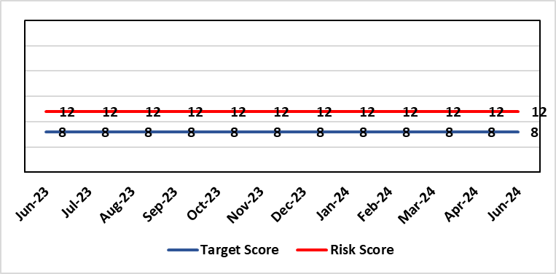 |  | Rationale for current score:  C – Opportunity cost of not acting on data could mean opportunities for improvement are missed, failures are not identified in a timely manner resulting in adverse national publicity and/or delays in care/increased length of stay.  L - Dashboard utilisation is lower than would be anticipated. Management Board have approved the investment for 4 BI partners to work with the SDGs to become more data driven.
Level of Control  = 70% |  |  | Rationale for target score:  C- Will remain the same or increase due to increased reliance in information  L- Investment in BI will lead to more information be available and used. The higher the use of information at operational level will lead to better quality data.
Date added to the HB risk register: June 2016
Controls (What are we currently doing about the risk?) |  |  | Mitigating actions (What more should we do?)
- BI partner roles have been funded and will be introduced to support the SDGs to become more data driven.  - COVID19 Dashboards Developed and utilised to inform the decision making process at Gold  - The Health Board has invested in interactive dashboards with the addition of the Power BI Business Intelligence software and infrastructure to support it.  - 33 dashboards in place including Cancer, Patient Flow, Outpatients, Mortality, Clinical Variation, Primary & Community Care Delivery Unit Dashboard and Ward Dashboard  - Safety Huddle implemented in Morriston has improved data quality and improved operational working  - Information Dept. working with Planning and Finance leads to develop meaningful indicators, utilising dashboards to present information in a user friendly way  - New technologies being reviewed for advanced analytics and integration into a new Health Board analytics platform.  - Health Board has representation on national groups such as the Advanced Analytics Group (AAG), all Wales Business Intelligence and Data Warehousing Group and Welsh Modelling Collaborative. |  |  | Action | Lead |  | Deadline
 |  |  | Start of 2nd tranche of Data Literacy Module Manager’s Pathway program | Assistant Director of Digital Intelligence |  | Completed
 |  |  | Certified Analytical Programme with access to self- service datasets | Assistant Director of Digital Intelligence |  | 30th June 2024
 |  |  | Three additional Data Literacy and Power BI Modules to be created and offered on ad-hoc basis. | Assistant Director of Digital Intelligence |  | 31st July 2024
Assurances (How do we know if the things we are doing are having an impact?)  More evidence based and proactive decisions being made.  Dashboard technology; assist in developing indicators / triangulating information to identify issues |  |  | Gaps in assurance (What additional assurances should we seek?)  Culture of the organisation needs to change to focus on information and Business intelligence for operational rather than reporting purposes. Capability of operational staff to utilise the tools and capacity to act on the intelligence provided.
Additional Comments / Progress Notes
01/05/2024 - Successful recruitment of BI Partner with start date end of May - action marked as completed. Monthly meeting invites sent to HCSE, VBHC and other reps to share learning. Have added another action around certified analytics programme - to give advanced users access to self-service data sets.
11/06/2024: Action completed: Start of 2nd tranche of Data Literacy Module Manager’s Pathway programme.

Datix ID Number: 1759  Health & Care Standard: |  |  | HBR Ref Number: 51  Risk Target Date: TBC | Current Risk Rating  4 x 3 = 12
Objective: Care is high quality, safe, efficient, and delivers the best possible outcomes for people |  | BAF Ref: 2.1 | Director Lead: Gareth Howells, Executive Director of Nursing  Assuring Committee: Workforce OD & Digital Committee
Risk: Non Compliance with Nurse Staffing Levels Act (2016) – Section 25B Wards  The Nurse Staffing Levels (Wales) Act 2016 (NSLWA) legally requires the health board to make provision for appropriate nurse staffing levels within their nursing services. In accordance with section 25B, there is a duty to calculate nurse staffing levels in adult and paediatric acute medical and surgical inpatient wards. There is a risk we may not meet these requirements fully due to increased acuity, unplanned staff absence and vacancies. The potential impact of this maybe non-compliance with the ‘Act’, poor patient outcomes and experience, and suspension of services. |  |  | Date last reviewed: June 2024
Risk Rating  (consequence x likelihood):  Initial: 4 x 4 = 16  Current: 4 x 3 = 12  Target 3 x 2 = 9 | 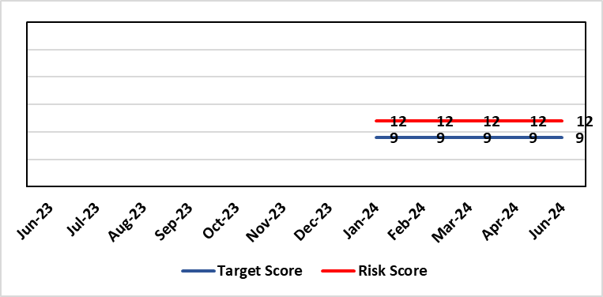 |  | Rationale for current score:  - The scope of the risk has been reviewed to disaggregate the 25B reportable wards as part of the NSLWA to enable clearer identification of risk of non-compliance with the’ Act’ from the aggregated risk across all nurse staffing areas of inadequate staffing levels previously scored 20.  - There has been a steady decline in the number of vacancies across the 25B wards as a result of successful international recruitment and student streamlining  - The Service Group risk assessments for 25B wards reported at the NMSSAIG 24.03.2024 are as follows:  - Morriston Service Group – 9 (unchanged)  - NPTSSG – 9 (unchanged)  - Paediatrics: In-patient wards – 16 (unchanged)
Level of Control  = |  |  | Rationale for target score:  - The health board has the required structures and processes in place to provide reassurance to the Board that SBUHB is compliant under the Act and as such are allocating resources accordingly.  - Health boards are duty bound to take all reasonable steps to maintain nurse staffing levels.  - Ward skill mix, recruitment and induction plans impacting on ward  - Projected continued decrease in vacancies by end of 2024.
Date added to the HB risk register
November 2018
Scope Refreshed:
January 2024
Controls (What are we currently doing about the risk?) |  |  | Mitigating actions (What more should we do?)
The Health board has put the following controls in place:  - The designated person as part of the requirements of the ‘Act’ is the Executive Director of Nursing & Patient Experience  - The responsibility for decisions relating to the maintenance of the nurse staffing level rests with the health board is based on evidence provided by, and the professional opinions of the Executive Directors with the portfolios of Nursing, Finance, Workforce, and Operations  - Bi-annual calculations undertaken across all Section 25B wards using the triangulated methodology which Service Groups formally present at Executive led scrutiny panels with representation from Nursing, Workforce and Digital and Finance Colleagues.  - The Ward Sister / Charge Nurse, Senior Nurses and Group Nurse Director continuously assess the situation and keep the designated person formally apprised  - The health board has representation at the All-Wales Nurse Staffing Group and its sub groups to ensure the organisation is aware of national updates  - The Board receive a bi-annual report - May (agreed Once for Wales) and November (mandatory). The 3 yearly mandatory paper to Welsh Government is due May 2024.  - Workforce planning & redesign, training and development. Recruitment and retention continues. HB Workforce Group has been set up and links to HEIW Retention Work stream, HB representatives on HEIW Group are Associate Head of HR, Recruitment and Retention Manager and Matron, Corporate Recruitment. Workforce plans have been developed by Service Group Nurse Directors and each Service Group agrees staffing, with consideration of all reasonable steps to maintain the nurse staffing level  - Work assessing the impact of the 'Team around the Person' continues on a HB and All Wales basis.  - Rostering Policy - the Service Groups have a robust roster scrutiny process that is undertaken to ensure roster efficiency and appropriate utilisation of temporary staff.  - The health board has a nursing retention plan and actively supports the Retire and Return policy.  - SafeCare has been implemented, the All Wales SOP remains a working document as understanding evolves.  - Service Groups continue daily staffing huddles and daily staffing tool and escalate as appropriate. |  |  | Action |  | Lead | Deadline
 |  |  | Student Streamlining and Overseas recruitment |  | Executive Director of Nursing | 31/12/2024  Monthly ongoing
 |  |  | Review of workforce, consider more diverse skill mix, including development of Band 3 and Band 4 roles. Bi-annual re-calculations of inpatient wards have resulted in the addition of Band 3 and 4 roles within the NSA templates. These posts are being recruited into, there is a need for training and supervision for these new posts. Development of Service Group workforce plans to support an overall Corporate Workforce Plan. |  | Executive Director of Nursing | 31/12/2024
Assurances (How do we know if the things we are doing are having an impact?)  - Ongoing robust recruitment and retention plans in place to reduce vacancies in key clinical areas.  - Accurate reporting of acuity data and governance around sign off.  - Agreed establishments are funded.  - E-Rostering implemented and roster scrutiny undertaken, ensuring effective staff allocation.  - All Wales Templates are visible informing patients/visitors of planned roster on all Section 25B wards. Patient Information available on all Section 25B wards, Service Groups have access to all HEIW documents via a SharePoint  - Bi-annual Board reports, provide assurance and outline compliance and any key risks, submitted in November and May each year, with three yearly report to Welsh Government due May 2024.  - The Health Board Nursing and Midwifery Safe Staffing Assurance and Improvement Group (formally the Nurse Staffing Act Steering Group, amended July 2023) meets on a bi-monthly basis, ensuring risks from all Service Groups are presented, discussed and escalated as appropriate at each meeting. This group is chaired by an Associate Director of Nursing and reports to Nursing and Midwifery Board and the Workforce, Organisational Development and Digital Committee  - Service Group risk assessments have been updated and disaggregated into 25B and 25A areas to enable clear risk assessment and escalation of specific risks to ensure robust governance and risk assurance  - There is a clear process for scrutiny during bi-annual re-calculations and at any other time when wards require a re-calculation, for example: change to ward purpose, increased bed numbers or increase patient acuity  - SafeCare system has been implemented. Support given to help embed the system into everyday use. Use of SafeCare linked to daily staffing huddles.  - Historical information and all reporting templates available on a share drive |  |  | Gaps in assurance (What additional assurances should we seek?)  - Issue remains regarding Information Technology barriers around the capture of data required for the Act on an All- Wales and Health Board basis. All Wales work with Allocate (Safecare) to improve reporting capabilities of Safecare, via a dashboard continued to progress, SBU is pilot site for testing. Update to Allocate system received, working with rostering team and BCU NSA Lead to check accuracy of reporting.  - Ongoing work across Wales to ensure IT systems are compatible with each other for operational and reporting purposes.
Additional Comments / Progress Notes
Section 25B wards covered by this risk:
NPTSSG |  | Morriston Service Group
Ward 2  Ward 4  Ward 12  Ward A  Ward E  Paediatric: Ward M and Oakwood Ward |  | Ward A, B, W and Clydach Ward  Ward C, Cyril Evans Ward, Dan Danino Ward  Powys Ward, Tempest Ward  Cardigan Ward  Ward K, L, R, T and Pembroke Ward  Ward D, E, F, G, H, J, S and Gower Ward
For information – 25A areas not covered by this risk include (These are managed within Service Groups and would be escalate for Executive consideration as appropriate).
Morriston Service Group | NPTSG | Mental Health & Learning Disabilities | Community Areas
Critical care areas – GITU & CITU  Short stay and assessment areas  AMU,SDMU  Emergency Department | Neonates  Theatres  Ward B, C, D NPTH | Mental Health and Learning Disabilities | District Nursing  Health Visiting  Gorseinon Hospital  Ty Olwen
Midwifery is not covered as part of the NSLWA – Refer to Midwifery Staffing Risk ID 2788 (HBR 81)
24/01/2024: Discussed and agreed in Nurse and Midwifery Safe Staffing Assurance and Improvement Group (NMSSAIG) on 24th January 2024.
The scope of this risk has changed. The description has been refreshed to clarify that only those services covered under Section 25B of the Act are within its scope.
Work is being undertaken to review risks in services outside this section of the Act (including Neonates and MH&LD where staffing level risks have been highlighted previously) in order to reflect separately on HBRR as appropriate. This also includes ensuring the relevant clinical services achieve the required standards set out in the all Wales district nursing and mental health principles as well and the BAPM standards for Neonatal Units and Birth rate plus,
27/03/2024: Risk reviewed and confirmed no change.
19/06/2024: Risk reviewed at Nursing Assurance Meeting 20.5.24 and remains the same as an aggregated score. To note the risk score for Paediatric Wards was increased by the Service Group to 16 as a result of skill mix challenges. The Service Group have a mitigation plan and trajectory to deescalate.

Datix ID Number: 2788  Health Care Standards: |  |  | HBR Ref Number: 81  Risk Target Date: 30/10/2024 |  | Current Risk Rating  5 x 4 = 20
Objective: Maternity Services |  | BAF Ref: 2.8 | Director Lead: Gareth Howells, Executive Director of Nursing  Assuring Committee: Quality & Safety Committee  For Information: Workforce OD & Digital Committee
Risk: Critical staffing levels – Midwifery  Unplanned absences resulting from long and short-term sickness, alongside maternity leave, have resulted in critical staffing levels, which undermine the ability to maintain the full range of expected services safely, increasing the potential for harm, poor patient outcomes and/or choice of birthplace. Poor service quality or reduction in services could impact on organisational reputation. |  |  | Date last reviewed: June 2024
Rationale for current score:
The vacancy position has improved further and for Band 5 & 6 registered staff there are no vacancies. Some aspects of service provision continue to be suspended and this is subject to review currently. In view of this the risk was reduced from 25 to 20 initially. Whilst the service is now over-established with registered midwives, the score remains as high risk (20) due to unregistered vacancies (which we are recruiting to) and unavailability (due to parenting leave and sickness). There are improved numbers of registered midwives per shift with most shifts achieving the required 14 midwives. Additional staff required in AAU to ensure two on duty at all times.
Risk Rating  (consequence x likelihood):  Initial: 4 x 5 = 20  Current: 5 x 4 = 20  Target: 4 x 4 = 16 | 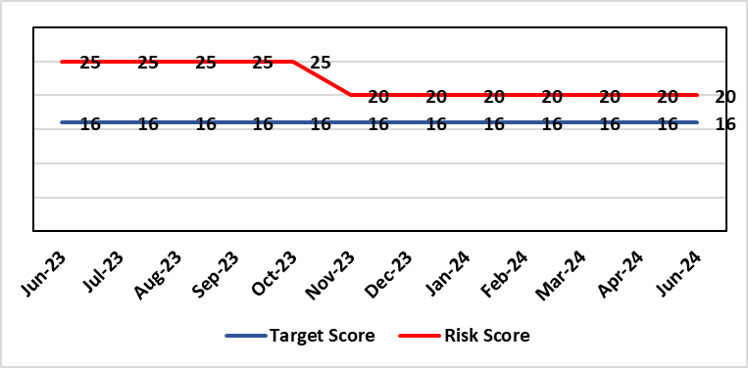
Level of Control  = % |  |  | Rationale for target score:  It is intended that through actions currently identified to address vacancies we can reinstate services fully and reduce the likelihood of the need to suspend elements further.
Date added to the risk register
12/10/2021
Controls (What are we currently doing about the risk?) |  |  | Mitigating actions (What more should we do?)
- Service Group Nurse Director chairs fortnightly roster scrutiny meetings to ensure effective deployment of staff.  - All midwives are working at the hours they require up to full time.  - Specialist midwives and management redeployed to support clinical care as required  - Birth rate plus Intrapartum acuity tool completed 4 hourly to guide safe service provision and escalation  - Escalation meeting held daily during the week to review rotas and reallocate staff as required chaired by Head of Midwifery  - Morning safety huddle for community midwifery teams  - Morning safety huddle for obstetric unit generates RAG-rated daily acuity and shares this with the Service Group for its daily meeting.  - Additional shifts offered via Bank, additional hours and overtime at enhanced rates  - Utilisation of off-contract midwifery agency authorised by Executive Director of Nursing  - Open advert for recruitment on TRAC (recruitment system)  - On-Call Manager Rota in place.  - Continue to suspend services in the FMU (Freestanding Midwifery Unit) at Neath Port Talbot Hospital.  - International recruitment campaign initiated with MEDACS.  - Offer of additional support worker shifts particularly in the postnatal area for additional support for women  - Maternity Care Assistance (MCA) role in place to support Midwives in providing care in women and their families.  - Regular communication with stakeholders includes: Early warnings to Welsh Government; Verbal and formal communication with Llais; Internal communications on home births, RCM updates; weekly staff briefings and bulletins.  - Maternity Services Improvement & Assurance Board has been instated, meeting fortnightly, chaired by NPTS Nurse Director. This will report into the Midwifery & Neonatal Service Performance Board in place chaired by EDON |  |  | Action | Lead |  | Deadline
 |  |  | Advertising for Community Team Leaders (Band 7) to support plans to re-open services in Neath Port Talbot. Three in post, but further interviews taking place in April with expected start end June. | Community Matron / Consultant Midwife |  | Complete
 |  |  | Recruitment of 5 WTE (whole time equivalent) Band 2 HCA (health care assistant) positions at Singleton: Some staff in post – start dates expected for others in May. | Obstetric Matron |  | Complete
 |  |  | Gateway review in place in relation to reinstatement of community services, first point is recruitment of band 7 community team leaders. Paper to go to Management Board. | HOM |  | Complete
 |  |  | Seventeen newly qualified midwives through streamlining to commence employment form October 2024 onwards. Expect to be in post by December 2024. | HOM |  | 31/12/2024
 |  |  | Business case to support implementation of BSOTS (Birmingham Symptom Specific Obstetric Triage System) in the Ante Natal Assessment Unit to be developed. The service plans to implement a new AAU pathway and documentation process. | DHOM |  | 30/09/2024
Assurances (How do we know if the things we are doing are having an impact?)  The following assurance mechanisms in place currently:  Birth-rate Plus Intrapartum acuity tool completed 4 hourly  Daily staff escalation meetings chaired by Head of Midwifery which considers sickness & other absences and daily review of safety and quality outcomes. The Group Head of Quality Safety & Risk is supporting daily oversight of Datix incidents. The following red flag events are monitored:  • Delayed or cancelled elective caesarean sections;  • Missed or delayed care incidents;  • Delayed or cancelled induction of labour;  • Delay of 2 hours or more between admission for induction of labour and beginning of process;  • Delay of 30 minute or more between presentation and triage.  Birthrate Plus assessment outcome (last internal assessment Oct 2023 – now compliant) |  |  | Gaps in assurance (What additional assurances should we seek?)
Additional Comments / Progress Notes
01/07/2024: Action completed: Gateway review in place in relation to reinstatement of community services, first point is recruitment of band 7 community team leaders. Paper has been to Management Board. Following discussion there issues have been raised by staff side requiring further consideration. This is subject to review currently by the service and Executive Team.
Action completed: Recruitment of 5 WTE (whole time equivalent) Band 2 HCA (health care assistant) positions at Singleton: All five now in post.
Action Completed: Community Team Leaders (Band 7) to support plans to re-open services in Neath Port Talbot. All in post.

Datix ID Number: 3071  Health Care Standards: |  |  | HBR Ref Number: 89  Target Risk Date: 31/07/2024 | Current Risk Rating  4 x 5 = 20
Objective: Primary & Community Care |  | BAF Ref: 2.2 | Director Lead: Gareth Howells, Executive Director of Nursing  Supporting Director: Deb Lewis, Chief Operating Officer  Assuring Committee: Quality & Safety Committee
Risk: Healthcare Nursing Staff Levels at HMP Swansea  There is a risk that the men in HMP Swansea will not receive the appropriate standard of care. This is due to the fact that the nursing establishment within the prison no longer fully meets the changed demographics and numbers of men being detained. The maximum operational capacity of the Prison can reach circa 480 men. The Health Board investment into the Prison is based on delivering services to 250 men. This was also highlighted as a risk in the June 2022 HIW governance review. In addition there is no head room built into the Prison nursing establishment so periods of sickness, leave and study renders the roster short. |  |  | Date last reviewed: June 2024
Risk Rating  (consequence x likelihood):  Initial: 4 x 5 = 20  Current: 4 x 5 = 20  Target: 2 x 2 = 4 | 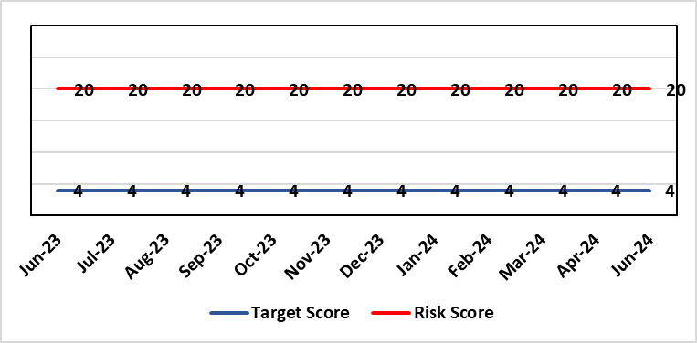 |  | Rationale for current score:  Consequence major – unable to fully deliver on the recommendations of HIW due to low healthcare staffing numbers, further impacted during periods of sickness or absence as no headroom. Recommendations also raised in Prison & Probation Ombudsman reports. Likelihood expected – suboptimal care provided on a daily basis.
Level of Control  = % |  |  | Rationale for target score:  Consequence minor – With sufficient staffing numbers the prison will be able to deliver on HIW recommendations and fully implement the actions in the Health Delivery Plan. Likelihood unlikely – With full establishment and headroom, suboptimal care is less likely.
Date added to the risk register
30/11/2022
Controls (What are we currently doing about the risk?) |  |  | Mitigating actions (What more should we do?)
Daily communication with the Governor about the availability and priority of healthcare nursing staff.  Pharmacy technician role established – can administer drugs to support nursing establishment.  Agreed that Health Care Support Workers to be 2nd checkers for CD drugs and to support substance withdrawal monitoring (awaiting accreditation).  Bank and agency staff are used in a limited way, when skillset allows.  E-roster implemented and scrutinised with regular reporting to Service Group Patient Safety & Compliance Group.  Escalation for overtime and additional hours to fill shortfalls. |  |  | Action | Lead | Deadline
 |  |  | Further baseline assessment commencing in July 2024, led by MH Substance Misuse & Vulnerable Groups Division of WG. | Healthcare Lead | 30/09/2024
 |  |  | Service Group are considering how it might reduce the risk and source additional resource | Service Group Director | 20/07/2024
Assurances (How do we know if the things we are doing are having an impact?)  Prison feedback and complaint process  Progress reporting on action plans through Service Group PS&C Group, and Health Board Q&S structures (via Patient Safety & Compliance Group). |  |  | Gaps in assurance (What additional assurances should we seek?)  Implementation and reporting of clinical audits. Audit framework for HMP Swansea in development - Clinical Pathways/Audits and Health Promotion groups taking forward.
Additional Comments
19/06/2024: Awaiting a start date for the mental health and clinical substance misuse service review. Public Health Wales have provided support to undertake the Prison Health Needs Assessment this work commenced June 2024 and will conclude September 2024. The assessment will contain data in relation to prison population health need and services delivered.
Actions completed: HCSW second checkers of CDs to be accredited externally; Fresh gap analysis to be undertaken to identify staffing shortfall and set out further proposals to address.
The service group are reviewing all services within PCT. Prison Healthcare lead will meet with Finance for review of health services baseline and nursing headroom cost. Most recent cost is £298.037 for 26.9% Nursing Headroom of which approx. £36,544 has been invested from the service group.

Datix ID Number: 2796  Health Care Standards: |  |  | HBR Ref Number: 90  Target Risk Date: 30th April 2024 |  | Current Risk Rating  4 x 4 = 16
Objective: The delivery of care is supported by innovative digital solutions |  | BAF Ref: 4 | Director Lead: Matt John, Director of Digital  Assuring Committee: Workforce OD & Digital Committee
Risk: Non-compliance with UK-GDPR Article 15 regarding Subject Access Requests (SARs), along with other health records requests for disclosure of personal data  The Health Board does not have adequate resources to deal with the sustained increase in volume and complexity of subject access /access to health records requests received from requestors. The ICO have previously been involved with a number of breaches and complaints in this area and there is the potential for future enforcement action if significant improvements are not made. Misfiling and redaction are major issues for Health Records, IG and Health Professionals. SAR breaches have led to successful compensation claims and media interest. |  |  | Date last reviewed: June 2024
Rationale for current score:
C – The Health Board has a statutory requirement to comply with UK GDPR and Data Protection Act 2018. This includes compliance with an individual’s Right to Access their personal data. The Information Commissioner has the power to take enforcement action, including substantial monetary penalties, for non-compliance. A number of complaints regarding the handling of SARs within SBUHB have been highlighted previously in both the mainstream media and on social media, leading to a loss of trust in the Health Board with damage to staff and Health Board reputation.
L- The Health Board does not have adequate resources to deal with the sustained increase in volume and complexity of SARs received from both patients and staff. There are inconsistent processes across the Health Board, with varying levels of robustness regarding legal compliance. The increased use of various digital applications has impacted the volume and complexity of content and the ability to retrieve the personal data required to comply with SARs. The process for ensuring information is appropriately reviewed and redacted by health professional within services has become far more complex and resource intensive increasing the likelihood of personal data breaches and/or non-compliance with legal timescales for disclosure. The ICO have previously been involved with a number of complaints in this area and there is an increased potential for future enforcement action if significant improvements are not made. There continues to be an increase in both the number and complexity of SARs received as data subjects become more aware of their rights and the mediums in which data are recorded expands.
Risk Rating  (consequence x likelihood):  Initial: 4 x 4 = 16  Current: 4 x 4 = 16  Target: 4 x 2 = 8 | 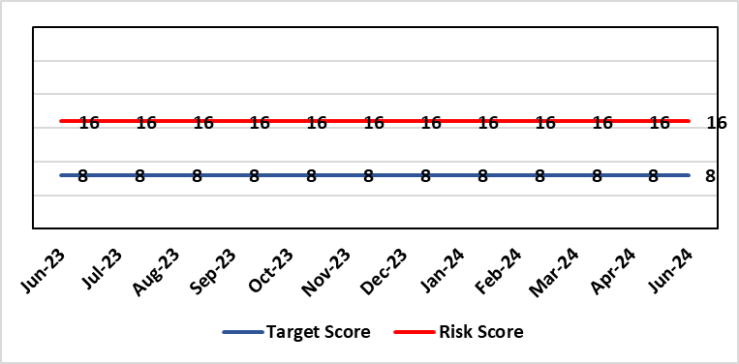
Level of Control  = 50% |  |  | Rationale for target score:  C – As above  L – Additional resources would allow the organisation to make significant improvements to the process by which SARs are managed. Being able to adequately comply with legal requirements reduces the likelihood of enforcement action and fines from the ICO, as well as minimising the risk of reputational damage.
Date added to the risk register
Jan 2023
Controls (What are we currently doing about the risk?) |  |  | Mitigating actions (What more should we do?)
- New SAR (Subject Access Request) Working Group established in February 2024  - Prioritisation of workload  - Revised SAR policy in place (to be reviewed & updated in line with Working Group actions)  - Advice sought from Legal and Risk on complex cases  - Escalating areas of concern to IGCAG (Information Governance & Cyber Assurance Group) |  |  | Action | Lead |  | Deadline
 |  |  | Undertake GAP analysis and develop action plan | Data Protection Officer |  | 31st July 2024
 |  |  | Implement priority tasks outlined within the action plan within agreed timescales | Data Protection Officer |  | 31st March 2025
Assurances (How do we know if the things we are doing are having an impact?)  - Bi-monthly IGCAG chaired by SIRO (Senior Information Risk Owner) and attended by Deputy Caldicott Guardian and Data Protection Officer  - Escalation reports from IGCAG to Management Board & Workforce OD & Digital Committee as required  - IG governance structures in place with key roles and responsibilities established e.g. SIRO, Caldicott Guardian, DPO (Data Protection Officer) |  |  | Gaps in assurance (What additional assurances should we seek?)  Recent internal audit identified the requirement to invest in resources to address gap in assurance.
Additional Comments / Progress Notes
09/10/2023 – SAR Lead starting date confirmed as the 30th October 2023.
16/11/2023 – SAR Policy approved by WODDC in October 2023. Previous action to review all SAR documentation amended to indicate re-establishment of SAR working Group to perform gap analysis.
08/02/2024 - First meeting of new SAR Working Group to take place on 8 February 2024. Terms of Reference have been agreed and an action plan is to be developed, approved and implemented with priority tasks to be given attention in the coming months.
10/05/2024 – Updated progress 2 to include entry: 08/05/24 - GAP analysis has been circulated for completion by membership of SAR Working Group to inform action plan. Comment added to reflect the above.

Risk Score Calculation

For each risk identified, the LIKELIHOOD & CONSEQUENCE mechanism will be utilised. Essentially this examines each of the risks and attempts to assess the likelihood of the event occurring (PROBABILITY) and the effect it could have on the Health Board (IMPACT). This process ensures that the Health Board will be focusing on those risks which require immediate attention rather than spending time on areas which are, relatively, a lower priority.

