Meeting Date | 21 April 2026 |  | Agenda Item |  |  | 3.4
Name of Meeting | Workforce & OD committee
Report Title | Variable pay plan overview and progress update
Report Author | Emma Owen, Assistant Director of Workforce & OD
Report Sponsor | Tina Ricketts, Executive Director of Workforce & OD
Presented by | Tina Ricketts, Executive Director of Workforce & OD
Freedom of Information | Open
Purpose of the Report | To update the committee on the variable pay reduction plan and the progress that has been made to date.
Key Issues | This report is to update the committee on the progress of the variable pay reduction plan.  Good progress has been made in reducing our reliance on variable pay this year. However, as part of our annual plan, a target has been set to reduce our variable pay in 2026/7 by 50% or the equivalent of 300wte.
Specific Action Required  (please choose one only) | Information | Discussion |  | Assurance | Approval
Specific Action Required  (please choose one only) | ☐ | ☐ |  | ☒ | ☐
Recommendations | The Committee is asked to consider the report which is provided for assurance.

VARIABLE PAY PLAN OVERVIEW AND PROGRESS UPDATES

- INTRODUCTION
Variable pay remains a key challenge for the Health Board. Whilst reductions have been achieved the Health Board continues to use high levels of variable pay.

- BACKGROUND
The Health Board must achieve £55.4m in savings in 2025/6 if it is to meet its financial plan. The Recovery and Sustainability Programme Board was established to achieve the required savings with 12 overarching workstreams. Enhanced workforce controls have been implemented in addition to a dedicated variable pay steering group.

A multi-disciplinary approach is being adopted to provide an overarching structure and cohesive approach to sustainable workforce changes focussed on:
- Variable Pay
- Staffing Unavailability
- Workforce establishment
The Variable Pay Steering Group has dedicated plans covering all professional groups that are led by Executive Directors. Overarching highlight reports are provided to the Recovery & Sustainability Board to monitor progress and ensure delivery.

- Progress in the last reporting period
The newly established workforce steering group has approved a number of plans for each professional group to address the on-going workforce challenges.

The key deliverables during February & March 2026 include:

3.1 Top 100 leaders network
The second session of the top 100 leaders Network was held on Wednesday 4th February 2026. The session was well attended and focussed on reviewing the current Health Board position, progress, and set out the steps required to deliver our in-year financial plan and associated performance, along with a clear and continued plan for 2026/2027. The session also included some sickness absence management case studies to share the best practice across the Network. There is a third session planned in April 2026 that will be centred on shared leadership, our values, and the future we are shaping together.

3.2 Enhanced vacancy management

Further control measures have been implemented on the vacancy approval process to continue to support core roles whilst further work is undertaken to achieve the right structural arrangements for the Health Board and support the headcount reduction. These include:

- New starters will be delayed (where possible) until 1st May 2026.
- Adoption of a three category “break glass” exception process.
  - Category 1 – legislative posts
  - Category 2 – Externally Funded posts
  - Category 3 – Posts that require urgent recruitment due to clinical risk.

3.3 Quality Impact Risk Assessments
Revised quality impact assessments have been adopted and will be applied to all programmes that are identified under the Health Board recovery plan to ensure that risks are identified, minimised and appropriately mitigated. All new posts will also require a corresponding quality impact assessment.

3.4 Workforce Control Governance Group
A workforce control governance group has been established to oversee the agreed schemes that directly impact on staff. The remit of the group will be to discuss and agree the approach for the workforce plans and to assist in implementation across the service groups. The workforce Control Governance Group will report into the overarching workforce steering group.

- FINANCIAL IMPLICATIONS
The information below outlines the variable pay spend. It is possible to see some continued reductions across categories however this needs to significantly reduce to achieve the savings target.

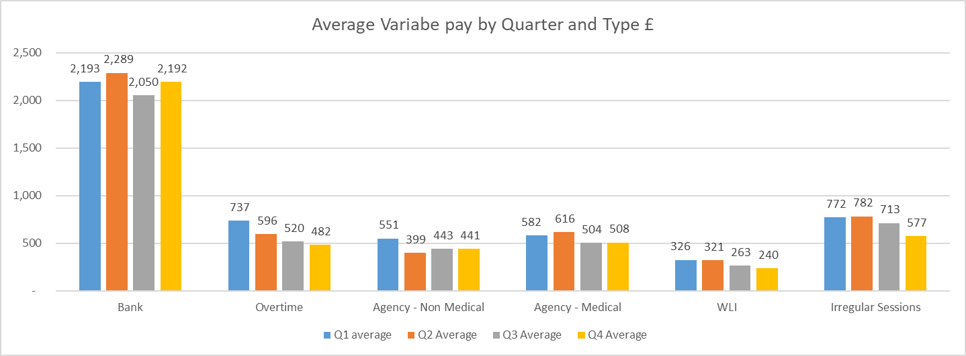

Agency
The table below outlines the whole time equivalent (WTE) usage for 2025/6 split between framework and non-framework. The increase in non framework agency use in March is due to Emergency department, Intensive Treatment Unit, Neonatal and Allied Health Professionals.

The table below outlines the agency use for Medical which confirms comparable usage to the same period in 2024 despite there being a decline in usage between August and December 2025.

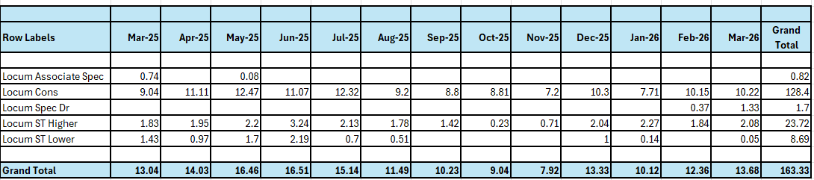

Please note that there is no off-framework agency usage recorded for medical cover.

Below is the capped rate information for internal medical locums and agency for January, February & March 2026. Please note that data for March 2026 may change due to corrections being applied for pay processing periods.

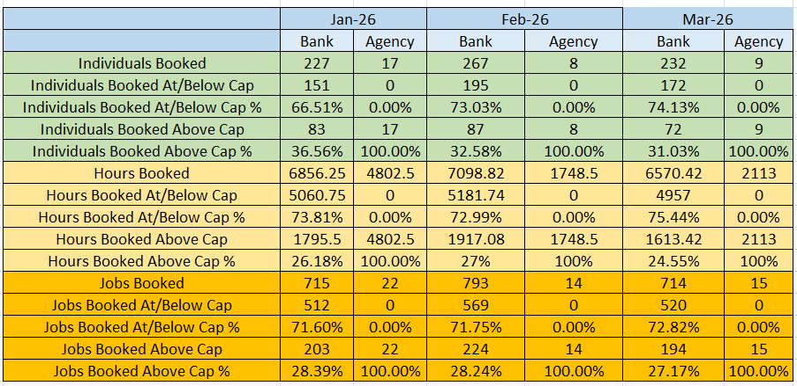

- RECOMMENDATION
The committee is asked to consider the report which is provided for assurance.

Governance and Assurance

Link to Enabling Objectives  (please choose) | Supporting better health and wellbeing by actively promoting and empowering people to live well in resilient communities
Link to Enabling Objectives  (please choose) | Partnerships for Improving Health and Wellbeing |  | ☒
Link to Enabling Objectives  (please choose) | Co-Production and Health Literacy |  | ☐
Link to Enabling Objectives  (please choose) | Digitally Enabled Health and Wellbeing |  | ☐
Link to Enabling Objectives  (please choose) | Deliver better care through excellent health and care services achieving the outcomes that matter most to people
Link to Enabling Objectives  (please choose) | Best Value Outcomes and High Quality Care |  | ☒
Link to Enabling Objectives  (please choose) | Partnerships for Care |  | ☐
Link to Enabling Objectives  (please choose) | Excellent Staff |  | ☒
Link to Enabling Objectives  (please choose) | Digitally Enabled Care |  | ☐
Link to Enabling Objectives  (please choose) | Outstanding Research, Innovation, Education and Learning |  | ☐
Health and Care Standards
(please choose) | Staying Healthy |  | ☐
(please choose) | Safe Care |  | ☐
(please choose) | Effective Care |  | ☒
(please choose) | Dignified Care |  | ☐
(please choose) | Timely Care |  | ☐
(please choose) | Individual Care |  | ☐
(please choose) | Staff and Resources |  | ☒
Quality, Safety and Patient Experience
Engaged motivated and health staff will impact on patient care and clinical outcomes.
Financial Implications
We need to reduce our variable pay by £34.5m if we are to meet the financial target set by the Government.
Legal Implications (including equality and diversity assessment)
None identified.
Staffing Implications
Staffing issues will impact on both the quality and financial sustainability of services.
Long Term Implications (including the impact of the Well-being of Future Generations (Wales) Act 2015)
Best use of resources.
Report History |  | Not applicable
Appendices |  | None

