Meeting Date | 10th April 2025 |  | Agenda Item |  |  | 4.3
Name of Meeting | Workforce and OD Committee
Report Title | Oversight of Medical Professional Affairs
Report Author | Liz Wonnacott, Head of Service – Medical Director  Dr Anjula Mehta, Deputy Medical Director
Report Sponsor | Dr Richard Evans, Executive Medical Director
Presented by | Dr Anjula Mehta, Deputy Medical Director
Freedom of Information | Open
Purpose of the Report | The purpose of the report is to provide assurance as to the structures in place to oversee professional affairs within the health board.
Key Issues | - All health boards and NHS trusts are required to have a Responsible Officer (RO), which is a senior, licenced medical professional who ensures clinicians are working within their licence requirements;  - In NHS Wales, this role is allocated to the Executive Medical Director (in other home nations, it can be delegated to someone within their senior structure, such a deputy);  - At the October 2024 Workforce and OD Committee meeting, a briefing was requested as to the way in which professional affairs are managed in the health board;  - The report focuses on managing concerns around professional behaviours and revalidation as these are the key areas for professional affairs;  - Oversight of these is through the Responsible Officer Advisory Group (ROAG) which reports to the Workforce and OD Committee and this report is an introduction into a ‘new look report’ for that committee;  - A recent review of governance arrangements has been undertaken which has led to a number of improvements including the introduction of professional advisory groups in the service groups, a new reporting format to ROAG and workshops to enhance the awareness of professional concerns for clinical leads and directors.
Specific Action Required  (please choose one only) | Information | Discussion |  | Assurance | Approval
Specific Action Required  (please choose one only) | ☐ | ☐ |  | ☒ | ☐
Recommendations | Members are asked to:  - ACKNOWLEDGE the role of the Responsible Officer and that this resides with the Executive Medical Director;  - ACKNOWLEDGE recent improvements made within the governance and assurance processes to strengthen the management of any professional concerns raised about doctors in Swansea Bay.  - BE ASSURED that robust processes are in place to oversee and manage professional concerns  - BE ASSURED a structure is in place to manage the revalidation of doctors for them to retain their GMC licence;  - ACKNOWLEDGE that quarterly report will be provided to the Workforce and OD from the ROAG which will encompass high-risk medical cases and revalidation and appraisal updates into one report.

OVERSIGHT OF MEDICAL PROFESSIONAL CONCERNS

- INTRODUCTION
The purpose of the report is to provide assurance as to the structures in place to oversee professional affairs within the health board.

- BACKGROUND
Maintaining high professional standards of doctors and dentists employed in Swansea Bay is vital to maintain safe and high quality patient care, service efficiency, improved outcomes and will provide confidence to patients.

All health boards and NHS trusts are required to have a Responsible Officer (RO), which is a senior, licenced medical professional who ensures clinicians are working within their licence requirements. In NHS Wales, this role is allocated to the Executive Medical Director (in other home nations, it can be delegated to someone within their senior structure, such a deputy).

The main components are to ensure:
- Patient safety – doctors are maintaining and developing their standards of care and performance;
- Effective care – ensuring doctors are fit to practice and have the appropriate skills, training and experience for their role;
- Patient experience- enable patient feedback and views to be a valid part of performance appraisals.

All doctors are legally required to be registered with the General Medical Council (GMC) in order to retain their licence to practice. Upon doing so, those working within NHS Wales will be assigned a designated body - this will be the organisation for which they work – and the relevant RO.

As doctors do not come under agenda for change, there are three key national guidelines to which to refer:

- The GMC’s (General Medical Council) Good Medical Practice framework which sets out professional standards and outlines the values, knowledge, skills and behaviours expected of all doctors, PAs and AAs working in the UK.
- Upholding Professional Standards in Wales (UPSiW) which sets out the approach for addressing concerns about capability, performance and conduct for all doctors and dentists
- GMC appraisal and revalidation guidance for doctors. The RO ensures there are clinical governance and quality assurance systems in place for all doctors who work in their organisation – and monitor, act and report on these

As such, it is key that the health board maintains robust relationships with its designated liaison officers within the GMC, General Dental Council (GDC) and NHS Resolutions, who provide support around UPSiW. Regular meetings take place between the health board and its liaison officers to update on ongoing cases and seek advice on more complex issues.

At the October 2024 Workforce and OD Committee meeting, a briefing was requested as to the way in which professional affairs are managed in the health board with oversight of the RO. This report describes the legal, contractual and professional frameworks available to maintain high professional standards within the medical workforce. This includes the management of any professional concerns relating to conduct or capability which are not aligned with the standards set within the Good Medical Practice guidance issued by the GMC and/or fall outside of expected best practice resulting in substandard clinical practice.

There have been a number of improvements made to strengthen the governance and assurance processes in the management of professional concerns which are listed in this paper. The report also describes the current governance processes in place in to ensure compliance with contractual and professional appraisal and revalidation requirements.

- GOVERNANCE AND RISK ISSUES
As part of the governance for the RO role, the health board has a Responsible Officer Advisory Group (ROAG). A body within Swansea Bay that provides formal advice to the RO on the management of doctors’ performance, appraisal and revalidation. This meets monthly and receives an update on all high-level or high-risk professional cases which have been escalated from the service groups for advice and guidance on what next steps should be taken in the management of professional concerns.

Possible outcomes would be
- Continue current management within service group’s Professional Advisory Group (PAG);
- New or amendments to existing action plans;
- Commence UPSiW process;
- GMC referral;
- Restricted practice to mitigate identified risks;
- Exclusion.

Service groups medical directors and/or respective clinical leads/directors are invited to ROAG to provide progress updates on any action plans or present new cases.

Any doctors within UPSiW are discussed and monitored within ROAG to ensure a timely, transparent and fair approach is taken. Planned or completed investigations undertaken under UPSiW will be reported to ROAG including the terms of reference, methodology, report findings and recommendations for endorsement and next steps. Any advice received from the GMC and/or NHS Resolutions will also be reported to the group.

- Professional Concerns
Current processes have been reviewed and developed to support a fair and proportionate management of concerns about doctors across the health board with a focus on early intervention and prevention and effective use of the low-level concerns processes. This will ensure that any disruptive and unprofessional behaviour is addressed promptly and consistently offering meaningful support and advice to the medical professional. The aim is to avoid any repetition or pattern of this behaviour and reduce potential outcomes of implementing restrictions to clinical practice or exclusions as a result of UPsiW processes.

The Vanderbilt Health Center for Patient and Professional Advocacy (CPPA) in America has partnered with hospitals and health systems in more than 300 sites with over 200,000 professionals, in conducting research, training peer professionals, and developing the tools and processes to identify, intervene, and support the 2.5 to 4% of the professional workforce who display professional concerns which threaten outcomes of care.

An outcome of the research undertaken at Vanderbilt is the development of the Vanderbilt Professional Accountability Pyramid which has provided the basis of the approach taken in Swansea Bay to manage professional concerns. This aligns with the health board’s 10-year vision of a high-quality organisation which treats staff compassionately as well as provides a freedom with which to raise concerns.

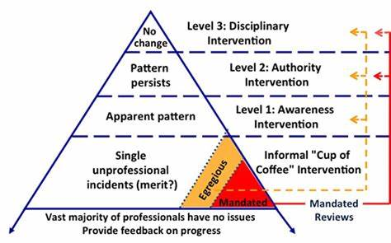

For one-off isolated and low-level concerns, sharing begins with a respectful, non-judgmental, peer delivered “cup of coffee”. This informal supportive intervention allows a discussion with the individual professional and their trusted colleague such as the service manager or clinical lead/director. This is an opportunity for the doctor to hear why the behaviour was wrong and to reflect and respond. Often they will not realise the issue until it is highlighted.

If subsequent reports suggest emergence of a pattern, the pyramid directs escalation to an “awareness” intervention, delivered by a trusted colleague within the department supported by the departmental senior management team. This informal intervention should be supported by specialty specific comparison data or reference to professional standards to encourage the professional to pause and reflect why their practice seems to stand out. During this discussion, reasons for the behaviour can be identified and an informal action plan developed to address the concerns. The action plan should include relevant support, CPD (continuous professional development), advice regarding health and wellbeing support, follow up or provision of a point of contact.

For the small number of clinicians who are unable or unwilling to respond, combining leader directed corrective action plans with appropriate resources for these professionals including coaching, health screenings, and potentially treatment, encourages action prior to the need for disciplinary interventions and associated consequences.

The health board has transferred the escalation stages into a governance structure which gives clarity on its approach of managing professional concerns. Although any concerns or complaints received directly via GMC, safeguarding team or police sit outside this framework and will directly entered and overseen within ROAG.

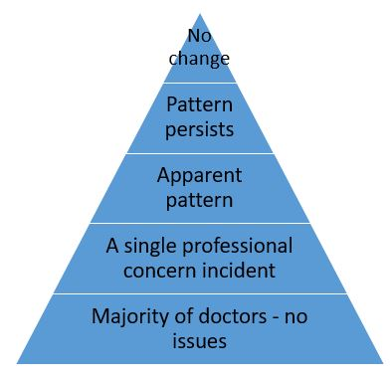 |  | Referral to ROAG
 |  | Referral to Service Group PAG
 |  | Formal discussion with clinical director
 |  | Informal ‘cup of coffee’ discussion

To implement this new framework the following actions have been identified and completed:

- Professional Advisory Groups (PAGs): implementation of a Professional Advisory Group within three service groups (a PAG was already in place within Primary, Community and Therapies Service Group). All three PAGs are now operational with terms of reference (example at appendix one) in place and clarity on roles of responsibilities of this group. Service group communication to all service leads to advise on referral pathway into PAG has been facilitated;
- Training and education: series of three workshops have been arranged for managerial and clinical service leads to enhance awareness, knowledge and confidence in the management of professional concerns. The workshop included presentations from GMC, NHS Resolutions, Safeguarding and HR.
- Introduction of standard operating procedure (SOP) (appendix two) for reporting professional concerns, which includes an SBAR (situation, background, assessment and recommendation) referral form into ROAG to ensure consistent and comprehensive information sharing between PAG and ROAG, a flow chart making clear the process and a feedback form to provide actions from ROAG back to the PAGs.

Concerns raised around a doctor’s behaviour, conduct or clinical care need to be taken seriously, but also managed in a way that supports the individual until it is clear there is a significant issue to address. While for the majority of medical staff there will be no concerns around their clinical or professional conduct, there are a small minority which have to be formally managed by the RO.

Single or first time low level professional concerns should be managed with an informal supportive and corrective discussion with the doctor. This will identify constraints and challenges the doctor is experiencing, awareness and levels of insight but also areas where targeted and meaningful support are required. Evidence from the Vanderbilt research suggests that more than 90% of professional concerns can be resolved if this interventions is conducted promptly and consistently.

If the issue reoccurs into an apparent pattern, this results in a more formal discussion with the individual. During this discussion, reasons for the behaviour can be identified and an informal action plan developed to address the concerns.

Should the pattern persist, more formal action is needed by the service group’s PAG to review these cases. During these meetings, a decision is made as to what action needs to be taken (if any) against the doctor and to identify a formal action plan and training requirements to be completed before the matter is closed.

Implementation of PAGs will ensure initial local management considering service level knowledge and intelligence about the doctor. The aim is to increase ownership, accountability and confidence at service group level to manage any professional concerns within their medical workforce fairly and consistently. Advice and guidance to support decision making can be sought from the RO’s office at any point.

Escalation to ROAG will need to be initiated in case of partial or non-engagement and progress with agreed action plans, new incidents/complaints of professional concerns or concerns regarding lack of insight and reflection displayed by the doctor.

As well as picking up the cases which see no change within the PAGs, ROAG also oversees the more serious professional concerns whereby a consultant is under investigation by the GMC and/or police for example. For some of these cases, it may be incidents which have occurred in their personal lives which present a safeguarding risk or relate to their behaviour towards staff or patients rather than their clinical care.

Where relevant, doctors will be referred to the GMC for that organisation to consider if the issues may affect the fitness to practice. In addition, NHS Resolutions will be engaged to support any disciplinary action which has to be undertaken under UPSiW.

- Revalidation
Medical revalidation is the process by which the GMC confirms the continuation of a doctor’s licence to practise in the UK. All doctors who wish to retain their licence to practise need to participate in revalidation.

There are currently 1,325 doctors with a or GMC, connection to the health board, which is an increase of 93 since January 2024. Each one of these will require an annual appraisal, and revalidation every five years. The numbers due to revalidation but on average, 253 require revalidation each year.

The purpose of revalidation is to provide greater assurance to patients and the public, employers and other healthcare professionals that licensed doctors are up-to-date and fit to practise. It is a key component of a range of measures designed to improve the quality of care for patients. Revalidation is based on a local evaluation of doctors’ practice through appraisal. Through a formal link with an organisation, determined usually by employment or contracting arrangements, each doctor relates to a senior doctor in the organisation, the RO.

The RO makes a recommendation about the doctor’s fitness to practise to the GMC based on all work undertaken using their GMC licence. The recommendation will be based on the outcome of the doctor’s annual appraisals over the course of five years, combined with information drawn from the organisational clinical governance systems. As part of whole practice appraisal (WPA) doctors will need to include other roles and/or private work, using their GMC licence, within annual appraisals – governance checks will be undertaken at the stage of revalidation.

Following the RO’s recommendation, the GMC processes the doctor’s revalidated licence.

The RO is accountable for the quality assurance of the appraisal and clinical governance systems in their organisation. Improvement to these systems will support doctors in developing their practice more effectively, adding to the safety and quality of health care. This also enables early identification of doctors whose practice needs attention, allowing for more effective intervention.

Swansea Bay’s local processes are managed by the Appraisal and Revalidation Team who hold a regular Revalidation Decision Group (RDG) meetings chaired the Deputy Medical Director (also the deputy RO). Other panel members include the Appraisal Leads from each service group and a lay member (in this instance the health board’s vice-chair attends) and primary care.

During these meetings, each revalidation submission is reviewed to agree one of three revalidation decisions:
- Recommendation to revalidate;
- Recommendation to defer;
- Recommendation of non-engagement.

RDG members review all supporting information provided in the completed appraisals within the five-year revalidation cycle and consider information received from clinical governance checks from all services where clinical practice is delivered by the doctor including outside the organisation/NHS.

These governance checks would include:
- Investigations into incidents or concerns;
- Disciplinary or other human resources processes;
- Processes that address a doctor’s non-engagement with appraisal and revalidation;
- Remediation programmes in which a doctor is participating;
- Occupational Health or return to work programmes.

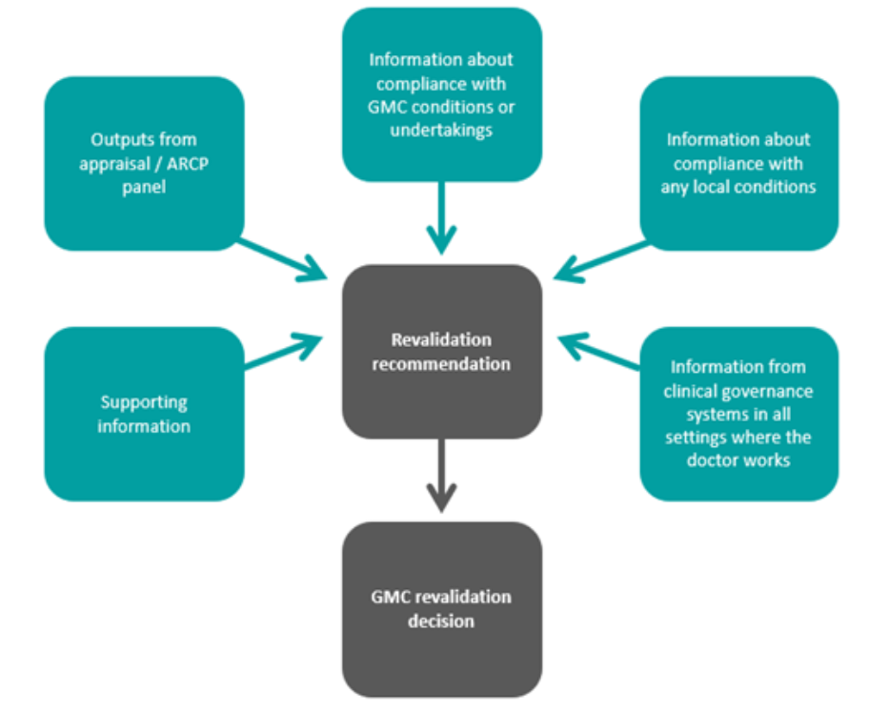

A recommendation to revalidate is a formal declaration from the RO that a doctor remains up to date and fit to practise. This would indicate that:

- The doctor is engaging in clinical governance systems including participating in annual appraisal in line with Good Medical Practice as its focus;
- The doctor has collected and reflected on supporting information drawn from across the whole of their practice as outlined in the guidance on supporting information for revalidation;
- Relevant information from local clinical and corporate governance systems has been considered with no concerns identified;
- The doctor is complying with any locally or GMC agreed conditions or undertakings and there are no ongoing local performance management processes;
- Based on the information available there are no ongoing or outstanding concerns about the doctor’s fitness to practise.

Where doctors are not engaging with the revalidation and/or appraisal process, the RO will report this to the GMC for further action. This is also the case if any concerns are raised during the process as to the doctor’s fitness to practice.

The latest position for revalidation and appraisal is reported to ROAG, including and any non-engagement issues. In addition, transfers of information, which are sent between health boards and NHS trusts for starters/leavers to highlight any concerns for the new employers, are also noted at this meeting.

- Physician Associate (PA) and Anaesthesia Associate (AA)
There is now requirement for PAs and AAs to now be registered with the GMC. This came into being from December 2024 following a period of consultation and PAs/AAs have two years to register. These are trained healthcare professionals, who work alongside doctors to supplement the medical workforce and provide medical care as an integral part of the multidisciplinary team. They have a dedicated medical supervisor and work with appropriate support, and can be based in a range of specialties in primary, community and/or secondary care

The GMC are in the process of working through certain governance areas for these roles, such as fitness to practice issues and revalidation, and once they have finalised policies and processes, these will be implemented within the health board’s ROAG and revalidation arrangements.

- Governance Arrangements
ROAG is a reporting sub-group of the Workforce and OD (organisational development) Committee, but it does not provide a report of all areas discussed within meetings. A standalone appraisal and revalidation report is received on a quarterly basis as is a report which highlights the most high-risk professional concerns cases, it does not consider all cases under review by ROAG.

As such, it is proposed that this report serves not only as a briefing to the Workforce and OD Committee as to the processes in place to discharge the RO role but also act as a launch for an overarching report from ROAG providing an update on all aspects of RO business, rather than through multiple reports.

- FINANCIAL IMPLICATIONS
There are no financial implications to this report.

- RECOMMENDATION
Members are asked to:
- ACKNOWLEDGE the role of the Responsible Officer and that this resides with the Executive Medical Director;
- ACKNOWLEDGE recent improvements made within the governance and assurance processes to strengthen the management of any professional concerns raised about doctors in Swansea Bay.
- BE ASSURED that robust processes are in place to oversee and manage professional concerns
- BE ASSURED a structure is place to manage the revalidation of doctors for them to retain their GMC licence;
- ACKNOWLEDGE that quarterly report will be provided to the Workforce and OD from the ROAG which will encompass high-risk medical cases and revalidation and appraisal updates into one report.

Governance and Assurance

Link to Enabling Objectives  (please choose) | Supporting better health and wellbeing by actively promoting and empowering people to live well in resilient communities
Link to Enabling Objectives  (please choose) | Partnerships for Improving Health and Wellbeing |  | ☒
Link to Enabling Objectives  (please choose) | Co-Production and Health Literacy |  | ☐
Link to Enabling Objectives  (please choose) | Digitally Enabled Health and Wellbeing |  | ☐
Link to Enabling Objectives  (please choose) | Deliver better care through excellent health and care services achieving the outcomes that matter most to people
Link to Enabling Objectives  (please choose) | Best Value Outcomes and High Quality Care |  | ☐
Link to Enabling Objectives  (please choose) | Partnerships for Care |  | ☐
Link to Enabling Objectives  (please choose) | Excellent Staff |  | ☒
Link to Enabling Objectives  (please choose) | Digitally Enabled Care |  | ☐
Link to Enabling Objectives  (please choose) | Outstanding Research, Innovation, Education and Learning |  | ☐
Health and Care Standards
(please choose) | Staying Healthy |  | ☐
(please choose) | Safe Care |  | ☐
(please choose) | Effective Care |  | ☐
(please choose) | Dignified Care |  | ☐
(please choose) | Timely Care |  | ☐
(please choose) | Individual Care |  | ☐
(please choose) | Staff and Resources |  | ☒
Quality, Safety and Patient Experience
The role of the responsible officer is to ensure that doctors have the skills, knowledge and experience to deliver high quality, safe services and maintain professional standards while doing so. They also ensure a patient’s voice is heard as part of appraisal and developments.
Financial Implications
There are no financial implications.
Legal Implications (including equality and diversity assessment)
Doctors have a legal requirement to register with the GMC in order to retain a licence to practice.
Staffing Implications
There are no staffing implications.
Long Term Implications (including the impact of the Well-being of Future Generations (Wales) Act 2015)
A robust governance and infrastructure to support the Responsible Officer will help ensure a well developed and engaged medical workforce.
Report History |  | First report
Appendices |  | Appendix One – Example PAG Terms of Reference;  Appendix Two – SOP for Managing Professional Concerns

