10. Workforce Updates and Actions
This section of the report provides further detail on key workforce measures. Caveats and Limitations (C&L) detailed beneath data in each section.
Staff sickness rates - Percentage of sickness absence rate of staff (two metrics provided, ‘rolling 12 month’ and ‘in month’)  Sickness absence target – 5.5% | % of full time equivalent (FTE) days lost to sickness absence  Caveat & Limitations;- Report generated March 2024, within SBUHB (Performance Team) for substantive and FTC employee types. Data source – ESR. Target of 5.5% added as blue line
Current Performance
In month sickness absence has decreased from 7.73% to 7.06% reported in February 2025. Long term sickness has reduced by 1.19% since the last reporting period. Short term sickness has decreased by 0.53% since the last reporting period.
- Anxiety/stress related absence remains the highest reason for absence, a trend witnessed across NHS Wales. Anxiety/Stress/Depression reported in February 2025 accounts for 2.4% of all in month sickness absence, the number of FTE days lost due to Anxiety/Stress/Depression has reduced by 38% since the last reporting period.
- The number of FTE days lost due to Cold/Cough/Flu have also reduced by 35% which is expected due to seasonal illness trends
- The Directorate with the highest absence levels at the end of this quarter is the COO Directorate at 11.76%. This is as a result of high long term absences recorded as stress/depression/anxiety within Hotel Services.
- Mental Health & Learning Disabilities remains the Service Group with the highest levels of absence at 7.75%, a 1% reduction since the last quarter
- Primary Community Care & Therapies Service Group remain to be the Service Group with the lowest level of sickness absence which has further reduced to 5.73% in February 2025. It is reported that this reduction in sickness absence is due to employees returning to work from sickness absence
- Sickness absence in both Morrison (7.35%) and Neath Port Talbot Service Groups (6.93%) has reduced since the last reporting period. Whilst Anxiety/Stress/Depression remains the highest reason for long term absence, both Service Groups saw a decrease in Cough, Cold and Flu cases.

Actions for Next Period
General
Current focus on areas with high absences rates, examples of initiatives to support our employees:

- Case conference training for leaders in partnership with OH
- The HRBPs leading on the initiatives listed above are working together to share best practice with the intention to deploy initiatives across the HB

Occupational Health and Staff Health and Wellbeing
The services continue to develop high quality multi-disciplinary interventions to contribute to an engaged, motivated and healthy workforce.
- Recruited substantive Occupational Health Specialist Doctor, commences 1/5/25 – this will provide financial and clinical sustainability/stability to the service – May 2025
- Paper to be presented to Medical Agency Review Panel to ensure planned approach to gaining 1x monthly session of Consultant support – April 2025
- Continue undertaking the UK Occupational Health gold standard quality kite-mark initial assessment (SEQOHS) and consistently meeting WG Occupational Health delivery KPI’s - April/May 2025
- Commence Staff Health Passport on 1st April 2025 to support staff health and wellbeing in work, improve communication between staff and line managers and improve staff experience – April 2025

Mandatory & Statutory Training-  Percentage compliance for all completed Level 1 competencies within the Core Skills and Training Framework by organisation  Mandatory & Statutory Training target – 85% | % of compliance (Headcount) with Core Skills and Training Framework  C&L;- Report generated March 2025, within SBUHB (Performance Team) for substantive and FTC employees. Data source – ESR (OLM Module). Accuracy levels subject to local maintenance and validation standards. Target of 85% added as blue line
Current Performance
- Welsh Government (WG) requirement for All Staff (Target 85%) – Overall compliance rate of 89.2% achieved in the 12 modules.
- Welsh Government (WG) requirement for Staff in Public Facing Role (Target 85%), achieved 46.08% to date **
**Please note: Paul Ridd Learning Disabilities Awareness Training was mandated for completion by ALL Staff in SBUHB as of 1st February 2025. The figure of 46.08% is in reference to All Staff, this is an improvement on the compliance rate of 19.45% as of January 2025.
- SBU Health Board requirement for All Staff (Target 85%) - Overall Compliance - 86.37% achieved in the full 15 mandated modules:
- Service Groups - MH&LD 88.53%, PCCT 90.31%, Morriston 83.10%, Finance & Estates 84.93%, NPTS 89.53%
- Staff Groups - Medical and Dental Staff Group remain the lowest performing area with 67.46%. Support for this staff group is ongoing, with the E-learning Project Support Manager working with Executive Medical Directors Department to reach out to staff.

Actions for Next Period
- Subscription to Learning Certification and Enrolment onto Statutory/Mandatory Courses – User issues identified are being supported on a case-by-case basis via Action Point and from direct contact. The number of queries seen are minimal, however there has been a slight increase in the past month due to the mandating of Paul Ridd, NHS|MAND|Paul Ridd Learning Disability Awareness Training - No Specified Renewal. These have been investigated and resolved with no impact to compliance figures reported.
- Medical and Dental Staff Group – Ongoing support sessions arranged in conjunction with the Executive Medical Directors Department and the E-Learning Project Support Manager to assist Dr’s with e-learning access issues to continue through 2025.
- Monitoring Compliance – Completion of e-learning and compliance rates to be scrutinised bi-monthly to identify where learning has been completed but compliance not recorded due to technical issues experienced by user when undertaking the e-learning, this is to ensure that the learning has been updated accurately for the user and to reflect in overall levels of compliance.
- NPTSG updated that there is a need to continue to focus on improving Mandatory Training compliance within the Medical Staff Group.
Vacancies  Medical and Nursing and Midwifery | 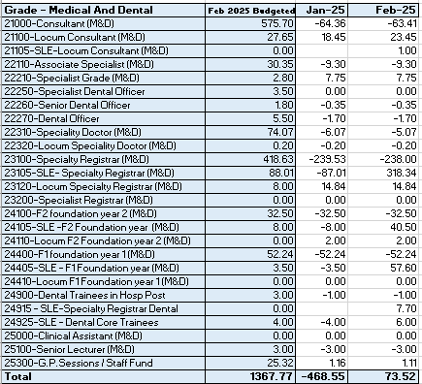  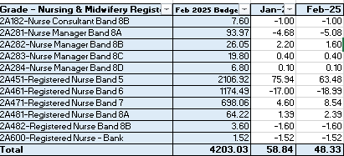  Vacancies (FTE) Jan 25 to Feb 25 (note that both tables have been updated)  C&L;- Report generated March 2025, within SBUHB (ESR Team), using currently available methodology. Data source – ESR (Workforce) and General Ledger (Finance). We compare the SIP v’s the finance ledger, appreciating limitations on accuracy in some areas. Accuracy levels are subject to local validation practices based on budget holder’s intelligence.
Current Performance
- The registered nursing establishment data indicates that we continue to show an over-recruited position at the end of February 2025 by 48.33 FTE. Due to a slight increase in budgeted establishment for this staff group of 7 WTE, the overall increase in staff in post is approximately 14 WTEs, since December 2024.
- For Band 5 nurses in particular, we were over-recruited by 63.48 FTE as of Feb 25. This is due to the Health Board continuing to accommodate newly qualified nurses starting in Band 5 roles through our student streamlining programme, whereby 145 have now started in post between 01/09/24 and 18/03/2025 (an increase of 13FTE since December 2024). A further 33 from the March 2025 cohort are currently undergoing pre-employment checks and 9 are ready for a start date or have their start date booked.
- Our corporate nursing team continue to support service groups with overseas recruitment for hard to recruit roles, having recruited 11 mental health nurses and 3 midwives in January and February 2025. However, note these will have commenced in Band 4 posts until they have passed their OSCE and completed their NMC registration, which can take up to 3 months. For 2025/26, 16 international nurses have been offered posts in the NPTS Service Group (10 for theatres and 6 for medicine/ cancer services)
- In addition to the above, our Central Resourcing Team (CRT) continue to support service groups with any other Band 5 recruitment needs. For example, they have recently supported with the successful appointment of 7.84wte Band 5 Emergency Department Paediatric Nurses for Morriston Service Group. They also continue to receive and provide support for the Mental Health and Learning Disabilities Service Group for various Nursing and HCSW vacancies
- The rich supply of Band 5 nurses from all three recruitment sources should ensure that no band 5 nursing gaps arise over the next 12 months due to turnover and/or internal movements into higher banded roles
- It is important to note that the vacancy exception process remains in place which is impacting on timescales, staff wellbeing/experience and is can be demonstrated within the high levels of variable pay.

Actions for Next Period
- International nurse recruitment, student streamlining and domestic recruitment will continue as per the above
- The CRT have developed a checklist of actions for recruiting managers to consider when trying to fill hard to recruit roles, which is due to be published this month
- The CRT are also supporting with the implementation of Welsh Language compliance actions in recruitment. In addition to training 116 managers, they have also supported managers with 202 vacancies (an increase of almost 100 since the previous reporting period) which have been non-compliant since the new process was implemented on 1st November 2024.

Recruitment  Metrics provided by NWSSP. Comparison with all-Wales benchmarking  Target 44 days | 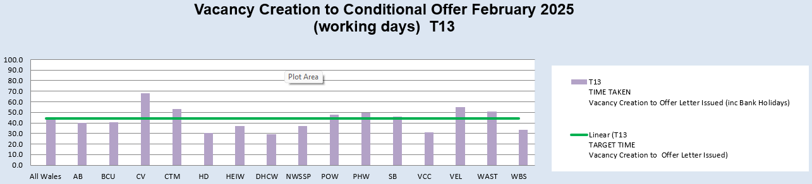  Vacancy Creation to Conditional Offer February 2025 (working days) T13  C&L;- Report generated March 2025, by NWSSP (Recruitment). Data source – TRAC system. Outliers are excluded. This is day to day vacancy management. Data excludes outliers.
Current Performance
- Swansea Bay UHB’s in-month time to hire performance has started to exceed the 44 day All Wales T13 target for the first time in over 12 months. This is due to Welsh language translation requirements and the admin and clerical recruitment pause, whereby managers have been asked to submit vacancy requests on the Trac recruitment system while waiting for approvals to be received from our executive team and for Welsh translation to be returned.
- SBUHB’s 12m T13 average is still currently below the 44-day target at 41.5 days, however the in-month figures for January and February 2025 were 54.3 days and 45.9 days respectively, showing a decline in time to hire performance in recent months. The All-Wales monthly average performance remains below target at 43.3 days.
- SBUHB’s time to hire performance continues to be significantly below the 27 day All Wales T23 metric (target of 27 days) which is the measure from point of issuing an offer letter to agreeing a start date. SBUHB’s 12-month average is 14.8 days which is below the All-Wales monthly performance figure of 16.7 days.
- The Central Resourcing Team (CRT) have continued to coach candidates through the pre-employment check process for Band 5 nursing roles and Band 2 Health Care Support Worker roles in particular and have also been supporting with other stages of the recruitment process for some areas (e.g., shortlisting for mental health nursing and HCSW roles) to continue to assist in reducing the T13 and T27 time to hire targets, mentioned above
Actions for Next Period
- NWSSP continue to provide training sessions and drop-in sessions for SBU recruiting managers to improve time to hire. They are also delivering a recruitment module as part of SBU’s management development programme
- The CRT will continue focussing on the recruitment of B5 nurses, B2 ward based HCSWs, assisting with overseas nurse recruitment and newly qualified nurses, as well as specific hard to recruit posts and Exec recruitment.
- In collaboration with NWSSP, the CRT will continue to chase outstanding management actions on vacancies and pre-employment checks with applicants, to further improve the HB’s overall time to hire performance. This includes the Welsh language translation requirement as of 01/11/24 to comply with legislation, which is currently having an impact on time to hire but will be monitored closely. The CRT continue to support managers who are adding vacancies to Trac with Welsh language requirements to ensure they are compliant.
- Members are asked to note that the HB’s time to hire performance is likely to continue to deteriorate over the coming months due to the above changes in the recruitment process.

Turnover  % turnover by occupational group | 12 month rolling Turnover Rate (Swansea Bay) – 01 Mar 2024 – 28 Feb 2025  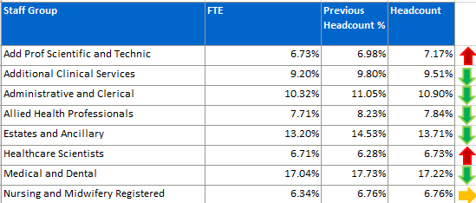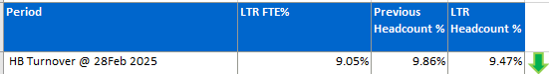  C&L;- Report generated March 2025, within SBUHB (ESR Team). Data source – ESR (Workforce). Small risk of margin of error due to late communication of terminations. Report excludes Bank, Locum, Honorary & Widow/Widower, Junior M&D staff. Internal movement not included – measure is about leaving Swansea Bay UHB.
Current Performance
- Organisationally, turnover has remained relatively stable in this reporting period, with a marginal decrease. This demonstrates the ongoing impact of retention-focused initiatives.
- Admin and Clerical has seen a slight decrease in turnover, with a 0.15% reduction in headcount and a 0.11% reduction in FTE. While this is a positive trend, continued monitoring is necessary, especially considering recruitment pauses that may impact future figures.
- Estates and Facilities has experienced the most significant decrease in turnover, with a 0.82% reduction in headcount and a 1.00% reduction in FTE. This highlights the success of ongoing initiatives in this area and should be built upon to maintain progress.
- Healthcare Scientists have seen an increase in turnover, with a 0.45% rise in headcount and a 0.34% rise in FTE. This contrasts with previous downward trends and will require further analysis to determine key drivers.
- Medical and Dental turnover has decreased again this period, with a 0.51% decrease in headcount and a 0.36% decrease in FTE.
- Nursing and Midwifery turnover has remained stable, with no change in headcount turnover and only a marginal 0.01% reduction in FTE. While this is not a significant shift, it suggests that retention efforts continue to provide stability in the workforce.
- AHP (Allied Health Professionals) turnover has decreased, with a 0.39% decrease in headcount and a 0.29% decrease in FTE.
- Additional Professional, Scientific, and Technical turnover has increased slightly in headcount (0.19%) but has seen a more notable increase in FTE turnover (0.42%). Further exploration may be needed to understand the movement in FTE figures.
- Additional Clinical Services has experienced a small decrease in turnover (Headcount 0.29%, FTE 0.27%), reflecting positive retention efforts within this staff group.
- These trends will continue to be monitored, with targeted actions taken to address areas of increasing turnover and maintain positive momentum in areas where reductions have been achieved.

Actions for Next Period
- The retention plan will be presented at key forums for final ratification and implementation, ensuring alignment with organisational priorities and workforce strategies.
- The ESR flexible working request system, will be launched in April, will continue to be embedded, with sub-groups focusing on communications, training, and the review of declined requests to enhance uptake and effectiveness.
- The Retention Lead will work closely with Workforce Business Partners to further embed best practices and targeted retention strategies across all staff groups.
- The Emergency Department retention plan will continue to be refined and implemented, addressing specific challenges and ensuring sustainable workforce improvements.
- Increased focus will be placed on staff groups experiencing rising turnover, particularly Healthcare Scientists, Medical and Dental, and Allied Health Professionals (AHPs), to develop tailored interventions and mitigate workforce risks.
- Ongoing engagement with key stakeholders in Medical and Dental will be prioritised to identify turnover drivers and targeted solutions for workforce stability.

PADR  % staff who have a current PADR review recorded  PADR target – 85% | % of staff (Headcount) who have had a PADR in previous 12 months  C&L;- Report generated March 2025, within SBUHB (Performance Team). Data source – ESR (OLM Module). Accuracy levels subject to local maintenance and validation standards. Target of 85% added as blue line.
Current Performance
- Staff who have had a Personal Appraisal and Development Review (PADR) as of 28th February 2025 is 72.04 %, this is a 0.02% increase in completion rates over the past 6 months.
- During January and February 2025, a total of 27 staff completed 130 PADR-Personal Appraisal Review for Managers delivered by the Education and Learning Team. In addition, the How to Complete PADR Documentation and PADR Hints & Tips bitesize learning modules have been added to the Brilliant Basics Platform from January 2025. Colleagues are signposted to SBU ESR - ESR User Guides SharePoint Page for resources on how enter PADR Dates in ESR. This is also linked to the Brilliant Basics platform.
- Compliance figures per Service Group (excluding Medical and Dental Staff) – MH&LD 75.15%, NPTS 77.90%, PCCT 82.33%, Morriston 64.32%, Finance and Estates 64.91%
Actions Planned for Next Period
- Supporting activity outlined in previous reports continues, Service Groups continue to focus on highlighting areas for focus.
NPTSG updated that Improvement plans should be in place for Divisions below the target of 85% (this is coordinated via the Divisional Workforce Groups)
Operational Casework  Number of current operational cases. | C&L;- Report generated March 2024, within SBUHB (Workforce Digital). Data source – ER Tracker. Accuracy levels subject to local maintenance and validation standards.
Current Performance
- No. of open Formal Disciplinaries since the last reporting period have decreased from 50 to 45 open cases
- Number of Formal requests for Resolution raised within this period have decreased from 24 to 16. There are currently 41 Formal Respect & Resolution cases open – it is noted that whilst there has been a reduction in formal cases being raised there is an increase in the formality in which staff side are raising issues whereby they are not engaging informally in the first instance, however, we are resolving issues informally resulting in the reduction.
- Suspensions, since the last reporting period have increased from 11 to 12
- ET’s – increased to 4
- It is noted that we do not currently fully record whistleblowing cases on our reporting system. However, intelligence confirms that we have a number of concerns linked to our Raising Concerns policy, some of which are currently being addressed informally and some formally. Workforce & OD are involved in below 5 cases at this stage. It is noted that Service Groups may well be addressing such matters locally that is not reported centrally. This will be picked up as part of the S[peaking up Safely action plan to ensure organisation oversight of such concerns.
- A number of actions are on-going in line with the Best Practice Review
- The Best Practice Review project has been refreshed with the introduction of multidisciplinary subgroups focusing on priority areas of work, reporting into the Core Working Group.
- 3 workshops have taken place in partnership with our Trade Unions facilitated by HEIW and SBUHB covering the following: Employee Investigations – Avoiding Employee Harm.
- We have successfully launched the Management Review document, to replace the initial assessment, which allows us to determine the most appropriate course of action at an early stage with the intention to resolve cases informally where possible – education and training ongoing with HR and leaders, this is being embedded and continually reviewed
- Suspension Guidance for leaders and employees has been shared for comment with the aim of supporting both groups and clarifying the process

