Meeting Date | 10th April 2025 |  |  | Agenda Item |  | 3.3
Name of Meeting | Workforce and OD Committee
Report Title | Sickness Absence Action Plan
Report Author | Sarah Jenkins, Interim Director of Workforce & OD, Paul Dunning, Head of Occupational Health and Wellbeing, Emma Owen, Assistant Director of Workforce & OD, Jessica Rogers, Head of HR Operations and Business Partnering
Report Sponsor | Sarah Jenkins, Interim Director of Workforce & OD
Presented by | Sarah Jenkins, Interim Director of Workforce & OD
Freedom of Information | Open
Purpose of the Report | To update the Committee on a new Action Plan to help support reduction of sickness absence.
Key Issues | The paper highlights the key roles and responsibilities for proactive management of staff absence and includes a proposed action plan for further support to help reduce sickness absence.  Evidence supports that the main responsibility for supporting and ensuring our staff are fit and well in work sits critically with the relationship between line manager and staff member.  The Workforce & OD function have a responsibility to ensure the infrastructure is in place to support effective staff management around absence.  There are also wider responsibilities for the Executive team and organisation around creating a culture to support our staff to be engaged motivated and healthy in work.  Each of these aspects are important in ensuring a positive trend in sickness absence reduction.
Specific Action Required  (please choose one only) | Information |  | Discussion | Assurance | Approval
Specific Action Required  (please choose one only) | ☐ | ☒ |  | ☐ | ☒
Recommendations | Members are asked to:  - Consider the roles and responsibilities set out in the report;  - Approve the newly proposed action plan.

SICKNESS ABSENCE ACTION PLAN

- INTRODUCTION
The Board have asked for further assurance around management of sickness absence. This work is connected to the Recovery & Sustainability programme and connects with the concerns around staff availability. Sickness is one aspect of this challenge. A proposed action plan is attached for support and approval.

- BACKGROUND
The health and wellbeing of our staff is central to our People Strategy. Our People Aim 1 focuses on ensuring our staff are “Engaged, Motivated and Healthy”. Sickness absence is one measure for us to assess this.
Currently our sickness absence is as follows:
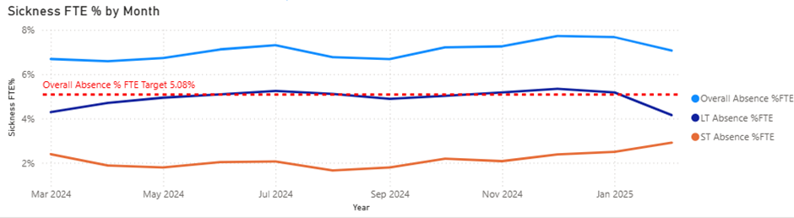
This shows that despite the significant programme of work in place to support our prevention agenda, our sickness absence is still the second highest across NHS Wales. This has historically been the case. It is noted that post covid, levels of sickness absence have increased across NHS Wales. We are seeing increasing trends of sickness in certain services eg Estates and Facilities. Intelligence also suggests that we are seeing increased trends in areas under pressure linked to burnout of staff reflected in a 29% increase in mental health referrals to the staff wellbeing service during 2024.
In the context of staff availability, it is also important to recognise the following in terms of our nurse and additional clinical services staff group (data taken from the weekly bank and agency report):
- Our Nurse and AHP bank regularly uses on average approximately 650 whole time equivalents (“WTE”) weekly. In recent weeks, this has been up to 800 WTE.
- On average over recent months, sickness (long term and short term) equates to approximately 22% of this utilisation.
- In contrast, additionality (such as surge, 121, acuity) relates to approximately 44%.
In terms of our medical and dental staff groups:
- Approximately 20% of locum spend is attributed to covering sickness absence.
- 20% of locum spend is due to additional activity/surge.
Not all our areas have headroom attached to support effective financial management of staff availability. This is only covered in some clinical services. For example, it does not cover our Therapies, Sciences, Facilities & Estates workforce. In terms of management of sickness absence within effective rostering, it would be expected that services accommodate long term sickness within regular and effective rostering, but it is accepted that this may not be possible for short term absence. Our current trend is suggesting our long term sickness is overall on a reduction trajectory, but short term sickness is rising. This is of concern when initial highlights of intelligence raise burnout as a potential concern in some areas. The proactive management of health and wellbeing of our staff is paramount.
- EFFECTIVE SICKNESS ABSENCE MANAGEMENT
To ensure our management of sickness absence is effective across the organisation the following needs to be in place:
- A fit for purpose policy
- Rights skills to implement
- Occupational Health and Wellbeing Support
- Proactive Prevention agenda
- Effective management of sickness absence by managers
- The right Performance Management to gain assurance of impact; and
- An overarching cultural approach for Health and Wellbeing.
The paper covers them in more detail below for assurance in the context of roles and responsibilities.
3.1 THE ROLE OF THE BOARD AND EXECUTIVE TEAM IN SETTING THE TONE OF THE CULTURE OF THE ORGANISATION
Ensuring we have proactive sickness absence management it is much more than compliance with a policy. This is important, but more important is the tone of the culture set across the organisation. It is the role of the Board and Executive team to ensure the following key elements to enable effective sickness absence management across the organisation:
- The right Performance Management to gain assurance of impact; and
- An overarching cultural approach for Health and Wellbeing
It is recognised that the organisation is currently reviewing its organisational performance management approach. But recognition of how we currently report and manage performance is set out below:
Our sickness reporting
We already manage and track sickness absence as part of our regular performance management framework and Board governance as follows:
- This data is provided for all to access in our new Workforce & OD (“WOD”) Dashboard. This enables managers to keep a track of their teams sickness absence data. It also enables more senior managers to understand hot spot areas for focus. The sickness absence is uploaded monthly from ESR (and then the Dashboard) so it is possible and expected that managers track their absence at least on a monthly basis. A snapshot of our Dashboard is shown below:
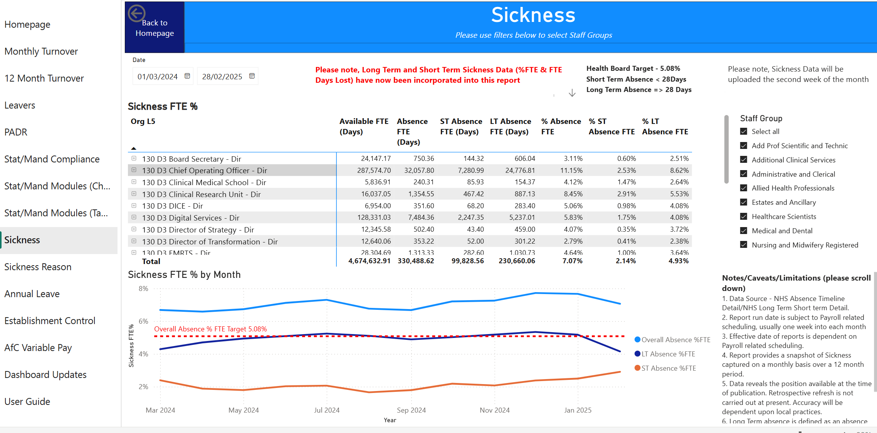
- Executive led performance management meetings that take place with each Service Group focuses on performance of key mandatory metrics including sickness absence. To ensure this is not looked at in isolation, PADR and Mandatory Training are also considered
- A Performance Report is issued to Management Board including sickness absence
- A detailed WOD Metrics Report is issued to the Partnership Forum for consideration every meeting (bi monthly)
- The same detailed WOD Metrics Report is also presented to WOD Committee every meeting (bi monthly); and
- Our WOD Committee now has a Deep Dive focus on hot spot areas. Service Groups Management will come and share their challenges and approach.
Sickness absence is a key reported metric with high visibility across the organisation and the introduction of the new WOD Dashboard means that managers have access to their staff sickness absence data daily from ESR.
We are currently shaping a HR Heatmap to use within the new performance framework. This will focus on enabling the following key metrics:
- Overall, Short term and long term sickness for service groups
- Completion numbers for MAAW training from ESR since October 2024
Number of Employees | Completed | Confirmed | Did Not Attend | Not Completed | Withdrawn | Total
Managing Attendance at Work | 10 | 152 |  |  |  | 162
People Management Skills - Part 1 & Part 2 | 78 |  | 17 | 2 | 25 | 122
Grand Total | 88 | 152 | 17 | 2 | 25 | 284

This data will be RAG rated to allow clear visibility of hot spots to ensure Service Groups and Directorates take personal ownership to manage this. There is a need for us to increase attendance at this training as the numbers indicated do not represent the number of people with manager responsibility across the organisation (see below training offering provided).
Overall Cultural Approach to Health and Wellbeing
Organisationally we have had recognised that health and wellbeing is a core part of our People Strategy. But strategies only take us so far. This has to be seen, heard and felt across the organisation. Context of the challenges being faced by the organisation is therefore important. We are in Recovery and Sustainability, with significant financial pressures. Equally our Urgent and Emergency Care system is under pressure. These factors cannot be ignored. There is significant evidence base to support that good work is good for your health. It is challenging to be in some of our services at present. It is critical therefore that the steps we take in managing sickness absence are appropriate and proportionate. It is equally important for every manager and leader to ensure appropriate check in’s with staff. Nothing stops us from doing this daily in our interactions and it should be part of our approach to be compassionate leaders. This is everyone’s responsibility.
3.2 THE ROLE OF WOD IN SUPPORTING AND ENABLING EFFECTIVE SICKNESS ABSENCE MANAGEMENT
It is the role of the Workforce function to ensure the following are in place:
- A fit for purpose policy – There is in place a nationally agreed Management Attendance at Work Policy (“MAAW”). This is collectively agreed through our national partnership forum with our Trade Unions. Such policy is regularly reviewed through the national governance structures and programmes of work. It is not possible to vary locally. Equally it is necessary to ensure consistent approach to the policy in implementation across NHS Wales. How we bring this to life across Swansea Bay University Health Board (“SBU”) therefore is very relevant to this.

- Rights skills to implement – This is currently multi faceted in SBU:
- There is a national training module the “All Wales Managing Attendance at Work”, which is scheduled bi-monthly by the HR Operations team. Staff can book on through ESR which allows us to track those who have completed the module.
- The Operational HR Team have recently developed bite sized learning which is now available on our Brilliant Basics 24/7 digital learning platform; and
- The operational HR and Business Partnering teams provide bespoke and requested training as required.

- Occupational Health and Wellbeing (“OH and Wellbeing”) Support – our offering in SBU is extensive. Training and support is cascaded for awareness through the Monthly Executive led Team Brief sessions as well as through the intranet. Timely, multi-disciplinary Occupational Health and Wellbeing Support for mental health and musculoskeletal problems as detailed in February 2024 WF & OD Committee. This includes an increased focus on prevention, including staff health checks and trauma risk assessment training for all staff.
In addition to the support from the OH and Wellbeing team, we also provide the following mechanisms of support for staff and managers including advice including: Trade Unions, Guardian Service, HR Business Partners, HR Operations team advice and support, OD team advice and support. Our offering is extensive.

- Proactive Prevention agenda – this has been a key focus for us for the last few years. We recognise good work is good for your health. This has seen an investment in our OH and Wellbeing service and the scope it provides. It is acknowledged that current data shows over 53% of staff access the wellbeing service whilst in work, therefore helping to prevent higher sickness absence rates; this equates to approximately 42 staff each month who may have been prevented from taking sick leave. The Healthy People Forum aims to provide a strategic focus on sickness absence, including the social determinants of health and how charitable funds can support staff wellbeing – the Health Board roll-out of Carers Wales initiatives will provide resources and support to staff with caring responsibilities, which through our deep dives on absence has confirmed is a challenge being faced by our staff in some areas.
3.3 THE ROLE OF MANAGERS AND OPERATIONS IN ENSURING EFFECTIVE SICKNESS ABSENCE MANAGEMENT
It is both the responsibility of all managers and senior managers to ensure effective sickness absence management. There is evidence to confirm that the relationship between manager and employee is central to positive engagement, motivation and performance impact. Effectively managing absence in line with the policy is a minimum. We would expect all of our managers to support our staff who are unwell compassionately. We would also expect them to take ownership of updating their skills in accessing training on a regular basis. It is their responsibility to ensure they understand the policy, complete the requisite training and management appropriately. This is the key factor that impacts sickness absence management.
- CURRENT SUPPORT FROM THE WOD TEAM
To help provide scale and context here we have provided this detail in the context of sickness data for January and February 2025 (January is generally one of our higher month).
a) We have reviewed the data from January – it illustrates how many instances of sickness were paid at 0% - from 3672 instances in January, 59 were 0 pay, 120 half pay, 79 approaching half, 3414 instances were on full pay – so that’s 1.6% of all instances on 0 pay in month for January 25 only.
b) In January short term sickness (STS) 3.16%, long term sickness (LTS) 4.55%. Due to limited capacity within the operational HR team, they only support Final Short – Term Absence reviews. At this stage, we have only dismissed less than 5 this year for sickness. Each Service Group (SG) is responsible for ensuring they comply with the policy and are auditing the paperwork on absence management including short term absence. HR team do not routinely review and support all short – term cases, due to capacity. When we do, we find the paperwork is absent or that the 1st or 2nd review meetings haven’t taken place. Training has been developed to support, but responsibility for compliance with the policy rests with the line manager.
c) Each SG have also introduced Absence Summits or Intervention. On a monthly basis the operational HR team review LTS cases and update the action plan against each case in conjunction with the Line Manager. In terms of data, 856 employees reported absent in February 2025 (not instances) – Long Term and Short Term; 488 employees have been absent since 1st December 2024.This helps provide an idea of the scale of numbers that gives rise to our absence figures.
d) The team are supporting 47 cases which are at the Final Stage of absence. Currently there is not capacity to support 488 employees who are on long term absence. This is a Service Group responsibility. MAAW training looks to support leaders with managing long term absence, bite size training implemented and Absence Summits/audits in place. In addition to this, the team are now advising the managers to conduct the first formal meeting at the point in which the employee has reported absent for 4 weeks or soon after, to encourage proactive management of absence.
e) A recent change in support from the HR team means we are now engaging in the process earlier. This has helped to avoid some sickness cases becoming prolonged which had historically attracted reinstatement of sick pay or long periods on 0 pay. Our adjustment to this approach, has attracted all Wales discussions by TU at the Welsh Partnership Forum. We are complying with the Policy.
f) OH advice – the advice we receive from OH practitioners doesn’t always provide clarity in terms of whether an employee is unfit for the foreseeable future – it quite often states ‘review in 3 months time’ or ‘maybe fit in 3-6 months ‘. The team do push back but it does cause delays in absence management as this information can be relied upon at the final stage.
- PROPOSAL FOR FURTHER ACTION
Attached is a proposed further Sickness Action Plan to support effective management of sickness absence across the organisation. This will mean deployment of other members of the WOD team to focus on management of sickness absence. This will impact the progression and completion of other WOD priorities, particularly within the Business Partnering team.

- GOVERNANCE AND RISK ISSUES
Initial evidence from discovery work has indicated a proportion of our stress and anxiety related absence are connected with caring responsibilities and bereavement. It is acknowledged that Swansea is one of the oldest city in the UK. Understanding how our population health may well be impacting our staff sickness is something we have started to explore. We are learning that our demographic population is having an impact on our patient profile. Our staff are in our communities.
There is a risk that more proactive management of sickness absence, which may be a shift change, is open to challenge from our trade union colleagues in terms of SBU current custom and practice of the policy. This may lead to national references for application of the policy in the national Partnership Forum and to industrial relations concerns. Proactive management of our approach with our trade unions will be critical.
It is envisaged that all governance and risk related issues will continue to be reported regularly to the Workforce and OD committee.

- FINANCIAL IMPLICATIONS
The purpose of this paper is not to set out details in terms of the cost of absence, but it is recognised this was highlighted in the last Deep Dive paper to WOD Committee in February 2025.

- RECOMMENDATION
The Committee are asked to:
CONSIDER the roles and responsibilities set out in the paper; and
AGREE the proposed Sickness Absence Plan.
Governance and Assurance

Link to Enabling Objectives  (please choose) | Supporting better health and wellbeing by actively promoting and empowering people to live well in resilient communities
Link to Enabling Objectives  (please choose) | Partnerships for Improving Health and Wellbeing |  | ☒
Link to Enabling Objectives  (please choose) | Co-Production and Health Literacy |  | ☐
Link to Enabling Objectives  (please choose) | Digitally Enabled Health and Wellbeing |  | ☐
Link to Enabling Objectives  (please choose) | Deliver better care through excellent health and care services achieving the outcomes that matter most to people
Link to Enabling Objectives  (please choose) | Best Value Outcomes and High Quality Care |  | ☒
Link to Enabling Objectives  (please choose) | Partnerships for Care |  | ☐
Link to Enabling Objectives  (please choose) | Excellent Staff |  | ☒
Link to Enabling Objectives  (please choose) | Digitally Enabled Care |  | ☐
Link to Enabling Objectives  (please choose) | Outstanding Research, Innovation, Education and Learning |  | ☐
Health and Care Standards
(please choose) | Staying Healthy |  | ☒
(please choose) | Safe Care |  | ☒
(please choose) | Effective Care |  | ☒
(please choose) | Dignified Care |  | ☐
(please choose) | Timely Care |  | ☒
(please choose) | Individual Care |  | ☐
(please choose) | Staff and Resources |  | ☒
Quality, Safety and Patient Experience
Evidence demonstrates a direct correlation between staff health and wellbeing/experience and high quality patient care and outcomes. Supporting and enhancing staff wellbeing and increasing attendance at work will help fulfil the aims of the people strategy and 10 year vision and contribute to improved patient safety and experience. This approach supports the People Strategy, Managing Attendance at Work (MAWW) policy principles and incorporates the “Healthier Wales Quadruple Aim” of supporting staff health & wellbeing.

Financial Implications
Many of the interventions and actions identified can be implemented within current resources and it is anticipated that the reduction of sickness absence will contribute to the Health Boards’ financial plans and help meet anticipated cost-savings

Legal Implications (including equality and diversity assessment)
Ensures compliance with Equality Act 2010.

Staffing Implications
Recruited to fixed-term Band 8a Workforce Effectiveness Manager to support managing sickness absence

Long Term Implications (including the impact of the Well-being of Future Generations (Wales) Act 2015)
Actions outlined in report promote “A Healthier Wales Quadruple Aim” these being:
- Improved population health & wellbeing
- Better quality & more accessible health & social care services
- Motivated & sustainable health & social care workforce

Report History |  | None
Appendices |  | Appendix 1- Staff Sickness Action Plan

APPENDIX 1
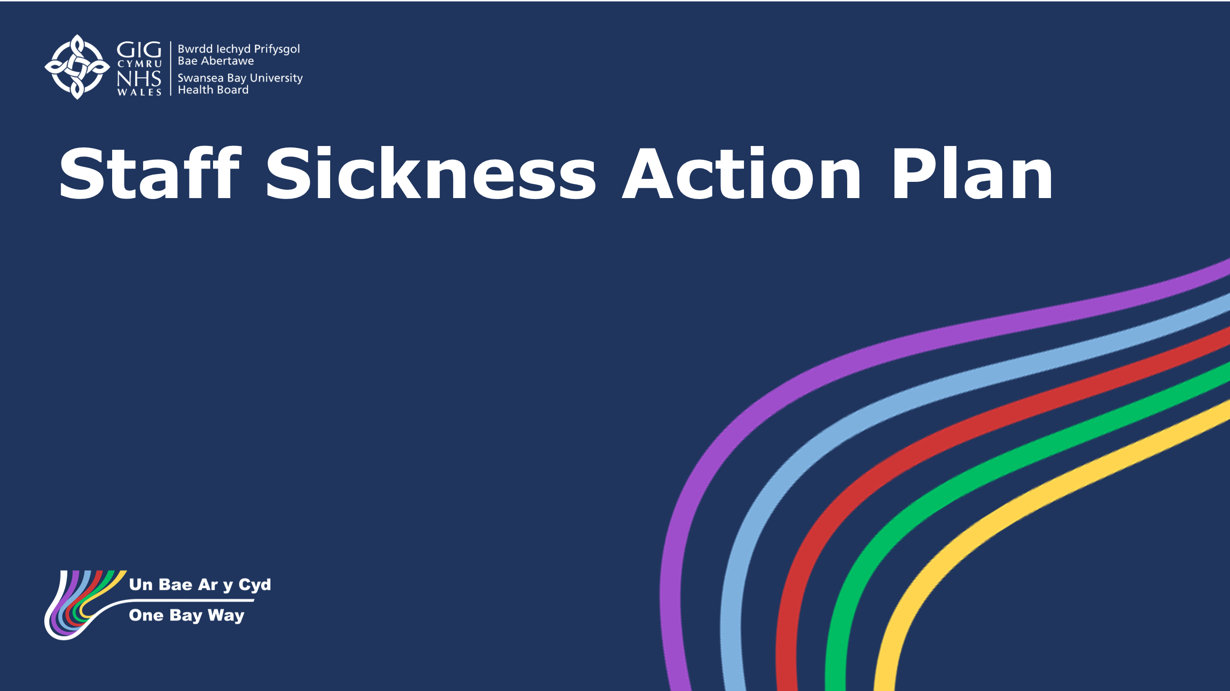

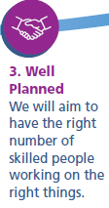
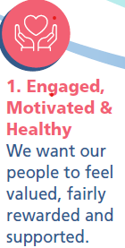
Sickness Absence Action Plan – April 2025
Action | Impact/Risk | Date | RAG Status | Comments/  Update
Deploy Business Partner (BP) teams to coordinate responses within Service Group (SG) – creating SG teams who will focus on absence | Will limit time to support SG on wider BP responsibilities e.g. workforce planning, recruitment, L & M support, coaching, hot spot support etc.  Impact BP Team morale | Immediate Effect |  | HRBPs aware of need to increase focus on Sickness Absence
Pull dedicated support from HR operations team to work with SG Team to support the audit of 10 hot spot areas for sickness and confirm action plans | Will delay ER processes due to limited capacity within HR Operations team. Will mean other HR work may pause for a while. Impact on TU relations; | Immediate Effect |  | HR Operations team already supporting hot spot areas
Deploy Corporate Nursing to coordinate roster managers on roster efficiency to engage in SG teams – focus of review on efficiency of roster scrutiny process |  | Immediate Effect
Deploy LW from Morriston SG to train SG teams on deep dive audits | Impact SG Morriston as other responsibilities. Capacity minimised if provided for a short period. | Immediate Effect |  | Agreement from COO and SG Lead to deploy LW temporarily on a train the trainer basis (already completed)
Each SG and Department to deploy someone to coordinate their deep dives and to be trained by LW | Suggest include roster managers as well as a coordinating manager within high hot spot sickness area. | Immediate Effect |  | Confirmation from each SG to be confirmed
Dashboard Utilisation to help track and manage sickness absence | Minimal/to ensure one source of truth used to track performance. (Risk cross charging vacancies within Establishment Control Dashboard so have to agree principles to manage with Finance) | Immediate Effect |  | All manager have access to dashboard
BPs to create and publish a consistent report which will be issued to R&S on a monthly basis | Site by site comparisons, best practice identification | w/c 14th April |  | Data can be reviewed in the dashboard
Each BP team to coordinate a review of those staff who have exhausted sick pay (currently circa 59 on nil pay and 79 further approaching) | National impact of policy approach. Custom & Practice has been to allow to remain on. Therefore impact on TU relations. Already experiencing this following more recent proactive management. ET claims. | Immediate Effect |  | MAAW Action plan in place for those who have exhausted sick pay – to be validated and supported by the BP
OH to prioritise nil pay group for review. BP team to ensure “effective” OH referral” and support to be given for longer term locum in OH to speed up timescales. | General staff engagement, presenteeism, disability discrimination, TU relations and ET claims | TBC (will depend on locum cover for PH being approved) |  | Will escalate discussions with OH team to review current status of cases

