Meeting Date | 10th April 2025 |  | Agenda Item |  |  | 2.2
Name of Meeting | Workforce & OD Committee
Report Title | Managing Attendance at Work
Report Author | Carol Clayton Assistant HR Business Partner
Report Sponsor | Dermot Nolan Director Mental Health & Learning Disabilities, Deb Lewis, Chief Operating Officer and Sarah Jenkins, Interim Director of Workforce and OD.
Presented by | Dermot Nolan Director Mental Health & Learning Disabilities
Freedom of Information | Open
Purpose of the Report | This paper provides an overview of current levels of absence within Mental Health & Learning Disabilities Services and what plans are in place to address Attendance at work.
Key Issues | Attendance at Work supports the People Strategy for engaged, motivated and healthy staff
Specific Action Required  (please choose one only) | Information | Discussion |  | Assurance | Approval
Specific Action Required  (please choose one only) | ☒ | ☐ |  | ☐ | ☐
Recommendations | Members are asked to:  - Consider the content for information.  - Take Assurance from the action plans in place.

Managing Attendance at Work
Mental Health and Learning Disabilities

- INTRODUCTION

This report provides an overview of the current sickness absence levels within Mental Health & Learning Disability Services and outlines processes in place to both prevent and enable the return of staff from absence.

- BACKGROUND

Mental Health & Learning Disability Services ESR Sickness reports for February 2025 are attached.

Overall total absent days by total employees amounted to 4180 work days lost during February 2025 ranging between 136 to 162 absences per day. In total for the period there were 376 staff absent from work.

Mental Health & Learning Disabilities sickness in-month on 28th February 2025 was at 7.75%.
Whilst long term absence decreased to 4.93% in February 2025, short term absence increased to 2.81% in February 2025.

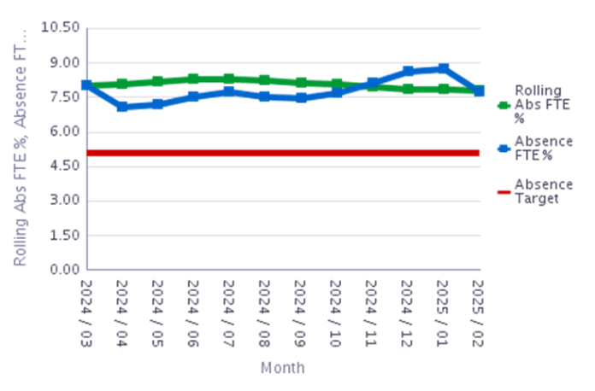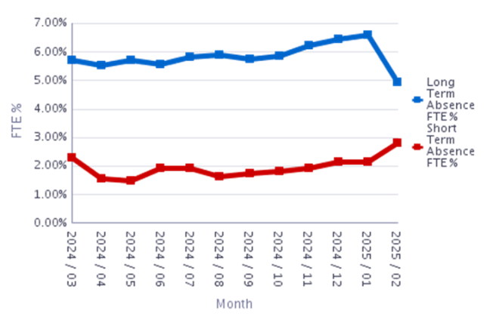

Directorates short term absence and long term absence are monitored, for February 2025 those highlighted in red are above the service group target level any absence above 2% for short term is monitored and for long term above 5%.

Monday remains our highest day of absence with a steady decline through the weekdays rising again on Sunday. The highest level of absences was between 0 days and 1 days in February with absences between 28 days and 6 months the next highest area.

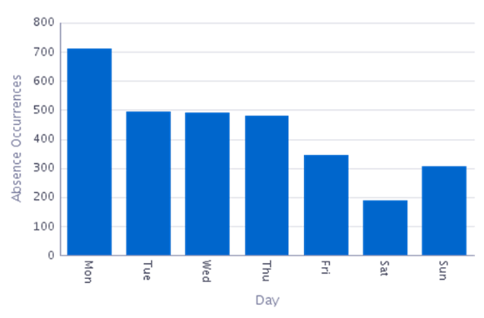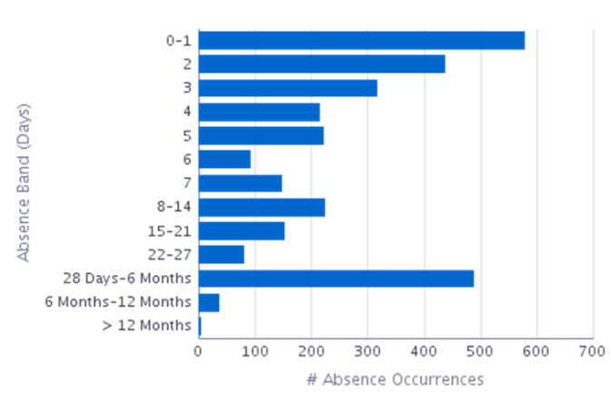

The three main reasons for sickness absences within the group during February 2025 were:

Absence Reason | Grand Total
S10 Anxiety/stress/depression/other psychiatric illnesses | 100
S13 Cold, Cough, Flu - Influenza | 84
S25 Gastrointestinal problems | 40

Additional Nursing and Clinical Services roles remain the highest absence.

Staff Group | Absence FTE | Available FTE | Absence FTE %
Add Prof Scientific and Technic | 1,213.71 | 36,940.19 | 3.29%
Additional Clinical Services | 19,120.41 | 206,864.13 | 9.24%
Administrative and Clerical | 4,560.02 | 73,150.60 | 6.23%
Allied Health Professionals | 28.13 | 1,372.17 | 2.05%
Estates and Ancillary | 308.20 | 4,396.81 | 7.01%
Medical and Dental | 1,255.27 | 23,634.47 | 5.31%
Nursing and Midwifery Registered | 21,123.53 | 265,141.85 | 7.97%

In order to determine the reasons for anxiety and stress a questionnaire was sent to all staff who had had a period of absence during 2024 which was recorded for this reason. In addition to staff having absence due to mental health, ill health of dependents or undertaking a carer role, there was a correlation between staff absence from incidents in the workplace due to environmental factors, patient /client group and staffing levels. In 2024 there were 101 incidents of physical assault to staff within Mental Health & Learning Disabilities.

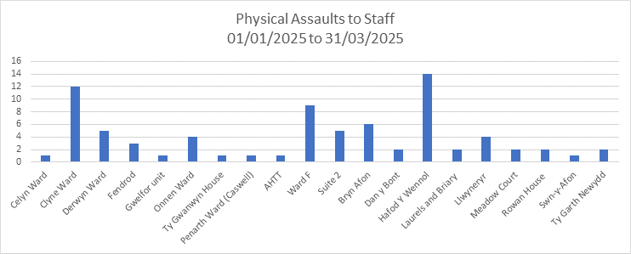

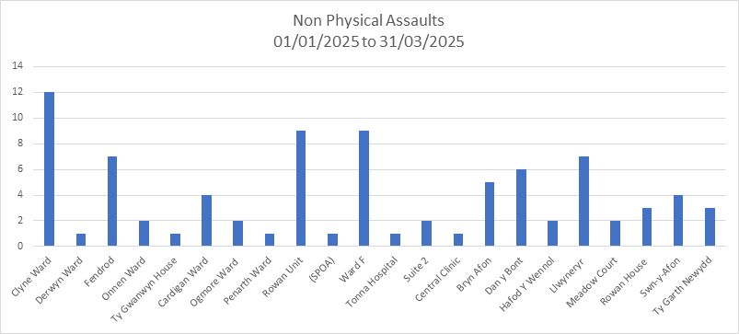

It was noted that the lack of violence and aggression training within the organisation may have contributed to the safe management of these incidents, with staff unable to access V & A refresher training for over 12 months or initial training for new starters to the service group.

- Addressing the high level of Absence in the workplace

A number of approaches are being taken to address the high level of absence within the service group an outline of a number of them are shared below.

3a) Action plans

Absence is an agenda item in all senior meetings, including Board, Divisional and Nursing and Medical Workforce meetings. Data is critical to monitoring patterns this is accessed from HR dashboard, ESR and the e rostering weekly unavailability report. The service group have an overall MAAW action plan and each Directorate also hold their own action plan which feeds into the overall plan. Monthly Directorate meetings are held with HR Business team and Directorate Managers and Lead Nurses to review current absence and update their MAAW action plans to address attendance. In addition the allocated HR Operations representative for the service group meets with Managers to address individual long term sickness cases to facilitate employees return to work and also reviews short term absence in line with policy to addressee underlying issues.

3b) Education

Managing Attendance at Work sessions were held during September, October, November and December 2024 within the service group for Managers which were well attended this reinforced the importance of compassionate leadership and engagement with staff in addition to policy knowledge and processes.

Each year we hold a wellbeing focus on World Mental Health Day this year we focused on staff wellbeing in the workplace, this resulted in a video record of staff sharing their experience of mental health and what tools can be accessed to improve your Mental Health.

Staff are encouraged to attend health board staff wellbeing events and the programmes are circulated to all staff within the service group. Staff are encouraged to take flu / covid vaccination.
The service group have introduced a comprehensive violence and aggression training program tailored to the needs of staff within the service group, which focuses on de-escalation techniques, personal safety, and managing high-risk situations. It will also incorporate resilience-building strategies to equip staff with tools to manage stress effectively, assist with team cohesion and impact positively upon staff attributions towards patients in their care, this is being embedded as a core element of the workforce strategy to address staff wellbeing holistically. The rollout of this training commenced in November 2024.

3c) Post Incident Support

TRiM is delivered to help raise staff awareness of trauma the Service group supports the release of 1 Manager, 3 Practitioners and 15 supporters to deliver the support within our service group. The manager has now since retired, there is a new TRiM manager identified and is awaiting training. In the interim, the TRiM practitioners are covering. Since January 2025 to date there have been 4 formal TRiM requests, 4 TiB’s (TRiM Briefing Meetings) and 11 sessions for 1:1 with staff members. Referrals were received from CAMHS, Learning Disabilities, Secure Services and MH Inpatient areas.
Staff are offered to self-refer or have a management referral to Occupational Health and Wellbeing for direct support from them has for any absence reason. Staff are encouraged to utilise 111 press 2 open to them and should they warrant psychological support post incident, then they can seek a cross Health Board referral to a neighbouring health board for a service. Staff are also supported by the Lead psychologist for their area. Staff can also access GTEP- Trauma-Focused Intervention and /or Trauma-focused therapy from OH.

3d) Prevention Measures
We appointed a staff counsellor to support the wellbeing of our staff within MH & LD service group. The Staff Counsellor engages in ‘hotspot’ work, areas are identified in conjunction with Head of Nursing for Quality, Head of Psychology and HR Business Partner. The Service Group Staff counsellor can also offer 1:1 therapy where staff have previously accessed OH and have needs remaining. The Staff Counsellor received 4 new referrals in February from known hotspot areas in the service group. There are currently 36 clients on their case load who work within areas identified as hotspot, of these 26 remain in work and therefore aiming to prevent absences for the workplace, and 10 are currently not in work and therefore working to improve their wellbeing to a state where they are able to return. In addition the staff counsellor is facilitating a Grief and Loss Group on a monthly basis in-person.
The Service Group is currently setting up a Disability Support Network for staff to access support of colleagues and peers who have similar lived experience and to have support to work through challenges and remain in work.

Flexible working is also actively supported within the service group one of the main reasons it is requested is linked to wellbeing. This is supported on a preventative basis or utilised to enable the return of an individual to work through a period of absence.

Plans to modernise the work environment and practices are currently under review within the service group to address in particular those identified has high risks for safe service provision.

- RECOMMENDATION

The committee are asked
- To consider the content of the report.
- Take Assurance from the action plans in place.

Governance and Assurance

Link to Enabling Objectives  (please choose) | Supporting better health and wellbeing by actively promoting and empowering people to live well in resilient communities
Link to Enabling Objectives  (please choose) | Partnerships for Improving Health and Wellbeing |  | ☐
Link to Enabling Objectives  (please choose) | Co-Production and Health Literacy |  | ☐
Link to Enabling Objectives  (please choose) | Digitally Enabled Health and Wellbeing |  | ☐
Link to Enabling Objectives  (please choose) | Deliver better care through excellent health and care services achieving the outcomes that matter most to people
Link to Enabling Objectives  (please choose) | Best Value Outcomes and High Quality Care |  | ☐
Link to Enabling Objectives  (please choose) | Partnerships for Care |  | ☐
Link to Enabling Objectives  (please choose) | Excellent Staff |  | ☐
Link to Enabling Objectives  (please choose) | Digitally Enabled Care |  | ☐
Link to Enabling Objectives  (please choose) | Outstanding Research, Innovation, Education and Learning |  | ☐
Health and Care Standards
(please choose) | Staying Healthy |  | ☐
(please choose) | Safe Care |  | ☐
(please choose) | Effective Care |  | ☐
(please choose) | Dignified Care |  | ☐
(please choose) | Timely Care |  | ☐
(please choose) | Individual Care |  | ☐
(please choose) | Staff and Resources |  | ☒
Quality, Safety and Patient Experience
If staff attendance is improved there will be a direct correlation with patient experience, staff who are trained to manage V & A will also result in improved patient experience
Financial Implications
N/a

Legal Implications (including equality and diversity assessment)
Staffing Implications
To reduce staff absence or enable the earliest return to work for staff, reduce absences arising from incidents in the workplace

Long Term Implications (including the impact of the Well-being of Future Generations (Wales) Act 2015)
Report History
Appendices |  | None.

