Meeting Date | 18 April 2024 |  | Agenda Item |  |  | 4.1
Report Title | Deep Dive – Our Employee Relations Best Practice Review
Report Author | Stephanie Hornblower, HR Business Partner,  Sarah Jenkins, Interim Executive Director of Workforce & OD
Report Sponsor | Sarah Jenkins – Interim Executive Director of Workforce & OD
Presented by | Jessica Rogers, Head of HR Operations & BP & Stephanie Hornblower, HR Business Partner
Freedom of Information | Open
Purpose of the Report | To provide the Workforce, OD and Digital Committee with insight into the employee relations Best Practice Review for the Health Board, providing detail on how the review will support the Health Boards People Strategy and improve collaborative partnership working, enabling delivery of our People Strategy.
Key Issues | To provide the Workforce, OD and Digital Committee assurance that the Health Board continues to take proactive and innovative actions to ensure the Health Board is operating in an employee relations best practice culture and is supporting and delivering on the vision and strategy of the Organisation, ensuring we work within our values and supporting wellbeing for our staff.
Specific Action Required  (please choose one only) | Information | Discussion |  | Assurance | Approval
Specific Action Required  (please choose one only) | ☐ | ☐ |  | ☒ | ☐
Recommendations | Workforce, OD and Digital Committee is asked to note:  The contents of the best practice review deep dive and the plans for delivering the review and implementing a culture of best practice within the Health Board.

BEST PRACTICE DEEP DIVE

- INTRODUCTION
The purpose of this paper is to provide a deep dive into Employee Relations Best Practice Review activity and future plans in SBUHB.

- BACKGROUND
SBUHB Workforce and OD division are committed to supporting and delivering the SBUHB People Strategy 2024-2029 which is derived from the National strategies “A Healthier Wales: A Workforce Strategy for Health and Social Care” and the “National Workforce Implementation Plan”, the Health Boards 10 year One Bay Way Vision, the Health Board’s Strategic objectives and feedback from Our Big Conversation (2022) staff engagement programme.
The WOD Divison recognise that the wellbeing of our staff and providing positive working environments is crucial to achieving the One Bay Way vision and it’s People Strategy.
To achieve this vision, it is crucial for the organisation to prioritise the wellbeing and satisfaction of its employees, with proven research available that directly correlates physical and psychosocially safe environments with improvement performance and workplace engagement. In order to create a psychologically safe working environment we must acknowledge and address the risks and potential for harm to employee wellbeing that may occur as a result of inappropriate or suboptimal deployment of workforce processes and policies. In order to do this, we launched a Best Practice Review in April 2023.
What is the Best Practice Review?
The Best Practice Review is a way for SBUHB to evaluate how its workforce policies, procedures and practices across the organisation are applied through a best practice lens and what impact they have on our staff. How our staff feel when progressing through an employee relations process and the way we manage them, is a strong determinant of culture across our organisation and our staff health and wellbeing. This is a collaborative approach with our Trade Unions. We are both committed through our Compact to putting people at the centre of what we do and to enable the usage of our policies in a proactive enabling way.
What is the objective of the Review?
The Best Practice Review aims to achieve the following:
- Improve relations with our Trade Union colleagues to ensure we work more collaboratively in partnership around employee relations;
- Improve our management of Employment Tribunal cases to provide effective learning and minimising risk for the organisation;

- Establish the base line application of policies, procedures and practices across the Organisation to understand where we are demonstrating good or best practice and where we can improve practices to enhance employee experience and prevent avoidable employee harm; and
- Analyse available employee relation data to establish a baseline position of cases over a 5 year period to allow in-depth analysis of case management, allowing a data driven approach to benchmarking (both internally and externally), areas for targeted replication or improvement and identification of trends.
How will the Review help us deliver our People Strategy?
The outcome of the best practice review will have a direct and indirect impact on the seven strategic aims of the Health Boards People strategy and workforce GMO’s.
Strategic Aims: | Best Practice
Engaged, Motivated and Healthy workforce | Ensuring we have practices and procedures that put people before processes, that are people centric, are managed compassionately and align to a just and restorative culture.
Attract and Recruit | By creating an environment that is compassionate, supportive, just and restorative will enable SBU to become an employer of choice.
Well planned | By creating an environment that is compassionate, supportive, just and restorative will improve employee wellbeing and reduce sickness absence, which in turn will improve workforce availability and higher levels of performance.
Digitally Ready | By ensuring our employees work within a psychologically safe environment we will enable them to feel more empowered and confidant to try new things without fear of retribution.
Excellent Learning and Education | By extending a continuous learning culture to our workforce policies and practices we can foster a culture that seeks learning and development opportunities across all aspects of the Organisation.
Leaders that Live our Values | We will empower our leaders to apply compassionate leadership to workforce policies and practices, ensuring they embody the values of the Organisation throughout all aspects of their role and interactions.
Equality, diversity and belonging | We will ensure that workforce policies and procedures respect equality and diversity and employees have a sense of belonging even when going through a procedure.

What the data is telling us
To date a high-level data gathering exercise on Employee Relations cases has taken place, with an initial summary of the analysis shown below;
SBU Initial analysis of Employee Relations data over 5 year period:
Disciplinary cases:
The data on disciplinary cases shows a steep reduction between 2019 and 2020 with a 41% reduction in cases. This was linked to an organisation wide review of cases supported by Legal & Risk, which allowed the teams to really establish a more manageable baseline. In 2021 cases rose with 17% increase. In 2022 cases decreased again, with a 20% reduction. During the period of 2020 – 2023 the case average was 51. This is comparable for similar NHS organisations in Wales and based on intelligence is better than some of the larger Health Boards.
Respect & Resolution:
Dignity at work / Grievance cases have been combined to reflect the new Respect and Resolution policy scope.
The data shows consistent average of 13 cases. Between the periods of 2019 – 2023, (with the exception of 2020 when cases numbers reduced 50%, believed to be as a result of the pandemic). The recorded data does not include informal resolution, which cannot be underestimated.

Capability:
The data shows a fluctuation between the periods of 2019 – 2023, fluctuating within the median range of 1 to 5 and generating an average of 3 cases for the period.
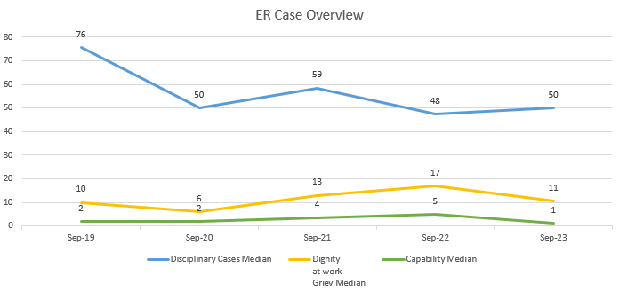

Disciplinary Case Analysis:
 | Disciplinary average cases open in month | Disciplinary average cases closed in month | Disciplinary over 2 years | % cases over 2 years
Sep-19 | Data unavailable | Data unavailable | 3 | 0%
Sep-20 | 3 | 7 | 5 | 1%
Sep-21 | 11 | 12 | 9 | 1%
Sep-22 | 12 | 11 | 20 | 3%
Sep-23 | 6 | 7 | 21 | 4%
Sep-23 to Dec-23 | 5 | 6 | 4 | 3%

On review of the available data the number of disciplinary cases opened on average in a 12 month period versus the number of cases closed in a 12 month period is balanced, which is a positive indicator for overall case management.

Over the last 5 year period (reporting period October to September) the number of disciplinary cases that have taken 2 or more years to conclude has increased. This is based on a trend being observed of increased complexity of cases and issues impacting our workforce. The wider environmental impact has a direct impact on the health and wellbeing of our staff, this in turn can impact behaviour. A review of the data available since September 23 to the current period of December 23 has shown that 3% of open cases during that period were open for 2 or more years. Further analysis on this data is needed to understand why this increase has taken place and appears to be continuing.
 | % of cases where suspension has occurred | % of Suspensions that have lasted over 6 months
Sep-19 | 14% | 48%
Sep-20 | 23% | 75%
Sep-21 | 15% | 39%
Sep-22 | 8% | 54%
Sep-23 | 9% | 29%
Sep-23 to Dec-23 | 11% | 76%

On review of the available data the number of disciplinary cases that resulted in suspension over a 5 year period ranges between 8% – 23%. Encouragingly the number of cases resulting in suspension has reduced significantly since 2021 with an average of 8.50% cases resulting in suspension, however the review of the data available since September 23 to the current period of December 23 has shown an increase in suspension with 11% of cases resulting in suspension. Further analysis on this data is needed to understand the reasons behind the overall reduction and recent increase in suspensions as well as obtaining data on the number of cases that action short of suspension has been taken. It is of note that there have been some suspensions linked to alleged criminal allegations. The Best Practice review has taken the opportunity to look for an alternative way of managing such issues where possible by adapting our internal processes to enable more timely management.
Over the 5 year period in cases where a member of staff has been suspended from work resulted in the suspension lasting 6 months or more, on average, affected 50% of cases, with a range of 39% - 75%. On review of the data available since September 23 to the current period of December 23 suspension cases lasting over 6 months is reported as being at 76%. Further analysis on this data is needed to understand why the process takes 6 months or longer in a high number of cases where an act of suspension has taken place. Initial reviews indicate that the

involvement of other authorities or safeguarding processes may often have an impact. As does the capacity of the team to manage.
Summary:
The gathering of data and its analysis is currently high level, however it has provided us with a good starting point around the number of cases that have gone through a workforce process and the high level statistics for these cases. Based on this data the best practice review will focus initially on the disciplinary process and respect and resolution process as these processes have the largest amount of cases and the largest overall impact on our employee’s wellbeing.
Data Analysis – Next Steps
As part of the Best Practice review a deep-dive of ER data available will be conducted to fully understand all the detail around ER cases, the deep-dive data analysis will attempt to review the below;
- Break down of cases by band
- Break down of cases by length of service
- Average length of time taken from start to close (R&R and Disciplinary)
- Number of cases that result in sanction (Disciplinary)
- Breakdown of cases by warning or dismissal
- Number of suspensions and action short of suspension
- Average duration of a suspension
- Number of Disciplinary that go through fast track
- Number of appeals submitted (R&R and Disciplinary)
- Number of appeals where a sanction was overturned or downgraded
- Number of Disciplinary process that resulted in a grievance being raised
- Number of reflective case reviews held following a processes concluding
- Number of process that lead to sickness (R&R and Disciplinary)
Obtaining the above data may prove challenging due to the amount of data that the review is looking to collate and analysis and also due to availability of the data. As part of the review how SBU records data in relation to ER cases will also be reviewed and recommendations provided to support ongoing monitoring and performance measurements. To date this detailed data has not been recorded, so an incremental approach will be taken to improve this.
Our Best Practice Journey so far?
Through multiple feedback mechanisms, such as the outcome of our Big Conversation, listening to Trade Unions, Staff concerns, Management feedback and Workforce and OD feedback we have begun our Best Practice Review journey.
The Big Conversation allowed us some valuable insight into areas of which the best practice review will consider and provided us a good base to take these conversations even further. Some of the main feedback points taken from the Big Conversation are below;

- The new All Wales Respect & Resolution policy is welcomed and seen as beneficial in supporting healthier working relationships.
• Staff want direct and effective action taken to address cases of incivility and ‘bullying’ when this is identified and formally raised.
• Equality issues to be tackled across the board, including; racism, career progression – particularly for women and BAME Staff, and between different staff groups i.e. introducing multi-professional break rooms and having consistency in the treatment of staff, regardless of role and banding.
• An increased focus on wellbeing is needed to address sickness absence and retention issues.
• Mediation network to be promoted and utilised more as part of enhancing the Respect & Resolution Policy and Healthy Working Relationships. The ‘Just Culture’ work to be embedded into all staff processes and leadership development programmes.
• Our Health Board Values & Behaviours need further promotion and embedding to ensure consistency of experience across the organisation.
• Visible improvement in partnership working between staff representatives and management.
• Increased use of ‘staff stories’ as a way of hearing staff voices, increasing learning and improving both staff and patient experience.

The above feedback has helped shape the People Strategy and the workforce GMO’s. Part of this strategy included creating our new Partnership Compact to allow us to improve partnership working within the Organisation. The following set of principles have been agreed with our Partnership Forum and describe how we will work together to deliver the People strategy:

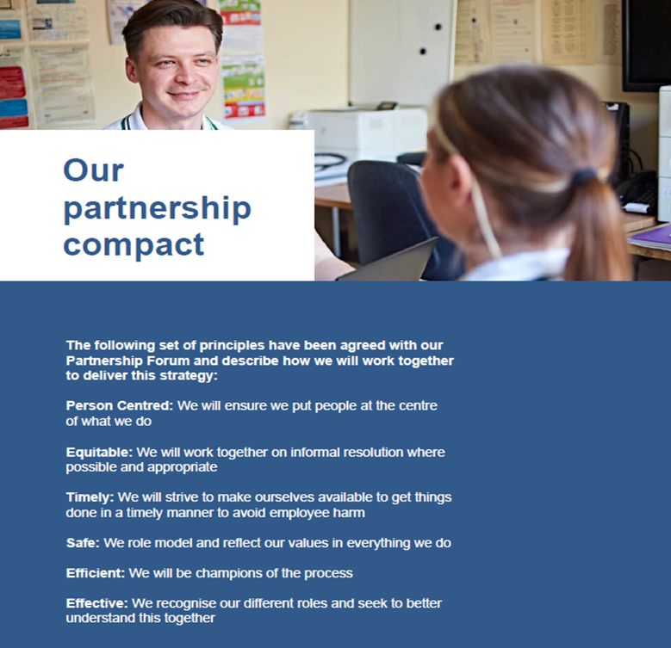

On commencing the review it was clear there was a need to increase trust with our Trade Union partners are really listen to what they were saying. Moving from dysfunctional to more functional conflict. Our Big Conversation laid the foundations to establish a different way of working together and the Review has allowed us to progress the work together that will put our staff at the centre of what we do when it comes to how we manage these spaces which at time can be challenging for all.
The other elements of feedback will be embedded within the overall best practice review to ensure we focus on what matters to our employees.
Other forms of feedback relating to workforce policies and procedures came from listening to Trade Unions, Staff concerns, Management feedback and Workforce and OD feedback. Initial feedback provided will allow the best practice review to gain further insights from key individuals and groups on what we are doing well and where we need to improve. Some of the key feedback points we have received so far are below;
Feedback on what are we doing well:
- The fast track process reduces time and stress
- The Respect and Resolution Policy is a good opportunity to look for a resolution rather than blame

Feedback on where we can improve:
- Our processes can be too long
- There can be a lack of communication during processes
- Processes are felt to be punitive rather than restorative
- Processes can be stressful for all those involved (including management)
- Processes can be confusing
To support launching the Best Practice journey we have undertaken the following to help us better understand the things that are important:
- Created a rolling agenda item in our Sub-Group to allow for continuous dialogue around any issues we need to work on together. This is a WOD across discussion with support from OD as well as Operational HR;
- Nominated two Trade Union leads to work will us every fortnight to nip things in the bud where at all possible around case issues;
- Undertaken initial HR Operations team workshop to understand “what are the thing that we want to change”;
- Held joint workshops with our Trade Unions partners in October 2023 on avoidable employee harm to set the tone of intent around what we were trying

to achieve. This session invited key stakeholders; HR teams, OH and Wellbeing, OD, trade union and management. It generated good areas of discussion around how we can improve our practices. Some of the suggestions for improvement that are currently being reviewed and updated to reflect a best practice approach are below;
- Initial assessment form to provide a more holistic assessment of the initial allegation/compliant and take into consideration all factors that may offer mitigation. It was also recommended that the form could apply to all workforce processes and could facilitate triaging and support just an restorative considerations to allow decisions around the outcome and process to be made early on, achieving a right first time approach that puts the person at the centre.
- Suspension practice and guidance to be reviewed to enable better decision making and management of suspensions from work.
- Cultural shift around disciplinary action to support more of a just and restorative culture and seeing disciplinary action as a last resort.
- Introducing learning from events process which allows us to reflect and learn from any case. Next steps will see our Trade Union colleagues being part of this process to enable joint learning.
To ensure a collaborative and partnership led approach to conducting the Best Practice review an initial working group was established to initiate the review jointly with Trade Union partners. This working group has now been expanded to ensure key members are involved in shaping the Best Practice Review and the trajectory that it will take. A Business Partner lead has been appointed to work jointly with the Head of Operational HR, to ensure the approach is cascaded amongst the BP team. The key to success will be about embedding across the organisation, so the role of the BP will become increasingly important to help achieve this.
The working group will present areas of practice that can be improved to raise the standards and achieve a best practice culture. The working group will hold regular reviews and assess progress aligned with agreed tasks derived from the best practice project plan.

The Best practice collaborative working group objectives are as follows;
• Establish a baseline position for current practices, using workforce data and stakeholder feedback.
• Establish which areas are identified as having poor practice or where practice can be improved.
- Utilise data and feedback to understand where organic best practice has occurred as well as established best practice from other Organisations both internal to the NHS and externally.
• Work together to present recommendations for improvements to practice aligned to supporting the Partnership Compact principles
• Update and develop documents that support recommendations of improvement to practice.
• Support and develop recommendations for Health Board wide training and development programmes and materials.
• Support and recommend cultural development aligned to implementing a best practice culture on an Organisational, management, staff and partnership level.
- Continue the workshop roll out to ensure engagement across the organisation, particularly educating managers to think differently in how we manage these processes.
Changing our approach to managing our Employment Tribunal cases
Over the course of the last 11 months we have also focused on ensuring more proactive management of our Employment Tribunal cases. By understanding the risks, engaging with appropriate legal advice at earlier stages around merits and proactively challenging aspects of claims that have either no foundation, or have limited merit, we have managed to change our approach to lead to successful withdrawals and resolutions.

We need to focus on avoiding settlement of cases where possible. This proves a strong message to the organisation that we are confident in our approach and also ensures we support the management of public money effectively where possible. In the event that settlement has been undertaken since commencement of the review, the learning from the cases, has been shared with the HR Operations team through a learning from event approach referenced above. To ensure this is done in a collaborative and supportive way creating a learning environment. This aligns with the key principles of the review.

Our case numbers (excluding medical) remain relatively low – currently 5 cases. Since the review, this new approach has meant we have managed to resolve 3 cases through withdrawal and successfully struck out 1 case following Full Hearing at Tribunal.
Benchmarking: Best Practice Review Success
Aneurin Bevan University Health Board (ABUHB) undertook a 15 month employee relations review in an attempt to avoid unnecessary investigations and reduce avoidable employee harm. As a result, ABUHB found that 78 out of the 109 misconduct investigations they reviewed did not result in dismissal and could have been addressed through more lenient processes. The review also identified the average length of investigation was 156 days (over 5 months), during which employees were facing potential dismissal, causing a significant impact on both a personal and professional level, as well as having an impact on their families and work colleagues.
ABUHBs best practice review resulted in a number of interventions being developed and actioned which, within the first 12 months of implementing seen a 50% reduction in investigations. ABUHB are now reporting 71% reduction in investigation cases post intervention which they have directly correlated to a decrease of 3,308 sickness days and a saving of £738,133 (Based on direct savings and costs averted).
As a result of ABUHB’s review they changed their approach to focus on avoidable employee harm and found that removing unnecessary investigations from the process and reducing the time taken for necessary investigations was key in them achieving this.
The success seen by ABUHB demonstrates that conducting a review and implementing changes that support a people centric approach within a just and restorative framework benefits the Organisation and its employees. The work ABUHB has done mirrors the objectives within our own People Strategy and so we have partnered with ABUHB and HEIW to share learning and best practice approaches that will support us through our own best practice journey.
It is important to recognise that whilst benchmarking is important, we need to recognise the differences in our challenge and our base line. We are at a different

stage of the journey in Swansea Bay. Ensuring we focus on our challenges will enable us to focus on the critical things that matter to us. For example:
- In December 2018 we had 120 Disciplinaries and 45 grievances. We had already had success in reducing our case levels linked to a previous Legal and Risk review and our Just Culture work;
- In September 2023 we had 50 disciplinary cases (which had reduced again since commencement of our Review in April 2023) and 25 Respect & Resolutions. Our case levels are much lower and we need to recognise the good work of the team in achieving this. What is necessary for us to focus on is embedding practice so it becomes the every day approach.
Equally our timescales are different: For cases considered from 1st October 2022 to 30th September 2023 which is the year the review commenced, 54% of our cases were completed within 60 days, which is an improved position.
Whilst this can provide some assurance, this does not mean we do not focus on continuing to improve.
Our Best Practice Review Next Steps
Now that the preliminary work has been conducted to win hearts and minds and collaboration with our Trade Union Partners to progress this together, our next steps will require effective focus and delivery of key outcomes. The review will now move to a project management stage and will be managed using an agile project methodology that will allow the review to be delivered in line with the below key principles that allow us to achieve our goals effectively.
To provide a structured and managed approach to the review, a project plan has been developed. The Best Practice Review will begin by reviewing disciplinary and respect and resolution practices. The activities within the project plan are outlined below;
Deep-dive data analysis
As outlined in the section ‘Data analysis – Next steps’ a full review of the data available will be conducted to provide a full understanding of current practices through an analytical lens which will provide an internal benchmarked position to enable us to set improvement targets.
Quick win – Practice and Document Review and Development
Based on the feedback we have already received, as outlined in the section ‘Our best practice journey so far’, we have prioritised the review and development of documents accompany policies or procedures that will support our aim to manage workforce practices in a best practice way.

All our HR documentation are now freely available on our intranet. This has increased transparency so our staff know what to expect. We recognise we need to improve them with a person centred lense. This accessibility allows anyone to help us improve this collaborative.
Some practices and documents that have been prioritised and the reason they are being reviewed are outlined below;
- Initial Assessment (IA) Form – The current IA form is a basic document that helps to facilitate the initial assessment conversation when an allegation or complaint is raised. The current IA form is often associated with Disciplinaries and informal feedback from staff and managers is that when an Initial Assessment is instigated they already feel they are in a disciplinary process. The current form also doesn’t provide a robust framework for managers to conduct a holistic initial assessment that takes into consideration both employee and organisational mitigation and although this is what should happen as part of an initial assessment initial evidence suggest that the approach has wide variations into how these assessments are conducted. We are developing a new form which we are calling a Management Review, taking best practice from other organisations to allow us to consider the question – do we really need to go down a formal route or can we do something different to resolve?

The below diagram outlines the proposal of how the ‘Management Review’ form would facilitate triaging to an outcome and would fit within the process;
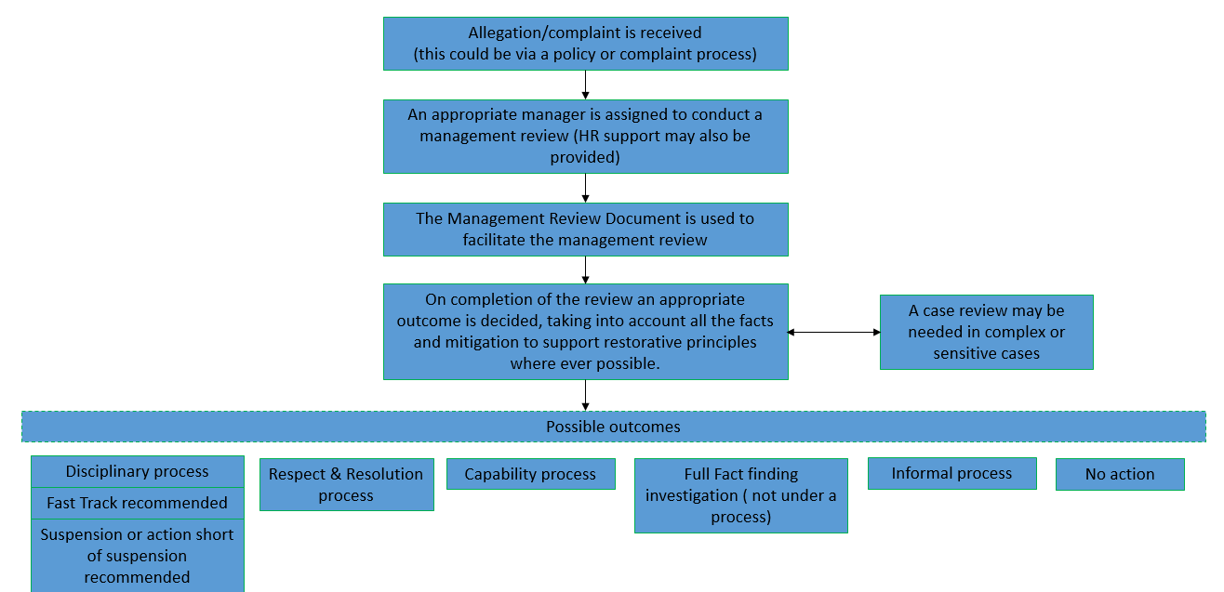

Suspension practice and guidance – a review of our suspension practice and guidance is under review to enable better decision making and management of suspensions from work. Based on the initial data we are currently averaging 8.5% of all disciplinary cases result in suspension and 50% last 6 months or more. Informal feedback gathered so far suggests that those on suspension have a negative experience whilst on suspension with limited or poor communication and support and detriment to their wellbeing. Feedback from our Trade Union colleagues who form part of the review have also confirmed adjustment to duties can be equally challenging, so this needs to be better understood.
- Exploring the opportunity for a Fast Track process for up to final written warnings. This will need to be considered on an All Wales basis as it will be a variation of policy, by our Trade Union colleagues are keen to explore a case where this provides an opportunity. This will be fed into the national agenda as the All Wales Disciplinary process is currently under review.
Stakeholder Feedback
A key part of the review will be understanding how policies and procedures translate into practice. Understanding the perception, experiences and understanding of each individual who is involved in a process will aid in mapping out areas of inconsistencies, current good/best practice and areas for improvement. We have already started listening to staff experiences to help us better understand this which has been very powerful. The review will hold further feedback sessions with HR Ops, HR BP’s, Trade Union, management (at all levels) and employees who have gone through a process.
Supporting Change and Management Enablement
As the project progresses it will be key that the Organisation progresses with it and that those involved in processes are engaged and are part of the learning and development journey. To enable this the project plan will schedule a number training workshops that are held at regular intervals that will focus on avoidable employee harm, a just and restorative culture, a people-centric culture, sharing what the best practice review has learnt and introducing and supporting new ways of working.
As appropriate educational material, management guides and staff information documents will also be created to support any new or updated documentation or procedures. The management documents will help support consistent messaging on how to manage a process or use a document. But most importantly to consider the human impact. Where appropriate employee information documents may be created to support staff understand a process they are going through, what the potential outcomes are and how they will be supported through the process.
A review on additional and supplementary training to support managers will also be undertaken along with stakeholder feedback throughout the review to understand how we can further support and enable the changes and embodiment of change.

Continuous Improvement and Development
Throughout the review both qualitative and quantitative data will be analysed and reviewed to understand what we are doing well and what we need to improve, using a Stop, Start, Do more, Do less model. This will inform an overall approach to how we manage practices and the culture we need to support a change in practice.
As the project plan progresses a case for change may be necessary depending on the outcome of the second phase of the review. The third phase of the review will focus on an action plan and will have fluid populated as and when actions arise from the review.
As necessary regular reports can be provided to the committee to update on findings and progress.

- GOVERNANCE AND RISK ISSUES

The Best Practice Collaborative Working group will be utilised to develop and scrutinise the ongoing plan. The work of the group will be reported to the Workforce Delivery group through to the Workforce, OD and Digital Committee.

- FINANCIAL IMPLICATIONS
There may be financial investment required as the project plan progresses to support the delivery and success of the best practice review.

Poor management of ER cases can result in successful Employment Tribunal claims and any associated financial costs.

- RECOMMENDATION
Workforce, OD and Digital Committee is asked to note:
• The contents of the best practice review deep dive and the plans for delivering the review and implementing a culture of best practice within the Health Board.
Governance and Assurance

Link to Enabling Objectives  (please choose) | Supporting better health and wellbeing by actively promoting and empowering people to live well in resilient communities
Link to Enabling Objectives  (please choose) | Partnerships for Improving Health and Wellbeing |  | ☒
Link to Enabling Objectives  (please choose) | Co-Production and Health Literacy |  | ☐
Link to Enabling Objectives  (please choose) | Digitally Enabled Health and Wellbeing |  | ☐
Link to Enabling Objectives  (please choose) | Deliver better care through excellent health and care services achieving the outcomes that matter most to people
Link to Enabling Objectives  (please choose) | Best Value Outcomes and High Quality Care |  | ☒
Link to Enabling Objectives  (please choose) | Partnerships for Care |  | ☐
Link to Enabling Objectives  (please choose) | Excellent Staff |  | ☒
Link to Enabling Objectives  (please choose) | Digitally Enabled Care |  | ☐
Link to Enabling Objectives  (please choose) | Outstanding Research, Innovation, Education and Learning |  | ☐
Health and Care Standards
(please choose) | Staying Healthy |  | ☒
(please choose) | Safe Care |  | ☐
(please choose) | Effective Care |  | ☐
(please choose) | Dignified Care |  | ☐
(please choose) | Timely Care |  | ☐
(please choose) | Individual Care |  | ☐
(please choose) | Staff and Resources |  | ☒
Quality, Safety and Patient Experience
The wellbeing and satisfaction of our employees is key for the quality of patient care.

Financial Implications
There may be financial investment required as the project plan progresses to support the delivery and success of the Best Practice Review.

Poor management of ER cases can result in successful Employment Tribunal claims and any associated financial costs and reputational impacts.

Legal Implications (including equality and diversity assessment)
Ensuring Best Practice Review takes into consideration all aspects of Employment Legislation (Including Equality Act 2010).

Staffing Implications
To directly improve staff wellbeing and experience. Indirectly improve staff absence levels, turnover and performance.

Long Term Implications (including the impact of the Well-being of Future Generations (Wales) Act 2015)
Not Applicable

Report History |  | First report.
Appendices |  | Presentation - Our Employee Relations Best Practice Review

