Meeting Date | 18 April 2024 |  | Agenda Item |  |  | 3.3
Report Title | NICU Critical Staffing
Report Author | Vicki Burridge Head of Nursing Children Services
Report Sponsor | Sharron Price – Service Group Nurse Director (NPTS), Hazel Powell, Interim Director of Nursing
Presented by | Vicki Burridge – Head of Nursing Children Services (NPTS)
Freedom of Information | Open
Purpose of the Report | To provide the Board with an update on the current registered Nursing staffing position within the Neonatal Unit at Singleton Hospital.  To provide an overview of current and planned actions to support the effective recruitment and retention of the Registered and non-Registered Nursing workforce in the Neonatal Unit.
Key Issues | The key issues identified for this report:  - Staffing risk has the potential to increase from a score of 20 to 25. The current mitigation that is in place is maintaining the risk at a risk score of 20.  - National UK challenges recruiting into Neonatal Nursing posts.  - Consistent weekly use of Agency staff due to staff unavailability. High cost Agency (Thornbury) use has been in place (details of costs are outlined in the table below). The Unit has recently been able to switch to the use of alternative agencies which should result in a reduction in variable pay costs.  - Staffing pressures often result in challenges achieving the correct skill mix across the service.  - PADR compliance rates require improvement to meet the Welsh Government target rate of 85% (overall compliance for the team in the Neonatal Unit cost centre as at 01/24 is 56.04% / ANP and NP PADR compliance is 33.33% as at 01/24). Plans are in place to improve this compliance rate.  - Overall mandatory and statutory training compliance rates for the Unit comply with the Welsh Government rate of 85% (this applies to the 15 core modules) – however compliance within some modules requires some targeted improvement as outlined in this document.  - The requirement to allocate specialist trained employees to the CHANTS transport service every three weeks places additional staffing pressures on the Unit.  - The Unit has insufficient clinical practice hours funded in the staffing establishment to enable the Unit to release Nurses to access the higher level of education standards required for a Neonatal Nurse.  - Staffing pressures present a risk and threat to patient / family experience.  - Staffing pressures present a risk to the Unit’s cot capacity with the potential risk of impacting on maternity service and neighbouring Health Boards – which could also impact on organisational reputation.
Specific Action Required  (please choose one only) | Information | Discussion |  | Assurance | Approval
Specific Action Required  (please choose one only) | ☒ | ☐ |  | ☐ | ☐
Recommendations | Members of the Board are asked to note:  - The ongoing and added risk of closure of SCBU (Ward 5) to support the nursing establishment on the neonatal intensive care unit.  - The ongoing impact of Neonatal staffing levels on other associated services within the Health Board.  - Challenging Service to recruit into key roles – an integrated workforce plan is being developed to support the unit in developing a sustainable workforce model that meets the requirements of the Neonatal service.  - Robust Retention Plans are in development to further support the unit in achieving a sustainable and engaged workforce (note a Recruitment and Retention Task and Finish group has already been established and some retention actions have already been implemented).  - Escalation and Staffing Reviews - weekly meetings with Head of Nursing – Children and Young People and Matron are in place to review current and future staffing levels across the Neonatal Service. An escalation process is in place to alert staffing risks to the Service Group Nurse Director / Service Group Director.  - Education Needs Assessments – these are routinely completed by the CPD Lead to identify training requirements to support the career pathway for nurses making the transition from Band 5 roles to Band 6 roles (over the two-year period post registration). This arrangement is in place to support the service’s ‘Grow our Own’ initiative due to challenges recruiting directly into Band 6 posts.  - Increased CPD resource (by 2 WTE). This expansion of the CPD team is in place to support the education and training needs of existing employees, new employees and International Nurses recruited into the service.  - Recruitment strategy – Plans are in place to support the services ability to recruit (e.g. Open Days / links with Universities / Social Media campaigns etc). Recruitment activity for the service is supported by the Health Board’s Central Resourcing Team.  - NICU Nurse Bank – The bank will continue to be promoted and expanded.  Board Members are asked to confirm support for:  - Team Wellbeing – the service requests support to submit a business case for introducing NICU employee access to dedicated psychological support (e.g. help with processing of psychological trauma / reflective practice and psychological debriefs)  - The Unit anticipates that there will be a need to increase staffing levels to BAPM standards. There is also a requirement to over recruit into Band 5 roles to enable the service to release staff for training / backfill high levels of maternity leave and support the ‘Grow our Own’ approach to facilitate recruiting into Band 6 roles (medium / long term). A further Business case will be submitted to the Service Group SMT / Management Board following completion of the Workforce Plan.

1.0 INTRODUCTION

The purpose of this report is to inform the Neath Port Talbot and Singleton Service Group (NPTSSG) on Registered and non-Registered Nursing staffing levels in the Neonatal Unit at Singleton Hospital and the deficit in establishment against the BAPM standards of staffing.

The report will also outline current and planned actions to support the effective recruitment and retention of the Registered and non-Registered Nursing workforce in the Neonatal Unit.

2.0 BACKGROUND

Neonatal care is a dynamic progressive speciality, both in terms of organisation and workforce. Outcomes for babies and families in our care improve year on year.

Singleton is one of three tertiary neonatal intensive care units (NICU) across South Wales providing specialist care for babies 22 weeks gestation and above. The neonatal service is unique in that it covers a whole pathway of care including, Intensive Care, High Dependency, Special care, Transitional care, Outreach care, and a neonatal network transport service. Providing. Neonatal units require highly skilled staff with the qualifications and experience in speciality in care. The neonatal network, work closely to ensure babies are born in the right place in accordance to gestation. Repatriation is managed effectively with Neonatal and Maternity services across all District General Hospitals to ensure where possible that babies are born locally and cared for within Wales.

The remit of the Singleton Neonatal Intensive Care Unit is to provide Intensive Care, High Dependency and Special Care for residents of SBUHB as well as ITU and some HDU care for Hywel Dda University Health board residents and the Princess of Wales Hospital catchment areas. Frequently, Singleton neonatal services will provide care to babies and their families from the wider Health community when cots are not available in one of the other two ICU’s and can include babies from English NHS Trusts. This activity also generates an income for the Health Board.

For Intensive Care Units (Level 3 – Note: The Singleton Neonatal ICU is a Level 3 Unit) the British Association of Perinatal Medicine (BAPM) standards state that these units are required to care for at least 100 very low birth weight (VLBW) babies per year and also undertake at least 2000 intensive care (IC) days per year as a minimum. In SBUHB this level of activity has not been met which has been as a result in some part due to current staffing levels – this could have an impact on WHSCC funding.

The neonatal service in Singleton is one of three Intensive Care Units in South Wales providing a transport service on a ‘one in three’ week rota. Cymru Inter Hospital Acute Neonatal Transfer Service (CHANTS) delivers a 24-hour service. This ensures sick or premature babies born outside specialist centres can be transferred for ongoing specialised treatment. The staffing resource to cover the transport service is from within the current establishment in the Singleton Neonatal Unit and it is completely reliant on staff agreeing to work extra hours. This arrangement is also reflected in other Health Boards. The service is managed from within current establishments – this will form a consideration as part of the workforce planning process.

The NICE quality standard (2010) 'In support of the Toolkit for high quality neonatal services’ (DH 2009) includes a standard for safe staffing in neonatal care. This recommends an adequate and appropriate workforce, with leadership and skill mix competencies to provide excellent care at the point of delivery for babies receiving medical and surgical interventions.

The standards for nurse staffing levels for each category of care for neonates are (DH 2009, NICE 2010, BAPM 2010):

- Neonatal Intensive Care: 1:1 nursing for all babies
- Neonatal High Dependency Care: 2:1 nursing for all babies
- Neonatal special care: 4:1 nursing for all babies

A daily acuity tool is completed in line with BAPM standards, indicating the required safe nurse staffing requirements. This information informs the weekly staffing review meetings.

At times of high acuity, the unit is reliant on staff working extra hours, together with utilisation of bank and agency staff acknowledging there is a risk associated with using staff from outside the organisation. There has been increased occasions where training has been cancelled to allow for safe staffing of the unit during these times.

The location of SCBU on a level below the NICU poses a number of challenges in terms of staffing. Managing this situation is complicated due to the isolation and distance of the SCBU from NICU. Ensuring nurses with appropriate skills and experience is essential in ensuring the staffing is appropriate for the area to reduce risk

In recent months, staffing both areas ITU and special care has been challenging due to the unavailability of nursing staff through sickness, maternity leave and secondments.

There are occasions when the decision to close special care has been made due to the low activity of special care and the staffing availability at the time. This allows all babies to be nursed within NICU utilising skill mix effectively. Before such a decision is made, all measures are taken to ensure that SCBU (Ward 5) remains open. Senior leaders appreciate that closing Ward 5 denies the parents the experience of their baby being nursed within in a purpose-built area. Progress has been made to appoint a Team Leader role for SCBU (Ward 5) –. This role provides assurance and leadership to manage this area effectively and provides an additional career progression pathway for existing and new employees.

The neonatal network SITREP meetings are held three times a week and these meetings assist in the escalation process across the network. The meeting supports the assessment of demand and capacity across all NHS Wales Health Boards (which includes maternity services). This approach ensures infants receive the right care in the right place at the right time, allowing the timely repatriation of neonates to their ‘booking’ Hospital and freeing up critical care cots.

The following section provides further details relating to the current Registered and non-Registered Nursing workforce in the Neonatal Unit.

3.0 WORKFORCE PROFILE / KEY PERFORMANCE INDICATOR DATA

3.1 Workforce Profile

Neonatal Unit - Registered Nurses (RN)
Over the 13-month period assessed (11/22 – 11/23) between 79 and 83 RNs were employed in the Neonatal Service. These RNs are employed in roles ranging from Band 5 through to Band 7.
Retirements due (based on age 60): One Band 6 RN is potentially due to retire as at 01/24 with four RN employees due to retire in five years’ time. One Band 5 RN and one Band 7 RN is due to retire in five years’ time.
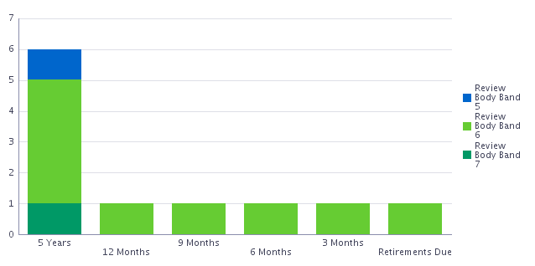
Age profile: The profile of the current RN workforce in this service has changed over the last few years following several retirements of very experienced Neonatal Nurses. Most of the Nursing workforce are now between the age of 21 – 35.
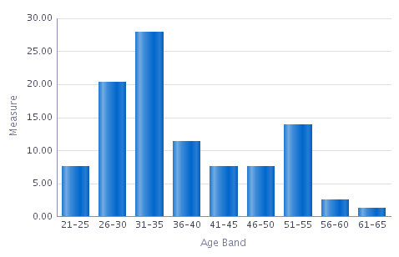
Length of service: Just over 42% of Nurses in the service have under 5 years’ service. This reflects the challenges with roster management, allocation of intensive care babies meeting the standards of BAPM 1:1 and every three weeks provision of CHANTS (Cymru Hospital Acute Neonatal Transport service). The service requires experienced QIS Nurses to maintain the service - these staff are drawn from the existing establishment.
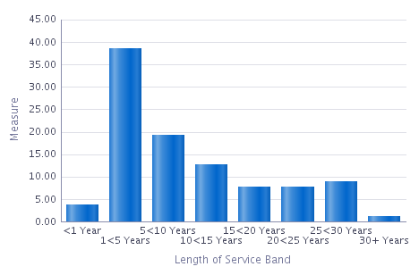
Neonatal Unit – Advanced Nurse Practitioners (ANP) and Nurse Practitioners (NP)
Over the 13-month period assessed (up until 11/23), six ANP / NPs were employed in the Neonatal Service (Band 8a and 8b). One currently in training again drawn from existing nursing establishment.
Retirements due (based on age 60): One Band 8a Nurse is potentially due to retire during the next 5 years.
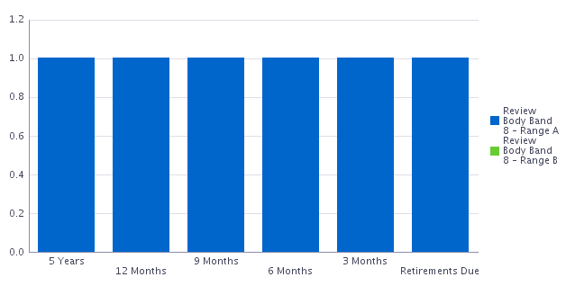
Age profile: The profile of the current ANP / NP workforce is distributed across all age groups.
Length of service: Five out of the six ANP/NPs have over 10 years of service.

3.2 Sickness absence

The following sickness absence data has been taken from ESR for the period 1/2/22 – 30/11/23.
Neonatal Unit - Registered Nurses
Overall absence trend: We have observed a downward trend in absence rates for this staff group between 11/22 (9.38%) and 11/23 (4.56%). As at 11/23 the in-month sickness absence rates for this staff group are < the Welsh Government target rate of 5%. Sickness rates during this period have ranged between 11.78% and 3.52%. See graph 1.
Long Term / Short Term: As at 11/23 the long-term sickness absence rate was 2.74% with short term sickness reducing back to <2% (1.82%).
Graph 1.
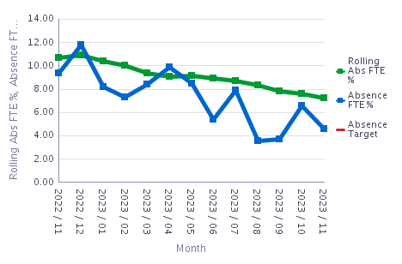
Absence reasons: The service has access to absence reason data and analysis of this data. This has not been included in this Board report, but it informs Wellbeing and Retention plans.
Additional note - Maternity Leave: Between one and nine RNs were on Maternity leave each month during the period 11/22 – 11/23. As at 11/23 eight RNs were on Maternity leave (which equates to approx. 10% of the RN workforce).
Neonatal Unit – Additional Clinical Services (Band 2 / Band 4)
This data has been taken from ESR for the period 1/11/22 – 30/11/23. During this period between 7 and 12 employees in the Additional Clinical Services Staff Group were employed within the service.
Overall absence trend: Between 03/23 and 11/23 absence rates in this staff group have been increasing. As at 11/23 the in-month absence rate was 29.92%. Sickness rates during this period have ranged between 0% and 38.34% (see graph 2).
Long Term / Short Term: Current levels of absence within this (relatively small) group of staff are due to long term sickness absence.
Graph 2.
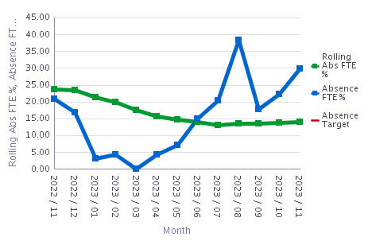
Absence reasons: The service has access to absence reason data and analysis of this data. This has not been included in this Board report, but it informs Wellbeing and Retention plans.
Neonatal Unit – Advanced Nurse Practitioners / Nurse Practitioners (Band 8a / 8b)
During the period 1/11/22 – 30/11/23, 6 employees in this group of staff (from cost centre H551) were employed in the service.
Overall absence trend: Between 03/23 and 11/23 absence rates in this group have fluctuated through the 13-month period. As at 11/23 the in-month absence rate was 0%. Sickness rates during this period have ranged between 0% and 20.23% (see graph 5).
Long Term / Short Term: There has been no long-term sickness absence in this group of staff. Six months out of the 13 month period assessed had 0% sickness reported. February 2023 had relatively higher levels of short-term sickness absence (20.23% absence – note this percentage rate will be high as the group of individuals working in this role is relatively low so a few occurrences of sickness absence will impact on the overall sickness rate).
Graph 3.
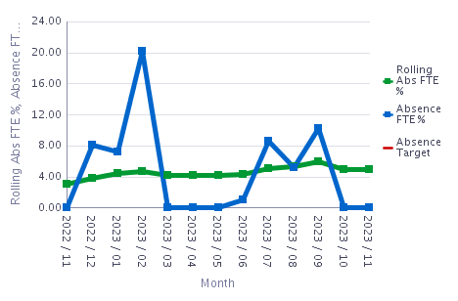
Absence reasons: The service has access to absence reason data and analysis of this data. This has not been included in this Board report, but it informs Wellbeing and Retention plans.

Neonatal Unit – Overall absence (all staff groups)
To help inform how sickness absence can be supported within the Nursing and Additional Clinical Services staff groups it is useful to understand sickness absence for all staff groups working in the Neonatal service (RN / Additional Clinical Services / Medical and Dental / Admin and Clerical). The table below illustrates the ‘in month’ and cumulative sickness absence rates for all staff groups working in the Neonatal service (across cost centres H542 and H551).
Overall sickness absence rates for cost centre H542 exceed the Welsh Government sickness absence target rate of 5% (11/23 = 6.26% IM). Sickness rates for the cost centre H551 are below the Welsh Government target rate.
Based on the data outlined in this document the service should focus primarily on improving sickness absence rates for Additional Clinical Services employees and RNs working within H542 – recognising that absence rates in this service are lower than rates observed in many other clinical services across the Health Board.
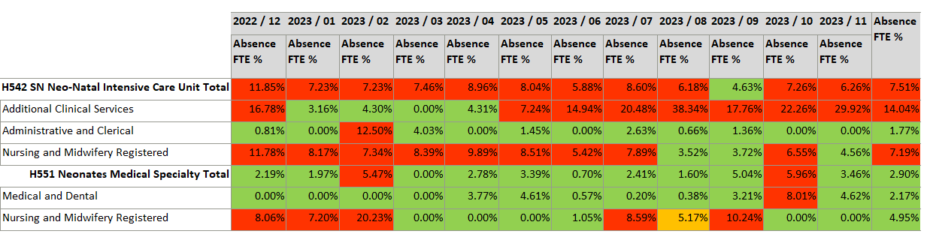
When focusing on all employee sickness absence across the Neonatal service during the 12 month period 11/22 – 11/23, it is possible to identify that the highest amount of ‘FTE lost’ is due to Anxiety Stress Depression other Psychiatric illness. Levels of Anxiety Stress Depression other Psychiatric illness have reduced since 07/23, over the 12 month period 11/22 – 11/23, however as the Unit is an ITU service there would be benefit in focusing on how the Unit can provide appropriate wellbeing support for employees working in this type of clinical environment.

When reviewing the provision of wellbeing support in other similar Units across the UK and when referencing research relating to psychological support for Neonatal Units it is recommended that the service proposes developing a business case to consider funding a dedicated psychological service for Neonatal employees to access. This business case will be submitted to the NPTSSG SMT / Management Board for further consideration.

3.3 Nursing Unavailability

The unavailability of the Registered Nursing workforce according to the most recent report w/c 19/2/24 is 31.05% this equates to 22.77 WTE. Unavailability levels generally sit at around 30 – 35%.

The tables below summarise and outline the current funded establishment, the vacancies and staff unavailability due to sickness absence and Maternity Leave. The data is accurate as at week commencing 19/2/24.

 | Funded Establishment (WTE) | Staff in Post (WTE) | Vacancies (WTE) | LT Sickness Absence (WTE) | Maternity Leave (WTE) | Secondments (WTE)
Band 7 | 11.92 | 7.68 | 1.32 (1.0 appointed on TRAC) | 0.96 | 0.96 | 0.4
Band 6 | 32.09 | 17.72 | 9.49 | 0.88 | 4.0 | 1.0
Band 5 | 36.14 | 35.96 | Agreed plan to over establish at Band 5 level by 8.78 | 0 | 3.96 | 1.0

Recent staff unavailability levels have resulted in an increased need for additional hours and non-contract agency usage. Regardless of acuity levels on the Unit, the aim is to have 11 Registered Nurses allocated to each shift. The recent unavailability levels met the threshold for needing to limit admissions and decline in-utero transfers from other Health Boards. Given the requirement to provide specialist support across the network this can have an impact on our local Maternity services and neighbouring Health Boards.

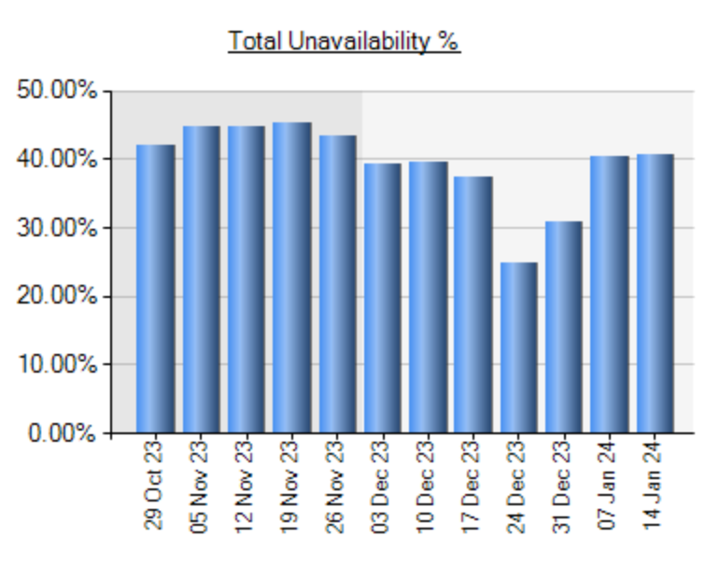

Unavailability data demonstrates the consistent percentage over the past few months. This information will be utilised to further support the business case for further investment into the staffing levels for the neonatal service.

3.4 Turnover
Neonatal Unit – Registered Nurses
- During the 13-month period 11/22 – 11/23, nine RNs (headcount) 7.44wte left the service, resulting in a monthly turnover rate of between 0% and 3.66% (headcount).
- The 12-month turnover rate (headcount) ranged between 6.21% - 8.59%.
- There were 4.2wte new starters joining the service (five headcount)
- The majority of RNs who resigned had less than 5 years-service.
- Four out of the nine leavers over the 13-month period chose to voluntarily resign due to work-life balance – it is reasonable to assume that the service may have been able to prevent the resignations of these four employees.

See table below:

Leaving Reason | Leavers
Flexi Retirement | 1
Retirement Age | 1
Voluntary Resignation – Relocation | 3
Voluntary Resignation – Work Life Balance | 4
Grand Total | 9

Neonatal Unit – Additional Clinical Services
- During the 13-month period 11/22 – 11/23 one employee from the Additional Clinical Services staff group left the service, resulting in a monthly turnover rate ranging between 0% and 10% (headcount). The 12-month turnover rate (headcount) ranged between 0 and 22.22%.
- The one employee who resigned during this period resigned to undertake further education / training.
Advanced Nurse Practitioners / Nurse Practitioners
- There was 0% turnover in this group of staff during the period 11/22 – 11/23.

3.5 Mandatory and Statutory Training Compliance

3.5.1 15 Core Modules
The Welsh Government have set a target rate of 85% compliance across all 15 statutory / mandatory training modules. As the Neonatal Service is a clinical area the team will also be required to complete a number of additional mandatory training modules. Compliance across these additional modules can be found in section 3.5.2.
Overall compliance rates (for the core 15 modules) across the service for all staff groups as at 12/23 comply with the Welsh Government target compliance rate – see table below:
Org L8 | Assignment Count | Required | Achieved | Compliance %
130 H542 SN Neo-Natal Intensive Care Unit | 94 | 1410 | 1304 | 92.48%
130 H551 Neonates Medical Specialty | 25 | 375 | 333 | 88.80%

When assessing compliance across the 15-core mandatory / statutory modules (for all staff groups working in the service), compliance rates are summarised as follows – see table below:
Summary | Percentage Compliant | Percentage Not Compliant
Equality Diversity & Equal Rights | 90.00% | 10.0%
Fire Safety | 86.67% | 13.3%
Health Safety & Welfare | 90.00% | 10.0%
Infection Prevention & control | 98.33% | 1.7%
Infection Prevention & control 2 | 80.83% | 19.2%
Information Governance | 82.50% | 17.5%
Moving & Handling | 88.33% | 11.7%
Resuscitation | 87.50% | 12.5%
Safeguarding Adults | 92.50% | 7.5%
Safeguarding Children | 90.83% | 9.2%
Violence & Aggression | 95.83% | 4.2%
Welsh Language Awareness | 88.33% | 11.7%
Dementia Awareness | 95.83% | 4.2%
Social Services & Wellbeing Act | 94.17% | 5.8%
Violence against Women | 91.67% | 8.3%

Compliance rates (all staff groups) for the Infection Prevention and Control Module 2 (80.83%) and Information Governance (82.50) are both below the Welsh Government target rate of 85%.
The table below focuses on compliance rates for Additional Clinical Services and Registered Nursing staff groups working in the Neonatal Service. Areas highlighted in red and amber identify modules that are non-compliant and < the Welsh Government target rate of 85%.
 |  | ACS | RGN
 |  | % Compliance | % Compliance
1 | Dementia Awareness | 75 | 100
2 | Equality Diversity and Equal Rights | 62.5 | 91.95
3 | Fire Safety | 62.5 | 91.95
4 | Health Safety and Welfare | 62.5 | 91.95
5 | Infection Prevention and Control 1 | 87.5 | 98.85
6 | Infection Prevention and Control 2 | 62.5 | 83.91
7 | Information Governance | 62.5 | 81.61
8 | Moving and Handling | 62.5 | 90.8
9 | Resuscitation | 62.5 | 87.36
10 | Safeguarding Adults | 62.5 | 93.1
11 | Safeguarding Children | 62.5 | 93.1
12 | Social Services and Wellbeing Act | 75 | 100
13 | Violence and Aggression | 75 | 98.85
14 | Violence against Women | 75 | 90.8
15 | Welsh Language Act | 75 | 88.51

Compliance rates for the eight employees within the Additional Clinical Services Staff Group are the lowest. When assessing the detailed compliance data that is supplied to all Managers in the NPTSSG Service Group as part of their Mandatory Training Compliance Performance pack it is possible to identify the following (data originally sourced from ESR as at 5/1/24):
 | Number of Core modules to be completed
Employee 1 | 15
Employee 2 | 12
Employee 3 | 9
Employee 4 | 1
Employee 5 | 1
Remaining 3 employees | 0

From the RN staff group when focusing on the two modules classified as amber compliance, 14 employees are required to complete the IPC2 Infection Prevention and Control module, and 16 employees are required to complete the Information Governance module.
3.5.2 Additional Mandatory and Statutory Training Modules
Specific additional Mandatory and Statutory Modules that need to be completed by the team working in the Neonatal Unit include:
- QIS (Qualification in speciality) which comprises of two parts:
- Module one 56%
- Module two which equate to QIS is 53%. Network requirements is 70% of neonatal workforce. A further recruitment of two Band 5 and a Band 6 have this qualification which will take our compliance to 59%.
- NLS (Neonatal Life support) based on eligible nurses, those that have been in post a year is 95.5%. This is run by resuscitation council, staff are required to be released for 12 hours to attend and is held 4 times a year releasing 4 – 6 nurses to maintain compliance.

3.6 PADR Compliance
The Welsh Government have set a target rate of 85% compliance for PADRs.
As at 1/24 for all RNs, Additional Clinical Services and A&C employees working in the Neonatal Unit (H542) compliance was 56.04% (<the WG target rate – this equates to 91 employees without an up-to-date PADR). PADR compliance rates in the service were compliant as at 07/23 (85.11%) but compliance rates have then reduced each month.
The compliance rate for ANPs and NPs (H551) as at 12/23 was even lower 33.33% (this equates to six employees without an up to date PADR). Compliance rates for this group of staff have not improved for a significant period.
By the end of February 2024 there will be a further 18 employees (H542) / 1 (H551) with out-of-date PADRs which will result in a further decline in PADR compliance rates.

4.0 GOVERNANCE AND RISK ISSUES

Safe care is paramount, the chance of survival of the smallest and most preterm babies relates not only to nurse staffing ratios but also to the specialist levels of education and experience of nurses delivering care. The organisation has a responsibility and accountability to ensure that babies and families receive high quality care, in the right place, at the right time delivered by staff equipped to provide safe dignified, compassionate care.

Managers with a professional registration must also always act in accordance with their professional accountability, for the provision of safe care under their Code of Conduct.

Staff deficits has the potential to increase the risk of reported incidents. Examples of incidents caused include:

- Closing to admissions displacing families out of the area including long distance transfers to centres in England.
- Families must spend many weeks away from home at a stressful time of life with mental health and economic implications.
- This has an impact on maternity services not only in SBUHB but across Wales.
- Increase in Agency staff increases the risk of incidents and poor compliance with standards for example infection prevention and control (note: current availability of Agency staff is limited, as other Health Boards across Wales are also experiencing recruitment challenges with a known national shortage of Neonatal Nurses, there is a competitive market for Agency staff).
- The wellbeing and resilience of the Neonatal workforce (with a possible increased risk of burnout, poor staff retention, inability to recruit etc).
- Inability to meet income generated targets set by WHSSC due to insufficient staffing to facilitate intensive care and HDU care.

5.0 RECOMMENDATIONS / ACTIONS

The following section describes actions and arrangements that are planned / currently in place to mitigate against the risks described above and to support the service in developing a stable and sustainable workforce:

Escalation arrangements / staffing reviews | - Daily regular assessment of the patient levels of care and acuity are in place to enable early escalation in relation to the neonatal cot capacity. This is reported through the Network and the Cot locator to inform the availability of cots in South West Wales.  - To Support safe staffing all nurses are offered additional hours and enhanced overtime.  - The service is part of the Service Group’s Roster Scrutiny group to ensure that effective rostering practices are embedded within the service.  - Embedded escalation to Service Group Director of Nursing to alert potential or anticipated staffing difficulties.  - Increase staffing levels to BAPM standards. Present budgeted establishment does not meet BAPM standards however the Health Board have agreed to recruit above this establishment to meet BAPM standards. A further Business Care will be presented to the NPTSSG SMT / management Board.
Sickness absence | - Recording of absence reasons - There is a high usage of the reason code S98 – Other known cause. This reason should not be in use. Individuals responsible for recording absence for staff working in the Unit should cease the use of this absence reason.  - A Long-Term and Short-Term absence audit has been commissioned by the Head of Nursing – Children and Young People. This audit will be completed by 03/24. The audit will be completed by the HR Business Partner Team. The purpose of the audit is to gain insight into how sickness absence is managed within the service. This is a supportive measure to identify how the HR BP team can better design their support provided to the Neonatal Services management team. Note: There aren’t existing concerns about the management of sickness absence in this service.  - Identify further requirement for Managers to access MAAW training / support. It may be beneficial to include a session focusing on work related Stress, Depression, Anxiety other Psychiatric illness (and the Wellbeing support and ‘tools’ available to managers). It may be beneficial to include a session focusing on how to support pregnant staff in the workplace e.g. ensuring the correct risk assessments are completed etc.  - Develop and submit a Business Case to NPTSSG SMT to establish NICU employee access to dedicated psychological support (e.g. help with processing of psychological trauma / reflective practice and psychological debriefs)
PADR Compliance | - The services PADR compliance improvement plan needs to be reviewed based on the data outlined in this document.  Note: PADR performance information is already provided to the service each month showing the status of each employee PADR. The report also provides an overview of how many PADRs will fall out of compliance each month. This data should be used to regularly support managers to proactively book dates for PADRs before they ‘expire’.  - The service can consider the opportunity to undertake group PADRs (support for this can be provided by the HR BP / L&D team if required).  - The service should assess who currently undertakes PADRs to understand if it is appropriate for other senior members of the team to support colleagues with the completion of PADRs (HR BP team can help provide advice in relation to this). PADR training can also be arranged.  - Improvement against this plan should be monitored via the monthly CYP Workforce Group (chaired by the CYP Divisional Manager).  - Longer term the service should also focus on ensuring that high quality PADRs are being undertaken across the service.
Mandatory and Statutory Training | - A targeted plan is required to improve some aspects of compliance – as generally compliance is >the Welsh Government target levels across the core 15 modules.  - When developing this plan, the service should consider the following actions:  - Undertake a risk assessment to prioritise modules that need to be urgently completed by employees (the training performance report supplied to the team on a monthly basis can support this).  - Identify time and access to Computers to support employees to undertake the training.  - Identify if it would be helpful to host facilitated sessions to support employees accessing and completing training modules).  - Improvement against this plan should be monitored via the CYP Workforce Group which is chaired by the CYP Divisional Manager.  - Ensure that employees are reminded to monitor their own personal compliance by accessing their own ESR record during Team Meetings / Safety Huddles.  - Additional Modules to be aligned with position numbers which will improve compliance for all modules.
Staff Experience / Retention | - Robust Retention Plans are in development to further support the unit in achieving a sustainable and engaged workforce (note a Recruitment and Retention Task and Finish Group has already been established chaired by the Head of Nursing (CYP) and some retention actions have already been implemented).  A template Retention Plan has been developed incorporating the HEIW Nurse Retention Guidance 2023 / NHS England Best Practice / Swansea Bay People Strategy / Delivery of the 2022-24 Collective Agreement. The themes of this plan include:  - Compassionate Leadership and Culture  - Valuing Staff  - Supporting new starters and those changing roles  - Supporting International Nurses  - Development and Career Planning  - Flexible Working  - Health and Wellbeing  - Recognition and Incentives  - Evaluating Impact / Understanding data and information  The plan needs to be finalised and implemented as soon as possible (recognising that some urgent retention actions are already being progressed).  There will be benefits in progressing the development and implementation of this plan in collaboration with the team and in partnership with Trade Union Representatives. A key aspect of developing the plan will be to host a number of listening events with the Neonatal Team. These Listening Events will provide an opportunity to gain critical intelligence and insight to inform the plan.  The Plan should utilise the HEIW Nurse Retention Resources and the data included in this report as well as local qualitative and quantitative date (specific examples from this report could include a. understand how employees work life balance could be better supported b. how RNs could be better supported during the first 5 years of their employment in the service and enable them to progress from Band 5 to Band 6 roles).  - The service has invested in an Increased CPD resource to meet the training requirements, improve compliance with mandatory and statutory training and ensure a skilled and competent workforce.  - Exit Interviews - An essential component of the Retention plan will be to include details on how to ensure that there is a robust Exit Interview process in place across Neonatal services.  The revised Exit Interview process was introduced in the service 2/24. The exit interview information will need to be reviewed regularly to identify how the information can help inform the Retention Plan.
Recruitment / Workforce Model | - An integrated workforce plan is being developed to support the unit in developing a sustainable workforce model that meets the requirements of the Neonatal service. This work is being supported by the HR Business Partner and Workforce Planning Teams.  - Recruitment strategy – Plans are in place to support the services ability to recruit (e.g. Open Days / links with Universities / Social Media campaigns etc).  - The service will continue to request the support of the Health Board’s Central Resourcing Team to support recruitment activity.  - The service will continue to recruit International Nurses.  - The service will continue to recruit via the NHS Wales Student Streamlining process (this has moved to twice yearly to reach both Adult and Child Branch trained student Nurses). It is anticipated that the service will recruit 10 Nurses in the September 2024 cohort.  - The service has established a ‘Grow our Own’ approach due to difficulties in recruiting to Band 6 Registered Nursing posts. The service now has plans to over establish at Band 5 level and it has in place a structured education and development programme / career pathway to support Band 5 Registered Nurses to apply and make the transition into Band 6 roles (within 2 years post registration).  - The service has established several different career pathways to improve its’ ability to recruit and retain Registered Nurses – these pathways include:  - Staff have the option to continue a clinical career pathway to Advanced Neonatal Nurse practitioner level (the Singleton Unit was the first Unit to introduce the Advanced Nurse Practitioner role onto the tier 2 medical rota).  - Specialist Role Career Pathway (Leadership, Outreach, Infant Feeding, or Education). The intention is to use the Workforce Planning process to understand the need / benefit of increasing the number and types of specialist roles supporting the service.  Note: To support Nurses to progress to these roles, the unit has recently invested into the Clinical Practice Development team – and the service is currently recruiting into two additional Band 6 posts. Note: There is currently a deficit within the Practice Development Team as one of the team members is currently being supported on a secondment to the Maternity Neonatal Safety Support Programme. Arrangements are in place to backfill this secondment arrangement.
NICU Bank | A Bank was established some time ago and recently there has been a drive to promote the bank and encourage individuals to join the NICU bank (internal employees and externally). The service will continue to support the expansion and promotion of this bank.

FINANCIAL IMPLICATIONS
.
The current cot configuration in the neonatal services is:

Cot type | Number of cots
Intensive Care | 6
High dependency | 8
Special Care | 10
TOTAL | 24

To staff these cots there is a requirement for 73.91 WTE direct clinical Registered Nurses for the 24 cots. This includes 26.9% ‘headroom’.

The current budgeted establishment is 68.21 WTE which allows for 12 WTE Registered Nurses per shift (this does not comply with BAPM).

Current Establishment

Band | WTE
Registered Nurse Band 7 | 11.92
Registered Nurse Band 6 | 32.09
Registered Nurse Band 5 | 36.14
Nursery Nurse Band 4 | 4.25
HCSW Band 3 (non-clinical) | 0.90
HACSW Band 2 (non-clinical) | 2.40
Admin & Clerical Band 3 | 1.00
Admin & Clerical Band 2 | 2.84

BAPM Standards | Number of beds | Ratio | Per shift | WTE 24/7
ITU | 6 | 1:1 | 6.00 | 34.11
HDU | 8 | 1:2 | 4.00 | 22.74
Special Care Beds | 10 | 1:4 | 3 | 17.06
Total |  |  | 13 per shift | 73.91

The current use of overtime, bank and agency is a financial pressure – the table below demonstrates usages this financial year.
Period | Bank | Overtime | Agency-Non Medical | Total Variable
P01 | 16,842 | 12,512 | 25,934 | 55,287
P02 | 14,105 | 9,147 | 60,631 | 83,882
P03 | 17,741 | 5,879 | 43,297 | 66,918
P04 | 14,712 | 13,099 | 71,279 | 99,090
P05 | 11,092 | 4,765 | 51,282 | 67,138
P06 | 16,329 | 8,152 | 61,127 | 85,608
P07 | 13,631 | 9,291 | 122,616 | 156,776
P08 | 20,228 | 13,017 | 123,530 | 156,776
P09 | 11,283 | 11,365 | 106,607 | 129,255
P10 | 33,073 | 18,532 | 95,673 | 147,278
 | 169,036 | 105,758 | 761,976 | 1,036,770

Governance and Assurance

Link to Enabling Objectives  (please choose) | Supporting better health and wellbeing by actively promoting and empowering people to live well in resilient communities
Link to Enabling Objectives  (please choose) | Partnerships for Improving Health and Wellbeing |  | ☐
Link to Enabling Objectives  (please choose) | Co-Production and Health Literacy |  | ☐
Link to Enabling Objectives  (please choose) | Digitally Enabled Health and Wellbeing |  | ☐
Link to Enabling Objectives  (please choose) | Deliver better care through excellent health and care services achieving the outcomes that matter most to people
Link to Enabling Objectives  (please choose) | Best Value Outcomes and High Quality Care |  | ☒
Link to Enabling Objectives  (please choose) | Partnerships for Care |  | ☐
Link to Enabling Objectives  (please choose) | Excellent Staff |  | ☒
Link to Enabling Objectives  (please choose) | Digitally Enabled Care |  | ☐
Link to Enabling Objectives  (please choose) | Outstanding Research, Innovation, Education and Learning |  | ☒
Health and Care Standards
(please choose) | Staying Healthy |  | ☐
(please choose) | Safe Care |  | ☒
(please choose) | Effective Care |  | ☒
(please choose) | Dignified Care |  | ☐
(please choose) | Timely Care |  | ☒
(please choose) | Individual Care |  | ☒
(please choose) | Staff and Resources |  | ☒
Quality, Safety and Patient Experience
Meeting the BAPM standards of staffing levels reduces the risk of poor patient and family experience. The neonatal unit prides itself on delivering excellent quality care despite being under pressure, giving a good family experience and very low numbers of concerns being submitted to the Health Board. Adequate staffing levels will support the Unit in ensuring excellent PADR / Mandatory and Statutory training compliance, the reduction of agency use and will help support the Unit in maintaining strong employee engagement levels, will support the wellbeing of employees in the Unit and will improve both the recruitment and retention of the workforce.
Financial Implications
- Financial implications if staffing levels are not met there is a consistent and possible increase in the use of high-cost Agency.
Legal Implications (including equality and diversity assessment)
Staffing Implications
.
- Staffing levels for NICU is currently on the risk register for Children and Young People Services at a risk score of 20
- Risk of increased numbers of staff leaving the service
- Risk of increase in sickness due to burn out working under high levels of pressure
- Risk of standards of care being compromised with increase of incidents
Long Term Implications (including the impact of the Well-being of Future Generations (Wales) Act 2015)
Report History
Appendices |  | Appendix 1  Appendix 2

