10. Workforce Updates and Actions
This section of the report provides further detail on key workforce measures. Caveats and Limitations (C&L) detailed beneath data in each section.
Staff sickness rates - Percentage of sickness absence rate of staff (two metrics provided, ‘rolling 12 month’ and ‘in month’)  Sickness absence target – 5.5% | % of full time equivalent (FTE) days lost to sickness absence  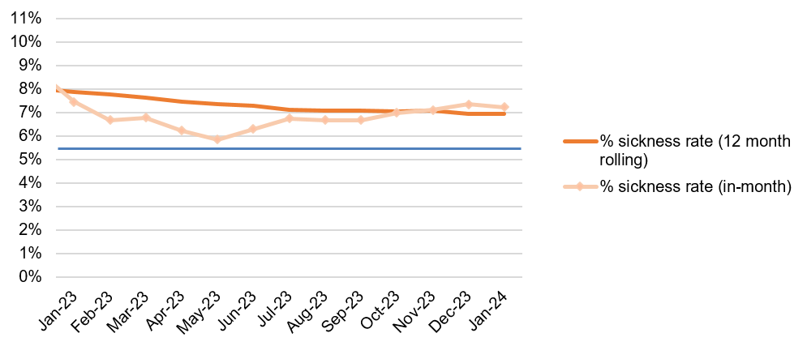  Caveat & Limitations;- Report generated Nov 2023, within SBUHB (Performance Team) for substantive and FTC employee types. Data source – ESR. Target of 5.5% added as blue line
Current Performance
- Health Board total for in month sickness absence for January 2024 has decreased slightly from the last reporting period to 7.23% (compared to 7.35% Dec 23 and 7.22% in Nov).
- Interrogation of data reveals that ‘Cold, Cough, Flu’ category spiked in December where there were approximately 3597 cases reported as the reason for absence. In January, absences relating to ‘Cold, Cough, Flu’ reduced to 712 and will likely continue to reduce slightly as we enter Spring. Cold, Cough, Flu remains the highest reason for short term absence. Other categories remain fairly consistent.
- Anxiety/stress related absence remained the highest reason for long term absence, with MSK remaining second. This is consistent across NHS Wales and is a long-term sickness absence pattern.
- In January 2024, we identified a 1.30% decrease in absences across MH&LD compared to the previous reporting period (7.70% Jan 24 compared to 9% in Nov 23). NPT/SG absence rate has also decreased by 0.65%. Absence rates across Morriston and PCC remain consistent since the last reporting period. Absence within Estates and Facilities remains high at a rate of 10.31% and has increased since the last reporting period (Nov 9.5%).
- The balance of short and long term sickness remains stable. Long term absence spiked in December 23 to 5.19% compared to the last reporting period (Nov 23 4.99%), and has slightly reduced in Jan 24 to 4.43%. Short term absence has increased slightly since the last reporting period (Nov 23 2.25%, Jan 24 2.80%).

Actions for Next Period
Current focus on areas with high absences rates, examples of initiatives to support our employees:
- Piloting Tailored Adjustments training for managers to increase experience of using these to flexibly support staff to remain in work/return to work
- Targeted sickness absence management has begun within NPT Housekeeping which has significantly reduced absence from 14% to 3.94% in January 2024
- Wellbeing resource pack – physical and electronic copies available – includes new starter feedback questionnaires
- Case conference training for leaders in partnership with OH
- The HRBPs leading on the initiatives listed above are working together to share best practice with the intention to deploy initiatives across the HB
- Managing Attendance at Work training to be rolled out to all leaders

Staff Health and Wellbeing
The services continue to develop prudent processes and multi-disciplinary working to maximise resources and maintain waiting times within KPI’s.
- Evaluation of Staff Wellbeing Services completed with aspects being presented to Board on 28th March 2024. Evidence suggests reductions in symptoms of anxiety/depression in staff using standardised outcome measure (EQ5D-L).
- Roll out of staff health checks from April 2024 to support prevention/early intervention approach to staff wellbeing.
- Team Physiotherapists undertaking preventative ergonomic assessments in areas with higher prevalence of upper limb disorders.
- Some team members attended National Health& Wellbeing@Work in conference in March – to implement learning into practice.
- Team have contributed to HEIW’s ‘Staff Health and Wellbeing - A Best Practice Guide for NHS Wales’ - to be launched April 2024.

Mandatory & Statutory Training-  Percentage compliance for all completed Level 1 competencies within the Core Skills and Training Framework by organisation  Mandatory & Statutory Training target – 85% | % of compliance (Headcount) with Core Skills and Training Framework  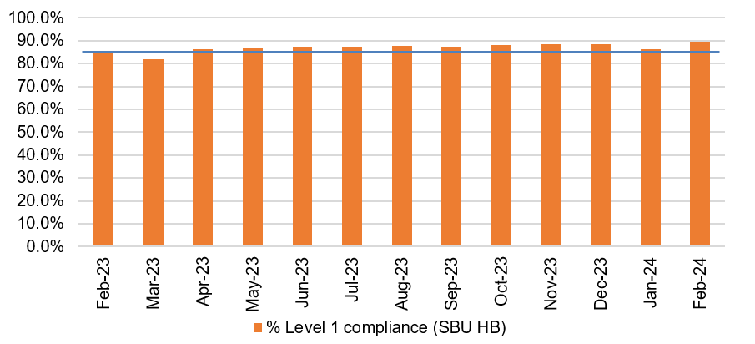  C&L;- Report generated Nov 2023, within SBUHB (Performance Team) for substantive and FTC employees. Data source – ESR (OLM Module). Accuracy levels subject to local maintenance and validation standards. Target of 85% added as blue line
Current Performance
- Health Board Statutory and Mandatory Training compliance rates as of 29th February 2024 are:
89.66% - 10 CSTF (Core Skills Training Framework) competencies as reported to Welsh Government (The Welsh Government target is 85%).
87.77% - *15 core competencies (including the 10 CSTF and *5 additional competencies required by SBUHB)
*Please note: there has been an increase in the number of required competencies by 1, this is following the mandating of Infection Prevention and Control Level 2 for ALL Staff as of 1st January 2024.
- Medical & Dental staff Group remain the lowest performing area with 60.77% compliance against the *15 combined competencies showing a reduction of 1.5% due to the increase in the number of required competencies.
- Compliance figures (*15 core competencies) per Service Group - MH&LD 88.75%, PCCT 91.84%, Morriston 83.51%, Finance & Estates 87.48%, NPTS 89.73%
- Ad-Hoc ESR E-Learning Support Sessions are being provided to support colleagues with any access or competence recording issues.
Actions for Next Period
- Subscription to Learning Certification and Enrolment onto Statutory/Mandatory Courses (E-Learning) – User issues identified are being supported on a case-by-case basis via Action Point and from direct contact. This has been the case over a number of months and continues to be the case going forward.
- NPTS - The Service Group must continue to focus on improving compliance rates for the Medical and Dental staff group (note we have observed an improvement within this staff group).
Vacancies  Medical and Nursing and Midwifery | Vacancies (FTE) Dec 2023 to Feb 2024  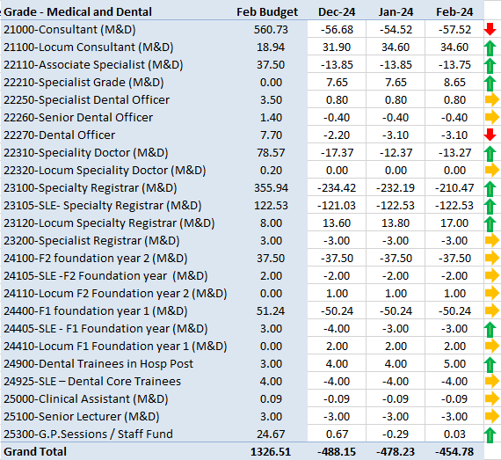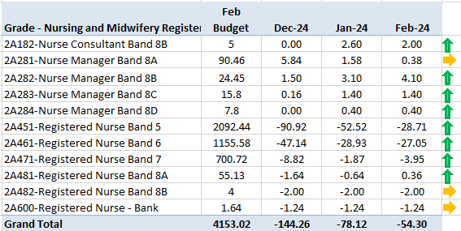  C&L;- Report generated 18 Sep 2023, within SBUHB (ESR Team), using currently available methodology. Data source – ESR (Workforce) and General Ledger (Finance). We compare the SIP v’s the finance ledger, appreciating limitations on accuracy in some areas. Accuracy levels are subject to local validation practices based on budget holders intelligence. N.B. a 12 month project (ESR Establishment control) has commenced which will harmonise vacancy data including Grade detail shown above.
Current Performance
- NMC vacancies have reduced progressively at Band 5 due to a number of contributing factors.
- Recruitment activity in the central team has focused on A&E with good results. There is also a steady stream of overseas nurses completing OSCE training and becoming employed by SBUHB.
- A reduction in Band 6 NMC vacancies due to recruitment promotion activity within Midwifery.
- Latest cohort of circa 14 overseas nurses (6 adult and 8 mental health) commenced OSCE preparation training in January. Further cohorts are being carefully planned as vacancies for general Band 5 nurses have mostly been recruited in terms of active pipeline, as per feedback from Service Groups. Focus is now on more specialist areas i.e. Mental Health, Midwifery and Neonates.
Actions for Next Period
- Overseas Nurse recruitment business case for 2024/25 has been approved by Management Board.
- Pre-employment checks for circa 70 newly qualified nurses (NQNs) due to qualify in March 24 recently been allocated posts with the Health Board via Student Streamlining Process (SSP) are nearing completion by SBUHB Recruitment Team and will continue. The SSP process for nurses due to qualify in September has commenced and onboarding of these once finalised will be supported by the Resourcing team.
- The Retention Lead funded for two years by HEIW has now been appointed and will commence in post in April 24 .
- Support continues to various Therapy services to attract newly qualified staff due to qualify this summer into existing vacancies across the Health Board.

Recruitment  Metrics provided by NWSSP. Comparison with all-Wales benchmarking  Target 44 days | 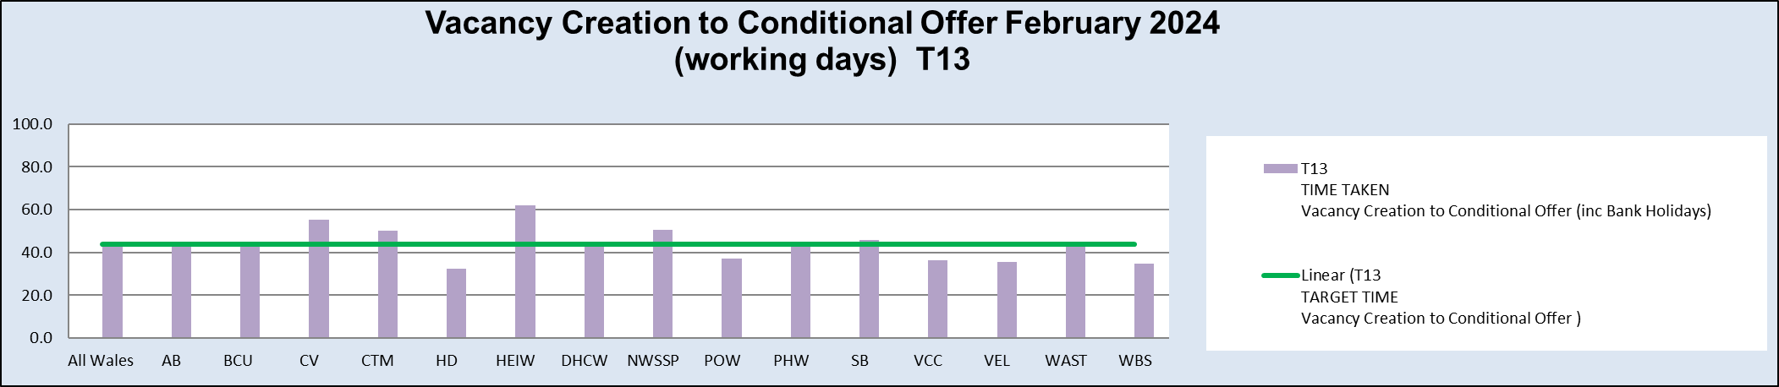  C&L;- Report generated Feb 2024, by NWSSP (Recruitment). Data source – TRAC system. Outliers are excluded. This is day to day vacancy management. Data excludes outliers.
Current Performance
- Swansea Bay UHB overall performance continues to be on target in February 24, and our monthly average over the last 12 months remains in target. Performance for conditional offer to ready for start date start date was 21 days, which remains below the set target of 27 days.
- The Central Resourcing Team continue to focus efforts on the recruitment of acute ward based HCSW’s and Band 5 nurses as well as providing support to specific difficult to recruit to posts (see above) and vacancy gap has closed significantly evidenced by significant reduction in nurse temporary agency spend
- Current KPI’s (Feb 24) comparing SBUHB averages vs the CRT on HCSW recruitment is 69 days vs 51 days based on average time taken from vacancy creation to unconditional offer.

Actions for Next Period
- HRBP’s continue to discuss with Service Groups opportunities to reducing the lag between the date termination of posts are being requested versus date a TRAC entry was initiated.
- The Central Resourcing Team will continue focusing on the recruitment of B5 nurses, B2 ward based HCSW’s and assisting in overseas nurse recruitment. In addition, they are assisting in the recruitment of newly qualified nurses, via the all Wales Student Streamlining process. As well as specific identified hard to recruit to posts.
- In collaboration with NWSSP, we will continue supporting the wider HB by trying to resolve outstanding actions on vacancies / pre-employment checks with applicants, in an effort to further reduce the overall HB time to hire.
- For doctors we continue to recruit overseas on a post by post basis.

Turnover  % turnover by occupational group | Period Turnover Rate (Swansea Bay) – 01 Feb 2023 - 31 Jan 2024  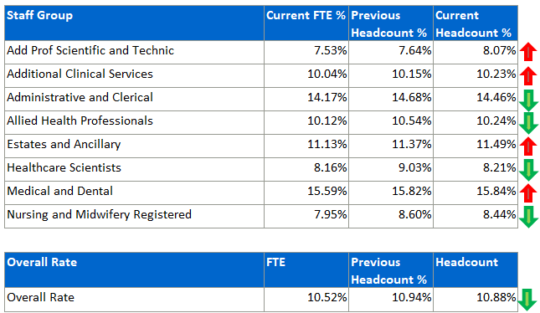  C&L;- Report generated Sep 2023, within SBUHB (ESR Team). Data source – ESR (Workforce). Small risk of margin of error due to late communication of terminations. Report excludes Bank, Locum, Honorary & Widow/Widower, Junior M&D staff. Internal movement not included – measure is about leaving Swansea Bay UHB.
Current Performance
- Organisationally our turnover has decreased marginally in this reporting period (from 10.94% to 10.88%). It is important to recognise that this is reporting on a 12 month rolling period of turnover.
- Medical and Dental appears as the highest turnover at 15.84%, however it is important to note that expected spikes in activity created by seasonal SLE turnover which will lead to elevated M&D levels overall.
- Admin and Clerical is the second highest area, although this has decreased slightly from 14.68 to 14.46%. This high figure is influenced by a service transfer of ‘Delivery Unit’ consisting of 75 individuals in March 2023 from SBUHB to Public Health Wales. This large peak will continue to influence the 12 month rolling figure until April 2024.
- The largest increase is seen within Add Prof Scientific and Technical, which shows a 0.43% increase. However, this is a small staff group, Leavers total amounts to just 4 Headcount over the period. Two of these relate to retirement, with one being ‘flex’ indicating that the individual returned to work in this field.
- Other categories are either relatively stable or improving.

Actions for Next Period
Actions which will feed into Turnover improvement are currently being led by two ongoing groups – Recruitment and Retention, and Flexible Working Group.
- Flexible Working Group meetings are taking place, to identify means of improving retention by reducing attrition attributable to flexibility.
- Newly appointed Retention Lead will commence in post in April and begin to facilitate the implementation of all Wales Nurse Retention plan
- “Thinking of Leaving” process rolled out and evaluation of initial phase will take place

PADR  % staff who have a current PADR review recorded  PADR target – 85% | % of staff (Headcount) who have had a PADR in previous 12 months  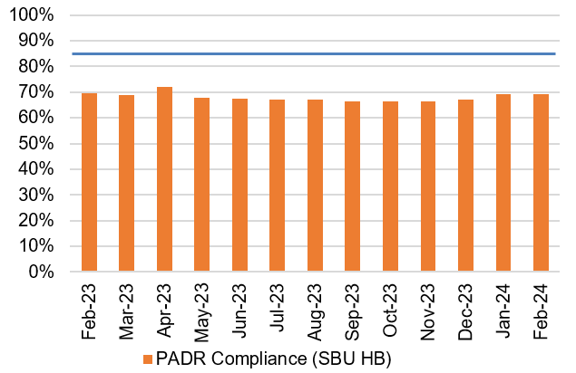  C&L;- Report generated Sep 2023, within SBUHB (Performance Team). Data source – ESR (OLM Module). Accuracy levels subject to local maintenance and validation standards. Target of 85% added as blue line.
Current Performance
- Staff who have had a Personal Appraisal and Development Review (PADR) at the end of this time period stands at 69.35%.
In the past two months 46 staff have attended 130 PADR - Personal Appraisal Reviews for Managers. The Learning and Education Team continue to highlight and signpost colleagues to SBU ESR - ESR User Guides SharePoint Page for resources on how enter PADR Dates in ESR.
- Compliance figures per Service Group (excluding Medical and Dental Staff) - MH&LD 71.30%, NPTS 70.49%, PCCT 82.44%, Morriston 65.29%, Finance & Estates 66.29%

Actions Planned for Next Period
- Morriston, MH&LD, PCCT, Estates and Facilities - No further update since last report
- NPTS - The Service Group will need to continue focusing on improving compliance across the staff groups and Divisions. Monthly Workforce Groups remain one of the key forums for developing improvement plans and monitoring improvement.
Compliance rates within the ACS / Nursing and Midwifery staff groups remain areas of concern and focus.

Operational Casework  Number of current operational cases. | C&L;- Report generated Nov 2023, within SBUHB (Workforce Digital). Data source – ER Tracker. Accuracy levels subject to local maintenance and validation standards.
Current Performance
- No. of open Formal Disciplinaries since the last reporting period has decreased to 39 open cases
- Number of Formal requests for Resolution is 29
- Suspensions have increased since the last reporting period to 9
- ET’s remain at 3
Actions for Next Period
- A number of actions are on-going in line with the Best Practice Review
- Workshops have been arranged during 2024 in partnership with our Trade Unions facilitated by HEIW and SBUHB covering the following: Employee Investigations – Avoiding Employee Harm.
- Learning from Events sessions will commence to inform best practice and identify opportunities for development
- We have successfully launched the Management Review document, to replace the initial assessment, which allows us to determine the most appropriate course of action at an early stage with the intention to resolve cases informally where possible – education and training ongoing with HR and leaders
- A deep dive will be undertaken on long term sickness absence management and suspensions with actions identified and outcomes measured
- Information sessions will be held for the HR teams from Safeguarding and Counter Fraud to ensure partnership working and robust case management

