Meeting Date | 11 September 2025 |  | Agenda Item |  |  | 3.1
Name of Meeting | Quality and Safety Committee
Report Title | Clinical Audit and Learning from Deaths Update
Report Author | Sharon Rağbetli, Clinical Audit & Effectiveness Manager
Report Sponsor | Dr Richard Evans, Executive Medical Director
Presented by | Dr Helen Dean, Associate Medical Director – Professional Concerns and Quality and Safety
Freedom of Information | Open
Purpose of the Report | The report provides an overview of the recent work of the Clinical Outcomes and Effectiveness Group (COEG) including a section on the Learning from Deaths Panel and the Clinical Audit Annual Report 2024/25.
Key Issues | - Progress against the identified audits for 2022/23 has increased from 94% to 96% and from 77% to 85.7% for 2023/24. Completion for 2024/26 currently stands at 29.5%.  - Only six overdue responses to NICE/HTW (National Institute for Clinical Excellence/ Health Technology Wales) guidance or national audit/registry publications were recently escalated to the Quality and Safety Group;  - Deep dive presentations from individuals and/or Service Delivery Groups are received as required at the COEG meetings;  - The Clinical Audit Annual Report for 2024/25 was signed off via Chair’s action on 25th July 2025 following no concerns or comments raised by members.
Specific Action Required  (please choose one only) | Information | Discussion |  | Assurance | Approval
Specific Action Required  (please choose one only) | ☐ | ☐ |  | ☒ | ☐
Recommendations | Members are asked to:  - ACKNOWLEDGE the progress made within all clinical audit areas;  - ACKNOWLEDGE the outstanding Welsh Government proformas and responses to NICE/HTW Guidance are escalated to the Quality Safety Group;  - ACKNOWLEDGE the achievement of completing 96% of the 22/23 Audit Plans and increasing to 85.7% for 2023/24;  - ACKNOWLEDGE the number of Level 3 Mortality Reviews closed;

CLINICAL OUTCOMES AND EFFECTIVENESS REPORT

- INTRODUCTION
The health board’s hierarchy of audit activities lists five levels, as set out in the Clinical Audit and Effectiveness Policy:

- Level one - mandated national audits and registries;
- Level two - a small number of HB (health board) Audit Priority Topics to support resident doctors and others needing to turn around participation in audit for training and appraisal purposes
- Level three - audit topics that are planned or triggered by risk/assurance scores assigned on conclusion of a previous audit cycle
- Level four – audit topics listed for delivery by Departments and
- Level five - emergent necessary ad-hoc topics

Within an audit period, it is now possible for some additional cycles of audit to “trigger”, depending on the risk/assurance scores allocated in the outcomes section by project contacts and subsequently signed off by designated Audit Leads. In these instances, they are added to the work programme at level 3. The report provides an update on progress with delivery of projects in Levels 1-4.

In addition, it provides an update against the NHS Delivery Unit and Welsh Government National Learning from Deaths Framework, adopted by the HB to support local processes established to screen, review and provide feedback on any queries or concerns identified by the Medical Examiners (ME) Service and/or the bereaved. It forms a key part of the clinical outcomes work. The approach enables the health board to address any concerns and themes that emerge from the data collected, supported by a customised dashboard.

2. BACKGROUND
Patient outcomes and clinical effectiveness is part of the remit of the Quality and Safety Group but is discharged through the Clinical Outcomes and Effectiveness Group (CEOG). Meetings are held monthly, with the exception of August and December, to review progress on a number of key agenda items and to receive Service Group updates and focus presentations. The COEG reports to the Quality and Safety Group on a bi-monthly basis and to the Quality and Safety Committee as required.

As previously reported, a review of performance against clinical audit plans and time taken to close-down audit topics, the current audit period was extended to 2024/26.

- GOVERNANCE AND RISK ISSUES

3.1 Mandated National Audits/Registries (Level 1)
All health boards are required to participate in the NHS Wales National Clinical Audit and Outcome Review Plan Annual Rolling Programme. The list was refreshed in June 2025 and maintains the steer towards more topics running as continuous data collection.

Participation in Level 1 topics, any issues or concerns and areas of good practice feature as part of the Service Group presentations, allowing areas to focus time as required to support improvements.

In late July 2025, a dashboard was completed to support the COEG, Service Groups, Clinical Directors and Audit Leads in monitoring completion of required tasks for key agenda items. Updates from Level 1 Leads now features as part of the dashboard. The process will now be reset utilising the refreshed list of mandated topics.

    - Responses to Key National Guidance and Publications
In addition to requiring quarterly updates from Level 1 leads, COEG retains the two-stage assurance proforma process following publication of mandated national audit/registry topics previously mandated by Welsh Government.

On identification of appropriate respondents, usually undertaken within the senior team meetings, a deadline for responses is set at eight weeks. Breaches of the eight-week timescales are escalated to the Quality and Safety Group by the COEG as part of the governance route and for onward management.

Regular follow up emails are issued until the deadline.

After routine follow up emails and no/incomplete response, the Associate Medical Director for Professional Concerns and Quality and Safety and/or Deputy Executive Medical Director contact with the relevant leads to progress completion. Table 1. below reflects the overarching position to date;

Responses Issued/Completed | 2023/24 | 2024/25
National Audit/Registry Assurance Proforma | 33/39 (85%) | 39/54 (76%)
HTW & NICE Guidance | 106/113 (93%) | 38/70 (54%)
Total | 139/152 (91%) | 77/124 (62%)

Table 1

Table 2. provides the detail of recently escalated topics;

Currently Escalated/New For Escalation |  | Escalated | New
Singleton/ NPT | National Joint Registry 20th Annual Report 2023 | ü
Singleton/ NPT | Using the national database to improve hip fracture care (NHFD) | ü
HB Wide | NCEPOD – End of Life Care (2024) | ü
Singleton/ NPT | Oesophago-gastric cancer report (NOGCA / NATCAN) | ü
Singleton/ NPT | Fracture Liaison Service Database report (FFFAP) | ü
Singleton/ NPT | Fetal alcohol spectrum disorder | ü
Table 2.

    - NCEPOD (National Confidential Enquiry in Patient Outcome and Death) Studies
All required cases for both the Early Inflammatory Arthritis and the Acute Limb Ischaemia studies have been submitted. Acute Illness in People with Learning Disability is in progress.

3.2 Health Board Priority Topics (Level 2)
A number of topics are identified by the Executive Medical Director’s Department in order to generate data for the health board and to support healthcare professionals in training to evidence participation in audit and quality improvement activities.

Presentations on each of the Level 2 topics are scheduled into the COEG meetings regularly. With the National Audit of Care in the Last Days of Life now running continuously, the topic will focus on deaths within the Community. Amendments to the audit tool are being progressed by the Clinical Lead.

The overarching Antimicrobial Stewardship topic was paused to run a tailored audit tool specific to Hospital Acquired Pneumonia.

Cognitive Impairment is currently running utilising the National Audit of Dementia dataset to boost the number of cases available for local analysis.

The All-Wales Decision Making and Consent Group and Welsh Risk Pool audit returns in 2026. At the July 2025 meeting, COEG endorsed an exercise to identify all procedure specific consent forms in use within the health board to raise awareness of guidance and ensure that they meet minimum standards.

Resuscitation Services have added to the dataset for Do Not Attempt Resuscitation (DNACPR) to incorporate mental capacity in line with all-Wales discussions.

Re-audit of Use of Chaperones data was presented at the COEG in July 2025. Service Groups were asked to share the results within their areas for discussion and progress improvement plans through their governance structures. They will be asked to update on progress with action plans as part of their routine summaries to the COEG.

Figure 1. below provides an overview of progress to date;
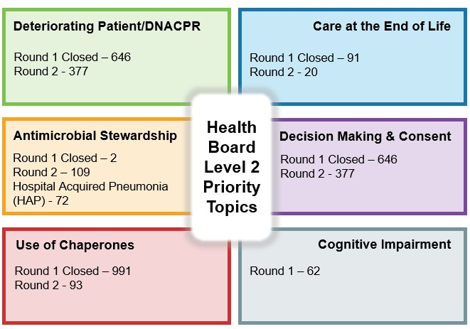
Fig. 1

3.3 Service Delivery Group and Department Plans (Level 3 and Level 4)
Service Delivery Groups now present on a number of key agenda items on a rota basis using a uniform template. Changeover in management of the Singleton/Neath Port Talbot Service Group means they are yet to present to COEG and support is being provided to populate and prepare for the first presentation.

A new COEG dashboard has replaced Hub Pages created to support the Service Groups and goes further in pulling together in one place, the number of actions required for each area. It provides direct access to the relevant individual records. It reports on Audit Hierarchy Levels 1-5, responses to national guidance/publications and participation in NCEPOD studies.

Table 3. below provides an overview of the current status of plans, Service Delivery Group;

Service Delivery Group | Current Completion Rates
Service Delivery Group | 2022/23 | 2023/24 | 2024/26
Mental Health & Learning Disabilities | 12 (100%) | 14 (100%) | 5 (50%)
Morriston | 56 (100%) | 43 (82.7%) | 7 (20%)
Primary Care, Community & Therapies | 11 (100%) | 15 (100%) | 10 (47.6%)
Singleton and Neath Port Talbot | 17(78%) | 12 (70.6%) | 1 (5.3%)
Total % | (96%) | (85.7%) | (29.5%)
Table 3.
  - Emergent Necessary Ad-hoc Topics (Level 5)
Service Delivery Groups and Departments/Specialties are able to add audit topics to the programme as needed. These include Medical Student topics that cannot be pre-planned, additional regional/national projects not included on the Level 1 list.

  - Deep Dives to COEG
Audit leads are invited to COEG meetings to provide focus presentations and updates on topics which support learning for the organisation and/or require improvement in service delivery.

For the June 2025 and July 2025 meetings, these focus presentations were;
- Update on progress with the Level 1 topic National Audit of Care at the End-of-Life (NACEL), following the issues with data submission highlighted in the previous report
- Presentation on the Level 1 Children and Young People Asthma project covering key performance criteria and suggested improvement actions
- Summary presentation of data received from the Level 2 ‘Use of Chaperones Re-Audit’ to support Service Delivery Groups in formulating improvement plans
- Update on Hospital Acquired Thromboprophylaxis continuous audit covering deep vein thrombosis and pulmonary embolism events occurring during admission or within 90 days post discharge

3.6 Clinical Audit Annual Report 2024/25
The annual report for 2024/25 detailing individual completed project summaries was circulated to COEG members for comment and subsequently prior to the July 2025 COEG meeting (Appendix 1). As agreed in the meeting, Chair’s action was taken after a two-week consultation period with no comments received. Also included in the report is a summary of the year’s compliance with the National Learning from Deaths Framework, another key area of focus for the COEG.

3.7 Mortality and Medical Examiner (ME) Service Reviews
Referrals from the ME service are initially screened by the Clinical Audit and Effectiveness team to identify cases already undergoing an established process for the concerns raised in the referral and can be closed with no further action taken.

Those which remain and require greater scrutiny are reviewed by the Clinical Audit and Effectiveness Team and if the concerns are unrelated to the patient’s care (for example issues with car parking) or meet a set of agreed criteria (Covid death, Welsh Ambulance NHS Trust involvement), these can be closed at level one.

Those which have multiple clinical queries are moved to level two, which is the Learning from Deaths Scrutiny Panel. This was established in May 2021 to screen, review and provide feedback on any concerns identified by the ME.

COEG continues to receive monthly updates on the work of the Learning from Deaths Panel regarding progress with reviews, themes generated and compliments received. The Panel meets on a weekly basis to review and consider the ME referrals received.

The COEG summary presentation template for use by the Service Delivery Groups takes into account the cases referred to the area for further investigation and also summarise associated actions.

Reviews are now undertaken for deaths within Primary Care and the Community setting.

The Once for Wales DATIX Module to support Medical Examiners Reviews remains in development. Locally data is supported by a SharePoint site feeding into a dashboard created by Digital Services.

For July 2025, a total of 194 deaths were recorded. Whilst a total of 80 referrals were received, this number would include cases from older time periods as the ME Service work through their caseload. 84% of referrals did not need to progress past Level 1;
- 52 cases were closed
- 14 cases are already subject to existing processes and feedback is awaited
- One case has been shared with teams to discuss and provide feedback on

13 cases are progressing to Level 2 for review and discussion by the Learning from Deaths Panel. Where relevant, cases can be referred to level three, which under the framework is proportionate investigation, but the health board has created three sub-sections:

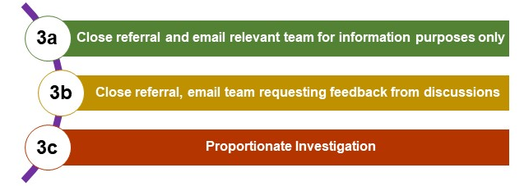 Fig. 2.

Chart 1. illustrates the total number of Level 3 reviews completed since February 2023
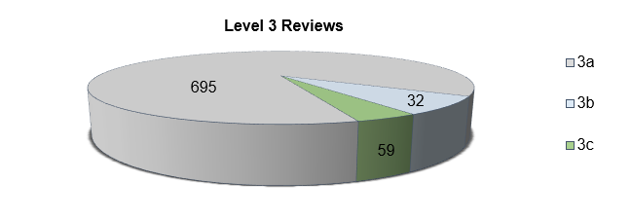
Chart 1.

Aligning themes to the Health and Care Quality Standard, communication with the patient/family remains the most frequently reported concern by the bereaved while Cardiac Arrest was the most frequently reported issue by the ME Service;

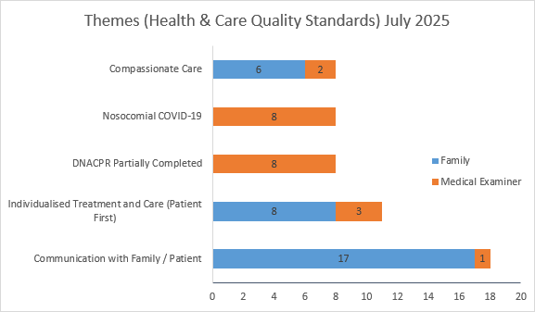
Chart 2.

- FINANCIAL IMPLICATIONS
There are no financial implications relating to this report.

- RECOMMENDATIONS
Members are asked to:
- ACKNOWLEDGE the progress made within all clinical audit areas;
- ACKNOWLEDGE the outstanding Welsh Government proformas and responses to NICE/HTW Guidance are escalated to the Quality Safety Group;
- ACKNOWLEDGE the achievement of completing 96% of the 22/23 Audit Plans and increasing to 85.7% for 2023/24;
- ACKNOWLEDGE the number of Level 3 Mortality Reviews closed.

Governance and Assurance

Link to Enabling Objectives  (please choose) | Supporting better health and wellbeing by actively promoting and empowering people to live well in resilient communities
Link to Enabling Objectives  (please choose) | Partnerships for Improving Health and Wellbeing |  | ☐
Link to Enabling Objectives  (please choose) | Co-Production and Health Literacy |  | ☐
Link to Enabling Objectives  (please choose) | Digitally Enabled Health and Wellbeing |  | ☒
Link to Enabling Objectives  (please choose) | Deliver better care through excellent health and care services achieving the outcomes that matter most to people
Link to Enabling Objectives  (please choose) | Best Value Outcomes and High Quality Care |  | ☒
Link to Enabling Objectives  (please choose) | Partnerships for Care |  | ☐
Link to Enabling Objectives  (please choose) | Excellent Staff |  | ☒
Link to Enabling Objectives  (please choose) | Digitally Enabled Care |  | ☒
Link to Enabling Objectives  (please choose) | Outstanding Research, Innovation, Education and Learning |  | ☒
Health and Care Standards
(please choose) | Staying Healthy |  | ☐
(please choose) | Safe Care |  | ☒
(please choose) | Effective Care |  | ☒
(please choose) | Dignified Care |  | ☒
(please choose) | Timely Care |  | ☒
(please choose) | Individual Care |  | ☒
(please choose) | Staff and Resources |  | ☒
Quality, Safety and Patient Experience
Submission of data to national topics allows benchmarking performance for quality, safety and patient experience, while the appropriate identification and planning of necessary local priorities can support improvements and provide assurance.

The Learning from Deaths approach supports learning to ensure patients at the end of life and their loved ones, have the best possible experience.
Financial Implications
None
Legal Implications (including equality and diversity assessment)
None
Staffing Implications
None
Long Term Implications (including the impact of the Well-being of Future Generations (Wales) Act 2015)
Continue to embed appropriate prioritisation of audit activities while balancing the need to meet requirements placed on doctors and healthcare professionals in training. Generating themes and learning from deaths contributes towards striving to give patients at the end of their life and their loved ones, the best possible experience.
Report History |  | Quarterly report to the Committee
Appendices |  | Appendix One – Clinical Audit Annual Report

