Meeting Date | 11 September 2025 |  | Agenda Item |  |  | 2.5
Name of Meeting | Quality and Safety Committee
Report Title | Update on Stroke Performance
Report Author | Abi Landeg – Directorate Manager Medicine Specialties  Peter Slade – Stroke Clinical Lead
Report Sponsor | Neil Cooper – Assistant Director of Operations  Deb Lewis – Chief Operating Officer
Presented by | Peter Slade – Stroke Clinical Lead
Freedom of Information | Open
Purpose of the Report | This report includes plans and timescales for improving Stroke performance and updates the Committee on several key service developments currently taking place. This report includes an update on the establishment of a Comprehensive Regional Stroke Centre (CRSC). This report also highlights positive progress made in relation to improving the flow of patients between Morriston Hospital and Neath Port-Talbot Hospital.
Key Issues | - Compliance against the 4-hour access target and the ring-fencing of beds for admission to the Acute Stroke Unit continues to remain challenging due to system wide pressures. However, work is taking place to improve flow between Morriston Hospital and Neath Port Talbot (NPTH).  - Funding still not received to implement a 24/7 stroke consultant rota.  - Performance against the new Key Performance Indicators (KPI) metrics remain challenging.  - Continued high compliance of thrombolysis rate, swallow assessments and therapeutic assessments.  - Performance against the new KPI CT head within 20 minutes has positively increased  - Reducing door to needle time for Thrombolysis is an area for improvement, more so since the introduction of the new KPI  - Increase of Mechanical Thrombectomy a priority.  - Embedding of CT Perfusion and MRI Perfusion.  - Stroke improvement plan revised.
Specific Action Required  (please choose one only) | Information | Discussion |  | Assurance | Approval
Specific Action Required  (please choose one only) | ☒ | ☐ |  | ☒ | ☐
Recommendations | Members are asked to:  Consider the content of the report and endorse actions to improve performance

UPDATE ON STROKE PERFORMANCE

- INTRODUCTION

This report aims to provide the Committee with an update on performance against the stroke pathway in Swansea Bay. Continued year-round pressures on acute hospitals such as Morriston mean that performance against access targets has been challenging to improve. A Stroke services action plan (Appendix 1) for performance recovery and improvement has been developed and will be enhanced further as required in line with updated performance measures taking effect in 2025.

Whilst investment into the Stroke service was received in 2023/2024 the service is yet to receive the additional agreed funding (by a previous Chief Executive) to allow recruitment into further consultant and therapy posts. A paper was submitted to performance and finance committee on 29th July that outlined an update on previously allocated funding and its usage, alongside an update performance position.

- BACKGROUND

  - Stroke Performance

Due to changes to the Sentinel Stroke National Audit Programme (SSNAP) data repository in October 2024, there have been significant challenges in extracting data from the national system. However, access has now been restored with updated indicators and reporting options.

The next section will outline the progress of each Stroke Key Performance Indictor (KPI) at Swansea Bay UHB and will identify any immediate actions being put in place to improve compliance.

    - Key Performance Indicator 1: 4 Hour Admission to ASU (National Target 95%)
In July 2025, performance against the 4-hour admission target to the Acute Stroke Unit (ASU) was recorded at 35.7%, significantly below the national target of 95%. Several key factors continue to impact the ability to meet this target:
- Lack of available beds due to continued movement of non-stroke patients into the ASU
- Constant use of additional potential pre-empt space (therapies) to accommodation additional patients onto the ASU
- Increase in airborne infections on the ASU leading to an inability to move patients in or off the unit due to infection control procedures
- Increased pressure on the Morriston Hospital site and over occupancy in the emergency department which is making it difficult to promptly identify and transfer patients to the ASU from the Emergency Department (ED).
Access to dedicated Stroke beds continues to impact on performance. Compliance remains low around the 4-hour target compared to pre-pandemic levels, but future service developments should further improve access for patients.

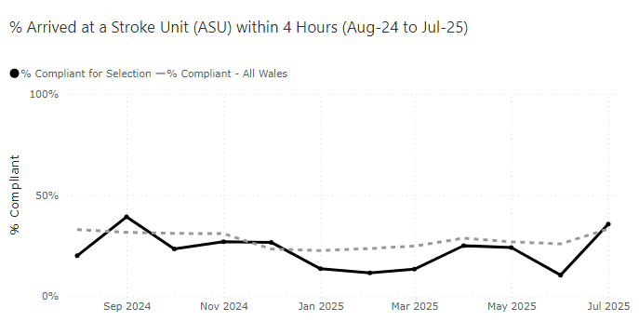

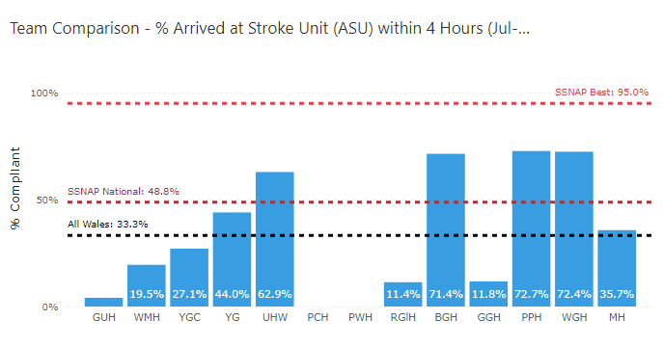
Performance is discussed weekly in the Stroke performance meeting held at Morriston alongside clinicians, ED staff and bed site managers. NHS executive colleagues have also attended monthly for assurance.

As of 10th July 2023, Morriston was asked to ringfence 18 Stroke beds for Stroke to improve 4 hours compliance further. To date this has rarely been achieved with medical outliers regularly exceeding the limit of 6 that should be in place. The actions detailed below, held within the services stroke action plan, outline the immediate steps being taken to address compliance against the ASU 4 hour target:

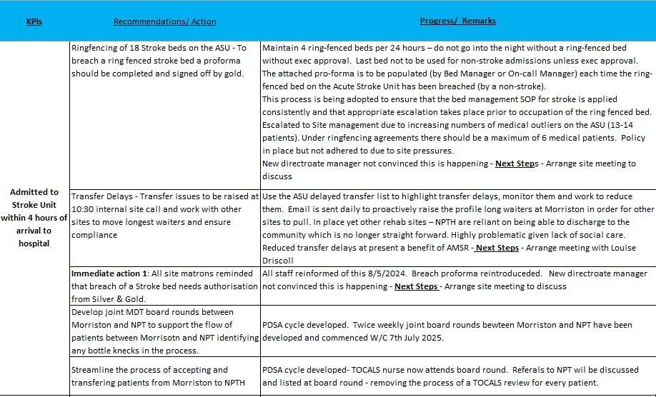

The 4-hour access issues are also affecting the other major admitting sites in Wales, such as POW and The Grange hospitals. SBUHB 4-hour performance is in line with other sites of similar size. Sites dealing with smaller volumes of Stroke patients such as Bronglais and Bangor have much higher access rates as demonstrated below. Cardiff and Vale UHB do enforce strict ringfencing of Stroke beds and their compliance far exceeds other sites in Wales on this measure despite seeing more Strokes than any other site.

2.1.2 Key Performance Indicator 2: Thrombolysis rates – (National Target 20%)
Thrombolysis rates as of July 2025 was 15.3% against a national target of 20%. This is an area where Swansea Bay performs well in comparison with other centres.

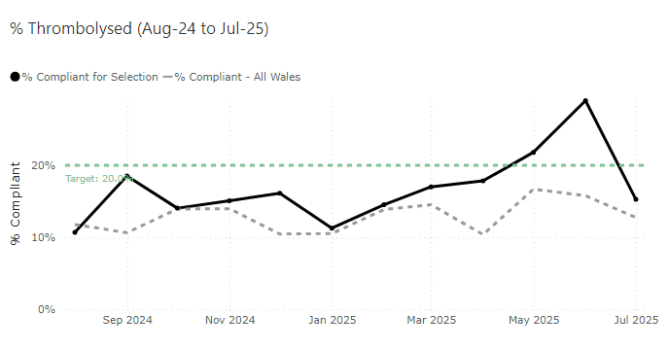
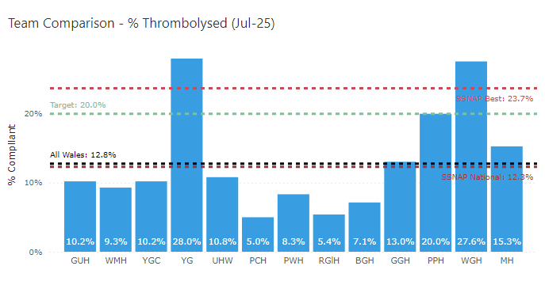
The expansion of the CT Perfusion service which now runs Monday – Friday, 09:00 – 17:00 has had a positive impact upon our Thrombolysis rate as seen above. However, we would like to further improve this by extending this provision out of hours (OOH) by implementing an OOH consultant stroke rota. We are unable to progress this further given the health boards financial situation and the pull back of the consultant recruitment monies.

2.1.3 Key Performance Indicator 3: Thrombolysis door to needle time <30 minutes (National Target 95% of eligible patients)

No patients eligible for Thrombolysis received this within 30 minutes in June 2025 and 16.9% received this within 45 minutes (old KPI).
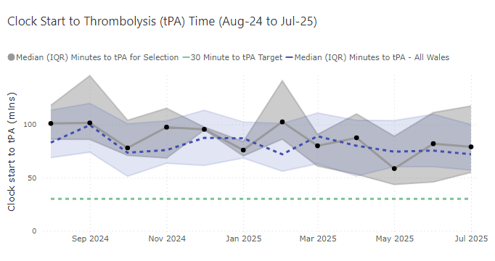
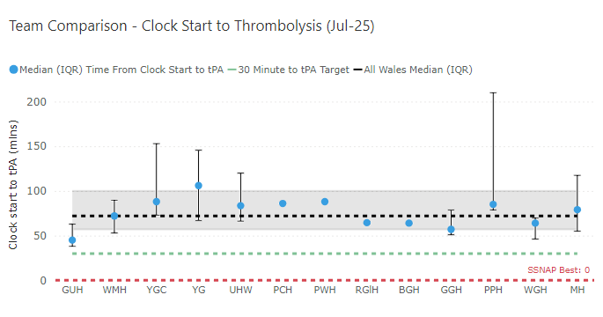
A comparatively high volume of patients suffering a Stroke receive thrombolysis at Morriston, but these patients require observation when given this treatment. Clinical Nurse Specialists (CNS) and doctors are not always able to leave a patient who has received thrombolytic therapy to attend any other call or alert that goes off.

Developing an Advance Nurse Practitioner (ANP) workforce as per the Comprehensive Regional Stroke Centre (CRSC) plan will allow these members of staff to attend to other patients suffering a Stroke and reduce door to needle time. 6 Trainee ANP’s are now in post ahead of regional service plans for 2026 by which time all should be qualified

2.1.4 Key Performance Indicator 4: CT head within 20 minutes (National Target - 95%)
Performance for CT head within 20 minutes for July 2025 was 12.5%. Compliance against this new KPI has positively increased over the recent 3 months:

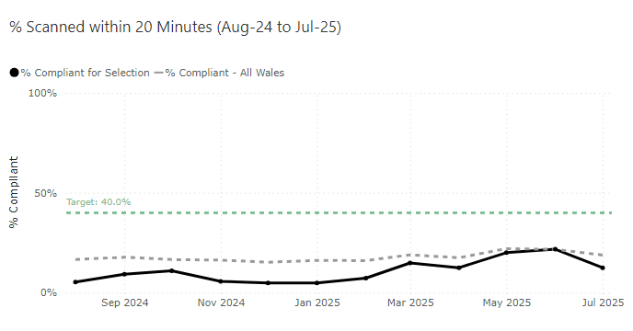
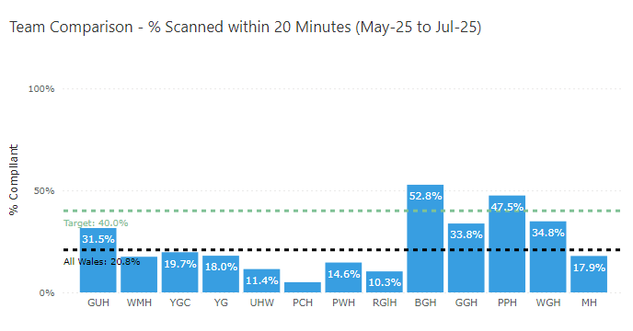

Performance for CT head within 1 hour, which was the previous KPI was 45.8% for July 2025 and remains average for us as a health board.
Overall median clock time to CT is reducing which should aid in increasing compliance against this target. One measure put in place is a “Direct to CT” pilot in conjunction with the Welsh Ambulance Service Trust (WAST). A successful “Direct to CT” pilot took place back in 2024 and was very successful however this pilot relies upon the ability to ring-fence beds on Ward F in Morriston Hospital. Although we are unable to progress this further, we are working with the site team to look at how we can ring-fence beds on Ward F.

2.1.5 Key Performance Indicator 5: Mechanical Thrombectomy – (National Target 10%)

Thrombectomy is offered to patients via an agreement with North Bristol NHS Trust and since July 2025 some patients are treated in Cardiff and Vale UHB. Suitable patients with acute ischaemic stroke with an intracranial anterior large vessel occlusion presenting within 24 hours of onset of symptoms or with an intracranial vertebral or basilar occlusion presenting within 12 hours of onset and an NIHSS of 10 or more should be considered for mechanical thrombectomy. Although services have expanded hours, accepting patients from 6am to 10pm 7 days a week, centres in Wales still do not have access to 24/7 thrombectomy services.

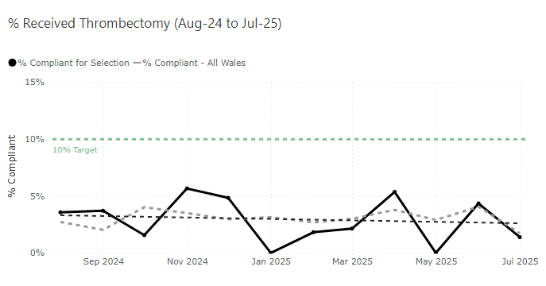

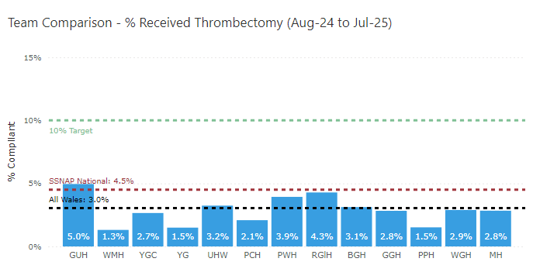

2.1.6 Key Performance Indicator 6: Swallow Test within 4 hours – (National Target 95%)

87.5% of patients received a swallow test within 4 hours in July 2025 against a national target of 95% and we continue to perform well against this KPI.
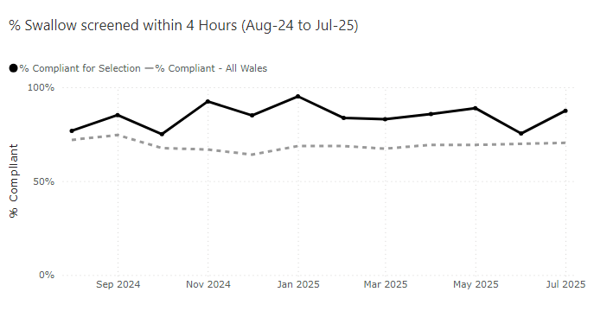

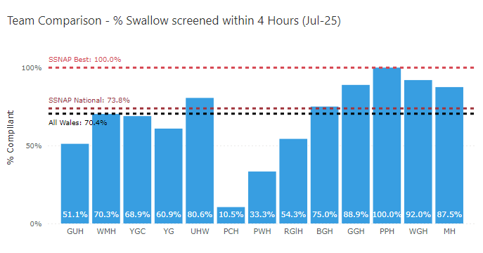

2.1.7 Key Performance Indicator 7: Consultant assessment within 14 hour – (National Target 95%)

Reporting against the new KPI, 51.4% of patients were reviewed by a consultant within 14 hours which remains average for us as a health board.

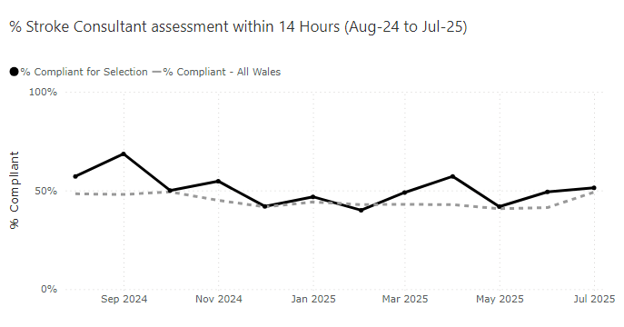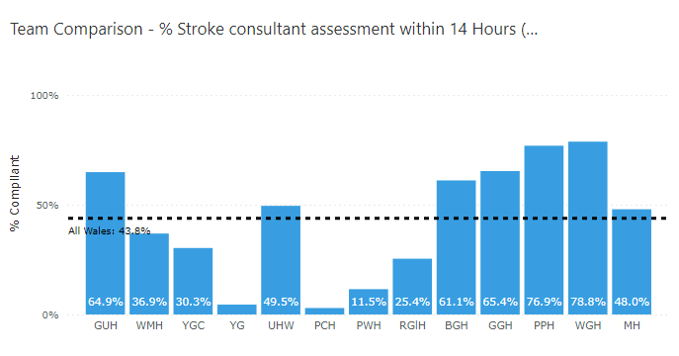

Reviewing performance against the older KPI, 84.7% of consultant assessments took place within 24 hours against a national target of 95%.

2.1.8 Key Performance Indicator 8: Therapeutic Assessment - (National Target 95%).

Data highlights the current performance of therapy services for stroke patients against the national target:

- Physiotherapy (PT): 68.3 % of patients were assessed within 24 hours.
- Occupational Therapy (OT): 73.3 % of patients were assessed within 24 hours
- Speech and Language Therapy (SLT): 88.9% of patients were assessed within 72 hours

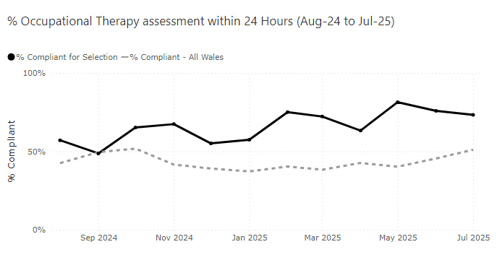

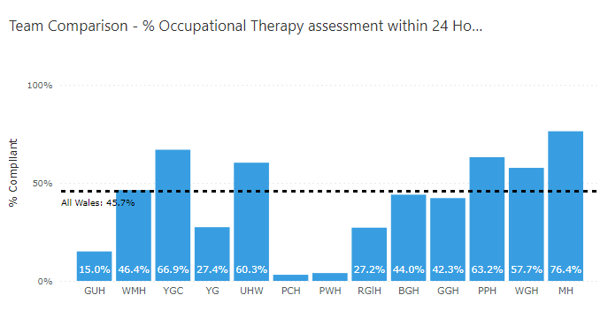
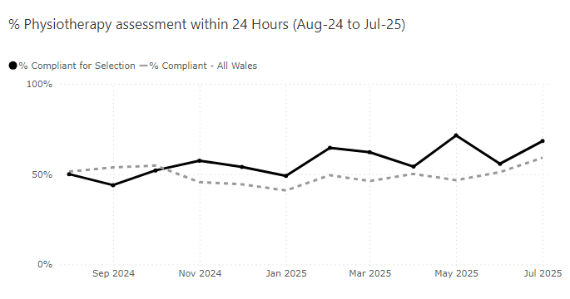

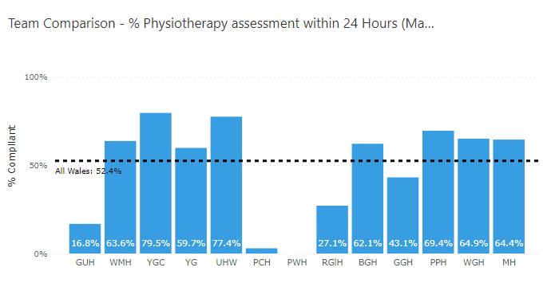

  - Service Developments

    - Improving the stroke pathway between Morriston and Neath Port Talbot hospital (NPTH)

Managing patient flow and timely admission onto the acute stroke unit at Morriston hospital is a challenge that the unit have been facing for some time. This is due to a number unscheduled care pressures but includes:

- Delays in listing patients who require a bed at NPT for ongoing rehabilitation

- Delayed transfers from Morriston Hospital to Ward B2 in NPTH resulting in patients remaining on the ASU unnecessarily.

- Poor communication between Morriston and NPT in terms of upcoming bed requirements

- High levels of COP patients ready for discharge but awaiting packages of care at NPT

To address the above issues on 7th July 2025 several ‘tests of change’ launched and include:

- The launch of twice weekly joint MDT board rounds between Morriston and NPTH.

- The development of a joint stroke bed requirement list for Morriston and NPTH.

- Patients who require a bed in NPTH (Stroke specific or any medical bed) are now immediately listed daily during board round as ‘green’ or ‘amber’. Any patients listed as green are immediately ready for transfer and those patients who are amber will be ready following medical intervention. Identifying patients early on allows NPTH colleagues the ability to forward plan bed requirements.

- During board round, patients are listed against NPTH criteria reducing the requirement of each patient needing a review before being listed.
Whilst the changes above are in its infancy, in July 24 patients moved across to B2 which is a huge improvement.

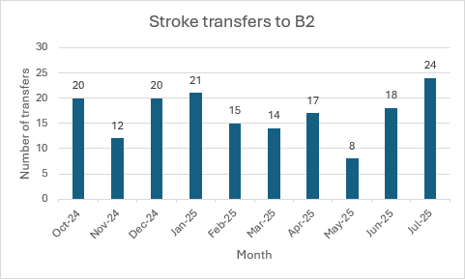

    - Pre-Hospital Triage Screening Pilot

A pilot commenced on 10th March 2025 which allows WAST crew members to contact the consultant stroke physician on call via teams to help confirm whether the patient being reviewed is having a suspected stroke. This means that the stroke team will be available and waiting at the front door when the patient arrives via ambulance. This is an All-Wales pilot, being initiated by NHS Executive teams.

- Up to 21st July, there have been 19 calls received within the current operating time of 9am to 5pm, Monday to Friday.
- 5 of these calls resulted in an eventual diagnosis of stroke, the other 14 assessments resulted in alternative final diagnoses.
- 13 patients were conveyed with an initial triage diagnosis of possible stroke. 5 patients were directed to the traditional ED pathway. 1 call resulted in an admission avoidance.
- There were no video triage calls that were initially triaged as an alternative diagnosis that that a final diagnosis of stroke.
- Of the 5 stroke patients, 3 received thrombolysis, 2 patients were transferred for thrombectomy and 1 patient received rapid blood pressure lowering for their intracerebral haemorrhage.
- Video triage calls lasted for a mean time of 4:26

    - CT Perfusion

To maximise the potential benefit from revascularisation treatments and the acute management of intracerebral haemorrhage, a corresponding increase in the availability of advanced imaging techniques is required, and all hyperacute stroke services should have timely access to brain imaging including CT or MR angiography and perfusion. This is featured in the 2023 national Stroke Guidelines.

Work has already taken place to improve the access to CT Perfusion however further conversations are taking place between Radiology and our Clinical Lead to look at improving access to this provision.

The use of advanced imaging such as CT perfusion and MRI in the acute setting, although limited to current specialist staffing availability (Monday to Friday, 9am to 5pm), has resulted in a high proportion of potentially eligible patients receiving appropriate imaging and subsequent treatments. The current percentage of wake up stroke receiving advanced imaging on first imaging visit is 22.5% (national average 22.6%). The current percentage of stroke patients with extended indications for thrombolysis receiving thrombolysis is 23.2% (national average 15.7%). Once specialist staffing levels have been appropriately increased there could be expansion of the hours of availability of these investigations.

2.3 Comprehensive Regional Stroke Centre (CRSC) Development

The South West Wales region covers the areas served by Swansea Bay University Health Board (SBUHB) and Hywel Dda University Health Board (HDUHB); the largest geographic region in Wales with currently 5 Acute Stroke Service admitting sites.
In March 2023, a Business Case was developed for Morriston Hospital to become a Comprehensive Regional Stroke Centre (CRSC) with an intake of patients from SBUHB and Carmarthenshire residents. However, the cost of establishing a CRSC were determined to be prohibitive at time and it was also acknowledged that both health boards needed to focus on and improve their services first before a regional model could be established. It was agreed that the health boards would meet periodically to maintain relationships, keep each other informed of developments within the service and share best practice.
Since then, SBUHB has continued with it investment of £1.5 million in revenue funding over three years to increase staffing across the stroke pathway, resulting in improved SSNAP and Welsh Government tier 1 measures; SBUHB has increased its SSNAP rating, consistently scoring a C for Acute Services and a B for non-acute services in the last quarter. Work is also being carried out to investigate the possibility of Community Discharge as well as Early Supportive Discharge within the health board.
In HDUHB, there has been an investment of £500,000, through the Welsh Government Community AHP funding stream, to develop the Integrated Community Stroke Service; early supportive discharge is an integral part of this development. This service now covers the three counties, delivering stroke rehabilitation in the patient's home rather than in a hospital bed. The provision of Stroke also a service that the Health Board will focus on as part of the development of their Clinical Service Plan.
The South West Wales Regional Stroke Programme Managers has also been working with the National Stroke Programme to develop the programme to all worked to be completed Once for Wales.
Over the past 9 months several work streams have been set up these are
- Innovations and Service Improvement
- Workforce and Education
- Data
- Demand and Capacity
- Comms and Engagement
- Hyper Acute Stroke Service
- Prevention and Early Detection
- Service Specification Pathways

2.4 Recruitment into Acute Stroke Services.

Recruitment into 2 consultants posts and a number of therapy posts were due to go to advert are currently on hold due to finances. Integrated Community Stroke Service development is in Health Board investment priorities for 2025/26 and this will result in a host of additional community posts, if the business case being developed is agreed.

- GOVERNANCE AND RISK ISSUES

Removed Risk - Risk 3751 was removed on 2nd June 2025 from the risk register following the successful completion of the installation of the oxygen and suction ports on Ward F. All beds on Ward F now have suitable oxygen and suction facilities for use. Remedial works also took place to temporarily fix the 6x broken buzzers. Further conversations are taking place in order to discuss a more permanent solution for the buzzer system on Ward F.

The risks detailed below are being reviewed on weekly basis by the Directorate Manager and in partnership with the clinical lead where appropriate. Updates are provided at monthly Quality and Safety meetings to ensure progress. Current risks are:

Risk ID | Title | Risk Level | Risk Handler
2901 | Inability to admit patients in a timely manner to the ASU | High Risk – 20 | Abi Landeg
3340 | Lack Of Therapies space on Ward F and B2 in NPT | High Risk – 16 | Abi Landeg
2147 | Potential significant harm due to lack of senior stroke medicine on-call rota | High Risk – 12 | Abi Landeg

- FINANCIAL IMPLICATIONS
£1.5m expenditure plan over the next few years approved at Management Board in 2023. Funding previously agreed to and minuted in Management Board has not been forthcoming in 2024/25 which has hindered progress in this speciality.

- RECOMMENDATION
The Committee is asked consider the content of the report.

Governance and Assurance

Link to Enabling Objectives  (please choose) | Supporting better health and wellbeing by actively promoting and empowering people to live well in resilient communities
Link to Enabling Objectives  (please choose) | Partnerships for Improving Health and Wellbeing |  | ☐
Link to Enabling Objectives  (please choose) | Co-Production and Health Literacy |  | ☐
Link to Enabling Objectives  (please choose) | Digitally Enabled Health and Wellbeing |  | ☐
Link to Enabling Objectives  (please choose) | Deliver better care through excellent health and care services achieving the outcomes that matter most to people
Link to Enabling Objectives  (please choose) | Best Value Outcomes and High Quality Care |  | ☒
Link to Enabling Objectives  (please choose) | Partnerships for Care |  | ☐
Link to Enabling Objectives  (please choose) | Excellent Staff |  | ☐
Link to Enabling Objectives  (please choose) | Digitally Enabled Care |  | ☐
Link to Enabling Objectives  (please choose) | Outstanding Research, Innovation, Education and Learning |  | ☐
Health and Care Standards
(please choose) | Staying Healthy |  | ☐
(please choose) | Safe Care |  | ☐
(please choose) | Effective Care |  | ☒
(please choose) | Dignified Care |  | ☐
(please choose) | Timely Care |  | ☒
(please choose) | Individual Care |  | ☐
(please choose) | Staff and Resources |  | ☐
Quality, Safety and Patient Experience
In relation to Stroke services, four main areas of risk are highlighted in detail in section 3 of this report. These include the inability to admit patients in a timely manner into the Acute Stroke Unit, inappropriate use of therapies space on Ward F, lack of equipment and lack of a dedicated consultant rota which affects KPI as highlighted in the paper. These risks are being reviewed on weekly basis by the Directorate Manager and in partnership with the clinical lead where appropriate. Updates are provided at monthly Quality and Safety meetings to ensure progress. Current risks are:
Financial Implications
£1.5m expenditure plan over the next few years approved at management board in 2023. Funding previously agreed to and minuted in management board has not been forthcoming in 2024/25 therefore the two further consultant posts that need to be recruited to may not be able to proceed.
Legal Implications (including equality and diversity assessment)
No implications to note.

Staffing Implications
The inability to introduce a core service requirement (stroke consultant on call rota)

Long Term Implications (including the impact of the Well-being of Future Generations (Wales) Act 2015)
Briefly identify how the paper will have an impact of the “The Well-being of Future Generations (Wales) Act 2015, 5 ways of working.
- Long Term – Providing enhanced Stroke Services for the SBUHB region.
- Prevention – Enabling timely intervention in patient’s pathways resulting in better outcomes for Stroke survivors.
- Integration – Integrating with other hospital sites to ensure rehabilitation pathways are utilised.
- Collaboration - Acting in collaboration with any other areas such as other hospital sites and tertiary organisations such as the Stroke Association.
- Involvement – Stroke performance is monitored weekly by a range of staff from different backgrounds as well as being scrutinised before a regular executive board.
Report History |  | V1
Appendix 1 |  | Stroke Improvement Plan

