Swansea Bay University Health Board

Patient Experience
&
Concerns Report
Quarter 1 2025/26

CONTENTS
Report Summary | Page 2
Complaints | Page 4
Complaint Themes | Page 7
Highlight Areas | Page 12
Nutrition & Hydration | Page 24
Morriston Service Group | Page 27
Neath Port Talbot Singleton Service Group | Page 32
Mental Health & Learning Disabilities Service Group | Page 37
Primary and Community Service Group | Page 41
Medical Examiners Compliments | Page 46
Ombudsman Cases & Learning | Page 47
Report Summary and Overview
COMPLAINTS | Apr | May | Jun
Total number of complaints received | 216 | 203 | 247
Complaints acknowledged within set timescale | 100% | 100% | 100%
Number of re-opened complaints | 5 | 2 | 3
 | Apr | May | June
Complaints responded to within agreed timescale - formal | 63% | 68% | 62%
OMBUDSMAN | Apr | May | Jun
Number of Ombudsman Investigations received | 1 | 1 | 1
Number of actions outstanding (within timescale) | 0 | 10 | 8
Number of actions overdue | 0 | 0 | 0
PATIENT EXPERIENCE | Apr | May | Jun
No. of Friends & Family surveys received | 4,926 | 5,707 | 5,792
Recommendation score | 90% | 91% | 92%
New Bespoke Surveys | 2 | 0 | 1
NATIONAL REPORTABLE INCIDENTS | Apr | May | Jun
Number of National Reportable Incidents reported | 4 | 8 | 9
Number of Never Events | 1 | 2 | 0

Successes | Priorities
Complaints;  - Concerns Redress Assurance Group (CRAG) meetings with Service Groups continue to be held.  - Bespoke training for complaints handling provided to Service Groups and specific areas at their request.  Patient Experience  - The overall satisfaction score for this quarter is 91%. Feedback is collected through a variety of methods, including online surveys, paper-based questionnaires, SMS messaging, QR codes, IVRs, and BSL, supporting continuous improvement in the quality of care and patient experience.  - The National Maternity and Neonatal Surveys are now live. These surveys explore the mother's journey across five key phases of pregnancy and postnatal care. Maternity team reviewing the feedback, building action plans aligning learning to the themes identified. Monthly meetings are held to review the data and themes.  - Standards of Accessible Information  As a request from Welsh Risk Pool for all Health Boards to review The Standards of Accessible Information for Condition Specific Leaflet Guidance. A revised version of the guidance document setting out proposed minor changes was considered and agreed by the Health Board’s Editorial Board on 26th June 2025. | Complaints;  - Undertaking review of current processes for dealing with complaints. Discussions with Service Group Quality & Safety Leads held. A learning event relating to complaint process changes to be held in September.  - Working with the Service Groups and meeting regularly to discuss their longest open complaints and open Member of Senedd/Member of Parliament cases to improve the overall performance  - Attendance at national workstreams regarding the re-write of the Putting Things Right Guidance and Regulations (PTR). Anticipated date for implementation of this re-write is April 2026.  Patient Experience;  - People’s Experience Framework self-assessment toolkit has been circulated to the Service Group Nurse Directors to complete. The Patient Experience team will be hosting drop-in sessions to support Service Groups with this process. An initial meeting has already taken place with the Workforce and Organisational Development team who are in the process of completing the toolkit.  - Patient Experience Team reviewing the current Patient Experience Strategy to align with the new People’s Experience Framework.  - Internal Audit have undertaken an audit of Patient Experience processes and how patient feedback is managed — including how it is collected, where it goes, and how it is used. Service Groups have also contributed to the process. We are awaiting the draft internal audit report.
Opportunities | Risks & Threats
Complaints;  - Workshops to be held to discuss the re-write of the Putting Things Right guidance  - Attendance at the Complex Case Management workshop to develop All Wales guidance for managing complex complaints  - Attendance at Compliment Workstream to introduce process for sharing and learning from compliments  Patient Experience;  - We have completed a redesign of the Children’s and Young people’s service group reports. | Complaints;  - The increase in complex complaints being received  - Number of overdue complaints exceeding the 30 day timescale  Patient Experience;  - Once for Wales, Welsh Risk Pool and Once for Wales Programme Steering committee have agreed a Standard Operating Procedure if the Civica SMS messages fail to be sent in an agreed timescale. We have shared this across the Organisation.

- COMPLAINTS

1. Complaints performance –
The Health Board is committed to supporting patients, relatives, and carers in resolving their concerns. Our service is visible, accessible, and impartial, with every issue taken seriously. Our aim is to provide compassionate , empathetic , honest and open responses in a way that can be easily understood by the recipient.

1.1 Total complaints received

The Health Board received 666 complaints in quarter 1 (Q1) of 2025/26 (April, May, June). This compares with 622 complaints in quarter 4 (Q4) of 2024/25 (January, February, March). As shown in the graph, fewer complains were received in December, which is impacted on the overall total for Q3, this is a reoccurring trait for the month of December due to Christmas. This total includes complaints received and managed via either formal, early resolution and any re-opened complaints. Graph 1 provides a long-term view of complaints received per month. Both Morriston and SNPT Service Groups appear to have received more complaints during Q1, this is explained and looked in to further in the Service Group Reports section below.

Graph 1: Total number of complaints per month

Graph 2: Formal v Early resolution complaints per month

Graph 2 (above) shows complaints dealt with via the Formal Putting Things Right (PTR) investigation process compared with those dealt with via the early resolution investigation process, over the same period. We continue to deal with a higher proportion of complaints via the formal process, this is due to the tight timescale of two working days for early resolution complaints. Any early resolution complaint that is not resolved within two working days, will convert to a formal following guidance issued by Welsh Government.
1.2 Complaint responses within agreed timescale
Whenever a complaint is managed through the formal PTR process, the Health Board is required to investigate the complaint and write to the complainant with our findings, within 30 working days. If this target is not achievable, it is essential that the complainant is kept up to date throughout and any delays are explained.

1.2.1 Formal Investigations
The Health Board’s internal target is to respond to at least 85% of formal complaints within the agreed timescale. Welsh Government also issue a target for all Health Board’s to achieve at least 75% each month.

Graph 3 shows the Health Board’s performance in responding to complaints since July 2024. The Health Board performance for June 2025 was 62%.
Graph 3: Percentage of formal complaints responded to within agreed timescale

1.3 Overdue complaints

The Service groups are actively working to reduce the number of complaints that have exceeded the 30-working day timescale which is a recommendation timescale within the ‘Putting Things Right Guidance on dealing with concerns about the NHS 2011.’

The Corporate complaints team monitor the overdue complaints and send out bi-weekly reports to each Service Group requesting updates.

1.4 Re-opened complaints
The Health Board aims to resolve all complaints within the first response however, there are times when the complainant remains dissatisfied or needs further clarification. If the complainant writes back to the Health Board expressing their dissatisfaction, the correspondence will be reviewed by the Corporate Complaints Team and a decision made in conjunction with the appropriate Service Group as to whether the complaint should be re-opened. This may be when the complainant feels not all issues raised in the initial complaint have been addressed or if a meeting is required.

Graph 4 shows the number of re-opened complaints per month since July 2024.

Graph 4: Number of re-opened complaints by Service Group per month

The number of re-opened complaints appears to have decreased. The ethos for any complaint investigation is ‘Investigate once, Investigate well’.

2. Complaints Themes

2.1 – Themes - Health Board overview
Every complaint received by the Health Board is coded in the Datix Once for Wales system against the relevant subject codes. This allows the Health Board to identify any themes in the complaints received.

Table 1 provides a breakdown of complaints received by primary subject code in Q1 2025/26 compared with Q4 for 2024/25.

Table 1: Complaints by primary subject
Subject/Theme | Q4 2024/25 | Q1 25/26
Communication Issues | 90 | 104
Appointments | 90 | 97
Clinical treatment/Assessment | 143 | 165
Admissions | 35 | 41
Attitude and Behaviour | 48 | 45
Medication | 33 | 43
Test and Investigation Results | 34 | 43
Referral | 15 | 32
Discharge Issues | 25 | 23
Environment/Facilities | 17 | 10
Monitoring/Observation Issues | 20 | 17
Equipment | 7 | 4
Personal Property/Finance | 5 | 2
Assault | 0 | 1
Confidentiality | 0 | 0
Consent | 6 | 4
Record Keeping | 2 | 2
Access (to Services) | 9 | 8
Accident/Falls | 14 | 10
Catering | 4 | 2
Cleanliness | 0 | 0
Infection Control | 2 | 1
Nutrition/Hydration Issues | 0 | 3
Other | 0 | 2
Patient Care | 0 | 1
Resources (lack of staff) | 14 | 1
Skin Damage | 0 | 0
Privacy and Dignity | 0 | 0

Top theme; Clinical Treatment;
During Q1, 235 complaints were received regarding clinical treatment. A breakdown of the sub-subjects are below – please note, some complaints include more than one of these issues.
What we are doing about this?
- Outsourcing of patients to other Healthcare providers to help reduce waiting times.
- Continuous Flow Model to help reduce delays and improve patient and staff experience.
- Emergency Department redesign to improve patient flow
- ‘Your Next Patient’ introduced in Morriston Hospital to improve patient flow and ambulance waiting times
- Emergency Department. Patient Experience feedback for Quarter 1. The wordle below highlights in green mainly positive comments for ‘Professional and Competent’ while the negative red comments are relating to ’Emotional & Physical Support’.
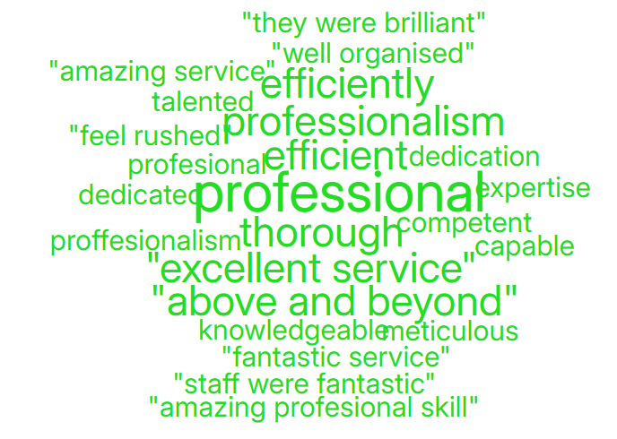
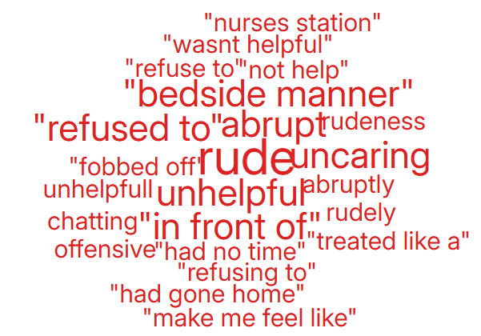

Clinical Treatment | Data
Delay/Lack of treatment or Assessment | 150
Reaction to procedure/ treatment | 36
Incorrect diagnosis | 34
Delay/Lack of diagnosis | 30

Theme 2; Communication;
Communication Improvement Plan;
- Training during consultant development programme where the importance of good and clear communication is discussed.
- Complaints/communication training sessions delivered by the Corporate team to Service Groups – this training is ongoing
- Bespoke training provided to Service Groups and specific departments on complaints which includes communication
- Reminders in CRAG meetings of the importance of clear communication and regular meaningful updates to complainants or patients

- Outpatient Department – Quarter 1 – Wordles related to communication were all positive. However, upon reviewing the comments in the charts, I identified two negative comments that highlight issues with communication. Please see below:
“Where to start; this is the 3rd time I have seen a consultant and 2 of them NHS consultants turned up 30 minutes late for my appointment and treated me like I turned up to the wrong appointment. He had the audacity to tell me I made the wrong decision in surgery, even though I’ve never seen him before and 2 other consultants recommended it. Why am I paying to be treated like dirt on his shoe. He prescribed a drug my GP already tried. Clearly didn’t even read my file. Useless.”

“Having had lower end bleeding for 12 months, my GP did a general surgery referral. Had to wait 4-months for the appointment. I had it yesterday, the consultant did not examine my issue at all or discuss my issues with me. He saw me for a total of a couple of minutes max. He gave me no opportunity to speak. He just sent me to another department that will take another countless amount of time, whilst I’m still bleeding. I feel absolutely hopeless and uncared for, dangerous patient care.”
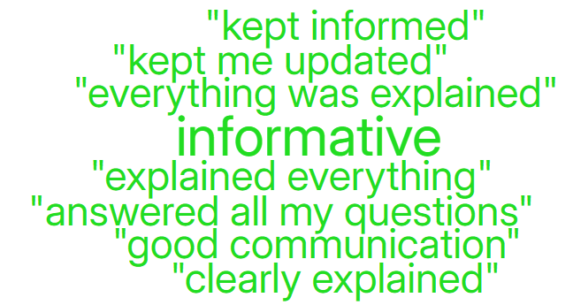

During Q1, 197 complaints were received relating to communication. A breakdown of the sub-subjects are below – please note, some complaints include more than one of these issues.
Communication Issues;
Insufficient/Incorrect information | 152
Communication with patient/service user | 29
Communication between Services/Departments | 3
Communication with External Agencies or Other NHS Organisations | 1
Communication with family | 22
Guidance, Policies & Procedures - issues raised | 3

Theme 3; Appointments;
What we are doing about this?
- Outsourcing of patients to other Healthcare providers to help reduce waiting times.
- Rapid Diagnostic Centre expansion.
- Expansion of our virtual wards to widen the range of disciplines involved, so increasing the number of patients who can be treated appropriately out of hospital
All Wales questions do not have ‘appointments’ as a question set. Therefore, as an alternative a search was undertaken on the words delay/delays/appointment.
Below are some comments we found relating to ‘appointments’ for Adult Mental Health in Quarter 1.
- “They booked me in for an in person appointment today 08/04/2025 at 10:30am. I've turned up to no appointment on the system and been told I'm discharged from their service.”
- “I have requested multiple times not to be booked in for video call appointments. Just regular phone calls or in person. This gets accepted upon request and then the next appointment will be a video call without fail.”
- “I get told appointment at x,y,z time, I've been unable to attend maybe 50% of these appointments because of their lack of listening. I don't even get the option to have choices about my care because of their lacklustre care for patients.”
Below are some comments relating to ‘appointments’ for Gynaecology in Quarter 1.
- “I was seen promptly at my allocated appointment time.”

- “The wait!!! Given an appointment time of 145, not being seen until almost an hour after. not good at all and I wasn’t the only patient who experienced the long wait.”

- “Clinic was running late”

During Q1, 120 complaints were received regarding appointment issues. Many of these complaints will have more than one sub-subject, see breakdown below;
Appointments;
Delay in appointment/waiting time/transport | 71
Appointment cancelled | 24
Cancelled appointment/transport | 5
Location of appointment unsuitable | 3
Patient booked into wrong outpatient clinic | 2
Cancelled Admission - Urgent | 1

- HIGH RISK AREAS

As part of the Health Board’s focus on Urgent Care, Planned Care and Cancer Services the following section highlights complaints received in:
- Orthopaedics
- Emergency Department (ED)
- General Surgery
- Cancer Services
- Mental Health
Graph 1 below shows the number of complaints for each of these areas received per month since July 2024.
Graph 1: Complaints per month
As shown in the graph, there have been no complaints for Cancer Services within the last two quarters. A breakdown of the issues raised within the other services during Q1 can be found below;

3.1 – Orthopaedic Complaint themes

Patient Experience Feedback: Orthopaedic Services
As Orthopaedics is classed as a ‘High Risk Area’, the Patient Experience Team have investigated the feedback for Orthopaedic Services. In total, Orthopaedic Services received 109 responses to the Friends and Family Survey during Quarter 1.
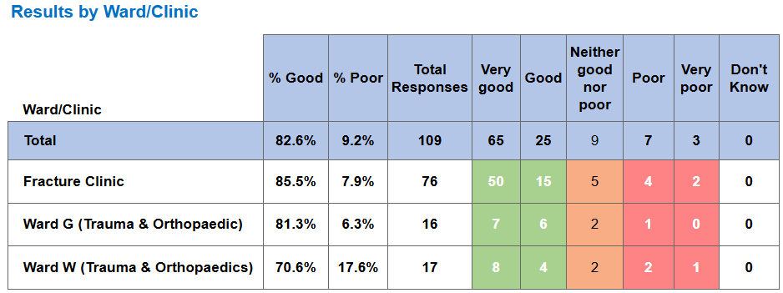
Top themes for Orthopaedic services:
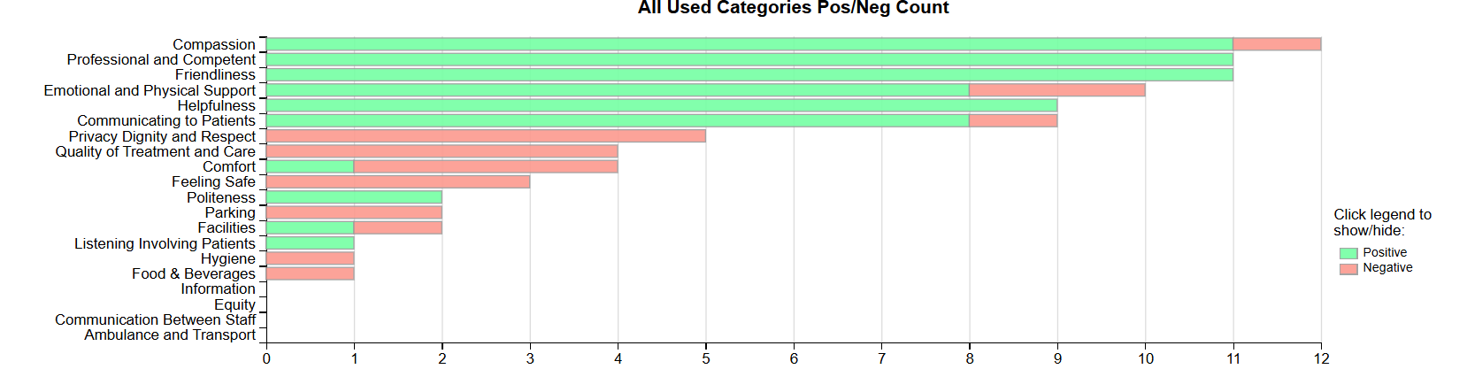

Positive Themes
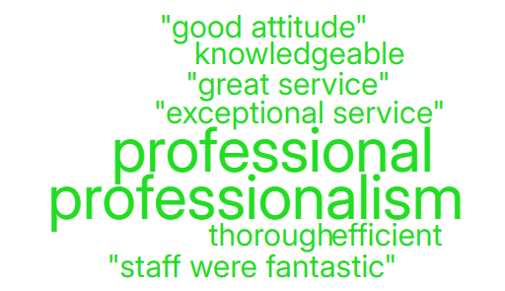
‘Professional & Competent’ ‘Friendliness’
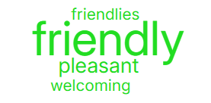

Negative Themes
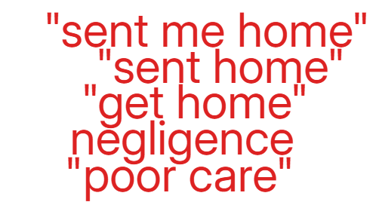
‘Privacy, Dignity & Respect’ ‘Quality of treatment & Care’
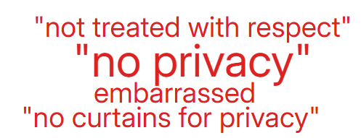
3.2– Emergency Department (ED) Complaints
During Q1 of 2025/26, ED received 38 complaints, this compared with 35 during Q4, a breakdown of the issues raised in Q1 is below;

The 21 ‘clinical treatment/assessment’ complaints mainly relate to delays in treatment or assessment.
Patient Experience Feedback: ED Services
As ED is classed as a ‘High Risk Area’, the Patient Experience Team have investigated the feedback for ED Services. In total, ED Services received 1082 responses to the Friends and Family Survey during Quarter 1.
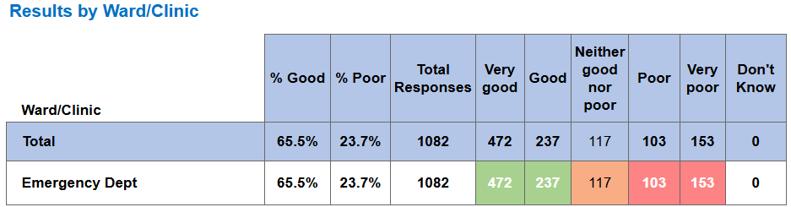
Below are the top themes for ED services:
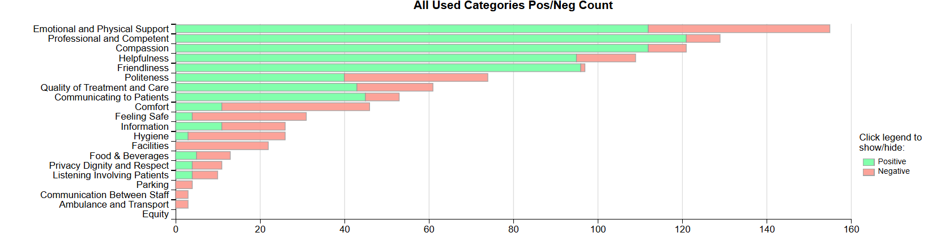
Positive Themes
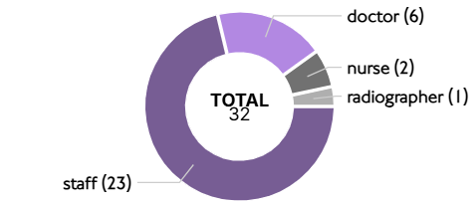
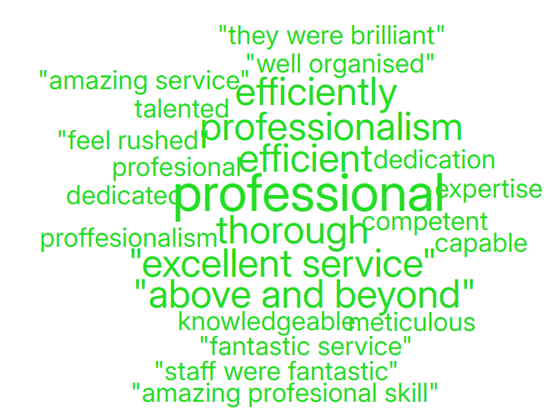
‘Professional & Competent’ Sub theme ‘Professional’

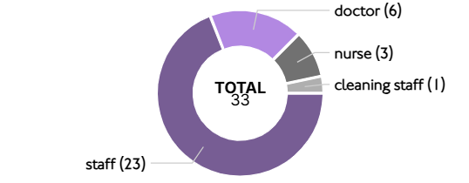
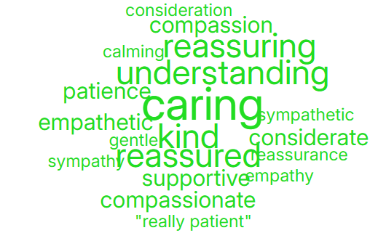
‘Compassion’ Sub theme ‘Caring’

Negative Themes
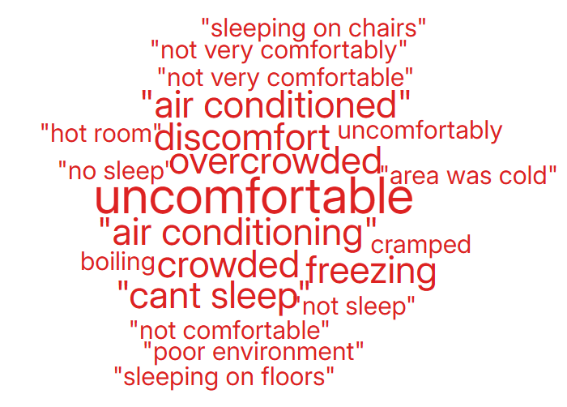
‘Comfort’ ‘Emotional & Physical Support’
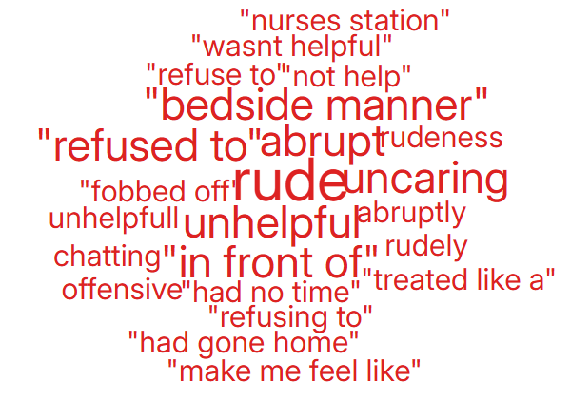

  - – General Surgery Complaints
During Q1 of 2025/26, General Surgery received 28 complaints, a breakdown of the issues is below;
Patient Experience Feedback: General Surgery
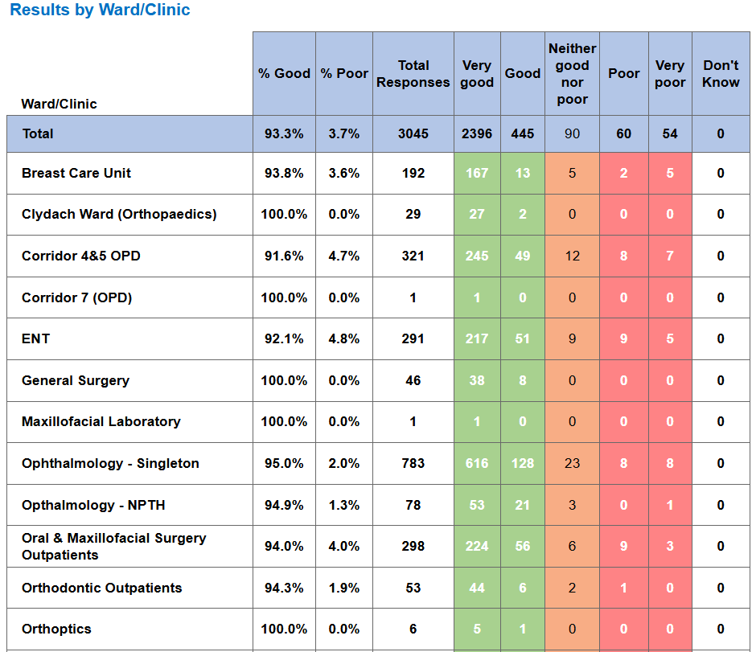
As General Surgery is classed as a ‘High Risk Area’, the Patient Experience Team have investigated the feedback for General Surgery Services. In total, General Surgery Services received 3,045 responses to the Friends and Family Survey during Quarter 1.

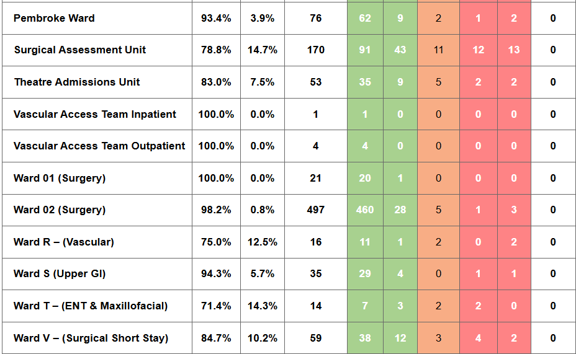
Below are the top themes for General Surgery services:
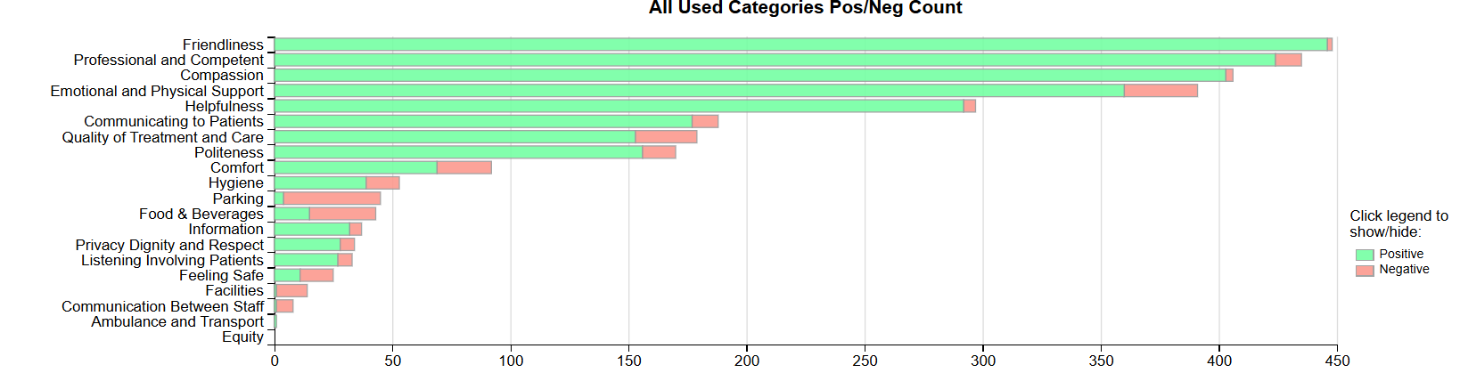
Positive Themes
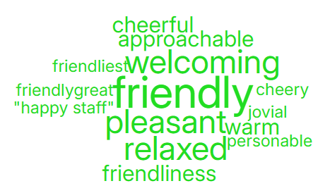
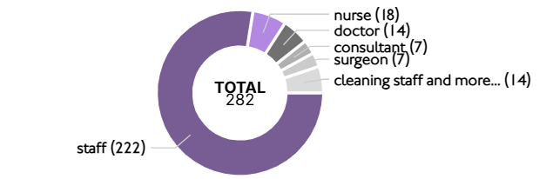
‘Friendliness’ Sub theme ‘Friendly’

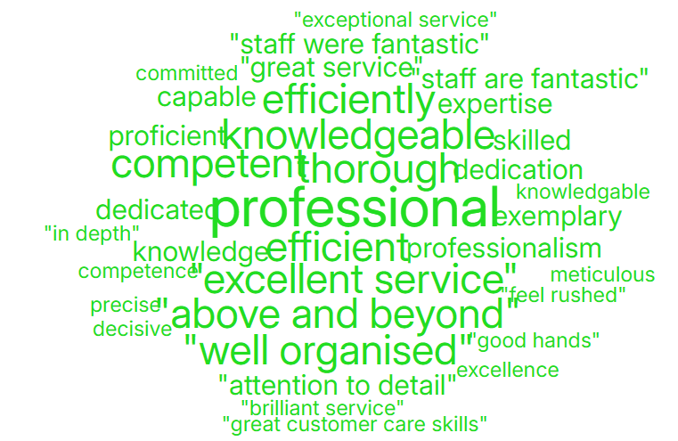
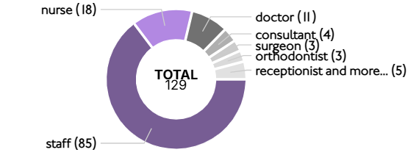
‘Professional & Competent’ Sub theme ‘Professional’

Negative Themes
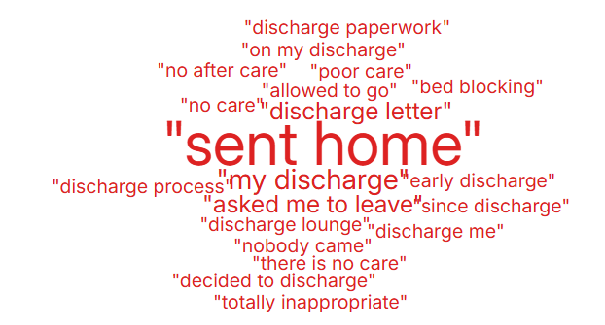
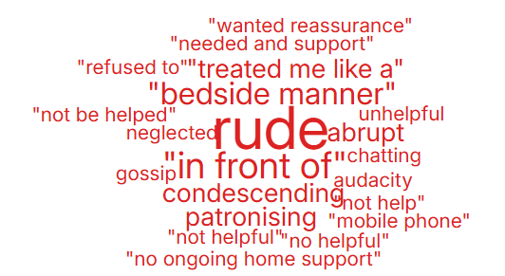
‘Emotional & Physical Support’ ‘Quality of Treatment & Care’

Cancer Service Complaints
As shown in graph 1 above, there were no complaints relating to cancer services received in Q1.

Patient Experience Feedback: Cancer Services
As Cancer is classed as a ‘High Risk Area’, the Patient Experience Team have investigated the feedback for Cancer Services. In total, Cancer Services received 764 responses to the Friends and Family Survey during Quarter 1.
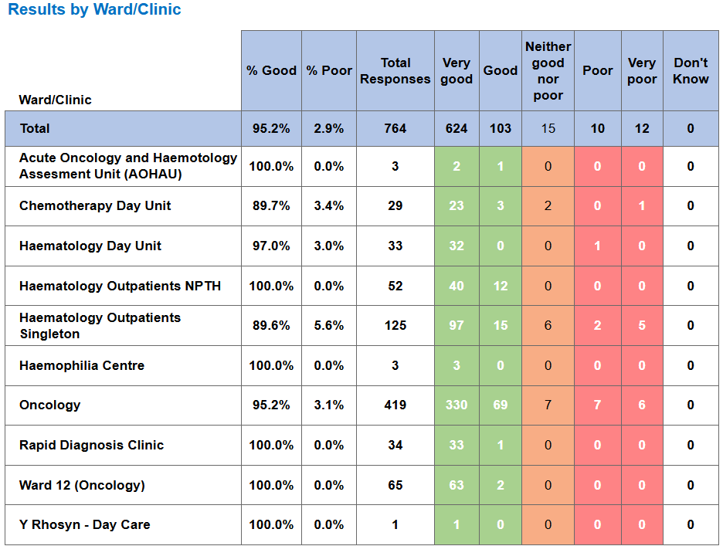

Below are the top themes for Cancer services:
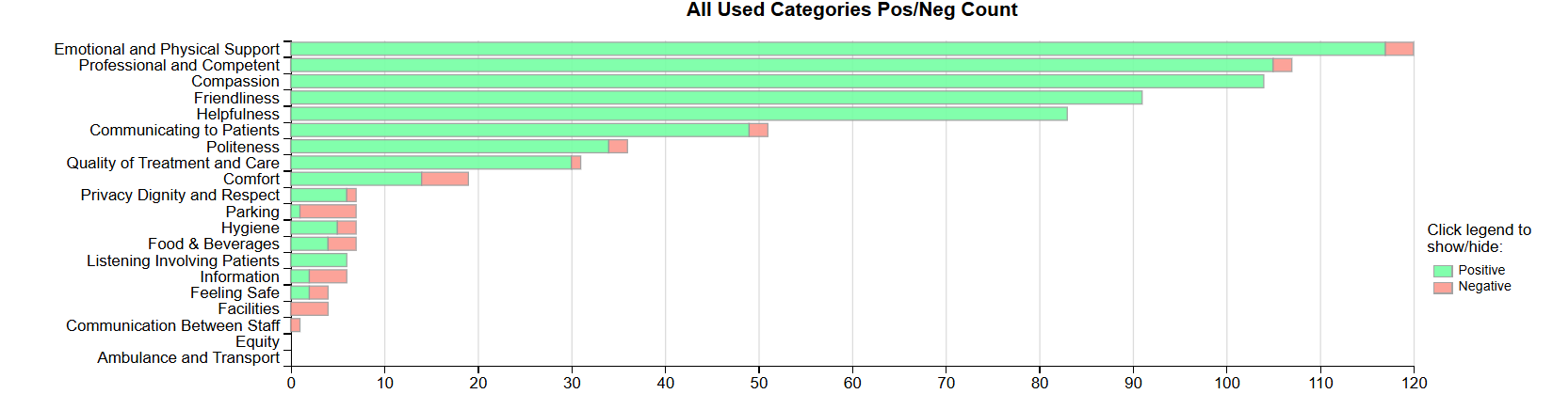

Positive Themes
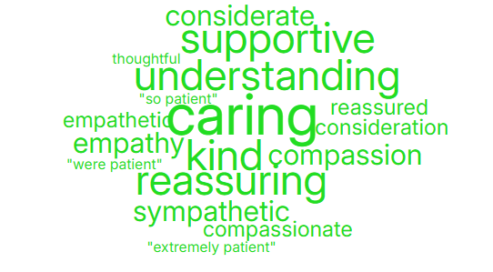
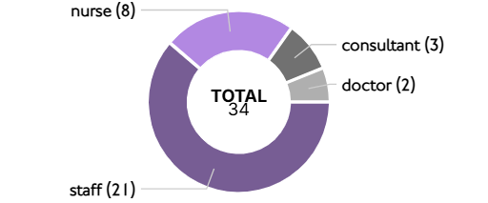
‘Compassion’ Sub themes ‘Caring’

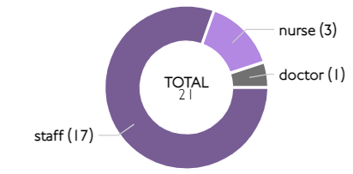
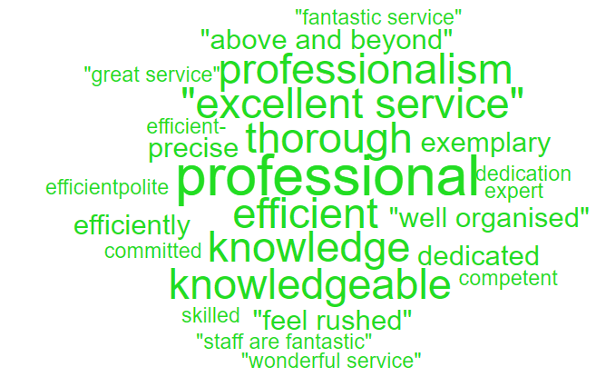
‘Professional & Competent’ Sub themes ‘Professional’

Negative Themes


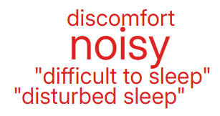
‘Comfort’ ‘Information’

3.4 Mental Health Complaints
During Q1 of 2025/26, Mental Health received 82 complaints, a breakdown of the top 10 areas these relate to is shown below;

Also below is a breakdown of the issues raised within these complaints;
Communication Issues | 18
Appointments | 17
Monitoring/Observation Issues | 12
Clinical treatment/Assessment | 11
Attitude and Behaviour | 7
Medication | 5
Access (to Services) | 3
Discharge Issues | 3
Referral | 2
Admissions | 1

Patient Experience Feedback: Mental Health
For our Mental Health feedback, we primarily utilise a Service/User/Carer survey that is designed to be more user-friendly. In Quarter 1, we received 349 responses, with an overall satisfaction score of 98% for the question, "Overall, how was your experience?"
Additionally, we received 2 Friends and Family responses, resulting in an average score of 100%.

Below are the top themes for Mental Health services:

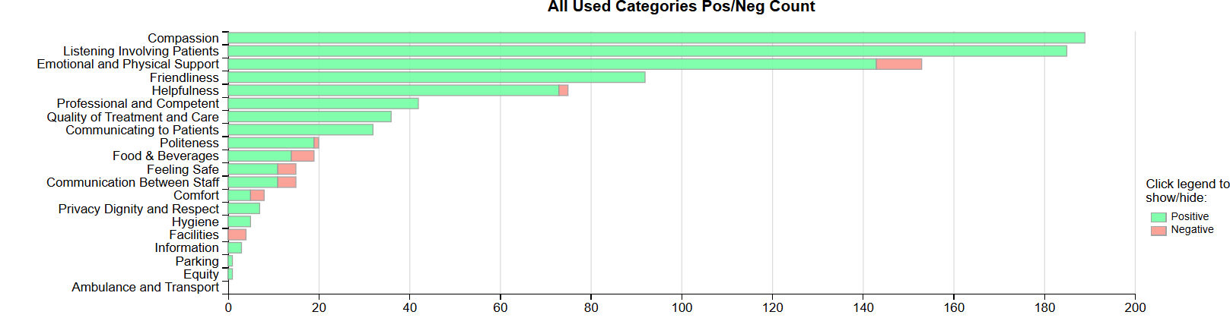

Positive Themes
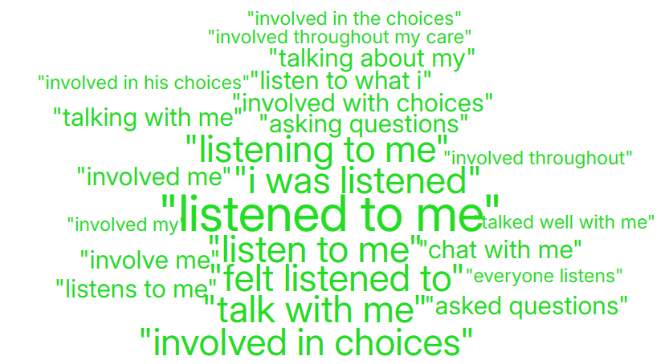
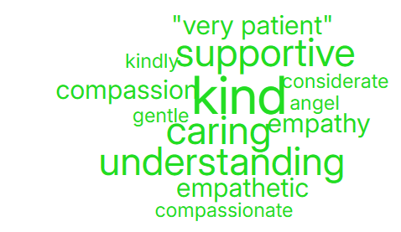
‘Compassion’ ‘Listening & Involving Patients’

Negative Themes
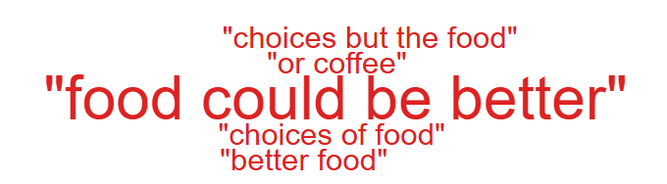
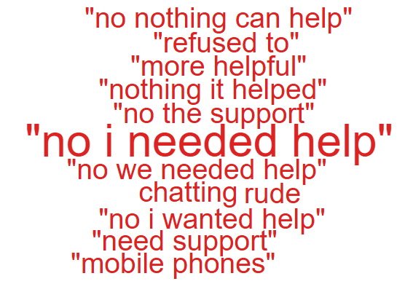
‘Emotional & Physical Support’ ‘Food & Beverages’

Nutrition & Hydration
As Nutrition & Hydration is currently one of the Health Board’s priorities, for this quarterly report please see below overview of the feedback received.
The Health Board received 12 complaints between 1st April 2025 – 30th June 2025 which involved Nutrition & Hydration issues. Please see breakdown below of what services these complaints related to;

The specific issues raised in these complaints are below (please note some of these complaints may have more than one sub-subject);
Patients not properly hydrated | 7
Appropriateness of food/Dietary options | 6
Availability of nutritional supplements | 3
Lack of assistance with Patients feeding/hydration | 2
Temperature (too hot/too cold) | 1

The ‘patient not properly hydrated’ issues relate to the following areas;
Derwyn Ward | 1
Anglesey Ward(Morriston) | 1
Clydach Ward | 1
Labour Ward or Delivery Room | 1
Ward 19 | 1
Ward 4 | 1
Acute Medical Unit (AMU) | 1

Patient Experience Feedback – Nutrition & Hydration.

The question below is the only one in the National People’s Experience Survey that relates to Nutrition & Hydration

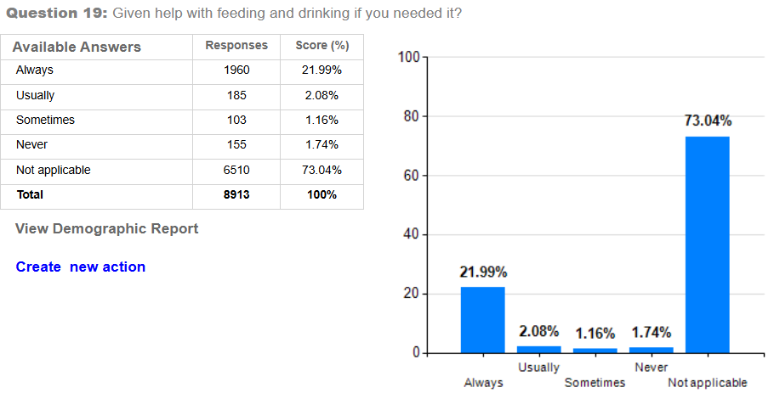

The following questions are related to our Paediatric Questionnaire

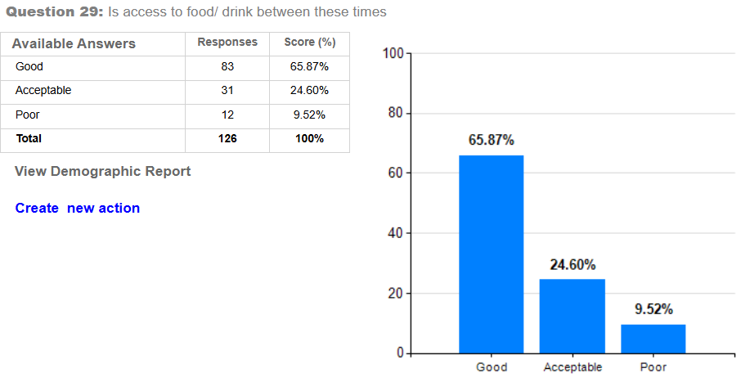
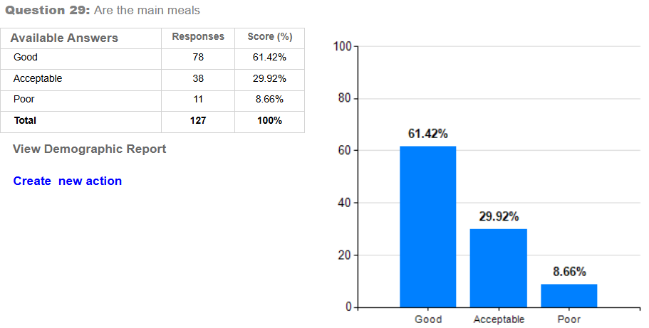
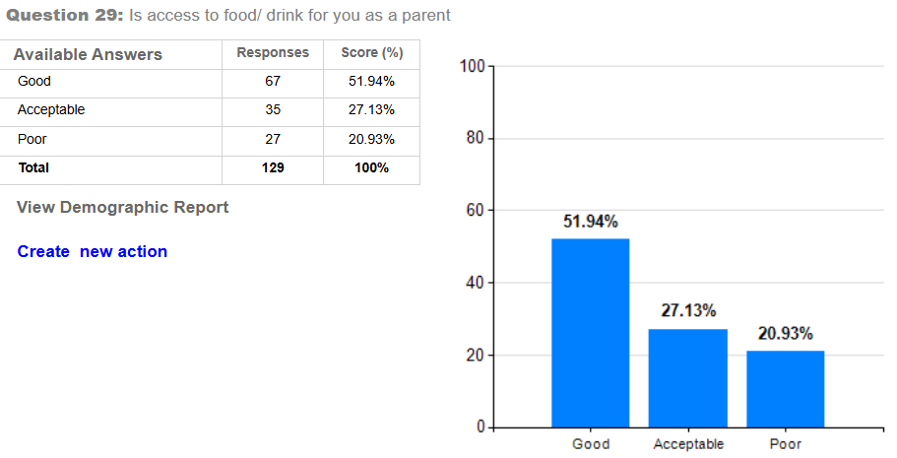
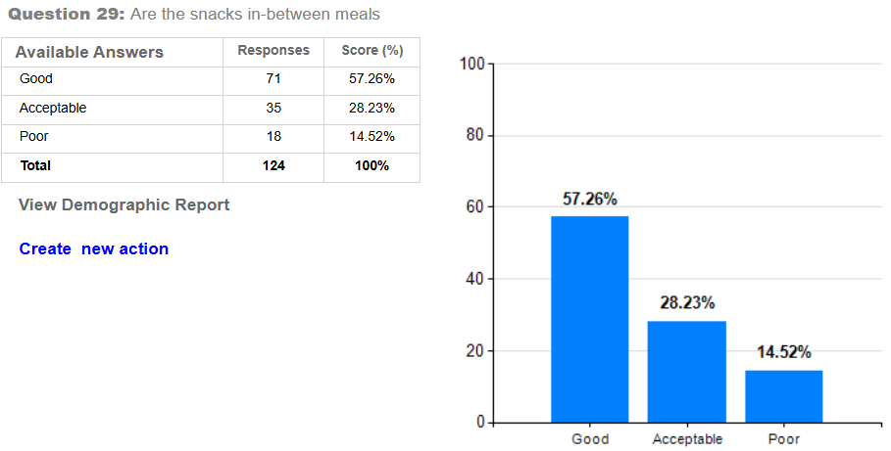
Top Themes – Nutrition & Hydration
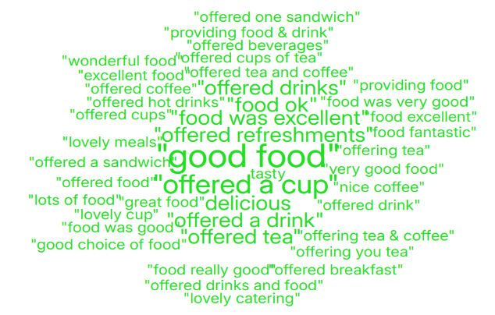
‘Positive’ ‘Negative’
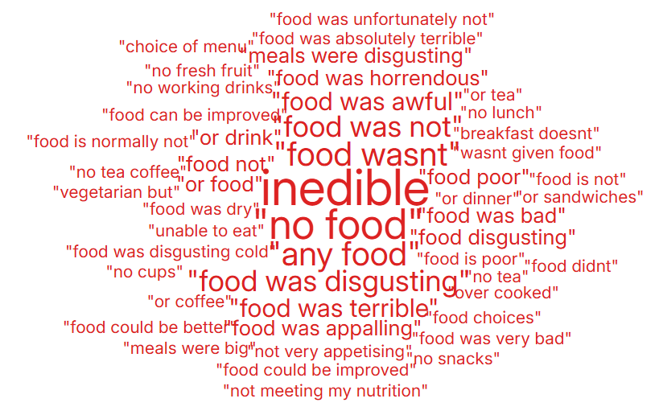

- SERVICE GROUP COMPLAINTS, INCIDENTS, COMPLIMENTS AND PATIENT FEEDBACK HIGHLIGHTS

MORRISTON SERVICE GROUP
4.1 – Morriston Service Group complaints
Morriston Service Group received a total of 274 complaints during Q1 2025/26, this compares with 246 complaints during Q4 2024/25. The increase doesn’t appear to be one service in particular however, as shown in Graph 2, Cardiology has more complaints when compared with the previous quarter. Graph 1 below shows the total number of complaints received relating to Morriston Service Group since July 2024. The graph breaks the total number received down by Formal Putting Things Right, Early Resolution and Re-opened complaints.
Graph 1: Morriston Service Group complaints by month and type

Graph 2 shows the top five services that had the most complaints since July 2024.
Graph 2: Top 5 Services by month

As shown in the graph, there appears an increase in ED and Cardiology complaints which would contribute to the overall increase to Morriston complaints received in Q1.
4.2 – Morriston Service Group Incidents
Morriston Service Group reported 2312 incidents in quarter 1 (Q1) of 2025/26 (April, May, June). This compares with 2493 incidents in quarter 4 (Q4) of 2024/25 (January, February, March). Graph 1 shows the number of incidents per month broken down by severity.
Graph 1: Morriston Incidents by Severity and month

There appeared to be an increase in severe incidents reported in June with 22 reported. These have been reviewed and all but two incidents have now been downgraded to low or no harm. The two remaining severe were the one NRI reported and one Mental Health patient death.
Graph 2 shows the top 5 incident types, of all incidents reported by Morriston Service Group since April - June 2025.
Graph 2: Top 5 incidents per month

4.3 – Morriston Service Group National Reportable Incidents
Morriston Service Group reported 6 Nationally Reportable Incidents (NRI’s) during Q1 2025/26, this compared to 8 being reported during Q4 of 2024/25. Of the NRI’s reported, 1 x Never Event – wrong site surgery, 1 x NEWS, 1 x infection outbreak, 1 x Resuscitation event, 1 x Treatment or procedure issues and 1 x delayed diagnosis.
Graph 1: Nationally Reportable Incidents reported per month by Morriston Service Group

4.4 – Morriston Service Group Compliments
Morriston received 129 compliments during Q1 of 2025/26. Graph 1 shows the number received per month since July 2024.
Graph 1: Morriston compliments per month

Graph 2: Morriston compliments – Top 5 Services

4.5 Morriston Service Group Patient Experience Feedback
Overall, during quarter 1 there were 111,601 is this number of patients seen under Morriston Service Group (This includes Emergency Department and Minor Injury Unit).

There were 8,376 Friends and Family survey returns which equates to 8% responding to the survey. Out of the 8% who responded, 88% of people stated they would highly recommend the Health Board to Friends and Family.
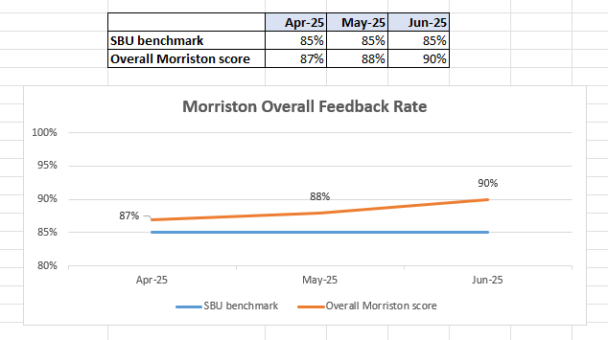

Below are the number of responses in a line graph:

Below are the main themes mentioned for Morriston:
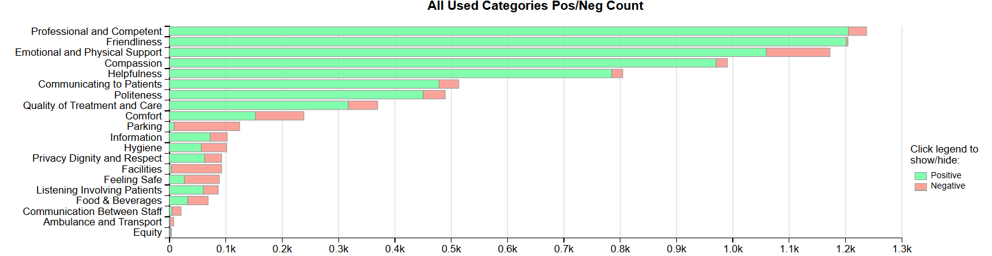

NEATH PORT TALBOT SINGLETON SERVICE GROUP
4.6 – NPTSSG Complaints
NPTSSG received a total of 207 complaints during Q1 2025/26 which compares with 171 complaints during Q4 2024/25. Graph 1 below shows the total number of complaints received relating to NPTSSG since July 2024. The graph breaks the total number received down by Formal Putting Things Right, Early Resolution and Re-opened complaints.

Graph 1: NPTSSG complaints by month and type

Graph 2 shows the top five services that had the most complaints since July 2024.

Graph 2: Top 5 Services by month

There appears an overall increase in complaints for NPTSSG during Q1 compared with the previous quarter. As shown in the graph above, Gynaecology appear to have received more complaints during June 2025. Out of the 17 complaints for Gynaecology, the main issues were delays in treatment and insufficient information.
4.7 – NPTSSG Incidents
NPTSSG reported 1428 incidents in quarter 1 (Q1) of 2025/26 (April, May, June). This compares with 1434 incidents in quarter 4 (Q4) of 2024/25 (January, February, March). Graph 1 shows the number of incidents per month broken down by severity.
Graph 1: NPTSSG Incidents by Severity and month

Graph 2 shows the top 5 incident types, of all incidents reported by NPTSSG since April - June 2025.
Graph 2: Top 5 incidents per month

4.8 – NPTSSG National Reportable Incidents
NPTSSG reported 12 Nationally Reportable Incidents (NRI’s) during Q1 2025/26, this compares to 10 Nationally Reportable Incidents (NRI’s) during Q4 2024/25. Of the NRI’s reported – 1 x Never Event – Wrong Site Surgery, 1 x Maternal Adverse Occurrence, 1 x Assessment, Investigation, Diagnosis, 1 x Never Event -Retained Guidewire, 1 x Maternal Death, 3 x Neonatal death, 1 x Injury of unknown origin / unwitnessed, 2 x Stillbirth, 1 x Unexpected death.
Graph 1: Nationally Reportable Incidents reported per month by NPTSSG

4.9 – NPTSSG Compliments
NPTSSG received 63 compliments during Q1 of 2025/26, compared with 56 during Q4. Graph 1 shows the number received per month since July 2024.
Graph 1: NPTSSG compliments per month

Graph 2: NPTSSG compliments – Top 5 Services

4.10 NPTSSG Patient Experience Feedback
Overall, during Quarter 1 there were 109,529 number of patients seen under Neath Port Talbot and Singleton Service Group.

There were 6,017 Friends and Family survey returns which equates to 5% responding to the survey. Out of the 5% who responded, 94% of people stated they would highly recommend the Health Board to Friends and Family during this quarter.

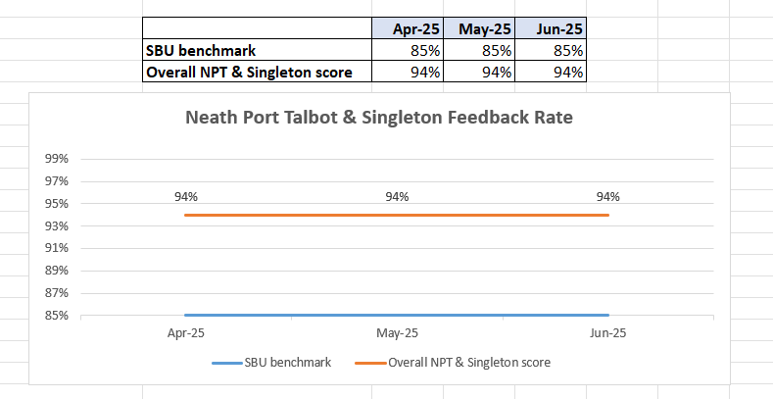
Below are the number of responses in a line graph:

Below are the main themes mentioned for NPT & Singleton:
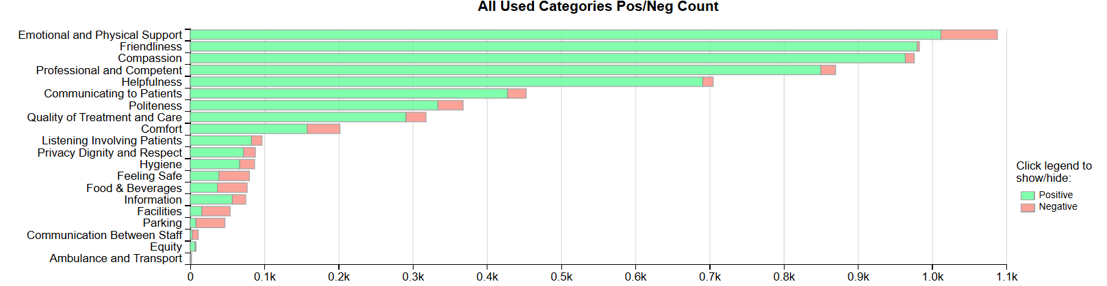
MENTAL HEALTH AND LEARNING DISABILITIES SERVICE GROUP
4.11 – MH&LD Complaints
MH&LD received a total of 82 complaints during Q1 2025/26 (April, May, June) compared with 81 complaints during Q4 2024/25 (January, February, March). Graph 1 below shows the total number of complaints received relating to MH&LD since July 2024. The graph breaks the total number received down by Formal Putting Things Right, Early Resolution and Re-opened complaints.
Graph 1: MH&LD complaints by month and type

As you can see from the graph, MHLD had an increase in complaints during June. This was due to multiple complaints being received from one complainant who is known to the service.
Graph 2 shows the top five areas within MH&LD that had the most complaints since July 2024.
Graph 2: Top 5 Services by month

4.12 – MH&LD Incidents
MH&LD reported 923 incidents in quarter 1 (Q1) of 2025/26 (April, May, June). This compares with 898 incidents in quarter 4 (Q4) of 2024/25 (January, February, March). Graph 1 shows the number of incidents per month broken down by severity.
Graph 1: MH&LD Incidents by Severity and month

Graph 2 shows the top 5 incident types, of all incidents reported by MH&LD since April – June 2025

Graph 2: Top 5 incidents per month

4.13 – MH&LD National Reportable Incidents
MH&LD reported 0 NRI’s during Q1 of 2025/26, compared with 3 NRI’s during Q4 of 2024/25.

4.14 – MH&LD Compliments
MH&LD received 4 compliments during Q1 of 2025/26. Graph 1 shows the number received per month since July 2024.

Graph 1: MH&LD compliments per month

4.15 MH&LD Patient Experience Feedback
This data is from Quarter 1.

The Mental Health and Learning Disabilities Service Group are using a different set of survey questions. The role out of the semi structured interview surveys have been managed in stages. Roll out, awareness posters and meetings with managers and teams continues.
Month | Percentage
Apr-25 | 96%
May-25 | 99%
Jun-25 | 99%

Below are the number of responses in a line graph:

PRIMARY AND COMMUNITY SERVICE GROUP
4.16 – P&C Complaints
P&C received a total of 88 complaints during Q1 2025/26 (April, May, June) compared with 105 complaints during Q4 2024/25 (January, February, March). Graph 1 below shows the total number of complaints received relating to P&C since April 2024. The graph breaks the total number received down by Formal Putting Things Right Early Resolution and Re-opened complaints.
Graph 1: P&C complaints by month and type

Graph 2 shows the top five services that had the most complaints since July 2024.
Graph 2: Top 5 Services by month

From the graph it is evident that the overall increase in Q4 was due to the number of prison complaints received.
4.17 – P&C Incidents
P&C reported 1101 incidents in quarter 1 (Q1) of 2025/26 (April, May, June). This compares with 1068 incidents in quarter 4 (Q4) of 2024/25 (January, February, March). Graph 1 shows the number of incidents per month broken down by severity.
Graph 1: P&C Incidents by Severity and month

Graph 2 shows the top 5 incident types, of all incidents reported by P&C since July 2024.
Graph 2: Top 5 incidents per month
4.18 – P&C National Reportable Incidents
P&C reported 4 Nationally Reportable Incidents (NRI’s) during Q1 2025/26, which was the same as Q4 of 2024/25. The 4 NRI’s reported in Q1 included 2 x Pressure Ulcers, 1 x Dental - Wrong Tooth, 1 x Treatment or procedure wrong or inappropriate.
Graph 1: Nationally Reportable Incidents reported per month by P&C

4.19 – P&C Compliments
P&C received 110 compliments during Q1 of 2025/26, compared with 73 during Q4. Graph 1 shows the number received per month since July 2024.
Graph 1: P&C compliments per month

Graph 2: P&C compliments – Top 5 Services

4.2 P&C Patient Experience Feedback
During Quarter 1, a total of 1,332 patients were seen under the Primary and Community Service Group.

A total of 2,111 Friends and Family survey responses were received during this quarter, with 94% of respondents stating they would highly recommend the Health Board to their friends and family.

Patient Experience Team are currently working with I.T to automate SMS messages from the PIMS, PIMS+ platform to automate SMS survey messages to Primary Care and Therapies patients. This will increase the number of returns.
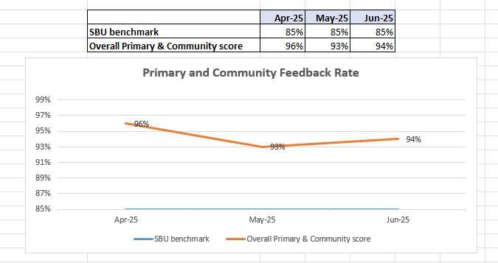

Below are the number of responses in a line graph:

Below are the main themes mentioned for Primary & Community:
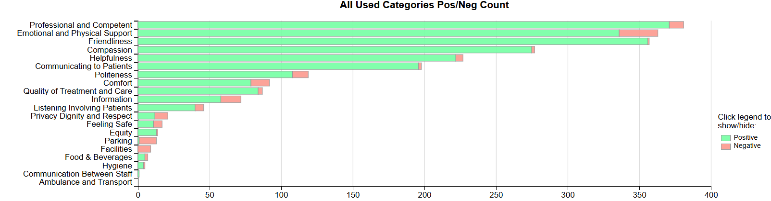

- MEDICAL EXAMINER COMPLIMENTS

5.1 ME Compliments
The Health Board has received a number of compliments from families through the Medical Examiner. This evidences the good work being done when treating these end of life patients. During Q1, approximately 136 compliments were received. A few examples are shown below;

“ACT team were marvellous, they let us make decisions and kept us informed. EOL team, DN could not fault them. They have looked after us as well as …...”
ACT Team

“The care they all received by the staff was brilliant, they were treated like royalty. They did everything they could for Lynwen. Very happy with the care and the aftercare from the care after death team. high praise to all involved including our service.”
Ward F, Morriston

“The hospital was absolutely wonderful. I could not speak more highly of them. The doctors and nurses were so kind to family as well. All family were so grateful. .”
Ward R, Morriston

- OMBUDSMAN CASES

6.1 Ombudsman investigations
3 new Ombudsman investigations were received during Q1 2025/26, this compares to 5 in Q4 2024/25. Graph 1 shows the number of investigations received per month;

Graph 1: Number of Ombudsman investigations per month

The Health Board has also received 25 decisions not to investigate from the Ombudsman during Q1. Graph 2 below shows these by month.

Graph 2: Ombudsman decisions not to investigate

There are a number of different reasons why the Ombudsman decided not to investigate these complaints, a few of these reasons are detailed below;

- Health Board already identified learning and put changes in place since complaint
- Thorough investigation and detailed response from Health Board
- Ombudsman unable to achieve anything further – Health Board already met and explained everything to complainant
- Complaint out of time
Ombudsman Annual Letter Data
The Health Board received the attached Annual Letter data for 2024-2025 from the Public Services Ombudsman for Wales on 6th August 2025. Please see extracts of the data below;
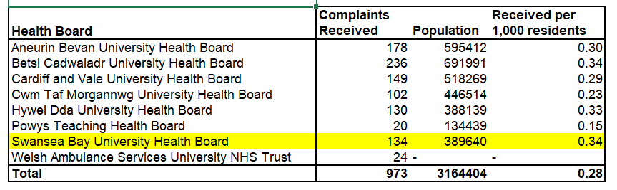
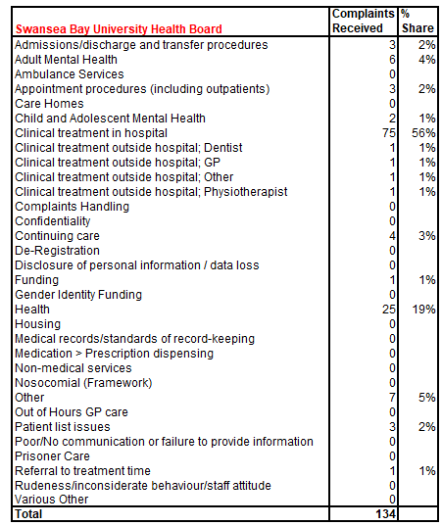
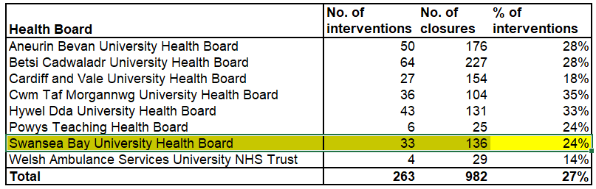
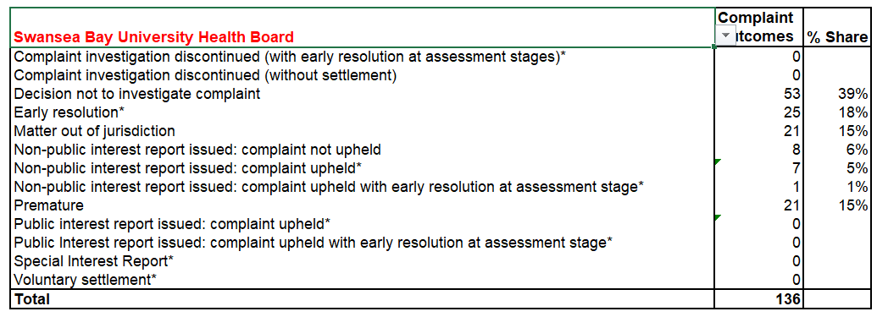
The Ombudsman’s Improvement and Complaints Standards Manager, has advised that the actual Annual Letter will follow the above disclosure in late August-early September.
On review of the Annual Letter data, in comparison to last year’s data, the following is noted:
- The amount of Complainants approaching the Ombudsman has increased in numbers by 2, from 132 (0.35%) last year to 134 (0.34%) this year – Swansea Bay’s percentage per 1000 residents in our catchment area is 0.34%, which is 0.01% lower per 1000 residents than last year. This is similar to Betsi Cadwaladr also at 0.34% and Hywel Dda at 0.33%. The Service Groups Quality & Safety Teams always ensure that the Ombudsman paragraph is in all communications with patients and encourage Complainants to approach the Ombudsman if they are not content with their response.
- The number of interventions by the Ombudsman is 33 interventions, reduced from 41 last year, the Ombudsman intervened in 24% of all complaints received (28% last year) Swansea Bay is the third lowest Health Board in Wales for Ombudsman interventions, which is very positive.
- The number of complaints closed by the Ombudsman has fallen from 141 last year to 136 this year.
- Complaints about complaint handling have decreased to 0 (0%) this year from 26 (20%) last year – which is extremely positive.
- There has been an increase of clinical treatment complaints from 55 (42%) to 75 (56%) this is for treatment provided within the Hospital setting.
- There has been a decrease from 10 Mental Health complaints last year, to 6 this year.
- Patient listing complaints have decreased from 6 last year to 1 this year – despite this, this one is a potential Public Interest Report in relation to the Orthopaedic Waiting List, similar to the 3 Ombudsman Public Interest Reports received in relation to the Orthopaedic Waiting List in January 2024.

In consideration of the attached and above, it is evident that there have been many positive improvements from last year’s Annual Letter data, particularly in relation to:
- Swansea Bay being the third lowest Health Board for Ombudsman interventions
- No complaints handling complaints referred to the Ombudsman
- Patient Listing complaints have decreased
- Mental Health complaints have decreased

