Meeting Date | 24 September 2024 | Agenda Item | 4.2
Report Title | Infection Prevention and Control Report
Report Author | Joanne Walters,  Deputy Head of Nursing Infection Prevention & Control
Report Sponsor | Hazel Powell,  Acting Director of Nursing & Patient Experience
Presented by | Delyth Davies,  Head of Nursing Infection Prevention & Control
Freedom of Information | Open
Purpose of the Report | This assurance report provides the Quality & Safety Group with the Infection Prevention & Control position to the end of Quarter 1 2024/25 that was submitted to the Infection Prevention & Control Strategic Group (IPCSG) meeting that was held on the 31st July 2024, and escalates the increased number of C. difficile infections reported in August.  The report provides also an update on the high consequence infectious disease (HCID), Clade 1 Mpox (Monkeypox).
Key Issues | - The key issues identified in the IPC report to IPCSG to the end of June 2024 are detailed on page 3 of this report.  - C. difficile cases: the number of cases in August was the highest reported since the establishment of the health board in April 2019; approximately 66% of these cases occurred in Morriston. To date, genome results do not indicate a possible hospital-wide outbreak, although there has been a number of genomically-linked clusters involving 2 – 3 patients. A Gold High Incidence Management Group meeting will be held on 5th September, chaired by the Acting Executive Medical Director.  - Clade 1 Mpox:  - On August 14th, the World Health Organisation determined that the increase of Clade 1 Mpox cases in a growing number of countries in Africa constituted a Public Health Emergency of International Concern (PHEIC). Since then, single cases have been reported to have been exported to Sweden and Thailand. Clade 1 Mpox is classified as a high consequence infectious disease (HCID).  - As of August 2024, no cases have ever been detected in the UK. However, clinicians have been alerted to the possibility of Clade 1 Mpox in presenting patients if there is a link to the specified countries in the African region.  - The Health Board has established a High Consequence Infectious Disease (HCID) Strategic Preparedness Task & Finish Group (HCID SPG), to support planning and preparations.

Specific Action Required  (please choose one only) | Information | Discussion | Assurance | Approval
Specific Action Required  (please choose one only) | ☐ | ☐ | ☒ | ☐
Recommendations | Members are asked to:  • NOTE the content of the IPCSG paper 31st July 2024, including the escalation by Welsh Government to Targeted Intervention the health board’s performance in relation to healthcare associated infections.  - NOTE the escalation of C. difficile infections during August, and the establishment of a Gold High Incidence Management Group.  - NOTE the briefing on Clade 1 Mpox and the establishment of a health board strategic preparedness task and finish group (HCID SPG).

Meeting Date | 31 July 2024 |  | Agenda Item |  |  | 3.2
Report Title | Infection Prevention and Control
Report Author | Joanne Walters, Deputy Head of Nursing, Infection Prevention & Control
Report Sponsor | Lesley Jenkins, Acting Deputy Executive Director of Nursing
Presented by | Joanne Walters, Deputy Head of Nursing, Infection Prevention & Control
Freedom of Information | Open
Purpose of the Report | This is an assurance report that provides an update on prevalence, progress and actions for healthcare associated infections (HCAIs) within Swansea Bay University Health Board for the reporting period Quarter 1, to the end of June 2024.
Key Issues | - The number of C. difficile infections, and Klebsiella spp. bacteraemia cases continues to increase across the health board. The number of Staphylococcus aureus, E. coli and Pseudomonas bacteraemia cases have reduced.  - The number of cases of C. difficile continues to increase. Cases of C. difficile infection have increased year-on-year for the last five financial years.  - There was a high number Covid-19 incidents managed during Quarter 1 across all hospital sites, which led to temporary bed closures and compounded existing service pressures.  - Compliance in completing the mandatory Infection Prevention & Control (IPC) Level 2 training compliance has increased to 77.90%.  - The Health Board continues to face significant challenges relating to healthcare associated infection risks, which are recorded in the Health Board’s Risk Register.  - The number of C. difficile genomically linked clusters has increased during this reporting period.
Specific Action Required (please choose one only) | Information | Discussion |  | Assurance | Approval
Specific Action Required (please choose one only) | ☐ | ☐ |  | ☒ | ☐
Recommendations | The Infection Prevention & Control Strategic Group is asked to:  - NOTE: the health board’s Quarter 1 position in relation healthcare associated infections.  - NOTE: the performance of the health board to Targeted Intervention for performance in relation to HCAIs. Progress is reported and monitored fortnightly by the Overarching Targeted Intervention Group, chaired by the Chief Operating Officer.  - NOTE: progress on Infection Prevention & Control Improvement Plan to 30th June 2024.  - NOTE: the improvement in IPC Level 2 training from 68.13% compliance reported at 5th January 2024 to 77.90% compliance reported at 3rd July 2024.  - NOTE: the challenges and risks within the health board currently and associated mitigations
INFECTION PREVENTION AND CONTROL

- INTRODUCTION
This report provides an overview of progress against Welsh Government Targeted Intervention de-escalation criteria. The health board additionally has internal reduction goals for healthcare-associated infections (HCAIs), and the report provides a summary of progress against these internal goals also. The reporting period is 1st April 2024 – 30th June 2024. The key HCAIs are:
- Clostridioides difficile infection
- Staphylococcus aureus bacteraemia
- Gram negative bacteraemia (Escherichia coli, Klebsiella spp., Pseudomonas aeruginosa)
An update in relation to respiratory viruses and other key infection-related incidents and outbreaks to 30th June 2024 is provided also.
The report provides a summary of the activities carried out across the health board in relation to the prevention, control and management of infection. The report also identifies key risks, and makes recommendations to address areas requiring action or improvement.

- Progress on key healthcare associated infections (HCAI)

2.1 Progress against Targeted Intervention
The health board’s monthly progress against the Targeted Intervention de-escalation criteria for hospital onset, healthcare associated infections (HCAI) is presented in Table 1. Hospital Onset (HO) infections are defined as a positive microbiology result for a sample collected on day 3 or more of a hospital admission (day 1 being the first day of the admission to an in-patient location).
Welsh Government has set de-escalation criteria for the health board to reduce infections to a maximum number of cases per month. The number of cases should be at or below the maximum set, and these reductions should be maintained for at least 3 months before the health board would be considered for de-escalation from Targeted Interventions.

Table 1.
In Quarter 1, the health board number of hospital onset cases was at or below the maximum in May only, and increased above the maximum in June 2024.
A Targeted Intervention action plan has been developed. The action plan, and the number of cases of hospital onset infection, is reviewed fortnightly by the Overarching Targeted Intervention Group, chaired by the Chief Operating Officer.
Each service group has developed their HCAI Improvement Plans, which have been reviewed by the health board’s Infection Prevention & Control Strategic Group. Implementation and progress of service group plans is reviewed centrally through monthly Executive HCAI Scrutiny Group meetings, co-chaired by the Acting Executive Medical Director and Acting Executive Director of Nursing and Patient Experience.

2.2 Progress against internal health board reduction goals for key Healthcare Associated Infections (HCAIs): 1st April 2024 – 30th June 2024
Prior to the escalation to targeted interventions, the health board monitored infection reduction performance against all Tier 1 key healthcare associated infections, not only those that were defined as hospital onset. Using the Tier 1 infection data from 2023/24 as the baseline, health board and service group annual reduction goals and trajectories for 2024/25 were presented to Management Board on 6th March 2024.
These internal health board HCAI reduction goals will continue to be monitored and reported within the health board, maintaining a focus on infection reduction for our patients, in primary care and community settings and in hospital and inpatient settings.
Progress against these internal health board HCAI reduction goals is shown in Table 2.

Table 2: Internal health board HCAI reduction goals. Cumulative cases to end of June 2024
Infection | Cumulative Cases to end of June 2024 | Internal improvement goal trajectory to end of June 2024 | Actual cases versus internal reduction goal (+/-)
C. difficile (CDI) | 61 | 29 | + 32
Staph. aureus bacteraemia (SABSI) | 27 | 20 | + 7
E. coli bacteraemia (EcBSi) | 52 | 65 | - 13
Klebsiella spp. bacteraemia  (Kl BSI) | 34 | 23 | + 11
Ps. aeruginosa bacteraemia (PAERBSI) | 1 | 5 | - 4

A summary position for service groups is shown in Table 3. This identifies the cumulative number of cases up to the end of June 2024, with the annual increase or reduction shown in brackets.

Table 3: Service Group Annual Comparison to end of June 2024
 | CDI | SaBSI | EcBSI | KlBSI | PAER BSI
SBUHB - Total | 61 (22% ) | 27 (31% ) | 52 (29% ) | 34 (42% ) | 1 (86% )
PCTSG - CAI | 20 (5% ) | 10 (38% ) | 25 (26% ) | 14 (17% ) | 0 (2 cases )
PCTSG - HAI | 1 (1 case ) | 1 (1 case ) | 0 (equal to) | 0 (equal to) | 0 (equal to)
MH&LD – HAI | 0 (equal to) | 0 (equal to) | 1 (1 case ) | 1 (1 case ) | 0 (equal to)
MORR – HAI | 26 (18% ) | 9 (36% ) | 14 (48% ) | 9 (13% ) | 1 (67% )
NPTH - HAI | 4 (3 cases ) | 0 (1 case ) | 3 (equal to) | 3 (1 case ) | 0 (equal to)
SH - HAI | 7 (40% ) | 7 (13%) | 8 (14% ) | 5 (3 cases ) | 0 (100% )
Other HB Cases Identified in SBUHB | 3 (N/A) | 0 (N/A) | 1 (N/A) | 2 (N/A) | 0 (N/A)

Charts showing the position of the Health Board and Service Group progress against the infection improvement trajectories, up to 30th June 2024, are detailed in Appendix 1.
Appendix 2 provides a comparison with other acute health boards in Wales in relation to incidence of these infections per 100,000 population and per 1,000 admissions.
- Clostridioides difficile
The number of cases of C. difficile continues to increase. Cases of C. difficile infection have increased year-on-year for the last five financial years.
To the end of Quarter 1, there has been a 22% increase in case numbers when compared with the number of cases in the same period in 2023/24. All Service Groups, with the exception of Mental Health and Learning Disability Service Group have seen an increase in case numbers compared to the previous year.
Of the 61 positive cases to date, 62% were categorised as hospital-acquired infections (HAI) with the majority of the cases being attributed to Morriston Hospital (68%). Three of the cases were patients who reside outside of the health board’s boundaries, who were found to be positive on, or soon after, admission.
The health board currently has the highest incidence of C. difficile infection when compared with other Welsh acute health boards (63.81/100,000 population). This is significantly higher than the Wales average of 48.67/100,000 population. All acute health boards in Wales have seen an overall increase in case numbers compared to the previous financial year, with percentage increases ranging from 15% - 89%.
Following the hospital-wide outbreak of C. difficile (cluster code WGS22-00159_737) and the admission of a case colonised with a highly toxigenic strain of C. difficile RT 955 to Morriston Hospital, high level disinfection services have been procured from BIOQUELL and a site-wide ward disinfection programme has commenced. To date, 11 of the 25 areas implicated in the outbreak have received a light refresh and have been disinfected with Hydrogen Peroxide Vapour technology. It is anticipated that this programme of work will be completed by September 2024.
- Staph. aureus bacteraemia

The maximum number of cases of Staph. aureus bacteraemia required to achieve the 2024/25 infection reduction goal should not exceed 71 cases. To the end of Quarter 1, there has been a 31% decrease in the number of cases compared with the same period in the previous financial year. Each of the service groups are demonstrating reductions in their cases numbers. Hospital acquired infections (HAI) accounted for 63% of the total number of cases, with 37% being categorised as community acquired infections. Twenty percent of hospital acquired infections were associated with vascular devices, predominantly identified in the oncology and haematology patient population. Bone and joint infections were the most common source for the community acquired cases during Quarter 1.
- Gram negative bacteraemia (E. coli, Klebsiella spp., Pseudomonas aeruginosa),
The maximum number of E. coli bacteraemia cases required to meet the internal reduction target should not exceeded 234 cases. To the end of Quarter 1, there have been 52 cases, this represents a 29% reduction when compared with the same time period in the previous financial year. One case was recorded for a patient who resides outside the boundaries of the health board, but who had an E. coli bacteraemia within the first two days of admission to Morriston. Fifty percent of the cases are recorded as community acquired infections and 50% as hospital acquired cases. The urinary tract was considered to be the most common source recorded for all of the bacteraemia cases (65%), and was also considered to be the source in 71% of the community acquired cases.
Primary Care, Community and Therapies and Morriston Hospital service groups have both demonstrated reductions of 26% and 48% respectively. Morriston are maintaining a trajectory below that which is required to achieve the internal annual reduction goal. Singleton has seen a 14% increase compared with the same period in the previous financial year, with the majority of cases being seen within the oncology and haematology patient population.
The annual total number of Klebsiella spp. bacteraemia cases should not exceed 94 cases in order to achieve the internal reduction goal. There have been 34 cases to the end of June 2024, which includes 2 cases being identified in patients who reside outside the boundaries of the health board, but who had a Klebsiella spp. bacteraemia within the first two days of admission to Morriston. There has been a 42% increase in case numbers when compared with the same period in the previous financial year. The distribution of hospital and community acquisition are recorded as 53% and 47% respectively. The most common sources for bacteraemia identified in the hospital setting are reported as urinary tract infections (33%) followed by hepatobiliary disease (22%). These are also the two most common sources identified in community acquired cases (57% related to the urinary tract; 31% related to hepatobiliary disease).

In order to achieve the internal infection reduction goal for Pseudomonas aeruginosa bacteraemia, the maximum annual number of cases should not exceed 21. The cumulative total for Quarter 1 is currently 1 case. This demonstrates an 86% reduction compared with the same time period in the previous financial year.

- Infection Prevention & Control Improvement Plan
  - Overarching 2024/25 Infection Prevention Improvement Plan
The infection prevention improvement plan focuses on core themes to reduce episodes of harm caused by healthcare associated infections (HCAI).
The core themes include:
- Improving the Culture
- Leadership
- Clean & Safe Healthcare Environment
- Antimicrobial Stewardship
Progress to the end of Quarter 1 is presented in Appendix 3 (separate document).
At the last meeting on 30th April 2024, it was agreed that the submitted service group improvement plans would be reviewed by the executive leads for infection prevention & control, and that Chair’s action would be taken for approval. In reviewing the plans, consideration was given to the following points:
- alignment of the plan to the overarching health board improvement plan;
- clear governance and reporting mechanisms at service group level;
- clear identification of specific service group challenges that contribute to episodes of harm caused by healthcare-associated infections;
- clear identification of key priorities for the service group, with specific actions that demonstrate a commitment to delivering measurable improvement in relation to healthcare-associated infection and antimicrobial stewardship within the given time frame;
- infection reduction goals and trajectories that support the health board in achieving the expected HCAI reduction for a quality driven organisation committed to improving safe, quality care for our population.
Feedback was provided to each service group, with suggested amendments to plans, and service groups are required to submit their revised plans in July’s Infection Prevention & Control Strategic Group.

- Outbreaks and clusters, untoward incidents, Periods of Increased Incidence (PII), and ward/bay closures from diarrhoea and vomiting
  - Periods of Increased Incidence (PII)
A period of increased incidence (PII) is triggered when two hospital acquired cases of C. difficile are attributed to the same ward location within a 28 day time period. This includes both toxin positive and toxin negative cases.
Table A in Appendix 4 includes the details of twenty-three PII that occurred in eighteen wards during Quarter 1 of this year. The total number of patients included in the PII are also shown. This is an increase in the number of PII compared with those reported in Quarter 4 2023/24.
Whole Genome Sequencing (WGS) is performed by the anaerobic reference lab in Cardiff on all C. difficile positive samples. If cases have the same genomic cluster code, they are considered to be genetically related and may indicate that a possible transmission event has occurred. When the WGS cluster code is shared by two or more cases and epidemiological links are established, these are reported as probable outbreaks.
WGS results take approximately two weeks to be reported to the health board, this means that linked cases are identified and reported retrospectively. In some instances, the WGS results may identify cases with the same cluster code that are not associated to a PII. In these instances, a further review of the patient pathway is undertaken to establish if there are epidemiological links in time or place.
For the 23 PII reported in Quarter 1, WGS results available at the time of reporting, indicate that the majority of the cases in these PII are not genomically linked. Whilst it is reassuring to know that transmission has not occurred, the number of PII suggests a need for greater focus around antimicrobial stewardship in wards with a high incidence of C. difficile.
Two probable transmission events have been identified for wards in PII during Quarter 1. These were associated to the PII on Ward 12 and the Chemotherapy Unit. Cluster Code WG21-00594_1694 was confirmed for two patients who had been on Ward 12 in March - April. The second Cluster Code WG24-00057_382 was confirmed for two patients who had also been on Ward 12 during June. Root cause analysis is required to understand what factors may have contributed to these transmission events.
  - Genomically linked C.difficile clusters:
The WGS results received during Quarter 1 have been reviewed to identify if there are any epidemiological links between individual cases previously reported and this may identify outbreaks retrospectively.
Table B in Appendix 4 provides the details of eleven genomically linked clusters involving 2 patients in each cluster. Seven of the eleven clusters have been found to be epidemiologically linked in time and place. The locations of probable transmission are identified within Table 2.
  - Gastro-enteric incidents and outbreaks

There have been 14 separate ward incidents of Norovirus in acute hospitals between April and June. Eleven of these ward incidents involved single cases only. Three wards had incidents involving multiple patients (2 cases, 5 cases and 6 cases respectively), all of which had an impact on bed capacity for a limited period.
Ward C in Neath Port Talbot Hospital identified 2 patients with Campylobacter sp. An Incident Management Team (IMT) meeting was held and membership included Consultant in Health Protection and a Local Authority Environmental Health Officer. Both cases were reviewed and the IMT agreed that both were probable community acquired infections.
  - Respiratory pathogens
- There were 48 individual Covid-19 incidents managed during Quarter 1 across all hospital sites, but predominantly affecting Morriston and this impacted on bed closures in 10 of the areas, compounding existing service pressures. There were 27 incidents where 2 or more cases were confirmed. There were two Influenza incidents managed, but only 1 where onward transmission was likely, which affected 3 patients on Ward 3 Singleton during May.
- Although a number of cases of whooping cough (Bordetella pertussis) were diagnosed during Quarter 1, these were community acquired cases which did not require admission to hospital. The health board’s Regional Health Protection Team has been working closely with front door admission pathways to ensure prompt triage and recognition of potential cases. The immunisation team have also been holding vaccination clinics to encourage staff vaccine uptake.
- An Incident Management Team (IMT) meeting was held in June following identification of a possible case of Tuberculosis identified post-admission to hospital, to establish whether there was a risk to other patients and staff. On further review by the IMT it was established that this was a case of miliary Tuberculosis, with no cavitating lung lesions. On that basis, it was determined that there was no risk to patient or staff contacts.

4.5. Carbapenemase Producing Enterobacterales (CPE)

Table 4 shows the three wards in Morriston where patients were identified to be colonised with CPE. Screening of patient contacts did not identify any transmission events in any of the wards.

Table 4.
Wards Affected | Start date of the incident
Ward R | 25/04/2024
Ward W | 08/05/2024
Ward T | 09/05/2024

- Education & Training
Training compliance
The IP&C Team, along with local training practice leads, continues to deliver IPC training and updates to both clinical and non-clinical staff employed by the health board. This is in addition to any online training undertaken by staff.
The following tables identify the numbers of staff (with percentage compliance where available) that have undertaken IPC-related training to 3rd July 2024.

Table 5: Level 1 – Infection Prevention and Control Training
Staff Group  Infection Prevention & Control –  Level 1 – 3-yearly | % Compliance  to 3rd July 2024 | Increase () or decrease () in compliance from previous quarterly report
Add Prof Scientific and Technic | 94.53% | (93.20%)
Additional Clinical Services | 92.30% | (91.10%)
Administrative and Clerical | 93.54% | (92.55%)
Allied Health Professionals | 95.95% | (95.07%)
Estates and Ancillary | 85.60% | (88.31%)
Healthcare Scientists | 91.33% | (90.19%)
Medical and Dental | 68.06% | (63.20%)
Nursing and Midwifery Registered | 94.20% | (92.81%)
OVERALL COMPLIANCE | 91.28% | (90.16%)

Table 6: Level 2 - Infection Prevention and Control Training
Staff Group  NHS|CSTF| Infection Prevention and Control - Level 2 – Annual | % Compliance  to 3rd July 2024 | Increase () or decrease () in compliance from previous report
Add Prof Scientific and Technic | 84.25% | (67.76%)
Additional Clinical Services | 81.59% | (72.33%)
Administrative and Clerical | 78.19% | (67.34%)
Allied Health Professionals | 86.92% | (81.90%)
Estates and Ancillary | 57.58% | (47.01%)
Healthcare Scientists | 77.55% | (68.17%)
Medical and Dental | 45.82% | (31.81%)
Nursing and Midwifery Registered | 84.55% | (75.63%)
OVERALL COMPLIANCE | 77.90% | (68.13%)
IPC Level 2 training became mandatory for all Swansea Bay University Health Board staff on 1st January 2024. All staff groups have shown a significant improvement in compliance; Allied Health Professional staff are the first group to achieve the minimum compliance of 85%.
Table 7 details the number of staff within each service group who have had a hand hygiene practice assessment over the last 12-month rolling period (1st July 2023 to 30th June 2024), with the assessment undertaken by the IPC nurses or by the department based hand hygiene coaches. This information is provided directly from Infection Prevention & Control manual updated records, not via ESR.
Table 7: Hand Hygiene Practice Assessment
Service Groups | Number of staff hand hygiene, practice assessments.
Morriston | 973
NPT & Singleton | 691
Primary Care & Community | 355
Mental Health & Learning Disabilities | 362
Support Services | 97
Corporate | 20
GRAND TOTAL | 2498

Table 8: Aseptic non-touch Technique (ANTT)
Staff Group  Aseptic Non Touch Technique  Assessment - 3 Yearly  e-Learning - once only | % Compliance to  3rd July 2024 |  | Increase () or decrease () in compliance compared to previous report
 | Competence Assessment  (3 yearly) | e-Learning  (once only) | Competence Assessment  (3 yearly) | e-Learning  (once only)
Add Prof Scientific and Technic | 1.97% | 6.35% | (1.97%) | (5.70%)
Additional Clinical Services | 17.15% | 32.98% | (14.56%) | (31.58%)
Allied Health Professionals | 10.35% | 22.48% | (10.24%) | (20.47%)
Healthcare Scientists | 4.85% | 11.22% | (5.31%) | (12.47%)
Medical & Dental | 2.86% | 8.06% | (3.33%) | (7.80%)
Nursing & Midwifery Registered | 34.48% | 54.90% | (33.28%) | (52.95%)
OVERALL COMPLIANCE | 16.00% | 27.68% | (15.13%) | (26.65%)

Training reports from ESR uses all health board staff as the denominator for compliance. Not all health board staff are required to undertake ANTT e-learning or competency assessment, therefore the compliance percentage is not a true representation of compliance.
ANTT Assessor training is available from the IPCT or can be procured directly from the developers of the ANTT framework. The IPCT continues to enter the ANTT Competency Assessor training records received from each Service Group. Each of the Service Groups Infection Prevention Improvement plans includes improvement in ANTT training compliance levels.

- Assurance
Reporting
- The follow up audit of the NWSSP Audit and Assurance Services IPC Governance review has concluded that all of the recommendations had been fully implemented and, therefore considered that all actions were closed.
- The Quality & Safety Group receives quarterly assurance reports relating to the Infection Prevention and Control within the Health Board. In addition, any issues for escalation would be taken to the Quality & Safety Group outside of the quarterly reporting schedule.
- The assurance reports are formally presented to the Quality & Safety Committee quarterly.
- The performance tracker, showing performance against the Tier 1 infection reduction expectations, is circulated weekly to the Executive Team and Service Group Directors and is available on the IPC SharePoint site.
- Senior IP&C staff attend each Service Group Infection Control Group. The IP&C Matrons and the Matron, Decontamination Operational Lead, together with Band 7 Infection Control Nurses, ensure support is provided to the Service Group Triumvirates.
- The IP&C team actively participates in healthcare associated infection review panels within Service Groups, liaising closely with service group IP&C leads and clinical staff from each ward/department.
- The IP&C Matrons, along with other Corporate Nurses, participate in Quality & Safety assurance visits across the health board to review Safe & Effective Care provision.

- Infection Prevention Team Audit Programme
The IPCT completed 104 Standard Infection Prevention and Control audits across the service groups between April and June 2024 (Table 9). Each area has received their audit feedback report and, where necessary, the appropriate advice or recommendations was provided. Low compliance scores were recorded for the condition of the care environment, compliance with equipment cleaning between use, safe assembly of sharps containers, and segregation of waste.
The IPS Standard Precautions Environment and Practice audit tools have been added to the Audit Management and Tracking (AMaT) system that is being rolled out across the health board. In patient areas in Neath Port Talbot and Singleton hospitals have been trained to use the system; the roll out of training to all inpatient areas in Morriston is predicted to be complete by July/August 2024.
Table 9.
Service Group | MHLD | MSG | NPTHSG | PCTG | Total
No. of SICP Environment audits (inc Theatre) | 8 | 29 | 15 | 1 | 53
Average compliance % (range). | 84%  (69-96%) | 85%  (77-92%) | 91%  (79-100%) | (77%)
No. of SICP Practice Audits | 8 | 24 | 18 | 1 | 51
Average compliance score % (range) | 85%  (67-93%) | 82%  (53-100%) | 82%  (73-100%) | 47%

- Infection-related Incidents and Risks in DATIX
Risk Register
At 9th July 2024, there were no new infection-related risks reported; there were 17 open and accepted infection-related risks on the Risk Register.

Table 10: Open and Accepted infection-related risks on the Risk Register
Infection-related risks on the Risk Register | Total
Executive Director of Nursing | 6
Mental Health and Learning Disabilities Delivery Unit | 1
Morriston Hospital Service Delivery Unit | 8
Singleton and Neath Port Talbot Delivery Unit | 2
Total | 17

Of the 17 open and accepted infection-related risks on the Risk Register, 8 had passed the review date. There has been email communication with all relevant Risk Handlers to request a review and update of overdue risks, the detail of which can be found in Table 11, below.

Table 11: Overdue review of infection-related risks, by Service Group | Overdue Review | Risk Register ID
Mental Health and Learning Disabilities Delivery Unit | 1 | 2520
Morriston Hospital Service Delivery Unit | 7 | 3678, 35, 1754, 797, 535, 3011, 3515

Infection-related incidents
At 9th July 2024, RLDatix system identified the following infection-related incidents:
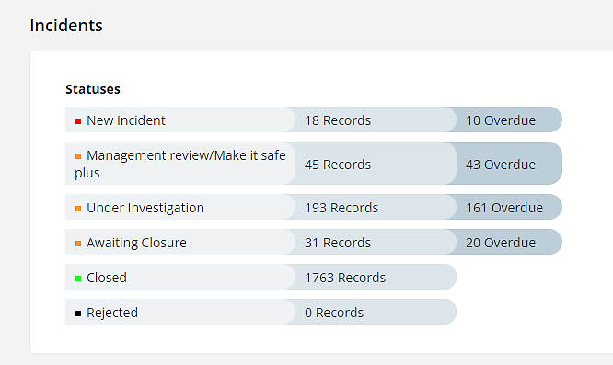

From the Datix Incidents graphic above, there are currently 43 overdue management reviews, 161 overdue incidents under investigation and 20 overdue incidents awaiting closure.

- CHALLENGES, RISKS AND MITIGATION
HCAI
- Lack of a dedicated decant facility (Datix Risk ID 2210). Morriston Hospital site had identified two wards which had been closed temporarily to allow for a pro-active and reactive programme of estates repairs and enhanced cleaning on wards associated to the hospital-wide outbreak of C. difficile. This action has been agreed by the Gold Outbreak Control Group, and supported by Management Board, as an essential action to reduce the spread of C. difficile.
- Increased risk to patients for acquisition of C. difficile infection (Datix Risk ID 2286).
- Service pressures across the acute sites preclude the ability to undertake a regular pro-active programme of 4D cleaning, and compromise the ability to undertake reactive 4D cleaning following episodes of infection such as C. difficile.
- The limited availability of single room isolation facilities continues to present a challenge to the appropriate management of patients with suspected or confirmed infections resulting in a risk of extended exposure of other patient contacts to the risk of transmissible infections, such as MRSA and other multi-drug resistant organisms. Additionally, due to the competing demands for single rooms, there can be a delay in isolating patients, while staff await confirmation of an infection prior to moving patients, adding to the exposure risk for other patients and an extended period where organisms continue to contaminate the environment – HBR 4 (Datix Risk ID – 739).
- The high numbers of clinically optimised patients awaiting packages of care has also put increased pressure on bed capacity in the acute sites. This has resulted in additional patients “boarding” on wards throughout Morriston, without additional staffing or equipment. This model also has an impact on further reducing bed spacing. These factors increase the risk of infection transmission due to non-compliance with bed spacing guidance (Datix Risk ID – 2488).
- Frequent patient movement was identified as a risk during the Morriston C. difficile outbreak and currently there is not a consistent system for recording the rationale for patient movement. Digital Intelligence have added this function to the Signal system with the aim of ensuring that every patient move has a documented rationale.
- Bed spacing and ventilation within the majority of inpatient wards poses an ongoing risk in relation to transmission of infections, including COVID-19 and other seasonal viral infections, including influenza, Respiratory Syncytial Virus, parainfluenza, and Norovirus (Datix Risk ID 2488).
- Across the health board (as is the case across NHS Wales) there are increasing numbers of those living with high-risk co-morbidities and risks for C. difficile.

- GOVERNANCE AND RISK ISSUES
Healthcare associated infections are associated with poor patient outcomes, and are significant quality and safety issues. Continuing failure to achieve the infection reduction improvements is an unacceptable position for our patients (HBR 4), and has resulted in an escalation from Enhanced Monitoring to Targeted Intervention.

- FINANCIAL IMPLICATIONS
A Department of Health impact assessment report (IA No. 5014, 20/12/2010) stated that the best estimate of costs to the NHS associated with a case of Clostridioides difficile infection is approximately £10,000. The estimated cost to the NHS of treating an individual cost of MRSA bacteraemia is £7,000 (the cost of MSSA bacteraemia could be less due to the availability of a wider choice of antibiotics). In an NHS Improvement indicative tool, the estimated cost of an E. coli bacteraemia is between £1,100 and £1,400, depending on whether the E. coli is antimicrobial resistant. Estimated costs related to healthcare associated infections, from 01 April 2024 to the end of June 2024 is as follows: C. difficile - £610,000; Staph. aureus bacteraemia - £189,000; E. coli bacteraemia - £59,900; therefore, a total cost of £858,900.

- RECOMMENDATION
The Infection Prevention & Control Strategic Group is asked to:
- NOTE: the health board’s Quarter 1 position in relation healthcare associated infections.
- NOTE: the performance of the health board to Targeted Intervention for performance in relation to HCAIs. Progress is reported and monitored fortnightly by the Overarching Targeted Intervention Group, chaired by the Chief Operating Officer.
- NOTE: progress on Infection Prevention & Control Improvement Plan to 30th June 2024.
- NOTE: the improvement in IPC Level 2 training from 68.13% compliance reported at 5th January 2024 to 77.90% compliance reported at 3rd July 2024.
- NOTE: the challenges and risks within the health board currently and associated mitigations.

Governance and Assurance

Link to Enabling Objectives  (please choose) | Supporting better health and wellbeing by actively promoting and empowering people to live well in resilient communities
Link to Enabling Objectives  (please choose) | Partnerships for Improving Health and Wellbeing |  | ☐
Link to Enabling Objectives  (please choose) | Co-Production and Health Literacy |  | ☐
Link to Enabling Objectives  (please choose) | Digitally Enabled Health and Wellbeing |  | ☐
Link to Enabling Objectives  (please choose) | Deliver better care through excellent health and care services achieving the outcomes that matter most to people
Link to Enabling Objectives  (please choose) | Best Value Outcomes and High Quality Care |  | ☒
Link to Enabling Objectives  (please choose) | Partnerships for Care |  | ☐
Link to Enabling Objectives  (please choose) | Excellent Staff |  | ☐
Link to Enabling Objectives  (please choose) | Digitally Enabled Care |  | ☐
Link to Enabling Objectives  (please choose) | Outstanding Research, Innovation, Education and Learning |  | ☐
Health and Care Standards
(please choose) | Staying Healthy |  | ☐
(please choose) | Safe Care |  | ☒
(please choose) | Effective Care |  | ☐
(please choose) | Dignified Care |  | ☐
(please choose) | Timely Care |  | ☐
(please choose) | Individual Care |  | ☐
(please choose) | Staff and Resources |  | ☐
Quality, Safety and Patient Experience
Effective infection prevention and control needs to be everybody’s business and must be part of everyday healthcare practice and be based on the best available evidence so that people are protected from preventable healthcare associated infections.
Financial Implications
A Department of Health impact assessment report (IA No. 5014, 20/12/2010) stated that the best estimate of costs to the NHS associated with a case of Clostridioides difficile infection is approximately £10,000. The estimated cost to the NHS of treating an individual cost of MRSA bacteraemia is £7,000 (the cost of MSSA bacteraemia could be less due to the availability of a wider choice of antibiotics). In an NHS Improvement indicative tool, the estimated cost of an E. coli bacteraemia is between £1,100 and £1,400, depending on whether the E. coli is antimicrobial resistant. (Trust and CCG level impact of E.coli BSIs accessed online at:
https://improvement.nhs.uk/resources/preventing-gram-negative-bloodstream-infections/ ).
Estimated costs related to healthcare associated infections, from 01 April 2024 to the end of June 2024 is as follows: C. difficile - £610,000; Staph. aureus bacteraemia - £189,000; E. coli bacteraemia - £59,900; therefore, a total cost of £858,900.
Legal Implications (including equality and diversity assessment)
Potential litigation in relation to avoidable healthcare associated infection.
Staffing Implications
None identified.
Long Term Implications (including the impact of the Well-being of Future Generations (Wales) Act 2015)
A healthier Wales: preventing infections
Report History |  | Previous meeting 30th April 2024
Appendices |  | Appendix 1. HB & SG Infection reduction trajectory charts  Appendix 2. All Wales comparison - Incidence of Tier One infections - June 2024  Appendix 3. HB Improvement Plan 2024_25 to end Q1 24/25 (separate document).  Appendix 4. PII and WGS clusters for Quarter 1 24/25

C. difficile
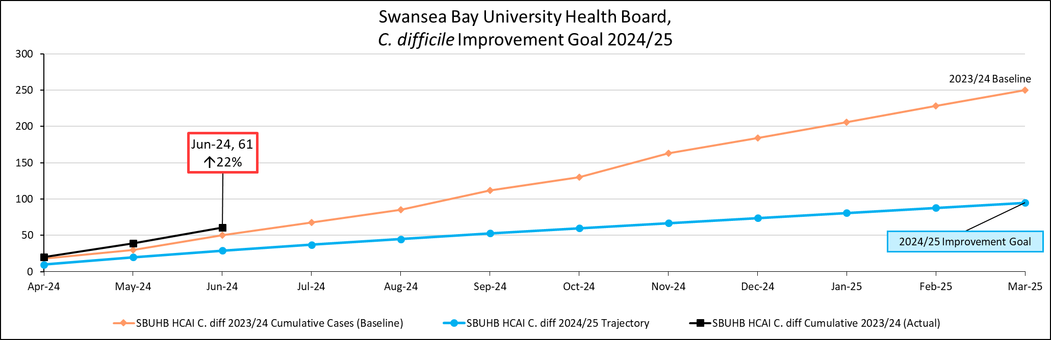
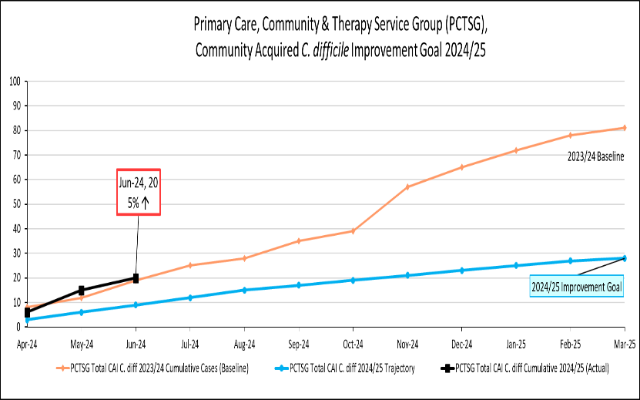 | 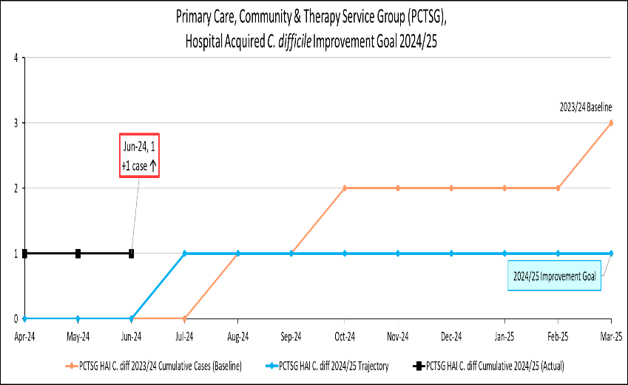
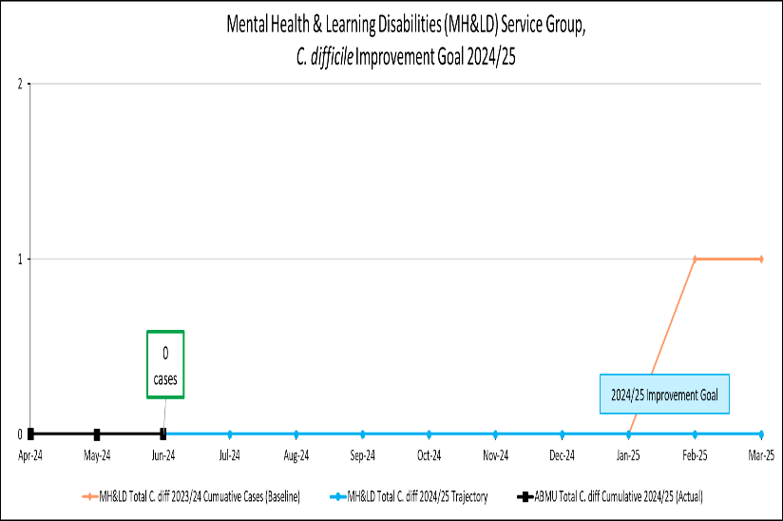 | 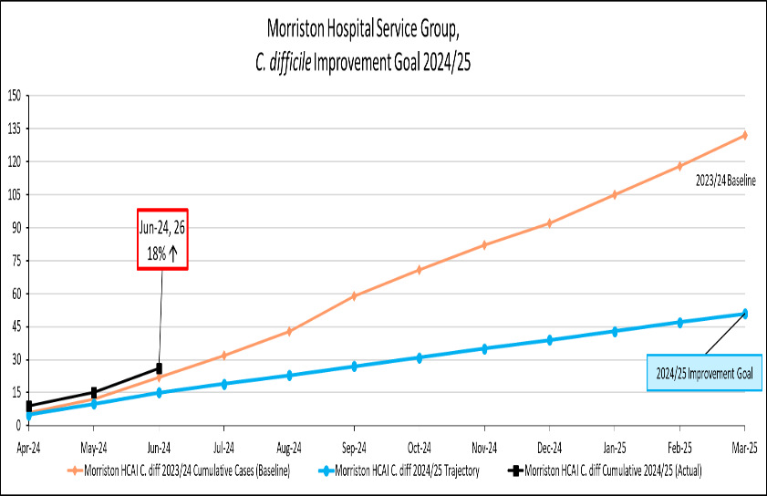
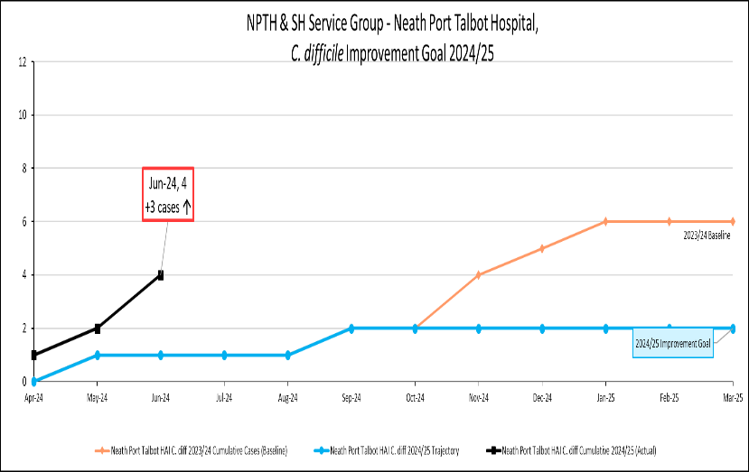 | 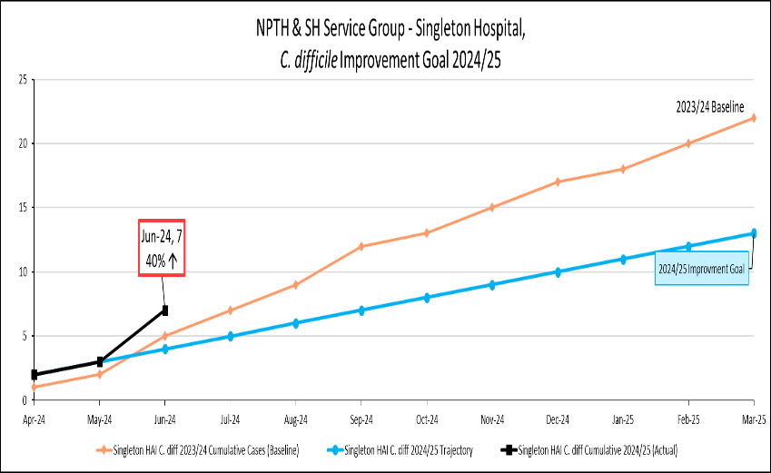

Staph. aureus bacteraemia
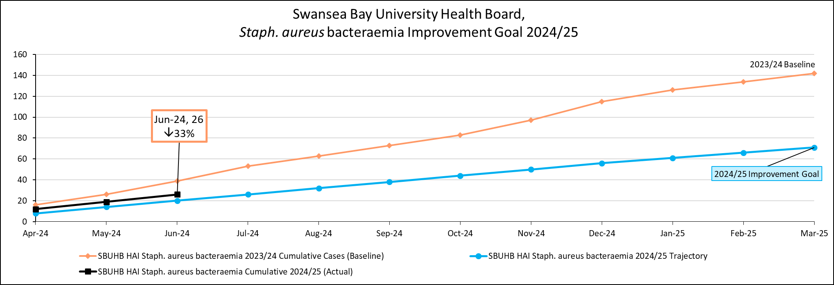
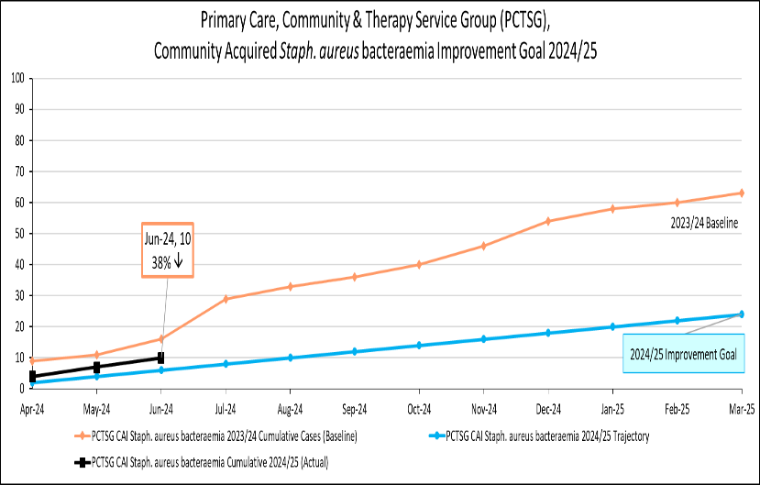 | 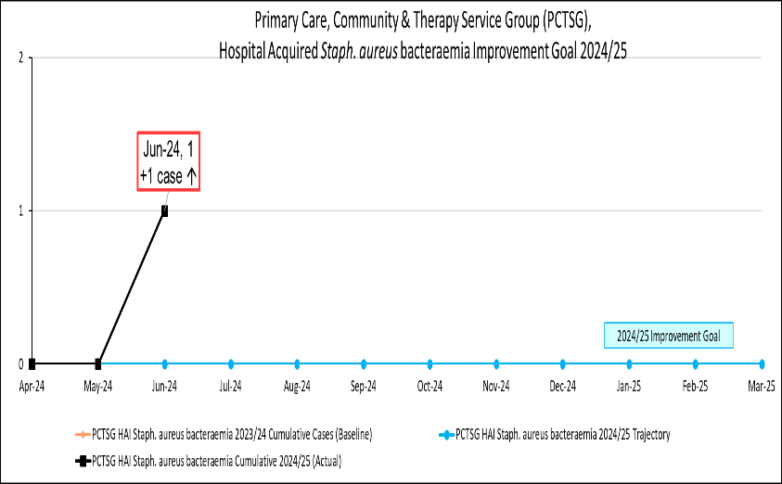
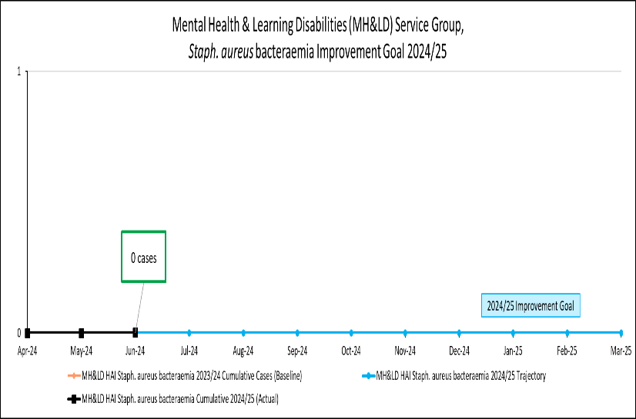 | 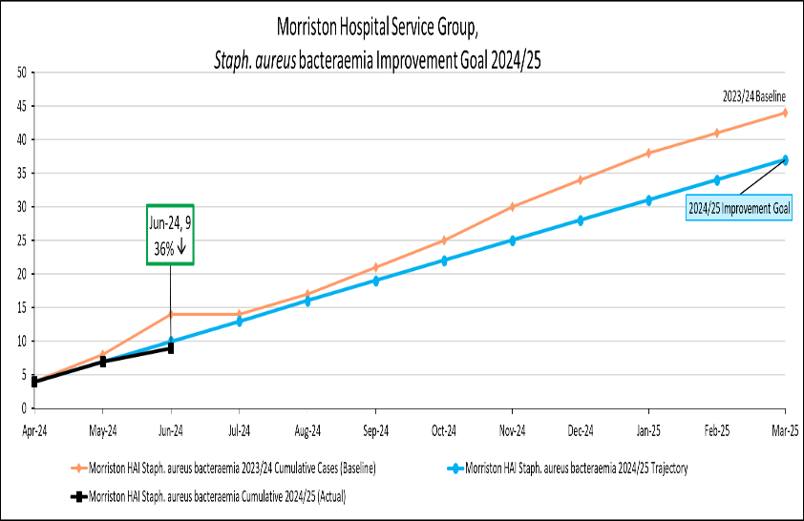
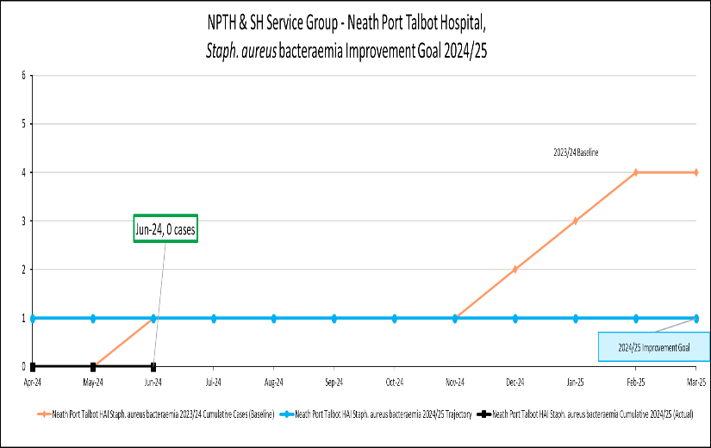 | 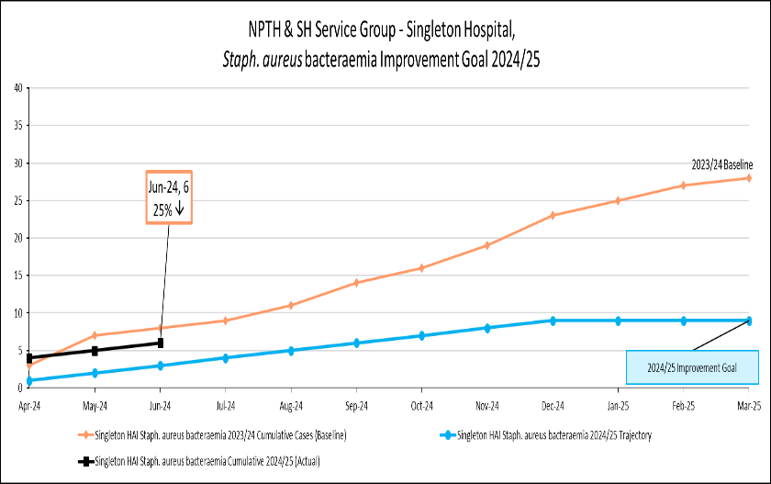

E. coli bacteraemia
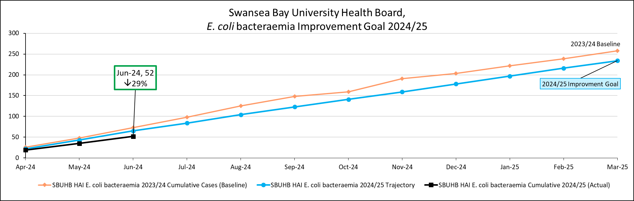
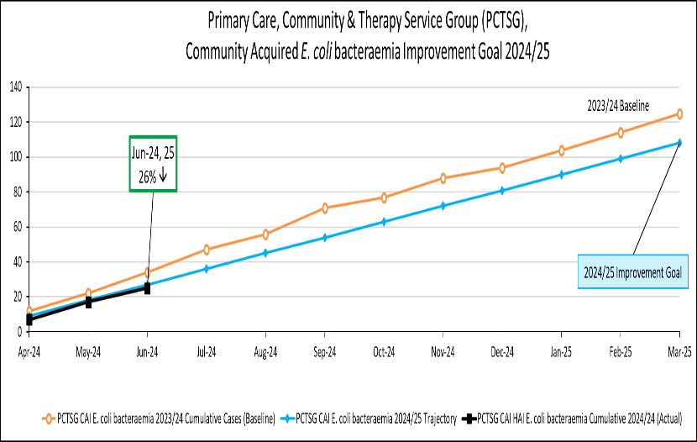 | 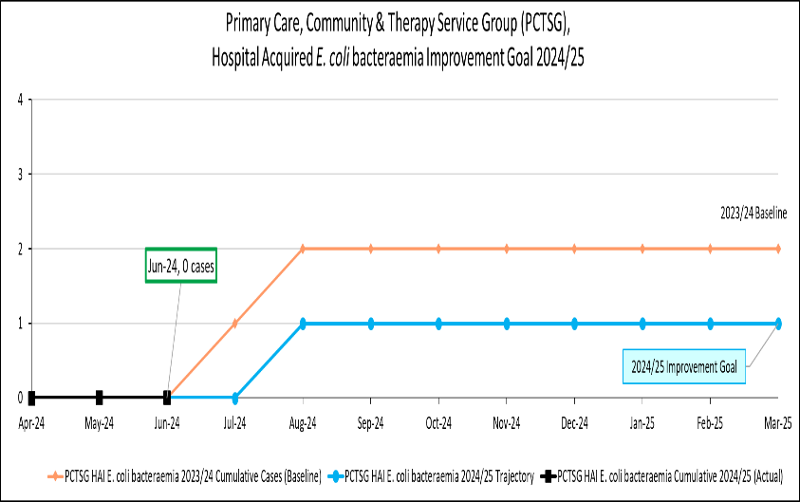
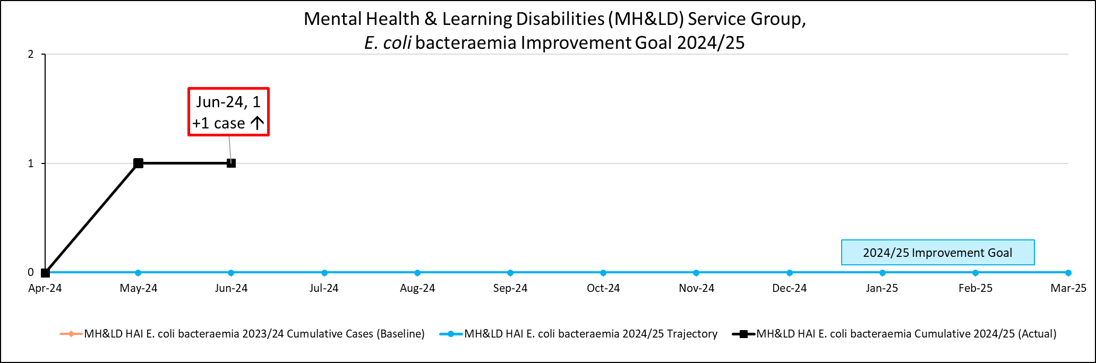 | 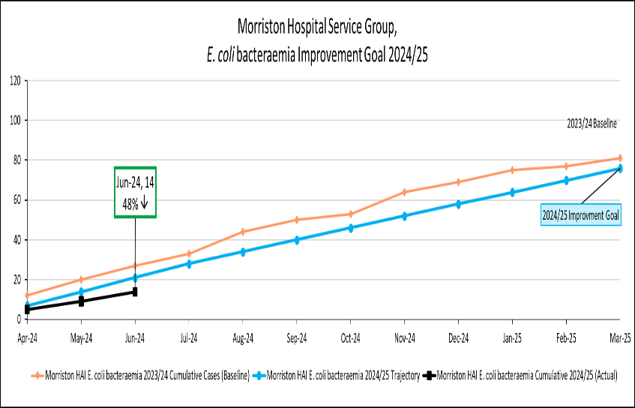
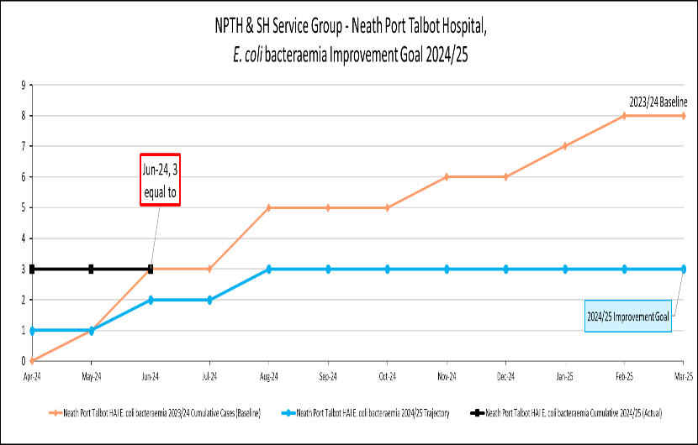 | 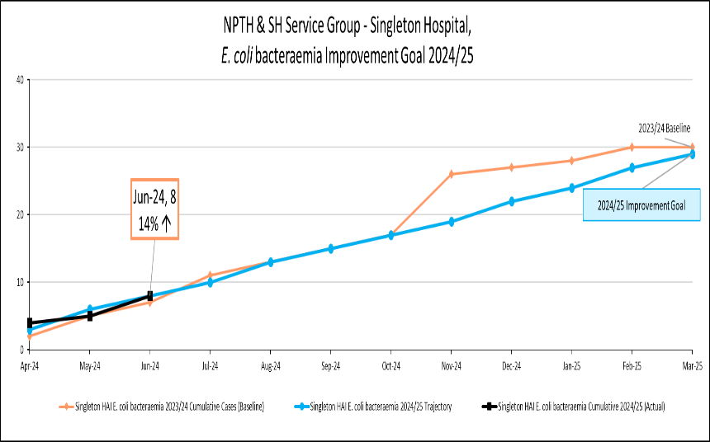

Klebsiella spp. Bacteraemia
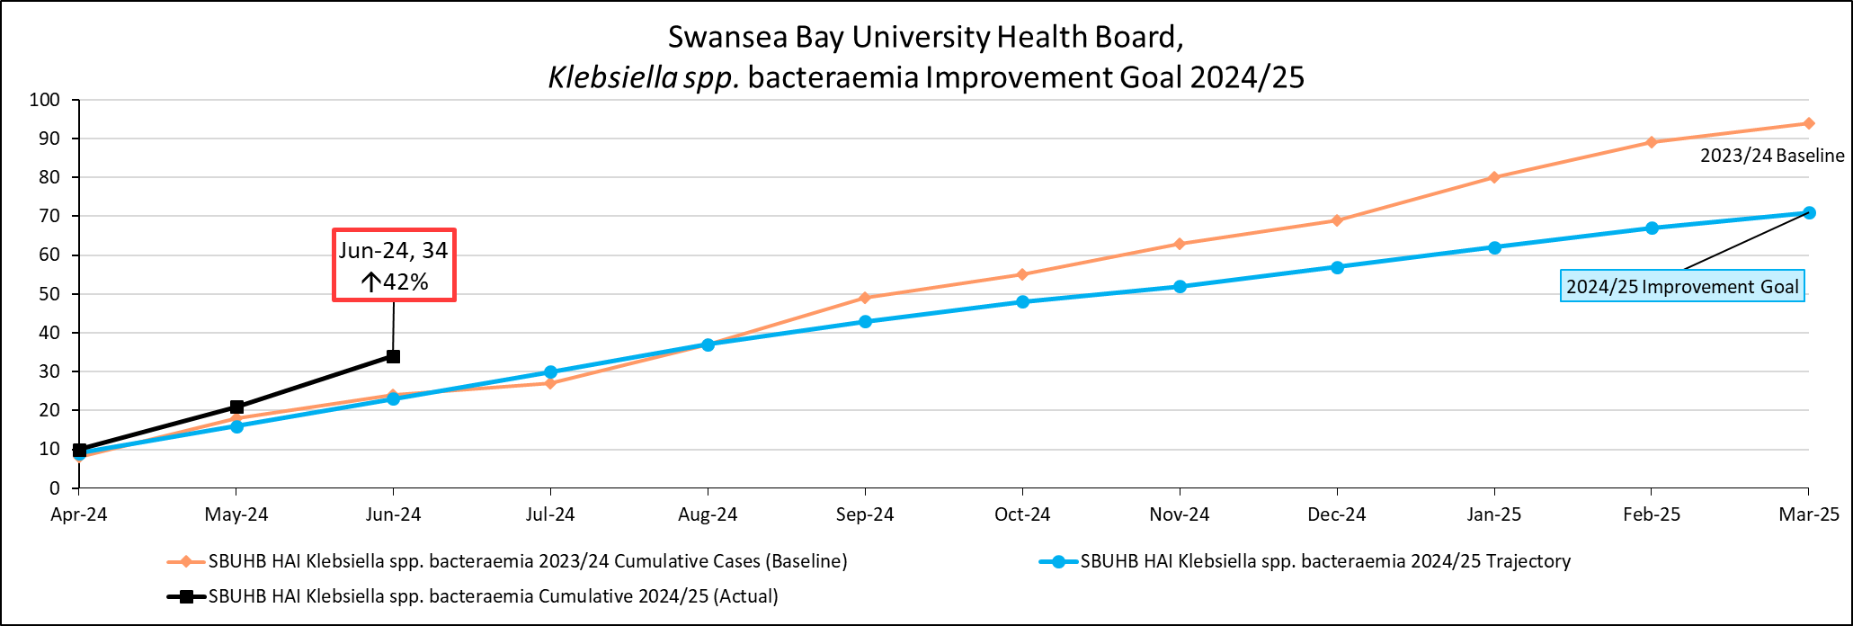
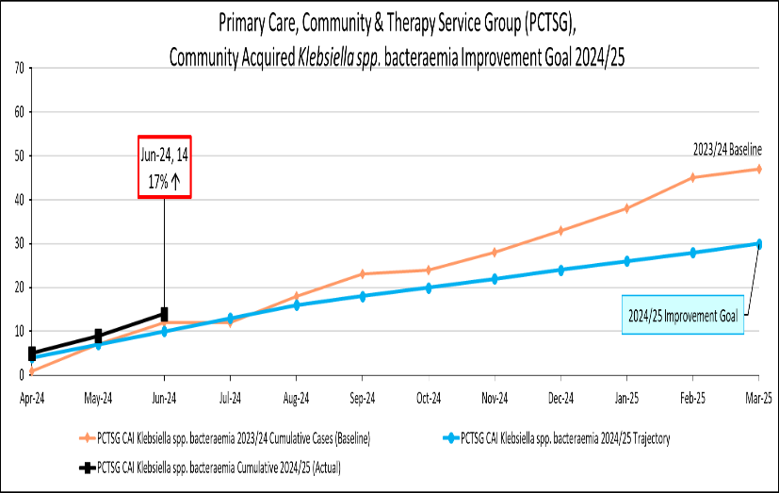 | 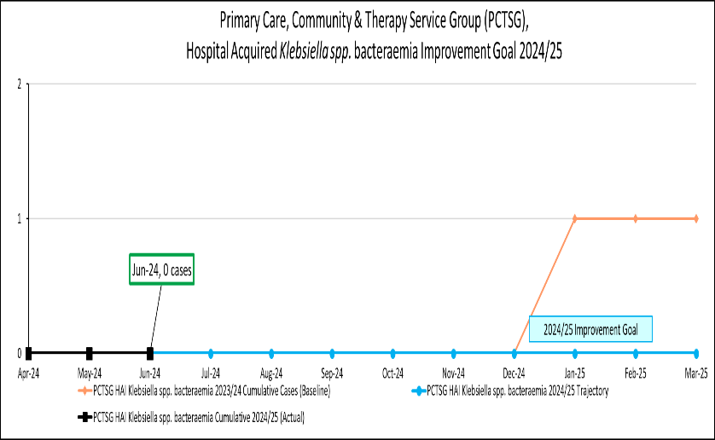
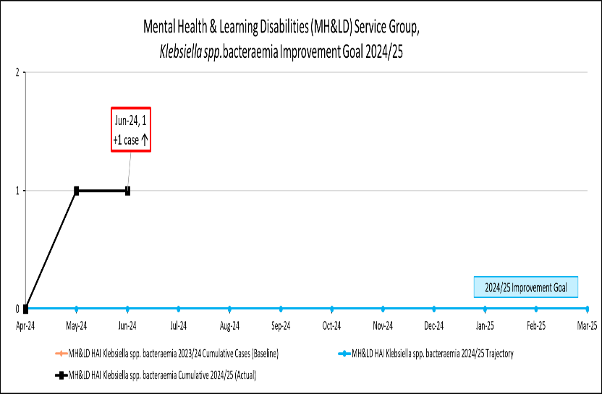 | 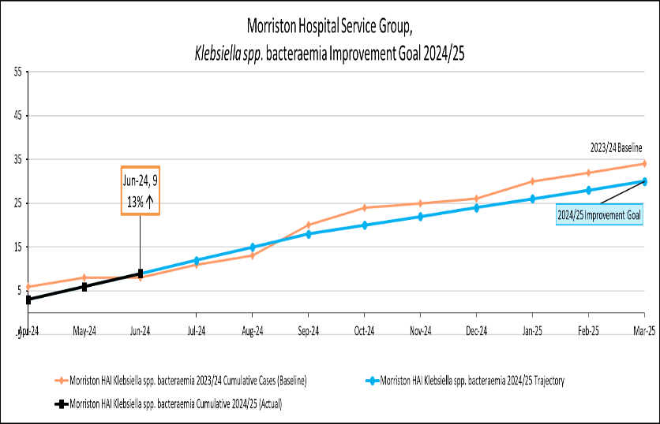
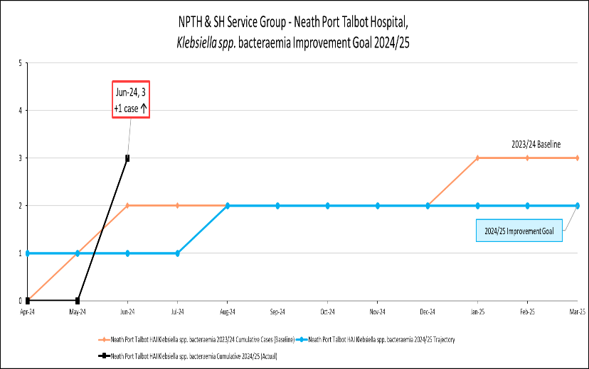 | 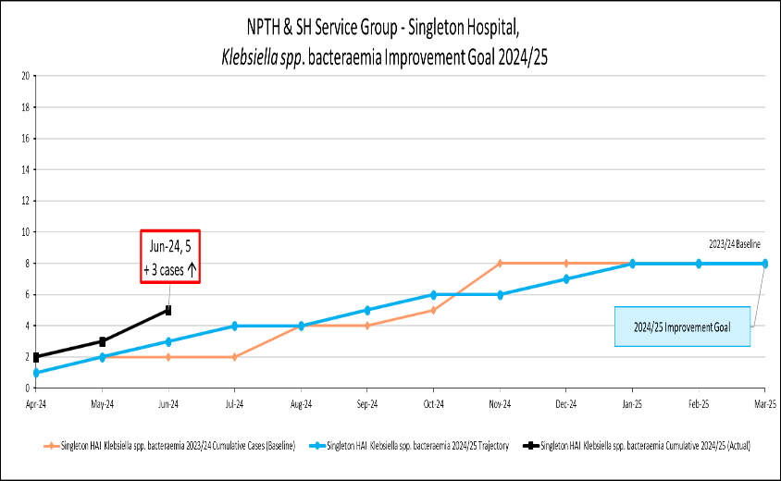

Pseudomonas aeruginosa bacteraemia
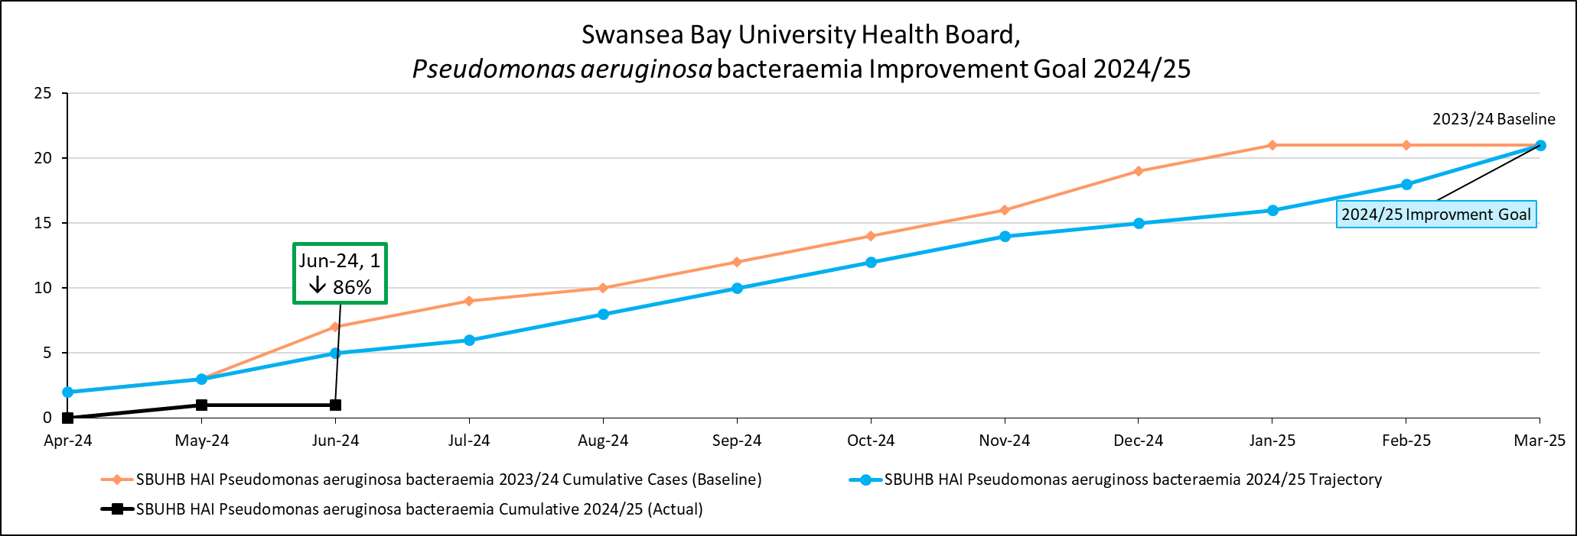
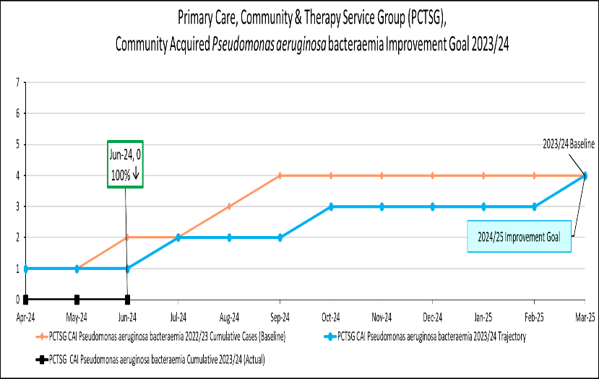 | 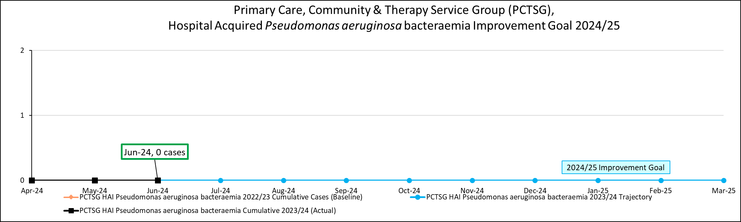
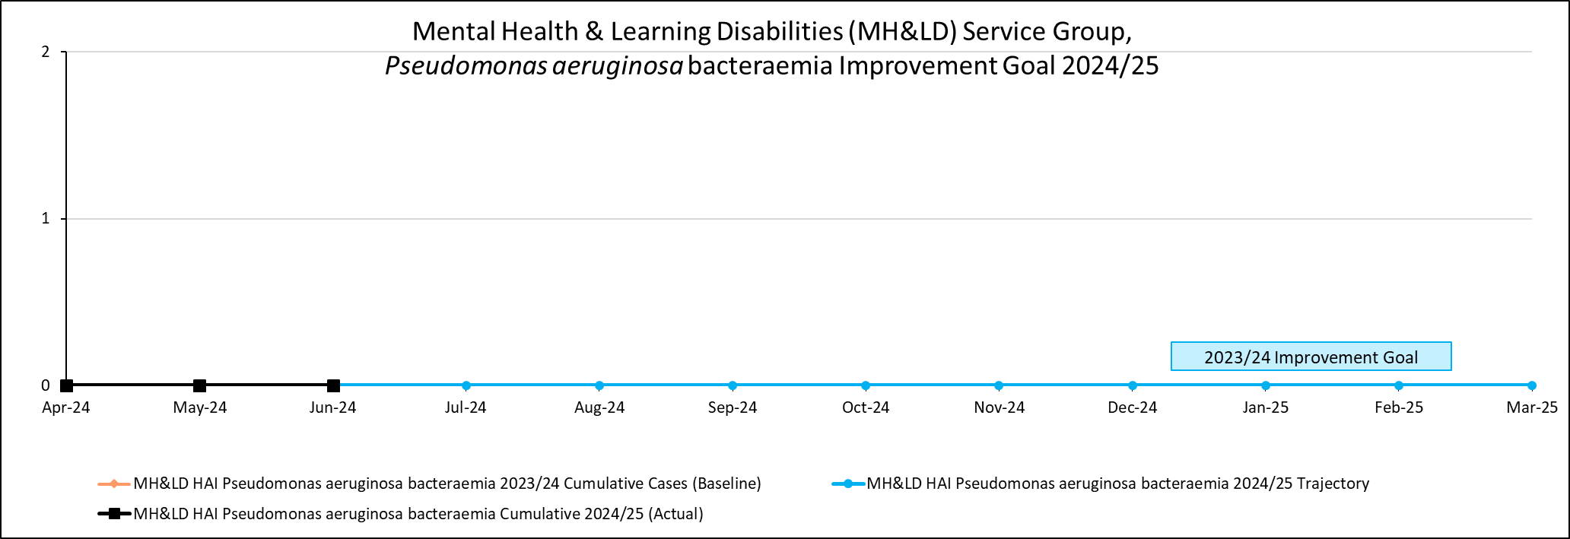 | 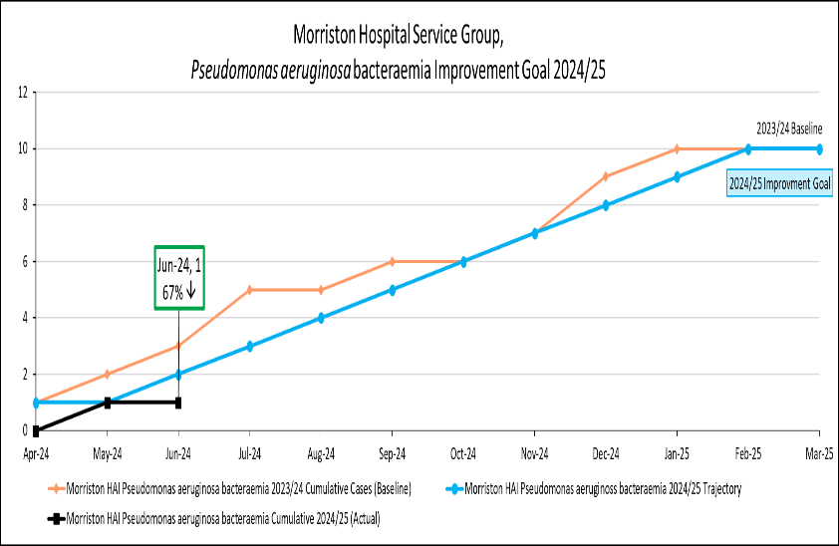
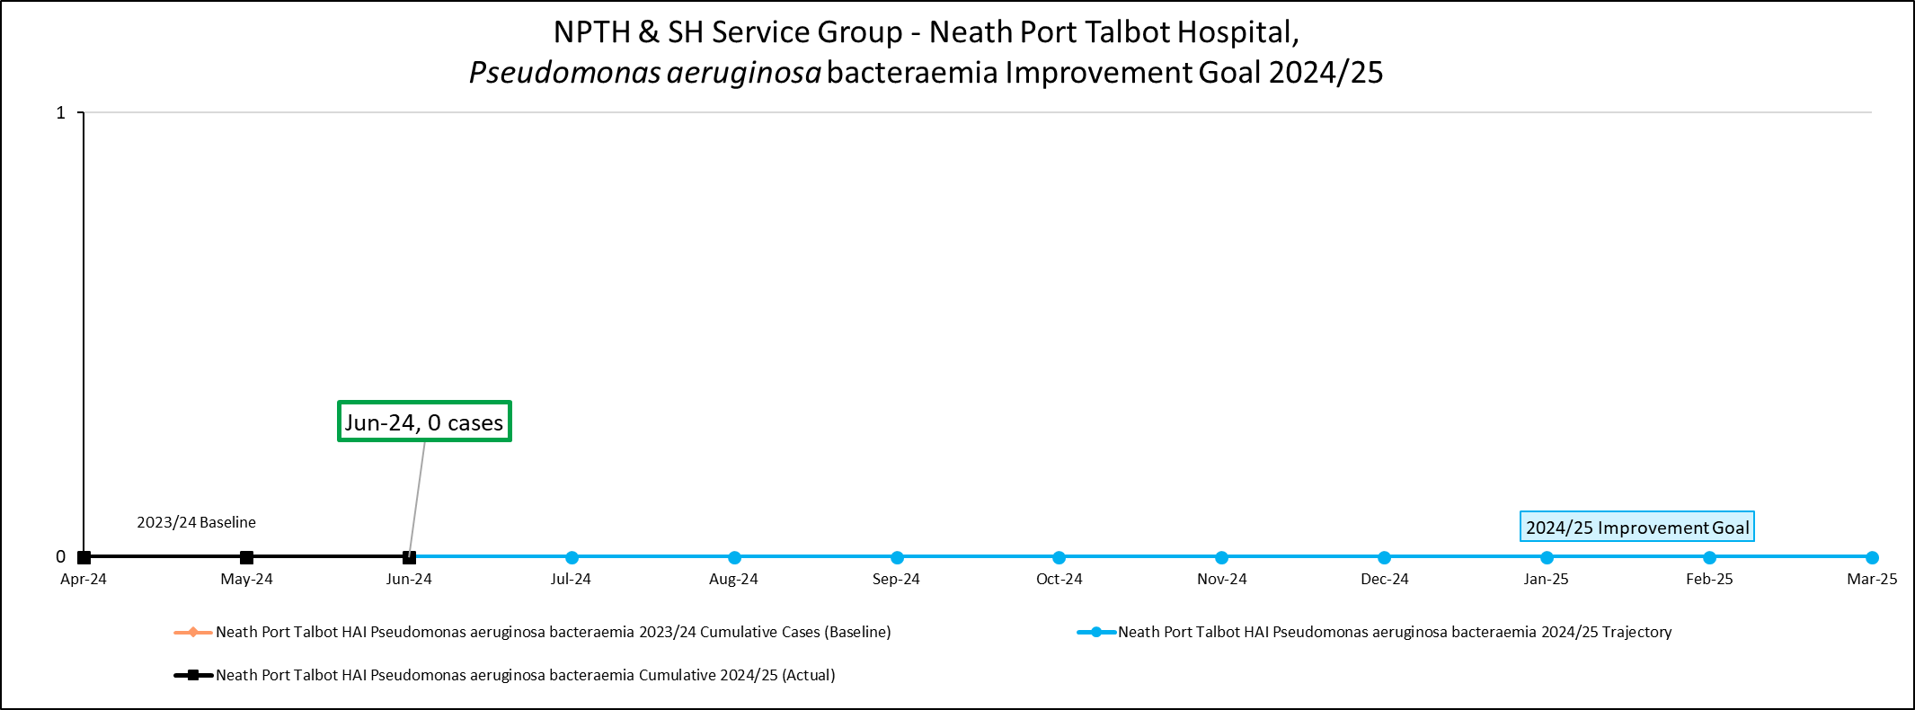 | 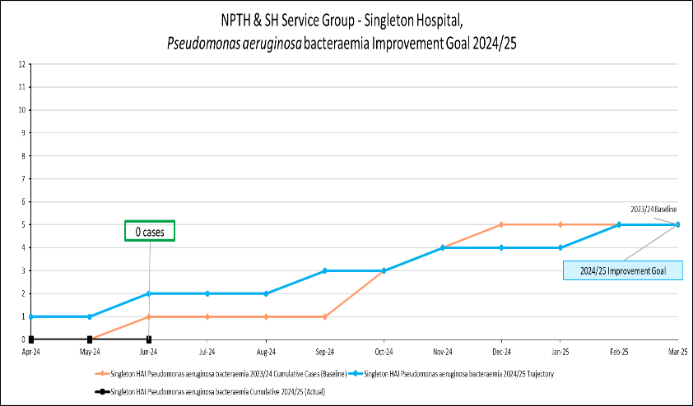

Incidence/100,000 population | Incidence/1,000 admissions
C. difficile infection
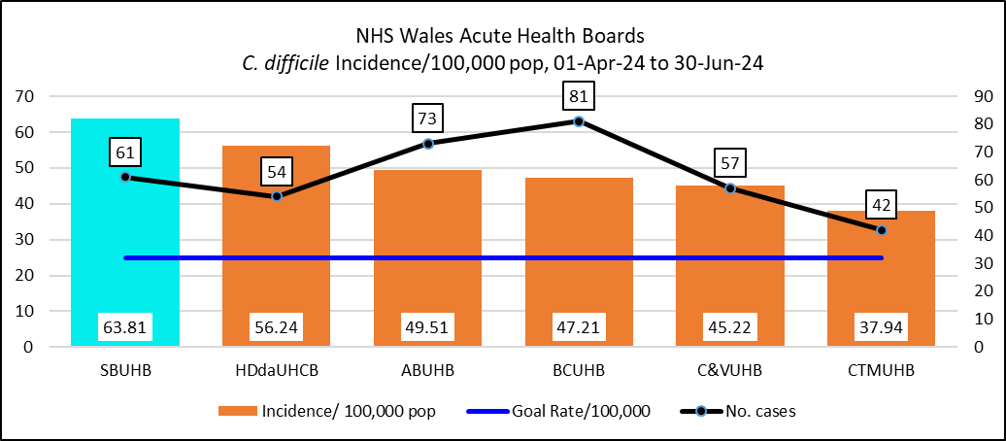 | 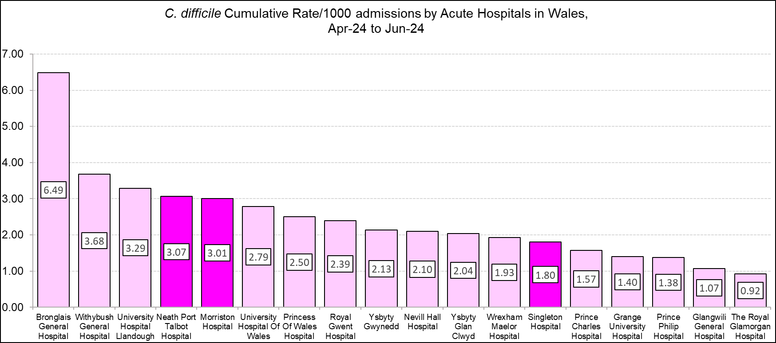
Staph. aureus bacteraemia
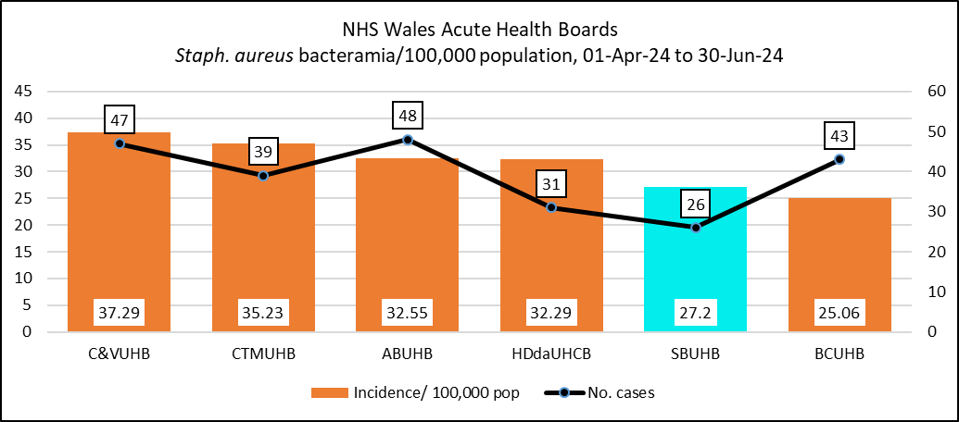 | 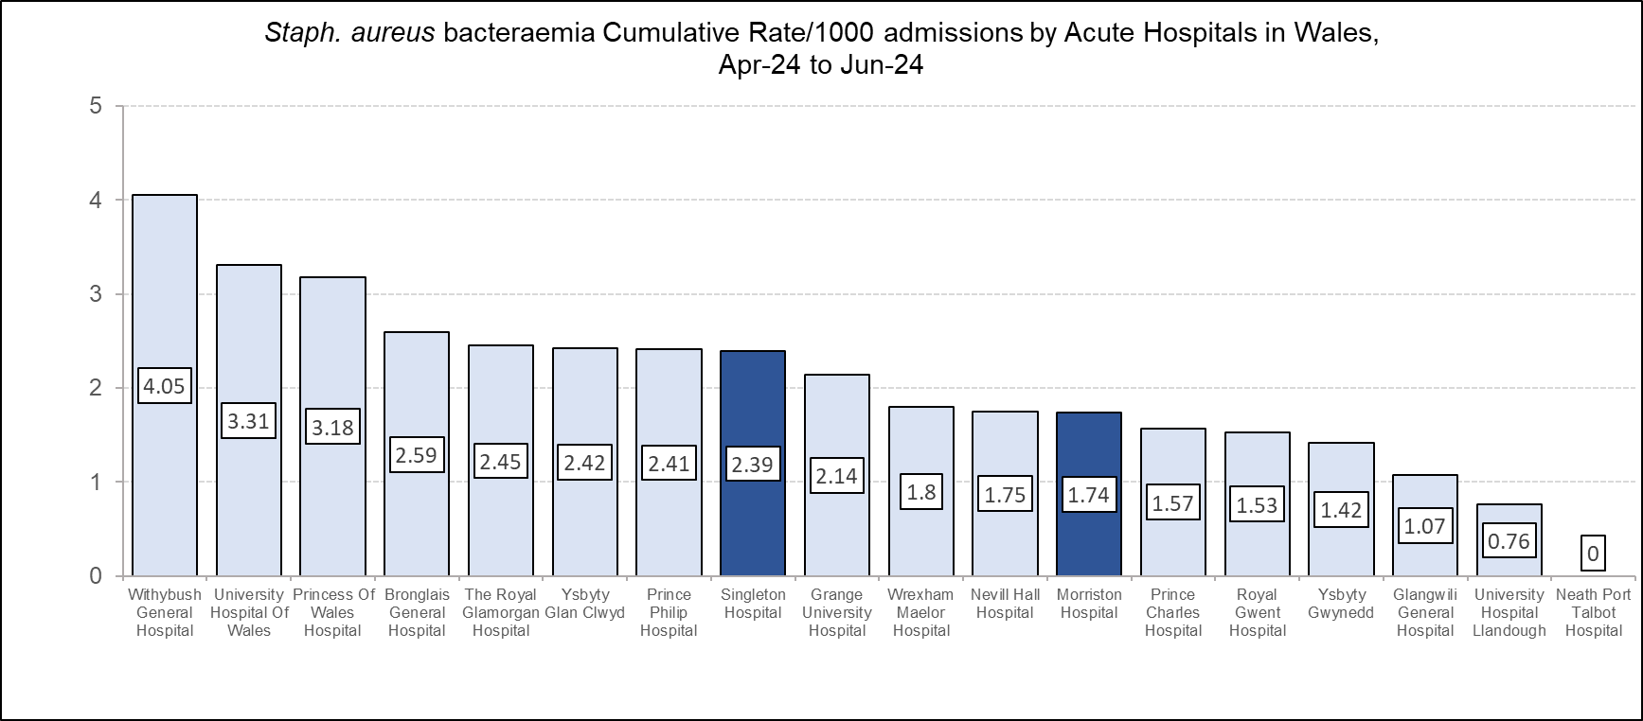
Incidence/100,000 population | Incidence/1,000 admissions
E. coli bacteraemia
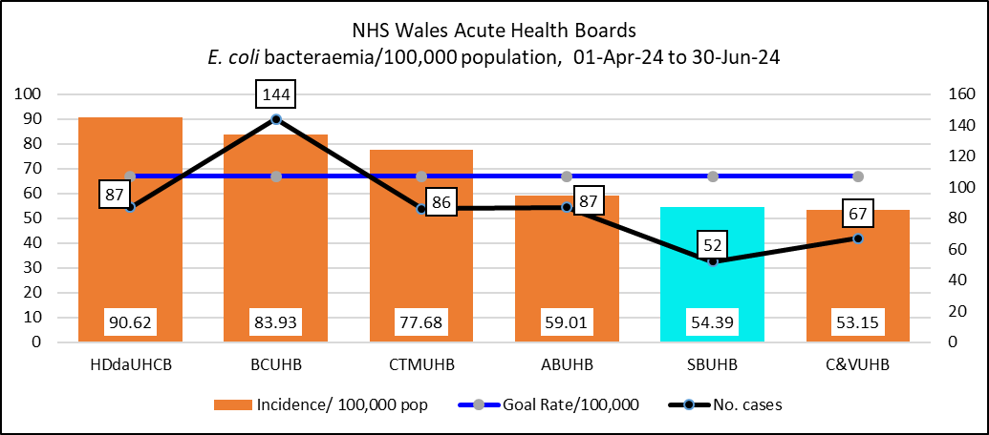 | 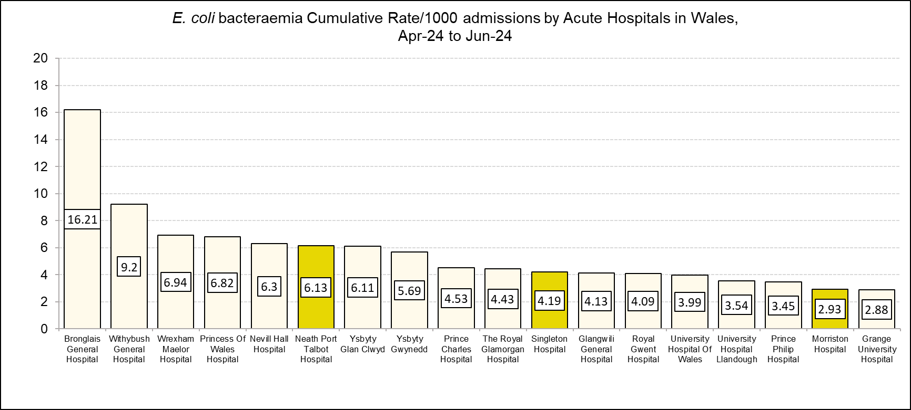
Klebsiella spp. bacteraemia
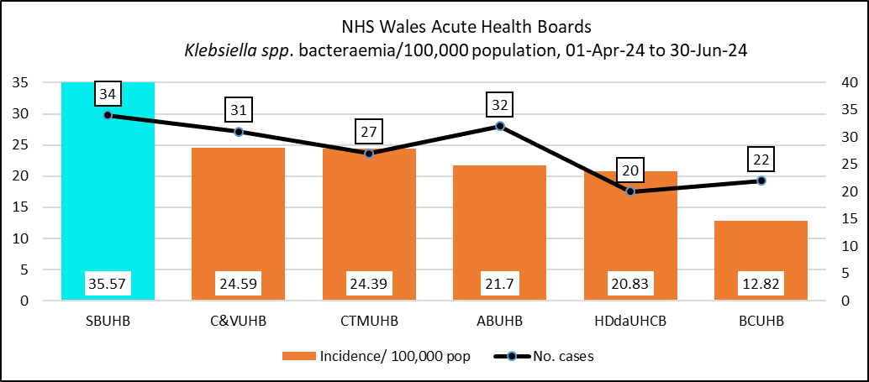 | 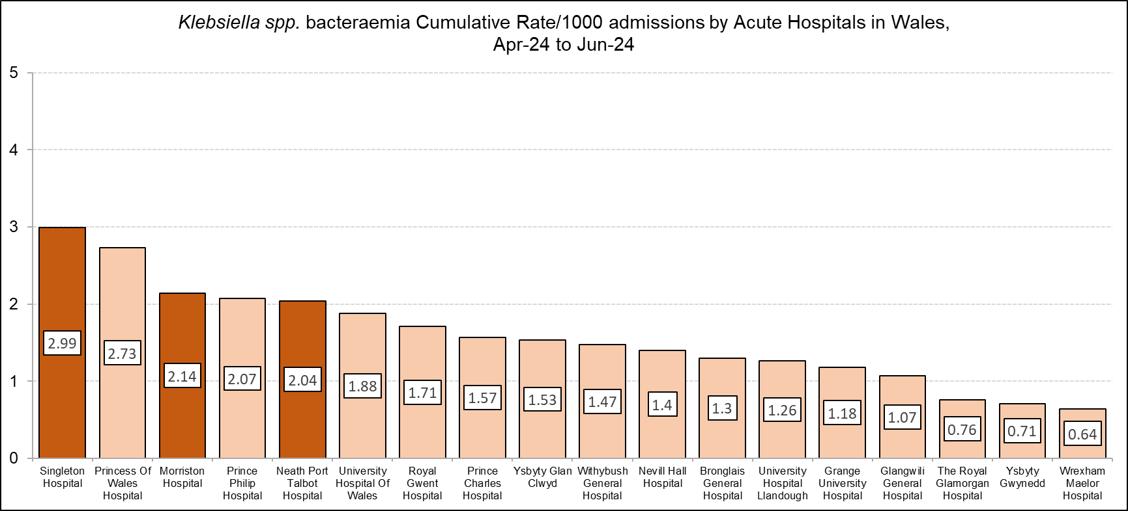
Incidence/100,000 population | Incidence/1,000 admissions
Pseudomonas aeruginosa bacteraemia
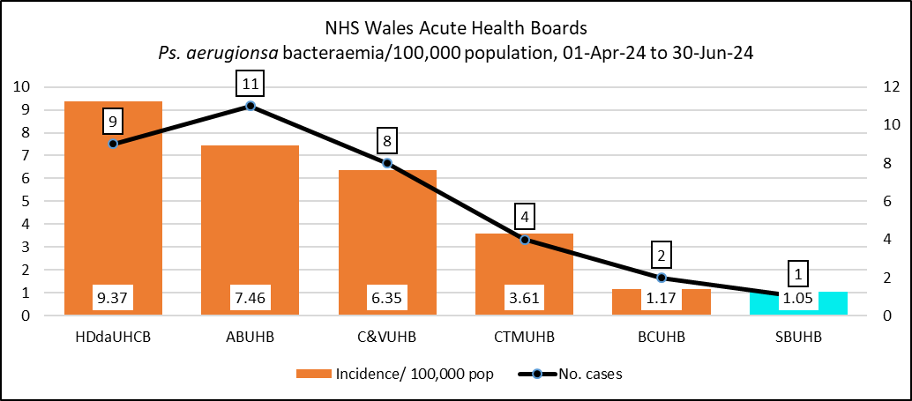 | 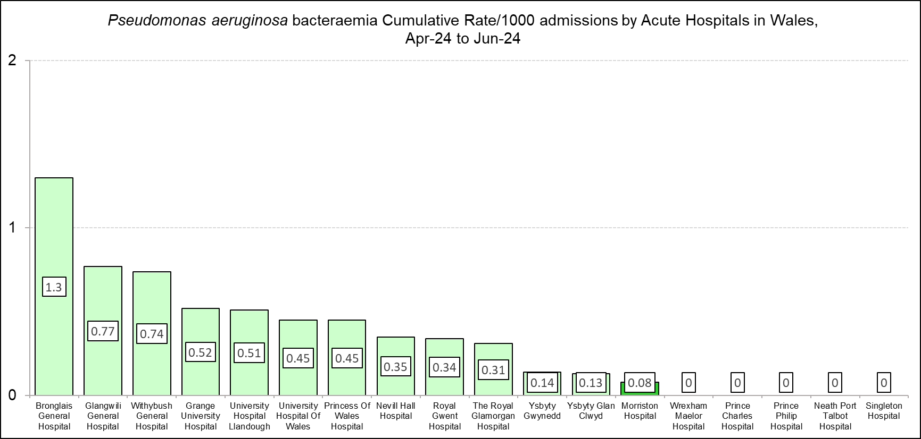

Table A: Periods of Increased Incidence (PII) of Clostridioides difficile, Quarter 1, 2024/25

Table B. Genomically linked clusters reported in Quarter 1, 24/25.

