REACT MH and Suicide Prevention Level One Evaluation Report – March 2024
Situation
Over 3500 members of staff have been trained in REACT MH. Just over 1400 of these staff members have undertaken a joint REACT MH and Suicide Prevention Level 1 session.
The React MH section of the training aims to support staff to feel confident to have a conversation with a colleague who may be suffering from psychological distress and to assess the need to refer to specialist services.
The Suicide Prevention Level 1 part of the training aims to offer all staff groups, volunteers and students a first level of awareness of suicide prevention. This training is underpinned by the talk to me 2 strategy with a clear message of how to recognise someone who may be struggling by seeing the signs, asking the question/having the conversation and how to keep someone who is vulnerable safe with signposting in a timely manner to organisations that can help. To date both React and Suicide prevention training have reached 30% of the workforce.
Background
Kirkpatrick’s model of evaluation was chosen as it is one of the most widely cited and influential in evaluating training programmes (Kirkpatrick, 1994; 2006). The Kirkpatrick Four-Level Training Evaluation Model is designed to objectively measure the effectiveness of training.

In order to evaluate REACT MH training, the framework has been used since 2021 to guide our data collection at each level as follows:
- Level 1: Reaction / Satisfaction with Training
  - Post-training evaluation has been gathered using questionnaires accessed via QR codes and links to Microsoft Forms. The aim is to continually explore attendees' satisfaction with the training. Results to date indicate a high level of satisfaction
- Level 2: Evidence of Learning or Increased Knowledge
  - In 2021, Pre- and Post- training questionnaire were sent out to the first 130 participants in REACT MH training. This demonstrated that there was an increase in learning and new knowledge and that the training was effective.
- Level 3: Application and Behaviour Change
  - Current study
- Level 4: Results
  - A future study that will consider organisational impact by measuring project KPIs e.g. workforce data, sickness absence rates, referrals to Staff Wellbeing etc.
REACT MH and Suicide Prevention Level 1 was combined into a single training session in September 2022 and this evaluation aims to look at Level 3 i.e. application and behaviour change in practice.
Assessment
1400 staff who had attended REACT and Suicide Prevention Level 1 training between September 2022 and January 2024 were invited to complete a questionnaire which asked about the use of REACT MH and Suicide Prevention skills in practice.
There was a response rate of 19.5% (273 participants) with representation from all staff groups (Table 1). The highest response rate came from Nursing and Midwifery (35%) followed by Allied Health Professionals (25%) and Administrative and Clerical (22%).
With regard to service group, the highest number of participants came from Primary Care, Community and Therapies (29%), followed by Morriston Hospital (25%), Mental Health and Learning Disabilities (20%)and Singleton and Neath Port Talbot (18%). There were no responses from Estates and Facilities or Corporate Services.
The majority of participants had attended REACT MH and Suicide Prevention training (REACT MH & SP) throughout July – December 2023 (55%), with 25% attending between January – June 2023 and the remainder attending in 2022 (20%)
REACT MH
When asked whether participants felt confident to offer their support to colleagues using the REACT MH framework 76% agreed or strongly agreed. 21% were neutral and 3% felt that they were not confident to offer support following training (Table 2).
81% of participants had not supported a colleague using the REACT MH framework but 19% stated that they had (Table 3).
Exploring the reasons why those that had not used REACT MH, 76% stated that the need to use REACT MH had not arisen, while 2% stated that they were not confident to have a REACT MH conversation. No participants stated that time was a barrier to holding a REACT MH conversation (Table 4).
Of those that had facilitated a REACT MH conversation (19% of participants), 94% reported a positive response in their ability to support a colleague in psychological distress while 6% reported a neutral response. No participants felt that they were not able to support a colleague (Table 5).
When asked whether the colleague appeared satisfied with the REACT MH intervention, 87% reported a positive response with 11% reported a neutral response. 2% of participants did not feel that their colleague appeared satisfied with the intervention (Table 6).
96% of participants stated that they would offer support again to a colleague using the REACT MH framework should the need arise, with 4% remaining neutral (Table 7).
Qualitative data is largely very positive (Appendix 1) with participants referring to the benefit they have gained from undertaking REACT MH training. There are a very small number of participants that criticise the format of the questionnaire.
Suicide Prevention Level 1
77% of participants felt confident to have a conversation using skills and knowledge gained in the Suicide Prevention section of the training. 19% were neutral and 4% did not feel confident to have this conversation (Table 8).
25% of participants had supported a colleague in suicide prevention since they had completed the training. 75% had not utilised the knowledge and skills to the time of completion of the questionnaire (Table 9).
Of participants that had not utilised the knowledge and skills, 71% had not had the need to initiate such a conversation with a colleague, 1% were not confident to engage in such a conversation and 2% did not state their reason for not holding the conversation. 0.3% (1 person) did not initiate a conversation with a colleague about suicide prevention because of time pressures (Table 10).
Of those that had held a conversation using skills and knowledge in suicide prevention (69), 94% felt that they had effectively supported their colleague. 6% were neutral but no participants felt that they had not been able to support a colleague (Table 11).
88% of participants that had utilised the skills and knowledge in suicide prevention felt that their colleague seemed satisfied with the intervention while 12% reported a neutral position. There were no participants that felt that their colleague had not seemed satisfied (Table 12).
When asked about whether participants that had utilised the skills and knowledge in suicide prevention to support a colleague were confident to do so again in the future, 92% reported a positive response while 8% were neutral (Table 13).
Considering the qualitative feedback (Appendix 1), three participants refer to the need to inform participants that despite their best efforts, they may not always be able to prevent a person completing suicide and that they should not take responsibility for this.
Discussion
There was a satisfactory response rate of 19.5% with representation from all staff groups largely representative of their relative numbers within the organisation. It was positive to see representation from the four clinical service groups.
It was positive to note that the majority of respondents were confident to utilise the REACT MH framework in practice (76%) however with 21% maintaining a neutral stance and 3% stating that they do not feel confident, further work may be needed to scrutinized post training evaluation reports and consider whether changes should be considered to the training programme.
220 (81%) of participants had not utilised the REACT MH framework in practice but it is positive to note that the main reason for this was not time pressure (0%) or lack of confidence (2%) but that the need had not arisen (76%)
Of those that had had a REACT MH conversation (19%), 94% reported that it had been a positive experience with a perceived colleague satisfaction with the process of over 87%. 96% of this group of participants reported that they would be happy to have another REACT MH conversation with a colleague.
With regard to the suicide prevention element of the evaluation, it was surprising to note that 25% of participants had had a conversation with a colleague utilising the skills and knowledge that they had gained around suicide prevention.
Again, feedback is largely positive with 94% feeling that they had effectively supported a colleague and 88% reporting that the colleague had seemed satisfied with the interaction. 92% of participants also reported that they felt confident to have such a conversation again should the need arise.
Of the participants that had not used the suicide prevention knowledge in practice (75%), the main reason for this (71%) was that the need had not arisen. Only 4 people (1%) reported a lack of confidence to initiate a conversation and 1 person felt that time was a barrier. With this being such an emotive subject, it is assumed that not all participants are going to be fully engaged, confident and capable following one episode of training.
Following analysis of the qualitative feedback, the trainer will consider the need to stress to participants that despite their best efforts, suicide cannot always be prevented and there should be no sense of blame apportioned to the participant who has attempted to support a person who is suicidal.
Recommendations
The level 3 evaluation of REACT MH utilising the Kirkpatrick model (application and behaviour change), demonstrates that both areas of training are being utilised in practice with positive results for the participant and colleague.
Where skills and knowledge have not yet been put into practice, this is not because of time pressures in the workplace or lack of participant confidence, but that the need has not arisen.
Findings from this evaluation suggest that it would be prudent to continue with REACT MH and Suicide Prevention Level 1 training in its current form as a single, combined session. However, we will continue to monitor training evaluation with a specific focus on confidence to use REACT MH and Suicide Prevention Level 1 in practice.

Results
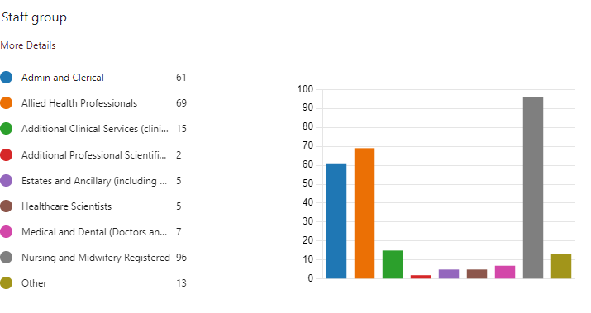
Table 1: Staff Group
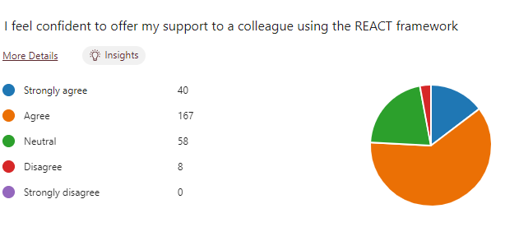
Table 2: Confidence Using REACT MH
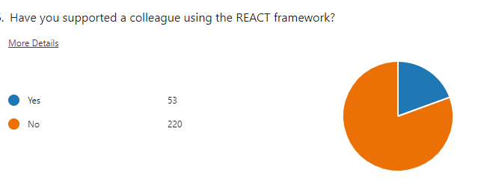
Table 3: REACT MH in practice

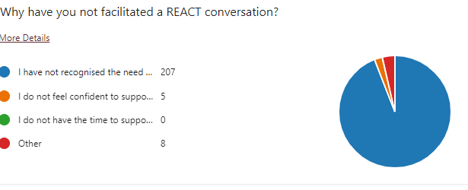
Table 4: Reasons for not using REACT MH

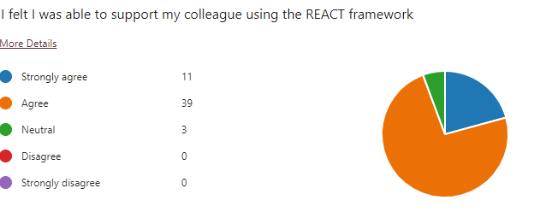
Table 5: Ability to support a colleague using REACT MH
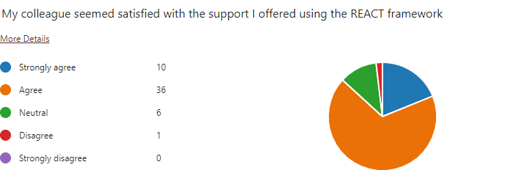
Table 6: Perceived colleague satisfaction with a REACT MH conversation

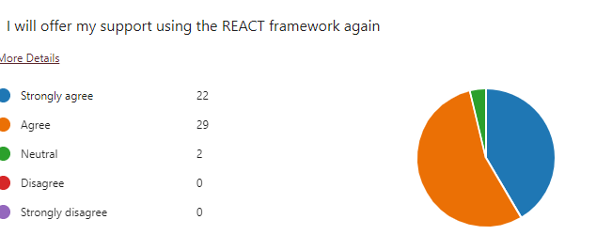
Table 7: Confidence to use REACT MH framework again in future

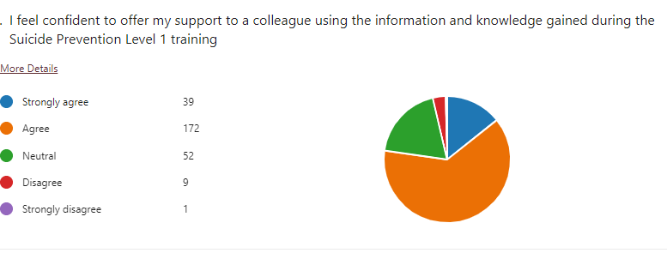Table 8: Confidence following Suicide Prevention training
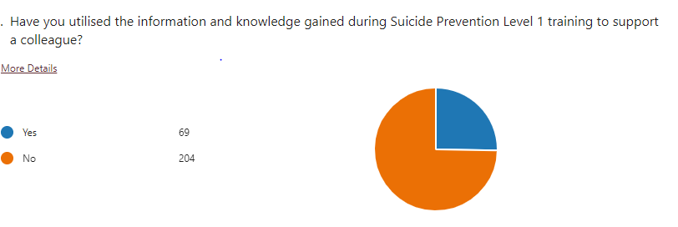
Table 9: Suicide Prevention training in practice

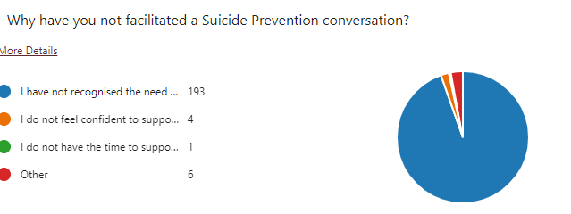
Table 10: Reasons for not using Suicide Prevention skills

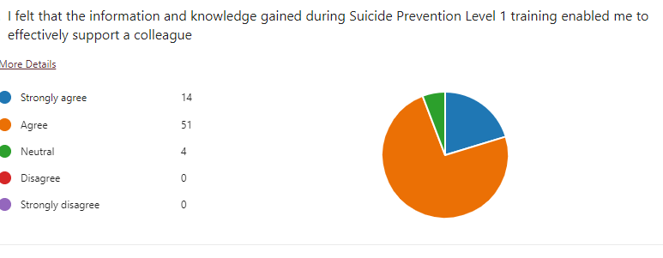Table 11: Ability to support a colleague using Suicide Prevention skills

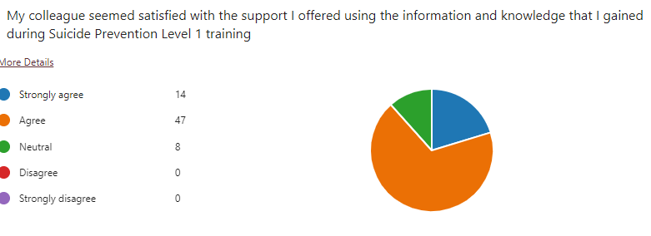
Table 12: Perceived colleague satisfaction with suicide prevention intervention

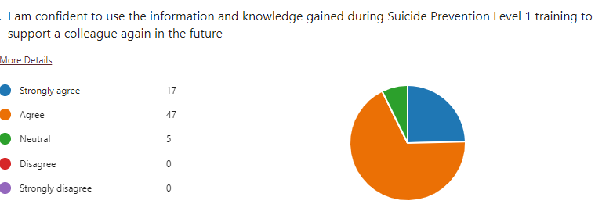
Table 13: Confidence to use suicide prevention skills again in the future

