

Meeting Date | 26 September 2023 |  | Agenda Item |  |  | 4.1
Report Title | Morriston Hospital Service Group progress against Tier 1 infections to 30th June 2023, with Quarter 1 progress update on the 2023/24 Infection Prevention Improvement Plan.
Report Author | Louise Wade, Deputy Head of Nursing, Critical Care and Radiology (Service Group HCAI Improvement Lead), Morriston Hospital Service Group
Report Sponsor | Ceri Matthews, Interim Nurse Director, Morriston Hospital Service Group
Presented by | Ceri Matthews, Interim Nurse Director, Morriston Hospital Service Group
Freedom of Information | Open
Purpose of the Report | Progress is reported for Morriston Hospital Service Group against Tier 1 infections to 30th June 2023, with a Quarter 1 update on the 2023/24 Morriston Hospital Service Group Infection Prevention Improvement Plan.
Key Issues | To 30th June 2023, the cases of Tier 1 infections to the end of June 2023 were above the reduction trajectory for C. difficile, Staph. aureus bacteraemia and E. coli bacteraemia; cases of Klebsiella spp. bacteraemia were below the reduction trajectory, and cases of Pseudomonas aeruginosa bacteraemia were on trajectory.  As a year-on-year comparison, cases of Staph. aureus, Klebsiella and Pseudomonas aeruginosa bacteraemia were below the number cases seen between April and June 2022, whilst cases C. difficile and E. coli bacteraemia had increased. Charts showing the Quarter 1 position against infection improvement trajectories, with a year-on-year comparison, are shown in Appendix 1.  The Service Group’s 2023/24 Infection Prevention Improvement Plan, updated to end of June 2023, is attached in Appendix 2.
Specific Action Required | Information | Discussion |  | Assurance | Approval
Specific Action Required | ☐ | ☐ |  | ☒ | ☐
Recommendations | Committee members are asked to note:  - the Quarter 1 position against Tier 1 infections,  - progress against Morriston Hospital Service Group Infection Improvement Plan 2023/24.
Morriston Hospital Service Group progress against Tier 1 infections to 30th June 2023, with Quarter 1 progress update on the 2023/24 Infection Prevention Improvement Plan.

- INTRODUCTION

The paper provides a Quarter 1 update in relation to reduction of key Tier 1 infections within Morriston Hospital Service Group (see Charts in Appendix 1). The Service Group’s 2023/24 Infection Prevention Improvement Plan (Appendix 2) is presented in Appendix 2 and has been updated with progress to the end of Quarter 1, using RAG rating.

- BACKGROUND

Tier 1 Infections – Quarter 1 Progress:
The Health Board healthcare associated infection (HCAI) improvement goals for 2023/24 are calculated with the goal of achieving Welsh Government expectations (as outlined in WHC 2023/031 - AMR & HCAI Improvement Goals for 2023-24).
Morriston Hospital Service Group’s HCAI improvement goals for 2023/24, and progress to end of June 2023, is shown in the table below and in the charts in Appendix 1.
Table 1: Service Group Summary Position to 30 June 2023
Infection | Cumulative Q1 trajectory to June 2023 (max.) | Cumulative Cases (Actual) to end of June 2023 | Position against trajectory  (+/-) | Year-on-year comparison
C. difficile | 15 | 22 | +7 cases  above trajectory | 22%
Staph. aureus bacteraemia | 10 | 14 | +4 cases  above trajectory | 26%
E. coli bacteraemia | 21 | 27 | +6 cases  above trajectory | 29%
Klebsiella spp. bacteraemia | 9 | 8 | -1 case  below trajectory | 27%
Ps. aeruginosa bacteraemia | 3 | 3 | on trajectory | 50%
In relation to the Tier 1 infection reduction goals for Morriston in 2023/24, the cases of infection to the end of June 2023 were above the reduction trajectory for C. difficile, Staph. aureus bacteraemia and E. coli bacteraemia. Cases of Klebsiella spp. bacteraemia were below the reduction trajectory, and cases of Pseudomonas aeruginosa bacteraemia were on trajectory.
When reviewing year-on-year comparison in the first quarter of 2023/24, compared with Quarter 1, 2022/23:
- There have been increases in cases of C. difficile and E. coli bacteraemia;
- There has been reduction in cases of Staph. aureus bacteraemia, Klebsiella spp. bacteraemia and Pseudomonas aeruginosa bacteraemia;

Infection Improvement Plan 2023/24 – Quarter 1 progress
The Service Group Infection Improvement Plan is attached in Appendix 2. There are key priorities identified within the improvement plan. These are:
- Achieve reduction in 5 key healthcare associated infections through application of evidence-based practice and best practice guidance. Quarter 1 position detailed above.
- Sustained improved compliance with Antimicrobial Stewardship and Start Smart Then Focus Standards (SSTF).
Position for Morriston to end Q1:
- % appropriate choice - 93%
- % Indication documented - 87%
- % Stop Review - 66%
- % 72 hour review - 93%
- IV to Oral Switch @ 72 hours - 10%
This data is discussed at Clinical Cabinet. Three key areas have been identified: vascular, oral maxilla-facial, and respiratory as key areas for targeted quality improvement work.
- Achieve improved compliance with national training target for infection prevention & control-related mandatory training, working toward IP&C Training, Level 1 and Level 2 – ≥85% compliance (available staff).
It is acknowledged that Medical & Dental compliance with IPC-related mandatory training is an issue across the Health Board. The proposed changes to Study Leave approval for medical & dental staff, whilst approved by the BMA and LMC, needs Health Board sign-off and wider communication. Once Health Board approved and communicated, this will be included within the appraisal and revalidation process and this should help to improve the position. Compliance with mandatory training is reviewed also at Morriston Divisional performance review.
- Continue to undertake and report monthly IPC-related audit in clinical areas and establish an assurance process to monitor and track result, actions and improvements.
Results of IPC-related audit are reviewed at weekly case presentation reviews with Service Group Directors. Ward monthly IPC-related audits are reported and monitored divisionally via the Nursing Metrics Dashboards. These are included also within the Divisional reports to Morriston Service Group Infection Control Committee. It is acknowledged that these audits represent a snapshot of compliance at a specific time.
- Sustained compliance with Environmental Cleanliness standards – My Audit scores for Morriston Hospital remain above 95%.
- Work towards compliance with the national decontamination standards.

To 30th June 2023, six of the improvement actions were graded Green and on track, two were graded Amber, with some slippage; two were graded Red, where cases of C. difficile and E. coli bacteraemia were above the trajectory and above the 2022/23 position.

- GOVERNANCE AND RISK ISSUES
- The demand for unscheduled acute care remains high, leading to increased demand for inpatient beds, with surge capacity being utilised. In addition to the above, increased length of stay and staff shortages increase risks of delivering safe patient care.
- The service pressures on acute sites continue to impede the ability to decant bays for 4D cleaning bay areas, and clinical areas affected by periods of increased incidence of C. difficile in line with Health Board standards. 3D cleaning is undertaken using disinfectants and all single rooms, bathrooms and toilets are reactively & proactively 4D UV-C cleaned.

- FINANCIAL IMPLICATIONS
Notwithstanding the harm caused to our patients and service users, the overall financial impact of healthcare associated infections for the Service Group is significant. Success would support a reduction in bed occupancy, reduced harm, reduced medication spend, increased patient satisfaction and a reduced mortality.

- RECOMMENDATION

Committee members are asked to note:
- the Quarter 1 position against Tier 1 infections,
- progress against Morriston Hospital Service Group Infection Improvement Plan 2023/24.
Governance and Assurance

Link to Enabling Objectives  (please choose) | Supporting better health and wellbeing by actively promoting and empowering people to live well in resilient communities
Link to Enabling Objectives  (please choose) | Partnerships for Improving Health and Wellbeing | ☐
Link to Enabling Objectives  (please choose) | Co-Production and Health Literacy | ☐
Link to Enabling Objectives  (please choose) | Digitally Enabled Health and Wellbeing | ☐
Link to Enabling Objectives  (please choose) | Deliver better care through excellent health and care services achieving the outcomes that matter most to people
Link to Enabling Objectives  (please choose) | Best Value Outcomes and High Quality Care | ☒
Link to Enabling Objectives  (please choose) | Partnerships for Care | ☐
Link to Enabling Objectives  (please choose) | Excellent Staff | ☐
Link to Enabling Objectives  (please choose) | Digitally Enabled Care | ☐
Link to Enabling Objectives  (please choose) | Outstanding Research, Innovation, Education and Learning | ☐
Health and Care Standards
(please choose) | Staying Healthy | ☐
(please choose) | Safe Care | ☒
(please choose) | Effective Care | ☐
(please choose) | Dignified Care | ☐
(please choose) | Timely Care | ☐
(please choose) | Individual Care | ☐
(please choose) | Staff and Resources | ☐
Quality, Safety and Patient Experience
Effective infection prevention and control needs to be everybody’s business and must be part of everyday healthcare practice and be based on the best available evidence so that people are protected from preventable healthcare associated infections.
Financial Implications
A Department of Health impact assessment report (IA No. 5014, 20/12/2010) stated that the best estimate of costs to the NHS associated with a case of Clostridioides difficile infection is approximately £10,000. The estimated cost to the NHS of treating an individual cost of MRSA bacteraemia is £7,000 (the cost of MSSA bacteraemia could be less due to the availability of a wider choice of antibiotics). In an NHS Improvement indicative tool, the estimated cost of an E. coli bacteraemia is between £1,100 and £1,400, depending on whether the E. coli is antimicrobial resistant. Estimated costs related to healthcare associated infections, from 01 April 2023 to the end of June 2023 is as follows: C. difficile - £150,000; Staph. aureus bacteraemia - £70,000; E. coli bacteraemia - £23,100; therefore, a total cost of £243,100.
Legal Implications (including equality and diversity assessment)
Potential litigation in relation to avoidable healthcare associated infection.
Staffing Implications

Long Term Implications (including the impact of the Well-being of Future Generations (Wales) Act 2015)
A healthier Wales: preventing infections
Report History
Appendices | Appendix 1 – Morriston Hospital Service Group Tier 1 infection position to 30th June 2023.  Appendix 2 – Morriston Hospital Service Group 2023/24 Infection Prevention Improvement Plan.

C. difficile
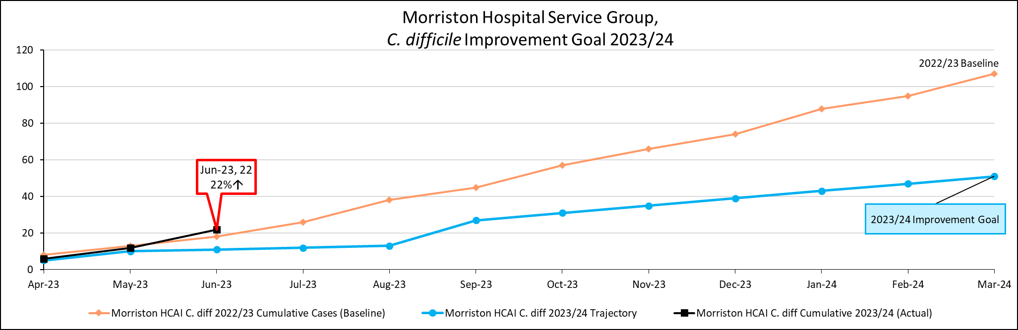
Staph. aureus bacteraemia
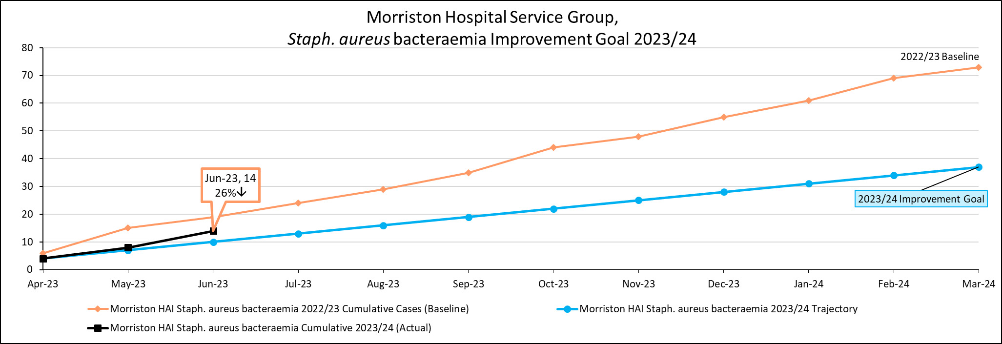

E. coli bacteraemia
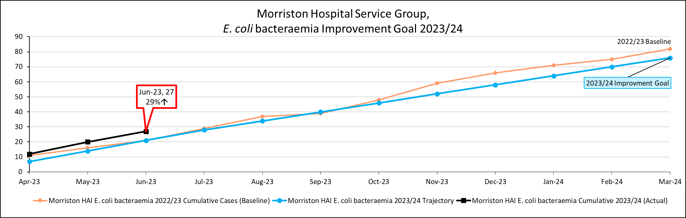
Klebsiella spp. bacteraemia
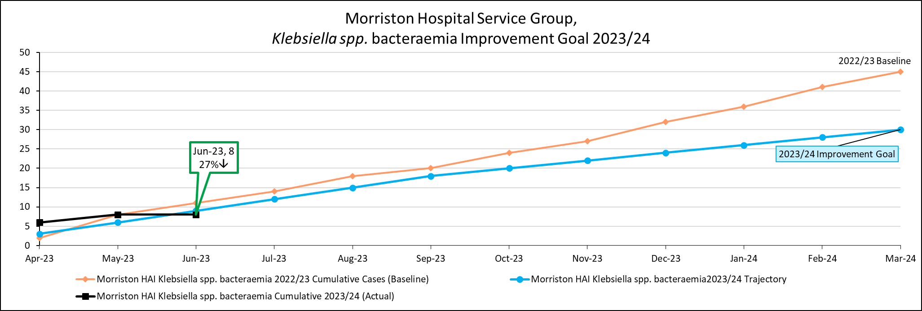

Pseudomonas aeruginosa bacteraemia
