



Meeting Date | 15th August 2023 |  | Agenda Item
Report Title | Healthcare Acquired Infections Update Report
Report Author | Nicola Lewis, Interim Matron, Infection Prevention & Control
Report Sponsor | Gareth Howells, Executive Director of Nursing & Patient Experience
Presented by | Delyth Davies, Head of Nursing, Infection Prevention & Control
Freedom of Information | Open
Purpose of the Report | This paper provides the Committee with an update on prevalence, progress and actions for healthcare associated infections (HCAIs) within Swansea Bay University Health Board for the reporting period to the end of July 2023 and progress against Tier 1 Target organisms to the end of Quarter 1.
Key Issues | - The Health Board position against infection reduction expectations to 30th June 2023 is presented in Appendix 1. There is year-on-year reduction in episodes of harm for Pseudomonas aeruginosa and Staph aureus bacteraemia compared with the position to June 2022. (Risk register ID 739).  - Compliance with infection-related mandatory training is provided in Appendix 2 (against a national target of 85% compliance). Infection Prevention & Control Level 1 & Level 2 training compliance is reported as 90% and 26% respectively (01/07/23). Management Board has accepted the proposal to mandate IPC level 2 training in ESR to all HB staff. This will support the minimum 85% compliance being achieved at both levels. ANTT E learning compliance is reported on ESR as being 27%. Some reconfiguration of the certification within ESR will hopefully provide improved assurances of the compliance levels (Risk Register ID 1750).  - The 2023/24 over-arching Infection Improvement Plan was discussed at Infection Control Committee in June and is included as Appendix 3. The plan focuses on a reduction in the five key indicator healthcare associated infections, a pro-active schedule of audit, compliance with infection prevention and control mandatory training and a quality improvement programme to work towards compliance with the National Decontamination Agenda.
Specific Action Required | Information | Discussion |  | Assurance | Approval
Specific Action Required | ☐ | ☐ |  | ☒ | ☐
Recommendations | Members are asked to:  - NOTE the position against the key indicator infections (Tier 1) to 30/06/2023 (Appendix 1);  - NOTE the Infection Control Committee Report – June 2023 (attached separately).  - NOTE the proposed changes to the governance arrangements for the Infection Prevention & Control Committee, including Terms of reference.

Summary of Current Position to end of quarter 1
This paper will present a summary of the overarching position in relation to the number of cases of key indicator infections within the Health Board, and by Service Group, to the end of June 2023.
Health Board progress against the Tier 1 infection reduction goals to the end of June 2023 is shown in Appendix 1.
A summary position for the Health Board is shown in the table below, identifying the cumulative position for the financial year 2023/24, the monthly case numbers, and the average monthly goal.
Table 1: Health Board Summary Position for June 2023
Infection | Cumulative Cases to end of June 2023 | Monthly total:  June 2023 | Average monthly reduction goal (max.)
C. difficile (CDI) | 52 | 20 | <8 (annual maximum: <95 cases)
Staph. aureus bacteraemia (SABSI) | 39 | 13 | <6 (annual maximum: <71 cases)
E. coli bacteraemia (EcBSI) | 73 | 25 | <19 (annual maximum: <234 cases)
Klebsiella spp. bacteraemia (Kl BSI) | 24 | 6 | <6 (annual maximum: <71 cases)
Ps. aeruginosa bacteraemia (PAERBSI) | 7 | 4 | <2 (annual maximum: <24 cases)
A summary position for Service Groups is shown in the table below, identifying the cumulative number of cases, in the reporting month and the maximum number of cases to achieve reduction target in brackets.
Table 2: Service Group Summary Position for June 2023 (cumulative)
 | CDI | SABSI | EcBSI | KlBSI | PAERBSI
SBUHB Total | 52 (30% ) | 39 | 73 (6% ) | 24 (9%) | 7 (13% )
PCTSG - CAI | 19 (4 cases ) | 15 (6 cases ) | 36 (1 case ) | 12 (8 cases ) | 2 (equal to)
PCTSG - HAI | 0 (1 case ) | 0 (equal to) | 0 (2 cases ) | 0 (equal to) | 0 (equal to)
MH&LD – HAI | 0 (equal to) | 0 (equal to) | 0 (1 case ) | 0 (equal to) | 0 (equal to)
MORR – HAI | 22 (4 cases ) | 14 (5 cases ) | 27 (6 cases ) | 8 (3 cases ) | 3 (3 cases )
NPTH - HAI | 1 (1 case ) | 1 (equal to) | 3 (2 cases ) | 2 (1 case ) | 0 (equal to)
SH - HAI | 5 (1 case ) | 8 (5 cases ) | 7 (equal to) | 2 (3 cases ) | 1 (1 case )
Other HB cases identified in, but not associated with, SBUHB |  |  | 2 |  | 1

There is year-on-year reduction in episodes of harm for Pseudomonas aeruginosa and Staph. Aureus bacteraemia compared with the position to June 2022.
Escherichia coli and Klebsiella spp. bacteraemia have increased year-on-year, with the majority of cases associated within Morriston Hospital and the community. Escherichia coli bacteraemia continues to have an association with a urinary source, whereas Klebsiella spp. bacteraemia continues to have an association with Hepato-biliary disease, such as gallstones.
There has been an increase in C. difficile cases to the end of June 2023 with the majority of cases occurring at Morriston and the community. Whole genome sequencing results continue to indicate that there are few confirmed transmission events within the Health Board. Further detail regarding Cdifficile periods of increased incidence and transmission events is available in Appendix 2. (Risk register ID 2286).
The publication of the Clostridioides difficile Strategy and Action Plan for Wales 2023-2025 is still awaited.
Challenges, risks and mitigations
- A band 6 Infection Prevention and Control Nurse has been successfully seconded as Band 7 Care Home Lead for IP&C. This post commenced in July and has been agreed until 1st April 2025. A secondment opportunity to backfill this post has been agreed by Vacancy Control Panel and will be advertised imminently. Three further posts have also been agreed by Vacancy Control Panel and are currently out to advert; two band 7 Senior IPCN posts, one of which is a new post, and a new band 3 administrative assistant post.
- An internal audit report at the end of the last financial year highlighted the lack of an IPC Audit programme. An audit programme for 2023-24 was taken to Infection Control Committee in June and has since commenced. A number of previously expired policies have also been updated and approved by the committee. (Risk register ID 739).
- Service pressures, insufficient single rooms and a lack of dedicated decant facilities are continuing to impact on the acute sites’ ability to decant bays and facilitate high level environmental decontamination to take place (Risk register ID 1750, 2210, 2286).
- Bed spacing and ventilation within the majority of wards in inpatient settings poses an ongoing risk in relation to transmission of COVID-19 and other seasonal viral infections, including influenza, Respiratory Syncytial Virus, parainfluenza, and Norovirus. (Risk register ID 1750).
- Following a number of cases of Pseudomonas bloodstream infections in Singleton Hospital, it was found that the estates department had received water samples positive for Pseudomonas. The IPC team and site team had not been made aware of these results and due to the delay in notification, it is not possible to undertake further testing to establish if the water was the source of the patient infections. Following this, processes have been put in place to improve communications between the laboratory responsible for processing water samples, the estates departments and the Infection Prevention and Control team. (Risk register ID 739).
- Continuing failure to achieve the infection reduction improvements is an unacceptable position for our patients, for the Health Board and Welsh Government and is likely to be a consideration in a decision to escalate to Special Measures. (Risk register ID 739)

C. difficile

Staph. aureus bacteraemia

E. coli bacteraemia
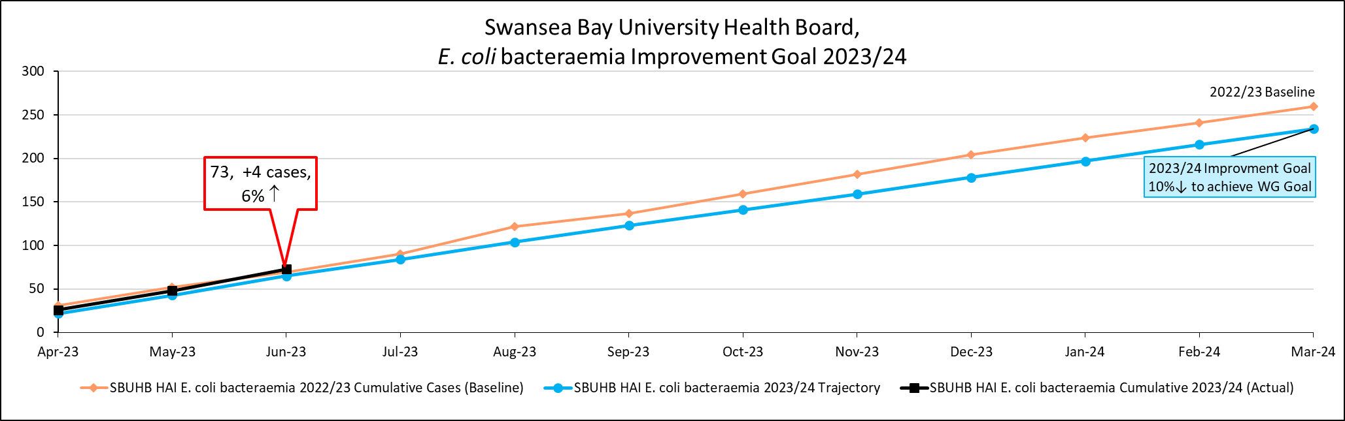

Klebsiella spp. bacteraemia
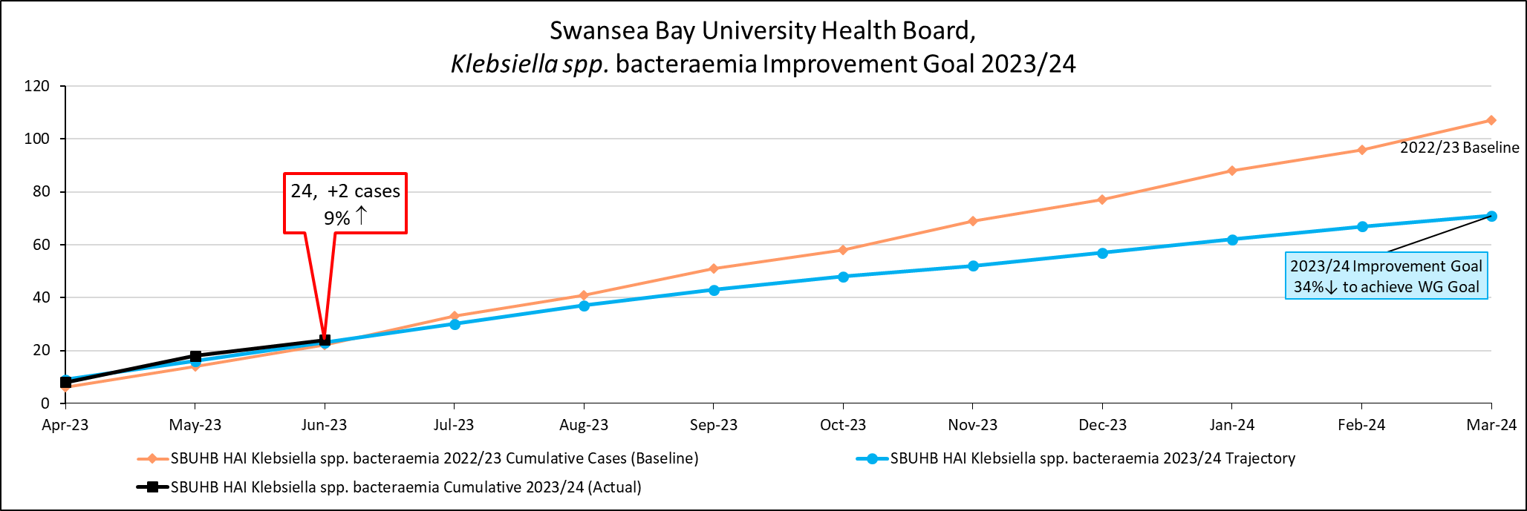

Pseudomonas aeruginosa bacteraemia
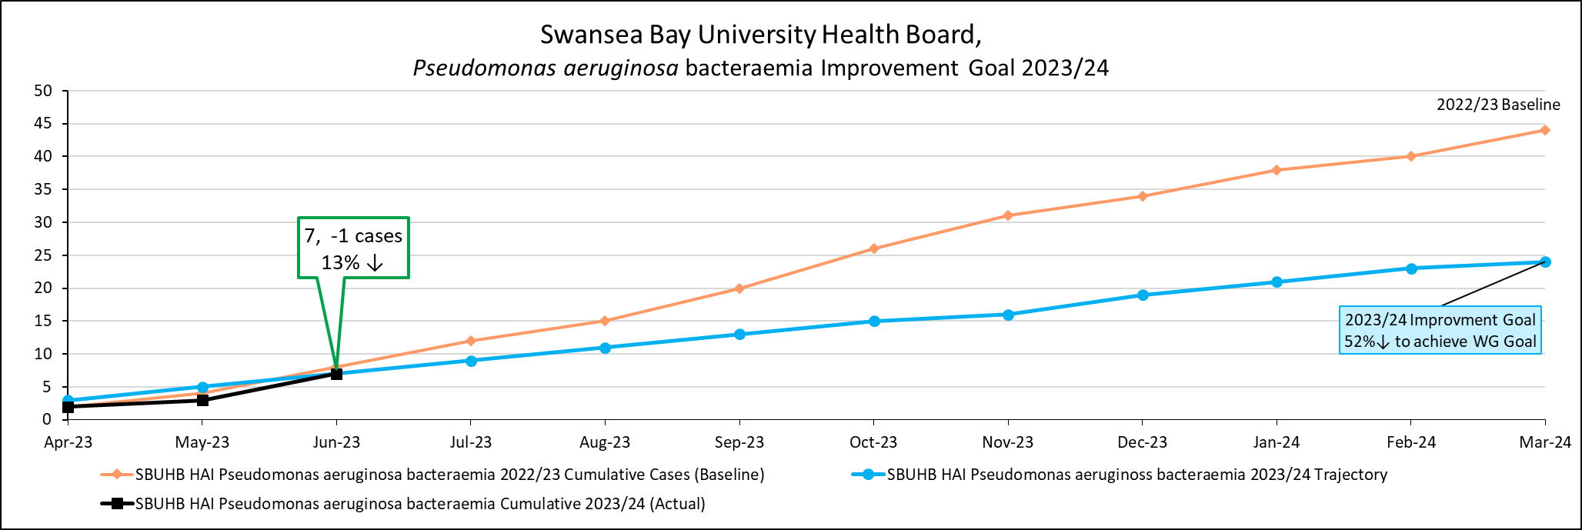

Appendix 2.
Infection Control Committee report June 2023

Appendix 3

