
Service Groups’ Highlight Report for
Quality and Safety Committee

Meeting Date: | Tuesday 26th September 2023
Service Group: | Primary, Community and Therapies Service Group (PCTSG)
Author: | Claire Lewis, Quality and Safety Improvement Manager
Sponsor: | Sian Passey, Group Nurse Director
Presenter: | Ceri Todd, Group Medical Director
Progress Against the Quality Priorities: reduction in healthcare acquired infections; improving end-of-life care; sepsis; suicide prevention; and reducing injurious falls (as applicable).
Healthcare Acquired Infections

Tier 1 infections: PCTSG current position

HCAI | Total Cumulative cases (Q1 Apr 23 – June 23) | 2023/2024 Trajectories | Position Against 2023/2024 Trajectories | 2023/2024 improvement plan
Clostridioides difficile | 16 | 9 | +6 cases | Scrutiny panels to identify learning  Significant Event Analysis reporting to trace, chase, audit and analyse data  C diff prescribing guidance  Targeted newsletters
Staph Aureus bacteraemia | 14 | 6 | +8 cases | GP engagement for simple and complex wound management  Patient education  Collaboration between Microbiology and Wound Care Service
E.Coli bacteraemia | 31 | 33 | -2 cases | Appointment of clinical lead role  UTI task and finish group  Targeted newsletters  Prescribing pilots  Care home education
Klebsiella bacteraemia | 12 | 10 | +2 cases | Scope the establishment of a task and finish group with hepatobiliary surgeons / teams
P. aeruginosa bacteraemia | 2 | 2 | On Target | Focus on antibiotic prescribing in primary care and community

The group continues to work through the 2023/24 improvement plan to achieve improvements against the current position. As well as those highlighted above, further actions include:
- Level 1 IPC training - maintain compliance with national training target for infection prevention for PCT staff. The current compliance rate for the service group is 90%
- Baseline compliance data is unavailable due to lack of reporting mechanisms for a number of mandatory staff specific training. A key action is to develop robust mechanisms to collate compliance data for the following training:
  - Level 2 IPC training
  - Hand hygiene training
  - Aseptic non touch technique training

Improving end of life care

The recent move of Specialist palliative care to the group will allow us to have more involvement in the pathway and to understand any gaps or duplications. The Safe Care Collaboration project continues which is focussed on developing a palliative care register.

Sepsis
NEWS scoring scoping exercise completed for the Upper Valleys - 128 patients reviewed on caseload for a baseline NEWS score: 2 patients scored a NEWS score of 3 or more, normal escalation to GP initiated, patients treated for infection and remained at home, not conveyed to hospital. Plan to meet with SEPSIS Lead to analyse the scoping exercise findings, and develop an adapted NEWS suitable for community use, which would include an escalation process. This will align with escalation pathways to Acute Clinical Team and Virtual Ward.

Suicide prevention
Training continues to be offered to all PCTSG staff with compliance monitored centrally through the development of a training dashboard.

The group continues to work with HMP Swansea to complete action plans following deaths in custody within the prison. At present, all actions have been completed.

Reducing injurious falls

Falls scrutiny panels continue at Gorseinon Hospital. Themes and issued identified from the investigations include:
- Excellent lying and standing BP monitoring undertaken by staff
- Bay nursing with nursing stations in each patient bay ensuring staff visibility in all areas at all times. Breaks are allocated to ensure patient visibility
- Falls awareness board for updated information and guidance
- Monthly falls sessions, communicating falls prevention work and our previous month’s falls position

A directory of falls prevention services is being developed

A Safe Care Collaboration project to promote the i-stumble app in care homes in conjunction with the Welsh Ambulance Service is being scoped.

Areas of Greatest Quality Risk and Mitigating Actions
Risk register
High scoring risks are detailed below for PCTSG, with controls and mitigations in place (please note that the risks associated with Lymphoedema and Specialist Palliative Care Services are in the process of transfer and are not recorded below) :

Risk ID | Description | Current rating | Controls and mitigations
3384 | Capital funding for a new dental patient management system as a result of the company not providing the existing system from April 2024. | 20 | Task and finish group to develop specifications and start the tendering process
3071 | The standard of patient care and resource to complete HIW actions in HMP Swansea as a result of funding for prison health care staff | 20 | Short term funding identified by PCTSG to increase recruitment in the highest risk areas.  Working with MHLD Service Group to identify and address gaps  Regular reporting on progress against HIW action plans  Escalation of risk to Health Board Risk Register
2964 | Loss of key staff in the physiotherapy learning disability service due to requirement to undertake extensive case management duties | 20 | Remaining member of staff will not undertake case management duties  Discussion between service groups about case manager roles and continued elevation of risk  Caseload mapping across physio service and prioritisation of highest acuity patients  Progressing recruitment into the vacancies
3225 | Risk of not implementing ALNET Act due to funding and capacity within the following therapy areas:  - Speech and Language  - Occupational Therapy  - Nutrition and Dietetics  - Physiotherapy | 20 | Prioritisation of workload and demand  Systems review of SLT paediatric services  Streamlining paperwork to create efficiencies  Partnership working with local authority partners  Working as an MDT to streamline processes and pathways  Legal training to understand legal implications of ALN Act  Additional training providing to staff around ALN  Therapy representation at operational meetings  Therapy supporting and leading on operational processes and workstreams  Raise awareness with DECLOs, DoTHS, Clinical Director and SG Director  Accessible universal and targeted provisions on education platforms  Scope the impact of ALN and identify any risks re: gaps in service and/or workforce
3368 | Risk that the new all Wales full clinical system for Out of Hours will not be fully operational by the time the current contract ends in December 2023 | 20 | Business continuity plan in place which will need to be updated closer to the time, put in to reduce the patient safety risk but will have limited impact on the sustainability of service.  Updates to be developed for regular communication with GPs and staff to inform them of the forthcoming system change
1587 | Parkway clinic paediatric dental risk | 20 | 1. Consultant Anaesthetist present for every General Anaesthetic clinic.  2. Assurance Documentation supplied by Parkway Clinic including confirmation of arrangements in place with WAST and Morriston Hospital for transfer and treatment of patients  3. New care pathway implemented - no direct referrals to provider for GA.  4. Multi -drug sedation ceased from Sep 2018 in line with WHC 2018 009  5. Revised SLA/Service Specification  6. HIW Inspection Visit Documentation provided to HB  7. All extended GA cases require approval from paediatric specialist prior to treatment
3095 | Workforce and assurance risk that PCTSG governance and quality team will not meet statutory and performance targets or be able to fulfil full range of assurance activities. This risk has escalated as result of new services transferring to the group and the additional impact on the team. | 20 | Prioritisation of workload for team  Escalation of concerns and discussions with Triumvirate  Sops for services to carry out activities  Workplans, template agendas and reports developed for 1st and 2nd level Q&S groups  Service and Head of Service reporting mechanisms in place  Recruitment currently underway for some additional posts  Local arrangements in place for referring service groups to continue to manage governance related work for the transferred services
3224 | Risk to SLT financial income targets due to introduction of ALN legislation | 20 | - Continue to build and develop relationships with Local Authority Colleagues  - Offering Local Authorities with a menu of options with evidence based rationale underpinning SLT offer as part of ALN  - Careful consideration of all current vacancies and advertising any vacancies within SLAs as fixed term where appropriate  - Careful financial management of SLT budget  - Escalation to PCTSG and DoTHS
1519 | Sustaining general medical services in SBU Health Board GP Practice | 20 | Dedicated senior oversight, GMD, AD for PC, HOPC, CD. Senior Manager (Practice Service Improvement Manager) working on site in managed practice). Interim Practice Manager appointed.  Improvement Plan developed and agreed supported with required financial resources.  Recruitment of vacant posts underway.  Locums being booked for vacant and additional sessions. Agreement 21/08/23 to recruit 2 x WTE GPs.  Administration support through HB Imms Team  Bank and Agency cover being explored.
3533 | Symptom management at end of life | 16 | Every patient has 'just in case' meds prescribed  Make special notes on the GP out of hours portal  Updated list of pharmacies that hold drugs for OOH  Service improvement lead to focus on improvement project

A PCTSG Risk Management Group is being developed with Terms of Reference, to provide scrutiny over scoring, controls and mitigations for service group risks.

Incidents and Duty of Candour
Workshops, standard operational procedures and processes have been agreed to reduce the numbers of open incidents and maintain status. Numbers have already reduced from almost 800 to 450, with an expected trajectory of 400 open incidents at end of Q2.

There are four incidents that have triggered the duty of candour process for the service group.
- One relates to a patient who was referred to Speech and Language Therapy from a residential home. A joint strategy meeting is underway where learning and actions for PCTSG involves development of an automated referral system.
- Two incidents relate to pressure ulcer incidents. A quality summit is planned for November to focus on learning from these serious incidents
- A strategy meeting is underway to identify early learning and improvements as a result of a recent death in custody. PPO and HIW investigation will take place in due course. NHS Executive notification form submitted
Complaints
The service group are consistently achieving and maintaining performance standards. This has been due to managing green complaints by early resolution or informally through telephone contact with complainants.
Patient Experience Update
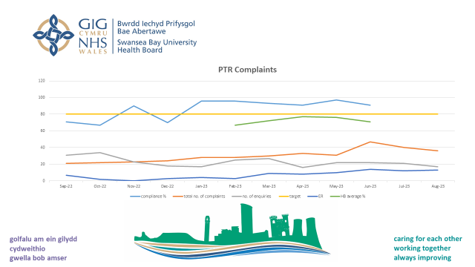

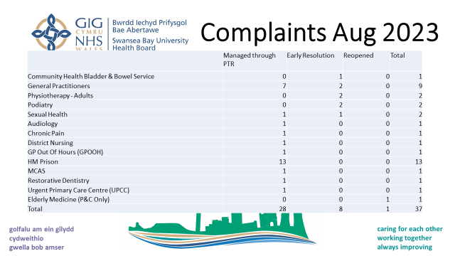
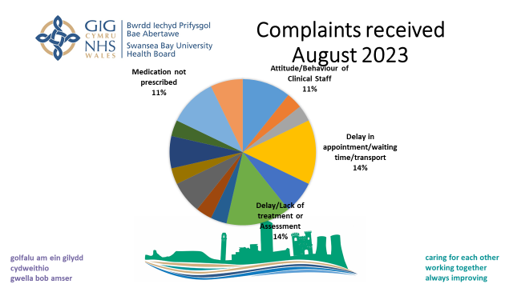

- The highest number of complaints and enquiries received are for GP and HMP Swansea. The Prison improvement plan is focussed on reducing medication complaints and is to be presented to October 2023 PCTSG Patient and Stakeholder Experience Group and monitored.
- There is an increased number of complaints received for the Health Board GP Practice. During July several public meetings were held, called by the local MS, to enable patients to share their experiences of accessing services at the Health Board Managed GP practice. A number of themes have been identified including telephone and digital access / response times, communication and attitude of practices staff. An action plan has been developed to respond to the concerns and take forward improvements within the practice.

Patient feedback
- PCTSG are currently working with Corporate and DHCW to pilot automating friends and family questionnaire as a result of PIMMS appointments.
- The group are achieving performance against positive feedback standards, currently 93.8% of feedback is positive.

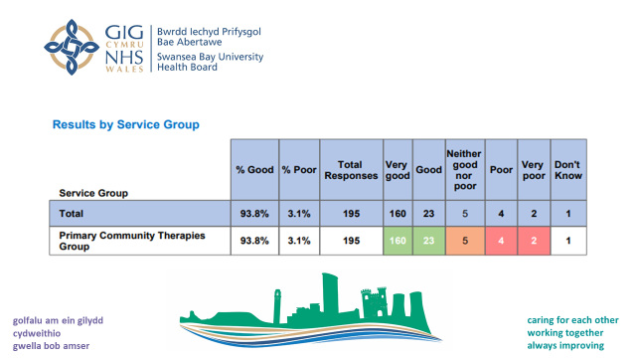

- There are a limited number of staff trained within the Service Group to produce patient and staff stories. Alternative formats of obtaining stories and feedback into services are being considered.

HIW visits
- Inspections have been undertaken at SA1, Pontardawe and Riverside Practices which, due to findings, all were required to provide an immediate action plan. Pontardawe has until the end of September to complete some outstanding actions. All other actions are complete.
- The updated HMP Swansea Improvement Plan update was submitted to HIW in June. In August the Health Board received confirmation from HIW that it was accepted as providing assurance that the recommendations are being addressed.
Staff Experience Update
- Physiotherapy hold a monthly physio partnership forum between physio managers and CSP union reps. This is a general information sharing (2 way). They are also holding a new graduate 2 day band 5 induction programme. There has been lots of discussion and engagement. There has been very positive feedback about why the graduates chose to work in SBU and we are taking this learning forward to support recruitment and retention. Some of the feedback has included; they are made to feel part of the team very quickly in SBU physio and that there is a phased introduction and support before they are required to participate in the on call rota independently.
- Podiatry and Orthotics have undertaken a staff engagement event and are currently putting on a listening event supported by a member of the learning and development team. Drivers for the session were:
  - Indicators post covid morale is lower than it should be (across organisation and dept)
  - Open door policy
  - Importance of listening to staff
  - Engagement session will help us to understand what we expect from each other
  - Determine action plan going forward
The team were asked
  - How happy are you in work? Baseline scores captured and will be re-evaluated after implementation of action plan
  - “What would make you happier in work”?
The session was facilitated by our staff side rep and one of the podiatrists
Themes are to be reviewed by SLT and Learning and Development in conjunction with the second phase of the event staff side rep
The second phase is a listening event - questionnaire sent to all staff inviting their participation in 30 minute individual session as an opportunity for staff to chat informally to an impartial facilitator about what’s going on for them. The sessions are confidential (subject to the exceptions of harm or illegality) and will enable the facilitator to identify themes for the team to share and work on moving forward and will be added to the themes identified at the team engagement event held on the 3rd May 2023.
Initial feedback and action plan etc to be presented by Learning and Development at Podiatry and Orthotics team meeting in October.
- Speech and Language Therapy have held focus groups for staff to discuss their concerns post Covid due to identified low morale. A ‘you said, we did’ approach has been taken for sharing back with the teams any actions based on their feedback.
- Lymphoedema clinic attended for the launch of the new lymphoedema formulary. The learning outcomes: staff aware of new garments on formulary; staff aware of new processes of garment ordering; staff building contacts with companies who were successful on getting garments and applicators on the formulary. Individual staff have attended lymphoedema agored courses, one of which completed in July and they are now qualified to perform manual lymphatic drainage, which is a treatment modality we offer lymphoedema patients.
- Engagement events have been held with staff who have recently moved over to PCTSG, Specialist Palliative Care and Lymphoedema. This has included site visits.
- Large scale staff engagements over a 6 month period as a result of Organisational Change Policy in the District Nursing team
- Wellbeing and support provided from a psychologist linked to occupational health referrals in relation to staff wellbeing.
- Staff engagement with the Guardians Service to provide staff with support with an ongoing complaint issue.

Recommendations
Members are asked to note the contents of this report.

Service Groups’ Health and Safety
Highlight Report

Summary of Health and Safety key issues since last report to the Committee
(Reporting period: September 22 to September 23 )
The Health and Safety Operational Group meets on a six weekly cycle. Updated Terms of reference have been prepared for the group to reflect updated membership and to ensure alignment of function with the corporate Health and Safety Operational Group.
The Associate Director of Operations, chairs the Health and Safety Group, from October 2023, the group will benefit from additional operational support from within the new operations team. A set of priority actions have been discussed at the Health & Safety meeting to frame a work plan for the new Operations Business Manager posts. It is intended that this will enable full operational assurance to be achieved on Health and Safety management within the group. Table 1 outlines these priorities.
Challenges, Risks, Mitigation and Action being taken relating to Health and Safety issues noted above (what, by when, by who and expected impact)

Currently there are a number of priority areas, which require remedial work to enable assurance to be provided. These have been identified following discussion in the Health and Safety operational group. A full action plan will be developed for presentation to the group in October for completion by December 2023. These include:
- Effective Risk Management
- Implementing an environment of continuous learning and Improvement
- Ensuring appropriate support from corporate functions including Health & Safety and Estates to enable Heads of Service to fulfil H & S requirements
- Mitigation of operational group capacity to support H & S

Table 1- Priority Actions/Action Plan

Subject | Action | Owner
PCTSG H & S Work Programme | Develop work programme aligned to Deep Dives | Ops Mgr/ LH
Risk Reporting | Create risk register of summary themes for review at each meeting/ Align with new Risk reporting Group | Ops Mgr/CL/AR
Risk Management | Convene working group to implement new operational processes to improve risk management of H & S functions across PCTSG
Fire Safety Assurance | Creation of a Group Dashboard on Fire Safety and clear identification of action owners (i.e. HOS or Estates) | Huw George/Steve Davis & Ops Mgr
MOU with Estates | Create an MOU with estates to include HB owned sites and PFI to set out clear Roles and Responsibilities | Ops Mgr/Estates
Review of relevant policies | Review relevant H & S policies to ensure fit for purpose for PCTSG i.e line worker policy/unreasonable behaviour policy | Ops Mgr

Performance Progress to include: Statutory and Mandatory Training; PADR compliance; Serious Incidents; Staffing and Sickness Levels;

The service group are currently achieving statutory training compliance at 91%
PADR compliance is just below target at 81% and managers are being reminded of the importance of undertaking PADRs with staff members.
The turnover rate FTE (12 months) for PCTSG is 10.87% which is the lowest it has been over the last 12 months.
Vacancies stand at 203.10 WTE
The sickness rate for the service group is slightly lower than the Health Board rate, currently at 6.76%.

It is recognised that further work is required to improve staff experience and improvements are monitored at PCTSG Management Board.

Governance and Risk Issues to include risks relating to Health and Safety on the risk register
Current issues for 2023-24 for the Attention of the Committee
The report provides an overview of the issues being discussed at the Health and Safety Operational meetings, with key themes being:
- Capacity
- Risk Management
- Violence and Aggression
- Estates Management.
Recommendations
Members are asked to: Note the report

