Meeting Date |  |  | 04 June 2026 | Agenda Item |  | 2.5
Name of Meeting |  |  | Quality & Safety Committee
Report Title |  |  | Patient Experience & Concerns Report
Report Author |  |  | Susan Ford, Head of Concerns Assurance
Report Sponsor |  |  | Executive Director of Nursing and Patient Experience
Presented by |  |  | Liz Rix, Executive Director of Nursing and Patient Experience
Freedom of Information |  |  | Open
FoI Closed detail |  |  | If closed, choose detail
Impact Assessment Summary Outcome |  |  |  | IA Completion date
Not applicable |  |  |  | Click or tap to enter a date.
Purpose of the Report |  |  | For Assurance
Report Summary; detailing any action required
The purpose of this report is to provide the Committee with a quarterly update against the work of the Patient Experience and Concerns Department.
Key Issues
- Deteriorating complaints performance – 56% of complaints responded to within 30-working day timescale, despite targeted work within corporate and service group services
- As of 15th May 2026, 344 complaint responses are overdue
- Rising volume of complaints – 742 received, an increase on the previous quarter. This reflects sustained operational pressure across services
- Access and waiting time pressures (delays in care, diagnostics, and follow-up) are the dominant driver of complaints, particularly in the Emergency Department, Orthopaedics, and Gynaecology
- Emergency Department patient satisfaction is notably lower (64%) with consistent themes of waiting time, discomfort, and environment
- Communication is a recurrent theme resulting in ongoing complaints about inconsistent or insufficient information to patients, especially while they are waiting for care
The format of this report has been revised following feedback from Quality and Safety Committee, further comments are invited in order that we can improve the report to meet the needs of the Committee.
Decision / Action required |  |  | No
Recommendations
Members are asked to:
RECEIVE the quarterly update against the work of the Patient Experience and Concerns Department.

Governance and Assurance

Link to Enabling Objectives  (please choose) | Supporting better health and wellbeing by actively promoting and empowering people to live well in resilient communities
Link to Enabling Objectives  (please choose) | Partnerships for Improving Health and Wellbeing |  |  |  | ☒
Link to Enabling Objectives  (please choose) | Co-Production and Health Literacy |  |  |  | ☐
Link to Enabling Objectives  (please choose) | Digitally Enabled Health and Wellbeing |  |  |  | ☐
Link to Enabling Objectives  (please choose) | Deliver better care through excellent health and care services achieving the outcomes that matter most to people
Link to Enabling Objectives  (please choose) | Best Value Outcomes and High Quality Care |  |  |  | ☒
Link to Enabling Objectives  (please choose) | Partnerships for Care |  |  |  | ☒
Link to Enabling Objectives  (please choose) | Excellent Staff |  |  |  | ☒
Link to Enabling Objectives  (please choose) | Digitally Enabled Care |  |  |  | ☐
Link to Enabling Objectives  (please choose) | Outstanding Research, Innovation, Education and Learning |  |  |  | ☐
Health and Care Standards
(please choose) | Staying Healthy |  |  |  | ☒
(please choose) | Safe Care |  |  |  | ☒
(please choose) | Effective Care |  |  |  | ☒
(please choose) | Dignified Care |  |  |  | ☒
(please choose) | Timely Care |  |  |  | ☒
(please choose) | Individual Care |  |  |  | ☒
(please choose) | Staff and Resources |  |  |  | ☒
Quality, Safety and Patient Experience
The report demonstrates that while overall patient experience remains positive, ongoing pressures on access, waiting times, and complaint responsiveness are presenting clear challenges to the consistent delivery of high-quality care.
Financial Implications
There are no direct financial implications associated with this report, however there is a risk of redress or financial fines being incurred through poor quality care or poor concerns handling.

Legal Implications (including equality and diversity assessment)
Investigation are ongoing in relation to the incident and complaints and will be managed in accordance with the Civil Procedure Rules of the NHS Concerns, Complaints and Redress Arrangements Wales Regulations 2011
Staffing Implications
None

Long Term Implications (including the impact of the Well-being of Future Generations (Wales) Act 2015)
No implications for the Team to be notified of.
Report History |  | - Quarterly to the Quality and Safety Committee
Appendices |  | Appendix 1: Complaints  Appendix 2: Focussed Services  Appendix 3: Service Group Data

Patient Experience & Concerns Report
Quarter 4 2026
Contents
Report Summary and Overview 4
Table 1 5
Learning from Complaints 5
Patient Experience 7
Feedback from the Medical Examiner 7
Focus Areas 8
Orthopaedic Services 8
Emergency Department 8
General Surgery 8
Cancer Services 8
Mental Health and Learning Disabilities 9
Service Group Summaries 9
• Morriston 9
• Neath Port Talbot Singleton 9
• Mental Health and Learning Disabilities 10
• Primary Care, Community and Therapies 10
Appendix 1: Complaints 11
Appendix 2: Focus Areas 16
Appendix 3 Service Group Data 23

Report Summary and Overview
In Quarter 4, the Health Board received 742 complaints, an increase on the previous quarter, reflecting ongoing system pressures. Overall patient experience remains positive, with 92.5% satisfaction, and no new Never Events reported, providing assurance in relation to serious harm. However, performance in complaints management has declined, with only 56% of complainants responded to within timescales and 344 complaints remain overdue representing a key area of concern.
Key themes across feedback and complaints continue to be communication, waiting times and access to care, particularly within the Emergency Department and planned care pathways.
An overview of complaints, patient experience and patient safety data for quarter 4 is included in Table 1

Table 1
COMPLAINTS | Total
Total number of complaints received | 742
Complaints acknowledged within set timescale | 100%
Number of re-opened complaints | 21
Complaints responded to within agreed timescale – formal  (% based on the period Nov- Jan, which reflects the 30-working day response period) | 56%
OMBUDSMAN | Total
Number of Ombudsman Investigations received | 1
Number of actions outstanding (within timescales) | 2
Number of actions overdue | 2
PATIENT EXPERIENCE | Total
No. of Friends & Family surveys received | 19144
Recommendation score (quarterly average) | 92.5%
New Bespoke Surveys | 1
NATIONAL REPORTABLE INCIDENTS | Total
Number of Nationally Reportable Incidents reported | 22
Number of Never Events | 0

Learning from Complaints

The volume of complaints received increased in quarter 4 with the highest numbers being received in January and February. This reflects both seasonal demands and wider system pressures across our services. The increase in volume of complaints and demands on clinical teams has resulted in the health board not meeting its own, or national targets, for response times to complaints managed under Putting Things Right. Average performance for the quarter was 56%. Alongside this, at the time of writing there were 344 complaints overdue for responses. Whilst the implementation of the new Listening to People framework will support the early resolution of over 40% of complaints in future, there remains a risk to patient experience due to the number of overdue complaints within the health board.

There is a clear trend in complaints linked to poor communication, waiting times, delayed diagnosis and access to care, particularly within the Emergency Department, Orthopaedics and Gynaecology. These include issues in relation to cancellations and follow-up care.

A new Ombudsman case was opened in quarter 4 which relates to the Surgical Decision-Making Unit in Morriston Hospital. There remains two overdue actions from a public interest Ombudsman report relating to the management of patients on orthopaedic waiting lists.

Communication remains a key theme within complaints, primarily in relation to provision of information when waiting for care and the consistency of information provided to patients. To improve the experience for patients waiting for planned care, the Corporate Patient Feedback Team have been working with colleagues in planned care to streamline a route for service users contacting the organisation with enquiries regarding waiting times. This has been supported with changes to our website information.

The implementation of the Listening to People framework on 1st April 2026 has involved a cultural change in the management of complaints. It is now easier for complainants to contact the relevant team and to discuss issues regarding care through a listening discussion. Early indications are that this change has been positively received by people raising a complaint who are finding the process helpful and that it provides them with the resolution they were seeking.

A full breakdown of complaints activity and themes can be found in Appendix 1.

Reducing Overdue Concerns

During Quarter 3 and 4 targeted work has been undertaken across service groups and Corporate Nursing teams to reduce the number of overdue concerns. This includes the following: -
- Deployment of staff from the Corporate Nursing Team to support Morriston, Neath Port Talbot Singleton and Mental Health and Leaning Disabilities service groups
- Establishment of daily concerns huddles in Mental Health and Learning Disabilities and Neath Port Talbot Singleton to provide oversight of individual concerns management
- Temporary team restructure within Morriston Service Group to provide dedicated support to overdue concerns
- Central management of individual concerns where the person has complex needs
- Corporate support to service groups in drafting individual concerns responses
- Engagement with the Waiting Well service to streamline enquiries relating to waiting times

These interventions have had some positive impact, with concerns reducing from 322 in January 2026 to 258 on March 16th. Since then, the number of overdue concerns has increased week on week, despite the additional support measure being in place. These increases in overdue concerns, correlate with system-wide pressures. Work to address the overdue concerns position continues and this is reported monthly to Quality and Safety Group.

Patient Experience

Feedback is collected through a variety of methods, including online surveys, paper-based questionnaires, SMS messaging, QR codes, Interactive Voice Responses and British Sign Language. The overall satisfaction score for this quarter is 92.5%. During the quarter the National Endoscopy Survey has been launched and is being issued to patients.

Feedback from the Medical Examiner

Compliments from families are received by the health board via the Medical Examiner. During quarter 4, 71 compliments were received via this route. Each related to care at end of life. Quotes from such feedback include the following:
- Dr X and the team were amazing, they showed them the utmost respect and tried their very best for the patient which gave him hope, Dr X made him feel listened to which gave him strength to accept what he was being told. She spoke very highly of the team and is grateful for everything they did.
- He had the very best care from the ITU team, they were marvellous, he cannot fault them, they did everything they possible could for him

Focus Areas

The Corporate Patient Feedback Team review experience data from specific areas; these are specialties that have higher levels of complaints or ones that the health board has identified as requiring increased oversight. A breakdown of patient experience in these areas of focus is included in Appendix 2.

Orthopaedic Services

During Quarter 4, 1,170 Friends and Family survey responses were received for orthopaedic services, within an overall satisfaction score of 94%. Within the negative feedback the key themes were waiting times, parking and emotional and physical support for patients. The highest rates of positive feedback were in relation to the friendliness of staff, emotional and physical support, professionalism and competence.

Emergency Department

The department received 953 Friends and Family survey responses during quarter 4 with an overall satisfaction score of 64%. This is a decrease on the previous quarter. Top themes within the negative feedback were waiting times, pain, (dis)comfort (whilst waiting), hygiene, feeling (un)safe and facilities. Highest numbers of positive responses were received for compassionate care and helpfulness of staff. The department also received 44 complaints during the same period.

General Surgery
In Quarter 4, the service received 600 Friends and Family survey responses and achieved an overall score of 97%. The over-riding theme within negative feedback related to waiting times, and the highest positive feedback was received in relation to compassionate care. During the quarter the service received 26 complaints.

Cancer Services

In Quarter 4, the service received 823 Friends and Family survey responses and achieved an overall score of 96%. The highest positive feedback was received in relation to friendliness, professionalism and competence, compassion and emotional and physical support. Negative feedback centred on waiting times and parking. No complaints were received in relation to the service for the same period.

Mental Health and Learning Disabilities

The feedback used for Mental Health and Learning Disabilities services is deigned to be more appropriate for this care setting. In quarter 4, 301 responses were received through this survey with an overall satisfaction rate of 99%. Highest rates of positive feedback were in relation to compassion, and emotional and physical support, with food and beverages receiving the greatest number of negative comments. During the period the service received 97 complaints.

Service Group Summaries

The following section provides an overview of the quality and safety issues within services groups. A full breakdown of each service group’s data is provided in Appendix 3.
- Morriston

Morriston has received the highest number of complaints during the period (293), which reflect the types of services within the group. The highest numbers of complaints were received for the Emergency Department. Overall patient experience of services within the group was 91%.
The high number of complaints is also mirrored with the number of incidents reported in the same period (over 2,400). The most common themes of incidents reported were pressure damage and falls, both of which are areas that the service group is looking to improve through quality improvement workstreams.

- Neath Port Talbot Singleton

Complaints received within the group have increased to 232, with increases in orthopaedics and gynaecology.
There were over 1,600 incidents reported in the period and the number of nationally reported incidents was higher than in other areas. This reflects maternity services being managed within the service group where there are national criteria for ‘must report’ incidents. There were 12 nationally reported incidents in the period.
- Mental Health and Learning Disabilities

The service group received 97 complaints during the period, the majority relating to appointments and monitoring/safety arrangements. There were over 850 incidents reported in the period Themes within incidents reported included aggression, self-harm and use of restrictive practices. There were three nationally reported incidents reported within the period.
- Primary Care, Community and Therapies

There is an increasing shift towards the early resolution of complaints through a test of change within the service, who received the lowest number of complaints (89). There were over 1,100 incidents reported in the period. Incident themes within the group related to pressure damage and injury of unknown origin for patients within the community.

Appendix 1: Complaints
1.Complaints Activity and Performance

Total complaints received

The Health Board received 742 complaints in Quarter 4. This compares with 656 complaints in quarter 3. As shown in the graph, an increase in complaints were received in January and February which is impacted on the overall total for quarter 4. This total includes complaints received and managed via either formal, early resolution and any re-opened complaints. Graph 1 provides a long-term view of complaints received per month.
Graph 1: Total number of complaints per month

Graph 2: Formal v Early resolution complaints per month

Graph 2 (above) shows complaints dealt with via the formal Putting Things Right process compared with those dealt with via the early resolution process over the same period. We continue to deal with a higher proportion of complaints via the formal process; this is due to the tight timescale of two working days for early resolution complaints. Any early resolution complaint that is not resolved within two working days will convert to a formal following guidance issued by Welsh Government.
Complaint responses within agreed timescale
Whenever a complaint is managed through the formal Putting Things Right process, the Health Board is required to investigate the complaint and write to the complainant with our findings within 30-working days. If this target is not achievable, it is essential that the complainant is kept up to date throughout and any delays are explained.

Formal Investigations
The Health Board’s internal target is to respond to at least 85% of formal complaints within the agreed timescale. Welsh Government also issue a target for all Health Board’s to achieve at least 75% compliance each month.

Graph 3 shows the Health Board’s performance in responding to complaints since January 2025. The Health Board performance for January 2026 was 55%.
Graph 3: Percentage of formal complaints responded to within agreed timescale

Overdue complaints

Service groups are actively working to reduce the number of complaints that have exceeded the 30-working day timescale which is a recommendation timescale within the ‘Putting Things Right Guidance on dealing with concerns about the NHS 2011.’

The Corporate Patient Feedback Team monitor the overdue complaints and send out weekly reports to each Service Group requesting updates. Extensive ongoing support continues to be provided to the Quality and Safety teams within the Service Groups.

Re-opened complaints
The Health Board aims to resolve all complaints within the first response however there are times when the complainant remains dissatisfied or needs further clarification. If the complainant writes back to the Health Board expressing their dissatisfaction, the correspondence will be reviewed by the Corporate Patient Feedback Team and a decision made in conjunction with the appropriate Service Group as to whether the complaint should be re-opened. This may be when the complainant feels not all issues raised in the initial complaint have been addressed or if a meeting is required.

Graph 4 (below) shows the number of re-opened complaints per month since March 2025.
Number of re-opened complaints by Service Group per month

The number of re-opened complaints appears to have increased for Neath Port Talbot Singleton Service Group in March.

2. Complaint Themes

2.1 Themes - Health Board overview
Every complaint received by the Health Board is coded in the Datix Cymru system against the relevant subject codes. This allows the Health Board to identify any themes in the complaints received.

Table 1 provides a breakdown of complaints received by primary subject code in quarter 4 compared with quarter 3.

Table 1: Complaints by primary subject
Subject/Theme | Q3 2025/26 | Q4 2025/26
Communication Issues | 79 | 97
Appointments | 75 | 117
Clinical treatment/Assessment | 161 | 190
Admissions | 46 | 56
Attitude and Behaviour | 63 | 47
Medication | 30 | 29
Test and Investigation Results | 43 | 30
Referral | 28 | 28
Discharge Issues | 32 | 27
Environment/Facilities | 6 | 19
Monitoring/Observation Issues | 23 | 27
Equipment | 3 | 6
Personal Property/Finance | 1 | 2
Assault | 1 | 4
Confidentiality | 4 | 8
Consent | 6 | 4
Record Keeping | 1 | 13
Access (to Services) | 7 | 7
Accident/Falls | 5 | 3
Catering | 1 | 1
Cleanliness | 1 | 7
Infection Control | 4 | 1
Nutrition/Hydration Issues | 4 | 1
Other | 1 | 1
Patient Care | 1 | 11
Resources (lack of staff) | 6 | 1
Skin Damage | 0 | 1
Privacy and Dignity | 0 | 3

Appendix 2: Focus Areas
As part of the Health Board’s focus on Urgent Care, Planned Care and Cancer Services the following section highlights complaints received in:
- Orthopaedics
- Emergency Department
- General Surgery
- Cancer Services
- Mental Health
Graph 1 below shows the number of complaints for each of these areas received per month since March 2025.
Graph 1: Complaints per month
As shown in the graph, there have been no complaints for Cancer Services for the whole of 2025. A breakdown of the issues raised within the other services during quarter 4 can be found below;

Orthopaedic Complaint themes

Patient Experience Feedback: Orthopaedic Services
In Quarter 4, the service received 1,170 Friends and Family Survey responses and achieved an overall score of 94%. This is a slight increase in ‘very good’ ratings compared to quarter 3, when the figure was 93%.
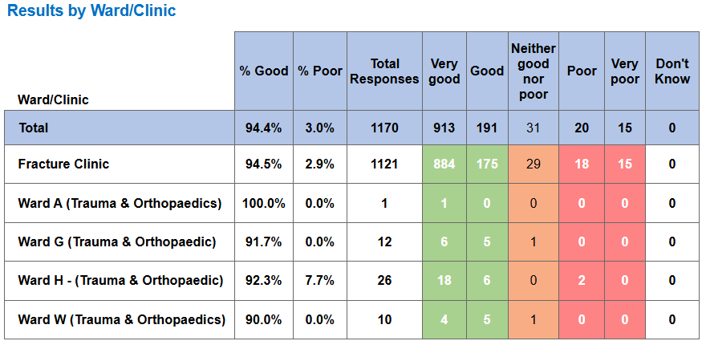

Top themes for Orthopaedic services:
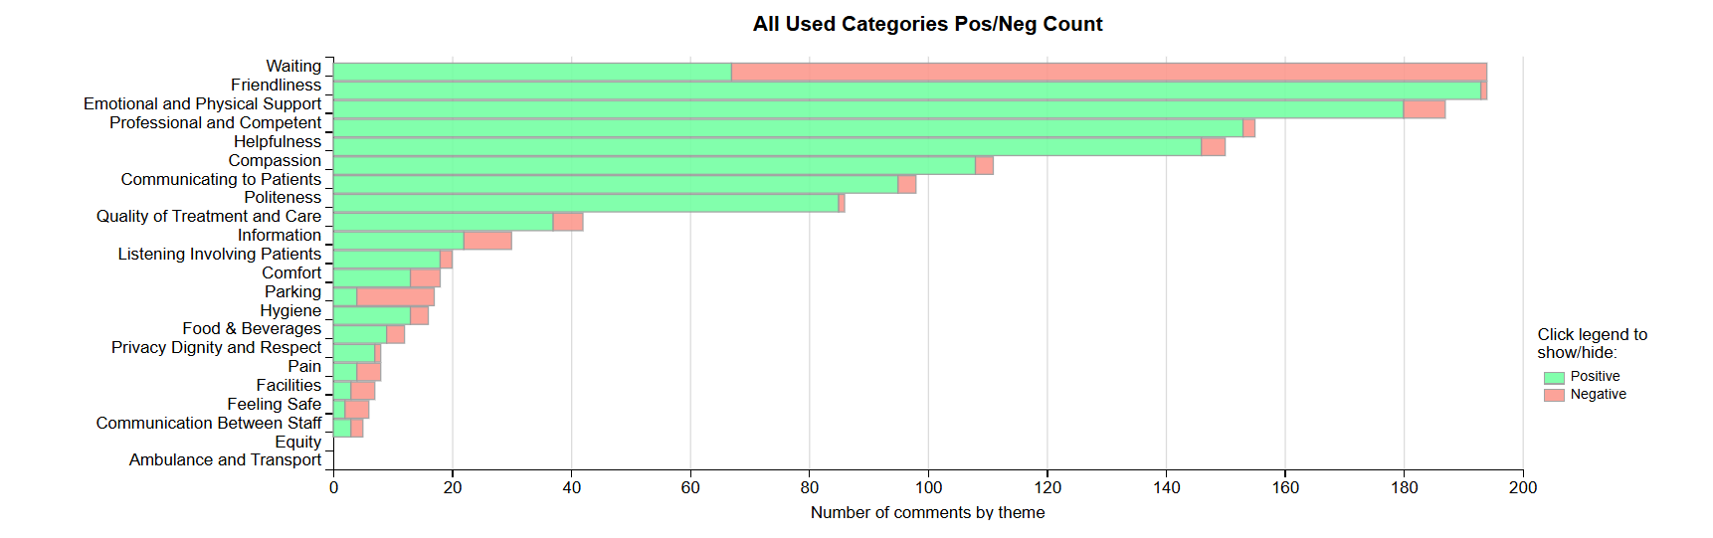

Emergency Department Complaints
During quarter 4, the Emergency Department received 44 complaints, this compared with 41 during quarter 3. A breakdown of the issues raised in quarter 4 is below;

The 27 ‘clinical treatment/assessment’ complaints mainly relate to delays in treatment or assessment.
Patient Experience Feedback: Emergency Department Services
In Quarter 4, the department received 953 Friends and Family Survey responses, with an overall score of 64%, showing a decrease in ‘very good’ ratings compared to quarter 3, when the score was 71%.
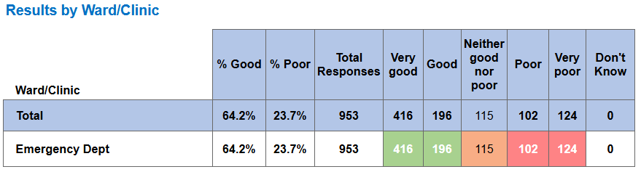

Below are the top themes for Emergency Department:
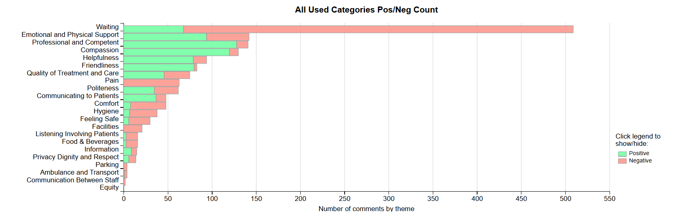
General Surgery Complaints
During quarter 4, General Surgery received 26 complaints. A breakdown of the issues is below;

Patient Experience Feedback: General Surgery
In Quarter 4, the service received 600 Friends and Family Survey responses and achieved an overall score of 97%. This is a slight decrease in ‘very good’ ratings compared to quarter 3, when the figure was 98%.
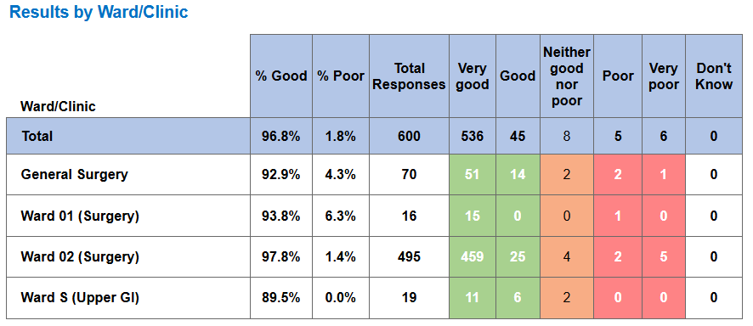

Below are the top themes for General Surgery services:
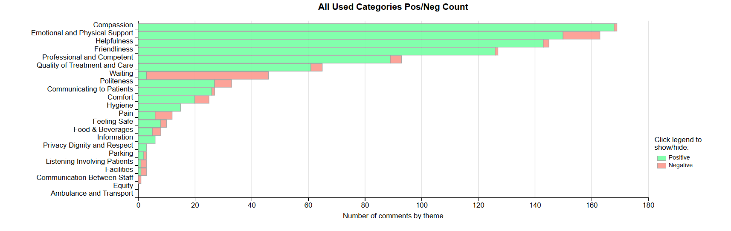

Cancer Service Complaints
As shown in graph 1 (above), there were no complaints relating to cancer services for the whole year of 2025/26.
Patient Experience Feedback: Cancer Services
In Quarter 4, the service received 823 Friends and Family Survey responses and achieved an overall score of 96%. This is a slight increase in ‘very good’ ratings compared to quarter 3, when the figure was 95%.
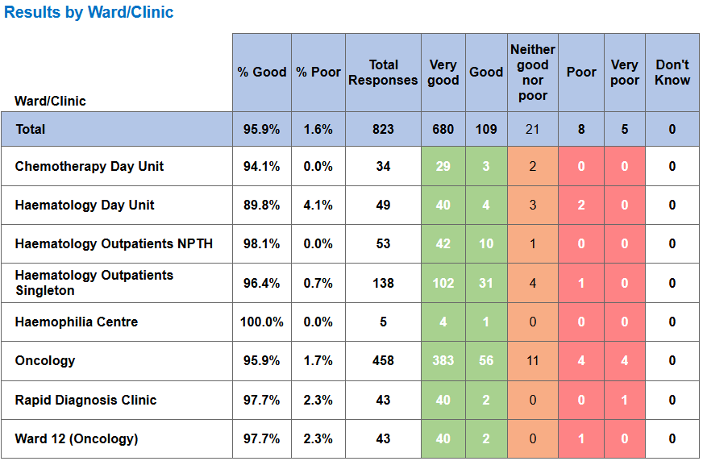
Below are the top themes for Cancer services:
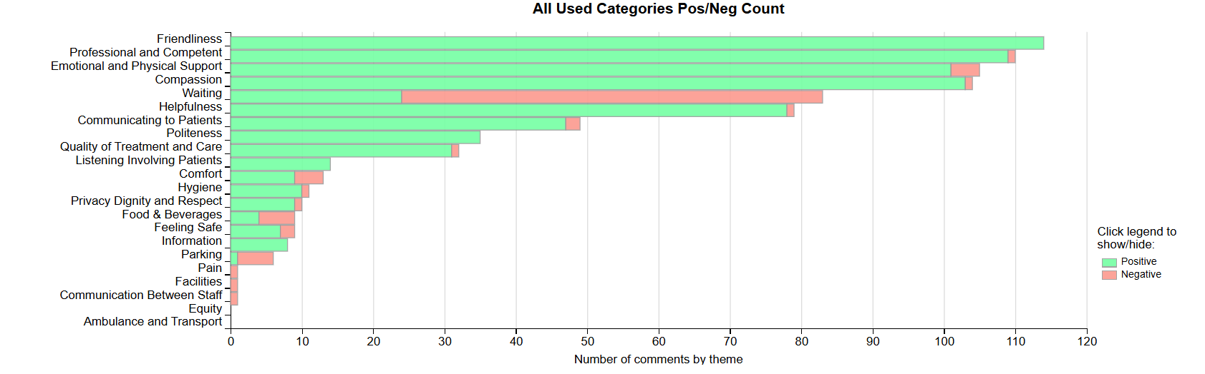

Mental Health and Learning Disabilities Complaints
During quarter 4, Mental Health and Learning Disabilities received 97 complaints. A breakdown of the top 10 areas these relate to is shown below;

Also below is a breakdown of the issues raised within these complaints:
Appointments | 18
Monitoring/Observation Issues | 18
Communication Issues (including Language) | 15
Medication | 13
Clinical treatment/Assessment | 7
Attitude and Behaviour | 5
Admissions | 4
Discharge Issues | 3
Environment/Facilities | 3
Patient Care | 3
Referral | 3
Access (to Services) | 1
Assault | 1
Cleanliness | 1
Personal Property/Finance | 1
Record Keeping | 1

Appendix 3 Service Group Data
MORRISTON SERVICE GROUP
Morriston Service Group complaints
Morriston Service Group received a total of 293 complaints during quarter 4. This compares with 292 complaints during quarter 3. Graph 1 below shows the total number of complaints received relating to Morriston Service Group since April 2025. The graph breaks the total number received down by formal Putting Things Right, Early Resolutions and re-opened complaints.
Graph 1: Morriston Service Group complaints by month and type

Graph 2 below shows the top five services that had the most complaints since April 2025.
Graph 2: Top 5 Services by month

As shown in the graph, there appears to be an increase in Emergency Department complaints in February and an increase in Neurology and General Surgery complaints in March. This has been addressed and action has been taken to improve patient experience.
Morriston Service Group Incidents
Morriston Service Group reported 2,427 incidents in quarter 4. This compares with 2,395 incidents in quarter 3. Graph 1 shows the number of incidents per month broken down by month and severity.
Graph 1: Morriston Incidents by Severity and month

Graph 2 (below) shows the top 5 incident types, of all incidents reported by Morriston Service Group in quarter 3 and quarter 4.
Graph 2: Top 5 incidents per month

Morriston Service Group National Reportable Incidents
Morriston Service Group reported 5 Nationally Reportable Incidents during quarter 4. These relate to 2 x Pressure Ulcers, 3 x Unexpected Deaths.
Nationally Reportable Incidents reported per month by Morriston Service Group

Morriston Service Group Compliments
Morriston received 83 compliments during quarter 4. Graph 1 shows the number received per month since January 2025.
Graph 1: Morriston compliments per month

Graph 2: Morriston compliments – Top 5 Services

Morriston Service Group Patient Experience Feedback
Overall, during quarter 4 a total of 115,314 patients were seen under Morriston Service Group (this includes the Emergency Department and Minor Injury Unit).

There were 10,298 Friends and Family survey returns which equates to 9% responding to the survey. Of the 9% who responded, 91% of people stated they would highly recommend the Health Board to Friends and Family.

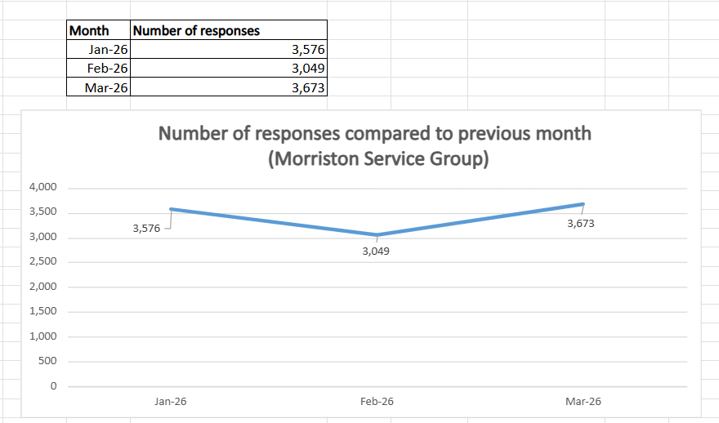

Below are the number of responses in a line graph:
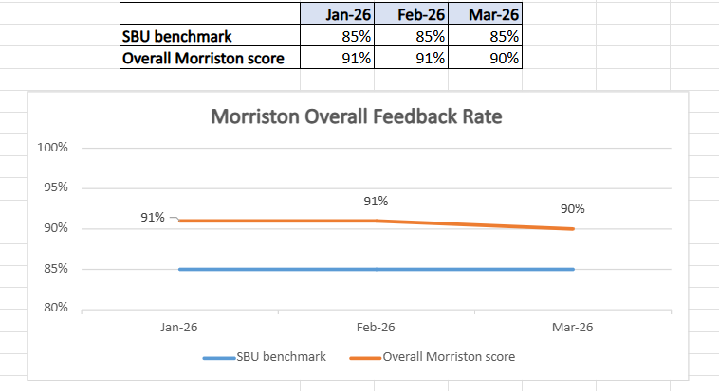

Below are the main themes mentioned for Morriston:
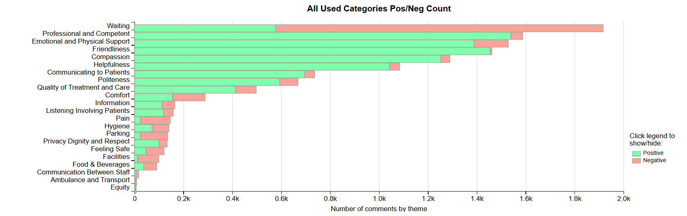

NEATH PORT TALBOT SINGLETON SERVICE GROUP
Complaints
Neath Port Talbot Singleton Service Group received a total of 232 complaints during quarter 4 which compares with 185 complaints during quarter 3. Graph 1 below shows the total number of complaints received relating to Neath Port Talbot Singleton Service Group since April 2025. There appears to be an increase in February 2026 compared to previous months. The graph breaks the total number received down by formal Putting Things Right, Early Resolutions and re-opened complaints.

Graph 1: Neath Port Talbot Singleton Service Group Complaints by month and type

Graph 2 shows the top five services that had the most complaints since April 2025.
Graph 2: Top 5 Services by month

As shown in the graph, there appears to be an increase in Orthopaedic and Gynaecology complaints received in February which would contribute to the overall increase to Neath Port Talbot Singleton Service Group complaints received in quarter 4.
Neath Port Talbot Singleton Service Group Incidents
Neath Port Talbot Singleton Service Group reported 1,628 incidents in quarter 4. This compares with 1,438 incidents in quarter3. Graph 1 shows the number of incidents reported since January 2025 broken down by month and by severity.
Graph 1: Neath Port Talbot Singleton Service Group Incidents by Severity and Month

Graph 2 shows the top 5 incident types, of all incidents reported by Neath Port Talbot Singleton Service Group during quarter 4.
Graph 2: Top 5 incidents per month

Neath Port Talbot Singleton Service Group National Reportable Incidents
Neath Port Talbot Singleton Service Group reported 12 Nationally Reportable Incidents during quarter 4. This compares to 8 during quarter 3. Of the Nationally Reportable Incidents reported these relate to 4 x Pressure Ulcers, 1 x Fall, 1 x Stillbirth, 3 x neonatal death and 1 x Clinical Assessment Not completed, 1 x treatment / procedure issue, 1 x failure to discontinue treatment.

Graph 1: Nationally Reportable Incidents reported per month by Neath Port Talbot Singleton Service Group

Neath Port Talbot Singleton Service Group Compliments
Neath Port Talbot Singleton Service Group received 36 compliments during quarter 4, compared with 49 during quarter 3. Graph 1 shows the number received per month since April 2025.
Graph 1: Neath Port Talbot Singleton Service Group compliments per month

Graph 2: Neath Port Talbot Singleton Service Group compliments – Top 5 Services

Neath Port Talbot Singleton Service Group Patient Experience Feedback
Overall, during quarter 4 there were 114,061 patients seen under Neath Port Talbot and Singleton Service Group.

There were 6,662 Friends and Family survey returns which equates to 6% responding to the survey. Of the 6% who responded, 94% of people stated they would highly recommend the Health Board to Friends and Family during this quarter.

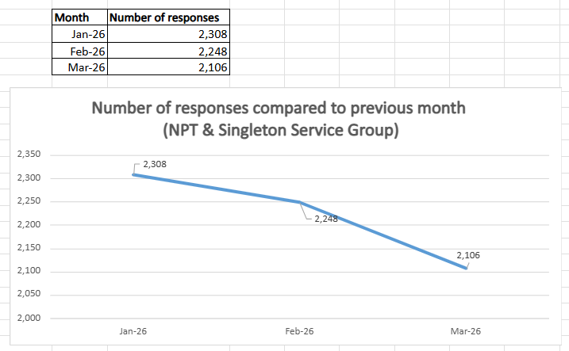

Below are the number of responses in a line graph:
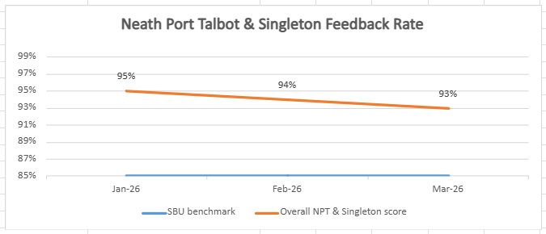
Below are the main themes mentioned for NPT & Singleton:
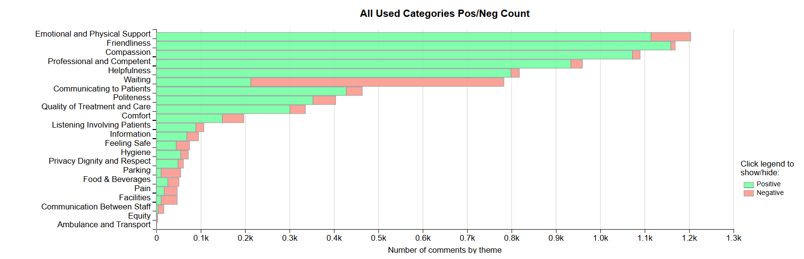

MENTAL HEALTH AND LEARNING DISABILITIES SERVICE GROUP
Mental Health and Learning Disabilities Complaints
Mental Health and Learning Disabilities received a total of 97 complaints during quarter 4 compared with 89 complaints during quarter 3. Graph 1 below shows the total number of complaints received relating to Mental Health and Learning Disabilities since April 2025. The graph breaks the total number received down by formal Putting Things Right, Early Resolutions and re-opened complaints.

Graph 1: Mental Health and Learning Disabilities complaints by month and type

As you can see from the graph, Mental Health and Learning Disabilities had an increase in complaints during June. This was due to multiple complaints being received from one complainant who is known to the service.
Graph 2 shows the top five areas within Mental Health and Learning Disabilities that had the most complaints since April 2025.
Graph 2: Top 5 Services by month

Mental Health and Learning Disabilities Incidents
Mental Health and Learning Disabilities reported 874 incidents in quarter 4. This compares with 871 incidents in quarter 3.
Graph 1 shows the number of incidents per month broken down by severity since January 2025.
Graph 1: Mental Health and Learning Disabilities Incidents by Severity and month

Graph 2 shows the top 5 incident types, of all incidents reported by Mental Health and Learning Disabilities in quarter 4 and quarter 3
Graph 2: Top 5 incidents per month

Mental Health and Learning Disabilities National Reportable Incidents
Mental Health and Learning Disabilities reported 3 Nationally Reportable Incidents during quarter 4, compared with 2 during quarter 3.

Mental Health and Learning Disabilities Compliments
Mental Health and Learning Disabilities received 3 compliments during quarter 4. Graph 1 shows the number received per month since April 2025.
Graph 1: Mental Health and Learning Disabilities compliments per month

Mental Health and Learning Disabilities Patient Experience Feedback
This data is from quarter 4.

The Mental Health and Learning Disabilities Service Group are using a different set of survey questions. The role out of the semi structured interview surveys have been managed in stages. Roll out, awareness posters and meetings with managers and teams continues.
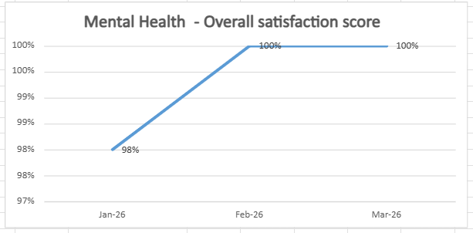

Below are the number of responses in a line graph:
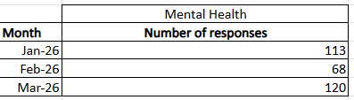

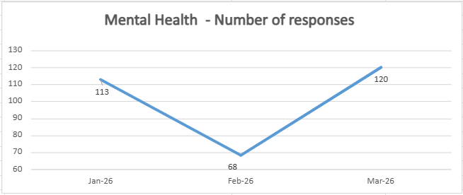

PRIMARY, COMMUNITY AND THERAPIES SERVICE GROUP
Primary, Community and Therapies Complaints
Primary, Community and Therapies received a total of 89 complaints during quarter 4 compared with 68 complaints during quarter 3. Graph 1 below shows the total number of complaints received relating to Primary, Community and Therapies since April 2025. There appears to be an increase in Early Resolution complaints and a decrease in formal complaints received in February and March. The graph breaks the total number received down by formal Putting Things Right, Early Resolution and re-opened complaints.
Graph 1: Primary, Community and Therapies complaints by month and type

Graph 2 shows the top five services that had the most complaints since April 2025.
Graph 2: Top 5 Services by month

From the graph it is evident that the number of Prison complaints has decreased over the last six months. The Prison Service send complaints to the Health Board retrospectively in batches therefore, it is likely there will be an increase again in the coming months.
Primary, Community and Therapies Incidents
Primary, Community and Therapies reported 1,117 incidents in quarter 4. This compares with 1,078 incidents in quarter 3. Graph 1 shows the number of incidents per month broken down by severity since January 2025.
Graph 1: Primary, Community and Therapies Incidents by Severity and month

Graph 2 shows the top 5 incident types, of all incidents reported by Primary, Community and Therapies since January 2025.
Graph 2: Top 5 incidents per month

Primary, Community and Therapies National Reportable Incidents
Primary, Community and Therapies reported 2 Nationally Reportable Incidents during quarter 4, which compares to 3 reported during quarter 3. Nationally Reportable Incidents reported in quarter 4 include 2 x pressure damage incidents.

Graph 1: Nationally Reportable Incidents reported per month by Primary, Community and Therapies

Primary, Community and Therapies Compliments
Primary, Community and Therapies received 96 compliments during quarter 4, compared with 84 during quarter 3. Graph 1 shows the number received per month since April 2025.
Graph 1: Primary, Community and Therapies compliments per month

Graph 2: Primary, Community and Therapies compliments – Top 5 Services

Primary, Community and Therapies Patient Experience Feedback
During quarter 4, a total of 1,082 patients were seen under the Primary, Community and Therapies Service Group.

A total of 1,992 Friends and Family survey responses were received during this quarter, with 93% of respondents stating they would highly recommend the Health Board to their friends and family.

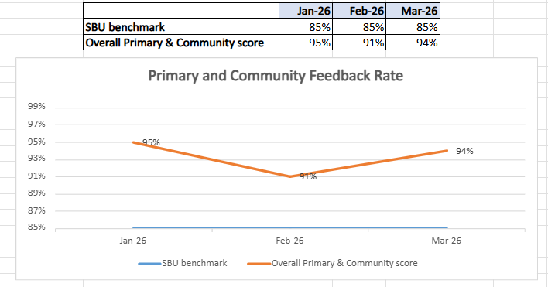

The Corporate Patient Experience Team are currently working with Digital Services to automate SMS messages from the Patient Information Management System (PIMS) platform to automate SMS survey messages to Primary, Community and Therapies patients. This should increase the number of returns.

Below are the number of responses in a line graph:

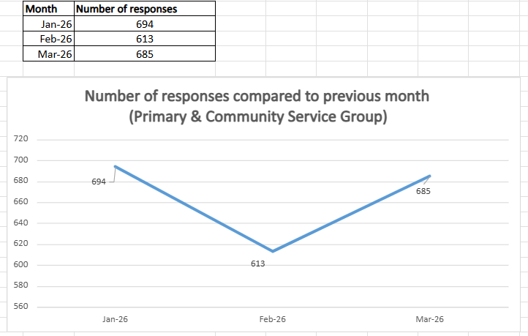
Below are the main themes mentioned for Primary, Community and Therapies:
