Meeting Date | 29 October 2024 |  | Agenda Item |  |  | 3.6
Report Title | SBUHB Integrated Discharge Strategy 2024
Report Author | Helen StJohn, Head of Integrated Community Services and Emily Warren, Associate Director of Operations – PCTSG
Report Sponsor | Deb Lewis, Chief Operating Office
Presented by | Craige Wilson, Deputy COO / Interim Service Group Director – PCTSG  Emily Warren, Associate Director of Operations – PCTSG
Freedom of Information | Open
Purpose of the Report | To provide assurance on the processes around discharge planning and specifically progress against the Integrated Discharge strategy, which commenced in May 2024.
Key Issues | The Integrated Discharge strategy, is comprised of four programmes, designed to drive forward rapid and sustainable improvements to the discharge process, reducing LOS and reducing the number of clinically optimised patients.  The strategy is comprised of:  - Programme 1: Integrated Discharge Hub  - Programme 2: Refreshed Pathways of Care Action Plan  - Programme 3: Home First Operational Improvement Plan  - Programme 4: Refreshed COP process
Specific Action Required  (please choose one only) | Information | Discussion |  | Assurance | Approval
Specific Action Required  (please choose one only) | ☒ | ☒ |  | ☐ | ☐
Recommendations | The Committee is asked to take assurance from the report that discharge planning remains a key focus for the Health Board and that progress is being made.

Integrated Discharge Strategy

- INTRODUCTION
This paper provides an updated overview of the Integrated Discharge Strategy (IDS) and its progress towards its objectives. Established in May 2024 on a resource neutral basis, it supersedes previous strategies on discharge planning, The objective of the strategy is to support the delivery of the UEC Six Goals Programme through improved discharge planning achieving a sustainable reduction in the number of Clinically Optimised Patients (COP) and their prolonged length of stay (LOS).
The Integrated Discharge Strategy is led by Primary, Community and Therapies Service Group (PCTSG) in partnership with acute Service Groups, social care and third sector. It is predicated on the SBUHB ‘one system approach’.
This paper provides assurance on the specific programmes within the Integrated Discharge Strategy including:
- Programme 1: Integrated Discharge Hub
- Programme 2: Refreshed Pathways of Care Action Plan
- Programme 3: Home First Operational Improvement Plan
- Programme 4: Refreshed COP process
The strategy is supported by robust governance and a collaborative approach to improvement. It has been developed working in partnership with Local Authorities and Neath & Swansea Councils for Voluntary Services (CVS). The strategy is predicated on best practice and a networked approach enabling learning and best practice to inform the approach in SBUHB and ensure improvement is achieved at pace.
In October, a multidisciplinary team gathered to carry out a length of stay audit across Morriston, Singleton, Neath Port Talbot, and Gorseinon. While the findings and recommendations are not yet available, they are expected to inform and support the ongoing workstreams within each programme.
- BACKGROUND
This paper provides updated assurance on the ongoing activity and progress made by the Integrated Discharge Strategy since its launch in May 2024.
Activity has been focused on developing a robust multi agency process to discharge planning, with better alignment of existing resources and delivery of Discharge to Recover and Assess (D2RA) principles, predicated on reducing assessments which take place on the acute hospital site. with a clear expectation that proportionate assessment is delivered across the hospital sites.
Programme 1: Integrated Discharge Hub
‘One Patient, One Form, One Process’
The Integrated Discharge Hub (IDH), which launched on July 8th 2024, is part of continuous improvement work to support the Six Goals Programme, and improve discharge processes into community services. Led by PCTSG and delivered in collaboration with Morriston Hospital and UEC leads, IDH was launched in phases, with the IDH being a single point of access for all ward referrals for primary and community services. This alleviates expectations and pressure on ward staff and deliver a coherent model of discharge management as part of the ‘One System’ approach across SBUHB. This will enable improved risk management, improved flow and a tighter grip on capacity and demand management, to support future community service redesign.
The Hub outputs are measured through a set of key performance indicators (KPIs), reviewed at weekly assurance meetings. With phases 1 and 2 now complete, the IDH is able to demonstrate the following impact:
- 100% of individuals discharged on correct D2RA pathway since start in June. This has improved by 30% (Approx. 144 patients with improved LOS/ Safer discharge)
- Time between individual declared COP and referral onwards to appropriate service for discharge reduced by 69% (1st week 2.2 days/now reduced to 0.7 days)
- Average referrals =60 per week – reduction =1.5 days x 60 =90 Bed days removed from total average LOS per week for D2RA pathways.
- 100% referrals for discharge deemed appropriate from Week 1 due to MDT decision making model

Looking ahead to phase 3, an all site roll out has been agreed in principle to operate a Hub and spoke approach, with the functions of the IDH extended to coordination of discharge planning. This requires identifying suitable workforce resource to operate as an Integrated Discharge Team within the Hub. It is expected that the full role out and extended functions as part of a Phase 3, will be live by early December.

For the period July to August, the IDH is able to demonstrate breadth and growth:

Table 1: IDH Ward Referral Breakdown

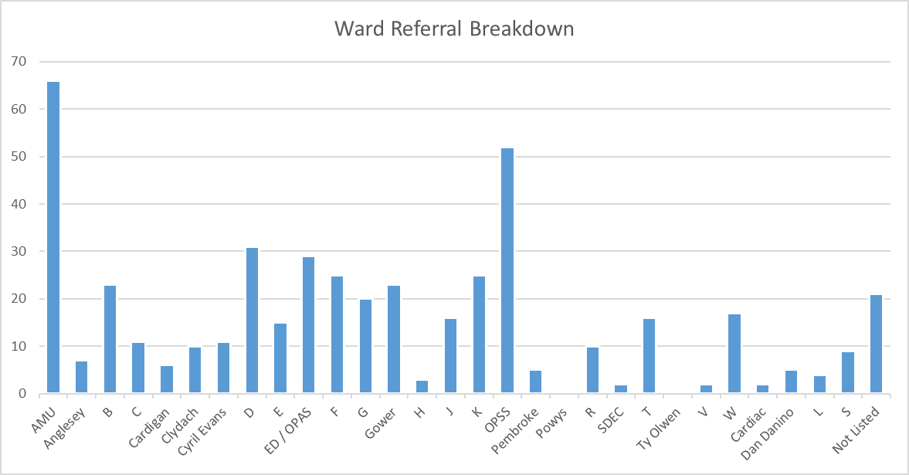

Table 2: IDH Referrals by Week

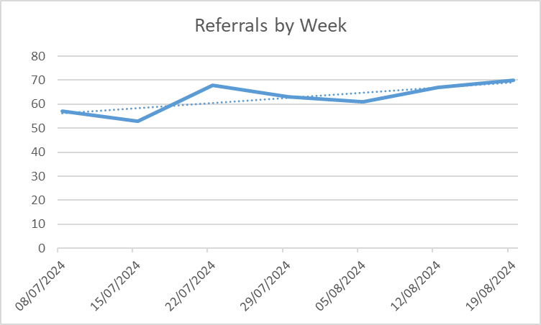

Against its performance metrics, the IDH can demonstrate the following:

- Measure 10 - 100% of referrals have been accepted by receiving community services indicating the IDH are referring onwards to the appropriate services with full information provided to accept the referral.
- Measure 11 - The average time between referral to the IDH and referral onwards to receiving service is 17.87 hours (Due to incomplete info received)
- Measure 12 - The average time between individual being declared COP and referral to the IDH is 89.41 hours (3.7 days)
- Measure 13 - Contact response function achieved within target of one working day 100% of the time
- Measure 14 - 84.16% of referrals to the IDH are referred onwards to appropriate service within one working day. The remaining 15.84% that were delayed are broken down below.
- Measure 15 - 100% of patients referred to community services were placed on the correct pathway. This is a 23% increase in patients placed on the correct D2RA pathway in comparison to pre IDH.
- Measure 16 - Average length of time between referral to the IDH and discharge from hospital is 99 hours

Table 3: IDH Referrals Discharged
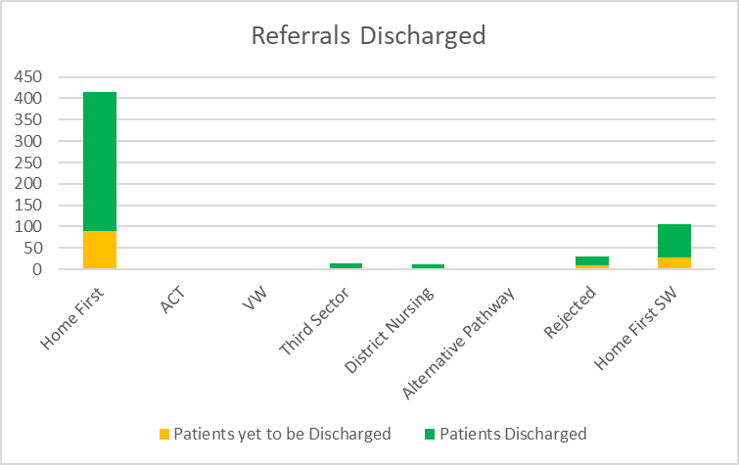
Programme 2: Refreshed Pathways of Care Delays (PoCD) Action Plan

Monthly PoCD action plans continue to be submitted to Welsh Government, with fortnightly assurance meetings providing scrutiny to drive forward progress on reducing unnecessary delays, as required by Welsh Government. Led by PCTSG the programme has implemented refreshed governance and accountability structures.

Against a benchmark of March 2024, SBUHB has been tasked with reducing Total POCD delays by 15% by November, Assessment Delays by 20% and Total Days Delayed by 20%.

September’s Total Days Delayed metric saw a fall of 1,835 days (14,209 to 12,374), making it the third consecutive month that the difference to trajectory has narrowed. It was also the fifth consecutive reduction, leaving the metric 225 days behind the trajectory to November’s target.

After a period where Total Delays was tracking the trajectory to target, two consecutive monthly increases sees the metric rise to 42 delays behind the trajectory.

Table 4: POCD Delays & Welsh Government Trajectory (15% Reduction)

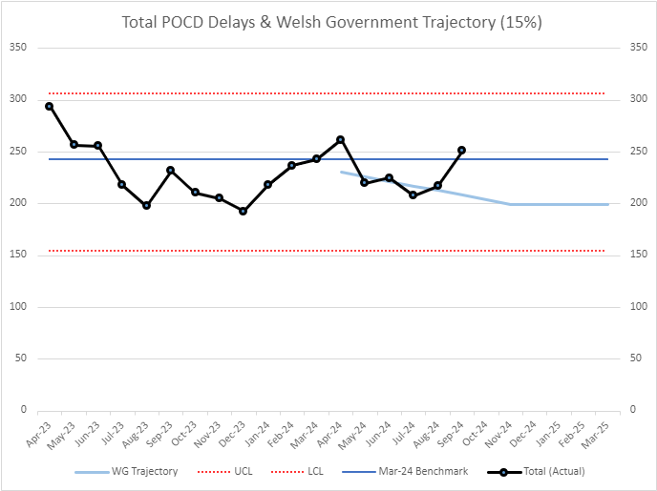

Total Delays is strongly correlated with Assessment Delays, and three consecutive monthly increases sees the metric 41 behind the trajectory.

Table 5: POCD Assessment Delays & Welsh Government Trajectory (20% Reduction)

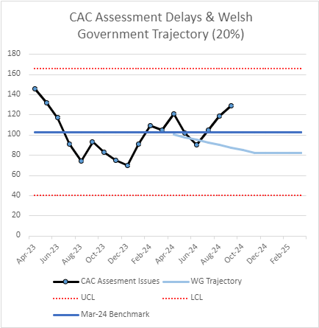

The latest plan continues to feature actions that address assessment delays. Most notably, the lead for MCA and DOLS is now involved in progressing targeted training sessions, as well as feedback mechanisms to address poor quality. Also, a Working Group is exploring how to use relations with Hengoed Court as a Trusted Assessor model, and how it can be replicated with other third parties (Hengoed Court: 23.6 days COP to discharge Vs 50.2 for rest of care homes)

Table 6: Pathway 3 Average Days from COP until Discharge Jul – Sept 2024

Programme 3: Home First (HF) Operational Improvement Plan

The Home First Operational Improvement Plan continues to be active in support the wider IDS and particularly PoCD trajectories. The objective of the programme is to build sustainability into the service, improve productivity and enhance patient flow.

The plan has five elements, each with agreed GMO’s and which are reviewed at weekly operational accountability meetings:

1. Performance/ Productivity

2. Quality Improvement

3. Workforce sustainability

4. Communications

5. Digital/Data Infrastructure

Immediate priorities remain progressing joint activity between HF/POCD programme team to scope Trusted Assessor delivery model. The plan is also active in exploring advancing professional standards through SOP’s/SLA’s/MOUs with services and external agencies with a view to improving flow (i.e. housing, community equipment).

Following a workshop with Welsh Government on October 7th, all 56 POCD codes will be reviewed and aligned to the appropriate Home First theme to ensure a clear route of escalation for delays.

Programme 4: Clinically Optimised Patient Management (COP)

To support the current Targeted Intervention programme for UEC, the current COP process has been reviewed and refreshed, to ensure the grip and control needed to support a sustained improvement in the reduction of COPs.

Daily COP meetings have been refreshed, focusing on individual wards, prioritising medicine as that is where the majority of our COP pts are sitting. The expectation at these meetings is that they are solution focused, staff attending have up to date overview of where the patient is in relation to the plan for their discharge. There is a weekly open door COP meeting and an option to stand up focused meetings if individual areas are experiencing particular problems in the timely discharge of patients to their next destination.

Refreshed monthly site-wide COP meetings have been implemented and are focused on capturing PoCDs / reason in bed data, providing reliable, cleansed data to WG. The bi-weekly meeting will be attended by health and local authority partners, plus or minus other agencies as appropriate and an action log kept to maintain traction on actions agreed at the site meeting.

In addition, two wards (D and E) on the Morriston site have been incorporated into the UEC directorate and are managed by the frailty team. This allows for flow from the Older Person Assessment Unit (OPAU) and the Older Persons Short Stay Unit (OPSS) when admission is unavoidable and allows for focused intervention to prevent extended LOS and deconditioning. There is a focus on a 10 day LOS or less and clear escalation points to ensure this is achieved.

Taken together the refreshed process, provides rigour into the system, allowing a clear overview of COP patients, ensuring that their care requirements remain the same and that we are not over commissioning services that we no longer require.

Table 7: Average Length of Stay (Inpatients)

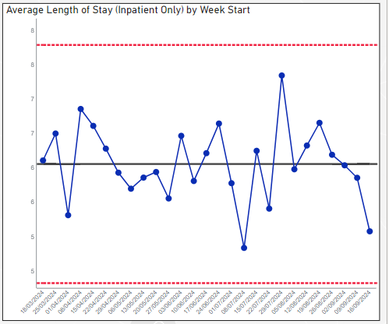

- GOVERNANCE AND RISK ISSUES

None identified.

- FINANCIAL IMPLICATIONS

None identified.

- RECOMMENDATION
The Committee is asked to take assurance from the report that discharge planning remains a key focus for the Health Board and that progress is being made.

Governance and Assurance

Link to Enabling Objectives  (please choose) | Supporting better health and wellbeing by actively promoting and empowering people to live well in resilient communities
Link to Enabling Objectives  (please choose) | Partnerships for Improving Health and Wellbeing |  | ☒
Link to Enabling Objectives  (please choose) | Co-Production and Health Literacy |  | ☒
Link to Enabling Objectives  (please choose) | Digitally Enabled Health and Wellbeing |  | ☐
Link to Enabling Objectives  (please choose) | Deliver better care through excellent health and care services achieving the outcomes that matter most to people
Link to Enabling Objectives  (please choose) | Best Value Outcomes and High Quality Care |  | ☒
Link to Enabling Objectives  (please choose) | Partnerships for Care |  | ☒
Link to Enabling Objectives  (please choose) | Excellent Staff |  | ☒
Link to Enabling Objectives  (please choose) | Digitally Enabled Care |  | ☒
Link to Enabling Objectives  (please choose) | Outstanding Research, Innovation, Education and Learning |  | ☐
Health and Care Standards
(please choose) | Staying Healthy |  | ☒
(please choose) | Safe Care |  | ☒
(please choose) | Effective Care |  | ☒
(please choose) | Dignified Care |  | ☒
(please choose) | Timely Care |  | ☒
(please choose) | Individual Care |  | ☒
(please choose) | Staff and Resources |  | ☒
Quality, Safety and Patient Experience
All proposals are in line with required Quality and Safety standards. A specific
emphasis on patient outcomes has been rooted into the IDS.

Financial Implications
None at this point
Legal Implications (including equality and diversity assessment)
None at this point.
Staffing Implications
Staffing considerations for phase 3 of the IDH are still being finalised, however the realignment of resource across all sites based on demand and capacity may require an OCP. Any realignment, if approved by UEC Board, would be done through appropriate engagement and consultation.

Long Term Implications (including the impact of the Well-being of Future Generations (Wales) Act 2015)
The IDS aligns with the five ways of working and is predicated on improved wellbeing, sustainability within services alongside collaboration and co-production with staff and external partners.
Report History |  | N/A
Appendices |  | Supporting information to the report should be listed here.

