Swansea Bay University Health Board

Patient Experience
&
Concerns Report
Quarter 2 2024/25

CONTENTS
Report Summary | Page 2
Complaints | Page 4
Complaint Themes | Page 6
Highlight Areas | Page 11
Nutrition & Hydration | Page 30
Morriston Service Group | Page 3
Neath Port Talbot Singleton Service Group | Page 39
Mental Health & Learning Disabilities Service Group | Page 44
Primary and Community Service Group | Page 49
Medical Examiners Compliments | Page 54
Ombudsman Cases & Learning | Page 55
Report Summary and Overview
COMPLAINTS | Jul | Aug | Sep
Total number of complaints received | 217 | 185 | 175
Complaints acknowledged within set timescale | 100% | 100% | 100%
Number of re-opened complaints | 7 | 4 | 3
 | May | Jun | Jul
Complaints responded to within agreed timescale - formal | 73% | 70% | 66%
OMBUDSMAN | Jul | Aug | Sep
Number of Ombudsman Investigations received | 1 | 1 | 1
Number of actions outstanding (within timescale | 3 | 3 | 3
Number of actions overdue | 0 | 0 | 0
PATIENT EXPERIENCE | July | Aug | Sept
No. of Friends & Family surveys received | 6,071 | 5,006 | 5,556
Recommendation score | 93% | 93% | 92%
New Bespoke Surveys | 1 | 3 | 1
NATIONAL REPORTABLE INCIDENTS | Jul | Aug | Sep
Number of National Reportable Incidents reported | 5 | 7 | 8
Number of Never Events | 1 | 0 | 0

Successes | Priorities
Complaints;  - Improvement in Ombudsman variance data – responses and compliance being sent within target date  Patient Experience;  - The overall satisfaction score for this quarter is 93%  - The National Covid19 survey closed in July Summary report sent to nosocomial leads in SBU.  - New all Wales outpatients Childrens survey developed and currently being added to the SMS platform.  - Pilot Visiting survey for NPT. SBU received 300 responses. The summary report has been sent to SBU visiting leads. | Complaints;  - Working with the Service Groups and meeting regularly to discuss their longest open complaints to improve the overall performance  Patient Experience;  - We are presenting the upcoming new Peoples Experience framework – sharing the changes nationally/new scoring/ self-assessment toolkit, across the organisation, management board, service groups etc. The actual release of the WHC is like to be later October , with soft launch April 2025.
Opportunities | Risks & Threats
Complaints;  - Train the trainer session with the Ombudsman trainer being held in Cardiff 13th November, this will support the roll out of complaints and communication training throughout Heath Board.  Patient Experience;  - Working with neonatal teams to develop the neonatal local survey, this is a temporary survey while we wait for the national neonatal and maternity survey currently being developed with All Wales T&F group and Once For Wales (OFW).  - Working with Radiotherapy teams to add them to the SMS platform for capturing feedback.  - Met with Looked after Children (LOC) lead to update her on the National survey work being undertaken by the NHS executive. No start date or formulated survey yet. | Complaints;  - The increase in complex complaints.  - Number of overdue complaints  Patient Experience;  - The National Beacon Dashboard which hosts the All Wales Emergency Department (ED) survey, there is ongoing discussion around the incorrect data being pulled from local systems and work continues to investigate this.  - The Digital story platform, ‘Movavi’ is coming to the end of its licence. Work is ongoing on the new platform called ‘Clip Champ’. Story facilitators will be updated, offered training.

- COMPLAINTS

1. Complaints performance –
The Health Board is committed to supporting patients, relatives, and carers in resolving their concerns. Our service is visible, accessible, and impartial, with every issue taken seriously. Our aim is to provide honest and open responses in a way that can be easily understood by the recipient.

1.1 Total complaints received

The Health Board received 577 complaints in quarter 2 (Q2) of 2024/25 (July, August, September). This compares with 518 complaints in quarter 1 (Q1) of 2024/25 (April, May June). This total includes complaints received and managed via either formal, early resolution and any re-opened complaints. Graph 1 provides a long-term view of complaints received per month.
Graph 1: Total number of complaints per month

Graph 2: Formal v Early resolution complaints per month

Graph 2 (above) shows complaints dealt with via the Formal Putting Things Right (PTR) investigation process compared with those dealt with via the early resolution investigation process, over the same period. We continue to deal with a higher proportion of complaints via the formal process, this is due to the tight timescale of two working days for early resolution complaints. Any early resolution that is not resolved within two working days, converts to a formal following guidance issued by Welsh Government.
1.2 Complaint responses within agreed timescale
Whenever a complaint is managed through the formal PTR process, the Health Board is required to investigate the complaint and write to the complainant with our findings, within 30 working days. If this target is not achievable, it is essential that the complainant is kept up to date throughout and any delays are explained.

1.2.1 Formal Investigations
The Health Board’s target is to respond to at least 85% of formal complaints within the agreed timescale. Welsh Government also issue a target for all Health Board’s to achieve at least 75% each month.

Graph 3 shows the Health Board’s performance in responding to complaints since August 2023. The Health Board performance for July 2024 was 66%.
Graph 3: Percentage of formal complaints responded to within agreed timescale

1.3 Overdue complaints

The Service groups are actively working to reduce the number of complaints that have exceeded the 30 working day timescale which is a recommendation timescale within the ‘Putting Things Right Guidance on dealing with concerns about the NHS 2011.’

The Corporate complaints team monitor the overdue complaints and send out bi-weekly reports to each Service Group requesting updates.

1.4 Re-opened complaints
The Health Board aims to resolve all complaints within the first response however, there are times when the complainant remains dissatisfied or needs further clarification. If the complainant writes back to the Health Board expressing their dissatisfaction, the correspondence will be reviewed by the Corporate Complaints Team and a decision made as to whether the complaint should be re-opened. This may be when the complainant feels not all issues raised in the initial complaint have been addressed or if a meeting is required.

Graph 4 shows the number of re-opened complaints per month since October 2023.
Graph 4: Number of re-opened complaints by Service Group per month

The number of re-opened complaints appears to have decreased. The ethos for any complaint investigation is ‘Investigate once, Investigate well’.

2. Complaints Themes

2.1 – Themes - Health Board overview
Every complaint received by the Health Board is coded in the Datix Once for Wales system against the relevant subject codes. This allows the Health Board to identify any themes in the complaints received.

Table 1 provides a breakdown of complaints received by primary subject code in Q2 2024/25 compared with Q1 for 2024/25.

Table 1: Complaints by primary subject
Subject/Theme | Q1 2024/25 | Q2 2024/25
Communication Issues | 71 | 102
Appointments | 72 | 76
Clinical treatment/Assessment | 130 | 135
Admissions | 45 | 43
Attitude and Behaviour | 39 | 55
Medication | 36 | 26
Test and Investigation Results | 20 | 13
Referral | 16 | 15
Discharge Issues | 17 | 27
Environment/Facilities | 9 | 14
Monitoring/Observation Issues | 12 | 20
Equipment | 6 | 5
Personal Property/Finance | 3 | 4
Assault | 0 | 3
Confidentiality | 2 | 1
Consent | 4 | 5
Record Keeping | 0 | 1
Access (to Services) | 9 | 7
Accident/Falls | 5 | 8
Catering | 2 | 2
Cleanliness | 0 | 0
Infection Control | 2 | 1
Nutrition/Hydration Issues | 0 | 1
Other | 1 | 3
Patient Care | 0 | 0
Resources | 10 | 3
Skin Damage | 3 | 1
Privacy and Dignity | 3 | 2

Top theme; Clinical Treatment;
During Q2, 176 complaints were received regarding clinical treatment. A breakdown of the sub-subjects are below – please note, some complaints include more than one of these issues.
What we are doing about this?
- Outsourcing of patients to other Healthcare providers to help reduce waiting times.
- OCP theatres opened in NPT to reduce waiting times.
- Continuous Flow Model to help reduce delays and improve patient and staff experience.
- Unscheduled care summit for ED
Emergency Department. Patient Experience feedback for Quarter 2. The wordle below highlights mainly positive comments for ‘Professional & Competent’ while the negative comments are relating to ‘Waiting’
Positive Comments from Pt Exp report – The Patient Experience Team presented a Q2 Emergency Department report, highlighting positive feedback regarding the service provided by staff. The key themes identified were friendliness, supportiveness, and kindness..
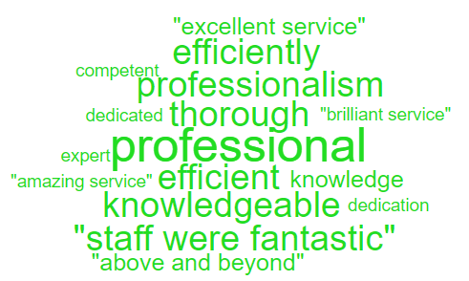
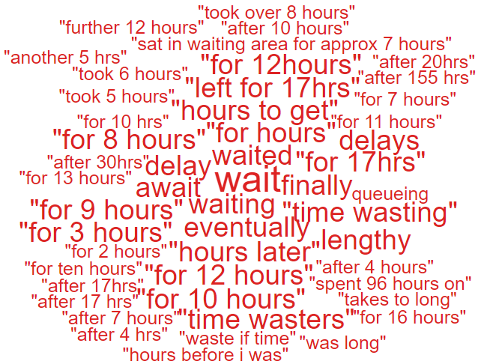
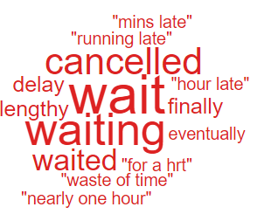
Clinical Treatment;
Delay/Lack of treatment or Assessment | 100
Incorrect/insufficient treatment or Assessment | 58
Reaction to procedure/ treatment | 22
Delay/Lack of diagnosis | 21
Incorrect diagnosis | 16

Theme 2; Communication;
Communication Improvement Plan;
- Face to face meeting being held in November 2024 with Ombudsman trainer to start roll out of complaints and communication training throughout the Health Board
- Training during consultant development programme where the importance of good and clear communication is discussed.
- Complaints/communication training sessions delivered by the Corporate team to Service Groups – this training is ongoing
- Focus training undertaken by Departmental Trainer – 55 sessions delivered since January 2024 which includes Duty of Candour training, Documentation and Managing Telephone/Visitor Aggression.

- Outpatient Department – Wordles relating to communication were mainly positive, there was one negative comment
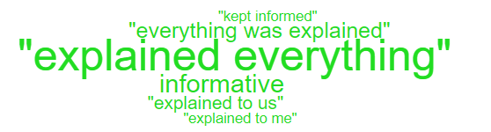


During Q2, 178 complaints were received relating to communication. A breakdown of the sub-subjects are below – please note, some complaints include more than one of these issues.
Communication Issues;
Insufficient/Incorrect information | 128
Communication with patient/service user | 13
Communication with family | 8
Communication with External Agencies or Other NHS Organisations | 2
Communication between Services/Departments | 1
Concerns relating to DNR decision | 1

Theme 3; Appointments;
What we are doing about this?
- Outsourcing of patients to other Healthcare providers to help reduce waiting times.
- Rapid Diagnostic Centre expansion.
- Expansion of our virtual wards to widen the range of disciplines involved, so increasing the number of patients who can be treated appropriately out of hospital
All Wales questions do not have ‘appointments’ as a question set. Therefore, as an alternative a search was undertaken on the words delay/delays/appointment.
Below are some comments we found relating to ‘appointments’ for Adult Mental Health:
- Merging the groups (Mondays) meant that not many people could talk as the numbers were so many

- I am feeling anxious that the Monday group has now been merged, I don't feel comfortable talking about my PTSD with the group now being merged. I am afraid I will trigger other people that have been merged from other groups that don't suffer with PTSD

- I suffer with terrible anxiety as well as being autistic, so the size of the group is the only drawback as at times it can be too many people at once, especially when our Monday group only lasts an hour so too short for everyone to speak and voice any difficulties or ask for advice. Thursdays seem to cope better with the higher volume of people, running more smoothly due being a 2hours window. I will say though that it has helped me learn new strategies for when it is busy/overwhelming!

- I was given the number of the Crisis team in Swansea. It took a few calls for them to pick up, but I have spoken to a lady there and have been sent some literature. I know someone is there so that was good.

During Q2, 88 complaints were received regarding appointment issues. Many of these complaints will have more than one sub-subject, see breakdown below;
Appointment Issues;
Delay in appointment/waiting time/transport | 47
Appointment cancelled | 23
Patient lost to follow-up | 13
Cancelled appointment/transport | 4
Capacity of clinics | 3
Continuity of staff | 1

- HIGH RISK AREAS

As part of the Health Board’s focus on Urgent Care, Planned Care and Cancer Services the following section highlights complaints received in:
- Orthopaedics
- ED
- General Surgery
- Cancer Services
- Mental Health
Graph 1 below shows the number of complaints for each of these areas received per month since October 2023.
Graph 1: Complaints per month
As you can see from the graph, the number of Orthopaedic complaints has decreased significantly which is likely to be as a result of the new theatres and the reduction in waiting lists. A breakdown of the issues raised in Q2 can be found below;

3.1 – Orthopaedic Complaint themes

Patient Experience Feedback: Orthopaedic Services
As Orthopaedics is classed as a ‘High Risk Area’, the Patient Experience Team have investigated the feedback for Orthopaedic Services. In total, Orthopaedic Services received 219 responses to the Friends and Family Survey during Quarter 2.

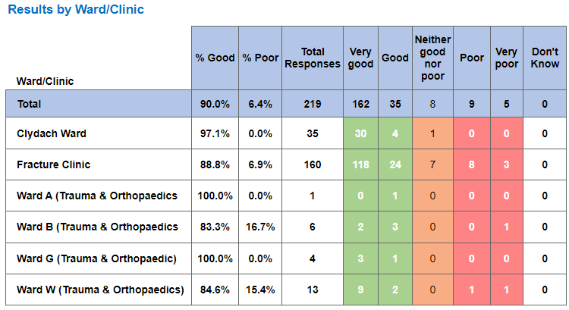

Below are the top themes for Orthopaedic services:
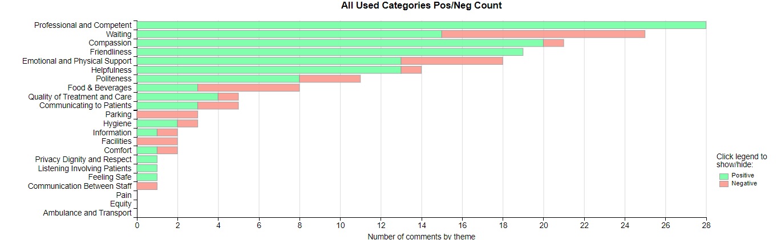

NB: The Civica system on occasions is oversensitive with the word ‘Pain’ and ‘Waiting’ and sometimes feeds these as a negative in charts and wordles. This is a national platform issue affecting all Health Boards. The overall satisfaction score is not affected by this.

Positive Theme
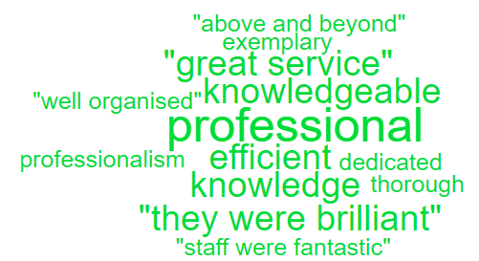
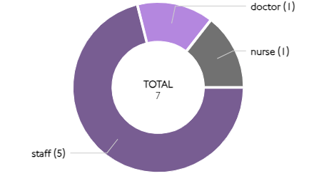
‘Professional & Competent’’ Sub themes ‘Professional’

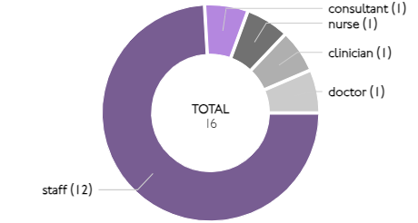
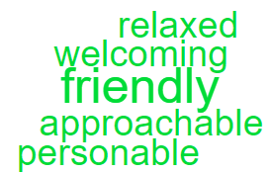
‘Friendliness’ Sub themes ‘Friendly’

Here are some of the positive comments we’d like to share:
- The Staff I met at Clydach Ward were all absolutely remarkable, professional caring and dedicated. Made my short stay a breeze. My Consultation was superb explaining my procedure and also side effects that I could experience. The Ward Staff on my discharge got me a pack of medicine and dressings and letters for my GP.

- All doctors and nurses were fantastic communication was excellent

- The service was very quick and efficient, and mostly professional.

- Professional, efficient and friendly service thanks

- Staff were really friendly and knowledgeable and dealt with me with respect and kindness

- This was the quickest appointment I've ever had. Checked in with receptionist then waited approximately 5 minutes before seeing consultant

Negative Themes

The chart above highlights a few areas relating negative feedback. Here is an in-depth breakdown of these areas.

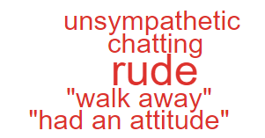
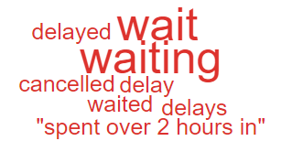
‘Waiting’ ‘Emotional & Physical Support’

These are the comments highlighted in the above ‘Wordles’.

- Waiting one and three-quarter hours past the appointment time without anyone having the courtesy to say anything. I appreciate you are busy, but it turns out that you had plenty of ancillary staff but will lacking in one key worker. It would’ve taken only a few moments to say were down a key person and there is a long delay

- Appointment was to discuss MRI results. No report had been completed so have to return again in 3 weeks. Ongoing issue since December and still waiting on answers.

- parking was a nightmare 40 minutes to park for a 3-minute appointment staff were very rude

- At the beginning after my surgery - excellent - could not fault. Staff extremely attentive. Later I was moved to another room and I felt isolated. Two nights running I was not given a wash bowl. Tablets were late. Foot atrocious. I had to ask for tablets. The physio & OT team excellent. Pain specialist rude. Domestic lady lovely. Enjoyed a chat and great company. All have provided me with ample tea

  - – ED Complaints
During Q2 of 2024/25, ED received 41 complaints, a breakdown of the issues is below;

The 10 ‘clinical treatment/assessment’ complaints all relate to delays in treatment or assessment.

Patient Experience Feedback: ED Services
As ED is classed as a ‘High Risk Area’, the Patient Experience Team have investigated the feedback for ED Services. In total, ED Services received 808 responses to the Friends and Family Survey during Quarter 2.

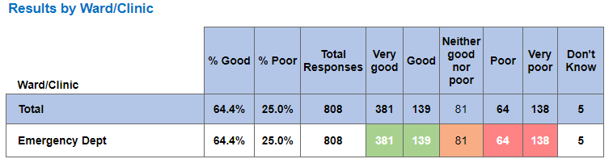

Below are the top themes for ED services:
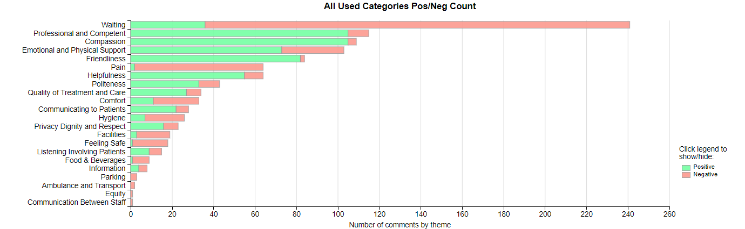

Positive Themes
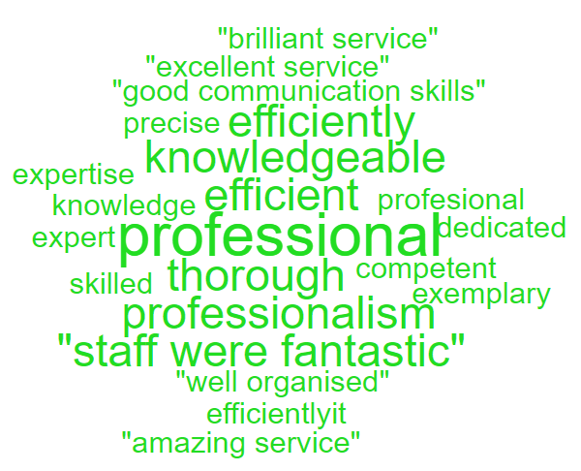
‘Professional & Competent’ Sub theme ‘Professional’
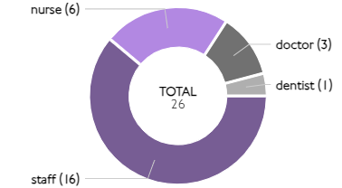

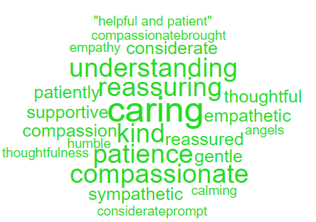
‘Compassion’ Sub theme ‘Caring’
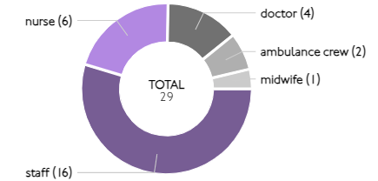

Here are some of the positive comments we’d like to share:
- The staff were excellent. Very attentive midwives and theatre staff, very caring attitude.

- Lovely staff, efficient, professional, was in and out in less than 2.5 hours. What a brilliant NHS. Thank you

- The doctor, who happened to be a consultant was excellent. Very thorough and didn’t rush me and was very pleasant.

- The Staff in OPAS was second to none. They couldn't do enough for me. I was greeted warmly and was treated with respect, and they sorted out my problem promptly

- Amazing staff working under so much pressure and extremely professionally.

- The staff were phenomenal and deserve every bit of recognition possible. They really are heroes each of them and should all be praised for their hard and dedicated work

Negative Themes
‘Waiting’
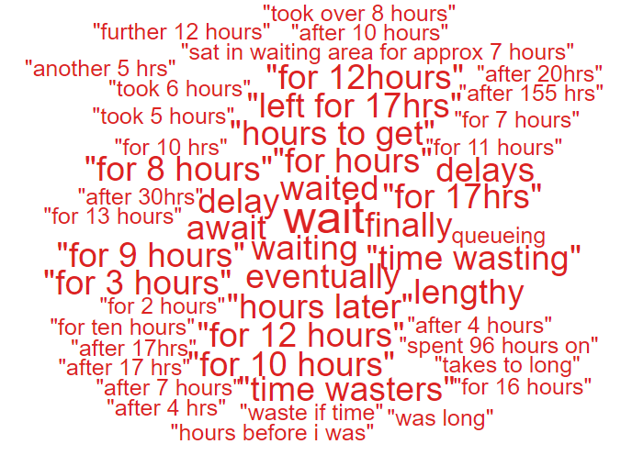

NB: The Civica system on occasions is oversensitive with the word ‘Pain’ and ‘Waiting’ and sometimes feeds these as a negative in charts and wordles. This is a national platform issue affecting all Health Boards. The overall satisfaction score is not affected by this.
Here are the negative comments relating to ED:
- 8 hours wait no examination just morphine and home.
- A 5 hour wait for an ambulance for someone with chest pains and a shortage of breath is unacceptable.
- When I finally got treatment, it was the best. Staff were excellent hospital clean.
- Although the waiting time in A&E was lengthy the care I received from both clinical and ancillary staff was excellent. Everyone was courteous, kind and maintained their humour and patience under highly pressurised demanding and challenging work conditions.
- Nothing at all spent 96 hours on a chair waiting for a bed.

  - – General Surgery Complaints
During Q2 of 2024/25, General Surgery received 27 complaints, a breakdown of the issues is below;

Patient Experience Feedback: General Surgery
As General Surgery is classed as a ‘High Risk Area’, the Patient Experience Team have investigated the feedback for General Surgery Services. In total, General Surgery Services received 1,445 responses to the Friends and Family Survey during Quarter 2.
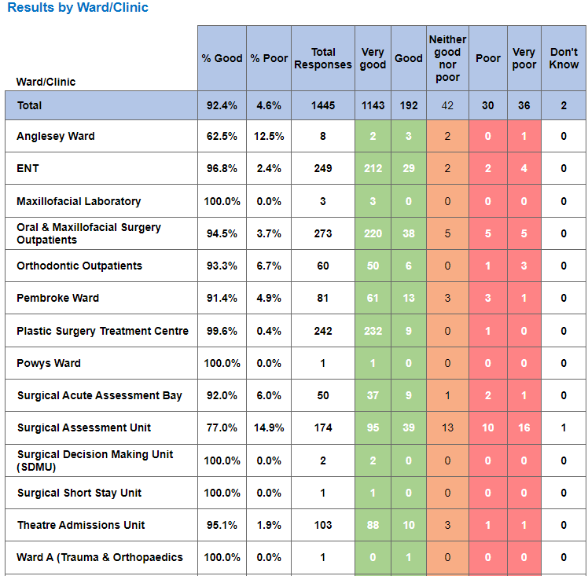
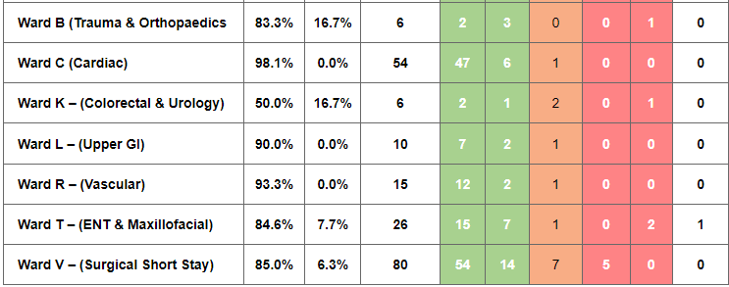
Below are the top themes for General Surgery services:
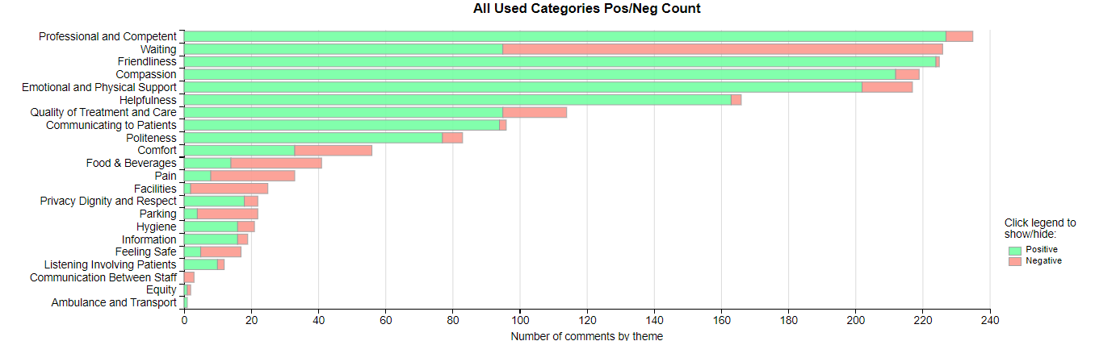
NB: The Civica system on occasions is oversensitive with the word ‘Pain’ and ‘Waiting’ and sometimes feeds these as a negative in charts and wordles. This is a national platform issue affecting all Health Boards. The overall satisfaction score is not affected by this.
Positive Themes
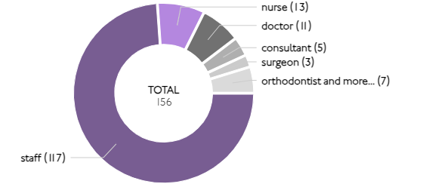
‘Friendliness’ Sub theme ‘ Friendly’
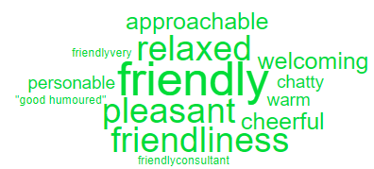

‘Professional & Competent’ Sub theme ‘ Professional’
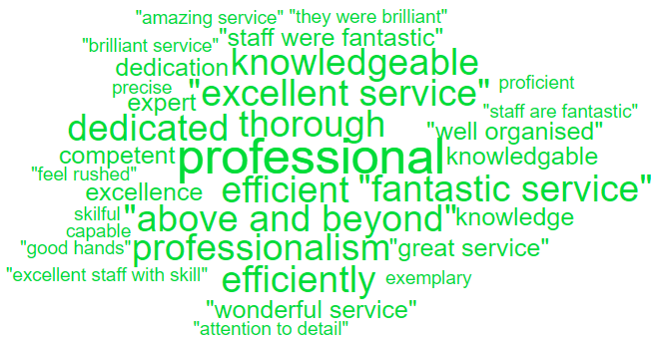
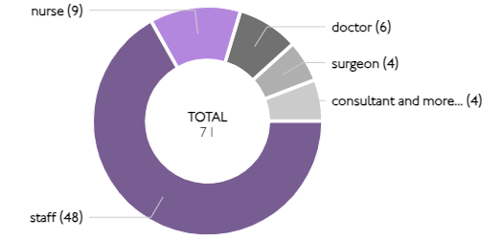

Here are some of the positive comments we’d like to share:
- The staff looking after me on ward c very helpful and good laugh making me feel happy when I am down

- Even though they were very busy everyone took the time to make sure that you were ok and well looked after

- The nurses who attended upon me were very professional, understanding and friendly. They were a credit to their department and the NHS as a whole

- The staff is friendly and very very kind. They took care of me in all the way. I completely recovered not only by the medication but also the love, kind and care of the staff.

- Care and attention from all staff, from reception through to surgeon. I felt cared for, supported and well informed throughout the procedure. The staff are a credit to the NHS. Thank you.

- The specialist and consultant were the loveliest people. They believed me about the pain the ulcers cause although they weren’t present in the app and actually helped me. They explained everything so well and ensure I left the appointment with answers. They went above and beyond to help me understand and made me feel so comfortable and relaxed through it all. Both were extremely polite and even ensures to explain how I would feel when I would need to take the medication. I came out of the appointment thinking finally people who care and believe me and will do anything to help. They ensured in the meantime whilst I wait to be referred to Cardiff that I had an emergency number for them and reassured me I could call anytime. Absolutely amazing service with both going above and beyond to put my health and wellbeing first. They are a prime example of outstanding workers that put the patient first. (I hope this makes sense as I have dyslexia) but I came out of the appointment and had teams in my eyes from feeling proud I was about to have an appointment with people who actually care and wanted me to understand everything. Absolutely fantastic humans!

Negative Themes

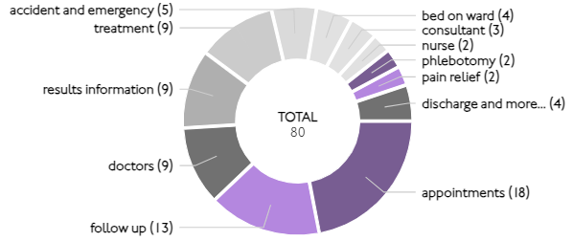
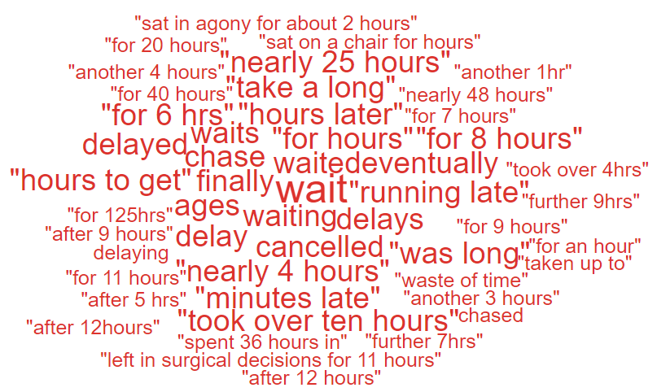
‘Waiting’ Sub theme ‘Wait’

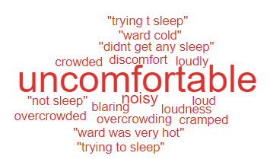
‘Comfort’

Below are some Negative comments relating to General Surgery:
- Felt uncomfortable being the only woman on the ward, however, I was glad of the bed and staff were great
- Treatment bays a bit cramped trolleys & chairs hard & uncomfortable for long waits
- Although the department were running late all the staff were very obliging
- The clinic was running late, and we could have been informed of that. it was only when a couple of people queried the wait someone checked at let us know
- Apart from 12 month wait for appointment all was good

  - – Cancer Services Complaints
Cancer complaints received in Q2 are relatively low with 7 received therefore, there are no major obvious themes however, 4 out of the 7 complaints include communication issues.

Patient Experience Feedback: Cancer Services
As Cancer is classed as a ‘High Risk Area’, the Patient Experience Team have investigated the feedback for Cancer Services. In total, Cancer Services received 751 responses to the Friends and Family Survey during Quarter 2.
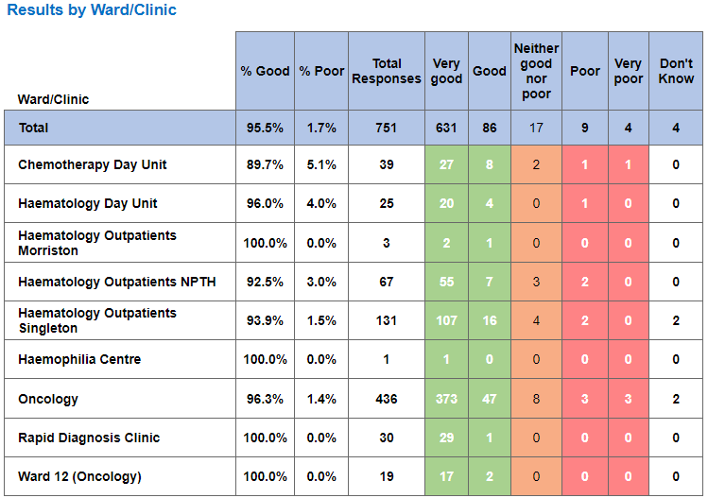

Below are the top themes for Cancer services:
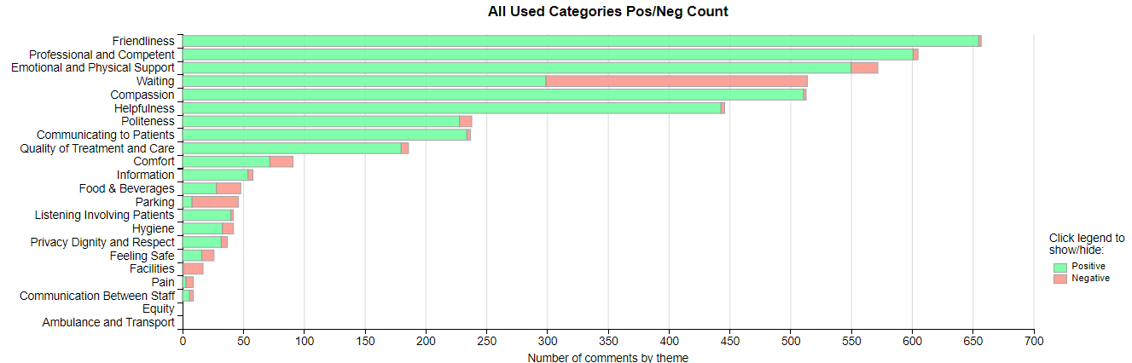
NB: The Civica system on occasions is oversensitive with the word ‘Pain’ and ‘Waiting’ and sometimes feeds these as a negative in charts and wordles. This is a national platform issue affecting all Health Boards. The overall satisfaction score is not affected by this.
Postive Themes
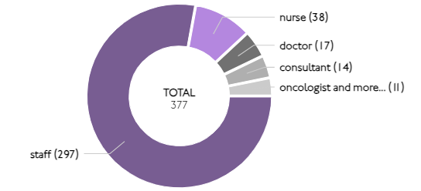
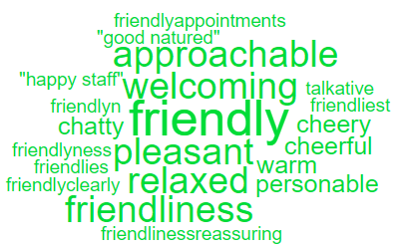
‘Friendliness’ Sub themes ’Friendly’

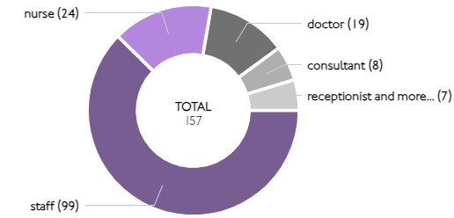
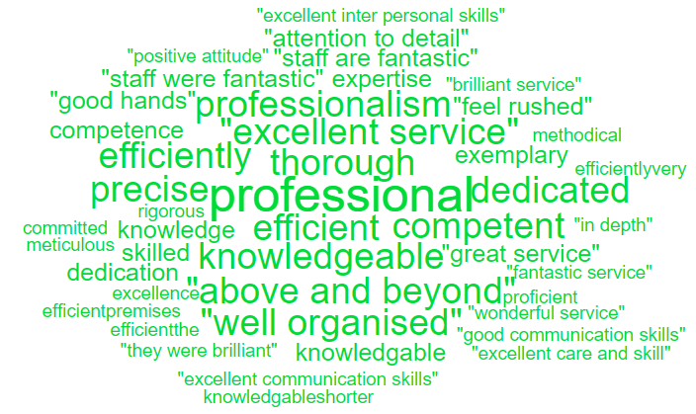
‘Professional & Competent’ Sub themes 'Professional’
Here are some of the positive comments we’d like to share:
- Very concise and informative, delivered with care and compassion. Excellent thank you all.

- Very friendly staff put you at ease they couldn't do more than what they are doing

- My first visit this time. Everyone very helpful, communicative and caring - as usual. Great teams.

- The oncologist nurse was thorough and reassuring, couldn't be more he more helpful

- The doctor was very kind and listened to my concerns. The staff were kind and helpful which put my mind at rest.

Negative Themes

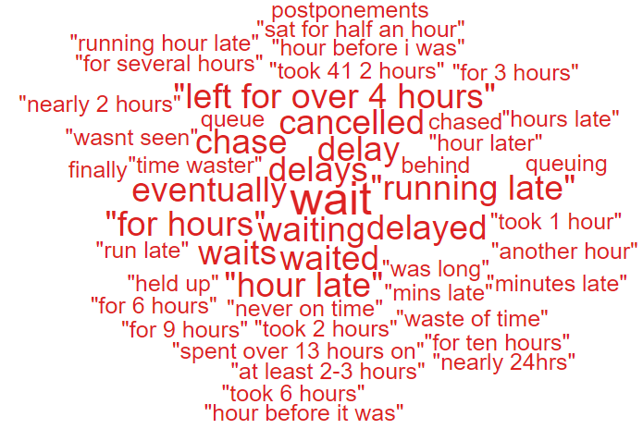
‘Waiting’
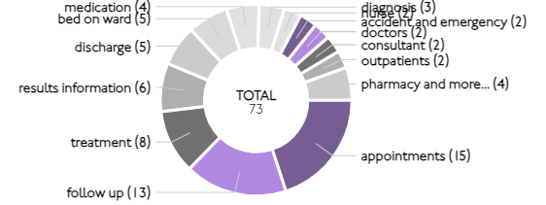

Looking at the chart above it highlights comments specifically related to ‘waiting’ as negative feedback. Here are some examples of the comments written to give context.

- Had a slight wait to get back to reception but no great problem - maybe consider giving a map of the corridors dave time and the time of the nurse who had to come and get me
- Not to wait so long for my treatment to be sent up from the ward
- Staff were very helpful and busy because they were short of staff, but they coped well. Had to wait an hour before having my chemo treatment
- Allow more time for appointments so clinics are not constantly running late
3.5 Mental Health Complaints
During Q2 of 2024/25, Mental Health received 90 complaints, a breakdown of the top 10 areas these relate to is shown below;

Also below is a breakdown of the issues raised within these complaints;
Appointments | 18
Clinical treatment/Assessment | 14
Communication Issues (including Language) | 13
Monitoring/Observation Issues | 11
Attitude and Behaviour | 10
Discharge Issues | 4
Medication | 4
Access (to Services) | 2
Confidentiality | 2
Privacy and Dignity | 2

Patient Experience Feedback: Mental Health
For our Mental Health feedback, we primarily utilise a Service/User/Carer survey that is designed to be more user-friendly. In Q2, we received 258 responses, with an overall satisfaction score of 93% for the question, "Overall, how was your experience?"
Additionally, we received five Friends and Family responses, all of which were positive, resulting in an average score of 100%.
Themes

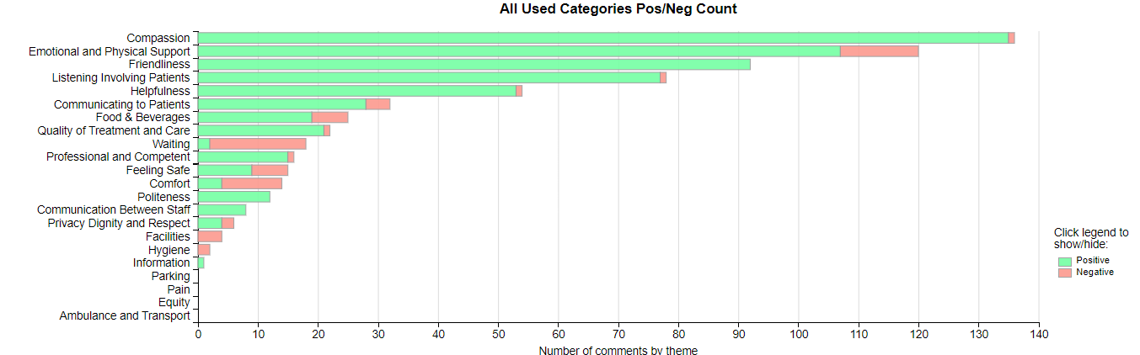
Top Themes
'Compassion positive' 'Friendliness positive'
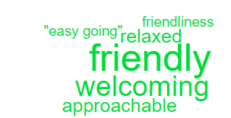
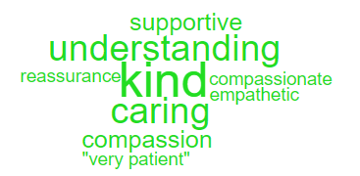

Please see below some positive comments:
- The Adult Forensic community team have been very good to me.
- I find the staff on Ward F are good and they help and look after me.
- I have been on Ward F for a year and ready to move to another place. Ward F is good and I have been looked after here.
- My Prison in Reach staff member has been very good and kind to me.
- The nurses and doctors are very good to me here on Fendrod ward. I am safe and being looked after by them.
- I find all the staff are very helpful and good on Clyne Ward.
- I do like the doctors and nurses on Onnen ward they are kind with me.
- My brother was being looked after by all the wonderful team on Suite 2 in Tonna. They were always kind and looked after him and all the patients so well. Thank them from me.

'Waiting negative' 'Comfort negative'

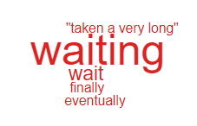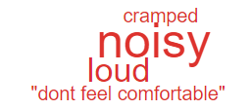
Please see below some negative comments:
- Its noisy here sometimes.
- Some people are very loud.
- Nothing it has helped me.
- We can’t drink tea or coffee after 12 midnight.
- I find it boring here, I would like there to be more to do
- Keep me more occupied as we get bored easily and that's when it can be bad here
- Too much boredom, nothing to really do here, time goes by really slowly.
- There could be more activities for us patients.
- Not many activities, cleaners not doing their job, food is not good as well. We need more outside benches as the broken ones have not been fixed.

Nutrition & Hydration
As Nutrition & Hydration is currently one of the Health Board’s priorities, for this quarterly report please see below overview of the feedback received.
The Health Board received 6 complaints between 1st July 2024 – 30th September 2024 which involved Nutrition & Hydration issues. Please see breakdown below of what services these complaints related to;

The specific issues raised in these complaints are below (please note some of these complaints may have more than one sub-subject);
Appropriateness of food/Dietary options | 2
Patients not properly hydrated | 4

The ‘patient not properly hydrated’ issues relates to the areas below;
Clyne Ward | 1
Ward S | 1
Ward W | 1
Acute Medical Unit (AMU) | 1

Patient Experience Feedback – Nutrition & Hydration;

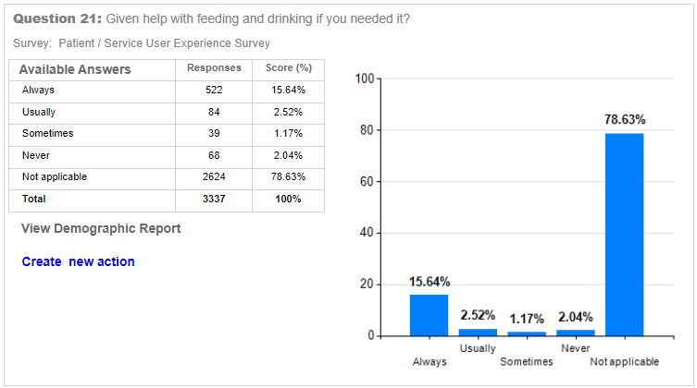

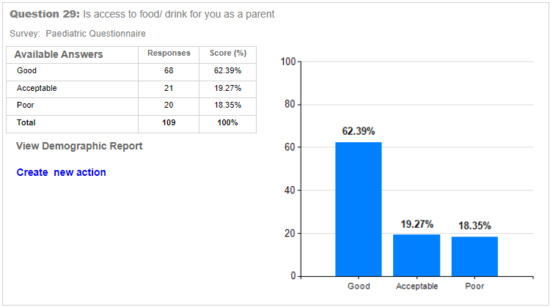

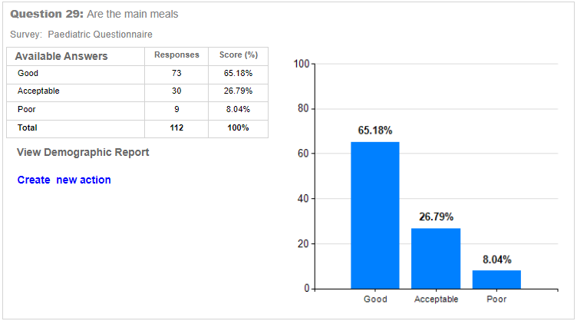
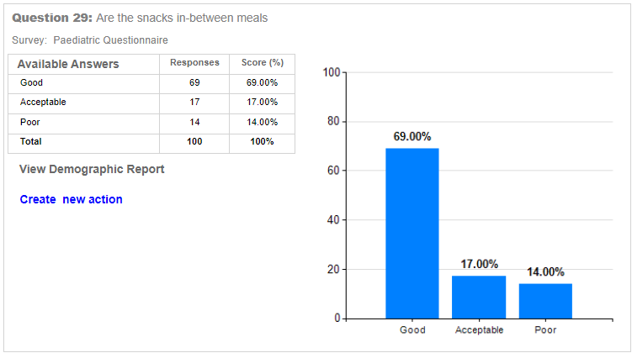
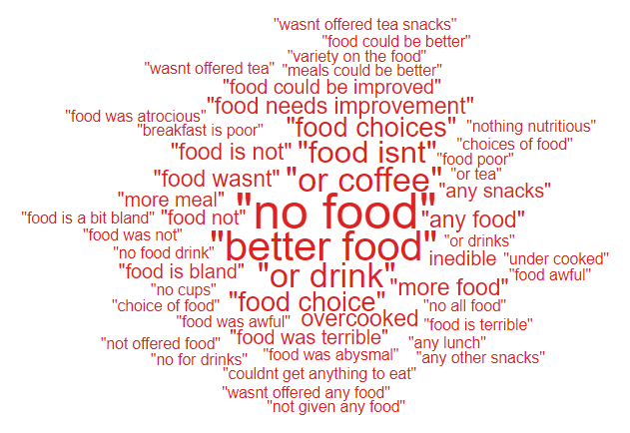
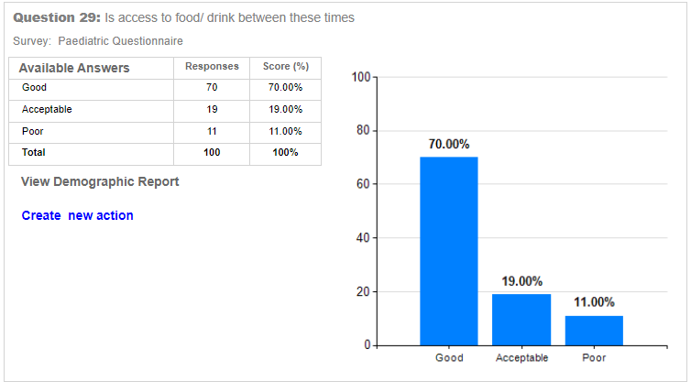
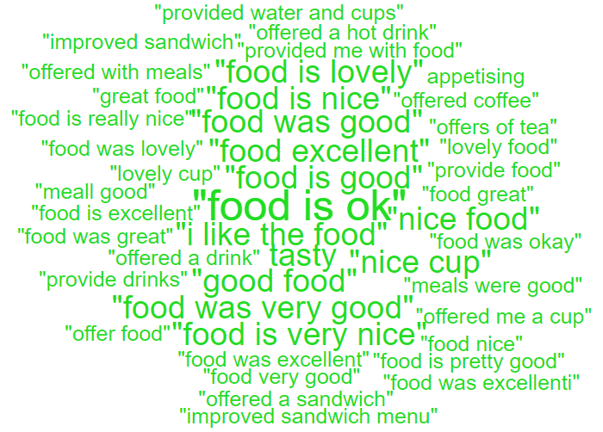
- Wonderful nurses’ doctors. The whole experience was excellent start to finish. I am profoundly deaf and was treated with great care and respect throughout my stay, what a wonderful experience. Thank you to all the staff on the cardiac short stay unit. I was served a very tasty lunch of roast beef with all the trimmings. Excellent.
- Excellent very clean. Food great, staff very professional, well trained and friendly as well. Could not be better. Nice to be a female only room
- The service is brilliant. The staff are lovely. The doctors are good at explaining things in a way that I could understand. The food is lovely
- No food offered as parent just hot drinks.
- Treatment from the doctors was very good. I’ve had a stroke and sat in the main A&E dept for 28 hours with no food that is why!
- SERVICE GROUP COMPLAINTS, INCIDENTS, COMPLIMENTS AND PATIENT FEEDBACK HIGHLIGHTS

- Food awful, I was on a special diet and the same pureed fish dish turned up 3 days running.

MORRISTON SERVICE GROUP
4.1 – Morriston Service Group complaints
Morriston Service Group received a total of 243 complaints during Q2 2024/25, this compares with 176 during Q1 of 2024/25. Graph 1 below shows the total number of complaints received relating to Morriston Service Group since October 2023. The graph breaks the total number received down by Formal PTR, Early Resolution and Re-opened complaints.
Graph 1: Morriston Service Group complaints by month and type

Graph 2 shows the top five services that had the most complaints since October 2023. Although the graph shows a reduction in Orthopaedic complaints, this is due to the change over with Service Group and Orthopaedics now sitting under NPTSSG.

Graph 2: Top 5 Services by month

4.2 – Morriston Service Group Incidents
Morriston Service Group reported 1886 incidents in quarter 2 (Q2) of 2024/25 (July, August, September). This compares with 1942 incidents in quarter 1 (Q1) of 2024/25 (April, May, June). Graph 1 shows the number of incidents per month broken down by severity.

Graph 1: Morriston Incidents by Severity and month

Graph 2 shows the top 5 incident types, of all incidents reported by Morriston Service Group since April – September 2024.

Graph 2: Top 5 incidents per month

4.3 – Morriston Service Group National Reportable Incidents
Morriston Service Group reported 6 Nationally Reportable Incidents (NRI’s) during Q2 2024/25, this compared to 3 also being reported during Q1 of 2024/25. Of the NRI’s reported, 1 x delay in test results, 1 diagnosis issues, 1 x equipment failure, 1 x NEWS, 1 x patient suicide and 1 x unexpected death.
Graph 1: Nationally Reportable Incidents reported per month by Morriston Service Group

4.4 – Morriston Service Group Compliments
Morriston received 243 compliments during Q2 of 2024/25. Graph 1 shows the number received per month since October 2023.
Graph 1: Morriston compliments per month

Graph 2: Morriston compliments – Top 5 Services

4.5 Morriston Service Group Patient Experience Feedback
Overall, during quarter two there were 105,897 number of patients seen under Morriston Service Group (This includes ED).

There were 8,207 Friends and Family survey returns which equates to 8% responding to the survey. Out of the 8% who responded, 90% of people stated they would highly recommend the Health Board to Friends and Family.

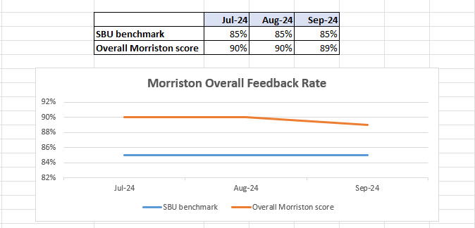

Below are the number of responses in a line graph:

Below are the main themes mentioned for Morriston:
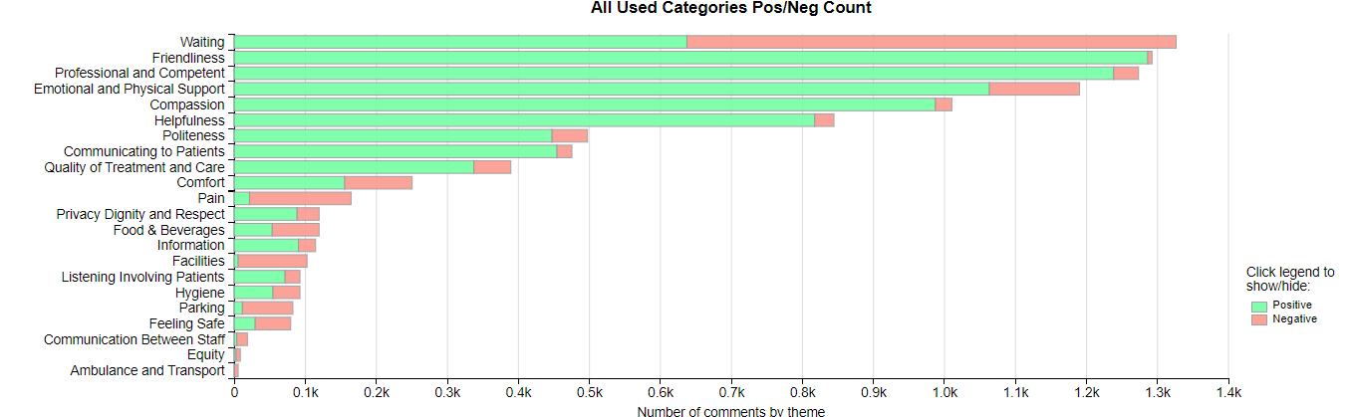

NEATH PORT TALBOT SINGLETON SERVICE GROUP
4.6 – NPTSSG Complaints
NPTSSG received a total of 145 complaints during Q2 2024/25 compared to 187 during Q1. Graph 1 below shows the total number of complaints received relating to NPTSSG since October 2023. The graph breaks the total number received down by Formal PTR, Early Resolution and Re-opened complaints.
Graph 1: NPTSSG complaints by month and type

Graph 2 shows the top five services that had the most complaints since October 2023.

Graph 2: Top 5 Services by month

As you can see from the graph, Orthopaedic complaints have decreased which is hopefully as a result of the new theatres and the reduction in waiting times.
4.7 – NPTSSG Incidents
NPTSSG reported 1516 incidents in quarter 2 (Q2) of 2024/25 (July, August, September). This compares with 1445 incidents in quarter 1 (Q1) of 2024/25 (April, May, June). Graph 1 shows the number of incidents per month broken down by severity.
Graph 1: NPTSSG Incidents by Severity and month

Graph 2 shows the top 5 incident types, of all incidents reported by NPTSSG since April – September 2024.

Graph 2: Top 5 incidents per month

4.8 – NPTSSG National Reportable Incidents
NPTSSG reported 11 Nationally Reportable Incidents (NRI’s) during Q2 2024/25, this compares to 3 being reported during Q1 of 2024/25. Of the NRI’s reported 5 x still births, 1 x neonatal deaths, 1 x Maternal adverse occurrence, 1 x Unintended injury during procedure, 1 x Treatment or procedure delayed, 1 x Never Event Medical device user error.
Graph 1: Nationally Reportable Incidents reported per month by NPTSSG

4.9 – NPTSSG Compliments
NPTSSG received 75 compliments during Q2 of 2024/25, compared with 94 during Q1. Graph 1 shows the number received per month since October 2023.
Graph 1: NPTSSG compliments per month

Graph 2: NPTSSG compliments – Top 5 Services

4.10 NPTSSG Patient Experience Feedback
Overall, during quarter two there were 89,002 number of patients seen under Neath Port Talbot and Singleton Service Group.

There were 6,346 Friends and Family survey returns which equates to 7% responding to the survey. Out of the 7% who responded, 95% of people stated they would highly recommend the Health Board to Friends and Family during this quarter.

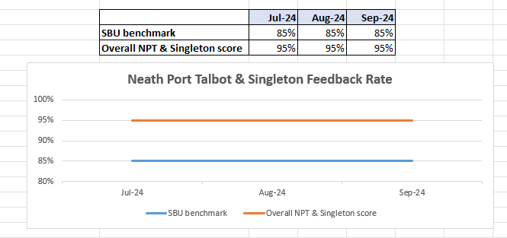

Below are the number of responses in a line graph:

Below are the main themes mentioned for NPT & Singleton:
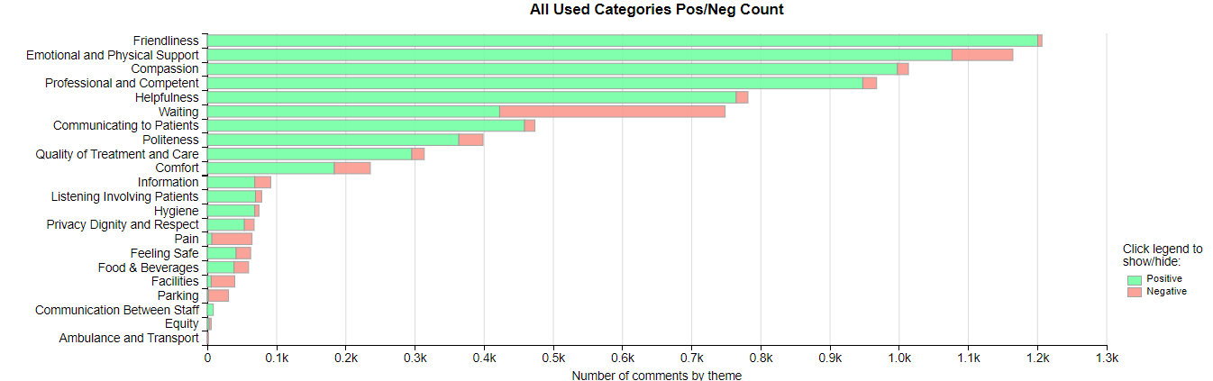

MENTAL HEALTH AND LEARNING DISABILITIES SERVICE GROUP
4.11 – MH&LD Complaints
MH&LD received a total of 90 complaints during Q2 2024/25 (July, August, September) compared with 63 during Q1 (April, May, June). Graph 1 below shows the total number of complaints received relating to MH&LD since October 2023. The graph breaks the total number received down by Formal PTR, Early Resolution and Re-opened complaints.
Graph 1: MH&LD complaints by month and type

Graph 2 shows the top five areas within MH&LD that had the most complaints since October 2023. As shown in the graph, Tonna Hospital appear to have had a slight increase in complaints during March.
Graph 2: Top 5 Services by month

4.12 – MH&LD Incidents
MH&LD reported 1145 incidents in quarter 2 (Q2) of 2024/25 (July, August, September). This compares with 1105 incidents in quarter 1 (Q1) of 2024/25 (April, May, June). Graph 1 shows the number of incidents per month broken down by severity.
Graph 1: MH&LD Incidents by Severity and month

Graph 2 shows the top 5 incident types, of all incidents reported by MH&LD since April - September 2024.

Graph 2: Top 5 incidents per month

4.13 – MH&LD National Reportable Incidents
MH&LD reported no NRI’s during Q2 of 2024/25, compared with 3 reported during Q1 of 2024/25.

4.14 – MH&LD Compliments
MH&LD received 9 compliments during Q2 of 2024/25. Graph 1 shows the number received per month since October 2023.
Graph 1: MH&LD compliments per month

4.15 MH&LD Patient Experience Feedback
This data is from Quarter 2.

The Mental Health and Learning Disabilities Service Group are using a different set of survey questions. The role out of the semi structured interview surveys have been managed in stages. Roll out, awareness posters and meetings with managers and teams continues.
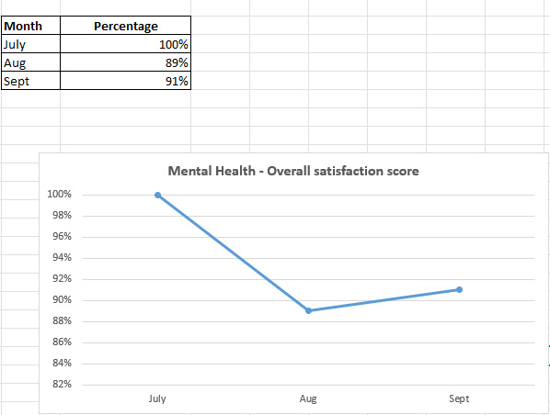
Below are the number of responses in a line graph:

PRIMARY AND COMMUNITY SERVICE GROUP
4.16 – P&C Complaints
P&C received a total of 77 complaints during Q2 2024/25 (July, August, September) compared with 71 during Q1 (April, May, June). Graph 1 below shows the total number of complaints received relating to P&C since October 2023. The graph breaks the total number received down by Formal PTR, Early Resolution and Re-opened complaints.
Graph 1: P&C complaints by month and type

Graph 2 shows the top five services that had the most complaints since October 2023. As seen in the graph, HMP Swansea appear to have received the most complaints, a system is in place whereby the Prison send their complaints to the Health Board for logging weekly. Since this process has been in place we have seen an increase.
Graph 2: Top 5 Services by month

4.17 – P&C Incidents
P&C reported 1226 incidents in quarter 2 (Q2) of 2024/25 (July, August, September). This compares with 1172 incidents in quarter 1 (Q1) of 2023/24 (April, May, June). Graph 1 shows the number of incidents per month broken down by severity.
Graph 1: P&C Incidents by Severity and month

Graph 2 shows the top 5 incident types, of all incidents reported by P&C since April - September 2024.

Graph 2: Top 5 incidents per month

4.18 – P&C National Reportable Incidents
P&C reported 3 Nationally Reportable Incidents (NRI’s) during Q2 2024/25, this compares to 4 being reported during Q1 of 2024/25. The 4 NRI’s reported in Q2 included 1 x pressure ulcer, 1 x delay in clinical assessment, 1 x Treatment or procedure not given as directed.
Graph 1: Nationally Reportable Incidents reported per month by P&C

4.19 – P&C Compliments
P&C received 74 compliments during Q2 of 2024/25, compared with 83 during Q1. Graph 1 shows the number received per month since October 2023.
Graph 1: P&C compliments per month

Graph 2: P&C compliments – Top 5 Services

4.20 P&C Patient Experience Feedback
Overall, during quarter two there were 2’160 number of patients seen under Primary and Community Service Group.

There were 1,756 Friends and Family survey returns which equates to 81% responding to the survey. Out of the 81% who responded, 95% of people stated they would highly recommend the Health Board to Friends and Family during this quarter.

Patient Experience Team are currently working with I.T to automate SMS messages from the PIMS, PIMS+ platform to automate SMS survey messages to Primary Care and Therapies patients. This will increase the number of returns.

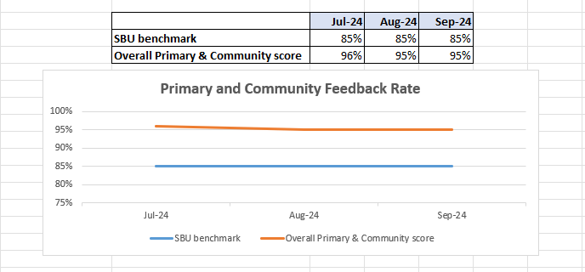

Below are the number of responses in a line graph:

Below are the main themes mentioned for Primary & Community:
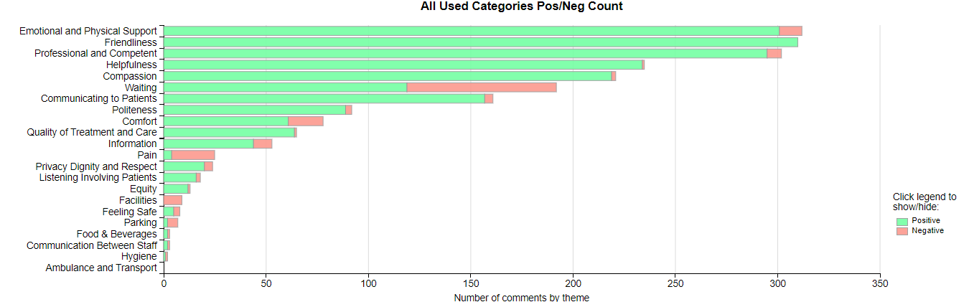
- MEDICAL EXAMINER COMPLIMENTS

5.1 ME Compliments
The Health Board has received a number of compliments from families through the Medical Examiner. This evidences the good work being done when treating these end of life patients. During Q2, approximately 114 compliments were received. A few examples are shown below;
“Care received was absolutely wonderful they couldn't have done any more for her and mum spoke highly of the care she received.”
West Ward, Gorseinon

“They were unbelievable for the whole admission. Cannot speak highly enough of them all. They were all really helpful and caring at a difficult time. Dr…………. was great..”
Dan Danino Ward, Morriston

“Ty Olwen were amazing and gave first glass top notch care. The Consultant was caring and compassionate, nurses and staff also wonderful. Ben said he will be sending a card and flowers to give thanks.”
Ty Olwen

- OMBUDSMAN CASES

6.1 Ombudsman investigations
3 new Ombudsman investigations were received during Q2 2024/25, this compares to 8 in Q1 2024/25. Graph 1 shows the number of investigations received per month;

Graph 1: Number of Ombudsman investigations per month

The Health Board has also received 26 decisions not to investigate from the Ombudsman during Q2. Graph 2 below shows these by month.

Graph 2: Ombudsman decisions not to investigate

There are a number of different reasons why the Ombudsman decided not to investigate these complaints, a few of these reasons are detailed below;

- Detailed and thorough response provided
- Out of time (Ombudsman timescale)
- Complainant seeking financial compensation
- No evidence that Health Board has failed to provide appropriate care
- Appropriate clinical action taken

Ombudsman Compliance to timescales
Here is the position for Average Variance to Target for Health Board’s in August 2024. As a reminder, this is a measure of how Health Board’s perform against the target dates to provide evidence to comply with individual recommendations. Anything over a ‘0’ in the ‘traffic light’ formatted section is seen as days over target date on average for the Health Board to provide compliance evidence and anything with a minus indicates the amount of days under, on average, a Health Board takes to provide evidence to comply with a target date to provide evidence to comply with a recommendation.
The NHS average for August 2024 is 3.35 compared with 3.56 in July 2024. On average compliance evidence is reaching the Ombudsman’s office over 3 days later than the target dates.
 |  | 23/24 | 24/25
Aneurin Bevan University Health Board |  | -1 | -3
Betsi Cadwaladr University Health Board |  | -2 | 1
Cardiff and Vale University Health Board |  | -1 | -1
Cwm Taf Morgannwg University Health Board |  | 3 | 70
Hywel Dda University Health Board |  | -2 | -10
Powys Teaching Health Board |  | -13 | -27
Swansea Bay University Health Board |  | 3 | -2
Velindre University NHS Trust |  | 13 | -1
Welsh Ambulance Services NHS Trust |  | - | -
NHS Average AVT |  | 0.14 | 3.35

Ombudsman Annual Letter
The Ombudsman Annual Letter was received on 9th September 2024, which followed the Annual Letter Data which was received on 30th July 2024. The Ombudsman Annual Letter and Data will be presented at the next Q&S Group, Q&S Committee and Management Board.

- 46 (33%) cases closed this year following consideration as opposed to 60 last year (45%) – which means no further action to be taken.
- 26 (18%) early resolutions this year compared to 22 (16%) last year – there is a drive on more of these from the Ombudsman as per the Ombudsman Plan.
- 2 (1%) discontinued this year compared with 3 (2%) last year.
- 6 (4%) not upheld this year compared with 3 (2%) last year.
- 12 (9%) reports upheld compared to 11 (8%) last year.

The Ombudsman Annual Letter is most positive regarding Health Board continued engagement with the Ombudsman, including the regular attendance of the Health Board’s Ombudsman Lead in meetings with the Ombudsman Improvement Team.

