

Learning from Deaths Panel
Annual Report 2022/23
Swansea Bay University Health Board

Dr Raj Krishnan, Acting Executive Medical Director/Chair of the Learning from Deaths Panel

October 2023

CONTENTS

- Introduction 3

- Delivering the National Learning from Mortality 3-.5 Reviews Framework

3. Facilitating the ME Process at SBUHB 5-6
- Deaths Scrutinised by ME Service 6-7

5. Referrals Received from ME Service 7-8
6. Thematic Reviews and Learning 8-15
7. Previous Three Stage Mortality Review System 15-16
8. Reporting 16-18

APPENDICES

Appendix 1 All Wales Learning from Mortality Review Model Framework
Appendix 2 Thematic Data

1. Introduction
Implementation of the Medical Examiners (ME) Service began in England and Wales in 2019 with the appointment of the National Medical Examiner and recruitment of national and regional teams.

In Wales, the ME service was implemented by NHS Wales Shared Services Partnership (NWSSP), an independent organisation, owned and directed by NHS Wales.
Four hub sites cover all areas (Fig 1.) The Mid/West Wales Regional Hub covers SBUHB. They are currently in the process of continuing to recruit to complete their team in order to meet the needs of the service. A core part of the ME Service’s role is to provide the bereaved with clear information about the cause of death and opportunities
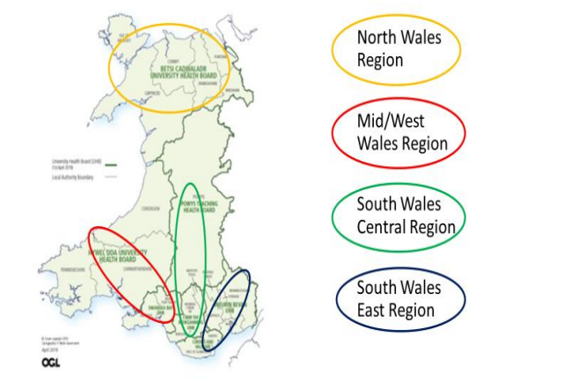 Fig 1.
to raise any concerns in relation to the care and treatment provided to their loved one. The Medical Examiners supported by Medical Examiner Officers undertake a proportionate review of patient records, liaise with the Qualified Attending Practitioner (QAP) and issue the Death Certificate for the family to register the death. In identifying any concerns about patient care promptly, referral for further investigation where required contributes to learning and improvements.
Importantly, the ME Service will also inform health organisations of the compliments received from the bereaved.
As you will note in more detail throughout the report, the Learning from Deaths Panel has made significant advances during the 2022/23 period in; streamlining local processes for the management and review of ME Service referrals, accessing mortality data and themes in a more-timely manner and facilitating the agreement and delivery of necessary actions within clinical teams.
Identifying learning opportunities and providing answers to questions or concerns raised by the bereaved, remains at the very centre of the work of the Learning from Deaths Panel.

2. Delivering the National Learning from Mortality Reviews Framework
Originally issued in August 2021 and revised in September 2022, the “National Learning from Mortality Reviews Framework” (Appendix 1.) was distributed across Wales as a guide to implementing the ME service processes within Health Boards and Trusts. SBUHB has adopted this framework. Within SBUHB, the ME referral process (Fig 2. overleaf) is currently supported by the Clinical Audit & Effectiveness Department.

Fig 2.
ME Service referrals received into the Health Board (HB) undergo initial reviews (Level 1 of the framework) to screen out those cases where existing investigations or processes are already in place, to review the concern or establish if an incident report has already been addressed or closed.

Level 2 of the framework requires those cases not addressed at Level 1 to be reviewed by the Learning from Deaths Panel. The multi-disciplinary Panel with representation from; Resuscitation Services, Welsh Ambulance Services, Medicine, Surgery, Oncology, Palliative Medicine, Primary Care, Mental Health, Pharmacy, Nursing, Allied Health Professionals and the Quality & Safety team meet on a weekly basis. The Panel determines whether a further investigation (at Level 3) is required, in addition to agreeing the specific questions that need to be addressed during the proportionate investigation.
The processes for Levels 4 and 5 pertaining to thematic reviews and learning is described in more detail in the main body of the report.

3. Facilitating the ME Process at SBUHB
To provide an efficient and effective service to the ME Service and importantly, the bereaved families, the HB invested in the existing Bereavement Services to develop the new Care After Death Team (CADT). Resources were also made available to support a dedicated scanning team within Health Records to facilitate digital provision of records. Together, they ensure that the independent ME Service is informed of deaths and provided with scanned copies of the relevant case notes in a timely manner.
Throughout 2022/23 as the workforce within these areas increased, so too did the capacity for cases to be reviewed. Figure 3 below illustrates by site, the increased provision of records to the ME Service during the time-period.

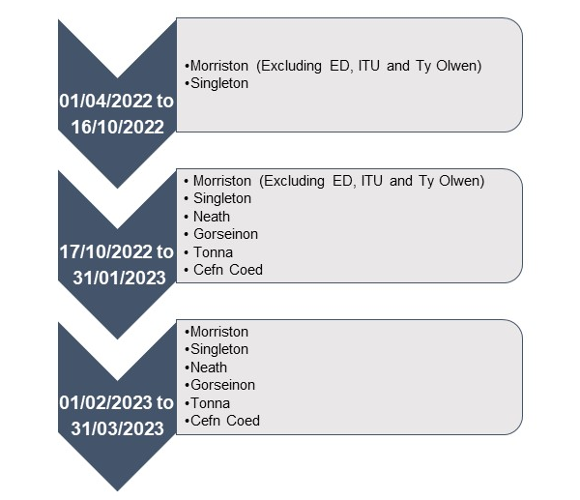Fig 3.
As of 1st February 2023, scanned episodes of all in-hospital deaths from six sites across the HB have been provided to the ME Service.
The Clinical Audit and Effectiveness team facilitates the Learning from Deaths Panel meetings, undertaking initial checks at Level 1 to establish if the case is currently subject to existing complaints or incident processes. During the Level 1 review, information from the referral is recorded onto the Datix Mortality Module in addition to an Excel sheet. This will continue whilst the Datix Module is still in the development stage and cannot provide thematic information, which is used to provide monthly reports for the HB from an Excel sheet.
At Level 2, Panel members are issued with cases to scrutinise on a rota basis and are required to summarise their findings at the weekly meetings, generating discussions on appropriate actions.
In the Clinical Audit and Effectiveness team communicating findings via template emails to clinical teams, service leads etc. Level 3 of the All Wales approach is initiated.
In the coming months, further work will be undertaken to finalise arrangements in gaining assurance that action is undertaken within the relevant clinical areas.

4. Deaths Scrutinised by ME Service
During 2022/2023, there were a total of 2045 in-hospital deaths recorded, with 1692 (83%) subsequently being reviewed by the ME Service as the Health Records and ME Service teams grew in capacity, illustrated in Figure 4 below.
Fig 4.
The only deaths not processed through the ME Service are those directly referred to the Coroners Service. It is normal therefore for there to be a small discrepancy between the number of deaths reported as being reviewed by the ME Service and the total deaths recorded on clinical systems. The difference in these numbers were noted to be higher than normal in February and March 2023, meaning that the Chair of the Learning from Deaths Panel will be liaising with Digital Services and other colleagues to investigate potential causes, including delayed reporting.

5. Referrals Received from ME Service
Figure 5 below illustrates the volume of referrals received from the ME Service over the report period, indicating those points in time when additional resources within the ME Service, Care After Death and Health Records teams could accommodate an increase in the number of cases scanned over for review;
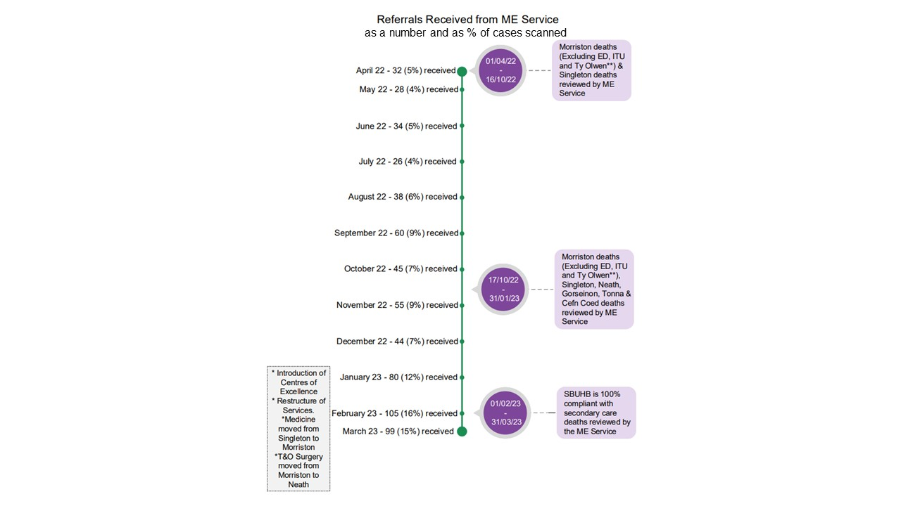Fig 5.
Of those cases reviewed by the ME Service, 646 (38%) were subsequently referred back to the HB with questions/concerns which could have been raised by the Service, the QAP or the bereaved.
Figure 6 below provides a breakdown of the referrals received, per site. In the past, it has been possible to report on the All Wales average for compliance with mandated Mortality Review processes. Currently, not all health organisations in Wales are under the ME Service’s scrutiny and collecting data in the same way.

Fig 6.
It should be noted that the HB will also periodically receive referrals related to deaths that occurred within another organisation, but where concerns or queries have arisen pertaining to care provided by SBUHB as part of or prior to, the relevant admission episode. Referrals can be received for deaths from within the reported month in addition to older time-periods, depending on capacity of the ME Service.

5.1 Compliments Received
Moving forward compliments from the bereaved reported to the HB and subsequently shared with the relevant clinical areas will be reported. The ME Service initiated sharing these compliments in May 2023.

6. Thematic Reviews and Learning
All referrals received, whilst scrutinised at Level 1 or 2, will have the themes of the concerns recorded and categorised. Figures 7-16 overleaf provide a flavour of the types of graphical representations now available on the newly developed and evolving Mortality Dashboard created in partnership with Business Intelligence colleagues.
The dashboard helps to identify outlier status and is monitored on a monthly basis. This is inclusive of area specific mortality and condition specific mortality ratios (Figures 7-15).

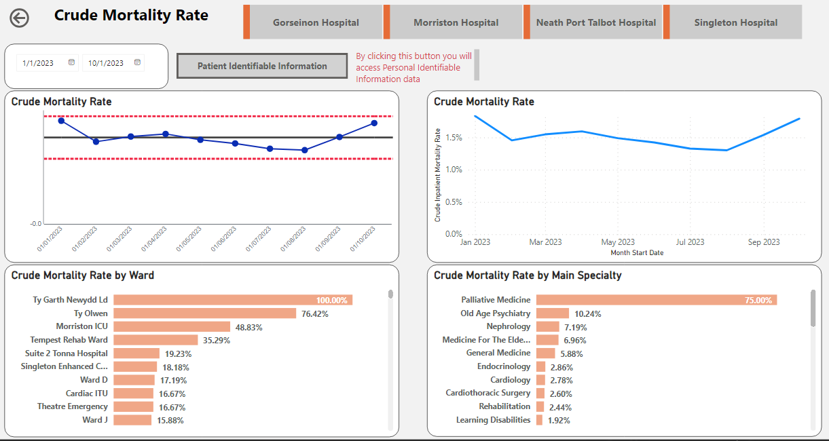
Fig 7. – Crude Mortality Ratio

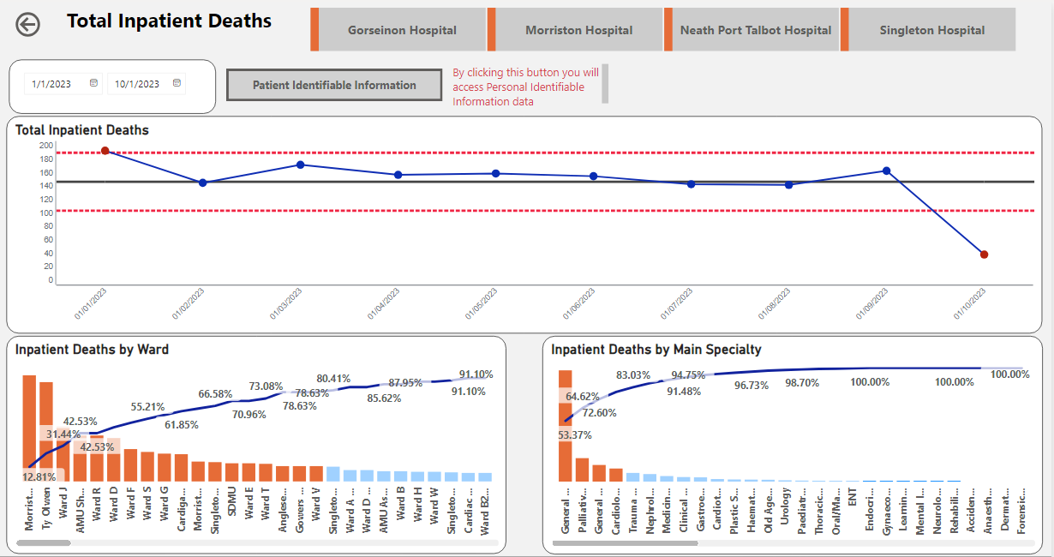
Fig 8. – Total Inpatient Deaths

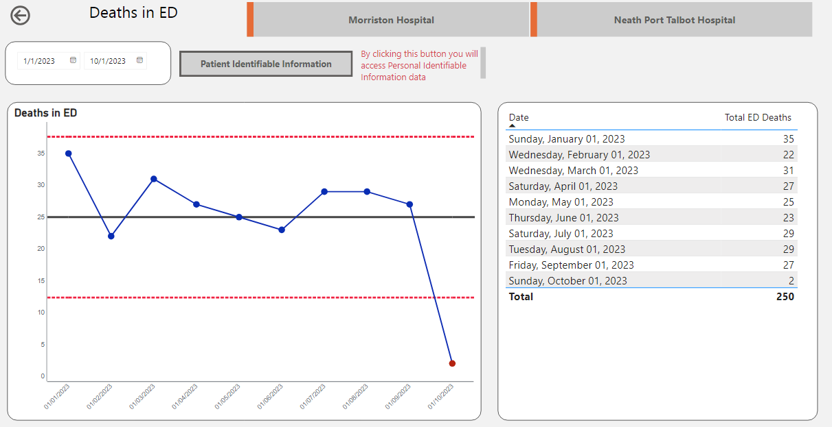
Fig 9. – Total Deaths in ED

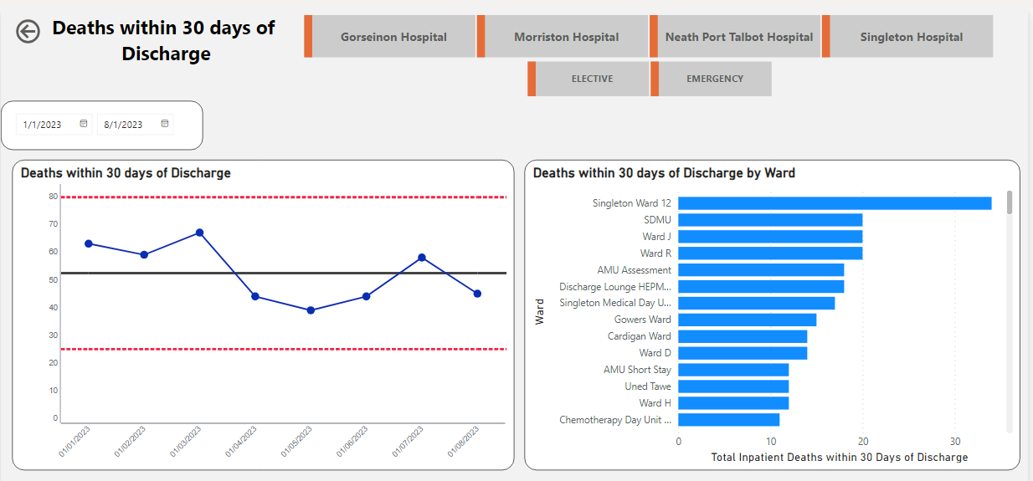
Fig 10. – Deaths, Within 30 Days of Discharge

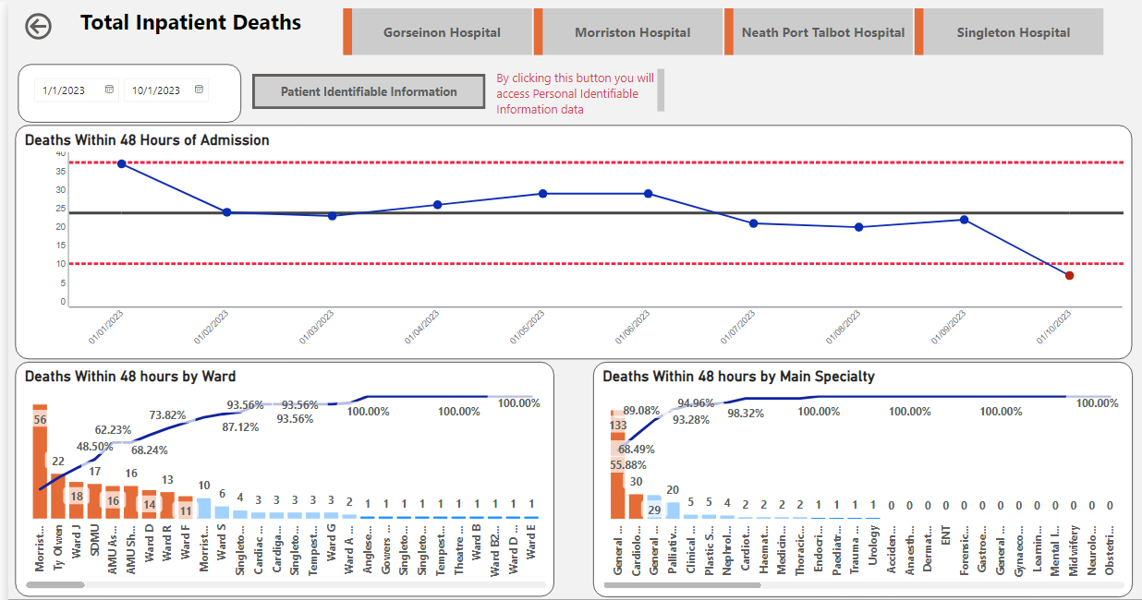
Fig 11. – Deaths, Within 48 hours of Admission

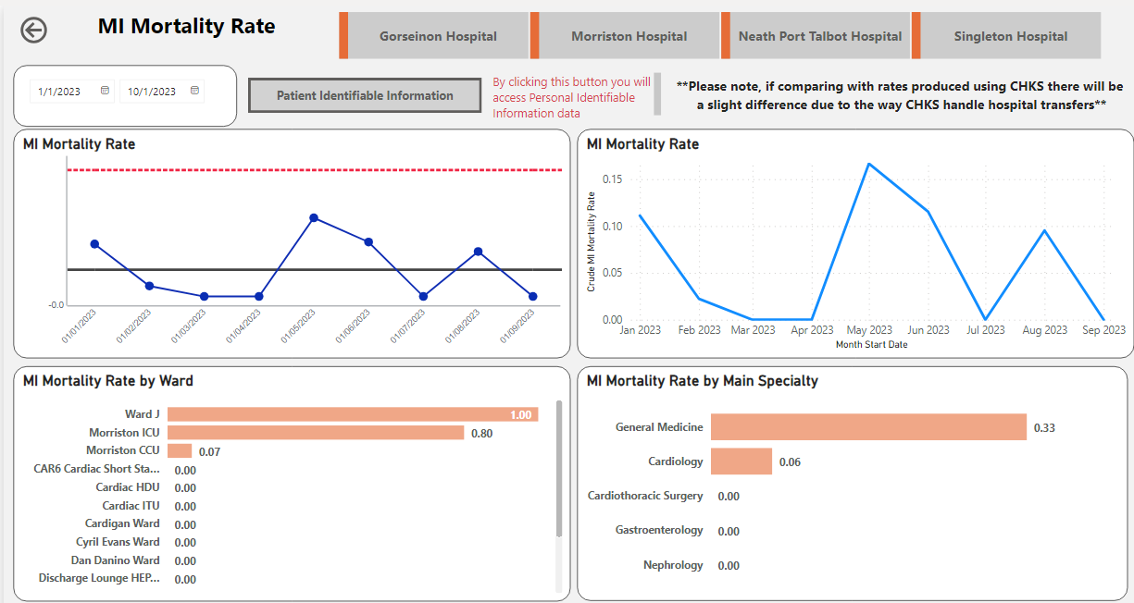
Fig 12. – Deaths Due to Myocardial Infarction
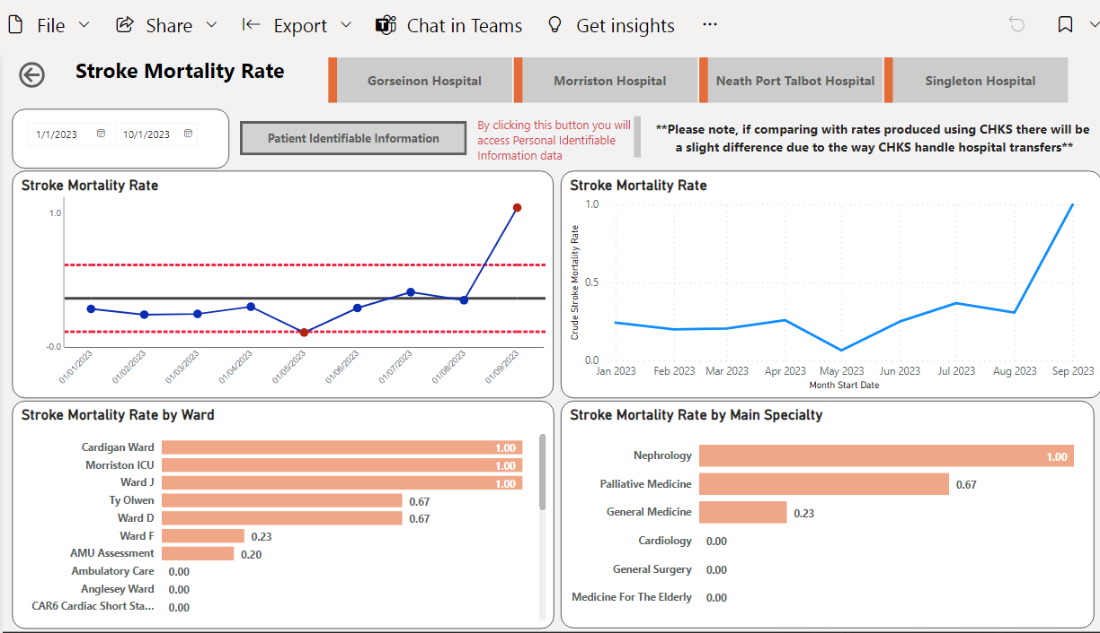
Fig 13. – Deaths Due to Stroke

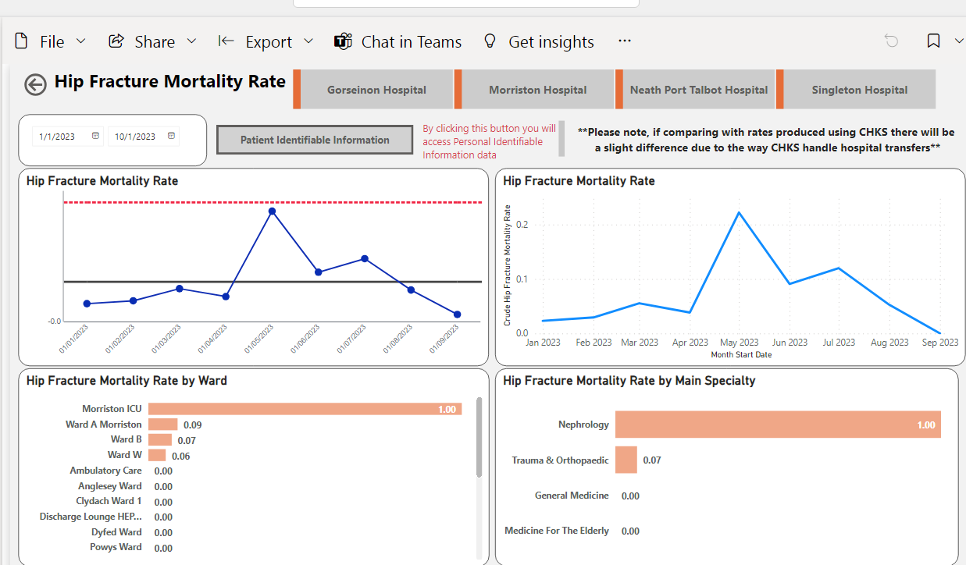

Fig 14. – Deaths Due to Hip Fracture

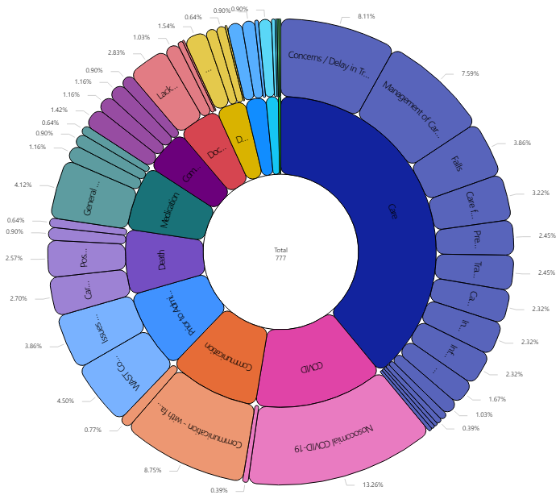
Fig 15. – Themes from Medical Examiner Reviews
If an outlier data is identified in any of the above data sets, then the data is analysed and reported according to the schematic plan as below (Figure 16).
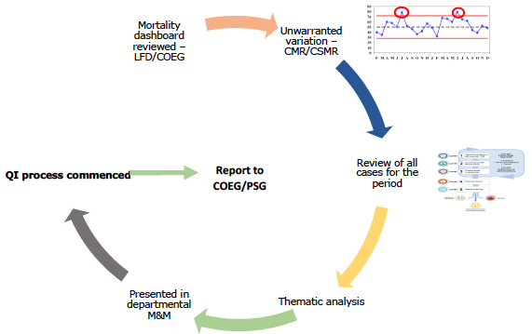Fig 16.
During the 2022/23 report period, significant time and energy has been put into ensuring that Levels 4 and 5 of the All Wales Framework are supported with early access to the information generated by the ME Service and Learning from Deaths Panel.
These graphs are interactive and can be filtered and sorted by Learning from Death Panel members or Service Delivery Groups, Departments and individuals to dive into specific categories of concerns or, can be generated using condition specific values.
More details on the wide-ranging themes generated for the report period are attached as an Excel export in Appendix 2.

6.1 Deaths per Department
With the data collected from the CADT and the ME Service, Service Delivery Groups and Departments are in a position to retrieve their mortality data to monitor performance in specific areas and along with the thematic data generated, look in greater detail at areas to target for improvement.
Table 1 provides a summary of the total deaths per department, by hospital site for the 2022/23 report period. The new Mortality Dashboard allows areas to drill down for example to speciality, ward and individual patient level data. This will aid those areas such as General Medicine and Palliative Medicine with higher numbers, to better manage monitoring data and facilitate their own morbidity and mortality meetings to optimise educational and improvement opportunities.
 | Hospital Site
Specialty | M | S | N | G | T | C | L
General Medicine | 819 | 275 | 56
Palliative Medicine | 178
General Surgery | 154 |  | 1
Cardiology | 100 | 18
Trauma & Orthopaedics | 79
Clinical Oncology | 1 | 56 | 1
Nephrology | 55
Gastroenterology | 11 | 27
Medicine for the Elderly | 16 | 5 | 4 | 10
Haematology | 1 | 29
Endocrinology |  | 29
Old Age Psychiatry |  |  |  |  | 17 | 5
Cardiothoracic Surgery | 21
Urology | 19
Plastic Surgery | 15
Thoracic Medicine | 15
Paediatrics | 3 | 9
ENT | 5
Neurology | 5
Oral Max Fax Surgery | 3
Learning Disabilities |  |  |  |  |  |  | 2
Gynaecology | 1

Key: M – Morriston, S – Singleton, N – NPT, G – Gorseinon, T – Tonna, C – Cefn Coed, L – The Laurels (Learning Disabilities Unit)
Table 1.
6.2 Neonatal and Stillbirth Data
Dashboards are currently being developed to monitor neonatal and stillbirth data. All of these deaths are reported as DATIX incidents and an in-depth review is carried out in all cases by the clinical team. The figures for stillbirth and neonatal deaths are as follows;
Year | Crude Neonatal Deaths | Crude Stillbirths
2018 | 7 | 15
2019 | 11 | 15
2020 | 3 | 20
2021 | 12 | 11
2022 | 4 | 12
2023 (to date) | 2 | 13*

Table 2.
7. Previous Three Stage Mortality Review System
Prior to the introduction of the ME Service, deaths occurring within the Emergency Department (ED), Paediatrics and the Obstetric Department were not reviewed under the SBUHB Mortality Three Stage process, as these deaths were subject to National Independent reviews. All other deaths falling outside of these categories and not reviewed by the ME Service were subject to the Mandated Stage 1 Mortality Review.
During 2022-2023, 9 cases did not undergo a Stage 1 Mortality Review, which would have been required at the time of death.

Fig 16.
The number of historic missing stage 1 forms (Figure 8) has significantly improved from the same period in 2021/22, which stood at 218. These remaining 9 outstanding forms will now be processed through the Learning from Deaths Panel meetings.

8. Reporting
The Learning from Deaths Panel chaired by the Acting Executive Medical Director, feeds via its membership and reports into the monthly Clinical Outcomes and Effectiveness Group (COEG) that in turn, reports at the required frequency to the Quality and Safety Group, a sub-group of the Quality and Safety Committee.
A standing agenda item at COEG meetings provides an opportunity to review to most recent data coming out of the Learning from Deaths Panel and supports the agreement and delivery of necessary actions via the Service Delivery Group Medical Directors.
New for the 2023/24 period, compliments are now reported via mutual membership of the Panel and the Patient Experience and Stakeholder Group that meets on a monthly basis in addition to featuring in quarterly reports to the Quality and Safety Committee. Delivery Group Quality and Safety Leads also deliver the information in their monthly Service Delivery Group meetings.
Completion of the SharePoint site and Mortality Dashboard means that the Service Delivery Groups, Departments and individual clinicians will have real-time access to template reports and the ability to drill down into particular areas and condition specific data as necessary.

8.1 Positives Identified in 2022/2023
The Mortality Dashboard was implemented as a work in progress towards the end of 2022 with the aim of it being fully functional in 2023 following additional input from the Business Intelligence team, the Clinical Audit and Effectiveness Department’s own Digital Officer and supporting team members with responsibility for facilitating the ME Referral process. A move from Excel to a SharePoint site has provided a secure platform for recording the data and feeding into the new Mortality Dashboard.
With the aid of the Mortality Dashboard, in February 2023 a higher than average number of ED deaths recorded in December 2022 was identified. Subsequently, the Learning from Deaths Panel contacted the Senior Management team in Morriston Hospital to instigate a review, which concluded that the additional deaths were due to palliative care patients in the terminal phase attending the ED and ultimately passing away prior to transfer to a more appropriate setting.
The findings generated several actions and were presented to the Clinical Outcomes and Effectiveness Group to support shared learning via the Service Delivery Group Medical Directors.
8.2 Barriers Identified in 2022/2023
There is currently the need for some duplication of data due to the electronic systems being unable to provide adequate reporting material. Work is ongoing to address and resolve these concerns. The Clinical Audit & Effectiveness Department currently enters the ME Service referral twice, once onto the DATIX Mortality Module and then again onto the SharePoint Page. This is due firstly to DATIX not recording the Thematic Data and secondly the DATIX Module being unable to provide the required reports. Work is currently underway to address these issues and improve the DATIX application to eliminate the need for HB’s and Trusts to duplicate this work.
This has been ongoing since the implementation of the ME Service.

8.3 Continuing and Future Projects
8.3.1 DNACPR Thematic Reviews
A workshop was planned by The Wales Delivery Support Unit in May 2023 with the aim of each HB reviewing 4 cases where Do Not Attempt Cardio Pulmonary Resuscitation (DNACPR) has been identified as a concern. A Learning from Deaths Panel representative will be carrying out the Thematic Reviews on the cases and feeding back on the key issues, the root causes identified and actions from the reviews to the workshop.

8.3.2 Medication Errors
From the thematic data, the Learning from Deaths Panel have identified a rise in concerns from the ME Service relating to the Hospital Electronic Prescribing and Medication Administration (HEPMA) and medication errors. In 2023/24, improvement work is planned to address these concerns with the support of the Clinical Teams and Service Delivery Groups.

8.3.3 Digital Developments
As reported, work continues to further develop the SharePoint site recently created to enable completion of the Level 2 review by the identified Panel members, reducing the paperwork and enabling discussion of the reviews to progress in the absence of the relevant Panel member at a scheduled meeting.
Development of the Mortality Dashboard continues, in addition to those in support of neonatal and stillbirth data. ME Service information and the introduction of further Condition Specific Data are just two of the planned enhancements to aid Service Delivery Groups, Departments and individual clinicians with the information required for reviewing data and targeting improvements to ensure that both individuals and their families receive the best care and experience in the last stages of a patients’ life.
In the coming months, further work will be undertaken to finalise arrangements in the Learning from Deaths Panel and the HB gaining assurance that action is undertaken within the relevant clinical areas.

8.3.4 Sharing Compliments
In future Annual Reports, we will be able to report on the volume and themes of compliments received from the bereaved. At time of writing, these compliments are averaging around 40-50 per month.
New for the 2023/24 period, compliments are reported via mutual membership of the Panel and the Patient Experience and Stakeholder Group that meets on a monthly basis, in addition to featuring in quarterly reports to the Quality and Safety Committee. Delivery Group Quality and Safety Leads also deliver the information in their monthly Service Delivery Group meetings.
Only shared by the ME Service since May 2023, these instances have and will continue to be issued to the relevant clinical areas.
Appendix 1.


All Wales Learning from Mortality Review
Model Framework

All Wales Learning from Mortality Review Model Framework.

Version Number: 03
Authors: JRix/ARoeves
Implementation date of current version:
Date for revision: September 2022

Approved by: Name/Position:

Signature:

Date:

Stakeholder consultation | Name | Title
Stakeholder consultation | Ref: Appendix 4
Methodology  (How content was derived) | Researched published documents  Contacted colleagues in other devolved nations  Contacted organisations for detail of local systems  Review of relevant legislation  Communication with Lead Medical Examiner and ME Team

All Wales Learning from Mortality Review Model Framework

This document will be amended according to feedback from stakeholders

Contents
1 Exec summary 16
2 The Vision for this Framework - 17
3 Background 19
3.1 Putting Things Right (PTR) 19
3.2 Integrated risk managment 20
3.3 Commissioned services 20
4 Inter-organisation communication arrangements for review of referred ME cases 21
5 Key processes for managing MRs 21
5.1 Role of Medical Examiners 21
5.2 Role of Executive Medical Director – HB and Trust 21
5.3 Mortality Review Functions to be undertaken by organisations 22
5.4 Multi-disciplinary approach - Panels 22
5.5 Mortality Review 5 Levels of management 24
5.6 Following the 5 Levels of Managing an MR 25
Level 1: Signposting of ME Concerns 25
Level 2: Screening MDT Review 26
Level 3: Proportionate Investigation 27
Level 4: Local Thematic Review 29
Level 5: Sharing Learning and Implementation of Actions 29
6 Closing the loop – Governance arrangements 31
6.1 Assurance 31
7 Forthcoming work 31
Appendix 1 33
Medical Examiners screening tools administration Error! Bookmark not defined.
Appendix 2 33
Key definitions 33
Appendix 3 36
Mortality Review Toolkit 36
Appendix 4 36
Stakeholders 36
Appendix 5 37
References 37
APPENDAGES
Mortality Revews for General Practice

1 Exec summary

The advent of Medical Examiners (MEs) offers an opportunity for NHS Wales to look at how mortality reviews can be conducted to maximise learning, prevent future harm and improve the experience of patients, families and NHS staff. Many concerns leading to the need for a mortality review are likely to involve multiple professions and services. This Framework aims to provide a co-ordinated and systematic all wales approach to the mortality review process to enable local and national implementation of learning.
NHS services include emergency, primary care, community, mental health, learning disabilities, acute, Trusts, tertiary services, as well as social services and the independent sector (Herein referred to as organisations).
An independent process for raising concerns about the care delivered in a patient’s final illness will be put place in Wales. MEs are independent to organisations, HBs and Trusts and will review all deaths other than those that are covered by HM Coroners. They will refer any concerns identified at their initial review, including cases involving GMS practices to the relevant HB, Trust or GP Practice. This will provide an objectivity to the reviews undertaken.
This Framework aims to support NHS organisations in Wales ensure that:
- A mortality review process is in place that covers every sector of the patient care pathway, so that concerns raised in relation to one sector will be addressed even when the death occurs in another sector and where more than one organisations is involved
- There is a clear structure, governance process, and consistency across Wales for undertaking MRs providing a whole system approach to learning from mortality reviews.
- An integrated approach to the management of risk is implemented, which uses the analysis of linked data to target key areas of concern.
- All areas of healthcare will be included in the review processes conducted by organisations so that the review follows the patient pathway throughout the episodes of care.
- Local arrangements should meet the principles of this framework.

2 The Vision for this Framework -

All Wales approach | Wales is in a unique position to utilise its Health Boards and trusts, as well as its clinical and managerial networks to maximise sharing of lessons and good practices to improve patient safety. The potential is to help speed up learning and implement change in all healthcare delivery.
Whole System Approach | Because of Wales’s Health Board structure, covering primary, secondary and tertiary care, it should be possible to look at experience of the patient across the whole pathway of their final illness in one integrated review.
Prudent Based Care Philosophy | It is essential that the processes used are efficient and effective, where every step adds value, with participants only doing what only they can do.
Identifying avoidable root causes | By promoting and standardising high quality reviews and investigations, it will improve the identification of root causes. The reviews and investigations will need to consider the different cultures of care across primary, secondary and tertiary care in order to capture avoidable root causes.
Local Learning and implementation from reviews | Learning from reviews means that deficiencies in the service, once identified, can therefore be addressed. Involvement of clinicians and managers from primary, secondary and tertiary care, drawing on their collective experience and expert knowledge, is a vital part of the learning and improvement process. Organisational structures are vital in ensuring that lessons are implemented as sustainable long term solutions and compliance monitored, and audited thereafter. Organisations need to ensure that their quality and safety processes are linked closely with continuing education for all staff, employed directly and by independent contractors in primary care.
Sharing learning nationally | Sharing learning through robust communication structures will enable the implementation of improvements. Sharing improvements nationally will help all healthcare organisations benchmark themselves
Peer Reviews | A programme of peer review will be undertaken in line with the All Wales Framework. This will support the mortality review work and confirm whether organisations are heading in the right direction at the right pace compared to peers. Sharing good practice in conducting reviews will also promote confidence that key issues will be identified and that learning is implemented.  nhs-wales-peer-review-framework.pdf (gov.wales)
Thematic Reviews | Sharing thematic reviews will support the process of identifying key risks for targeted action at local and national level. The clinical and managerial networks that exist in Wales will act as key links between HBs, Trusts and independent contractors in Primary Care. Through the OfWCMS a list of codes has been created for use in all functions of the system. These will support the theming of the primary issues raised by the ME.
Implementing change to prevent harm | Despite important breakthroughs in the design and performance of safer systems, many are short lived and not shared across organisations or nationally. Methods for translating lessons from incidents into practical long term solutions for change need to be embedded into the culture and routine practices of organisations.
Improving experience and outcomes for patients and families | Being open about what has happened and discussing the problem promptly, fully and compassionately can help relatives/carers cope better with the after-effects when things have gone wrong. This approach can also avoid events becoming formal complaints and litigation claims. The perspective of the carer/relative also offers an invaluable insight on events that has led to adverse outcomes. Evidence shows that the majority of families/carers want an apology and an explanation of what went wrong.
Duty of Candour | The principles of the duty of candour will apply in all cases. In essence this means that if an investigation determines that serious harm was caused by an action then the organisation must share this information with the family/carers. This duty of candour applies whatever the sector of the health service.
Improving experience for staff | A motivated workforce, empowered to instigate and to be a part of change is central to an organisation’s ability to learn, develop and improve. This provides a solid foundation for implementing change as long term and sustainable improvement.  Evidence highlights that the majority of staff try to create a safe environment and prevent things from going wrong. The best people can make the worst mistakes. This should be recognised in positive feedback wherever possible, and support a ‘just culture’ in primary, secondary and tertiary care organisations

3 Background

This document describes a framework for how the outcome of reviews performed by MEs will be processed by organisations. The Framework seeks to build on the Palmer Report (2014) and ministerial statements that highlighted the good practice in Wales on mortality reviews in hospitals. It also seeks to build on the work of the All-Wales Mortality Review Steering Group in improving consistency of good practice across Wales.
MEs have been appointed across Wales to undertake reviews of all deaths in all health care settings, other than those that are addressed by the coronial service. After consultation with professionals and family members, they will raise any concerns or feedback with the organisation, who will be required to have processes in place to ensure that the concern is appropriately managed.
This Framework describes an integrated and multi-disciplinary approach to the management of mortality cases to ensure that reviews are conducted once, and robustly across the entire patient’s care pathway. The aim is to avoid silo working and to provide the opportunity to instigate collaborative and whole healthcare system learning.
There will be a statutory requirement for an independent review of all deaths by April 2022.

3.1 Putting Things Right (PTR)

This document has been written in line with the principles of Putting Things Right (PTR), which is an integrated process for the raising, investigation of and learning from concerns which include patient safety incidents, claims and complaints.
This framework proposes the way that all concerns and feedback reported by the ME to an organisation should be aligned to the Putting Things Right process. This means that when ME referrals are received by organisations that they shall be screened via the PTR process to determine the most appropriate method for managing the referral. The organisation will decide when external stakeholders are informed via their existing processes.
The ME is a third party who is raising a concern on behalf of the person who has died, or on behalf of another person (such as family member or clinician) who is concerned about the care delivered. The relevant text is reproduced below from Guidance on dealing with concerns about the NHS from 1 April 2011 (Version 3 - November 2013):

Who can raise a concern?

“5.5. Almost anyone can raise a concern and the Responsible
Body will be under a duty to consider whether it can be investigated ……

5.6. As set out in Regulation 12, concerns can be raised by:

    - a third party acting on behalf of a person who is unable to raise a concern … or because that person wants someone else to represent them;
    - a third party on behalf of a person who has died.”

http://www.wales.nhs.uk/governance-emanual/putting-things-right
http://www.wales.nhs.uk/governance-emanual/gweithio-i-wella

3.2 Integrated risk managment

An integrated approach to risk management means that lessons learnt in one area of risk can be quickly spread to another area, so that the scale and nature of risk to patients can be properly assessed and acted upon in all areas e.g. clinical audit, complaints, litigation and claims, proactive risk assessments etc. This is turn can enable organisations to prioritise areas of risk for targeted intervention and escalate through the organisations quality and assurance structures, to prevent the recurrence of events.
Aligning mortality reviews to the Putting Things Right process will reinforce this integrated approach and to the triangulation of data. This in turn will lead to better informed organisations.

3.3 Commissioned services

Most HBs and Trusts will commission some NHS services, within their own boundaries, from neighbouring HBs and Trusts or outside of Wales. HBs and Trusts are responsible, directly, or indirectly for all the services involved.
Where this happens the following principles will apply to ensure equity:-
• the organisation where the patient safety incident occurred is responsible for
reporting and investigating in line with its relevant national framework;
- when notified of an incident the commissioned service must notify the commissioning HB / Trust and should liaise with the investigating organisation as appropriate as part of the investigation.
- assurance should be sought that the patient and / or their family form part of the investigation process
- assurance must be obtained to confirm that any immediate make safes have been put in place which protects the ongoing safety of patients.
- any incident learning should be shared with the service commissioner, as part of its internal assurance processes that commissioned services outside of its boundaries are safe and of high quality.

4 Inter-organisation communication arrangements for review of referred ME cases

Organisations must ensure that they have arrangements in place to contact other
organisations who were involved in the care of the patient. A multi-disciplinary
approach should be adopted when reviewing ME cases. Members of other organisations should be invited to participate in the MDT review discussions. These would include clinicians or other representatives from learning disabilities, mental health, primary and community care, and emergency services. Benefits of regular attendance by such professions include increased familiarity with processes, broader range of experience to inform decsions and solutions, and increased robustness of challenges.

5 Key processes for managing MRs

The following section describes key responsibilities and functions within the process of managing MRs.

5.1 Role of Medical Examiners

MEs are independent to HBs and are responsible for completing the Medical Examiner’s Advice and Scrutiny Form (Appendix – Medical Examiner’s Advice and Scrutiny Form ME-1 (Part B) MESW v1.1). The aim is to complete these within 3 days of receipt of a death certificate. All deaths in hospital or the community will be passed on to the organisation by MEs where concerns or good practice are identified, unless they are already referred to the coroner.

There is a requirement for the ME to obtain information about the outcome of any reporting of concerns to organisations:

The death certification (medical examiners) (England) regulations (publishing.service.gov.uk)
When the ME refers a case to a GMS practice, the ME will simultaneously inform the relevant HB.

5.2 Role of Executive Medical Director – HB and Trust

It will be the responsibility of the Executive Medical Director (EMD) or equivalent to ensure the following:
- When a Medical Examiner’s Advice and Scrutiny Form (Appendix 1) is received by an organisation systems are in place to acknowledge receipt and monitor the case through to final closure and feedback to the ME.
- The Medical Examiner’s Advice and Scrutiny Forms are appropriately managed in line with the principles of Putting Things Right and this framework.
- Organisational structures and processes are established and are effective, where roles and responsibilities have been clearly defined, to achieve the key outcomes of a mortality review, which results in implemented improvements.
- Organisational structures and processes are effective in supporting local and national learning.
- Systems are in place to identify named individuals who will be trained in the MR and investigation process.

5.3 Mortality Review Functions to be undertaken by organisations

The organisation will decide on the most appropriate process for managing cases that have been sent to them by the ME, via the All Wales Medical Examiner’s Advice and Scrutiny Forms” (Appendix 1 ).
The standard process for screening and reviewing referrals will contain questions which will identify whether significant risks exist in the services involved in the final illness of the deceased, this will include all healthcare settings.

5.4 Multi-disciplinary approach – Panels

A multi-disciplinary screening panel, including membership from primary and secondary care, will meet regularly, to decide on the most appropriate method for managing the MR standard system. Below are suggested members of the multi-disciplinary panel, these will vary from case to case and as considered appropriate to local arrangements.
- Primary care doctor
- Secondary care doctor
- Nurse
- Therapist
- Administrator (to access records, arrange meetings and document decisions) – this should be a consistent individual/team
- Member of the risk management/patient safety/legal risk/patient feedback

All panel members will be trained in the use of the MR standard processes and methods of investigation. A multidisciplinary approach improves robustness, transparency and outcome.

5.5 Mortality Review 5 Levels of management

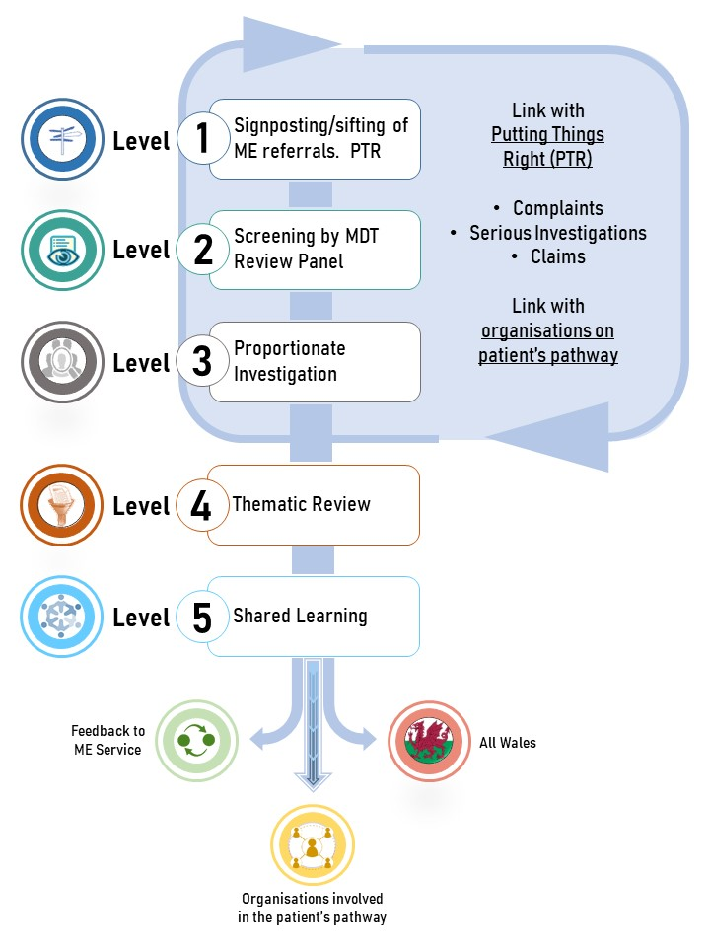

5.6 Following the 5 Levels of Managing an MR

Below are suggested procedures for local adaptation as considered most appropriate. They support organisations to meet their governance and assurance procedures and the requirements of MR and ME processes.

Level 1: Signposting of ME Concerns
The aim of Level 1 is to ensure that only referrals requiring further scrutiny by a mortality review process, progresses down that route (via level 2), and all other concerns are signposted to existing alternative processes.
Level 1: Suggested Standard Operating Procedure:
All referrals raised by the ME will be sent to a dedicated email address provided by the organisation. It will be monitored by an appointed officer identified by the Executive Medical Director.
- The referrals received from the ME will be registered on an All Wales Learning from Mortality Reviews Module which will provide an audit, assurance and learning trail as it is managed through the organisation and will be monitored consistently.
- An automated acknowledgement of receipt will be sent to the ME.
- Each new referral from the ME will be initially reviewed by an individual in accordance with criteria agreed with the Executive Medical Director and in line with PTR to determine immediate next steps and timeliness.

- Next steps:

  - A Mortality Review Lead will be allocated with responsibility for managing the case up to and at Level 2.
  - The MR Lead individual will:
    - Have access to any complaints, concerns or incidents relating to the patients case (as recorded on Datix/OfW)
    - Consider which services have been involved in the care of the patient prior to death and ensure that they are included in panel meetings e.g. primary care, emergency services, community, mental health, learning disabilities etc)
    - Consider which records need to be accessed
    - Decide if sufficient information is available and what further input will be required.
    - Recommend to the level 2 panel if the referral should be managed by:

- Either using the PTR route as a claim, complaint, Serious incident, or
- Via the Mortality Review route to Level 2/3

Level 2: Screening MDT Review

At Level 2 the Panel will consider the case in line with the MR process which will involve an MDT review of the case.
Level 2: Suggested Standard Operating Procedure:
The MDT Panel should meet on at least a weekly basis and consist of a cross section of clinical and non-clinical professions, including representation from Quality/Safety/Risk Management.
The MR Lead for the case will be responsible for ensuring that the case is presented to an MDT Panel.
The Panel should consider the presentation by the MR Lead and discuss any concerns arising, including identifying missing data that may be needed to make a decision, and whether issues have a low, moderate or significant impact. The panel should also consider whether support from specialists or experts NOT involved in the case is required
The panel should, for each case, decide one of the following actions:
- There is already an existing process underway which will effectively address the issues raised in the ME’s referral
- The case can be closed to further investigation at Level 2 under the MR Process
- The case requires a more in-depth investigation under Level 3: Proportionate Investigation
Where a case requires C. a more in depth investigation under Level 3, the panel should recommend
- Which process (e.g. PTR, Mortality Screening Tool) should be used for the investigation?
- Who will commission the investigation?
- Draft Terms of Reference
Where issues relate to independent contractors, the AMD for Primary Care will decide on how the independent contractor is informed.
The MDT panel will then inform relevant service managers & quality and safety meetings, including Mortality and Morbidity meetings, of its findings and any action plan where appropriate.
The implementation of the action plan where relevant will be assigned to a lead manager for progression and will be monitored by the relevant Quality Board until the loop is closed.
All Decisions and actions should be recorded in the All Wales Learning from Mortality Reviews System

Level 3: Proportionate Investigation

Where a case has not been resolved in the first two levels a proportionate investigation should be arranged. The scale and scope of the investigation should be proportionate to the case to ensure resources are effectively used. Cases which indicate the most significant need for learning to prevent serious harm should be prioritised. The aim is to prevent the incident recurring.
A proportionate investigation may include the use of the All Wales Mortality Review Tool, a formal investigation methodology as included in the OfW/Datix module (Link: module under development), or even an external review. Wherever possible, the organisations existing investigation and reporting processes should be used if they meet the requirements of the case, rather than set up a new service.
As a general measure an organisation will proceed to Level 3 and base this decision on:
- Whether key issues and corrective actions have been identified, which could ultimately prevent or reduce the likelihood of the case recurring.
- how assurance can be provided that risks have been reduced so far as is reasonably practicable, to ensure that appropriate control measures have been identified.
In line with the principles and arrangements for Putting Things Right (PTR), a standardised process in the investigation of concerns in order to “investigate once, investigate well” is emphasised. This will ensure that the investigation is thorough, systematic and avoids shortcuts which impact negatively on the final outcome of the quality and findings of the investigation.
Investigators should be trained in the standardised investigation, methodology and the investigation team should be drawn from several departments and organisations, which will reflect the patient pathway. A collaborative approach should be used throughout.
Investigations will reflect the All Wales Incident Management Process:
- Management Review (equivalent to level 1)
- Concise Investigation (equivalent to level 2)
- Comprehensive investigation (equivalent to level 3)

Level 3: Suggested Standard Operating Procedure:
- Commissioning Manager
- Lead investigator
- Agree Terms of Reference
- Investigation Team Membership
- Chair of Team
- Scope of Investigation
- Standard Methodology to be used e.g. Root Cause Analysis (Fact-finding, Analysis, Conclusions, Action Plan,)
- Expected duration of investigation
- Investigation process
- Clinical specialists, not involved in patient care under investigation, may be required to provide internal clinical opinion (independent of the service).
- The AMD for primary care will advise on how best to involve independent contractors
- The investigation Report is shared with the Commissioning Manager, and copied to the Level 2 screening panel
- The relevant Quality & Safety meeting and Executive leads will monitor progress against implementation of any resulting action plans.

Level 4: Local Thematic Review

There should be a regular summary report of the themes of concerns raised by medical examiners, organisations and the associated outcomes. This report provides an opportunity to reflect on common issues that have arisen both within a specific service or site, and across multiple services or sites.
This report may lead to further thematic review of cases sharing common factors. e.g. deaths involving anticoagulation or DMARDs. HBs and Trusts may wish to focus in more detail on specific services according to local need, which will include primary care services.
Thematic reports can be commissioned by the chair of the Level 2 Mortality Review Panel and/or the Executive Medical Director.
Level 4: Suggested Standard Operating Procedure:
Thematic Reports can be commissioned by the chair of the Level 2 Mortality Review panel, or executive medical director
A regular summary report every 6-12 months of the themes of concerns raised by medical examiners and organisations and the associated outcomes
Local Thematic Reviews may consist of
- Descriptive statistics of themes
- Interpretative statistics of patterns and clusters in the data
- Triangulation with other reports
    - Ombudsman
    - Patient experience
    - Serious Incidents
    - Claims
    - Complaints
    - Risk Registers
    - Thematic reviews provided by the Medical Examiners Service
- Lessons learned from screening tools and proportionate investigations

A thematic Review Tool will be made available to support organisations in undertaking reviews that have led to the death of a patient. It can however, be applied to all patient safety incidents.

Level 5: Sharing Learning and Implementation of Actions

Local analysis of reviews should be triangulated with information produced from other sources, e.g. Coroners, SIs, which will lead to co-ordinated local action plans to ensure lessons are applied throughout the organisation as long term and sustainable solutions. Solutions should be identified that address the themes or root causes of what has gone wrong to reduce the likelihood of recurrence.
Learning is often considered as a one off event where the problem is focused upon for a short time but moves on to new priorities as they emerge, so that sustained learning is lost. The impact of action plans should be measured over time as part of a core clinical governance activity review programme. This maintains a record of changed recommended and action taken to implement those changes.
Change requires the use of a number of communication channels to spread the message, build awareness of the new process and provide support to staff through re-training, empowerment and involvement in the process. Locally this means use of robust infrastructures that can be relied upon to disseminate key information.
Nationally, sharing learning should involve the use of existing networks and creation of new if not already in place. Networks need to be inter-linked so that all wales learning can be shared and progress monitored. Existing all Wales networks should have standing agenda items for learning from reviews:
- Exec Medical Directors
- Exec Nursing Directors
- Exec Therapies Directors
- AMDs in Primary Care
- Mortality review steering group has a wide membership, who are tasked with taking key messages back to their respective organisations or professional groups.
- Welsh Legal & Risk Pool
- Medical Examiner
- Heads of Patient Experience Network
- All Wales Listening and Learning group
- Coroners

6 Closing the loop – Governance arrangements

6.1 Assurance

It is essential that all Boards have robust systems are in place for the reporting and management of MR cases in line with the Quality and Safety Assurance Framework.
This will ensure that when cases are closed by the relevant panel or committee, lessons have been shared and action plans implemented across the various healthcare organisations involved.
The compliance and hence impact of these action plans should be measured over time as part of an ongoing core clinical governance/audit activity review programme. This can be effectively managed via a rolling programme of testing compliance with SOPs/safety process.
Organisations should be able to demonstrate that:
- The board and executive is aware of deaths and any learning and actions that have resulted
- The risk of recurrence has been appropriately managed as far as is reasonably practicable
- Feedback on actions and learning has been shared with
  - Carer/family
  - Staff and teams
  - The medical examiner

7 Forthcoming work

A “National Learning from Deaths” Programme will be developed to maximise the learning, using two key approaches:
- Extrinsic:

  - Regular national meetings, e.g. monthly, which look at both processes & quality, as well as themes e.g. suicides, peri-operatives deaths
  - Multiple Sources (e.g. Medical Examiners, Clinical Reviews, Coroners Inquests and Regulation 28s, Serious incidents etc.)
  - Communication via safety alerts, newsfeeds via DU Website and briefings into local bulletins

- Intrinsic:
- A system of regular peer review of organisations to facilitate formative assessment and learning prompted by colleagues

This co-ordinated approach to analysing information from different sources will help target and prioritise the key risks that require local and national attention.

Appendix 1

Medical Examiner’s Advice and Scrutiny Form ME-1 (Part B) MESW v1.1

Appendix 2

Key definitions

Medical Examiner (ME) | Medical examiners are part of a national network of specifically trained independent senior doctors (from any specialty). Overseen by a National Medical Examiner, they scrutinise all deaths that do not fall under the coroner’s jurisdiction across a local area.
Concerns | These are issues identified from patient safety incidents, complaints and, in respect of Welsh NHS bodies, claims about services provided by a Responsible Body in Wales.
Patient Safety Incident | Any unintended or unexpected incident(s) that could have or did lead to harm for one or more persons receiving NHS-funded healthcare.
Mortality review  (MR) | A structured systematic assessment of the care provided to patient during their final illness. The aim is to learn and share from a patient’s death, to identify if there are concerns and establish if similar situations may affect other patients and to improve overall quality of care.
A case that requires further review | HB need to determine if there were factors in the care of the patient which should have been in place but were absent or if healthcare interventions took place which were detrimental to the outcome. (Replace)
MCCD | Medical Certification of Cause of death (completed by Drs)
QAPS | Qualified Authorised practitioner can sign the death certificate
Structured investigation | This is a systematic technique used to find out what went wrong, how and why. The technique looks beyond the individuals concerned and seek to understand the underlying causes and organisational context in which the incident occurs, so that they can be addressed and managed.  Organisations need to understand the underlying contributory factors of patient safety incidents so that the key problems can be addressed.
Proportionate investigation | The scale and scope of any investigation should be proportionate to the concern to ensure resources are effectively used. The impact and complexity of the incident, in terms of severity of patient harm, should be a guide to the scope of investigation. Concerns which indicate the most significant need for learning to prevent serious harm should be prioritised. This ensures that organisations are focusing resources in an appropriate way.
Mortality Review Tools
Administrative Information  Form ME-1 (Part A) | A national template form to be provided to a medical examiner or coroner following a death by medical examiner’s officer, bereavement care officer, and clinical staff.
Medical Examiner’s Advice and Scrutiny Form ME-1 (Part B) MESW v1.1 | A national template form to be completed by MEs where concerns or good practice have been identified and sent to the HB to decide on further action. , except for those that have been referred to the coroners or where deaths have been registered and signed off by the ME.
Mortality Review Module (OfW) | A method adopted by HBs to help identify where problems are suspected to have occurred in the patients episodes of care. It is completed by clinicians/multi-disciplinary group who have been trained in the use of the tool. A prompt to using this tool is defined as ‘any point when the patient’s healthcare fell below an acceptable standard and led to harm and or death’.
Structured investigation methodology | This is a technique for undertaking a systematic investigation that looks beyond the individuals concerned and seeks to identify the underlying causes and organisational context. It allows the real causes of an event to emerge to enable learning and for remedial action to be put in place. This will be included an investigation module as part of OfW Incident reporting.
Template for feedback to MEs | An all wales, structured template to feedback to the ME will support the process for further analysis of this information. This will be included as part of the OfW module.
Peer Review Process | This is an approach to support a peer review relating to MRs across Wales. It will help inform the process of learning from deaths on an ongoing basis.
Thematic Review | This is a process that helps organisations understand what happened in multiple cases that underwent investigation, linked by specific common features, to learn from them and to make changes that will consequently lead to improvements in the service.

Appendix 3

Mortality Review Toolkit

- All Wales Mortality Review Template (in development)
- Feedback Template from Organisation to ME
- Thematic Review Template for Case Series of Deaths
- Peer Review Protocol
- Principles of National Learning Event

Appendix 4

Stakeholders

- GPC Wales
- Exec medical directors
- Exec nursing directors
- Exec Directors of Therapies & Health science
- Primary Care Reference group
- Mortality review steering group
- Patient Safety risk managers
- Welsh Legal & Risk (“Once for Wales Concerns Management System”)
- AMDs for primary care & community care
- Welsh Government Quality & Safety group
- Patient Representation – via HB
- Medical examiners and lead medical examiner
- Coroners peer group
- Improvement Cymru

Appendix 5

References

- A Healthier Wales (Welsh Government, 2018)
- Wellbeing of Future Generations Act (2015)
- Health and Social Care (Quality and Engagement) (Wales) Act 2020
  - Duty of quality improvement
  - Duty of candour
- WG Quality Framework (due 2021)
- Primary Care Strategic Programme Review of Governance, Quality & Safety (2020)

- Putting Things Right legislation (2011, revised 2013)
- Death Certification (Medical Examiners) (Wales) Regulations 2018
- National Clinical Framework for Wales (2021)
- Patient Safety Incidents Policy – WG.2021-4-23

APPENDAGES

The following section includes processes for undertaking mortality reviews in different specialties. They have been developed in line with this framework. This section will be added to as and when these processes become available.

A Single Process for Mortality Review in General Practice Wales
Background
Scrutiny of death certification by the recently appointed Medical Examiner Service (MES) in Wales will identify situations where concerns are expressed or come to light. Ensuring that any concerns are passed to the relevant party is a fundamental role of the MES process. A mortality review should be considered in both primary and secondary care where concerns have been raised. It is logical to assume that in some cases there will be a need for review in both settings. Secondary and tertiary care centres in Wales are already very familiar with the process of mortality review but this is a new concept for most of the primary care setting. This paper outlines the process for mortality review in General Practice in Wales, to be used by all General Practices where a review is indicated.
Process
It is important to stress that the mortality review is not part of the complaints process or litigation process. Where these situations apply, there are already methods of management in place and a mortality review is not the appropriate process to follow. These would be managed via the Putting Things Right process. The main output from a mortality review is understanding and learning from both good practice and where things could have been done better, and ensuring that actions are implemented to address areas of concern. There are three main outcomes from the process of scrutiny applied by the MES in Wales. These are
- The issue of a medical certificate of the cause of death (MCCD),
- A referral to the coronial service or
- The identification of some concerns by the MES or relatives of the deceased that suggest a stage two mortality review should be considered (in secondary care this is referred to as a second stage mortality review). a) and c) can occur in tandem.
Where a referral to the coroner is not indicated, but the MES is made aware of concerns that should be brought to the attention of the service, the MES will convey such concerns they detect in primary care to the deceased’s general practitioner (via the practice manager) by completing the standardised ME-1 form parts A and B (Part B is at Appendix A). The MES cannot direct a requirement for a mortality review but will suggest to the practice that a review should be considered. The matter then sits with the practice.
At the same time as notifying the GP Practice Manager, the MES will inform the relevant Health Board Medical Director (or Associate MD for Primary Care) that such a notification has been sent to the deceased’s GP practice manager. This ensures that the Health Board is aware at the outset of the process. This also indicates the beginning of the process which should be expected to be completed in a timely fashion by the GP practice. A specific timescale is not applied because there will be a range of complexity and breadth of engagement that will apply to different scenarios. The GP practice will inform the Health Board and the Medical Examiner Service of practice’s response including:
- whether or not a mortality review was undertaken and the reasons for not doing so if not
- a summary of the review if undertaken
- the main outcomes of the review
- any relevant learning or changes in practice that have resulted from the review.

Methods
The process will be supported by use of the Significant Event Analysis process and completing a Summary Template of Event and Action plan (Appendix B)
The process for undertaking a mortality review should be akin to any other significant event analysis. This is a very familiar process to the vast majority of general practices in Wales. A multi-professional approach would usually be required and should include all relevant staff including GPs, Admin member of staff, reception staff, Practice Nurses, District Nurses, Mental Health Worker, Social or Care worker or any other community health or care worker significantly involved in the care of the deceased. It may be necessary to include secondary care or other organisations (e.g. WAST or the Prison Service) input if the case involved these interfaces.
The review should include
- The names of participants
- The reasons for the review
- The findings
  - A summary of all relevant consultations, prescribing, investigations, referrals or not, actions on any results
  - Commentary on whether the above actions were appropriate and timely
  - Commentary on all aspects of good practice
  - A description of any issues that could or should have been handled better
  - A description of any learning that was identified and how this was shared and achieved.
Further advice on issues to be covered, and a structured template can be seen at Appendix B. It is a word document that should be used to provide a consistent approach. This can be saved for submission to the Health Board and MES on completion of the review and can be uploaded to MARS and used for individual appraisal processes (in a redacted form to remove any patient identifiable data).
Wider learning
It is envisaged that all reviews will be held on an electronic platform. How and by whom?
On conclusion of the report, the practice should share its findings with the Health Board. This could be at an annual review, but the documents should be sent as soon as completed. The Health Board will be in a position to collate a number of mortality reviews and may be able to identify any patterns or trends over a larger population base. This could lead to an opportunity to learn at a HB and Wales-wide level through sharing anonymised mortality review outcomes.
It is recognised that some practices may struggle, due to capacity, complexity or other reasons, to undertake effective mortality reviews. In these circumstances help should be available primarily to facilitate the process, or unusually complete the process on behalf of the practice. This could be from a range of sources, for example at cluster level, by buddying with another practice or from the Primary Medical Care Advisory Team (PMCAT) service. The strong preference of the working group was to use the independence and existing skill set of the PMCAT.
Where it identified that there is a need to address concerns in more than one setting, a joined-up approach to the review will help identify any service-wide learning.

Appendix 2. Thematic Data
COVID
  Nosocomial COVID-19
  ME Service | 142
  Grand Total |  | 142
  Community COVID
  Family | 1
  ME Service | 2
  Grand Total | 3
Communication
  Communication - with family / Patient
  Family | 90
  ME Service |  | 11
  Grand Total |  |  | 101
  Communication - between Staff / Wards / Hospitals in SBU
  Family | 4
  ME Service |  | 9
  Grand Total |  | 13
Communication - between other HBs
ME Service | 2
Grand Total | 2

Documentation
  Documentation Not Completed/ Wrong details
  Family | 1
  ME Service | 7
  Grand Total |  | 8
  Lack of or No Documentation
  ME Service | 28
  Grand Total |  | 28
  Illegible
  ME Service | 6
  Grand Total | 6
  Poor Quality / Not in Order
  ME Service | 4
  Grand Total | 4
Accessibility of ED Documentation
ME Service | 1
Grand Total |  | 1

DNACPR
  DNACPR Partially Completed / No senior signature
  ME Service | 10
  Grand Total | 10
  CPR performed with DNACPR in place
  ME Service | 7
  Grand Total | 7
  DNACPR Not in Notes
  ME Service |  | 1
  Grand Total |  | 1
  Failure to escalate DNACPR discussions with family
  ME Service | 1
  Grand Total | 1
General DNACPR Concerns
Family | 1
ME Service | 12
Grand Total | 13

Medication
  Missed Medication
  Family | 2
  ME Service | 13
  Grand Total | 15
  Delayed Medication
  Family | 4
  ME Service | 3
  Grand Total | 7
  Wrong Medication
  Family | 2
  ME Service | 9
  Grand Total | 11
  General Medication
  Family | 8
  ME Service | 33
  Grand Total | 41
Prior Admission
  WAST Concerns
  Family | 9
  ME Service | 38
  Grand Total | 47
  Issues with Offloading
  Family | 5
  ME Service | 32
  Grand Total | 37
Care
  Inappropriate Discharge
  Family | 11
  ME Service | 11
  Both | 2
  Grand Total |  | 24
  Delayed Discharge
  Family | 1
  ME Service | 3
  Grand Total | 4
  Previous Admission Concern
  Family | 8
  ME Service | 1
  Grand Total | 9
  Transfer Between Hospitals / Wards
  Family | 14
  ME Service | 15
  Grand Total |  | 29
  Long Admission
  ME Service | 8
  Grand Total | 8
  Infection Control Concerns
  Family | 1
  ME Service | 25
  Grand Total |  | 26
  Falls
  Family | 2
  ME Service | 32
  Grand Total | 34
  Pressure Sores
  ME Service | 27
  Grand Total | 27
  Care by Clinicians Concerns
  Family | 12
  ME Service |  | 12
  Grand Total |  | 24
  Care from Nurses Concerns
  Family | 29
  ME Service | 7
  Grand Total |  | 36
  Wrong Area of Treatment
  Family | 2
  Grand Total | 2
  Lack of/Delay in Referral to other speciality
  ME Service | 8
  Grand Total | 8
  Advanced Future Care Planning
  ME Service | 1
  Grand Total | 1
  Concerns with EOL Care
  Family | 3
  ME Service | 2
  Grand Total | 5
Care Cont.
Dignity / Respect
Family | 6
ME Service | 1
Grand Total | 7

NEWS
  Score Not Correct
  ME Service | 1
  Grand Total | 1
  Not Followed Correctly
  ME Service | 2
  Grand Total | 2
Death
  Post Op Death (Surgical)
  ME Service | 27
  Grand Total | 27
  Death within 30 days of Chemo
  ME Service | 6
  Grand Total |  | 6
  Unexpected Death
  ME Service | 9
  Grand Total | 9
  Cardiac Arrest
  Family | 1
  ME Service | 28
  Grand Total | 29
Community
  Package of Care
  Family | 4
  ME Service | 5
  Grand Total | 9
  HB Community Services Concerns
  Family | 6
  ME Service |  | 4
  Grand Total |  |  | 10
  Nursing / Residential Care Home Concerns
  Family | 3
  ME Service |  | 6
  Both | 1
  Grand Total |  | 10
  GMS(GP) Acute Care Management Concerns
  Family | 13
  ME Service |  | 3
  Grand Total |  |  | 16
Additional Processes
  DOLS / POVA / MHA
  ME Service |  | 4
  Grand Total | 4
  Safeguarding
  Family | 1
  ME Service | 8
  Grand Total | 9
  POA
  ME Service | 1
  Grand Total | 1
  Putting Things Right (PTR)
  ME Service | 4
  Grand Total | 4
Other
  Visiting Restrictions
  Family | 7
  Grand Total | 7
  Lost Property
  Family | 2
  Grand Total | 2
  Count of Faulty Hospital Equipment
  Family | 3
  ME Service | 2
  Grand Total | 5
  Count of Staff Capacity Issues
  Family | 2
  ME Service | 3
  Grand Total | 5

Other contd.
  Time delay from death to MCCD issued
  ME Service | 1
  Grand Total |  | 1
  Delay in/Issues with Death verified off ward /CADT
  Family | 1
  ME Service | 5
  Grand Total | 6
Influenza A
ME Service | 3
Grand Total | 3

