


Meeting Date | 01 September 2023 |  | Agenda Item
Report Title | Pharmacy & Medicines Management Progress Report
Report Authors | Amy Jayham (Head of Pharmacy Operations  Rhys Howell (Advanced Pharmacist – Governance, Improvement and Transformation)
Report Sponsor | Judith Vincent (Clinical Director for Pharmacy & Medicines Management & Controlled Drugs Accountable Officer)
Presented by | Judith Vincent (Clinical Director for Pharmacy & Medicines Management & Controlled Drugs Accountable Officer)
Freedom of Information | Open
Purpose of the Report | This paper provides a progress report on Quality, Safety & Governance in Pharmacy and Medicines Management and Controlled Drugs Assurance.
Key Issues

Specific Action Required  (please choose one only) | Information | Discussion |  | Assurance | Approval
Specific Action Required  (please choose one only) | ☐ | ☐ |  | ☒ | ☐
Recommendations | Members are asked to receive this update report

Pharmacy & Medicines Management Progress Report

1. National Prescribing Indicators

The All Wales Medicines Strategy Group endorse a number of National Prescribing indicators annually, which are used to highlight therapeutic priorities for NHS Wales and compare the ways in which different prescribers and organisations use particular medicines or groups of medicines.

They are developed to promote rational prescribing of medicines in Wales. The choice of indicators is evidence-based and the indicators allow health boards, primary care clusters, GP practices and prescribers to compare their current prescribing practice against an agreed standard of quality.

The below graphs show Swansea Bay’s performance against quality, safety and efficiency indicators for the latest quarter data available (Quarter 1, 2023/24

1.1 4C Antibacterial items per 1,000 patients

The use of 4C antibacterials (co-amoxiclav, cephalosproins, fluoroquinalones and clindamycin) can lead to resistance and an increased risk of C difficile, MRSA and resistant urinary tract infections. Swansea Bay HB are the lowest prescribers in Wales and continue to make reductions. This area of prescribing is a focus at Cluster Prescribing Leads and various HB wide antimicrobial stewardship groups.
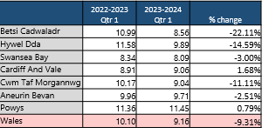
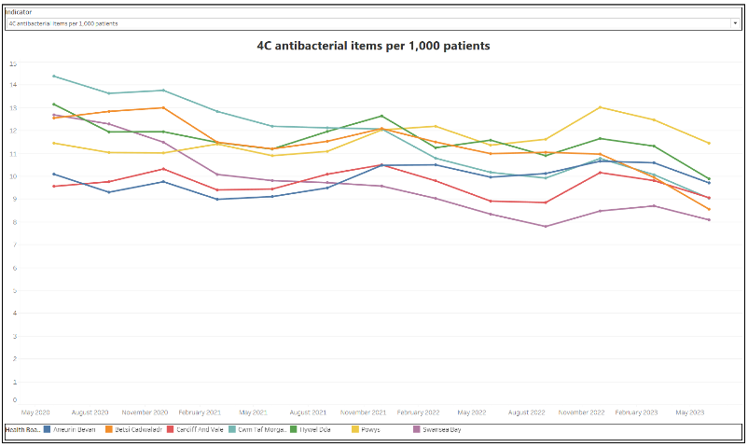

1.2 Antibacterial items per 1,000 STAR-Pus

This indicator aims to encourage the appropriate prescribing of antibiotics in primary care to minimise resistance. Swansea Bay is the 2nd highest prescribing HB in Wales but has seen a minimal increase comparing quarter one this year to last year. Work is supported and driven by various HB groups and Cluster Prescribing Leads led by the Consultant Antimicrobial pharmacist.

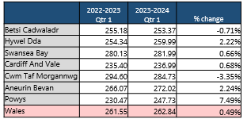
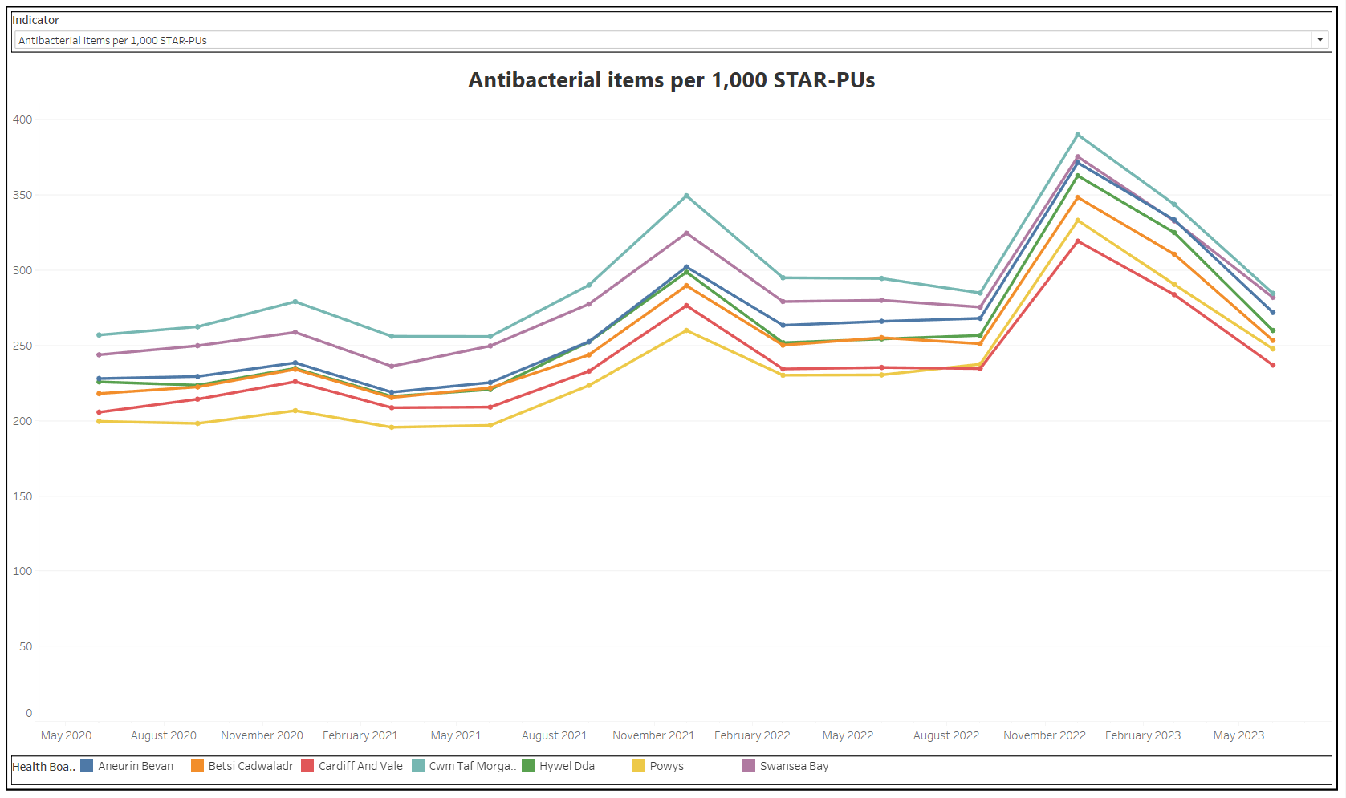

1.3 DPIs and SMIs as a percentage of all inhalers

This indicator aims to encourage increased prescribing of ‘low’ global warming potential (GWP) inhalers such as dry powder inhalers (DPI) and soft mist inhalers (SMI), to reduce the overall carbon footprint of medicines. Metered dose inhalers are estimated to be responsible for 4% of the NHS’s entire carbon footprint. The target is to increase prescribing of DPIs and SMIs to 80% by 2025.
Unfortunately, Swansea Bay are making slow progress in this area. However, the team have won a number of decarbonisation awards over the last year (Green Team and LOV awards) and they continue to work closely with primary care to provide education to GPs and practice nurses, promoting a whole system approach across sectors.

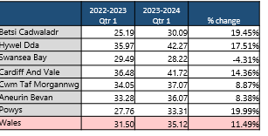
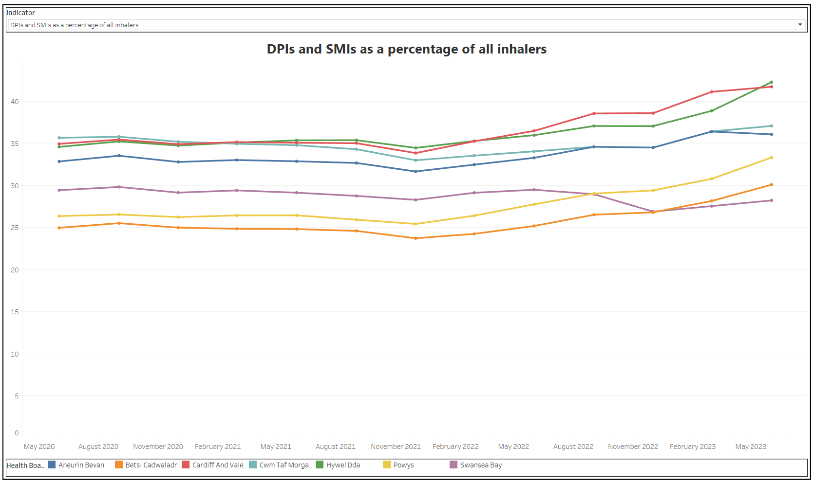

1.4 Opioid burden DDDs per 1,000 patients

There is a lack of evidence to support strong clinical recommendation for long term use of opioids in chronic non-cancer pain. Reduction has been demonstrated in most areas across Wales with Swansea Bay continuing to make progress. The indicator promotes a prudent approach to prescribing taking into account indication, risks and benefits, to encourage timely review of patients with chronic pain indications.

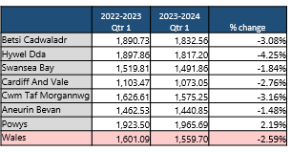
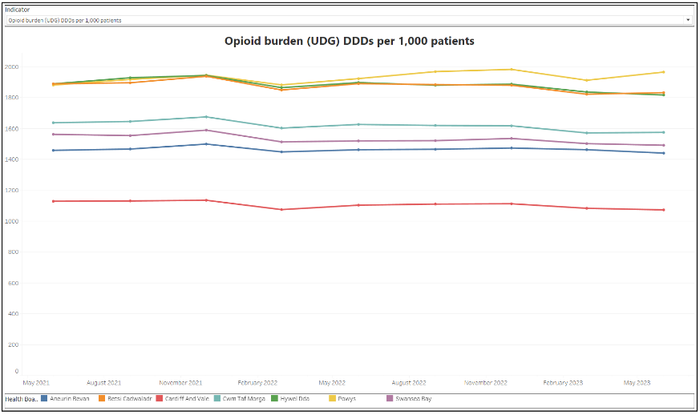

1.5 High strength opioids DDDs per 1,000 patients

Across Wales high strength opioid prescribing has reduced by 10.14% comparing quarter 1 year on year. Reduction in Swansea Bay is 1.67%. However overall prescribing remains lower than the all Wales level. Work progresses in this area to encourage review of patients prescribed high strength opioids by GPs via the Prescribing Management Scheme (PMS) and cluster prescribing leads meetings. The analgesic stewardship work aims to highlight appropriate prescribing across all sectors. It has been suggested that increases are due to extended waiting list times for surgery post pandemic.

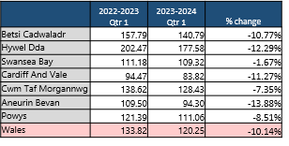
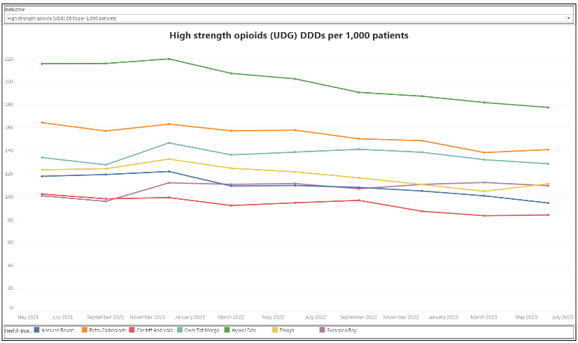

1.6 Tramadol DDDs per 1,000 patients

Whilst there is a recognised place in pain management for tramadol, there are concerns regarding the risks associated with dependence, diversion and misuse and adverse drug reactions. Swansea Bay continues to make good progress in reducing prescribing in line with the rest of Wales.

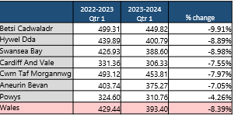
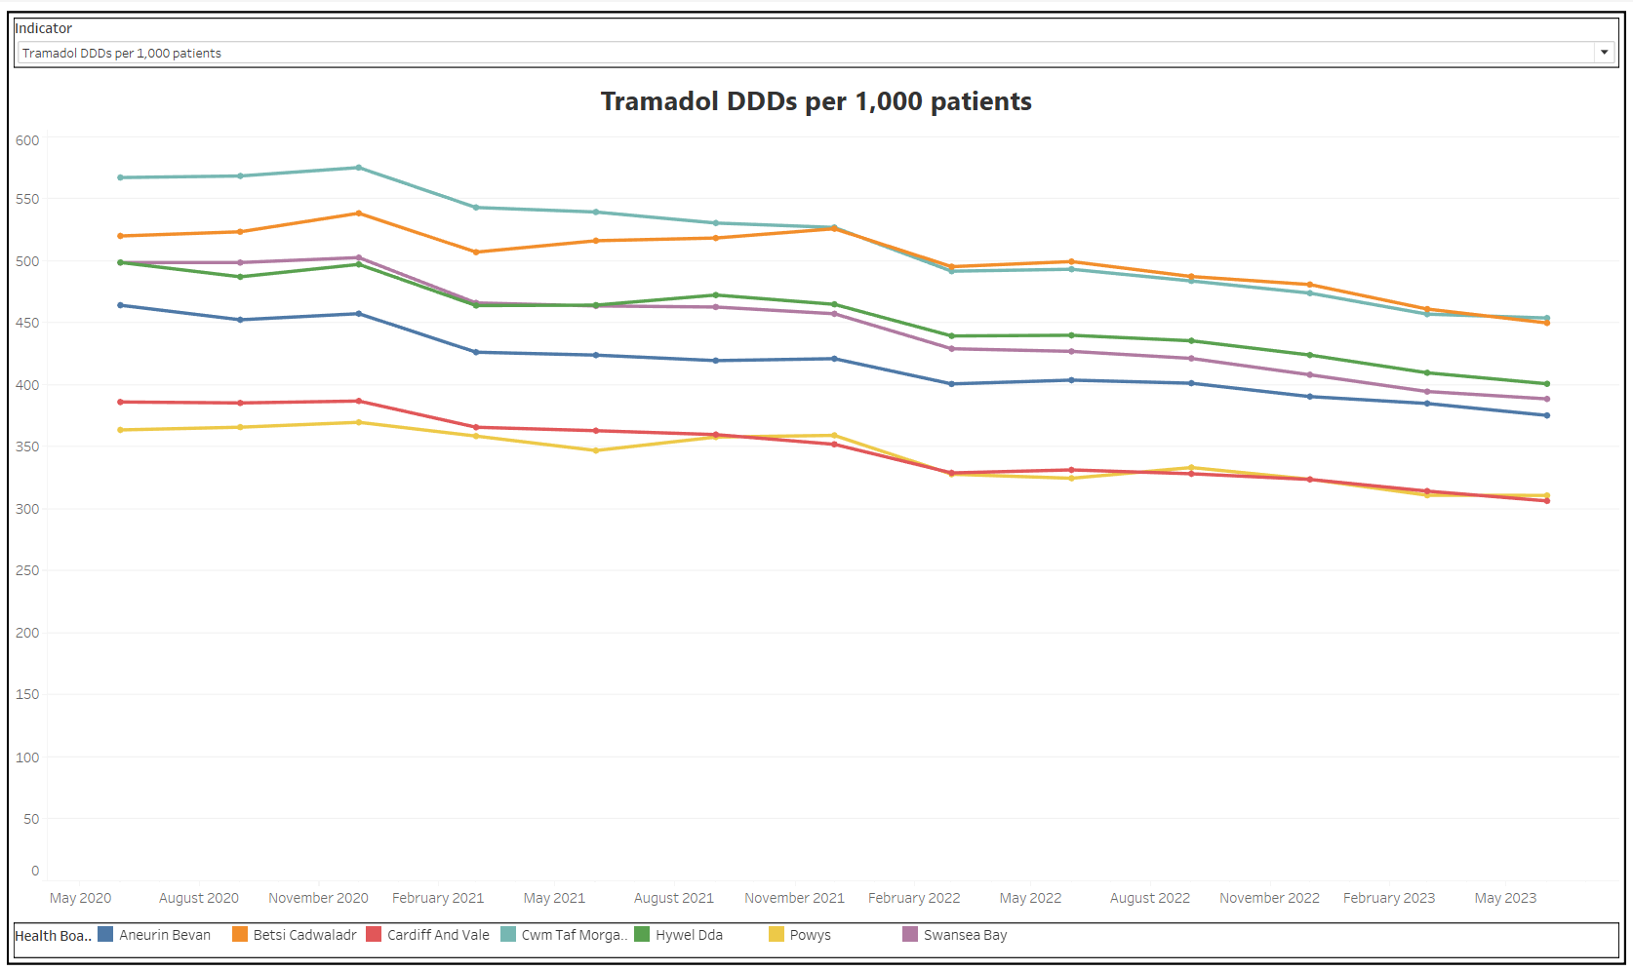

1.7 Gabapentin and pregabalin DDDs per 1,000 patients

These drugs have a well defined role in the treatment of epilepsy and neuropathic pain, with pregabalin also used for generalised anxiety disorder. However both drugs have the potential for dependence forming, diversion, misuse and adverse drug reactions. Ongoing review of patients prescribed these drugs for neuropathic pain is required to check for efficacy and side effects.
Swansea Bay is the only HB in Wales to reduce prescribing over the last year. This in part is due to the focus given in Cluster Prescribing Leads meetings, engagement with acute pain teams and the prescribing management scheme.

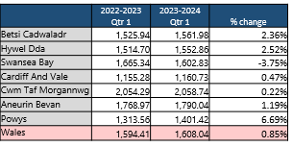
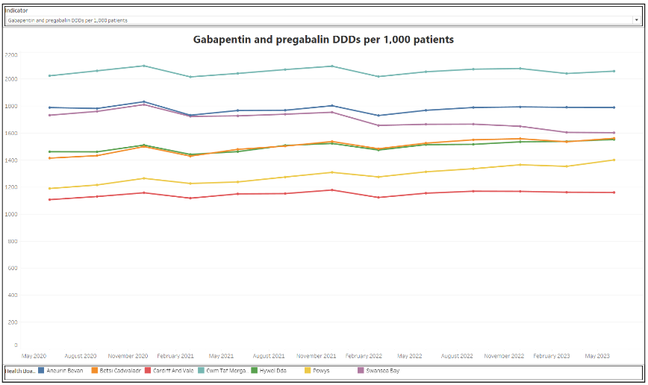

1.8 Hypnotics and anxiolytics ADQs per 1,000 STAR-Pus

This indicator encourages a reduction in the inappropriate prescribing of hypnotics and anxiolytics, which can contribute to problems of physical and psychological dependence and may mask underlying depression. Swansea Bay continues to make reductions in this area as the second highest prescribing HB in Wales.

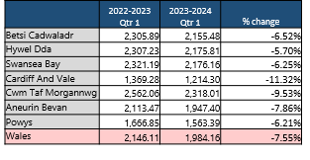
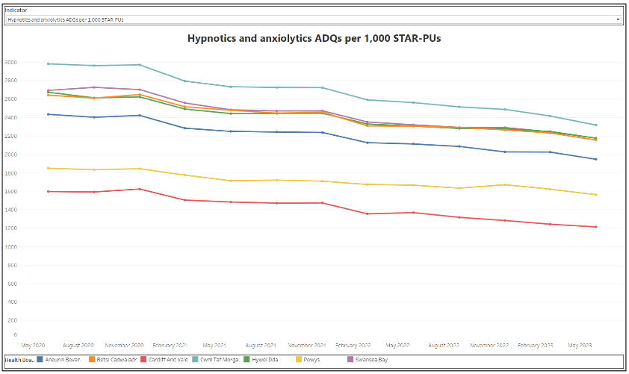

1.9 Low value for Prescribing spend (£) per 1,000 patients

The aim of this indicator is to reduce the prescribing of items considered as not suitable for routine prescribing (e.g. co-proxamol, lidocaine plasters, omega 3, liothyronine). Prescribing in Swansea Bay remain low overall despite a recent increase which can be attributed to a small number of patients on high cost items.
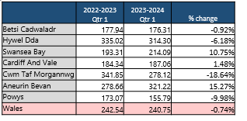
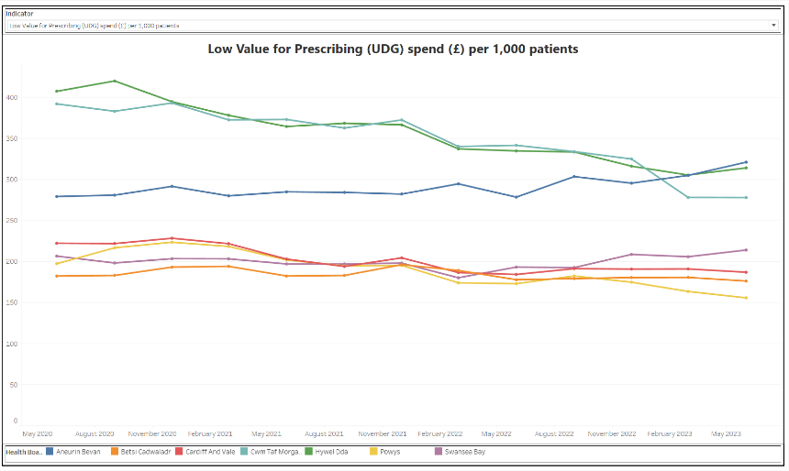

2. Controlled Drugs Update
2.1 Home Office Controlled Drug Licenses
As part of wider activity ongoing across the Health Board to ensure compliance with Home Office controlled drug licensing requirements, Pharmacy & Medicines Management have applied for an additional four such licenses in addition to the one already held. See table below.

Pharmacy Site | License | Scheduled Home Office Visit
Morriston Hospital | New application | 27/09/2023
Singleton Hospital | New application | 27/09/2023
Neath Port Talbot Hospital | New application | 26/09/2023
NPHT Pharmacy Pre-Packing Unit | New application | 26/09/2023
Cefn Coed | Existing License | 13/11/2023 (Renewal)
Table: Pharmacy & Medicines Management Home Office CD licenses: Applied for and existing.

2.2 Internal Audit of Controlled Drug Compliance
In support of recommendation 2 of the Health Board wide, ‘Internal Audit of Controlled Drug Compliance,’ Pharmacy and Medicines Management have strengthened the Health Board, ‘Ward/Department Controlled Drugs Audit Form.’ Roll out of this new form is expected imminently and compliance will be re-audited in 6-9 months.
PMM continue to support the Health Board’s ward quality assurance programme through participation in unannounced visits. A broad review of medicines management is undertaken including a specific appraisal of controlled drug management.

2.3 Quarterly Monitoring of NHS Controlled Drug Prescribing by GP Practices in Primary Care
The mandate given within, ‘The Controlled Drugs (Supervision of management and Use) Wales Regulations 2008,’ to monitor and analyse prescribing of controlled drugs includes prescribing by GP practices in primary care. The Pharmacy and Medicines Management team work closely with PCT Service Group colleagues to undertake this monitoring and analysis. Given the volume of data, specialist software is used to create dashboards that support this work. It has been identified recently that these dashboards need to be re-built to ensure ongoing accuracy of reporting.

3. Risk Register update

The following PMM risks remain/ have increased to 20 in September 2023:
- No capital funding available for estates to commission drawings for plans to redevelop Morriston dispensary to increase capacity/ ensure safe practices. Risk score increased on RR to 20 (RR 2283).
- Outsourcing of medicines supply to commercial sector & fragility of homecare market- Score of 20 on risk register (RR 3080).
- Risk of failure of Pharmagraph Host PC (Dell Windows7 PC) due to age. RR score increased to 20 as no funding identified for IT installation (RR 3047).
- Acute and ongoing staffing issues across Pharmacy. Risk score of 20 (RR 2819).
- Introduction HEPMA has increased time taken for pharmacy to complete medicines reconciliation, clinical review of patients and discharges. Score 20 (RR 3233).

The new risks below have been added during the reporting period:
- Urgent need for digital patient database for patients receiving Medicines Homecare Services by general homecare team and Pharmacy Cancer team (Score 16). Medicines Homecare service (for general homecare & oncology) relies on a crude Excel sheet to monitor c.4000 (and since inception 13,000+) active patients’ prescriptions, deliveries, monitoring requirements and order/invoice reconciliation. This is a high cost, high-risk area of prescribing & medicines management; with annual medicines spend of £29m and delivering savings of £5.8m for SBU. Risks of current system- include loss of patient data, restriction of access, lack of detailed outputs without laborious interrogation, duplication of work, no audit trail. A digital solution is required to improve patient safety, workforce efficiency and finance controls (RR 3505).

- Pharmacy Technical Services single Air Handling Unit (AHU) Chiller Unit resilience (Score 16). The chiller unit is now 6 years old and has experienced several failures in the past 12 months resulting in temperature excursions. Risk flagged with Capital planning. Plans under way to source funding, design, order and install a second chiller unit on site. Target date November/December 2023 (RR 3437).

- Pharmacy & Medicines Management service provision to CAMHS (Score 12). Swansea and Neath Port Talbot CAMHS community services repatriated to SBU April 2023. No Pharmacy resource made available, e.g. medicines information queries, advice of supply or primary / secondary care prescribing interface issues, development of medicines related polices for patients < 18 yrs with mental health needs. Queries currently directed to pharmacy in Cefn Coed where there is already a limited pharmacy resource, and a lack of specialist CAMHS knowledge. There are no medicines related policies on COIN relating to MH patients under 18 yrs. Resource should be provided in order to address the gap in pharmacy capacity and to develop local expertise in prescribing for CAMHS patients (RR 3526).

- Delayed discharges due to lack of dedicated Pharmacy support on Clydach Ward (Score 15). Lack of allocated pharmacy support on Clydach ward for TTO’s. Drug charts are taken to other Orthopaedic wards for assistance, this can time consuming and cause delayed discharges. Pharmacy are attempting to support but they do not have the required resource available. Added by Morriston SG (RR 3494).

- Reduced ability of the Health Board to identify GMS CD prescribing issues (Score 6). Shortcomings with the CD monitoring tool for GMS prescribing have been identified. As a result, the CD monitoring tool needs to be rebuilt and tested but this will take some time due to limited team capacity. As such, it has not been possible to undertake the GMS prescribing data monitoring for quarter 4 2022/23 (RR 3377).

Governance and Assurance

Link to Enabling Objectives  (please choose) | Supporting better health and wellbeing by actively promoting and empowering people to live well in resilient communities
Link to Enabling Objectives  (please choose) | Partnerships for Improving Health and Wellbeing |  | ☐
Link to Enabling Objectives  (please choose) | Co-Production and Health Literacy |  | ☐
Link to Enabling Objectives  (please choose) | Digitally Enabled Health and Wellbeing |  | ☒
Link to Enabling Objectives  (please choose) | Deliver better care through excellent health and care services achieving the outcomes that matter most to people
Link to Enabling Objectives  (please choose) | Best Value Outcomes and High Quality Care |  | ☒
Link to Enabling Objectives  (please choose) | Partnerships for Care |  | ☒
Link to Enabling Objectives  (please choose) | Excellent Staff |  | ☐
Link to Enabling Objectives  (please choose) | Digitally Enabled Care |  | ☒
Link to Enabling Objectives  (please choose) | Outstanding Research, Innovation, Education and Learning |  | ☐
Health and Care Standards
(please choose) | Staying Healthy |  | ☐
(please choose) | Safe Care |  | ☒
(please choose) | Effective Care |  | ☒
(please choose) | Dignified Care |  | ☐
(please choose) | Timely Care |  | ☐
(please choose) | Individual Care |  | ☐
(please choose) | Staff and Resources |  | ☒
Quality, Safety and Patient Experience
Action taken to strengthen medicines governance across the Health Board will include improvements in the quality and safety of care provided, as it relates to medicines usage and hence the patient experience.

Financial Implications
To fully address the risks identified in section 3 above further investment is required in terms of staff recruitment as well as software and hardware. However, it is anticipated that this investment together with other action detailed in this paper to strengthen medicines governance will result in cost avoidance through improved patient safety, flow and experience.

Legal Implications (including equality and diversity assessment)
The Controlled Drugs (Supervision of Management and Use) (Wales) Regulations 2008 place a statutory responsibility on the Health Board and its CDAO to ensure the safe management and use of CDs. Strengthening of CD governance is required across the Health Board in order to move towards a fully compliant position against these statutory responsibilities.

Staffing Implications
Risks to service activity relating to staffing have been identified in section 3 above.
Long Term Implications (including the impact of the Well-being of Future Generations (Wales) Act 2015)
- Long Term – The Health Board will have strengthened medicines governance.
- Prevention – Strengthened medicines governance will help to prevent medication related incidents.
- Collaboration – Pharmacy and Medicines Management continue to work collaboratively with teams both within the Health Board and externally to strengthen medicines governance
- Involvement – Health Board wide involvement in the development of strengthened medicines governance will produce a synergistic effect at a whole system level.

Appendices |  | N/A

