
Meeting Date | 24th October 2023 |  | Agenda Item | 3.2
Report Title | Quality & Safety Performance Report
Report Author | Meghann Protheroe, Head of Performance
Report Sponsor | Darren Griffiths, Director of Finance and Performance
Presented by | Darren Griffiths, Director of Finance and Performance
Freedom of Information | Open
Purpose of the Report | The purpose of this report is to provide an update on the current performance of the Health Board at the end of the most recent reporting window (end of September 2023 primarily) in delivering key local performance measures as well as the national measures outlined in the 2023/24 NHS Wales Performance Framework.
Key Issues | The Quality and Safety Report is a routine report that provides an overview of how the Health Board is performing against the National Delivery measures and key local quality and safety measures.  The Performance Delivery Framework 2022/23 was published in June 2023, and the measures have been updated accordingly in line with current data availability.  Key high level issues to highlight this month are as follows:  COVID19  - The number of new cases of COVID19 has saw a further increase in September 2023 to 139 cases, compared with 132 reported in August 2023.  Unscheduled Care  - Emergency Department (ED) attendances have increased in September 2023 to 11,196 from 10,947 in August 2023.  - Performance against the 4-hour access is currently above the outlined trajectory in September 2023. ED 4-hour performance has improved slightly by 0.85% in September 2023 to 77.04% from 76.19% in August 2023.  - Performance against the 12-hour wait has deteriorated slightly in-month, however it is currently above the outlined trajectory. The number of patients waiting over 12-hours in ED increased to 1,180 in September 2023 from 1,156 in August 2023.  - Unscheduled care performance has seen an improvement throughout Quarter 1 as a result of developing and implementing a new on-boarding/escalation operational policy to support more timely ambulance handovers.  - The number of emergency admissions has decreased slightly in September 2023 to 4,027 from 4,236 in August 2023.  Planned Care  - September 2023 saw a 3% in-month reduction in the number of patients waiting over 26 weeks for a new outpatient appointment.  - Additionally, the number of patients waiting over 36 weeks at stage 1 decreased by 19% to 5,327.  - The number of patients waiting over 104 weeks for treatment decreased, with 4,645 patients waiting at this point in September 2023.  - In September, there was a further reduction in the number of patients waiting over 52 weeks at Stage 1, with 180 patients waiting at this stage.  - As a Health Board, updated ministerial priority trajectories for the 2023/24 planned care position have been developed and submitted to Welsh Government.  - Therapy waiting times have slightly improved, there are 182 patients waiting over 14 weeks in September 2023, which is above the outlined trajectory.  - The number of patients waiting over 8 weeks for an Endoscopy has decreased in September 2023 to 4,148 from 4,415 in August 2023. The Endoscopy team also continue to maintain their compliance for all cancer waits.  Cancer  - August 2023 saw 49% performance against the Single Cancer Pathway measure of patients receiving definitive treatment within 62 days (measure reported a month in arrears).  - Backlog figures have seen a reduction in recent weeks and are almost in line with the submitted trajectory. The total backlog at 08/10/2023 was 329.  Mental Health  - Performance against the Mental Health Measures continues to be maintained. However, one of the Welsh Government targets was not achieved in August 2023.  - In August 2023, 81% of patients waited less than 26 weeks for Psychological Therapy. This was below the national target of 95%.  Child and Adolescent Mental Health Services (CAMHS)  - Access times for crisis performance has been maintained at 100% August 2023.  - Updated CAMHS performance trajectories have recently been submitted to Welsh Government which show a more realistic delivery position for 2023/24.  - Neurodevelopmental Disorders (NDD) access times within 26 weeks continues to be a challenge, the performance has deteriorated to 31% in August 2023 against a target of 80%.  Nationally Reportable Incidents  - In September 2023, there were 5 Nationally Reportable Incidents reported.  - There were no new Never Events reported in September 2023  Patient Experience  - September 2023 data is included in this report showing 92% satisfaction through 4,084 surveys completed.
Specific Action Required | Information | Discussion | Assurance | Approval
Recommendations | Members are asked to:  - NOTE- current Health Board performance against key measures and targets.

QUALITY & SAFETY PERFORMANCE REPORT

- INTRODUCTION
The purpose of this report is to provide an update on current performance of the Health Board at the end of the most recent reporting window in delivering key performance measures outlined in the NHS Wales Delivery Framework and local Quality & Safety measures.

- BACKGROUND
The NHS Wales Delivery Framework sets out measures under the quadruple aims which the performance of the Health Board is measured. The aims within the NHS Delivery Framework are:

- Quadruple Aim 1: People in Wales have improved health and well-being with better prevention and self-management
- Quadruple Aim 2: People in Wales have better quality and more accessible health and social care services, enabled by digital and supported by engagement
- Quadruple Aim 3: The health and social care workforce in Wales is motivated and sustainable
- Quadruple Aim 4: Wales has a higher value health and social care system that has demonstrated rapid improvement and innovation, enabled by data and focused on outcomes

In recent years, performance management against the Performance Framework targets has been undertaken by reviewing the previous months’ performance, to reduce the reporting function during the COVID-19 pandemic. Welsh Government have now deemed it appropriate to move away from reporting performance against the ‘Quadrants of Harm’ and focus will return to providing comprehensive performance updates in line with the All-Wales Performance Management Framework 2023/24.

- GOVERNANCE AND RISK ISSUES
Appendix 1 of this report provides an overview of how the Health Board is performing against the National Delivery measures and key local measures. Mitigating actions are listed where performance is not compliant with national or local targets as well as highlighting both short term and long terms risks to delivery.

- FINANCIAL IMPLICATIONS
At this stage in the financial year there are no direct impacts on the Health Board’s financial bottom line resulting from the performance reported herein.

- RECOMMENDATION
Members are asked to:
- NOTE- current Health Board performance against key measures and targets

Governance and Assurance
Link to Enabling Objectives  (please choose) | Supporting better health and wellbeing by actively promoting and empowering people to live well in resilient communities
Link to Enabling Objectives  (please choose) | Partnerships for Improving Health and Wellbeing |  | ☒
Link to Enabling Objectives  (please choose) | Co-Production and Health Literacy |  | ☒
Link to Enabling Objectives  (please choose) | Digitally Enabled Health and Wellbeing |  | ☒
Link to Enabling Objectives  (please choose) | Deliver better care through excellent health and care services achieving the outcomes that matter most to people
Link to Enabling Objectives  (please choose) | Best Value Outcomes and High Quality Care |  | ☒
Link to Enabling Objectives  (please choose) | Partnerships for Care |  | ☒
Link to Enabling Objectives  (please choose) | Excellent Staff |  | ☒
Link to Enabling Objectives  (please choose) | Digitally Enabled Care |  | ☒
Link to Enabling Objectives  (please choose) | Outstanding Research, Innovation, Education and Learning |  | ☒
Health and Care Standards
(please choose) | Staying Healthy |  | ☒
(please choose) | Safe Care |  | ☒
(please choose) | Effective Care |  | ☒
(please choose) | Dignified Care |  | ☒
(please choose) | Timely Care |  | ☒
(please choose) | Individual Care |  | ☒
(please choose) | Staff and Resources |  | ☒
Quality, Safety and Patient Experience
The performance report outlines performance over the domains of quality and safety and patient experience, and outlines areas and actions for improvement. Quality, safety and patient experience are central principles underpinning the National Delivery Framework and this report is aligned to the domains within that framework.

There are no directly related Equality and Diversity implications as a result of this report.

Financial Implications
At this stage in the financial year there are no direct impacts on the Health Board’s financial bottom line resulting from the performance reported herein.

Legal Implications (including equality and diversity assessment)
A number of indicators monitor progress in relation to legislation, such as the Mental Health Measure.

Staffing Implications
A number of indicators monitor progress in relation to Workforce, such as Sickness and Personal Development Review rates. Specific issues relating to staffing are also addressed individually in this report.

Long Term Implications (including the impact of the Well-being of Future Generations (Wales) Act 2015)
The ‘5 Ways of Working’ are demonstrated in the report as follows:
- Long term – Actions within this report are both long and short term in order to balance the immediate service issues with long term objectives.
- Prevention – the NHS Wales Delivery framework provides a measurable mechanism to evidence how the NHS is positively influencing the health and well-being of the citizens of Wales with a particular focus upon maximising people’s physical and mental well-being.
- Integration – this integrated performance report brings together key performance measures across the seven domains of the NHS Wales Delivery Framework, which identify the priority areas that patients, clinicians and stakeholders wanted the NHS to be measured against. The framework covers a wide spectrum of measures that are aligned with the Well-being of Future Generations (Wales) Act 2015.
- Collaboration – in order to manage performance, the Corporate Functions within the Health Board liaise with leads from the Service Groups as well as key individuals from partner organisations including the Local Authorities, Welsh Ambulance Services Trust, Public Health Wales and external Health Boards.
- Involvement – Corporate and Service Groups leads are key in identifying performance issues and identifying actions to take forward.

Report History |  | The last iteration of the Quality & Safety Performance Report was presented to Quality & Safety committee in September 2023. This is a routine monthly report.
Appendices |  | Appendix 1: Quality & Safety performance report





Appendix 1- Quality & Safety Performance Report
October 2023

CONTENTS PAGE
 | Page numbers:
- QUADRANTS OF HARM SUMMARY | 10
- HARM QUADRANT- HARM FROM COVID ITSELF  - Overview  - Updates on key measures:  - COVID cases and Testing  - Staff absence due to COVID | 11  12  13
- HARM QUADRANT- HARM FROM OVERWHELMED NHS AND SOCIAL CARE SYSTEM
- Overview  - Updates on key measures:  - Unscheduled care  - Fractured Neck of Femur (#NOF)  - Healthcare Acquired Infections  - Pressure Ulcers  - Serious Incidents  - Inpatient Falls  - Discharge Summaries  - Crude Mortality | 14-16  17-26  27-28  29-31  31  32  33  33  34
- HARM QUADRANT- REDuction in non-covid activity  - Overview  - Updates on key measures:  - Planned care  - Theatre Efficiency  - Diagnostics & Therapies  - Cancer  - Follow-up appointments  - Patient Experience  - Complaints | 35-36  37-40  41  42  43-45  46  47  48
- HARM QUADRANT- harm from wider societal actions/ lockdown  - Overview  - Updates on key measures:  - Adult Mental Health  - Child and Adolescent Mental Health | 49-50  51  52
Appendix 2: Summary of key measures by service group | 53-57
Appendix 3: INTEGRATED PERFORMANCE DASHBOARD | 58-61
- Quadrants of Harm Summary
The following is a summary of all the key performance indicators included in this report.
Number of new COVID cases* |  | Number of staff referred for testing*
COVID related.  incidents** |  | COVID related complaints*
COVID related risks** |  | COVID related staff absence**

Unscheduled Care* |  |  | Medically Fit for Discharge (MFFD)* |  | NOF
Stroke* |  |  | Infection Control |  | Nationally Reportable Incidents
 |  |  | Never Events |  | Pressure Ulcers*
 |  |  | Inpatient Falls |  | Mortality

Harm from COVID
Itself

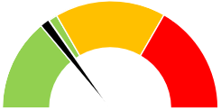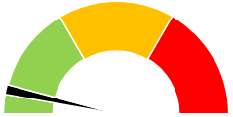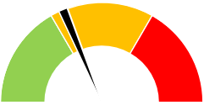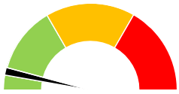
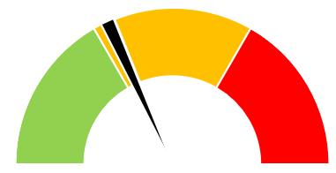

Harm from overwhelmed NHS and Social Services
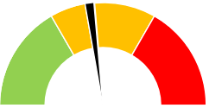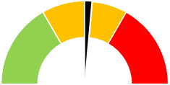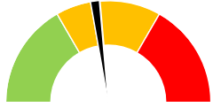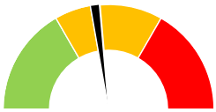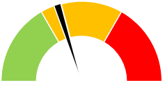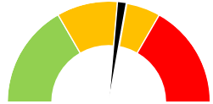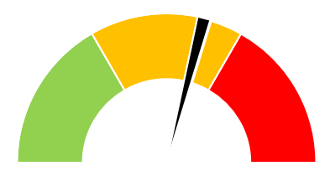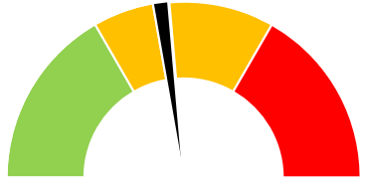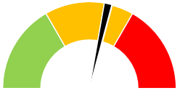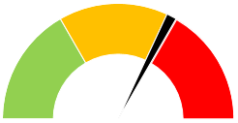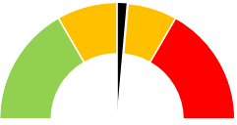

Harm from wider societal actions/ lockdown
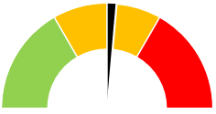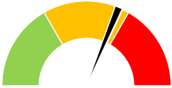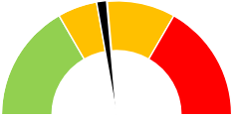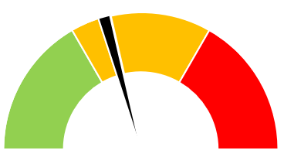
Harm from reduction in non-COVID activity
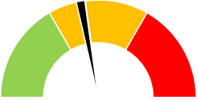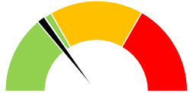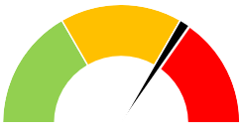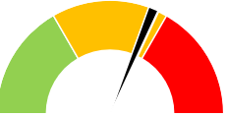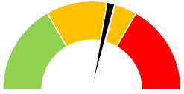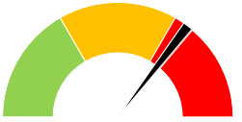

Cancer* |  | Planned Care*
Follow-up appointments* |  | Patient Experience
Complaints |  | Activity

Childhood Immunisations
Adult Mental Health
Child & Adolescent Mental Health*

NB- RAG status is against national or local target  ** Data not available | *RAG status based on in-month movement in the absence of local profiles
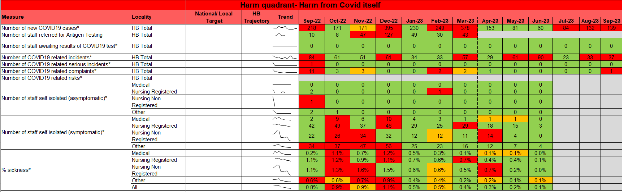

  - Updates on key measures

COVID TESTING
Description | Current Performance | Trend
1. Number of new COVID19 cases in Swansea Bay population area  2. Number of staff referred for Antigen testing | 1. Number of new COVID cases  In September 2023, there were an additional 139 positive cases recorded bringing the cumulative total to 120,757 in Swansea Bay since March 2020.  - Staff referred for Antigen testing  The cumulative number of staff referred for COVID testing between March 2020 and March 2023 is 18,230 of which 19% have been positive (Cumulative total).  *WG have now ceased data collection for staff testing centres* | 1.Number of new COVID19 cases for Swansea Bay population  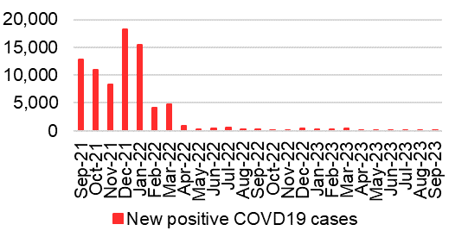  2.Outcome of staff referred for Antigen testing  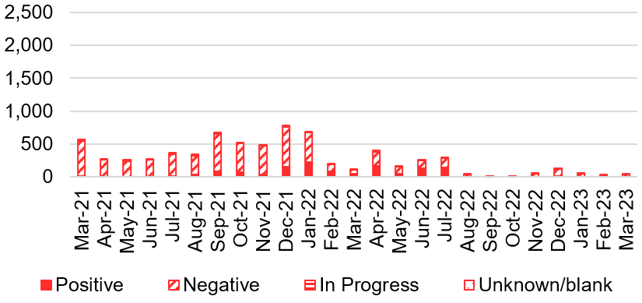
COVID related staff absence
Description | Current Performance | Trend
Staff absence due to COVID19  1.Number of staff self-isolating (asymptomatic)  2.Number of staff self isolating (symptomatic)  3.% staff sickness | The following data is based on the mid-month position and broken down into the categories requested by Welsh Government.  1. & 2. Number of staff self-isolating (asymptomatic and symptomatic)  Between May 2023 and June 2023, the number of staff self-isolating (asymptomatic) remained at 0 and the number of staff self-isolating (symptomatic) decreased from 27 to 7. In June 2023, the “other” staff group had the largest number of self-isolating staff who were symptomatic.  *WG have now ceased data collection*  3. % Staff sickness  The percentage of staff sickness absence due to COVID19 in June 2023 has reduced to 0.1% from 0.2% in May 2023.  *WG have now ceased data collection*. | 1.Number of staff self isolating (asymptomatic)  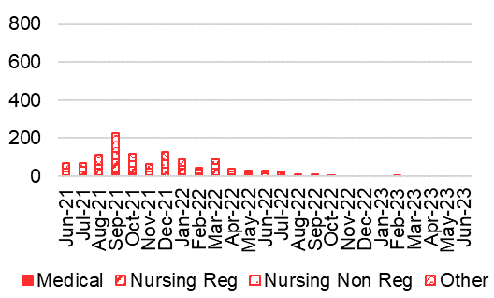  2.Number of staff self isolating (symptomatic)  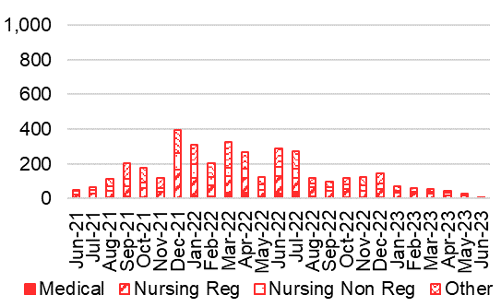  3.% staff sickness  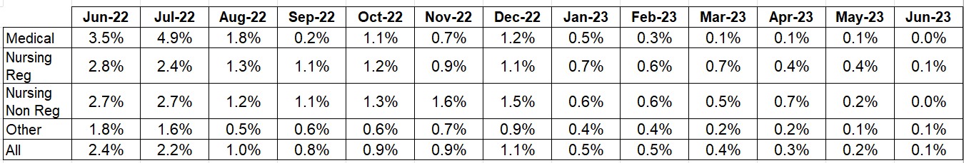
- HARM QUADRANT- HARM FROM OVERWHELMED NHS AND SOCIAL CARE SYSTEM
  - Overview
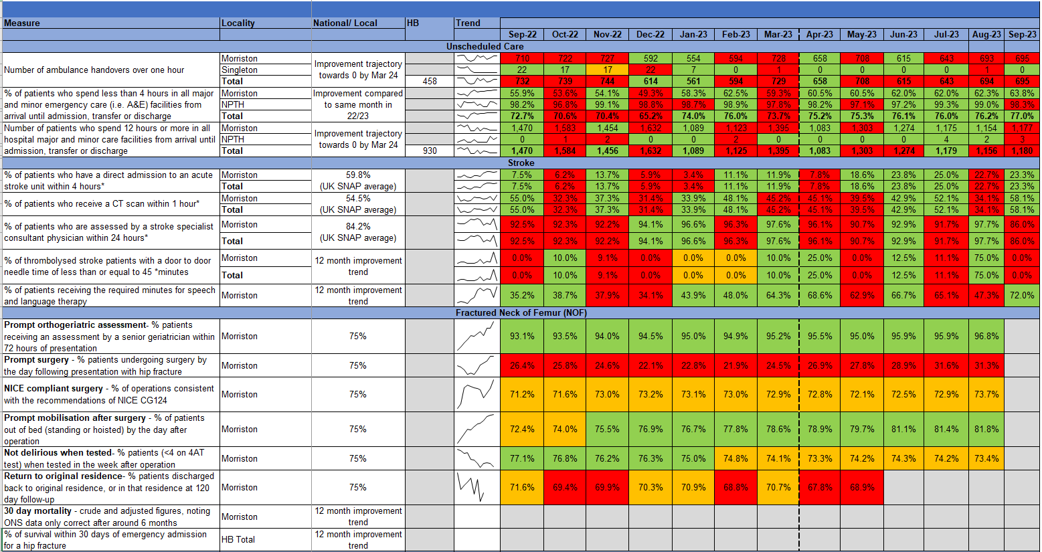

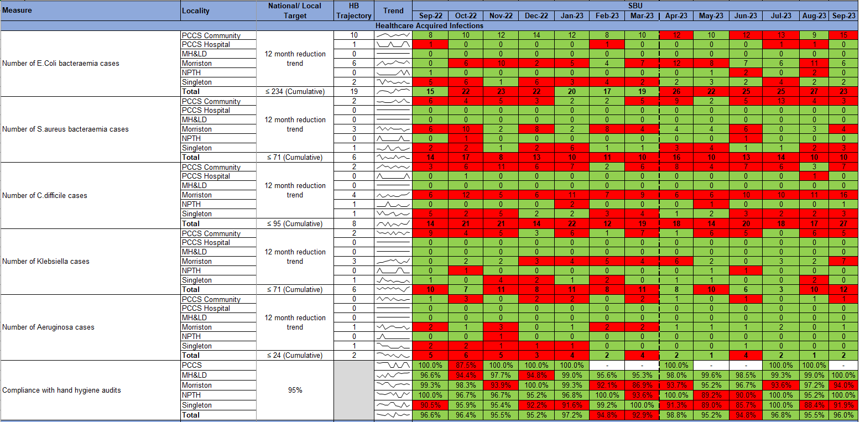

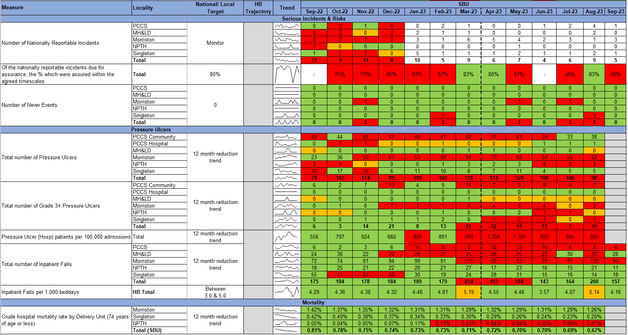

  - Updates on key measures
UNSCHEDULED CARE
Description | Current Performance
Ambulance responses  1. The percentage of emergency responses to red calls arriving within (up to and including) 8 minutes.  2. The number of ambulance calls by category.  3.The percentage of emergency responses to red calls arriving within 8 minutes (last 90 days) | In September 2023, the number of red calls responded to within 8 minutes deteriorated to 49.1% from 55.7% in August 2023. In September 2023, the number of green calls decreased by 1%, amber calls increased by 8%, and red calls increased by 21% compared with August 2023.
 | Trend
 | - % of red calls responded to within 8 minutes    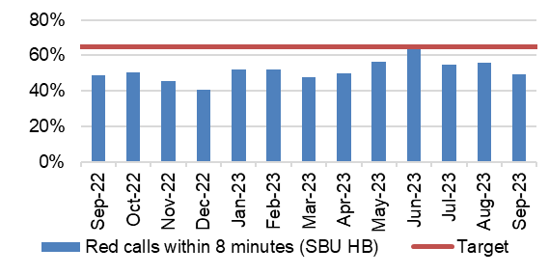 |  |  | - Number of ambulance call responses  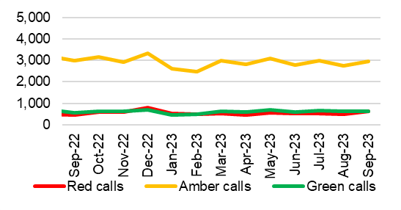
- % of red calls responded to within 8 minutes – HB total last 90 days
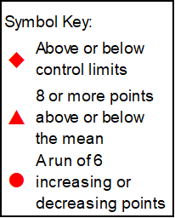
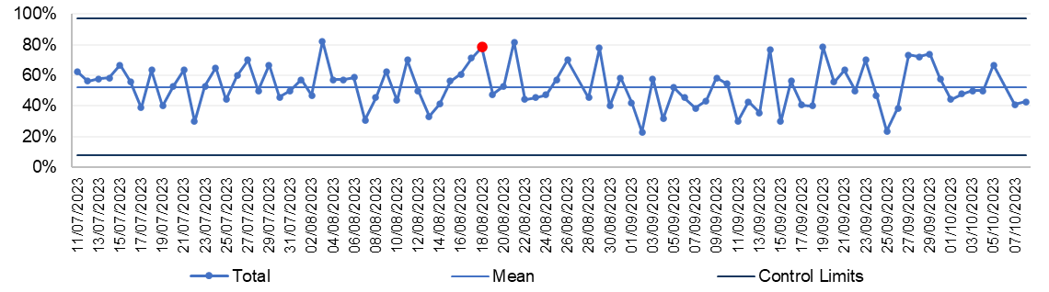

NSCHEDULED CARE
Description | Current Performance
Ambulance handovers  1.The number of ambulance handovers over one hour  2. The number of ambulance handovers over one hour- Hospital level  3.The number of ambulance handovers over one hour (last 90 days) | In September 2023, there were 695 ambulance to hospital handovers taking over 1 hour; this is a minor increase in figures compared with 694 in August 2023. In September 2023, all handovers over 1 hour were attributed to Morriston Hospital.  The number of handover hours lost over 15 minutes have decreased from 4,075 in August 2023 to 3,807 in September 2023.
 | Trend
 | - Number of ambulance handovers- HB total    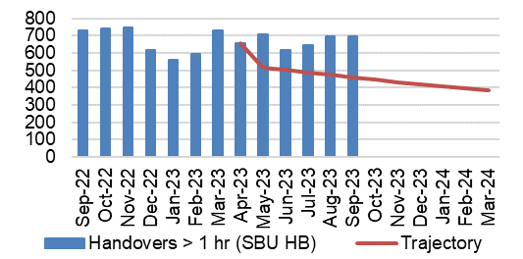 |  |  | - Number of ambulance handovers over 1 hour- Hospital level  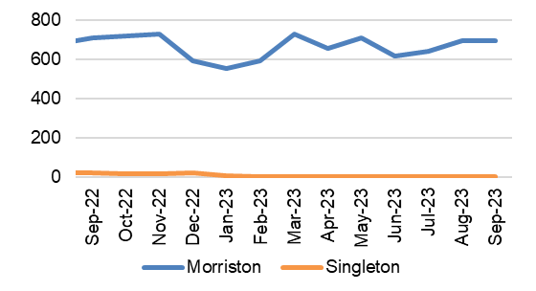
- Number of ambulance handovers- HB total last 90 days
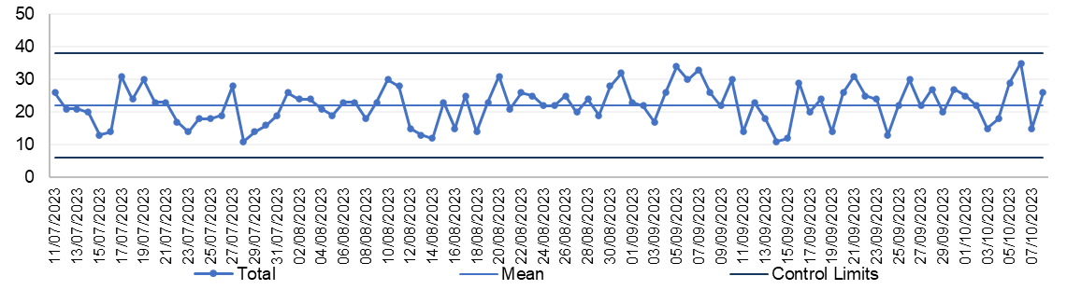
UNSCHEDULED CARE
Description | Current Performance
A&E Attendances  1.The number of attendances at emergency departments in the Health Board  2.The number of attendances at emergency departments in the Health Board – Hospital level  3.The number of attendances at emergency departments in the Health Board (last 90 days) | ED/MIU attendances significantly reduced in April 2020 during the COVID19 first wave but have been steadily increasing month on month until September 2020 when attendances started to reduce. In September 2023, there were 11,196 A&E attendances, this is 2% higher than August 2023.
 | Trend
 | - Number of A&E attendances- HB total  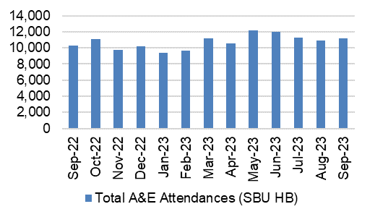 |  |  | - Number of A&E attendances- Hospital level  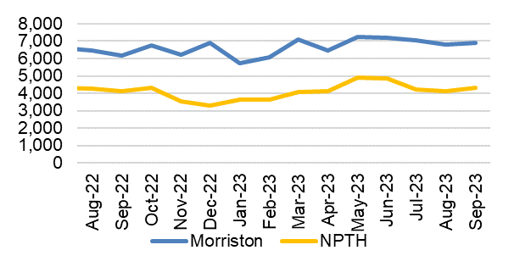
- Number of A&E attendances -HB total last 90 days
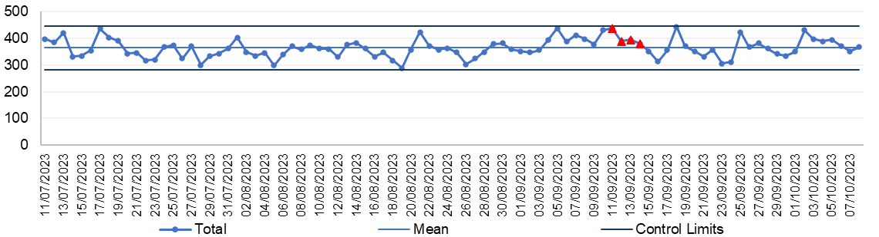
UNSCHEDULED CARE
Description | Current Performance
A&E waiting times  1.% of patients who spend less than 4 hours in all major and minor emergency care facilities from arrival until admission, transfer or discharge  2. % of patients who spend less than 4 hours in A&E- Hospital level  3. % of patients who spend less than 4 hours in A&E (last 90 days) | The Health Board’s performance against the 4-hour measure improved slightly from 76.19% in August 2023 to 77.04& in September 2023. Neath Port Talbot Hospital Minor Injuries Unit (MIU) has remained above the national target of 95% achieving 98.31% in September 2023. Morriston Hospital’s performance improved between August and September 2023, achieving 63.75% against the target.
 | Trend
 | - % Patients waiting under 4 hours in A&E- HB total  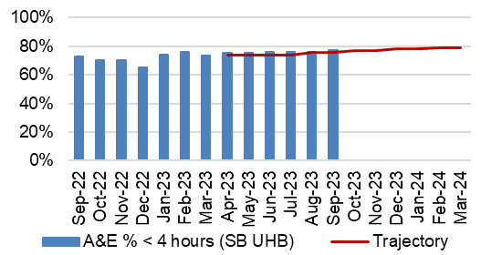 |  |  | - % Patients waiting under 4 hours in A&E- Hospital level  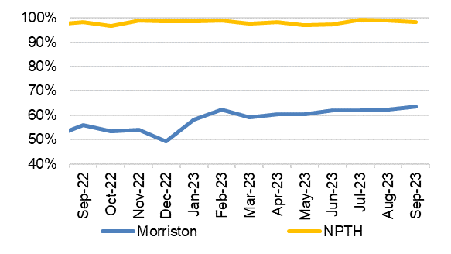
- % Patients waiting under 4 hours in A&E- HB total last 90 days
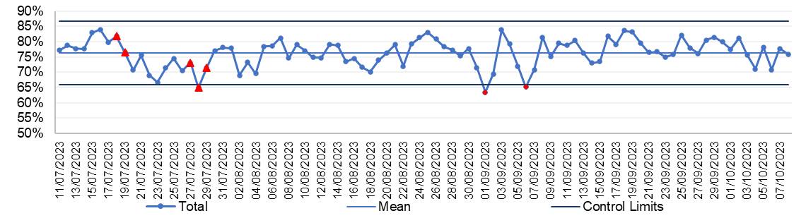
UNSCHEDULED CARE
Description | Current Performance
A&E waiting times  1.Number of patients who spend 12 hours or more in A&E  2.Number of patients who spend 12 hours or more in A&E- Hospital level  3.Number of patients who spend 12 hours or more in A&E (last 90 days) | In September 2023, performance against the 12-hour measure slightly deteriorated when compared with August 2023, increasing from 1,156 to 1,180. This is an increase of 24 compared to August 2023. 1,177 patients waiting over 12 hours in September 2023 were attributed to Morriston Hospital, with 3 attributed to Neath Port Talbot Hospital.
 | Trend
 | - Number of patients waiting over 12 hours in A&E- HB total  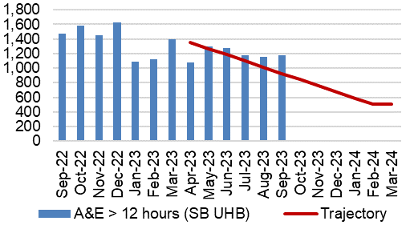 |  |  | - Number of patients waiting over 12 hours in A&E- Hospital level  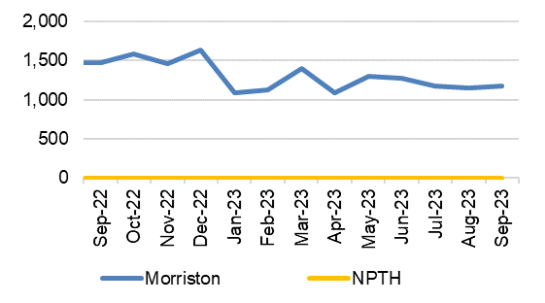
- Number of patients waiting over 12 hours in A&E – HB total last 90 days
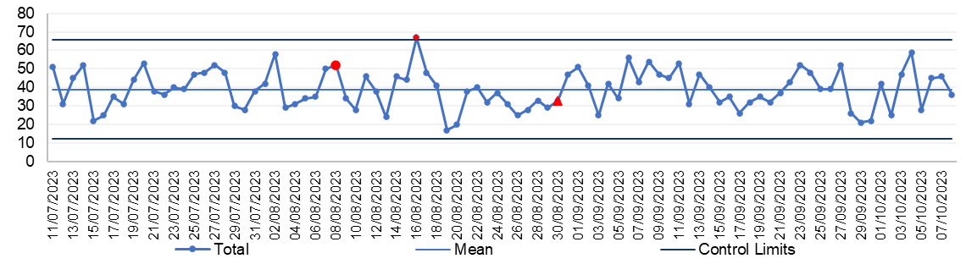

UNSCHEDULED CARE
Description | Current Performance
Emergency admissions  1. The number of emergency inpatient admissions  2. The number of emergency inpatient admissions-Hospital level  3. The number of emergency inpatient admissions (last 90 days) | In September 2023, there were 4,027 emergency admissions across the Health Board, which is 209 lower than August 2023.  Singleton Hospital saw an in-month reduction, with 5 less admissions (from 323 in August 2023), Morriston Hospital saw an in-month reduction from 3,797 admissions in August 2023 to 3,579 admissions in September 2023.
 | Trend
 | - Number of emergency admissions- HB total    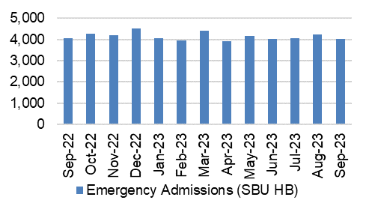 |  |  | - Number of emergency admissions- Hospital level  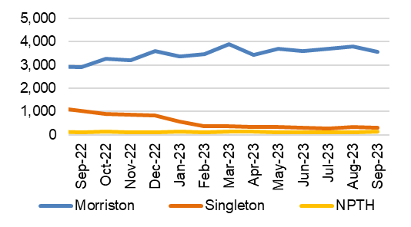
- Number of emergency admissions- HB total last 90 days
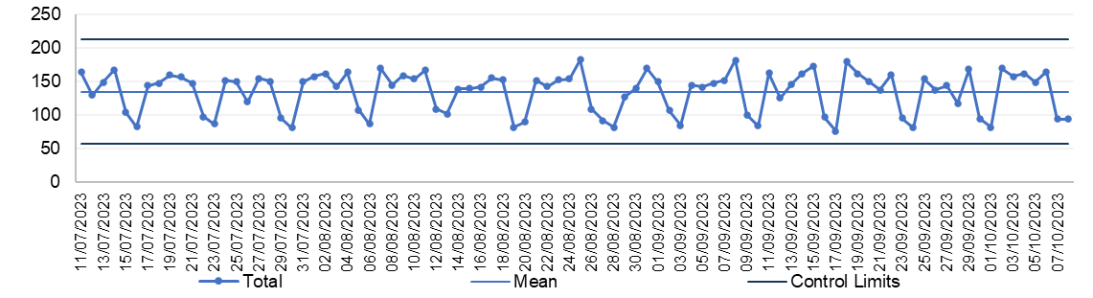

Updates on UNSCHEDULED CARE – Performance Escalation updates
- Submitted recover trajectory for A&E 4hr performance  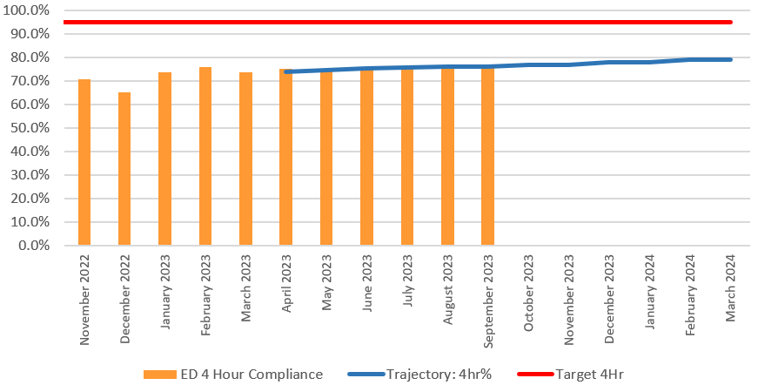  - Submitted recovery trajectory for A&E12-hour performance  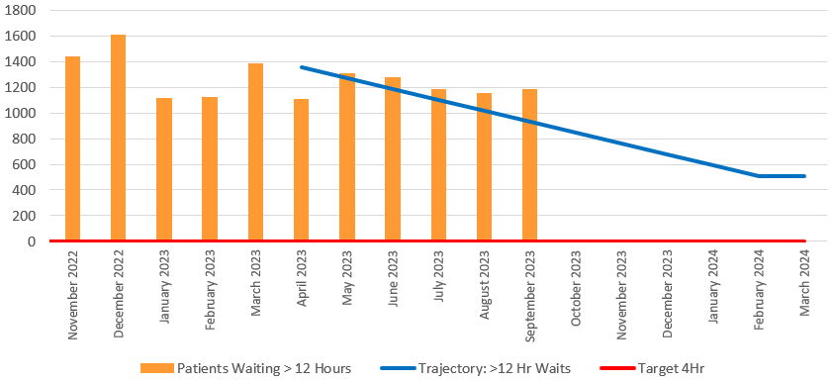  - Ambulance Handover over 4 hours  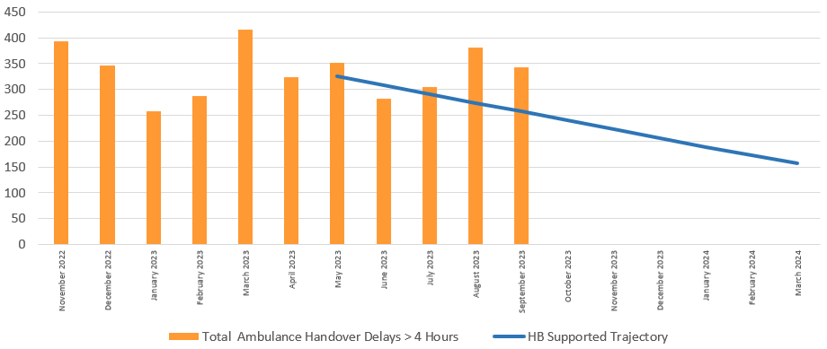  - Average Ambulance Handover Rate  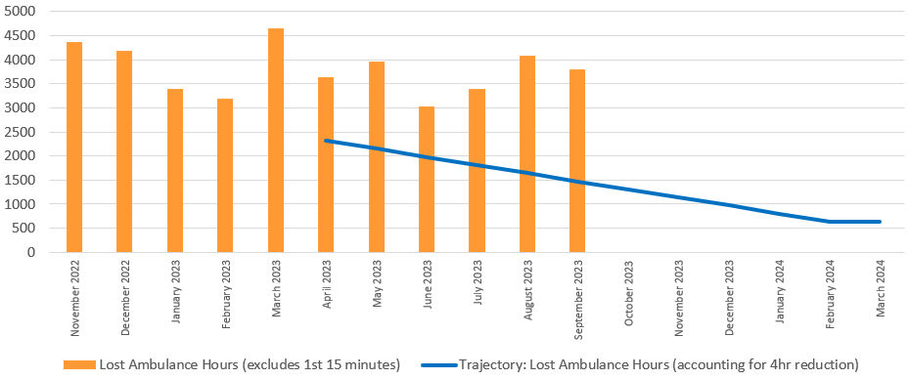 | - Performance against the 4-hour access is currently outperforming the Health Board trajectory in September 2023. Emergency Department 4-hour performance has seen a minor improvement of 0.85% in September 2023 to 77.04% from 76.19% in August 2023.  - Performance against the 12-hour wait has slightly deteriorated in-month and it is currently performing above the outlined trajectory. The number of patients waiting over 12-hours in the Emergency Department increased to 1,180 in September 2023 from 1,155 in August.  - The Ambulance handover rate over 4 hours have decreased in September 2023. The handover times over four hours decreased to 342 in September 2023 from 381 in August 2023. The figures are above the outlined trajectory for September 2023 which was 0.  - The ambulance handover lost hours rate has seen a reduction in September 2023. The ambulance handover lost hours decreased from 4,075 in August 2023 to 3,807 in September 2023, which is above the outlined trajectory for September 2023 (1,475).

UNSCHEDULED CARE
Description | Current Performance
Critical Care- Delayed Transfers of Care (DTOC)- Morriston Hospital  1.Total Critical Care delayed discharges (hours)  2. Average lost bed days per day  3.Percentage of patients delayed:  - Up to 8 hours  - Between 8 and 24 hours  - Over 24 hours | In September 2023, there were a total of 84 admissions into the Intensive Care Unit (ICU) in Morriston Hospital, this is a slight reduction when compared with 85 admissions in August 2023. September 2023, saw an increase in the number of delayed discharge hours from 4,097.05 in August 2023 to 4,129.4 in September 2023. The average lost bed days increased to 5.73 per day. The percentage of patients delayed over 24 hours decreased to 61.19% in September from 63.64% in August 2023.
 | Trend
 | - Total Critical Care delayed discharges (hours)  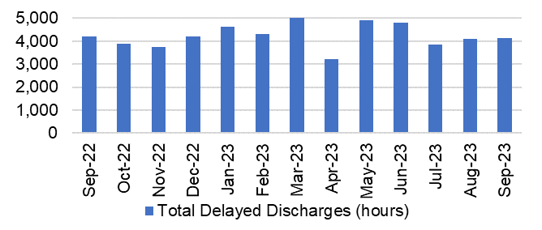 |  |  | - Average lost bed days per day  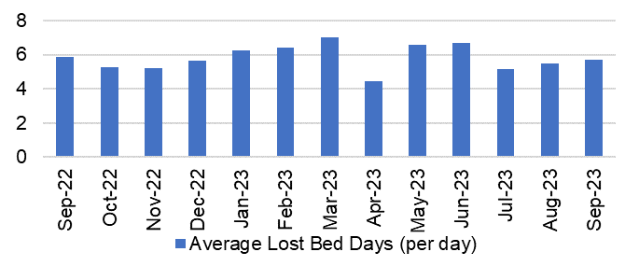
- Percentage of Critical Care patients delayed
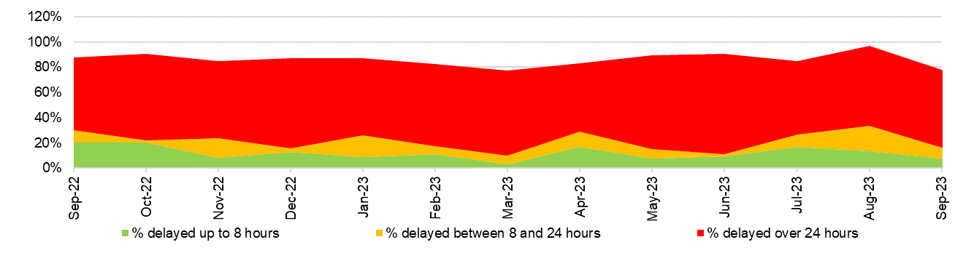
UNSCHEDULED CARE
Description |  | Current Performance | Trend
Clinically Optimised  The number of patients waiting at each site in the Health Board that are clinically optimised |  | In September 2023, there were on average 262 patients who were deemed clinically optimised but were still occupying a bed in one of the Health Board’s Hospitals.  In September 2023, Morriston Hospital had the largest proportion of clinically optimised patients with 148, closely followed by Neath Port Talbot Hospital with 97.  Actions of Improvement;  Continued work is underway to implement opportunities to reduce the number of Clinically Optimised Patients in the Hospital.  Work is also underway to review the definitions of Clinically Optimised Patients within the Health Board, this work is expected to lead to improvements in the reported figures. | The number of clinically optimised patients by site  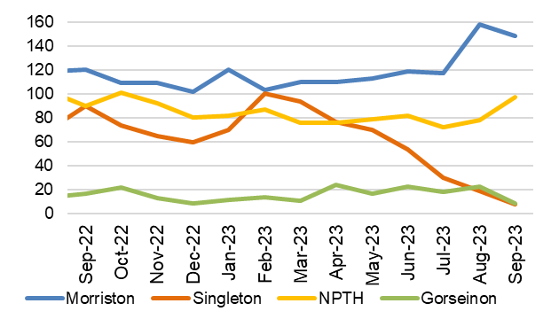
Elective procedures cancelled due to lack of beds  The number of elective procedure cancelled across the hospital where the main cancellation reasons was lack of beds |  | In September 2023, there were 17 elective procedures cancelled due to lack of beds on the day of surgery. This is 15 more cancellations than those seen in August 2023.  Of the cancelled procedures, 16 were attributed to Morriston Hospital and 1 was attributed to Neath Port Talbot Hospital in August 2023. | Total number of elective procedures cancelled due to lack of beds  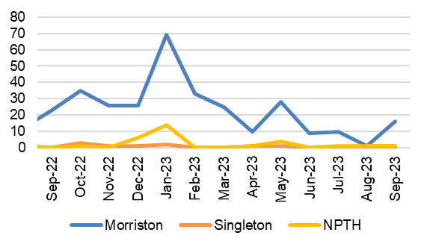
FRACTURED NECK OF FEMUR (#NOF)
Description | Current Performance | Trend
Fractured Neck of Femur (#NOF)  1. Prompt orthogeriatric assessment- % patients receiving an assessment by a senior geriatrician within 72 hours of presentation  2. Prompt surgery - % patients undergoing surgery the day following presentation with hip fracture  3. NICE compliant surgery - % of operations consistent with the recommendations of NICE CG124  4. Prompt mobilisation after surgery - % patients out of bed (standing or hoisted) by the day after operation | - Prompt orthogeriatric assessment- In August  2023, 96.8% of patients in Morriston hospital received an assessment by a senior geriatrician within 72 hours.  - Prompt surgery- In August 2023, 31.3% of patients had surgery the day following presentation with a hip fracture. This is a 4.8% improvement from August 2022 which was 26.5%  - NICE compliant surgery- 73.7% of operations were consistent with the NICE recommendations in August 2023. This is 2.1% more than in August 2022.  - Prompt mobilisation- In August 2023, 81.8% of patients were out of bed the day after surgery. This is 11.6% more than in August 2022. | - Prompt orthogeriatric assessment  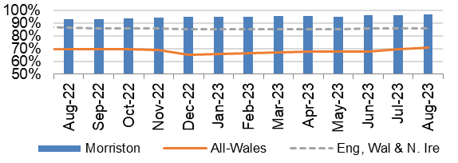  - Prompt surgery  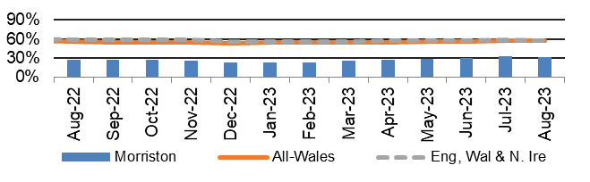  - NICE compliant Surgery  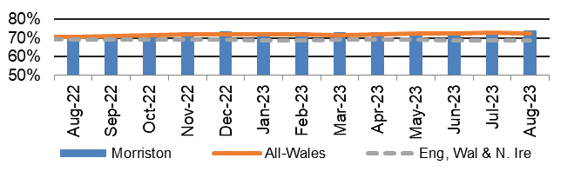  - Prompt mobilisation  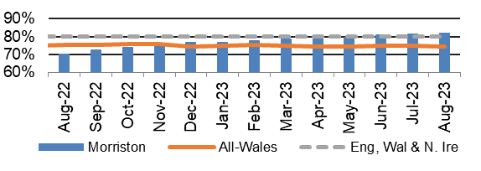
FRACTURED NECK OF FEMUR (#NOF)
Description | Current Performance | Trend
- Not delirious when tested- % patients (<4 on 4AT test) when tested in the week after operation  - Return to original residence- % patients discharged back to original residence, or in that residence at 120 day follow-up  - 30 day mortality rate | - Not delirious when tested- 73.4% of patients were not delirious in the week after their operation in August 2023.  - Return to original residence- 68.9% of patients in May 2023 were discharged back to their original residence. This is 1% less than in May 2022.  - 30 day mortality rate- In January 2021 the morality rate for Morriston Hospital was 7.5% which is 0.5% less than January 2020. The mortality rate in Morriston Hospital in January 2021 is higher than the all-Wales average of 6.9% but lower than the national average of 7.6%.  * Updated data is currently not available, but is  being reviewed. | 5. Not delirious when tested  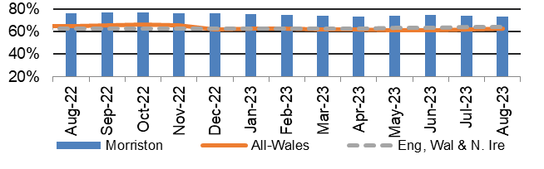  6. Return to original residence  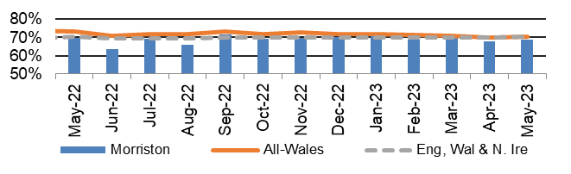  7. 30 day mortality rate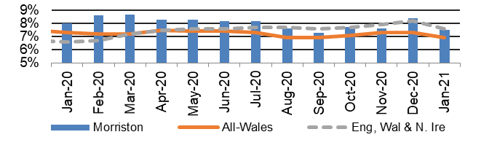
HEALTHCARE ACQUIRED INFECTIONS
Description | Current Performance | Trend
Healthcare Acquired Infections (HCAI) - E.coli bacteraemia- Number of laboratory confirmed E.coli bacteraemia cases | - 23 cases of E. coli bacteraemia were identified in September 2023, of which 8 were hospital acquired and 15 were community acquired.  - The Health Board total is currently above the Welsh Government Profile target of 19 cases for September 2023.  Actions of Improvement;  Each Service Group has developed detailed action plans which reinforce the quality and safety guidelines to support the reduction of Infection rates | Number of healthcare acquired E.coli bacteraemia cases  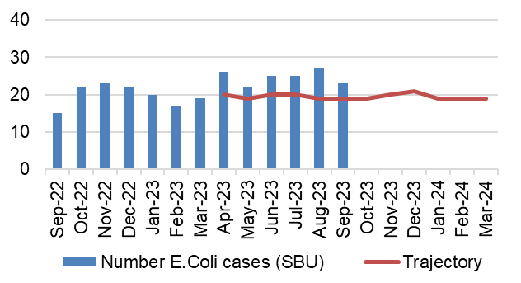
Healthcare Acquired Infections (HCAI)-  S.aureus bacteraemia- Number of laboratory confirmed S.aureus bacteraemias (MRSA & MSSA) cases | - There were 10 cases of Staph. aureus bacteraemia in September 2023, of which 7 were hospital acquired and 3 were community acquired.  - The Health Board total is currently above the Welsh Government Profile target of 6 cases for September 2023.  Actions of Improvement;  Each Service Group has developed detailed action plans which reinforce the quality and safety guidelines to support the reduction of Infection rates | Number of healthcare acquired S.aureus bacteraemia cases  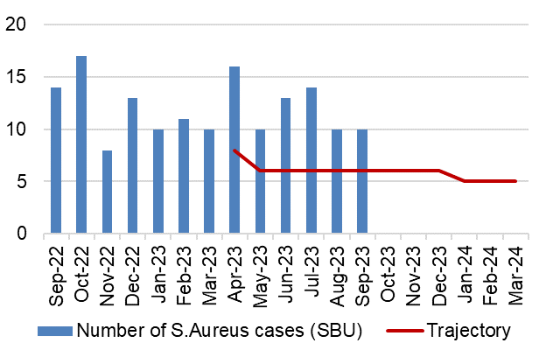
HEALTHCARE ACQUIRED INFECTIONS
Description | Current Performance | Trend
Healthcare Acquired Infections (HCAI)-  C.difficile-  Number of laboratory confirmed C.difficile cases | - There were 27 Clostridium difficile toxin positive cases in September 2023, of which 20 were hospital acquired and 7 were community acquired.  - The Health Board total is currently above the Welsh Government Profile target of 8 cases for September 2023.  Actions of Improvement;  Each Service Group has developed detailed action plans which reinforce the quality and safety guidelines to support the reduction of Infection rates | Number of healthcare acquired C.difficile cases  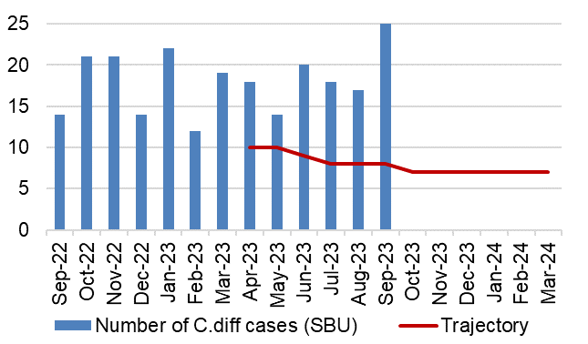
Healthcare Acquired Infections (HCAI)-  Klebsiella sp- Number of laboratory confirmed Klebsiella sp cases | - There were 12 cases of Klebsiella sp in September 2023, of which 7 were hospital acquired and 5 were community acquired.  - The Health Board total is currently above the Welsh Government Profile target of 6 cases for September 2023.  Actions of Improvement;  Each Service Group has developed detailed action plans which reinforce the quality and safety guidelines to support the reduction of Infection rates | Number of healthcare acquired Klebsiella cases  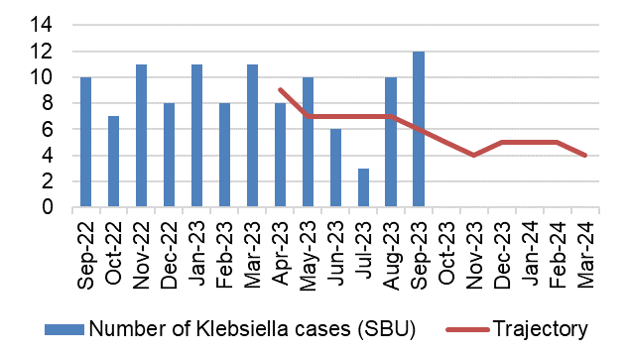
HEALTHCARE ACQUIRED INFECTIONS
Description | Current Performance | Trend
Healthcare Acquired Infections (HCAI)-  Aeruginosa-  Number of laboratory confirmed Aeruginosa cases | - There were 2 cases of P.Aerginosa in September 2023, 1 of which was community acquired and 1 of which was hospital acquired.  - The Health Board total is currently in line with the Welsh Government Profile target of 2 cases for September 2023.  Actions of Improvement;  Each Service Group has developed detailed action plans which reinforce the quality and safety guidelines to support the reduction of Infection rates | Number of healthcare acquired Pseudomonas cases  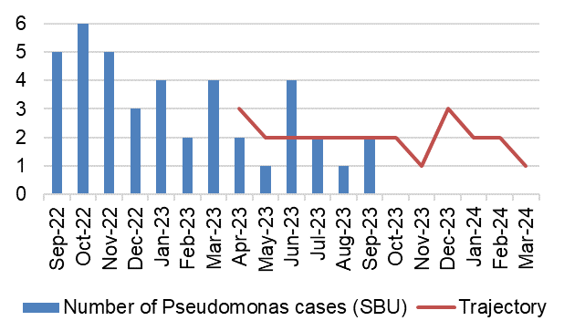
PRESSURE ULCERS
Description | Current Performance | Trend
Number of pressure ulcers  1. Total number of pressure ulcers developed in hospital and in the community  2. Rate of pressure ulcers per 100,000 admissions | - In August 2023 there were 98 cases of healthcare acquired pressure ulcers, 38 of which were community acquired and 60 were hospital acquired.  There were 11 grade 3+ pressure ulcers in August 2023, 7 of which were community acquired and 4 were hospital acquired.  - The rate per 100,000 admissions decreased from 904 in July 2023 to 803 in August 2023. | Total number of hospital and community acquired Pressure Ulcers (PU) and rate per 100,000 admissions  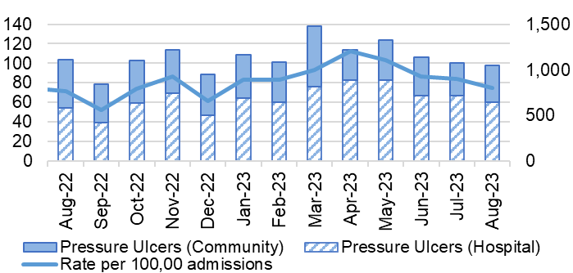
NATIONALLY REPORTABLE INCIDENTS
Description | Current Performance | Trend
Nationally Reportable Incidents (NRI’s)-  1. The number of Nationally reportable incidents  2. The number of Never Events  3. Of the nationally reportable incidents due for assurance, the percentage which were assured within the agreed timescales | - The Health Board reported 5 Nationally Reportable Incidents for the month of September 2023 to Welsh Government. The Service Group breakdown is as follows;  - Morriston – 3  - Singleton – 1  - Primary Care – 1  - There were no new Never Event reported in September 2023.  - In September 2023, 50% of the NRI’s were closed within the agreed timescale. | 1. and 2. Number of nationally reportable incidents and never events  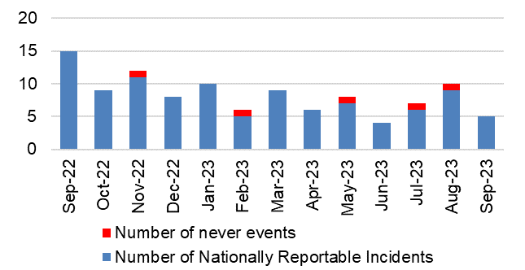  3. % of nationally reportable incidents closed within the agreed timescales  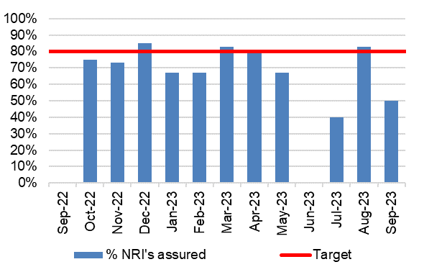
INPATIENT FALLS
Description | Current Performance | Trend
Inpatient Falls  The total number of inpatient falls | - The number of Falls reported via Datix web for Swansea Bay UHB was 157 in September 2023. This is 27% more than August 2023 where 200 falls were recorded. | Number of inpatient Falls  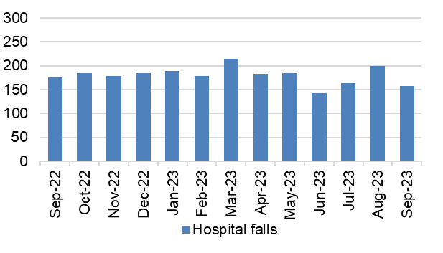
DISCHARGE SUMMARIES
Description | Current Performance | Trend
Discharge Summaries  Percentage of discharge summaries approved and sent to patients’ doctor following discharge | The latest data shows that in September 2023, the percentage of completed discharge summaries was 61%.  In September 2023, compliance ranged from 43% in Singleton Hospital to 70% in Mental Health & Learning Disabilities. | % discharge summaries approved and sent  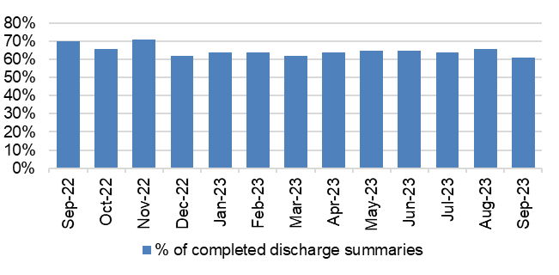
CRUDE MORTALITY
Description | Current Performance | Trend
Crude Mortality Rate | August 2023 reports the crude mortality rate for the Health Board at 0.67%, which is slightly below the figure reported in July 2023 (0.69%).  A breakdown by Hospital for August 2023:  - Morriston – 1.26%  - Singleton – 0.20%  - NPT – 0.07% | Crude hospital mortality rate by Hospital (74 years of age or less)  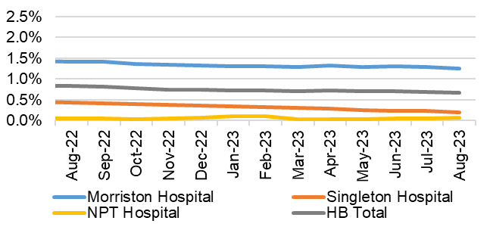
READMISSION RATES
Description | Current Performance | Trend
Readmission Rates | In September 2023, 21% of patients were readmitted as an emergency within 28 days of their previous discharge date. This is 1% higher than those figures reported in August 2023. | Emergencies readmitted within 28 days of previous discharge  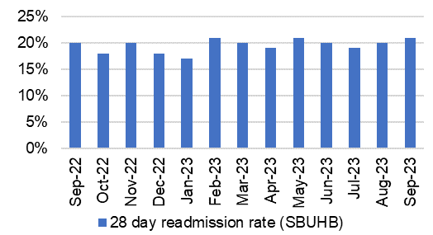
- HARM QUADRANT- HARM FROM REDUCTION IN NON-COVID ACTIVITY

  - Overview
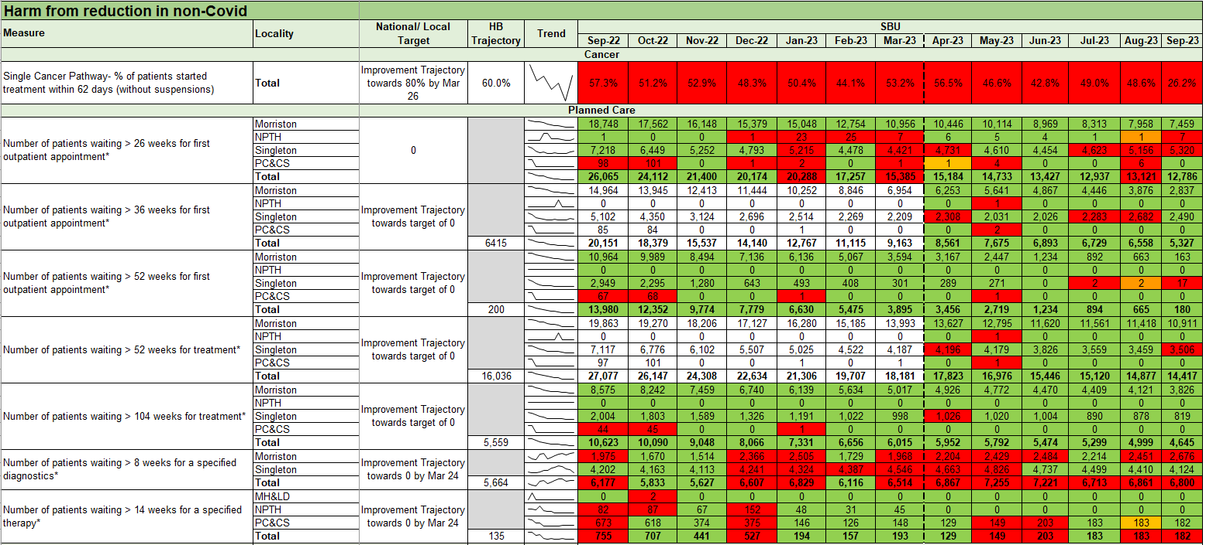

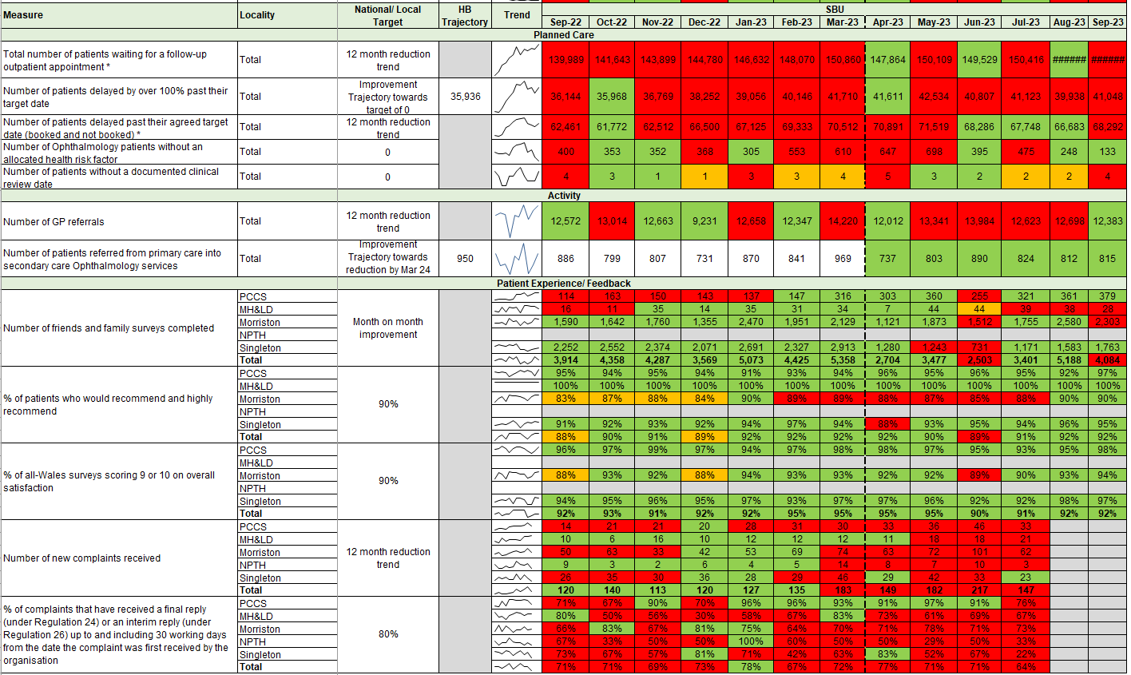

5.3 Updates on key measures
PLANNED CARE
Description | Current Performance
Referrals and shape of the waiting list  - GP Referrals  The number of Stage 1 additions per week  - Stage 1 additions  The number of new patients that have been added to the outpatient waiting list  - Outpatient activity undertaken  Total number of patients seen each month  - Size of the waiting list  Total number of patients on the waiting list by stage as at September 2023 | September 2023 has seen a minor reduction in referral figures compared with August 2023 (12,698). Referral rates have continued to rise slowly since December 2021, with 12,383 received in September 2023. Chart 4 shows the shape of the current waiting list and Chart 3 shows the outpatient activity undertaken over the last year.
 | Trend
 | - Number of GP referrals received by SBU Health Board  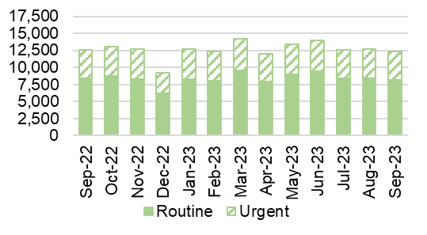 |  | - Number of stage 1 additions per week  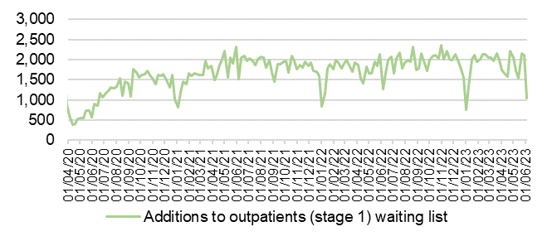
 | - Outpatient activity undertaken  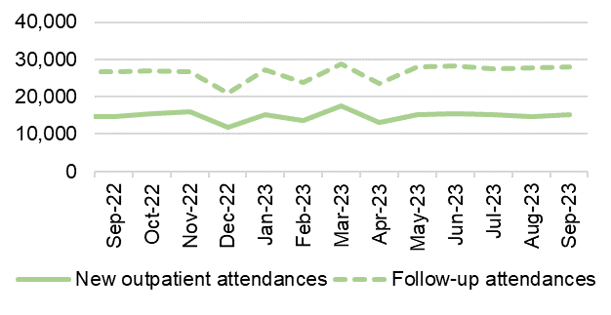 |  | - Total size of the waiting list and movement (September 2023)  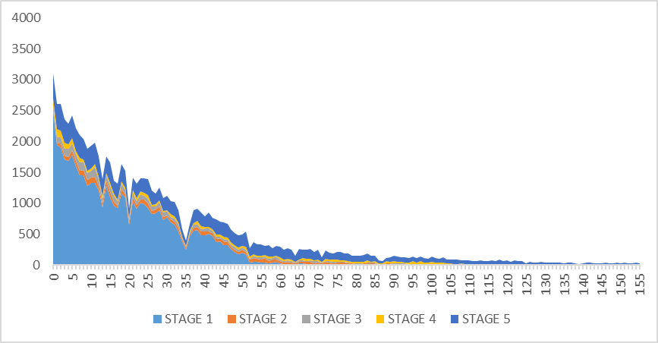
PLANNED CARE
Description | Current Performance
Outpatient waiting times  1. Number of patients waiting more than 26 weeks for an outpatient appointment (stage 1)- Health Board Total  2. Number of patients waiting more than 26 weeks for an outpatient appointment (stage 1)- Hospital Level  3. Patients waiting over 26 weeks for an outpatient appointment by specialty  4. Percentage of patients waiting less than 26 weeks | The number of patients waiting over 26 weeks for a first outpatient appointment is still a challenge. September 2023 saw an in-month reduction of 3% in the number of patients waiting over 26 weeks for an outpatient appointment. The number of breaches decreased from 13,121 in August 2023. Orthopaedics has the largest proportion of patients waiting over 26 weeks for an outpatient appointment, closely followed by Ophthalmology and Gynaecology. Chart 4 shows that the number of patients waiting less than 26 weeks for an outpatient appointment, this figure has slightly deteriorated to 60.7%.
 | Trend
 | - Number of stage 1 over 26 weeks- HB total  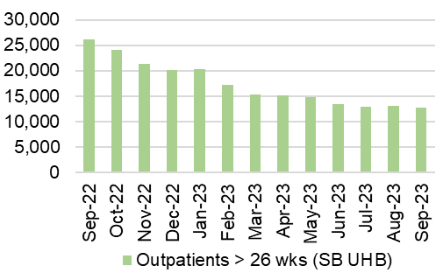 |  | - Number of stage 1 over 26 weeks- Hospital level  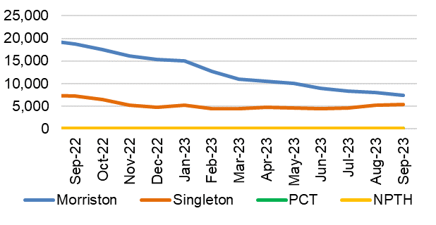
 | - Patients waiting over 26 weeks for an outpatient appointment by specialty as at September 2023  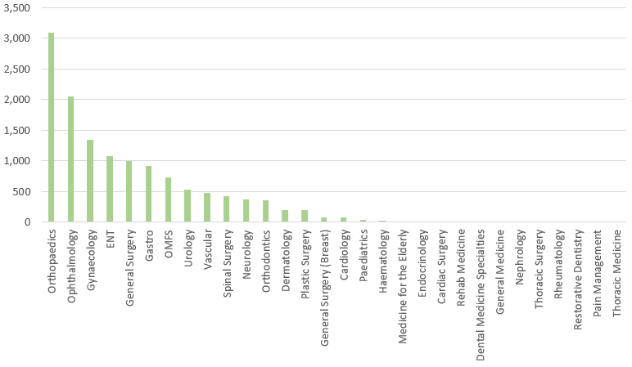 |  | - Percentage of patient waiting less than 26 weeks  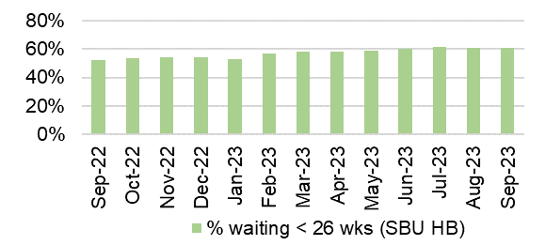
PLANNED CARE
Description | Current Performance
Patients waiting over 36 weeks for treatment  1. Number of patients waiting more than 36 weeks for treatment and the number of elective patients admitted for treatment- Health Board Total  2. Number of patients waiting more than 36 weeks for treatment  3. Number of elective admissions  4. Number of patients waiting more than 104 weeks for treatment | In September 2023, there were 5,327 patients waiting over 36 weeks at Stage 1, which is a 19% in-month reduction from August 2023. 14,417 patients were waiting over 52 weeks at all stages in September 2023. In September 2023, there were 4,645 patients waiting over 104 weeks for treatment, which is a 7% reduction from August 2023. The Health Board are currently out-performing all submitted recovery trajectories for 2023/24.
 | Trend
 | - Number of patients waiting over 36 weeks at Stage 1  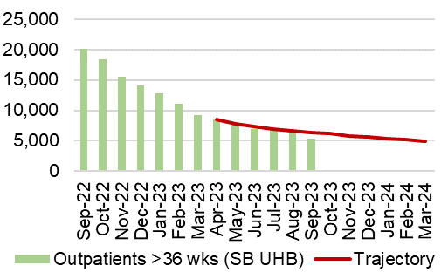 |  | - Number of patients waiting over 52 weeks at Stage 1- HB total  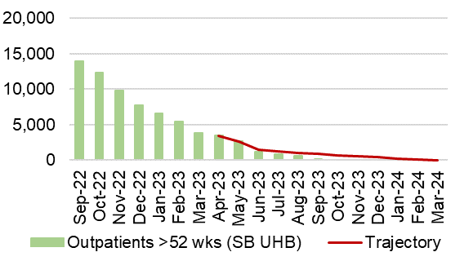
 | 3. Number of elective admissions  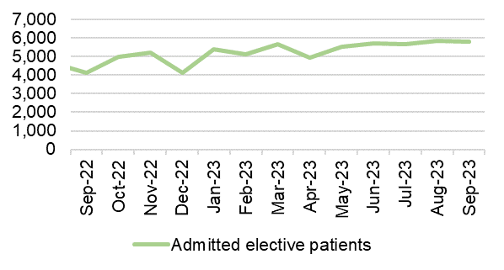 |  | 4.Number of patients waiting over 104 weeks- HB total  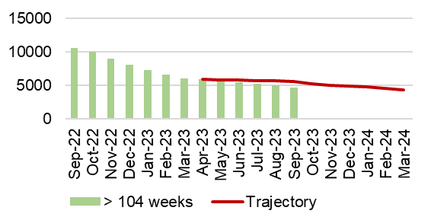
PLANNED CARE
Description | Current Performance
Ophthalmology Referrals  Number of patients referred into secondary care Ophthalmology services | In September 2023, there were 815 patients referred from Primary Care into secondary care ophthalmology services. This is a slight increase on the number of patients referred in August 2023, which was 812.  The figures reported are outperforming the submitted Ophthalmology referrals trajectory to Welsh Government for 2023/24 in September 2023 (950). |  | Number of referrals into secondary care Ophthalmology service  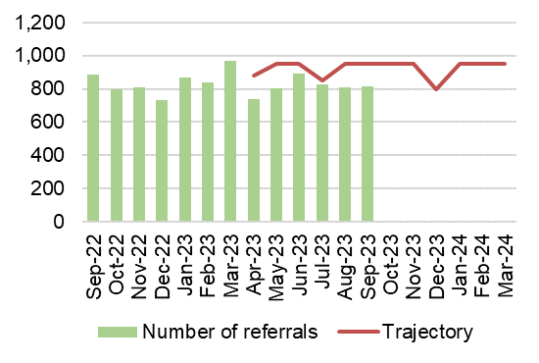
Ophthalmology waiting times  Percentage of ophthalmology R1 patients who are waiting within their clinical target date or within 25% in excess of their clinical target date for their care or treatments | In September 2023, 63.7% of Ophthalmology R1 patients were waiting within their clinical target date or within 25% of the target date.  Actions of Improvement;  A detailed Ophthalmology action plan is currently being executed which focusses on performance improvement schemes using insourcing and outsourcing resources, administrative validation and active recruitment to fill any current vacancies impacting capacity |  | Percentage of ophthalmology R1 patients who are waiting within their clinical target date or within 25% in excess of their clinical target date for their care or treatments  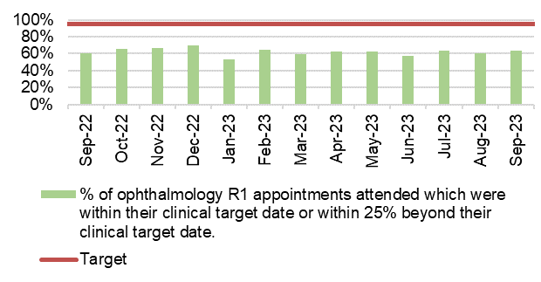
THEATRE EFFICIENCY
Description | Current Performance | Trend
Theatre Efficiency  1. Theatre Utilisation Rates  2. % of theatre sessions starting late  3. % of theatre sessions finishing early  4. % of theatre sessions cancelled at short notice (<28 days)  5. % of operations cancelled on the day | In September 2023 the Theatre Utilisation rate was 73%. This is 7% higher than the figure’s reported in August 2023 and are 2% higher than those seen in August 2022 (71%).  38% of theatre sessions started late in September 2023. This is a 2% deterioration on performance seen in August 2023 (36%).  In September 2023, 50% of theatre sessions finished early. This is 1% lower than figures seen in August 2023 and 2% higher than those seen in September 2022  7% of theatre sessions were cancelled at short notice in September 2023. This is 3% higher than the figure reported in August 2023 and is 2% lower than figures seen in September 2022.  Of the operations cancelled in September 2023, 38% of them were cancelled on the day. These are the same figures reported in August 2023. | - Theatre Utilisation Rates  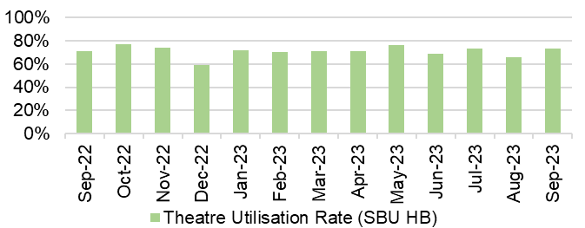  - and 3. % theatre sessions starting late/finishing  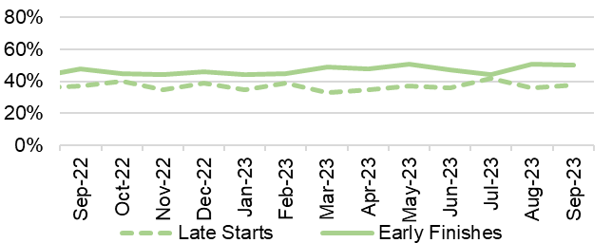  4.% theatre sessions cancelled at short notice (<28 days)  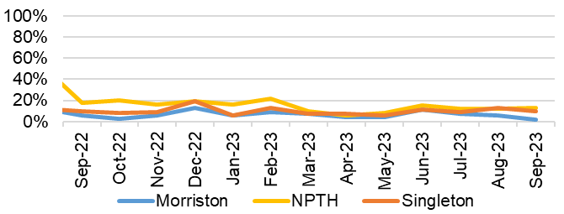  - % of operations cancelled on the day  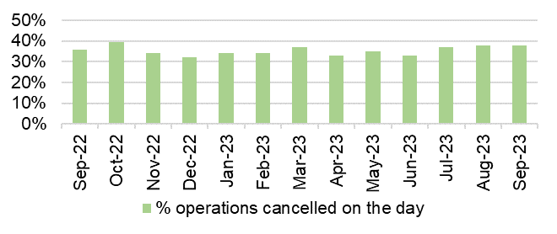
PLANNED CARE
Description | Current Performance |  |  | Trend
Diagnostics waiting times  The number of patients waiting more than 8 weeks for specified diagnostics | In September 2023, there was a slight reduction in the number of patients waiting over 8 weeks for specified diagnostics. It decreased from 6,861 in August 2023 to 6,800 in September 2023.  The following is a breakdown for the 8-week breaches by diagnostic test for September 2023:  - Endoscopy= 4,148  - Cardiac tests= 712^  - Other Diagnostics = 1,940^  Actions of Improvement;  Detailed demand and capacity work is currently underway to develop a diagnostic recovery trajectory which works towards the ministerial target of 0 by March 2024. |  |  | Number of patients waiting longer than 8 weeks for Diagnostics  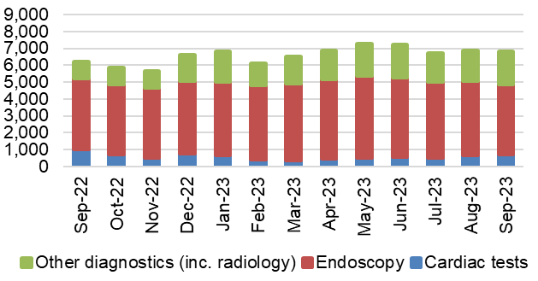
Therapy waiting times  The number of patients waiting more than 14 weeks for specified therapies | In September 2023 there were 182 patients waiting over 14 weeks for specified Therapies.  The breakdown for breaches in September 2023 are:  - Speech & Language Therapy= 160^  - Dietetics = 22  Actions of Improvement;  The Service Group have already identified the previous declining position in Dietetics and SLT and have developed detailed recovery trajectories in both areas. |  |  | Number of patients waiting longer than 14 weeks for therapies  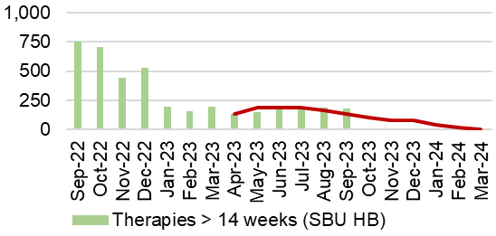
CANCER
Description | Current Performance |  |  | Trend
Cancer demand and shape of the waiting list  Single Cancer Pathway  Percentage of patients starting first definitive cancer treatment within 62 days from point of suspicion (regardless of the referral route)  Single Cancer Pathway backlog- patients waiting over 63 days | October 2023 backlog by tumour site: |  |  | Number of patients with a wait status of more than 62 days  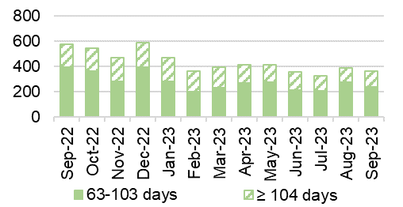
  Tumour Site | 63 - 103 days | ≥104 days
  Acute Leukaemia | 0 | 0
  Brain/CNS | 1 | 1
  Breast | 18 | 2
  Children's cancer | 0 | 0
  Gynaecological | 33 | 26
  Haematological | 8 | 5
  Head and neck | 13 | 6
  Lower Gastrointestinal | 29 | 20
  Lung | 12 | 7
  Other | 3 | 0
  Sarcoma | 3 | 1
  Skin(c) | 37 | 8
  Upper Gastrointestinal | 23 | 20
  Urological | 32 | 21
  Grand Total | 212 | 117
 | September 2023 saw an increase in the number of patients waiting over 63 days. The following actions have been outlined to support backlog reduction;  - Individual meetings have taken place with tumour sites to explore additional work to support a further reduction in the backlog.  - The cancer tracking facility has now been centralised (October 2023) to support focussed tracking with a whole system approach  - Targeted work is being undertaken to focus on reducing the number of patients waiting >104 days as a priority |  |  | Percentage of patients starting first definitive cancer treatment within 62 days from point of suspicion  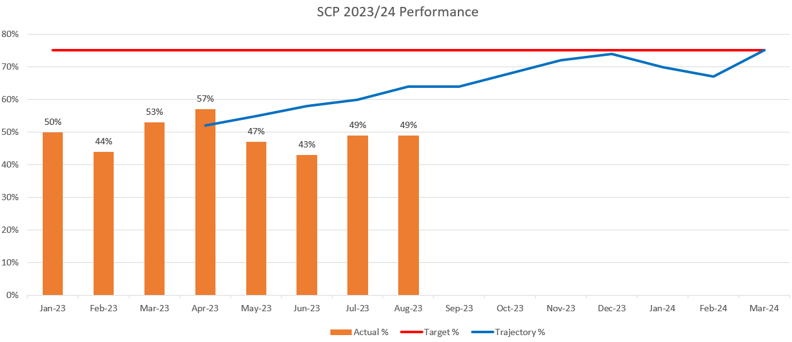
CANCER
Description |  | Current Performance | Trend
USC First Outpatient Appointments  The number of patients at first outpatient appointment stage by days waiting | To date, early October 2023 figures show total wait volumes for first outpatient appointment have decreased by 3% when compared with the previous week.  Of the total number of patients awaiting a first outpatient appointment, 49% have been booked, which is higher than figures seen in the previous months’ performance. | The number of patients waiting for a first outpatient appointment (by total days waiting) – October 2023  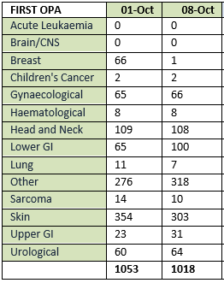
Radiotherapy waiting times  The percentage of patients receiving radiotherapy treatment | Radiotherapy waiting times are challenging however the provision of emergency radiotherapy within 1 and 2 days has been maintained at 100% | Radiotherapy waiting times  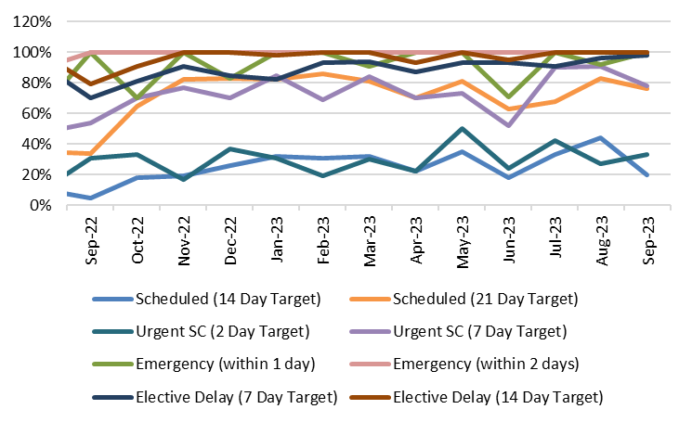
  Measure | Target | Sept-23
  Scheduled (14 Day Target) | 80% | 20%
  Scheduled (21 Day Target) | 100% | 76%
  Urgent SC (2 Day Target) | 80% | 33%
  Urgent SC (7 Day Target) | 100% | 78%
  Emergency (within 1 day) | 80% | 100%
  Emergency (within 2 days) | 100% | 100%
  Elective Delay (7 Day Target) | 80% | 98%
  Elective Delay (14 Day Target) | 100% | 100%
Cancer Services – Performance Escalation Updates
1.SCP performance trajectory  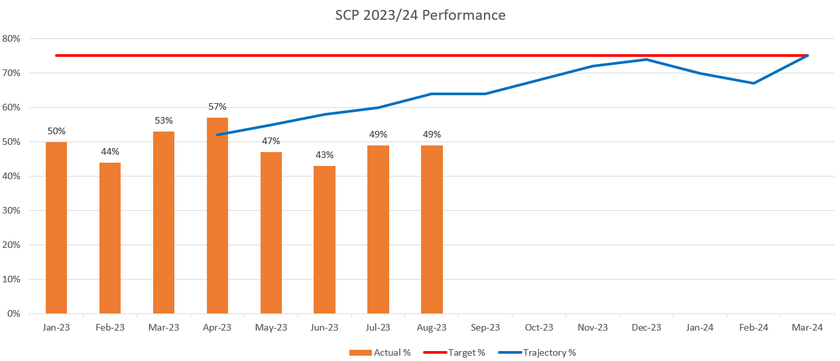  Proposed backlog improvements to support SCP performance  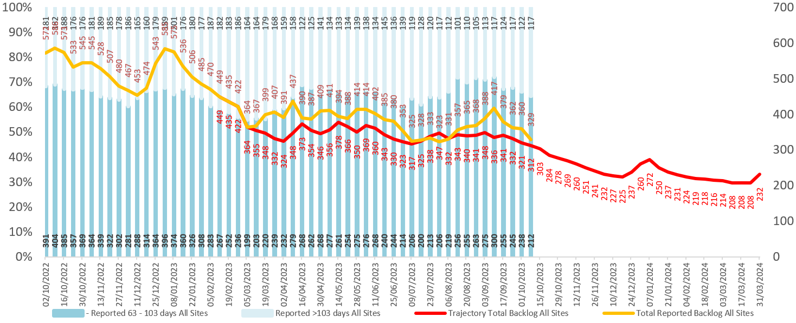 | - The final SCP performance for August 2023 was 49%, which is the same figure reported in July 2023. Performance is below the submitted trajectory (64%).  - Backlog figures have seen a reduction in recent weeks and have almost returned in line with the submitted trajectory. The total backlog at 08/10/2023 was 329. | - SCP performance in December was reported as 54% which is tracking below the outlined trajectory of 66%. January 2022 performance is still in draft format, however current projections suggest performance will be below the recovery trajectory.

FOLLOW-UP APPOINTMENTS
Description | Current Performance | Trend
Follow-up appointments  1. The total number of patients on the follow-up waiting list  2. The number of patients waiting 100% over target for a follow-up appointment | In September 2023, the overall size of the follow-up waiting list increased by 1,965 patients compared with August 2023 (from 150,060 to 152,025).  In September 2023, there was a total of 68,292 patients waiting for a follow-up past their target date. This is a slight in-month increase of 2.4% (from 66,683 in August 2023 to 68,292).  Of the 68,292 delayed follow-ups in September 2023, 11,430 had appointment dates and 56,862 were still waiting for an appointment.  In addition, 41,048 patients were waiting 100%+ over target date in September 2023. This is a 2.8% increase when compared with August 2023.  . | - Total number of patients waiting for a follow-up  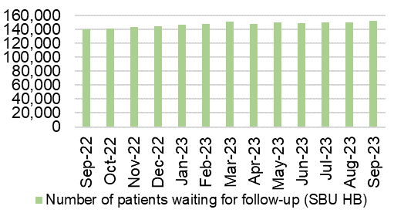  - Delayed follow-ups: Number of patients waiting 100% over target  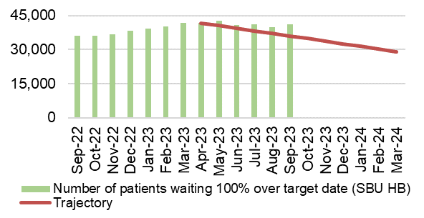
PATIENT EXPERIENCE
Description | Current Performance | Trend
Patient experience  1. Number of friends and family surveys completed  2. Percentage of patients/ service users who would recommend and highly recommend | - Health Board Friends & Family patient satisfaction level in September 2023 was 92% and 4,084 surveys were completed.  - Singleton/ Neath Port Talbot Hospitals Service Group completed 1,763 surveys in September 2023, with a recommended score of 95%.  - Morriston Hospital completed 2,303 surveys in September 2023, with a recommended score of 90%.  - Primary & Community Care completed 379 surveys for September 2023, with a recommended score of 97%.  - The Mental Health Service Group completed 28 surveys for September 2023, with a recommended score of 100%. | - Number of friends and family surveys completed  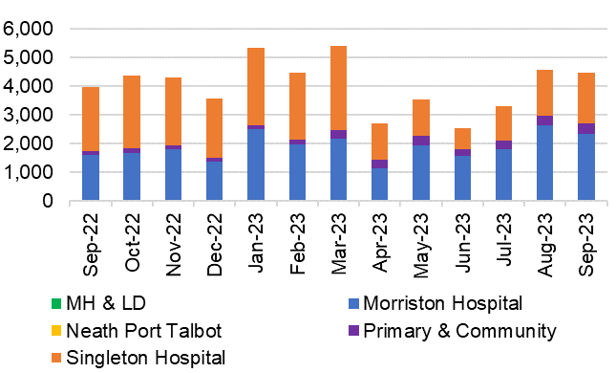  - % of patients/ service users who would recommend and highly recommend  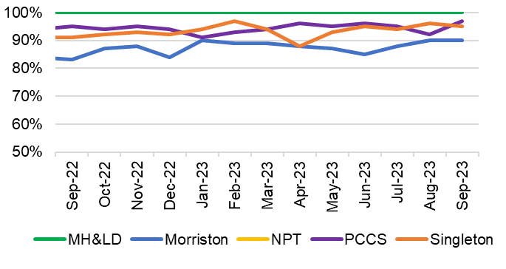
COMPLAINTS
Description | Current Performance | Trend
Patient concerns  1. Number of formal complaints received  2. Percentage of concerns that have received a final reply or an interim reply up to and including 30 working days from the date the concern was first received by the organisation | 1. In July 2023, the Health Board received 147 formal complaints; this is a reduction when compared with June 2023 figures (217) and this is a 4% reduction on the number seen in July 2022.  2. The overall Health Board rate for responding to concerns within 30 working days was 64% in  July 2023, against the Welsh Government target of 75% and Health Board target of 80%.  Below is a breakdown of performance against the 30- day response target: | - Number of formal complaints received  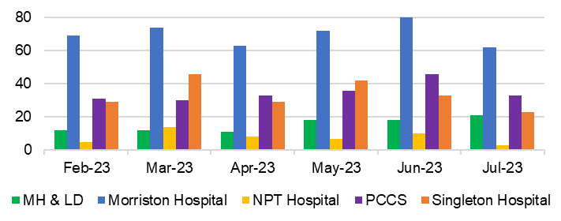  - Response rate for concerns within 30 days  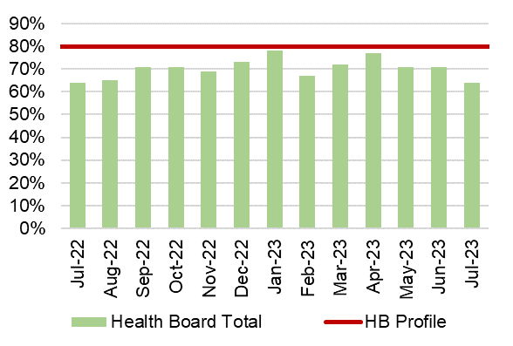
   | 30 day response rate
  Neath Port Talbot Hospital | 33%
  Morriston Hospital | 73%
  Mental Health & Learning Disabilities | 67%
  Primary, Community and Therapies | 76%
  Singleton Hospital | 22%

6.1 Overview
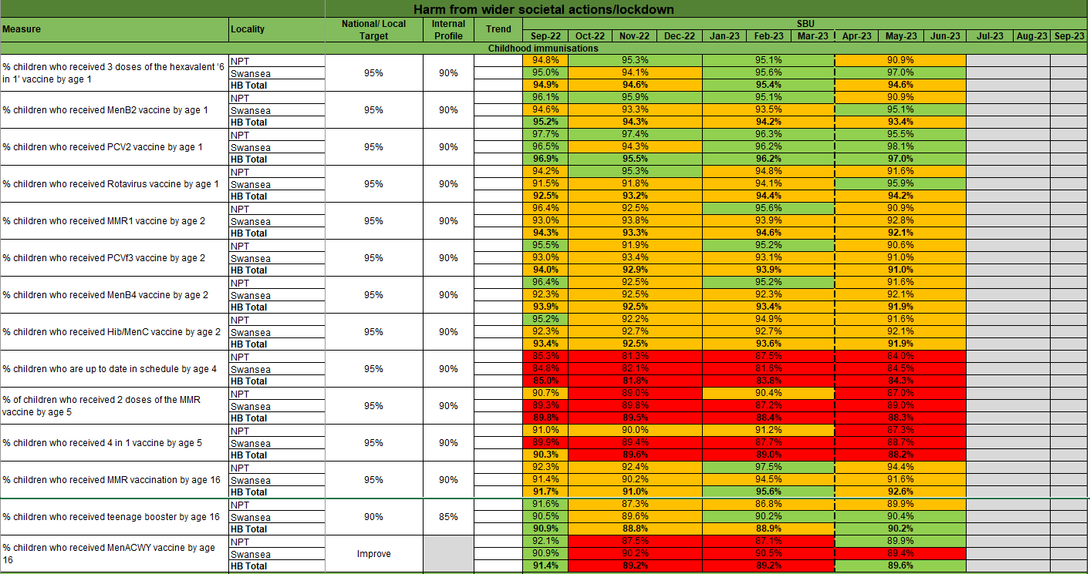

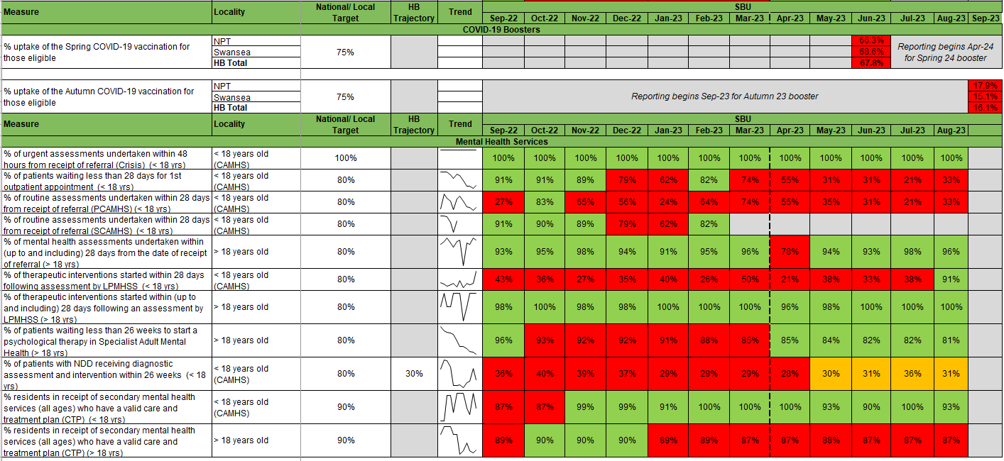

6.3 Updates on key measures
ADULT MENTAL HEALTH
Description | Current Performance | Trend
Adult Mental Health Measures:  - % of MH assessments undertaken within 28 days from the date of receipt of referral (18 years and over)  - % of therapeutic interventions started within 28 days following an assessment by LPMHSS (18 years and over)  - % of health board residents in receipt of secondary mental health services who have a valid Care and Treatment Plan (CTP) (18 years and over)  - % of patients waiting less than 26 weeks to start a psychological therapy in Specialist Adult Mental Health | - In August 2023, 96% of assessments were undertaken within 28 days of referral for patients 18 years and over.  - In August 2023, the percentage of therapeutic interventions started within 28 days following an assessment by the Local Primary Mental Health Support Service (LPMHSS) was 100%.  - 87% of residents in receipt of secondary care mental health services had a valid Care and Treatment Plan in August 2023.  - In August2023, 81% of patients waited less than 26 weeks for psychological therapy. This was below the national target of 95%. | - % Mental Health assessments undertaken within 28 days from receipt of referral  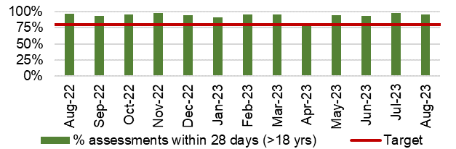  - % Mental Health therapeutic interventions started within 28 days following LPMHSS assessment  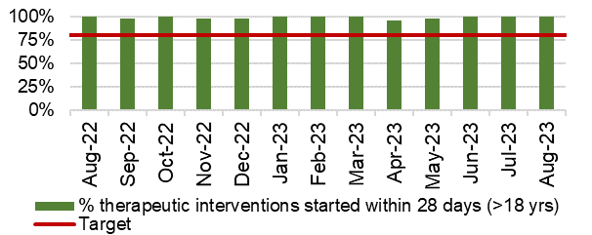  - % residents with a valid Care and Treatment Plan (CTP)  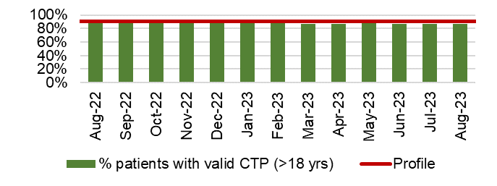  - % waiting less than 26 weeks for Psychology Therapy  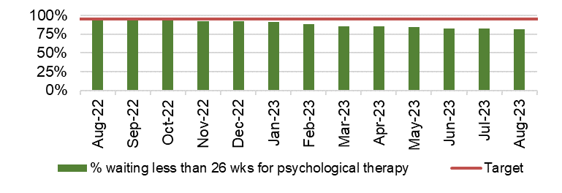
CHILD & ADOLESCENT MENTAL HEALTH (CAMHS)
Description | Current Performance | Trend
- Crisis - % Urgent Assessment by CAMHS undertaken within 48 Hours from receipt of referral  - Primary CAMHS (P-CAMHS) - % Routine Assessment by CAMHS undertaken within 28 days from receipt of referral  - Primary CAMHS (P-CAMHS) - % Therapeutic interventions started within 28 days following assessment by LPMHSS  - NDD - % Neurodevelopmental Disorder patients receiving a Diagnostic Assessment within 26 weeks  - Specialist CAMHS (S-CAMHS) - % Routine Assessment by SCAMHS undertaken within 28 days from receipt of referral | - In August 2023, 100% of CAMHS patients received an assessment within 48 hours.  - 33% of routine assessments were undertaken within 28 days from referral in August 2023 against a target of 80%.  - 91% of therapeutic interventions were started within 28 days following assessment by LPMHSS in August 2023.  - 31% of NDD patients received a diagnostic assessment within 26 weeks in August 2023 against a target of 80%.  - 82% of routine assessments by SCAMHS were undertaken within 28 days in February 2023.  *Updated data is not currently available to report* | - Crisis- assessment within 48 hours  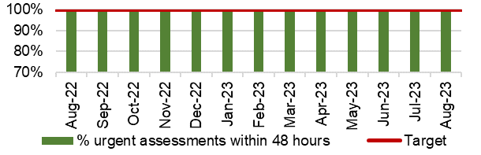  - and 3. P-CAMHS % assessments and therapeutic interventions within 28 days  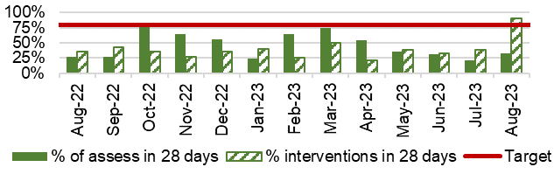  - NDD- assessment within 26 weeks  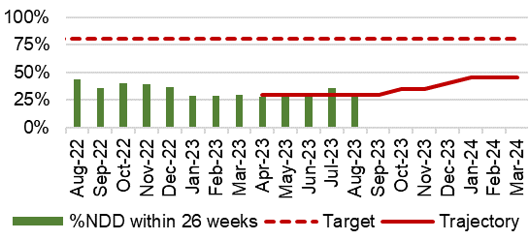  5. S-CAMHS % assessments within 28 days  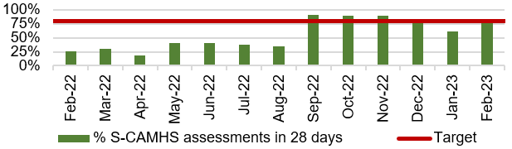

APpendix 2: Summary
The following table provides a high level overview of the Health Board’s most recent performance against key quality and safety measures by quadrant component measure.

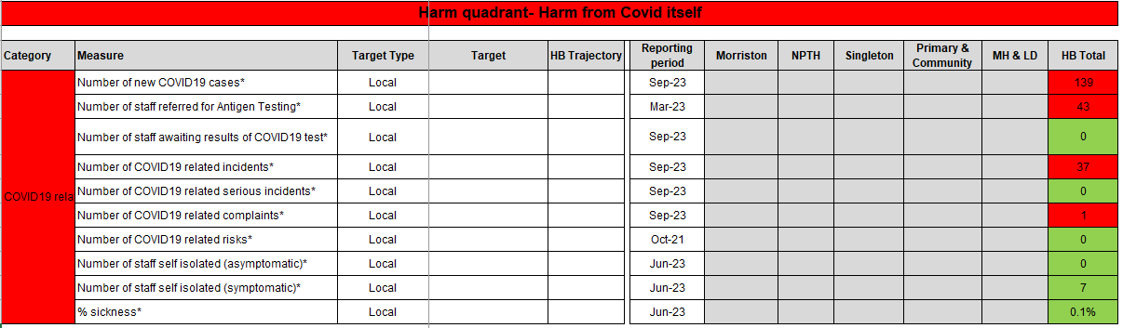

* In the absence of local profiles, RAG is based on in-month movement

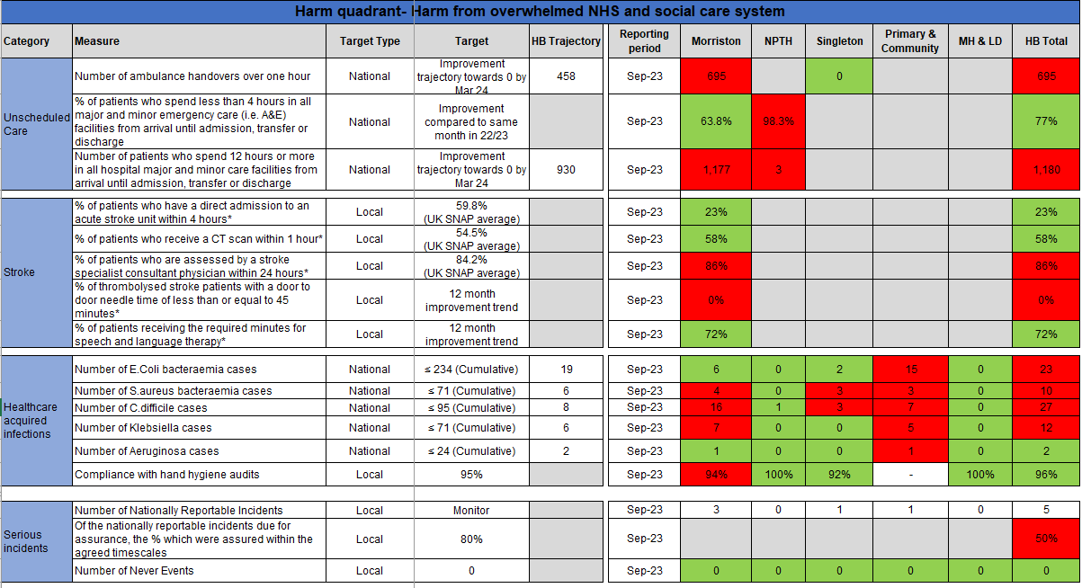

* In the absence of local profiles, RAG is based on in-month movement

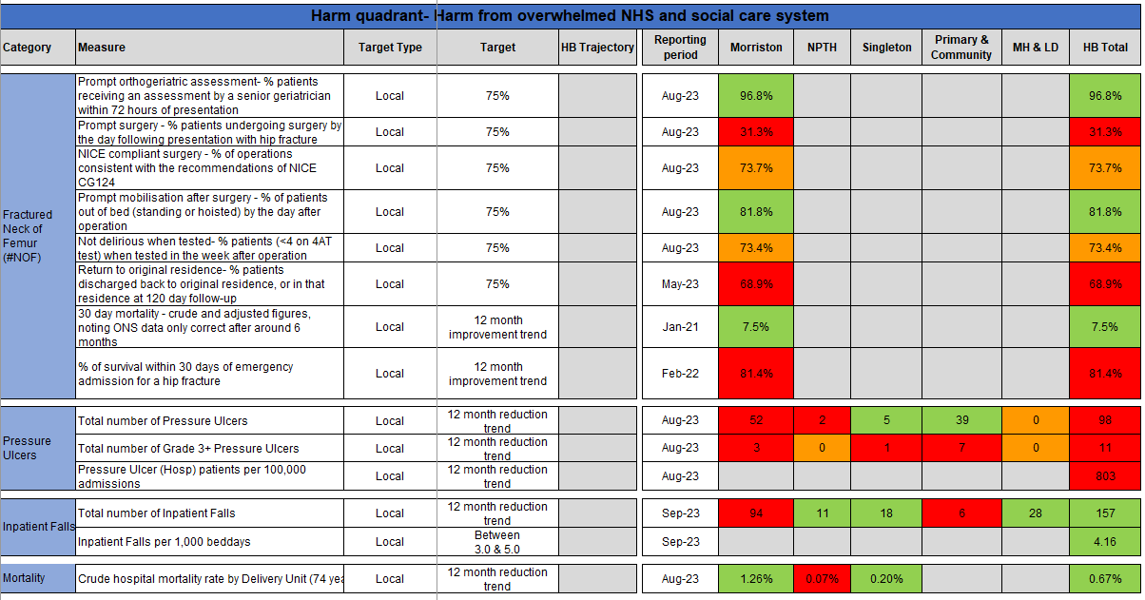

* In the absence of local profiles, RAG is based on in-month movement

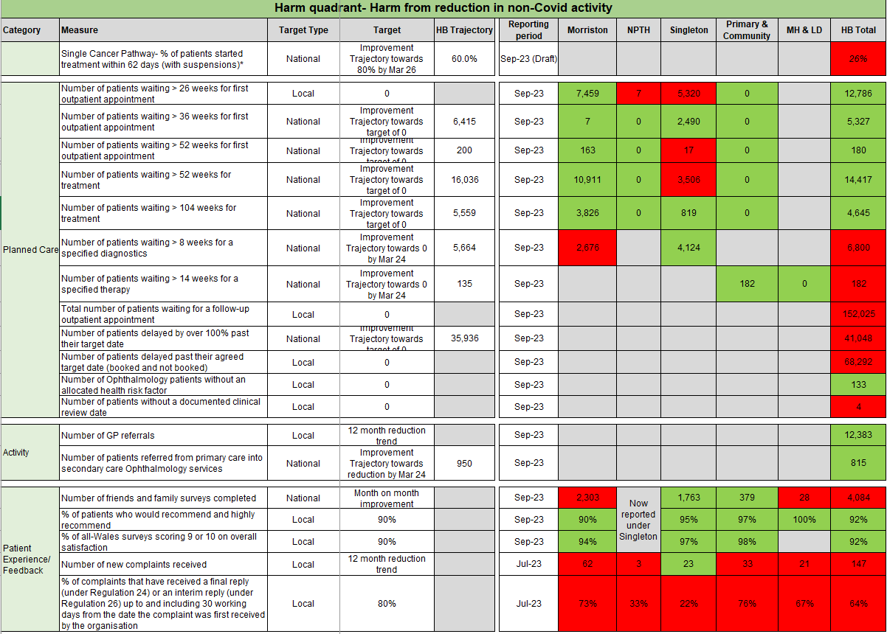

* In the absence of local profiles, RAG is based on in-month movement

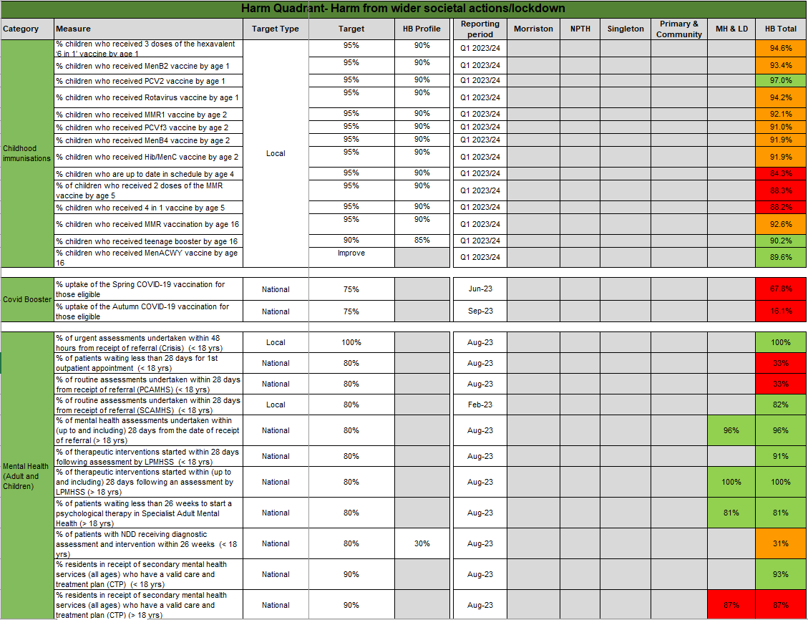

* In the absence of local profiles, RAG is based on in-month movement

Appendix 3: INTEGRATED Performance Dashboard

