

Meeting Date | 24th October 2023 |  | Agenda Item |  |  | 3.1
Report Title | Deep Dive End of Life Care
Report Author | Sue Morgan, Senior Responsible Officer, End of Life Care  Emma Smith, Quality Improvement Information Manager
Report Sponsor | Hazel Powell, Deputy Director Nursing and Patient Experience
Presented by | Sue Morgan, Senior Responsible Officer, End of Life Care
Freedom of Information | Open
Purpose of the Report | To provide an update on the goals, methods and outcomes for the End of Life Care (EOLC) quality priority and how these will be transferred into business as usual.
Key Issues | - Currently Swansea Bay residents are more likely to die in hospital (52%) than residents in other part of Wales (48%) and England (44%)  - Since End of Life Care has become a Quality Priority the following has been achieved  - Education training programmes established; champion programme, bespoke packages, education and induction based sessions. 16.6% of Health Board (HB) staff have been trained since January 2022. This is continuing.  - NACEL audit 2022 showed improved results compared to 2021. A local audit has been developed to bridge the gap between National audits.  - Key documents adopted; My Life My Wishes, Care Decision Guidance, Treatment escalation plan, projects taking place to increase use of these.  - Palliative Care register identified as a key enabler – pilot with 3 GP clusters and District Nursing to maximise use of this to support Advanced & Future Care Planning (A&FCP) in the community.  - Discussions and initial agreements by Digital to support Digital developments to support end of life care recording and sharing.  - Communications to engage the workforce and the public in understanding end of life care.
Specific Action Required  (please choose one only) | Information | Discussion |  | Assurance | Approval
Specific Action Required  (please choose one only) | ☐ | ☐ |  | ☒ | ☐
Recommendations | In order to progress EOLC Quality Priority work and embed it as business as usual, all Service Groups (SG) must engage with the improvement projects and ensure clinicians are encouraged to:  - Continue to engage with EOLC education and training:  - Ensuring there are 2 members of staff per area attending the EOLC champions programme  - Identifying areas of bespoke education needs –through action plans following incidents and complaints, audit reports, mortality and morbidity review reports and staff/service requests.  - The aim is to have another 1000 staff attend training by March 2024.  - Increase identification of people who may be in the last six to twelve months of life, to support their information and care needs adopting:  - Complete A&FCP discussions and documentation when recognising that patients are in their last 6-12 months of life  - Introduce patients to My Life My Wishes document when having discussions  - Recording of A&FCP discussions in the WCP notification to highlight the activity to other clinical teams – aim to have 100 per month across all areas by March 2024  - Sharing of identification of last 6-12 months of life, A&FCP discussions and recommendations to GPs in usual correspondence methods  - Utilise Treatment Escalation Plans increasing proactive decision making around setting ceilings of treatment – current pilots in ED & AMU in Morriston and plans for further pilots in Gorseinon and Oncology. These will continue and expand as use increases through the year.  - Complete Care decision guidance (CDG) document when the patient is identified to be in their last days of life, this is available to use across all areas. Aim to have 55% of deaths having A CDG document by March 2024.  - Maximise use of the Palliative care register, through recommendations to add to register, attendance of MDT meetings and referrals to District Nursing – aim to increase register to 0.40% by March 2024  - Ensure reporting on EOLC in the SG quality and safety groups; participate in the EOLC action log reporting and in EOLC delivery group and EOLC & Palliative steering group by September 2024.  - Participate in the HB last days of life clinical audit – each department within secondary care to undertake the audit at least once by April 2024.  To support Service Groups to undertake this:  - Digital to deliver on internal audit recommendations to identify gaps in existing EOLC data to support development of a dashboard covering all aspects of EOLC. Scoping to be complete by July 2023 and a plan presented by Sept 2023.  - Digital to support IT system development to allow recording and sharing of patients recognised to be in the last year of life, palliative care register, details of conversations around A&FCP, Do Not Attempt Cardiopulmonary Resuscitation (DNACPR) and Treatment escalation plans across IT platforms and service groups. Plan in place by September 2023.  - Communications, core EOLC group and Swansea University to support development of public facing resources to support public understanding of their conditions, care in the last year of life, advance and future care planning, treatment options. To start in October and include HB website and podcasts.  - A&FCP literature made available in all ward and outpatient clinic areas.  - Core EOLC team to provide support to clinical teams to undertake EOLC audit.  - Provide reporting templates for investigation of incidents/complaints; audits; Mortality/Morbidity reviews; will include EOLC education needs identified.

Quality Priority – End of Life Care

- INTRODUCTION

The Health Board has identified End of Life Care (EOLC) as a Quality priority. This paper will outline what has been achieved so far for the EOLC Quality Priority and the focus in 2023/2024 and the actions required to incorporate this into business as usual.

- BACKGROUND

NICE Quality Standard (QS13) was updated September 2021 and covers care for adults (aged 18 and over) who are approaching their end of life. This includes people who are likely to die within 12 months, people with advanced, progressive, incurable conditions and people with life-threatening acute conditions. It also covers support for their families and carers. It includes care provided by health and social care staff in all settings. It describes high-quality care in priority areas for improvement.
- Identification - Adults who are likely to be approaching the end of their life are identified using a systematic approach.
- Advance care planning - Adults approaching the end of their life have opportunities to discuss advance care planning.
- Co-ordinated care - Adults approaching the end of their life receive care that is coordinated between health and social care practitioners within and across different services and organisations.
- Out of hours care - Adults approaching the end of their life and their carers have access to support 24 hours a day, 7 days a week.
- Support for carers - Carers providing end of life care to people at home are supported to access local services that can provide assistance.

The key to providing the right care in the right place at the right time in the last days of life is dependent upon an understanding of what matters to the individual patient and the patient’s understanding of what is the matter with them, including understanding their individual likely disease journey, and the realistic therapeutic options remaining. Advance and future care planning, alongside serious illness conversations, with health care professionals ensures that patients (and those important to them) understand how their conditions are impacting on their function and reserve and helps health care professionals understand what the patient’s priorities and preferences are.
- Enables greater autonomy, choice and control - respects the person's human rights, enabling a sense of retaining control, self-determination and empowerment.
- Enables deeper discussions and consideration of spiritual or existential issues, reflection on meaning and priorities and encourage resilience and realistic hope.
- There is greater concordance with wishes if they have been discussed, for example more people die in their preferred place of death (three in four patients who express a preference die in their preferred place of death^{v})
- Reduced unwanted or futile invasive interventions, treatments or hospital admissions, guiding those involved in care to provide appropriate levels of treatment (Six out of seven patients who engage in robust advance care planning die outside of hospital^{v})
- Enhanced proactive decision making reduces later burden on family and relieves anxiety
- Improves the quality of end of life care provided for individuals and populations and enables better planning of care, including provision by care providers
- Greater satisfaction, reduced anxiety and depression in bereaved relatives
- Economically cost-effective in reducing costs

In 2022, approximately 4,500 residents of Swansea Bay died (ONS, 2023). This is 1.2% of the population (ONS). It has been anticipated that the number of deaths will increase by 25% over the next 10 to 15 years. It is also expected the palliative care needs of an elderly population with multiple co-morbidities will increase by 42%^{iv}. Residents of Swansea Bay are more likely to die in hospital (52%) than residents in other part of Wales (48%) and England (44%)^{iii}.

It is essential that Swansea Bay develops robust values and processes in EOLC to support the population in their last year of life and to be able to deliver the right care in the right place at the right time in their last year, months and weeks of life.

- Delivery of the EOLC quality priority
Table 1: Requirements for delivery of Q&S priority
Step | Action | Requirements
 | 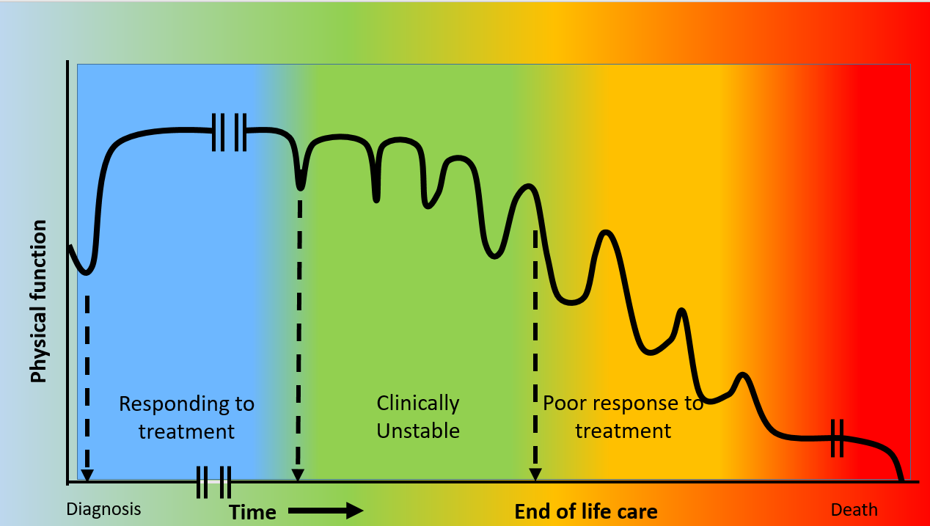
1 | Systematic clinical triggers for identifying when patients with chronic conditions are changing phase of illness from  - Stable and responsive to treatment  - Unstable  - Poorly responsive to treatment  - Dying | Clinical staff to understand Gold Standard Framework Proactive Identification Guidance (PIG) (Appendix 1)  Develop locally relevant /accepted PIG
2 | Clinicians identifying when patients are changing from one phase of illness to the next | Clinicians to understand PIG
3 | Clinicians sharing that with other clinicians and with patient and family  Highlight to GP that patient is suitable for inclusion on Primary Care Palliative Care Register | Good communications skills – and confidence in using those skills  IT systems and processes to support sharing and accessibility to information across primary and secondary care , including with GPOOH, WAST, DNs  Good functioning Primary care palliative care register
4 | Sensitive communicating with patient and family about  clinical situation and what the future looks like  - What the disease journey is likely to look like  - What treatment options remain including option of no active treatment/focus on symptom control/best supportive care  - likelihood of benefit, magnitude of benefit, duration of benefit  - Likelihood of harm/burdens, magnitude of burdens, duration of burdens. Including option of no treatment  - What is important to the patient  - Identifying patient needs and planning for them | Good communication skills and confidence in using those skills
5 | Share details of conversation with other clinical teams | IT systems and processes to support sharing and accessibility to information across primary and secondary care , including with GPOOH, WAST, DNs
6 | Clinicians across all care settings to  - Identifying patient needs and planning for them  - support patient to formulate preferences  - My life my wishes  - Advance decision to refuse treatment  - Record of best interest decision  - Lasting power of Attorney  - Care decision guidance for last days of life | Clinician access to detail of previous clinical conversations  Good communication skills and confidence in using those skills  Clinician knowledge of advance and future care planning options and supporting documents  Access to A&FCP supporting documents  Patient acceptance and willingness to engage in conversation
7 | Clinicians set treatment escalation plan, with patient | Good communication skills and confidence in using those skills  Patient (and those important to them) understanding phase of illness and options available
8 | Sharing of TEP with other clinicians | IT systems and processes to support sharing and accessibility to information across primary and secondary care , including with GPOOH, WAST, DNs
9 | Clinicians acting on A&FCP | IT systems and processes to support sharing and accessibility to information across primary and secondary care , including with GPOOH, WAST, DNs

Table 2: GMOs for 2022-23
Goal | Methods | Outcomes | Progress
Improve the recognition and compliance of End of Life Care (EOLC) | Review findings of National Audit of Care at End of Life (NACEL): Build in feedback mechanism from HB mortality Reviews, All Patients to be recognised and receive EOLC throughout HB (working toward 100%) | Improvement in 2022 findings compared to 2021 and national average  EOLC internal audit  HB last days of life audit  Feedback mechanism in mortality reviews | - Review completed in 2022 for 2021 audit and considered as part of the EOLC plans. Initial 2022 audit results have been released showing improvements compared to 2021 in: planning for end of life, discussions with patients and nominated persons, assessment of common symptoms, anxiety & distress, emotional, psychological and cultural needs.  - There was an EOLC Internal Audit conducted between March and May 2023. This was given reasonable assurance.  - A HB wide last days of life audit has been set up. This can help to support SGs to monitor their activity around supporting the five priorities of the dying person in between the annual NACEL. Currently 85 deaths has been input into the audit for 2022-23 period, supporting areas of ortho-geriatrics and care of the elderly. Therefore, the audit needs to be more widely used across all care settings.  - The Learning from Deaths Panel/Medical Examiner process collates learning around quality of A&FCP and care in the last days of life is being undertaken. It is currently in its infancy and it is expected that, as the process matures, more learning can be included.
 | Ensure training in recognition and management of patients approaching EOLC from 1yr down: Review of Mandatory and Statutory training to ensure EOLC adequately provided, >95% staff compliance (available staff) | Numbers attending EOLC champion programme  Numbers and proportion of staff attending all courses include bespoke and education sessions | - The EOLC Parasol team has developed a range of end of life care material and training packages, delivering across the HB and outside the organisation.  - Delivery of the champion programme overall 417 attended, 373 since additional capacity was recruited in January 2023  - Delivery of bespoke EOLC training to areas identified by SGs  - Regularly attend HCSW and nursing inductions  - Attend Internal Medical training, Practicing Medicine Made Easy and Mental Health training.  - Delivered covering all types of sessions to 17.7% of HB staff overall, 16.6% of that since January 2022 when the additional capacity was included in the team.  - It is has been recognised that it is not possible to make this training mandatory and therefore achieve 95% compliance.  - This method will continue into 2023-24 as it is a key enabler of the other methods and delivery of the goal but has changed to focus on priority areas per service group and establish an ongoing plan.
 | Develop the use of digital technology to map compliance and notification of patients who require or receiving EOLC | Systems able to allow recording and sharing of EOLC and A&FCP conversations | - Initial discussions with Digital to support this have taken place in 2022-23.  - Dependency on digital developments has been raised in various forums and enabling conversations with Digital.  - This method will move to 2023-24 and strengthened following internal audit recommendations:  - The health board should develop performance measures that are aligned to the five priorities of care and the NACEL Action Plan  - Identify gaps in existing data which are required to align our measures to the five priorities of care and NACEL action plan by July 2023  - Present plan to Quality Priority Programme Board with timescales for implementation of measures September 2023

NACEL Audit 2022-23 Key Findings

The NACEL is a national comparative audit of the quality and outcomes of care experienced by the dying person and those important to them during the last admission leading to death in acute hospitals, community hospitals and mental health inpatient providers in England, Wales and Northern Ireland.

Initial review of the NACEL audit 2022-23 and compared to 2021-22 found improvements in some areas:

- Plan in place and discussions with patient & nominated person:
  - The presence of an individualised plan of care for the needs in the last days of life is the area that Swansea Bay UHB was an outlier in the 2021 round of the NACEL audit, with only 25% of deaths being supported by an individualised plan of care. This proportion increased to 42% in the 2022.
  - There was also increase in the proportion of patients involved in that planning (20% to 38%) and those close to the person (70% to 90%)

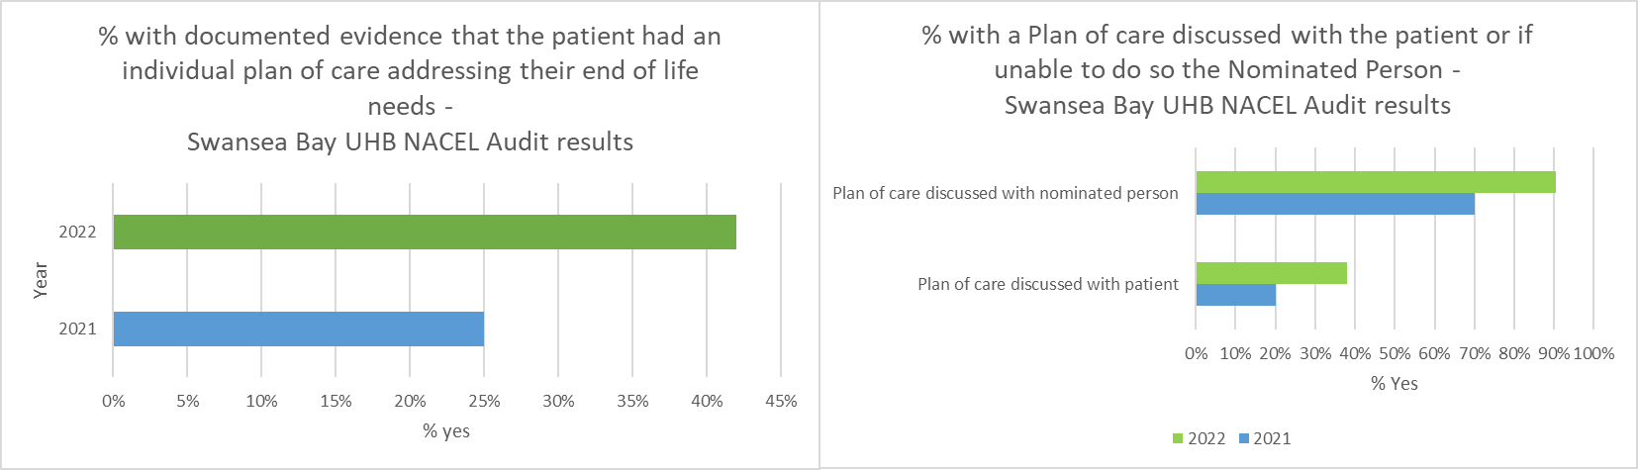

- Recognising dying until death - Acknowledgement of the dying patient was made prior to 24 hrs of death in 66% deaths in 2021 and reduced to 61% in the 2022 NACEL audit. This shows a decline however, it is possible that earlier recognition of dying in hospital facilitates patients to return to die in their usual place of residence.
- There was in increase in evidence of assessment of the common symptoms in the last days of life including assessment of pain, Swansea Bay performed higher than the national average in the 2022 round of the audit and an improvement locally from 55% to 85%
- There was an increase in the assessment of cultural, spiritual and religious needs between the 2021 and 2022 rounds of the audit, from 5% of deaths to 12.5%.
- Assessment of Emotional and psychological need increased from 7.5% to 30%. Assessment of anxiety and distress increased from 27% in 2021 to 45% in 2022.

End of life care education and training
The Parasol team was established in 2021 and is the first and only team of its kind in Wales. Its capacity widened in January 2022 with the recruitment of an additional Clinical Nurse Specialist (CNS). Parasol stands for: Person-centred approach, Assessment, Recognition, Approach, Sensitive, Observe and Lastly, as a framework for how they deliver and promote end of life care.

Training includes the EOLC Champion Programme, bespoke training on request of SGs and the delivery of sessions within education and induction settings. Since starting in May 2021, the team has delivered training to 2,426 HB staff, which is over 17.7% of our total staff. Since the recruitment of the additional CNS, the staff were able to deliver training to 16.6% of that.

The EOLC champion programme has had 417 staff attend, around 50 of these were external to the HB including care homes and WAST. Since January 2022, the numbers have increased by 367.

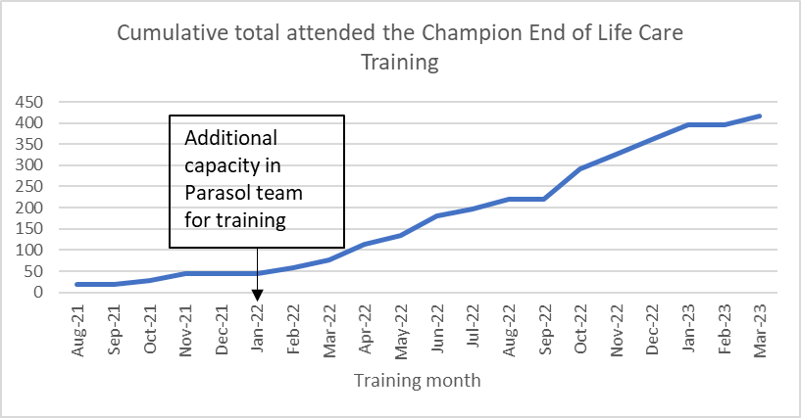

Bespoke sessions have been delivered to teams identified by all SGs. There are regular End of life sessions on Registered Nurses induction and update sessions and Health Care Support Worker (HCSW) induction and update sessions. The team delivers EOLC Sessions on Medical training – Internal Medical training, Practicing Medicine Made Easy and Mental Health training. All wards in Singleton, Morriston and Neath Port Talbot have access to EOLC Resource folders.

A reflective review of the EOLC champion training in May 2023 included 10% of those who had attended the training. From the workshops, it demonstrated that some Champions need more support in their clinical areas. Some areas the Champions are promoting AFCP and CDG within their clinical areas, which needs to be correlated with the NACEL outcomes and the Medical Examiner data showing increased use in CDG. The team are continuing to deliver the training, having altered the programme for the Champion day based on feedback, where they have introduced a session on anticipatory grief. They will constantly review the education we deliver based on feedback and Datix outcomes.

Table 3: GMOs for 2023-24

Goal | Methods | Outcomes | Target | Progress
End of Life Care (EoLC)  Increase proportion of Swansea Bay residents receiving the right care at the right place at the right time in the last year, months, weeks, days of life | Increased correct identification of people who may be in the last year of life | Increase % of deaths outside of hospital  Increase % of patients on the palliative care register | 0.40% on Palliative care register by March 2024 | - Palliative Care project is part of the Safe Care Collaborative  - Pilot in 3 GP clusters; Penderi, Cwmtawe and Upper Valleys with District Nursing is starting July 2023
 | Increase Advance & Future Care Planning across all care settings | Increase in the number of advance future care plans recorded in WCP​ | 100 A&CP WCP notifications per month by March 2024 | - Increase in A&FCP notifications in WCP  - My life my wishes document adopted by the HB and promoted in forums  - Treatment escalation plan is being piloted in ED & AMU Morriston with plans to start in Gorseinon and Oncology
 | Increased correct identification of people who may be in the last days of life | Increase in the % and number of cases reviewed by the Medical Examiner who have a CDG Document in place​  Decrease % of deaths within 48hrs of emergency attendance | 55% of deaths with a CDG by March 2024 | - CDG document is available to all areas  - 25% of hospital deaths had a CDG confirmed by the medical examiner review  - Focussed work has started in ED to increase usage
 | Increase the number of staff given education and training to support high quality EOLC | Increase number of staff receiving education and training in recognition and management of patients approaching EOLC from 1yr down | 3500 total staff trained (1000 within the year) | - Continue to deliver the training reviewed following evaluation.  - Complete the five care home train the trainer by September 2023.  - Develop a for Practice Development Nurses (PDNs) training programme to deliver EOLC training in their clinical areas.  - Plans to develop a series of CPD modules around EOLC for Doctors
 | Identify and produce systems that support sharing of advance and future care planning across all care settings | Systems enabled to share end of life care/advance & future care planning information across platforms | At least 1 system able to share across care settings | The internal audit recommends the HB to develop performance measures aligned to the 5 priorities of care and the NACEL Action Plan. The HB response agreed the following, with the Director for Digital responsible:  - Identify gaps in existing data which are required to align our measures to the five priorities of care and NACEL action plan; and  - Present plan to Quality Priority Programme Board with timescales for implementation of measures

Increased correct identification of people who may be in the last year of life

Ideally, our overall aim would be to increase the % of Swansea Bay residents dying in their preferred place of death. However, due to a lack of digital recording, it is difficult to demonstrate this; therefore, the proxy measure % of Swansea Bay residents dying outside of hospital is used. Currently this data groups deaths in Ty Olwen as a hospital death but further work with Digital intelligence will allow us to understand the proportion of hospital deaths that are Ty Olwen. The median since 2020 is that 52% of Swansea Bay residents die outside of hospital.

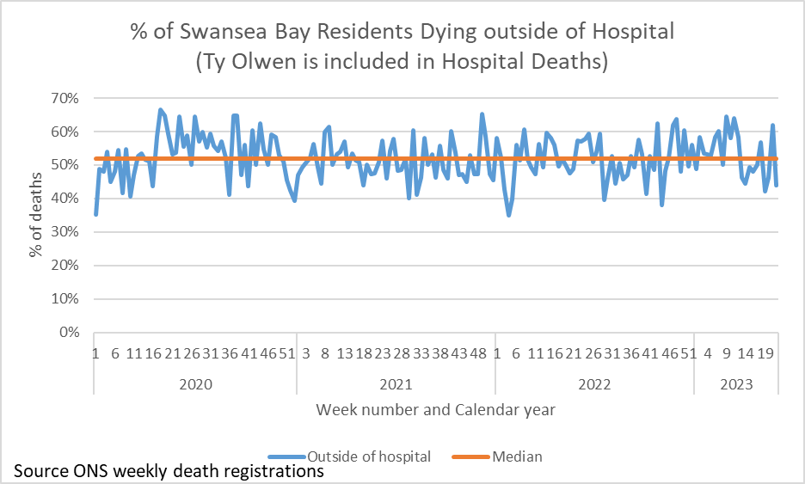

The main project within this method currently is to increase the use of the Primary Care Palliative Care Register, which forms part of the GP contract. Within Swansea Bay, the use of the Palliative Care Register has been variable. In March 2022, 0.22% of the Swansea Bay GP registered population were on the register. This ranged from 0.14% in one GP Cluster to 0.26% in another (PCIP, 2023). The aim in 2023-24 is to increase to 0.40% by March 2024 to move toward the expectation that 1% of the population will be in their last year of life.

The Primary Care Clinical lead for End of life care has produced guidance for the register and two monthly meetings, which in May 2023 was shared with all Swansea Bay GP Practices after being shared in LMC. This will aim to standardise the processes for adding to the Primary Care Palliative Care Register and 2 monthly MDT meetings. This project is one of the national Safe care collaborative work stream projects which will focus on maximising the use of the Primary Care Palliative Care Register, the running of MDT 2 monthly meetings and starting referrals to District Nursing team to start A&FCP discussions within three clusters; Cwmtawe, Penderi and Upper Valleys.

Currently we are only able to access the palliative care register information annually by GP cluster. We are in discussions to agree access to this information more regularly by GP Practice within each of the pilot clusters and gather information from District Nurses where they are involved.

Increase Advance & Future Care Planning (A&FCP) across all care settings

Anecdotally we know that A&FCP takes place in pockets across the Swansea Bay area but there is no systematic way of how it is shared and recorded digitally and therefore this method links with the last method around Identify and produce systems that support sharing of advance and future care planning across all care settings.

Currently the only electronic measure for A&FCP available is the A&FCP notification flag in Welsh Clinical Portal (WCP). There has been an increase in notifications in recent months. A request has been made to understand the breakdown of this information by Service but it is thought to be Specialist Palliative Care service as they have made a renewed effort to increase use of this. The use of this flag is being explored as part of the Palliative Care Register project and promotion of the flag is being made to other HB services.

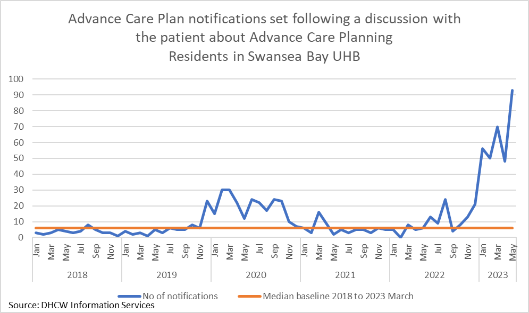

There has also been initiation of work with clinical teams to identify processes for both identification of triggers for advance and future care planning and for sharing detail between clinical teams supporting the patients, across all care setting (primary care/secondary care/WAST/ GPOOH).
The Health Board has adopted My Life My Wishes document (originated from Powys HB), which is an Advance Care Plan or Statement of Wishes. This has been shared through some of the Parasol team training programmes, in the last 9 months 320 documents have been shared. It is available on Coin and is accessed by the Virtual Wards to assist in A&FCP discussions.
The Treatment escalation plan (TEP) form is being introduced in the HB, with a pilot starting in Morriston ED and AMU week commencing 7th June 2023. The TEP form is a way for the healthcare team to record a patient’s individual care plan should they deteriorate in an emergency, focusing on which treatments may or may not be most helpful to them. The next pilot is planned for Oncology and Gorseinon.

Increased correct identification of people who may be in the last days of life
The CDG for the last days of life document is available across the HB. Projects. It is currently a paper document but there is plans to include it in the Welsh Nursing Care Record. Currently the Medical Examiner in reviewing all hospital deaths records if the document was completed. The baseline is 22% of hospital deaths reviewed by the Medical Examiner have a CDG document. The aim is to increase this to 55% of hospital deaths. There will be an improvement project that will focus on improving the use of this in particular health settings, further work to scope this and identify the areas of focus is needed. The focus to increase use is currently happening within Morriston ED, there is examples of it being used and maintained by ED staff and supporting discharge home/care home to those patients in the last days of life.
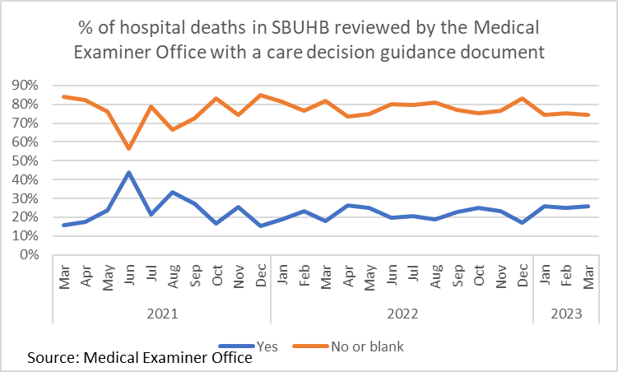

Communication and engagement with HB staff and wider community

There have been a series of messages relating to EOLC shared via various online media releases between January 2023 and May 2023 including the Parasol EOLC team, the Clinical Lead for EOLC and GP lead for EOLC and the Bay Magazine release in June 2023. The EOLC Core message was released on HB screensavers in May 2023.
A Good Grief event at Morriston Hospital proved it’s good to talk about death, dying and bereavement. The End of Life Parasol Service, Ty Olwen and Care After Death Service welcomed public, patients and staff to Morriston Hospital to the event, which encouraged openness and discussion about death, while raising awareness of all the different services and people who can be involved following a death. The event coincided with Dying Matters Awareness Week (May 8-14), with a number of local firms including funeral directors, cancer charities and bereavement services invited to host information stands. “The overall feeling from this event was that everyone who attended – patients, the general public and our staff – took a lot from it.” Kimberley Hampton-Evans, Care After Death Service Manager.
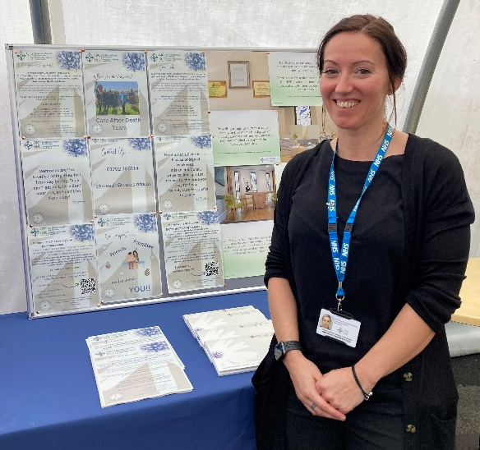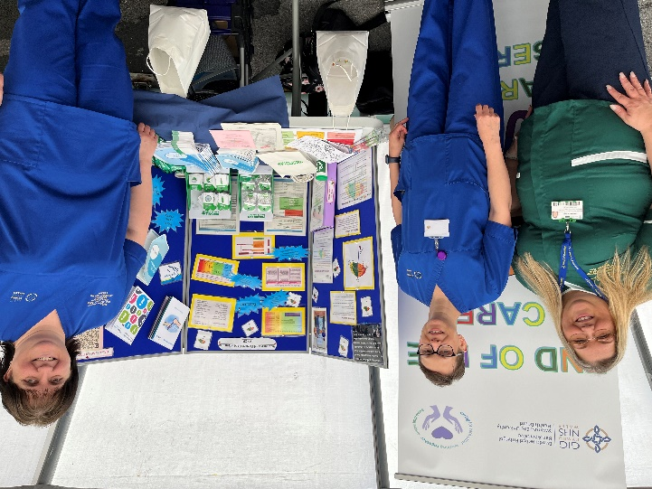
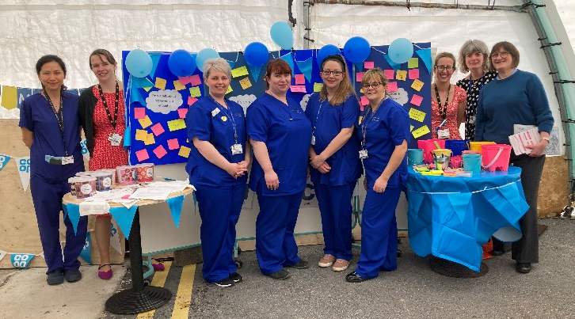

For the remainder of the year podcasts with care in the last year of life message is being planned with both care professionals and public as focus. Promotion through grand round, meeting with individual clinical teams. There are plans for creating HB intranet site with education material and a public facing HB internet page including priorities of the person in the last year of life.
- SUMMARY

The End of Life Care Quality and Safety Priority has been an essential component of the HB’s strategy development for providing the right care in the right place at the right time, through the last year of life. Positive results have already been identified through changes in care evidenced through the National Audit of Care at the End of Life, with increased evidence of assessing humanistic needs (symptom control, spiritual needs, emotional/psychological needs, hygiene/bowel and bladder care) and planning in the last days of life in the hospital setting. This has been a consequence of the increased focus on care in the last days of life and the training being provided through the PARASOL Team.

The longer terms aims are focused on building firm foundations in the last year of life, through conversations – understanding what is important to the patient and helping the patient to understand their disease journey, to support the right care in the right place in the last days of life. Changing away from what is often seen as “normal” (admission to emergency department/hospital in the last days of life) to providing end of life care in the person’s preferred place of care. There will be a period of lag between implementing change to realising the change in patient outcomes, as conversations in the last six to twelve months of life influence clinical decision making in the last days of life.

- GOVERNANCE AND RISK ISSUES

The recent internal audit of end of life care has demonstrated that there is appropriate governance and oversight arrangements are in place. Key issues are escalated and reported to Board.

The health board’s governance structures in respect of quality and safety were updated during 2022, with a number of groups being replaced. The reporting framework for EOLC includes:
- Board
- Quality and Safety Committee
- Management Board
- Quality and Safety Group
- Quality Priorities Programme Board
- Palliative and End of Life Steering Committee.

The following risks have been identified within the above forums are:

- Digital Informatics – Dashboard not yet in place effecting Service Groups ability to have access to EOLC data and therefore take accountability and influence change in a more timely way.
- Digital systems – there is limited ability to record that patients are recognised to be at end of life and any A&FCP discussions. There has been little progress made with this in 2022-23 and therefore it has been moved to the GMOs for 2023-24
- Delays in DNACPR documentation to support clinical decision due to inability to comply with All Wales DNACPR policy (completion of Section 5 by non-medical staff)

- FINANCIAL IMPLICATIONS

Through the Quality Improvement programme, there are projects that may require additional funding however, details for this will follow through individual project groups.
This may include increased community care needs if increased numbers are dying outside of hospital. If earlier A&FCP takes, place and more residents are cared for outside of hospital this could result in less demand within the hospitals such as beds and investigations.

- RECOMMENDATION

Members are asked to note the report and approve the following:
In order to progress EOLC Quality Priority work and embed it as business as usual, all Service Groups (SG) must engage with the improvement projects and ensure clinicians are encouraged to:

- Continue to engage with EOLC education and training:
  - Ensuring there are 2 members of staff per area attending the EOLC champions programme
  - Identifying areas of bespoke education needs –through action plans following incidents and complaints, audit reports, mortality and morbidity review reports and staff/service requests.
  - The aim is to have another 1000 staff attend training by March 2024.
- Increase identification of people who may be in the last six to twelve months of life, to support their information and care needs adopting:
  - Complete A&FCP discussions and documentation when recognising that patients are in their last 6-12 months of life
  - Introduce patients to My Life My Wishes document when having discussions
  - Recording of A&FCP discussions in the WCP notification to highlight the activity to other clinical teams – aim to have 100 per month across all areas by March 2024
  - Sharing of identification of last 6-12 months of life, A&FCP discussions and recommendations to GPs in usual correspondence methods
  - Utilise Treatment Escalation Plans increasing proactive decision making around setting ceilings of treatment – this is being piloted in ED & AMU in Morriston and plans for further pilots in Gorseinon and Oncology. These will continue and expand as use increases through the year.
  - Complete Care decision guidance (CDG) document when the patient has been identified in their last days of life, this is available to be used across all areas. Aim to have 55% of deaths having A CDG document by March 2024.
  - Maximise use of the Palliative care register, through recommendations to add to register, attendance of MDT meetings and referrals to District Nursing – aim to increase register to 0.40% by March 2024
- Ensure reporting on EOLC in the SG quality and safety groups; participate in the EOLC action log reporting and in EOLC delivery group and EOLC & Palliative steering group by September 2024.
- Participate in the HB last days of life clinical audit – each department within secondary care to undertake the audit at least once by April 2024.

To support Service Groups to undertake this:

- Digital to deliver on internal audit recommendations to identify gaps in existing EOLC data to support development of a dashboard covering all aspects of EOLC. Scoping to be complete by July 2023 and a plan presented by Sept 2023.
- Digital to support IT system development to allow recording and sharing of patients recognised to be in the last year of life, palliative care register, details of conversations around A&FCP, Do Not Attempt Cardiopulmonary Resuscitation (DNACPR) and Treatment escalation plans across IT platforms and service groups. Plan in place by September 2023.
- Communications, core EOLC group and Swansea University to support development of public facing resources to support public understanding of their conditions, care in the last year of life, advance and future care planning, treatment options. To start in October and include HB website and podcasts.
- A&FCP literature will be made available in all ward and outpatient clinic areas (September)
- Core EOLC team to provide support to clinical teams to undertake EOLC audit.
- Reporting templates for investigation of incidents/complaints; audits; Mortality/Morbidity reviews; will include EOLC education needs identified (September)

References
- National Institute for Health and Care Excellence(NICE), 2021. End of life care for adults. https://www.nice.org.uk/guidance/qs13/chapter/Quality-statement-1-Identification
- Primary Care Information Portal (PCIP), 2023. Palliative Care Register. http://gig01srvisdlogi/pcip/rdPage.aspx?rdReport=_Menu
- Office of National Statistics (ONS), 2023. Deaths register monthly in England and Wales. https://www.ons.gov.uk/peoplepopulationandcommunity/birthsdeathsandmarriages/deaths/datasets/monthlyfiguresondeathsregisteredbyareaofusualresidence
- Bone A, et al. What is the impact of population aging on the future provision of end of life care? Populations-based projections of place of death. Palliative Medicine 2018; 32(2): 329-336
- Electronic Palliative Care Co-ordinations System (EPaCCS) Review and Benefits Summary. 2016 Greater Manchester and Eastern Cheshire Strategic Clinical Networks Accessed on line June 2023 https://www.england.nhs.uk/north-west/wp-content/uploads/sites/48/2022/05/1-EPaCCs-Benefits-Summary-final.pdf
- Once Change to Get it Right 2014 Leadership Alliance for the Care of Dying People

Governance and Assurance

Link to Enabling Objectives  (please choose) | Supporting better health and wellbeing by actively promoting and empowering people to live well in resilient communities
Link to Enabling Objectives  (please choose) | Partnerships for Improving Health and Wellbeing |  | ☒
Link to Enabling Objectives  (please choose) | Co-Production and Health Literacy |  | ☒
Link to Enabling Objectives  (please choose) | Digitally Enabled Health and Wellbeing |  | ☒
Link to Enabling Objectives  (please choose) | Deliver better care through excellent health and care services achieving the outcomes that matter most to people
Link to Enabling Objectives  (please choose) | Best Value Outcomes and High Quality Care |  | ☒
Link to Enabling Objectives  (please choose) | Partnerships for Care |  | ☒
Link to Enabling Objectives  (please choose) | Excellent Staff |  | ☒
Link to Enabling Objectives  (please choose) | Digitally Enabled Care |  | ☒
Link to Enabling Objectives  (please choose) | Outstanding Research, Innovation, Education and Learning |  | ☐
Health and Care Standards
(please choose) | Staying Healthy |  | ☐
(please choose) | Safe Care |  | ☒
(please choose) | Effective Care |  | ☒
(please choose) | Dignified Care |  | ☒
(please choose) | Timely Care |  | ☒
(please choose) | Individual Care |  | ☒
(please choose) | Staff and Resources |  | ☒
Quality, Safety and Patient Experience
EOLC Quality Priority reports to the Quality Priorities Programme Board, which reports to Quality & Safety Group and the Palliative and EOLC steering group, which reports to Quality, Safety and Patient Services Group. The overall aim is to increase proportion of Swansea Bay residents receiving the right care at the right place at the right time in the last year, months, weeks, days of life.

As focus changes towards what is important to the person, there is an expectation that patient experience will become more positive, with fewer complaints around care in the last days of life.
Financial Implications
No financial implications noted in this report.

Legal Implications (including equality and diversity assessment)
Each SG reports into the EOLC delivery group and the Palliative and EOLC steering Group. These both report to the Quality Priority Programme Board and Q&S governance structures.
Staffing Implications
EOLC medical and nursing leads have been identified for each SG and the EOLC training delivered by the Parasol team delivers EOLC champions across all SG areas, bespoke team training and induction training. The clinical lead for end of life care role is 2 days a week the remainder being clinical.
Long Term Implications (including the impact of the Well-being of Future Generations (Wales) Act 2015)
The focus of the EOLC QP work is earlier detection of someone nearing who may be in the last year/months/weeks/days of their life. This has a positive impact on the well-being of the person who is in the last year of life.
To support this activity across the HB, it is essential that, alongside the education of staff across all care settings, that there is accompanying public facing resources and conversations to both inform and reassure in supporting care in the last year of life. A positive activity promoting the right care in the right place at the right time; and not a negative activity that is focused on denying people the care and resources they would benefit from.

Better support of the dying person (and those important to the dying person) has been shown to reduce longer term mental health complications of bereavement.

The Quality Improvement programme ensures integration with partner agencies such as care homes. There is collaboration with both partner agencies and Improvement Cymru to progress QI work streams.
Report History |  | Management Board July 2023
Appendices |  | Gold standard framework guidance

