

HEALTH BOARD RISK REGISTER
September 2025
RISKS ALLOCATED TO THE
QUALITY & SAFETY COMMITTEE

Datix ID Number: 738  Health & Care Standard: |  |  | HBR Ref Number: 1  Risk Target Date: 31/12/2025 |  | Current Risk Rating  4 x 4 = 16
Objective: Urgent & Emergency Care (UEC) |  | BAF Ref: 2.4 | Director Lead: Deb Lewis, Chief Operating Officer  Assuring Committee: Performance & Finance Committee  For information: Quality & Safety Committee
Risk: Access to Unscheduled Care  If we fail to provide timely access to Unscheduled Care, then this will have an impact on quality & safety of patient care as well as patient and family experience and achievement of targets. There are challenges with capacity/staffing across the Health and Social care sectors. (This risk includes ED, AMU and impact in community from ability to release ambulances at both front doors.) |  |  | Date last reviewed: September 2025
Risk Rating  (consequence x likelihood):  Initial: 4 x 5 = 20  Current: 4 x 4 = 16  Target: 3 x 4 =12 | 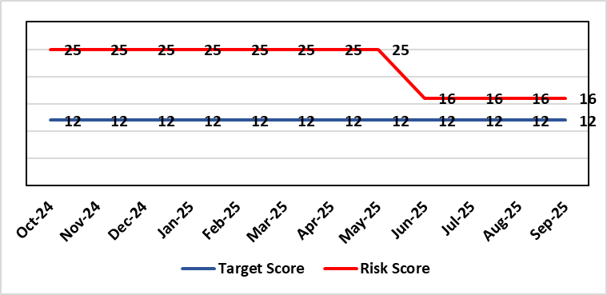 |  | Rationale for current score:  The UEC system continues to see high demand, with ambulance attendances higher than seen previously. However, this demand has been mitigated (beginning June 25) by improvement activity across the hospital resulting in improved flow away from ED. This improvement activity has been married with additional capacity at the front door (Ward) to decongest ED and resulted in the resultant reduced risk score (previously 25).
Level of Control  = 50% |  |  | Rationale for target score:  The HB is currently under escalating performance monitoring from WG (Targeted Intervention or TI) for delivery of UEC services. The improvement plan developed as a response to TI and that already included in the HB annual plan is to implement models of care that reflect best practice and focus on areas that will benefit patients, staff and the UEC system most. The implementation of this plan will improve patient flow, length of stay and reduce emergency demand.
Date added to the SBU HB risk register
Apr 2019
Controls (What are we currently doing about the risk?) |  |  | Mitigating actions (What more should we do?)
Five main areas of work within the plan:  - Frailty strategy (already achieved: Older Persons Assessment & Short Stay Unit stood up; Hub stood up to triage/stream/capture outcomes from incoming calls; standard operating procedures developed for Short Stay, Assessment Unit, Neck of Femur Pathways/beds, and Hub; Phase 1 capital works completed)  - Grip & control operational management and centralisation of patient flow resources  - Senior decision makers at front door services  - Pathway of care delays (PoCD) Implementation of Discharge-To-Reassess (D2RA)  - Home First  - Acute Care Team (ACT)  - Interface with local authority (LA)  - Urgent & Emergency Care redesign programme linked to capital expansion scheme.  - Development of a UEC Care Co-ordination Hub to promote pre-hospital triage redirection and streaming.  In addition to (Business As Usual) BAU improvement actions:  - Continued focussed roll-out of 6-Goals schemes of work  - D2RA / Trusted assessor model  - SAFER  - Criteria-led discharge  - Continuous Flow Model (CFM)  - Robust SDEC model  During June 25 improvement work (PDSA) was undertaken (and subsequently continued) at Morriston Hospital including:  - Anglesey Ward to temporarily operate as a General Medical ward to help decompress the ED  - Streamlining ED assessment and direct referrals to medicine Redesigning the medical assessment model in the AMU  - Enhancing specialty assessment and patient allocation  - Implementing a 7-day Same Day Emergency Care (SDEC) model  - Reviewing and applying consistent criteria to reside  - Roll-out of a new Patient Flow Model: ‘Your Next Patient |  |  | Action | Lead |  | Deadline
 |  |  | Implementation of revised senior decision-making capacity within SDEC (Same Day Emergency Care) and AMU (Acute Medical Unit) | Group Medical Director, Morriston |  | 31/10/2025
 |  |  | Amended action: Review of community services being undertaken by Group Nurse Directors for PCT / Morriston to ensure return of investment ahead of expansion. (See below) | Group Nurse Directors (Morriston & PCT) |  | 31/10/2025
 |  |  | Implementation of UEC (Urgent & Emergency Care) Navigation Hub to decrease demand and implement right patient right place process. | Chief Operating Officer |  | Complete  (Initial launch – SPOA (Single Point Of Access) in place from Oct 2025. National Clinical Conversation Before Conveyance implemented in line with Six Goals framework.
 |  |  | Focus on reducing pathway of care delays (POCDs) as per the Care Action Committee 50-day Challenge.  Update: Initial improvement made through ‘Test of Change’ and advanced D2RA work. Some deterioration in POCD position – working with LA partners to mitigate the risk. Formal agreement to progress to permanent D2RA Hub. | Associate Service Group Director, PCTS |  | 31/01/2026 (reduce to 100 Clinically Optimised Patients)
 |  |  | Further develop admission avoidance pathways with Welsh Ambulance Services Trust, focussing on Falls prevention and Respiratory conditions. Level 2 Falls service launch October 25. | Assistant Director Operations UEC |  | 31/10/2025 (linked to 6 Goals reporting & funding)
 |  |  | Discharge improvement sprint, focusing on clinically optimised patient (COP) wards, to free up bed capacity/ improve flow across Morriston site.  This will be followed by refresh of the Optimal Hospital Flow Framework at Board Rounds via sustainable ward-level discharge coaching and support. | Assistant Director Operations UEC/ Group Director Morriston |  | Discharge sprint - 13/10/2025-23/10/2024  Flow activity – Oct 25-Mar 26
Assurances (How do we know if the things we are doing are having an impact?)  - Urgent & Emergency Care Board is meeting monthly chaired by the COO.  - Six Goals programme reviews the plan on a monthly basis  - UEC Redesign held 2-weekly to update on work streams  - UEC Summit meetings held x 2 with Executive Management Board – 3rd summit planned March 25.  - D2RA Executive meeting held Feb 25 – Memorandum of Understanding (MOU) re D2RA agreed. Operational workshop held Mar 25 with a plan to test D2RA principles pre-Easter weekend  - Ongoing delivery of the Integrated Discharge Hub with both front and back door focus – programme of work in progress to design sustainable solution  - Improved performance metrics (ambulance handover, patient time in ED department, flow & discharge) |  |  | Gaps in assurance (What additional assurances should we seek?)  Affordability of the UEC Care Co-ordination Hub longer term post 25/26 F/Y when WG Six Goals funding ceases.  Affordability of a sustainable D2RA model and right sizing of the community services and bedded facilities to support timely discharge.  Commitment of Local Authorities to support the Integrated Discharge Hub (IDH) at the required level.  Although the Test of Change initiatives have had a positive impact on ambulance handovers and flow through to down-stream wards, there remain unacceptably long delays for ED patients to be seen and treated. Therefore, the risk score remains as noted until improvement is made in this area. This is now a focus in Q2/Q3.  Availability of project resource to roll out all improvement initiatives in a timely way.
Additional Comments / Progress Notes
08/08/2025: Reviewed & no change
16/10/2025: Risk entry reviewed & actions updated. Recent UEC diagnostic demonstrates increased ambulance and ED attendance profile.

Datix ID Number: 739  Health & Care Standard: |  |  | HBR Ref Number: 4  Risk Target Date: 31/03/2026 | Current Risk Rating  4 x 5 = 20
Objective: Care is high quality, safe, efficient, and delivers the best possible outcomes for people |  | BAF Ref: 2.1 | Director Lead: Richard Evans, Executive Medical Director  Assuring Committee: Quality & Safety Committee
Risk: Healthcare Acquired Infection (HCAI)  Risk of patients acquiring infection as a result of contact with the health care system, resulting in avoidable harm, impact on service capacity, and failure to achieve Tier 1 national infection reduction goals. |  |  | Date last reviewed: September 2025
Risk Rating  (consequence x likelihood):  Initial: 4 x 5 = 20  Current: 4 x 5 = 20  Target: 4 x 3 =12 | 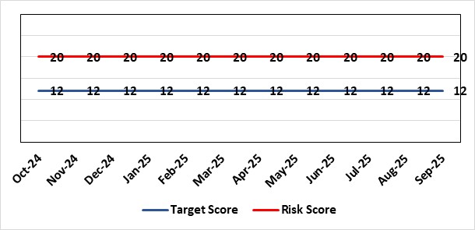 |  | Rationale for current score:  Health Board incidence of key Tier 1 infections per 100,000 population above All Wales rates, indicating Health Board’s population at greater risk of infection. High occupancy rates & frequent ward moves associated with increased risk of infection transmission. Lack of decant facilities compromises environment deep cleaning & decontamination and planned preventative maintenance programmes.
Level of Control
= 40%
Date added to the SBU HB risk register
Apr 2019
Date added to the SBU HB risk register  Apr 2019 |  |  | Rationale for target score:  Improved governance structures for IPC and antimicrobial stewardship will drive improved local ownership and embed responsibility for these priorities for all levels of staff. Adequately maintained & clean environments facilitate good IPC & minimise infection risks. Reduced occupancy & frequency of patient moves mitigate against infection transmission. Compliant ventilation systems and water safety minimise infection risks. Access to timely data on infections, training, antimicrobial stewardship, cleaning at ward/unit/practice level enables Service Groups to identify areas for focused QI programmes, drive improvement, & effectively measure outcomes.
Controls (What are we currently doing about the risk?) |  |  | Mitigating actions (What more should we do?)
- Policies, procedures, protocols and guidelines supplement the National Infection Control Manual.  - Infection Prevention & Control (IPC) related training provided programmes.  - Surveillance of infections, with early identification of increased incidence, and instigation of controls.  - Antimicrobial stewardship programmes and systems of monitoring and feedback.  - Provision of cleaning service to meet National Standards of Cleanliness.  - Engineering controls for water safety, ventilation, and decontamination.  - Infection Prevention Improvement Plans 2025/26 for HB and Service Groups were approved by the Health Board's Infection Prevention & Control Strategic Group on 29/04/2025. Progress is reported at Service Group Infection Control Committees, Health Board Infection Prevention & Control Group, Quality & Safety Group, Quality & Safety Committee, and Management Board. These include trajectories to meet national targets and report performance against them.  - The Health Board has been escalated to Targeted Intervention for its position relating to healthcare associated infection (HCAI). Governance processes for HCAI have been revised to provide strengthened scrutiny and assurance. |  |  | Action |  | Lead | Deadline
 |  |  | Revised: Achieve 80% compliance with IPC mandatory training (Levels 1 & 2) |  | Service Group Directors | 31/03/2026
 |  |  | Achieve reduction in Tier 1 infections to meet de-escalation criteria for intervention targets |  | Service Group Directors | 31/03/2026
Assurances (How do we know if the things we are doing are having an impact?)  - Clear Corporate and Service Group IPC Assurance Framework in place.  - Infection Prevention Improvement Plans for HB and Service Groups with progress reported at SG Infection Control Committees, HB Infection Prevention & Control Group, Quality & Safety Group and at Management Board. These include trajectories to meet national targets and report performance against them. This is also reported to Quality & Safety Committee.  - Ongoing monitoring of infection control rates.  - IPC, antimicrobial, decontamination and cleaning audit programmes.  - Annual completion of IPC Level 2 mandatory training for all HB staff.  - Compliance and validation systems for water safety, ventilation systems and decontamination.  - Revised and strengthened governance structure for HCAI, including monthly meetings of Executive HCAI Scrutiny Group. |  |  | Gaps in assurance (What additional assurances should we seek?)  - High occupancy rates & frequent ward moves associated with increased risk of infection transmission.  - Lack of single room availability, leading to delays in isolating patients with infections and increasing risks to patient contacts.  - Increased numbers of clinically optimised patients remaining in hospital leads to increased length of stay, increased risk of over-occupancy and over-crowding, with consequence of increasing risks of acquisition of infection.  - General infrastructure of the aging hospital estate compromises the ability to clean and decontaminate effectively.  - Antimicrobial prescribing, relating particularly to total volume of antibiotics, with the SBUHB having second highest total volume of antibiotics prescribed in primary care in Wales.  - Lack of decant facilities compromises environment deep cleaning & decontamination and planned preventative maintenance programmes.  - Varying levels of IPC responsibility embedded across all disciplines and groups, with variable medical engagement at all levels in infection prevention-related Quality Improvements programmes.
Additional Comments / Progress Notes
13/10/2025:
No updates to the AMR (Anti-Microbial Resistance)/HCAI (Healthcare Acquired Infection) reduction goals have been received from WG to date.
Health Board Q2 position to end of Sept 30th 2025 for HCAI Tier one infections:
• C. difficile – 19 hospital onset cases (target 6). * Combined (hospital onset and community onset) cumulative total – 122 cases.
• Staph. aureus - 5 hospital onset cases (target 3). * Combined cumulative total - 63 cases.
• E. coli - 6 hospital onset cases (target 4). * Combined cumulative total - 138 cases.
• Klebsiella spp. - 2 hospital onset cases (target 4). * Combined cumulative total – 60 cases.
• Pseudomonas aeruginosa (Not included within targeted interventions) * Combined cumulative total – 15 cases.
IPC training compliance target has been achieved during Q2 2025/26 – ESR report compliance levels as of Sep 30th 2025: Level 1 = 91.03%, Level 2 = 85.32%.

Datix ID Number: 840  Health & Care Standard: |  |  | HBR Ref Number: 16  Risk Target Date: 31/03/2026 | Current Risk Rating  4 x 3 = 12
Objective: Planned Care |  | BAF Ref: 2.5 | Director Lead: Deb Lewis, Chief Operating Officer  Assuring Committee: Performance & Finance Committee  For information: Quality & Safety Committee
Risk: Access and Planned Care  There is a risk of harm to patients if we fail to diagnose and treat them in a timely way.  NB: Whilst cancer care is an element of Planned Care this risk does not include the Cancer Waiting Times target, which is covered in HBR Ref 50. |  |  | Date last reviewed: September 2025
Risk Rating  (consequence x likelihood):  Initial: 4 x 4 = 16  Current: 4 x 3 = 12  Target: 4 x 2 = 8 | 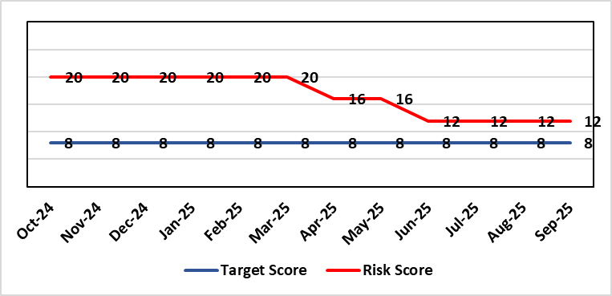 |  | Rationale for current score:  The Health Board delivered the 104 week and 52 week waiting time targets at the end of March 2025. This has been sustained during Qtr 1 & 2 of 25/26. Current risk score reflects that improved position.
Level of Control
= 90%
Level of Control  = 90% |  |  | Rationale for target score:  There is scope to reduce the likelihood score to reduce the overall risk to an acceptable level. The risk target date indicates when we expect to see some reduction in waiting lists – albeit the overall risk level may remain as work continues.
Date added to the SBU HB risk register
Apr 2019
Controls (What are we currently doing about the risk?) |  |  | Mitigating actions (What more should we do?)
- There is a bi-weekly Enhanced Monitoring meeting specifically for assurance on the recovery of our elective programme.  - Specialty level capacity and demand models set out the baseline capacity and identify solutions to bridge the gap this financial year.  - A focused intervention is in train to support to the 10 specialties with the longest waits.  - Long waiting patients are being outsourced to the Independent Sector, where appropriate  - Additional internal activity is being delivered on weekends (via insourcing), which is working towards reducing the wait for outpatient appointment to below 26 weeks.  - Planned care trajectories were developed and submitted to Welsh Government.  - Governance process put in place to monitor performance against trajectories internally, and with Welsh Government as part of Targeted Intervention.  - External & internal validation continues.  - All long waiting patients are receiving clinical reviews to ascertain continued need for surgery.  - Monitoring of complaints and concerns in respect of waiting times are in place to identify issues and trends. |  |  | Action |  | Lead | Deadline
Assurances (How do we know if the things we are doing are having an impact?)  - TI dashboard developed to monitor performance in a live state  - Weekly monitoring meetings chaired by the Assistant Director of Performance  - Bi-weekly planned care meetings chaired by the Chief Operating Officer  - Monthly TI monitoring meetings with Welsh Government |  |  | Gaps in assurance (What additional assurances should we seek?)
Additional Comments / Progress Notes
16/05/2025: Action complete: Theatre Optimisation Programme now in place to maximise efficient use of theatre capacity. Risk assessment revised to reflect improved performance and de-escalation by Welsh Government to Enhanced Monitoring status. Monitoring of continued delivery is ongoing.
18/07/2025: Risk score reduced in line with continued delivery of RTT targets.
08/08/2025: Reviewed and no change – no patients waiting over 104 weeks.

Datix ID Number: 1043  Health & Care Standard: |  |  | HBR Ref Number: 36  Risk Target Date: TBC | Current Risk Rating  4 x 4 = 16
Objective: The delivery of care is supported by innovative digital solutions |  | BAF Ref: 4 | Director Lead: Matt John, Director of Digital  Assuring Committee: Digital, Research & Innovation Committee  For information: Quality & Safety Committee
Risk: Paper Record Storage  Lack of a single electronic record means there is greater reliance on the provision of the paper record. If we fail to provide adequate storage facilities for paper records, then this will impact on the availability of patient records at the point of care. Quality of the paper record may also be reduced if there is poor records management in some wards. There is an increased fire risk where medical records are stored outside of the medical record libraries. |  |  | Date last reviewed: September 2025
Risk Rating  (consequence x likelihood):  Initial: 4 x 5 = 20  Current: 4 x 4 = 16  Target: 3 x 3 =9 | 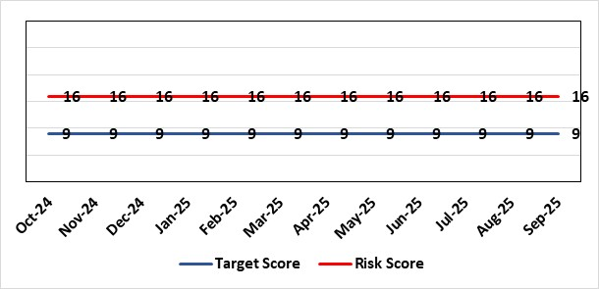 |  | Rationale for current score:  C - Inability to find records for patients could delay care/increase length of stay over 15 days. Could also mean patients receive incorrect treatment. Increased risk of fire where records are stored outside of the medical record libraries.  L - we know this happens from incidents raised
Level of Control  = 70% |  |  | Rationale for target score:  C - The increased development and adoption of the digital record will reduce the need for the paper health record being available at the point of care.  L - The increased development and adoption of the digital record, the introduction of RFID and the approach to management of the paper record identified in the Business case process should reduce the amount of paper required to be stored and managed.
Date added to the SBU HB risk register
Apr 2019
Controls (What are we currently doing about the risk?) |  |  | Mitigating actions (What more should we do?)
- There is a plan in place to increase the functionality of the electronic record to document patient care. The delivery of the plan is overseen by the Digital Leadership Group and progress provided to Management Board. (Supported by individual project boards as appropriate).  - Records managed by the Medical Records libraries are RFID-tagged (Radio Frequency Identification) and location tracked.  - Medical Record libraries are regularly risk assessed for fire by health and safety.  - Alternative offsite storage arrangements have been identified.  - All records must be documented on the Information Asset Register (IAR). |  |  | Action |  | Lead | Deadline
 |  |  | Allow for new process to stabilise and evaluate benefits of new centralised unit. |  | Head of Health Records & Clinical Coding | 31/12/2025
Assurances (How do we know if the things we are doing are having an impact?)  - RFID has been implemented for the acute record improving the management and storage of records  - Health Records performance reports developed in line with RFID technology  - Attainment of the Tier 1 Health Board target for clinical coding completeness which relies on the timely availability and quality of the Paper record and electronic sources  - Monitoring complaints and incident reporting.  - Electronic record is being implemented in accordance with the plan e.g. implementation of WNCR (Welsh Nursing Care Record), ETR (Electronic Test Requesting), HEPMA (Hospital Electronic Prescribing and Medicines Administration) |  |  | Gaps in assurance (What additional assurances should we seek?)  Investment required supporting the delivery and operational costs of the Digital strategy.  Reliance on DHCW (Digital Health & Care Wales) for delivery of the solution for a fully electronic patient record.  Impact of the Infected Blood Enquiry on the Health Boards ability to destroy notes.  Process for ensuring clinical adoption of electronic ways of working and cessation of adding information to the paper record that is already available electronically needs to be agreed and enforced by the Health Board.  Impact of the infected Blood Inquiry on the health board’s ability to destroy notes and the change in the records code of practice is being reviewed by the Director of Digital.
Additional Notes
08/09/2025 – Reviewed, no further comments or amendments required
14/10/2025 – Action date reviewed and amended.

Datix ID Number: 1514  Health & Care Standard: |  |  | HBR Ref Number: 43  Risk Target Date: TBC |  | Current Risk Rating  4 x 4 = 16
Objective: Mental Health & Learning Disability Services |  | BAF Ref: 2.3 | Director Lead: Elizabeth Rix, Executive Director of Nursing  Assuring Committee: Quality & Safety Committee  For Information: Mental Health Legislation Committee
Risk: Deprivation of Liberty Safeguards  Due to a limited resources within the MCA/DoLS (Mental Capacity Act/Deprivation of Liberty Safeguards) service (lack of Best Interest Assessor resource and signatory approval) there is a risk of failure to complete and authorise the assessments associated with Deprivation of Liberty within the legally required timescales, exposing the health board to potential legal challenge and reputational damage. |  |  | Date last reviewed: September 2025
Risk Rating  (consequence x likelihood):  Initial: 4 x 4 = 16  Current: 4 x 4 = 16  Target: 3 x 2 = 6 | 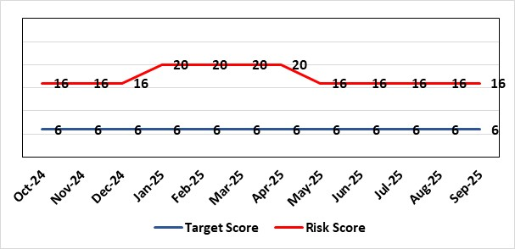 |  | Rationale for current score:  Multiple breaches in statutory duty  Breaches confirmed as expected at least as frequently as weekly, but not daily.  No claims received to date.
Level of Control  = 40% |  |  | Rationale for target score:  Consequences of DoLS breaches for the Health Board will not change. With controls in place, over time likelihood should decrease.  Risk target date indicates date of review following mitigating actions
Date added to the SBU HB risk register
Apr 2019
Controls (What are we currently doing about the risk?) |  |  | Mitigating actions (What more should we do?)
- Duty system in place. Duty BIA (Best Interest Assessors) scrutinise referrals and liaise with managing authority to ensure safeguards are in place to mitigate risks.  - Four signatory authorisers in place.  - Monthly Performance & Assurance Meeting  - Monthly Legislative Assurance Meeting with Group Nurse Director and Finance. |  |  | Action | Lead |  | Deadline
Assurances (How do we know if the things we are doing are having an impact?)  Monthly Legislative Assurance Meeting with Group Nurse Director and Finance.  Quarterly reports to Mental Health & Legislative Committee on MCA/DoLS compliance. |  |  | Gaps in assurance (What additional assurances should we seek?)  Current resources  - 3 substantive BIA (3 wte)  - 6 external BIA (£250 per assessment)  - 4 (band 8) signatories  - Specialist Practitioner Band 7 vacancy – out to advert.  Additional 4 WTE BIAs required to meet service demands.  Substantive BIA’s role includes additional duties compared to external BIA whose only role is to complete form 3a of the DoLS process. In addition to form 3a completion, substantive BIA also undertake the following to meet service demand (Daily Duty Rota to scrutinise referrals; Facilitate Level 3 MCA/DoLS Training; Capacity Assessments; Advice and support to Managing Bodies; Support during Best Interest Meetings)
Additional Comments / Progress Notes
14/10/2025: Risk reviewed. Service is reporting one vacancy – Band 7 Specialist Practitioner. Now out to advert. Breaches for August were 7 and reduced to 1 for September. Due to the increase in breaches for August, to keep risk score of 16 and continue to monitor and review monthly, to ensure reduction is sustained. Likely risk that breaches will increase for October due to vacancy within the service.

Datix ID Number: 1761  Health & Care Standard: |  |  | HBR Ref Number: 50  Risk Target Date: TBC | Current Risk Rating  5 x 4 = 20
Objective: Cancer Care |  | BAF Ref: 2.6 | Director Lead: Deb Lewis, Chief Operating Officer  Assuring Committee: Performance & Finance Committee  For information: Quality & Safety Committee
Risk: Access to Cancer Services  There is a risk of delay in diagnosing patients with cancer, and consequent delay in commencement of treatment, which could lead to poor patient outcomes and failure to achieve targets.  The health Board remains unable to deliver on the target of 75% of patients being treated within 62 days and is currently under targeted intervention by Welsh Government to improve performance. |  |  | Date last reviewed: September 2025
Risk Rating  (consequence x likelihood):  Initial: 4 x 5 = 20  Current: 5 x 4 = 20  Target: 4 x 3 = 12 | 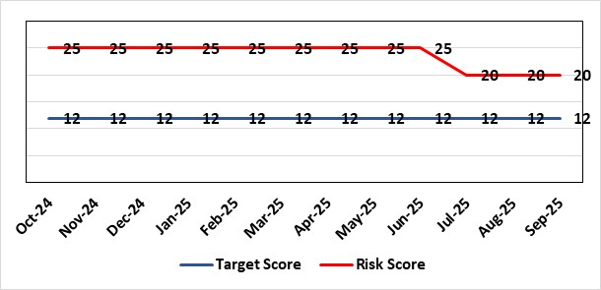 |  | Rationale for current score:  Risk score is based on being off trajectory for SCP but reduced (July 25) in line with improvements in delivery.
Level of Control  = 70% |  |  | Rationale for target score:  Target score reflects the challenge this area of work presents the Board and where small numbers of patients impact on the potential to breach target.
Date added to the SBU HB risk register:
Apr 2019
Controls (What are we currently doing about the risk?) |  |  | Mitigating actions (What more should we do?)
- Tight management processes to manage each individual case on the Single Cancer Pathway (SCP). Enhanced monitoring & weekly monitoring of action plans for top 6 tumour sites.  - Initiatives to protect surgical capacity to support SCPs have been put in place  - Tumour sites have been given additional targets to achieve by the end of Qtr1:  - Achieve the 10-day 1st Outpatient target  - Deliver a decision to treat (DTT) by day 31  - A specific plan is being delivered to support Pathology services and ensure SCP tests are turned around within 5 days. |  |  | Action |  | Lead | Deadline
 |  |  | Following a review of governance processes for our Annual plan, Cancer monitoring will now be included in the Planned Care Board |  | Chief Operating Officer / Director of Planning Partnerships | Complete
Assurances (How do we know if the things we are doing are having an impact?)  - TI dashboard developed to monitor performance in a live state  - Weekly TI monitoring meetings chaired by the Chief Operating Officer  - Bi-weekly Cancer meetings chaired by the Deputy Chief Operating Officer  - Monthly TI monitoring meetings with Welsh Government |  |  | Gaps in assurance (What additional assurances should we seek?)  Performance and activity data monitored, but delays to treatment continue while sustainable solutions found.
Additional Comments / Progress Notes
15/10/2025: Action completed – Cancer monitoring included in Planned Care Board

Datix ID Number: 1587  Health & Care Standard: |  |  | HBR Ref Number: 61  Risk Target Date: TBC |  | Current Risk Rating  4 X 4 = 16
Objective: Planned Care |  | BAF Ref: 2.5 | Director Lead: Deb Lewis, Chief Operating Officer  Assuring Committee: Quality & Safety Committee
Risk: Paediatric dental GA (General Anaesthetics)/Sedation services provided under contract from Parkway Clinic, Swansea. Medical Safety risk as general anaesthetics are performed on children outside of an acute hospital setting. Repatriation of service to acute site delayed due to theatre capacity which means the health board continues to commission services for delivery outside of national guidance (WHC 2018-09) attracting reputational risk. There is also an associated risk in that the diagnosing clinician does not deliver the care to the patient resulting in increased risk of need for multiple General Anaesthetics. |  |  | Date last reviewed: September 2025
Risk Rating  (consequence x likelihood):  Initial: 5 x 3 = 15  Current: 4 x 4 = 16  Target: 4 x 2 = 8 | 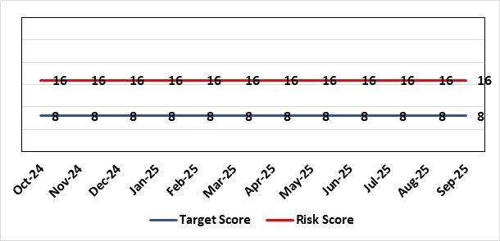 |  | Rationale for current score:  There is no immediate access to crash team/ICU facilities in in Parkway Clinic – the client group are undergoing GA (general anaesthetic)/sedation. Paediatric GA/Sedation services provided under contract from Parkway Clinic, Swansea continue due to lack of capacity for these patients to be accommodated in Secondary Care.
Level of Control  = 60% |  |  | Rationale for target score:  Relocation of the paediatric general anaesthetics service [provided by Parkway Clinic] to a hospital site being treated as a priority.
Date added to the SBU HB risk register
Apr 2019
Controls (What are we currently doing about the risk?) |  |  | Mitigating actions (What more should we do?)
Consultant Anaesthetist present for every general anaesthetic clinic.  Assurance Documentation supplied by Parkway Clinic including confirmation of arrangements in place with WAST and Morriston Hospital for transfer and treatment of patients  New care pathway implemented - no direct referrals to provider for general anaesthetics.  Multi-drug sedation ceased from Sep 2018 in line with WHC 2018 009  Revised SLA (Service Level Agreement)/Service Specification  HIW (Healthcare Inspectorate Wales) Inspection Visit Documentation provided to Health Board  All extended general anaesthetics cases require approval from paediatric specialist prior to treatment |  |  | Action | Lead |  | Deadline
Assurances (How do we know if the things we are doing are having an impact?)  RMC (Referral Management Centre) collate referral and treatment outcome data for review by Paediatric Specialist  Regular clinical meeting arranged with Parkway to discuss individual cases/concerns  Regular clinical/ management meeting for CDS/primary care management team to discuss service pathway /concerns/issues arising |  |  | Gaps in assurance (What additional assurances should we seek?)  Deputy Chief Operating Officer-led Task & Finish Group is no longer in place – it will need to be re-established to progress transfer when theatre capacity is agreed.  Pressures on the Princess of Wales special care dental general anaesthetics list and this service is considered alongside any plans for the Parkway contract.
Additional Comments / Progress Notes
11/03/2025: A paper is going to Management Board in March 2025 to consider extension of Parkway Contract to 31/03/2026.
06/05/2025: Health Board Management Board agreed that current contract with provider will be extended for 2+1 years whilst the Health Board explores capital bid for regional service as part of wider Paediatrics Day Case Unit
04/08/2025: This risk remains as at last update.

Datix ID Number: 2159  Health & Care Standard: |  |  | HBR Ref Number: 64  Risk Target Date: 31/03/2026 | Current Risk Rating  4 X 5 = 20
Objective: Care is delivered in safe and appropriate settings |  | BAF Ref: 3 | Director Lead: Darren Griffiths, Director of Finance & Performance  Assuring Committee: Quality & Safety Committee
Risk: Health & Safety (H&S) Infrastructure  Insufficient resource and capacity of the health, safety and fire function within SBUHB to maintain legal and regulatory compliance for the workforce and for the sites across SBUHB. |  |  | Date last reviewed: September 2025
Risk Rating  (consequence x likelihood):  Initial: 5 x 4 = 20  Current: 4 x 5 = 20  Target: 4 x 3 = 12 | 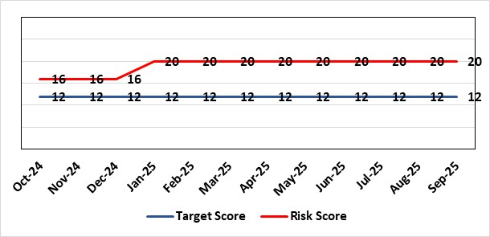 |  | Rationale for current score:  The Health Board received 12 Health & Safety Executive (HSE) improvement notices during 2019-20 covering various Health & Safety legal breaches covering a range of areas. There is the potential for future multiple notices for not meeting legal requirements based on current available resources. Due to retirement resources in the team has reduced and the risk level increased to 20.
Rationale for target score:
Compliance with the notices and to have sufficient resources to implement a sustainable health and safety provision to support the legal requirements of the Health Board and demonstrate that suitable resources are in place to undertake the roles and responsibilities of the department, also to undertake suitable and sufficient training, provide corporate overview/audit to ensure practices are being employed in the workplace.
Level of Control
= 70%
Date added to the SBU HB risk register
September 2019
Controls (What are we currently doing about the risk?) |  |  | Mitigating actions (What more should we do?)
- Assistant Director of Health and Safety in post to support strengthening and develop the H&S function to support the organisation. Business case submitted for additional resources.  - Health and Safety Operational Group and the Health and Safety Committee monitor compliance. Refreshed the Fire Safety Group with additional controls in place.  - Fire risk assessments (FRA) are being prioritised with temporary additional resources put in place in March 2021 to reduce the number of FRA overdue and brought up to date. However, due to leavers and recruitment, resource levels have fluctuated along with compliance levels that are continually monitored.  - Fire training in place and fire wardens in place  - Fire risk assessment schedule in place for the next 12 months to maintain 100% compliance of completion and is regularly reviewed |  |  | Action |  | Lead | Deadline
 |  |  | Having completed staffing structure review, next action is to work through Health Board governance processes to ensure affordability and to agree a risk-based, phased approach to implement any agreed structure going forward. |  | Assistant Director of Capital and H&S | 31/03/2026
Assurances (How do we know if the things we are doing are having an impact?)  - Monitoring through the appropriate group/committees (H&S committee) to receive assurance and or identify gaps for key compliance and adherence to applicable legislation.  - Site visits/tours to identify compliance and gaps in compliances. |  |  | Gaps in assurance (What additional assurances should we seek?)  Health and safety, capital and estates now sit under the umbrella of Finance and is currently going through a restructure, with the H&S structure also included in this and will be phased in, with a target date of 31/03/2026 for the proposed new structure to be in place.
Additional Comments / Progress Notes
09/07/202: Interviews for Head of H&S scheduled 23/07/2025, if successful recruitment anticipated commencement end October/beginning November 2025, with risks monitored and prioritised within resources.
27/08/2025: Successful conclusion to interviews, with an agreed commencement date 01/11/2025. No change in overall risk rating, with risks monitored and prioritised within current resources.

Datix ID Number: 1834  Health & Care Standard: |  |  | HBR Ref Number: 66  Risk Target Date: 28/02/2026 | Current Risk Rating  5 X 4 = 20
Objective: Cancer Care |  | BAF Ref: 2.6 | Director Lead: Richard Evans, Executive Medical Director  Assuring Committee: Quality & Safety Committee
Risk: Access to SACT (Systemic Anti-Cancer Therapy)  The demand & complexity of planned treatment regime for cancer patients requiring chemotherapy currently exceed the available chair capacity, risking unacceptable delays in access to SACT treatment in Chemotherapy Day Unit with impact on targets and patient outcomes. |  |  | Date last reviewed: September 2025
Risk Rating  (consequence x likelihood):  Initial: 5 x 5 = 25  Current: 5 x 4 = 20  Target: 2 x 2 = 4 | 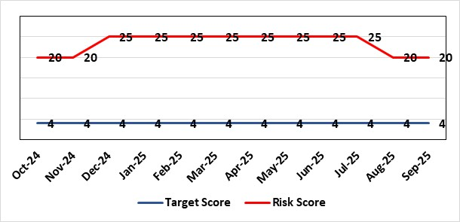 |  | Rationale for current score:  Demand for SACT continues to exceed current service capacity.  Ongoing workforce challenges persist within the Chemotherapy Day Unit (CDU) and Pharmacy Technical Services (PTS), impacting service delivery.  Patient waiting times remain elevated, with a continued number of breaches against SACT Key Performance Indicators (KPIs).  The introduction of new cancer diagnoses and NICE-approved treatments necessitates the implementation of additional SACT regimens, further straining resources.  Approval has been granted for additional treatment chairs, and initial recruitment to posts successful. Training of staff is essential prerequisite before this expansion can be operationalised. It is likely to take until Feb 2026 to fully train.  Improved performance from Q4 24/25 to Q1 25/26.
Level of Control
=
Date added to the SBU HB risk register  30/11/2019 |  |  | Rationale for target score:  Reduced delays in treatment will reduce risk of harm.
Controls (What are we currently doing about the risk?) |  |  | Mitigating actions (What more should we do?)
- Review of scheduling by staff to ensure all chairs used appropriately.  - A daily scrutinizing process in progress to micro-manage individual cases, deferrals etc.  - Changes made to prescribing & authorising processes to improve workflow for PTS reducing potential delays to supply and administration of treatment.  - Responsibility for checking bisphosphonate prescriptions in CDU moved to nursing staff to free up Pharmacy capacity allowing them to focus on key clinical tasks within Pharmacy.  - Joint project with Nuclear Medicine to streamline pathways and prioritise SACT patients appropriately halved the average time waiting for MUGA/EDTA tests required before starting SACT.  - Increased homecare capacity  - Adopted principles from UK SACT board publication: General Principles to Support Systemic anti-Cancer Therapy Aseptic Pressures September 2023 |  |  | Action | Lead | Deadline
 |  |  | Recruiting to posts  (dependency on recruitment process changes) | Divisional Manager (Cancer) | 31/10/2025
 |  |  | Training of new staff (full competency) | SACT Training Team / Pharmacy | 28/02/2026
Assurances (How do we know if the things we are doing are having an impact?)  - To support increased demand, additional funding has been secured to expand the nursing establishment, ensuring appropriate staffing levels during the unit’s core operating hours.  - Posts are currently out to advert or in the recruitment process. Once successful appointments are made and training is completed, improvements in performance are expected to be reflected in service delivery metrics.  - Waiting times are tracked against the new SACT metrics, which are based on treatment intent rather than average waiting times, providing a more outcome-focused measure. These metrics are reported through our Cancer Performance Report to Welsh Government, the Management Board, and internally via governance structures within NPTSSG, where Oncology services are hosted.  - Patient experience continues to be monitored through the Friends and Family Test and the Welsh Cancer Patient Experience Survey, in line with our Putting Things Right (PTR) procedures.  - The SBU Capacity Task and Finish Group meets monthly to analyse demand and capacity gaps. Common delay themes are identified and reviewed monthly, with a quarterly report presented to the SACT Consultant Meeting and the Divisional Business Meeting to inform service planning.  - Current breach trends are primarily linked to CDU capacity constraints and SACT booking delays, as evidenced in quarterly reporting. Work is ongoing to explore new models of care in addition to the approved posts to address these issues.  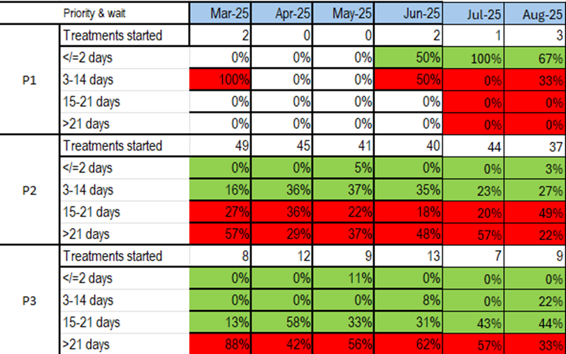  Welsh SACT performance metrics – P2 to start within 14 days. P3 to start within 21 days |  |  | Gaps in assurance (What additional assurances should we seek?)  Workforce requirements have and continue to be mapped to identify the additional capacity needed to meet both current and projected future demand for SACT services. While initial funding has been secured to support the first phase of this work, it does not guarantee the sustainability of future capacity. This marks the beginning of a phased approach to workforce planning and service development
Additional Comments / Progress Notes
Sep 2025:
Current trend showing reduction in performance – no change to score.
Quality Improvement Practitioner is currently investigating the reasons behind the performance dip over the summer with report expected by the end of October 2025.
Action plan created to ensure all efficiencies are in place, including mitigating actions to address any potential challenges during the Christmas period.

Datix ID Number: 1418  Health & Care Standard: |  |  | HBR Ref Number: 69  Risk Target Date: See Target Rationale |  | Current Risk Rating  5 X 4 = 20
Objective: Children & Young People Services |  | BAF Ref: 2.7 | Director Lead: Deb Lewis, Chief Operating Officer  Supporting Director: Elizabeth Rix, Executive Director of Nursing  Assuring Committee: Quality & Safety Committee
Risk: Issues related to adolescent patient admission to adult mental health inpatient wards  Risk of inappropriate settings resulting in 'Safeguarding Issues'. The Welsh Government has requested that Health Boards identify Secondary Care in -patient facilities for the care of adolescents- in Swansea Bay University Health Board Ward F NPT hospital is the dedicated receiving facility with one bed identified. |  |  | Date last reviewed: September 2025
Risk Rating  (consequence x likelihood):  Initial: 2 x 3 = 6  Current:5 x 4 = 20  Target: 2 x 3 = 6 | 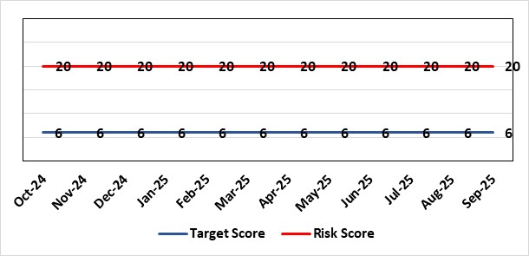 |  | Rationale for current score:  Every health board is required to have an admission facility for adolescent Mental Health patients. Whilst ward F has been identified as the single point of access in SBU and provides access to a bed for adolescent admissions if available at the time of request it is a mixed sex adult ward. Therefore, the facilities are less than ideal for young patients in crisis.
Level of Control
=
Date added to the SBU HB risk register  27/02/2020 |  |  | Rationale for target score:  The longer-term aim for the Health Board remains to create an admission facility for adolescent Mental Health patients but this will not be possible until the new Adult Inpatient Unit is built.
Controls (What are we currently doing about the risk?) |  |  | Mitigating actions (What more should we do?)
Safeguarding Training for Staff, Joint protocol with Cwm Taf LHB [CAMHS] currently subject to review, Local SBUHB policy on providing care to young people in this environment. This includes the requirement for all such patients on admission to be subject to Level 3 Safe and Supportive observations.  Only Adolescents within 16-18 age range are admitted to the adult ward.  The health board works with CAMHS to make sure that the length of stay is as short as possible. |  |  | Action | Lead |  | Deadline
 |  |  | Next service group review of effectiveness of current controls. | MH&LD Head of Operations & Clinical Directors |  | 01/02/2025
Assurances (How do we know if the things we are doing are having an impact?)  Individual Rooms with en Suite Facilities, Joint working with CAMHS, monitoring of staff training, Monitoring of admissions by the MH&LD SG Legislation Committee of the Health Board. The ongoing issues with the risks presented by the use of this has recently been raised at an all-Wales level with Welsh Government and a formal review is anticipated. The Service Group continues to flag the risk particularly in light of Ward F being identified as the SPOA for AMH in the Health Board which has resulted in an increase in acuity and a greater concentration of individuals who are experiencing the early crisis of admission - this has served to increase the already identified risks for young people in the environment. |  |  | Gaps in assurance (What additional assurances should we seek?)
Additional Comments / Progress Notes
01/07/2025: No change in service provision but this will now be incorporated in the refresh of the Clinical Services Plan.
28/08/2025: Controls have been reviewed by the Divisional Manager. No change. Service Group to review in six months.

Datix ID Number: 1832  Health & Care Standard: |  |  | HBR Ref Number: 80  Risk Target Date: 31/12/2025 | Current Risk Rating  4 x 5 = 20
Objective: Urgent & Emergency Care |  | BAF Ref: 2.4 | Director Lead: Deb Lewis, Chief Operating Officer  Assuring Committee: Quality & Safety Committee
Risk: Transfer of Clinically Optimised Patients  Risk that we fail to significantly reduce the number of Clinically Optimised Patients in hospital beds. A deficit in the availability of appropriate community / domiciliary care results in unacceptable delays in discharging patients from acute hospital beds. As a result, patients can decompensate and never gain the independence that could have been available from an early discharge.  Lack of access to same day domiciliary care/emergency placements in the community hinders ability to avoid admission and associated harms. |  |  | Date last reviewed: September 2025
Risk Rating  (consequence x likelihood):  Initial: 4 x 5 = 20  Current: 4 x 5 = 20  Target: 4 x 2 = 8 | 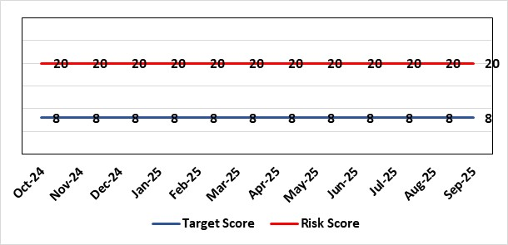 |  | Rationale for current score:  - Sustained levels of clinically optimised patients (COPs) leading to overcrowding within ED, use of inappropriate or overuse of decant capacity in ED and delays in accessing medical bed capacity, clearly emerged as themes.  - Constraints in relation to all patient flows out of Morriston to a more appropriate clinical setting, identified and included in an expanded risk.  - Delay in discharge for clinically optimised patients can result in deterioration of their condition.  - Increase in demand for Pathway 1.
Level of Control
= 25%
Level of Control  = 25% |  |  | Rationale for target score:  Targeted reduction of Clinically Optimised patients remains a priority for the HB in order to minimise risk of avoidable harm to patients within the HB and in the wider community.
Date added to the SBU HB risk register
May 2021
Controls (What are we currently doing about the risk?) |  |  | Mitigating actions (What more should we do?)
- One of the measures under targeted intervention is to see a reduction in pathway of care delays, which specifically supports the reduction in the number of clinically optimised patients.  - Review is undertaken on a patient-by-patient basis – with explicit action agreed in order to progress transfer to appropriate clinical setting.  - Critical constricts in relation to access/time delays for social workers and assessment for package of care and social placement  - Weekly escalation meetings are held with health and social service colleagues to ensure the requirements of the patients are reviewed and patients are pulled through the system where possible. |  |  | Action |  | Lead | Deadline
 |  |  | Work programme and governance structure agreed by local partnership (health board & local authorities) to work up sustainable D2RA model. |  | Associate Director UEC | 31/03/2026
 |  |  | Formal agreement through Communities and Older Persons Board to proceed to OCP for health employees to deliver the D2RA hub and recruitment into Swansea LA, with a limited offer from NPT LA. |  | Service Group Director (PCT) | 31/01/2026
Assurances (How do we know if the things we are doing are having an impact?)  - Patient level dashboard allows breakdown by delay type  - Regular (weekly) COP reviews and escalations  - Shared vision with NPT & Swansea LA CEOs agreed and governance structure with Executive Directors for sign off |  |  | Gaps in assurance (What additional assurances should we seek?)  Capacity and demand exercise required to inform reshaping of community services
Additional Comments / Progress Notes
12/05/2025: Action previously completed: The Care Action Committee (CAC) focus on reducing the impact of clinically optimised patients within acute hospitals. The Health Board engaged with the work from the CAC and currently developing the Winter Plan for 24/25, of which reducing COPs will be a key focus. This work is being taken forward by the Associate SGD PCTS to ensure cross-boundary support.
Integrated Discharge hub now established from within existing resources following a successful test of change. Positive turnaround of patients from front door services reducing admission demand and long-term care demand. Roll-out of true Discharge to Recover then Assess (D2RA) principles/ activity planned in conjunction with Local Authority partners to improve timeliness of all discharges (which will positively impact COP position)
17/07/2025: Action complete: Reintroduce D2RA Principles across the Health Board with external consultancy support
16/10/2025: See HBR1 for update on related actions (‘Test of Change’ and advanced D2RA work; discharge improvement sprint (focusing on COP wards) to free up bed capacity/ improve flow across Morriston site; refresh of the Optimal Hospital Flow Framework at Board Rounds via sustainable ward-level discharge coaching and support.) Exploring a revised model of COP management health board wide.

Datix ID Number: 2561  Health & Care Standard: |  |  | HBR Ref Number: 85  Risk Target Date: 31/07/2026 | Current Risk Rating  4 x 5 = 20
Objective: Children & Young People Services |  | BAF Ref: 2.7 | Director Lead: Christine Morrell, Director of Therapies & Health Sciences  Assuring Committee: Quality & Safety Committee
Risk: Non-Compliance with ALN Act  There is a risk of the Health Board not fulfilling the statutory requirements of the Additional Learning Needs and Education Tribunal (Wales) Act 2018 (the ALN Act) within the timescales that are required under the ALN Act, resulting in non-compliance with these duties.  The Health Board has historically held a risk of ALN non-compliance caused by gaps in the data regarding its compliance with statutory duties. The Health Board now has a digital infrastructure that provides data regarding its compliance with its statutory duties under Sections 65 and 20 of the ALN Act. These duties relate to the timely provision of information to support Education planning and decision-making (Section 65), and to timely decision-making about relevant Health provision followed by delivery of this provision where it is found to be required (Section 20). Data for 2025 shows there are breaches against both duties with a high level of frequency (as at July 2025, breaches are generally occurring on an approximately daily basis).  Informed by this data, activity is planned to better understand the causes of the risk and to identify and progress mitigating actions.  In addition to the above, the Health Board is currently unable to provide assurance with its duty to notify Education of pre-school children with probable ALN under Section 64 of the legislation. This risk is caused by process and data quality issues.  Potential consequences of the risk of the Health Board not fulfilling the statutory requirements of the ALN Act within the timescales required are: non-compliance with statutory duties; parent / carer and young peoples' dissatisfaction leading to complaints and legal challenge; reputational impact; and children failing to access the multi-agency support that they need with their learning needs, leading to poor outcomes. |  |  | Date last reviewed: September 2025
Rationale for current score:
2025 compliance data shows that the Health Board is breaching multiple statutory duties (duties under both Sections 65 and 20 of the ALN Act) with a high level of frequency (approximately daily). The Health Board is currently unable to provide assurance regarding compliance with its legal duties under Section 64 of the Act,

The risk consequence is major (multiple breaches of a statutory duty - 4) and the likelihood is expected (breaches occurring approximately daily - 5), hence the current risk score of 20.
Risk Rating  (consequence x likelihood):  Initial: 5 x 5 = 25  Current: 4 x 5 = 20  Target: 2 x 3 = 6 |  |  | Rationale for target score:  As the ALN Act is new legislation, there remains some ongoing likelihood of risk events during the initial phases of implementation, though with lessened consequences as a result of mitigating actions.
Level of Control
=
Date added to the SBU HB risk register
14/05/2022
Controls (What are we currently doing about the risk?) |  |  | Mitigating actions (What more should we do?)
- Designated Educational Clinical Lead Officer (DECLO) is in post, providing a single point for direction and co-ordination of the Health Board’s activity under the ALN Act. The post is a statutory requirement.  - Operational processes through which the Health Board fulfils its statutory duties under the ALN Act are in place.  - Activity is planned to develop a clear understanding of the causes of the current risk and to identify the actions required to mitigate the risk. This activity will be progressed within the Health Board’s ALN governance structures.  - Health Board ALN Steering Group has been established, with ALN Operational Group working under the governance of this,  - There is close and ongoing collaborative working with Local Authority Education partners, including their involvement in the ALN Steering and Operational Groups as noted above. |  |  | Action | Lead | Deadline
 |  |  | Amended: Securing longer-term business and project management support, to support activity required to mitigate the risks. | Executive Director of Allied Health Professions & Health Science | 30/11/2025
 |  |  | Activity to be progressed to revise and refresh the Health Board’s ALN operational workplan for the 2025 / 26 school year, with a focus on actions required to mitigate the compliance risk. | DECLO | 30/10/2025
 |  |  | Revise processes through which the Health Board fulfils its duty under Section 64 of the ALN Act and ensure that accurate and reliable data is available. | DECLO | 30/10/2025
Assurances (How do we know if the things we are doing are having an impact?)  - The Health Board has a digital infrastructure to monitor compliance  - There is regular reporting on compliance with the ALN Act that is now data-informed through the Patient Safety and Compliance Group.  - The Health Board has an ALN Steering Group, chaired by the Deputy Director for Allied Health Professions and Health Sciences, ensuring oversight at a senior level within all impacted operational and corporate areas. The Health Board also has an ALN Operational Group, chaired by the DECLO, to co-ordinate activity required to address the risk. The Operational Group has an ALN workplan and reports are made to the Steering Group regarding progress |  |  | Gaps in assurance (What additional assurances should we seek?
Additional Comments / Progress Notes
08/08/2025: Activity is in train to revise and refresh ALN workplan to support improved compliance, started by a workshop with Education partners has been held to identify shared priority areas for work moving forward. The DECLO is now meeting regularly with relevant Service Leads to validate data and strengthen understanding of barriers to compliance; learning from these meetings will support the refreshed workplan. Position regarding risk remains as at previous month.
20/08/2025: Action to establish a structure of regular meetings between the DECLO and leads for ALN-impacted operational services is now in place. This action is therefore closed. Position regarding risk otherwise remains as at 08/08/2025 update.

Datix ID Number: 3071  Health Care Standards: |  |  | HBR Ref Number: 89  Target Risk Date: TBC | Current Risk Rating  4 x 5 = 20
Objective: Primary & Community Care |  | BAF Ref: 2.2 | Director Lead: Elizabeth Rix, Executive Director of Nursing  Supporting Director: Deb Lewis, Chief Operating Officer  Assuring Committee: Quality & Safety Committee
Risk: Healthcare Nursing Staff Levels at HMP Swansea  There is a risk that the men in HMP Swansea will not receive the appropriate standard of care. This is because the nursing establishment within the prison no longer fully meets the changed demographics and numbers of men being detained. The maximum operational capacity of the Prison can reach circa 480 men. The Health Board investment into the Prison is based on delivering services to 250 men. This was also highlighted as a risk in the June 2022 HIW governance review. In addition, there is no head room built into the Prison nursing establishment, so periods of sickness, leave and study render the roster short. |  |  | Date last reviewed: September 2025
Risk Rating  (consequence x likelihood):  Initial: 4 x 5 = 20  Current: 4 x 5 = 20  Target: 2 x 2 = 4 | 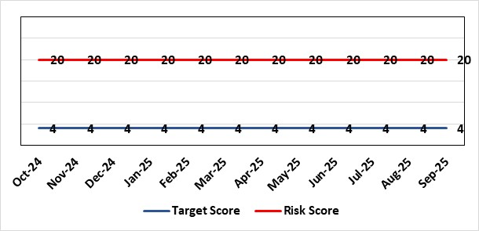 |  | Rationale for current score:  Consequence major – unable to fully deliver on the recommendations of HIW due to low healthcare staffing numbers, further impacted during periods of sickness or absence as no headroom. Recommendations also raised in Prison & Probation Ombudsman reports. Likelihood expected – suboptimal care provided on a daily basis.
Level of Control  = % |  |  | Rationale for target score:  Consequence minor – With sufficient staffing numbers the prison will be able to deliver on HIW recommendations and fully implement the actions in the Health Delivery Plan. Likelihood unlikely – With full establishment and headroom, suboptimal care is less likely.
Date added to the SBU HB risk register
30/11/2022
Controls (What are we currently doing about the risk?) |  |  | Mitigating actions (What more should we do?)
Daily communication with the Governor about the availability and priority of healthcare nursing staff.  Pharmacy technician role established – can administer drugs to support nursing establishment.  Agreed that Health Care Support Workers to be 2nd checkers for CD drugs and to support substance withdrawal monitoring (awaiting accreditation).  Bank and agency staff are used in a limited way, when skillset allows.  E-roster implemented and scrutinised with regular reporting to Service Group Patient Safety & Compliance Group.  Escalation for overtime and additional hours to fill shortfalls. |  |  | Action | Lead | Deadline
 |  |  | Review of staffing in prison. Royal College of Psychiatrists Substance Misuse and Mental Health Baseline assessment completed – analysis of outcome and agreement of further action next. (Following financial deep dives) | Deputy Head of Nursing | 30/11/2025
Assurances (How do we know if the things we are doing are having an impact?)  Prison feedback and complaint process  Progress reporting on action plans through Service Group PS&C Group, and Health Board Q&S structures (via Patient Safety & Compliance Group). |  |  | Gaps in assurance (What additional assurances should we seek?)  Implementation and reporting of clinical audits. Audit framework for HMP Swansea in development - Clinical Pathways/Audits and Health Promotion groups taking forward.
Additional Comments / Progress Notes
08/08/2025: The financial deep dive of the service undertaken in July. Identifies an overspend in terms of variable pay, bank use. Action taken to progress a Vacancy Control Form for a substantive Band 5, was rejected at Panel. A review of the rosters is planned to identify alternative ways of working. Meetings and discussions have commenced with mental health colleagues to reduce duplication, if any, and maximise workforce and outputs by using a more collaborative approach to service delivery. A work plan is being developed.
Health protection monies have been utilised to increase capacity for screening and meeting the population health needs of HMP Swansea.
08/10/2025: HMP and Mental Health service group workshop to develop and improve care pathway and provision to be held on 08/10/25. SBAR (Situation Background Assessment Recommendation) report, risk assessment and Quality Impact Assessment has been submitted to PCT Head of Nursing for review – it covers developing and enhancing substance misuse service in HMP in line with recommendations of RSP (Royal Society of Psychiatry) report 2024, and development of recommended actions and delivery plan for Healthcare Needs Assessment (PHW 2024) and mental health and substance misuse report (2024). Roster to be reviewed 10/10/25 with Finance. Vacancies will be advertised on TRAC when agreed at relevant panels.

Datix ID Number: 3516  Health Care Standards: |  |  | HBR Ref Number: 94  Risk Target Date: TBC |  | Current Risk Rating  4 x 3 = 12
Objective: Mental Health & Learning Disability Services |  | BAF Ref: 2.3 | Director Lead: Deb Lewis, Chief Operating Officer  Assuring Committee: Performance & Finance Committee  For information: Quality & Safety Committee
Risk: CAMHS failure to meet required standards of performance  The CAMHS service is unable to meet the required level of performance due to workforce deficits in the team across all staff groups including medics, psychological therapies and nursing.  Links to other CAMHS risk register entries: (Ref: 3410/3373/3351/3346/3349/3350) |  |  | Date last reviewed: September 2025
Risk Rating  (consequence x likelihood):  Initial: 4 x 5 = 20  Current: 4 x 3 = 12  Target: 3 x 3 = 9 | 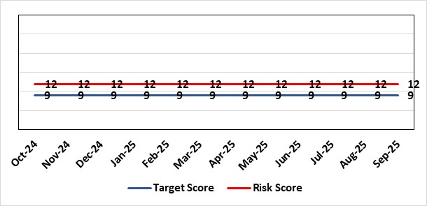 |  | Rationale for current score:  Marked improvement in the performance against the Mental health Measure for CAMHS. Data validation for new patients complete. Current risk score 12 in view of improved performance however this reflects the fragility in the workforce to deliver sustained performance. Work is still ongoing within CAMHs to maintain and improves the situation.
Level of Control  = % |  |  | Rationale for target score:  The rationale for the target score is linked to successful recruitment and more timely access to services for children and young persons which will reduce risk.
Date added to the SBU HB risk register
October 2023
Controls (What are we currently doing about the risk?) |  |  | Mitigating actions (What more should we do?)
-Ongoing recruitment into all staff groups  -Temporary agency workforce in nursing at premium pay rates to sustain current levels of performance  -Recent appointment into psychological therapies lead posts.  -Recent appointments to substantive consultants psychiatrist posts.  -Moved vacancy nursing establishments into part 1 of the services to recruit and increase capacity. |  |  | Action | Lead |  | Deadline
 |  |  | Continued efforts at recruitment | Acting Associate Service Director |  | 31/10/2025
Assurances (How do we know if the things we are doing are having an impact?)  -Monthly CAMHS Directorate meeting in place where performance and workforce are scrutinised  -Reporting into Weekly Business Team and MH & LD management board.  -Reporting into SBU Performance & Finance Committee and IQPD (Integrated Quality & Performance Delivery) meeting with Welsh Government  -Ongoing validation of the waiting list to ensure robust reporting going forward |  |  | Gaps in assurance (What additional assurances should we seek?)
Additional Comments / Progress Notes
01.09.25: Performance against Part 1B will remain a challenge until the backlog of >28-day waiters is cleared. However, there is a recovery plan to support this, and demand & capacity review will help to identify the gap.
Agency usage has been reduced since October 2024 in line with the need to support the Health Board financial position from 8.4wte to 3.5wte. However, the continuation of 3.5wte agency use is essential to maintain current capacity/performance levels whilst vacancies are recruited, and new staff are inducted. Current vacancies (2.65wte) are live on TRAC recruitment system.

Datix ID Number: 443  Health & Care Standard: Effective Care 3.1 Clinically Effective Care |  |  | HBR Ref Number: 104  Risk Target Date: 31/03/2027 |  | Current Risk Rating  4 x 5 = 20
Objective: Care is delivered in safe and appropriate settings supported by innovative digital solutions |  | BAF ref: | Director Lead: Matt John, Director of Digital  Assuring Committee: Digital Data & Innovation Committee  For information: Quality & Safety Committee
Risk: Failure to meet Tier 1 targets in Clinical Coding Completeness  Because: The volume of new inpatient episodes exceeds the available clinical coding staff capacity; There are difficulties recruiting and retaining a sufficient number of trained clinical coding staff to address the gap, and clinical information is not always of sufficient quality or completeness electronically (such as DALs) to support swift coding.  There is a risk that: Clinical notes for inpatient episodes will not be coded in a timely way.  Resulting in: The non-achievement of the Tier 1 Welsh Government target (which is that 95% of inpatient activity should be coded within 30-days of discharge); Insufficient coded data to support effective service planning for population health needs; Inadequate data being available for mortality review/quality and safety purposes, with increased risk of failure to spot variance that are negatively impacting levels of patient care and potentially causing avoidable deaths; Negative impact on accuracy of analysis to understand how resources are being allocated and used at Health Board level and national level (programme budgeting); Delays in claiming casemix sensitive contract lines with JCC, Hywel Da and Cwm Taff (circa 70m per annum value in total) due to lack of coding data. |  |  | Date last reviewed: September 2025
Risk Rating  (consequence x likelihood):  Initial: 3 x 4 = 12  Current: 4 x 5 = 20  Target: 4 x 3 =12 | 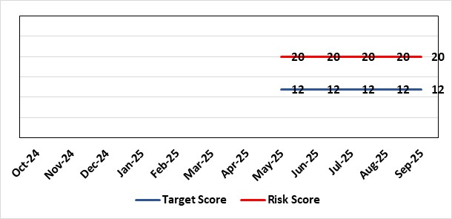 |  | Rationale for current score:  C - Insufficient coding data will negatively impact service planning for population health needs and inadequate data being available for mortality review/quality and safety purposes. This could result in failures at spotting patterns of variance that are negatively impacting levels of patient care and potentially causing avoidable deaths.  Clinically coded activity is also used to understand how resources are being allocated and used at Health Board level and national level (programme budgeting), and therefore a reduction in coding completeness will impact on the accuracy of this analysis. It is also used to claim casemix sensitive contract lines with JCC, Hywel Da and Cwm Taff of circa 70m per annum with lack of coding data impacting on the timeliness in making these claims.  L - Tier 1 target is currently not being met on a regular basis.
Level of Control  = |  |  | Rationale for target score:  C - Insufficient coding data will negatively impact service planning for population health needs and inadequate data being available for mortality review/quality and safety purposes. This could result in failures at spotting patterns of variance that are negatively impacting levels of patient care and potentially causing avoidable deaths.  Clinically coded activity is also used to understand how resources are being allocated and used at Health Board level and national level (programme budgeting), and therefore a reduction in coding completeness will impact on the accuracy of this analysis. It is also used to claim casemix sensitive contract lines with JCC, Hywel Da and Cwm Taff of circa 70m per annum with lack of coding data impacting on the timeliness in making these claims.  L – Increase in what can be coded electronically, unit centralisation, greater staff retention and the development of an auto-coding model will lead to increased capacity and a reduction in likelihood for targets not being met.
Date added to the SBU HB risk register
18/06/2025
Controls (What are we currently doing about the risk?) |  |  | Mitigating actions (What more should we do?)
- A three-year coding modernisation plan has been approved by executive board on 26th February 2025. This plan will see the implementation of an auto-coding solution and a re-banding of the clinical coding department within existing budgets to attain Tier 1 targets by 27/28.  - The coding management team assess the staffing complement on a daily basis to ensure resources are deployed in the most efficient and effective manner, in line with demand and clinical coding priorities.  - There is a comprehensive training programme in place for new Trainee Coders.  - The Clinical Coding Departments raise incidents when clinical information is missing from the patient’s health records and prevents the activity being coded in a timely manner. These incidents are highlighted at the Directorate Business Meetings held on a monthly basis as part of the Clinical Coding Key Performance Indicators.  - Clinical coding staff performance continues to be monitored and discussed during the monthly Clinical Coding Managers Meetings, which are chaired by the Head of Health Records & Clinical Coding, and an update is also reported and presented on the Health Board Performance Scorecard.  - An App has been developed by Digital Intelligence that shows any relevant data relating to a patient episode from different systems including Signal, TOMs, EPOA and DAL in one place. This will reduce the number of systems a clinical coder needs to log into. |  |  | Action | Lead |  | Deadline
 |  |  | Completion of all Actions on Audit Action Plan | Head of Digital Intelligence Programmes |  | 31/10/2025
 |  |  | Auto-coding model in production for two specialties | Head of Digital Intelligence Programmes |  | 01/11/2025
 |  |  | Centralising of coding department leading to efficiencies | Head of Health Records & Clinical Coding |  | 31/10/2025
 |  |  | Primary Procedure and Primary Condition Coding paper approved | Head of Health Records & Clinical Coding |  | Complete
Assurances (How do we know if the things we are doing are having an impact?)  - Attainment of the Tier 1 Health Board target for clinical coding completeness which relies on the timely availability and quality of the paper record and electronic sources. Coding 95% of in-patient activity within 30 days of discharge is a tier 1 Welsh Government target that is currently not being achieved regularly within SBU – with an average of circa 74% for 24/25. Performance is reported to Digital Business Meeting every 3 months, and to Digital, Data, Research & Innovations Committee via a Coding Paper.  - Episodes are coded from paper and electronic sources; the ability to code from electronic sources improves the timeliness & accuracy; approximately 52,000 episodes of 150,000 episodes are coded from electronic sources currently. This is reported to Digital Business Meeting every 3 months, and to Digital, Data, Research & Innovations Committee via a Coding Paper.  - An Audit has been carried out by NHS Wales Assurance and Audit Services of the Coding Department was completed in June 2024 with a result of limited assurance. In response a twelve-point action plan was developed of which one action remains which is the escalation of the coding risk to the Health Board Risk register. |  |  | Gaps in assurance (What additional assurances should we seek?)  Investment required supporting the delivery and operational costs of the Digital strategy.  Replacing qualified coders who have left the department with trainees reduces productivity - the only mitigation against this is an auto-coding product to increase productivity and re-banding across coding department to put staff at same bandings as NHS England and help staff retention – the investment required for this is yet to be funded.  The Quality of Discharge Summary provision and standard of clinical information available at the point of coding requires improvement to assist with prompt and accurate coding.  There continues to be missing clinical information at the point of coding, preventing accurate and timely coding.
Additional Comments / Progress Notes
Supplementary Notes:
- Coding 95% of in-patient activity within 30 days of discharge is a tier 1 Welsh Government target that is currently not being achieved regularly within SBU – with an average of circa 74% for 24/25.
- Contract coders and overtime have been used to achieve that 75% average which has stopped due to the current financial situation of the Health Board.
- Retaining and recruiting qualified coding staff is a big challenge due to higher bandings in England and the availability of digitised record to allow home working.
- 6 WTE qualified coders have been lost to English Health Boards or DHCW in the last 3 years due to higher bandings with a further 2WTE retiring. This has resulted in circa 44% of the current coding WTE being trainees/unqualified. Currently, there are 5 qualified coder vacancies (June 2025).

14/07/2025: The Service improvement role will now be advertised following the conclusion of the Clinical Coding OCP which concludes end of August 2025. New completion date for the advertising of the post of October 2025.
05/08/2025: Action complete: OCP process for qualified clinical coders now completed with re-banding now having taken place. Auto-coding dataset to be sent across to 3rd party supplier to fine tune model ahead of being available in September 2025. Paper going to IGCAG and then Management Board around coding primary procedure and condition to boost coding completeness rates.
05/09/2025 - Primary Procedure and Condition Coding has been signed off by IGCAG and Management Board and will be implemented from September 2025. Neurology Dataset for auto-coding has been sent for fine-tuning the auto-coding model with testing set to begin by the end of September 2025. Production date moved to November 2025.
13/10/2025 - OCP Process now complete and rebanding of qualified coders has taken place. Auto-coding model about to be tested for implementation with neurology episodes and Primary Procedure coding started in September with the number of episodes coded and rate of coding showing an increase on than previous months.

Datix ID Number: 3114  Health & Care Standard: 3.4 Information Governance and Communications Technology |  |  | HBR Ref Number: 105  Target Date: TBC |  | Current Risk Rating:  4 x 4 = 16
Objective: Care is delivered in safe and appropriate settings supported by innovative digital solutions |  | BAF Ref: | Director Lead: Matt John, Director of Digital  Supporting Director: Chris Morrell, EDAHPHS  Assuring Committee: Quality & Safety Committee  For information: Digital, Data & Innovation Committee
Risk: Significant increased cost for the replacement Pathology System LIMS  If the new Laboratory Information Management (LIMS) system is not live before 31st December 2025 then there will be significant more cost across NHS Wales which could impact the Health Board’s financial plans in 2025/26 and 2026/27. Costs would have to be covered to avoid pathology losing access to the current LIMS system resulting in the inability of pathology to deliver diagnostic results and blood transfusion services across all Health Board services including emergency, acute, primary and community services. |  |  | Date last reviewed: September 2025
Risk Rating  (consequence x likelihood):  Initial: 5 x 5 = 25  Current: 4 x 4 = 16  Target: 4 x 1 = 5 | 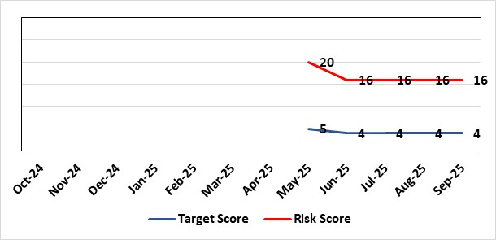 |  | Rationale for current score:  Consequence – Additional costs could be in region of approximately £1m for the Health Board depending on the length of delay  Likelihood – probable (10-50% chance currently) – due to being off-track on project and lack of confirmed back-up plan.
Level of Control  = |  |  | Rationale for target score:  Consequence as above  Likelihood will be negligible if effective system / mitigations put in place in time
Date added to the SBU HB risk register
18/06/2025
Controls (What are we currently doing about the risk?) |  |  | Mitigating actions (What more should we do?)
Configuring and testing the new LIMS system with the aim of go-live with all disciplines before 31st March 2026  SBUHB Pathology services are working in collaboration with other Health Boards and Trusts to share configuration and testing as part of a national programme. The project has agreed a go-live of Cellular Pathology in November. However, national replanning is still underway for other disciplines (Microbiology, Andrology, Blood Sciences and Blood Transfusion) to secure go-live dates before 31st March 2026 when funding for the national programme ends. The two months allocated by the national programme for User Acceptance Testing has been extended to over 12 months as the number of defects in the system remains high. There remain significant defects to be addressed by the supplier, most notably for Blood Sciences with over 400 defects – over 300 of which must either be resolved or worked around before go-live.  Pursuing only a ‘Minimal Viable Product’ to avoid scope-creep  SBUHB Pathology Services are only seeking to pursue a safe replacement system, known as a ‘Minimal Viable Product’. This is to eliminate the possibility of testing timescales being extended. Other Health Boards and Trusts report they are following the same approach.  Challenging the supplier and Digital Health and Care Wales for their technical delivery  The supplier is responsible for addressing any defects identified during testing. Digital Health and Care Wales (DHCW) are responsible for delivering some of the technical integrations (in addition to co-ordinating the national programme). The SBUHB Project Team, through the programme governance, challenge the supplier and DHCW to deliver on their commitments. |  |  | Action | Lead |  | Deadline
 |  |  | Determine what additional local costs may be attracted due to extending the project from 31st December 2025 until 31st March 2026 and how these could be funded. | SBUHB Project Team |  | 31/12/2025
 |  |  | Continue to work in collaboration with other NHS Wales organisations to challenge supplier delivery and secure go-live dates before 31st March 2026. | SBUHB Project Team |  | 31/03/2026
Assurances (How do we know if the things we are doing are having an impact?)  National Programme Board  SBUHB, together with all Health Boards, Trusts and the supplier belong to the national LIMS Programme Board.  The Programme Board receives updates on Digital Health and Care Wales progress towards procuring extended licenses, or a replacement of, the current remote access software.  The Programme Board receives updates on testing activities, including metrics showing the number of outstanding system issues. It is chaired by the Executive Director of Allied Health Professions and Health Science for Aneurin Bevan University Health Board.  SBUHB Project Team  A Project Manager is in place to manage the SBUHB Project Team on daily basis.  Operational Delivery Network LIMS 2.0 Sub-Group  SBUHB work in regional partnership with Hywel Dda University Health Board (HDUHB) and hold a joint, monthly Operational Delivery Network LIMS 2.0 Sub-Group, which receives reports from the SBUHB and HDUHB Project Managers, along with Programme Managers from the supplier and Digital Health and Care Wales.  This group is jointly chaired by the SBUHB Clinical Lead for Laboratory Medicine and HDUHB Head of Pathology Service, who are also Senior Responsible Officers for the SBUHB and HDUHB projects.  Morriston Management Board  The SBUHB project regularly reports progress to the Morriston Management Board.  Digital, Data, Research and Innovation Committee  The SBUHB project regularly reports progress to the Digital, Data, Research and Innovation Committee. |  |  | Gaps in assurance (What additional assurances should we seek?)  Meeting the costs of extending the project and access to the current LIMS  A national mitigation plan was previously proposed that would enable go-lives of all SBUHB pathology disciplines by 31st December 2025. The national programme has since reported they have extended the programme until 31st March 2026.  Welsh Government have confirmed they will cover the £1.6m cost of the mitigation plan that would fund the programme until 31st December 2025.  Digital Health and Care Wales are seeking to cover a further £0.69m of national costs not previously included in the mitigation plan, that would fund national components of the programme until 31st March 2026.  The SBUHB project needs to determine what additional local costs may be attracted due to extending the project from 31st December 2025 until 31st March 2026 and how these could be funded.  Resource Constraints  All available staff are committed to the programme, with no external resources readily available. This has contributed to the programme’s red RAG status.
Additional Comments / Progress Notes
User Acceptance Testing sign-off
User Acceptance Testing across Wales was originally expected to take place across the two months of September and October 2024. However, a significant number of issues in the system, coupled with partial delivery of integrations between the LIMS and national systems managed by Digital Health and Care Wales, were identified early in the process. Maintaining the availability of Pathology staff to undertake testing across an extended duration, alongside maintaining service delivery, has also been challenging.

User Acceptance Testing has been extended to, depending on the pathology discipline, around twelve months. Go-lives have not been delayed by the same amount and the decreased duration between the end of User Acceptance Testing and go-live puts additional pressure on the project:
 | Previously | Currently
Duration of User Acceptance Testing | 2 months | 12 months
Duration between User Acceptance Testing sign-off and go-live | 3 months | 1 month

Business Continuity
The Health Board’s current Business Continuity Plan to address a failure in digital pathology systems is to revert back to paper based reporting, which is unsustainable and would only be effective over a very short-term period (days).

Blood Transfusion services in other part of Wales
SBUHB Blood Transfusion are the only Blood Transfusion service in Wales that have successfully migrated onto the current LIMS system. Other Blood Transfusion services use other legacy systems and will potentially be impacted after the 15th December 2025 in other ways (e.g. by having to extend support for their existing legacy systems).

Pathology resource for testing
Testing is reliant on the knowledge and skills of Health Board staff whose availability is limited, having to manage testing alongside normal service delivery. With a national shortage of Biomedical Scientists, there is no readily available external resource to support this process.

Update Aug 2025: The LIMS risk is no longer framed as a “loss of system” but as a financial risk—specifically, the cost implications of ensuring continued provision of a functioning pathology system. The programme is experiencing significant delays and defect volumes, impacting deployment timelines and operational readiness.
Deployment Plan & Tranche 1 delay: The programme is structured into five tranches, with go-live dates staggered from July 2025 to March 2026. A sixth tranche (PHW/Microbiology/Cervical Screening) remains unscheduled due to unresolved middleware dependencies. Originally scheduled for mid-July, the technical go-live for Tranche 1 was deferred due to unresolved defects, including the critical trickle feed interface needed for dual running of LIMS 1.0 and 2.0. A revised dry-run is planned for late August, with go-live in early September.
Defects: Approximately 160 new severity 1 and 2 defects are raised monthly. While a third have been fixed, they require retesting. Completion of UAT is contingent on resolving these defects.
Dependencies and Risks: Blood Sciences must complete testing by end of August to meet the October deployment target. Significant sign-off activity is pending both locally and nationally.

Risk Score Calculation

For each risk identified, the LIKELIHOOD & CONSEQUENCE mechanism will be utilised. Essentially this examines each of the risks and attempts to assess the likelihood of the event occurring (PROBABILITY) and the effect it could have on the Health Board (IMPACT). This process ensures that the Health Board will be focusing on those risks which require immediate attention rather than spending time on areas which are, relatively, a lower priority.

