Incidence/100,000 population | Incidence/1,000 admissions
C. difficile infection
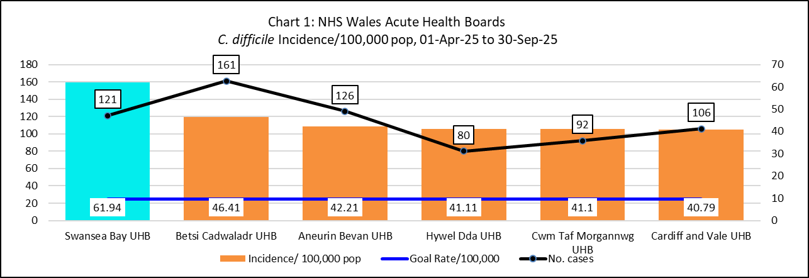 | 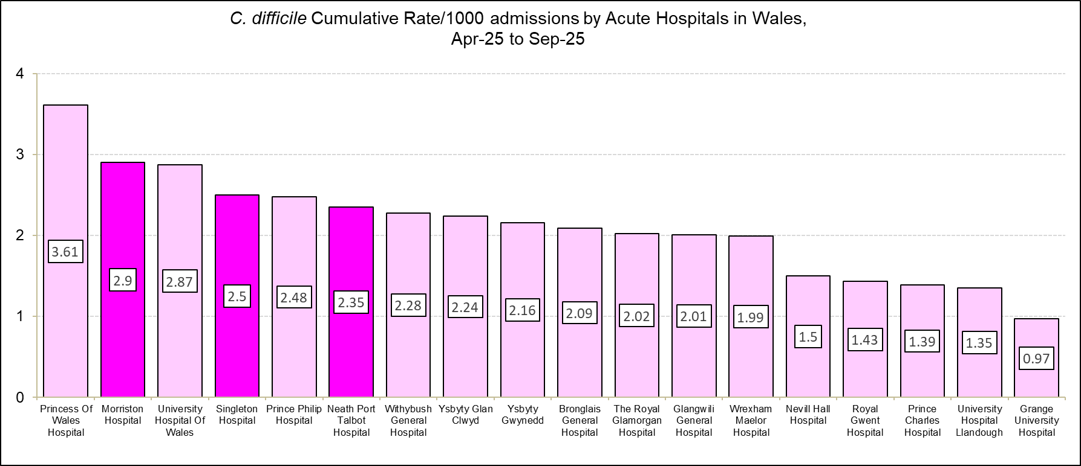
Staph. aureus bacteraemia
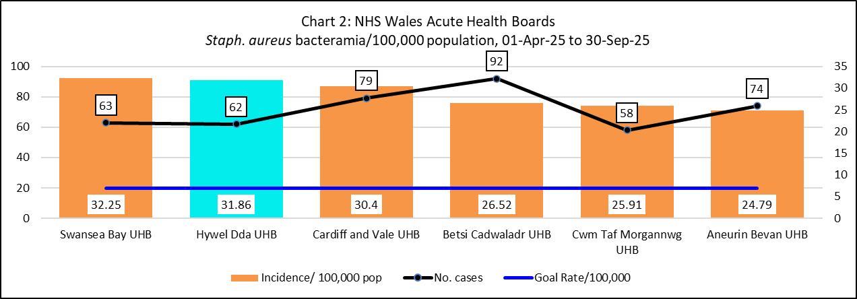 | 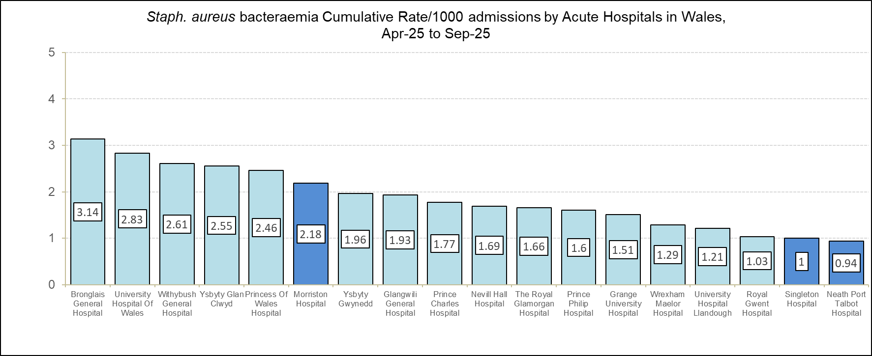

Incidence/100,000 population | Incidence/1,000 admissions
E. coli bacteraemia
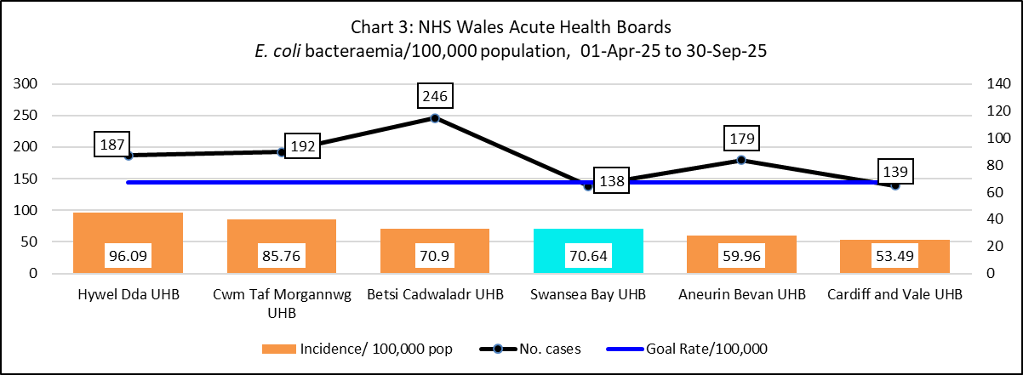 | 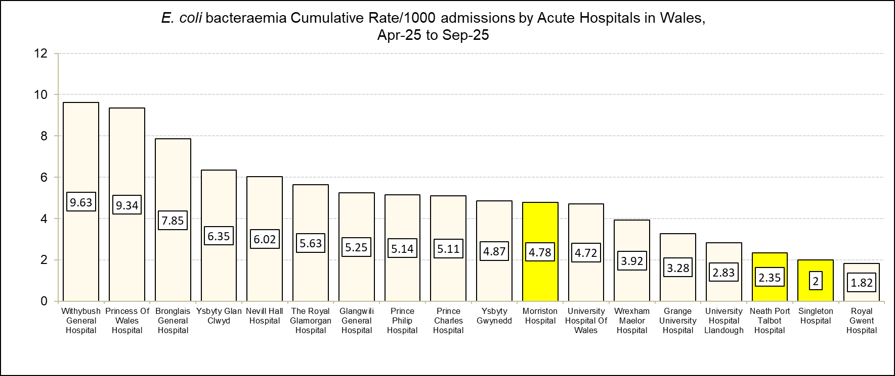
Klebsiella spp. bacteraemia
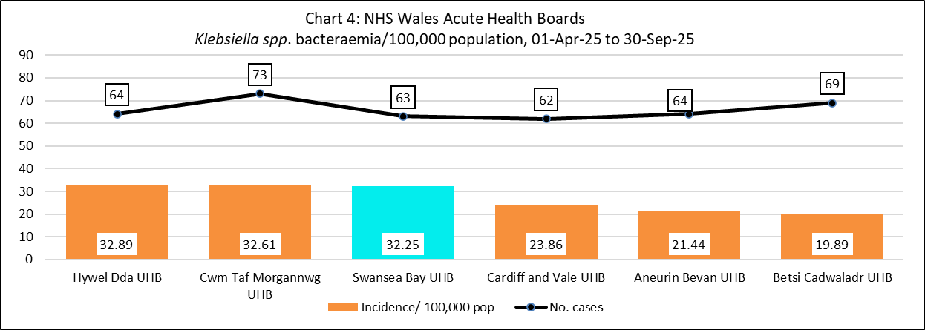 | 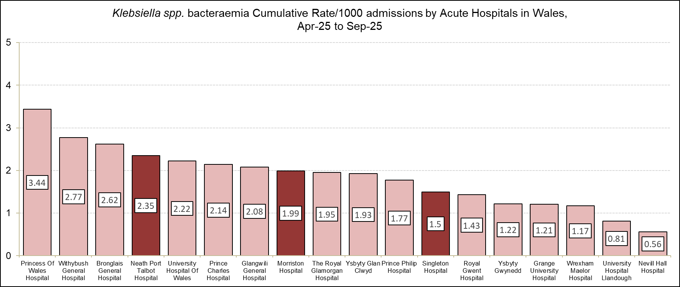
Incidence/100,000 population |  | Incidence/1,000 admissions
Pseudomonas aeruginosa bacteraemia
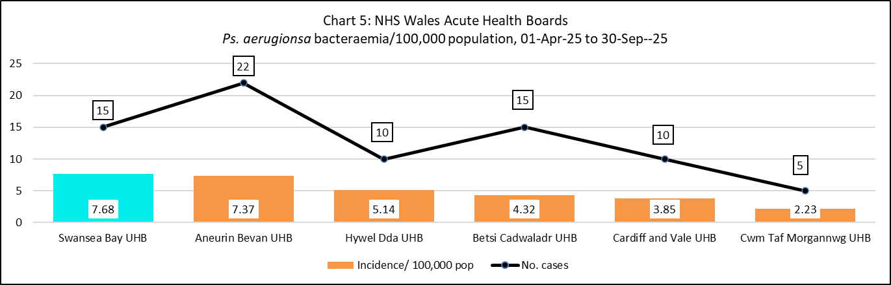 |  | 