

Meeting Date | 06 November 2025 |  | Agenda Item |  |  | 2.5
Name of Meeting | Quality and Safety Committee
Report Title | Staffing Assurance of the Children’s Community Nursing Team Service – Progress Report
Report Author | Janet Millward – Deputy Head of Nursing - Children and Young People (CYP)  Vicki Burridge Head of Nursing - Children and Young People (CYP)
Report Sponsor | Lesley Jenkins, Deputy Executive Director of Nursing and Patient Experience (on behalf of Elizabeth Rix, Executive Director of Nursing and Patient Experience)  Michelle Mason Gawne Associate Service Group Director Women and Child Health
Presenter | Sharron Price Group Nurse Director Neath Port Talbot Singleton
Freedom of Information | Open
Purpose of the Report | To provide The Quality and Safety Committee with an update of current challenges and areas for improvements within the community children team with specific focus on the staffing levels and their impact on service delivery.
Key Findings & Issues identified. | - Workforce Availability and recruitment  There are ongoing difficulties in recruiting and retaining suitable qualitied staff within the children continuing care team. High vacancy numbers have led to increased reliance on temporary staffing solutions, including Health Care Support Worker bank staff,  - Lack of Continuity in care packages  Due to staffing shortages, there is a heavy dependence on Bank staff rather than substantive staff. This has resulted in a lack of continuity for the children and families which can negatively affect the quality of care and the relationship with the families.  - Risk of service disruption  An increase in unavailability due to sickness, maternity leave reduces the availability of staff from within the team.  These factors have led to instances where care packages have not been fulfilled, resulting in missed episodes of care and an increased risk to the service users.  - Parental expectations and preferences  The service has experienced an increase of families requesting a small cohort of staff to deliver care to their child. While this approach supports continuity and trust it presents challenges when integrating new staff into the packages and limits the cover that can be fulfilled.
Specific Action Required  (Please choose one only) | Information | Discussion |  | Assurance | Approval
Specific Action Required  (Please choose one only) | ☒ | ☐ |  | ☒ | ☐
Recommendations | Members are asked to:  Be assured by: The Community Children Team remains committed to delivering high quality safe and consistent care, however sustained workforce challenges require urgent attention and strategic action to ensure service continuity and meet the needs of children and their families.  Be assured by: areas of improvement identified within the paper.

Staffing risk within the Community Children Nursing Team

- INTRODUCTION

The purpose of the report is to provide the group with an updated position following escalation of a current risk score of 16 for the service due to increased percentage of unavailability within the workforce to deliver care packages.

The community children team continues to experience significant pressures related to workforce availability, particularly within the continuing care aspect of the service. These challenges are impacting the consistency of care being delivered to children and families across Swansea Bay Health Board (SBUHB).

This paper concentrates on the staffing challenges in community nursing which are multifaceted and require a skilled workforce for delivering patient centred care for our Children’s Continuing Care (CCC) packages.

- BACKGROUND

In the autumn of 2020, the Executive team commissioned an external review of the Children’s Community Nursing (CCN) Team Service. The review was commissioned in response to concerns raised by families who used the service and undertaken by two external reviewers. The reviewers had experience in providing social care services for families with children and long-term commissioning.

The focus of the review back in 2020 identifying key areas of strength to build on, and areas of potential risk, one of which included staffing. The review highlighted the importance of aligning workforce planning with national guidance. Key references include:

Royal College of Nursing 2019 report
Explored the challenges in delivering sustainable and robust children community nursing services. It recognised the evolving nature of the role with increasingly complex care being delivered outside of the hospital settings.

RCN 2020 Publication – Future Proofing Community Children Nursing
Emphasised the importance of flexibility in service planning and models to meet the needs of children eligible for continuing acre It also emphasised the need that care delivery by staff with the appropriate knowledge and skills.

Methodology

- A review of the current staffing establishment and sickness/absence data.
- Assessment of the vacancy trend – recruitment and retention factors
- Evaluation of complexity of nursing care needs, including the training and education required to support the appropriate ratio for HCSW for the packages of care.
- Review of packages and Health Care Support Worker (HCSW) banding requirements for each Children & Young Persons (CYP) which is derived from the CCC panels and approval.
This approach ensures that the workforce structure and establishment are aligned with patient acuity.

- GOVERNANCE

Overall summary of packages of care
This summarises the packages of care and the level of care requirements and hours needed to fill these requirements that equates to the staffing levels /skill mix for the CCN team:
July - September 2025
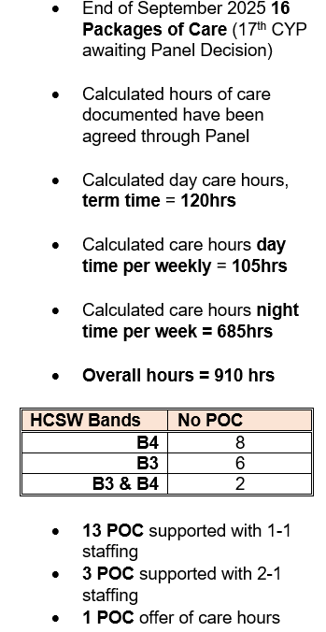

3.1 RISK REGISTER

A staffing related risk was added to the risk register on 29 July 2024 with a risk score of 20 this has recently been decreased to 16. This continues to reflect the significant risk around the ability to deliver a sustainable and safe service. Risk Description: Workforce inability to sustain a safe service for children and young people requiring continuing care:

The risk is reviewed monthly in alignment with CYP governance process.
A summary of controls and assurances currently in place:
- Weekly scrutiny of roster management (CCN manager, Roster co-ordinator)
- Weekly staffing unavailability presented at Head of Nursing meetings (Deputy Head of Nursing (DHON))
- Robust Monthly sickness meetings with Human Resources (CCN manager, DHON, HR)
- Monthly CCN Staffing catch up with the MDT (CCN Manager HR, Finance, DHON)

- Recent recruitment of a Roster co-ordinator to support the complex nature of staffing requirements.
- Monthly performance exception reports and KPI reporting (DHON)
- Monthly exception report to CYP Quality and Safety forum and Successes, Priorities, Opportunities Risks & Threats (SPORT) report to divisional business meeting
- Monthly report to CYP workforce meetings

The service also needs to consider Band 5 staff as Mitigation for the delivery of packages of care. This would be a temporary measure to ensure continuity and quality of care. This approach is not aligned with the current staffing model of the service but will be required of the current position of unable to delver care continues and adds risk to families and children. The Band 5 staff will require intense training for individual packages however they will provide an opportunity to reassess the care needs, plans and give assurance that current care plans in place are meeting the needs of the child. There is an acknowledgement that this is not a sustainable long-term solution due to the cost implication and workforce planning, however in the current climate the service is in this would be a mitigation that could sustain the delivery of care.

3.2 INCIDENT REPORTING

All Incidents are reported via the Datix incident reporting system. Incident data is subject to senior oversight through the governance structure Incidents includes:
- Missed care episodes.
- Non-compliance with the Continuing Care review process
- A wide range of other incidents reflecting the breadth of service provision.

The following graph demonstrates the incidents relating to missed care due to unavailability:

April – September 2025

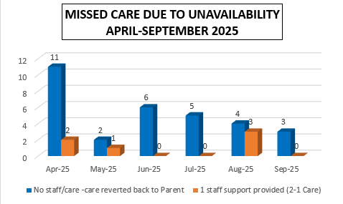

This demonstrates an overall decrease in missed/partial missed care as a result of increased bank staff support and new starters within this reporting period.

Unavailability
There is a robust sickness management process in place within the service. Absence trends demonstrate varied reasons and are monitored as part of routine reporting.
The senior nursing team monitors through:
- Weekly and monthly meetings supported by HR
- Escalation of concerns through Head of Nursing on a weekly basis
- Full compliance with the Health Board’s attendance at work policy
- Audit of compliance

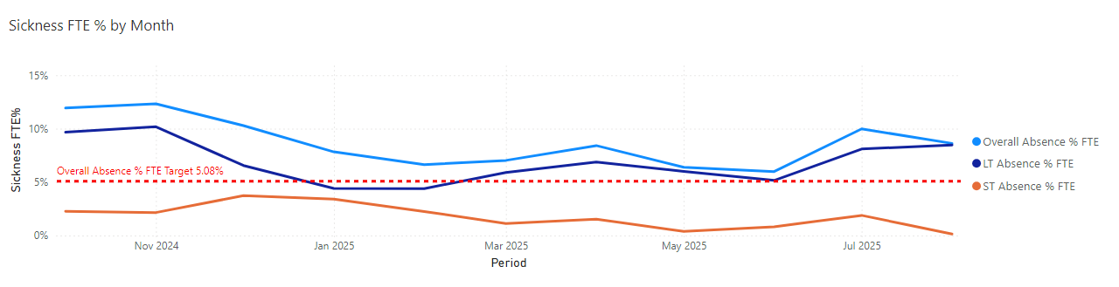
3.3 RECRUITMENT AND RETENTION
The main driver of retention, is staff having access to ongoing learning and development and these opportunities are important in the CCC service due to the specialist HCSW role with the CYP and their families.
. 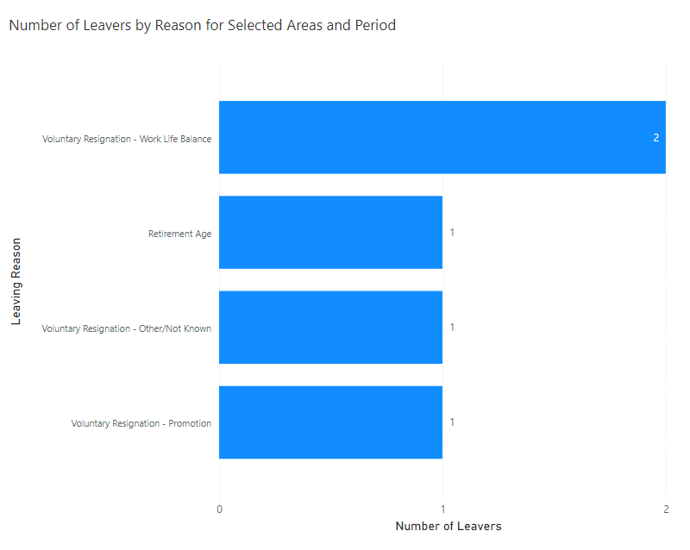

While recruitment is improving it cannot keep pace with the growing demand for CCC service. Within this reporting period five recruitment campaigns were completed, for band 3 and band 4 roles Fewer than half of the (whole time equivalent) WTE were successfully filled.
Challenges
- Lack of applicants meeting essential criteria
- Inappropriate application
- Candidate withdrawals post interview
- Limited understanding of the role
Action Taken
- Adverts have been rewritten to clearly outline role expectation and essential criteria.
- Informal discussion is encouraged prior to application to ensure candidates understand the role. The service continues with a “Grow your own” model which is one of our retention strategies to encourage staff to develop into Band 4 roles which has positively supported retention. It supports our HCSW and ‘grow your own’ workforce by supporting people to further their career in the NHS. During the last 12 months 4 band 3 staff completed the Band 4 training and have transitioned to band 4 posts.
Following a successful CYP service recruitment day in February 2025, the service recruited bank staff support through the TRAC system for Band 3 and 4 HCSW roles.
This was achieved through included:
- A competency-based training and assessment.
- A consistent pool of trained HCSW bank staff contributing 150 – 200 hours per week.
- Significant reduction in missed care episodes.
- Improved patient and family experience.
This has also supported internal recruitment with bank staff applying for and securing permanent roles.

Establishment and Education

The HCSW establishment is calculated based on the number of children receiving continuing care and the total of number of hours required to deliver each care package.

Over the past year there has been a 12.5 % increase in the requirement for Band 4 staff reflecting the growing complexity of care needs. This drives the education framework required:
- The need for enhanced skill sets aligned with national training and education frameworks.
- Increasing demand for Band 4 clinical competencies.
- The complexity of all seventeen current care packages, many involve long term high dependency care needs.

Action Taken

- A structured induction and competency-based training programme for all new starters
- Annual refresher training for both substantive and Bank only staff to maintain clinical standards.

3.4 COMPLIANCE WITH ALL WALES CCC GUIDANCE

The service is experiencing a notable increase in the complexity of the cases referred for CCC, with complex clinical care requirements, packages increasing to 2:1 ratio and a need for enhanced skill mix. There has been delays in commencement of new packages due to this increase, therefore not in compliance with the All-Wales Continuing Care guidance.
There are currently three packages that are not receiving a full complement of their package with only partial hours being fulfilled. Families, are kept fully informed of progression and mitigation in place:

- Exploration of agency commissioning to support care delivery, however initial efforts to commission agency support have not come to fruition to date work continues to look at a hybrid model.

Registered workforce

There are currently 3 wte Band 6 vacancies within the team. These have arisen due to:
- Internal professional development opportunities
- Staff leaving for other roles within health or due to their own personal reasons.
Each of the vacant post’s incudes a specialist service requirement not currently available within the Children services portfolio these include:
- A Cardiac Liaison Nurse
- A Continence Advisor

In terms of ongoing development
- Two community children nurses have successfully completed their specialist practitioner qualification (SPQ)
- A further two registered nurses, are being supported to commence postgraduate qualification in September 2025.
- Band 6 take on further leadership roles.
- Supervision on a twilight shift has improved confidence on the delivery of care and reinforced the support for the HCSW.

3.5 STAKEHOLDER VIEWS & PERSPECTIVES

Views of Families

The service communicates any missed care and unavailability to the families directly through the Nursing team during working hours and directly by staff out of hours. The CCN manager communicates regularly with the families and has recently been undertaking engagement and home visits to gather feedback. All feedback for CCC and the CCN service feeds into the patient experience forum and Quality Safety and risk for CYP division and the quality safety and risk service group. forum

- FINANCIAL IMPLICATIONS

The CCN Team meet monthly with the finance partner to review the establishment and tracker for the Children continuing care packages to consider and plan for vacancies / recruitment.

- RECOMMENDATIONS

Members are asked to:

Be assured by: The Community Children Team remains committed to delivering high quality safe and consistent care, however sustained workforce challenges require urgent attention and strategic action to ensure service continuity and meet the needs of children and their families.
Be assured by: areas of improvement identified within the paper.

Governance and Assurance

Link to Enabling Objectives  (Please choose) | Supporting better health and wellbeing by actively promoting and empowering people to live well in resilient communities
Link to Enabling Objectives  (Please choose) | Partnerships for Improving Health and Wellbeing |  | ☒
Link to Enabling Objectives  (Please choose) | Co-Production and Health Literacy |  | ☒
Link to Enabling Objectives  (Please choose) | Digitally Enabled Health and Wellbeing |  | ☐
Link to Enabling Objectives  (Please choose) | Deliver better care through excellent health and care services achieving the outcomes that matter most to people
Link to Enabling Objectives  (Please choose) | Best Value Outcomes and High-Quality Care |  | ☒
Link to Enabling Objectives  (Please choose) | Partnerships for Care |  | ☒
Link to Enabling Objectives  (Please choose) | Excellent Staff |  | ☒
Link to Enabling Objectives  (Please choose) | Digitally Enabled Care |  | ☐
Link to Enabling Objectives  (Please choose) | Outstanding Research, Innovation, Education and Learning |  | ☐
Health and Care Standards
(Please choose) | Staying Healthy |  | ☒
(Please choose) | Safe Care |  | ☒
(Please choose) | Effective Care |  | ☒
(Please choose) | Dignified Care |  | ☒
(Please choose) | Timely Care |  | ☒
(Please choose) | Individual Care |  | ☒
(Please choose) | Staff and Resources |  | ☒
Quality, Safety and Patient Experience
Progress against the overall workforce plan will improve the quality and safety of the children’s community nursing service
Financial Implications
Increase In use of Bank and Agency
Legal Implications (including equality and diversity assessment)
Staffing Implications
The children’s community nursing team have support and wellbeing through clinical supervision, group or individual as needed. Education programme in place weekly at Lunch and Learn. Continued monitoring of the risk held on the risk register.

Long Term Implications (including the impact of the Well-being of Future Generations (Wales) Act 2015)
The ‘what matters to me’ and ‘voice and control’ requirements that underpin the Social Services and Well-being (Wales) Act (2015) do not appear to have been reflected in the way services have been developed and offered.
The improvement plan for staffing levels has been developed to comply with this Act.
Report History |  | The Quality & Safety Committee have received regular updates of the progress made following the review of the Community Children Team
Appendices

