

Meeting Date | 06 November 2025 |  | Agenda Item |  |  | 2.3
Name of Meeting | Quality and Safety Committee
Report Title | Clinically Optimised Patients report (Reducing Pathways of Care Delay Programme)
Report Author | Emily Warren, Associate Group Director (Operations)  Primary, Communities and Therapies Group
Report Sponsor | Deb Lewis, Chief Operating Officer
Presented by | Emily Warren
Freedom of Information | Open
Purpose of the Report | To provide assurance on activity to support a reduction in Pathways of Care Delays (POCD)
Key Issues | A sustainable reduction in Pathways of Care delays has been achieved during 2025. The Health Board are on track to meet Welsh Government Ministerial Targets set for November 2025.  This is due to:  - Enhanced Governance & Accountability  - Strengthened Collaboration with partners  - Integrated POCD Action Plan  - Improvements to Operational Processes  - Service development/redesign  - Dedicated Improvement work in key delay areas such as Mental Health/Court of Protection/Assessment  Maintaining progress will be challenging during the winter months, with no additional resources provided by Government to enhance step down capacity or extend service hours/days. Workforce resilience also remains an issue with sickness absences in social work teams impacting activity levels.
Specific Action Required  (please choose one only) | Information | Discussion |  | Assurance | Approval
Specific Action Required  (please choose one only) | ☒ | ☐ |  | ☐ | ☐
Recommendations | Members are asked to:  - To consider the progress made in delivering Pathways of Care Delay reductions  - To consider the current risk around the Integrated Discharge Hub  - To consider the pace of progress is slowing and the mitigations required to support continued reductions to achieve a reduction to 150 and below in 2026

INTRODUCTION

This paper provides an update on the progress of the Pathways of Care Delays Programme (POCD). The programme delivers operational improvements, to achieve reductions in Pathway of Care Delays.

Progress has been achieved with a steady reduction in numbers month on month during 2025.The programme is on track to meet November’s Ministerial targets. This paper provides the detail on the actions taken to achieve the change, and the associated performance data detailing the reduction in total delays, total days delayed and assessment delays.

This programme is being delivered in tandem with the regional ‘Discharge to Recover and Assess’ (D2RA) programme, which leads the transformational change required to achieve a D2RA model across Swansea Bay. Both programmes are being delivered as part of West Glamorgan Regional Partnership Board (RPB), Older People and Communities Board (OP & CB).

Whilst progress has been made, significant challenges remain to achieve required reductions in 2026 of sub 150 patients delayed. It Is expected that the wider transformational activity, within the D2RA programme, will support progress. Working groups have been established to identify the transformational changes required and this includes work on Trusted Assessor, Demand and Capacity and Pathway review. However, increasing demand, higher acuity, limited resources and capacity across the Pathways, in tandem with a lack of workforce resilience (particularly in Social Care) remain challenging to navigate.

BACKGROUND

Pathways of Care Delay Programme

In January 2025, a new programme was established at a regional level, to deliver reductions in Pathways of Care Delays. An integrated Pathways of Care Delay Action Plan was developed with each Service Group and Professional leads asked to identify actions, milestones and outcomes to reduce Pathways of Care Delays.

Progress is reviewed on a weekly basis at the Regional Operational Assurance Group (ROAG) attended by senior leads for sites/services. A risk management approach is used with Red/Amber actions under weekly review. All sites/professional leads are required to undertake a weekly deep dive and identify any themes/actions required to further reduce delays and which are added to the plan. This approach is collaborative with partners from Social Care and Third sector.

A weekly Clinically Optimised Patients (COP) meeting is held for each site, to ensure oversight and ownership of all patients who are delayed 48 hours +. This is followed by weekly validation of the codes and Pathways of Care Delays numbers. This focused approach ensures all senior leads are sighted on the position, any challenges and are able to proactively mitigate. A slide deck detailing the weekly position and detailed performance metrics for each site and each delay code, is shared with Health and Local Authority Executives. This has ensured ownership, action and scrutiny on performance.

A key theme for delays, emerging from the weekly meetings was process taking longer than was necessary, cases being put on hold where staff were on leave or on sick leave or miscommunication between teams and actions not being followed up. To mitigate this, The Integrated Discharge Hub established in June 2024, is now the central point for discharge referrals, where a Multi-Disciplinary Team reviews the referrals and allocates the correct pathway. The Integrated Discharge Hub manages a daily central process of providing a SITREP and central point for escalation. The outcome of these improvements has been to duplication and avoid prolonged delays.

Pathways of Care Delay Action Plan

The plan is refreshed on a 3 monthly basis. The current priority actions within the plan are:
- Board Round Refresh
- Mental Health 12-week improvement programme (looking to replicate with LD)
- Review of processes at Pathway 1/Pathway 3
- Development of Integrated Discharge Hub
- Demand and Capacity Review
- Improved data collection/Development of BI ‘Live’ Dashboard

Completed Activity includes:
- Weekly COP & Validation Meetings
- IDH SITREP and daily escalation process launched
- Weekly meeting with Housing Colleagues in place to reduce delays on homelessness/unfit accommodation
- Mental Capacity Assessment Guidance re written and active partnership with Hywel Dda University Health Board to adopt a Trusted Assessor Model
- Central Business Intelligence Dashboard developed to show live performance

Work strands

- Improved Governance & Accountability: A weekly Regional operational assurance group (ROAG) has been established. This meeting provides weekly assurance and effective risk management on the delivery of the plan. A weekly SITREP has been developed and is issued to Directors for assurance.

- Weekly Census: SBUHB are the first health board in Wales to establish a weekly POCD Census. This requires weekly COP review and validation from all sites. This provides an accurate picture of the number of delays and the reasons for the delay, to enable effective mitigation and ownership. A weekly performance slide deck is issued to CEO and Exec Directors every Friday for both the Health Board and Swansea and Neath Councils.

- Development of the Integrated D2RA Hub: The Integrated Discharge Hub extended its remit to both front and back doors in April 2025 streamlining all D2RA discharge processes and workforce into one fully integrated Hub. This aligns with recent findings by Welsh Government in their Pathway of Care Delay Audit, noting that the IDH Model are creating greater efficiency and a single point of contact for the D2RA process. The IDH continues to need additional resource if it is to continue to develop into a central function for discharge management, and is part of a current community services review process. Additional therapies, patient flow and business support staff would enable IDH to increase its reach. Following the provision of additional funding to social care to reduce POCD, an enhanced social work presence is expected in the Hub from December 2025.

- 12 Week Mental Health Improvement Programme (Oct-Dec): A Task and Finish group was established to diagnose the root causes of the longest patient and assessment delays in the Mental Health service group. This was done in partnership with local authority colleagues and a 12 programme of operational improvement identified, focusing on reducing assessment delays through streamlined operational process and improved discharge planning process- focusing on improved DST management, reducing Court of Protection delays, development of new SOP’s and focused work to streamline funding process.

- Operational Policies: Work has been undertaken to ensure up to date policy and procedures. This has included new Mental Capacity Assessment Guidance to reduce delays and improve confidence and understanding across staffing groups to deliver a Trusted Assessor approach. SBUHB are currently working with colleagues in Hywel Dda who have successfully developed a Trusted Assessor Model for Mental Capacity Assessment. An updated version of the reluctant discharge policy has also been completed and a communications and delivery programme is being established to support staff to work with patients and families to manage expectations and communicate the next stages of care available for patients. The objective is to reduce the delays in hospital where a patient or family are uncertain are uncomfortable about the next stage in the care journey. A workshop is scheduled for November 3rd to review operational process at P1/P3 as there remain points of failure in each, leading to unnecessary delays.

Performance

West Glamorgan region are on track to achieve the Welsh Government targets, required for November 2025, already meeting 2/3 targets set. The targets are:

Reductions in:
- Total delays
- Total Days Delayed
- Total Assessment Delays

Figure 1: Welsh Government Targets

The length of stay in hospital has been reduced as a result of improved referral and triage via the Integrated Discharge Hub. Adopting a Trusted Assessor approach for elements of the Pathways has also resulted in a reduction in assessment delays, and it is expected both trends will continue. Total delays have continued to reduce but the reduction has stabilised, with capacity challenges in Pathway 1 reablement and Pathway 2 due to higher acuity and longer length of stay. A full analysis of Pathway 1 cohort is currently underway.

The Demand and Capacity review, which will be supported by Deloitte will also provide evidence to determine if resources across the pathways need to be realigned.

The below tables demonstrate the performance trajectory against each of the 3 Ministerial targets, showing a positive downwards trend noted for the duration of 2025.

Figure 2: Summary of Performance at all targets

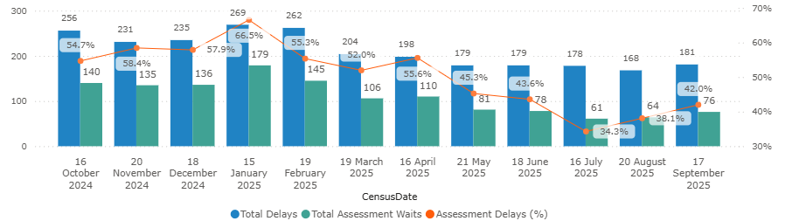
Figures 3: Total Days Delayed

Trajectory is the improvement required by Welsh Government

. 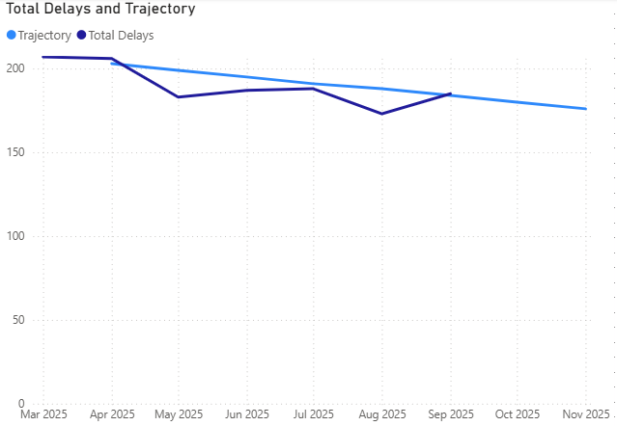

The 3 leading causes of Total Days Delayed are Care Home placement arrangements, Assessment Issues, Disagreements /Legislation account for

Since February 2025, Total Days delayed have fallen every month, with the exception of July.

Delay Reason Group | Total Days Delayed | %
Care Home placement arrangements | 2129 | 25%
Assessment Issues | 2059 | 25%
Disagreements /Legislation | 1699 | 20%
Housing Related Issues | 786 | 9%
Funding issues | 538 | 6%
Home care related issues | 485 | 6%
Home adaptation/equipment issues | 461 | 5%
Step down to recover and assess | 230 | 3%
Total | 8387

Figure 4 Assessment Delays & Trajectory

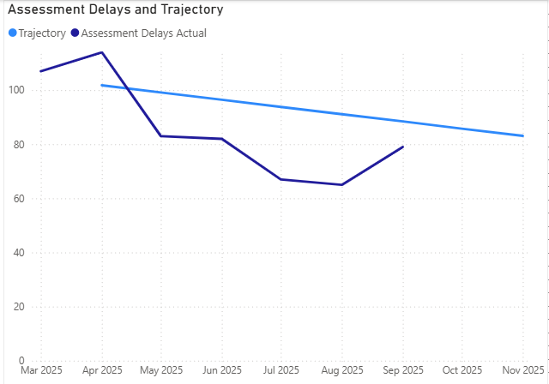

Assessment delays have fallen to 76 in September, from 179 in January. July saw the lowest number of Assessment Delays (61) for 2025 year to date.

Assessment Issues are the highest driver of delays, accounting for 40%- this will be mitigated when a full Trusted Assessor model is achieved.

A snapshot of reason in bed codes for October shows the delays at the assessment stage

Figure 5

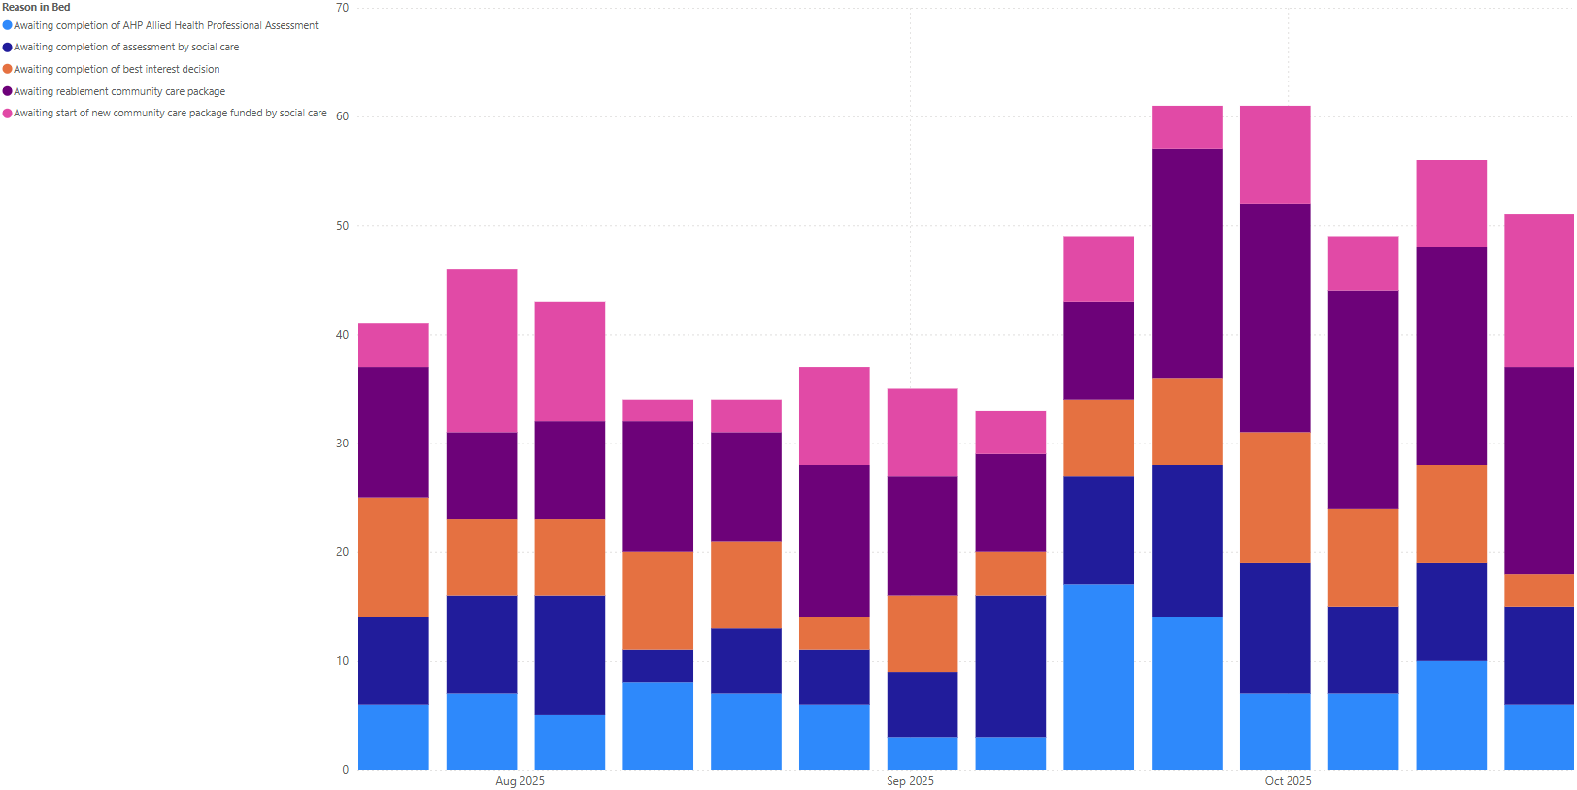

Figure 6: Total Days Delayed & Trajectory

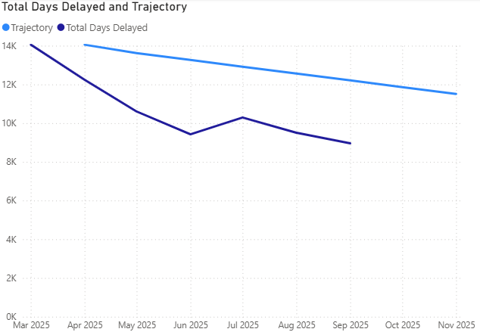

Total Delays have been fallen from 269 in January to 181 in September, with August seeing the lowest number of Total Delays (168) year to date, this is 12 below the target set for November.

.

GOVERNANCE & RISK IMPLICATIONS

Whilst progress has been made, the pace of reduction of delays has reduced with a number of themes identified and requiring mitigation. A face-to-face summit has been arranged for 3rd November to consider the actions required that can be operationally changed and to identify any escalations to Older Person and Communities Board for Executive decision. The outcome of this will inform the next refresh of the POCD Action Plan and will also support the ability to deliver reductions during the winter period.

Identified risks include:

Workforce: Significant sickness and absence leave in the social care workforce has impacted flow during September and October, requiring a period of rapid recovery. Without resilience in the workforce the ability to maintain flow is limited.

Capacity: Recent changes within the Pathways has created additional demand for Pathway 1 during recent months, with higher acuity patients entering the pathway it has reduced flow and led to increased waits in the system which are impacting flow.

Residential/Nursing Homes: Whilst the number of Pathway 3 patients has reduced in accordance with D2RA principles, delays continue to be incurred without a Trusted Assessor model for the sector, whilst staff from the homes attend hospitals to assess patients. This is a priority area for improvement.

Resource: Resourcing the pathways and new service models such as IDH and Trusted Assessor remain a challenge. A full demand and capacity analysis is under development and will be supported by Deloitte. This work will be undertaken in tandem with the Community Services Review currently underway. The outcome is to enable service and resource reconfiguration to proceed, to match capacity with demand- utilising our existing resources more effectively.

FINANCIAL IMPLICATIONS

All activity set out in this paper has been delivered within the envelope of existing resources. Whilst social services have received Welsh Government Grant funding to enhance reablement capacity in 2025, Health Boards have not received any D2RA/POCD specific funding. The Integrated Discharge Hub requires resourcing to deliver a stable workforce within the Hub, this risk has been noted on the PCT/Corporate risk registers and has been reported to Older People and Communities Board.

The demand and capacity review will also consider the demand for and capacity needed at each Pathway which have not received any additional funding since 2021. Anecdotal evidence suggests both demand and acuity are increasing. This review and the Community services review will provide an accurate overview of the resources available, what is needed to deliver efficient discharge pathways and will identify opportunities to realign within the current resource envelope, given the financial context.

RECOMMENDATIONS

- To consider the progress made in delivering Pathways of Care Delay reductions
- To consider the current risk around the Integrated Discharge Hub
- To consider the pace of progress is slowing and the mitigations required to support continued reductions to achieve a reduction to 150 and below in 2026

Governance and Assurance

Link to Enabling Objectives  (please choose) | Supporting better health and wellbeing by actively promoting and empowering people to live well in resilient communities
Link to Enabling Objectives  (please choose) | Partnerships for Improving Health and Wellbeing |  | ☒
Link to Enabling Objectives  (please choose) | Co-Production and Health Literacy |  | ☒
Link to Enabling Objectives  (please choose) | Digitally Enabled Health and Wellbeing |  | ☐
Link to Enabling Objectives  (please choose) | Deliver better care through excellent health and care services achieving the outcomes that matter most to people
Link to Enabling Objectives  (please choose) | Best Value Outcomes and High Quality Care |  | ☒
Link to Enabling Objectives  (please choose) | Partnerships for Care |  | ☒
Link to Enabling Objectives  (please choose) | Excellent Staff |  | ☒
Link to Enabling Objectives  (please choose) | Digitally Enabled Care |  | ☒
Link to Enabling Objectives  (please choose) | Outstanding Research, Innovation, Education and Learning |  | ☐
Health and Care Standards
(please choose) | Staying Healthy |  | ☒
(please choose) | Safe Care |  | ☒
(please choose) | Effective Care |  | ☒
(please choose) | Dignified Care |  | ☒
(please choose) | Timely Care |  | ☒
(please choose) | Individual Care |  | ☒
(please choose) | Staff and Resources |  | ☒
Quality, Safety and Patient Experience
Focused on reducing POCD and improving patient experience
Financial Implications
As set out in the document
Legal Implications (including equality and diversity assessment)
None
Staffing Implications
As set out in document, consistent staffing is required to manage the IDH and support expanded HB wide function
Long Term Implications (including the impact of the Well-being of Future Generations (Wales) Act 2015)
None
Report History
Appendices |  | Appendix 1 POCD SITREP  Appendix 2 POCD Summary

