Meeting Date | 26 November 2024 |  | Agenda Item |  |  | 4.1
Report Title | Quality Priority Deep Dive: Sepsis
Report Author | Dr Rangaswamy Mothukuri, Senior Responsible Officer, Sepsis  Lisa Fabb, Acute Deterioration Lead
Report Sponsor | Dr Richard Evans, Executive Medical Director
Presented by | Lisa Fabb, Acute Deterioration Lead
Freedom of Information | Open
Purpose of the Report | To provide an update on the goals, methods and outcomes for the Sepsis quality priority and how these are becoming business as usual by December 2024.
Key Issues | - Sepsis remains a leading cause of avoidable harm in Healthcare in Swansea Bay UHB (Crude Sepsis Mortality from January 2022);  - In view of current restructuring of acute services, it is difficult to maintain consistent levels of training and audit;  - A digital sepsis tool is being trialled in Neath Port Talbot Hospital;  - Engagement is taking place between microbiology and the emergency department around anti-biotic prescribing;  - Progress with the road map set out to deliver sepsis as business as usual by December 2024 is continuing.
Specific Action Required  (please choose one only) | Information | Discussion |  | Assurance | Approval
Specific Action Required  (please choose one only) | ☐ | ☐ |  | ☒ | ☐
Recommendations | Members are asked to:  - ACKNOWLEDGE the progress to date against the 2023-24 GMOs;  - ACKNOWLEDGE progress against the road map and plans to deliver sepsis as ‘business as usual’ by December 2024;  - ACKNOWLEDGE the risks to delivery and the mitigating actions.

Quality Priority Deep Dive: Sepsis

- INTRODUCTION
The Health Board identified Sepsis as a Quality priority in 2021. This paper outlines what has been achieved so far and the focus for 2024. It also sets out the actions required to incorporate this into business as usual, and highlights the developments during the last six months.

- BACKGROUND
The Sepsis lead and Senior Responsible Officer took up roles in April 2022 and have led on promoting the priority across the health board since this time.

When the review of the sepsis work started, it became clear that following COVID-19, a lot of the work done on sepsis over the previous years had taken a back seat and there was a lack of awareness around the importance of early diagnosis and intervention. There was a gap noted in the training amongst the staff and the trained staff numbers had fallen significantly. It was also noted that a lot of the resources being used before were not being used and implemented.

The sepsis quality priority work at this time demonstrated that the paper-based sepsis screening tool completion compliance was very poor across all areas due to various reasons. Therefore, the first year of the Sepsis Quality priority was spent understanding the causes of this and trialling other modes of screening. Around this time the Academy of Medical Royal Colleges (AoMRC) guidance was published and subsequently updated. This necessitated substantial changes to the sepsis screening system and make it aligned to the new guidance. This is now implemented and is being used.

Following discussions with digital team, it was agreed to trial a digital sepsis screening tool on Signal. Alongside this work there has been continuous work around microbiology, education, engagement of sepsis champions and service group leads.

- GOVERNANCE AND RISK ISSUES

- Progress to Date
Since the last update report, the following progress has been made:

1. National and local Sepsis Group:
- Swansea Bay UHB led in setting up the All-Wales Sepsis Steering Group and following multiple meetings, the Group provided a statement of recommendations including national measures which have been agreed in principle and will form part of the Quality, Safety and Improvement Directorates NHS Executive’s safety work. (Appendix 1)

2. Sepsis Communication Campaign
- Service Group educators are engaged and provide with regular updates. Sepsis team have recently collaborated with educators to provide easy decision guide and levels of sepsis training appropriate to the area of work. (Appendix 2)

3. Sepsis Screening Tool Launched May 2023
- Paper screening tool was launched in May 2023.
Digital sepsis screening tool is being trialled in Neath Port Talbot Hospital with the following compliance recorded:

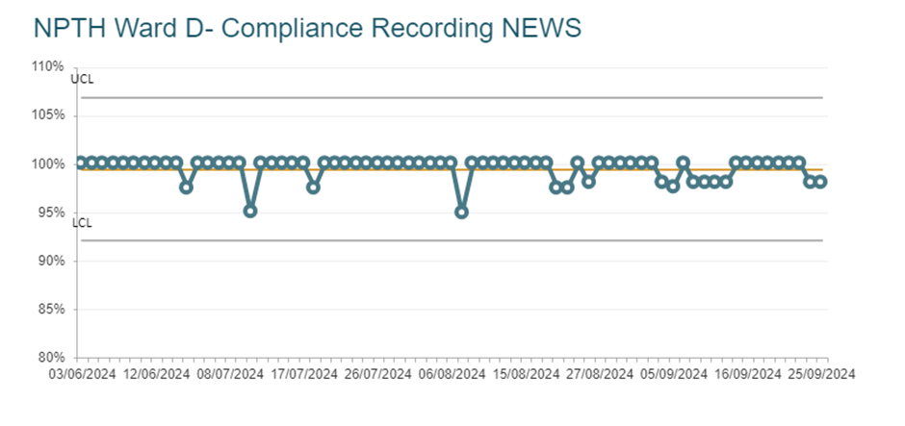
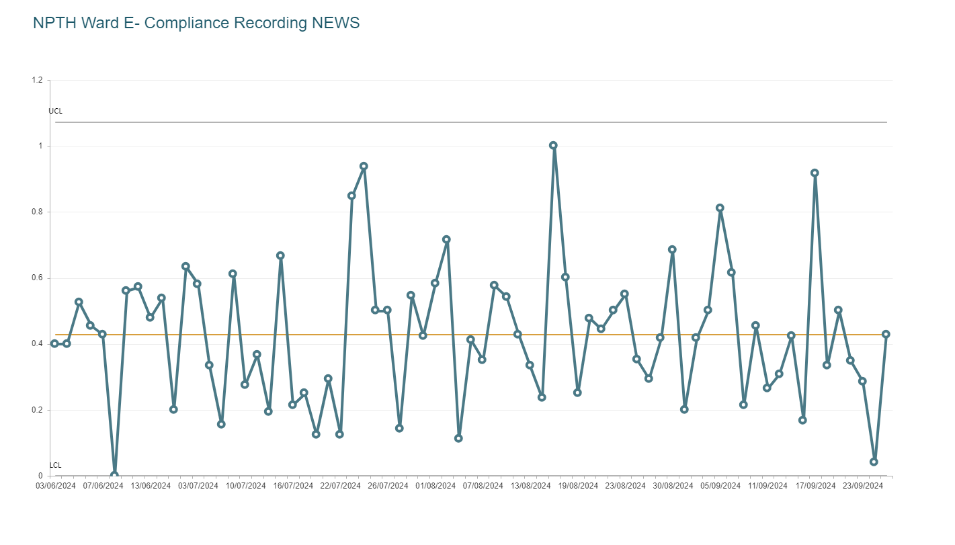

Fig 1

The numbers of ‘sepsis probable’ for the audit are low but the verbal feedback given was that it was being implemented and they are finding it very helpful.

4. Sepsis Awareness Training
- More than 3,000 staff trained – this has increased from 2,000 since the update in May 2024;
- Ward based briefing and training is currently being provided by the nurse educators and the sepsis champions. It was agreed that a baseline set of slides would be provided to all and then the areas can modify it to tailor to their local policy.

- The improved number of trained staff has once again helped in improving the general awareness of sepsis amongst staff. More importantly, it ensures that there are staff trained on sepsis awareness during most shifts

- National e-learning module on sepsis had been updated and signed off. This is available via ESR (Electronic Staff Record).

5. Audit
- 247 audits cycles of the completion of the sepsis screening tool completed over 12 months across adult acute sites.
- Improvement was seen post sepsis screening launch but over the last 12 months the submission of data has been variable. Feed for sepsis audit on ward where digital sepsis screening is being trialled is automatically updated and monitors all patients not as a monthly sample. Support for audit process has been focussed on admitting units currently.
- In an attempt to ensure sepsis assurance is ‘business as usual’ changes have been made to ward’s ‘Healthcare Standards’ audit when it moves to AMaT.

6. Engagement with Microbiology

As part of the review, the sepsis team looked at various aspects of management and tried to narrow down on aspects which would be the most valuable in terms of having the best outcome.

- Deep dive to look at first dose antibiotic prescribing in the Emergency Department was completed with a cross referencing antibiotic prescribing with blood culture results. The aim is to “Get it right the first time”.
- The findings will be presented in the ED Clinical Governance meeting in October 2024. Awaiting agreement of action plan as the findings showed that 75% of antibiotics were prescribed as per the micro-guide and those which were not were prescribed by junior doctors. Actions being considered were discussion with a consultant before prescribing and peer-led improvement and engagement with junior prescribers.
- The second thing looked at was collaboration with Emergency Department staff to improve blood culture filling and turnaround time, which can improve accuracy of results by 49% and help target antibiotic prescribing. A short efficient “Tik Tok style” training video has been developed to demonstrate the correct practice along with infographic branding. This was done after a review of the barriers to good practice. These finding will be discussed in the next ED clinical governance meeting.

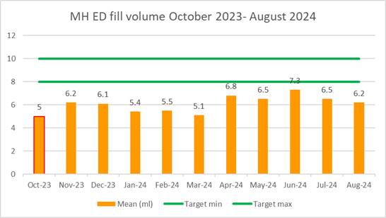
Fig 2.

The data above shows that since the discussion and the dissemination of the “tik tok” video, there has already been an improvement in the volume of blood collected for the blood culture samples. Although more work is required to consolidate that data, it is a step in the right direction and the aim is to disseminate this information across other ward areas.

- Delivery of the Sepsis quality priority
The GMOs (Goal, Methods, Outcomes) for 2023/24 are set out below:
Goal | Method | Outcome | 3 month Target | 6 month Target
Reduce sepsis mortality by improving recognition and response to acute deterioration | Raise awareness through education and events | Sepsis Summit completed on World sepsis day 13 Sept with an aim to engage staff in sepsis improvements.  Revise All Wales Sepsis E-learning training. | 50% of ward staff to have received sepsis training. | 75% of ward staff to have received sepsis training.  Currently Achieving  63%
Awareness and timely management of sepsis to become ‘business as usual’ by December 2024. | Achievement of above. | Sustained improvement in sepsis care and outcomes. | Sepsis Audit to be embedded in to Wards Monthly Audit via Audit Management and Tracking (AMaT) | Ward’s Monthly Audit (Sepsis questions) outcomes to be reported to each service group RADAR (or equivalent)

Some of the work to deliver the GMOs has included:

- Training:
Sepsis training remains key in the improvement of sepsis treatment and recognition. To ensure there is robust training programme reaching all areas of the health board, training has been devolved to nurse educators for clinical directorates supported by the Sepsis Quality Priority team. From the data available, 63% of ward staff have had sepsis training. Due to various acute services movement through restructuring it has been difficult to maintain robust training data.

Having training devolved has ensured that all staff, internationally trained nurses and newly registered nurses have sepsis training on induction as well as regular update training. To date, more than 3000 nurses have had Sepsis training since the Sepsis quality priority launch in November 2022. The sepsis team have updated the national ESR Sepsis e-learning module to improve learning records. This has gone live.

Sepsis team has collaborated with nurse educators to ensure that the right staff have appropriate training, this reduces the burden of training and ensures it remains relevant to their practice. A basic subset of slides has been given to all involved and they are tailoring it as per their needs in the area of practice. (Appendix 3)

- Communication:
Sepsis will be part of a quality priority ‘thankyou’ screen saver in the next few months, this will share some of the ‘good news’ around sepsis e.g. doubling the amount of sepsis screening.

The sepsis team are regularly supporting sepsis champions and service group educators to provide appropriate training and improve awareness around sepsis and its management. In view of trying to achieve the final aim of ‘business as usual’, the wards have been supported to independently monitor, implement, analyse and provide sepsis data to the service groups.

Resuscitation hub page is a central source of sepsis resources which was launched in October 2023.

- Audit:
The audit of completion of the sepsis screening tool is currently being collected via a Microsoft form. Going forward this will be collected via the ward monthly audit, as part of a larger regular audit it is hoped that submission will improve. The graph below provides an example of compliance with the tool:

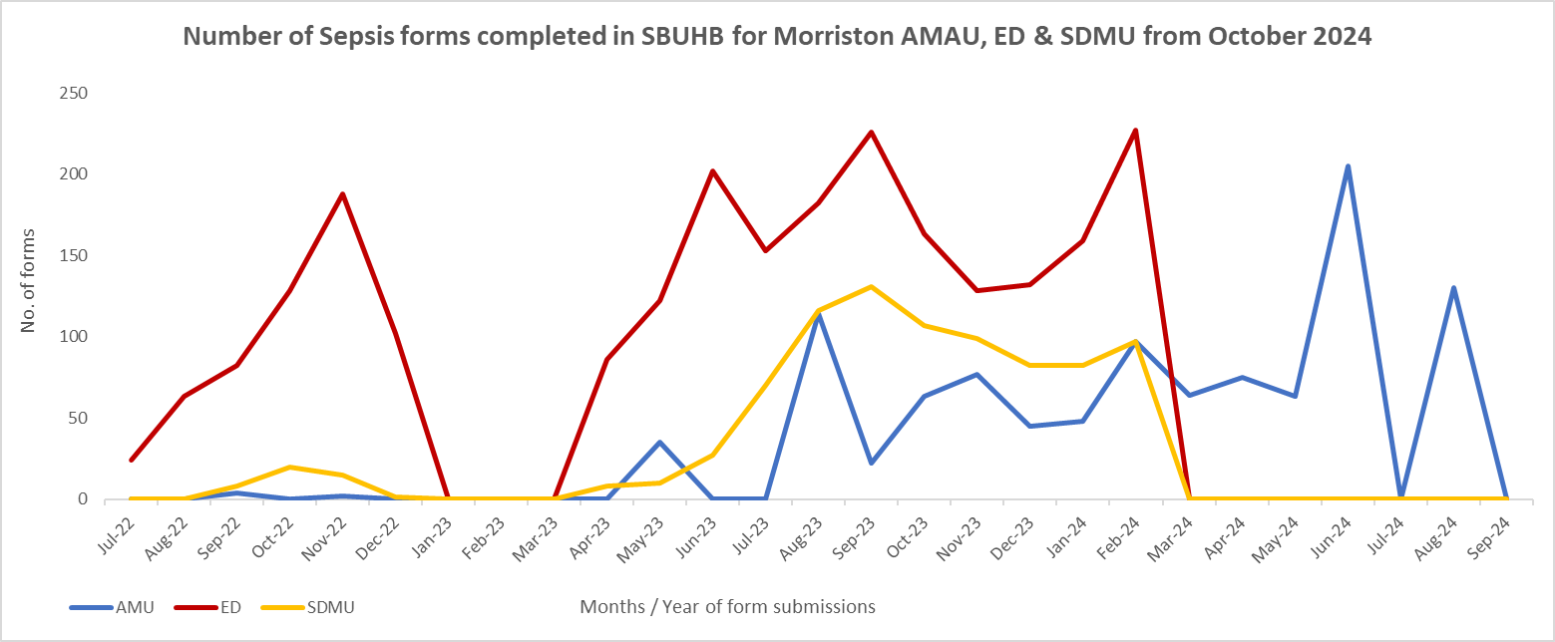

Fig 3

There is still a lot of variability in completion of the sepsis screening tools in the wards but the aim is to review the digital data from the trial area and then implement that in all the ward areas in future. The aim of doing it is to digitalise and do e- observation for all the ward areas as the final goal.

- Service Group Quality Improvement Projects
Two of the service groups have put forward quality improvement projects for sepsis:

NPTSSG (Neath Port Talbot/Singleton Service Group):
- Increase use of NEWS (National Early Warning Score) and Sepsis icons on Signal Boards, improving the use of visual management systems to improve sepsis awareness and monitoring. As above fig 1, there has been positive feedback from medical and nursing staff, however the variation in the completion of screening is evident in the above data.

MSG (Morriston Service Group) –
- Improving blood culture sampling in Emergency Department to improve antibiotic prescribing.
- A review of first dose antibiotics demonstrated good antibiotic prescribing and microbiology testing with some improvement required in Tazocin prescribing.

- Performance Metrics
As part of the discussion of the Management Board report in May 2024, a set of metrics were suggested for inclusion in the next iteration. These have been discussed, and where possible taken forward, and where not, an explanation provided:

- Readmission rates of Sepsis patients: data is now being collated by ITU to identify any readmissions within three months with sepsis. This information will be available for future reports.
- Morbidity from Sepsis: a review of all 18 to 60 year olds with a mortality as a result of sepsis from May to August 2024 was conducted:

4 cases reviewed | 2 End of Life | 2 sepsis diagnosis had timely interventions. | All cases were complex with multi morbidity.

The data showed that patients were managed appropriately and in a timely manner. The main finding was that patients presenting to ED or acute admissions areas received appropriate and timely interventions.
As an observation, the delay in identifying sepsis in some cases on the wards was for the patients who have been in the hospital with a different diagnosis initially and while being in the hospital had deteriorated and there was a delay in identifying the signs and implementing appropriate treatment.
The focus, team feels, going forward, should be to look at the role of the acute deterioration team and also include the outreach teach team in the review of this group of patients at an early stage.

- ICU admissions and whether any difference has been made:
The Sepsis Team continue to monitor admissions to ICU (intensive care unit) As a result of previous deep dive, the sepsis team are reviewing all sepsis mortality in those aged 18 -60 yrs.
- There were no noticeable delays which would alter the outcomes.
- All four patients had life limiting conditions.
- All four had complex conditions.
- Of nine cases on the sepsis mortality dashboard five were not sepsis.
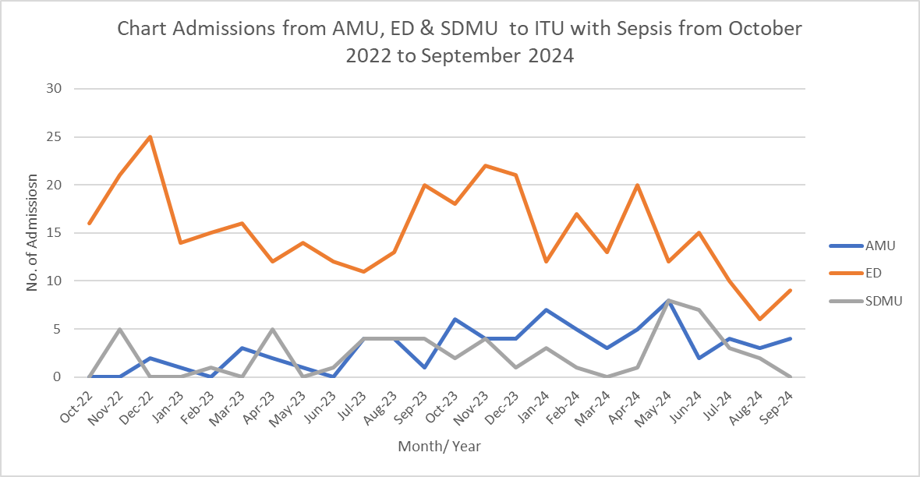
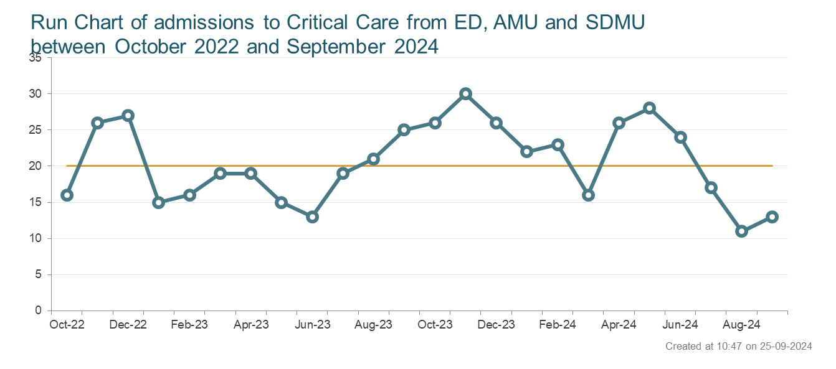

Fig. 4

- Mortality from Sepsis: see fig 5
Sepsis mortality Fig 5 since the introduction of the Sepsis Quality Priority.

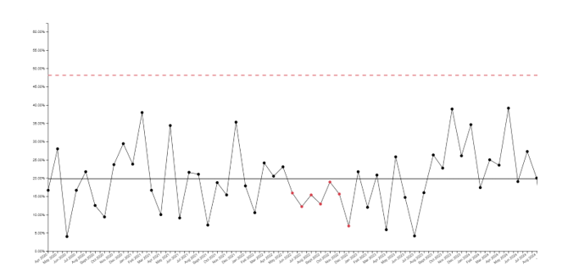

Fig 5.

Targets for the service groups, were set out in the Sepsis report submitted October 2023. These have been achieved although it is acknowledged that the measures were not clearly capturable, as a result a moved was made to ‘number of forms collected’ with a target of doubling forms collected.

The collaboration with the microbiology team is continuing to focus on “Getting it right the first time” for the first dose antibiotic prescription and correct blood culture sampling. See fig 2, some improvement in Blood Culture collection noted and overall good compliance with first dose antibiotic prescribing.
On a national basis, as a result of discussion in the All Wales Sepsis Steering Group (Appendix 1), the following sepsis measures, once finalised, will be recommended to Welsh Government for implementation at a national level. In preparation of these measures a small number have been trialled for data collection.

1. What % patients who screen as Probable Sepsis receive Antimicrobials within 1hr? (Time Zero = first NEWS2 score on initial assessment accompanied by suspected or confirmed infection) See results of trial audits below

Emergency Department 2024 | June | July
Sepsis Unlikely | 12 | 3
Sepsis Possible | 2 | 2
Sepsis Probable | 3 | 4
Antibiotics given within an hour | Only 1 of 3 recorded antibiotic administration that was within one hour. | 4

Measures 2 and 3 are more difficult to reliably collect, work is ongoing with Morriston Service Group as to a potential solution which will be shared with the clinical cabinet for thoughts before it is taken forward:
2. What % of patients have a review by a Senior Clinical Decision maker within 6 hours of a Probable Sepsis Diagnosis?
3. What % of patients have a Consultant or Micro review of Antimicrobials within 48hrs? (AoMRC)

The aim in SBUHB is to work towards achieving this over the next four months. This will be led by the Resuscitation and Acute Deterioration team and report to RADAR and Sepsis Steering Group.

- Governance and Reporting
The reporting structure for sepsis comprises:

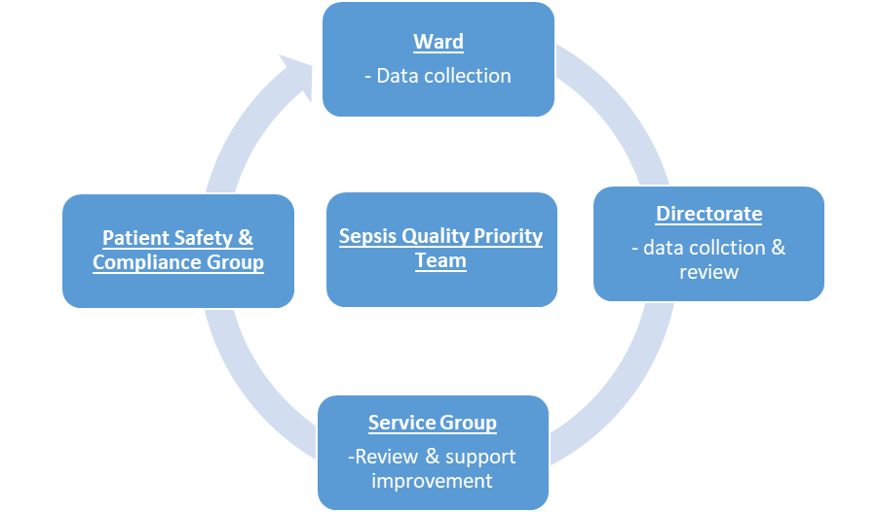

The health board’s governance structures in respect of quality and safety were updated during 2022, with a number of groups being replaced. The reporting framework for sepsis includes:

- Quality Management Board
- Quality and Safety Group
- Patient Safety and Compliance Group.
- RADAR & Quality Priorities Programme Board
- Sepsis Steering Group.

All Service Groups plans for governance, audit & training as Sepsis moves to business as usual.

Service Group | Lead | Audit | Governance | Training
Morriston | Senior Nurse, Quality Improvement | Monthly ward audit | QP and Q&S meetings | Nurse educators
Neath Port Talbot Singleton | Head of Nursing & Clinical Site Matron | Monthly ward audit | Q&S meeting | Nurse educators
Community and Primary Care | Head of Nursing PCT Services Group | Monthly review of notes | Q&S meeting | Nurse educators
Mental Health and Learning Disability | Senior education lead | Monthly ward audit | Q&S meeting | ESR elearning
Maternity | Deputy Head of Midwifery | Monthly ward audit | Q&S meeting | Nurse educators
Paediatrics | Consultant Paediatrician | Review of admission notes- quarterly | Q&S meeting | Nurse and medical Educators

- Future Direction
The roadmap below sets out the key priorities to achieve ‘business as usual’ for sepsis by December 2024:

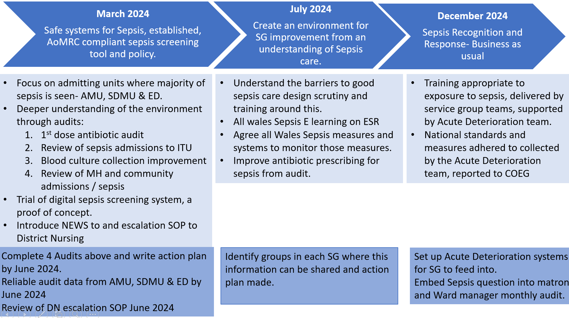

- Risks to Delivery
The following risks have been identified within the above forums:

- Engagement of Service Groups in Sepsis Audit remains a key risk to the delivery of the Sepsis Quality Priority as improvement cannot be measured. It is hoped that sepsis audit will be prioritised when the AMaT goes online for nursing use across the HB.
- There is still a lot of reorganising and restructuring happening within SBUHB and staff are moving to different areas. Ensuring that the training levels are maintained at all times so that there are staff aware of sepsis and its management will be challenging. When the process moves to the ‘AMaT Ward based Audit’ the data will be held by the wards, so it will move with the services should they move geographic location.
- Capacity across the central and service group teams in the context of competing demands, including clinical commitments. The mitigation to this is service group engagement and ownership and moving to digital solutions where possible.

- Summary:
Review of the work done over the past two years shows that the team has successfully managed to raise awareness on sepsis identification and timely management to pre COVID levels. The aim was to ensure that the sepsis related work (identification of signs, initiating timely intervention, teaching, and training) becomes “business as usual” and part of daily work by December 2024. This is on track.

The sepsis screening tool is available on COIN and there is an increased awareness of the importance of completion of the form amongst all hospital staff. There is increased level of training amongst all nursing staff, in spite of having a period of restructuring and reorganisation within the Health Board. The teaching has now been devolved to the respective specialities and training in being undertaken by the sepsis champions. Work is underway to finalise data collection by the wards using from forms and submission via AMaT. There is a clear governance structure within each service group with platforms for each specialty to present their results.

There is work done focussing along the lines of the Health Board’s aim with regards to getting the “antibiotic prescription right the first time” and also on improving sensitivity of test based on blood culture sampling which has shown positive results in the ED and will be taken to other acute areas within the Health Board.

Swansea Bay is leading the way in data collection as it is currently being done in all areas within the HB as opposed to data collection in other Health Boards which mainly focusses in ED.

There is work ongoing within Wales for introducing the NEWS2 as an observation chat. The triggering tool for sepsis would change based on that. The health board’s sepsis screening tool will need minimal changes to make it complaint.

There is still a lot of work to be done but there are steps in the positive direction.

- FINANCIAL IMPLICATIONS
Currently this is the position but it is under review. The Sepsis quality priority is supported through £67,000 investment from the quality priorities, which is funding:
- 1 clinical session to promote Sepsis;
- Investment into the Resuscitation Team to part fund 1 x WTE (whole time equivalent) 8b Resuscitation Team leader and Sepsis lead plus 0.8 x WTE 7 Resuscitation Officer.

Previous investment into 1 x clinical session to support the RADAR group across the health board has been allocated to a clinical Quality Priority lead role, following the retirement of the previous post holder.

- RECOMMENDATION
Members are asked to:
- ACKNOWLEDGE the progress to date against the 2023-24 GMOs;
- ACKNOWLEDGE progress against the road map and plans to deliver sepsis as ‘business as usual’ by December 2024;
- ACKNOWLEDGE the risks to delivery and the mitigating actions;

References
Bion JBG, Boyle A, Carrol E, et al. Academy of Medical Royal Colleges statement on the initial antimicrobial treatment of sepsis. 2022. https://www.aomrc.org.uk/reports-guidance/statement-on-the-initial-antimicrobial-treatment-of-sepsis/

Governance and Assurance

Link to Enabling Objectives  (please choose) | Supporting better health and wellbeing by actively promoting and empowering people to live well in resilient communities
Link to Enabling Objectives  (please choose) | Partnerships for Improving Health and Wellbeing |  | ☒
Link to Enabling Objectives  (please choose) | Co-Production and Health Literacy |  | ☒
Link to Enabling Objectives  (please choose) | Digitally Enabled Health and Wellbeing |  | ☒
Link to Enabling Objectives  (please choose) | Deliver better care through excellent health and care services achieving the outcomes that matter most to people
Link to Enabling Objectives  (please choose) | Best Value Outcomes and High Quality Care |  | ☒
Link to Enabling Objectives  (please choose) | Partnerships for Care |  | ☒
Link to Enabling Objectives  (please choose) | Excellent Staff |  | ☒
Link to Enabling Objectives  (please choose) | Digitally Enabled Care |  | ☒
Link to Enabling Objectives  (please choose) | Outstanding Research, Innovation, Education and Learning |  | ☐
Health and Care Standards
(please choose) | Staying Healthy |  | ☐
(please choose) | Safe Care |  | ☒
(please choose) | Effective Care |  | ☒
(please choose) | Dignified Care |  | ☒
(please choose) | Timely Care |  | ☒
(please choose) | Individual Care |  | ☒
(please choose) | Staff and Resources |  | ☒
Quality, Safety and Patient Experience
Sepsis Quality Priority reports to the Quality Priorities Programme Board, which reports to Quality & Safety Group, RADAR Committee and Sepsis Steering Group, which reports to Quality, Safety and Patient Services Group. The overall aim is to reduce harm from sepsis through timely review and treatment and provide a better patient experience.
Financial Implications
No financial implications noted in this report.
Legal Implications (including equality and diversity assessment)
Risk of Duty of Candour and clinical negligence claims from failure to identify and respond to sepsis
Staffing Implications
Sepsis medical and nursing leads have been identified for each service group (SG) and training is delivered by sepsis team and SG clinical educators and champions across all SG areas, bespoke team training and induction training. The SRO (senior responsible office) and project lead have dual roles with clinical commitment and service lead responsibilities.
Long Term Implications (including the impact of the Well-being of Future Generations (Wales) Act 2015)
The focus of the Sepsis quality priority work is earlier identification and treatment of sepsis. This will improve impact of sepsis for the individual and their loved ones. This has a positive impact on the well-being of patients and families.
The Quality Improvement programme ensures integration with partner agencies such as other Health Boards and care homes. There is collaboration with both partner agencies and Improvement Cymru to progress QI work streams.
Report History |  | Regular report to the committee
Appendices |  | Appendix 1 – all-Wales sepsis group letter;  Appendix 2 – Sepsis decision making leaflet;

