Meeting Date | 26 November 2024 |  | Agenda Item |  |  | 3.3
Report Title | Clinical Audit and Learning From Deaths Update
Report Author | Sharon Rağbetli, Clinical Audit & Effectiveness Manager
Report Sponsor | Dr Richard Evans, Executive Medical Director
Presented by | Dr Helen Dean, Associate Medical Director for Quality and Safety and Professional Concerns
Freedom of Information | Open
Purpose of the Report | This report provides an overview of the work of the Clinical Outcomes and Effectiveness Group (COEG) as well as a summary of performance against clinical audit plans, published mandated national audits/registries and on mortality through the Learning from Deaths Panel.
Key Issues | - Progress against clinical audit, outcomes and effectiveness is overseen on a monthly basis by the COEG and reported to the Quality and Safety Group;  - Progress against the service groups’ identified audits for 2022/23 remains at 87% and had increased to 55% for 2023/24. Completion for 2024/26 currently stands at 4%.  - 13 overdue responses to NICE (National Institute for Clinical Excellence)/HTW (Health Technology Wales) guidance or national audit/registry publications were escalated to the Quality and Safety Group;  - The annual report for 2023/24 was signed off at the July 2024 COEG meeting.
Specific Action Required  (please choose one only) | Information | Discussion |  | Assurance | Approval
Specific Action Required  (please choose one only) | ☐ | ☐ |  | ☒ | ☐
Recommendations | Members are asked to:  - ACKNOWLEDGE the progress made within all clinical audit areas;  - ACKNOWLEDGE the outstanding Welsh Government proformas and responses to NICE/HTW Guidance are escalated to the Quality Safety Group;  - ACKNOWLEDGE the achievement of completing 87% of the 22/23 Audit Plans and increasing to 55% for 2023/24;  - ACKNOWLEDGE the audit period for 2024/25 has been extended to 2024/26 to accommodate completion and presentation of topics and the resulting actions  - ACKNOWLEDGE the number of Level 3 Mortality Reviews closed;  - ACKNOWLEDGE completion and sign-off of the annual report for 2023/24.

CLINICAL OUTCOMES AND EFFECTIVENESS REPORT

- INTRODUCTION
The health board’s hierarchy of audit activities lists five levels, as set out in the Clinical Audit and Effectiveness Policy:

- Level one - mandated national audits and registries;
- Level two - a small number of HB (health board) Audit Priority Topics
- Levels three and four - audit Plans at Service Delivery Group and Department levels
- Level five - emergent necessary ad-hoc topics.

This report provides an update on delivery of and progress with planned audits at levels 1-4.

In addition, it provides an update against the NHS Delivery Unit and Welsh Government National Learning from Deaths Framework, adopted by the HB to support local processes established to screen, review and provide feedback on any queries or concerns identified by the Medical Examiners (ME) Service and/or the bereaved. It forms a key part of the clinical outcomes work. The approach enables the HB to address any concerns and themes that emerge from the data collected, supported by a customised dashboard.

2. BACKGROUND
Patient outcomes and clinical effectiveness is part of the remit of the Quality and Safety Group but is discharged through the Clinical Outcomes and Effectiveness Group (CEOG). COEG meetings are held on a monthly basis with the exception of August and December to report progress on each of the areas of focus as well as receive presentations on the lessons learned from various audits. The COEG reports to the Quality and Safety Group on a bi-monthly basis and to the Quality and Safety Committee as required.

Following a review of performance against clinical audit plans, it has been agreed to change the clinical audit plan period to two years, making this year’s plan now 2024/26, to acknowledge the time taken to be able to close-down an audit record; complete data collection, collation and presentation of results to an audit meeting to agree actions and timeframes. This should in theory, allow the service groups sufficient time to have the key learning outcomes summarised and listed actions completed or progressed sufficiently to complete the audit record.

- GOVERNANCE AND RISK ISSUES

3.1 Mandated National Audits/Registries (Level 1)
All health boards are required to participate in the Welsh Government list of mandated topics. The list was refreshed in Summer 2024. In recent years more topics have moved from time-limited to continuous data collection.

Having previously been contacted in April 2023, leads for the Level 1 topics were once again provided with a link in September 2023 to update the group on any issues preventing participation and to provide an opportunity to highlight areas of good practice. This will continue to happen on a quarterly basis during the extended 2024/26 audit period. Outstanding responses were escalated at the October 2024 COEG meeting. Submissions are reviewed by the senior team in action and agenda setting meetings to identify the areas required to present at COEG meetings in more detail.

    - Assurance Proformas
In addition to requiring quarterly updates from Level 1 leads, COEG retains the two-stage assurance proforma process following publication of mandated national audit/registry topics previously mandated by Welsh Government.

Table 1. below details the number of Assurance Proformas issued and the responses received by Audit Year;

Assurance Proformas Returned
1st April 23 – 31st March 24 | 1st April 24 to date
33/39 (85%) | 20/35 (57%)
Table 1.

It was acknowledged by the group that whilst 5 MBBRACE–UK (Mothers and Babies: Reducing Risk through Audits and Confidential Enquiries across the UK) topics were previously escalated and all subsequently completed and a number of further maternity related responses had been cleared by the new lead, there was a need to clear five historic responses and one recent. As such, the lead has been contacted to attend a future meeting, should responses not be cleared by the dates provided.

Breaches of the eight-week timescales are escalated to the Quality and Safety Group by the COEG as part of the governance route and for onward management. As at the October 2024 COEG meeting, no assurance responses needed to be redirected and therefore no exceptions were noted.

The previously escalated response on National Oesophageal Cancer Audit remains outstanding. The Associate Medical Director for Professional Concerns and Quality and Safety has contacted the relevant individuals to ensure action.

3.1.2 Responses to Key National Guidance and Publications
Responses to newly issued/updated NICE (National Institute for Health and Care Excellence) and/or Health Technology Wales (HTW) guidelines are also reviewed by COEG. Since 1st April 2023, 97/113 (86%) responses have been completed for the 2023/24 cohort. This is an improvement from 80% reported in the last paper. To date 50% of responses have been received for 2024/25.

The latest compliance data for responses to key national guidance and mandated national audit/registry topic publications, shows that the 8-week target had been breached for;
- IPG768 Irreversible electroporation for treating prostate cancer – previously escalated to Quality and Safety Group
- NG158 Venous thromboembolic diseases: diagnosis, management and thrombophilia testing – previously escalated to Quality and Safety Group
- NG126 Ectopic pregnancy and miscarriage – previously escalated to Quality and Safety Group
- NG235 Intrapatum care – previously escalated to Quality and Safety Group
- NG192 Caesarean birth – previously escalated to Quality and Safety Group
- NG229 Fetal monitoring in labour – previously escalated to Quality and Safety Group
- Assurance Proforma National Oesophago-gastric cancer audit – previously escalated to Quality and Safety Group
- QS75 Neonatal infection – previously escalated to Quality and Safety Group
- Health Technology Wales – Digital wound management tools – previously escalated to Quality and Safety Group
- Assurance Proforma National Joint Registry
- QS140 Transition from Children’s to Adult Services
- NG137 Twin and triplet Pregnancy
- Assurance Proforma State of Kidney care in the UK

These have been escalated to the Quality and Safety Group for action to be taken.

    - NCEPOD (National Confidential Enquiry in Patient Outcome and Death) Studies
The NCEPOD Study into ICU (Intensive Care Unit) Rehabilitation has concluded with no issues. It was reported at the October 2024 meeting that two Hyponatraemia questionnaires were outstanding. These have subsequently been submitted.

The NCEPOD – ‘Emergency (non-elective) Procedures in Children and Young People’ study has commenced with four questionnaires and case notes issued.

3.2 Health Board Priority Topics (Level 2)
A number of topics are identified by the Executive Medical Director’s Department in order to generate data for the HB (health board) and to support healthcare professionals in training to evidence participation in audit and quality improvement activities. Current progress with these topics is indicated in the table below;

Consent to Treatment Round 1 | 646
Consent to Treatment Round 2 | 357 (up from 319)
Antimicrobial Stewardship Round 1 | 2
Antimicrobial Stewardship Round 2 | 87 (static)
Do Not Attempt Cardiopulmonary Resuscitation Round 1 | 203
Do Not Attempt Cardiopulmonary Resuscitation Round 2 | 64 (static)
Care in the Last Days of Life Round 1 | 91
Care in the Last Days of Life Round 2 | 20 (static)
Table 2.

Updates to the ‘Do Not Attempt Resuscitation’ and ‘Care in the Last Days of Life’ audit tools are being finalised. Presentations on each of the Level 2 topics are scheduled into the COEG meetings regularly. The lead for ‘Care in the Last Days of Life’ previously indicated that due to the ‘National Audit of Care in the Last Days of Life’ now running continuously, the topic could be removed as duplication or targeted to specific areas experiencing lower volumes of deaths. The group awaits further clarification.

The overarching ‘Antimicrobial Stewardship’ topic has been paused to run a specific project on ‘Hospital Acquired Pneumonia’, with eight cases currently submitted as part of a pilot exercise.

3.3 Service Delivery Group and Department Plans (Level 3 and Level 4)
At the recent COEG meeting, the Chair set out his plans for the service groups to present on a number of key agenda items on a rota basis using a uniform template (appendix one). This will include progress and actions required with planned audits. The groups will be supported by new hub site pages created by the clinical audit team.

The team have met with key contacts within the Primary, Community Care and Therapies Service Group scheduled to present in January 2025 and from Mental Health and Learning Disabilities Service Group scheduled for February 2025. The remaining service groups will be supported in the same way prior to presenting in March 2025 and April 2025.

All areas have received the most up to date information on actions required for the three active audit periods. Completion of the 2022/23 audit plan is unchanged, currently standing at 87%, the status on the 2023/24 plan has improved to 55% of topics accounted for and the amended period for 2024/26 sits at 4% completed.

Table 3. provides the current status of plans within service group for 2022/23, 2023/24 and 2024/26;

Service Delivery Group | Current Completion Rates
Service Delivery Group | 2022/23 | 2023/24 | 2024/26
Mental Health and Learning Disabilities | 12 (100%) | 12 (86%) | 3 (19%)
Morriston | 51 (88%) | 22 (41%) | 0 (0%)
Primary Care, Community and Therapies | 11 (100%) | 14 (82%) | 1 (4.5%)
Singleton and Neath Port Talbot | 14 (70%) | 8 (47%) | 0 (0%)
Totals | 88 (87%) | 56 (55%) | 4 (4%)
Table 3.

As at the October 2024 meeting, completion of 2023/24 planned topics had increased for Mental Health and Learning Disabilities from 40% to 86%. Morriston improved from 32% to 41%, Singleton and Neath Port Talbot from 41% to 47% and Primary Care, Community and Therapies from 61% to 82%. This improved the overall picture from 41.5% to 55%.

Completions now are starting to come in for the 2024/26 extended audit period.

  - Emergent Necessary Ad-hoc Topics (Level 5)
Service groups and departments/specialties are able to add audit activities in year as needed. These include medical student topics that cannot be pre-planned, additional regional/national projects not included on the Level 1 list etc. While the activities are logged with the clinical audit team, it is the responsibility of the service groups to ensure that they are delivered, in line with the other levels of the audit hierarchy.

  - Deep Dives to COEG
Audit leads are invited to COEG meetings to provide focus presentations on topics which provide learning for the organisation and/or require improvement in service delivery. In relation to the latter, presenters are asked to return to the group at agreed intervals so progress can be monitored. Some of the deep dives undertaken this year include:

- Based on level 1 ‘National Neonatal Audit’ and ‘Lung Cancer Programme’ quarterly update responses, leads were invited to present to COEG, outlining areas where performance needs to improve, actions being taken and governance and pathway improvements;
- Summary presentation of data received from the level 2 ‘Use of Chaperones Audit’ and actions were agreed and circulated to all areas prior to re-audit in 2025/26;
- Update presentation on ‘Venous Thromboembolism’ and progress with the improvement work coming out of a national review by Welsh Risk Pool;
- Improvement work underway to support increased compliance with discharge summaries, with areas of good compliance outlining their approach as shared learning and updates from general surgery and general medicine on progress with actions being taken;
- Summary of cases submitted for the level 2 ‘Do Not Attempt Cardiopulmonary Resuscitation (DNACPR)’, outlining key findings and objectives moving forward;
- Presentation of a level 4 audit plan topic on mental health patients presenting to the emergency department, particularly patients who had attempted self-harm and/or overdose, a toolkit to categorise patients based on risk to be piloted;
- Six-monthly update presentation on the on-going audit of LocSSIPS (Local Safety Standards for Invasive Procedures) within theatres across the three main health board sites. A theatre board, which meets monthly, will provide an update in the new year;
- Update and methodology on the project for the level 2 ‘Decision Making and Consent’. Higher compliance with training should impact results seen in the audit due to greater awareness. The data will be reviewed by the Decision Making and Consent Committee.

The new service group presentation template will better support areas in regularly reviewing and identifying topics that require a closer look, locally and at COEG meetings.

3.6 Clinical Audit Annual Report 2023/24
The annual report for 2023/24 detailing individual completed project summaries for each of the service groups was circulated to COEG members for comment and subsequently signed off at the July 2024 COEG meeting (appendix 2). Also included in the report is a summary of the year’s compliance with the National Learning from Deaths Framework, another key area of focus for the COEG.

  - Mortality and Medical Examiner (ME) Service Reviews
The group receives monthly updates on the work of the Learning from Deaths Panel regarding progress with reviews, themes generated and compliments received. A new presentation template for use by the service groups will take into account the cases referred to the service groups for further investigation and also summarise associated actions.

It was noted that the issue of expanding reviews into Primary Care, Community and Therapies Service Group hinged on having a robust system in place to support.

For September 2024, a total of 204 deaths were recorded. Whilst a total of 36 referrals were received during September 2024, these referrals would include cases from older time periods as the ME Service work through their caseload. 83% of referrals did not need to progress past Level 1;

- 18 cases were closed
- 10 cases are already subject to existing processes and feedback is awaited
- 2 cases have been shared with teams to discuss and provide feedback on

6 cases are progressing to Level 2 for review and discussion by the Learning from Deaths Panel.

Level 3 Proportionate Investigation has been split into three sub-sections;
- 3a – Close referral and email relevant team for information purposes only
- 3b – Close referral and email relevant team requesting feedback from discussions with individuals/team
- 3c – Proportionate Investigation

This approach has been in place since January 2023. Chart 1. illustrates the total number of Level 3 reviews completed since February 2023

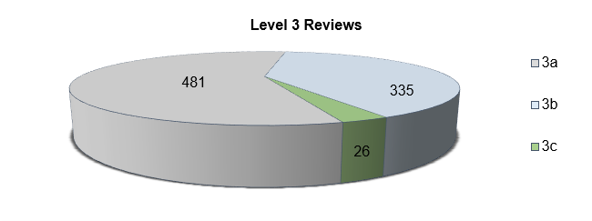
Chart 1.

Communication with the patient/family remains the most frequently reported concern by the bereaved while Cardiac Arrest was the most frequently reported issue by the ME Service;

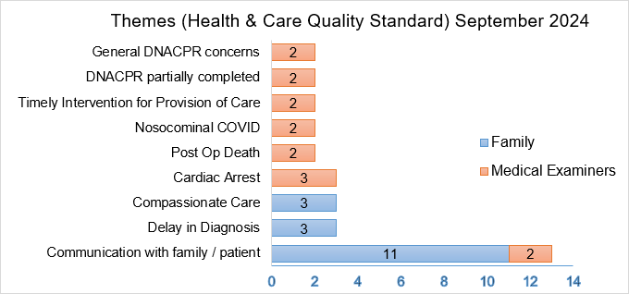
Chart 2.

14 compliments forwarded by the ME Service were shared with various wards across the HB; 1 for Neath Port Talbot, 1 for Gorseinon, 1 for Singleton, 4 for Community and the remaining 7 for Morriston.

- FINANCIAL IMPLICATIONS
There are no financial implications relating to this report.

- RECOMMENDATIONS
Members are asked to:
- ACKNOWLEDGE the progress made within all clinical audit areas;
- ACKNOWLEDGE the outstanding Welsh Government proformas and responses to NICE/HTW Guidance are escalated to the Quality Safety Group;
- ACKNOWLEDGE the achievement of completing 87% of the 22/23 Audit Plans and increasing to 55% for 2023/24;
- ACKNOWLEDGE the audit period for 2024/25 has been extended to 2024/26 to accommodate completion and presentation of topics and the resulting actions
- ACKNOWLEDGE the number of Level 3 Mortality Reviews closed;
- ACKNOWLEDGE completion and sign-off of the annual report for 2023/24.

Governance and Assurance

Link to Enabling Objectives  (please choose) | Supporting better health and wellbeing by actively promoting and empowering people to live well in resilient communities
Link to Enabling Objectives  (please choose) | Partnerships for Improving Health and Wellbeing |  | ☐
Link to Enabling Objectives  (please choose) | Co-Production and Health Literacy |  | ☐
Link to Enabling Objectives  (please choose) | Digitally Enabled Health and Wellbeing |  | ☒
Link to Enabling Objectives  (please choose) | Deliver better care through excellent health and care services achieving the outcomes that matter most to people
Link to Enabling Objectives  (please choose) | Best Value Outcomes and High Quality Care |  | ☒
Link to Enabling Objectives  (please choose) | Partnerships for Care |  | ☐
Link to Enabling Objectives  (please choose) | Excellent Staff |  | ☒
Link to Enabling Objectives  (please choose) | Digitally Enabled Care |  | ☒
Link to Enabling Objectives  (please choose) | Outstanding Research, Innovation, Education and Learning |  | ☒
Health and Care Standards
(please choose) | Staying Healthy |  | ☐
(please choose) | Safe Care |  | ☒
(please choose) | Effective Care |  | ☒
(please choose) | Dignified Care |  | ☒
(please choose) | Timely Care |  | ☒
(please choose) | Individual Care |  | ☒
(please choose) | Staff and Resources |  | ☒
Quality, Safety and Patient Experience
Compliance with national topics provides an opportunity to benchmark performance for quality, safety and patient experience, while the appropriate identification and planning of necessary local priorities can support improvements and provide assurance.

The Learning from Deaths approach supports learning to ensure that patients at the end of life and their loved ones have the best possible experience.
Financial Implications
None
Legal Implications (including equality and diversity assessment)
None.
Staffing Implications
None.
Long Term Implications (including the impact of the Well-being of Future Generations (Wales) Act 2015)
Long term the aim is to continue to embed a new culture in terms of the prioritisation of audit and improvement activities, while balancing the need to meet requirements placed on doctors and healthcare professionals in training.

Generating themes and learning from deaths will contribute towards striving to give patients at the end of their life and their loved ones, the best possible experience.
Report History |  | Quarterly report to the Committee
Appendices |  | Appendix 1 Service Group Update Presentation Template  Appendix 2 Annual Report 2023/24

Appendix 1 – Service Group Update Presentation Template

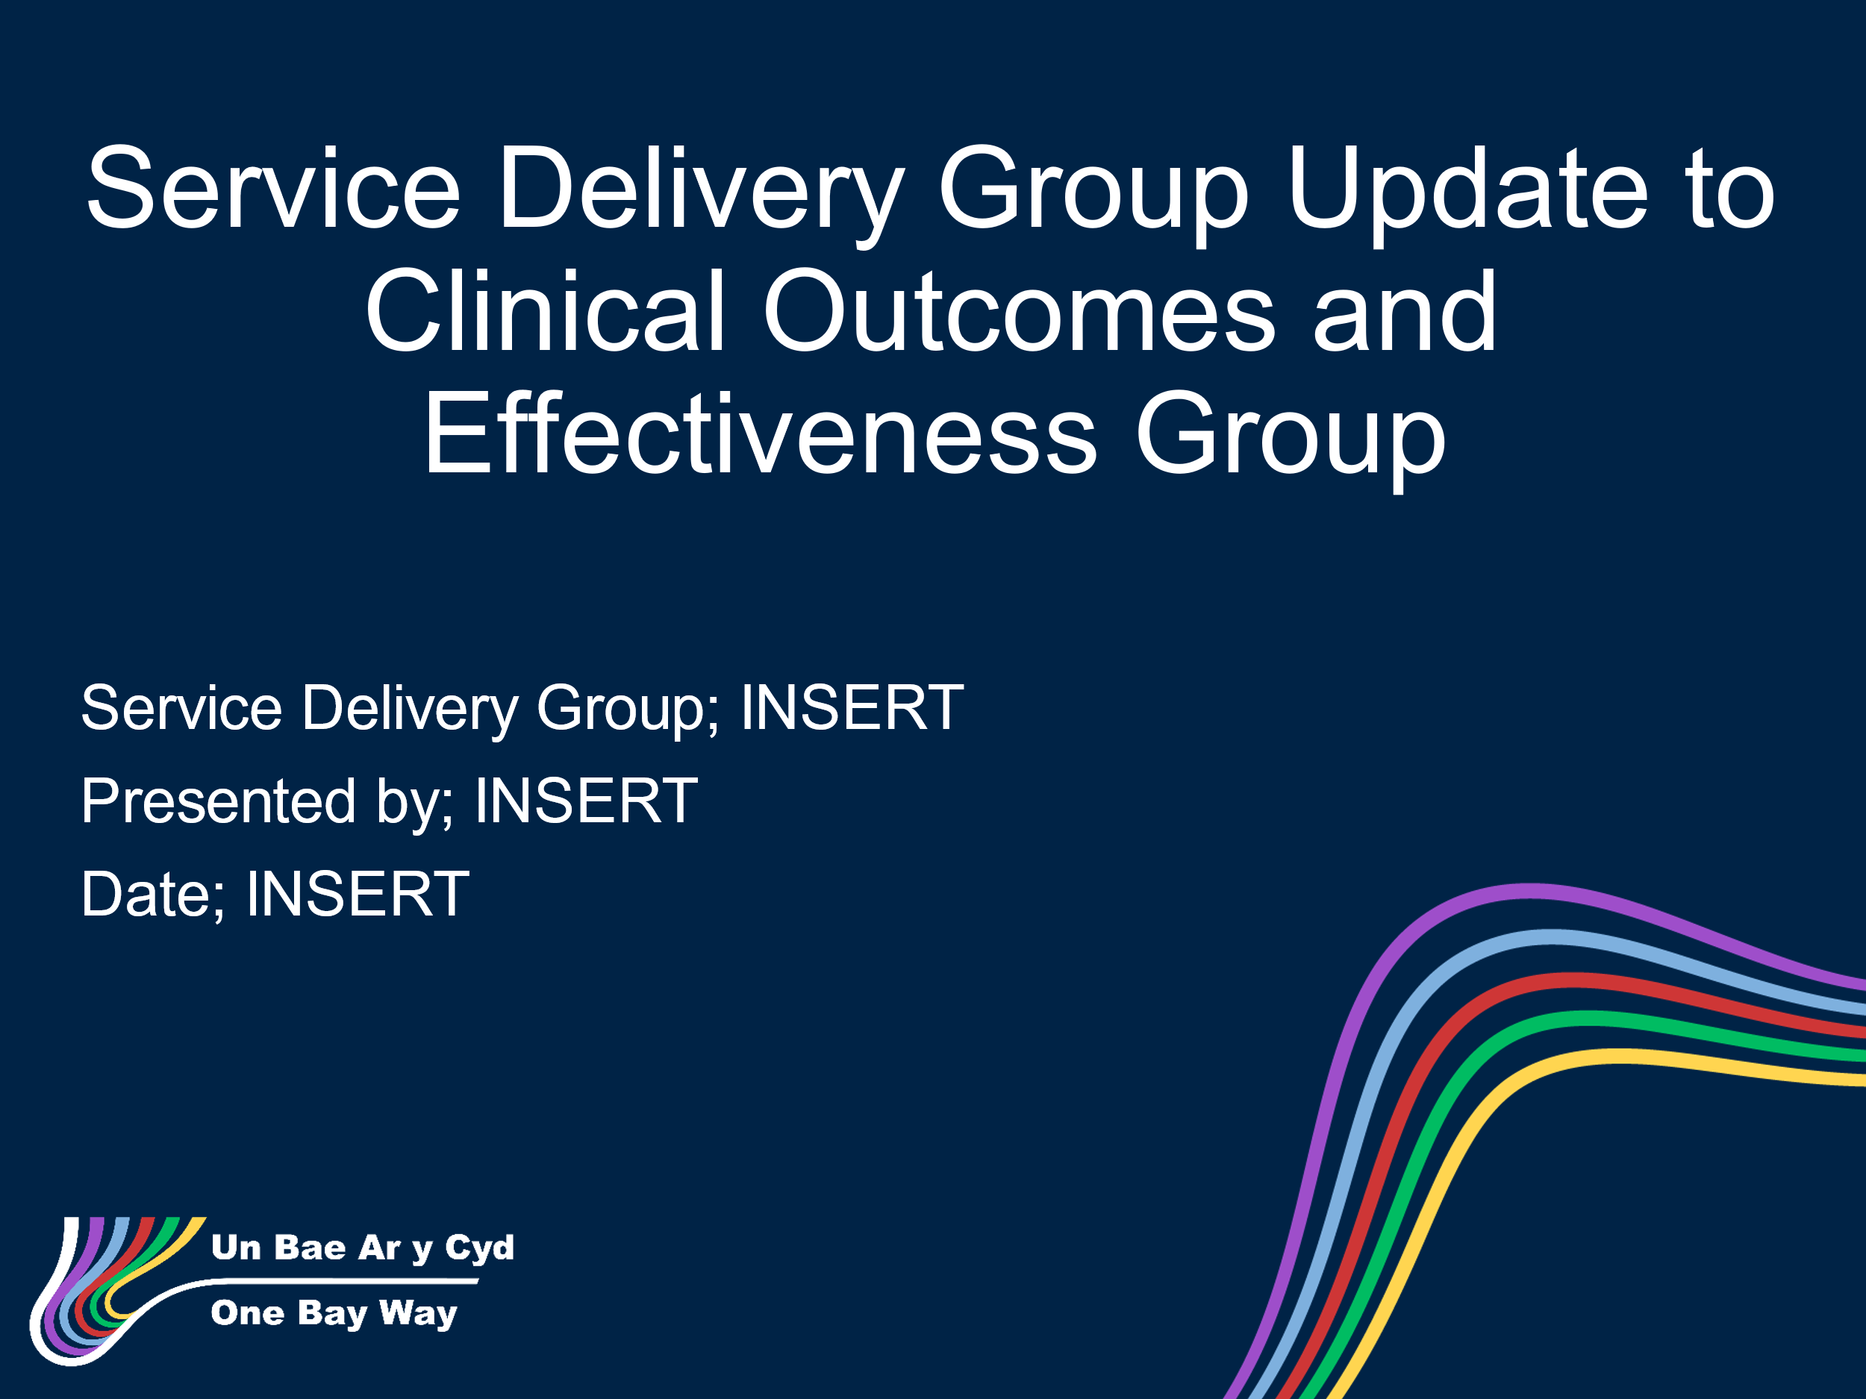
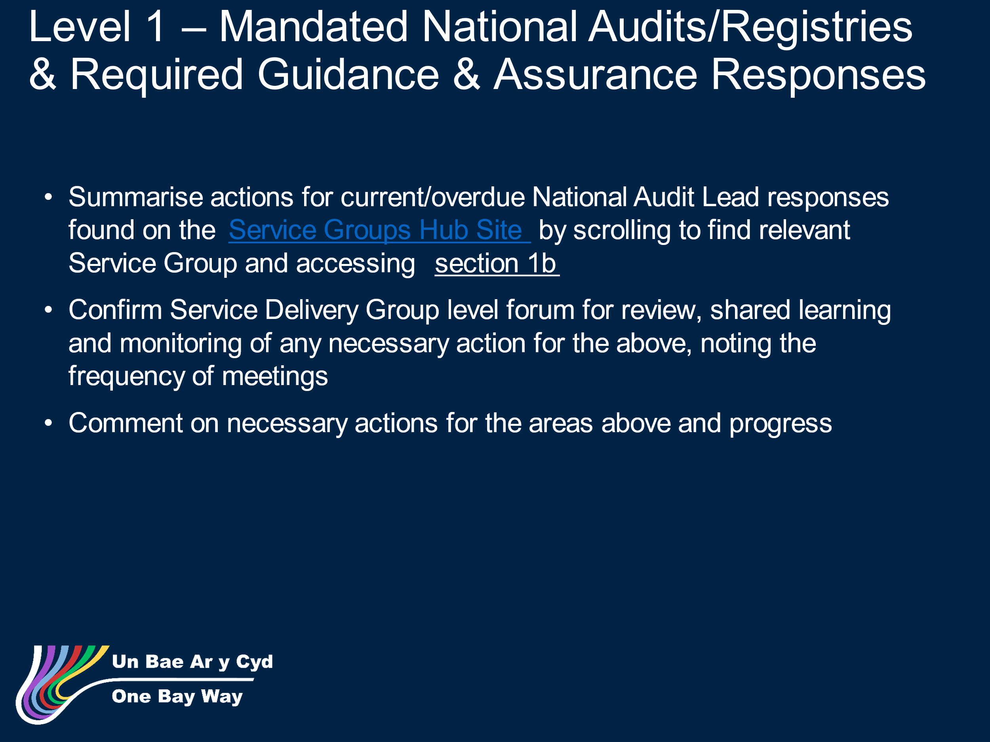
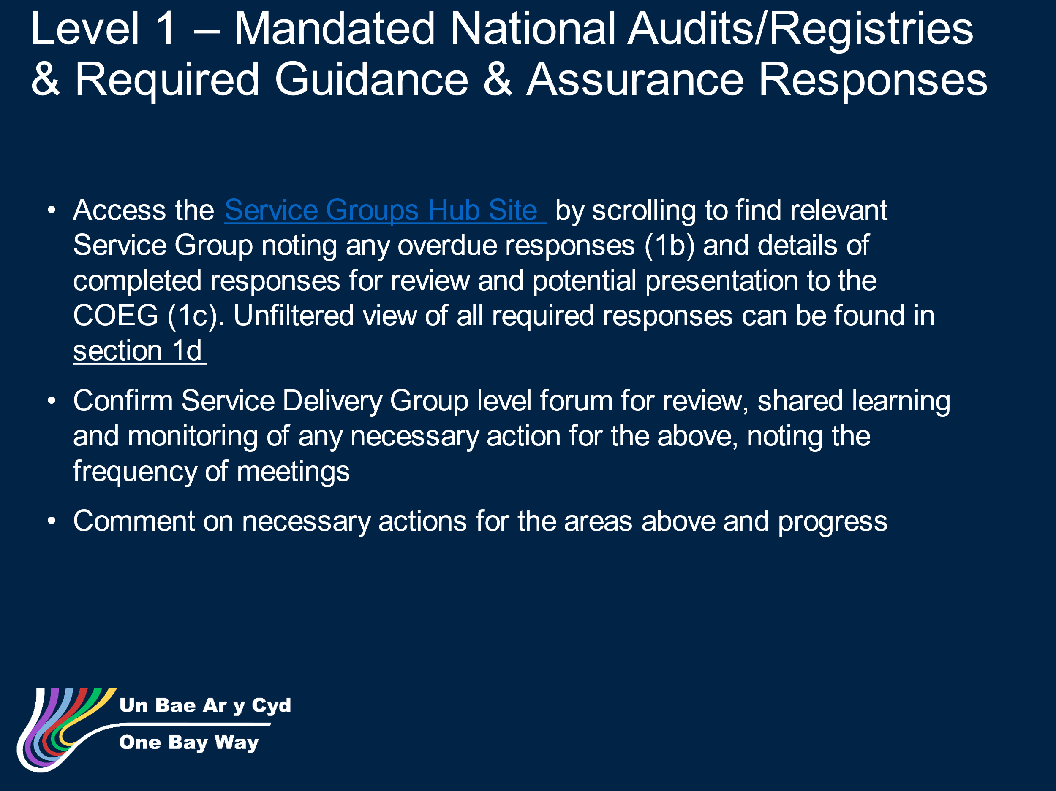
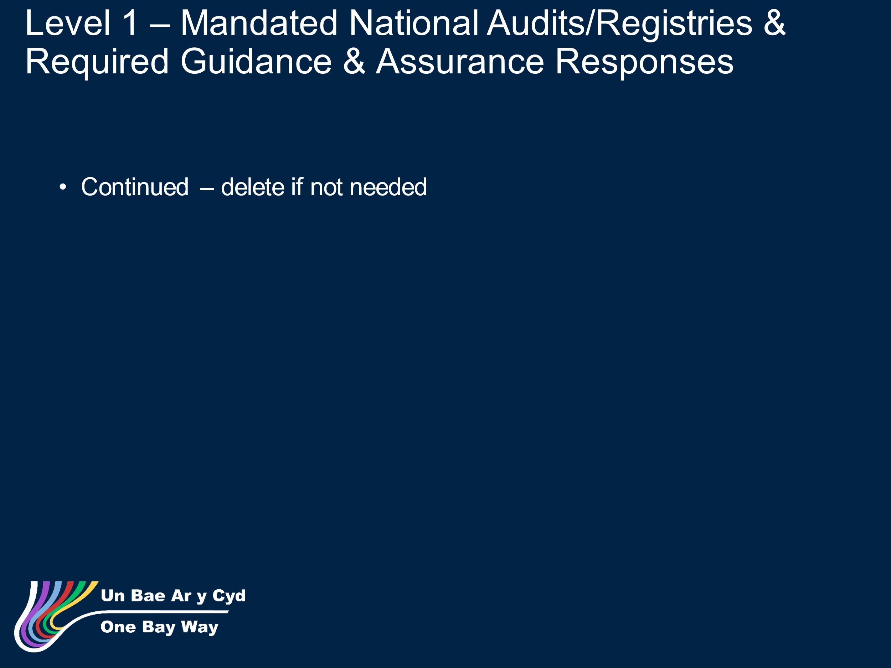
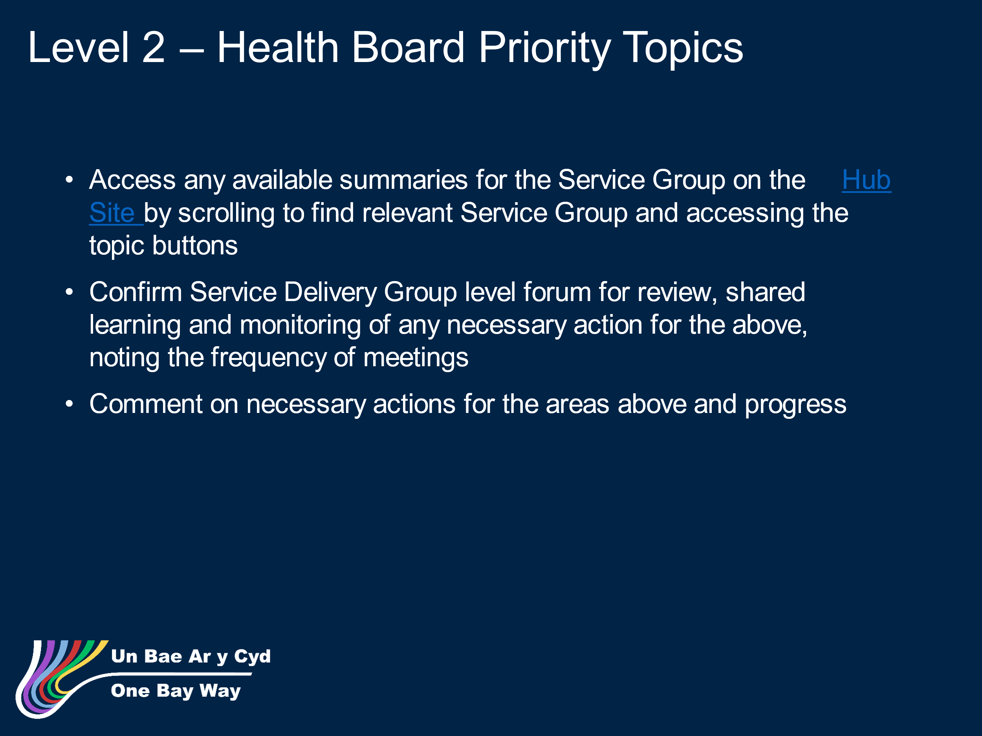
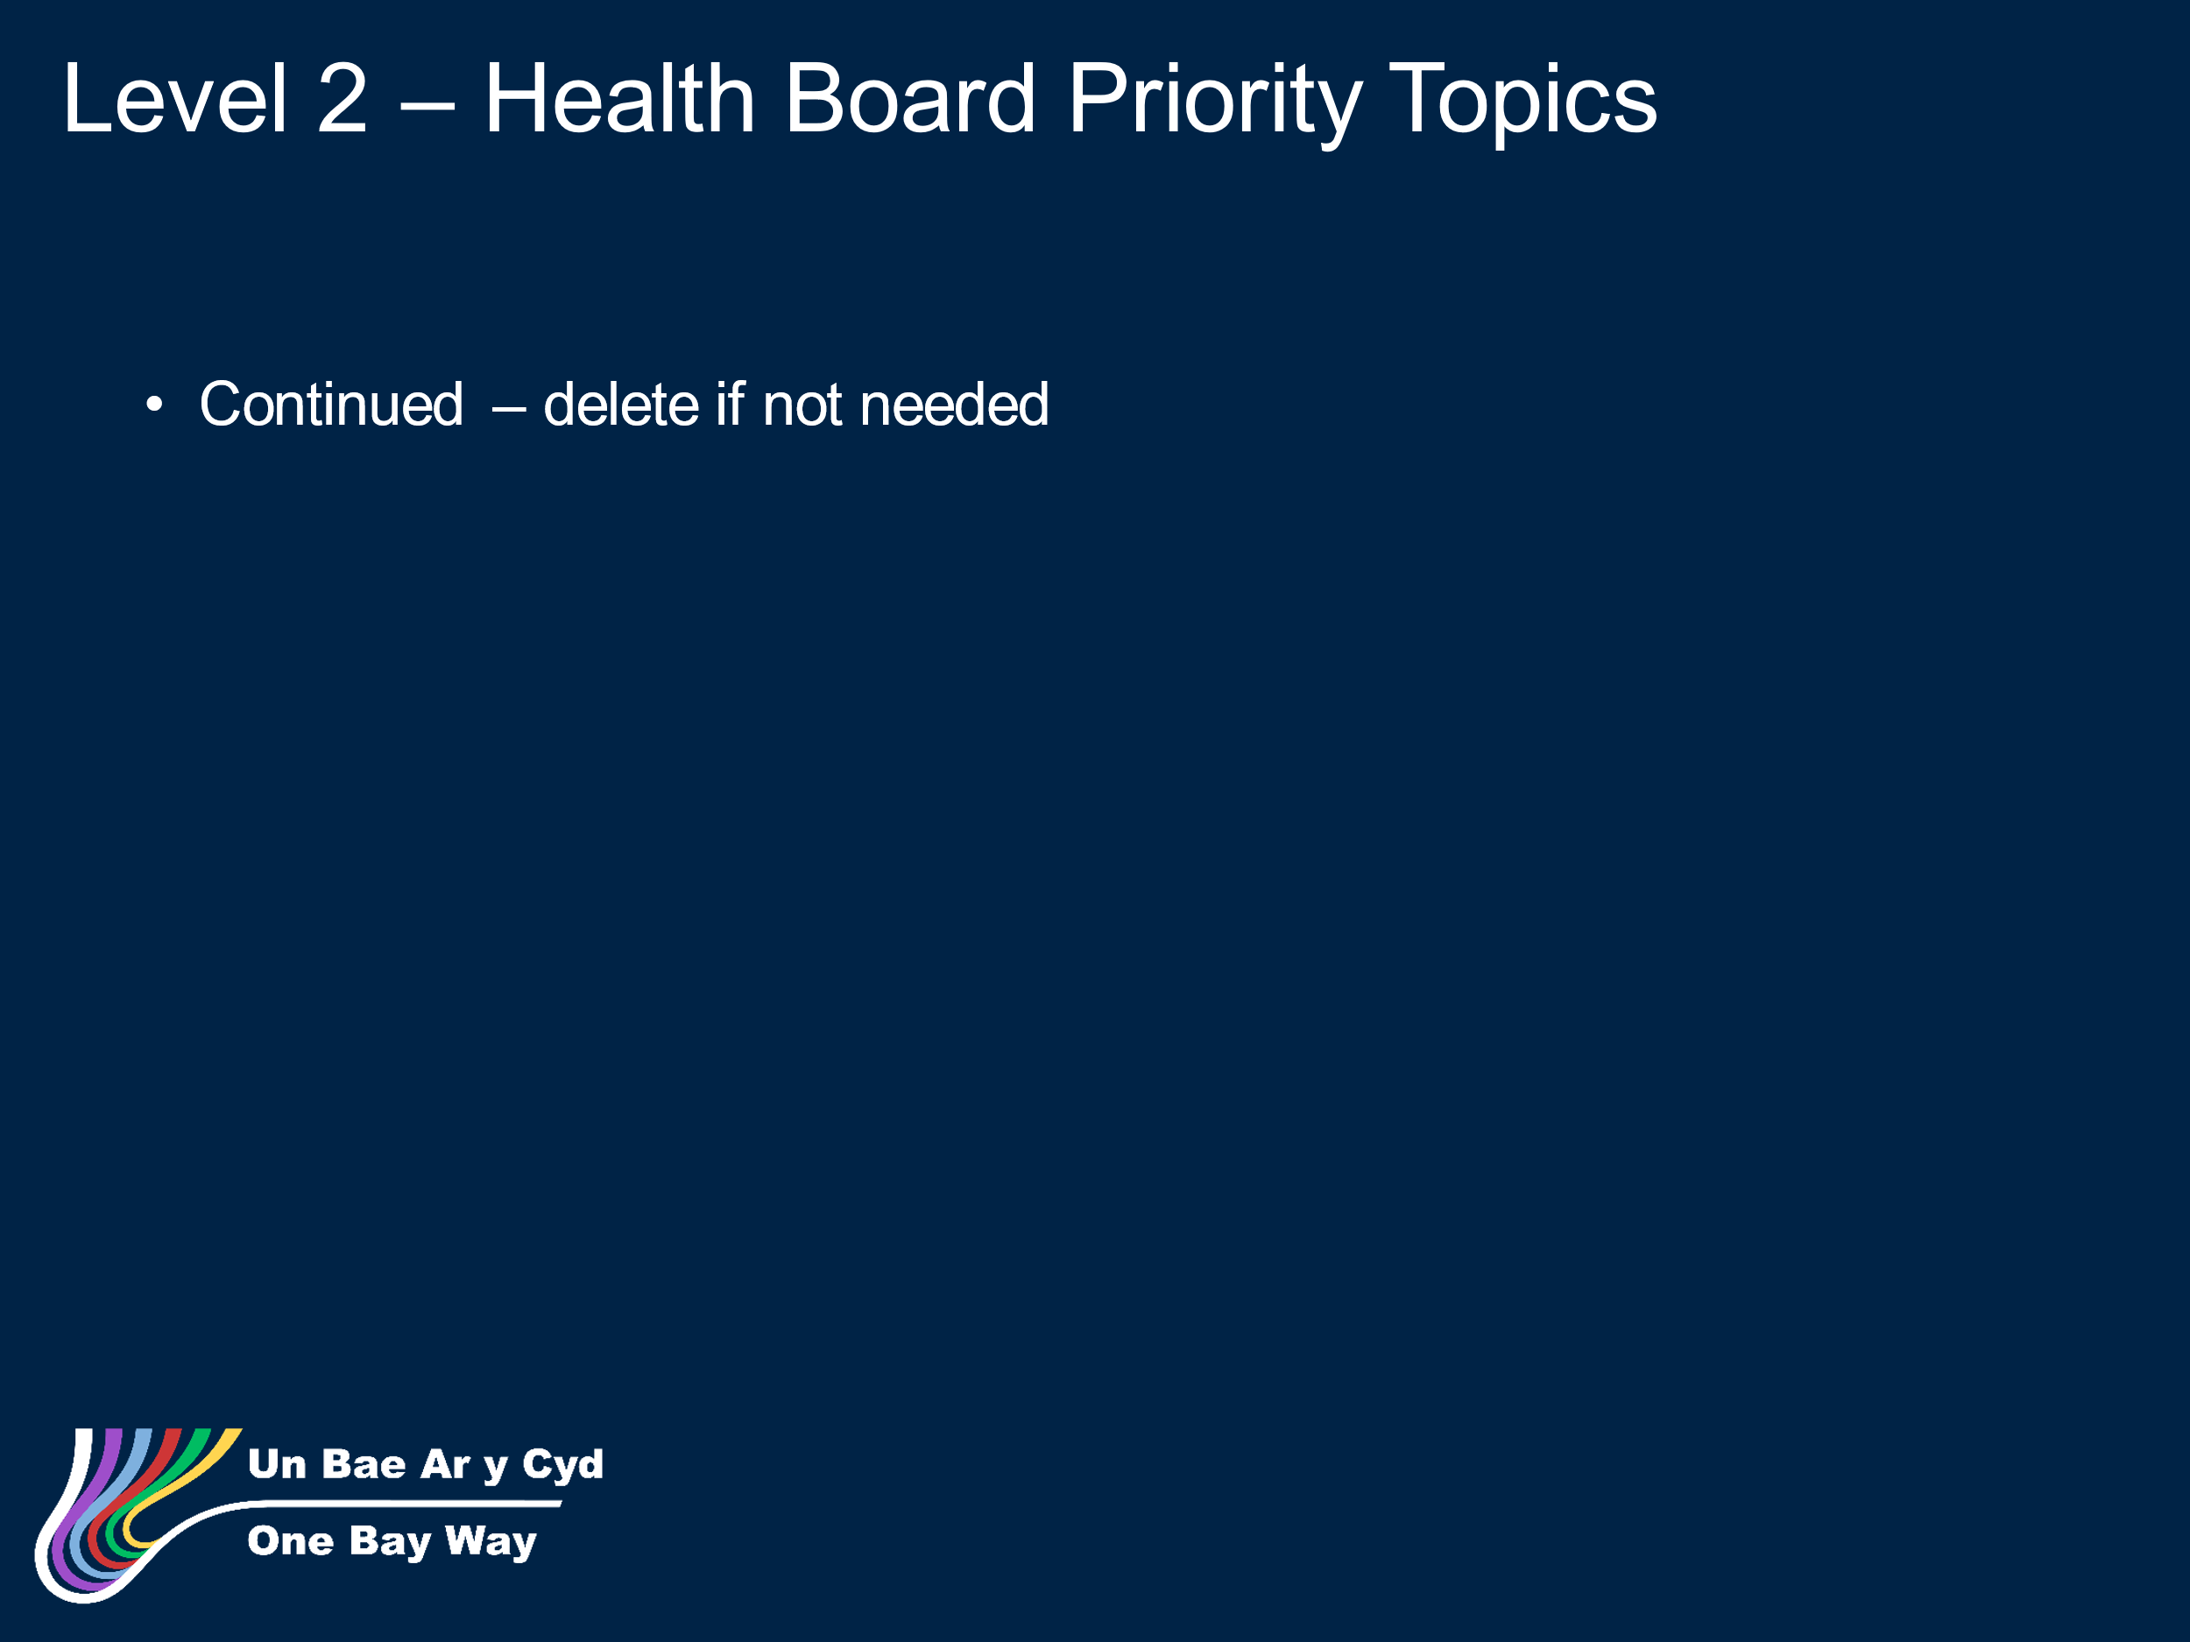
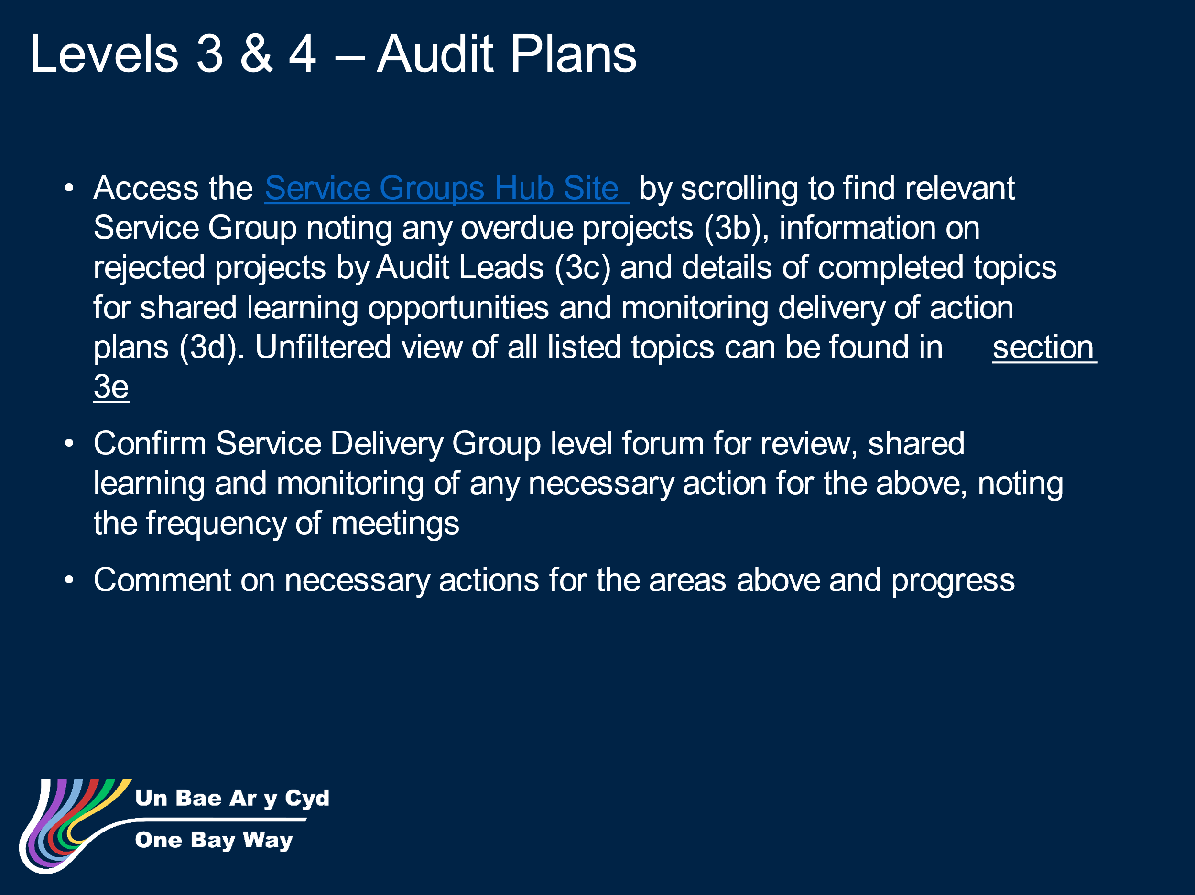
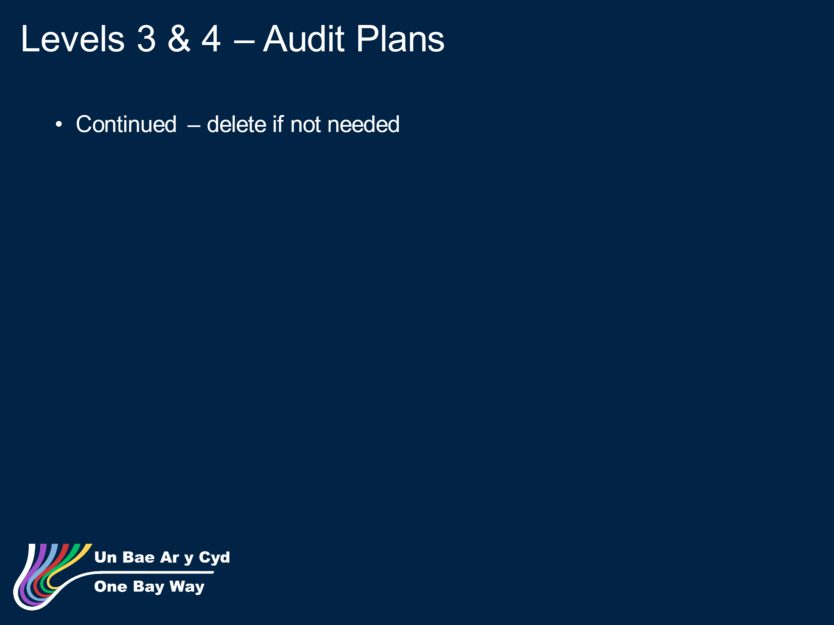
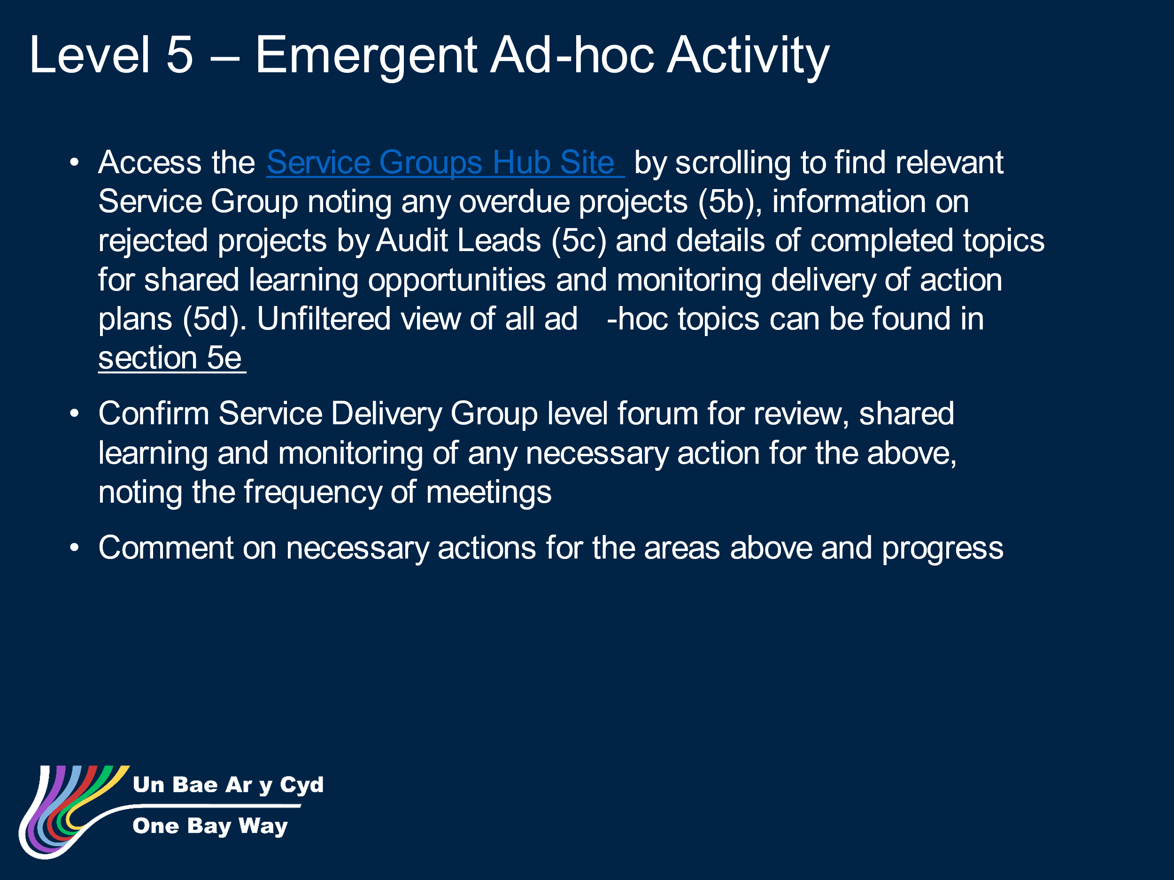
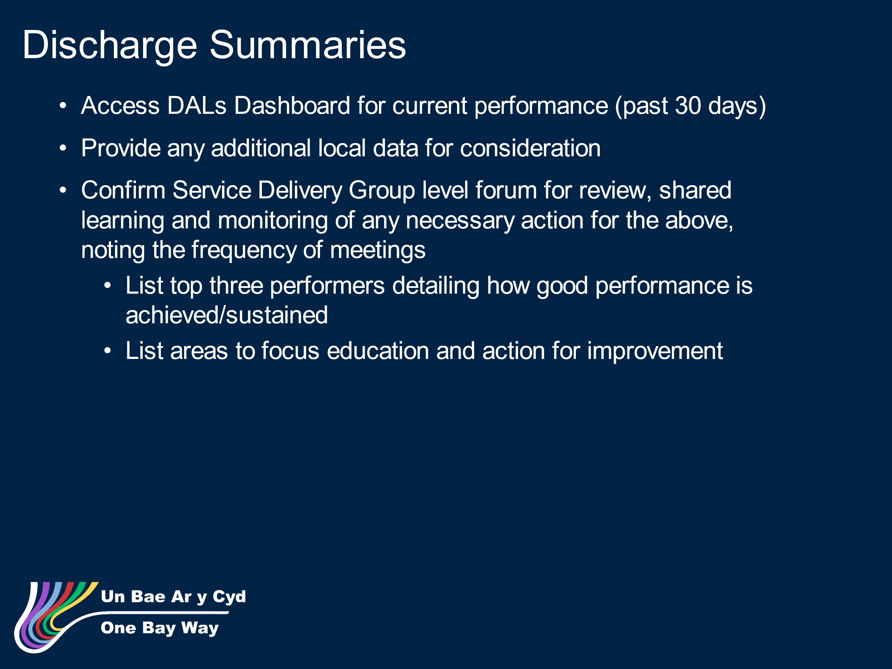
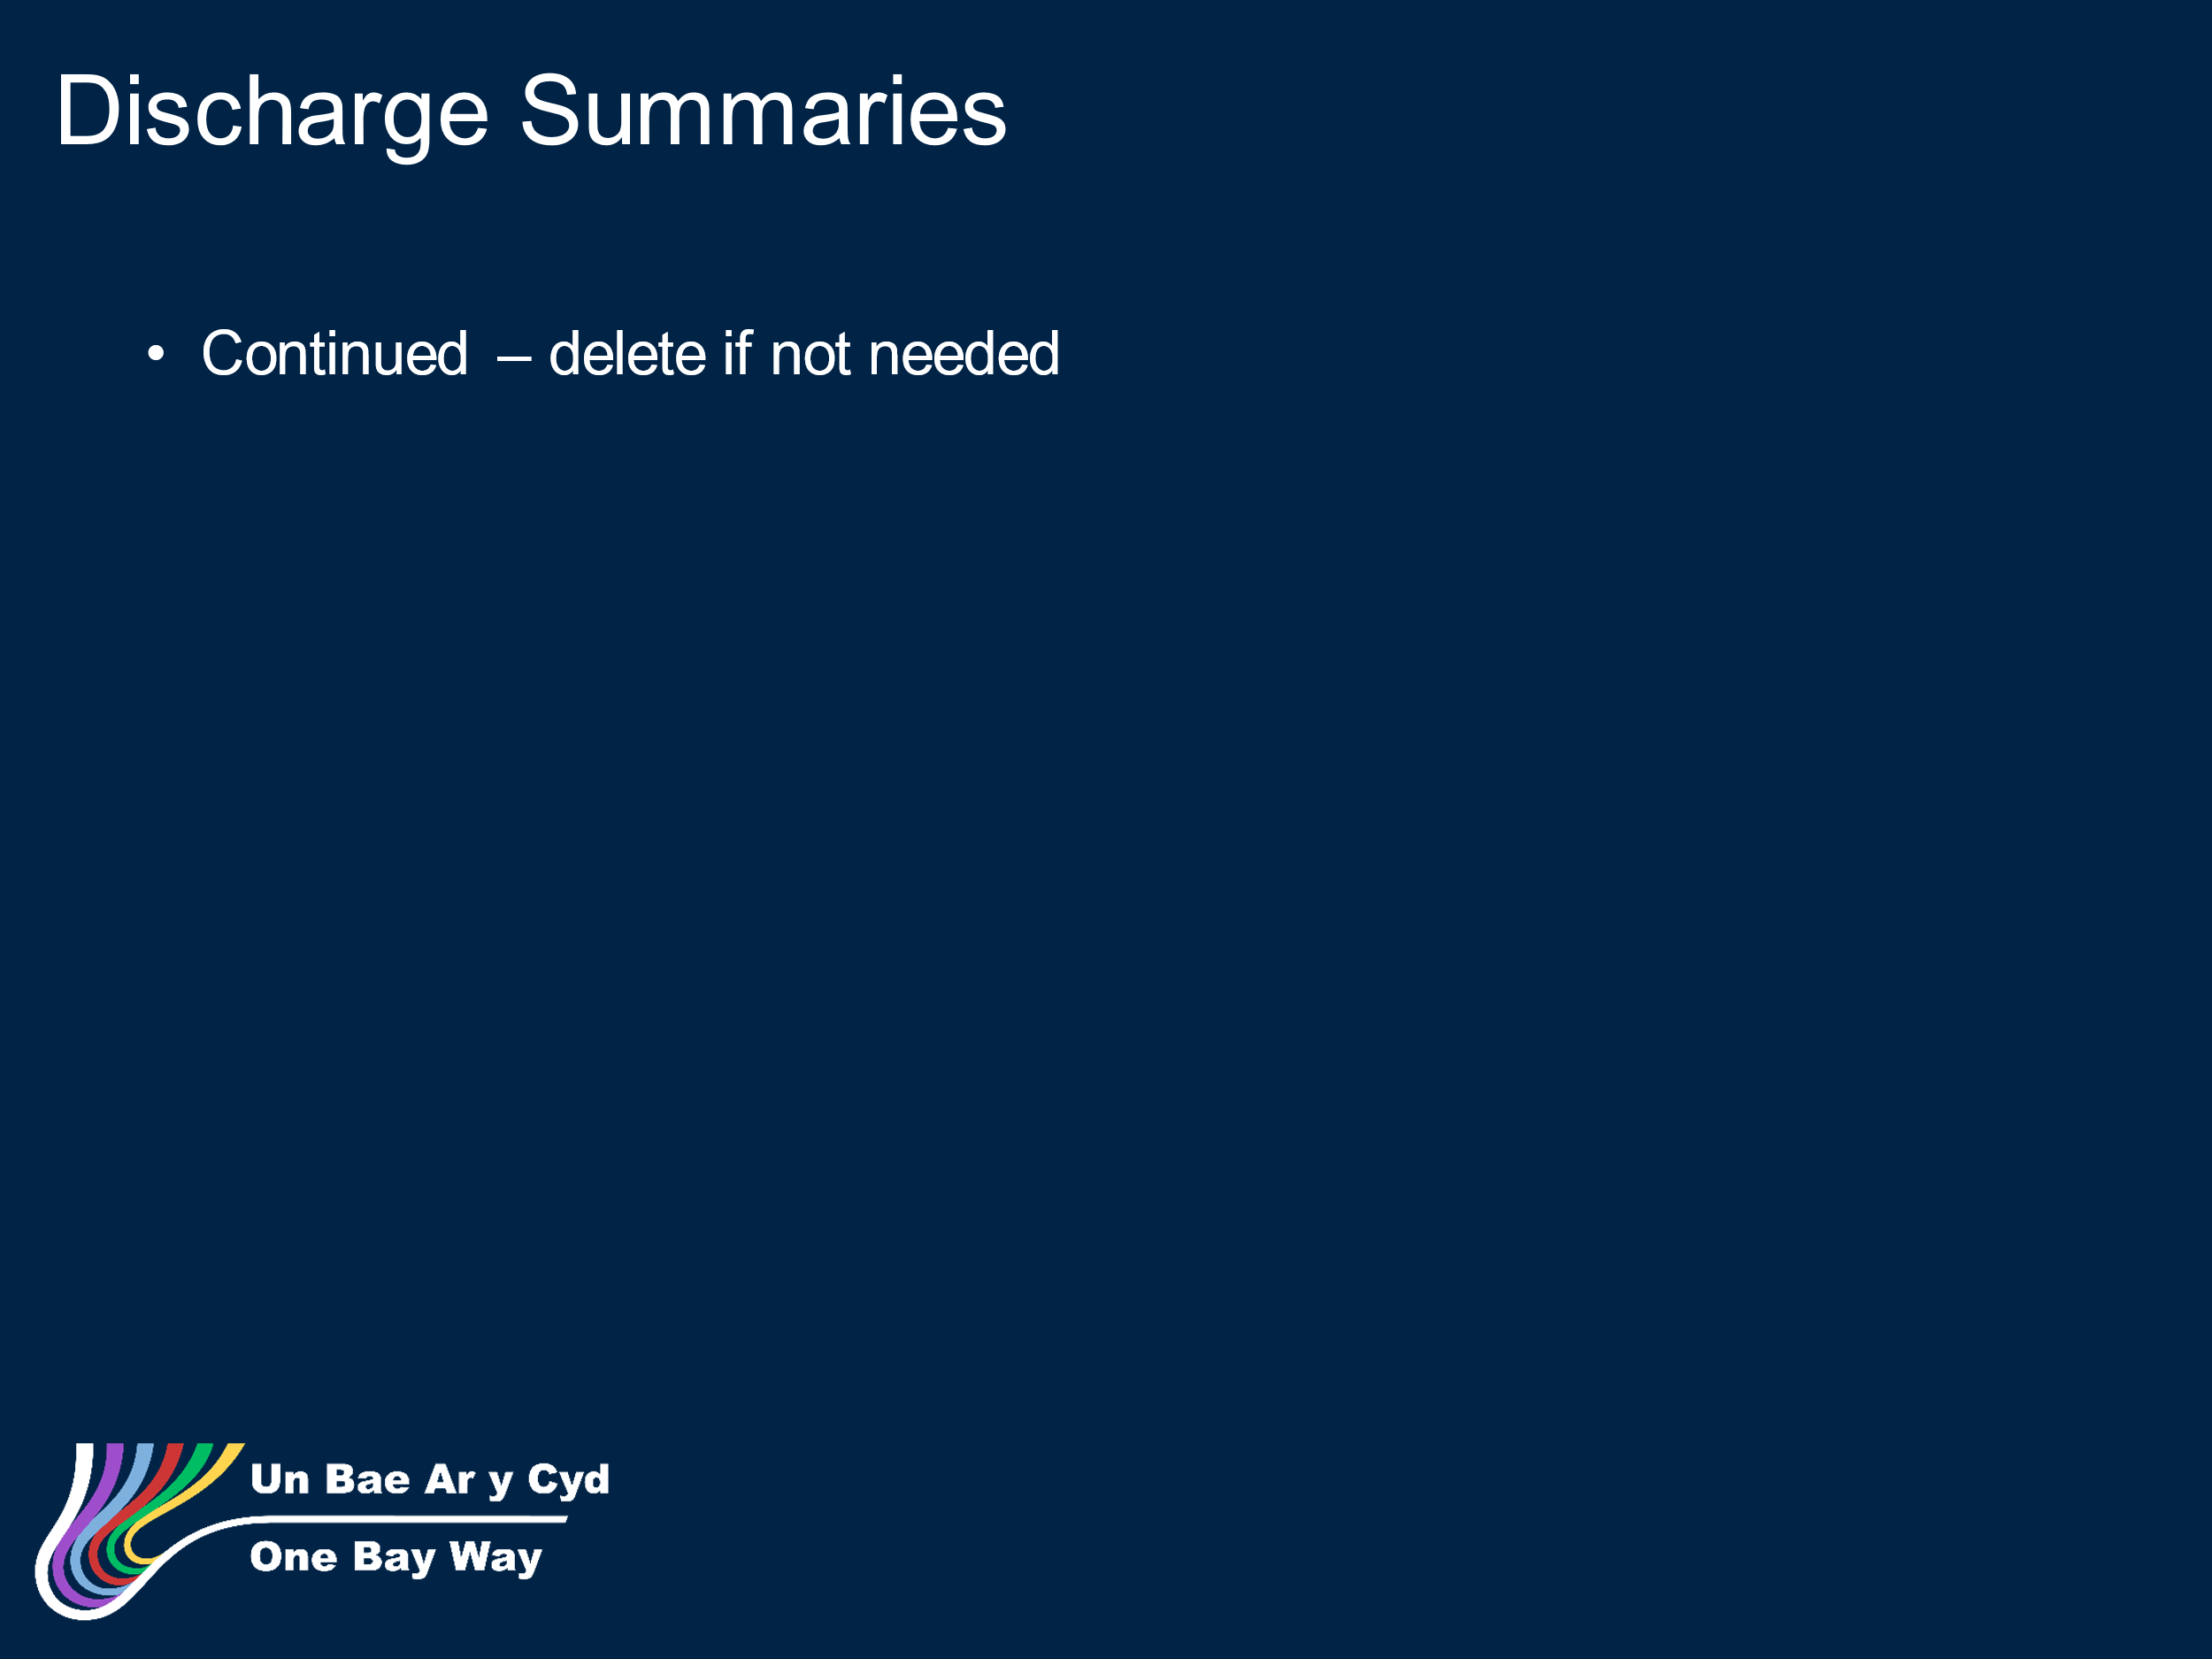
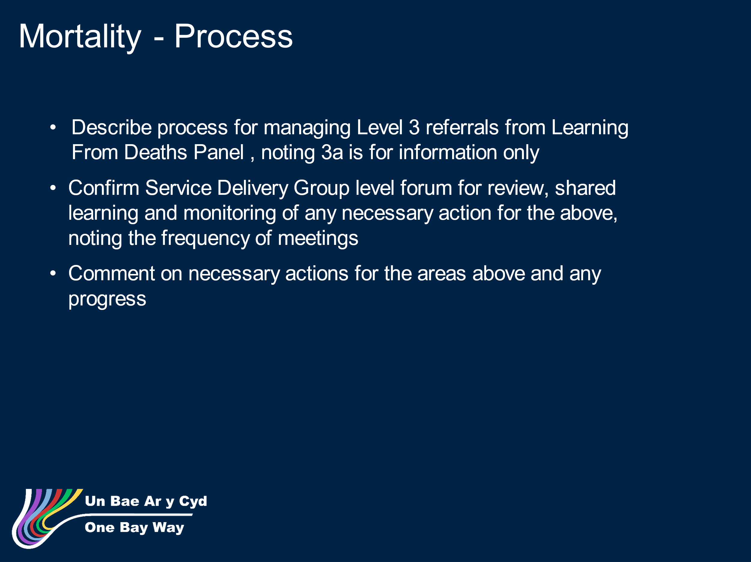
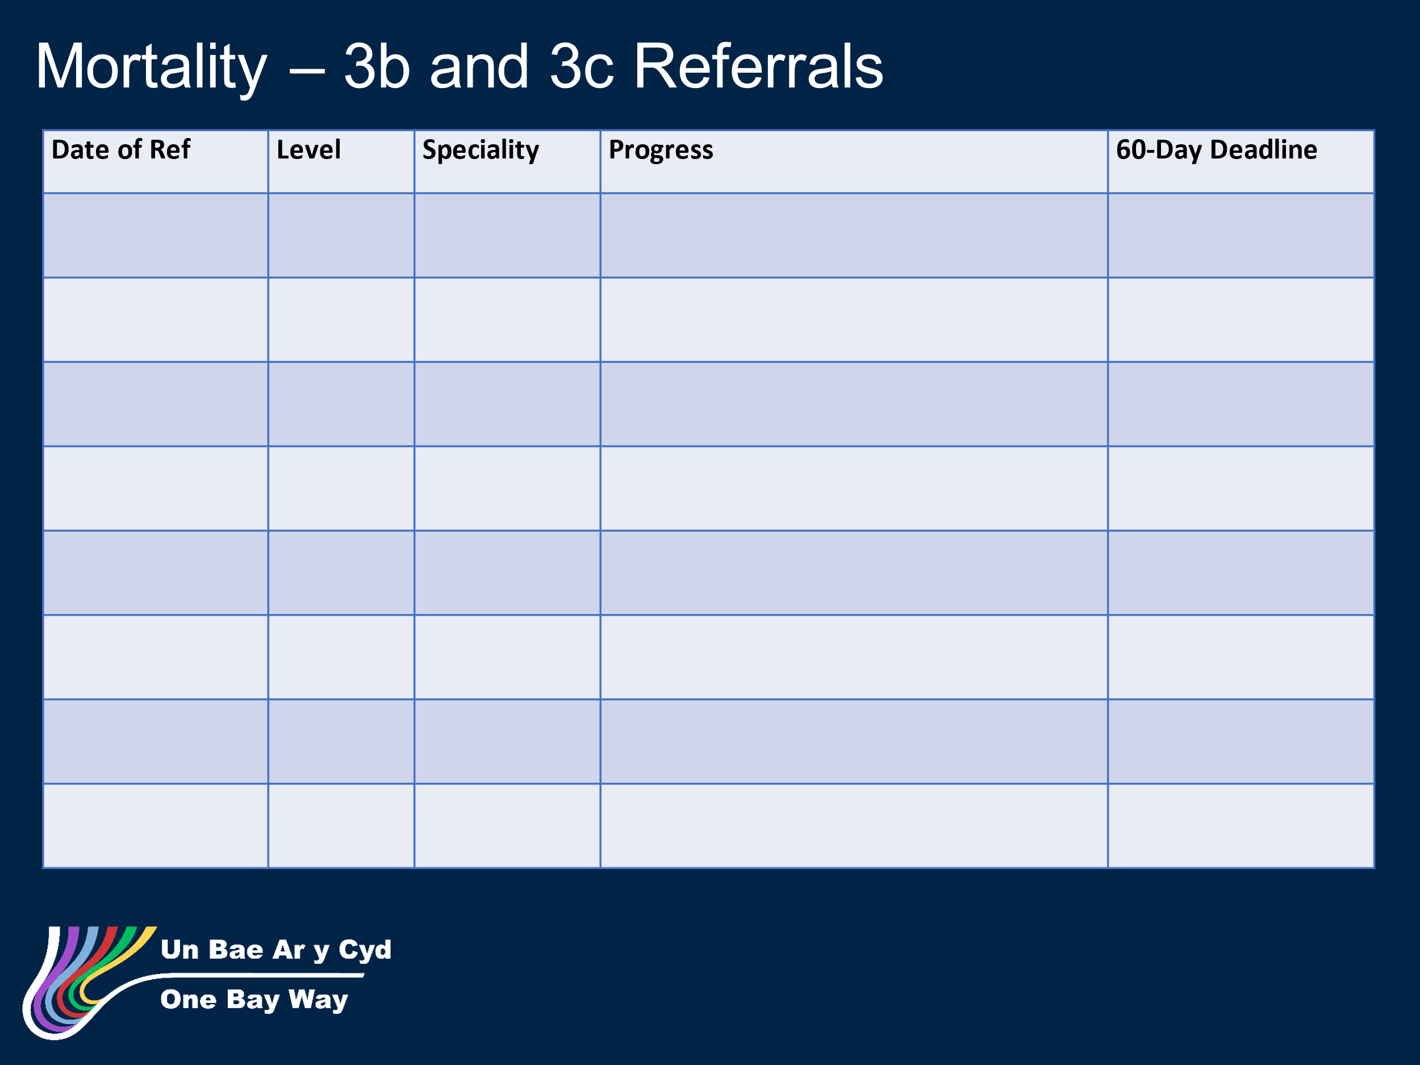
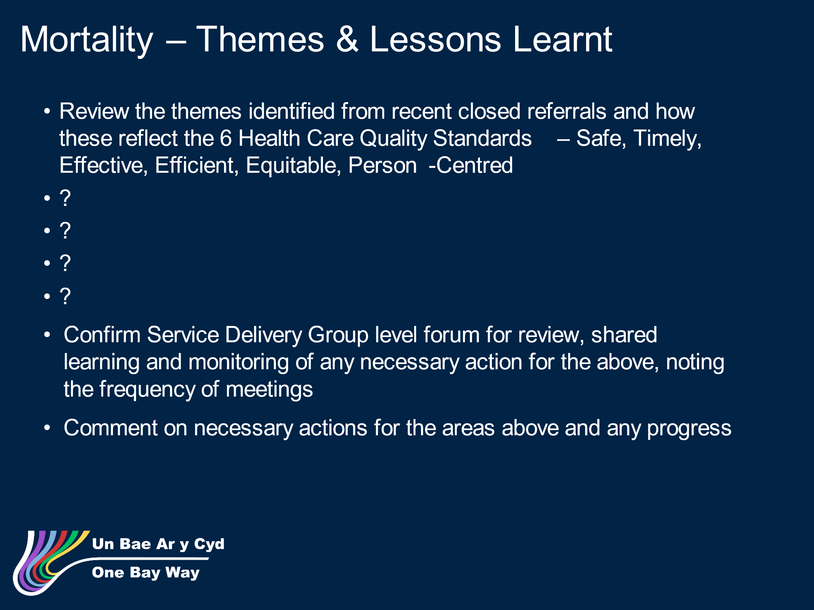
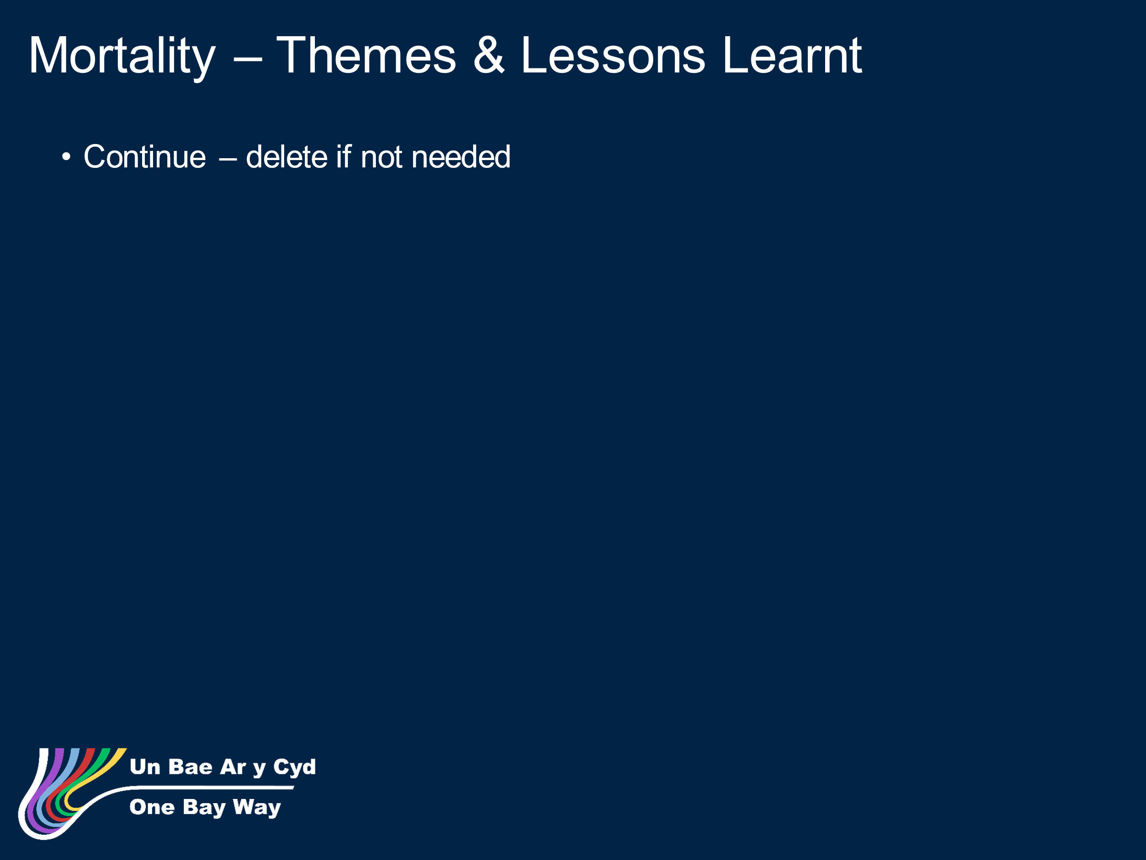

Appendix 2 Annual Report 2023/24

