


Meeting Date | 28 November 2023 |  | Agenda Item |  |  | 3.4
Report Title | Quality Priority - Falls Prevention
Report Author | Eleri D’Arcy, Falls Quality Priority Lead
Report Sponsor | Helen Annandale, Clinical Director of Therapies and Audiology  Gareth Howells, Executive Director of Nursing
Presented by | Eleri D’Arcy, Falls Quality Priority Lead
Freedom of Information | Open
Purpose of the Report | To provide an update on the Falls Prevention quality priority including the progression of mainstreaming elements of this work for sustainability.
Key Issues | - Continued improvement noted but further progress on embedding sustained improvement required  - Community Scoping and Gap analysis completed and report to board scheduled December 2023 where HB falls framework recommended reflecting the 10 year vision for a high quality organisation
Specific Action Required  (please choose one only) | Information | Discussion |  | Assurance | Approval
Specific Action Required  (please choose one only) | ☐ | ☒ |  | ☒ | ☐
Recommendations | Members are asked to note the report and approve the following:  In order to progress Falls Prevention Quality Priority work and embed it as business as usual, Service Groups (SG) must take a lead and ensure:  - Embed improvement plans as part of SG objectives and establish robust SG level governance structures with identified lead, reporting via their quality and safety groups  - Consistently share learning at HB wide Overarching Falls Steering Group via the SG representative  - Adopt the Falls Documentation Audit as part of the wider quality Assurance Programme and report compliance via QA mechanisms  - Regularly report Falls Brief Intervention training (via ESR) compliance to the overarching Falls Prevention Service Group and agree training schedule across all SGs  - Overarching Falls Steering Group to monitor SGs action and improvement plans  - Exploration of resource availability to support specific falls prevention offers within the HB  - Recognise the need to change the culture of physical activity by supporting reconditioning approaches

Quality Priority – Falls Prevention

- INTRODUCTION
Falls Prevention was identified as a Quality Priority by the Health Board (HB) in 2021. Board received and approved a similar paper to this one, in March 2023 (appendix 1). To summarise briefly, the first year of Falls Prevention as a Quality Priority saw the target of 10% reduction of injurious inpatient falls exceeded. Much work was focussed on improving governance structures, bringing with it stability and engaging partner agencies such as the Welsh Ambulance Services Trust (WAST), Local Authority (LA) and third sector organisations such as Age Cymru and Care & Repair.

Falls remain however, the highest cause of incidents within the HB, and nationally it is the second leading cause for accidents in the home. It is estimated approximately 130,000 older people will fall at least once in Wales this year. There are high individual/personal and socio-economic cost to falls, with a cost to the NHS as a whole of £2.3 billion annually.

This paper provides an update as to the progress of the Falls Prevention Quality Priority since March 2023 and describes the progress on the actions generated through discussion on the previous paper; scoping of community services and relaunching action against deconditioning.

- BACKGROUND
As we know, falls occur at all ages across the lifespan and are an inevitable part of a bipedal gait and physical activity. However, the risk increases as we age with an estimated 30% of adults aged over 65 years falling each year and for whom the consequences are more serious, despite concerted efforts of researchers and clinicians to understand, assess and manage their risks and causes.

In addition to personal distress, falls and fall related injuries are a serious healthcare problem because of their association with subsequent morbidity, disability, hospitalisation, institutionalisation and mortality. The number of falls and related injuries will likely further increase, partly due to an ageing population, but also because of increasing prevalence of multi-morbidity, polypharmacy and frailty among them.

In Swansea Bay UHB, like other HBs in the UK, a sustained trend of increased frailty has been seen, particularly following the pandemic; patients are frailer on admission to hospital and often-frailer still on discharge. Community teams face increased complexity on caseloads as patients with as many as 4-5 co-morbidities becomes the norm.

As stated, the primary GMO, to reduce inpatient injurious falls by 10% was achieved. Updated GMOs were then written for 2023/2024 and are set out below in Table 1.
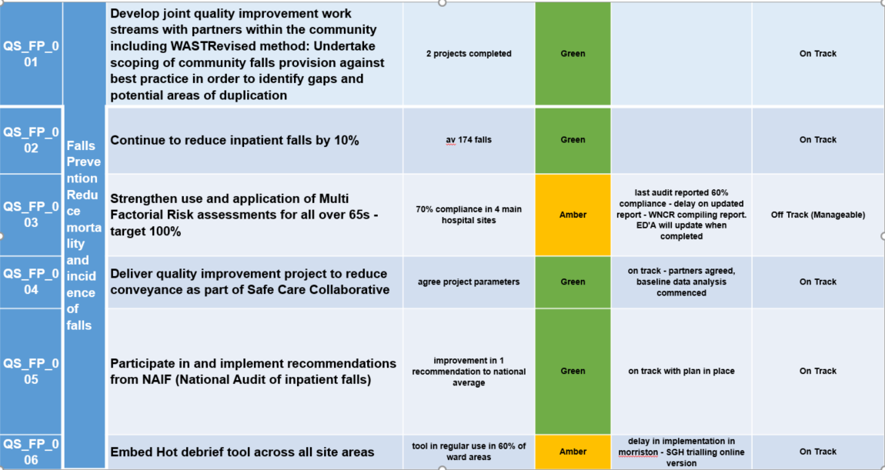

Table 1: GMOs set 2022/2023
Health Board Falls Prevention performance overview
Falls incidents (inpatients):
Falls incidents included in this data set is reflective of inpatients only but across all sites. This is due to inconsistent, complex, and non-digital reporting mechanisms in community settings. Incidents not reported through Datix Cymru remain unavailable.
All falls incidents with or without harm caused have been used for completeness. In Q1 & Q2 of this year, 1183 incidents have occurred with 284 of these causing no harm to patients.
The data, worked from last year’s figures provided an updated baseline of approximately 174 falls per month across the HB and a target of 157 injurious falls. Currently the average is 150 non-injurious falls per month on average, and so is ahead of this target. However, 32% of these incidents are yet to be closed following investigation and scrutiny processes, possibly resulting in some change to this figure.

Graph 1: Comparison data for inpatient falls incidents over the previous three years (2020 – Sept ember 2023)
Graph 1 shows that 2023/2024 data (red) tracks below previous years and reflects the same peak in August 2023 as seen in August 2022. Again, as in 2022, this rise appears attributable to a rise in incidents at Morriston Hospital and is not reflected across data from other Service Groups. IPC data has been reviewed for the same period and rise cannot be clearly attributed to any IPC issues including Covid-19 rates. Staffing rates have been reviewed for August in 2022 and 2023; the common theme is a high percentage on unavailability of staff due to sickness and annual leave. For both rosters, the wards were using a high percentage of bank and agency staff who may lack in-depth knowledge of the patients who are a high risk of falls as well as understanding of the falls policy and protocols in place. Some work has been identified to provide additional education for temporary and agency staff.
An additional falls focussed audit was completed (November 2023) in AMU, Morriston, due to significantly high falls rates in recent months. A number of opportunities for improvement have been identified including the introduction of a shortened falls risk assessment used within Minor Injuries Unit, NPTH. A repeat audit following a number of recommendations and QI plans have been put in place, will demonstrate if improvement has been made.

Falls Rates:
Using the Nationally recognised falls rate per 1000 bed days unit more accurately reflects current performance; taking into account increases in number of patients within the system.

Graph 2: HB Inpatient Falls Rate 2022/2023 (note awaiting March 2023 data)
The HB falls rate when reported in March was at 4.9 falls per 1000 days. This was an 18% decrease of the average yearly falls rate. In September 2023, this rate currently stands at 3.7 falls per 1000 bed days. This rate reflects all injurious and non-injurious falls and remains below the National average of 6.6 falls per 1000 bed days. Also reflected is the impact of increased profile of falls prevention, significant effort from the SBUHB workforce and the multiple Quality Improvement projects being completed within service groups and in conjunction with the QP team.
Serious Harm from Falls:

Graph 3: Falls Serious Incidents
Falls where serious harm has occurred in hospitals, are referred to the Serious Incident team where a decision as to if the incident is reportable to Welsh Government is made. All falls resulting in a hip fracture are reported to Welsh Government. There is a general downward trajectory with the exception of April 2023. When comparing Q1 &2 this year with the same period in 2022/2023 there were 15 falls related SI’s. This year there have been six to date demonstrating a significant 60% reduction. By improving knowledge/awareness and applying to all falls (not injurious falls alone), preventative measures can be started earlier, therefore reducing the risk of SIs occurring.

National Audit of Inpatient Falls 2022
The most recent report for the National Audit of Inpatient Falls (NAIF) was published in October 2022 and includes Clinical data from 2021 and Facilities data for 2022. Details of performance on this audit can be found in the previous report (appendix 1).
The actions to focus on since March 2023 were the accuracy of the multi factorial risk assessment (MFRA) and appropriateness of individual care planning. A new falls documentation audit has been released and is soon to be added to the Audit Management and Tracking (AMAT) system now live in the HB.
A number of audits have been completed across service groups and show significant lack of appropriate assessment in the use of bed rails. MH&LD are yet to transfer to the digitalised Welsh Nursing Care record (WNCR) and review of paperwork across these areas show better compliance with the bed rail assessment. Concerns that WNCR did not include this element of the assessment have been raised with system administrators. 30% of all HB falls occur from bed or transferring to bed. With poor compliance with bed rail assessment, assurance cannot be given regarding whether these falls were avoidable or not.
The Key Performance Indicators (KPIs) for the NAIF report 2023 have been included into the SBUHB Quality Priority GMOs for 2023/2024. In the absence of another audit since the previous update the falls documentation Audit can provide some assurance on monitoring and progress of these KPIs:
- High-quality MFRA prior to the fall – this remains an area for QI for all SGs requiring reporting and compliance in order to demonstrate improvement
- Check for injury before moving – Using latest audit results, checking for injury has been evident through documentation in 89% of falls incidents
- Flat lifting equipment used to move the patient from the floor where fracture is suspected – roll out for flat lifting equipment training continues with all sites receiving a minimum of one training session – a rolling programme of training has commenced. All appropriate equipment is now in situ.
- Assessment by a medic within 30 minutes of the fall – this is not consistently met throughout all SGs – further engagement required with medical groups

The National Hip Fracture Database:
The National Hip Fracture database (NHFD) is inputted into via the Health Boards Fracture Liaison Team. 169 hospitals from across the UK contribute to this. Details as to the 2022 report can be found in appendix 1.
Prompt surgery and prompt admission to specialist wards where SBUHB performance is lower than the national averages continues to be an area for improvement. The clinical team delivering our hip fracture service are making continuous improvement and this is reported both locally and through the National Fracture Discharge Group.
Additionally, the Fracture Discharge Service is now operational and supporting patients’ home from hospital, reducing length of stay. The reporting of this service will be via the PCC&T service group and will report on number of patients discharged via the service, effect on length of stay in hospital and patient outcomes.

Community Falls Incidents
Understanding the number of falls occurring in the community is difficult however, Welsh Ambulance Service have provided data showing the number of call outs to falls they attend. In 2022, WAST received approximately 5800 call outs for falls in SBUHB and approximately 60% of these were attended. The conveyance rate average is 56%, which is on par with the national average.

Graph 4: WAST call outs for falls (over 65yrs) and conveyance rates
The WAST data has stayed consistent over the last three to four years. We have however seen an increase in presentations to front door services of falls in the over 65 year’s population.

In 2022/2023 there were 27,614 admissions of over 65 year olds due to falls and since April 2023 to present there have been over 17,000 of the same admission type already. Anecdotally, emergency departments are reporting more patients are presenting who have made their own way to hospital (possibly due to response rates worsening for WAST) therefore further increasing the risks held in the front door services. This measure has now been added to service group reporting through the Overarching Falls Prevention Steering group (OFPSG). The below graph shows increased activity at front door services since May 2023 with upto 790 patients over 65 attending ED/MIU with a fall as primary reason. This demonstrates the impact falls have on unscheduled care. Opportunities

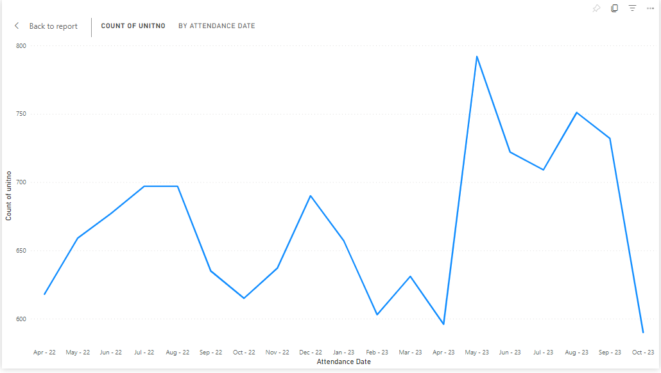

Graph 5: Number of patients over 65 presenting to front door service with a fall 2022/2023.
Due to the continued development of Virtual wards (VWs), demand for falls management in the community is clearer. The below graph shows referrals to VWs for patients over 65 years for falls management only. A reduction in community referrals and reduction in GP referrals is demonstrated resulting in less prevention work instigated. However further data shows Cwmtawe cluster has the highest number of referrals for falls and this provides an opportunity enabling targeted work with this cluster explore opportunities for improvement in falls prevention delivery. The VW In reach team have been pivotal in identifying patients in hospital and utilising the Fracture Discharge Service (FDS) to provide more robust discharge planning for patients recovering from a fracture sustained through a fall.
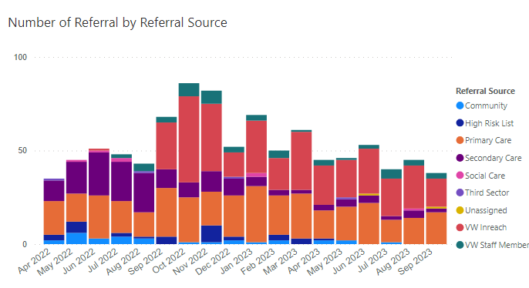

Graph 6: Referrals to VWs by Source
Scoping
A community scoping exercise has now been completed together with gap analysis identifying the need for closer review of existing services and recommending a HB Falls Strategy/Framework to ensure consistency and clarity for all services.
Dance to Health remains one of the HBs only offer for falls prevention that meets the necessary NICE guidelines and National standards of best practice. The service remains reliant on charitable funds although did receive funding from the Regional Partnership Board this financial year. Further exploration of a business plan to ensure groups can become self-sufficient is required but however further funds are required to ensure more groups can be set up, reaching more isolated areas of the HB.
Partnerships continue to strengthen through the Regional Falls prevention taskforce. The Falls Prevention Quality Priority lead has been working in partnership with the Public Services Board (PSB) and will be presenting on the progress being made in November 2023.

Service Group Performance in Falls Prevention
NPT and Singleton Service Group
Morriston Service Group

Graph 8: NPTSSG Falls Rates
Graph 7: Morriston Falls rates
NPTSSG key messages
Significant improvement in falls rates – this is evident in NPTH and not solely reliant on the reduction of beds in SGH
Memory Impairment Assessment team supporting falls prevention interventions and now
Excellent engagement with Active August (part of reconditioning programme of works)
Volunteer Programme Quality Improvement project underway
Recommendations:
Engage with HB Reconditioning programme of works
Data and learning to be shared at OFPSG

Morriston SG Key messages
Moriston’s footprint has changed significantly since the last paper written in March 2023
Falls rate in AMU in August rose to 13.1 falls per 1000 bed days - targeted falls audit scheduled for November 2023
Baywatch initiative has shown promising initial results and plans in place to scale the project across all wards and service groups
Recommendations:
Engage with HB Reconditioning programme of works
Hot debrief to be implemented across site
Data and learning to be shared at OFPSG

Mental Health and Learning Disabilities Service Group
Primary Care, Community & Therapies Service Group

Graph 10: PCC&TSG Falls rate (Gorseinon Hospital only)
Graph 9: MH&LDSG Falls Rate
MH&LD SG Key messages
Falls Documentation audit completed across all Older Persons Mental Health inpatient sites. Learning included; threshold of risk high therefore preventative measures not initialised, need for increased medical input pre and post fall
Planned engagement with NAIF audit 2023
Recommendations:
Engage with HB Reconditioning programme of works
Hot debrief to be implemented across site
Data and learning to be shared at OFPSG

PCC&T SG Key messages
Safe Care Collaboration with Improvement Cymru – using ‘iSTUMBLE app with domiciliary care agency to reduce WAST callouts
Similar project now starting with care homes
Funding from Neath Cluster to expand ‘Delta’ falls response service
Helpforce volunteer project currently on hold
Recommendations:
Engage with HB Reconditioning programme of works
Data and learning to be shared at OFPSG

Reconditioning:
An action from the previous deep dive report (submitted and discussed at Management Board March 2023) was to re prioritise reconditioning across the HB. Deconditioning occurs due to prolonged periods of inactivity and causes muscle wastage, skin breakdown, cardiovascular and respiratory failure as well as compromising the body’s immune system. As a result, patients require more support on discharge due to reduced function and independence, many becoming incontinent and unable to care for themselves. Normally attributed to prolonged hospital stays, the pandemic resulted in many older people, who are particularly susceptible, in deconditioning in the community, increasing the frailty levels then entering secondary care. Patients arriving at the front door, particularly if following an injurious fall and experiencing long waits for emergency response are already deconditioned.
In 2019, a campaign called End PJ Paralysis launched, successfully reducing the impact of deconditioning by encouraging patients to get up and dressed during their hospital admission. We now know to tackle deconditioning requires a multi-faceted, whole system approach. To this end, a programme of works is planned to promote reconditioning and change the culture of physical activity across the HB.
To kick start this, a successful Active August campaign was run with full support from the Communications team. Over 150 staff took part in multiple activities across the HB, including ward based exercise classes, social meal times on wards, social media campaign and a staff cycle event.
Active August was a PR action to raise the profile of reconditioning. Priority turns to sustaining and embedding change in order to effect culture. To tackle this a number of actions have been agreed through a working party established in August 2023. This consists of inclusion of reconditioning as an approach in all policies, both local and HB wide; the HB visiting policy has already been reviewed and reconditioning included.
It is recognised that deconditioning influences all Quality Priorities (QPs) and as such, a workshop was held in November 2023 to align all QPs and plan a collaborative approach to reconditioning. The workshop explored a number of ways the quality priorities could work collaboratively and will be shared at QP Board in December 2023.

Conclusions:
Progress of the falls prevention QP has continued and the profile of falls prevention being raised has ensured reduction in falls has continued to decrease and remains on target for another 10% reduction this financial year. Community partnerships continue to grow in importance as the focus shifts from response to prevention and further still into a healthy ageing approach.

- GOVERNANCE AND RISK ISSUES
There is now a robust governance structure in place and service groups are asked to ensure Falls prevention is an agenda item on quality and safety and or operational groups at SG level.
HB wide reporting has been agreed.

The following risks have been identified:
- Digital Informatics – Dashboard is in development but not yet in place effecting Service Groups ability to have access to real time falls data and therefore take accountability and influence change in a more timely way.
- Possible changes of medical work plans removing falls – engagement from medical colleagues at the Overarching falls steering group remains difficult making progression of work streams challenging

- FINANCIAL IMPLICATIONS

Through the Quality Improvement programme, there are a number of projects that may require additional funding; details for this will follow through individual project groups.

Dance to Health remains one of the HBs only offers in a preventative programme. Start-up costs (approx. £100k/yr. for 3 yrs.) are required to ensure the service develops and expands reaching the most isolated and vulnerable. A business model will need to be explored to ensure sustainability of these classes.

Workforce remodelling: Consideration of a band 4 workforce working as Falls co-ordinators across the HB which may improve patient experience and provide further assurance. Alternatively, the role would yield greater impact as a frailty/deconditioning role. Further benchmarking required before formal business case submitted and consideration over governance structures required.

- RECOMMENDATION

Members are asked to note the report and approve the following:
- Embed improvement plans as part of SG objectives and establish robust SG level governance structures with identified lead, reporting via their quality and safety groups
- Consistently share learning at HB wide Overarching Falls Steering Group via the SG representative
- Adopt the Falls Documentation Audit as part of the wider quality Assurance Programme and report compliance via QA mechanisms
- Regularly report Falls Brief Intervention training (via ESR) compliance to the overarching Falls Prevention Service Group and agree training schedule across all SGs
- Overarching Falls Steering Group to monitor SGs action and improvement plans
- Exploration of resource availability to support specific falls prevention offers within the HB
- Recognise the need to change the culture of physical activity by supporting reconditioning approaches

References
- GanzDA, LathamNK. Prevention of falls in community-dwelling older adults. NEnglJMed2020; 382:734–43.

- JamesSL, LucchesiLR, BisignanoCetal. The global burden of falls: global, regional and national estimates of morbidity and mortality from the global burden of disease study 2017. InjPrev2020;26:i3–11.

- Kwan MM, Close JC, Wong AK, Lord SR. Falls incidence, risk factors and consequences in Chinese older people: a systematic review.JAmGeriatrSoc2011;59:536–43.
- HaagsmaJA, OlijBF, MajdanMetal. Falls in older aged adults in 22 European countries: incidence, mortality and burden of disease from1990to2017. InjPrev2020;26:i67–74.
- Montero-Odasso MM, Kamkar N, Pieruccini-FariaFetal. Evaluation of clinical practice guidelines on fall prevention and management for older adults: a systematic review. JAMANetwOpen2021;4:e2138911.10.1001/jamanet-workopen.2021.38911.

- National Institute for Health and Care Excellence (NICE).2019 Surveillance of falls in Older People: Assessing Risk and Prevention (NICE Guideline CG161). London: National Institute for Health and Care Excellence, 2019

Governance and Assurance

Link to Enabling Objectives  (please choose) | Supporting better health and wellbeing by actively promoting and empowering people to live well in resilient communities
Link to Enabling Objectives  (please choose) | Partnerships for Improving Health and Wellbeing |  | ☒
Link to Enabling Objectives  (please choose) | Co-Production and Health Literacy |  | ☐
Link to Enabling Objectives  (please choose) | Digitally Enabled Health and Wellbeing |  | ☐
Link to Enabling Objectives  (please choose) | Deliver better care through excellent health and care services achieving the outcomes that matter most to people
Link to Enabling Objectives  (please choose) | Best Value Outcomes and High Quality Care |  | ☒
Link to Enabling Objectives  (please choose) | Partnerships for Care |  | ☐
Link to Enabling Objectives  (please choose) | Excellent Staff |  | ☐
Link to Enabling Objectives  (please choose) | Digitally Enabled Care |  | ☐
Link to Enabling Objectives  (please choose) | Outstanding Research, Innovation, Education and Learning |  | ☐
Health and Care Standards
(please choose) | Staying Healthy |  | ☐
(please choose) | Safe Care |  | ☒
(please choose) | Effective Care |  | ☐
(please choose) | Dignified Care |  | ☐
(please choose) | Timely Care |  | ☐
(please choose) | Individual Care |  | ☐
(please choose) | Staff and Resources |  | ☐
Quality, Safety and Patient Experience
Falls prevention Quality Priority reports directly to Q&S group and Patient safety Group. The overall aim is to reduce falls incidence and reduce the harm patients are caused through falls.

Financial Implications
No financial implications noted in this report.

Legal Implications (including equality and diversity assessment)
Each service group have Falls Prevention Meetings/Forums and these feed into a HB wide Overarching falls Prevention Steering Group. This report to both the Quality Priority Programme Board and Q&S governance structures.

As project is open for FOI, we should be able to provide robust data.

Staffing Implications
Falls prevention champions have been identified across all HB areas; role to be developed through QI programme.

Long Term Implications (including the impact of the Well-being of Future Generations (Wales) Act 2015)
The focus of the Falls QP work is prevention. The Quality Improvement programme ensures integration with partner agencies including social services and third sector services. There is collaboration with both partner agencies and Improvement Cymru to progress QI work streams.

Report History |  | 23rd May 2023
Appendices |  | None

