Swansea Bay University Health Board

Patient Experience
&
Concerns Report
Quarter 4 2024/25

CONTENTS
Report Summary | Page 2
Complaints | Page 4
Complaint Themes | Page 7
Highlight Areas | Page 12
Nutrition & Hydration | Page 29
Morriston Service Group | Page 34
Neath Port Talbot Singleton Service Group | Page 39
Mental Health & Learning Disabilities Service Group | Page 44
Primary and Community Service Group | Page 48
Medical Examiners Compliments | Page 53
Ombudsman Cases & Learning | Page 55
Report Summary and Overview
COMPLAINTS | Jan | Feb | Mar
Total number of complaints received | 221 | 201 | 200
Complaints acknowledged within set timescale | 100% | 100% | 100%
Number of re-opened complaints | 3 | 8 | 2
 | Dec | Jan | Feb
Complaints responded to within agreed timescale - formal | 72% | 63% | 69%
OMBUDSMAN | Jan | Feb | Mar
Number of Ombudsman Investigations received | 2 | 1 | 2
Number of actions outstanding (within timescale) | 0 | 0 | 0
Number of actions overdue | 0 | 0 | 0
PATIENT EXPERIENCE | Jan | Feb | Mar
No. of Friends & Family surveys received | 5,985 | 5,608 | 4,129
Recommendation score | 93% | 93% | 92%
New Bespoke Surveys | 1 | 0 | 9
NATIONAL REPORTABLE INCIDENTS | Jan | Feb | Mar
Number of National Reportable Incidents reported | 7 | 6 | 6
Number of Never Events | 0 | 0 | 0

Successes | Priorities
Complaints;  - Improvement in complaint responses reviewed at Service Group Concerns Redress Assurance Group (CRAG) meetings  - Bespoke training on complaints provided to Service Groups and specific areas at their request  Patient Experience;  - The overall satisfaction score for this quarter is 93%  - Developed external webpage with a ‘Wall of  Thanks’ sharing comments and thank you  messages we received from people’s  feedback.  - Launched the National Maternity and  Neonatal surveys. These new surveys look  at the mum’s pathway at different phases of  pregnancy and care afterbirth. SBU was  one of the pilot’s health boards along with  Powys and Cwm Taff. The NHS executives  will implement the role out across other  Health boards.  - Launched the ‘Looked after Children’ (LAC)  national survey. SBU the pilot site. NHS  executives will review and establish further  roll out across other Health Boards. | Complaints;  - Working with the Service Groups and meeting regularly to discuss their longest open complaints and open MS cases to improve the overall performance  - Understanding and rolling out new Putting Things Right (PTR) guidance once it has been agreed  Patient Experience;  - To imbed the All-Wales Peoples Experience Framework. Holding workshops/training sessions on how to complete the self-assessment toolkit.  To support maternity teams with the new feedback and results.
Opportunities | Risks & Threats
Complaints;  - Workshops being held to discuss the re-write of the PTR guidance  - Attendance at the Complex Case Management workshop to develop All Wales guidance for managing complex complaints  - Attendance at Compliment Workstream to introduce process for sharing and learning from compliments  Patient Experience;  - PE leads have been asked to help redesign  the National beacon dashboard. The new  surveys will now be able to feed into the  Beacon.  - Redesigning of the service group reports to include Demographic and Diversity feedback. | Complaints;  - The increase in complex complaints.  - Number of overdue complaints  Patient Experience;  - Drop in feedback overall scores as a result of a national Civica feedback system with sending SMS  - Due to staff resources, the paper copies of feedback were unable to be collected from the red boxes for February and March in the Neath Port Talbot Hospital. This resulted in a drop of their figures.

- COMPLAINTS

1. Complaints performance –
The Health Board is committed to supporting patients, relatives, and carers in resolving their concerns. Our service is visible, accessible, and impartial, with every issue taken seriously. Our aim is to provide honest and open responses in a way that can be easily understood by the recipient.

1.1 Total complaints received

The Health Board received 622 complaints in quarter 4 (Q4) of 2024/25 (January, February, March). This compares with 577 complaints in quarter 3 (Q3) of 2024/25 (October, November, December). As shown in the graph, fewer complains were received in December which is impacted on the overall total for Q3, this is a reoccurring trait for the month of December. This total includes complaints received and managed via either formal, early resolution and any re-opened complaints. Graph 1 provides a long-term view of complaints received per month.

Graph 1: Total number of complaints per month

Graph 2: Formal v Early resolution complaints per month

Graph 2 (above) shows complaints dealt with via the Formal Putting Things Right (PTR) investigation process compared with those dealt with via the early resolution investigation process, over the same period. We continue to deal with a higher proportion of complaints via the formal process, this is due to the tight timescale of two working days for early resolution complaints. Any early resolution complaint that is not resolved within two working days, will convert to a formal following guidance issued by Welsh Government.
1.2 Complaint responses within agreed timescale
Whenever a complaint is managed through the formal PTR process, the Health Board is required to investigate the complaint and write to the complainant with our findings, within 30 working days. If this target is not achievable, it is essential that the complainant is kept up to date throughout and any delays are explained.

1.2.1 Formal Investigations
The Health Board’s internal target is to respond to at least 85% of formal complaints within the agreed timescale. Welsh Government also issue a target for all Health Board’s to achieve at least 75% each month.

Graph 3 shows the Health Board’s performance in responding to complaints since March 2024. The Health Board performance for February 2025 was 69%.
Graph 3: Percentage of formal complaints responded to within agreed timescale

1.3 Overdue complaints

The Service groups are actively working to reduce the number of complaints that have exceeded the 30 working day timescale which is a recommendation timescale within the ‘Putting Things Right Guidance on dealing with concerns about the NHS 2011.’

The Corporate complaints team monitor the overdue complaints and send out bi-weekly reports to each Service Group requesting updates.

1.4 Re-opened complaints
The Health Board aims to resolve all complaints within the first response however, there are times when the complainant remains dissatisfied or needs further clarification. If the complainant writes back to the Health Board expressing their dissatisfaction, the correspondence will be reviewed by the Corporate Complaints Team and a decision made in conjunction with the appropriate Service Group as to whether the complaint should be re-opened. This may be when the complainant feels not all issues raised in the initial complaint have been addressed or if a meeting is required.

Graph 4 shows the number of re-opened complaints per month since April 2024.

Graph 4: Number of re-opened complaints by Service Group per month

The number of re-opened complaints appears to have decreased. The ethos for any complaint investigation is ‘Investigate once, Investigate well’.

2. Complaints Themes

2.1 – Themes - Health Board overview
Every complaint received by the Health Board is coded in the Datix Once for Wales system against the relevant subject codes. This allows the Health Board to identify any themes in the complaints received.

Table 1 provides a breakdown of complaints received by primary subject code in Q4 2024/25 compared with Q3 for 2024/25.

Table 1: Complaints by primary subject
Subject/Theme | Q3 2024/25 | Q4 2024/25
Communication Issues | 83 | 90
Appointments | 75 | 90
Clinical treatment/Assessment | 129 | 143
Admissions | 50 | 35
Attitude and Behaviour | 49 | 48
Medication | 20 | 33
Test and Investigation Results | 21 | 34
Referral | 20 | 15
Discharge Issues | 25 | 25
Environment/Facilities | 13 | 17
Monitoring/Observation Issues | 14 | 20
Equipment | 5 | 7
Personal Property/Finance | 3 | 5
Assault | 0 | 0
Confidentiality | 1 | 0
Consent | 5 | 6
Record Keeping | 0 | 2
Access (to Services) | 12 | 9
Accident/Falls | 2 | 14
Catering | 3 | 4
Cleanliness | 0 | 0
Infection Control | 1 | 2
Nutrition/Hydration Issues | 1 | 0
Other | 4 | 0
Patient Care | 0 | 0
Resources (lack of staff) | 5 | 14
Skin Damage | 1 | 0
Privacy and Dignity | 2 | 0

Top theme; Clinical Treatment;
During Q4, 201 complaints were received regarding clinical treatment. A breakdown of the sub-subjects are below – please note, some complaints include more than one of these issues.
What we are doing about this?
- Outsourcing of patients to other Healthcare providers to help reduce waiting times.
- OCP theatres opened in NPT to reduce waiting times.
- Continuous Flow Model to help reduce delays and improve patient and staff experience.
- ED redesign to improve patient flow
- Emergency Department. Patient Experience feedback for Quarter 4. The wordle below highlights in green mainly positive comments for ‘Professional and Competent’ while the negative red comments are relating to ‘Comfort’
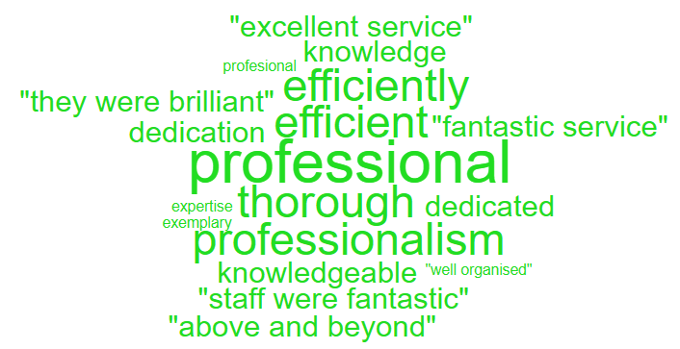
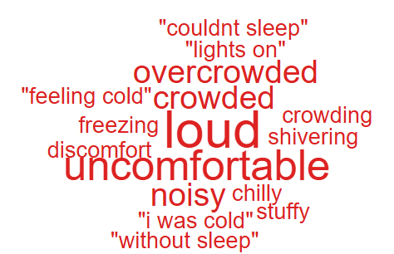

Clinical Treatment;
Delay/Lack of treatment or Assessment | 126
Incorrect/insufficient treatment or Assessment | 65
Reaction to procedure/ treatment | 36
Incorrect diagnosis | 16
Delay/Lack of diagnosis | 13

Theme 2; Communication;
Communication Improvement Plan;
- Training during consultant development programme where the importance of good and clear communication is discussed.
- Complaints/communication training sessions delivered by the Corporate team to Service Groups – this training is ongoing
- Bespoke training provided to Service Groups and specific departments on complaints which includes communication
- Reminders in CRAG meetings of the importance of clear communication and regular meaningful updates to complainants or patients

- Outpatient Department – Quarter 4– Wordles relating to communication were mainly positive, there was one negative comment.
- Negative comment - Staff were warm, welcoming, put me at my ease. I wasn’t kept waiting for long. Only constructive criticism is, I would have preferred to be asked if I wanted my partner present when discussing results, instead of just ringing him to be there. The bowel preparation was awful, I would expect the elderly to struggle with the volume and taste to be consumed.

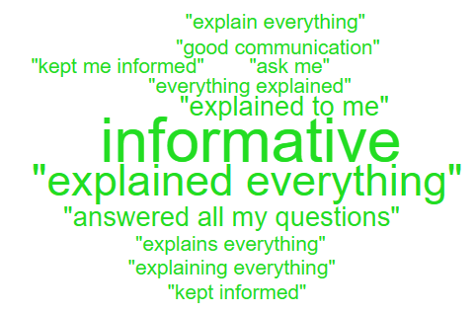

During Q4, 182 complaints were received relating to communication. A breakdown of the sub-subjects are below – please note, some complaints include more than one of these issues.
Communication Issues;
Insufficient/Incorrect information | 159
Communication with family | 20
Communication with patient/service user | 15
Communication between Services/Departments | 5

Theme 3; Appointments;
What we are doing about this?
- Outsourcing of patients to other Healthcare providers to help reduce waiting times.
- Rapid Diagnostic Centre expansion.
- Expansion of our virtual wards to widen the range of disciplines involved, so increasing the number of patients who can be treated appropriately out of hospital
All Wales questions do not have ‘appointments’ as a question set. Therefore, as an alternative a search was undertaken on the words delay/delays/appointment.
Below are some comments we found relating to ‘appointments’ for Adult Mental Health in Quarter 4.
- I don’t like the early appointments.

- Most of the time he is ok, but he does cancel a lot of our appointments

Below are some comments relating to ‘appointments’ for Orthopaedic in Quarter 4.
- My appointment was cancelled for the 6th time.

- My appt was 20 mins late, however it was a productive visit. Very informative and helpful.

- when I came back, I was told to go back to the waiting room.

During Q4, 100 complaints were received regarding appointment issues. Many of these complaints will have more than one sub-subject, see breakdown below;
Appointments;
Delay in appointment/waiting time/transport | 59
Appointment cancelled | 31
Patient lost to follow-up | 5
Cancelled appointment/transport | 2
Continuity of staff | 1

- HIGH RISK AREAS

As part of the Health Board’s focus on Urgent Care, Planned Care and Cancer Services the following section highlights complaints received in:
- Orthopaedics
- Emergency Department (ED)
- General Surgery
- Cancer Services
- Mental Health
Graph 1 below shows the number of complaints for each of these areas received per month since April 2024.
Graph 1: Complaints per month
As shown in the graph, there are minimal complaints for Cancer Services with none received during Q4. A breakdown of the issues raised within the other services during Q4 can be found below;

3.1 – Orthopaedic Complaint themes

Patient Experience Feedback: Orthopaedic Services
As Orthopaedics is classed as a ‘High Risk Area’, the Patient Experience Team have investigated the feedback for Orthopaedic Services. In total, Orthopaedic Services received 232 responses to the Friends and Family Survey during Quarter 4.
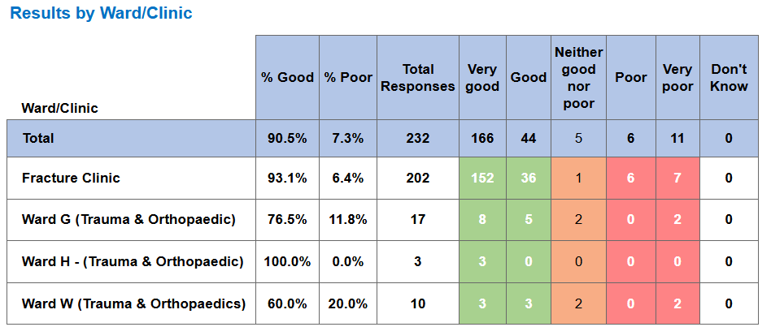

Below are the top themes for Orthopaedic services:
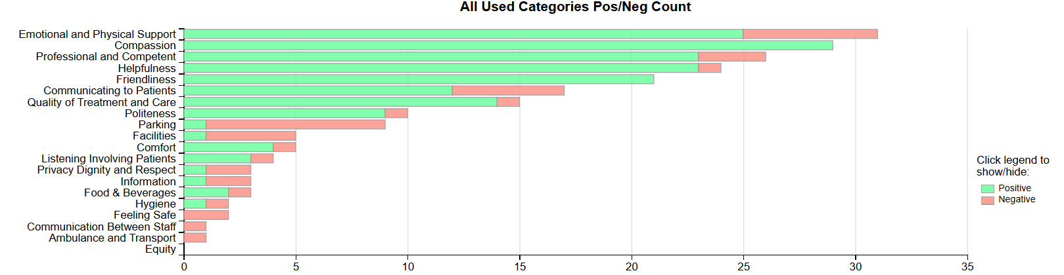

NB: The Civica system on occasions is oversensitive with the word ‘Pain’ and sometimes feeds these as a negative in charts and wordles. This is a national platform issue affecting all Health Boards. The overall satisfaction score is not affected by this.

Positive Themes
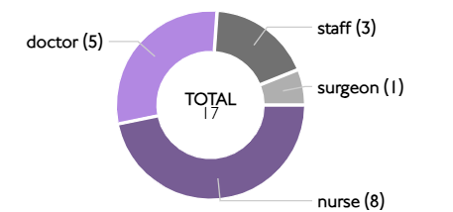
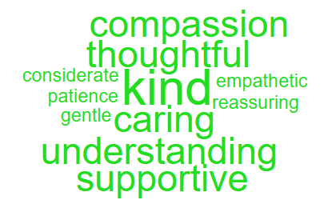
‘Compassion’ Sub themes ‘Kind’

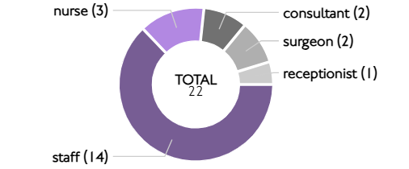
‘Friendliness’ Sub themes ‘Friendly’
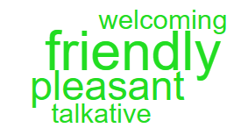

Here are some of the positive comments:
- Everyone was very kind and explained things clearly. I felt very well cared for. That was all very good. Excellent, even when we did have to wait a while for the CT scan, but I understand it was busy - just grateful to have that service.
- Seen early, very kind volunteers found me a wheelchair. The doctor and nurses were kind, efficient and professional. Made another appointment for next week.
- All the staff were superb. Very thoughtful and attentive to my needs. Cannot speak highly enough of them all.
- The staff were brilliant, kept me updated went and got my prescription. They were really kind.

Negative Themes
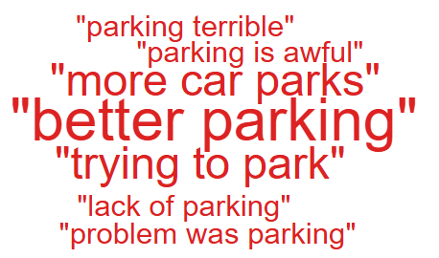
‘Emotional & Physical Support’ ‘Parking’
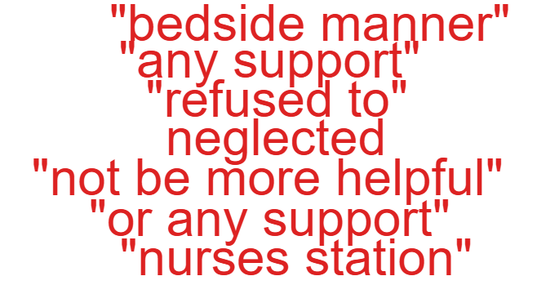

Below are comments linked to the ‘Negative themes’ above.

- Not really. There was a mix in competency and bedside manner in nursing staff - ranging from superb to very poor.

- Prior to attending Morriston A&E I visited NPTH and they refused to treat me and referred me to my GP.

- The food is unbelievably awful. I was in hospital for 6 weeks and found the predictable menu lacking in freshness taste and really not fit for purpose. I feel the lack of good food hampered my recovery. I also found the nurses station to be ridiculously noisy during changeover which was very disruptive for patients rest. I also found some of the care assistants too loud and talkative with each other. I felt for the main looked after but feel the nursing staff could have been more sensitive to the noise levels they were creating.

- Better parking! very stressful trying to park, especially afternoon and late morning.

  - – Emergency Department (ED) Complaints
During Q4 of 2024/25, ED received 35 complaints, a breakdown of the issues is below;

The 13 ‘clinical treatment/assessment’ complaints all relate to delays in treatment or assessment.

Patient Experience Feedback: ED Services
As ED is classed as a ‘High Risk Area’, the Patient Experience Team have investigated the feedback for ED Services. In total, ED Services received 842 responses to the Friends and Family Survey during Quarter 4.
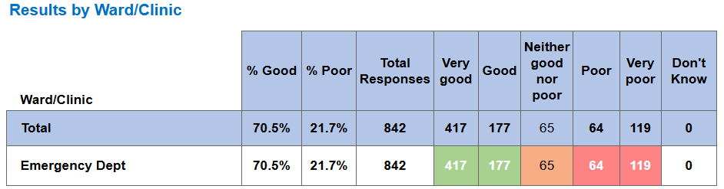
Below are the top themes for ED services:
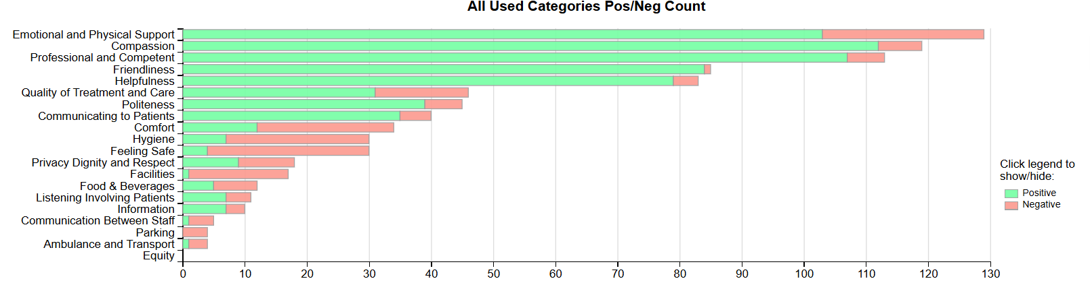
Positive Themes
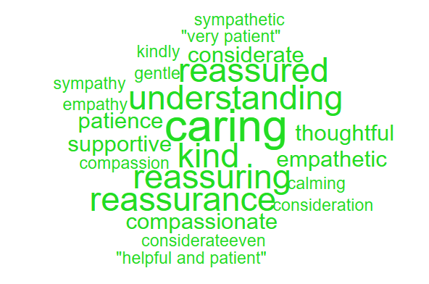
‘Compassion’ Sub theme ‘Caring’
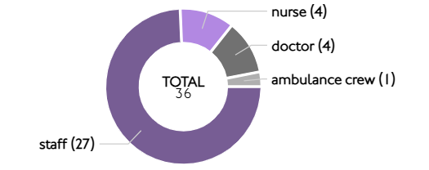
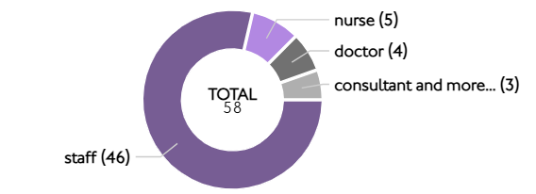
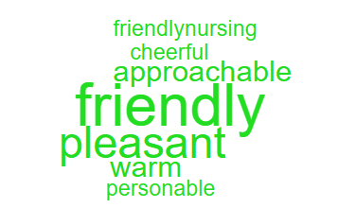
‘Friendliness’ Sub theme ‘Friendly’

Here are some of the positive comments:
- Friendly and helpful staff but of course very busy. Each stage was explained, and I felt listened to.
- Friendly kind staff made it more comfortable for my time there.
- I was seen very quickly. The staff were very helpful and pleasant. Once I had a diagnosis the doctor explained my situation and treatment without causing any alarm or concern. I was taken to the pharmacy where I was given an explanation of the medicine that I was prescribed. I believe that I was treated professionally and efficiently
- Staff were professional and pleasant under very busy and trying circumstances.

Negative Themes
‘Feeling safe’ ‘Emotional & Physical Support’
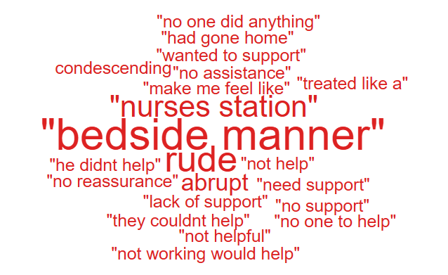
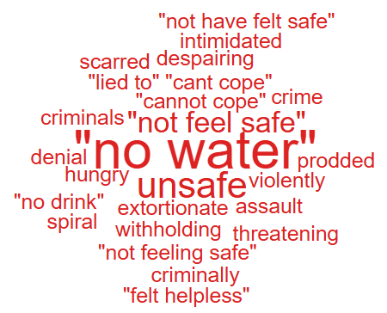

NB: The Civica system on occasions is oversensitive with the word ‘Pain’ and sometimes feeds these as a negative in charts and wordles. This is a national platform issue affecting all Health Boards. The overall satisfaction score is not affected by this.
Here are the negative comments relating to ED:
- There was no water available until we asked 3 times for the jugs to be filled. The staff were so busy, but we were desperate, and I was in so much pain we had not come with any supplies.
- Have a water cooler available for patients in the waiting areas to access so we don’t dehydrate waiting. The extortionate prices of water from WHSmith and costa franchise`s on your premises is shocking and very disappointing. More frequent checks and cleaning of public toilet areas. It only takes one inconsiderate person to make an unacceptable mess or high volume of patients where soap and paper towels run out.
- Please stop the blatant denial of my spinal cord compression vertebral artery compression neoplastic.
  - – General Surgery Complaints
During Q4 of 2024/25, General Surgery received 35 complaints, a breakdown of the issues is below;

There appears an increase in General Surgery complaints therefore, a further analysis of what the issues are has been undertaken. The two main concerns are;
- Delayed treatment/assessment – these include; bowel surgery, gallbladder/gallstone removal, hernia surgery.
- Communication – insufficient/incorrect information
Patient Experience Feedback: General Surgery
As General Surgery is classed as a ‘High Risk Area’, the Patient Experience Team have investigated the feedback for General Surgery Services. In total, General Surgery Services received 2,892 responses to the Friends and Family Survey during Quarter 4
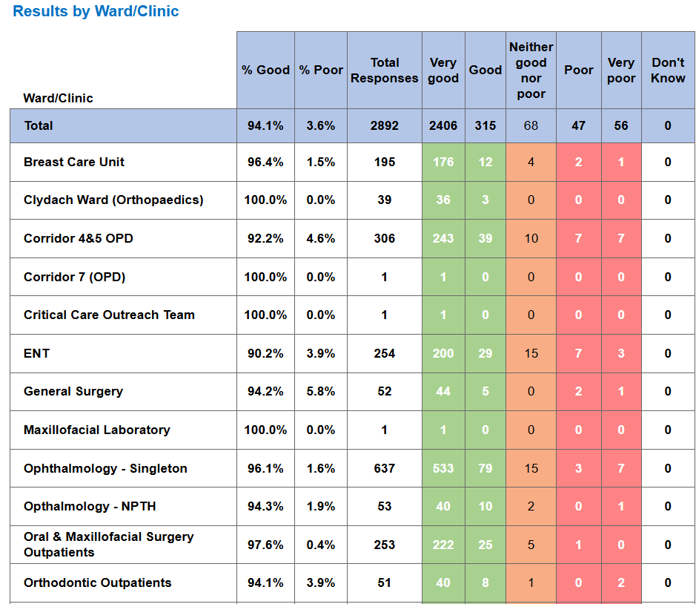

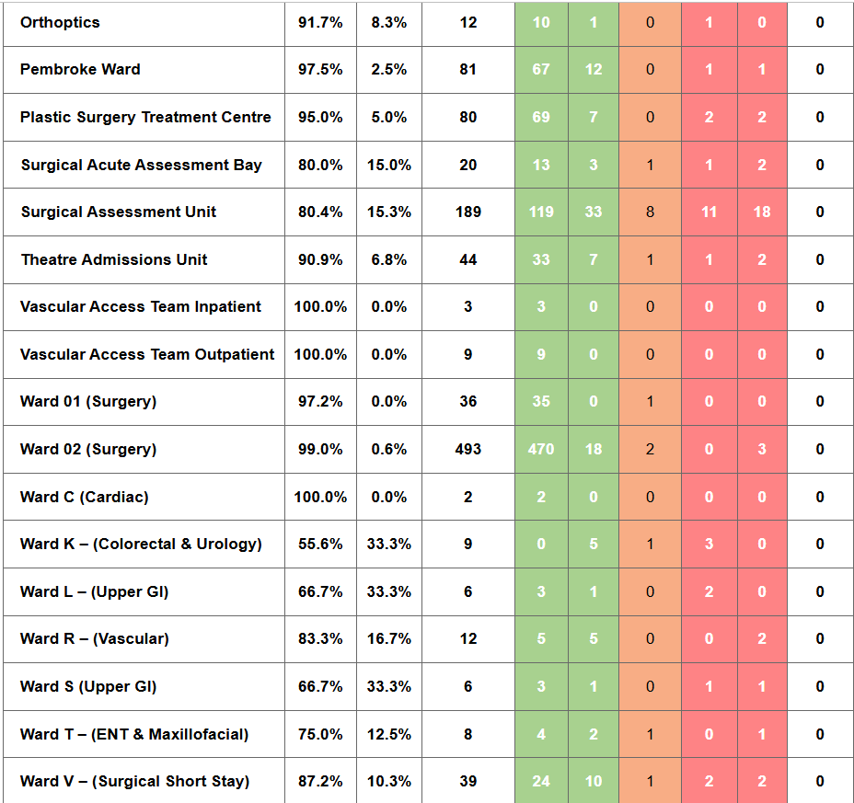
Below are the top themes for General Surgery services:
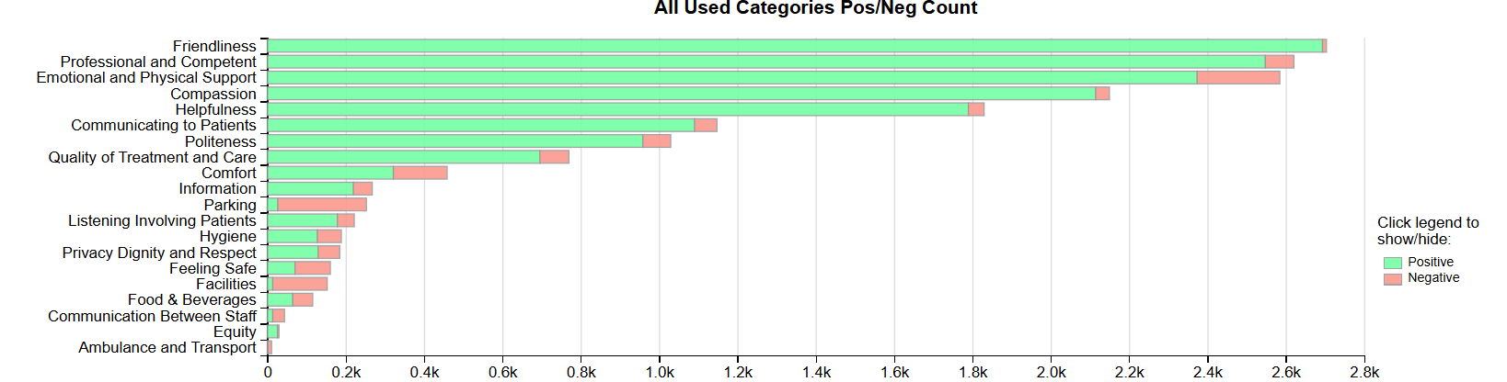
NB: The Civica system on occasions is oversensitive with the word ‘Pain’ and sometimes feeds this as a negative in charts and wordles. This is a national platform issue affecting all Health Boards. The overall satisfaction score is not affected by this.
Positive Themes

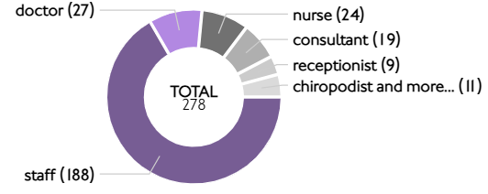
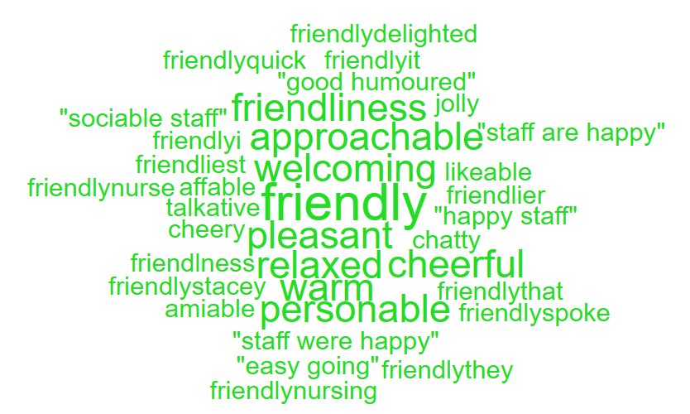
‘Friendliness’ Sub theme ‘ Friendly’

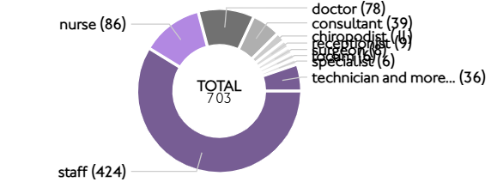
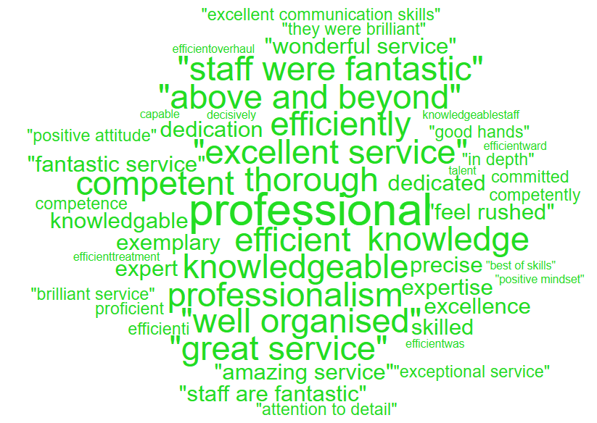
Professional & Competent’ Sub theme ‘ Professional’

Here are some of the positive comments:
- Calm and supportive professional undertaking the procedure.
- 15 years and every appointment is first class. All the staff are friendly and professional.
- Everything was excellent, the staff were fantastic. The day ward clean and relaxing, tried to do a review but couldn’t find where to do so I’m so glad I’ve had this

Negative Themes
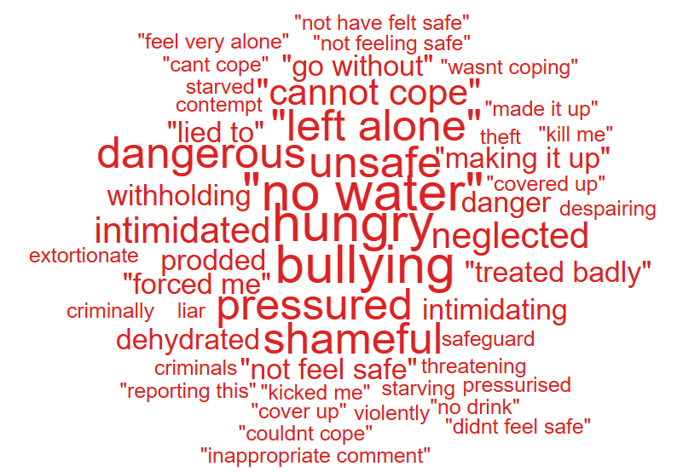
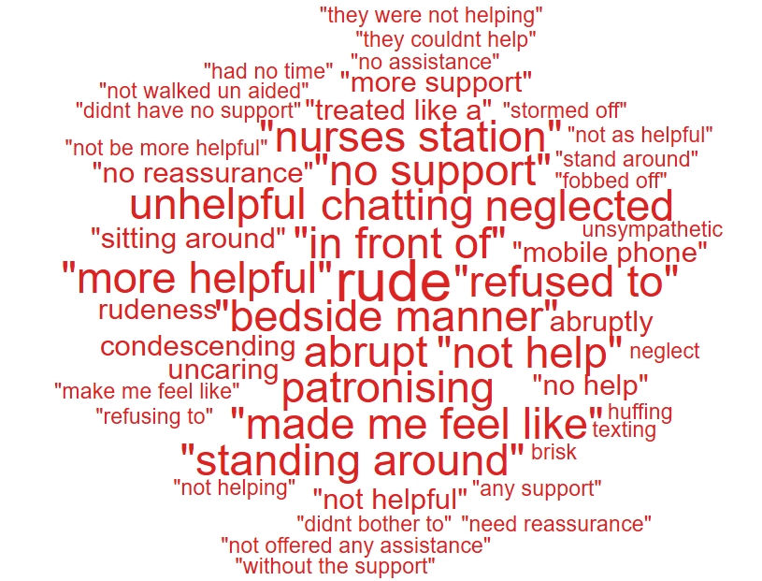
‘Emotional & Physical Support’ ’Feeling safe’

Below are some negative comments relating to General Surgery:
- All the doctors were lovely, although one at the end was very rude and abrupt.
- Receptionist rude, informed her of my need of reverse barrier due to palliative care. She was not caring, lack of empathy and shrugged her shoulders.
- Yes, I felt the consultant nurse I spoke too was very abrasive and abrupt in her manner. When asking relevant questions, she made me feel belittled and that the question I asked was stupid.
Cancer Service Complaints
As shown in graph 1 above, there were no complaints relating to cancer services received in Q4.

Patient Experience Feedback: Cancer Services
As Cancer is classed as a ‘High Risk Area’, the Patient Experience Team have investigated the feedback for Cancer Services. In total, Cancer Services received 749 responses to the Friends and Family Survey during Quarter 4.
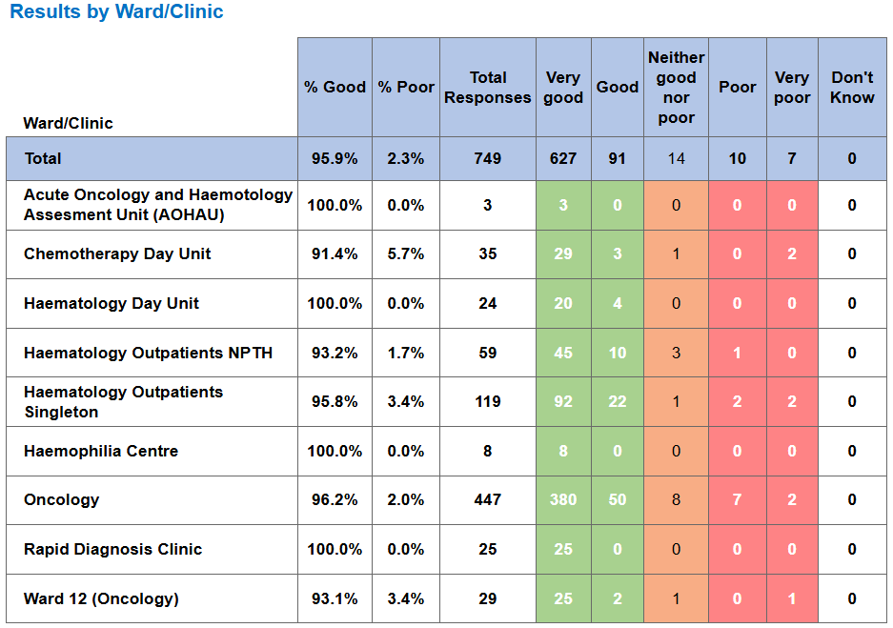
Below are the top themes for Cancer services:
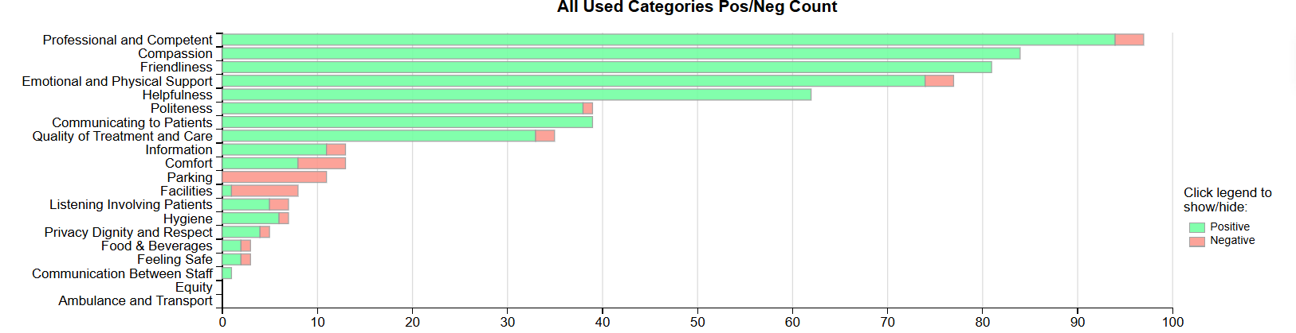
NB: The Civica system on occasions is oversensitive with the word ‘Pain’ and sometimes feeds these as a negative in charts and wordles. This is a national platform issue affecting all Health Boards. The overall satisfaction score is not affected by this.

Postive Themes
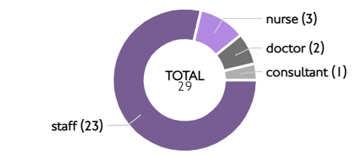
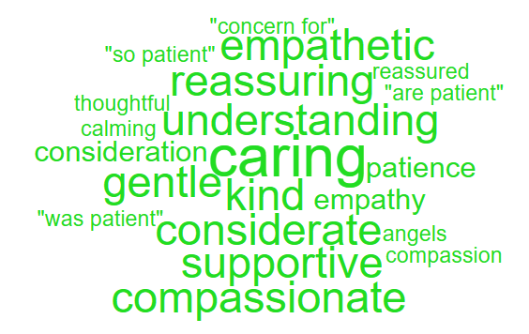
‘Compassion’ Sub themes ’Caring’

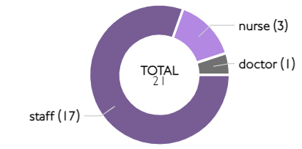
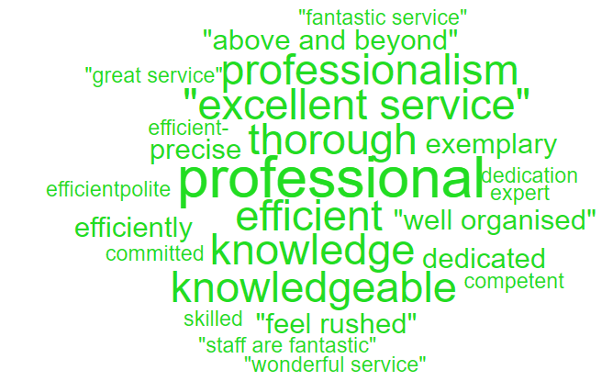
‘Professional & Competent’ Sub themes 'Professional’

Here are some of the positive comments:
- All staff are so caring and supportive they definitely go above and beyond the line of duty

- Brilliant team, very caring and professional, credit to Wales.

- The staff are fantastic, very caring and supportive. Cannot thank them enough.

- The doctor was very thorough and explained everything in detail. He was very understanding, easy to talk to and a pleasure to deal with.

- All my interactions have been positive with consideration of staff being busy, they are always understanding and helpful and that includes the next generation of staff that are training.

Negative Themes
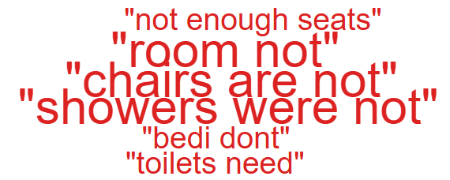
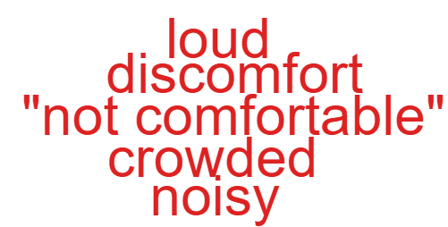
‘Comfort’ ‘Facilities’

Looking at the chart above it highlights comments specifically related to ‘waiting’ as negative feedback. Here are some examples of the comments written to give context.
- The chemo chairs are not comfortable for long periods of time.
- Very noisy outside the room.
- Move any prisoners into a room not in the ward. The wardens didnt stop talking all night and loud.
- Patients showers were not the best on my ward, weak flow and not the warmest.
- Yes, ward toilets need to be cleaned.

3.4 Mental Health Complaints
During Q4 of 2024/25, Mental Health received 81 complaints, a breakdown of the top 10 areas these relate to is shown below;

Also below is a breakdown of the issues raised within these complaints;
Appointments | 18
Monitoring/Observation Issues | 17
Attitude and Behaviour | 11
Communication Issues | 9
Access (to Services) | 5
Clinical treatment/Assessment | 5
Medication | 3
Patient Care | 3
Record Keeping | 3
Confidentiality | 2
Admissions | 1
Environment/Facilities | 1
Personal Property/Finance | 1
Referral | 1
Test and Investigation Results | 1

Patient Experience Feedback: Mental Health
For our Mental Health feedback, we primarily utilise a Service/User/Carer survey that is designed to be more user-friendly. In Quarter 4, we received 295 responses, with an overall satisfaction score of 95% for the question, "Overall, how was your experience?"
Additionally, we received 2 Friends and Family responses, resulting in an average score of 100%.

Themes
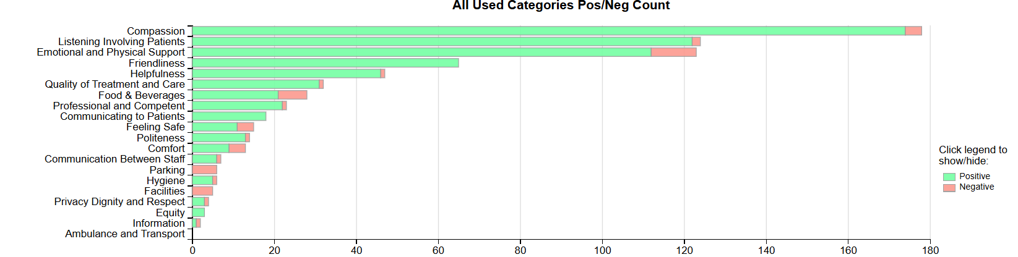
Top Themes - Positive
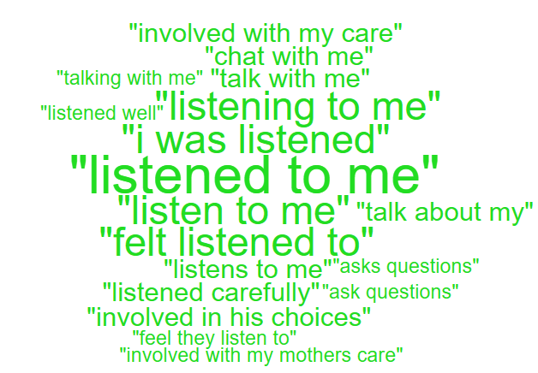
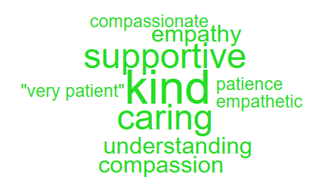
'Compassion' 'Listening & Involving patients'

Here are some of the positive comments:
- Always kind with me and very good with my mother. She trusts her so much.
- Cardigan ward, Caswell Clinic staff are very kind and look after me. They talk and listen and help me. I want to get better.
- I am very well looked after on Cardigan ward, Caswell Clinic. The staff are supportive and very good with me. The food is good to and it’s my favourite, faggots and chips tonight.
- The staff on Ogmore are a great team and they have been very supportive to me.
- I have felt listened to and they have remembered everything that I have said to them. That was good.

Negative Themes
‘Emotional & Physical Support’ ‘Food & Beverages’
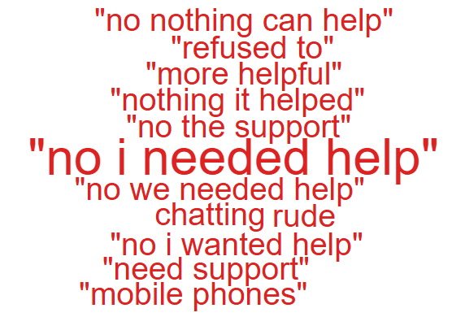
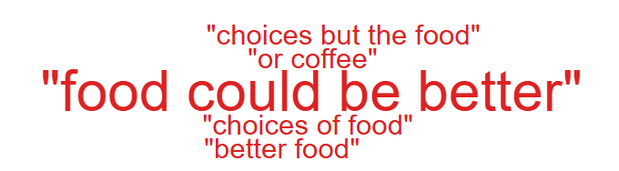

Please see below some negative comments:
- My GP have refused to contact primary mental health further to say that I need support urgently. If possible, please could I ask politely if this could be looked into as I feel that after working for the NHS for four years I should be given some support.
- There are a couple that are nice to us, but the majority are quite rude and will have an awful attitude with us. I wish they would be more helpful and actually help us. I asked for a 1 1 as I was feeling suicidal, this I was proud of as I usually don’t ask for any help, and I was told I’d have to wait as they were all busy. 5 days later someone came to me for the 1 1.
- Yes, I have had choices, but the food could be a bit better.
- Can we have tea or coffee 24 hours a day just in case I can’t sleep at night.

Nutrition & Hydration
As Nutrition & Hydration is currently one of the Health Board’s priorities, for this quarterly report please see below overview of the feedback received.
The Health Board received 16 complaints between 1st January 2025 – 31st March 2025 which involved Nutrition & Hydration issues. Please see breakdown below of what services these complaints related to;

The specific issues raised in these complaints are below (please note some of these complaints may have more than one sub-subject);
Availability of nutritional supplements | 9
Patients not properly hydrated | 5
Lack of assistance with Patients feeding/hydration | 1
Temperature (too hot/too cold) | 1

The ‘patient not properly hydrated’ issues relate to the following areas;
Emergency Department | 2
Acute Medical Unit (AMU) | 2
Surgical Assessment Unit (SAU) | 1

Patient Experience Feedback – Nutrition & Hydration.

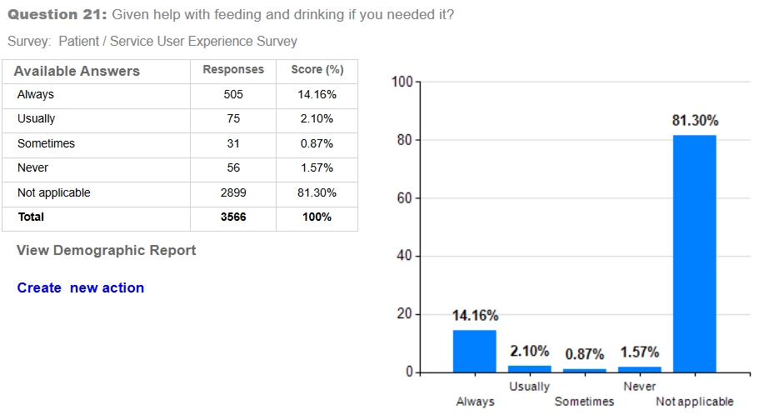

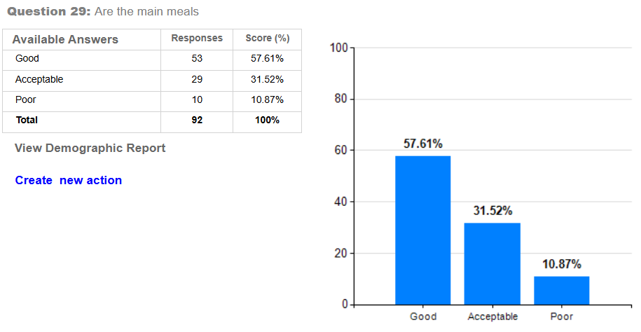
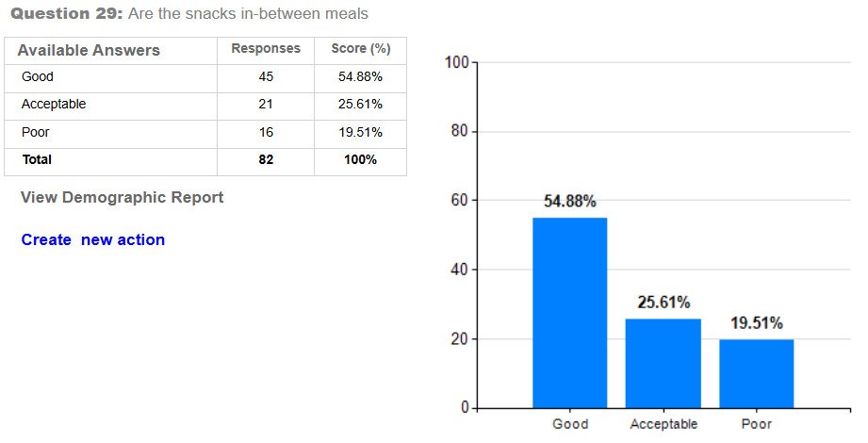
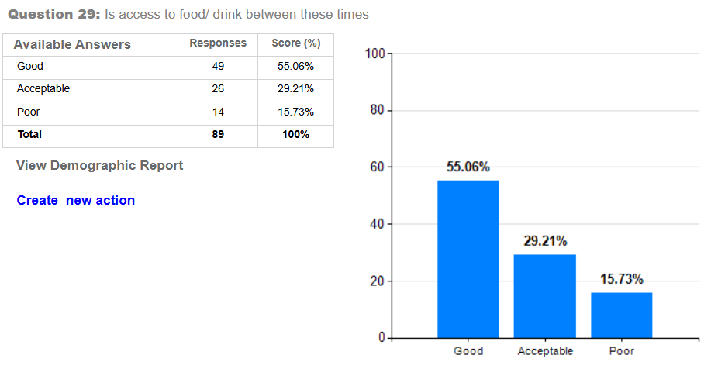
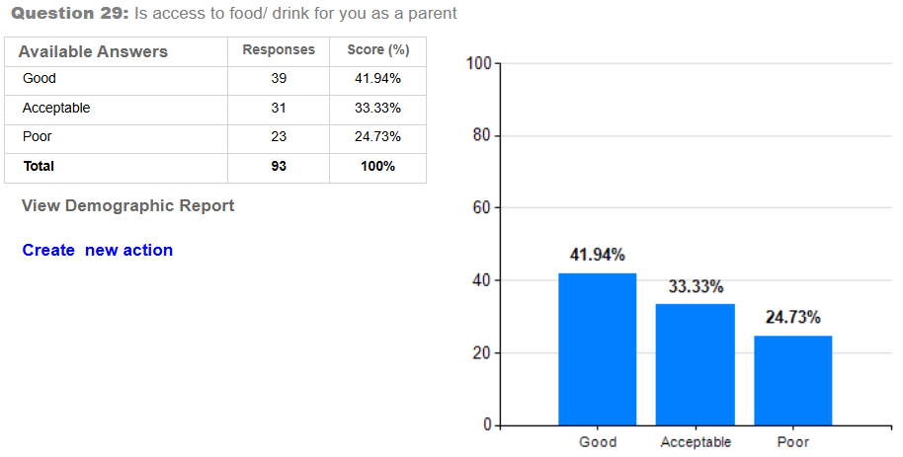
Top themes
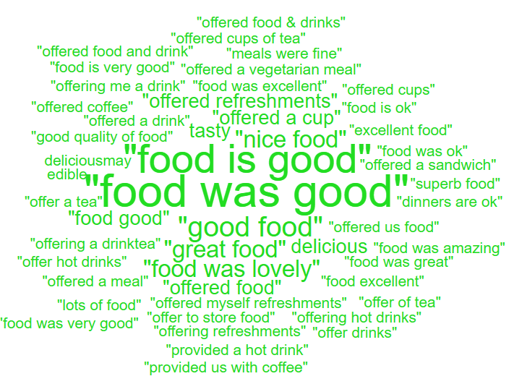
‘Positive’ ‘Negative’
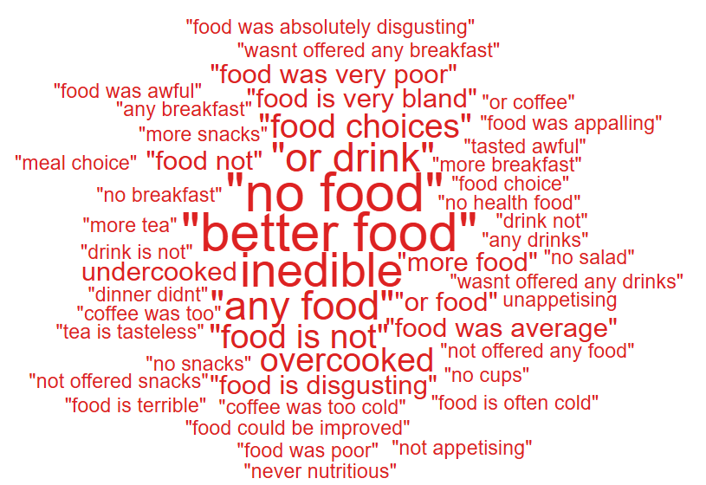

Please see below some positive and negative comments:
- Care very good and staff excellent. Food was good and happy.
- All staff very informative smiley friendly thoughtful good food. I am very grateful for their care
- Lacking in freshness taste and really not fit for purpose. I feel the lack of good food hampered my recovery.
- There was mold in the showers, I was left without a wash for 3 days. The food was very poor.
- She wasn’t offered any breakfast and when we were discharged, I had to go and buy food at costa due to them not offering her on the ward. This has never happened with any of my other children when they have been admitted. We didn’t leave the ward until gone 10am so I’m pretty sure breakfast should have been offered to her by then.
- They ensured me or mam were offered refreshments throughout our stay here at oakwood ward.
- SERVICE GROUP COMPLAINTS, INCIDENTS, COMPLIMENTS AND PATIENT FEEDBACK HIGHLIGHTS

MORRISTON SERVICE GROUP
4.1 – Morriston Service Group complaints
Morriston Service Group received a total of 246 complaints during Q4 2024/25, this compares with 212 complaints during Q3 2024/25. Graph 1 below shows the total number of complaints received relating to Morriston Service Group since April 2024. The graph breaks the total number received down by Formal Putting Things Right, Early Resolution and Re-opened complaints.
Graph 1: Morriston Service Group complaints by month and type

Graph 2 shows the top five services that had the most complaints since April 2024.

Graph 2: Top 5 Services by month

As explained above, there appears an increase in General Surgery complaints which would contribute to the overall increase to Morriston complaints received in Q4.
4.2 – Morriston Service Group Incidents
Morriston Service Group reported 2493 incidents in quarter 4 (Q4) of 2024/25 (January, February, March). This compares with 2412 incidents in quarter 3 (Q3) of 2024/25 (October, November, December). Graph 1 shows the number of incidents per month broken down by severity.
Graph 1: Morriston Incidents by Severity and month

Graph 2 shows the top 5 incident types, of all incidents reported by Morriston Service Group since January – March 2025.

Graph 2: Top 5 incidents per month

4.3 – Morriston Service Group National Reportable Incidents
Morriston Service Group reported 8 Nationally Reportable Incidents (NRI’s) during Q4 2024/25, this compared to 5 being reported during Q3 of 2024/25. Of the NRI’s reported, 3 x falls, 1 x suicide, 1 x abscondment from ED, 1 x reporting error ventilation-perfusion scan, 1 x delayed follow up and 1 x Delay in referral in patient pathway.
Graph 1: Nationally Reportable Incidents reported per month by Morriston Service Group

4.4 – Morriston Service Group Compliments
Morriston received 123 compliments during Q4 of 2024/25. Graph 1 shows the number received per month since April 2024.
Graph 1: Morriston compliments per month

Graph 2: Morriston compliments – Top 5 Services

4.5 Morriston Service Group Patient Experience Feedback
Overall, during quarter 4 there were 105,992 number of patients seen under Morriston Service Group (This includes Emergency Department and Minor Injury Unit).

There were 7,484 Friends and Family survey returns which equates to 7% responding to the survey. Out of the 7% who responded, 90% of people stated they would highly recommend the Health Board to Friends and Family.

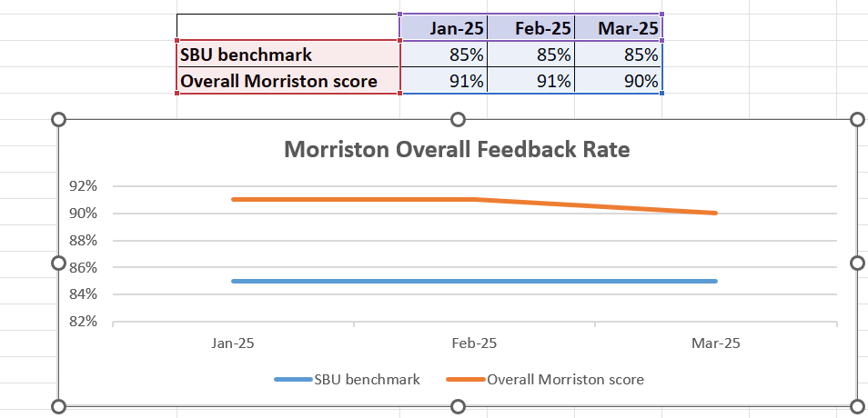
Below are the number of responses in a line graph:

Below are the main themes mentioned for Morriston:
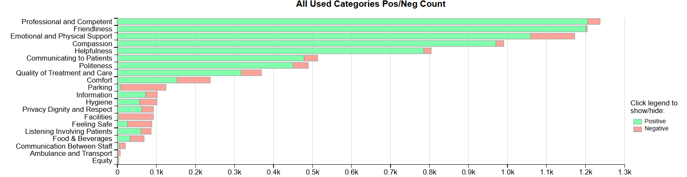

NEATH PORT TALBOT SINGLETON SERVICE GROUP
4.6 – NPTSSG Complaints
NPTSSG received a total of 171 complaints during Q4 2024/25 which compares with 145 received during Q3. Graph 1 below shows the total number of complaints received relating to NPTSSG since April 2024. The graph breaks the total number received down by Formal Putting Things Right, Early Resolution and Re-opened complaints.
Graph 1: NPTSSG complaints by month and type

Graph 2 shows the top five services that had the most complaints since April 2024.

Graph 2: Top 5 Services by month

There appears an overall increase in complaints for NPTSSG during Q4 compared with the previous quarter. There is not one particular service that has had an increase however, Rheumatology and Paediatrics have both had five more complaints when compared with the previous quarter.
4.7 – NPTSSG Incidents
NPTSSG reported 1452 incidents in quarter 4 (Q4) of 2024/25 (January, February, March). This compares with 1434 incidents in quarter 3 (Q3) of 2024/25 (October, November, December). Graph 1 shows the number of incidents per month broken down by severity.
Graph 1: NPTSSG Incidents by Severity and month

Graph 2 shows the top 5 incident types, of all incidents reported by NPTSSG since January – March 2025.
Graph 2: Top 5 incidents per month

4.8 – NPTSSG National Reportable Incidents
NPTSSG reported 10 Nationally Reportable Incidents (NRI’s) during Q4 2024/25, this compares to 19 being reported during Q3 of 2024/25. Of the NRI’s reported – 6 x IUD’s, 1 x Pressure Ulcer, 1 x neonatal death, 1 x Failure to follow protocol/SOP, 1 x Lack of prophylaxis medication.
Graph 1: Nationally Reportable Incidents reported per month by NPTSSG

4.9 – NPTSSG Compliments
NPTSSG received 56 compliments during Q4 of 2024/25, compared with 69 during Q3. Graph 1 shows the number received per month since April 2024.

Graph 1: NPTSSG compliments per month

Graph 2: NPTSSG compliments – Top 5 Services

4.10 NPTSSG Patient Experience Feedback
Overall, during quarter 4 there were 109,098 number of patients seen under Neath Port Talbot and Singleton Service Group.

There were 5,771 Friends and Family survey returns which equates to 5% responding to the survey. Out of the 5% who responded, 95% of people stated they would highly recommend the Health Board to Friends and Family during this quarter.

Below are the number of responses in a line graph:

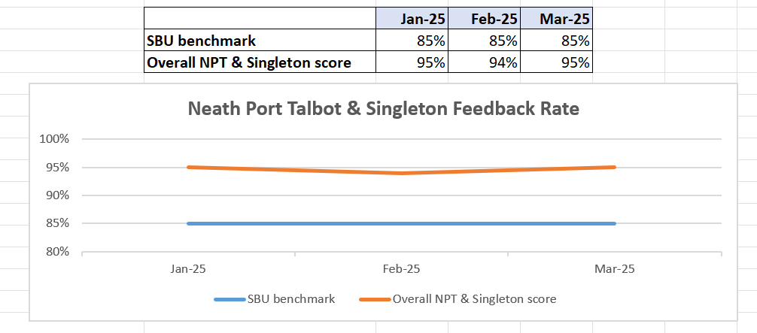

Below are the main themes mentioned for NPT & Singleton:
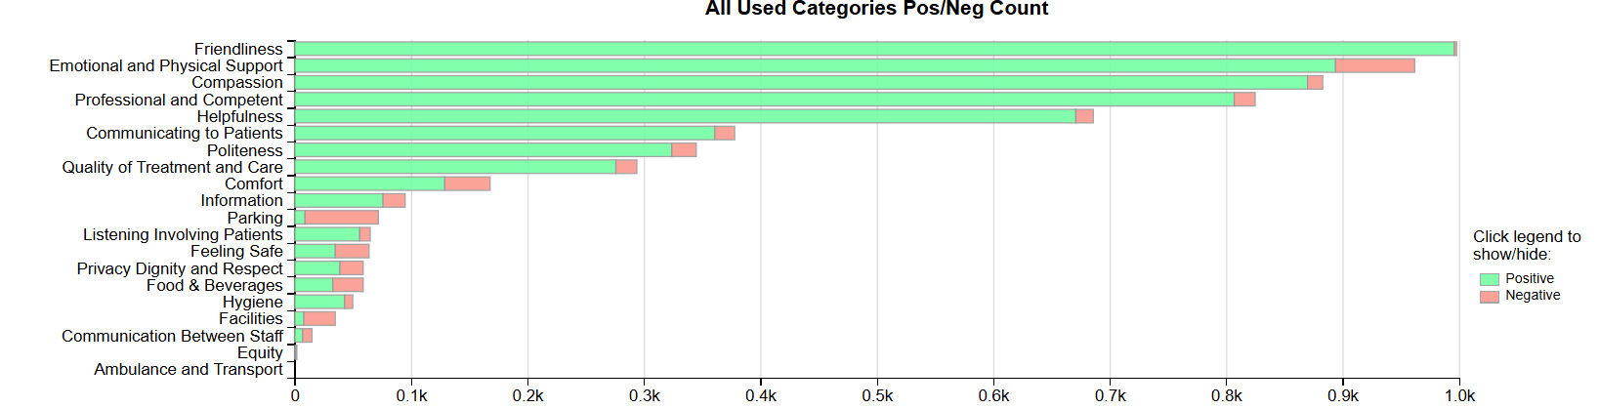

MENTAL HEALTH AND LEARNING DISABILITIES SERVICE GROUP
4.11 – MH&LD Complaints
MH&LD received a total of 81 complaints during Q4 2024/25 (January, February, March) compared with 86 during Q3 (October, November, December). Graph 1 below shows the total number of complaints received relating to MH&LD since April 2024. The graph breaks the total number received down by Formal Putting Things Right, Early Resolution and Re-opened complaints.
Graph 1: MH&LD complaints by month and type

Graph 2 shows the top five areas within MH&LD that had the most complaints since April 2024.
Graph 2: Top 5 Services by month

4.12 – MH&LD Incidents
MH&LD reported 898 incidents in quarter 4 (Q4) of 2024/25 (January, February, March). This compares with 1188 incidents in quarter 3 (Q3) of 2024/25 (October, November, December) Graph 1 shows the number of incidents per month broken down by severity.
Graph 1: MH&LD Incidents by Severity and month

Graph 2 shows the top 5 incident types, of all incidents reported by MH&LD since January – March 2025
Graph 2: Top 5 incidents per month

4.13 – MH&LD National Reportable Incidents
MH&LD reported 3 NRI’s during Q4 of 2024/25, compared with 1 reported during Q3 of 2024/25. The 3 NRI’s were 1 x Fall, 1 x Pressure Ulcer and 1 x Suicide.

4.14 – MH&LD Compliments
MH&LD received 8 compliments during Q4 of 2024/25. Graph 1 shows the number received per month since April 2024.
Graph 1: MH&LD compliments per month

4.15 MH&LD Patient Experience Feedback
This data is from Quarter 4.

The Mental Health and Learning Disabilities Service Group are using a different set of survey questions. The role out of the semi structured interview surveys have been managed in stages. Roll out, awareness posters and meetings with managers and teams continues.
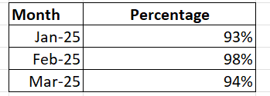

Below are the number of responses in a line graph:

PRIMARY AND COMMUNITY SERVICE GROUP
4.16 – P&C Complaints
P&C received a total of 105 complaints during Q4 2024/25 (January, February, March) compared with 75 complaints during Q3 2024/25 (October, November, December). Graph 1 below shows the total number of complaints received relating to P&C since April 2024. The graph breaks the total number received down by Formal Putting Things Right Early Resolution and Re-opened complaints.
Graph 1: P&C complaints by month and type

Graph 2 shows the top five services that had the most complaints since April 2024.
Graph 2: Top 5 Services by month

From the graph it is evident that the overall increase in Q4 is due to the number of prison complaints received which double in Q4 compared to Q3.
4.17 – P&C Incidents
P&C reported 1068 incidents in quarter 4 (Q4) of 2024/25 (January, February, March). This compares with 1026 incidents in quarter 3 (Q3) of 2024/25 (October, November, December).). Graph 1 shows the number of incidents per month broken down by severity.
Graph 1: P&C Incidents by Severity and month

Graph 2 shows the top 5 incident types, of all incidents reported by P&C since April 2024.
Graph 2: Top 5 incidents per month

4.18 – P&C National Reportable Incidents
P&C reported 4 Nationally Reportable Incidents (NRI’s) during Q4 2024/25, which was the same as Q3 of 2024/25. The 4 NRI’s reported in Q4 included 1 x Lost / Misplaced Controlled Drugs, 1 x Attempted Suicide, 1 x Suicide and 1 x GP Blood Results not acted upon.
Graph 1: Nationally Reportable Incidents reported per month by P&C

4.19 – P&C Compliments
P&C received 73 compliments during Q4 of 2024/25, compared with 86 during Q3. Graph 1 shows the number received per month since April 2024.
Graph 1: P&C compliments per month

Graph 2: P&C compliments – Top 5 Services

4.2 P&C Patient Experience Feedback
During Quarter 4, a total of 1,422 patients were seen under the Primary and Community Service Group.

A total of 2,116 Friends and Family survey responses were received during this quarter, with 96% of respondents stating they would highly recommend the Health Board to their friends and family.

Patient Experience Team are currently working with I.T to automate SMS messages from the PIMS, PIMS+ platform to automate SMS survey messages to Primary Care and Therapies patients. This will increase the number of returns.

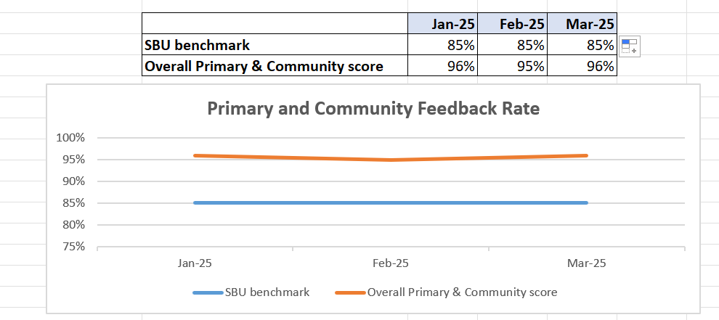
Below are the number of responses in a line graph:

Below are the main themes mentioned for Primary & Community:
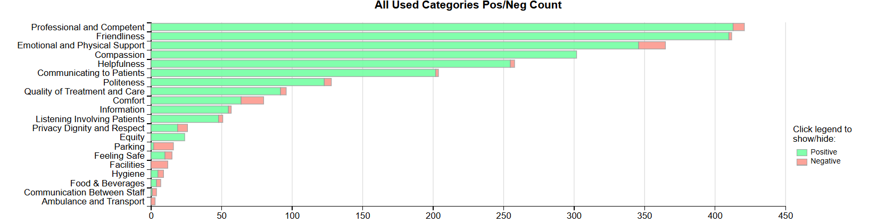

- MEDICAL EXAMINER COMPLIMENTS

5.1 ME Compliments
The Health Board has received a number of compliments from families through the Medical Examiner. This evidences the good work being done when treating these end of life patients. During Q4, approximately 74 compliments were received. A few examples are shown below;
“Care received was wonderful, everything they did was wonderful, it was lovely to have him home with the family around it brought them great comfort.”
GP, NPT

“Care was excellent, the service was phenomenal, they cared for him and for the whole family. Unbelievable care, it was the little things that made such a difference. Very high praise for all involved”
Ward 12, Singleton

“Everyone that looked after her was excellent all the staff involved in her care were very good and they were all very good at communication with the family. She feels they have had a very good experience.”
Tonna Hospital

- OMBUDSMAN CASES

6.1 Ombudsman investigations
5 new Ombudsman investigations were received during Q4 2024/25, this compares to 2 in Q3 2024/25. Graph 1 shows the number of investigations received per month;

Graph 1: Number of Ombudsman investigations per month

The Health Board has also received 34 decisions not to investigate from the Ombudsman during Q4. Graph 2 below shows these by month.

Graph 2: Ombudsman decisions not to investigate

There are a number of different reasons why the Ombudsman decided not to investigate these complaints, a few of these reasons are detailed below;

- Health Board offered second opinion in response which is an appropriate response
- Out of time
- Dental or GP concerns where practice needs to respond
- Health Board apologised for failures and no evidence of harm
- Not sufficient maladministration to open investigation against

Ombudsman Wales Quarterly Newsletter November 2024 - March 2025
The Ombudsman Quarterly Newsletter contains the following:
- The Ombudsman has completed the second year of their Strategic Plan 2023-26 ‘A New Chapter’. Many actions set out under the Plan have now been delivered and they continue to work towards their ambitious goals during 2025/26.
- The Ombudsman remain focused on rebuilding the reputation of their office, following the social media incident last year which called their impartiality into question. While an independent review of their investigation of Code of Conduct Complaints found that their decision making was appropriate, fair and free from political bias, it also made recommendations to improve the current safeguards for ensuring fairness and impartiality.
- 3 Public Interest Reports – one for WAST and Swansea Bay, although the Public Interest Report is solely for WAST, as nothing was upheld for Swansea Bay.
- Welsh Health Boards and Trusts logged just over 9,000 complaints – a slightly lower number compared to the same period last year
- Welsh Health Boards and Trusts closed more than 80% of complaints within the target of 30 working days – an improvement on the same period last year

Please follow the link below to access the full newsletter; Quarterly Newsletter November 2024 - March 2025

