Meeting Date | 01 May 2025 |  | Agenda Item |  |  | 2.2
Report Title | Neath Port Talbot & Singleton Service Group Quality & Safety Committee Highlight Report
Report Author | Sharron Price, Group Nurse Director
Report Sponsor | Deb Lewis, Chief Operating Officer
Presented by | Sharron Price, Group Nurse Director
Freedom of Information | Open
Purpose of the Report | This paper provides an update to the Quality & Safety (Q&S) Committee on matters of quality and safety overseen by the Service Group.
Key Issues | This paper provides the Q&S Committee with an update on and quality, safety & risk matters and provides a formal route of escalation to the Committee where necessary. Specifically, this paper aims to update the Committee on  - Improvements to quality, safety and patient experience;  - The provision of robust governance and assurance;  - Early identification and effective management of key risks;
Specific Action Required  (please choose one only) | Information | Discussion |  | Assurance | Approval
Specific Action Required  (please choose one only) | ☒ | ☐ |  | ☐ | ☐
Recommendations | Members are asked to:  - BE ASSURED BY the contents of this report

- INTRODUCTION

The purpose of this report is to provide the Quality & Safety Committee with information on the key issues, which have a direct impact on quality, safety & risk matters within the Service Group.

- QUALITY & SAFETY REPORT

2.1 Incident Management

There continues to be a steady improvement in the number of incidents open over 30 days for the Service Group.

The scrutiny and monitoring of progress by Division and speciality continues with weekly reviews at Service Group Business Assurance & Accountability Meetings (BAAM). Work is ongoing to review the number of incidents in the ‘Make it safe’ category in Datix, this will be reported at the next meeting.

The table below highlights the total incidents open for the Service Group

2.1.1 Nationally Reportable Incident
The Service Group has 4 Nationally Reportable Incident’s (NRI’s) which are overdue on closure. All 4 of these are in the CYPWH (Children, Young People & Women’s Health) division, the first is a neonatal death where the inquest has been postponed, the second is a still birth which has been submitted to the Executive Team for approval, the third is an adverse maternal outcome which is awaiting a learning event, and the fourth is a stillbirth which is awaiting the translation of the outcome letter.

2.1.2 Never Events
In the last 12 months there have been 3 "Never Events" reported within Theatres and Anaesthetics​

​These included: ​

Date |  | Speciality | Type of Never Event
Dec-24 | 70557 | Ophthalmology-Theatre | Wrong implant
Nov-24 | 66853 | Orthopaedics- Theatre | Wrong screw removed
Oct-24 | 65503 | Anaesthetics – Max Fax | Retained throat pack

2 incidents were reported by the Service Group as Never Events but following a review by the NHS executive these were downgraded
Date |  | Speciality | Type of Incident
Oct-24 | 65304 | Neonatal | Retained foreign object- downgraded by NHS exec 28/10/24
July-24 | 58440 | Theatre – Orthopaedics | Wrong laterality- downgraded from NE post closure – notified 19/3/25

An improvement plan has been developed and implemented and is being monitored via the Service Group QSR (Quality, Safety & Risk) Group and Corporate Q&S (Quality & Safety) Group.

Additional training across professional groups highlighting LOCSSIP (Local Safety Standards for Invasive Procedures) and NATSSIPs (National Safety Standards for Invasive Procedures), where to find them and correct actions ​has been undertaken. The formulation of a quality management system to support updates and sharing updates to processes across the MDT (multi-disciplinary team) is underway.

2.2 Concerns

The table below shows monthly performance against the 30-day Putting Things Right (PTR) target.

Month | September | October | November | December | January
Performance | 52% | 52% | 64% | 56% | 56%

The indicative data for February 2025 suggests this will remain at a static position.

The above graph demonstrates the trajectory of oldest concerns since October 2024.

As of the 24th April 2025, there were 3 complaints over a year old, the Divisions have given assurance these will completed by the end of May 2025. There are also 30 complaints that are between 6-11 months old, these are being monitored weekly in the SLT (Senior Leadership Team) meetings and the Group Nurse Director is in regular contact with the Divisional triumvirates for updates.

Whilst there is still work to do to bring performance in line with the regulations, the trajectories in terms of the Service Group’s oldest concerns have improved, with ongoing work to continue this improvement.

2.3 Quality and Engagement Act

Duty of Candour

The Service Group has consistently reported challenges in managing incidents under Duty of Candour (DoC) regulations. Service Group compliance with closed DoC incidents is 30%​.
The Service Group performs well with the Professional DoC with bedside conversations taking place and Datix reporting at earliest opportunity.

Areas for improvement are: Compliance with Datix Management of DoC​ and timely investigations. There are some very old incidents where DoC fields were completed incorrectly – changes to the Datix system makes correcting these challenging/time consuming. At present the service group is continuing to focus resources on dealing with current issues. There is a plan with supporting staff into work from long term sickness to focus on historical incidents to ensure outcome letters have been provided.

2.4 External reviews and inspections

- Independent External Review of Maternity and Neonatal Services

- Enhanced monitoring of Maternity and Neonatal Services

- Llais Review of Maternity and Neonatal Services

Health Inspectorate Wales (HIW) unannounced inspection – Birth Centre – February 2025
No immediate actions were found, an improvement plan has been submitted and accepted.

HIW – Maternity Services
The improvement plans for the 2019, 2023 and 2024 HIW inspections have now been completed in full. A report is on the agenda for the May Quality & Safety Committee.

HIW IR(ME)R (Ionising Radiation (Medial Exposure) Regulations) announced Inspection 03653 – Radiology (February 2025)
A letter of assurance with an evidence/action table was submitted on 13th March 2025, in response to a HIW request for further information/assurance regarding the use of the Mini C-Arm in Theatres.

HIW IR(ME)R announced inspection – Nuclear medicine & PET-CT (Positron emission tomography–computed tomography) (Oct 2023)
Improvement plan has been completed in full.

HIW - unannounced visit - Ward M & Oakwood - January 2023

2.5 Risks

Focused work has been undertaken in relation to the Risk Register with all risks of 20 and above being reviewed and presented to the SLT. This has allowed scrutiny and challenge in identifying, clarifying and confirming the risks for the service.

There is one risk (ID 3370 – Pharmacy provision for SACT (Systemic Anti-Cancer Therapy)) has recently been escalated from a score of 20 to 25, which has been agreed at the Service Group SLT.

There are currently three risks scored at 20 and one scored 25 which are currently not accepted on the Service Group’s risk register. These have been discussed at the Service Group’s SLT meeting, and the divisions have been requested to provide more information before the SLT can agree to accept/reject these.

2.6 Quality & Safety Priorities

2.6.1 Reduction in Health Care Acquired Infections (HCAI)
Achievements

- No cases of C difficile Ward C since September 2024 (6 toxcin +ve cases 24/25 following prolonged PII (Period of Increased Incidents) complete closure of the ward
- No cases of Staph Aureus in Neonates for 2024 / 2025 reporting period
- Achieved Staph aureus bacteraemia improvement goal 1 case reported ((Neath Port Talbot Hospital) NPTH) * Achieved E coli bacteraemia improvement goal set 29 cases – reported 23 cases 6 below trajectory (if counted together as Service Group this would have been within improvement goal for both hospitals)
- Achieved Pseudomonas improvement goal set a goal of no more than 5 cases achieved 3 below trajectory. (if counted together as Service Group this would have been within improvement goal for both NPTH & Singleton Hospital).

Key Issues
- Increase in C difficile cases across the service group and a deterioration from 2023/2024, improvement
- Increase in Klebsiella cases across the Service Group and a deterioration in cases from 2023/2024
- Deterioration in IPC (Infection, Prevention & Control) level 2 training compliance

Common Themes
- IPC mandatory training compliance
- Environmental cleanliness
- Hand Hygiene compliance
- Inappropriate or late sampling
- Microbiology advice
- Documentation of Microbiology advice
- Delays with isolating
- Cannula insertion bundles incomplete
- Poor documentation related to device Insertion, compliance & maintenance

The Service Group have finalised the HCAI improvement plan for 2025/26 which will build on some of the improvement work carried out 2024/25

2.6.2 Reducing injurious falls
The Service Group continues to hold monthly Falls Scrutiny Panels to review injurious falls and multi falls to identify learning. A new initiative “Call Don’t Fall” has been implemented, and there has been a continued reduction in the number of falls as acute beds have closed in Singleton Hospital. Across the previous two quarters, 82% of falls were low to no harm, with no severe incidents.

2.6.3 Nutrition and Hydration
“Sips to Send” has been implemented within Day Surgery Units​, Ward 2 are to trial "hydrants", this will allow post-operative patients to drink independently. Plans are being developed to engage patients in improving meal options and reducing waste particularly across Neath Port Talbot Hospital.

2.6.4 Pressure Damage
The scrutiny panels continue to review the investigation findings and outcomes. The common themes from the scrutiny panels include documentation, failure to implemented escalation in care when skin deteriorates, inconsistencies of reporting depth of damage.

2.6.5 End of Life Care
"Baby Loss Support Champions" on Ward 4 are now in place. EOLC (end of life care) training has been organised for all of the newly qualified CYP nurses and second year students. The relatives room has been reinstated, and appropriate use monitored daily in oncology/haematology.

2.6.6 Any other quality priorities
Dementia-friendly door frames have been installed in the oncology and haematology ward areas. TRIM (trauma risk management) support and leads are in place across the Service Group and a quarterly meeting for TRIM leads has been established.

2.7 Patient Experience

2.7.1 Friends and Family (F&F) survey

For the month of September, there were 2,077 Friends and Family (F&F) survey returns with an overall score of 95%.
The Heat map below showing F&F scores; when asked the question ‘Overall, how was your experience of our service’.
Benchmark Chart

For the month of February, there were 2,018 Friends and Family (F&F) survey returns with an overall score of 94%.

The Heat map below showing F&F scores; when asked the question ‘Overall, how was your experience of our service’.

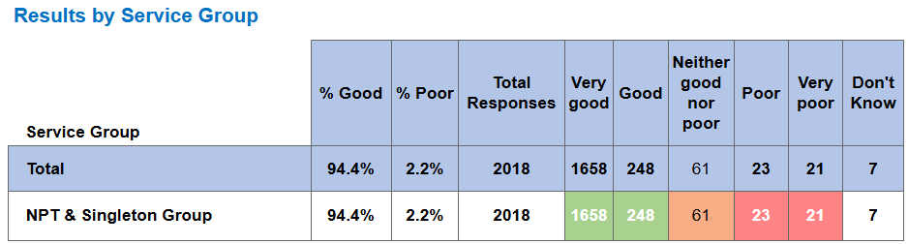

Benchmark Chart

Positive feedback received includes the following;

Oncology - I felt the care was excellent. My first hospital experience and have nothing but praise and admiration for all your staff.

Outpatient – Red - My appt was on time. Specialist easy and kind. I was pleased. No complaints whatsoever.

PMB Clinic - The staff of ladies were so professional and kept me up dated every step of the way. They reassured me through my uncomfortable process and kept me calm. After made me cup of tea and biscuit and still kept an eye on me in the waiting area until I could leave. Even when I had scan very professional ladies kept me updated with every step of the check up and helped me after.

Paediatric Echo - The person I saw was very friendly, patient and helpful. She took her time to explain what she was doing.

Orthoptics - Staff are exceptional - thoughtful, kind and caring.

Rheumatology – Everything from receptionist to seeing the Doctor Excellent!!!! Very informative regarding my condition. Also, very reassuring regarding follow up planning

Ophthalmology – Singleton - A warm welcome from smiling staff put me at ease. This occurred with each member of staff I encountered in the process.

Rapid Diagnosis Clinic - I was well looked after the nurses brilliant.

Breast Care Unit - Every single member of staff were just so lovely , all very friendly.

Ward 02 (Surgery) - Felt extremely well cared for, safe and informed.

Early Pregnancy Unit - Kind and supportive staff members

Antenatal Clinic – Singleton - Beatrice in the 20 weeks pregnancy scan room was excellent. Second pregnancy in singleton with over 6 scans in total done and this was the very first I enjoyed. She carried me along with everything she was doing, showed me different parts of the baby’s body which was very satisfying. Explained really well as she was going through the different body parts. For the first time in a scan, I felt seen. Unlike others that just do their thing with no explanation whatsoever and they’re done.

Birth Centre - Every member of staff was amazing - friendly and helpful. The atmosphere was incredible, and it made a wonderful birth experience

Clinic B1 - Efficient, rang department, few minutes later triage nurse rang back, apt made that day, attended, treatment received with support and advice for the future.

WFI (Welsh Fertility Institute) – Andrology - Everyone was very nice, kind and reassuring throughout the appointment.

Midwife Led Unit - I had the most wonderful experience with two amazing midwives. They were incredibly gentle, kind, and supportive throughout the process. Their warmth and care made me feel so comfortable, and they were always there to help with my baby boy. Their kindness and patience meant the world to me, and I truly appreciate everything they did. I couldn’t have asked for better care—thank you both!

Afan Nedd - Elderly Day Hospital - The services I’ve received have been excellent. Staff and facilities exceptional. friendly and informative.

Information Governance

There are 6 open risks on the Service Group risk register under risk type Information Governance (IG) and Communication/Information & Consent. 2 new risks have been added to the risk register since the last Quality & safety Committee.

To manage and mitigate these risks, the risk register is a standing item on the Service Group QSR Group. In addition, the Divisions have recently presented their risks scored 20+ to the SLT to agree whether these were scored appropriately. There is a further schedule in place for divisions to present their risks score 16-15 to SLT.

- HEALTH & SAFETY REPORT

The service group holds a quarterly Health & Safety (H&S) meeting following the Health Board H&S agenda.

3.1 Incident (NPTH/SGH) Q4 2024/25
Incident Type | Jan  2025 | Feb  2025 | Mar  2025 | Total
Aggression Patient to Staff | 3 | 7 | 2 | 12
Assault Patient to Staff | 10 | 2 | 3 | 15
Verbal Abuse Visitor to Staff | 0 | 2 | 0 | 2
Verbal Abuse Patient to Staff | 2 | 0 | 0 | 3
Aggression Visitor to Staff | 0 | 0 | 0 | 0
Harassment | 0 | 1 | 0 | 1
Sexual Harassment | 1 | 0 | 0 | 1
Sharps | 4 | 3 | 1 | 8
STF | 1 | 2 | 4 | 7
Burn | 1 | 0 | 0 | 1
Struck Immobile Object | 1 | 1 | 0 | 2
Expose radiation | 1 | 0 | 1 | 2
Expose biological substance | 0 | 1 | 0 | 1
Struck by Moving Object | 0 | 0 | 3 | 3
Expose chemical substance | 0 | 0 | 1 | 1
Manual Handling inanimate load | 1 | 0 | 0 | 0
Manual Handling patient load | 4 | 5 | 5 | 14
Total | 29 | 24 | 20 | 73

3.1.1 Number of RIDDOR Incidents reported

For the reporting period, 4 RIDDOR (Reporting of Injuries, Diseases and Dangerous Occurrences Regulations) incidents all of which was classed as an over 7 off work, and all reported incidents were reported as low severity.

3.2 H&S mandatory training

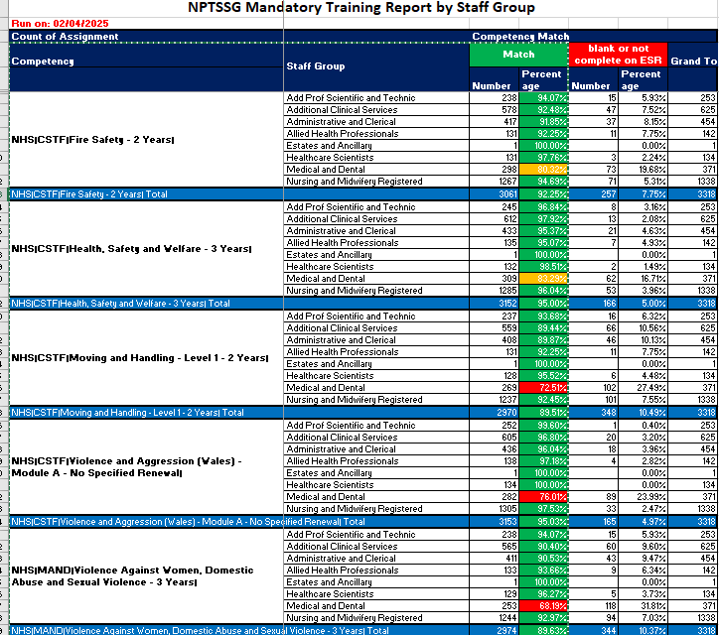

3.3 Unwanted Fire Signal

Ward/ Dept | Cause | Date
Ward F corridor (MHLD SG) | Break glass error | 12.02.25
Ward C | MCP activated in error | 17.03.25
Main Theatre WC | Vaping in toilet area | 10.02.25
WWB level 5 NICU | Unknown | 20.02.25
HMC OPD Paeds WWB | Steam from running water | 27.02.25
West Res BE | Toast | 05.03.25
Block D 1st Floor | Spray | 15.03.25
Endoscopy | Unknown | 22.03.25

3.3.1 Fire Wardens Singleton
We currently have 58 Fire wardens on Site. We continue to monitor areas to ensure they have Fire wardens within departments. Lymphodema have been in contact for Fire Warden training for identified staff due to staff leaving post.

3.3.2 Fire Wardens – NPTH
All areas now have at least one member of staff as a dedicated Fire Warden or lead.

3.3.3 Other Fire Updates
Singleton
- Still awaiting date for Fire Service drill debrief.
- Fire Service walkabout for intelligence gathering took place with Sketty watch with MRI (Magnetic resonance imaging), Radiology, Day Surgery Unit on the 21.03.2025.

3.3.4 Other drill/ training planned
- Maternity fire evacuation desk top exercise to be planned
- Live walkthrough drills for non-ward patient areas to be planned for 2025 OPD (out-patient department) in conjunction with the estates fire testing schedule for site.

3.3.5 Neath Port Talbot Hospital
- Live walkthrough drills for non-ward patient areas to be planned for 2025 with Fire Safety Team

3.3.6 Other Fire Activity and planning;
- Fire extinguisher training for NPTH ongoing.
3.3.7 Singleton Hospital
- Fire Door replacement project completed for Ward 9, 10 11 & 12 and replacement of damaged fire door on Ward 2 theatre entrance.

- RECOMMENDATION
Members are asked to:
- BE ASSURED BY the contents of this report

Governance and Assurance

Link to Enabling Objectives  (please choose) | Supporting better health and wellbeing by actively promoting and empowering people to live well in resilient communities
Link to Enabling Objectives  (please choose) | Partnerships for Improving Health and Wellbeing |  | ☐
Link to Enabling Objectives  (please choose) | Co-Production and Health Literacy |  | ☐
Link to Enabling Objectives  (please choose) | Digitally Enabled Health and Wellbeing |  | ☐
Link to Enabling Objectives  (please choose) | Deliver better care through excellent health and care services achieving the outcomes that matter most to people
Link to Enabling Objectives  (please choose) | Best Value Outcomes and High Quality Care |  | ☐
Link to Enabling Objectives  (please choose) | Partnerships for Care |  | ☒
Link to Enabling Objectives  (please choose) | Excellent Staff |  | ☐
Link to Enabling Objectives  (please choose) | Digitally Enabled Care |  | ☐
Link to Enabling Objectives  (please choose) | Outstanding Research, Innovation, Education and Learning |  | ☐
Health and Care Standards
(please choose) | Staying Healthy |  | ☐
(please choose) | Safe Care |  | ☒
(please choose) | Effective Care |  | ☒
(please choose) | Dignified Care |  | ☒
(please choose) | Timely Care |  | ☒
(please choose) | Individual Care |  | ☒
(please choose) | Staff and Resources |  | ☒
Quality, Safety and Patient Experience
This paper provides a summary of the key Quality, Safety & Risk issues within the Service Group.

Financial Implications
None

Legal Implications (including equality and diversity assessment)
None

Staffing Implications
N/A

Long Term Implications (including the impact of the Well-being of Future Generations (Wales) Act 2015)
As Wales faces a number of challenges now and in the future, such as climate change, poverty, health inequalities, jobs, and growth. To tackle these the Service Group need to work in collaboration to give current and future patients and their families an excellent quality, safe and effective service.

Report History |  | The Service Group presented the previous report to Committee in October 2024.
Appendices

