

HEALTH BOARD RISK REGISTER
RISKS ASSIGNED TO THE
QUALITY & SAFETY COMMITTEE
March 2024



Datix ID Number: 738  Health & Care Standard: 5.1 Timely Care |  |  | HBR Ref Number: 1  Risk Target Date: TBC |  | Current Risk Rating  5 x 5 = 25
Objective: Networked Hospitals: A Systems Approach – Urgent & Emergency Care |  | BAF Ref: 3.3 | Director Lead: Deb Lewis, Chief Operating Officer  Assuring Committee: Performance and Finance Committee  For information: Quality & Safety Committee
Risk: Access to Unscheduled Care  If we fail to provide timely access to Unscheduled Care then this will have an impact on quality & safety of patient care as well as patient and family experience and achievement of targets. There are challenges with capacity/staffing across the Health and Social care sectors. (This risk includes ED, AMU and impact in community from ability to release ambulances at both front doors.) |  |  | Date last reviewed: March 2024
Risk Rating  (consequence x likelihood):  Initial: 4 x 5 = 20  Current: 5 x 5 = 25  Target: 3 x 4 =12 | 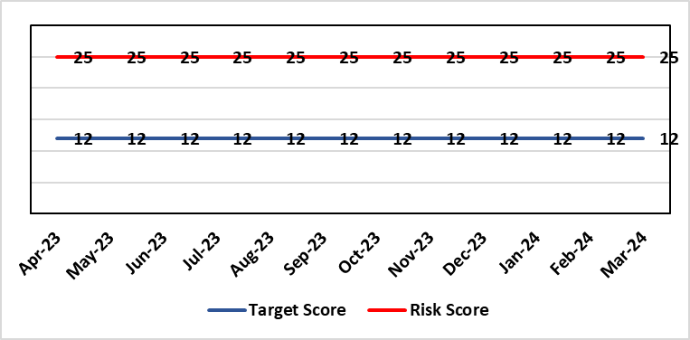 |  | Rationale for current score:  Post wave 2 of COVID 19 Morriston and Singleton have experienced a steady increase in emergency demand to pre-Covid levels. Current score raised due to increasing pressures. Implementation of All Wales Immediate Release Protocol puts additional pressure on already overcrowded ED dept.
Level of Control  = 50% |  |  | Rationale for target score:  Our annual plan is to implement models of care that reflect best practice. This will improve patient flow, length of stay and reduce emergency demand.
Date added to the HB risk register
26.01.16
Controls (What are we currently doing about the risk?) |  |  | Mitigating actions (What more should we do?)
- Increased reporting as a result of escalation to targeted intervention status.  - Phone First for ED model in place in conjunction with 111 to reduce demand.  - OPAS (Older People’s Assessment Service) have undertaken training with nursing homes (on management of patient falls) & set up direct contact details with nursing homes  - Frailty short-stay unit re-established  - Medical patient flow within Morriston has been refined between ED, AMU and wards.  - Roll out SAFER (Seen, Aim, Flow, Early Discharge and Recovery)  - WAST direct access to SDEC  - Expected medical patients conveyed by WAST go direct to AMU rather than ED, medical patients in ambulances outside ED diverted to AMU after initial assessment  - Stroke rehab pathway between MGH and NPT embedded  - Morning “golden” patients identified for early moves to discharge lounge freeing up beds earlier in the day  (Actions to improve the discharge of clinically optimised patients (risk HBR80) expected to assist with patient flow, are anticipated to free capacity to assist to address this risk HBR1 also.) |  |  | Action | Lead |  | Deadline
 |  |  | OPAS – exploring internal & external funding options. (Currently going through business case) | SDEC Clinical Lead |  | 31/03/2024
 |  |  | Looking to extend OPAS to non-surgical fractures. Resource requirements & options to be quantified and presented to the Chief Executive for consideration. | Head of Nursing (Service Transformation) |  | 31/03/2024
 |  |  | Monitoring of Continuous Flow Model now implemented. It will be monitored over 12 month period. | COO |  | 30/09/2024
 |  |  | Criteria led discharge roll out | Corporate patient flow team |  | Progress: Rolled out in Medicine. Other specialties to follow, timescales TBC
Assurances (How do we know if the things we are doing are having an impact?)  - Urgent & Emergency Care Board is meeting monthly.  - Six Goals programme has been reviewed, programme leads appointed  - UEC (Urgent and Emergency Care) dashboard has been developed and released by digital |  |  | Gaps in assurance (What additional assurances should we seek?)  The need to deliver sustained service.
Additional Comments / Progress Notes
12/02/2024: Action Complete: (1) Surgical SDEC open; (2) Continuous Flow Model implemented (from 9th October) but will be monitored over 12 months; (3) Zero tolerance on ambulance waits has been implemented. Criteria led discharge has been rolled out in Medicine and is continuing to embed. Further work will be required across other specialities over the course of the year.

Datix ID Number: 739  Health & Care Standard: 2.4 Infection Prevention & Control & Decontamination |  |  | HBR Ref Number: 4  Risk Target Date: TBC | Current Risk Rating  4 x 5 = 20
Objective: Demonstrably Improved Quality, Safety & Reduced Harm |  | BAF Ref: 1 | Director Lead: Gareth Howells, Executive Director of Nursing  Assuring Committee: Quality and Safety Committee
Risk: Healthcare Acquired Infection  Risk of patients acquiring infection as a result of contact with the health care system, resulting in avoidable harm, impact on service capacity, and failure to achieve Tier 1 national infection reduction goals. |  |  | Date last reviewed: March 2024
Risk Rating  (consequence x likelihood):  Initial: 4 x 5 = 20  Current: 4 x 5 = 20  Target: 4 x 3 =12 | 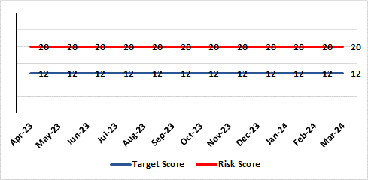 |  | Rationale for current score:  Health Board incidence of key Tier 1 infections per 100,000 population above All Wales rates, indicating Health Board’s population at greater risk of infection. High occupancy rates & frequent ward moves associated with increased risk of infection transmission. Lack of decant facilities compromises environment deep cleaning & decontamination, and planned preventative maintenance programmes.
Level of Control
= 40%
Date added to the HB risk register
January 2016
Date added to the HB risk register  January 2016 |  |  | Rationale for target score:  Improved governance structures for IPC and antimicrobial stewardship will drive improved local ownership and embed responsibility for these priorities for all levels of staff. Adequately maintained & clean environments facilitate good IPC & minimise infection risks. Reduced occupancy & frequency of patient moves mitigate against infection transmission. Compliant ventilation systems and water safety minimise infection risks. Access to timely data on infections, training, antimicrobial stewardship, cleaning at ward/unit/practice level enables Service Groups to identify areas for focused QI programmes, drive improvement, & effectively measure outcomes.
Controls (What are we currently doing about the risk?) |  |  | Mitigating actions (What more should we do?)
- Liaising with PHW expert advisors in relation to incidence of Cdifficile  - Policies, procedures, protocols and guidelines supplement the National Infection Control Manual.  - Infection Prevention & Control related training provided programmes.  - Surveillance of infections, with early identification of increased incidence, and instigation of controls.  - Provision of cleaning service to meet National Standards of Cleanliness.  - Engineering controls for water safety, ventilation, and decontamination.  - Infection Prevention Improvement Plans for HB and Service Groups with progress reported at SG Infection Control Committees, HB Infection Prevention & Control Group, Quality & Safety Group, Quality & Safety Committee, and Management Board. These include trajectories to meet national targets and report performance against them. |  |  | Action |  | Lead | Deadline
 |  |  | Drive improvements in prudent antimicrobial prescribing |  | Cons. Antimicrobial Pharmacist | 31/03/24
 |  |  | Reduce Key Tier 1 Infections to no more than WG maximum quarterly profile, identifying avoidability through Service Group scrutiny |  | Head of Infection Control | 31/03/24
 |  |  | Achieve 85% compliance with IPC mandatory training |  | Service Group Directors | 31/03/24
 |  |  | Maintain National Standards of Cleanliness compliance >95% |  | Support Services | 31/03/24
 |  |  | Develop a proactive schedule of IPC-related audit for Service Groups wards & services, and for IPC team. |  | Head of Infection Control  Service Group Directors | 31/03/24
Assurances (How do we know if the things we are doing are having an impact?)  - Clear Corporate and Service Group IPC Assurance Framework in place.  - Infection Prevention Improvement Plans for HB and Service Groups with progress reported at SG Infection Control Committees, HB Infection Prevention & Control Group, Quality & Safety Group and at Management Board. These include trajectories to meet national targets and report performance against them. This is also reported to Quality & Safety Committee.  - Ongoing monitoring of infection control rates.  - IPC, antimicrobial, decontamination and cleaning audit programmes.  - Compliance and validation systems for water safety, ventilation systems and decontamination. |  |  | Gaps in assurance (What additional assurances should we seek?)  - High occupancy rates & frequent ward moves associated with increased risk of infection transmission.  - Lack of decant facilities compromises environment deep cleaning & decontamination, and planned preventative maintenance programmes.  - Lack of robust system for Board oversight regarding IPC and ANTT training compliance due to ESR limitations.
Additional Comments / Progress Notes
18/02/24: Progress update re Tier 1 reduction goals 01 Apr- 31 January 2024.
The maximum, annual number of cases to achieve expected infection reduction goal for C. difficile, Staphylococcus aureus bacteraemia and Klebsiella bacteraemia have been exceeded.
• C. difficile - 208 cases (2023/24 annual profile – 95 maximum).
• Staphylococcus aureus bacteraemia - 125 (2023/24 annual profile – 71 maximum).
• Klebsiella spp. bacteraemia - 82 (2023/24 annual profile – 71 maximum).
Over trajectory for:
• E. coli bacteraemia - 222 (cumulative profile - 197 maximum).
Met trajectory for:
Pseudomonas aeruginosa bacteraemia – 21 (cumulative profile - 21 maximum).

Over-occupancy and over-crowding, reducing spacing between beds, is associated with an increased risk of healthcare associated infection.
Additionally, multiple intrahospital patient moves are considered to increase the probability of a healthcare associated infection.
Current service pressures at Morriston in particular, have resulted in over-occupancy, over-crowding and increased intrahospital transfers. This is considered to have contributed to the hospital-wide outbreak of genomically linked C. difficile in Morriston.

The multi-agency C. difficile Round Table event took place on 8th February. Discussions at the event are being worked through for developing action proposals.

Datix ID Number: 840  Health & Care Standard: 5.1 Timely Care |  |  | HBR Ref Number: 16  Risk Target Date: TBC | Current Risk Rating  5 x 4 = 20
Objective: Networked Hospitals – A Systems Approach – Planned Care |  | BAF Ref: 3.4 | Director Lead: Deb Lewis, Chief Operating Officer  Assuring Committee: Performance and Finance Committee  For information: Quality & Safety Committee
Risk: Access and Planned Care  There is a risk of harm to patients if we fail to diagnose and treat them in a timely way. |  |  | Date last reviewed: March 2024
Risk Rating  (consequence x likelihood):  Initial: 4 x 4 = 16  Current: 5 x 4 = 20  Target: 4 x 2 = 8 | 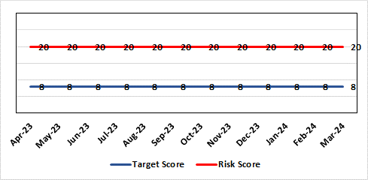 |  | Rationale for current score:  All non-urgent activity was cancelled due to response to the Covid-19 pandemic and has increased the backlog of planned care cases across the organisation. Whilst mitigating measures such as virtual clinics have been put in place new referrals are still being accepted which is adding to the outpatient backlog particularly in Ophthalmology and Orthopaedics. The significant reduction in theatre activity during the pandemic increased the number of patients now breaching 36 and 52 week thresholds.
Level of Control
= 90%
Level of Control  = 90% |  |  | Rationale for target score:  There is scope to reduce the likelihood score to reduce the overall risk to an acceptable level. The Risk target date indicates when we expect to see some reduction in waiting lists – albeit the overall risk level may remain as work continues.
Date added to the HB risk register
January 2013
Controls (What are we currently doing about the risk?) |  |  | Mitigating actions (What more should we do?)
- Post Covid 19 the focus is on minimising harm by ensuring that the patients with the high clinical priority are treatment first. The Health Board is following the Royal College of Surgeons guidance for all surgical procedures and patients on the waiting list have been categorised accordingly.  - There is a bi-weekly recovery meeting for assurance on the recovery of our elective programme.  - Specialty level capacity and demand models set out the baseline capacity and identify solutions to bridge the gap. Non-recurring pump – prime funding is available to support initial recovery measures. Fortnightly performance reviews track progress against delivery.  - A focused intervention is in train to support to the 10 specialties with the longest waits.  - Long waiting patients are being outsourced to the Independent Sector  - Additional internal activity is being delivered on weekends (via insourcing)  - Planned care trajectories developed and submitted to WG as part of IMTP.  - Governance process put in place to monitor performance against trajectories internally, and with Welsh Government.  - External & internal validation has commenced.  - A 10 bedded orthopaedic ward was created at Morriston Hospital in December to address the longest waits in the specialty that can only be operated on at Morriston.  - All long waiting patients are receiving clinical reviews to ascertain continued need for surgery. |  |  | Action |  | Lead | Deadline
 |  |  | Implement demand management initiatives |  | Deputy COO | 31/03/2024
 |  |  | Work ongoing with Finance colleagues to establish the funding allocation for elective recovery for 2023/24. |  | Deputy COO | 31/03/2024
Assurances (How do we know if the things we are doing are having an impact?)  - Weekly meetings in place to ensure patients with greatest clinical need are treated first. |  |  | Gaps in assurance (What additional assurances should we seek?)
Additional Comments / Progress Notes
09/11/2023: 52 week ministerial target was achieved at the end of Oct 2023 and will be sustained going forward. Alongside the Health Board plans we are looking at regional solutions for Orthopaedics to support SBU patients, and for SBU to support Hywel Dda in Ophthalmology.
29/01/2023: All but three of the longest waiting patients (5 years) will be treated by end January. Plans in place to treat all patients waiting over 4 years by end of March. Regional working in place for orthopaedics with SBUHB patients treated in Prince Philip Hospital and HDUHB patients treated in NPTH.

Datix ID Number: 1043  Health & Care Standard: Effective Care 3.1 Clinically Effective Care |  |  | HBR Ref Number: 36  Risk Target Date: TBC |  | Current Risk Rating  4 x 4 = 16
Objective: Adopting and Developing Innovative Digital Solutions to Support Care Delivery |  | BAF Ref: 5 | Director Lead: Matt John, Director of Digital  Assuring Committee: Workforce OD & Digital Committee  For information: Quality & Safety Committee
Risk: Paper Record Storage  Lack of a single electronic record means there is greater reliance on the provision of the paper record. If we fail to provide adequate storage facilities for paper records, then this will impact on the availability of patient records at the point of care. Quality of the paper record may also be reduced if there is poor records management in some wards. There is an increased fire risk where medical records are stored outside of the medical record libraries. |  |  | Date last reviewed: March 2024
Risk Rating  (consequence x likelihood):  Initial: 4 x 5 = 20  Current: 4 x 4 = 16  Target: 3 x 3 =9 | 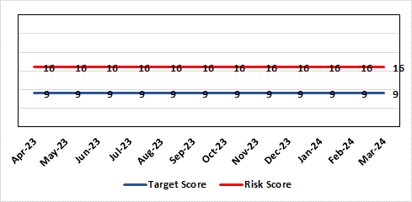 |  | Rationale for current score:  C - Inability to find records for patients could delay care/increase length of stay over 15 days. Could also mean patients receive incorrect treatment. Increased risk of fire where records are stored outside of the medical record libraries.  L - we know this happens from incidents raised
Level of Control  = 70% |  |  | Rationale for target score:  C - The increased development and adoption of the digital record will reduce the need for the paper health record being available at the point of care.  L - The increased development and adoption of the digital record, the introduction of RFID and the approach to management of the paper record identified in the Business case process should reduce the amount of paper required to be stored and managed.
Date added to the HB risk register
June 2016
Controls (What are we currently doing about the risk?) |  |  | Mitigating actions (What more should we do?)
- There is a plan in place to increase the functionality of the electronic record to document patient care. The delivery of the plan is overseen by the Digital Leadership Group and progress provided to Management Board. (Supported by individual project boards as appropriate).  - Records managed by the Medical Records libraries are RFID tagged and location tracked.  - Medical Record libraries are regularly risk assessed for fire by health and safety.  - Alternative offsite storage arrangements have been identified.  - All records must be documented on the Information Asset Register (IAR). |  |  | Action | Lead |  | Deadline
 |  |  | Amended: Awaiting WG approval for Health Records Business Case | Head of Health Records & Clinical Coding |  | 31/04/2024
 |  |  | Requirement for legal agreement with landlord once approval from WG received | Head of Health Records & Clinical Coding |  | 31/05/2024
 |  |  | Welsh Government sign off for the removal of the extended retention periods for patients with long term conditions | Head of Health Records & Clinical Coding |  | 30/04/2024
Assurances (How do we know if the things we are doing are having an impact?)  - RFID has been implemented for the acute record improving the management and storage of records  - Health Records performance reports developed in line with RFID technology  - Attainment of the Tier 1 Health Board target for clinical coding completeness which relies on the timely availability and quality of the Paper record and electronic sources  - Monitoring complaints and incident reporting.  - Electronic record is being implemented in accordance with the plan eg implementation of WNCR, ETR, HEPMA etc. |  |  | Gaps in assurance (What additional assurances should we seek?)  Investment required supporting the delivery and operational costs of the Digital strategy.  Reliance on DHCW for delivery of the solution for a fully electronic patient record.  Impact of the Infected Blood Enquiry on the Health Boards ability to destroy notes.  Process for ensuring clinical adoption of electronic ways of working and cessation of adding information to the paper record that is already available electronically needs to be agreed and enforced by the Health Board.  Impact of the infected Blood Inquiry on the health boards ability to destroy notes and the change in the records code of practice is being reviewed by the Director of Digital.
Additional Notes
15/03/2024 - Business case has been approved at Management Board pending confirmation of funding under IMTP sign off.
15/03/2024 - National collaboration has concluded that the retention period for long term conditions of 20 years only applies to Primary Care records. A paper will be taken through local governance for assurance in Q1 2024/25.
09/04/2024 - Business Case for Centralisation project approvals to date: Business Case Assurance Group 30th Jan 24, Management Board 13th March 24 & Health Board 28th March 24.

Datix ID Number: 1514  Health & Care Standard: Safe Care 2.1 Managing Risk & Promoting Health & Safety |  |  | HBR Ref Number: 43  Risk Target Date: TBC |  | Current Risk Rating  4 x 5 = 20
Objective: Mental Health & Learning Disability Services |  | BAF Ref: 3.2 | Director Lead: Gareth Howells, Executive Director of Nursing  Assuring Committee: Mental Health Legislation Committee  For Information: Quality and Safety Committee
Risk: Deprivation of Liberty Safeguards  Due to a lack of Best Interest Assessor resource, there is a risk of failure to complete and authorise the assessments associated with Deprivation of Liberty within the legally required timescales, exposing the health board to potential legal challenge and reputational damage. |  |  | Date last reviewed: March 2024
Risk Rating  (consequence x likelihood):  Initial: 4 x 4 = 16  Current: 4 x 5 = 20  Target: 3 x 2 = 6 | 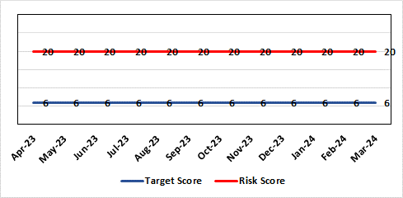 |  | Rationale for current score:  Although processes have been planned in order to reduce the breach position they have yet to be fully implemented. The impact is yet to be realised. Risk was increased to 20 in Feb 2023 following discussion at Mental Health Legislation Committee.
Level of Control  = 40% |  |  | Rationale for target score:  Consequences of DoLS breaches for the Health Board will not change. With controls in place, over time likelihood should decrease.
Date added to the HB risk register
July 2017
Controls (What are we currently doing about the risk?) |  |  | Mitigating actions (What more should we do?)
Additional supervisory body signatories in place – this is being undertaken as overtime using additional WG funds.  Additional funding received from WG to manage the backlog of DoLS assessments.  DoLS assessments are being undertaken via a number of difference sources to address the backlog;  - External BIA’s payment to be increased from £120 to £250 (utilising substantive recurring funding) to encourage a large cohort of BIA’s to undertake role.  - 2 band 6 WTE BIA’s have been appointed (using WG money). This will reduce the need for agency BIA’s.  - Overtime/additional hours agreed utilising WG money for sign off completion.  - DoLS database updated and DoLS dashboard in place, monitoring applications and breaches via dedicated BIAs and Admin.  - Delivery of DOLS Action plan reviewed monthly.  - Regular reporting to Mental Health Legislation Committee (MHLC).  - Monthly reporting to Unit Nurse Director and Finance on DoLS breaches.  - Health Board presence at National and regional meetings relating to DoLS / LPS.  - Increased IMCA services to support increased BIA resource.  - Current Mental Capacity Act practice reviewed to support MCA DoLS issues in practice. |  |  | Action | Lead |  | Deadline
 |  |  | Overtime/additional hours agreed to fund sign off from nurse assessor team to process the backlog assessments | GND Primary and Community |  | 30/09/2024
Assurances (How do we know if the things we are doing are having an impact?)  Regular scrutiny at Service Group and Safeguarding Committee and by DoLS Internal Audit; monitoring via DoLS Dashboard this will provide real-time accurate data.  Update report to MHLC, impact of backlog of DoLS breaches and new LPS implementation.  Monthly updates with Unit Nurse Director and Finance. |  |  | Gaps in assurance (What additional assurances should we seek?)
Additional Comments / Progress Notes
02/01/2024: Regular weekly scrutiny of the DoLS database is indicating that wait for allocation to BIA is improving. Breaches continue to occur but the improvement in allocation timescales to BIA, currently 4 to 6 weeks, ensures patients are safely and legally detained with the least restrictive care plan in place.
An increase in the BIA resource has been made in this year’s IMTP.
05/02/2024: Transition plan for a new enhanced MCA/DoLS team to be hosted in PCTSG from 1st April 2024. Oversight of BIA resource will from part of this.
MHL Committee will continue to monitor and scrutinise progress in embedding and enacting the actions in the associated development plan for the transition
19/04/2024: MCA has now transferred from Corporate to the DoLS team in PCTSG to provide a HB wide MCA/DoLS service 01/04/2024 which is hosted in PCTSG. Risk remains unchanged and to be reviewed in next Risk Meeting with PCTSG Governance. New MCA/DoLS Lead commenced 11/03/2024 and is in induction phase. Service remains to rely heavily on external BIA's to support the service. Substantive BIA's are running at 33.3% deficit due to long term sickness.

Datix ID Number: 1761  Health & Care Standard: Timely Care 5.1 Access |  |  | HBR Ref Number: 50  Risk Target Date: TBC |  | Current Risk Rating  5 x 5 = 25
Objective: Networked Hospital – A Systems Approach – Cancer Care |  | BAF Ref: 3.5 | Director Lead: Deb Lewis, Chief Operating Officer  Assuring Committee: Performance and Finance Committee  For information: Quality & Safety Committee
Risk: Access to Cancer Services A backlog of patients now presenting with suspected cancer has accumulated during the pandemic, creating an increase in referrals into the health board which is greater than the current capacity for prompt diagnosis and treatment. Because of this there is a risk of delay in diagnosing patients with cancer, and consequent delay in commencement of treatment, which could lead to poor patient outcomes and failure to achieve targets. |  |  | Date last reviewed: March 2024
Risk Rating  (consequence x likelihood):  Initial: 4 x 5 = 20  Current: 5 x 5 = 25  Target: 4 x 3 = 12 | 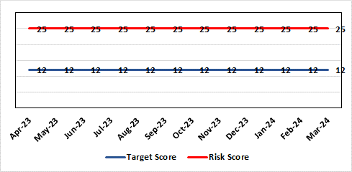 |  | Rationale for current score:  Risk score based on being off trajectory for SCP.
Level of Control  = 70% |  |  | Rationale for target score:  Target score reflects the challenge this area of work present the Board and where small numbers of patients impact on the potential to breach target.
Date added to the HB risk register: April 2014
Controls (What are we currently doing about the risk?) |  |  | Mitigating actions (What more should we do?)
- Tight management processes to manage each individual case on the Urgent Suspected Cancer Pathway. Enhanced monitoring & weekly monitoring of action plans for top 6 tumour sites.  - Initiatives to protect surgical capacity to support USC pathways have been put in place  - Additional investment in MDT coordinators, with cancer trackers appointed in April 2021.  - Prioritised pathway in place to fast track USC patients.  - Ongoing comprehensive demand and capacity analysis with directorates to maximise efficiencies. This will form part of the remit of the Cancer Performance Group.  - Weekly cancer performance meetings are held for both NPTS and Morriston Service Groups by specialty.  - The top 6 tumour sites of concern have developed cancer improvement plans – weekly monitoring arrangements have been put in place.  - Additional work being undertaken as part of diagnostic recovery and theatre recovery workstreams.  - Endoscopy contract has been extended for insourcing. |  |  | Action | Lead |  | Deadline
 |  |  | Cancer Performance Group to monitor improvement trajectories for both cancer backlog and SCP performance on a monthly basis | Deputy COO |  | 31/03/2024
 |  |  | Full review of gynaecology / gynae-oncology pathway given service constraints to be done. Additional theatre capacity for gynaecological cancer to be agreed to reduce current backlog | Deputy COO |  | 29/03/2024
Assurances (How do we know if the things we are doing are having an impact?)  Backlog trajectories updated at Management Board and will be going to Performance & Finance Committee in August. Cancer Performance Group established to support execution of the services delivery plans for improvements and meeting regularly. |  |  | Gaps in assurance (What additional assurances should we seek?)  Performance and activity data monitored, but delays to treatment continue while sustainable solutions found.
Additional Comments / Progress Notes
29/01/2024 – Slight in improvement in SCP performance during November and December, 52% and 53% respectively. Improvement in Upper GI performance (73%) but further work required in other tumour site area e.g. gynaecology, urology and breast.

Datix ID Number: 1587  Health & Care Standard: 3.1 Safe and Clinically Effective Care |  |  | HBR Ref Number: 61  Risk Target Date: 31st May 2024 |  | Current Risk Rating  4 X 4 = 16
Objective: Networked Hospitals – A Systems Approach – Planned Care |  | BAF Ref: 3.4 | Director Lead: Deb Lewis, Chief Operating Officer  Assuring Committee: Quality and Safety Committee
Risk: Paediatric dental GA (General Anaesthetics)/Sedation services provided under contract from Parkway Clinic, Swansea. Medical Safety risk as GA are performed on children outside of an acute hospital setting. Repatriation of service to acute site delayed due to theatre capacity which means the health board continues to commission services for delivery outside of national guidance (WHC 2018-09). There is also an associated risk in that the diagnosing clinician does not deliver the care to the patient. |  |  | Date last reviewed: March 2024
Risk Rating  (consequence x likelihood):  Initial: 5 x 3 = 15  Current: 4 x 4 = 16  Target: 4 x 2 = 8 | 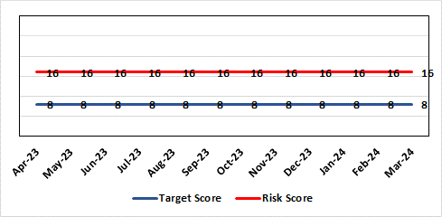 |  | Rationale for current score:  There is no immediate access to crash team/ICU facilities in in Parkway Clinic – the client group are undergoing G/A/sedation. Paediatric GA/Sedation services provided under contract from Parkway Clinic, Swansea continue due to lack of capacity for these patients to be accommodated in Secondary Care.
Level of Control  = 60% |  |  | Rationale for target score:  Relocation of the paediatric GA service [provided by Parkway Clinic] to a hospital site being treated as a priority.
Date added to the HB risk register
4th July 2018
Controls (What are we currently doing about the risk?) |  |  | Mitigating actions (What more should we do?)
Consultant Anaesthetist present for every General Anaesthetic clinic.  Assurance Documentation supplied by Parkway Clinic including confirmation of arrangements in place with WAST and Morriston Hospital for transfer and treatment of patients  New care pathway implemented - no direct referrals to provider for GA.  Multi-drug sedation ceased from Sep 2018 in line with WHC 2018 009  Revised SLA/Service Specification  HIW Inspection Visit Documentation provided to HB  All extended GA cases require approval from paediatric specialist prior to treatment |  |  | Action | Lead |  | Deadline
 |  |  | Transfer of services from Parkway. | Interim Head of Primary Care |  | 31/05/2024
Assurances (How do we know if the things we are doing are having an impact?)  RMC collate referral and treatment outcome data for review by Paediatric Specialist  Regular clinical meeting arranged with Parkway to discuss individual cases/concerns  Regular clinical/ management meeting for CDS/primary care management team to discuss service pathway /concerns/issues arising  Roll out of new pathway to encompass urgent referrals  T&F Group established to lead transfer from community centre to MHSDU. |  |  | Gaps in assurance (What additional assurances should we seek?)  ToR for the task and finish group should continue to include consideration of the pressures on the POW special care dental GA list and this service is considered alongside any plans for the Parkway contract.
Additional Comments / Progress Notes
18/08/2023 – Agreement with the Medical Director to maintain status with utilising Parkway. Suggested that Chief Dental Officer (CDO) be invited to visit Parkway for assurance.

Datix ID Number: 1605  Health & Care Standard: 3.1 Safe and Clinically Effective Care |  |  | HBR Ref Number: 63  Risk Target Date: 30/06/2024 | Current Risk Rating  4 X 5 = 20
Objective: Children, Young People & Maternity Services |  | BAF Ref: 3.6 | Director Lead: Gareth Howells, Executive Director of Nursing and Christine Morrell, Director of Therapies & Health Sciences  Assuring Committee: Quality and Safety Committee
Risk: Screening for Fetal Growth Assessment in line with Gap-Grow (G&G).  There is not enough Ultrasound scanning & clinic capacity within Swansea Bay UHB to offer all women serial ultrasound scan screening in the third trimester in line with the UK perinatal Institute Growth Assessment Programme (GAP). Welsh Government mandate fetal growth screening in line with the GAP programme, which states serial ultrasound growth scans should be performed at three weekly intervals. There is significant evidence of the increased risk for stillbirth or neonatal mortality/morbidity (hypoxic ischaemic encephalopathy) HIE, where a fetus is growth restricted (Intrauterine Growth Restriction - IUGR) and/or small for gestational age fetus (SGA). |  |  | Date last reviewed: March 2024
Rationale for current score:
Current score of 20 is 4 (consequence) x 5 (likelihood). Consequence score of 4 calculated due to the governance and assurance – non-compliance with national standards with significant risk if unresolved and likelihood of 5 as expected to happen daily/>50%.
The service is unable to provide third trimester scans at three weekly intervals in line with the Perinatal Institute recommendations.
Risk Rating
(consequence x likelihood):
Initial: 4 x 3 = 12
Current: 4 x 5 = 20
Target: 3 x 4 = 12
Level of Control
= 60%
Date added to the HB risk register  1st August 2019 |  |  | Rationale for target score:  When the service is able to provide third trimester ultrasound scan in line with GAP recommendations we will be providing care in line with evidence based best national practice as mandated by Welsh Government. Risk Target Date indicates when outcome of potential scanning/review capacity solutions anticipated.
Controls (What are we currently doing about the risk?) |  |  | Mitigating actions (What more should we do?)
All staff are required to complete the GAP GROW e-learning on an annual basis. Compliance is monitored via the Training & Education forum.  A local policy to scan women 4 weekly is in place.  Three qualified midwifery sonographers and a midwifery sonography lead who provides training are in place. One midwife sonographer continues training.  Lead sonographers created a governance process for the review of scan images of babies born with a birth weight centile under 10th centile to identify themes and trends within the department and areas for quality improvement. |  |  | Action |  | Lead | Deadline
 |  |  | Achieved 85% Gap Grow training compliance at end March 2024. Target of 95% set for achievement by end June 2024. |  | CPD Midwives & Deputy Head of Midwifery | 30/06/2024
 |  |  | Business case written, including administrative support for midwife sonographer clinics to be secured to ensure streamlined service - currently in circulation for comment with aim of discussion at Senior Management Team by end of June 2024. |  | Maternity service business manager | 30/06/2024
 |  |  | Follow up meeting to discuss scanning & review capacity |  | HOM, Divisional Manager, Midwifery Sonographer lead & Lead for Sonography Department | 31/05/2024
 |  |  | Lead Midwife for QSR, Lead Midwife Sonographer and Lead Digital Midwife to arrange business case for introduction of GAP Grow 2 |  | Lead Midwife for QSR, Lead Midwife Sonographer and Lead Digital Midwife | Complete
Assurances (How do we know if the things we are doing are having an impact?)  Target 95% Gap Grow training compliance by End November 2023 originally – updated to end January 2024 (W/c 16/10/23 Gap Grow compliance level 72%; w/c 22/01/24 increased to 77%).  Aim is the provision of serial ultrasound scans on a three weekly schedule in accordance with the recommendations from the Perinatal Institute. (Currently the provision of serial ultrasound scans is provided on a four weekly schedule.)  The detection rate of IUGR/SGA will increase leading to improved antenatal management plans and intrapartum planning. We will report a reduced rate of stillbirth and/or neonatal mortality/morbidity with improved management of IUGR/SGA babies.  The administration support for the service will be fully functional.  Lead Sonographers for Singleton and Neath and Lead Midwife sonographer have developed a governance review group to meet monthly to review all ultrasound scan images where there was a baby born under the 10th centile to identify themes and learning for quality improvement. |  |  | Gaps in assurance (What additional assurances should we seek?)  Assurance of maintaining a sustainable third trimester ultrasound service. The provision of serial ultrasound scans on a three weekly schedule in accordance with the recommendations from the Perinatal Institute. (Currently the provision of serial ultrasound scans is provided on a four weekly schedule.)
Additional Comments / Progress Notes
24/01/2023: Meeting held 10th January 2024 between Head of Midwifery, Divisional Manager, Midwifery Sonographer lead & Lead for Sonography Department (within Radiology) to discuss feasibility of more frequent clinics to review scans in addition to scanning capacity. Further discussion required, engaging with consultant colleagues and Radiology, regarding clinic capacity & provision. Follow up meeting after this on 6th March 2024. Re Gap-Grow 2: Meeting on 26/1/2024 to discuss whether business case required.
19/04/2024: Radiology Service Manager unable to attend scanning capacity meeting – to be rescheduled by end of May 2024. Implementation of Gap Grow 2.0 in place from w/c 15/04/2024. Gap Grow training Compliance 85% March 2024. Action to complete updated.

Datix ID Number: 2159  Health & Care Standard: Safe Care 2.1 Managing Risk & Promoting Health & Safety |  |  | HBR Ref Number: 64  Risk Target Date: TBC | Current Risk Rating  4 X 4 = 16
Objective: Delivering Care in Safe, Modern Environments |  | BAF Ref: 7 | Director Lead: Darren Griffiths, Director of Finance & Performance  Assuring Committee: Quality & Safety Committee
Risk: Health & Safety Infrastructure  Insufficient resource and capacity of the health, safety and fire function within SBUHB to maintain legal and regulatory compliance for the workforce and for the sites across SBUHB. |  |  | Date last reviewed: March 2024
Risk Rating  (consequence x likelihood):  Initial: 5 x 4 = 20  Current: 4 x 4 = 16  Target: 4 x 3 = 12 | 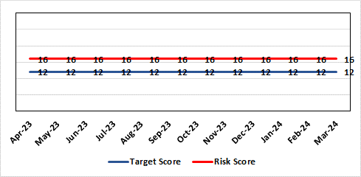 |  | Rationale for current score:  The Health Board received 12 Health & Safety Executive (HSE) improvement notices during 2019-20 covering various Health & Safety legal breaches covering a range of areas. There is the potential for future multiple notices for not meeting legal requirements. Score reduced to 16.
Level of Control  = 70% |  |  | Rationale for target score:  Compliance with the notices and to have sufficient resources to implement a sustainable health and safety provision to support the legal requirements of the Health Board and demonstrate that suitable resources are in place to undertake the roles and responsibilities of the department, also to undertake suitable and sufficient training, provide corporate overview/audit to ensure practices are being employed in the workplace.
Date added to the HB risk register
September 2019

Controls (What are we currently doing about the risk?) |  |  | Mitigating actions (What more should we do?)
- Assistant Director of Health and Safety in post to support strengthening and develop the H&S function to support the organisation. Business case submitted for additional resources.  - Health and Safety Operational Group and the Health and Safety Committee monitor compliance. Refreshed the Fire Safety Group with additional controls in place.  - Fire risk assessments are being prioritised with temporary additional resources put in place in March 2021 to reduce the number of FRA overdue.  - Fire training in place and fire wardens in place  - Fire risk assessment schedule in place for the next 12 months to maintain 100% compliance of completion and is regularly reviewed |  |  | Action |  | Lead | Deadline
 |  |  | It has been agreed to identify posts to progress recruitment on a phased approach over the next 12/24 months. This will be dependent upon availability of funding. |  | Assistant Director of H&S | 31/03/2024
Assurances (How do we know if the things we are doing are having an impact?)  - Monitoring through the appropriate group/committees (H&S committee) to receive assurance and or identify gaps for key compliance and adherence to applicable legislation.  - Site visits/tours to identify compliance and gaps in compliances. |  |  | Gaps in assurance (What additional assurances should we seek?)  Agreement of funding for resources identified in business case to implement structure in business case by Q2/3 2022/23 financial year.
Additional Comments / Progress Notes
15/12/2023: The H&S team will have an additional MH trainer/advisor from 15/01/2024, increasing establishment by 0.5wte. No change to risk score.
06/02/2024: Due to the resignation of a fire advisor and the timeframe to recruit another, there is no change in the current risk rating.

Datix ID Number: 1834  Health & Care Standard: 5.1 Timely Care |  |  | HBR Ref Number: 66  Risk Target Date: TBC | Current Risk Rating  5 X 3 = 15
Objective: Networked Hospital – A Systems Approach – Cancer Care |  | BAF Ref: 3.5 | Director Lead: Raj Krishnan, Acting Executive Medical Director  Assuring Committee: Quality and Safety Committee
Risk: Access to SACT (Cancer Services)  The demand & complexity of planned treatment regime for cancer patients requiring chemotherapy currently exceed the available chair capacity, risking unacceptable delays in access to SACT treatment in Chemotherapy Day Unit with impact on targets and patient outcomes. |  |  | Date last reviewed: March 2024
Risk Rating  (consequence x likelihood):  Initial: 5 x 5 = 25  Current: 5 x 3 = 15  Target: 2 x 2 = 4 | 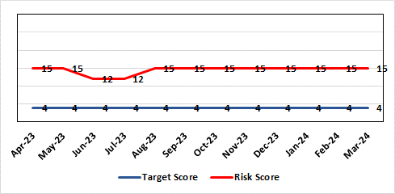 |  | Rationale for current score:  Risk was reduced to 12 in June 2023. Further feedback showed that this was not sustained and that there were still significant workforce challenges in CDU and PTS so the risk was returned to 15.
Level of Control
=
Date added to the HB risk register  30/11/2019 |  |  | Rationale for target score:  Reduced delays in treatment will reduce risk of harm.
Controls (What are we currently doing about the risk?) |  |  | Mitigating actions (What more should we do?)
Review of CDU by improvement science practitioner was completed in 2020. Resulted in change to booking processes to streamline booking process and deferral.  Review of scheduling by staff to ensure all chairs used appropriately.  Business case endorsed by CEO for shift of capacity to home care to be considered by the Management Board  A Daily scrutinizing process in progress to micro manage individual cases, deferrals etc.  Changes made to prescribing & authorising processes to improve workflow for PTS reducing potential delays to supply and administration of treatment.  Responsibility for checking bisphosphonate prescriptions in CDU moved to nursing staff to free up Pharmacy capacity allowing them to focus on key clinical tasks within Pharmacy.  Joint project with Nuclear Medicine to streamline pathways and prioritise SACT patients appropriately halved the average time waiting for MUGA/EDTA tests required before starting SACT.  Increased homecare capacity  Adopted principles from UK SACT board publication: General Principles to Support Systemic anti-Cancer Therapy Aseptic Pressures. September 2023 |  |  | Action | Lead | Deadline
 |  |  | A demand and capacity options paper is being prepared within the service and will be presented to Senior Management Team. Draft completed, further evidence required for SMT presentation May 2024. | Interim Divisional Manager (Cancer) | 31st May 2024
Assurances (How do we know if the things we are doing are having an impact?)  Additional funding agreed to support increase in nurse establishment to appropriately staff the unit during its main opening hours. Additional scheduling staff also agreed.  Pre-assessment process has been separated from start date in an attempt to fill deferral slots at short notice where possible. Improved communication between MDT to streamline booking and deferral process.  Continue to monitor patient experience via friends and family in conjunction with the Welsh Cancer Patient Experience Survey results under our PTR procedures. Monitoring our waiting times against new SACT metrics, which is a measure based on treatment intent and is no longer reported as average waiting time so is more linked to expected outcomes etc. This performance metric is included in our Cancer Performance report we send to WG and Management Board and internally via governance arrangements with NPTSSG where Oncology services sit.  SBU Capacity Task and Finish group meeting monthly to analysis demand and capacity gap. |  |  | Gaps in assurance (What additional assurances should we seek?)  Capital & Revenue assumptions & resources for second business case for increasing chair capacity in 2022/23 to meet increased demand.  No change to this area which is why the risk remains at 15. A demand and capacity options paper is being prepared within the service and will be presented to Senior Management Team March 2024.  Workforce within Pharmacy remains an issue to increase chair capacity.
Additional Comments / Progress Notes
Action complete: SACT has now relocated onto Ward 9 of the main hospital. Workforce options and further new ways of working will be discussed as part of options paper.
10.04.2024: A visit is planned in June 2024 to Christie Cancer Centre in Manchester where stakeholders will share best practice

Datix ID Number: 1418  Health & Care Standard: 5.1 Timely Access |  |  | HBR Ref Number: 69  Risk Target Date: See Target Rationale |  | Current Risk Rating  5 X 4 = 20
Objective: Children, Young People & Maternity Services |  | BAF Ref: 3.6 | Director Lead: Deb Lewis, Chief Operating Officer / Gareth Howells, Executive Director of Nursing  Assuring Committee: Quality & Safety Committee
Risk: Risk of issues related to adolescent patients being admitted to Adult MH inpatient wards- Inappropriate settings resulting in 'Safeguarding Issues' The WG has requested that HBs identify Secondary Care in -patient facilities for the care of adolescents- in Swansea Bay University Health Board Ward F NPT hospital is the dedicated receiving facility with one bed identified. |  |  | Date last reviewed: March 2024
Risk Rating  (consequence x likelihood):  Initial: 2 x 3 = 6  Current:5 x 4 = 20  Target: 2 x 3 = 6 | 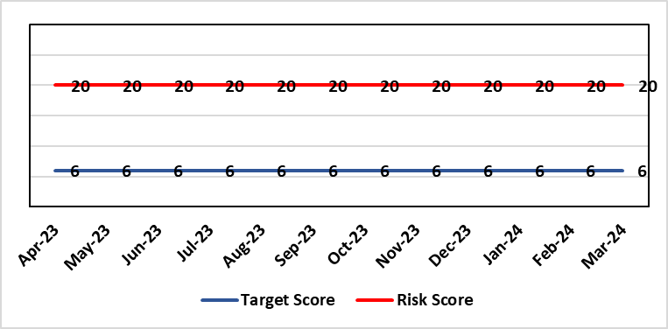 |  | Rationale for current score:  Every health board is required to have an admission facility for adolescent Mental Health patients. Whilst ward F has been identified as the single point of access in SBU and a dedicated bed is ring-fenced for adolescent admissions it is a mixed sex adult ward. Therefore the facilities are less than ideal for young patients in crisis.
Level of Control
=
Date added to the HB risk register  27/02/2020 |  |  | Rationale for target score:  The longer term aim for the Health Board remains to create an admission facility for adolescent Mental Health patients but this will not be possible until the new Adult Inpatient Unit is built.
Controls (What are we currently doing about the risk?) |  |  | Mitigating actions (What more should we do?)
Safeguarding Training for Staff, Joint protocol with Cwm Taf LHB [CAMHS] currently subject to review, Local SBUHB policy on providing care to young people in this environment. This includes the requirement for all such patients on admission to be subject to Level 3 Safe and Supportive observations.  Only Adolescents within 16-18 age range are admitted to the adult ward.  The health board works with CAMHS to make sure that the length of stay is as short as possible. |  |  | Action | Lead |  | Deadline
 |  |  | Next service group review of effectiveness of current controls. | MH&LD Head of Operations & Clinical Directors |  | 30/06/2024
Assurances (How do we know if the things we are doing are having an impact?)  Individual Rooms with en Suite Facilities, Joint working with CAMHS, monitoring of staff training, Monitoring of admissions by the MH&LD SG Legislation Committee of the Health Board. The ongoing issues with the risks presented by the use of this has recently been raised at an all Wales level with Welsh Government and a formal review is anticipated. The Service Group continues to flag the risk particularly in light of Ward F being identified as the SPOA for AMH in the Health Board which has resulted in an increase in acuity and a greater concentration of individuals who are experiencing the early crisis of admission - this has served to increase the already identified risks for young people in the environment. |  |  | Gaps in assurance (What additional assurances should we seek?)
Additional Comments / Progress Notes
12/02/2024: Recent out of hours CAMHS admission to ward F and was then transferred a few days later to the CAMHS regional inpatient unit in CTMUHB. After reviewing the ongoing issues and increased acuity on ward F for the previous 12 months it is agreed that this risk is scored correctly, but will continue to be closely monitored.

Datix ID Number: 1832  Health & Care Standard: : 3.1 Safe and Clinically Effective Care |  |  | HBR Ref Number: 80  Risk Target Date: TBC |  | Current Risk Rating  4 x 5 = 20
Objective: Networked Hospitals – A Systems Approach – Urgent & Emergency Care |  | BAF Ref: 3.3 | Director Lead: Deb Lewis, Chief Operating Officer  Assuring Committee: Quality & Safety Committee
Risk: Transfer of Clinical Optimised Patients  If the Health Board is unable to discharge clinically optimised patients there is a risk of harm to those patients as they will decompensate, and to those patients waiting for admission. |  |  | Date last reviewed: March 2024
Risk Rating  (consequence x likelihood):  Initial: 4 x 5 = 20  Current: 4 x 5 = 20  Target: 4 x 2 = 8 | 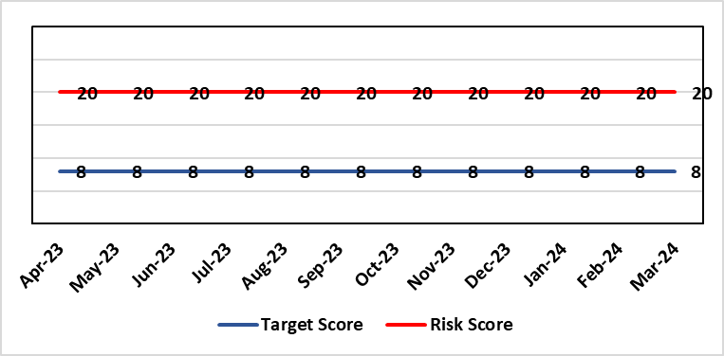 |  | Rationale for current score:  - Sustained levels of clinically optimised patients (COPs) leading to overcrowding within ED, use of inappropriate or overuse of decant capacity in ED and delays in accessing medical bed capacity, clearly emerged as themes.  - Constraints in relation to all patient flows out of Morriston to a more appropriate clinical setting, identified and included in an expanded risk.  - Delay in discharge for clinically optimised patients can result in deterioration of their condition.
Level of Control
= 25%
Level of Control  = 25% |  |  | Rationale for target score:  Targeted reduction of Clinically Optimised patients remains a priority for the HB in order to minimise risk of avoidable harm to patients within the HB and in the wider community.
Date added to the risk register
May 2021
Controls (What are we currently doing about the risk?) |  |  | Mitigating actions (What more should we do?)
- Clinically optimised numbers are monitored and reviewed weekly by the MDU. Delays are reported and escalated to try to ensure timely progress along a patient's pathway.  - Review on a patient by patient basis – with explicit action agreed in order to progress transfer to appropriate clinical setting.  - Critical constricts in relation to access/time delays for social workers and assessment for package of care and social placement – lead times in excess of 5 weeks.  - Patient COVID-19 status has added an additional level of complexity to decision making.  - The health board has procured 63 additional care home beds to provide additional discharge capacity.  - Clinically optimised patients have been cohorted into the available capacity at Singleton Hospital to ensure that their needs can be met more appropriately. This has reduced the number of COPs at Morriston Hospital. Weekly escalation meetings are held with health and social service colleagues to ensure the requirements of the patients are reviewed and patients are pulled through the system where possible. |  |  | Action | Lead |  | Deadline
 |  |  | Paper highlighting outputs and lessons learned from the implementation of the Patient Assessment Team to be considered by UEC Board to inform further actions / next steps. | Medical Director / HON (Transformation) |  | 31/03/2024
Assurances (How do we know if the things we are doing are having an impact?)  - Patient level dashboard allows breakdown by delay type Close management of utilization of additional care home beds. |  |  | Gaps in assurance (What additional assurances should we seek?)
Additional Comments
09/10/2023: IDH pilot completed, data being analysed, initial review shows a positive impact on turning patients around at the front door. Roll out to be completed in Q3.
13/02/2024: Action completed: Patient Assignment Team (PAT) element of an Integrated Discharge Hub is in place. There are further potential elements that have not be implemented, but are to be considered next – a Ward-based facilitation team and a Complex Discharge Team. A paper will submitted for consideration by the UEC Board (currently planned for 6th March). It will highlight the outputs and lessons learned from the implementation of a PAT in order to support discussion of next steps including consideration of the additional teams not currently in place.

Datix ID Number: 2788  Health Care Standards: 7.1 Workforce |  |  | HBR Ref Number: 81  Risk Target Date: 30/04/2024 |  | Current Risk Rating  5 x 4 = 20
Objective: Children, Young People & Maternity Services |  | BAF Ref: 3.6 | Director Lead: Gareth Howells, Executive Director of Nursing  Assuring Committee: Quality & Safety Committee  For Information: Workforce OD & Digital Committee
Risk: Critical staffing levels – Midwifery  Unplanned absences resulting from long and short-term sickness, alongside maternity leave, have resulted in critical staffing levels, which undermine the ability to maintain the full range of expected services safely, increasing the potential for harm, poor patient outcomes and/or choice of birthplace. Poor service quality or reduction in services could impact on organisational reputation. |  |  | Date last reviewed: March 2024
Rationale for current score:
The vacancy position has improved further and for Band 5 & 6 registered staff there are no vacancies. Some aspects of service provision continue to be suspended and this is subject to review currently. In view of this the risk was reduced from 25 to 20 initially. Whilst the service is now over-established with registered midwives, the score remains as high risk (20) due to unregistered vacancies (which we are recruiting to) and unavailability (due to parenting leave and sickness). There are improved numbers of registered midwives per shift with most shifts achieving the required 14 midwives.
Risk Rating  (consequence x likelihood):  Initial: 4 x 5 = 20  Current: 5 x 4 = 20  Target: 4 x 4 = 16 | 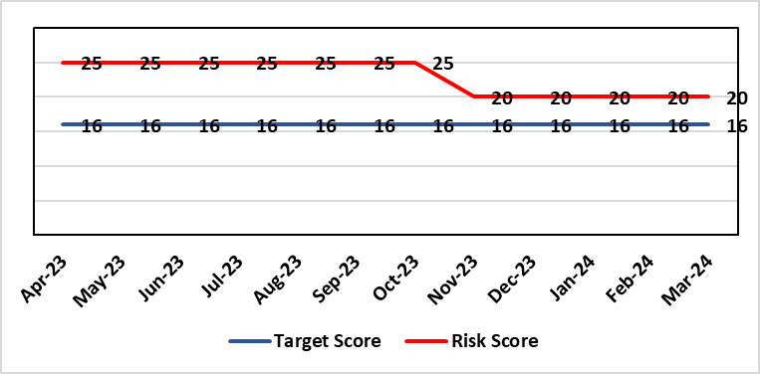
Level of Control  = % |  |  | Rationale for target score:  It is intended that through actions currently identified to address vacancies we can reinstate services fully and reduce the likelihood of the need to suspend elements further.
Date added to the risk register
12/10/2021
Controls (What are we currently doing about the risk?) |  |  | Mitigating actions (What more should we do?)
- Service Group Nurse Director chairs fortnightly roster scrutiny meetings to ensure effective deployment of staff.  - All midwives are working at the hours they require up to full time.  - Specialist midwives and management redeployed to support clinical care as required  - Birth rate plus Intrapartum acuity tool completed 4 hourly to guide safe service provision and escalation;  - Escalation meeting held daily during the week to review rotas and reallocate staff as required chaired by Head of Midwifery  - Morning safety huddle for community midwifery teams  - Morning safety huddle for obstetric unit generates RAG-rated daily acuity and shares this with the Service Group for its daily meeting.  - Additional shifts offered via Bank, additional hours and overtime at enhanced rates  - Utilisation of off-contract midwifery agency authorised by Executive Director of Nursing  - Open advert for recruitment on TRAC (recruitment system)  - On-Call Manager Rota in place.  - Continue to suspend services in the FMU (Freestanding Midwifery Unit) at Neath Port Talbot Hospital.  - International recruitment campaign initiated with MEDACS.  - Offer of additional support worker shifts particularly in the postnatal area for additional support for women  - Maternity Care Assistance (MCA) role in place to support Midwives in providing care in women and their families.  - Regular communication with stakeholders includes: Early warnings to Welsh Government; Verbal and formal communication with Llais; Internal communications on home births, RCM updates; weekly staff briefings and bulletins.  - Maternity Services Improvement & Assurance Board has been instated, meeting fortnightly, chaired by NPTS Nurse Director. This will report into the Midwifery & Neonatal Service Performance Board in place chaired by EDON |  |  | Action | Lead |  | Deadline
 |  |  | Advertising for Community Team Leaders (Band 7) to support plans to re-open services in Neath Port Talbot. Three in post, but further interviews taking place in April with expected start end June. | Community Matron / Consultant Midwife |  | 30/06/2024  (expected in post)
 |  |  | Recruitment of 5 WTE (whole time equivalent) Band 2 HCA (health care assistant) positions at Singleton: Some staff in post – start dates expected for others in May. | Obstetric Matron |  | 31/05/2024 (expected in post)
 |  |  | Developed Escalation Policy – to be ratified. | HOM |  | Complete
 |  |  | Gateway review in place in relation to reinstatement of community services, first point is recruitment of band 7 community team leaders. Paper to go to Management Board. | HOM |  | End May 2024
Assurances (How do we know if the things we are doing are having an impact?)  The following assurance mechanisms in place currently:  Birth-rate Plus Intrapartum acuity tool completed 4 hourly  Daily staff escalation meetings chaired by Head of Midwifery which considers sickness & other absences and daily review of safety and quality outcomes. The Group Head of Quality Safety & Risk is supporting daily oversight of Datix incidents. The following red flag events are monitored:  • Delayed or cancelled elective caesarean sections;  • Missed or delayed care incidents;  • Delayed or cancelled induction of labour;  • Delay of 2 hours or more between admission for induction of labour and beginning of process;  • Delay of 30 minute or more between presentation and triage.  Birthrate Plus assessment outcome (last internal assessment Oct 2023 – now compliant) |  |  | Gaps in assurance (What additional assurances should we seek?)
Additional Comments / Progress Notes
19/04/2024: Clinical Director of Midwifery appointed, expected to be in post by September 2024. Not all vacancies were filled during 1st round of recruitment of band 7 Community teams leads – 2nd round of interviews on 19/04/2024. Substantive post for Deputy Head of Midwifery to be advertised end of April 2024. Action completed: Escalation policy was ratified and is now published on WISDOM.

Datix ID Number: 2561  Health & Care Standard: Effective Care 3.1 Safe & Clinically Effective Care |  |  | HBR Ref Number: 85  Risk Target Date: TBC | Current Risk Rating  4 x 5 = 20
Objective: Children, Young People & Maternity Services |  | BAF Ref: 3.6 | Director Lead: Christine Morrell, Director of Therapies & Health Sciences  Assuring Committee: Quality & Safety Committee
Risk: Non-Compliance with ALNET Act There are risks to the Health Board’s ability to meet its statutory duties and establish the effective collaborative arrangements required by the ALN Act, which is being implemented through a phased approach. This risk is caused by:  - Lack of staff resource needed to carry out the additional work needed to comply with the ALN Act for operational services, especially those in the PCST Service Group.  - Issues around multi-agency working which may impact on levels of demand on operational services, and on existing SLAs through which the Health Board delivers some services to partner LAs.  - Implementation of the Act for those of above compulsory school age (post-16) commenced in September 2023. This presents risks because of gaps in service provision.  - Multiple pressures for operational services are impacting on capacity / engagement of leads within impacted services to progress tasks that need to be undertaken to mitigate the risks and current vacancy in ALN Project Manager post.  - Issues with Data Quality due to pressure on ALN and Service administration teams, process issues and absence of a robust system to enable data capture and analysis. This means that accurate and up-to-date data regarding the Health Board’s compliance is not available.  Potential consequences of this risk are: non-compliance with statutory duties, parent / carer and young peoples' dissatisfaction leading to complaints. Educational Tribunals and Judicial Reviews (this is new legislation with many points of ambiguity and is highly likely to be legally ‘tested’); reputational impact; and children failing to access the multi-agency support that they need with their learning needs, leading to poor outcomes. |  |  | Date last reviewed: March 2024
Rationale for current score:
Risk score reflects that while controls are in place, there are multiple areas of risks (relating to compliance with legislation; governance and assurance; workforce and OD; and sustainable services); and high probability (especially given multiple risk areas) of at least one of these areas of risk being realised. Caused by implementation timetable for the ALN Act, slippage against plan and need for strengthened governance (as described in ‘Risk’ section).

Risk Rating  (consequence x likelihood):  Initial: 5 x 5 = 25  Current: 4 x 5 = 20  Target: 2 x 3 = 6 |  |  | Rationale for target score:  As the ALN Act is new legislation, there remains some ongoing likelihood of risk events during the initial phases of implementation, though with lessened consequences as a result of mitigating actions.
Level of Control
=
Date added to the HB risk register
14/05/2022
Controls (What are we currently doing about the risk?) |  |  | Mitigating actions (What more should we do?)
- Progressing the necessary work within an appropriate structure (see under ‘ACTIONS’) are constrained by financial and/or service delivery pressures.  - DECLO (Designated Educational Clinical Lead Officer) is in post - this is a statutory requirement.  - Health Board ALN Steering Group has been established, with governance structure in place involving the ALN Operational Group working under the governance of this  - Operational processes through which the Health Board fulfils its statutory duties under the ALN Act are in place.  - Ongoing collaboration between the DECLOs at a national level ensures a broadly consistent approach across Wales to how Health Boards fulfil their requirements under the ALN Act. Some ongoing differences remain because of different Local Authority approaches, through Welsh Government have formed a national group to support improved consistency around Health-Education collaboration through the ALN Act.  - Regarding demand / capacity and staffing resource challenges, WG has a phased implementation timetable that has recently been extended from summer 2024 to summer 2025. From summer 2025, the Act will be fully in ‘delivery as usual’. The phased implementation offers partial short-term mitigation of the risks.  - Awareness has been raised at Board level through Development session and bi-monthly updates are provided to the Patient Safety & Compliance Group.  - Welsh Government have been engaging with the Designated Education Clinical Lead Officers on a national basis regarding ALN key performance indicators and compliance. A Welsh Health Circular requiring regular reporting against statutory key performance indicators is anticipated in the coming months.  - Audit and Assurance Services have conducted an audit of the Health Board in relation to the ALN Act, which provided an overall ‘limited assurance’ rating. Management responses have been developed and a work plan is in place, monitored through the ALN Steering Group, to address issues identified in the audit. |  |  | Action | Lead | Deadline
 |  |  | Requirement to establish data infrastructure to provide assurance regarding HB compliance with statutory duties | DECLO & Director of Digital | TBC
 |  |  | Develop and implement administrative operational model to support accurate data capture | DECLO | TBC
 |  |  | Effective, realistic operational processes - Activity to ensure operational processes through which statutory duties are fulfilled balance statutory duties and the ethos of the ALN Act with the need to deliver requirements without additional resource. | DECLO | 20/12/2024
 |  |  | Securing longer-term administrative and project management support needed to mitigate risks | DoTHS | 30/05/2024
 |  |  | Progress action plan in relation to ALN audit | DECLO | 30/09/2024
Assurances (How do we know if the things we are doing are having an impact?)  - There is regular reporting in respect of the ALN Act through the Patient Safety and Compliance Group.  - ALN Steering Board has been established, ensuring oversight at a senior level within all impacted operational and corporate areas.  - DECLO meets regularly with ADOTHS / DoTHS of the 3 health boards of South-West and Mid Wales for update and assurance.  - National ALN Reform Steering Group has been formed and will include Health representation (SBU Deputy DOTHS). This will provide a national forum for consideration of risks. |  |  | Gaps in assurance (What additional assurances should we seek?  - Extent of gap in staffing resource (gap between work required and capacity available) has been provisionally quantified, but data is imperfect and there remains some uncertainty. This is in a context where demands will increase significantly over the next year.
Additional Comments / Progress Notes
19/04/2024:
- ALN workplan has been developed and approved by ALN Steering Group. Action closed.
- The action ‘Work with Informatics colleagues to ensure robust data regarding compliance, for which it is anticipated that national reporting will required. Activity is ongoing nationally to establish the national dataset: engagement with digital services to establish the timescale for this,’ has been reworded to ‘Requirement to establish data infrastructure to provide assurance regarding HB compliance with statutory duties’. Progress remains outstanding and deadline date is now ‘TBC’.
- For the action, ‘Develop and implement administrative operational model to support accurate data capture,’ progress remains outstanding and deadline date is now ‘TBC’. This action is contingent on the action above and therefore cannot currently be progressed.
- For the action, ‘Securing longer-term administrative and project management support needed to mitigate risks,’ an update regarding financial allocations for 2024/25 remains outstanding, Deadline reset to 30/05/2024, by which point it is expected that there will be clarity regarding resource and timescales for having staff in post.
Limited progress means that the Health Board remains unable to provide assurance regarding the extent to which it is meeting its statutory requirements under the ALN Act and has no clear timescale for achieving this. Engagement with the Digital Director, Deputy DoTHS, and Therapies Clinical Director is planned with the aim of progressing work regarding digital infrastructure and establishing a realistic timeframe for this work.

Datix ID Number: 3071  Health Care Standards: Staff & Resources 7.1 Workforce |  |  | HBR Ref Number: 89  Target Risk Date: 31/06/2024 | Current Risk Rating  4 x 5 = 20
Objective: Primary & Community Care |  | BAF Ref: 3.1 | Director Lead: Gareth Howells, Executive Director of Nursing (lead) / Deb Lewis, Chief Operating Officer (support)  Assuring Committee: Quality & Safety Committee
Risk: Healthcare Nursing Staff Levels at HMP Swansea  There is a risk that the men in HMP Swansea will not receive the appropriate standard of care. This is due to the fact that the nursing establishment within the prison no longer fully meets the changed demographics and numbers of men being detained. The maximum operational capacity of the Prison can reach circa 480 men. The Health Board investment into the Prison is based on delivering services to 250 men. This was also highlighted as a risk in the June 2022 HIW governance review. In addition there is no head room built into the Prison nursing establishment so periods of sickness, leave and study renders the roster short. |  |  | Date last reviewed: March 2024
Risk Rating  (consequence x likelihood):  Initial: 4 x 5 = 20  Current: 4 x 5 = 20  Target: 2 x 2 = 4 | 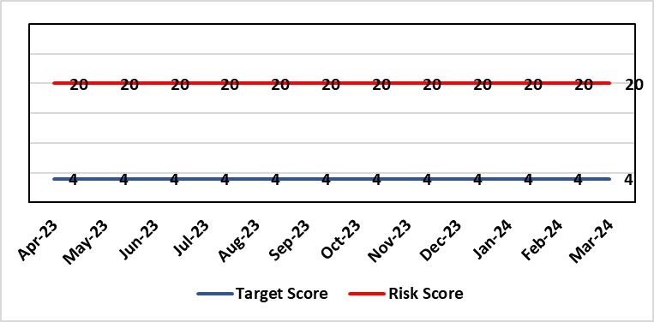 |  | Rationale for current score:  Consequence major – unable to fully deliver on the recommendations of HIW due to low healthcare staffing numbers, further impacted during periods of sickness or absence as no headroom. Recommendations also raised in Prison & Probation Ombudsman reports. Likelihood expected – suboptimal care provided on a daily basis.
Level of Control  = % |  |  | Rationale for target score:  Consequence minor – With sufficient staffing numbers the prison will be able to deliver on HIW recommendations and fully implement the actions in the Health Delivery Plan. Likelihood unlikely – With full establishment and headroom, suboptimal care is less likely.
Date added to the risk register
30/11/2022
Controls (What are we currently doing about the risk?) |  |  | Mitigating actions (What more should we do?)
Daily communication with the Governor about the availability and priority of healthcare nursing staff.  Pharmacy technician role established – can administer drugs to support nursing establishment.  Agreed that Health Care Support Workers to be 2nd checkers for CD drugs and to support substance withdrawal monitoring (awaiting accreditation).  Bank and agency staff are used in a limited way, when skillset allows.  E-roster implemented and scrutinised with regular reporting to Service Group Patient Safety & Compliance Group.  Escalation for overtime and additional hours to fill shortfalls. |  |  | Action | Lead | Deadline
 |  |  | HCSW second checkers of CDs to be accredited externally. | Healthcare Lead | 31/03/2024
 |  |  | Management Board paper to be presented setting out the current position and next steps. | Service Group Director (PCT) | 29/04/2024
 |  |  | Fresh Gap analysis to be undertaken to identify staffing shortfall and set out further proposals to address. | Service Group Director (PCT) | 30/04/2024
Assurances (How do we know if the things we are doing are having an impact?)  Prison feedback and complaint process  Progress reporting on action plans through Service Group PS&C Group, and Health Board Q&S structures (via Patient Safety & Compliance Group). |  |  | Gaps in assurance (What additional assurances should we seek?)  Implementation and reporting of clinical audits. Audit framework for HMP Swansea in development - Clinical Pathways/Audits and Health Promotion groups taking forward.
Additional Comments
27/11/2023: The Health care leads have only the capacity to support the clinical and operational aspects whilst performance, assurance and health promotion work is secondary. PCTG has not been able to identify recurrent funding post the 31st March 2023 to bolster the nurse roster. Action to establish task & finish group added. This will meet in early January 2024 and will focus on the following areas:
• Scope of the development work
• Current staffing challenges
• Clinical pathway development
• Benchmark with other models of care
• Specific areas of focus - Priority areas
• Who needs to be involved
• Updating Management Board
• Progress against the HIW Action plan
• Funding moving forward
22/01/2024: Actions Completed: Discussion in relation to internal sources of funding following cessation of the SLA with CTM – the Mental Health In-Reach team are now dedicated to Swansea; Task and finish group established between PCTSSG & MHLDSG – Executive Director of Nursing in Chair; Through Prison Partnership Board opportunities to implement the recommendations of HIW and Health Delivery Plan explored and progress reviewed at PCT Q&S Group – the Task & Finish Group is now reviewing opportunities and a programme of work set out as above.
A paper is being developed for presentation to the Management Board setting out the current position; this is to be followed by fresh gap analysis and proposals on how to address staffing issues and take forward the remaining work including the actions agreed within the Health Delivery Plan.
Two groups – Clinical Pathways/Audits and Health Promotion Groups have been established to take forward actions. Discussion is underway with Public Health colleagues to explore additional funding to cover vaccination and the Liver Plan.

19/04/2024: The Paper for management Board has been completed, the paper sets out the current position and options.
There have been initial meetings with WG Mental Health, Substance Misuse and Vulnerable groups division who are facilitating.
A baseline assessment for mental health and substance misuse needs in HMP Swansea. It is hoped that this work will form part of the overall gap analysis work. Baseline work will commence May 2024, an external team will complete the assessment. The risk rating remains at 20 whilst the baseline work is being completed.

Datix ID Number: 3432  Health & Care Standard: Safe Care 2.7 Safeguarding Children and Safeguarding Adults at Risk |  |  | HBR Ref Number: 91  Risk Target Date: TBC |  | Current Risk Rating  4 x 4 = 16
Objective: Mental Health & Learning Disability |  | BAF Ref: 3.2 | Director Lead: Gareth Howells, Executive Director of Nursing  Supporting Director: Hazel Lloyd, Director of Corporate Governance  Assuring Committee: Mental Health Legislation Committee  For Information: Quality and Safety Committee
Risk: Mental Capacity Act Assessments  There is a risk that assessments under the Mental Capacity Act (MCA) are not undertaken and recorded as required. This is caused by:  - There is no identified MCA structure or designated resource to support the implementation and compliance with MCA across the organisation  - Recent DoLS (Deprivation of Liberty Safeguards) audits show that there are significant deficits in knowledge and awareness of the MCA in some areas, which could result in the Health Board failing to meet its statutory responsibilities.  - Lack of funded budget for Health Board Level 2 and 3 training and a lack of coordination in the review and development of training content  - No agreed structure for oversight and management of HB IMCA (Independent Mental Capacity Advocate) contract  Where the UHB fails in its statutory duty to enact the MCA appropriately this could result in harm to vulnerable individuals, and/or unlawful deprivations of liberty, leading to litigation. Such cases could incur significant financial penalties, cause distress to staff members and patients, and risk damage to the organisations reputation. |  |  | Date last reviewed: March 2024
Rationale for current score:
- The implementation of the MCA is accountable to the Court of Protection, which is a higher-level court equivalent to the High Court. This means that decisions carry precedence and fines are considerably higher and often high profile.
- There is a mixed approach to referral to the Court of Protection, and as such a need to improve the Governance structures around this. There is no current central system up to date with current court of Protection cases
- There is no local agreed MCA Policy in place, although the MCA has associated guidance which provides advice on implementation
- Standard operating procedures have been identified as necessary relating to elements required under the act, but there is a need for these to be centrally identified developed and managed.
- It is difficult to access percentage compliance data with MCA training due to the ongoing challenges with ESR
- This risk is linked to HBRR 43: Deprivation of Liberty and the work ongoing in this area overseen by a Task & Finish Group.
Risk Rating  (consequence x likelihood):  Initial: 4 x 4 = 16  Current: 4 x 4 = 16  Target: 4 x 2 = 8 | 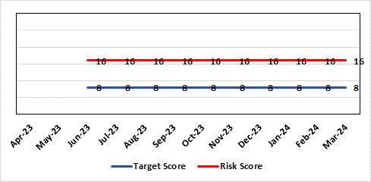 |  | Rationale for target score:  Consequences noncompliance for the Health Board will not change.  Addressing the oversight and Governance will reduce the likelihood of non-compliance.  The Risk Target Date reflects timescale for the MCA lead to take up position and the establishment of governance structures & processes.
Level of Control
=
Date added to the HB risk register
June 2023
Controls (What are we currently doing about the risk?) |  |  | Mitigating actions (What more should we do?)
- Director level responsibility confirmed in principle with the agreement to host the MCA / DoLS structure from April 2024. Head of Nursing MCA to continue to coordinate the various elements in the interim.  - Appointed a band 5 business manager and a band 6 professional development nurse 0.6 to support the coordination of the elements relating to MCA and support the service groups with application in practice.  - Agreement by the PCTSG Board in principle for PCT to host a combined MCA / DoLS team but not to include IMCA or Court of Protection at this point in time.  - Urgent support in practice is provided by the DoLS team lead and there are now three Best Interest Assessors in post to support increased monitoring of compliance and access to advice.  - Escalated and the Director of Nursing and Patient Experience has established a task and finish group to ensure any gaps in compliance are managed, the service is future proofed, and accountability agreed  - Core health board training remains in place. A review has demonstrated low compliance linked to the efficacy of the training to support the practical needs of front line staff. An all Wales benchmarking process showed training delivered in house to be more effective. The development of a training post will support delivery of training more flexibly to meet the needs of clinical staff.  - Corporate Head of Nursing is working with Corporate Governance and Service Delivery Group Governance leads to identify concerns, work to address these and ensure that those responsible for the local implementation of the MCA are aware of their responsibilities. |  |  | Action | Lead |  | Deadline
 |  |  | A review of training has been placed on the agenda for the MCA / DoLS / Subgroup of the West Glamorgan Safeguarding Board – Agreed to a regional approach to reviewing and planning MCA DoLS training. | Head of Nursing MCA |  | 26/04/2024
Assurances (How do we know if the things we are doing are having an impact?)  - Corporate Head of Nursing will provide regular updates and reports to Mental Health Legislation committee including any highlighted concerns.  - The ongoing development work to ensure a robust MCA DoLS process will continue to monitor MCA compliance and provide operational advice and support to the service groups  - Reporting processes are via  - The Mental Health Legislation Committee  - The safeguarding committee  - West Glamorgan Safeguarding Board |  |  | Gaps in assurance (What additional assurances should we seek?)  Policies, standard operating procedures, accountability and assurance not yet in place.  With LPS not being implemented during this parliament and no agreed future date likely, policies, standard operating procedures, accountability and assurance arrangements for the MCA to be confirmed via the task and finish group established.
Additional Comments / Progress Notes
- There has been an update from Government on 5 May 2023 advising that LPS (Liberty Protection Safeguards) will no longer be implemented during this parliament but Health Boards are required to have a robust MCA / DoLS system in place.
- The Service Delivery Groups need to be assured they are working towards embedding the Mental Capacity Act 2005 (MCA), into everyday practice.
- To safeguard vulnerable patients and protect the Health Board from complaints and potential litigation there needs to be clear lines of escalation and accountability
- Whilst the Act is a legal requirement, it is not yet well understood or embedded into clinical practice. Some concerns identified include, a tendency among health and social care staff to make assumptions based on impairment; failure to conduct assessments when necessary; the poor quality of assessments generally, and a failure to take into account the impact of specific conditions on assessment.
- The Board needs to be assured of the effectiveness of the MCA in practice with oversight, audit, and reporting mechanisms agreed from ward to board. This requires a dedicated MCA resource.
- Discussions have started on the overarching accountability for MCA within the organisation
- Cases remain managed by Corporate Governance and the Service Group Governance teams
- Advice and support in managing these comes from the DoLS lead
- Once in place, the MCA Lead post will support a regular meeting with Governance lead from all areas to develop systems to effectively track and manage cases across the Health Board. This will support reporting and monitoring of CoP work.
05/02/2024: Actions Completed: (1) Agreement of a required structure with senior accountability for MCA and the DoLS service; (2) Agreement of accountabilities and structure, and an assessment undertaken of resource needs and funding options.
22/04/2024: MCA has transferred from corporate to join the DoLS Team in PCTSG 01/04/2024 to form a MCA/DoLS Service which is hosted by PCTSG. The new Lead for MCA/DoLS commenced 11/03/2024 and is currently undergoing induction. Agreement to keep risk score at 16 until induction period completed, following which the risk will be discussed and reviewed in the PCTG Risk Meeting in 2 months.

Datix ID Number: 3516  Health Care Standards: Standard 3.1 safe and clinically effective services |  |  | HBR Ref Number: 94  Risk Target Date: TBC |  | Current Risk Rating  4 x 3 = 12
Objective: Children, Young People & Maternity Services |  | BAF Ref: 3.6 | Director Lead: Deb Lewis, Chief Operating Officer  Assuring Committee: Performance and Finance Committee  For information: Quality & Safety Committee
Risk: CAMHS failure to meet required standards of performance  The CAMHS service is unable to meet the required level of performance due to workforce deficits in the team across all staff groups including medics, psychological therapies and nursing.  This is further hindered by poor data quality which presents a risk to reporting until validation is complete.  Links to other CAMHS risk register entries: (Ref: 3410/3373/3351/3346/3349/3350) |  |  | Date last reviewed: March 2024
Risk Rating  (consequence x likelihood):  Initial: 4 x 5 = 20  Current: 4 x 3 = 12  Target: 3 x 3 = 9 | 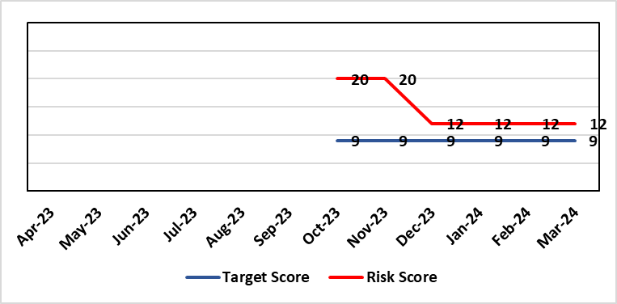 |  | Rationale for current score:  Marked improvement in the performance against the Mental health Measure for CAMHS. Data validation for new patients complete. Current risk score reduced to 12 in view of improved performance however this reflects the fragility in the workforce to deliver sustained performance.
Level of Control  = % |  |  | Rationale for target score:  The rationale for the target score is linked to successful recruitment and more timely access to services for children and young persons which will reduce risk.
Date added to the risk register
October 2023
Controls (What are we currently doing about the risk?) |  |  | Mitigating actions (What more should we do?)
-Ongoing recruitment into all staff groups  -Temporary agency workforce in nursing at premium pay rates to sustain current levels of performance  -Use of locum medical staff due to high vacancy level on medical workforce.  -Recent appointment into psychological therapies lead posts.  -Exploring fixed term appointment of Band 5 psychological therapies support staff to improve performance |  |  | Action | Lead |  | Deadline
 |  |  | Continued efforts at recruitment | Acting Associate Service Director |  | Monthly review
Assurances (How do we know if the things we are doing are having an impact?)  -Monthly CAMHS Directorate meeting in place where performance and workforce are scrutinised  -Reporting into Weekly Business Team and MH & LD management board.  -Reporting into HB Performance and Finance Committee  -Ongoing validation of the waiting list to ensure robust reporting going forward |  |  | Gaps in assurance (What additional assurances should we seek?)
Additional Comments / Progress Notes
13/12/2023: Marked improvement in the performance against the Mental health Measure for CAMHS. Data validation for new patients complete. Data validation for follow-up patients including ADHD in progress. Over recruitment into agency nursing has supported delivery of improved performance outputs however continue to struggle to recruit into substantive posts.
Current risk score reduced to 12 in view of improved performance however this reflects the fragility in the workforce to deliver sustained performance.

Datix ID Number: 3566 *Risk Closed*  Health Care Standards: Governance & Accountability; 6.3 Listening & Learning |  |  | HBR Ref Number: 95  Risk Target Date: 31/03/2024 |  | Current Risk Rating  4 x 1 = 4
Objective: Demonstrably Improved Quality, Safety & Reduced Harm |  | BAF Ref: 1 | Director Lead: Gareth Howells, Executive Director of Nursing  Assuring Committee: Quality & Safety Committee
Risk: National Nosocomial COVID-19 Programme  Failure to (effectively) complete the nationally mandated review of cases of nosocomial COVID-19 by the stipulated end date of the National Nosocomial COVID-19 Programme (NNCP), 31st March 2024, resulting in possible reputational damage and the cessation of funding prior to completion of the work. This risk is caused, in part, by uncertainty in relation to continued availability of appropriate staff capacity to meet the demands of the reviews. |  |  | Date last reviewed: March 2024
Risk Rating  (consequence x likelihood):  Initial: 4 x 5 = 20  Current: 4 x 1 = 4  Target: 4 x 2 = 8 | 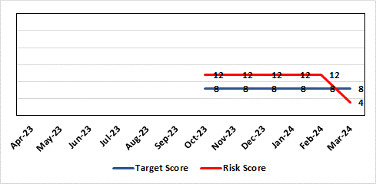 |  | Rationale for current score:  The National Nosocomial COVID-19 Programme drew to a close on 31.03.2024. All nosocomial COVID-19 cases were reviewed and closed in line with the National Framework for the Management of Patient Safety Incidents Following Nosocomial Transmission of COVID-19, by this date. Data reflecting this was submitted to the NHS Executive on 26.03.2024. In light of this, a score lower than the target score is applicable as there is no ongoing possibility of the risk occurring.
Level of Control  = % |  |  | Rationale for target score:  Reviews to continue at pace, with new approaches, referred to above, becoming slicker as they become practised. Application of the mitigating actions noted below will aid in proactively controlling activity which might, otherwise, distract from the processes of reviewing and communicating outcomes.
Date added to the risk register
October 2023
Controls (What are we currently doing about the risk?) |  |  | Mitigating actions (What more should we do?)
- Monthly data submission and highlight reports to the NHS Executive NNCP team;  - Workbook Review Process to determine outcomes for cases in which no harm has occurred.  - Triage Review Panels to determine outcomes for cases of no or low harm;  - Peer Review Panels to determine outcomes for cases of medium harm or above;  - Lessons identified reported via the Patient Stakeholder Experience Group;  - Lessons identified reported to operational staff during visits to site by the Nosocomial Review Team (NRT). The wellbeing offer to operational staff is being collated for reiteration in light of the emotive reception to visits;  - Recording progress and outcomes on Datix using set scripts and processes.  - Detailed Programme records kept to track progress, updates and notifications.  - Team processes documented, updated and shared to ensure consistency of approach. Rationale for approaches documented and approved by Executive, as required.  - Team communication channels which enable interim contact with patients/relatives monitored daily.  - Communication methods and content are adapted in response to feedback from the public / monitoring bodies.  - Programme timelines to ensure delivery targets are met at all stages of communication with the public are consistently monitored.  - Schedule of regular learning activity available to the team for development of skills specifically related to Programme.  - Input requested from specialist, multidisciplinary colleagues, as required, including IPC, medics, the patient feedback team and L&RS.  - Clinical Investigators appointed to undertake reviews are senior and experienced, affording a level of assurance across the Programme.  - Given the consistently difficult subject matter is considered by the Nosocomial COVID-19 Review Team, wellbeing is monitored which ensures that all team members remain able to work to an optimal level.  - NRT methodology has been shared for use by the Mortality Review Board in its consideration of nosocomial COVID-19 cases which are out of scope to the NRT (post-30.04.3022.) This will ensure some consistency in approach. |  |  | Action | Lead |  | Deadline
 |  |  | Review communication methods and content in response to feedback from the public | Business Manager (Nosocomial Review Team) |  | Complete.  Ongoing review was undertaken over the duration of the Programme, with communication adapted, where necessary, to requirements of individuals.
 |  |  | Develop the Nosocomial COVID-19 Review Team webpage to ensure the most up-to-date progress reports are available to the public | Business Manager (Nosocomial Review Team) |  | Complete.  Webpage was updated in line with NHS Executive-issued template. This has been amended to incorporate details on Programme-end.
 |  |  | Develop and implement an action plan for dissemination of lessons identified to operational colleagues of all levels. | Business Manager (Nosocomial Review Team) |  | Complete.  Dissemination of learnings was undertaken during visits to speak with operational colleagues and by presentation to key corporate meeting groups.
 |  |  | Adopt a process for the subsuming of nosocomial COVID-19 reviews into business as usual activity. This will need to consider all hospital-acquired COVID-19 infections occurring beyond the time remit of the NNCP, 30/04/2022. | Business Manager (Nosocomial Review Team) |  | Complete  Investigation of healthcare-acquired COVID-19 infections is to occur via the same process as the investigation of all other healthcare-acquired infections, in the future.
Assurances (How do we know if the things we are doing are having an impact?)  - Consistent progress shown against NHS Executive trajectory for completion of the NNCP.  - Positive feedback from the NHS Executive.  - Positive feedback from patients/relatives.  - No take up of cases for investigation by the Ombudsman / Llais Cymru.  - Processes now in place relating to each of the many aspects of the Programme, including proportionate approaches for the review of varying categories of case.  - Reporting to various fora such as Management Board, Quality & Safety Committee, etc. is well-received. |  |  | Gaps in assurance (What additional assurances should we seek?)  The finite nature of the NNCP presents a risk for potential residual activity to occur following the disbanding of the NRT from end of March 2024. Due to the high number of cases requiring review, the full length of the Programme will be required for completion of the work meaning that Programme activity which instigates interaction with patients and families in the latter stages will pose the biggest risk in this regard. All patients/relatives who receive a review outcome from the Nosocomial COVID-19 Review Team are offered the opportunity to discuss this and to feedback on the process via a satisfaction survey, should they wish. A means of handling this contact from the public will be required beyond the Nosocomial Review Team being in post (31.04.2024)
Additional Comments / Progress Notes
The risk is multifaceted in that each of the factors which could cause a delay to the progress of the Programme, thus lead to failure to complete all required reviews by 31st March 2024, carries its own risk, also. The following constitute some examples of this:
- Findings of review report a breach of duty which leads to qualifying liability resulting in reputational damage and/or financial impact.
- Distress caused to patients / relatives by communication of review findings/delayed communication of findings resulting in receipt of additional complaints and/or negative media attention.
- High take-up of offer to discuss cases with the team by patients / relatives resulting in a variety of concerns/queries raised, some of which are out of the scope of the nosocomial COVID-19 review resulting in high volumes of work for other Health Board teams who are already working to capacity.
- Failure to effectively disseminate lessons identified during NNCP reviews resulting in the continuation of practice which causes harm and which might, otherwise, be avoidable.
- Members of the Nosocomial Review Team seeking alternative employment due to the finite nature of the programme resulting in a need to re-recruit, and consequently, retrain.

14/04/2024: All nosocomial COVID-19 reviews were completed in line with the closure of the National Nosocomial COVID-19 Programme on 31.03.2024. In light of this, the risk of non-completion of the Programme no longer exists. There is potential for residual risks to occur, relating to the work completed by the Nosocomial Review Team, into the future. These are to be collated and presented in a final update paper to Management Board during May 2024. Should any of these risks require ongoing monitoring, they will be added to the risk register of the Executive Director of Nursing. From there, they will be monitored and escalated, as appropriate.

As a means of providing some mitigation to any potential risks, work is being undertaken to ensure an ‘organisational memory’ of key documentation from the Nosocomial Review Team. To this end, an archive of reviews, referenced on Datix, is to be built, plans are in place to further disseminate and embed Programme learnings and to absorb ongoing review of nosocomial COVID-19 reviews into routine business. In addition, contacts for the receipt of any future communication relating to the Programme have been designated and advertised via Nosocomial Review Team communication channels. The Health Board provided assurance to the NHS Executive on each of these aspects in a Board Governance and Assurance Exit Questionnaire, submitted on 10.04.2024.

Risk Score Calculation

For each risk identified, the LIKELIHOOD & CONSEQUENCE mechanism will be utilised. Essentially this examines each of the risks and attempts to assess the likelihood of the event occurring (PROBABILITY) and the effect it could have on the Health Board (IMPACT). This process ensures that the Health Board will be focusing on those risks which require immediate attention rather than spending time on areas which are, relatively, a lower priority.

