
Meeting Date | 21st May 2024 | Agenda Item | 4.2
Report Title | Quality Priority Deep Dive: Sepsis
Report Author | Dr Rangaswamy Mothukuri, Senior Responsible Officer, Sepsis  Lisa Fabb, Acute Deterioration Lead
Report Sponsor | Dr Raj Krishnan, Acting Executive Medical Director
Presented by | Lisa Fabb, Acute Deterioration Lead
Freedom of Information | Open
Purpose of the Report | To provide an update on the goals, methods and outcomes for the Sepsis quality priority and how these will be transferred into business as usual by December 2024.
Key Issues | - Sepsis remains a leading cause of avoidable harm in Healthcare in Swansea Bay UHB (Crude Sepsis Mortality from January 2022);  - Progress has been made in a number of areas including an increase in completion of sepsis training, identification of champions across a high number of wards across the three acute sites and almost 200 audits to check completion of the sepsis screening tool;  - Swansea Bay was the first Health Board in Wales to be compliant with AoMRC (Academy of Medical Royal Colleges) guidelines across the Health Board. This will allow the team to focus on quality improvement projects to reduce harm from sepsis  - A road map to set out the plan deliver sepsis as business as usual by December 2024 is in place;  - Alongside this is the development of an acute deterioration dashboard through AMaT, HEPMA (Hospital Electronic Prescribing and Medicines Administration) and Signal to inform staff of areas of risk and monitor performance.
Specific Action Required  (please choose one only) | Information | Discussion | Assurance | Approval
Specific Action Required  (please choose one only) | ☐ | ☐ | ☒ | ☐
Recommendations | Members are asked to:  - NOTE the progress to date against the 2023-24 GMOs;  - NOTE the road map and plans to deliver sepsis as ‘business as usual’ by December 2024;  - NOTE the risks to delivery and the mitigating actions;  - NOTE the development of an acute deterioration dashboard in April 2024 which will provide real-time data to service groups to inform services of areas of risk and monitor performance;  - RECEIVE a further update in September 2024

Quality Priority Deep Dive: Sepsis

- INTRODUCTION
The Health Board identified Sepsis as a Quality priority in 2021. This paper outlines what has been achieved so far and the focus for 2024. It also sets out the actions required to incorporate this into business as usual, and highlights the developments during the last six months.

- BACKGROUND
The Sepsis lead and Senior Responsible Officer took up roles in April 2022 and have led on promoting the priority across the health board since this time.

The sepsis quality priority work at this time demonstrated that the paper based sepsis screening tool completion compliance was very poor across all areas due to various reasons. Therefore, the first year of the Sepsis Quality priority was spent understanding the causes of this and trialling other modes of screening. Around this time the Academy of Medical Royal Colleges (AoMRC) guidance was published and subsequently updated. This necessitated substantial changes to the sepsis screening system.

The one modality for data capture was e-obs (electronic observations) but it was also recognised that the implementation of e-obs was not achievable in the short or medium term. Following this we had multiple discussions with digital team and as a proof of concept it was agreed to trial a digital sepsis screening tool on Signal.

Alongside this work there has been continuous work around microbiology, education and engagement of sepsis champions.

- GOVERNANCE AND RISK ISSUES

- Progress to Date
Since the last update report, the following progress has been made:

1. Establishment of National and local Sepsis Group:
- Health board (HB) wide Sepsis Delivery Group, Sepsis Task and Finish Group and Sepsis Steering Group established and meeting regularly (terms of reference at appendix-1).
- All-Wales Sepsis Steering Group to provide a statement of recommendations including national measures.

2. Sepsis Communication Campaign
- Sepsis champions in most wards in Morriston Hospital, Singleton Hospital and NPTH, who meet monthly (Appendix-2).
- Service Group educators are engaged and provided with regular updates.

3. Sepsis Screening Tool Launched May 2023
- Paper screening tool launched in May 2023. Work now ongoing for a digital tool which will be trialled from April 2024.

4. Sepsis Awareness Training
- Over 2000 staff trained
- Ward based briefing training provided on all wards
- National e-learning updates which will be available via ESR (Electronic Staff Record).

5. Leadership
- Sepsis leads identified for each service group.

6. Audit
- 198 audits cycles of the completion of the sepsis screening tool completed over 12 months across adult acute sites.
- Initial improvement seen post sepsis screening launch but over the last 12 months the submission of data has been variable. Support for audit process has been focussed on admitting units.
- In an attempt to ensure sepsis assurance is ‘business as usual’ changes have been made to matron’s audit. The same will be considered for ward managers audit once it is moved to AMaT.

7. Engagement with Microbiology
- Ongoing Deep dive to look at first dose antibiotic prescribing in the Emergency Department for February/March 2024, cross referencing antibiotic prescribing with blood culture results.
- Collaboration with Emergency Department staff to improve blood culture filling and turnaround time, which can improve accuracy of results by 49% and help target antibiotic prescribing. A short efficient “Tik Tok style” training video has been developed to demonstrate the correct practice along with infographic branding. This was done after a review of the barriers to good practice.

8. Paediatrics
- Dr Mazhar, consultant paediatrician, has provided a Paediatric Sepsis Group Report and currently waiting for the results of the joint work. (Appendix- 3)

9. Sepsis in the Community
- Community sepsis team are trialling NEWS (National Early Warning Score) and escalation protocol in one cluster.
- A deep dive was completed into the reasons for patients in Gorseinon Hospital being transferred to Morriston to inform further improvements in the management of probable sepsis (Appendix- 4).

10. Mental Health and Learning Disabilities
- Sepsis training continues.
- Planning a deep dive of all patients transferred from Mental Health in patient to acute hospital.

- Delivery of the Sepsis quality priority
The GMOs (Goal, Methods, Outcomes) for 2023/24 are set out below:
Goal | Method | Outcome | 3 month Target | 6 month Target
Reduce sepsis mortality by improving recognition and response to acute deterioration | Raise awareness through education and events | Sepsis Summit completed on World sepsis day 13 Sept with an aim to engage staff in sepsis improvements.  Revise All Wales Sepsis E-learning training. | 50% of ward staff to have received sepsis training. | 75% of ward staff to have received sepsis training.
Awareness and timely management of sepsis to become ‘business as usual’ by December 2024. | Achievement of above. | Sustained improvement in sepsis care and outcomes. | Sepsis Audit to be embedded in to Matron’s Monthly Audit via Audit Management and Tracking (AMaT) | Matron’s Monthly Audit (Sepsis questions) outcomes to be reported to each service group RADAR (or equivalent)

Some of the work to deliver the GMOs has included:

- Training:
Sepsis training remains key in the improvement of sepsis treatment and recognition. To ensure a there is robust training programme reaching all areas of the health board, training has been devolved to nurse educators for clinical directorates supported by the Sepsis Quality Priority team. This has ensured that all staff, internationally trained nurses and newly registered nurses have sepsis training on induction as well as regular update training. To date more than 2000 nurses have had Sepsis training since Sepsis quality priority launch Nov 2022. The sepsis team have updated the national ESR Sepsis e-learning module to improve learning records.

In addition, the mandated annual Immediate Life Support training contains a sepsis scenario for all bedside registered nurses.

- Communication:
The sepsis team are regularly supporting sepsis champions and service group educators to provide appropriate training and improve awareness around sepsis and its management. In view of trying to achieve the final aim of ‘business as usual’, the wards have been supported to independently monitor, implement, analyse and provide sepsis data to the service groups.

Resuscitation hub page is a central source of sepsis resources which was launched in October 2023.

- Audit:
The audit of completion of the sepsis screening tool is currently being collected via a Microsoft form. Going forward this will be collected via the matrons’ monthly audit, as part of a larger regular audit it is hoped that submission will improve. The graph below provides an example of compliance with the tool:

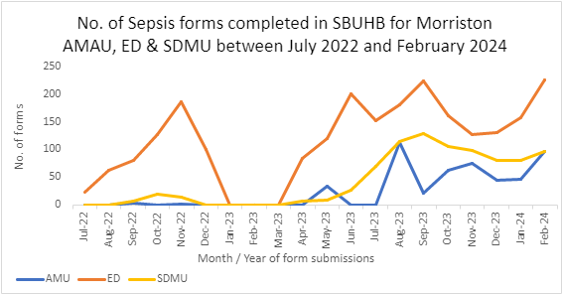

- Service Group Quality Improvement Projects
Two of the service groups have put forward quality improvement projects for sepsis:

NPTSSG (Neath Port Talbot/Singleton Service Group):
- Increase sepsis training with short ward based training sessions;
- Increase use of NEWS and Sepsis icons on Signal Boards, improving the use of visual management systems to improve sepsis awareness and monitoring.

MSG (Morriston Service Group) –
- This work has focussed on Surgical Decision Making Unit (SDMU) now Surgical Short Stay (SSSU). As a result of service redesign there are less beds which may equate to less sepsis screening forms.

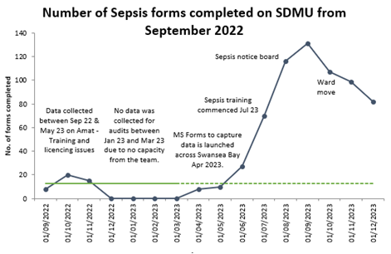

Other key achievements include:
- Current sepsis quality priority work has ensured that the Health Board is up to date with the AoMRC guidelines in all areas of the Health Board, with associated guidance available for best practice in End of Life Care and Antimicrobial Stewardship;
- SBUHB are the first Health Board in Wales to be AoMRC compliant across the Health Board and will allow the team to focus on quality improvement projects to reduce harm from sepsis;
- Since the launch of the new Sepsis Screening Tool there has been an increase in the number of patients screened for sepsis to goals as outlined Safe Care Collaborative.

- Performance Metrics
Through Improvement Cymru’s Safe Care Collaborative coaching support, the metrics for sepsis as a quality priority had been revised to focus on referrals to the Critical Care Outreach Team (CCOT) / Hospital at night (H@N) and emergency inter-hospital transfers to Morriston Hospital, in order to ascertain if there was timely referral to CCOT/ medical staff and was sepsis considered.

Following a deep dive of the admissions to ITU (intensive care unit) over a 12 months period and a review of 30 cases notes, it has become clear that the management for cases coming up to ITU via the Emergency Department (ED) and via the wards, was appropriate and in the majority of cases there were no noticeable delays which would alter the outcomes:

- Sepsis cases admitted via ED presented in extremis, and were rapidly transferred to ITU, highlighting possible delay in transfer from community to hospital.
- Those patients where there were delays transferring to ITU, the main presenting complaint was not sepsis.
- Many of these patients were appropriately recognised as end of life following referral to ITU.
- In view of the above, a review of 10 patients below 60 years of age was undertaken over 12 month period. Again most cases were managed appropriately, although in 3 cases, the cause for diagnosis of sepsis was not clear.

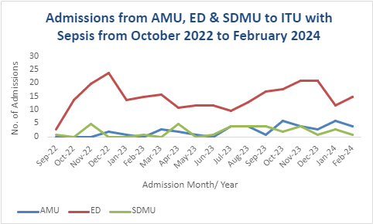

Based on the above findings and discussions, going forward, the focus on form completion will be for specific acute ward areas, where most admissions come to ITU. Over the next 6 months, ward 12 in Singleton and Cardigan Ward and Ward J in Morriston will use the updated digital sepsis screening question on Signal. This will be reviewed monthly for the next three months.

Targets for the service groups, were set out in the Sepsis report submitted October 2023:

- Increase the number of patients being screened for sepsis by December 2023
  - Target of 75% of ward staff trained per area, service group educators are leading this.
  - Service Groups to identify areas that require increased support and develop an appropriate action plan.
  - Continue with small tests of change that reduce reliance on memory and embed Sepsis screening as common practice, this is currently being done in three clinical areas.
  - Increase multi-disciplinary training.
  - Increase the documentation of Sepsis and NEWS Cymru on Signal by December 2023.
- Continue collaboration and focussed tests of change with EoL and Anti-Microbial Stewardship (AMS) teams.
- Develop robust Acute Deterioration systems that embed Sepsis recognition and treatment.

These have been achieved although we acknowledge that the measures were not clearly capturable, as a result we moved to ‘number of forms collected’ with a target of doubling forms collected.

The collaboration with the microbiology team is continuing to focus on “Getting it right the first time” for the first dose antibiotic prescription and correct blood culture sampling. The data is reported at a 6 monthly health board Sepsis group meeting.
On a national basis, as a result of discussion in the All Wales Sepsis Steering Group forum, the following sepsis measures, once finalised, will be recommended to Welsh Government for implementation at a national level:
- What % patients who screen as Probable Sepsis receive Antimicrobials within 1hr? (Time Zero = first NEWS2 score on initial assessment accompanied by suspected or confirmed infection)
- What % of patients have a review by a Senior Clinical Decision maker within 6 hours of a Probable Sepsis Diagnosis?
- What % of patients have a Consultant or Micro review of Antimicrobials within 48hrs? (AoMRC)

Our aim in SBUHB is to work towards achieving this over the next six months. This will be led by the Resuscitation and Acute Deterioration team and report to RADAR and Sepsis Steering Group.

- Governance and Reporting
The reporting structure for sepsis comprises:

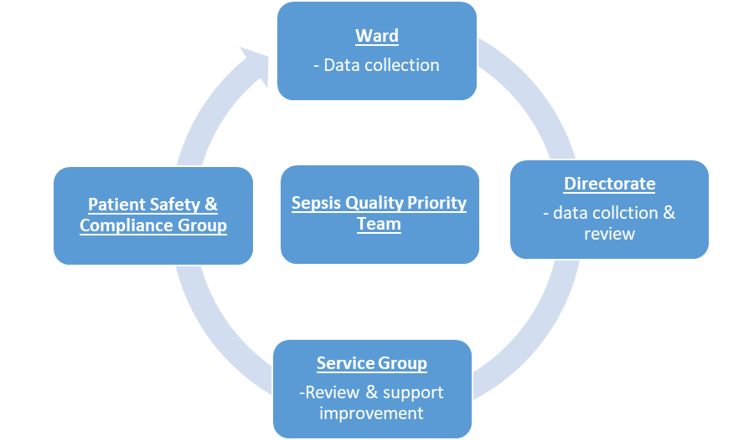

The health board’s governance structures in respect of quality and safety were updated during 2022, with a number of groups being replaced. The reporting framework for sepsis includes:

- Quality Management Board
- Quality and Safety Group
- Patient Safety and Compliance Group.
- RADAR & Quality Priorities Programme Board
- Sepsis Steering Group.

- Future Direction
The roadmap below sets out the key priorities to achieve ‘business as usual’ for sepsis by December 2024:

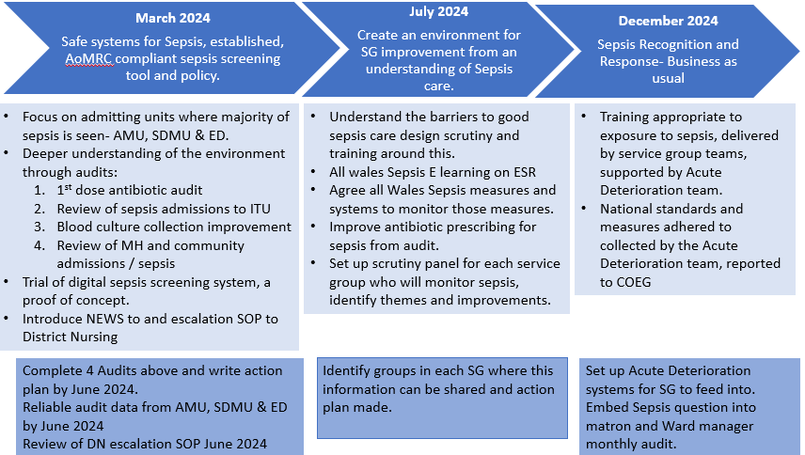

Key activities to support this work over the coming months include:
- Digitising the Sepsis Screening Tool in Signal in preparation for e-Obs.
- Sample volume for improving sensitivity for Blood Culture samples.
- Aim to create a central database of sepsis training.
- Improve 1st dose antibiotic prescribing compliance in SBUHB
- Development of an acute deterioration dashboard through AMaT, HEPMA (Hospital Electronic Prescribing and Medicines Administration) and Signal to inform staff of areas of risk and monitor performance. This is being taken forward by the Sepsis Steering Group and Business Intelligence Team April 2024

- Risks to Delivery
The following risks have been identified within the above forums:

- Engagement of Service Groups in Sepsis Audit remains a key risk to the delivery of the Sepsis Quality Priority as we are unable to measure improvement. It is hoped that sepsis audit will be prioritised when the AMaT goes online for nursing use across the HB.
- There is still a lot of reorganising and restructuring happening within SBUHB and staff are moving to different areas. Ensuring that the training levels are maintained at all times so that there are staff aware of sepsis and its management will be challenging. When the process moves to the ‘Matron’s Audit’ the data will be held by the speciality as not the ward, so it will move with the services should they move geographic location.
- Capacity across the central and service group teams in the context of competing demands, including clinical commitments. The mitigation to this is service group engagement and ownership and moving to digital solutions where possible.

- FINANCIAL IMPLICATIONS
Currently this is the position but it is under review. The Sepsis quality priority is supported through £67,000 investment from the quality priorities, which is funding:
- 1 clinical session to promote Sepsis;
- Investment into the Resuscitation Team to part fund 1 x WTE (whole time equivalent) 8b Resuscitation Team leader and Sepsis lead plus 1 x WTE 7 Resuscitation Officer.

Previous investment into 1 x clinical session to support the RADAR group across the health board has been allocated to a clinical Quality Priority lead role, following the retirement of the previous post holder.

- RECOMMENDATION
Members are asked to:
- NOTE the progress to date against the 2023-24 GMOs;
- NOTE the road map and plans to deliver sepsis as ‘business as usual’ by December 2024;
- NOTE the risks to delivery and the mitigating actions;
- NOTE the development of an acute deterioration dashboard in April 2024 which will provide real-time data to service groups to inform services of areas of risk and monitor performance;
- RECEIVE a further update in September 2024

References
Bion JBG, Boyle A, Carrol E, et al. Academy of Medical Royal Colleges statement on the initial antimicrobial treatment of sepsis. 2022. https://www.aomrc.org.uk/reports-guidance/statement-on-the-initial-antimicrobial-treatment-of-sepsis/

Governance and Assurance

Link to Enabling Objectives  (please choose) | Supporting better health and wellbeing by actively promoting and empowering people to live well in resilient communities
Link to Enabling Objectives  (please choose) | Partnerships for Improving Health and Wellbeing |  | ☒
Link to Enabling Objectives  (please choose) | Co-Production and Health Literacy |  | ☒
Link to Enabling Objectives  (please choose) | Digitally Enabled Health and Wellbeing |  | ☒
Link to Enabling Objectives  (please choose) | Deliver better care through excellent health and care services achieving the outcomes that matter most to people
Link to Enabling Objectives  (please choose) | Best Value Outcomes and High Quality Care |  | ☒
Link to Enabling Objectives  (please choose) | Partnerships for Care |  | ☒
Link to Enabling Objectives  (please choose) | Excellent Staff |  | ☒
Link to Enabling Objectives  (please choose) | Digitally Enabled Care |  | ☒
Link to Enabling Objectives  (please choose) | Outstanding Research, Innovation, Education and Learning |  | ☐
Health and Care Standards
(please choose) | Staying Healthy |  | ☐
(please choose) | Safe Care |  | ☒
(please choose) | Effective Care |  | ☒
(please choose) | Dignified Care |  | ☒
(please choose) | Timely Care |  | ☒
(please choose) | Individual Care |  | ☒
(please choose) | Staff and Resources |  | ☒
Quality, Safety and Patient Experience
Sepsis Quality Priority reports to the Quality Priorities Programme Board, which reports to Quality & Safety Group, RADAR Committee and Sepsis Steering Group, which reports to Quality, Safety and Patient Services Group. The overall aim is to reduce harm from sepsis through timely review and treatment and provide a better patient experience.
Financial Implications
No financial implications noted in this report.
Legal Implications (including equality and diversity assessment)
Risk of Duty of Candour and clinical negligence claims from failure to identify and respond to sepsis
Staffing Implications
Sepsis medical and nursing leads have been identified for each service group (SG) and training is delivered by sepsis team and SG clinical educators and champions across all SG areas, bespoke team training and induction training. The SRO (senior responsible office) and project lead have dual roles with clinical commitment and service lead responsibilities.
Long Term Implications (including the impact of the Well-being of Future Generations (Wales) Act 2015)
The focus of the Sepsis quality priority work is earlier identification and treatment of sepsis. This will improve impact of sepsis for the individual and their loved ones. This has a positive impact on the well-being of patients and families.
The Quality Improvement programme ensures integration with partner agencies such as other Health Boards and care homes. There is collaboration with both partner agencies and Improvement Cymru to progress QI work streams.
Report History |  | Regular report to the committee
Appendix |  | Appendix 1 – terms of reference for Sepsis Delivery Group, Sepsis Task and Finish Group and Sepsis Steering Group;  Appendix 2 – Sepsis champions and educators;  Appendix 3 – Paediatric sepsis report;  Appendix 4 – Deep dive for primary and community services

