Appendix 1.
Meeting Date | 30 April 2024 |  | Agenda Item |  |  | 3.2
Report Title | Infection Prevention and Control
Report Author | Nicola Lewis, Interim Matron, Infection Prevention & Control
Report Sponsor | Lesley Jenkins, Acting Deputy Executive Director of Nursing
Presented by | Joanne Walters, Deputy Head of Nursing, Infection Prevention & Control
Freedom of Information | Open
Purpose of the Report | This is an assurance report that provides an update on prevalence, progress and actions for healthcare associated infections (HCAIs) within Swansea Bay University Health Board for the reporting period to the end of March 2024.
Key Issues | - The Health Board exceeded the maximum annual number of cases of C. difficile infection, Staphylococcus aureus, Escherichia coli, and Klebsiella spp. bacteraemias required to achieve the Welsh Government infection reduction goals.  - Welsh Government has escalated the health board to Targeted Interventions for HCAI.  - There have been no further cases associated to the Health Board with cluster code WGS22-00159_737. The last confirmed case of the outbreak strain was identified on 26th January 2024 and the outbreak was declared closed at the last Gold Outbreak Control Group meeting on 22nd April 2024.  - A Round Table discussion event was held on 8th February with experts from Public Health Wales to focus on the worsening C. difficile position. A paper was later presented to Management Board on 6th March and included the outcomes of this discussion, the overall HCAI position and the proposed Infection Prevention Improvement Plan for 2024/25.  - A C. difficile strain (ribotype RT955), which had been associated in hospital outbreaks in England, was identified in a case in Morriston in early March. Contact screening was undertaken. No further cases were identified.  - Compliance in completing the mandatory Infection Prevention & Control (IPC) Level 2 training compliance has increased to 68.13%.  - The Health Board continues to face significant challenges relating to healthcare associated infection risks, which are recorded in the Health Board’s Risk Register.
Specific Action Required (please choose one only) | Information | Discussion |  | Assurance | Approval
Specific Action Required (please choose one only) | ☐ | ☐ |  | ☒ | ☐
Recommendations | The Infection Prevention & Control Strategic Group is asked to:  - NOTE: the health board’s end of year position in relation Healthcare Associated Infections.  - NOTE: the escalation of the health board to Targeted Intervention for performance in relation to HCAIs. Progress will be reported and monitored weekly by the Overarching Targeted Intervention Group, chaired by the Chief Operating Officer.  - NOTE: progress on Infection Prevention & Control Improvement Plan to 31st March 2024, and the core themes for the 2024/25 Infection Prevention Improvement Plan.  - NOTE: that there have been no new cases of the hospital-wide outbreak strain of C. difficile (WGS22-00159_737) since 26th January 2024 and the outbreak has been declared closed, and that there had been no hospital transmission of the C. difficile Ribotype of concern (RT955) since its introduction to the health board.  - NOTE: the improvement in IPC Level 2 training from 32.74 compliance reported at 5th January 2024 to 68.13 compliance reported at 4th April.  - NOTE: the challenges and risks within the health board currently and associated mitigations.

INFECTION PREVENTION AND CONTROL

- INTRODUCTION
This report provides an overview of progress against Welsh Government reduction targets, and actions to reduce healthcare-associated infections (HCAIs) within SBUHB for the period 1st April 2023 – 31st March 2024, specifically in relation to the following HCAIs:
- Clostridioides difficile infection
- Staphylococcus aureus bacteraemia
- Gram negative bacteraemia (Escherichia coli, Klebsiella spp., Pseudomonas aeruginosa)

An update in relation to COVID-19 to 31st March 2024 is provided also.

The report provides a summary of the activities carried out across the Health Board in relation to the prevention, control and management of infection. It also aims to identify key risks, and makes recommendations to address areas requiring action or improvement.

- PROGRESS TO TIER 1 INFECTIONS
2.1 Healthcare Associated Infections (HCAIs): 1st April 2023 – 31st March 2024
A summary position for the Health Board is shown in Table 1, identifying the cumulative position and the infection reduction trajectory to 31st March 2024, and the average monthly goal.

Table 1: Health Board Summary Cumulative Position to end of March 2024
Infection | Cumulative Cases to end of March 2024 | Improvement Goal trajectory to end of March 2024 | Actual number of cases versus reduction goal
C. difficile (CDI) | 250 | 95 | 155
Staph. aureus bacteraemia (SABSI) | 142 | 71 | 71
E. coli bacteraemia (EcBSi) | 258 | 234 | 24
Klebsiella spp. bacteraemia  (Kl BSI) | 94 | 71 | 23
Ps. aeruginosa bacteraemia (PAERBSI) | 21 | 24 | 3

A summary position for Service Groups is shown in Table 2. This identifies the cumulative number of cases up to the end of March 2024 with the annual increase or reduction shown in brackets.

Table 2: Service Group Annual Comparison to 31st March 2024
 | CDI | SABSI | EcBSI | KlBSI | PAERBSI
SBUHB - Total | 250 (24% ) | 141 (5% ) | 258 (1% ) | 94 (12% ) | 21 (52% )
PCTSG - CAI | 80 (27% ) | 63 (3% ) | 125 (8% ) | 47 (9% ) | 4 (67% )
PCTSG - HAI | 3 (1 case ) | 0 (equal to) | 2 (2 cases ) | 1 (1 case ) | 0 (equal to)
MH&LD – HAI | 1 (1 case ) | 0 (equal to) | 0 (1 case ) | 0 (equal to) | 0 (equal to)
MORR – HAI | 131 (22% ) | 44 (40% ) | 81 (1% ) | 34 (24% ) | 10 (58% )
NPTH - HAI | 6 (equal to) | 4 (equal to) | 8 (4 cases ) | 3 (1 cases ) | 0 (1 case )
SH - HAI | 23 (4% ) | 28 (56% ) | 30 (9% ) | 8 (43% ) | 5 (29% )
Other HB Cases Identified in SBUHB | 6 (N/A) | 3 (N/A) | 12 (N/A) | 1 (N/A) | 2 (N/A)

Charts showing the position of the Health Board and Service Group progress against the infection improvement trajectories, up to 31st March 2024, are detailed in Appendix 1.

Appendix 2 provides a comparison with other acute hospitals in Wales in relation to incidence of these infections per 100,000 population and per 1,000 admissions.

An overview of wards which have had more than 100 days between HCAI cases is included in Appendix 3.

- Clostridioides difficile
The number of cases of C. difficile exceeded the annual maximum number of cases to achieve the infection reduction goal. During 2023/24 there has been a 24% increase in C. difficile cases compared with the same period in 2022/23. All Service Groups with the exception of Singleton had an increase in case numbers compared to the previous year.

Of the 250 cases, 66% were categorised as hospital-acquired infections (HAI) and the remainder as community acquired infections. Six community acquired infections occurred in patients who reside outside this Health Board’s boundaries, but who were tested and found to be positive on admission to our services. 80% of hospital-acquired cases occurred at Morriston Hospital.

The Health Board currently has the highest incidence of C. difficile infection when compared to other Welsh Health Boards (65.2/100,000 population). This is significantly higher than the Wales average of 38.89/100,000 population. Whole genome sequencing results indicate that transmission events are increasing and are particularly associated to the Morriston Hospital Service Group. This trend correlates with the reconfiguration of acute medical services to Morriston Hospital (second phase concluded 5th February 2024).
A Round Table Discussion event was held on 8th February, including experts from the Public Health Wales Healthcare Associated Infection and Antimicrobial Resistance Programme (HARP) and the UK Anaerobic Reference Unit (who undertake the genome sequencing), as well as representatives from IPC, Microbiology and Morriston Service Group. Discussions were helpful, and there was strong challenge also, with an emphasis on the need for the health board to address the current worrying C. difficile case numbers.

- Staph. aureus bacteraemia

The number of cases of Staph. aureus bacteraemia exceeded the infection reduction goal for 2023/24 (there had been a 3% annual reduction in cases). 53% of Staph. aureus bacteraemia cases between April 2023 and March 2024 were categorised as hospital-acquired infections.

Morrison Hospital Service Group achieved a 40% reduction in Staph. aureus bacteraemias over the last year. Singleton Hospital had seen a 56% increase in cases. 28% of all hospital-acquired Staph. aureus infections were considered to be line-associated, whilst the largest proportion of community-acquired cases were attributed to skin and soft tissue infections (32%). Following review of HCAI cases in Singleton Hospital, 37% were considered to be line-related however, many of these patients have vascular access devices which are managed by both primary and secondary care. A collaborative approach between the Service Groups is required to undertake the necessary improvements in relation to providing care of vascular access devices in the community setting. The Deputy Head of Nursing for Primary Care is attending the acute hospital HCAI review meetings to understand the contributory factors and areas for improvement that are being identified through the secondary care HCAI case reviews.

Improvement programmes within the acute sites have continued to focus on reducing line-associated Staph. aureus bacteraemias by utilising device prevalence audits to promote the prompt removal of unnecessary devices, and education to improve care bundle compliance and reduce the number of devices inserted. Whilst admitted to hospital, patients will routinely receive chlorhexidine gluconate skin wash cloths to support infection risk reduction through skin decolonisation.

- Gram negative bacteraemia (E. coli, Klebsiella spp., Pseudomonas aeruginosa),
The number of cases of E. coli bacteraemia exceeded the infection reduction goal for 2023/24 (there had been a 1% annual reduction in cases). There were 258 cases of bacteraemia reported in the health board between April 2023 and the end of March 2024, 53% of which were community-acquired infections. The urinary tract is the more frequent source of infection for both community-acquired and hospital-acquired cases, accounting for 60% and 40% of cases respectively. Hepatobiliary disease is the second most common source for bacteraemia accounting for 14% of all E. coli cases with community- and hospital-acquired cases accounting for 13% and 14% respectively. 20% of bacteraemia cases are currently recorded as having an unknown primary source. There are reviews taking place in secondary care; the process for reviewing community acquired cases has not yet been established.

The number of cases of Klebsiella spp. bacteraemia exceeded the infection reduction goal. However, there had been an annual 12% reduction in the number of cases compared with 2022/23.

Of the annual total of 94 cases, 51% were community-acquired cases. For both community-acquired and hospital-acquired cases, the most frequent source of infection was urinary, with 18% and 21% of cases respectively. The second most common source was hepatobiliary disease, accounting for 10% and 14% of community-acquired and hospital-acquired cases respectively.

The health board achieved the 2023/24 reduction target for Pseudomonas aeruginosa bacteraemia with a 52% reduction in the number of cases compared with the financial year 2022/23.

2.2 Welsh Government Escalation Framework: Targeted Intervention – HCAI
Due to the lack of progress in HCAI reduction, Welsh Government has escalated the health board to Targeted Intervention for its performance against reducing the key Tier 1 healthcare associated infections. De-escalation criteria have been set and require the health board to maintain the criteria for 3 months before de-escalation would be considered by Welsh Government. The de-escalation criteria for HCAI improvements are:
- C. difficile: reduce the number of hospital onset infections by 40% and maintain for 3 months (from a baseline of the average number of cases in quarter 3 of 10 cases to no more than 6 per month).
- Staph aureus: reduce the number of hospital onset infections by 25% and maintain for 3 months (from a baseline of the average number of cases in quarter 3 of 4 cases to no more than 3 per month).
- E. coli: reduce the number of hospital onset infections by 20% and maintain for 3 months (from a baseline of the average number of cases in quarter 3 of 5 cases to no more than 4 per month).
- Klebsiella: reduce the number of hospital onset infections by 10% and maintain for 3 months based on 2017/18 figures (baseline – 54 cases in 2017/18, reduce to average of at most 4 per month).

A targeted intervention action plan will be developed and progress will be overseen and reported weekly to the Overarching Targeted Intervention Group, chaired by the Chief Operating Officer.
- Infection Prevention & Control Improvement Plan
  - Overarching 2023/24 Infection Prevention Improvement Plan
The 2023/24 Infection Prevention Improvement Plan, with progress updated to 31st March 2024, has been attached as Appendix 4. A summary of progress is provided below:
- An antimicrobial audit tool has been developed in the AMaT system. This has been publicised via the Antimicrobial Stewardship Group, and the induction sessions and direct communications. To date, there has only been limited uptake of the pilot tool (less than 5 doctors). A more focused audit tool for hospital acquired pneumonia (HAP) is being promoted via the priority audit programme / audit leads to see if this approach will improve uptake. Service Groups are being encouraged to recommend use of the antimicrobial audit tool in areas with high infection rates to get better reassurance of action around antibiotic prescribing in that area. Morriston has included this in their improvement plan.
- IPC audits will be piloted on the AMaT system in April, prior to further roll-out to clinical teams. A number of wards have piloted the manual tool also in preparation for when AMaT is fully functional for IPC audits. The nursing lead for AMaT has indicated that training on the IPC audits in AMaT will commence in August 2024. In the interim period, the IPC team have continued to undertake proactive audits, using Microsoft Excel versions of the tools and providing recommendations to make required improvements; these actions are progressed and monitored through the service group speciality matrons.
- IPC training compliance for Level 1, Level 2 and ANTT has improved in quarter 4 compared to quarter 3. Full details of training compliance are available in Section 5 of this report.

  - Overarching 2024/25 Infection Prevention Improvement Plan
The infection prevention improvement plan for 2024/25 was presented to Management Board on 6th March 2024. The plan focuses on core themes to reduce episodes of harm caused by healthcare associated infections (HCAI).
The core themes include:
1. Improving the Culture
2. Leadership
3. Clean & Safe Healthcare Environment
4. Antimicrobial Stewardship
Service Groups were asked to review their challenges relating to HCAI and develop Service Group specific improvement plans, to be submitted to the health board’s Infection Prevention & Control Group on 30th April 2024. These plans are to be monitored locally, with progress reported to the strategic Infection Prevention and Control Group, with updates on progress included in Service Group reports to Management Board and Quality & Safety Committee.
- Outbreaks and clusters, untoward incidents, Periods of Increased Incidence (PIIs), and ward/bay closures from diarrhoea and vomiting
  - Acute Respiratory Infection outbreaks (including COVID-19 (SARS-CoV-2))
The Health Board continues to manage clusters and outbreaks of infection associated with Influenza and COVID-19, although these have not resulted in large numbers of bed closures or disruption to services. The Service Groups hold regular internal incident management meetings, supported by the Infection Prevention & Control Team (IPCT).
  - Clostridioides difficile Period of Increased Incidence (PII) and genomically linked outbreaks:
There have been no further cases associated to the Health Board with cluster code WGS22-00159_737. This hospital wide outbreak was first identified in December 2023, with a total of 14 patients identified to have the outbreak strain and involving 23 wards on the Morriston site. Whilst additional cases have been identified across Wales, there are no links to Swansea Bay established. The last confirmed case of the outbreak strain was identified on 26th January 2024 and the outbreak was declared closed at the last Gold Outbreak Control Group meeting on 22nd April 2024.
The situation continues to be managed by Morriston operational Outbreak Control Group (Chaired by Service Group Nurse Director) and a Gold Outbreak Control Group, chaired by the Executive Medical Director, with alternate weekly meetings taking place. Following submission of a paper to Management Board on 17th April 2024, funding was approved to undertake a programme of ward refurbishment and hydrogen peroxide vapour (HPV) disinfection across 25 wards. Also, Task & Finish groups are being established to progress necessary actions across the health board to improve healthcare waste management in wards, the management and storage of hospital mattresses, and the development of a digital solution to monitor patient flow and a process to minimise unnecessary, non-clinical patient ward moves.
During January to March 2024, 11 C. difficile periods of increased incidence were reported via Datix (9 in Morriston, 2 in Singleton). The majority of these incidents have returned Whole Genomic Sequencing (WGS) which indicate that the cases were not linked. However, the genomic results have identified retrospectively a number of transmission events in Morriston Hospital, as shown in Table 3 below.
Table 3: C. difficile transmission events to 31st March 2024
Ward/Department | Whole Genome Sequence Cluster Code | Number of patients affected
Ward R, Morriston | WG23-00711_2194 | 2
Cardigan Ward, Morriston | WG22-00856_1840 | 2
Ward S, Morriston | WG19-00352_1561 | 3
Ward S, Morriston | WG21-00007 2329 | 3
Ward E, Morriston | WG24-00103 2344 | 2
Gower Ward, Morriston | WG23-00127_2236 | 2
Ward L, Morriston | WG24-00107_2346 | 2
  - Other significant infection incidents/outbreaks

C. difficile Ribotype of Concern (RT955)

In early March, the UK Anaerobic Reference Unit identified a patient with a C. difficile ribotype of concern. This patient was in Morriston Hospital. The strain is known to be highly transmissible, is associated with increased severity of symptoms, poor patient outcomes, and has been linked to a number of outbreaks in hospitals in NHS England.

An incident management team was convened, and included specialists from Public Health Wales, the UK Anaerobic Reference Unit, Medical Microbiology and the Infection Prevention and Control team. Due to the transmissibility and hyper-virulence of the strain, the wards in which the patient had received care prior to her C. difficile diagnosis, were closed to admissions. Contacts of the colonised patient were identified and an asymptomatic contact screening programme was commenced. To date, no further cases have been identified, providing assurance of the routine control measures that had been put in place.

During the incident management, it was identified that the patient with RT955 had previously spent extended periods of time in a hospital in England that had been associated with outbreaks of the RT955 strain. It is considered probable that the patient became colonised with the strain during the previous admissions in the English hospital.

Following confirmation that all in-patient contacts had screened negative, the affected wards were decanted to allow remedial estates work to be completed prior to HPV disinfection. The disinfection programme is due to commence by the end of April and will include all of the wards associated to the hospital-wide outbreak (WGS22-00159_737), and the genetically linked clusters referred to in 4.2 above.

Norovirus

During Quarter 4, there were a small number of Norovirus cases reported, only two of which resulted in minor outbreaks (one in Cefn Coed, one in Morriston). These were managed effectively, minimising the impact on the services involved.

Despite relatively small case numbers, the combination of Norovirus, COVID, Influenza A, and C. difficile continues to contribute to the already significant bed pressures, particularly on the Morriston site. Patients with these infections require single room isolation and the limited availability of single rooms continues to present a challenge to the appropriate management of patients with infections, as well as those with other conditions which require single rooms.

A summary of inpatient areas affected by clusters, outbreaks, incidents and Periods of Increased Incidence of infections is reported via an Outbreak and Incident Summary located on the IPC SharePoint “Daily update” page.

Carbapenemase Producing Enterobacterales (CPE)

In October, a patient on Ward T in Morriston hospital was found to have a carbapenemase producing strain of Klebsiella spp. Contact screening identified a second positive patient in early November. Contacts of both positive cases were screened, with no further cases detected. An outbreak control team was convened and mitigations to prevent spread were implemented including decanting and 4D cleaning of the environment. No further cases were identified and an outbreak report was produced and a closure meeting held on 4th January 2024.

- Education & Training
Training compliance
The IP&C Team, along with local training practice leads, continues to deliver IPC training and updates, alongside the online training, to both clinical and non-clinical staff employed by the health board.

Recording face-to-face IPC training for the health board has been updated by two members of IPC administration staff; temporary funding for one of those posts came to an end on 31st March 2024. Service Groups have identified staff who will update some of these training records in future.

The following tables identify the numbers of staff (with percentage compliance where available) that have undertaken IPC-related training.

Table 4: Level 1 – Infection Prevention and Control Training compliance to 4th April 2024
Staff Group  Infection Prevention and Control –  Level 1 – 3-yearly | % Compliance  to 4th April 2024 | Increase () or decrease () in compliance from previous quarterly report
Add Prof Scientific and Technic | 93.20% | (92.90%)
Additional Clinical Services | 91.10% | (89.56%)
Administrative and Clerical | 92.55% | (91.20%)
Allied Health Professionals | 95.07% | (94.92%)
Estates and Ancillary | 88.31% | (85.40%)
Healthcare Scientists | 90.19% | (89.66%)
Medical and Dental | 63.20% | (64.94%)
Nursing and Midwifery Registered | 92.81% | (92.27%)
OVERALL COMPLIANCE | 90.16% | (89.27%)

Table 5: Level 2 - Infection Prevention and Control Training compliance to 4th April 2024
Staff Group  NHS|CSTF| Infection Prevention and Control - Level 2 – Annual | % Compliance  to 4th April 2024 | Increase () or decrease () in compliance from previous report
Add Prof Scientific and Technic | 67.76% | (14.63%)
Additional Clinical Services | 72.33% | (39.24%)
Administrative and Clerical | 67.34% | (16.49%)
Allied Health Professionals | 81.90% | (54.90%)
Estates and Ancillary | 47.01% | (6.79%)
Healthcare Scientists | 68.17% | (28.91%)
Medical and Dental | 31.81% | (16.16%)
Nursing and Midwifery Registered | 75.63% | (45.19%)
OVERALL COMPLIANCE | 68.13% | (32.74%)

The data in Table 5 above is to 4th April 2024. IPC Level 2 training became mandatory for all Swansea Bay University Health Board staff as of 1st January 2024. The Level 2 Training now appears as a mandatory requirement on the learning Compliance and Competency dashboard for each member of staff, making accessing the correct course easier. This is shown in the compliance percentages in the above table. All staff groups have shown a significant improvement in compliance, since the training became mandatory.

Table 6: Hand Hygiene competence training
Service Groups | Number of staff completed Hand Hygiene Training
Morriston | 911
NPT & Singleton | 748
Primary Care & Community | 301
Mental Health & Learning Disabilities | 303
Support Services | 41
Corporate | 18
GRAND TOTAL | 2322

Table 6 details the number of staff within each Service Group who have received Hand Hygiene Training between 1st April 2023 and 31st March 2024. This information is provided directly from Infection Prevention & Control manual records, not via ESR.

NPT & Singleton Service Group have started recording their own training records onto ESR; therefore the data will not detail all records for NPT & Singleton Service Group.

Table 7: Aseptic non-touch Technique (ANTT)
Staff Group  Aseptic Non Touch Technique  Assessment - 3 Yearly e-Learning - once only | % Compliance to  5th April 2024 |  | Increase () or decrease () in compliance compared to previous report
 | e-Learning  (3 yearly) | e-Learning  (once only) | e-Learning  (3 yearly) | e-Learning  (once only)
Add Prof Scientific and Technic | 1.97% | 5.70% | (3.10%) | (2.00%)
Additional Clinical Services | 14.56% | 31.58% | (14.92%) | (18.76%)
Allied Health Professionals | 10.24% | 20.47% | (9.42%) | (10.55%)
Healthcare Scientists | 5.31% | 12.47% | (4.24%) | (10.08%)
Medical & Dental | 3.33% | 7.80% | (4.01%) | (5.07%)
Nursing & Midwifery Registered | 33.28% | 52.95% | (32.62%) | (29.09%)
OVERALL COMPLIANCE | 15.13% | 26.65% | (14.96%) | (14.80%)
COMBINED COMPLIANCE | 41.78% |  | 29.76%

ESR has an ANTT Practical Competency Assessment 3-yearly certificate available alongside the e-learning certificate, notifications are available to remind individuals when they need to be re-assessed. Support is being offered to upload any backlog of competency assessments. Training reports from ESR uses all health board staff as the denominator for compliance. Not all health board staff are required to undertake ANTT e-learning or competency assessment, therefore the compliance percentage is not a true representation of compliance. The IPCT continues to hold ANTT Competency Assessor training records received from each Service Group.

Over the past 12-months, a task and finish group has met regularly to identify actions to drive an improvement in ANTT e-learning and competence assessments. The IPCT will support specific areas whose device prevalence audits and ANTT training data in ESR indicate that improvements are required.

- Internal Audit Report
Infection Prevention & Control: Service Group Governance Arrangements
In March 2024, NHSWSSP Audit and Assurance Services undertook a follow up audit of the review of the 2023 internal audit of IPC: Service Group Governance Arrangements. The follow up audit looked at a sample of the closed actions in the Management Action Plan. The outcome of that follow up audit is awaited.

- Assurance
Reporting
- The Quality & Safety Group receives quarterly assurance reports relating to the Infection Prevention and Control within the Health Board. In addition, any issues for escalation would be taken to the Quality & Safety Group outside of the quarterly reporting schedule.
- The Quality & Safety Committee has asked for formal presentation of the report submitted to the Quality & Safety Group quarterly.
- The weekly performance tracker report showing performance against the Tier 1 infection reduction expectations are submitted to the Executive Team and Service Group Directors and is available on the IPC SharePoint site.
- Senior IP&C staff attend each Service Group Infection Control Committee. The IP&C Matrons and the Matron, Decontamination Operational Lead, together with Band 7 Infection Control Nurses, ensure support is provided to the Service Group Triumvirates.
- The IP&C team actively participates in healthcare associated infection review panels within Service Groups, liaising closely IP&C leads and clinical staff from each ward/department.
- The IP&C Matrons, along with other Corporate Nurses, participate in Quality & Safety assurance visits across the HB to review Safe & Effective Care provision.

Audit
IPC audits have continued. Table 8 shows the number of audits undertaken in each Service Group between April 2023 and March 2024.

Table 8: Summary of audits undertaken by the IPC Team
Service Group | Number of audits completed
Morriston Hospital | 174
Neath Port Talbot and Singleton Hospital | 161
Mental Health and Learning Disabilities | 8
Primary Care and Community Services | 1
Total Number of Audits Completed | 344

The IPCT provide immediate verbal feedback of findings, followed by an email containing the completed audit, recommendations and an action plan template. Audit findings are discussed at local governance meetings and Service Groups are able to monitor progress using the action plans created by the Ward Managers. The IPC team offer support and training to the clinical areas to assist in driving improvement.
The IPC audit tools are available in the AMaT system and members of the IPCT will be provided with training in early April to allow them to pilot the system. Once confirmation has been received that the system is working as intended and the correct individuals are receiving the audit feedback, further roll-out of training can commence.

- Infection-related Incidents and Risks in DATIX
Risk Register
At 15th April 2024, there were no new infection-related risks and 18 open and accepted infection-related risks on the Risk Register.

Table 9: Infection-related risks on the Risk Register added in quarter 4
Risk ID | Title | Date opened | Service Group | Risk Rating
3678 | Infection Control risk – one shower available for 18 patients with no single gender facility | 20/02/2024 | Morriston Hospital Service Group | 9

Risk 3574 has again been referred back to the Risk Handler, as it does not appear to be linked with an infection risk or risk of infection transmission. The risk relates to elective surgery patients who require intrathecal medication, who would not be able to be cared for on the ring-fenced elective surgery ward post-operatively due to a lack of staff training on monitoring these patients.

Table 10: Open and Accepted infection-related risks on the Risk Register
Infection-related risks on the Risk Register | Total
Executive Director of Nursing | 5
Mental Health and Learning Disabilities Delivery Unit | 1
Morriston Hospital Service Delivery Unit | 9
Singleton and Neath Port Talbot Service Delivery Unit | 3
Total | 18

Of the 18 open and accepted infection-related risks on the Risk Register, 8 had passed the review date. There has been email communication with all relevant Risk Handlers to request a review and update of overdue risks, the detail of which can be found in table 11, below;

Table 11: Overdue review of infection-related risks, by Service Group | Overdue Review | Risk Register ID
Mental Health and Learning Disabilities Delivery Unit | 1 | 2520
Morriston Hospital Service Delivery Unit | 6 | 535, 797, 1754, 2358, 3012, 3515
Neath Port Talbot & Singleton Hospitals Service Delivery Unit | 1 | 478

Infection-related incidents
At 15th April 2024, the RLDatix system identified the following infection-related incidents:
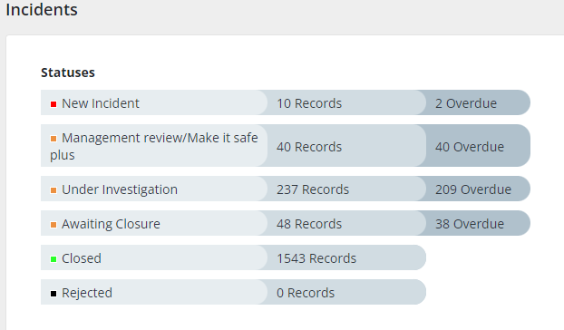
There has been a significant reduction in the number of infection-related incidents during Quarter 4, largely owing to the closure of incidents associated with COVID-19.

From the Datix Incidents graphic above, there are currently 40 overdue management reviews, 209 overdue incidents under investigation and 38 overdue incidents awaiting closure.

- CHALLENGES, RISKS AND MITIGATION
HCAI
- Lack of a dedicated decant facility (Datix Risk ID 2210). Morriston Hospital site has identified two wards which have been closed temporarily to allow for a pro-active and reactive programme of estates repairs and enhanced cleaning on wards associated to the hospital-wide outbreak of C. difficile. This action has been agreed by the Gold Outbreak Control Group, and supported by Management Board, as an essential action to reduce the spread of C. difficile.
- Increased risk to patients for acquisition of C. difficile infection (Datix Risk ID 2286).
- Service pressures across the acute sites preclude the ability to undertake a regular pro-active programme of 4D cleaning, and compromise the ability to undertake reactive 4D cleaning following episodes of infection such as C. difficile.
- The limited availability of single room isolation facilities continues to present a challenge to the appropriate management of patients with suspected or confirmed infections resulting in a risk of extended exposure of other patient contacts to the risk of transmissible infections, such as MRSA and other multi-drug resistant organisms. Additionally, due to the competing demands for single rooms, there can be a delay in isolating patients, while staff await confirmation of an infection prior to moving patients, adding to the exposure risk for other patients and an extended period where organisms continue to contaminate the environment – HBR 4 (Datix Risk ID – 739).
- The high numbers of clinically optimised patients awaiting packages of care has also put increased pressure on bed capacity in the acute sites. This has resulted in additional patients “boarding” on wards throughout Morriston, without additional staffing or equipment. This model also has an impact on further reducing bed spacing. These factors increase the risk of infection transmission due to non-compliance with bed spacing guidance (Datix Risk ID – 2488).
- Frequent patient movement was identified as a risk during the Morriston C. difficile outbreak and currently there is not a consistent system for recording the rationale for patient movement. Discussions are ongoing with Digital Intelligence to add this function to the Signal system with the aim of ensuring that every patient move has a documented rationale.
- Bed spacing and ventilation within the majority of inpatient wards poses an ongoing risk in relation to transmission of infections, including COVID-19 and other seasonal viral infections, including influenza, Respiratory Syncytial Virus, parainfluenza, and Norovirus (Datix Risk ID 2488).
- Across the health board (as is the case across NHS Wales) there are increasing numbers of those living with high-risk co-morbidities and risks for C. difficile.

- GOVERNANCE AND RISK ISSUES
Healthcare associated infections are associated with poor patient outcomes, and are significant quality and safety issues. Continuing failure to achieve the infection reduction improvements is an unacceptable position for our patients (HBR 4), and has resulted in an escalation from Enhanced Monitoring to Targeted Intervention.

- FINANCIAL IMPLICATIONS
A Department of Health impact assessment report (IA No. 5014, 20/12/2010) stated that the best estimate of costs to the NHS associated with a case of Clostridioides difficile infection is approximately £10,000. The estimated cost to the NHS of treating an individual cost of MRSA bacteraemia is £7,000 (the cost of MSSA bacteraemia could be less due to the availability of a wider choice of antibiotics). In an NHS Improvement indicative tool, the estimated cost of an E. coli bacteraemia is between £1,100 and £1,400, depending on whether the E. coli is antimicrobial resistant. Estimated costs related to healthcare associated infections, from 01 April 2023 to the end of March 2024 is as follows: C. difficile - £2,500,000; Staph. aureus bacteraemia - £994,000; E. coli bacteraemia - £299,400; therefore, a total cost of £3,793,400.

- RECOMMENDATION
The Infection Prevention & Control Strategic Group is asked to:
- NOTE: the health board’s end of year position in relation Healthcare Associated Infections.
- NOTE: the escalation of the health board to Targeted Intervention for performance in relation to HCAIs. Progress will be reported and monitored weekly by the Overarching Targeted Intervention Group, chaired by the Chief Operating Officer.
- NOTE: progress on Infection Prevention & Control Improvement Plan to 31st March 2024, and the core themes for the 2024/25 Infection Prevention Improvement Plan.
- NOTE: that there have been no new cases of the hospital-wide outbreak strain of C. difficile (WGS22-00159_737) since 26th January 2024 and the outbreak has been declared closed, and that there had been no hospital transmission of the C. difficile Ribotype of concern (RT955) since its introduction to the health board.
- NOTE: the improvement in IPC Level 2 training from 32.74 compliance reported at 5th January 2024 to 68.13 compliance reported at 4th April.
- NOTE: the challenges and risks within the health board currently and associated mitigations.

Governance and Assurance

Link to Enabling Objectives  (please choose) | Supporting better health and wellbeing by actively promoting and empowering people to live well in resilient communities
Link to Enabling Objectives  (please choose) | Partnerships for Improving Health and Wellbeing |  | ☐
Link to Enabling Objectives  (please choose) | Co-Production and Health Literacy |  | ☐
Link to Enabling Objectives  (please choose) | Digitally Enabled Health and Wellbeing |  | ☐
Link to Enabling Objectives  (please choose) | Deliver better care through excellent health and care services achieving the outcomes that matter most to people
Link to Enabling Objectives  (please choose) | Best Value Outcomes and High Quality Care |  | ☒
Link to Enabling Objectives  (please choose) | Partnerships for Care |  | ☐
Link to Enabling Objectives  (please choose) | Excellent Staff |  | ☐
Link to Enabling Objectives  (please choose) | Digitally Enabled Care |  | ☐
Link to Enabling Objectives  (please choose) | Outstanding Research, Innovation, Education and Learning |  | ☐
Health and Care Standards
(please choose) | Staying Healthy |  | ☐
(please choose) | Safe Care |  | ☒
(please choose) | Effective Care |  | ☐
(please choose) | Dignified Care |  | ☐
(please choose) | Timely Care |  | ☐
(please choose) | Individual Care |  | ☐
(please choose) | Staff and Resources |  | ☐
Quality, Safety and Patient Experience
Effective infection prevention and control needs to be everybody’s business and must be part of everyday healthcare practice and be based on the best available evidence so that people are protected from preventable healthcare associated infections.
Financial Implications
A Department of Health impact assessment report (IA No. 5014, 20/12/2010) stated that the best estimate of costs to the NHS associated with a case of Clostridioides difficile infection is approximately £10,000. The estimated cost to the NHS of treating an individual cost of MRSA bacteraemia is £7,000 (the cost of MSSA bacteraemia could be less due to the availability of a wider choice of antibiotics). In an NHS Improvement indicative tool, the estimated cost of an E. coli bacteraemia is between £1,100 and £1,400, depending on whether the E. coli is antimicrobial resistant. (Trust and CCG level impact of E.coli BSIs accessed online at:
https://improvement.nhs.uk/resources/preventing-gram-negative-bloodstream-infections/ ).
Estimated costs related to healthcare associated infections, from 01 April 2023 to the end of March 2024 is as follows: C. difficile - £2,500,000; Staph. aureus bacteraemia - £980,000; E. coli bacteraemia - £299,400; therefore, a total cost of £3,779,400.
Legal Implications (including equality and diversity assessment)
Potential litigation in relation to avoidable healthcare associated infection.
Staffing Implications
None identified.
Long Term Implications (including the impact of the Well-being of Future Generations (Wales) Act 2015)
A healthier Wales: preventing infections
Report History |  | Previous meeting 31st January 2024
Appendices |  | Appendix 1: Health Board & Service Group progress against the Tier 1 Infection reduction goals.  Appendix 2: All Wales comparisons - Incidence of Tier 1 infections to 31/03/2024.  Appendix 3: Wards achieving more than 100 days since last case of ward-attributed HCAI  Appendix 4: Infection Prevention Improvement Plan 2023_24 v2 Q4 update 08.04.2024.

C. difficile
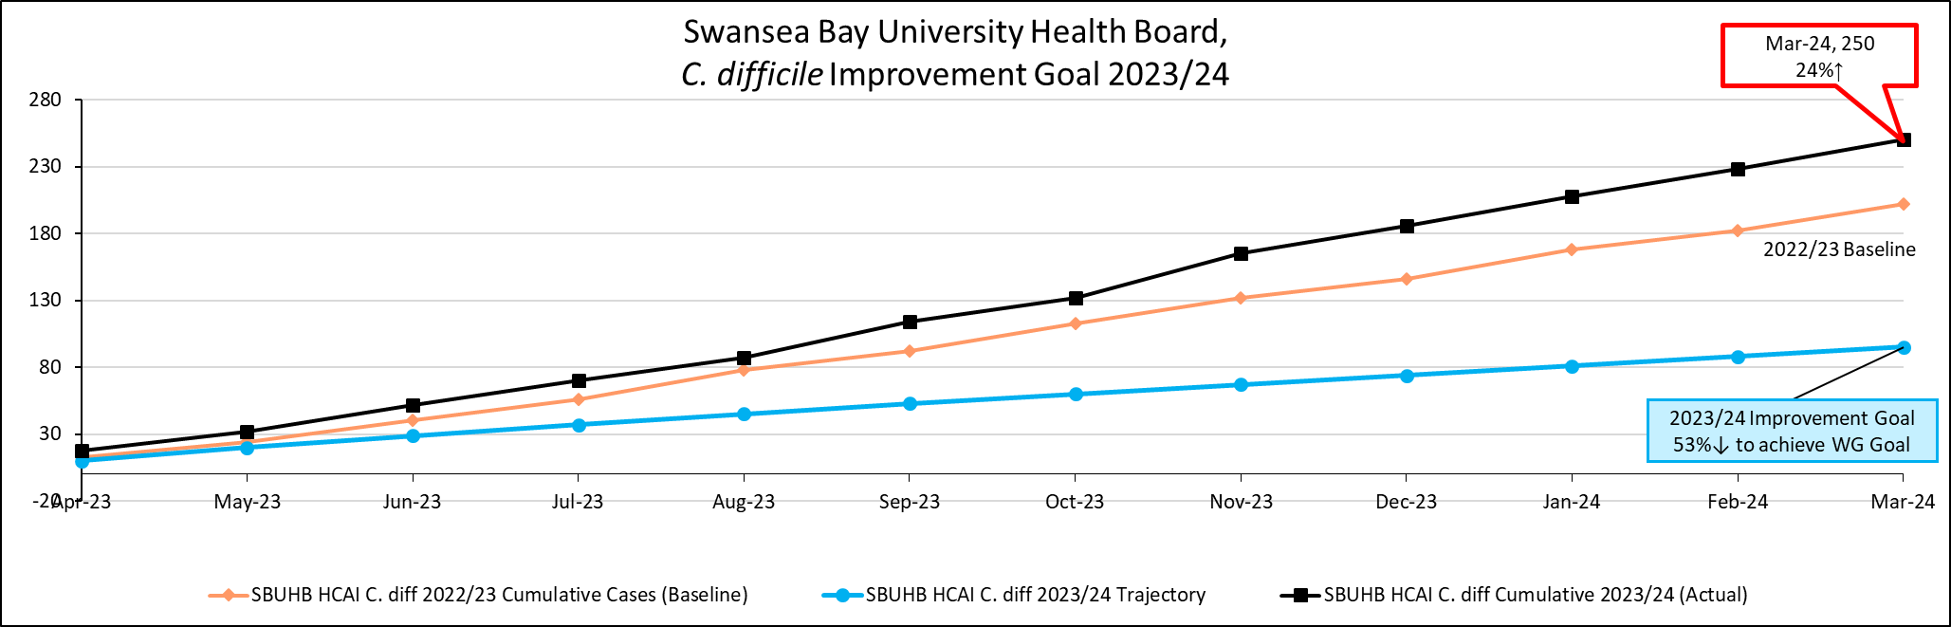
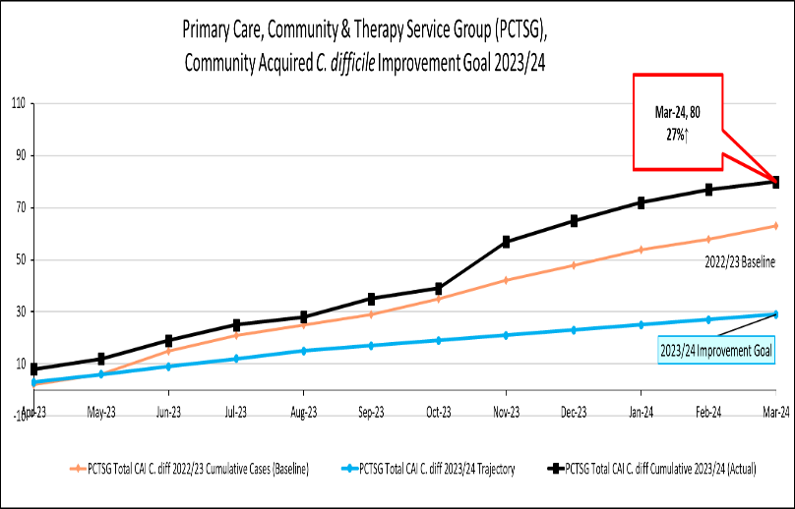 | 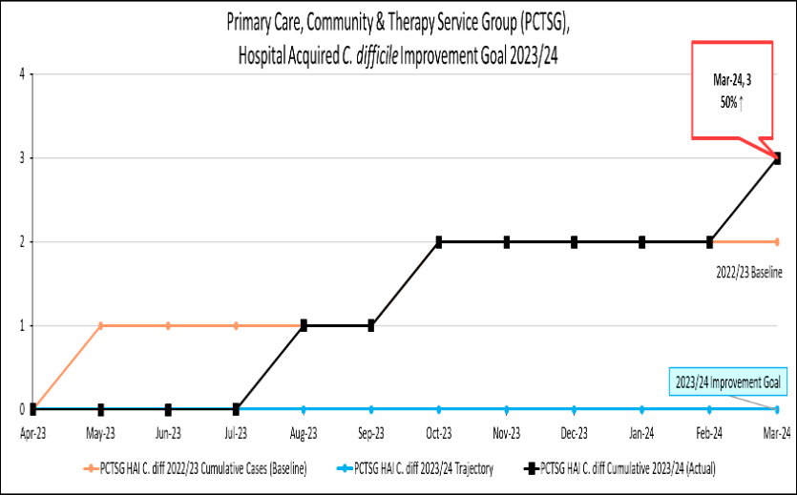
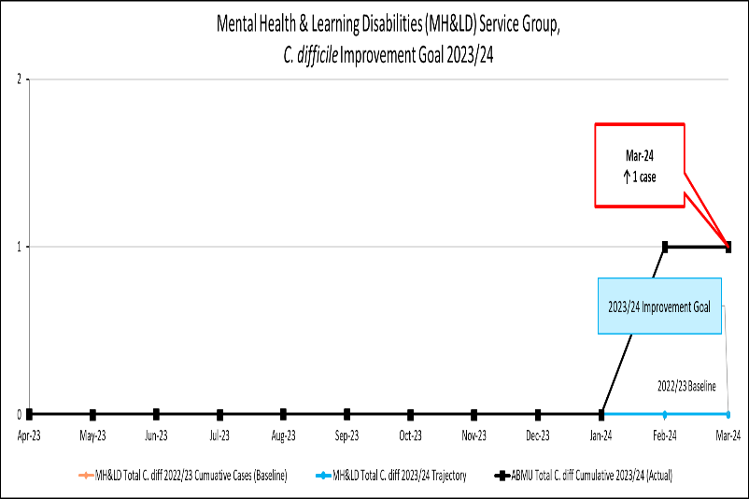 | 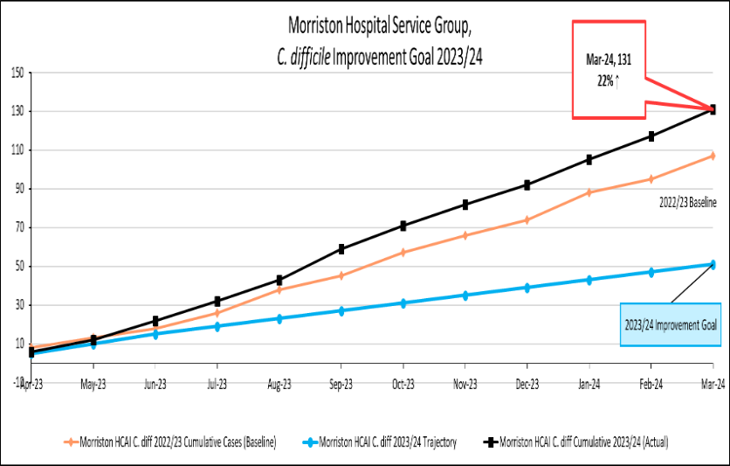
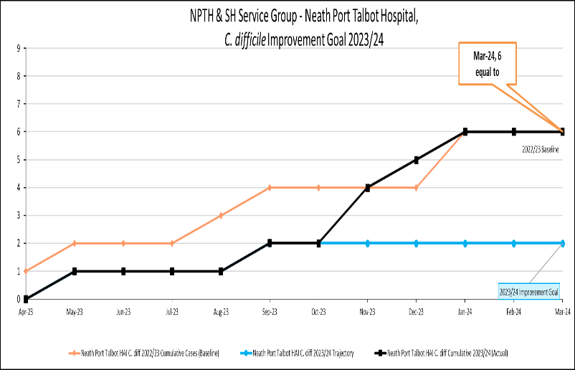 | 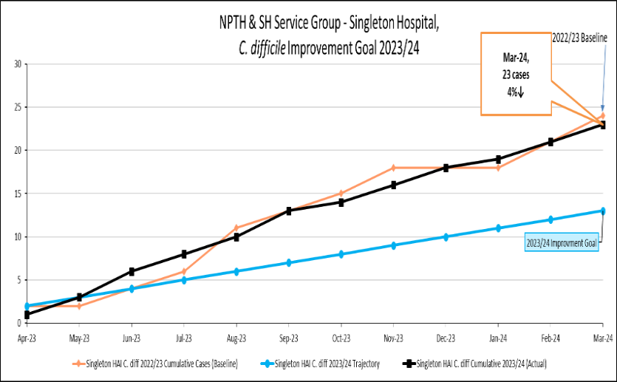

Staph. aureus bacteraemia
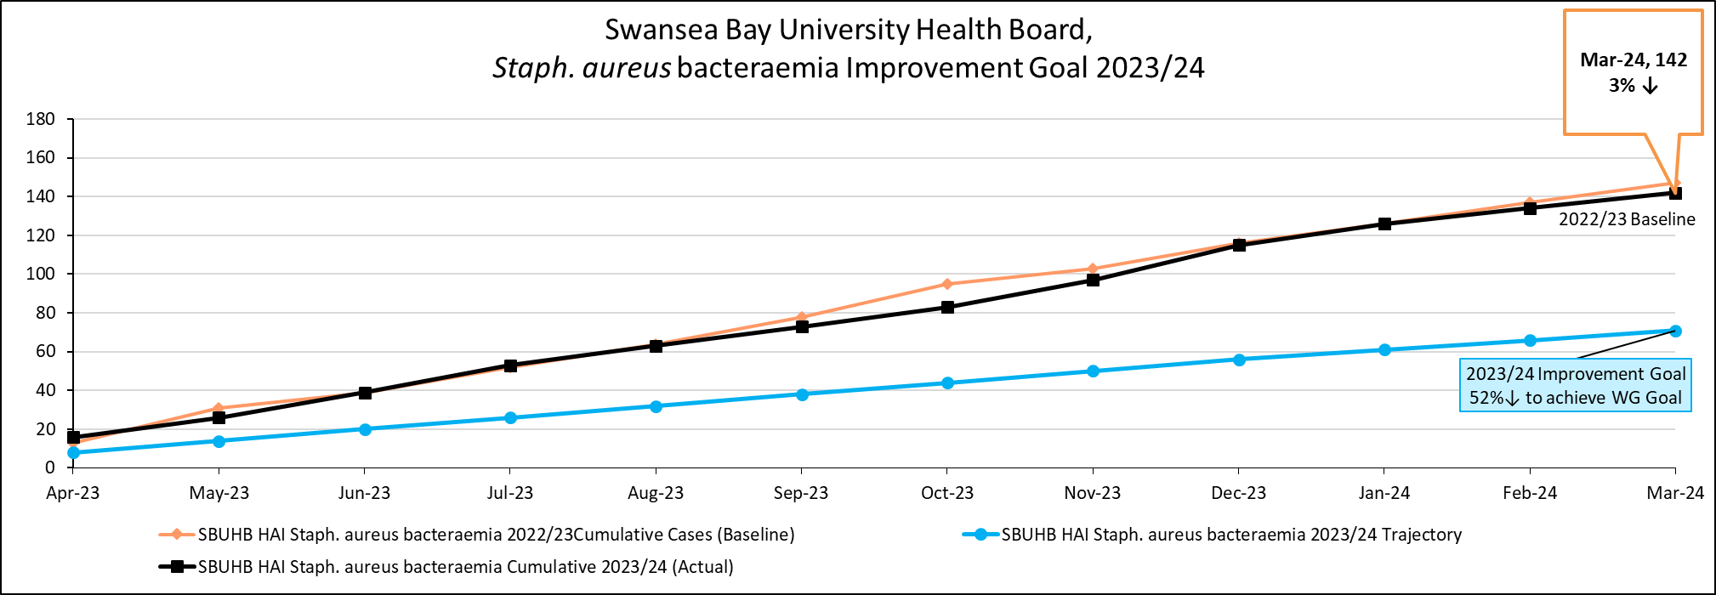
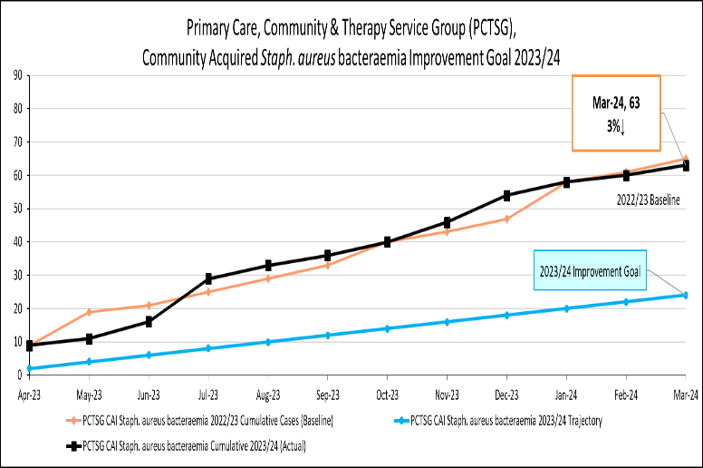 | 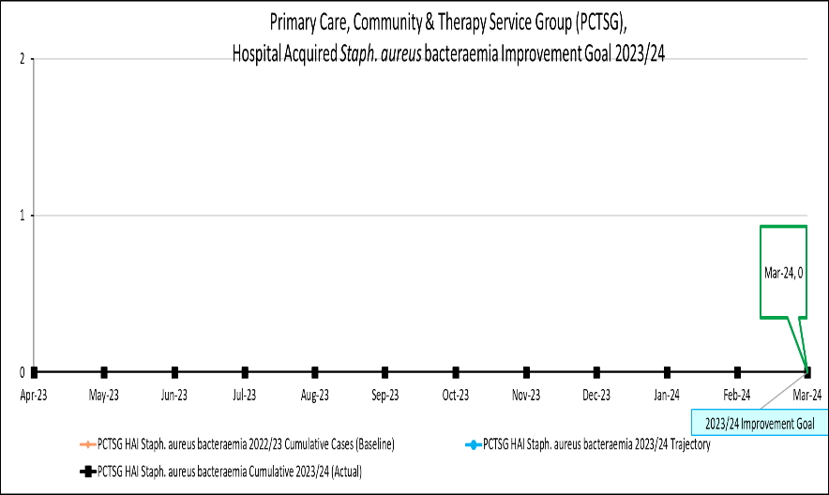
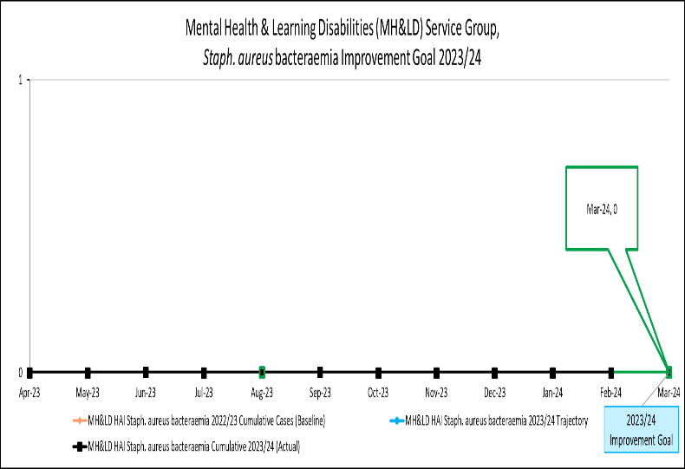 | 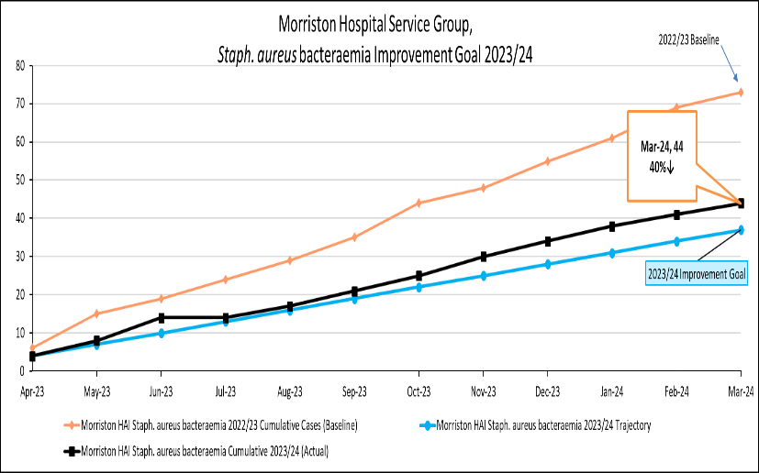
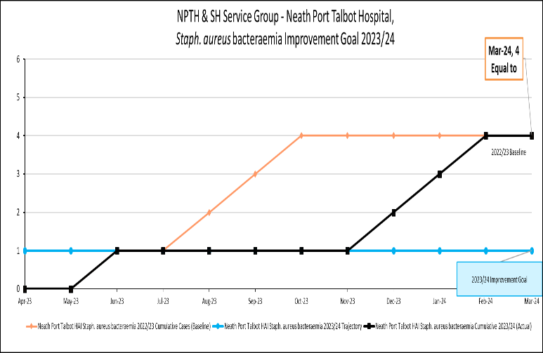 | 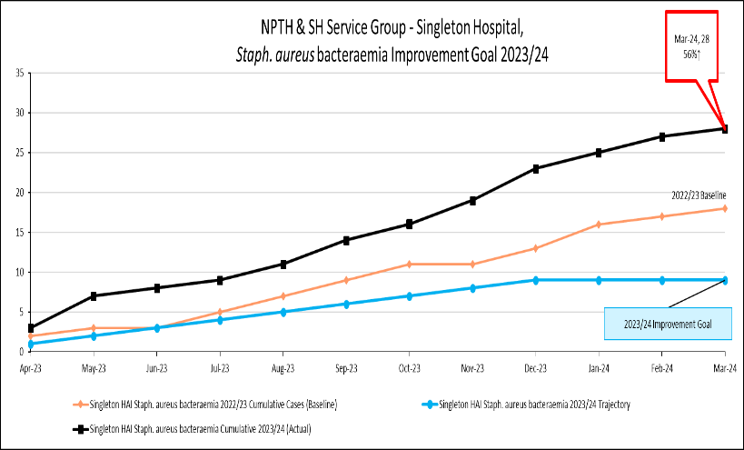

E. coli bacteraemia
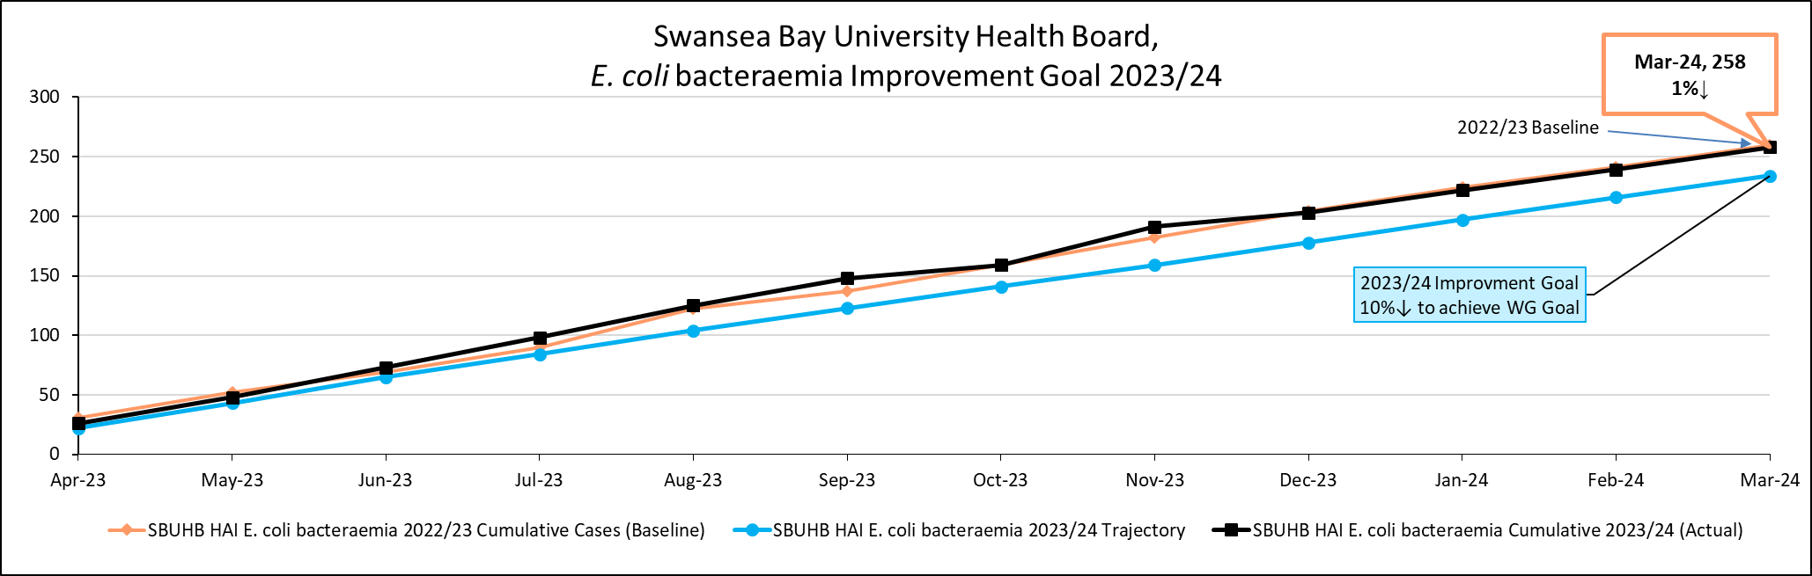
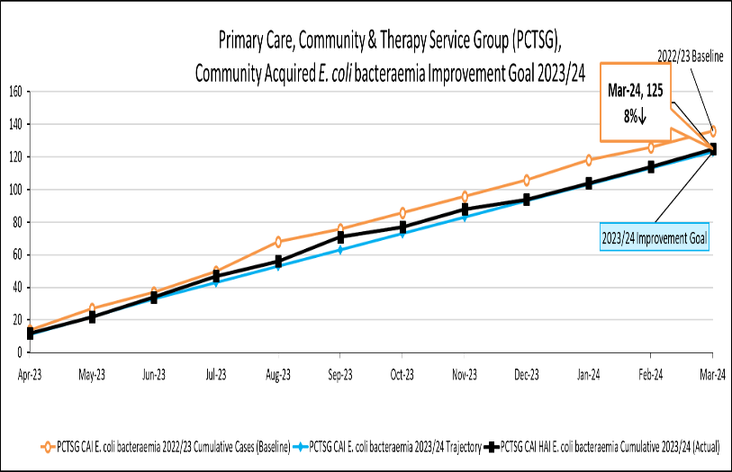 | 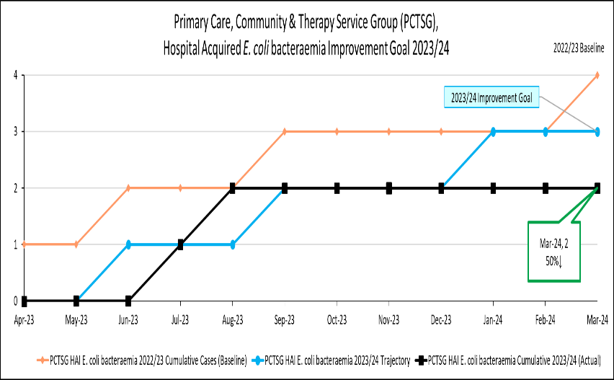
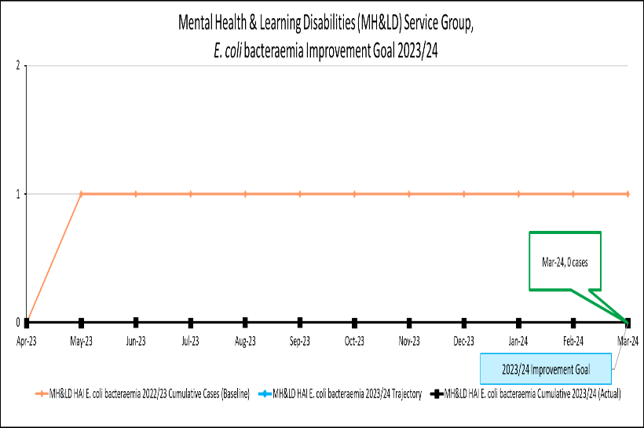 | 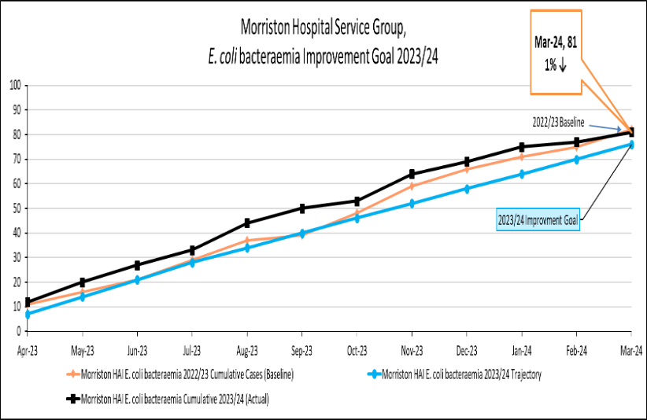
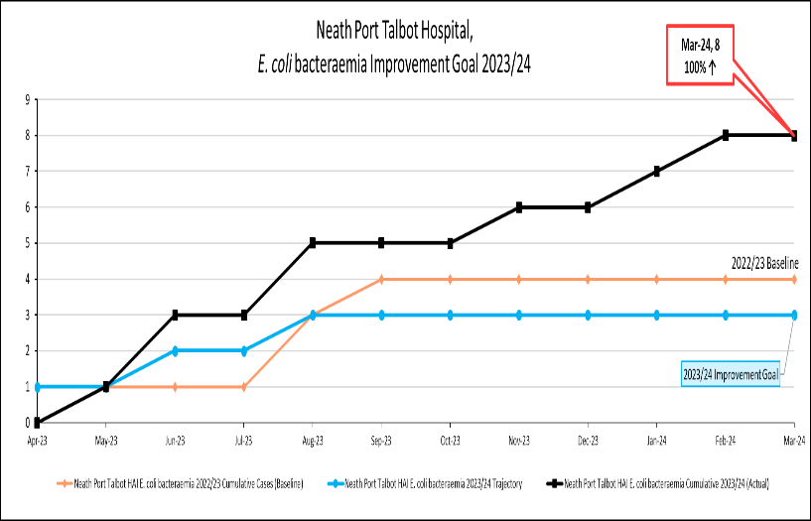 | 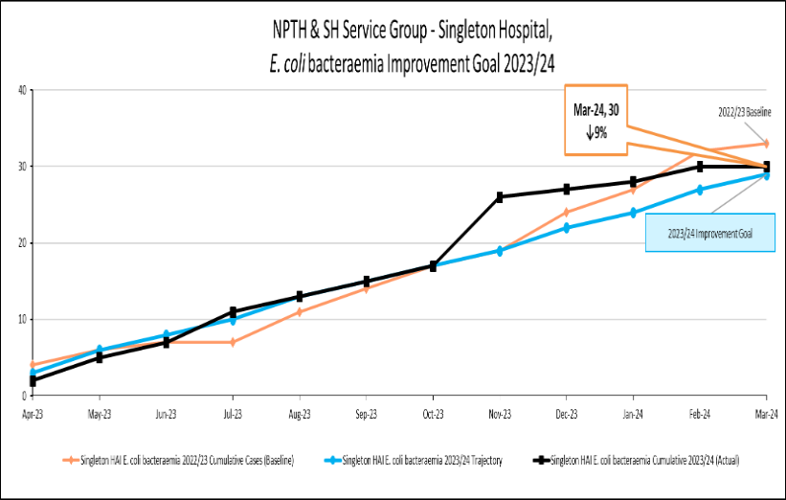

Klebsiella spp. Bacteraemia
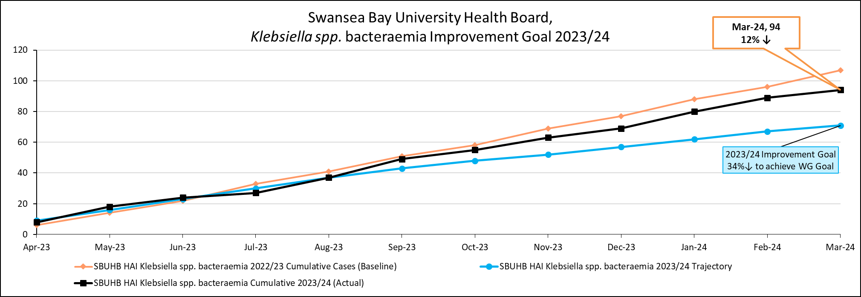
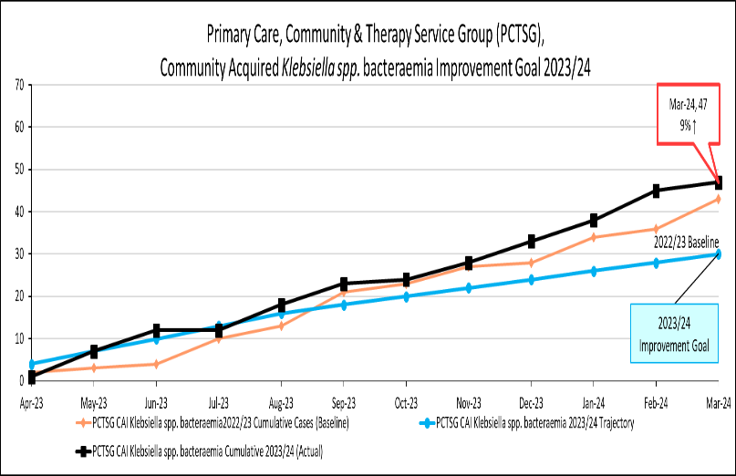 | 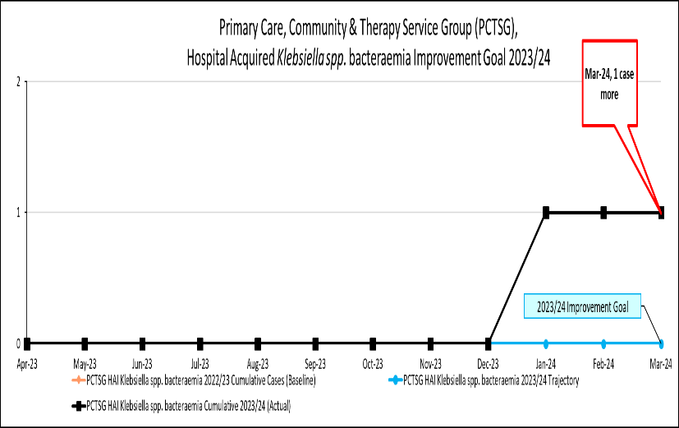
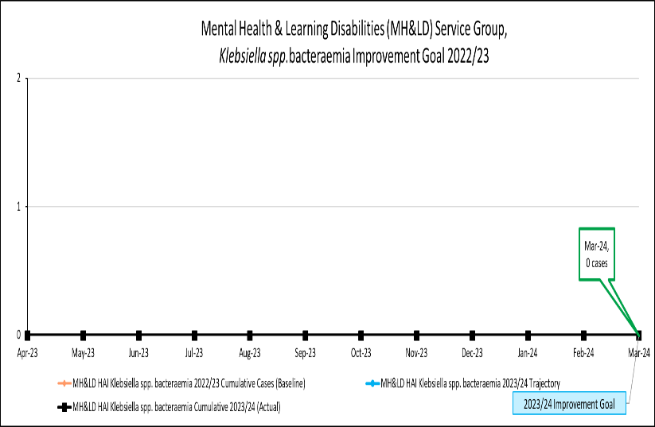 | 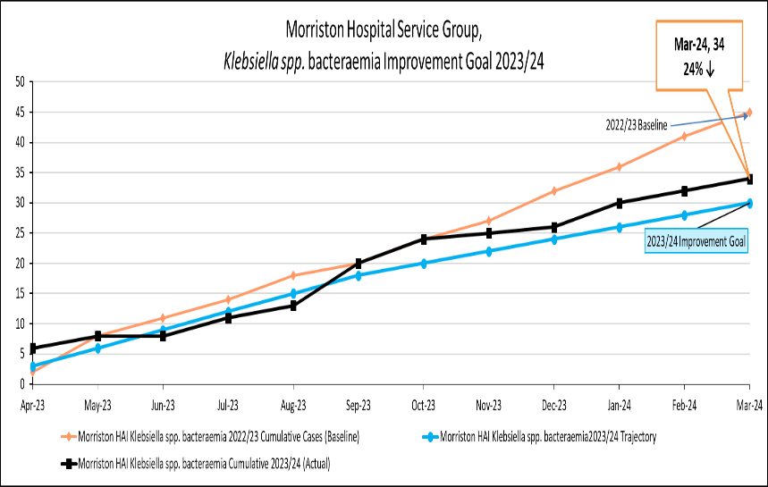
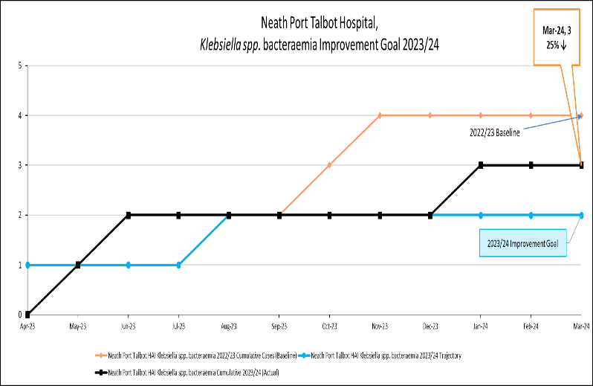 | 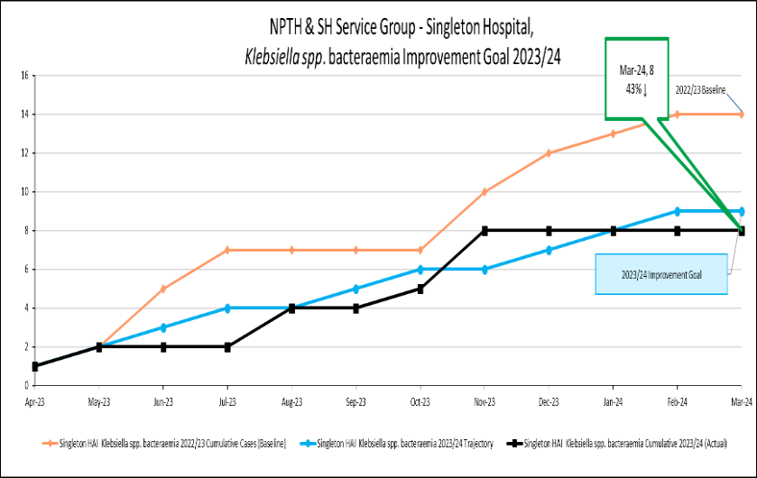

Pseudomonas aeruginosa bacteraemia
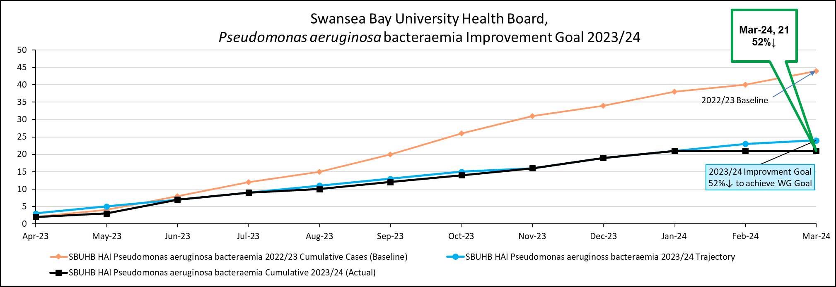
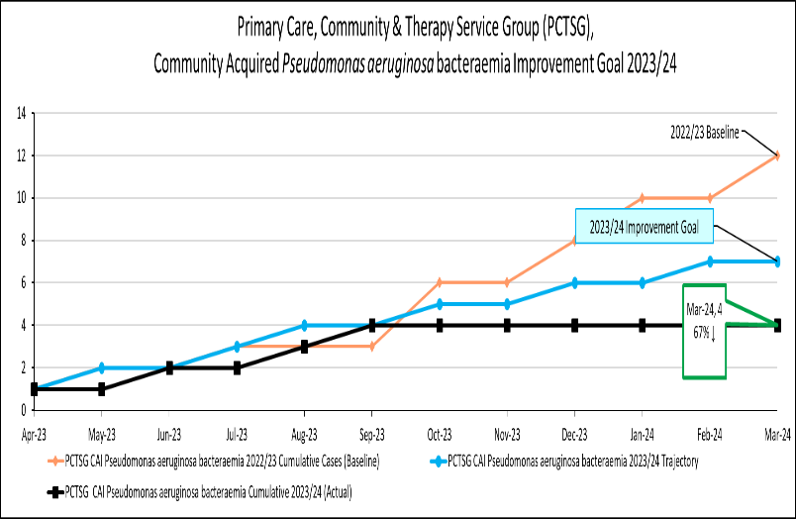 | 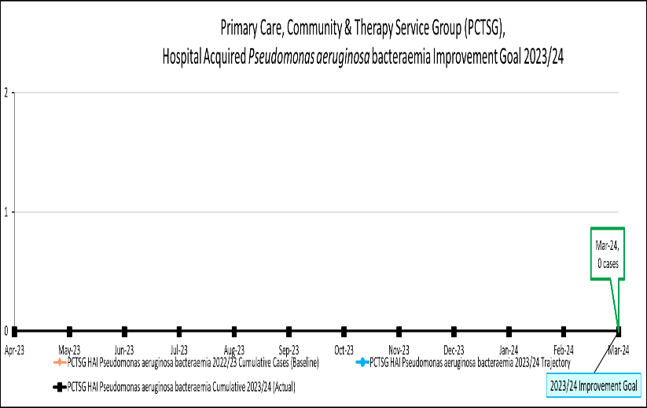
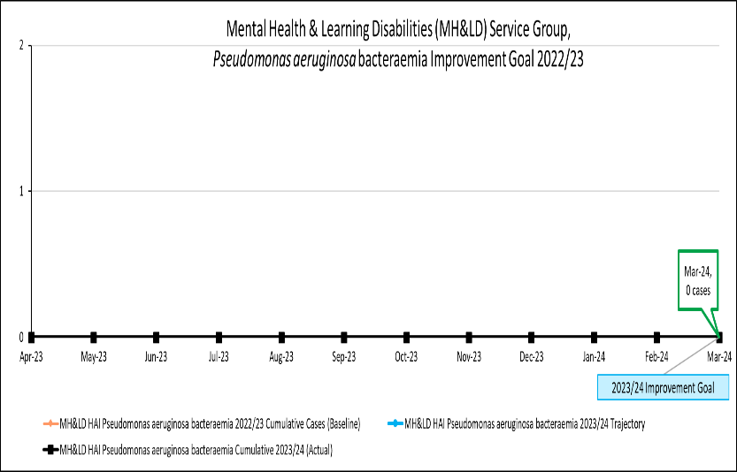 | 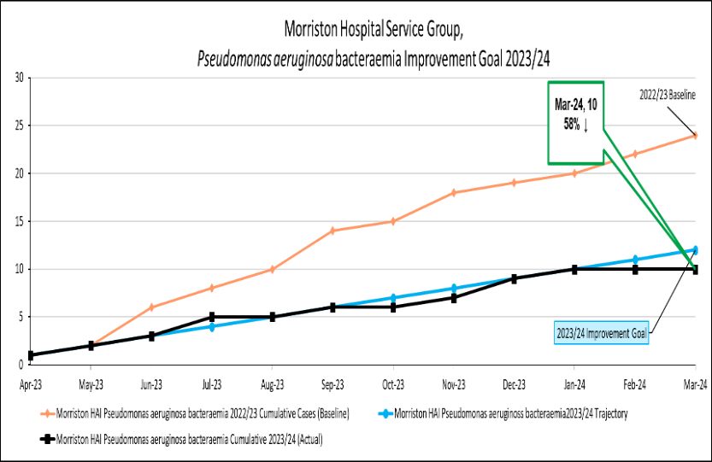
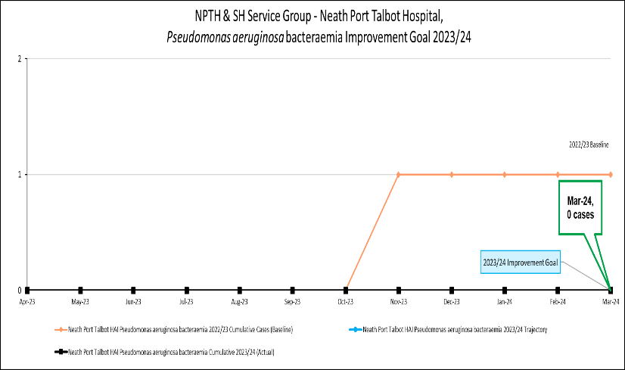 | 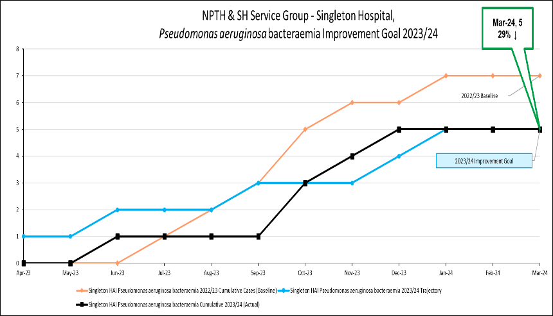

Incidence/100,000 population | Incidence/1,000 admissions
C. difficile infection
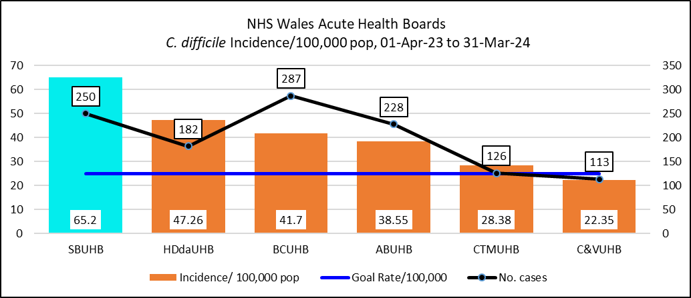 | 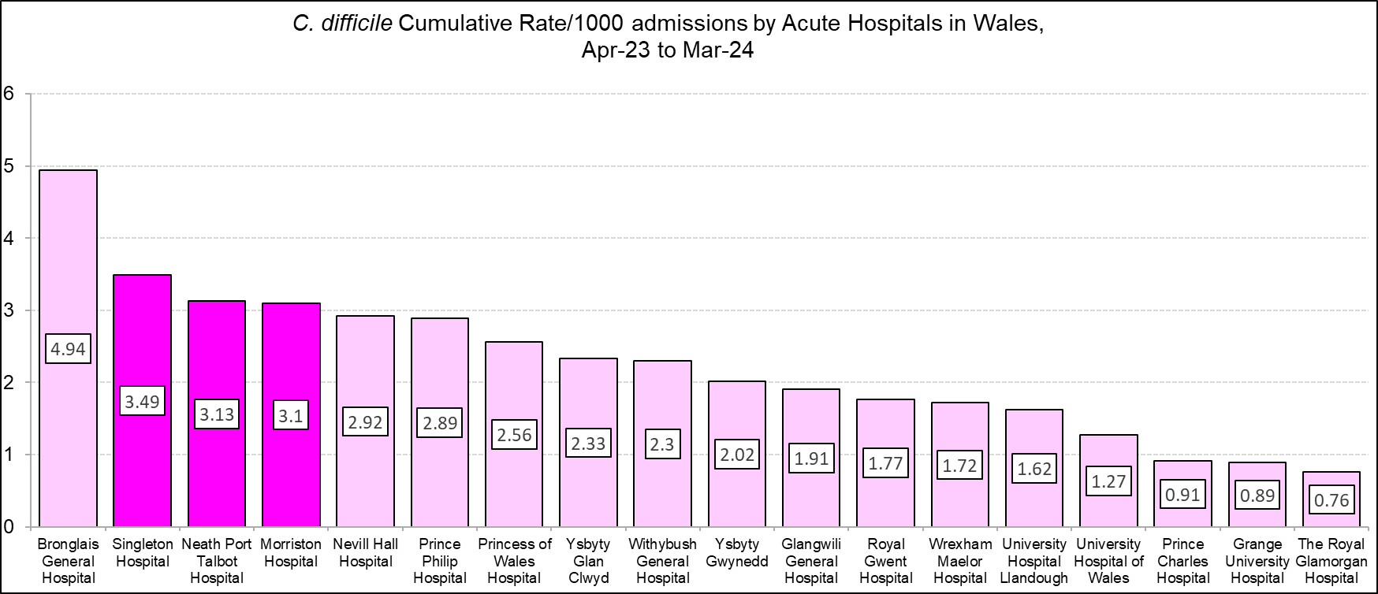
Staph. aureus bacteraemia
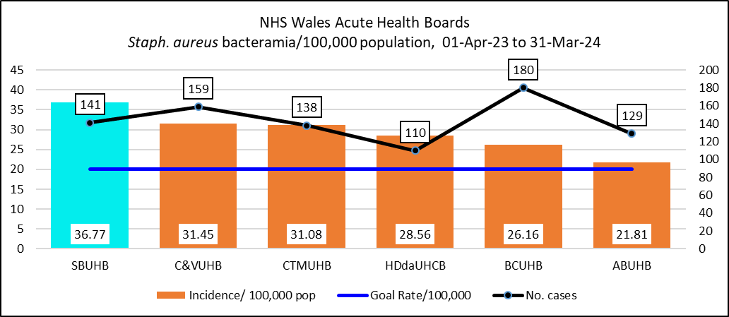 | 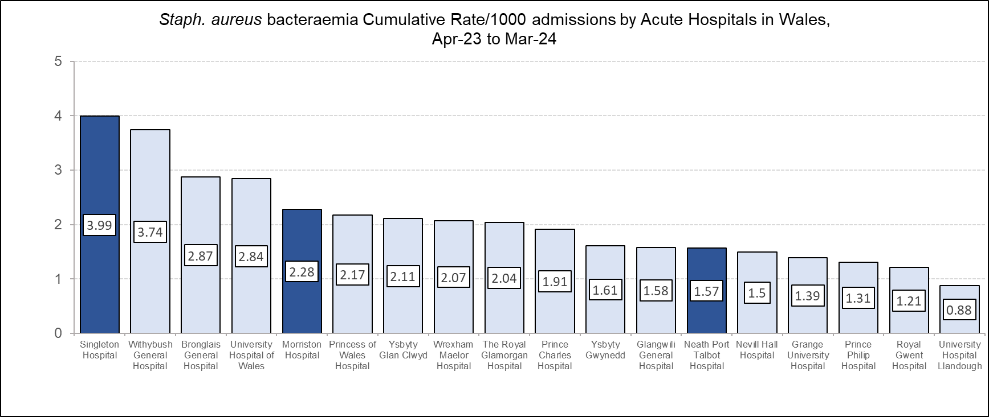
Incidence/100,000 population | Incidence/1,000 admissions
E. coli bacteraemia
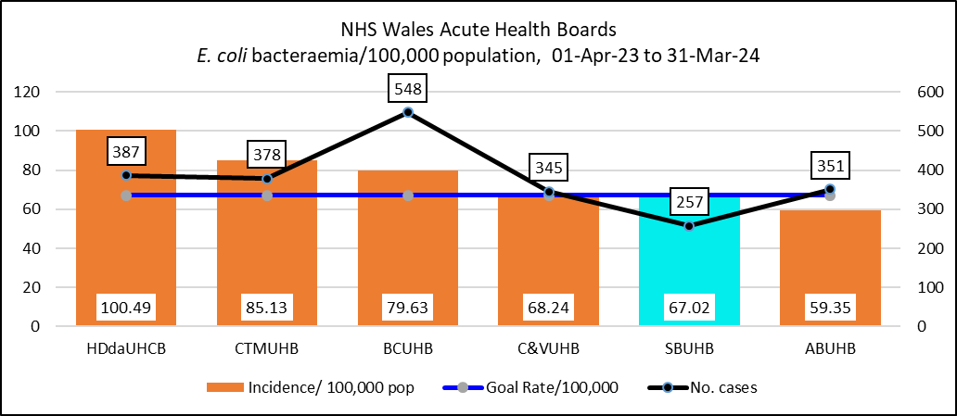 | 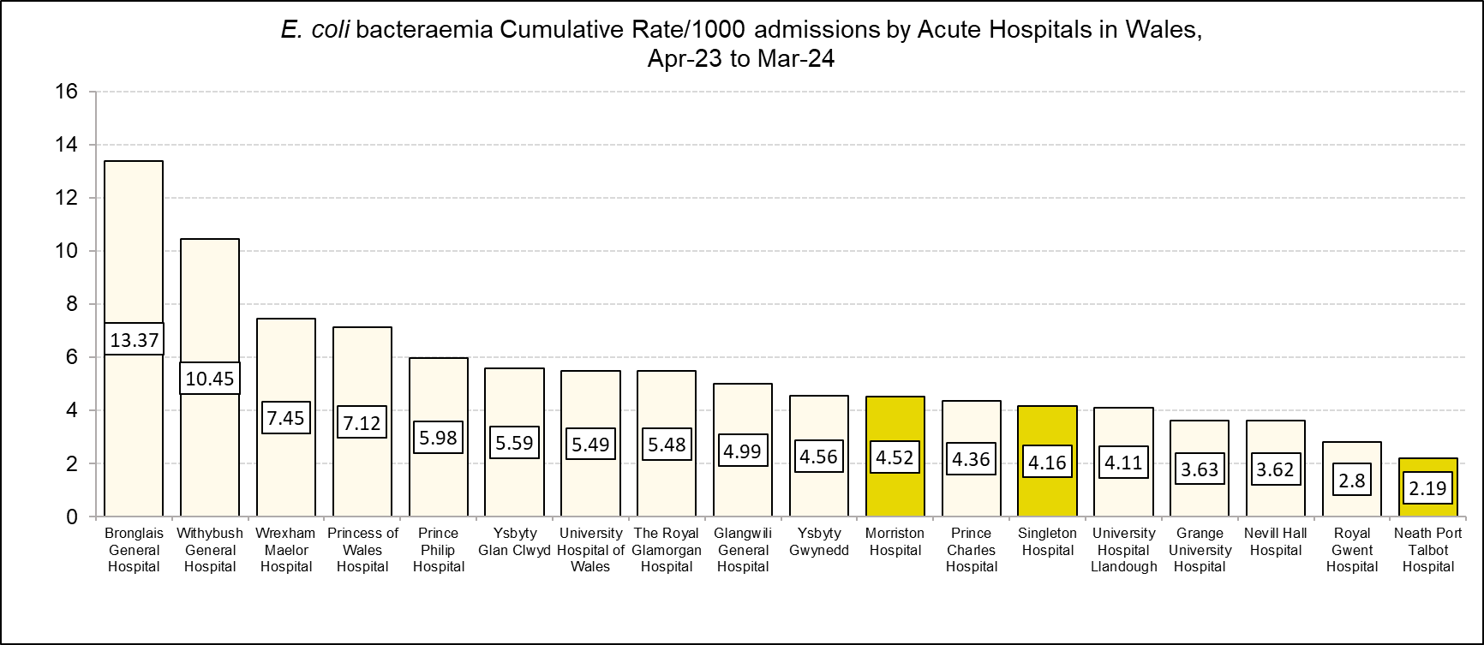
Klebsiella spp. bacteraemia
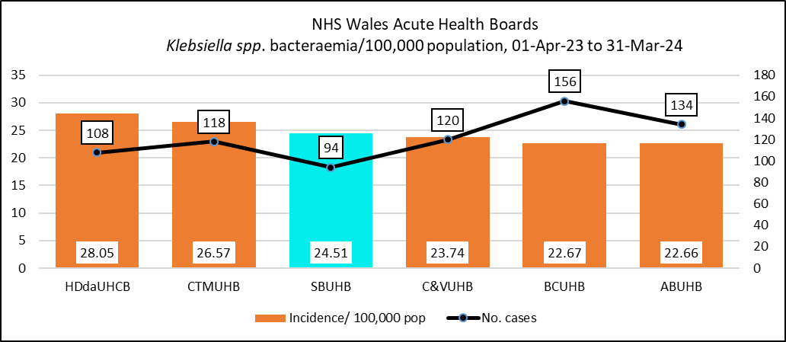 | 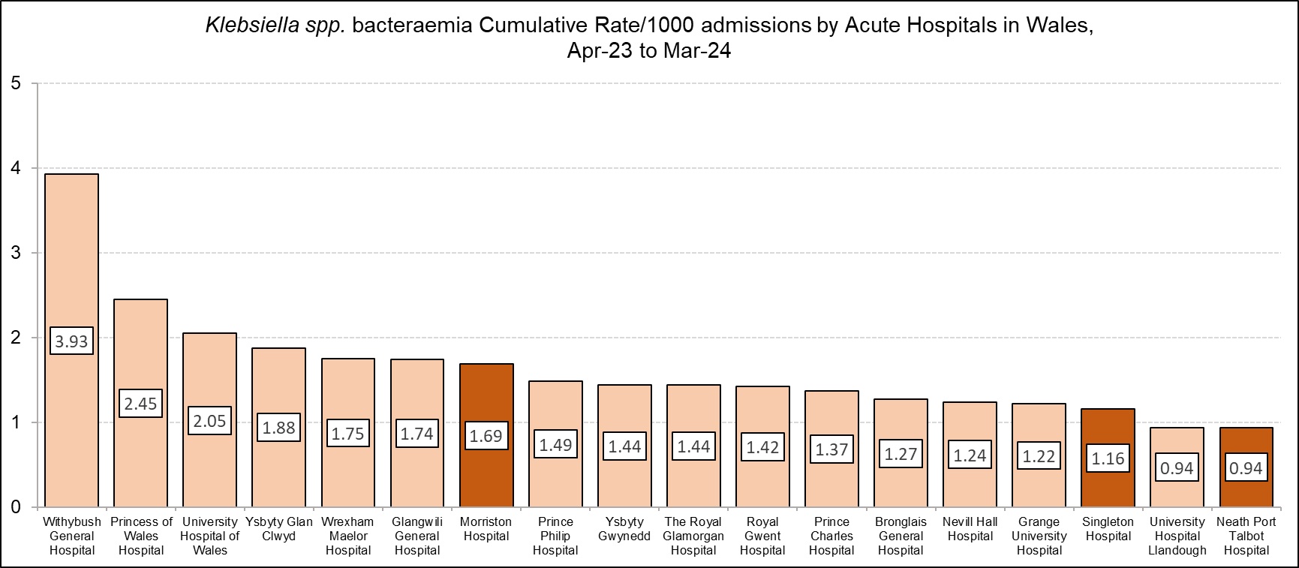

Incidence/100,000 population | Incidence/1,000 admissions
Pseudomonas aeruginosa bacteraemia
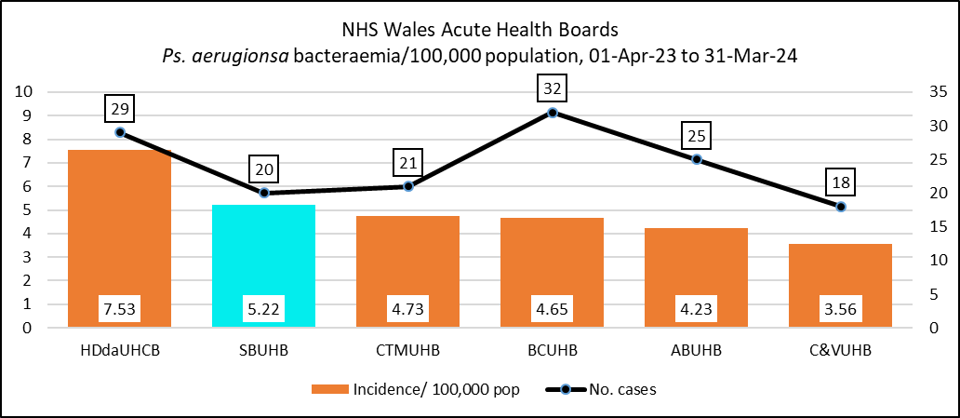 | 